“Removal of Nitrosamines, TAR and Carbonyl carcinogens from the mainstream of cigarette smoke with an aim of reducing toxicity of cigarette smoke by Activated Carbon-Zeolite & Amino Polymer cigarette filter”
*Dr. Narendra Singh, Dr. Govindasamy Jeyabalan, Mr. Shamba Sarkar
^{1,2,3}Alwar Pharmacy College, Alwar, Rajasthan, India Correspondence: nschoudhary82@gmail.com ABSTRACT
Over 100 million deaths were caused by tobacco in the 20th century, over all Tobacco accounts for 1 in 10 deaths in universe. In India about 1 billion cigarettes smokes every day. Nearly 70% of these ten lakh deaths
i.e. seven lakh people will die young. A report from “National Representative Case-Control Study of Smoking and Death-06” in India indicates that over 50% of the tobacco deaths will occur in illiterate men or women, with 80% of them residing in rural India.

Cigarette Smoking not only contribute to tuberculosis, respiratory disease like COPD development, but also implicated as a major risk factor in many diseases such as pulmonary and cardiovascular pathophysiological conditions. The lungs are the target organ for most of the damage associated with cigarette smoking. As the lungs are primary organ expose to the cigarette smoke, thus cigarette smoking give rise to no. of disorders in respiratory system. Chronic bronchitis and emphysema are Chronic Obstructive Pulmonary Disease (COPD) mainly caused by tobacco smoking.
In this present work we plan to control the effect of nicotine present in tobacco in the form of cigarettes mostly by “Removal of Nitrosamines, TAR and Carbonyl carcinogens from the mainstream of cigarette smoke with an aim of reducing toxicity of cigarette smoke by Activated Carbon-Zeolite & Amino Polymer cigarette filter” to treat different disease by different ways as: by removing of nitrosamines and tar from cigarette smoke. Determine the concentration of carcinogens in cigarette smoke after passing through CZC filter, synthesis of different product which reducing effect of nicotine/tobacco and introduce new cigarette filter and considering rethinking the warning “CIGARETTE SMOKING IS INJURIOUS TO HEALTH”.
Key words: Tobacco, cigarettes smokes, Chronic Obstructive Pulmonary Disease (COPD), carcinogens, Synthesis, CZC filter etc.

INTRODUCTION

TOBACCO SMOKING IS INJURIOUS TO HEALTH. WORLD HAS MORE THAN 1 BILLION TOBACOO SMOKERS.
Over 100 million deaths were caused by tobacco in the 20th century, over all Tobacco accounts for 1 in 10 deaths in universe. In India about 1 billion cigarettes smokes every day. A recent study in India by “New England Journal of Medicine” reveals that India is on threshold of a catastrophic pendemic of smoking and it will kill about 10 lakh people every day in India. Nearly 70% of these ten lakh deaths i.e. seven lakh people will die young. ^{[1]}
A report from “National Representative Case-Control Study of Smoking and Death-06” in India indicates that over 50% of the tobacco deaths will occur in illiterate men or women, with 80% of them residing in rural India.
Smoking is predominant mode of tobacco consumption in population and about 100 million deaths in 20th century due to tobacco intake or tobacco smoking. Tobacco smoking causes 38% of all deaths from tuberculosis, 31% from respiratory diseases and about 20% of all deaths from vascular diseases. “New England Journal of Medicine” indicates that consumption of tobacco in any form – cigarettes, bidis and gutkha are the primary cause behind one in five of all male deaths and one in 20 of all female deaths in the middle age (30-69 year) in India.^{[2]} An overview on cigarette smoking is that “Every cigarette takes about 7 minutes of the life of the smoker”.^{[3]}
Cigarette smoking is a highly sophisticated nicotine delivery system - Pipes, cigars, bidis and other products are used in particular region. Tobacco smoking products in the Indian market have higher level of nicotine & tar content than those found in developed countries. Traditional Indian smoky products like Bidi, Chutta show higher level of Nicotine & other minor tobacco alkaloids [Bidi (37.7 mg/g), Chutta (34.5 mg/g)], in comparison to Indian & US cigarettes (14- 16mg/g).^{[4]}
Man, who smokes bidi loses on average, 5 years of expected life. Woman with bidi smoking habit loses eight year and men with same lose about 10 years of their productive life, respectively. Studies say that smoking only few (1-7) bidis a day raises mortality risk by 25% while an equal number of cigarettes a day doubled the risk.
Cigarette Smoking not only contribute to tuberculosis, respiratory disease like COPD development, but also implicated as a major risk factor in many diseases such as pulmonary and cardiovascular pathophysiological conditions. Cigarette smoke is a prominent risk factor for

premature or accelerated peripheral, coronary and cerebral atherosclerotic vascular disease. Moreover, increasing evidences establish the causal relationship of tobacco smoke in the aetiology of larynx, oral cavity, esophagus, pancreases, kidney, stomach, liver, leukemia and colon cancer.
Tobacco smoking increases the risk of all histological type lung carcinoma including squamous- cell carcinoma, small-cell carcinoma, adenocarcinoma (including bronchiolar/alveolar carcinoma) and large-cell carcinoma. The association between adenocarcinoma of the lung and smoking has become stronger over time.^{[5]}
  - What makes a man chain smoker?
It is “Nicotine” that makes a man chain smoker. Cigarette smoking is a highly sophisticated nicotine delivery system. Nicotine exerts addiction activity by interfering with a natural neural pathway in the brain called the reward pathway, which normally occurs in response to activities that promote survival, like eating and drinking. ^{[6]}
This pathway is called the “Mesolimbic Dopaminergic System”. After its release, dopamine is quickly reabsorbed by the cells that release it by a specialized pump called the dopamine transporter. (Figure no. 1) Nicotine, exert its addictive effect through the mesolimbic dopaminergic system. It increases the amount of dopamine in the synaptic clefts of the mesolimbic dopaminergic system. Nicotine mimics the neurotransmitter Acetylcholine and binds to specific acetylcholine receptors on neurons in the ventral tegmental area of the brain.
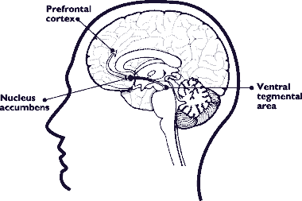
Figure No. 1 The Reward Pathway in the brain.

When cigarette smoke is inhaled, the nicotine from the smoke is absorbed into the systemic circulation, reaches the brain within 8 seconds of the first puff. Once in the brain, nicotine binds to receptor located on the cell bodies of neurons in the ventral tegmental area, as well as the terminals of these neurons. Normally these receptors, called “Nicotinic Acetylcholine Receptors”, bind the neural transmitter Acetylcholine. The nicotinic acetylcholine receptor, a transmembrane protein made up of five subunits (shown in Figure no. 2). Nicotine is able to bind in place of acetylcholine on the receptor and activate the receptor. The binding of either nicotine or acetylcholine to the receptor results in the transient opening of a cation-specific pore in the receptor, allowing cations to move into the neuron. This results in an electrical impulse down the nerve axon, which leads to the release of dopamine in the nucleus accumbens and the prefontal cortex, creating a sensation of pleasure.
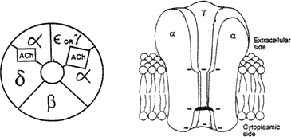

Figure No. 2 Acetyl Choline receptor
  - Cigarette Smoke: -
Cigarette Smoke, combustion product of tobacco, is a complex mixture of thousands of chemical agents. Many of these substances are organic compound which have been identified, but not yet thoroughly studied. Main constituents of cigarette smoke are Nicotine and Nicotine like alkaloids, PAHs, Aldehyde compounds, Aromatic amines, Heterocyclic amines, Aza-arenes, N- Nitrosamines and Miscellaneous organic/ Inorganic compounds.
Cigarette smoke also contains oxidizing substances among its > 4000 identified constituents including both free radicals in high concentration and chemical compounds that readily react to form other reactive substances. Mainstream and side stream gas-phase cigarette smoke contain about the 1×10¹⁶ free radicals per cigarette (5 ×10¹⁴ free radicals per puff).^{[7]}

  - Carcinogenic Smoke Constituents: (List no.1) ^{[7][8]}
According to the U.S. Department of Health and Human Service, the following carcinogenic chemicals
are found in cigarette smoke……….
Chemical Amount (per cigarette)

Acetaldehyde 980 micrograms to 1.37 milligrams

Acrylonitrile Formerly 1 to 2 milligrams.

- Aminobiphenyl 0.2 to 23 nanograms per cigarette

O-Anisidine Hydrochloride unknown

Arsenic unknown

Benzene 5.9 to 75 micrograms

Beryllium 0.5 nanograms

1, 3-Butadiene 152 to 400 micrograms

Cadmium 1.7 micrograms

1, 1-Dimethylhydrazine unknown

Ethylene oxide unknown

Formaldehyde unknown

Furan unknown

Heterocyclic amines unknown

Hydrazine 32 micrograms

Isoprene 3.1 milligrams

Lead unknown

2- Naphthylamine 1.5 to 35 nanograms
O-Toluidine 32 nanograms

Vinyl chloride 5.6 to 27 nanograms

Table 1. A. Summary of carcinogen | s in cigarette smoke* [8]
Type | No. of compounds
Polycyclic aromatic hydrocarbons | 10
Aza-arenes | 3
N-Nitrosamines | 7
Aromatic amines | 3
Heterocyclic aromatic amines | 8
Aldehydes | 2
Miscellaneous organic compounds | 15
Inorganic compounds | 7
Total | 55

  - Cigarette Smoking and Lungs: The lungs are the target organ for most of the damage associated with cigarette smoking. The lungs are absolutely essential for life, but also very vulnerable to the outside world. With every breath, environmental air comes into intimate contact with the delicate structures of the lower respiratory tract. Breathed air undergoes some preliminary processing before it reaches the lower respiratory parts. It is filtered to remove larger particles, humidified and then warmed to body temperature.
Approximately 10,000 liters of air pass through the nose every 24 hours requiring about three quarters of a quart of water to properly humidify inhaled air, every day. These defense mechanisms are efficient mean to remove most of the noxious environmental pulmonary irritants prior to reaching the lung surface. However, excessive exposure to toxic chemicals from cigarette smoking can easily overwhelm these defenses.

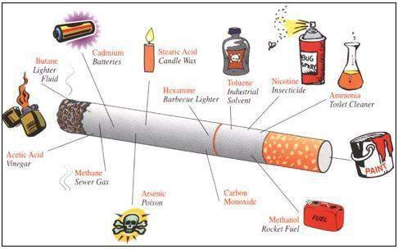

Figure No. 3 Showing the components of tobacco cigarette relevant hazards.
When smoker take a breath of air, to take in life sustaining oxygen and to get- rid of carbon dioxide, a waste product. In order to do this, the oxygen get down to the lung from the outside air and likewise carbon dioxide must get from the lungs to the outside. Air first is inhaled through the nose, down the throat, past the vocal cords (larynx), into the windpipe (trachea) down the smaller windpipes (bronchi) and into the alveoli where the real action occurs. Inspiration is under voluntary control but usually is a reflex action initiated by certain parts of the brain due to stimulants. There are many stimulants for respiratory tract, but one of the most powerful is carbon dioxide. When this chemical (a waste produce by metabolism) gets too high, it stimulates the respiration center to begin a breath. The major muscle of respiration, the diaphragm contracts from the neural input sent out by the brain, producing a negative pressure within the chest cavity. This negative pressure then draws air into the chest where gas exchange (oxygen for carbon dioxide) can then occur.
The nose, besides serving as decoration for the face, serves several important functions. The nose helps to warm and humidify the inspired air so that the delicate mucus membrane of the lower lung won't be dried out. There are hairs in the nose which filter out larger particles so they won't enter to the lungs. The throat has organized lymph nodes (such as the tonsils) which serve and kill unfriendly bacteria before they have a chance to cause an infection.
The trachea is a hollow tube that is partially surrounded by cartilage and that transport the air down to the lungs. The trachea can deform itself allowing for an effective cough. The trachea can be a

site of cancer, but lung cancer much more frequently occurs down in the lungs. Once past the trachea, the oxygen then has to travel into either the right or left lung through either the right or left mainstream bronchus. A bronchus is basically a hollow tube just like the trachea but where the cartilage is not as well organized. The bronchi also produce mucus which helps to keep the lungs moist and clean, have lymph nodes, produces antibodies to kill bacteria. Once into the mainstream bronchus, the oxygen passes through successively smaller and smaller branches until it finally gets to the bronchioles, which are simply smaller bronchi that are not invested with cartilage. After several more divisions, the oxygen now passes into the terminal bronchioles, respiratory bronchioles, alveolar ducts, alveolar sacs, and finally into the alveoli where the action occurs.
Cigarette smoking can affect the lungs anywhere along this long pathway from the mouth to the alveolus. Cigarette smoke may adversely affect the lungs either through lung cancer or by chronic obstructive pulmonary disease (COPD).
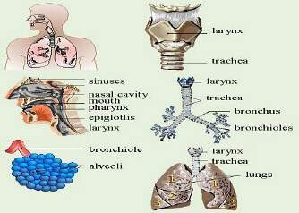
Figure No. 4 Showing part of respiratory tract affected by cigarette smoking.
COPD is divided into two main categories; that which mainly affects the bronchi (chronic bronchitis), and that which mainly affects the alveoli (emphysema). Smoker enjoys the short-term effect of smoking, but never thinks about the long-term side effects which, most of the time, are irreversible. Cigarette smoking actually increases the risk of suffering from life-threatening diseases.

If a person has smoked for five years, smoking does permanent effects on the following parts of a human body including lungs:
- Heart,
- Eyes,
- Throat,
- Urinary tract,
- Sex organs,
- Women's fertility zone,
- Men's sperm production,
- Digestive organs,
- Bones and joints,
- Skin.
  - Effects of Smoking:
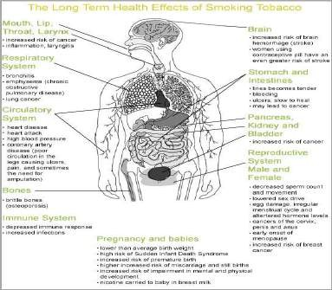
Figure No. 5 Lung cancer, the most common cause of cancer-related death in men and the second most common in women, is responsible for 1.3 million deaths worldwide annually.[9]

    - Cigarette Smoking and Chronic Obstructive Pulmonary Disease:
As the lungs are primary organ expose to the cigarette smoke, thus cigarette smoking give rise to no. of disorders in respiratory system. Chronic bronchitis and emphysema are Chronic Obstructive Pulmonary Disease (COPD) mainly caused by tobacco smoking.
Chronic bronchitis, an inflammation or irritation in the airways called bronchial tubes of the lungs. Thick mucus is formed plugging up the airways and making it difficult to get air in/out to the lung. Cough producing sputum, breathing trouble, tightness in the chest are main symptoms of the chronic bronchitis.
Cigarette Smoking is main cause behind chronic bronchitis in smokers. The tobacco smoke irritates the airways of the lung and produces mucus. Again, long time exposure to chemical fumes, dust and other harmful substances can also be reprecipitate bronchitis besides tobacco smoke.^{[10]}
Emphysema, involves loss of elasticity in the wall of small air sacs of the lung. Due to loss of elasticity, the wall cannot stretch normally, so they break into larger and less efficient air sacs. This way, the normal exchange of oxygen and carbon dioxide is hindered. As a result, breathing becomes a difficult process and consuming 20 % of resting energy of a human body.
Unfortunately, they frequently become infected. Additionally, they are prone to burst open producing a pneumothorax or collapsed lung.^{[11]}
Cigarette smoking also causes oxidative damages in lungs including genetic damage in both nuclear and mitochondrial genomes of smoker’s lung macrophages. Further evidences suggest the dose-related increases in lipid-peroxide content, mitochondrial DNA lesions and decreases in pulmonary function in lungs of smokers.^{[12]} Highly stable free radical and other oxidants from cigarette smoke might be involved in pathogenesis of COPD.

    - Cigarette Smoking and Inflammatory-Immune System Activation:
Cigarette Smoke (CS) induced respiratory tract injury involves the activation of inflammatory- immune cells, initiated by the primary and secondary CS related injury process. These are important defender of the lung against environmental pathogens, but can injure the lung, due to generation of reactive oxygen and nitrogen species in lung cells. This CS related activation of systemic inflammatory-immune processes is likely to be related to atherogenesis and possibly to carcinogenesis. ^{[13]}
    - Cigarette Smoking and Peripheral Vascular Disease: Cigarette smoking and other forms of tobacco consumption have been found to be responsible to a three-fourth degree for the occurrence of all peripheral vascular diseases. Peripheral vascular disease is a disorder that partially or completely blocks, narrows down or hardens the vessels carrying blood to the legs, arms or feet and restricts blood flow to these parts. Peripheral Vascular Disease (PVD) is also known as Peripheral Artery Disease (PAD) and Peripheral Artery Occlusive Disease (PAOD). Risk of PAD is astoundingly 16-fold higher in current smokers and seven-fold in ex-smokers in comparison to non-smokers. When a person indulges in smoking, the harmful chemicals present in tobacco destroy the vascular endothelium and accelerates coagulation of blood.
This further hardens the arteries and vessels carrying blood to the legs, arms, feet and when it happens the smoker ultimately becomes a PVD sufferer. Women, who continued smoking for a prolonged period, usually show a particular syndrome of PVD as well as “premature atherosclerosis”.^{[14][15]}

    - Cigarette Smoke Induce Erectile Dysfunction and Infertility:
The consequences of tobacco use, like lung cancer, strokes, heart attacks cataract etc. are commonly known. But smoking induced erectile dysfunction or male impotence is relatively a new area of knowledge which is yet to be acknowledged by common men. The alarming findings by Action on Smoking and Health (ASH) and the British Medical Association (BMA) show that 120,000 UK men in their 30s and 40s are impotent as a direct consequence of smoking.
Tobacco narrows down the blood vessels and impinges on the vascular system that leads to blockage of arteries. Penis cannot get sufficient blood, when arteries are clogged; the result is a failed erection. ^{[16]}

The possible mechanisms of smoking induced male impotency: ^{[17][18]}
      - As a result of long- t e r m smoking, Atherosclerosis deposits itself in the arteries, and blocks the route of blood into the penis.
      - Nicotine stimulations that are sent to brain cause rapid contraction in the penile tissues. This symptom is known as Acute Vasospasm that restricts blood flow into the penis.
      - When nicotine is present in the blood stream it damages the valve mechanism and traps blood in the penis. This symptom is known as venous dilation.
      - Nicotine is also related to pyospermia that minimizes the volume of ejaculation.
      - Cigarette smoking lower sperm count and the sperm develops in an abnormal shape.
      - As a result of pyospermia due to tobacco intake, sperm motility is also damaged.
      - Tobacco damages DNA in human lymphocytes.
      - The normal growth of sperm cannot tolerate exposure to radioactive particles from cigarette smoke.
Cigarette smoke constituents along with induction of erectile dysfunctions can also induce infertility in men and women. Cigarette smoking cause decreased sperm production in men and in women by reducing the quality of the eggs that induced infertility. Moreover, decrease level of testosterone in smoker and toxic chemical of Cigarette smoke in semen makes a man infertile; Cardiovascular Diseases ^{[17]}, Respiratory Tract Dysfunctions, Diabetes Mellitus, Cataract and Thyroid Diseases are under this category.

OBJECTIVES AND PLAN OF WORK

Objective and Plan of Work: The present investigation is based on the following evaluation parameters:
1.… The effects of CZC filter in removing of nitrosamines and tar from cigarette smoke.
2…. To determine the concentration of carcinogens in cigarette smoke after passing through CZC filter and
whether complies safety level as specified by IARC (International Agency for Research on Cancer). 3….To study the protecting effect of CZC filter in reducing lung cell cytotoxicity, DNA aberration and immunotoxicity will be determined.
4…. To introduce new cigarette filter and considering rethinking the warning “CIGARETTE SMOKING IS INJURIOUS TO HEALTH”.

EXPERIMENTAL SECTION
  - Synthesis I. Preparation of Polyaniline
Polyaniline was prepared by free radical polymerization of aniline with ammonium persulphate in dilute hydrochloride solution, as follows:.^{[19]}
5 grams of aniline was dissolved in 300 ml of (1M) HCl solution that was subsequently cooled on ice. In another beaker, 11gm Ammonium Persulphate (98% pure) was dissolved in 200 ml of (1M) HCl and cooled by using ice. The Ammonium Persulphate solution was added slowly to aniline solution; temperature was maintained below 10ºC with vigorous stirring on magnetic stirrer.
Solution was allowed to equilibrate to room temperature in about 2 h; dark bluish-green precipitate was obtained from resultant solution. After 20 h bluish-green precipitate was filtered and washed with water.
This dark bluish-green precipitate was a solid HCl-doped polyaniline that was subsequently suspended in 300ml (1M) NH4OH and stirred for 20 h, polymer was recovered by filtration and following washing with distilled water. Obtained polymer was dispersed in 300 ml of (1M) HCl and stirred for 20 h. Final product of polyaniline recovered and washed thoroughly with 2 litter of distilled water, dried at 50 ºC. Product characterized with IR, NMR spectral analysis. The yield of polyaniline was estimated to 20%.
4n 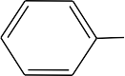NH2 HCl + 5n (NH4)2S2O8
H2N
H N
H N
NH
NH

+ 2n HCl + 5n H2SO4 + 5n (NH4)2SO4

Scheme No. 1

  - Synthesis II.
Preparation of Polyaniline with Activated Carbon Support: -
5gm of Activated Carbon (300 mesh sieve) was added to aniline solution [5gm in 500 ml (1M) HCl] and stirred for 18 hrs. at room temperature so that aniline can absorb on Activated Carbon.
Compound was filtered and washed with water. Aniline adsorbed Activated Carbon was dispersed in 300 ml of (1M) HCl. Ammonium per sulfate solution 11 gm in 300 ml (1M) HCl was added slowly with continuous mixing at below 10 ºC temperature. That result in initiation of free radical polymerization of aniline adsorbed on activated carbon. Further synthesis was similar to that previous experiment as performed in section 3.1.
Polyaniline with activated carbon solid support doped in HCl was filtered and dried at 50 ºC temperature.
  - Synthesis III.
Preparation of Polyaniline with Zeolite solid support: -
5gm of Zeolite was added to aniline solution (5gm in 500 ml 1M HCl), stirring allowed for 18 hr at room temperature so that aniline can absorb on Zeolite. Compound was filtered and washed with water. Aniline adsorbed Zeolite was dispersed in 300 ml of (1M) HCl, subjected for polymerization. To this, Ammonium Per sulfate solution 11 gm in 300 ml of (1M) HCl was added slowly with continuous mixing at below 10 ºC temperature condition. That resulted initiation of free radical polymerization of aniline adsorbed on Zeolite.
Further synthesis procedure was similar describe earlier in 3.1. Polyaniline with Zeolite solid support doped in HCl was filtered and dried at 50 ºC temperature.
  - Synthesis IV.
Preparation of Poly-1,2-diaminobenzene:

Poly-(1,2-diamino benzene), was prepared by free radical polymerization of 1,2 diamino benzene with ammonium persulphate in dilute hydrochloride solution, as follows.
10 gm of 1,2diamino benzene was dissolved in 300 ml of 1M HCl and cooled on ice bath. To this solution ice cooled solution of 11 gm Ammonium Persulphate in 200 ml of (1M) HCl was added

and temperature was maintained below 10 ºC. Resulting solution was stirred for 2hrs to equilibrate at room temperature; brick red precipitate was appeared. String was continued for 20 hrs.
Polymer product that obtained was filtered and washed with water. Second step involve, dispersion for 20 hrs. in 300ml 1M NH4OH. Third step was 20 hrs. dispersion in 300ml 1M HCl with 20 hrs. continuous stirring.
Final polymer was filtered and washed with 1000ml of water twice. Product characterized with IR, NMR spectral analysis.
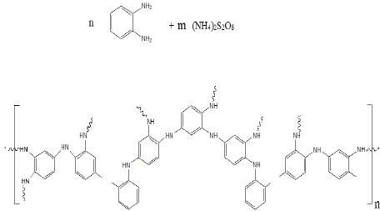

+ HCl + m H2SO4 + m (NH4)2SO4

Scheme No. 2

  - Synthesis V.
Preparation of Poly-1,2-diaminobenzene on Activated Carbon: -
5 gm Activated Carbon (300 mesh sieve) was added to 1,2-diamino benzene solution [10gm in 300ml (1M) HCl]. After 18 h mixing reaction mixture was filtered. Mixture was filtered and washed with water.
Addition of Ammonium Per sulfate solution 11 mg in 200 ml of 1M HCl, start the free radical polymerization. Further synthesis was similar as describe earlier in synthetic procedure section 3.4.
HCl-doped cross-linked poly-1,2diaminobenzene polymer with activated carbon solid support was obtained finally.
  - Synthesis VI.
Preparation of Poly-1,2-diaminobenzene on Zeolite: -

- gm Zeolite was suspended in 1,2-diamino benzene solution (10gm in 300ml 1MHCl) for 20hrs. Result in adsorption of 1, 2-diamino benzene on Zeolite. Mixture was filtered and washed with water. Ammonium Per sulfate solution 11 mg in 200 ml of (1M) HCl was added to start the free radical polymerization; mixture was stirrer for 20hrs.
Further synthesis was done with same procedure as earlier describe procedure.

Poly-12-diaminobenzene with Zeolite solid support was washed with distilled water and dried at 50 ºC temperature in hot air oven.
  - Synthesis of cellulose derivatives:
Cellulose powder was oxidized with 500ml 0.5M Sodium Metaperiodate solution under constant stirring condition for 20 hrs. ^{[19]}
Vicinal hydroxyl group of cellulose, oxidized by Sodium Metaperiodate to aldehydic groups, it was confirmed by IR spectra of the oxidized product that shows stretching for aldehydic group.
This oxidized product was used for further synthesis as describe in scheme no. 3

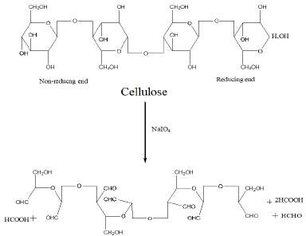

    - Synthesis VII.
Synthesis of Hydrazidocellulose.^{[20]}
Oxidized Cellulose
Scheme No. 3

Succinic dihydrazide solution (10 gm in 100ml water) was added to oxidized cellulose, stirred for 3hr at RT and Azomethine compound was formed.
Azomethine compound was reduced with NaBH4 (2%, 10 ml) in 1M NaOH, to cellulosehydrazine. Final resulting solution was stirrer for some 5 hrs. Product was dried at 60 ^{º}C in oven. Reaction presented in reaction scheme no. 4. Characterization was done by IR and NMR spectroscopic methods.

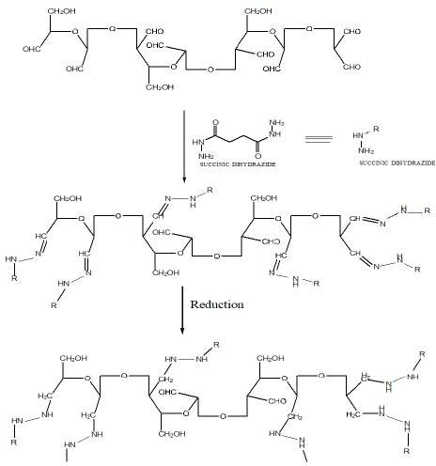

Cellulose Hydrazine Compound
Scheme No. 4

    - Synthesis VIII:
Synthesis of Carbohydrazidocellulose.

Oxidized cellulose was dispersed in water in ratio of 1:1. To this cellulose colloidal solution carbohydrazide solution, 10 gm in 100 ml water was added with vigorous stirring. Dense white precipitate was obtained and stirring was done for 6 hrs.
10 ml of NaBH4 in (1M) NaOH was added to reduced C=N bond formed in first step of synthesis. Rapid froth appeared on addition of NaBH4 solution to reaction mixture. Stirring was continued for 6 hrs. finally. (Scheme no. 5)
Product filtered and washed with large amount of water and dried at 50 ^{º}C in oven.
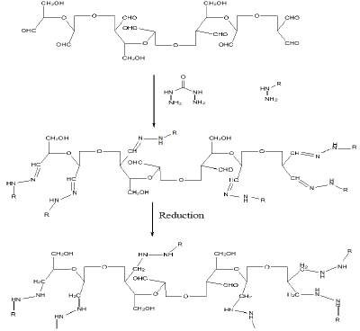

Carbohydrazidocellulose Scheme No. 5

PHARMACOLOGICAL EVALUATION

  - In vitro evaluation of cigarette filters for carcinogen elimination capacity: [20][21]
Invitro evaluation of the filter involve the estimation of efficiency of the filters to retain or adsorb the Nitrosamines, PAHs, Aldehyds and other carcinogens form the main stream of cigarette smoke. Evaluation experiment for the filters was done as describe by Baran S. et al. (2002) with slight modification. Entrapped chemical in Cigarette filter from cigarette smoke, were extracted with organic solvents and investigated in HPLC. Cigarette filter extract was investigated on C-18 RP-HPLC with UV detector at 37 ºC using Acetonitrile-Water [80:20] mobile phase.
HPLC analysis was performed under following conditions:

Analytical columns: Column-C18 (2) Phenomenex Luna Column,

2520X4.6MM

Security guard column- Phenomenex Co.USA,

Eluent: Acetonitrile-Water [80:20] (isocratic programme),

Eluent flow rate: 1.00mL/min,

Pump: LC-20 AT Pump-model,

Detector: UV-SPD-20A model from Shimazdu Co.

Sample injector: Microlitre Hamilton syringe for sample injection from

Bonadiz AG, Switzerland

Data acquisition and analysis unit-DS-200 software was used for experiment.

  - In vivo evaluation of cigarette filters: -
    - Animals and Experimental Procedure: -
Mature Wistar rats weighing 150-250 g were procured from Laboratory Animal Resource, Division of Animal Genetics, IVRI, Izatnagar, (Reg. No. CPC – 196) and acclimatized to laboratory condition at Animal House, IFTM, at Moradabad at room temperature 24±2°C with a 12h/12h/light/dark cycle and 70% RH).
All rats were treated in accordance with the guideline for the Care and Use of Laboratory Animals (NIH Publication No.86-23, revised 1985) with the permission of institute ethical committee (Proposal No.11). The animals were kept in polypropylene cages and maintained on balanced ration provided by Feed Technology Unit, Division of Animal Nutrition, IVRI, of following composition:
Ingredients %
Wheat (crude) 60
Maize (crushed) 30
Wheat bran 07
Mineral mixture 02
Common salt 01
Milk 10 ml/rat/day or 5% skimmed milk powder was added at mixture. Twenty g/rat/day feed was given. The animals had free access to clean drinking water.
All the synthesized polymer product were milled thoroughly in motor-pastel and passed through the sieve no… 150 mg of polymer products were placed in the tobacco cigarette containing 640
mg of tobacco leaves. Male Swiss albino rats were exposed to cigarette smokes 6 hour/ 2 cigarettes daily for 2 weeks. After 2-week rats were sacrificed and lung were removed.
For experimental procedure, rats were divided in the following eight groups containing six animals in each.
Group I. Sham Control Normal nonsmoker healthy rats were kept in very fresh environment and normal conditions.

Group II. Rats were exposed to smoke of non-modified Cellulose Acetate filter cigarettes (CA). Group III. These rats were exposed to smoke of the cigarette of Polyaniline-Cellulose Acetate filter (PCA) modified filters.
Group IV. These rats were under the smoke of cigarette with Activated Carbon-Polyaniline- Cellulose Acetate filter (CPCA) modified filters.
Group V. These rats were under the smoke of cigarettes with Zeolite-Polyaniline-Cellulose Acetate filter (ZPCA) modified filters.
Group VI. These rats were exposed to smoke of the cigarette with modified filter of Poly- (1,2diaminobenzene)-Cellulose Acetate filter (DCA).
Group VII. These rats were under the smoke of cigarette with Activated Carbon-Poly- (1,2diaminobenzene)-Cellulose Acetate filter (CDCA) modified filter.
Group VIII. These rats were under the smoke of cigarette with modified Zeolite-Poly- (1,2diaminobenzene)-Cellulose Acetate filter (ZDCA) filters.
    - Tissue procurement ^{[22]}
Blood samples were obtained from the right ventricle via a left anterior thoracotomy at the time of sacrifice. A portion of the lung was fixed in buffered 10% formalin, embedded in paraffin, and stained using hematoxylin and eosin (H&E). Another portion of lung tissue was kept in normal saline under deep frozen condition for determination of mitochondrial enzymes.
    - Isolation of epithelial alveolar cells ^{[23]}
After sacrifice of rats, lungs were cannulated and perfused at 6 to 8 ml/min with Earle’ balanced salt solution (EBSS) containing 0.25 mM EDTA (Na)2 for 4 min. The EDTA (Na)2 was flushed out with EBSS for 4 min followed by perfusion with EBSS containing 1mM calcium chloride,
0.68 mg/ml collagenase and 0.07 mg/ml trypsin inhibitor for 8 to 12 min until the cell matrix was seen to break. The cell was gently teased out of the lung into Willianm medium E (WME), pH7.4, containing 1%(w/v) BSA and the cell suspension was filtered through nylon mesh and centrifuged for 3 min at 100g. The supernatant was discarded; the cell pellet was resuspended in WME containing 1 % (w/v) BSA and centrifuges twice. The final the cell pellet was resuspended in WME containing 1 % (w/v) BSA and viability was obtained using the trypan blue exclusive method. Preparations with viability greater than 85% were used.

    - Estimation of Nitric Oxide production in epithelial alveolar cells ^{[24]}
Above prepared epithelial alveolar were used for NO estimation as described by Hibbs et al., 1988. Epithelial cell of all groups was seeded (5×10⁶/ml) in RPMI 1640 phenol red free medium supplemented with 10% fetal calf serum in Petri dished and incubated at 37 ºC in 5% CO2 for 4 hr. At the end of 48 hr, 5 ml of Griess reagent [mixture of 1:1 of napthlenediamine dihydrochloride (0.1% I water) ad sulphanilamide (1% in phosphoric acid)] was added ad incubated in the dark at 30 ºC. Finally, the absorbance was measured at 546 nm and standard curve using sodium nitrite was used to calculate the concentration of nitrite.
    - Estimation of lipid peroxidation ^{[25]}
To 100 µl separated epithelial cells in 0.1(M) phosphate buffer saline, 1ml of 28% trichloroacetic acid was added and centrifuge. Nine hundred µl of 1% Thio barbituric acid was added ti 1 ml of supernatant and volume was adjusted to 3 ml by of using phosphate buffer (pH 7.0), heated n boiling water for 60 minutes and cooled immediately. The absorbance was measured spectrophotometrically at 532 nm. The lipid peroxidation was calculated on the basis of the molar extinction coefficient of malondialdehyde (MDA) (1.56×10⁵) and expressed in terms of nmoles MDA/mg of protein.
    - Estimation of mitochondrial anti-oxidant marker enzymes.
      - Isolation of Lung Mitochondria ^{[26]}
A portion of Lung tissue was weighted and homogenized with 0.35M sucrose buffer at 4ºC and centrifuged at 10,000 g for 5 minutes. The resultant mitochondrial pallet was then resuspended in 0.25M sucrose solution containing 10 mM Tris-HCl (pH 7.4) and 1 mM EDTA and made up to a final volume of 2 ml with the same.
      - Estimination Reduced Glutathione (GSH) ^{[27]}
Mitochondria GSH was estimated by adding 0.2 ml mitochondrial enzyme to 2 ml distilled water followed by 3.0 ml of precipating mixture (1.67g metaphosphoric acid, 0.2 g EDTA and 30 g NaCl) and distilled water was added to make up to volume 100ml. Solution was centrifuged at 5000 x g for 5 min of supernatant 1 ml was added to 1.5 ml of phosphate buffer pH 7.4, followed by 0.5 ml DNTB reagent .The optical activity was measured at 412 nm using spectrophotometer. Absorbance of standard reduced GSH was noted and calculation was done.

      - Estimination Superoxide dismutase (SOD) ^{[28]}
50 μl of the mitochondrial enzyme was added to 75mM Tris-HCl buffer (pH 8.2), 30mM EDTA and 2mM of pyrogallol. Absorbance was recorded at 420nm at interval for 3 min by spectrophotometer. One unit enzyme activity is 50% inhibition of the rate of auto -oxidation of pyrogallol. The activity of SOD was expressed as units per mg of protein.
      - Estimination Catalase (CAT) [29]
Catalase activity was determined in mitochondrial lysates using Aebi’s method with some modifications. 20 µl of the lysates was added to a cuvette containing 2 ml of phosphate buffer (pH7.0) and 1 ml of 30 mM hydrogen peroxide. Catalase activity was measured at 240 nm for 1 min using spectrophotometer. The molar extinction coefficient of H2O2, 43.6 M c.m⁻¹ was used to determine the catalase activity. One unit of activity is equal equivalent to one mM of H2O2 degraded per minute and is expressed as units per mg of protein.
    - Morphological evaluation by light microscope assay
Serial of slice of the lung tissues were prepared from rat I each group and stained with hematoxylin-eosin (H&E) and then observed the histological changes under light microscope at 100X and 400X magnification.
    - Statistical analysis:
All values were expressed as mean±S.D. differences in mean values were compared using GraphPad InState by Mann-Whitney Test and Kruskal-Wallis Test (Nonparametric ANOVA).

CHANGES MITOCHONDRIAL ANTI-OXIDANT MARKER ENZYMES
Group study of the smoking rats shows significant down fall in mitochondrial antioxidant enzymes level SOD (P<0.01), GSH, CAT (P<0.05) and remarkable increment in LPO and NO (P<0.001) in comparison to the nonsmoking sham operated group of the rats. (Table no. 8 & figure no. 39)
Modification of the cigarette filters by Amino polymer with or without activated Carbon or Zeolite support, cause prevention against the damages induced by the smoking. Group of the rats smoked modified cigarettes shows lesser reduction in SOD, GSH, CAT and minimal increment in the cellular LPO and NO level.
Mitochondrial antioxidant enzyme level for the SOD and GSH in Zeolite (P<0.05) and carbon (P<0.001) supported Polyaniline and Poly-1,2 diamino bezene are significantly higher that

decreased in group of nonmodified conventional cigarette smoking rats. Lowered Catalase level of cigarette smoker of nonmodified filters, significantly altered in carbon supported polymer modified cigarette filter smoking group rats (P<0.001).
Lipid peroxidation and nitric oxide are decreased (P<0.01) on Zeolite based polymer modified filter cigarette smoking and (P<0.001) on smoking of Carbon supported polymer modified filter cigarette. (Table no. 2 & figure no. 34)
Modification of the cigarette filters shows improvement in the mitochondrial antioxidant enzymes level; polymer prevents from the damage induced by the cigarette smoke constituents inhaled by the smoker during smoking with nonfilter cigarettes and conventional filter cigarettes.
Table No. 2 E s t i m a t i o n of Lipid Peroxidation (LPO)

Animal

SHAM SMOKER PCA ZPCA CPCA DCA ZDCA CDCA
Group
1 | 1.81 | 3.33 | 2.87 | 2.48 | 2.28 | 2.87 | 2.42 | 2.21
2 | 1.76 | 3.28 | 2.81 | 2.57 | 2.23 | 2.81 | 2.51 | 2.29
3 | 1.69 | 3.13 | 2.91 | 2.69 | 2.34 | 2.76 | 2.46 | 2.41
4 | 1.79 | 3.19 | 2.84 | 2.83 | 2.31 | 2.74 | 2.57 | 2.36
5 | 1.83 | 3.26 | 2.79 | 2.59 | 2.43 | 2.69 | 2.43 | 2.31
6 | 1.67 | 3.18 | 2.94 | 2.63 | 2.39 | 2.83 | 2.48 | 2.29

STRUCTURE ANALYSIS
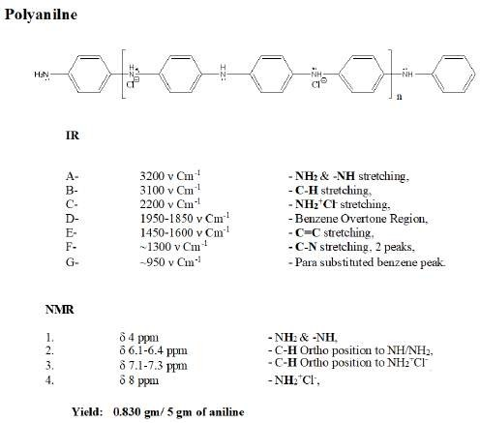

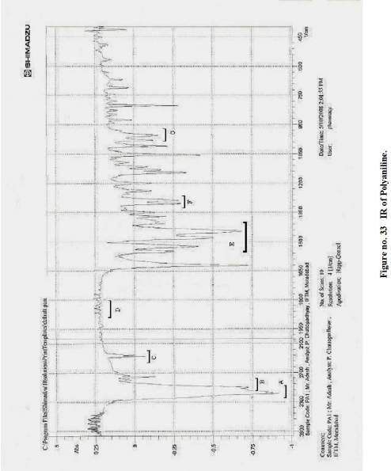

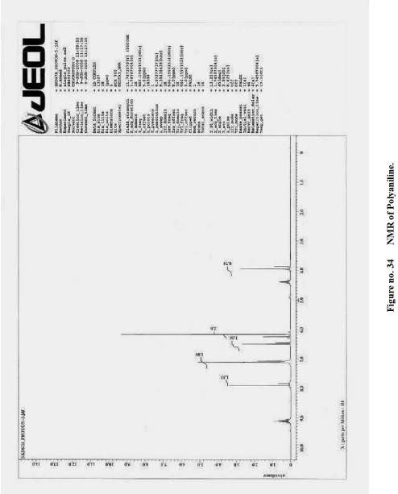

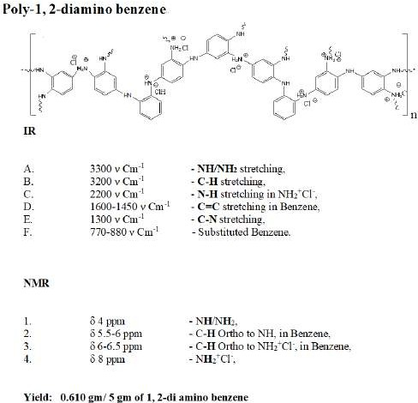

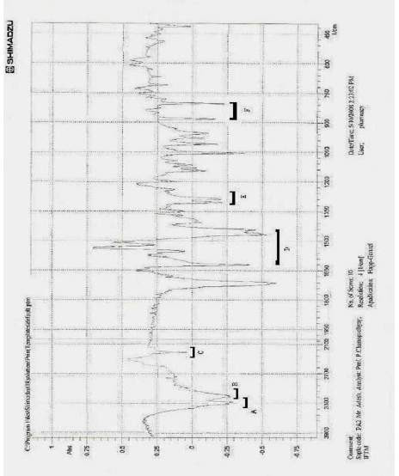

Figure No. 35 IR of Poly 1, 2 Di amino benzene

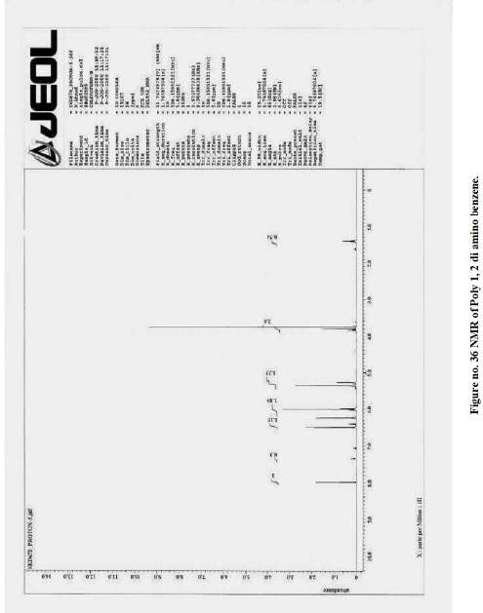

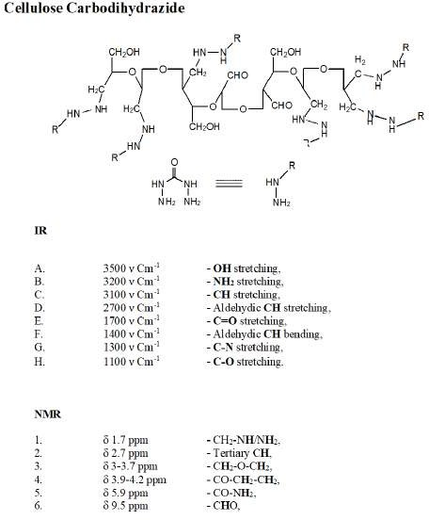

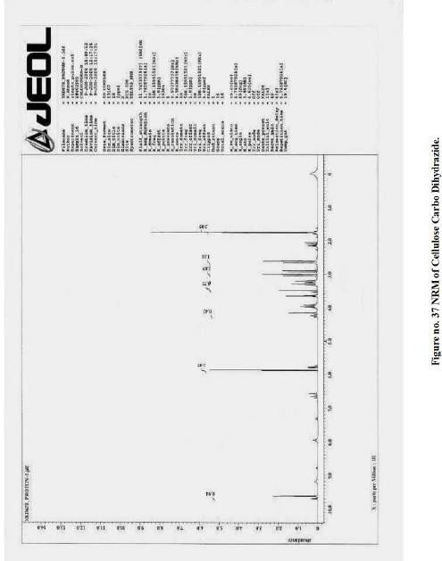

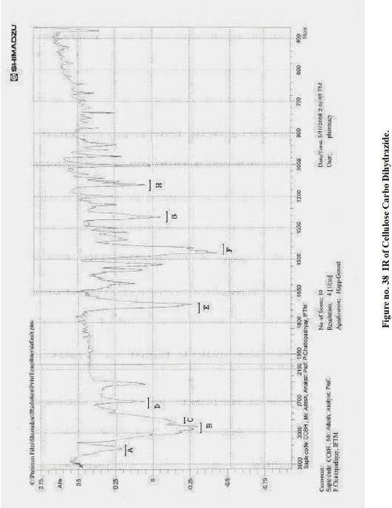

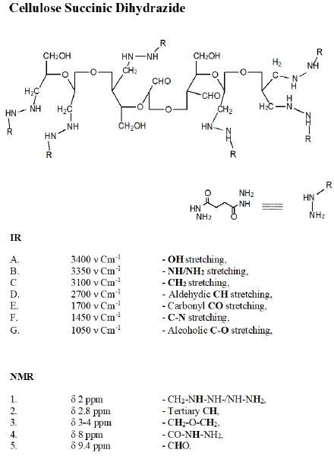

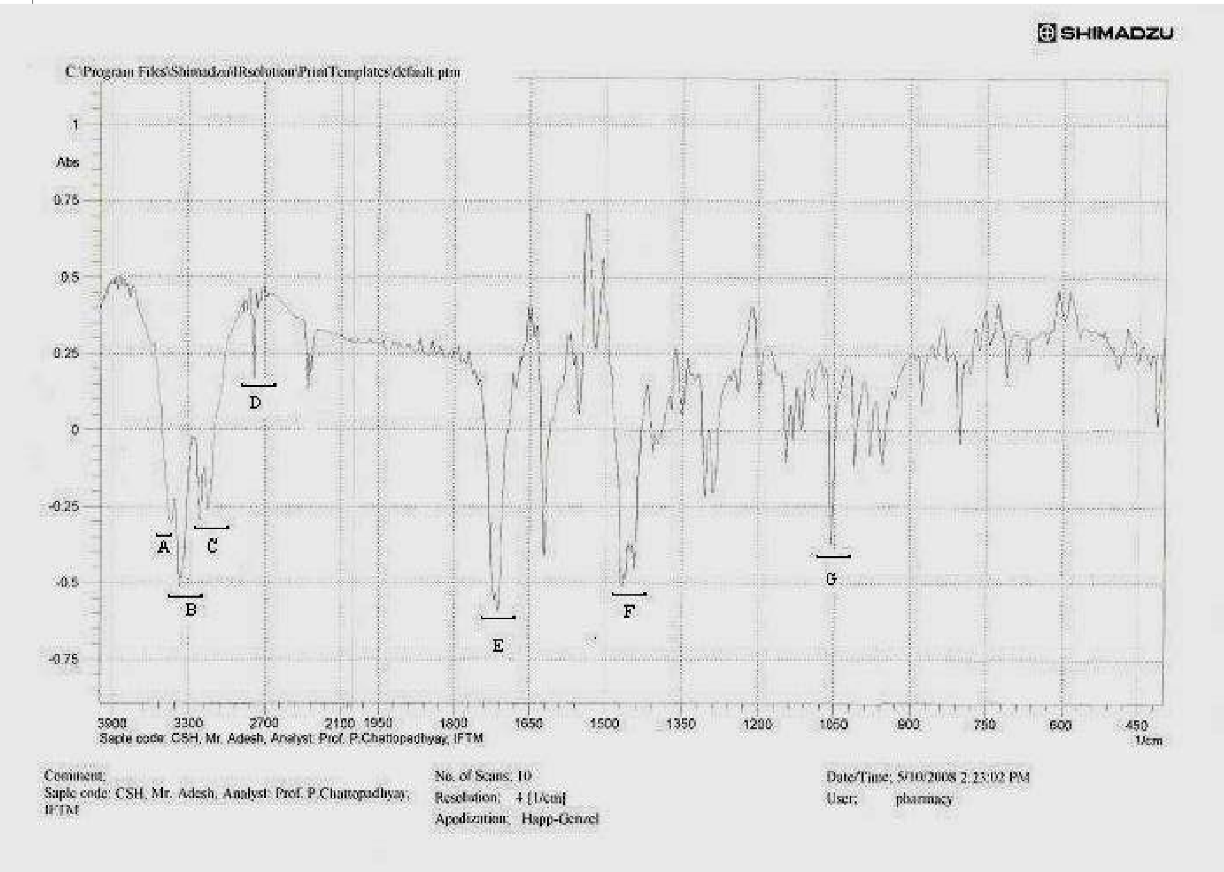
Figure no. 39 IR of Cellulose Succinic Dihydrazide.

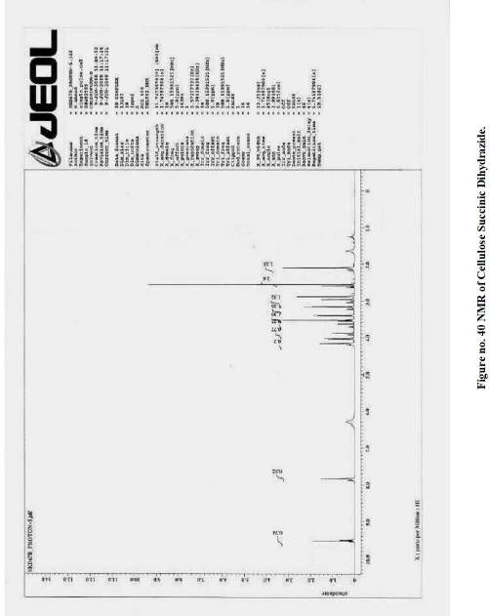

RESULT

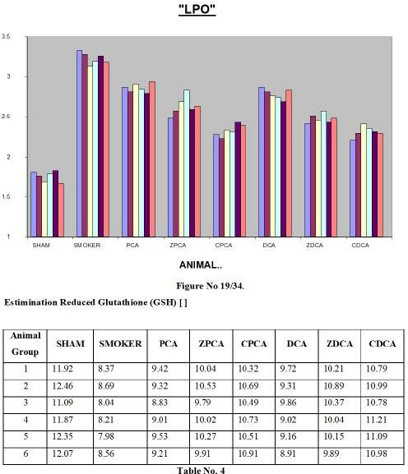

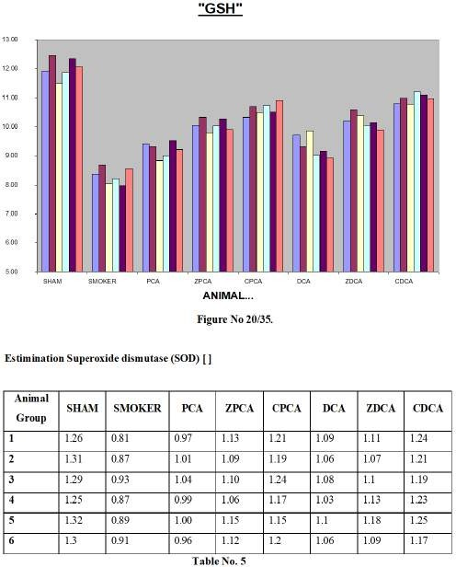

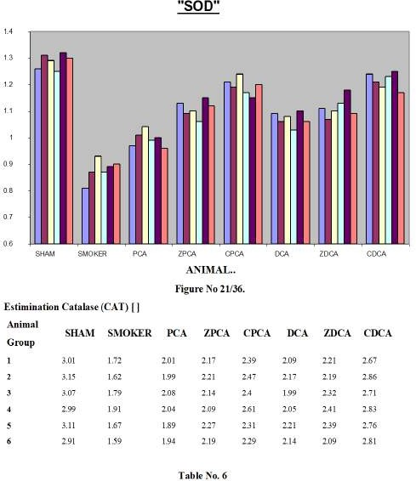

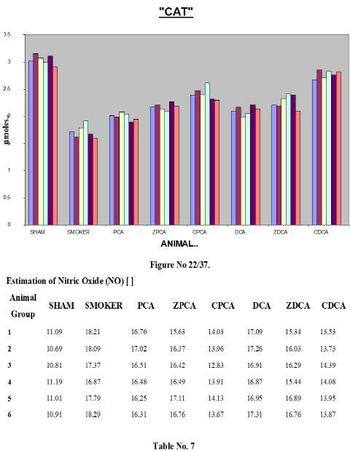

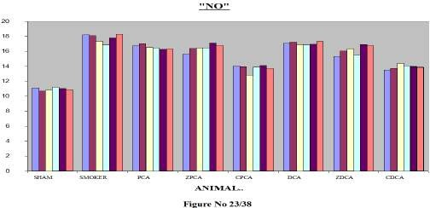
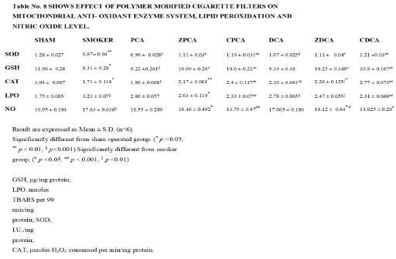

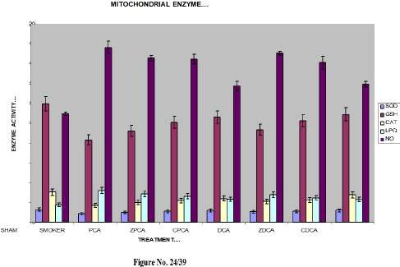

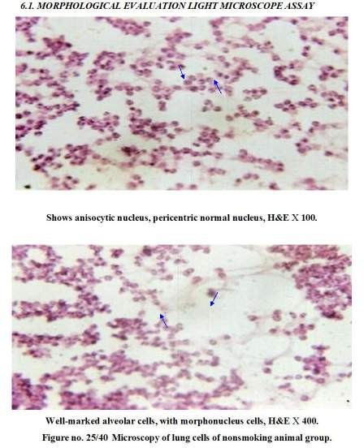

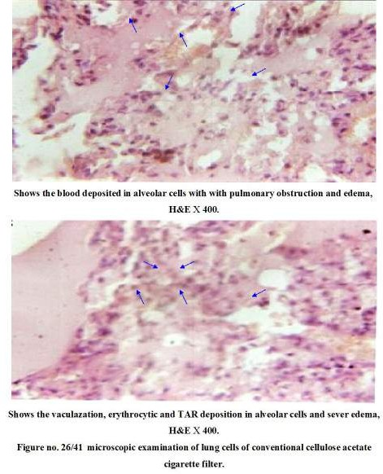

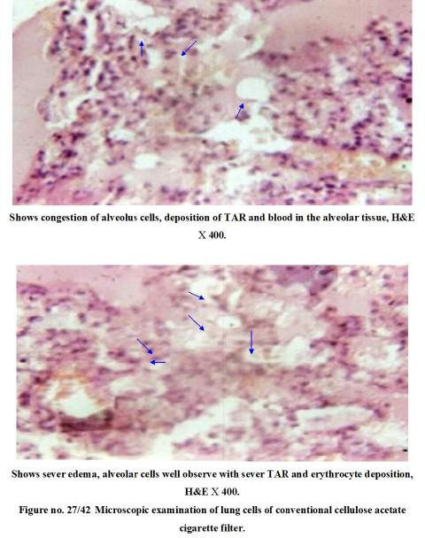

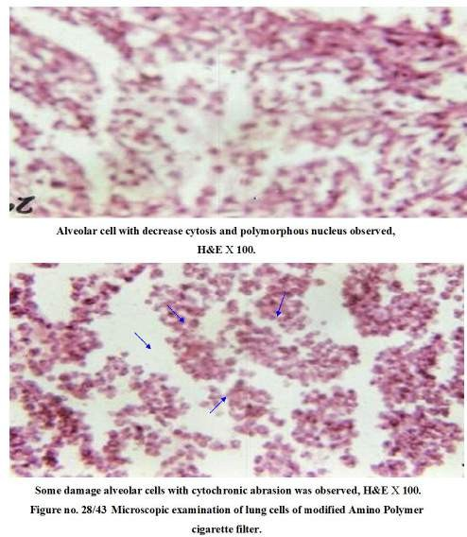

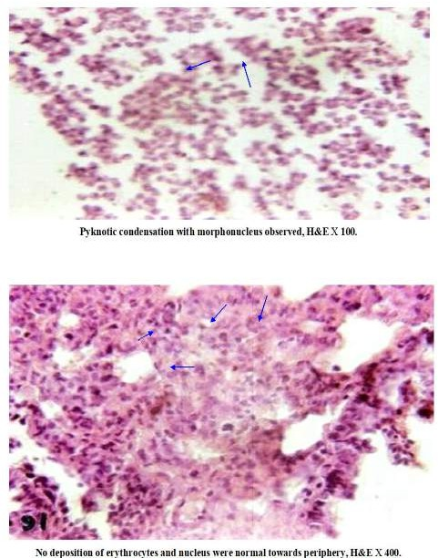

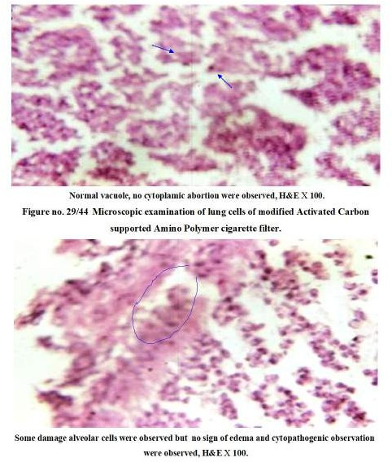

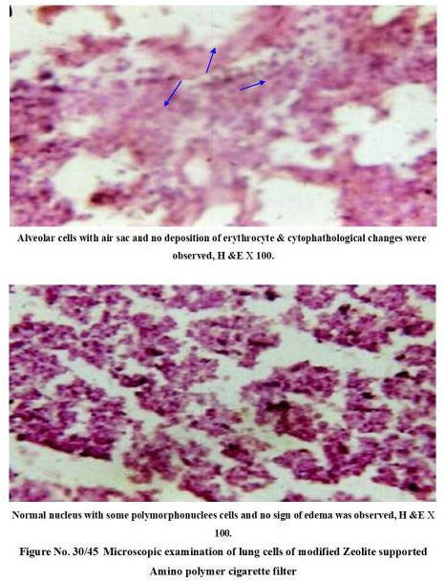

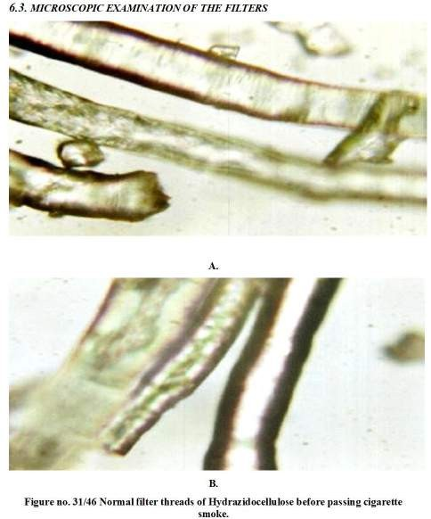

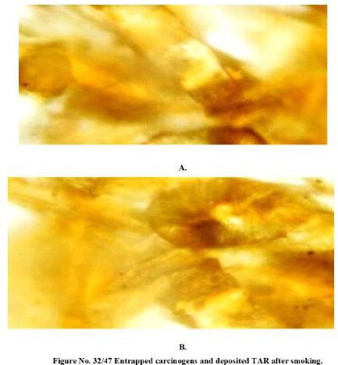
HPLC analysis of the filter extract and histological study of the lungs of the smoking rats with conventional cigarette filters (figure no. 40), gives the clear picture of filter efficacy in terms of preventing damage, induced by the cigarette smoke constituents to the smoker. Elevated level of the Lipid Peroxidation and Nitric Oxide are sign of alveolar cell damage. Smoking causes down regulation of mitochondrial anti-oxidant marker enzymes due increased oxidative stress in smoker. Morphological evaluation under light microscope of sham operated group shows, well-marked alveolar cells and anisocytic, pericentric normal nucleus. But cigarette smoking induces vaculazation, erythrocytic and TAR deposition in alveolar cells. Sever pulmonary edematous conditions are observed in histological studies. (Figure no. 41-42)

Nitric oxide is a ubiquitous intracellular and intercellular signaling molecule, which plays a role in the functions of various inflammatory cells including mast cells, lymphocytes, neutrophils and macrophages. Also supposed to play crucial role in smoking induced inflammatory edematous conditions.
Smoking elevates the level of the reactive species in the lung cells as well as causes down regulation of the mitochondrial anti-oxidant enzymes Reduced Glutathione (GSH), Superoxide dismutase (SOD), Catalase (CAT) in smoker in comparison to nonsmoker sham operated control animal group (Table no. 8 & figure no. 39). Excessive exposure of these reactive species and other toxic components from cigarette smoke causes down regulation of anti-oxidant enzymes. This high load of carcinogenic compounds and depletion of antioxidants could be one reason, in smoking related damages. Modified filter gives protection under these conditions and mitochondrial anti-oxidant enzymes actively protects against damaging components. Zeolite and carbon supported modified filters are showing better results in protecting from cigarette smoke constituents induced damage.
All these forms a complete carcinogenic complex mixture. Modification of the filter gives protection from this mixture. HPLC chromatogram report shows the elimination capacity of the filters, those are exceptionally far better than cellulose acetate filters. Use of carbon and zeolite, supporting to amino polymer increases the elimination capacity and protect from damaging exposure of the cigarette smoke constituents.

DICUSSION & CONCLUSION
Histological study of lung of smoking rats with conventional cigarette filters (figure no. 31), gives the clear picture of filter efficacy in terms of preventing damage, induced by the cigarette smoke constituents to the smoker. Elevated level of the Lipid Peroxidation and Nitric Oxide are sign of alveolar cell damage. Smoking causes down regulation of mitochondrial anti-oxidant marker enzymes due increased oxidative stress in smoker. Morphological evaluation under light microscope of sham operated group shows, well-marked alveolar cells and anisocytic, pericentric normal nucleus. But cigarette smoking induces vaculazation, erythrocytic and TAR deposition in alveolar cells. Sever pulmonary edematous conditions are observed in histological studies. (Figure no. 32-33).
Cigarette smoking induced edema is considered due to higher concentration of nitric oxide and other reactive constituents of the cigarette smoke. Freshly generated cigarette smoke contains up to 600 μg of NO and highly reactive free radicals 1x10¹⁶ per cigarette. Cigarette smoke contains about 55 and more well identified potent carcinogens categorizes in 7 groups. These altogether contribute to the toxicity of CS. In these highly stable TAR radicals induces damage to lower part of the respiratory tract and other unstable reactive radicals to upper respiratory tract. Moreover, PAH’s, nitrosamines and carbonyl constituents impart their carcinogenic effect to the smoker and conventional filters fails to prevent from the damage induce by the toxic carcinogenic constituents of the cigarette smoke. Figure no. 28 shows the carcinogen (mainly TAR) retention capacity of the conventional filters and figure no. 40 show histological pictures of lung cells of smoking rats with conventional cigarette filter; lower retention capacity and highly edematous condition, deposition of TAR & erythrocytes and severely damage alveolar cells are evidences of poor performance of cellulose acetate conventional cigarette filters. From the result of poor retention capacity and highly damage tissue, there is need for protection from this toxic complex mixture. Modification of the cigarette filters with polyaniline and other polymer with or without carbon/zeolite support increases the retention capacity of the filters and gives better protection from cigarette smoke constituents. Higher surface area and adsorbent properties of the carbon contribute to its efficacy in retention/elimination of smoke constituents. Zeolite use in
filter modification protects from smoking induced damages as well as increases the elimination of smoke constituents.

Smoking elevates the level of the reactive species in the lung cells as well as causes down regulation of the mitochondrial anti-oxidant enzymes Reduced Glutathione (GSH), Superoxide dismutase (SOD), Catalase (CAT) in smoker in comparison to nonsmoker sham operated control animal group (Table no. 8 & figure no. 30). Excessive exposure of these reactive species and other toxic components from cigarette smoke causes down regulation of anti-oxidant enzymes. This high load of carcinogenic compounds and depletion of antioxidants could be one reason, in smoking related damages. Modified filter gives protection under these conditions and mitochondrial anti-oxidant enzymes actively protects against damaging components. Zeolite and carbon supported modified filters are showing better results in protecting from cigarette smoke constituents induced damage.
Thus, modification of the cigarette filters with amino polymer for the carbonyl carcinogens elimination (confirm by IR spectroscopic analysis) and use of Carbon & Zeolite increases the efficiency of filters for retention of smoke components. Cellulose derivative like Hydrazidocellulose (cellulose succinic dihydrazide derivative) and Carbohydrazidocellulose are also very effective in elimination of carbonyl carcinogens. Modification of filter decrease the
Nitric Oxide and reactive species induced inflammation and edematous conditions. Re-elevate the mitochondrial anti-oxidants enzymes level and boosts the cellular defence mechanism system to fight against oxidative stress induces by cigarette smoking.

REFERENCES
- Thankappan K.R., “Case–Control Study of Smoking and Death in India”, N Engl J
Med, 2008, 358, 2842-2845.
- Jha P., et al., “A nationally representative case-control study of smoking and
death in India”, N Engl J Med, 2008, 358, 1137-1147.
- Patel, Salaam Bombay Foundation, IBP Vidyalaya, GOREGAON.
- Pakhale S.S, & Maru G.B., “Distribution of Major & minor alkaloids in Tobacco, Main stream & side stream smoke in Popular Indian smoking products”, Food and Chemical Toxicology, 1998, 36, 1131-1138.
- Wynder E.L. & Hoffmann D., “Smoking and Lung Cancer: Scientific Challenges and Opportunities”, Cancer Research 1994, 54, 5284-5295.
- Jain R. & Mukherjee K., “Biological basis of nicotine addiction” Indian journal
of Pharmacology, 2003, 35, 281-284.
- Hecht S.S., “Tobacco Smoke Carcinogens and Lung Cancer”, Journal of the
National Cancer Institute, 1999, 91, 1194-1204.
- Mulcahy S., “The Toxicology of Cigarette Smoke and Environmental Tobacco Smoke”, Biochemical Toxicology, 4927.
- World Health Organization [WHO] 2006. Cancer. World Health Organization. Retrieved on 2007-06-25.
- Ingel K.D. et al., “Role of apoptosis in the pathogenesis of COPD and pulmonary emphysema”, Respir Res., 2006, 7(1), 53.
- Hughes J.A., “Long term changes in lung function after surgical treatment of bullous emphysema in smokers and ex-smokers”, Thorax, 1984, 39(2), 140-142.
- Therriault M.J., “Immunomodulatory effects of the tobacco-specific carcinogen,
NNK, on alveolar macrophages”, Clin Exp Immunol., 2003, 132(2), 232–238.
- Burns D.M., “Epidemiology of smoking-induced cardiovascular disease”, Prog
Cardiovasc Dis., 2003, 46(1), 11-29.
- Nikodemowicz M., “The effects of smoking on cardiovascular system”, Przegl
Lek., 2007, 64(4), 42-44.
- Boyd A.S. et al., “Cigarette smoking-associated elastotic changes in the skin”, J
Am Acad Dermatol., 1999, 41(1), 23-26.
- Ernster V.L. et al., “Facial wrinkling in men and women, by smoking status”, Am J
Public Health. 1995, 85(1), 78–82.
17. Ursula K. & Charlotte E., “Cigarette Smoking, Metabolic Gene Polymorphism, and Psoriasis”, Journal of Investigative Dermatology, 2006, 126, 693–694.

- Rosen M.P. et al., “Cigarette smoking: an independent risk factor for atherosclerosis in the hypogastric-cavernous arterial bed of men with arteriogenic impotence”, J Urol., 1991, 145, 759.
- March J., “Advanced organic chemistry reaction, mechanism and structure”, John
Wiley & Sons, 9, 1174-1175.
- Joseph M., “HPLC detector options for the determination of Polynuclear Aromatic Hydrocarbons”, Varian Chromatography Systems, Varian Application Note, LC7:1291.
- Ostafe R. et al., “Assessment using HPLC analysis of influence of tobacco brand, type of filter and smoking habits on PAHs concentration in cigarette smoke”, Annales of West University of Timisoara, series chemistry, 2006, 15(1), 33-44.
- Hibbs J.B. et al., “Nitric Oxide: A cytotoxic activated macrophage effector molecule”, Biochemistry Biophysics Reaserch Communication, 1988, 157, 87-94.
- Stocks J. et al., “Autoxidation of human red cell lipids induced by hydrogen peroxide”, british journal of heamatology, 1971, 20, 95-111.
- Jonshon, D., & Lardy H., “Isolation of liver kidney mitochondria. In: methods
in enzymology”, (Ed.) Estarbook RW, 1947, 10, 94-96.
- Elman G.L., “Tissue sulfhydral groups”, Archives of Biochemistry and
Biophysics, 1969, 82, 70-77.
- Beatecheemp C. et al., “Superoxide dismutase”, Journal of Biological Chemistry 1969, 244, 6049-6055.
- Aebi H., “Catalyses invitro”, Methods Enzymology, 1954, 105, 121-126.
- Lapperre T.S. et al., “Smoking cessation and bronchial epithelial remodeling in
COPD: a cross-sectional study”, Respir Res., 2007, 8(1), 85.
- Mark D.E. et al., “Lifetime environmental tobacco smoke exposure and the risk of
chronic obstructive pulmonary disease”, Environ Health. 2005; 4: 7.
- Talbot P. et al., “Smoking and reproduction: The oviduct as a target of cigarette smoke”, Reproductive Biology and Endocrinology, 2005, 3, 52.
- Stellman S.D., “Impact of filter cigarette smoking on lung cancer histology”, Prev
Med., 1997, 26, 451-456.

