Migration and its impact on agriculture in Nainital district’s Bhabhar
region
Aprajit Puri
Abstract
Migration has emerged as a notable socio-economic occurrence in numerous rural areas of India. This research explores the primary causes and effects of migration in the Kaladhungi and Bealparao areas of Nainital district, Uttarakhand. The study emphasizes pinpointing the elements that drive individuals to leave these regions, including scarce job prospects, poor agricultural yields, absence of advanced educational institutions, and insufficient healthcare resources. Simultaneously, enhanced job opportunities, increased salaries, superior education, and elevated living conditions in cities serve as powerful attractions driving migration. This study explores the patterns and elements affecting land use and land cover change (LULCC) in these areas, employing a combination of remote sensing data, Geographic Information System (GIS) analysis, and field surveys to assess and demonstrate the spatial changes in land from conventional agriculture to orchard cultivation. Results indicate a notable increase in orchard spaces, often at the expense of traditional farming land, influenced by factors such as market demands, policy incentives, evolving labor circumstances, and the pursuit of enhanced financial benefits
Between 2011–12 and 2021–22, Nainital district experienced a notable decline in agricultural activity, with the net sown area decreasing by approximately 10.5% and the gross sown area dropping by about 7.4%. Concurrently, cultivable wasteland increased by roughly 14.8%, and fallow land surged by approximately 67%.
Key Words- land use and land cover change, Fragmented landholdings, land Rejuvenation
Introduction
Migration has become a significant challenge for agriculture in the foothill areas of the Himalayas, especially in locations like Kaladhungi and Bealparao in the Nainital district. Historically, agriculture has been the foundation of rural livelihoods in these areas, bolstering local economies and ensuring household food security. In recent decades, the outflow of rural populations—particularly young people and working-age persons—has increased, resulting in a notable decrease in agricultural labor availability and the gradual neglect of farmlands.
Various elements influence this trend, such as reduced agricultural profitability, small and scattered land parcels, susceptibility to wildlife harm, and the absence of modern infrastructure and market accessibility. Consequently, numerous residents move to nearby cities or other states looking for enhanced job prospects and better quality of life. Although migration can yield economic advantages via remittances, it simultaneously poses a challenge for the agricultural sector by diminishing the labor force, undermining traditional farming methods, and jeopardizing long-term sustainability in agriculture.
In the villages near Kaladhungi and Bealparao, the impact of migration is especially apparent through unused fields, an aging farming demographic, and reduced agricultural output. This scenario presents issues not only for the future of agriculture but also for socio-economic stability in rural areas and food security within the region. Thus, recognizing migration as a vital concern in Nainital district's agricultural context is crucial for formulating policies and strategies that can enhance rural livelihoods and promote sustainable agricultural growth

Study region
The Kaladhungi- Bealparao region lies in Nainital district of Uttarakhand state Kaladhungi at Coordinates 29° 17' 0.636" N & 79° 21' 3.6" E. It is well situated in the catchment area of river Koshi. The Kosi River, a significant geographical feature, forms a natural boundary between Nainital and Almora districts before merging with the Ramganga River flows through this region, and the region is well irrigated by these rivers. The region is rich in agriculture and orchards.
Objectives The following objectives are sufficient to understand the cause and changes in land use pattern due to migration in the study area.
- To study land use Management of the study area.
- Agricultural development and it’s challenges due to migration.
Research Methodology
The spatial data utilized in this research was mainly sourced from multi-temporal satellite imagery to examine land use and land cover (LULC) changes in the Kaladhungi area of Nainital district, Uttarakhand. Data from Landsat satellites, specifically Landsat 5 (TM), Landsat 7 (ETM+), and Landsat 8 (OLI/TIRS), was used because of their reliable temporal coverage and appropriate spatial resolution for regional-scale studies. Furthermore, RESOURCESAT imagery was utilized to improve the accuracy and validation of LULC classification. These datasets offered detailed spectral data necessary for recognizing and delineating different land use and land cover types in the study area
For the primary data collection several interviews of local resident were collected.

Labor Shortages & Declining Productivity
The migration of young men to urban centers has led to a significant labor shortage, impacting labor-intensive tasks such as weeding and terrace maintenance. Elderly farmers and women often struggle to manage distant plots, resulting in widespread field abandonment. Studies in the Himalayas indicate a decline in agricultural productivity, from approximately 583 kg/ha in 2001 to around 430 kg/ha in 2013, driven by reduced irrigation, erratic rainfall, and migration-related labor shortages.
Crop Pattern Changes
Traditional subsistence crops, including millets, pulses, and oilseeds, have largely been replaced by market-oriented crops like rice and wheat, or in some cases, farming has ceased entirely. This shift reduces crop diversity, increasing vulnerability to market fluctuations and extreme weather events, thereby undermining the region’s agricultural resilience.

Fig. 1.1 Landsat Images of Kaladhungi region
LULC Kaladhungi Bealparao region (2015-16) LULC Kaladhungi Bealparao region (2023)
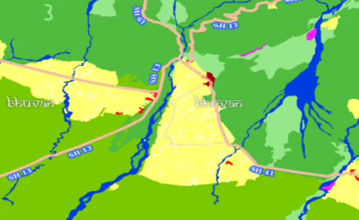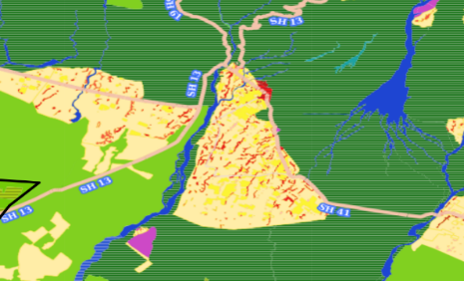
Fig 1.2 Legend 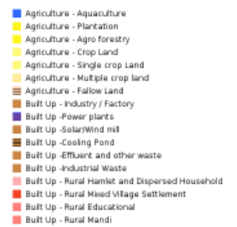 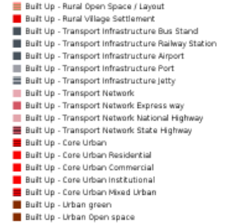

Environmental & Social Feedback Loops
In areas where farming has ceased, natural forest regrowth may stabilize slopes and reduce landslide risks. However, the increase in fallow land and the decline in active farming threaten biodiversity and weaken local food security. Many migrants rely on remittances, fostering a “money-order economy,” which contributes to the erosion of traditional agricultural knowledge and land stewardship across generations.

Adaptive Responses
In response to these challenges, some hill communities, such as those in Almora, have transitioned abandoned farmlands to high-value crops like medicinal and aromatic plants, supported by government initiatives. Opportunities exist to revitalize irrigation systems and equip farmers with climate-resilient techniques to enhance community resilience and agricultural sustainability in the Kaladhungi–Bealparao region.

Summary of Migration-Related Challenges
The key issues associated with migration in the Kaladhungi–Bealparao region include:
- A significant reduction in cultivated land, accompanied by a rise in uncultivated and wasteland areas.
- Labor shortages, particularly among young men, hindering terrace maintenance and reducing productivity.
- A shift away from traditional crops, decreasing diversity and increasing susceptibility to economic and climatic risks.
- Environmental consequences, including natural vegetation regrowth and diminished agricultural stewardship.
- Emerging adaptive strategies, such as cultivating medicinal plants, which show potential but require customization for the Kaladhungi–Bealparao context.
- Conversion of Fertile Agricultural Land: Prime farmland with rich soil and access to water from rivers and canals is being leased or sold for industrial and commercial purposes. Post-conversion, the land becomes unsuitable for agriculture due to soil pollution from chemicals or construction, topsoil removal during grading, and changes in land use designation.
- Urbanization and Infrastructure Expansion: The growth of tourism, particularly near Jim Corbett National Park, has increased demand for hotels, resorts and many new factories and small industries (Fig. 1.3). Infrastructure developments, including roads and parking lots, encroach on farmland, reducing crop production areas and disrupting the rural agricultural landscape.
- Disruption of Irrigation Systems: Commercial and industrial projects divert or overexploit water sources such as canals, wells, and rivers, reducing water availability for irrigation. This directly impacts crop yields, forcing farmers to abandon traditional farming practices.
- Rising Land Prices and Speculative Selling: High profits from land sales for commercial ventures incentivize small and marginal farmers to sell their plots, weakening the local agricultural economy and diminishing interest in farming as a sustainable livelihood.
- Environmental Degradation: Industrial and hospitality developments contribute to waste disposal issues, soil and water contamination, deforestation in buffer zones, and increased human-wildlife conflict near forest boundaries, all of which undermine the natural resources critical for agriculture.
- Small and Fragmented Landholdings Land fragmentation, resulting in small and scattered plots, hinders efficient mechanized farming and limits crop diversification (Fig. 1.4)
Fig. 1.3 Fig. 1.4
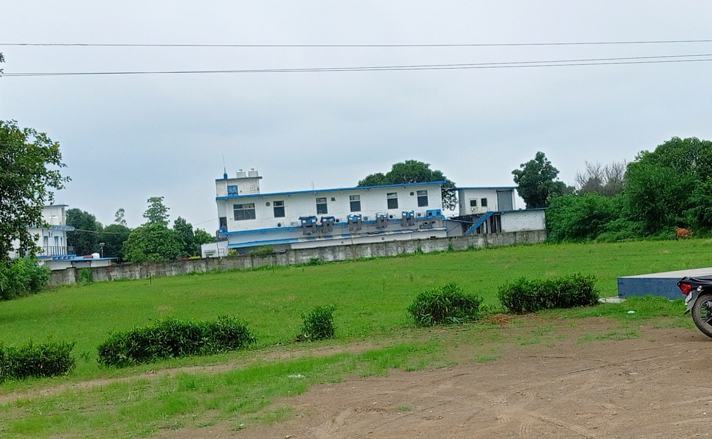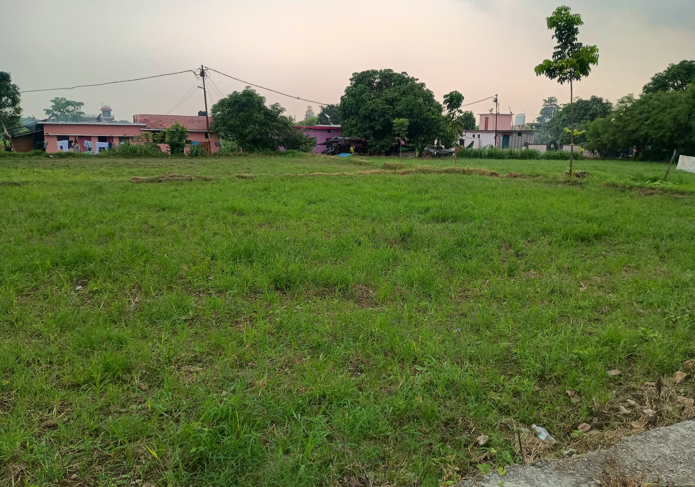

- Loss of Traditional Farming Practices: The shift to non-agricultural land uses erodes traditional agricultural knowledge and practices. Younger generations are increasingly migrating to urban areas or pursuing non-agricultural jobs, further reducing farming activities.
Conclusion
The Kaladhungi–Bealparao region is undergoing a significant land use transformation driven by tourism, industrial growth, and urban expansion. While these developments may yield short-term economic benefits, they threaten long-term agricultural sustainability, food security, and rural livelihoods. To mitigate these impacts, the following measures are recommended:
- Zoning Regulations: Implement strict zoning policies to protect agricultural land from conversion to non-agricultural uses.
- Sustainable Tourism: Promote eco-friendly tourism practices that minimize environmental degradation and support local communities.
- Community Awareness: Increase public awareness of the importance of preserving agricultural land and traditional practices.
- Land Rejuvenation: Map abandoned terraces to identify opportunities for revitalization, focusing on high-value crops suited to the region’s microclimate.
- Labor Assessment: Evaluate labor needs and availability to support sustainable agricultural practices.

References
- Rawat, J. S., Biswas, V., & Kumar, M. (2013). Changes in land use/cover using geospatial techniques: A case study of Ramnagar town area, Nainital, Uttarakhand, India. The Egyptian Journal of Remote Sensing and Space Science, 16(1), 111–117.
- Rautela, P., et al. (2014). Implications of rapid land use/land cover changes upon the environment of the area around Nainital, Uttarakhand, India. Asian Journal of Environment and Disaster Management, 6(1), 83–93.
- Rawat, J. S., Kumar, M., & Biswas, V. (2014). Land use/cover dynamics using multi-temporal satellite imagery: A case study of Haldwani town area, Nainital, Uttarakhand, India. International Journal of Geomatics and Geosciences, 4(3), ISSN 0976–4380.
- Wakeel, A., et al. (2005). Forest management and land use/cover changes in a typical micro-watershed in the mid-elevation zone of Central Himalaya, India. Forest Ecology and Management, 213(1–3), 229–242.
- Sharma, E., & Xu, J. (2007). Land use, landscape management, and environmental services in Mountain Mainland Asia: Introduction. Tropical Ecology, 48(2), 129–136.

