Targeting initiation and early recovery to reduce alcohol abuse: A Mathematical modeling study in Kenya

Abstract
Alcoholism is characterized as a chronic disease resulting from compulsive and uncontrollable consumption of alcoholic beverages, which leads to addiction and deterioration of both health and social functioning. 12.2% of the Kenyan population engages in alcohol abuse, while 10.4% are affected by alcohol-use disorders, showing the severity of this public health concern. A Susceptible-Experimenting-Moderate-Quitters-Heavy-Treated (SEMQHT) model was constructed to show the transmission dynamics of alcohol addiction through Ordinary Differential Equations (ODEs), which were solved using the fourth-order Runge-Kutta method. Invariant regions, epidemic thresholds, and model equilibria were analyzed, and the stability of these equilibria was examined. The model was further utilized to evaluate the effects of treatment interventions and cessation of alcohol use. The basic reproduction number was calculated using the next-generation matrix approach. Sensitivity analysis was performed employing normalized forward sensitivity techniques. Local stability of the alcohol-free equilibrium was studied using the Gershgorin Circle Theorem, and global stability was established via the Castillo-Chavez approach. The necessary conditions for the existence of an alcohol-endemic equilibrium were derived, and bifurcation analysis was carried out. Numerical analyses were performed in Python. The analyses showed that those measures that targeted initiation rate and early recovery would significantly reduce alcohol abuse more efficiently than those strategies that only targeted dependent users. Such measures limit the in ow to risky drinking and hasten the recovery of those infected.
Keywords: Alcoholism, Epidemiology, Reproduction number, Gershgorin Circle
- Introduction
Drug abuse, also known as substance abuse, is defined as the use of drugs in ways or quantities that result in harm to the user or others [1]. The geographical location of Eastern Africa, adjacent to countries such as India, China, Thailand, Pakistan, Saudi Arabia, and other Middle Eastern nations, has established the region as a central hub for tracking heroin, methaqualone, and cannabis resin, as reported by the United Nations Office on Drugs and Crime [2]. The same report notes that cocaine is trafficked into Eastern Africa from Southern Africa and Latin America. Recent data indicate a continued increase in drug and substance abuse, despite a persistently low number of drug seizures. The National Authority for the Campaign Against Alcohol and Drug Abuse (NACADA) reported a significant demand for rehabilitation services, with 2.5 million individuals in Kenya requiring rehabilitation in 2015 [3].
Studies conducted in sub-Saharan Africa have identified a strong association between drug and substance abuse and risky sexual behaviors, such as having multiple sexual partners, engaging in unprotected intercourse, and participating in commercial sex work [4]. According to Merz [5], there were 11 million active drug injectors worldwide in 2017, with 1.4 million living with HIV and 5.6 million with Hepatitis C. Other documented consequences of drug abuse include increased suicide rates, higher crime levels, more frequent traffic accidents, poisonings, and elevated government expenditure [6]. Drug and substance abuse (DSA) addiction also significantly diminishes the human resources necessary for national development due to risky behaviors and premature mortality [7].
The majority of adults with drug abuse disorders initiated drug use between the ages of 11 and 20 [8]. According to the NACADA [9] report, drug and substance misuse constitutes Kenya’s most critical social issue and poses significant health risks. NACADA further estimates that approximately half of Kenya’s drug and substance abuse (DSA) users are between 10 and 19 years old. Subsequent findings [10] indicate that alcohol remains the most commonly abused substance in Kenya, while cannabis use among youth aged 14 to 25 has nearly doubled over the past five years. Other frequently abused substances include cocaine, heroin, and shisha. These data underscore the urgent need for coordinated government intervention.
Research [[11], [12]] demonstrates that drug and substance abuse (DSA) exhibits transmission patterns analogous to infectious diseases, thereby justifying the application of mathematical modeling approaches. The intense euphoria produced by opiates such as heroin, morphine, codeine, oxycodone, hydrocodone, and fentanyl contributes to their high potential for addiction. Comprehensive prevention strategies are essential to mitigate early drug exposure. Similar to infectious diseases, DSA is a complex issue shaped by multiple interacting factors, including environmental influences. Existing literature [13] indicates that addiction frequently originates as a social activity before developing into a severe disorder.
Heavy drinking is defined as an average consumption of more than 7 drinks per week for women and more than 14 drinks per week for men over the past year. Light drinking is defined as an average of 3 or fewer drinks per week over the same period. Moderate drinking is defined as an average of 4 to 14 drinks per week for men and 4 to 7 drinks per week for women. Thus, heavy drinking refers to consumption exceeding 14 drinks per week for men and more than 7 drinks per week for women [14].
Public health, notably in the context of substance dependency, represents a prominent area for the application of mathematical modeling. Alcoholism, although treatable, is still a significant global concern. According to the World Health Organization (WHO), approximately 237 million men and 46 million women worldwide are affected by alcoholism and related problems [15]. In Kenya, 12.2% of the population (3,293,495 individuals) abuse alcohol, and 10.4% (2,807,569 individuals) meet the criteria for alcohol use disorders [16]. Factors that influence alcoholism encompass social interactions, psychological stress, mental health, age, ethnicity, and gender.
Addiction involves long-lasting biological changes caused by alcohol misuse., which impedes efforts to cease consumption. Quitters often experience withdrawal symptoms [17]. Various mathematical models have been created to tackle alcoholism. Bhunu [18] categorized the population into those who have never consumed alcohol (S(t)), non-dependent drinkers (D(t)), dependent individuals (A(t)), and recovered (R(t)). This model demonstrated that encouraging moderate drinkers to quit is more effective than targeting solely individuals who are already addicted, although it did not comprehensively address treatment.
Whitey and Comiskey [19] employed ordinary differential equations to model heroin outbreaks and treatment, offering valuable insights for policymakers regarding resource allocation for prevention and treatment. Their findings indicate that prevention strategies are more effective than treatment for drug substance abuse (DSA).
Sharma and Samantha [19] developed a mathematical model of alcohol misuse that classified individuals into four groups: heavy drinkers, individuals in treatment, those who have temporarily recovered, and moderate or occasional drinkers. The model incorporated a treatment program and accounted for all potential relapses and behaviors, concluding that effective control of alcohol addiction is essential for mitigating the issue.
Burattini [20] modeled the dynamics of crack cocaine use using a susceptible-infected recovered (SIR) framework, categorizing individuals as susceptible, injecting drug users, crack cocaine users, and those who use both substances. Their research demonstrates that crack cocaine use can influence HIV/AIDS prevalence, depending on factors such as the complex social networks among drug users.
In South Africa, Burattini [20] simulated the spread of crystal methamphetamine ("tik") within drug supply chains by incorporating drug supply networks, rehabilitation, and recovery processes. The study identified the rate at which light drug abusers quit and the frequency of contact between vulnerable individuals and "tik" users as the most significant factors influencing the epidemic.
Muli, in his study [21], differentiates between light and moderate drug abusers as separate categories, which contrasts with the classification used by Sharma and Samantha. He assumed that light drug abusers may discontinue use without medical intervention. The primary assumption is that individuals undergoing treatment or rehabilitation are significantly less likely to initiate drug use in others compared to light and heavy drug abusers. Consequently, light and heavy drug abusers are identified as the primary drivers of drug abuse.
Mathematical models enable analysis of these factors, support the development of productive interventions, and forecast how different strategies might affect alcohol-related problems [22], [23].
Mayengo [24] classified drinkers as light, medium, or alcoholic and included non-drinkers as either susceptible or recovered. His study recommended compulsory isolation treatment for individuals with addiction. Simulations showed that this approach can quickly decrease alcoholism but might also lead to greater stigmatization.
Nyabadza [25] developed a model comprising six population groups and a media group: S (never used alcohol), Sa (exposed to media campaigns and never used alcohol), L (light drinkers), H (heavy drinkers), T (under treatment or in rehabilitation), Q (permanently stopped drinking), and M (media campaign intensity). Their research shows that effective 3 media campaigns can prevent the initiation of alcohol use among those exposed. Simulations additionally show that higher treatment rates reduce addiction.
Additional studies have examined the relationship between stress and alcohol treatment, comparing individuals in treatment to those not receiving it. Individuals entering treatment are more likely to recognize their drinking problems, exhibit more dependence symptoms, experience greater stress, and encounter more negative life events, all of which increase the likelihood of recovery [26].
Mathematical modeling uses equations to represent real-world situations and helps predict outcomes by making complex systems simpler [27]. Breaking these systems into separate parts makes it easier to understand how they work [28], [29], [30] [31]. These models serve as analytical tools that describe systems mathematically and focus on how the parts interact, often using equations or numerical methods [32].
This study advances mathematical modeling by further classifying drinkers into experimenting, moderate, and heavy categories. It assumes that experimenting and moderate drinkers can quit independently after reflecting on the effects of alcohol, whereas heavy drinkers require treatment at specialized centers to achieve recovery. The model also incorporates quitting and treated categories. Both analytical and numerical analyses were conducted, and the results are discussed.

- Model formulation
A transmission model for alcohol addiction was developed using Ordinary Differential Equations (ODEs) to evaluate intervention strategies to decrease addiction.
2.1. Model assumptions
- Heavy drinkers cannot quit voluntarily, but rather, they must be taken to treatment centers.
- Deaths related to alcoholism were associated only with heavy drinkers.

2.2. Model development
The (SEMQHT) model was adapted to develop an alcoholism model comprising six compartments: Susceptible population (S), Experimental drinkers (E), Moderate drinkers (M), Quitters (Q), Heavy drinkers (H), and Treated class (T). Parameters are described in Table 1. Since the model pertains to the human population, all parameters were assumed to be positive. A schematic representation of the model is presented below.

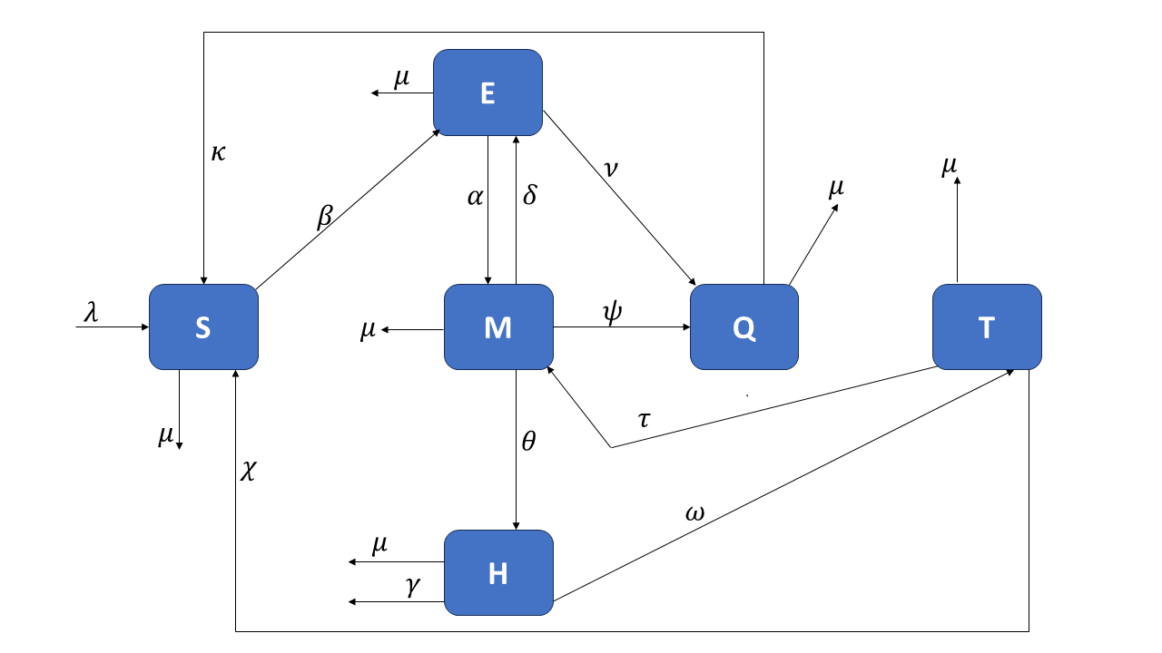
Figure1:Model owdiagram

2.3. Model Equations
$\left\{\begin{matrix}\frac{dS}{dt}=λ+κQ+χT-(μ+β)S \\ \frac{dE}{dt}=βS+δM-(μ+α+ν)E \\ \frac{dM}{dt}=αE+τT-(μ+δ+ψ+θ)M \\ \frac{dH}{dt}=θM-(μ+γ+ω)H \\ \frac{dQ}{dt}=ψM+νE-(μ+κ)Q \\ \frac{dT}{dt}=ωH-\left(μ+τ+χ\right)T.\end{matrix}\right\}$(1)
Where:
$$β=d\left(ϵ_{1}E+ϵ_{2}M+ϵ_{3}H\right).$$

Table 1: Parameter description
Parameter | Description | Value | Reference
$$λ$$ | Natural birth rate | 0.1595 | [33]
$$μ$$ | Natural death rate | 0.1595 | [33]
$$β$$ | Recruitment rate | 0.0546 | [34]
$$κ$$ | Transfer rate from quitters to susceptible | 0.03 | [35]
$$χ$$ | Transfer rate from treated to susceptible | 0.4 | [36]
$$α$$ | Recruitment rate from experimenting to moderate drinkers | 0.04 | [36]
$$δ$$ | Relapse rate from moderate to experimental drinkers | 0.02 | [37]
$$ψ$$ | Recruitment rate from moderate drinkers to quitters | 0.3 | [38]
$$τ$$ | Relapse rate from treated to moderate drinkers | 0.13 | [35]
$$θ$$ | Recruitment rate from moderate to heavy drinkers | 0.055 | [39]
$$γ$$ | The death rate due to the effects of alcohol | 0.00047 | [40]
$$ω$$ | Recruitment rate from heavy drinkers to the treated | 0.131 | [35]
$$ν$$ | Transfer rate from experimenting to quitters | 0.2 | Estimated
$$ϵ_{1}$$ | Experimental drinker transmissibility parameter | 0.2 | Estimated
$$ϵ_{2}$$ | Moderate drinker transmissibility parameter | 0.4 | [33]
$$ϵ_{3}$$ | Heavy drinker transmissibility parameter | 0.5 | [35]
$$d$$ | The force of infection of alcoholism | 0.4 | [33]

3. Model Analysis
3.1. Invariant regions
Theorem 1
The solutions of the proposed model equation 1 are feasible for all $t>0$ if they enter the invariant region [32] which is given by:
$$D=\left\{(S,E,M,H,Q,T):S>0,E>0,M>0,H>0,Q>0,T>0,N<\frac{λ}{μ}\right\}.$$
Proof
The total population of the model is given as:
$$N=S+E+M+H+Q+T,$$
The sum of the differential equations is:
$$\frac{dN}{dt}=\frac{dS}{dt}+\frac{dE}{dt}+\frac{dM}{dt}+\frac{dH}{dt}+\frac{dQ}{dt}+\frac{dT}{dt}.$$
Upon evaluating the algebraic term, the solution was
$$\frac{dN}{dt}≤λ-μN,$$
Solving by the integrating factor method gives:
$$N(t)≤\frac{λ}{μ}+\left(N(0)-\frac{λ}{μ}\right)e^{-μt}.$$
Applying Birkhoff and Rota's theorem on the inequality [41], gave: $0≤N≤\frac{λ}{μ}$ as $t→∞$.
Therefore, $D$ was positively invariant, and within this region, the model was considered valid. The model was both epidemiologically and mathematically well-posed. since the model tracks human populations, all variables and parameters are considered non-negative for $t⩾0$.
3.2. Positivity of the model
For the model involving human population, it was necessary to prove that all state variables of the model are non-negative for all time (t), for the model to be epidemiologically and mathematically well-posed in a feasible region D given by:
$$D=\left\{(S+E+M+H+Q+T)∈R_{+}^{6}:(S+E+M+H+Q+T)≤N\right\}$$
Lemma 1
Let the initial data for Model 1 be $(S+E+M+H+Q+T)>0$. Then the solution $(S,E,M,H,Q,T)>0$ are all positive for all time $t>0$
Proof
$$\begin{matrix}\frac{dS}{dt}=λ+κQ+χT-\left(μ+β\right)S, \\ \frac{dS}{dt}≥-\left(μ+β\right)S,\end{matrix}$$
Separating the variables and assigning the integration sign results in:
$$\int{\frac{dS}{S}}≥-\int{ }\left(μ+β\right)dt,$$
integrating results to:
$$ln⁡S≥-(μ+β)t+C,$$
where $C$ is the constant of integration.
$$S\left(t\right)≥Ce^{-\left(μ+β\right)t}.$$
Applying the initial condition: $t=0,S(0)=0$
Thus, $S(t)≥S(0)e^{-(μ+β)t}≥0$ since $(μ+β)>0$.
Following the same procedure, it can be shown that:
$$\begin{matrix}E(t)≥E(0)e^{-\left(μ+α+ν\right)t}≥0, \\ M(t)≥M(0)e^{-\left(μ+δ+ψ+θ\right)t}≥0, \\ H(t)≥H(0)e^{-\left(μ+γ+ω\right)t}≥0, \\ Q(t)≥Q(0)e^{-\left(μ+κ\right)t}≥0, \\ T(t)≥T(0)e^{-\left(μ+τ+χ\right)t}≥0.\end{matrix}$$
Hence the proof.
3.3 Equilibrium states, reproductive number, and stability
This section examined equilibrium states and investigated their stability. The basic reproduction number was also examined.
3.4 Alcohol-free equilibrium point (AFE).
The model system equation 1 yields an alcohol-free equilibrium (AFE) when all infectious and treated classes are set to zero. Therefore, the alcohol-free equilibrium point is defined as:
$$E^{0}=\left(S^{0},E^{0},M^{0},H^{0},Q^{0},T^{0}\right)=\left(\frac{λ}{μ},0,0,0,0,0\right).$$
3.5 The Basic Reproduction Number
To obtain the reproduction number, we employed the next-generation method [42]. Here, $f$ denotes the matrix of new infection terms, while $v$ represents the matrix of the remaining transfer terms in the system. This approach leads to:
$$\begin{matrix}f=\left(\begin{matrix}βS \\ 0 \\ 0\end{matrix}\right), \\ v=\left(\begin{matrix}-δM+(μ+α+ν)E \\ -αE-τT+(μ+δ+ψ+θ)M \\ -θM+(μ+γ+ω)H\end{matrix}\right),\end{matrix}$$
Where:
$$β=d\left(ϵ_{1}E+ϵ_{2}M+ϵ_{3}H\right).$$
$F$ and $V$ was obtained by computing the Jacobi of $f$ and $v$ respectively at AFE.

$$F=\left(\begin{matrix}dϵ_{1}S & dϵ_{2}S & dϵ_{3}S \\ 0 & 0 & 0 \\ 0 & 0 & 0\end{matrix}\right),$$
$$V=\left(\begin{matrix}μ+α+ν & -δ & 0 \\ -α & μ+δ+ψ+θ & 0 \\ 0 & -θ & μ+η+ω\end{matrix}\right),$$
$$\begin{matrix} \\ \\ FV^{-1}=\left(\begin{matrix}b_{1} & b_{2} & b_{3} \\ 0 & 0 & 0 \\ 0 & 0 & 0\end{matrix}\right),\end{matrix}$$
Where:
$$b_{1}=\frac{dS(δ+θ+μ+ψ)ϵ_{1}}{-αδ+(α+μ+ν)(δ+θ+μ+ψ)}+\frac{dSαϵ_{2}}{-αδ+(α+μ+ν)(δ+θ+μ+ψ)}+\frac{dSαθϵ_{3}}{(-αδ+(α+μ+ν)(δ+θ+μ+ψ))(η+μ+ω)} ,$$
$$b_{2}=\frac{dSδϵ_{1}}{-αδ+(α+μ+ν)(δ+θ+μ+ψ)}+\frac{dS(α+μ+ν)ϵ_{2}}{-αδ+(α+μ+ν)(δ+θ+μ+ψ)}+$$

$$\begin{matrix} & \frac{dSθ(α+μ+ν)ϵ_{3}}{(-αδ+(α+μ+ν)(δ+θ+μ+ψ))(η+μ+ω)} , \\ & \end{matrix}$$
$$b_{3}=\frac{dSϵ_{3}}{η+μ+ω}.$$
It followed that the basic reproduction numbers for model 1 denoted by $R_{0}$ was given by as:
$$R_{0}=\frac{dS\left[(δ+θ+μ+ψ)(η+μ+ω)ϵ_{1}+α(η+μ+ω)ϵ_{2}+αθϵ_{3}\right]}{[α(θ+μ+ψ)+(μ+ν)(δ+θ+μ+ψ)](η+μ+ω)}.$$
3.6 Local Stability Analysis of the Alcohol-Free Equilibrium Point(AFE)
Theorem 2
(Gershgorin Circle Theorem) [43] Let $A$ be an $n×n$ matrix with real entries. If the diagonal elements $α_{ii}$ of A satisfy $a_{ii}<r_{i}$. Here, $r_{i}$ denotes the sum of the absolute values of the non-diagonal elements in the $i^{th }$ row, where
$$r_{i}=\sum_{\begin{matrix}j=1 \\ j≠i\end{matrix}}^{n}{ }\left|a_{ij}\right|.$$
For $i=1,2,…,n$, let $r_{i}$ denote the sum of the absolute values of the non-diagonal elements in the $i^{th }$ row. If this condition holds for each row, then the eigenvalues of $A$ are either negative or possess negative real parts.
Corollary 1
The AFE of the model system is locally asymptotically stable (LAS) if $R_{0}<1$ and unstable whenever $R_{0}>1$.
Proof
The local stability of the Jacobian, $J^{*}$, for the model differential equations in equation 1, was assessed by evaluating it at $E^{0}$. The stability of the steady state was subsequently assessed by analyzing the eigenvalues of the corresponding Jacobian matrix.
$$J^{*}=\left(\begin{matrix}-μ & -{dS}^{0}ϵ_{1} & -{dS}^{0}ϵ_{2} & -{dS}^{0}ϵ_{3} & 0 & 0 \\ 0 & -α-μ-ν+{dS}^{0}ϵ_{1} & {dS}^{0}ϵ_{2} & {dS}^{0}ϵ_{3} & 0 & 0 \\ 0 & 0 & -δ-θ-μ-ψ & 0 & 0 & 0 \\ 0 & 0 & 0 & -γ-μ-ω & 0 & 0 \\ 0 & 0 & 0 & 0 & -κ-μ & 0 \\ 0 & 0 & 0 & 0 & 0 & -μ-τ-χ\end{matrix}\right).$$
The Gershgorin Circle Theorem (GCT) states that every eigenvalue of a matrix is located within at least one Gershgorin disc, each of which is defined for a specific row of the matrix. For row $i$ of matrix $J$, the corresponding Gershgorin disc $D_{i}$ is centered at the diagonal element $a_{i}$ and has a radius $R_{i}$ equal to the sum of the absolute values of the non-diagonal elements in that row. $D_{i}=\left\{z∈C:\left|z-a_{ii}\right|≤R_{i}\right\}$
Calculating the Gershgorin Discs for the matrix $J$;
$$\begin{matrix}a_{11}=-μ & R_{1}=\left|-{dS}^{0}ϵ_{1}\right|+\left|-{dS}^{0}ϵ_{2}\right|+\left|-{dS}^{0}ϵ_{3}\right| \\ a_{22}=-α-μ-ν+{dS}^{0}ϵ_{1} & R_{2}=\left|{dS}^{0}ϵ_{2}\right|+\left|{dS}^{0}ϵ_{3}\right| \\ a_{33}=-δ-θ-μ-ψ & R_{3}=0 \\ a_{44}=-γ-μ-ω & R_{4}=0 \\ a_{55}=-κ-μ & R_{5}=0 \\ a_{66}=-μ-τ-χ & R_{6}=0\end{matrix}$$
Condition for Stability:
When all Gershgorin discs are completely in the left half-plane and do not touch the imaginary axis, all eigenvalues have negative real parts. This indicates that the equilibrium is locally asymptotically stable.
Condition for Instability:
If any Gershgorin disc touches or crosses into the right half of the complex plane, the matrix has at least one eigenvalue with a positive real part, indicating instability. If all values where $a_{ii}$ belongs to set $1,3,4,5,6$ are sufficiently negative and the radii $R_{i}$ are small, then the Gershgorin discs are fully contained within the left half-plane, indicating local stability.
The critical situation occurs with the second disc, where the term $a_{22}=-α-μ-ν+dSϵ_{1}$ could cause the disc to move into the right half-plane if $dSϵ_{1}$becomes sufficiently large. If this disc crosses the imaginary axis, the system risks instability.
If any Gershgorin disc touches or crosses into the right half of the complex plane, the matrix has at least one eigenvalue with a positive real part, signaling instability. Therefore, the alcohol-free equilibrium (AFE) is locally asymptotically unstable. To attain local asymptotic stability (LAS), the following condition must be met:

$$\left\{a_{22}=-α-μ-ν+{dS}^{0}ϵ_{1}\right\}<0,$$
Simplifying these results to:
$$\frac{{dS}^{0}ϵ_{1}}{α+μ+ν}<1$$
3.7 Global Stability of the Alcohol-free equilibrium point (A.F.E)
Theorem 3
If equation 1 can be expressed as $\frac{dX}{dt}=F(X,Z)$
$$\frac{dZ}{dt}=G(X,Z),G(X,0)=0$$Where $X=(S,Q,T)∈R_{+}^{3}$ denotes non-infectious compartments and $Z=(E,M,H)∈R_{+}^{3}$ denotes the infectious compartments. $E_{0}=\left(X^{*},0\right)$ represents the Alcohol-free equilibrium point of the system if this point satisfies the following conditions:
(i.) $\frac{dX}{dt}=F(X,0)$ where $X^{*}$ is globally asymptotically stable.
(ii.) $\frac{dZ}{dt}=D_{z}G(X,0)Z-G(X,Z)≥0$ for all $X,Z∈Ω$,
where $A=D_{z}G\left(X^{*},0\right)$ is an M-matrix (the off-diagonal elements of A are non-negative) and $Ω$ is the region where the model makes biological sense [44]. Then we can conclude that $E_{0}$ is a globally asymptotically stable (GAS) equilibrium of the model, provided that $R_{0}<1$.
Proof
Applying Theorem 3 to model equation 1 gives
$$\begin{aligned}\overset{ˆ}{G}(X,Z)=\left(\begin{matrix}\left(1-\frac{λ}{μ}\right)d\left(ϵ_{1}E+ϵ_{2}M+ϵ_{3}H\right) \\ 0 \\ 0\end{matrix}\right)≥0\#(2)\end{aligned}$$
Since $\overset{˙}{G}(X,Z)≥0$, by Theorem 3, $E_{0}$ globally asymptotically stable.
3.8 Existence of Alcoholism Endemic Equilibrium point (AEE)
The conditions for the existence of equilibrium, under which the model remains endemic within the population, were established [45]. The existence of AEE requires that the infectious classes of the system equation 1 satisfy $E>0,M>0$, and $H>0$. Set ting the $E,M$, and $H$ classes to zero, substituting them into each other, and imposing the condition that they are greater than zero, yields the following:
$$\frac{dS\left[(δ+θ+μ+ψ)(η+μ+ω)ϵ_{1}+α(η+μ+ω)ϵ_{2}+αθϵ_{3}\right]}{[α(θ+μ+ψ)+(μ+ν)(δ+θ+μ+ψ)](η+μ+ω)}>1.$$
Thus, AEE exists since $R^{0}>1$.
3.9 Bifurcation Analysis
Consider the Jacobian matrix evaluated at the substance-free equilibrium:
$$J^{*}=\left(\begin{matrix}-μ & -dS^{0}ϵ_{1} & -dS^{0}ϵ_{2} & -dS^{0}ϵ_{3} & 0 & 0 \\ 0 & -α-μ-ν+dS^{0}ϵ_{1} & dS^{0}ϵ_{2} & dS^{0}ϵ_{3} & 0 & 0 \\ 0 & 0 & -δ-θ-μ-ψ & 0 & 0 & 0 \\ 0 & 0 & 0 & -γ-μ-ω & 0 & 0 \\ 0 & 0 & 0 & 0 & -κ-μ & 0 \\ 0 & 0 & 0 & 0 & 0 & -μ-τ-χ\end{matrix}\right).$$
All model parameters are considered to be positive.. Since the matrix is lower triangular, its eigenvalues correspond to the diagonal entries:
$$\begin{matrix} & λ_{1}=-μ, \\ & λ_{2}=-α-μ-ν+dS^{0}ϵ_{1}, \\ & λ_{3}=-δ-θ-μ-ψ, \\ & λ_{4}=-γ-μ-ω, \\ & λ_{5}=-κ-μ, \\ & λ_{6}=-μ-τ-χ.\end{matrix}$$
Condition for Transcritical Bifurcation
A transcritical bifurcation happens when a real eigenvalue passes through zero, with all other eigenvalues staying negative. This requires
$$λ_{2}=0 ⟹ -α-μ-ν+dS^{0}ϵ_{1}=0,$$
This expression simplifies to the following bifurcation condition
$$dS^{∘}ϵ_{1}=α+μ+ν.$$
A bifurcation occurs when $R_{0}=1$.
Right Eigenvector for $λ_{2}=0$.
The equation $Jv=0$ was solved to determine the right eigenvector $v={\left(v_{1},v_{2},v_{3},v_{4},v_{5},v_{6}\right)}^{T}$. The resulting matrix multiplication yields:
Row 1: $-μv_{1}-dS^{0}ϵ_{1}v_{2}-dS^{0}ϵ_{2}v_{3}-dS^{0}ϵ_{3}v_{4}=0$,
Row 2: $\left(-α-μ-ν+dS^{0}ϵ_{1}\right)v_{2}+dS^{0}ϵ_{2}v_{3}+dS^{0}ϵ_{3}v_{4}=0$,
Row 3: $(-δ-θ-μ-ψ)v_{3}=0$,
Row 4: $(-γ-μ-ω)v_{4}=0$,
Row 5: $(-κ-μ)v_{5}=0$,
Row 6: $(-μ-τ-χ)v_{6}=0$.
Because all diagonal entries except $λ_{2}$ were negative, it followed that $v_{3}=v_{4}=v_{5}=v_{6}=$ 0. Substituting these values into Row 2 and applying the bifurcation condition, Row2 was identically satised. Row1subsequently yields:

$$-μv_{1}-dS^{0}ϵ_{1}v_{2}=0 ⟹ v_{1}=-\frac{dS^{0}ϵ_{1}}{μ}v_{2}$$
By setting $v_{2}=1$ for normalization, the right eigenvector was given as follows:
$$v={\left(\begin{matrix}-\frac{dS^{0}ϵ_{1}}{μ} & 1, & 0, & 0, & 0, & 0\end{matrix}\right)}^{T}.$$
Left Eigenvector for $λ_{2}=0$
We solved $w^{T}J=0$, equivalently $J^{T}w=0$, for $w^{T}=\left(w_{1},w_{2},w_{3},w_{4},w_{5},w_{6}\right)$. The transpose Jacobian was:
$$J^{T}=\left(\begin{matrix}-μ & 0 & 0 & 0 & 0 & 0 \\ -dS^{0}ϵ_{1} & -α-μ-ν+dS^{0}ϵ_{1} & 0 & 0 & 0 & 0 \\ -dS^{0}ϵ_{2} & dS^{0}ϵ_{2} & -δ-θ-μ-ψ & 0 & 0 & 0 \\ -dS^{0}ϵ_{3} & dS^{0}ϵ_{3} & 0 & -γ-μ-ω & 0 & 0 \\ 0 & 0 & 0 & 0 & -κ-μ & 0 \\ 0 & 0 & 0 & 0 & 0 & -μ-τ-χ\end{matrix}\right).$$
Setting $J^{T}w=0$ :
Row 1: $-μw_{1}=0⟹w_{1}=0$,
Row 2: $-dS^{0}ϵ_{1}w_{1}+\left(-α-μ-ν+dS^{0}ϵ_{1}\right)w_{2}=0⟹0=0$ (satisfied at bifurcation),
Row 3: $-dS^{0}ϵ_{2}w_{1}+dS^{0}ϵ_{2}w_{2}+(-δ-θ-μ-ψ)w_{3}=0⟹w_{3}=\frac{dS^{0}ϵ_{2}}{δ+θ+μ+ψ}w_{2}$,
Row 4: $-dS^{0}ϵ_{3}w_{1}+dS^{0}ϵ_{3}w_{2}+0-w_{3}+(-γ-μ-ω)w_{4}=0⟹w_{4}=\frac{dS^{0}ϵ_{3}}{γ+μ+ω}w_{2}$.
Row 5: $(-κ-μ)w_{5}=0⟹w_{5}=0$,
Row $6: (-μ-τ-χ)w_{6}=0⟹w_{6}=0$.
With normalization by setting $w_{2}=1$, the left eigenvector is:
$$w^{T}=\left(0, 1, \frac{dS^{0}ϵ_{2}}{δ+θ+μ+ψ},\frac{dS^{0}ϵ_{3}}{γ+μ+ω},0,0\right)$$
Bifurcation analysis reveals the presence of a transcritical bifurcation at the threshold value $R_{0}=1$. When $R_{0}<1$, the substance-free equilibrium is stable, leading to the elimination of substance abuse in the population. Conversely, for $R_{0}>1$, an endemic equilibrium emerges, indicating the persistence of substance abuse.
The right eigenvector $v$ shows that the bifurcation mainly affects the susceptible ( $S$ ) and non-dependent user compartments. The non-dependent user compartment ( $ν_{2}=1$ ) drives most of the dynamics, while the susceptible compartment responds in proportion to $v_{1}=-dS^{0}ϵ_{1}/μ$. The heavier user compartments $\left(v_{3},v_{4},v_{5},v_{6}=0\right)$ do not play a direct role in the critical mode.
The left eigenvector $w^{T}$ demonstrates that, although heavier user compartments have zero entries in the right eigenvector, they influence bifurcation behavior through the parameters $ϵ_{2}$ and $ϵ_{3}$ present in $w_{3}$ and $w_{4}$. This finding highlights a subtle coupling: the direction and stability of the bifurcation are affected by interactions with heavier user groups, even though these groups are absent from the full space.
From a public health perspective, the analysis indicates that minor adjustments to prevention or treatment parameters near the threshold can lead to significant qualitative changes in population-level outcomes. Interventions targeting the initiation rate ( $ϵ_{1}$ ) or early recovery $(ν)$ are mathematically supported as more effective strategies for eliminating alcohol abuse than those that focus exclusively on dependent users. Specifically, reducing $ϵ_{1}$ or increasing $ν$ decreases $R_{0}$, which may bring it below unity.
3.10 Normalized Sensitivity analysis of the parameters
The sensitivity analysis technique utilized was based on reproduction numbers. This approach determines the contribution of each parameter value to the reproduction number by employing partial derivatives with respect to the parameters. These indices are given by
$$Λ_{ρ}^{R_{0}^{*}}=\frac{∂R_{0}^{*}}{∂ρ}×\frac{ρ}{R_{0}^{*}}$$
Table 2: Sensitivity indices based on parameters of the reproduction numbers
Parameter | Sensitivity Index
$$d$$ | 1.0000
$$α$$ | 0.0474
$$δ$$ | -0.0133
$$ψ$$ | -0.0632
$$θ$$ | 0.0117
$$ν$$ | -0.5151
$$ω$$ | -0.0105
$$ϵ_{1}$$ | 0.8784
$$ϵ_{2}$$ | 0.0984
$$ϵ_{3}$$ | 0.0232

The parameters $d,α,θ,ϵ_{1},ϵ_{2}$, and $ϵ_{3}$ all exhibited positive sensitivity indices, indicating that increases in any of these parameters would result in a higher basic reproduction number $R_{0}$. Among these, the force of alcohol recruitment $d$ and the transmission rate associated with experimental drinkers $ϵ_{1}$ were identified as the most influential. Specifically, a $10\%$ increase in $d$ would raise $R_{0}$ by approximately $10\%$, while a $10\%$ increase in $ϵ_{1}$ would increase $R_{0}$ by about $8.8\%$. These results suggest that interventions aiming to reduce alcohol-related harm should focus on decreasing both the overall recruitment into drinking and the social influence exerted by individuals in the experimental stage.
The sensitivity indices $δ,ψ,ν$, and $ω$ were negative. The most noticeable effect was seen for $ν=-0.5151$, signalling that increasing the transition of experimenting drinkers into the quitter class significantly reduced alcoholism transmission. The next significant control parameter was $ψ=-0.0632$, which represented the transition of moderate drinkers into the quitter class.
4. Numerical Simulations
To observe the dynamics of alcoholism over time, numerical simulations were performed with Python. The parameters in Table 1 are used in the simulation and the interpretations presented. Initial conditions were taken as follows: S(0) = 950, E(0) = 30, M(0) = 15, H(0) = 3, Q(0) = 2, T(0) = 0.

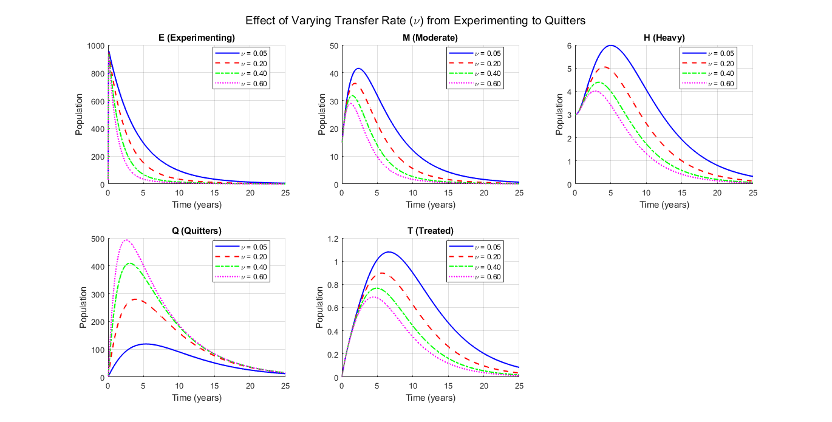

Figure 2: Graphs showing the effects of varying transfer rate ν from experimenting to quitters.
Figure 2 shows that increasing ν by 100% decreases both heavy drinkers and the treated class by 13.1% and 14.6%, respectively; conversely, decreasing ν by 75% increases heavy drinkers and the treated class by 18.4% and 20%, respectively.
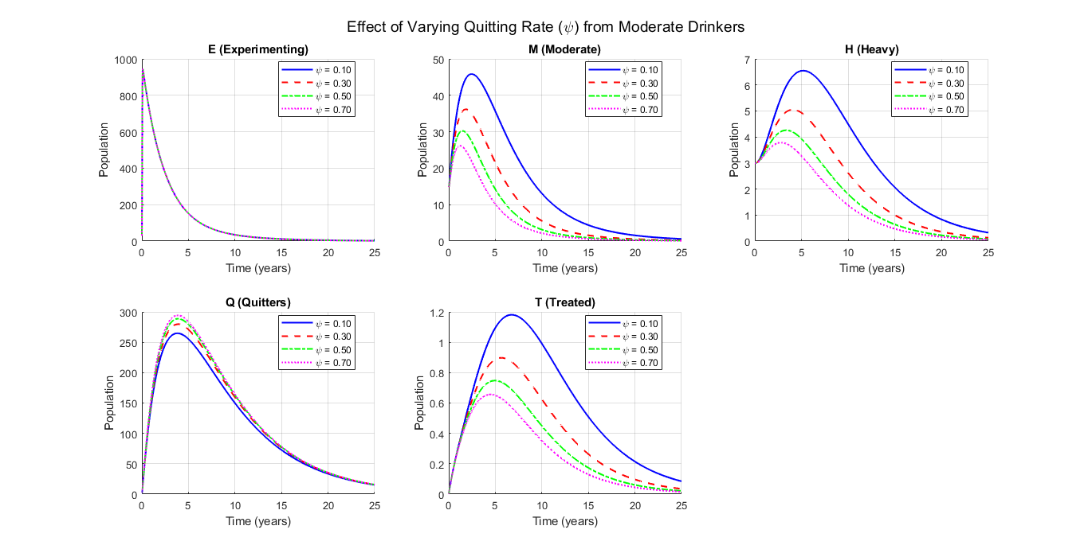
Figure 3: Graphs showing the effects of varying ψ on population.
Figure 3 shows that increasing ψ by 66.7% decreases Moderate drinkers by 16.6%, heavy drinkers by 15.7%, Treated class by 22.2%, and decreases Quitters class by 3.2%, while decreasing ψ by 66% increases Moderate drinkers by 36.2%, Heavy drinkers by 5.1%, Treated population by 33.3%, and increases Quitters by 5.4%, respectively.
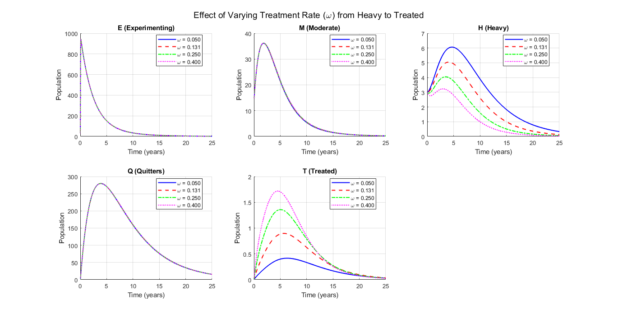
Figure 4: Graphs showing the effects of varying $ω$ on population.
Figure 4 demonstrates that increasing $ω$ by 90.8%, results in a 55.6% increase in the treated population, while decreasing ω by 61.8% results in a 55.6% reduction in the treated population. An increase of 90.8% in ω reduces the number of heavy drinkers by 19.6%, whereas a decrease of 61.8% in ω increases the number of heavy drinkers by 55.6%. Changes in $ω$ have minimal effects on the populations of experimenters, moderate drinkers, and quitters.
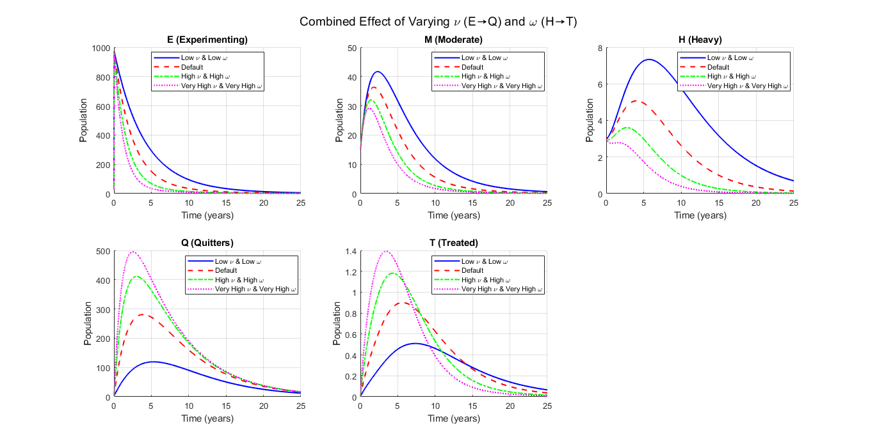
Figure 5: Graphs showing the effects of varying both ν and ω on the population.
Figure 5 shows the effects of varying ν and ω when they are low, high, and very high.
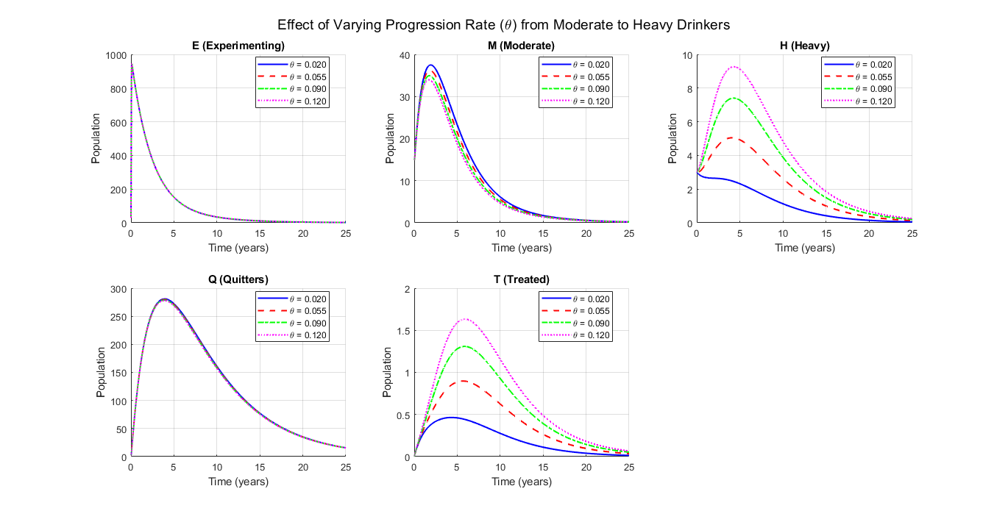
Figure 6: Graphs showing the effects of varying both θ on the population.
Figure 6 shows that an increase in θ leads to more heavy drinkers and a larger treated population, while a decrease in θ reduces both groups.

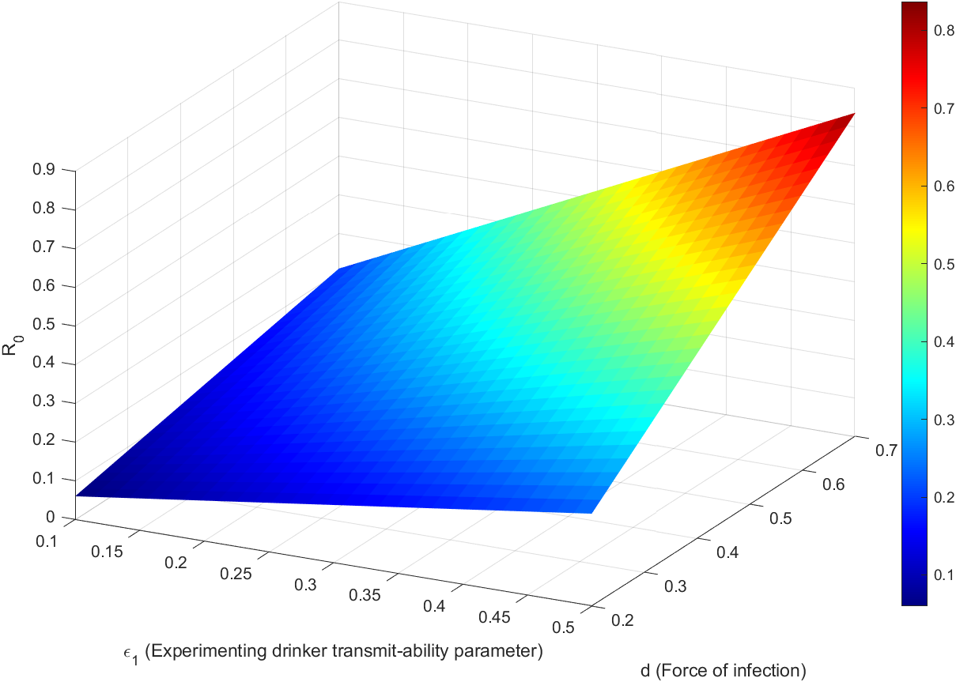
Figure 7: Reproduction number surface
Figure 7 shows the reproduction number surface of $ϵ_{1}$ and d.
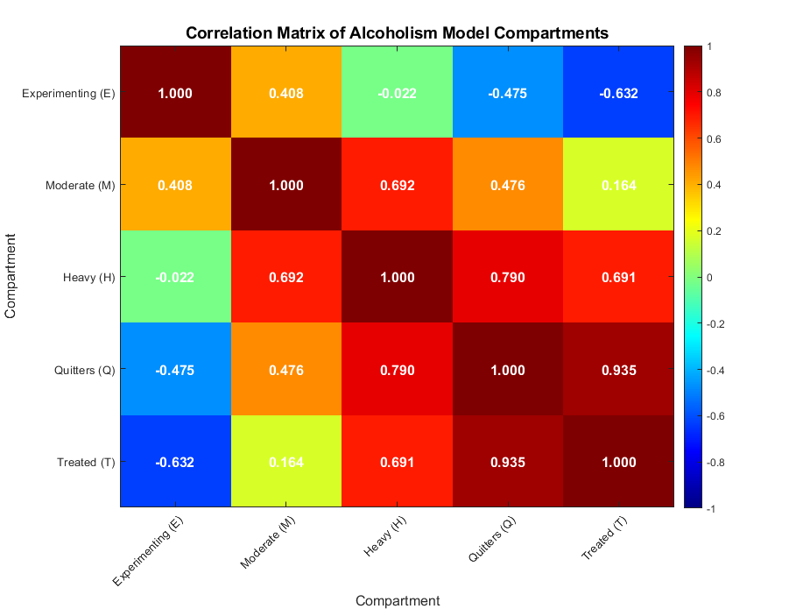
Figure 8: Variables Correlation matrix
Figure 8 shows the correlation matrix of the compartments.

5. Results, Discussion, and Conclusion
The study developed a Susceptible-Experimenting-Moderate-Quitters-Heavy-Treated (SEMQHT) deterministic model, formulated with Ordinary Differential Equations (ODEs), to describe the transmission dynamics of alcohol addiction and to assess interventions aimed at reducing addiction. The qualitative behavior of system 1 was examined by first establishing the positivity and boundedness of the solutions, ensuring biological consistency. the equilibrium points were then determined, and the control reproduction number was derived using the next-generation matrix method. The local stability of the alcohol-free equilibrium was assessed using the Gershgorin Circle Theorem, while global stability was established through the Castillo-Chevez method. Conditions for the existence of an alcohol endemic equilibrium point were derived, followed by a detailed bifurcation analysis. Finally, a normalized sensitivity analysis was performed to identify the most influential parameters, and numerical simulations were conducted to complement the analytical findings.
From the analysis carried out, the model was found to be bounded and lay in the positive region, and the alcoholism-free equilibrium given as $E^{0}=\left(\frac{λ}{μ},0,0,0,0,0\right)$.
The control reproduction number was found to be $R_{0}=0.2345$ from numerical computations. Stability of the alcoholism-free equilibrium was found to be locally asymptotically stable (LAS) and globally stable (GAS) whenever $R_{0}<1$. The alcoholism endemic equilibrium point (AEE) existed whenever $R_{0}>1$.
Bifurcation analysis reveals the presence of a transcritical bifurcation at the threshold value $R_{0}=1$. When $R_{0}<1$, the AFE is stable, leading to the elimination of alcohol abuse in the population. Conversely, for $R_{0}>1$, an endemic equilibrium emerges.
From the sensitivity analysis, the parameters $d,α,θ,ϵ_{1},ϵ_{2}$, and $ϵ_{3}$ exhibited positive sensitivity indices, indicating that increases in any of these parameters would result in a higher basic reproduction number $R_{0}$. Among these, the force of alcohol recruitment $d$ and the transmission rate associated with experimental drinkers $ϵ_{1}$ were identified as the most influential. Specifically, a $10\%$ increase in $d$ would raise $R_{0}$ by approximately $10\%$, while a $10\%$ increase in $ϵ_{1}$ would increase $R_{0}$ by about $8.8\%$. These results suggest that interventions aiming to reduce alcohol-related harm should focus on decreasing both the overall recruitment into drinking and the social influence exerted by individuals in the experimental stage.
The sensitivity indices $δ,ψ,ν$, and $ω$ were negative. The most noticeable impact was seen for $ν=-0.5151$, indicating that increasing the transition of experimenting drinkers into the quitter class significantly reduced alcoholism transmission. The next significant control parameter was $ψ=-0.0632$, which represented the transition of moderate drinkers into the quitter class.
Finally, numerical simulations showed that interventions to reduce alcohol-related harm need to focus on reducing overall recruitment into drinking and effective transfer to the treated class. These are the most efficient in curbing the spread of alcoholism. Strategies should aim to increase $ν$ and $ψ$ significantly, as well as increase those taken to recovery centers, that is, increase $ω$ substantially.
Data Availability
The parameter values incorporated into the mathematical models were sourced from existing literature (refer to Table 1 for specific values and sources). No new experimental data were collected for this research.
Conflict of interest
The authors declare no conflict of interest.
References
[1] D. Nutt, L. A. King, W. Saulsbury, and C. Blakemore, “Development of a rational scale to assess the harm of drugs of potential misuse,” the Lancet, vol. 369, no. 9566, pp. 1047–1053, 2007.
[2] M. Schuberth, “The impact of drug trafficking on informal security actors in Kenya,” Africa Spectrum, vol. 49, no. 3, pp. 55–81, 2014.
[3] K. Mottarella, L. M. Rubin, and T. J. Grites, “The NACADA Journal 2010–2020: A review and future directions,” NACADA Journal, vol. 42, no. 1, pp. 9–21, 2022.
[4] S. E. Woolf-King and S. A. Maisto, “Alcohol use and high-risk sexual behavior in Sub-Saharan Africa: a narrative review,” Arch. Sex. Behav., vol. 40, no. 1, pp. 17–42, 2011.
[5] F. Merz, “United Nations Office on Drugs and Crime: World Drug Report 2017. 2017.,” SIRIUS-Zeitschrift für Strategische Analysen, vol. 2, no. 1, pp. 85–86, 2018.
[6] T. Pankratz, “Understanding Transnational Organised Crime,” Practice (Vol. 2), vol. 41, p. 50, 2012.
[7] A. Oyefeso, H. Ghodse, C. Clancy, J. Corkery, and R. Goldfinch, “Drug abuse-related mortality: a study of teenage addicts over a 20-year period,” Soc. Psychiatry Psychiatr. Epidemiol., vol. 34, no. 8, pp. 437–441, 1999.
[8] R. Hornik et al., “Evaluation of the National Youth Anti-Drug Media Campaign: Fourth Semi-Annual Report of Findings, Executive Summary,” Bethesda, MD: National Institute on Drug Abuse Address, 2002.
[9] B. Kathungu, L. W. Mwaura, and B. Wambugu, “REPORT ON ALCOHOL, DRUGS AND SUBSTANCE ABUSE AMONG PERSONS WITH DISABILITY IN NAIROBI, COAST AND CENTRAL REGIONS KENYA,” 2013, NACADA.
[10] F. F. Marsiglia et al., “Substance use among adolescents in sub-saharan Africa: A narrative review of epidemiological data,” African Journal of Alcohol and Drug Abuse (AJADA), pp. 81–112, 2024.
[11] A. Lenhart and M. Madden, “Teens, privacy and online social networks: How teens manage their online identities and personal information in the age of MySpace,” 2007.
[12] A. K. Misra, A. Sharma, and J. B. Shukla, “Modeling and analysis of effects of awareness programs by media on the spread of infectious diseases,” Math. Comput. Model., vol. 53, no. 5–6, pp. 1221–1228, 2011.
[13] D. Ariyasinghe et al., “Feasibility and acceptability of an adapted WHO alcohol brief intervention,” 2026.
[14] P. Boersma, M. A. Villarroel, and A. Vahratian, Heavy drinking among US adults, 2018, vol. 374. US Department of Health and Human Services, Centers for Disease Control and~…, 2020.
[15] M. K. M. Kamenderi, J. M. J. Muteti, S. K. S. Kimani, and V. O. V. Okioma, “Alcohol use disorders and associated determinants among public sector employees in Kenya,” African Journal of Alcohol and Drug Abuse, vol. 7, no. 2, pp. 3–10, 2022.
[16] K. Lelei, J. Muteti, A. Njenga, V. Okioma, and K. Lelei, “Policy Brief on The Status of Alcohol And Drug Abuse Control in Kenya for the Period Between 1st January To 30th June 2020,” VOLUME 7: JUNE 2022, p. 66, 2022.
[17] C. M. Chen and H. Yi, “SURVEILLANCE REPORT# 84 TRENDS IN ALCOHOL-RELATED MORBIDITY AMONG SHORT-STAY COMMUNITY HOSPITAL DISCHARGES, UNITED STATES, 1979–2006,” 2008, National Institute on Alcohol Abuse and Alcoholism, Division of Epidemiology~….
[18] C. P. Bhunu, S. Mushayabasa, and others, “Assessing the effects of poverty in tuberculosis transmission dynamics,” Appl. Math. Model., vol. 36, no. 9, pp. 4173–4185, 2012.
[19] E. White and C. Comiskey, “Heroin epidemics, treatment and ODE modelling,” Math. Biosci., vol. 208, no. 1, pp. 312–324, 2007.
[20] M. N. Burattini, E. Massad, F. A. B. Coutinho, R. S. de Azevedo-Neto, R. X. Menezes, and L. F. Lopes, “A mathematical model of the impact of crack-cocaine use on the prevalence of HIV/AIDS among drug users,” Math. Comput. Model., vol. 28, no. 3, pp. 21–29, 1998.
[21] F. M. M. Muli, “Mathematical Analysis of Drugs and Substance Abuse in Kenya among the Adolescents,” Journal of Mathematical Analysis and Modeling, vol. 4, no. 2, pp. 80–100, 2023.
[22] K. Chinnadurai and S. ATHITHAN, “Mathematical Modelling of The Drinking Behaviour Effect on Society,” Asia Pacific Journal of Mathematics, vol. 10, pp. 10–36, 2023.
[23] K. Chinnadurai, S. Athithan, and M. G. Kareem, “Mathematical Modelling on Alcohol Consumption Control and its Effect on Poor Population.,” IAENG International Journal of Applied Mathematics, vol. 54, no. 1, 2024.
[24] M. M. Mayengo, “Modeling the prevalence of alcoholism with compulsory isolation treatment facilities,” Results Phys., vol. 48, p. 106428, 2023.
[25] F. Nyabadza, “Modeling the effects of treatment on alcohol abuse in Kenya incorporating mass media campaign,” Journal of Mathematical and Computational Science, 2019.
[26] J. W. Finney and R. H. Moos, “Entering treatment for alcohol abuse: A stress and coping model,” Addiction, vol. 90, no. 9, pp. 1223–1240, 1995.
[27] P. Renard, A. Alcolea, and D. Ginsbourger, “Stochastic versus deterministic approaches,” Environmental modelling: Finding simplicity in complexity, pp. 133–149, 2013.
[28] K. P. Slavkova et al., “Mathematical modelling of the dynamics of image-informed tumor habitats in a murine model of glioma,” Sci. Rep., vol. 13, no. 1, p. 2916, 2023.
[29] T. O. Alade, M. Alnegga, S. Olaniyi, and A. Abidemi, “Mathematical modelling of within-host Chikungunya virus dynamics with adaptive immune response,” Model. Earth Syst. Environ., vol. 9, no. 4, pp. 3837–3849, 2023.
[30] E. Gayathiri et al., “Computational approaches for modeling and structural design of biological systems: A comprehensive review,” Prog. Biophys. Mol. Biol., vol. 185, pp. 17–32, 2023.
[31] P. Asplin, M. J. Keeling, R. Mancy, and E. M. Hill, “Epidemiological and health economic implications of symptom propagation in respiratory pathogens: A mathematical modelling investigation,” PLoS Comput. Biol., vol. 20, no. 5, p. e1012096, 2024.
[32] P. W. Njori, “Mathematical model of sexual orientations in the presence of recovery centers,” International Journal of Statistics and Applied Mathematics, 2025.
[33] S. Li, Samreen, S. Ullah, M. B. Riaz, F. A. Awwad, and S. W. Teklu, “Global dynamics and computational modeling approach for analyzing and controlling of alcohol addiction using a novel fractional and fractal–fractional modeling approach,” Sci. Rep., vol. 14, no. 1, p. 5065, 2024.
[34] A. Vivas, J. Tipton, S. Pant, and A. Fernando, “Mathematical model for the dynamics of alcohol-marijuana co-abuse,” Communications Faculty of Sciences University of Ankara Series A1 Mathematics and Statistics, vol. 73, no. 2, pp. 496–516, 2024.
[35] S. Chege, M. O. Okongo, and J. O. Ochwach, “Mathematical Model of Alcoholism Incorporating Treatment: A Case Study in Kenya,” Journal of Mathematics Instruction, Social Research and Opinion, vol. 4, no. 1, pp. 73–90, 2025.
[36] I. J. Meem, R. Hossain, and S. A. Samad, “A mathematical model of alcoholism in bangladesh,” Khulna University Studies, pp. 281–290, 2022.
[37] J. L. Manthey, A. Y. Aidoo, and K. Y. Ward, “Campus drinking: an epidemiological model,” J. Biol. Dyn., vol. 2, no. 3, pp. 346–356, 2008.
[38] B. Khajji, L. Boujallal, M. Elhia, O. Balatif, and M. Rachik, “A fractional-order model for drinking alcohol behaviour leading to road accidents and violence,” Math. Model. Comput, vol. 9, pp. 501–518, 2022.
[39] D. R. M. A. LILLESKOV and D. R. C. CHAKUA, “ASSESSMENT OF ALCOHOL AND DRUG USE IN THE PRIVATE SECTOR IN KENYA,” 2013, NACANDA.
[40] W. H. Organization, Global status report on alcohol and health 2018. World Health Organization, 2018.
[41] A. C. JUMAI and A. C. AKPAGHER, “USING NONLINEAR MATHEMATICAL MODEL TO STUDY THE IMPACT OF INFECTIOUS DISEASE ON CORONAVIRUS DISEASE IN A FUZZY ENVIRONMENT,” Journal of Systematic and Modern Science Research, 2025.
[42] H. Cao, D. Yu, and C. L. P. Chen, “Spatiotemporal contagion dynamics driven by human mobility in multilayer activity-driven networks,” Appl. Math. Comput., vol. 522, p. 129993, 2026.
[43] M. Korkmaz, “Mathematically grounded state of charge estimation via Gershgorin-based feature engineering and ensemble learning from electrochemical impedance spectroscopy data,” Eng. Appl. Artif. Intell., vol. 174, p. 114559, 2026.
[44] Z. Jin, Y. Yang, J. Yu, B. Wang, S. Cao, and Z. Zhao, “Study on the global stability of members strengthened with outer sleeves,” J. Constr. Steel Res., vol. 239, p. 110250, 2026.
[45] Z. Faiz, A. S. Ali, A. Thaljaoui, M. A. Badawi, and others, “Modeling and treatment of social media addiction using a fractional-order and deep neural network approach,” Appl. Soft Comput., p. 115440, 2026.

