A Data-Driven Evaluation of Rustication Effects on Students’ Behaviour and Academic Outcomes: A Case Study of Achievers University
Authors:
Samuel Oluwadamilola OBASOOTO¹
Department of Computer Science
Achievers University, Owo, Nigeria

Emmanuella OKPIABHELE, PhD²
Corresponding Author
Department of Business Administration
Achievers University, Owo, Nigeria
okpiabhele.emmanuella@achievers.edu.ng
+234 8035301970

Prof. Adeboye Akanni AKINWUMI³
Department of Banking and Finance
Achievers University Owo, Nigeria

Olalekan Jesse BAMGBOLA⁴
Department of Computer Science
Achievers University, Owo, Nigeria

Paul Idowu OLANITORI⁵
Registry, Achievers University Owo, Nigeria

Michael Olaposi ADEGBUYIRO⁶
Student Disciplinary Committee
Achievers University Owo, Nigeria

Abstract
Rustication remains one of the most frequently deployed disciplinary tools in Nigerian universities, yet its actual impact on student behaviour and academic performance is not well established empirically. This study undertakes a data-driven evaluation of the effects of rustication on students’ academic outcomes at Achievers University, Owo, Nigeria. Using retrospective disciplinary and academic records of students rusticated or expelled between 2020 and 2024, the study examines whether temporary suspension functions as an effective corrective measure, particularly with respect to improving Cumulative Grade Point Average (CGPA). A retrospective longitudinal analytic design was employed. Descriptive statistics, paired sample t-tests, and Wilcoxon signed-rank tests were used to compare CGPA before and after rustication, while a multiple linear regression model was specified to identify demographic and institutional predictors of change in CGPA $(Δ\text{CGPA})$. The inferential results indicate that rustication did not yield a statistically significant improvement in academic performance. The paired t-test $\left(t=1.2194, p=0.2284\right)$ and Wilcoxon signed-rank test $(W=479.0, p=0.6638)$ both showed no significant difference between pre- and post-rustication CGPA at conventional confidence levels. In contrast, the multiple linear regression model was statistically significant overall $(R^{2}=0.713, F\left(13.36\right)=6.881, p<0.001)$, suggesting that institutional factors exert a meaningful influence on academic recovery. Academic level and college emerged as key predictors of $Δ\text{CGPA}$, with students from the College of Basic Medical Sciences (COBMS) exhibiting substantial positive improvement $(β=1.0604, p<0.001)$. Most demographic characteristics, including gender and offence category, were not statistically significant. The findings imply that although rustication may serve as a deterrent to misconduct, it does not consistently translate into improved academic outcomes in the absence of targeted support. The study concludes that disciplinary regimes should be embedded within a broader, holistic framework that incorporates counselling, mentoring, and structured academic remediation to foster both behavioural and academic recovery.

Keywords: Rustication, Academic Performance, Student Misconduct, Behavioural Reform, CGPA
- Introduction
Academic misconduct remains a persistent challenge in higher education, undermining assessment integrity, institutional credibility, and ethical standards. Universities respond through formal disciplinary systems, within which rustication temporary suspension with the possibility of reinstatement functions as both a punitive and corrective measure, unlike expulsion which permanently terminates enrolment. Rustication is assumed to promote self-reflection, behavioural reform, and improved academic engagement upon return.
In Nigeria, rising levels of academic dishonesty have been linked to social pressures, weak moral education, peer influence, economic hardship, and institutional enforcement gaps (Ojukwu, 2013; Ajayi & Omorogbe, 2019; Adebayo, 2020). Despite its widespread use, the effectiveness of rustication is rarely evaluated empirically, with existing studies largely adopting normative or qualitative approaches and offering limited statistical evidence on post-sanction academic outcomes (Bumbarger & Brooks, 1999a, 1999b; Omodan, 2018; Yemi-Peters & Obaniyi, 2018; Obadare, 2021). Consequently, robust quantitative evidence linking rustication to changes in academic performance, particularly CGPA, remains scarce.
Leveraging advances in educational data analytics, this study applies statistical modelling to examine the academic effects of rustication. Academic change is operationalised as:
$$Δ\text{CGPA}={\text{CGPA}}_{\text{after}}-{\text{CGPA}}_{\text{before}},$$providing a direct measure of post-rustication improvement or decline (Oladipo et al., 2021; Owusu et al., 2022).
Accordingly, this study employs a quantitative, retrospective design to assess the academic impact of rustication at Achievers University, Owo. Drawing on institutional data from 2020–2024, the analysis integrates descriptive statistics, paired-sample t-tests, Wilcoxon signed-rank tests, and multiple linear regression to examine (i) whether significant differences exist between pre- and post-rustication CGPA, and (ii) the demographic and institutional determinants of variation in ΔCGPA. The findings are intended to inform evidence-based disciplinary policy and promote a more rehabilitative, student-centred approach to academic governance.
- Literature Review
Academic misconduct is a persistent challenge across higher education, though its prevalence and forms vary by context. International studies associate student dishonesty with academic pressure, competitive environments, weak ethical internalisation, inadequate preparation, and limited academic support (Finn et al., 2009; McCabe et al., 2001). Nigerian evidence further identifies socio-economic constraints, peer influence, and weak enforcement mechanisms as significant contributors (Ojukwu, 2013; Ajayi & Omorogbe, 2019; Yusuf & Afolabi, 2020; Adebayo, 2020). Universities apply sanctions ranging from warnings and probation to suspension, rustication, and expulsion. Rustication is particularly salient because it assumes that temporary academic withdrawal can correct behaviour and restore academic commitment. This rationale aligns with classical deterrence theory, which posits that certain, timely, and proportionate sanctions discourage misconduct (Beccaria, 1764), thereby deterring both offenders and their peers.
Deterrence-based models are criticised for oversimplifying student behaviour, which is shaped not only by rational choice but also by social norms, mental health, institutional climate, and structural constraints. Consequently, exclusionary sanctions such as suspension and rustication may fail to achieve rehabilitative outcomes. The American Psychological Association (2008) finds that zero-tolerance policies do not significantly reduce misconduct and may worsen academic disengagement, dropout, and marginalisation, with implications for higher education. Bumbarger and Brooks (1999a, 1999b) further argue that sanctions lacking supportive interventions foster resentment and recidivism, while Finn et al. (2009) show that exclusionary practices weaken students’ sense of belonging and academic motivation.
In the Nigerian context, university disciplinary systems often reflect broader socio-political dynamics. Aghedo (2015) argues that student conduct is frequently criminalised in ways consistent with authoritarian governance, positioning sanctions as mechanisms of control rather than rehabilitation, and rendering rustication an instrument of institutional self-preservation. Administratively, enforcement is constrained by weak monitoring systems, identity verification challenges, and poor record management (Omodan, 2018; Yemi-Peters & Obaniyi, 2018). To improve transparency and consistency, biometric identification technologies, such as fingerprint authentication, have been proposed as viable solutions (Yemi-Peters & Obaniyi, 2018). McCabe et al. (2001) highlight the critical role of institutional culture and ethical climate in promoting academic integrity, showing that punitive sanctions alone are often insufficient where norms, peer influence, and staff–student relationships do not reinforce ethical behaviour. Tinto (2012) similarly emphasises that academic integration, institutional support, and engagement enhance student success, particularly after disciplinary interruptions. Effective recovery from rustication is more likely when universities provide structured reintegration, mentoring, and academic assistance. Together, these findings indicate that misconduct stems from both individual and systemic factors, sanctions alone rarely ensure lasting change, and institutional support is crucial. Yet, few studies quantitatively assess rustication’s impact on CGPA and its predictors.
This study uses a longitudinal, data-driven approach to assess rustication outcomes at Achievers University. By examining ΔCGPA and its determinants, it provides empirical evidence on the roles of deterrence, institutional support, and student discipline in shaping academic performance in Nigerian higher education.
2.1 Chronological Perspectives on Rustication and Discipline
A brief chronological overview helps to situate this study within a broader historical and theoretical context:
18th Century – Beccaria (1764): Classical deterrence theory is articulated, emphasising proportional, prompt, and certain punishment as a means of preventing crime. These principles later inform institutional disciplinary strategies, including university sanctions such as rustication.
Late 20th Century – Bumbarger & Brooks (1999a, 1999b): These authors challenge reliance on exclusionary discipline and advocate preventive, rehabilitative interventions counselling, mentoring, and conflict resolution as more effective in the long term.
Early 2000s – McCabe et. al, (2001): Through a decade of research on academic dishonesty, they highlight institutional culture, peer influence, and ethical norms as key determinants of academic integrity, rather than punishment alone.
2008 – American Psychological Association (APA): The APA’s evidentiary review of zero-tolerance policies concludes that such policies are of limited effectiveness and often associated with negative educational and behavioural outcomes.
2012 – Tinto: In Completing College, Tinto (2012) underscores the importance of institutional support, academic engagement, and structured reintegration pathways for students who experience interruptions in their academic progress.
2015 onwards – Aghedo (2015), Omodan (2018), Yemi-Peters & Obaniyi (2018), Obadare (2021): These works highlight sociopolitical dynamics, administrative complexities, and technological innovations in disciplinary systems within African universities.
Collectively, these contributions trace an evolution from theoretical justification of punishment to empirical critiques of exclusionary practices and the exploration of alternative, support-oriented models. Yet, the specific question of how rustication affects academic performance, measured quantitatively, remains insufficiently examined, hence the present study.
- Methodology
3.1 Research Design
The study employs a retrospective longitudinal design to evaluate the effects of rustication on student academic performance. This design enables the comparison of academic outcomes before and after the imposition of disciplinary sanctions, using archival data spanning four academic sessions (2020/2021–2023/2024).
3.2 Population of the Study
The research was conducted at Achievers University, a private university located in Owo, Ondo State, Nigeria. The population comprises all students who were rusticated during the study period. For inclusion in the analytical sample, students had to possess complete demographic and academic records, including CGPA values both before and after rustication.
3.3 Sources of Data
Data were extracted from official institutional records maintained by the University Disciplinary Committee and the Academic Registry. Variables were obtained through Anonymised student identification number; Sex; College and Department; Academic level at the time of rustication; Offence category and description; Verdict type and rustication duration; CGPA prior to rustication; CGPA after rustication; Resumption status and record of reoffending; and Campus zone of residence. Data cleaning and pre-processing were conducted using Microsoft Excel and Python (pandas, numpy). Missing values were handled via listwise deletion, and textual inconsistencies were standardised. The principal outcome variable, change in academic performance, was computed as:
$$Δ\text{CGPA}={\text{CGPA}}_{\text{after}}-{\text{CGPA}}_{\text{before}}.$$3.4 Analytical Framework
A two-track analytical framework was adopted:
3.4.1 Track 1: Descriptive and Inferential Statistics
Descriptive analysis: Distribution of offences, sex, colleges, academic levels, and summary statistics for CGPA and $Δ\text{CGPA}$.
Paired sample tests: A paired t-test (under normality assumption) and a Wilcoxon signed-rank test (non-parametric alternative) were used to determine whether post-rustication CGPA differed significantly from pre-rustication CGPA.
Chi-square tests: Used to examine association between categorical variables such as sex, offence type, and college.
3.4.2 Track 2: Predictive Modelling (OLS and Lasso Regression)
The predictive component of the analysis evaluates which factors influence $Δ\text{CGPA}$. The dependent variable is:
$$Y=Δ\text{CGPA}.$$
The predictors include sex, college, level, offence category, and rustication duration. The baseline OLS regression model is specified as:
$$Δ\text{CGPA}=β_{0}+β_{1}(\text{Sex})+β_{2}(\text{College})+β_{3}(\text{Level})+β_{4}(\text{Offence Category})+β_{5}(\text{Rustication Duration})+ε.$$
3.5 Lasso Regression and Rationale
Alongside OLS, Lasso (Least Absolute Shrinkage and Selection Operator) regression was implemented for the following reasons:
3.5.1 High dimensionality: The categorical predictors (e.g., college, level) were converted into multiple dummy variables. Lasso performs automatic variable selection by shrinking weaker coefficients towards zero, thus simplifying the model.
3.5.2 Multicollinearity mitigation: Although Variance Inflation Factors (VIFs) were within acceptable standards, natural correlations among dummy variables warranted the stabilising effect of Lasso.
3.5.3 Overfitting control: Given the modest sample size (approximately 50 students), standard OLS could be prone to overfitting. Lasso introduces an $L_{1}$penalty that constrains coefficient magnitude and improves generalisation.
3.5.4 Predictive performance: Lasso is particularly useful when many predictors have negligible influence, as it enhances predictive accuracy by focusing on the most impactful variables.
The Lasso objective function is:
$${\hat{β}}_{\text{Lasso}}=arg⁡\underset{β}{min⁡}\left\{\sum_{i=1}^{n}{(y_{i}-X_{i}^{'}β)^{2}}+λ\sum_{j=1}^{p}{∣β_{j}∣}\right\},$$where $λ$ is the regularization parameter, chosen via 10-fold cross-validation.
Diagnostic checks VIF analysis, residual normality, Durbin Watson statistic, and Breusch Pagan test were carried out to confirm the validity of the modelling assumptions.
3.6 Hypotheses
3.6.1 Inferential Hypotheses
- $H_{0}^{1}$: There is no significant difference between CGPA before and after rustication.
- $H_{A}^{1}$: There is a significant difference between CGPA before and after rustication.
- $H_{0}^{2}$: There is no association between sex and type of misconduct.
- $H_{A}^{2}$: There is a significant association between sex and type of misconduct.
3.6.2 Regression Hypotheses
- $H_{0}^{3}$: None of the predictors significantly influences $Δ\text{CGPA}$.
- $H_{A}^{3}$: At least one predictor significantly influences $Δ\text{CGPA}$.
3.7 Ethical Considerations
All records were fully anonymized to protect the identities of students. Ethical approval was obtained from the University’s Research Ethics Committee, and formal permission to access archival disciplinary and academic data was granted by the Disciplinary Board.
3.8 Limitations of the Methodology
The study’s conclusions are subject to certain limitations. Qualitative indicators of behavioural change (e.g., counselling outcomes, motivational shifts) were not available in the dataset. Academic performance was measured solely via CGPA, which may not capture all dimensions of learning and development. Additionally, the focus on a single institution limits the extent to which findings can be generalized across the Nigerian university system.
- Results and Discussion
4.1 Descriptive Overview
A total of 50 students with complete academic records comprising CGPA before and after rustication were included in the analysis. These students were drawn from six colleges and spanned multiple academic levels (200–500). The offences that led to rustication covered both academic and non-academic categories, including examination malpractice, assault, forgery, and disruptive behaviour.
Descriptive analysis revealed substantial variability in academic performance following rustication. The computed change in CGPA, denoted as:
$$Δ\text{CGPA}={\text{CGPA}}_{\text{after}}-{\text{CGPA}}_{\text{before}}$$showed both positive and negative shifts across individual students. This mixed pattern provided a strong justification for employing regression analysis to identify the key demographic and institutional factors that predict academic improvement or decline after rustication.
4.2 Regression Analysis
A multiple linear regression model was estimated to examine the extent to which demographic and institutional characteristics predict changes in academic performance following rustication. The dependent variable was:
$$Δ\text{CGPA}={\text{CGPA}}_{\text{after}}-{\text{CGPA}}_{\text{before}}$$The model explained a substantial proportion of the variance in CGPA change, with:
- $R^{2}=0.713$
- Adjusted $R^{2}=0.609$
This indicates that the set of predictors collectively accounts for about 71.3% of the variability in $Δ\text{CGPA}$. The overall model was statistically significant:
$$F(13,36)=6.881,p<0.001,$$demonstrating that, taken together, the predictors have strong explanatory power.
4.3 Regression Coefficients
Table: OLS Regression Estimates for Predictors of CGPA Change
Variable | Coef. | Std. Err. | t | p-value
Constant | 0.1161 | 0.122 | 0.954 | 0.347
Sex (Male) | 0.0356 | 0.064 | 0.553 | 0.584
College: CONAS | -0.1747 | 0.088 | -1.976 | 0.056
College: COSMAS | 0.0094 | 0.091 | 0.103 | 0.918
College: FOBMS | 1.0604 | 0.178 | 5.972 | 0.000
College: FOMLS | 0.0068 | 0.101 | 0.067 | 0.947
College: FONS | -0.1163 | 0.104 | -1.120 | 0.270
Level 200 | 0.0479 | 0.086 | 0.557 | 0.581
Level 300 | -0.0523 | 0.090 | -0.583 | 0.563
Level 400 | -0.1412 | 0.089 | -1.586 | 0.122
Level 500 | -0.0514 | 0.127 | -0.406 | 0.687
Level Missing | -0.9821 | 0.229 | -4.290 | 0.000
Offence: Non-Academic | -0.0521 | 0.054 | -0.957 | 0.345
Verdict: Expelled | -0.0010 | 0.118 | -0.009 | 0.993

4.4 Visualizations
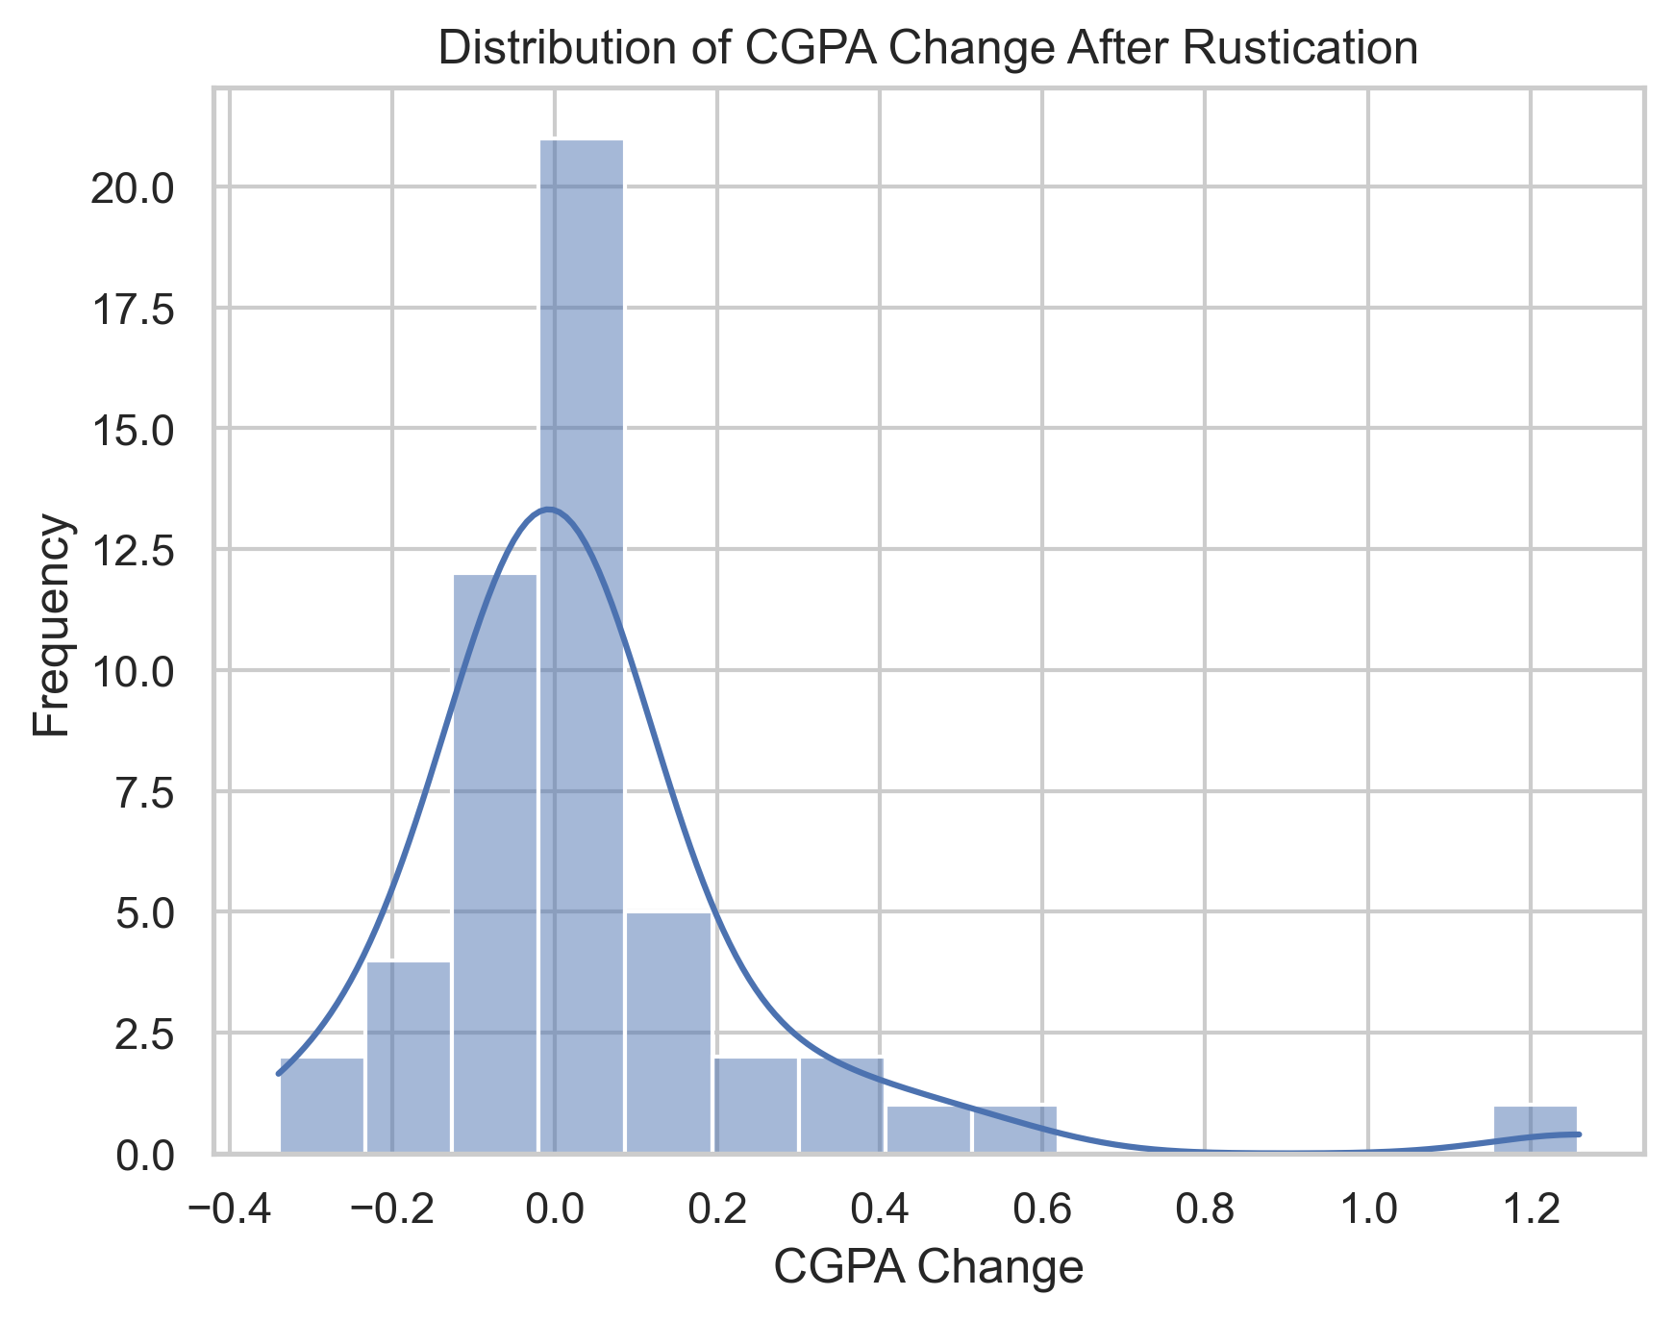
Distribution of CGPA Change After Rustication
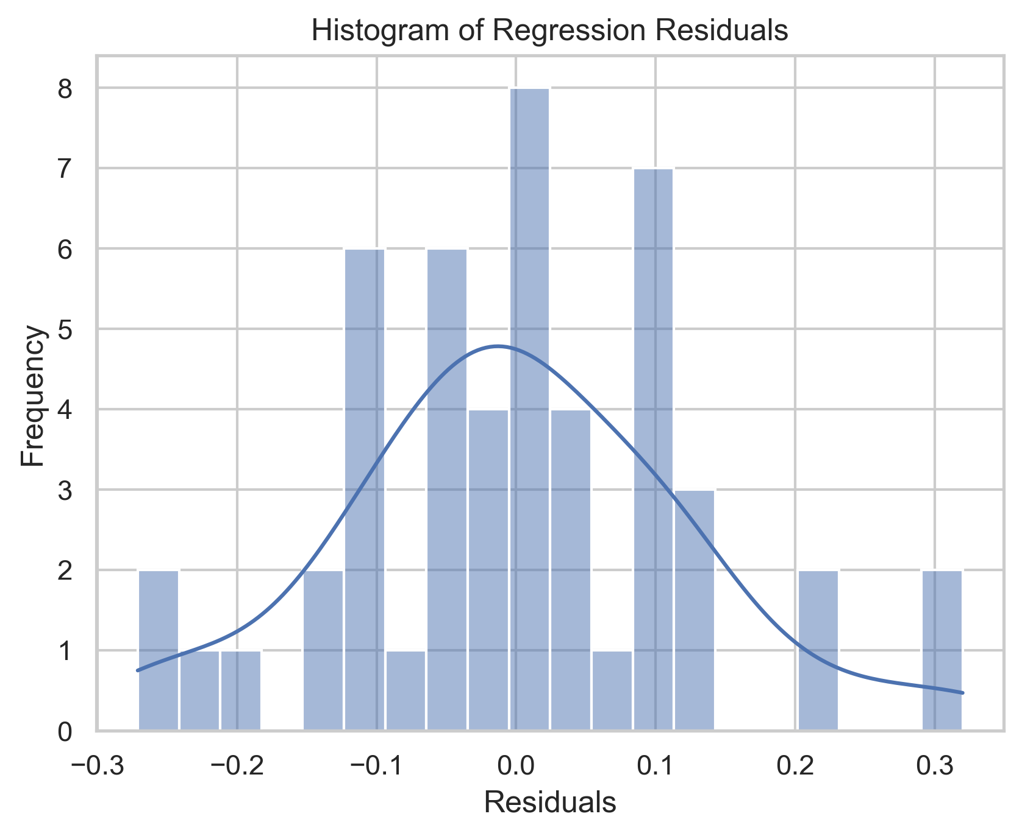
Histogram of regression residuals showing the distribution and assessing normality assumptions for the multiple linear regression model.
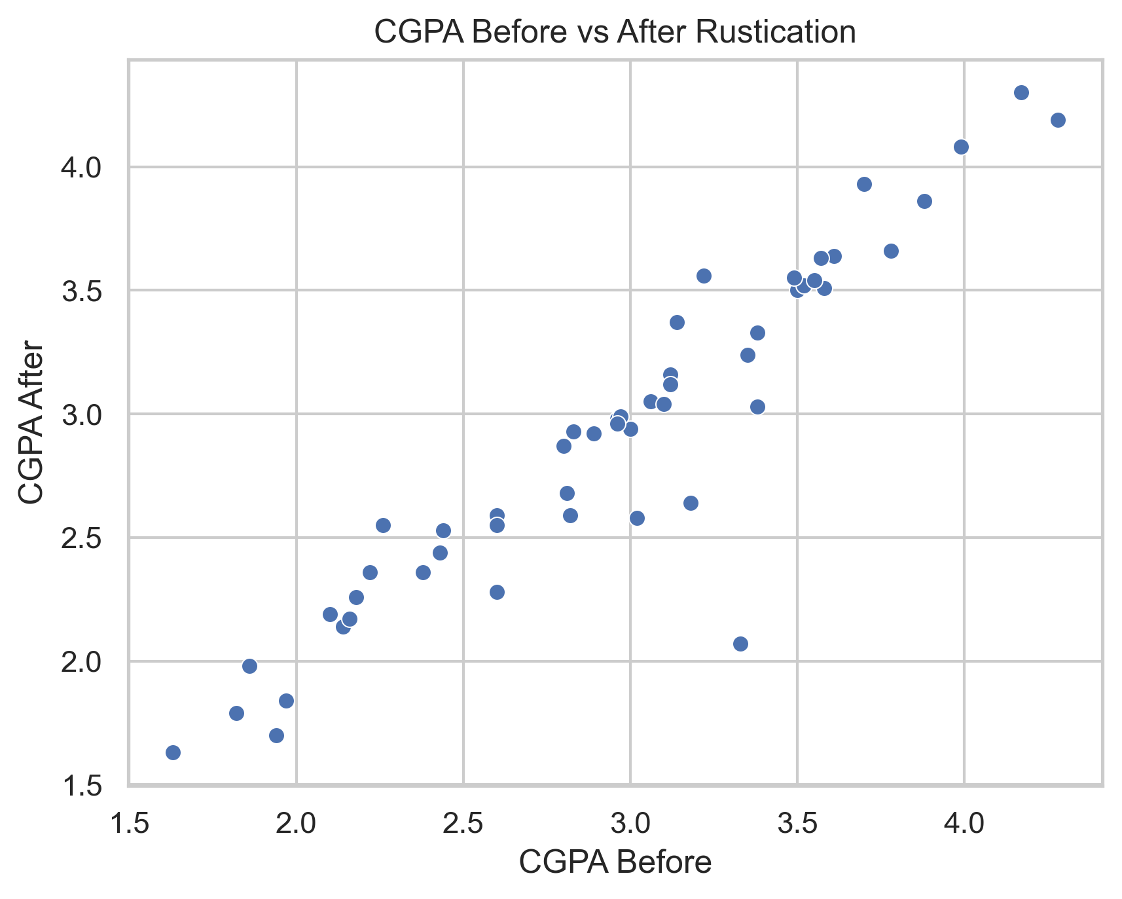
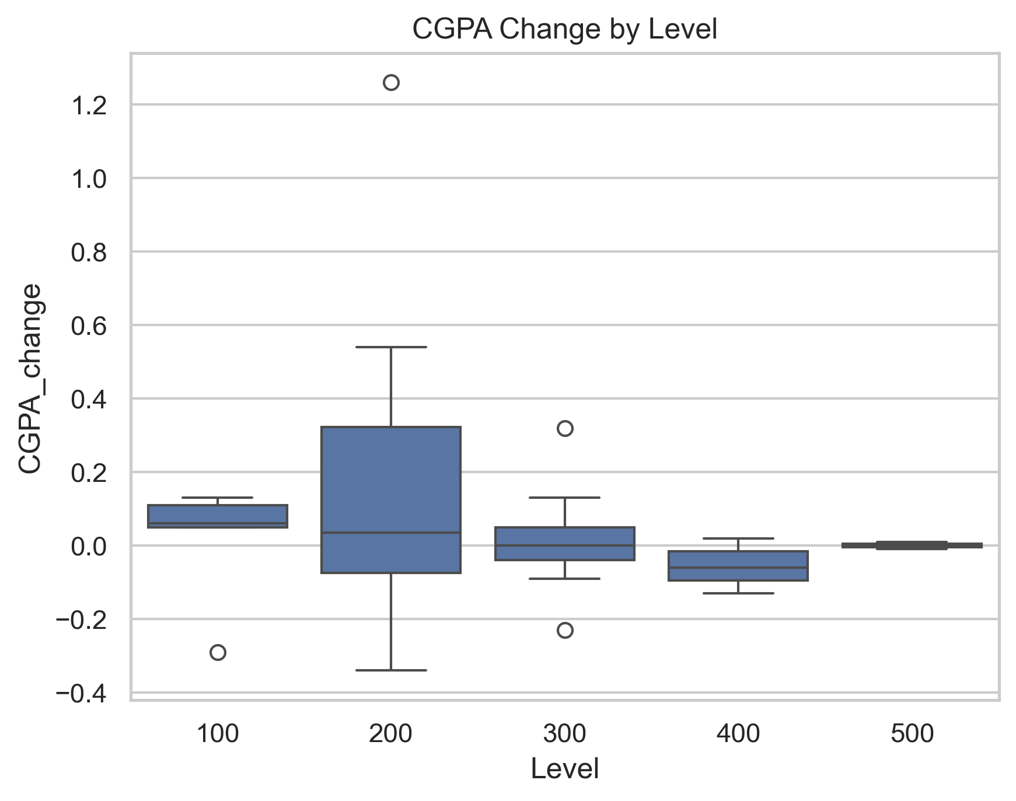
Mean CGPA Change by Level
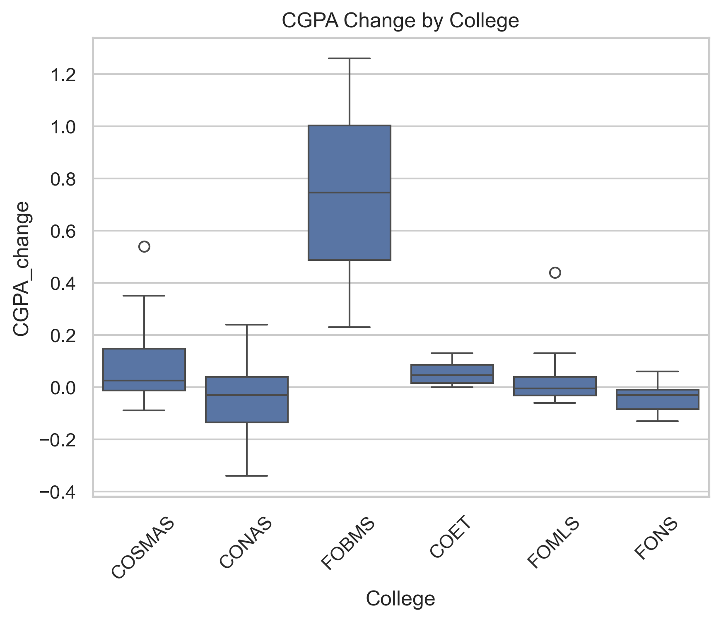
Mean CGPA Change by College
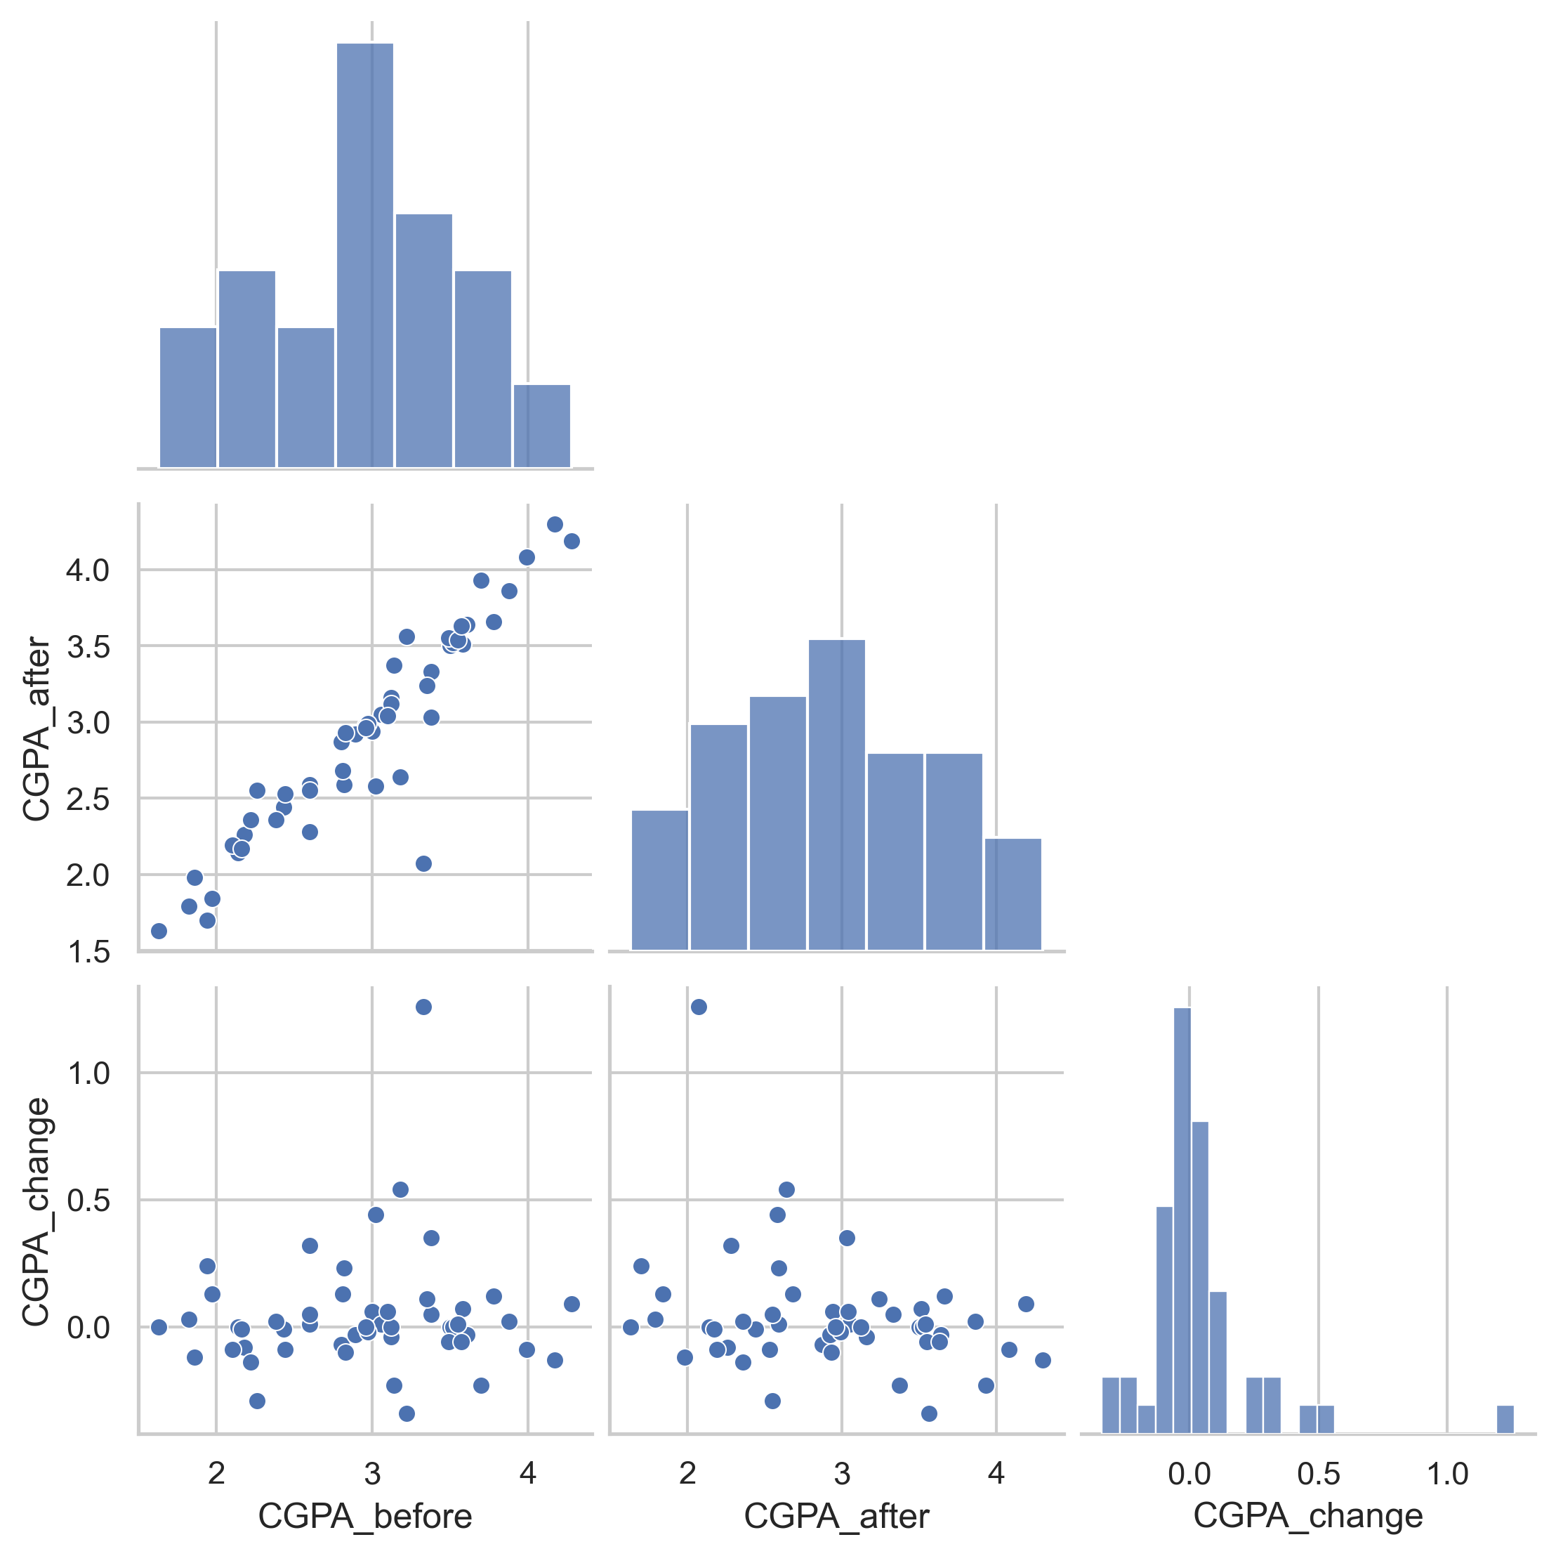
Pairplot illustrating the distributions and bivariate relationships between students’ pre-rustication CGPA, post-rustication CGPA, and CGPA change.
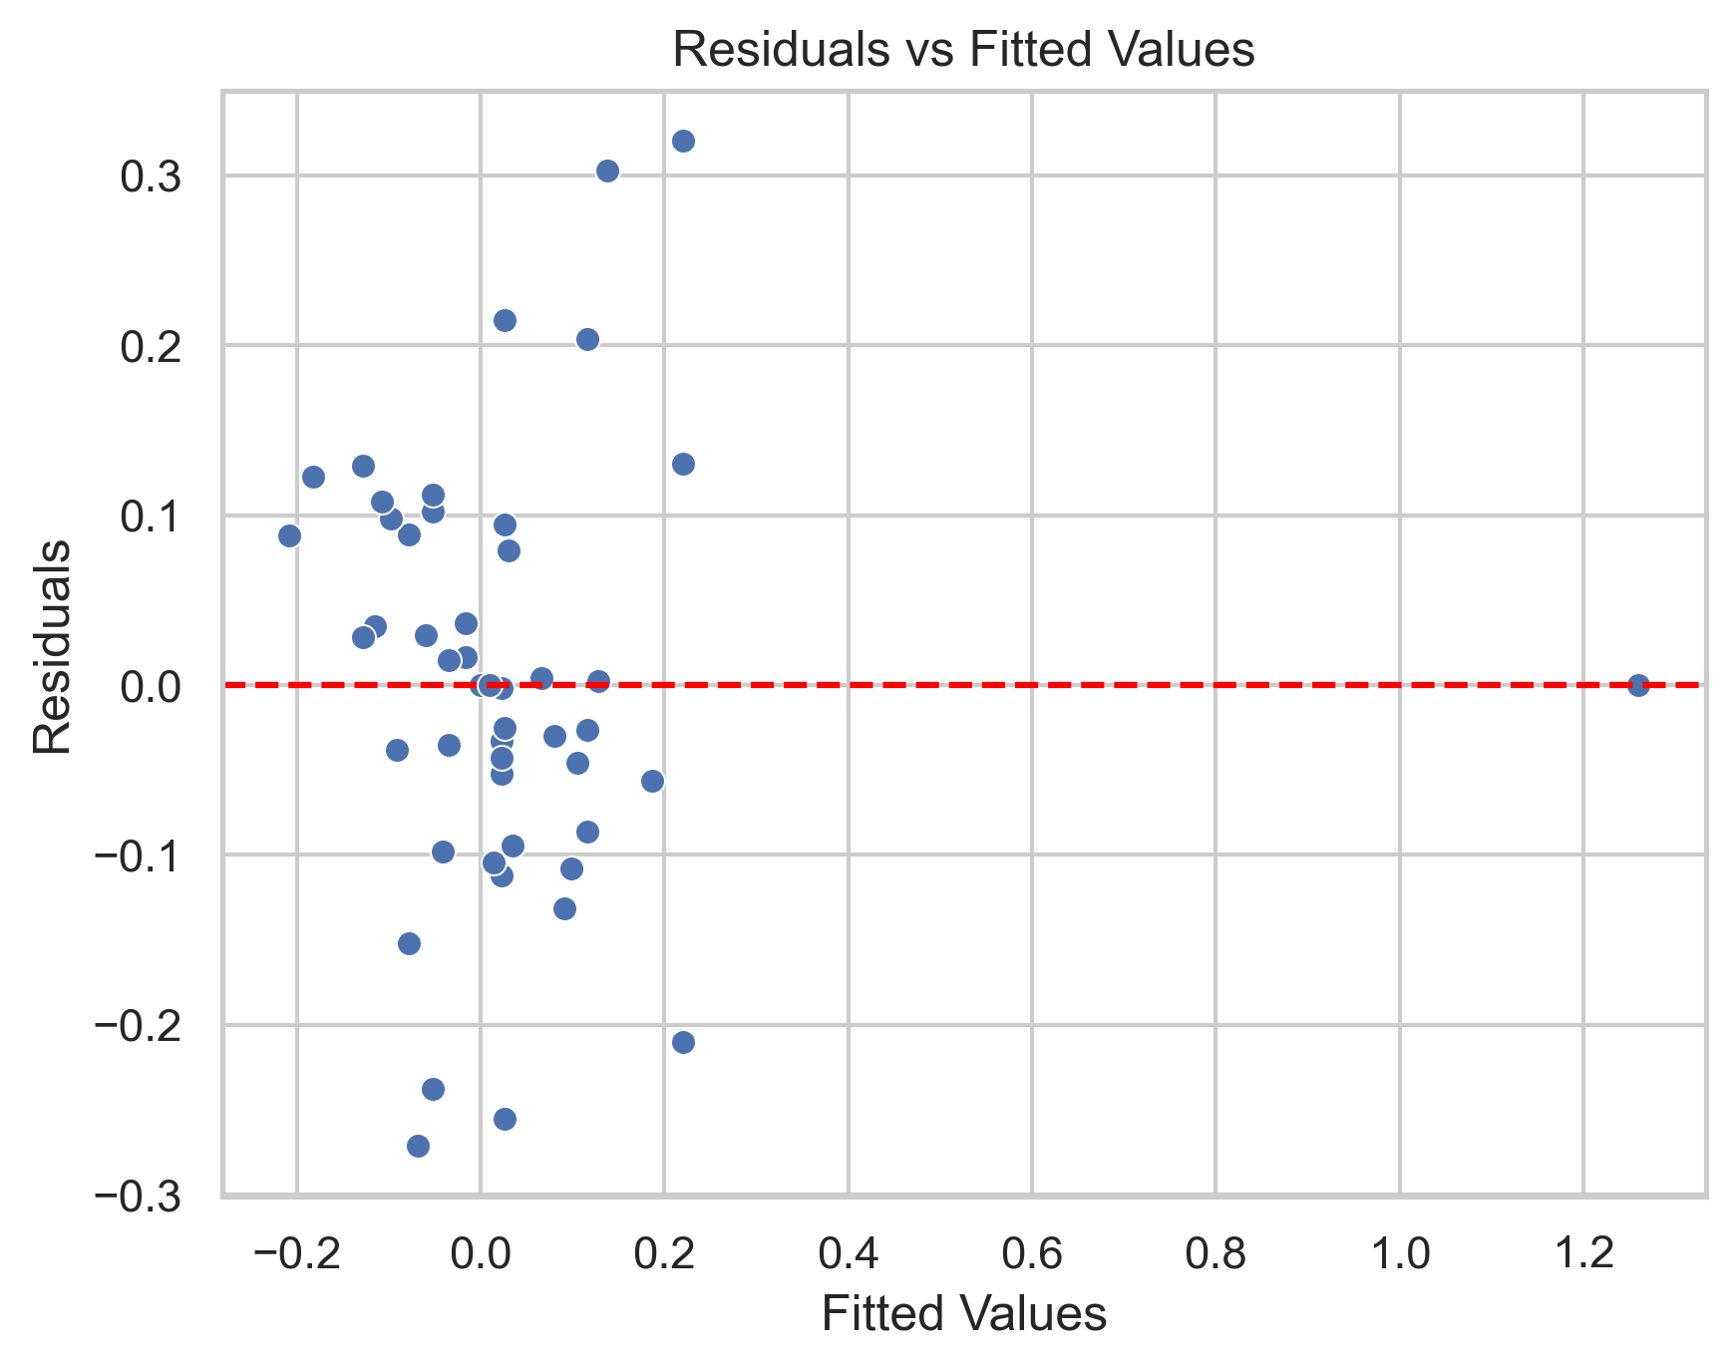
Residual Plot for the Regression Model
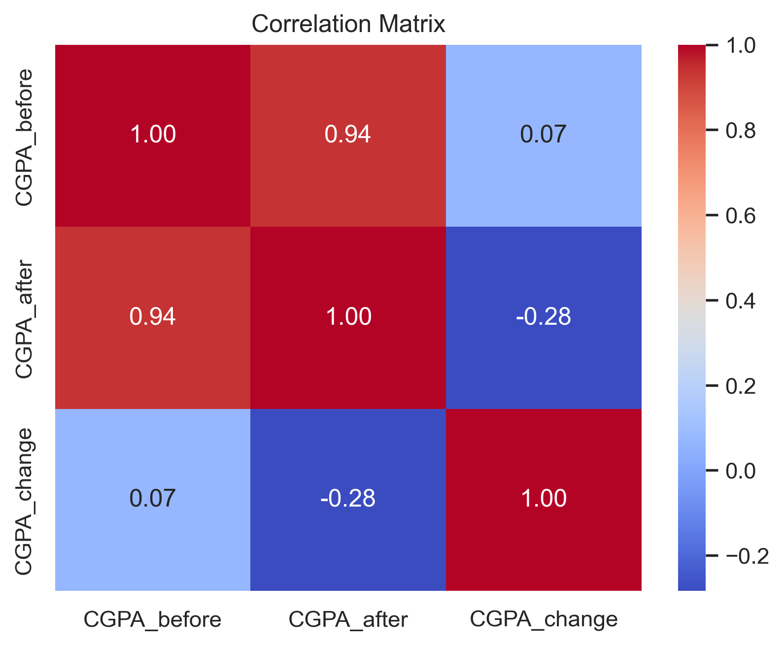
Correlation heatmap showing the relationship among numerical variables, including CGPA metrics and offence-related attributes.

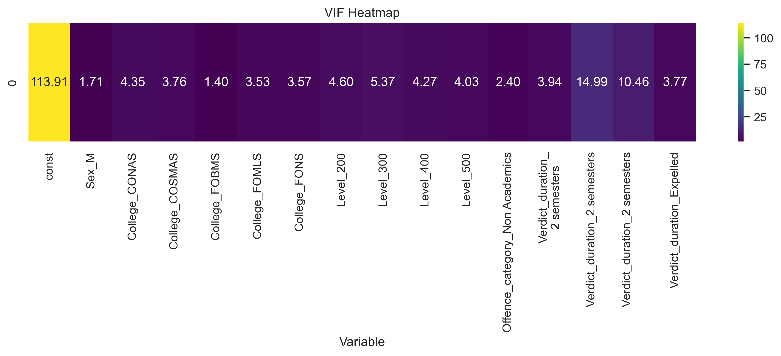
Collinearity Diagnostics Using VIF Heatmap
4.5 Discussion of Findings
Overall, the findings indicate that rustication does not exert a uniform or consistently positive influence on students’ academic outcomes. Rather than demographic characteristics, institutional factors especially those operating at the college level appear to play a more decisive role in shaping post-sanction academic recovery.
Students in the College of Basic Medical Sciences (COBMS) demonstrated pronounced academic improvement following rustication. This pattern may reflect the presence of stronger departmental oversight, well-structured and professionally oriented curricula, closer staff–student engagement, and a generally higher level of academic rigour. Such an environment is likely to provide clearer expectations and more robust support systems for students re-entering after a disciplinary interruption.
In contrast, students whose academic level information was missing experienced a marked decline in academic performance. This severe negative shift can plausibly be linked to administrative lapses, unstable enrolment status, or weak academic re-engagement. Missing level data may itself be symptomatic of broader institutional or personal instability, which in turn undermines the student’s capacity to recover academically after rustication.
Importantly, demographic variables such as gender and level of study were not found to exert a meaningful influence on changes in CGPA. This suggests that rustication does not disproportionately benefit or disadvantage specific demographic groups in academic terms. Instead, the evidence points to the centrality of institutional support systems, organisational structures, and administrative consistency in determining whether students are able to recover academically after a sanction.
Taken together, these findings reinforce the argument that punitive measures alone are insufficient. For rustication to contribute to genuine academic and behavioural rehabilitation, it must be complemented by structured reintegration programmes, targeted student support services, and systematic academic follow-up. This includes clear reintegration protocols, mentoring, counselling, progress monitoring, and deliberate efforts by faculties and departments to re-integrate sanctioned students into the academic community.
- Conclusion and Recommendations
5.1 Conclusion
This study investigated the academic consequences of rustication among students at Achievers University using a rigorous statistical framework that incorporated paired-sample tests, non-parametric procedures, chi-square analyses, and multiple linear regression modelling. Across all analytical techniques, the findings converged on a clear conclusion: rustication does not produce a statistically significant improvement in academic performance. Both the paired t-test and the Wilcoxon signed-rank test revealed no meaningful difference between CGPA before and after rustication, and the chi-square analysis showed no significant association between type of offence and academic outcomes.
Although the regression model accounted for a substantial proportion of the variance in CGPA change, most predictors including sex, academic level, type of offence, and category of sanction were not statistically significant. This suggests that academic trajectories following disciplinary sanctions are shaped less by the punitive measure itself and more by underlying psychosocial, motivational, and institutional factors.
These results align with global scholarship. Tinto’s model of student persistence emphasizes the role of academic integration, institutional support, and continuous engagement elements largely absent in punitive disciplinary frameworks. Similarly, the American Psychological Association’s review of zero-tolerance policies concludes that exclusionary sanctions rarely foster behavioural or academic improvement unless accompanied by comprehensive support systems. Research on academic dishonesty by McCabe, Treviño, and Butterfield further demonstrates that institutional culture, peer influence, and clarity of academic expectations are far more influential in promoting ethical behaviour than punishment alone.
The international evidence is further supported by Nigerian studies, which consistently highlight the limitations of punitive disciplinary systems in the absence of counselling, monitoring, and structured reintegration. Collectively, these insights challenge the assumption that rustication, on its own, encourages academic reflection or behavioural transformation. Rather, the findings point to the need for a more holistic, supportive, and rehabilitative disciplinary framework.
5.2 Recommendations
Drawing on the empirical findings and established best practices in higher education governance, the following recommendations are proposed:
- Returning students should be supported with academic advising, close mentoring, and monitored study plans. This aligns with Tinto’s emphasis on engagement as a key driver of academic success.
- Evidence from the APA (2008) and McCabe et al. (2001) demonstrates that combining disciplinary sanctions with psychosocial support leads to better behavioural and academic outcomes.
- Institutions should digitally track student performance before and after sanctions to inform policy decisions and identify at-risk students early.
- Mediation, restitution, reflective writing, and facilitated dialogue can promote accountability while maintaining students’ connection to the academic environment.
- Faculties especially those with demanding curricula should proactively follow up with students returning from rustication to ensure proper reintegration.
- Missing or incomplete academic information limited the depth of this study. Accurate documentation is essential for effective disciplinary evaluation and future research.
5.3 Limitations and Suggestions for Future Research
This study was constrained by several limitations. First, incomplete academic records particularly missing level information reduced the scope of the analysis and may reflect broader administrative challenges. Second, the study did not include behavioural or psychosocial indicators such as motivation levels, counselling participation, or emotional readiness, all of which likely influence academic recovery. Third, because the research focused on a single institution, the findings may not fully represent trends across the Nigerian higher education system.
Future studies should incorporate qualitative insights, such as interviews or counselling reports, to capture the psychological dimensions of academic reintegration. Multi-institutional comparative studies across public and private universities would broaden generalizability. Additionally, machine learning techniques could be explored to develop early-warning systems that predict misconduct risk and identify students most vulnerable to academic decline.
References
Adebayo K (2020) Institutional discipline and academic ethics in Nigerian Higher Education. Lagos University Press: Lagos.
Aghedo I (2015) Values and violence: explaining the criminalization of higher education students in Nigeria. Jou of Black Stud 46(2):172 198.
Ajayi T, Omorogbe R (2019) Academic dishonesty and institutional integrity in Nigerian Universities. Jour of Higher Edu Stud 8(2):33 45.
Association A P (2008) Are zero tolerance policies effective in the schools? an evidentiary review and recommendations. Technical report, APA Zero Tolerance Task Force.
Beccaria C (1764). On crimes and punishments.
Bumbarger B, Brooks A (1999a) School violence: disciplinary exclusion, prevention, and alternatives. Technical report, University of Pittsburgh.
Bumbarger B, Brooks M (1999b) Behavioral intervention strategies in education: a preventive approach to student discipline. Jour of Edu Res 92(3):189-197.
Finn J D, Fish R M, Scott L A (2009) Educational seclusion: student and parent perceptions of school discipline. Yth & Soc 41(4):541-570.
McCabe D L, Treviæo L K, Butter-eld K D (2001) Cheating in academic institutions: a decade of research. Eths & Bev 11(3):219-232.
Obadare S (2021) Comparative disciplinary policies in African universities: lessons for institutional governance. Jour of Edu Pol 15(4):210-226. Explores disciplinary policies across African universities and their governance implications.
Ojukwu M O (2013) Examination malpractice in Nigerian schools: an impediment to achieving quality education. Afri Res Rev 7(3):379-386.
Oladipo O, Ogunleye T, Bello A (2021) Predictive modelling of student academic performance using machine learning techniques. Jour of Comp Edu 9(2):115-132.
Olasehinde K J, Olatoye R A (2014) Predictive validity of students’ variables as correlates of examination malpractice in secondary schools in Nigeria. Edu Tho 9(2):46-57.
Omodan B I (2018) Student verification and disciplinary systems in African universities: an institutional approach. Afri Jour of ICT 11(1):54-67.
Owusu G, Boateng E, Mensah P (2022) Data analytics and behavioral prediction in higher education: a computational framework. Int Jour of Edu Data Sci 3(1):22-39.
Tinto V (2012) Completing College: Rethinking Institutional Action. University of Chicago Press: Chicago.
Yemi-Peters V I, Obaniyi O S (2018) Development of a verification system for rusticated and expelled Nigerian university students using fingerprint authentication. Afri Jour of Comp & ICT 11(1):1-11.
Yusuf K, Afolabi F (2020) Institutional policy and student conduct management in Nigerian universities. Edu Mgt Rev 6(3):101-117.

