Household Income Allocation and Investment Behavior in India: Insights from SEBI Investor Survey 2025
Dr. Santosh B. Kabade
Associate Professor
Government First Grade College, Navabag
Vijayapur-586101 (Karnataka)
Mobile No.8073233451 / 9986529073
Mail: prof.santosh.b.kabade@gmail.com
- Abstract
The SEBI Investor Survey 2025 highlights the financial behavior of Indian households, revealing a significant gap between awareness and actual investment participation. While households demonstrate moderate awareness of financial products and institutions, only a small proportion of income is allocated toward investments. This article analyzes income allocation patterns, investment preferences, financial goals, and awareness levels, offering insights into the evolving investment landscape in India.
- Keywords
SEBI Investor Survey 2025, Household Finance, Investment Behavior, Financial Awareness, Fixed Deposits, Mutual Funds, India Savings Pattern, Financial Inclusion
- Introduction
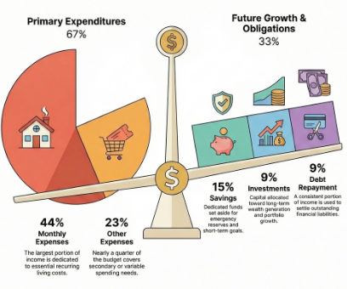
The Securities and Exchange Board of India (SEBI) plays a pivotal role in regulating and promoting investor protection in India. Its 2025 investor survey provides a comprehensive overview of how Indian households allocate income and approach investments.
Despite increasing financial literacy and expanding access to financial products, traditional saving instruments continue to dominate. This reflects a cautious investment mindset shaped by risk aversion, economic uncertainty, and cultural preferences.

4. Statistical Analysis Report

1. Monthly Income Allocation
The survey reveals the following distribution of household income: The monthly income allocation shows how households distribute their earnings across different needs and priorities. A major portion, 44%, is spent on monthly expenses, which include essential costs such as rent, food, utilities, transportation, and basic healthcare; this indicates that nearly half of the income is required to maintain daily living, which is generally reasonable. Another 23% goes toward other expenses, which are mostly non-essential or discretionary, such as entertainment, dining out, shopping, and travel, suggesting that a significant share of income is used for lifestyle and comfort, though it should be monitored to avoid overspending. The allocation of 15% to savings reflects a good financial habit, as it helps build emergency funds and supports short-term goals, aligning well with recommended saving practices. Meanwhile, 9% is invested in wealth-generating options like stocks, mutual funds, or retirement plans, indicating some focus on future financial growth, although increasing this share could further strengthen long-term financial security. Lastly, 9% is used for debt repayment, covering obligations like loans or credit card payments, which appears manageable and suggests that debt levels are under control. Overall, this distribution represents a fairly balanced financial approach with stable spending, decent savings, and controlled debt, though reducing discretionary expenses and increasing investments could improve long-term financial stability and wealth creation.

2. Investment Preferences
Among households that invest, the distribution reflects a clear bias toward low-risk instruments:

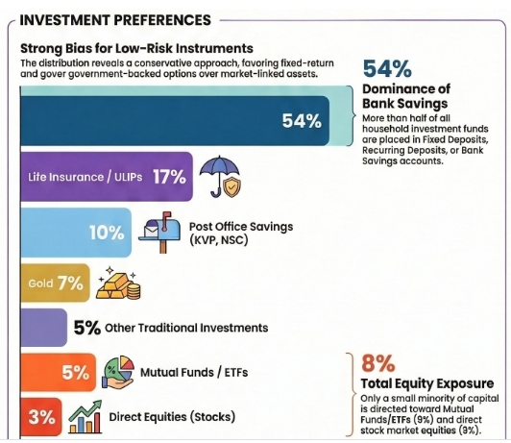
Interpretation:
The investment preferences of Indian households, as highlighted in the survey, clearly indicate a strong inclination toward safety and capital preservation. A majority share—about 54%—is allocated to traditional banking instruments such as fixed deposits, recurring deposits, and savings accounts, which are perceived as secure and stable despite offering relatively lower returns. Insurance-linked products, including life insurance and ULIPs, account for 17%, reflecting a dual preference for protection and modest investment growth. Another 10% is directed toward post office savings schemes like Kisan Vikas Patra (KVP) and National Savings Certificate (NSC), which continue to attract investors due to government backing and guaranteed returns. Gold, a culturally significant asset in India, comprises 7% of investments, serving both as a hedge against inflation and a store of value. Additionally, 5% is invested in other traditional avenues, further reinforcing the conservative nature of household portfolios. In contrast, modern market-linked instruments receive comparatively limited attention, with mutual funds and ETFs accounting for only 5%, and direct equity investments making up just 3%. Overall, the distribution reflects a cautious investment approach, where minimizing risk takes precedence over maximizing returns.

3. Investment Goals
Households prioritize security-driven goals:Investment Goals Table

Investment Goal | Percentage (%)
Children’s Education | 20%
Family Support | 16%
Wealth Creation | 11%
Home Purchase | 11%
Emergency Fund | 9%
Children’s Marriage | 8%
Retirement | 4%

Observation:
The investment goals of households clearly reflect a strong preference for security and family-oriented priorities. The highest allocation, 20%, is directed toward children’s education, indicating that families consider education a crucial investment for future stability and success. This is followed by 16% for family support, showing the importance placed on meeting the needs and well-being of dependents and extended family members. Wealth creation and home purchase, each receiving 11%, highlight a balanced focus on both building financial assets and achieving long-term stability through property ownership. Additionally, 9% is allocated to emergency funds, which demonstrates awareness of the need for financial preparedness in unexpected situations. Children’s marriage accounts for 8%, reflecting cultural and social responsibilities that households plan for in advance. However, only 4% is dedicated to retirement, suggesting that long-term personal financial security after working years is given relatively less importance. Overall, the distribution emphasizes immediate and family-related financial goals over individual long-term planning, indicating a conservative and security-driven investment approach.

4. Awareness of Financial Institutions
Awareness levels vary significantly across institutions:
- 73%: Reserve Bank of India (RBI)
- 24%: Bombay Stock Exchange (BSE)
- 22%: National Stock Exchange (NSE)
- 21%: SEBI
- 13%: Association of Mutual Funds in India (AMFI)
Insight:
The awareness of financial institutions among households shows a clear variation, with the highest recognition for the Reserve Bank of India (RBI) at 73%, indicating that most people are familiar with the country’s central banking authority due to its prominent role in regulating monetary policy and the banking system. In contrast, awareness of market-related institutions is significantly lower, with only 24% aware of the Bombay Stock Exchange (BSE) and 22% aware of the National Stock Exchange (NSE), suggesting limited exposure to stock market operations among the general population. Similarly, just 21% of respondents recognize the Securities and Exchange Board of India (SEBI), which is responsible for regulating and protecting investors in the securities market, indicating a gap in understanding of investor protection mechanisms. The lowest awareness is observed for the Association of Mutual Funds in India (AMFI) at 13%, highlighting limited knowledge about mutual fund-related institutions and investment avenues. Overall, the pattern suggests that while people are well aware of the central banking system, there is comparatively low awareness of financial market institutions, pointing to a need for improved financial literacy and education. Highlights
- Indian households invest less than 10% of their income.
- Traditional instruments dominate investment portfolios (over 80%).
- Equity participation remains minimal (3%), despite potential for higher returns.
- Financial goals are family-centric rather than retirement-focused.
- Awareness is highest for banking institutions but low for market regulators and mutual fund bodies.
- Conclusion
The SEBI Investor Survey 2025 underscores a conservative financial ecosystem in India, where safety and liquidity are prioritized over growth. Despite increasing financial awareness, behavioral inertia and risk aversion continue to limit participation in capital markets.
To bridge this gap, policymakers and institutions must focus on:
- Enhancing financial literacy programs
- Promoting long-term investment culture
- Increasing trust in market-linked instruments
- Encouraging retirement planning
A shift from savings to strategic investing will be essential for improving household wealth creation and strengthening India’s financial ecosystem.
- References
- Securities and Exchange Board of India (2025). SEBI Investor Survey 2025.
- Reserve Bank of India Reports on Household Financial Savings.
- Association of Mutual Funds in India Industry Data and Investor Awareness Reports.
- National Stock Exchange and Bombay Stock Exchange Market Participation Data.

