Evaluating the Transition to Sustainable Waste Management Practices in South Mumbai
Dr. Payal Acharekar* Jaihind College, Department of Botany, Deepak Rana Rizvi College, Department of Botany
*Assistant Professor, Jaihind College, Department of Botany.
A Rd, Churchgate, Mumbai, Maharashtra 400020
+919819972966
payal.acharekar@jaihindcollege.edu.in

ABSTRACT
Urban waste management is a very critical challenge in rapidly expanding Indian cities, especially South Mumbai, making it necessary to have a shift toward integrated sustainable practices due to increasing population density and limited disposal space. This review evaluates localized initiatives within educational institutions, places of worship, and local government as key catalysts of change.
Educational institutions, such as Jai Hind College, Siddharth College, KC College, promote behavioral change through active waste segregation and on-site composting, serving as micro-models of sustainability. Similarly, places of worship like the Atmaram Buwa’s Kalaram Temple integrate spiritual traditions with ecological stewardship by composting floral offerings.
Local government bodies, particularly in D ward, introduce policy-driven innovations like waste-to-manure conversion machines, promoting a circular urban metabolism. These efforts, supported by municipal representatives, reduce landfill burden.
Emerging household-level innovations, such as domestic composting kits and clothing recycling, further decentralize waste management.
Collectively, these multi-scalar examples underscore a significant transition in South Mumbai. The interplay of institutional, cultural, and governmental roles offers a comprehensive framework for how localized, stakeholder-driven initiatives can inform India’s broader urban sustainability agenda, despite challenges like inconsistent monitoring. Addressing these gaps through collaboration is essential for mainstreaming sustainable urban governance. (UN-Habitat, 2018)
Keywords: Sustainable waste management, South Mumbai, Educational institutions, Religious organizations, Municipal governance, Recycling, Composting (Stri Mukti Sanghatana, 2019)

INTRODUCTION
Urbanization has emerged as one of the defining phenomena of twenty-first-century India, bringing with it complex environmental and infrastructural challenges. Among these, the management of urban waste occupies a critical position, directly influencing public health, ecological balance, and the quality of urban life. Rapid population growth, expanding economic activities, and the intensification of consumer culture have collectively strained existing waste management systems, revealing the urgent need for sustainable and inclusive approaches. (UN-Habitat, 2018)
In this context, South Mumbai provides a compelling example for examining the dynamics of urban sustainability. Characterized by high population density, historical neighborhoods, and limited spatial capacity for waste disposal, the region faces acute challenges typical of metropolitan India. Yet, it also exemplifies the potential of localized, collaborative interventions in transforming waste governance. The participation of diverse social actors, educational institutions, religious organizations, and municipal bodies has become increasingly significant in reimagining waste not as refuse, but as a resource within a circular urban metabolism. (UN-Habitat, 2018)
This study examines the evolving landscape of sustainable waste management practices in South Mumbai through a literature-based analysis. By focusing on institutional initiatives, cultural responses, and policy-driven innovations, it seeks to illustrate how community engagement and technological adaptation together contribute to an emerging framework of urban ecological resilience.

BACKGROUND:
Over the years the quantity of waste generated has increased drastically and proper measures need to be taken to combat this problem and reduce the load on the dumpyards. BMC is making tremendous efforts to handle this issue. One of the most important steps taken was to identify the bulk waste generators of each and every locality of an individual ward. As per the new BMC mandate bulk waste generators are supposed to segregate their wet waste from dry waste and dispose of them effectively.
Case Study 1: Simple Innovation in Waste Management in Places of Worship
This case study highlights how a simple, low-cost solution can effectively manage organic waste within a community setting, specifically focusing on the daily floral and leaf offerings at a place of worship. It demonstrates that effective biocomposting does not require expensive, high-tech infrastructure but rather dedication and a clever use of existing materials. (Ms Joshi, Rashmi, 2019)
The Mandir faced a common challenge among places of worship: the disposal of a significant volume of biodegradable waste. The flowers and leaves offered to the deities daily, while sacred and natural, presented a consistent waste stream that required sustainable management. The goal was to transform this waste from a disposal problem into a valuable resource, aligning with principles of environmental stewardship and circularity.
The Innovation: A DIY Biocomposter (Ms Joshi Rashmi, 2019)
The solution implemented by the temples is a prime example of appropriate technology—a design that is simple, manageable, and highly effective for its specific context. The system uses readily available, inexpensive materials:
● A Standard Water Storage Tank: A durable plastic or polyethylene water tank serves as the main composting vessel. This choice is practical due to its availability, durability, and ability to be sealed to manage moisture and odour. (Ms Joshi Rashmi, 2019)
● Organic Matter and Soil Mixture: The primary inputs are the daily organic offerings (flowers and leaves) mixed with local soil. The soil acts as a natural inoculant, providing the essential microorganisms required to kickstart the decomposition process. A microbial culture specially available from IIT, Mumbai can also be added to initiate or hasten the process of decomposition.
The Process: It involved Daily Engagement and contribution
The major highlight of this system is consistency and manual engagement. Basic training for the staff is needed to handle the pit. The process is straightforward:
- Input: Daily organic waste is added to the water tank along with a measured amount of soil.
- Aeration and Mixing: The mixture in the tank was stirred manually every single day. This daily agitation is crucial. It ensures proper aeration, which accelerates the aerobic decomposition process and prevents the material from becoming anaerobic (which produces foul odors).
- Output: Over time, this daily commitment transforms the organic waste into rich, usable compost that can be used for the temple gardens or local agriculture, closing the loop on their waste stream. (Mr Kothare Lalit,, 2019)
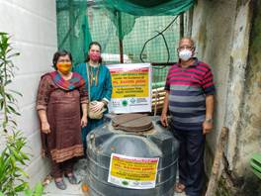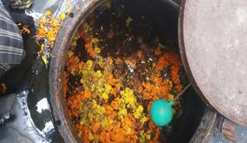
Fig 1.1 and 1.2 showing images of the temple showing biocomposting (Ms Rashmi Joshi, 2019)
Conclusion
The Atmaram Bua's Shree Ram Mandir case study illustrates that sustainable solutions often rely less on capital investment and more on ingenuity and consistent maintenance. By repurposing a simple water tank and committing to a daily stirring routine, the temple established a successful, self-sufficient waste management system that is both environmentally sound and cost-effective.

Case Study 2: Educational Institutions in South Mumbai – A Multi-faceted Approach to Zero Waste
Premier educational institutions in Churchgate, Mumbai, have adopted a comprehensive, institution-wide strategy to achieve a "zero waste" campus status. Unlike standalone projects, the colleges integrate waste management into their core operations and educational philosophy, demonstrating how large urban institutions can mitigate their environmental impact through a combination of policy, infrastructure, and student engagement. (Dr. Nissey Sunil, 2018)
The Challenges faced
Located in the densely populated area of South Mumbai, efficient waste management is a significant logistical and environmental challenge. The colleges generate diverse waste streams, including substantial amounts of paper, plastic, e-waste, and organic waste (from canteens and gardens). The colleges proactively address the objective of minimizing waste sent to landfills, a critical concern in a city grappling with limited dumping ground capacity.
The Process: Segregation at Source and Diversified Recycling
The college's approach is characterized by rigorous segregation at the source and collaboration with specialized external partners for recycling and processing. Their strategy involves managing multiple waste types:
● Dry Waste (Paper, Plastic, Aluminum, Glass): The colleges organize regular waste collection drives across all departments. The waste is generated from various locations, such as the office, exam unit, or individual department project reports. Some teachers are willing to share their waste too as a contribution to the college’s green initiative. This material is systematically collected and sent to designated recycling units in Vapi. Due to a minimum requirement of 5 tonnes of waste to be sent, the waste collected is compacted and temporarily stored at a godown in Sakinaka, Andheri. The minimum weight criterion is to make sure that other expenditure such as transport and labor costs, are also taken care of. This initiative is done in collaboration with Ms. Rashmi Joshi, an environment consultant. The waste is segregated in specially labelled bins placed all over the campus. The success of this program is tangible; the colleges often receive consumables like books, envelopes, letterheads, seed paper diaries, seed pens, etc. in return for the recycled paper, creating a closed-loop economy within the institution. The Green Clubs of the colleges, which have now become a mandate, also organize small workshops such as Waste to Wow, to make beautiful artifacts using waste paper, plastic or pouches. Other such initiative was to donate plants for the purpose of tree plantation.

Table 1 showing the sample data of waste collected and sent for recycling
Sr. No. | Date | Quantity Collected (in Kg)
1 | 13/08/2025 | 1765
2 | 23/04/2025 | 707
3 | 05/03/2025 | 785
4 | 23/12/2024 | 506
5 | 03/10/2024 | 355

Figure: 2.1, 2.2, 2.3, 2.4, 2.4, 2.6 showing dry waste collection at educational institutions
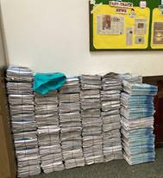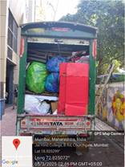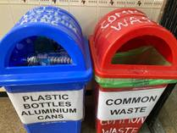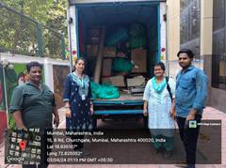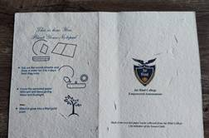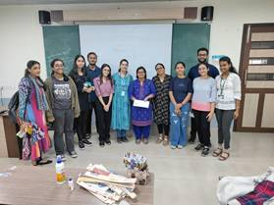
● E-Waste: Recognizing the specific hazards of electronic waste, the colleges organize dedicated e-waste drives, often in collaboration with other local schools and colleges. These campaigns raise awareness and ensure proper disposal, with collected e-waste handed over to certified recycling companies. Ms. Rashmi Joshi makes a thankless contribution to this initiative.
● Organic/Wet Waste: The composting infrastructure consists of 2 major things: the composting pit, which is placed outside the canteen or any such suitable area. The college actively promotes converting kitchen and garden waste into manure. This endeavor was initiated by Stri Mukti Sanghatana, an NGO that promotes eco-friendly activities. The colleges also have small-scale laboratory-level bokashi composting and vermicomposting meant for discarding laboratory organic waste. Seminars and workshops are held to educate students and staff on simple composting methods, aiming to utilize organic waste on-site for campus gardening needs. (Stri Mukti Sanghatana, 2019)
Fig 3.1, 3.2, 3.3 Showing biocomputing of wet waste in educational institutions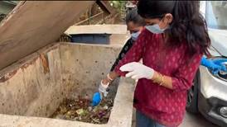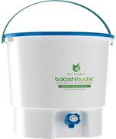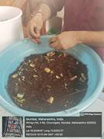 (Stri Mukti Sanghatana, 2019)
Outcomes
The initiative is driven by both administrative policy (via the IQAC and various committees) and enthusiastic student body engagement, notably through the National Service Scheme (NSS) unit and various clubs.
● Awareness and Education: A core component of the college’s success is its focus on sensitizing students and staff to the importance of waste recycling and sustainable practices through workshops, lectures, and community clean-up drives (e.g., beach cleanups).
● Empowered Autonomy: The college's autonomous status allows it to integrate contemporary environmental challenges into its curriculum and project-based learning, fostering critical thinking and innovative solutions among students.
Conclusion
This case study illustrates a successful institutional model for waste management that moves beyond a single technology solution. By combining consistent source segregation, external partnerships for specialized recycling, and a strong emphasis on education and awareness, the college is proactively working towards its goal of becoming a zero-waste campus, proving that a holistic approach can yield significant environmental results in a challenging urban environment.

Case Study 3: Solid Waste Management in D Ward, Mumbai – A Model for Decentralized Urban Solutions (Gupta et al., 2015)
D Ward in Mumbai, encompassing areas such as Malabar Hill, Tardeo, and Mahalaxmi, presents a fascinating case study of urban solid waste management initiatives that combine municipal efforts with mandatory public participation and innovative technology. The ward's approach highlights the potential for localized solutions to a city-wide challenge, moving beyond traditional landfill disposal methods. (Gupta et al., 2015)
The Context: A Diverse Urban Landscape
D Ward is a mix of high-density residential areas, commercial zones, and major institutions, generating a substantial volume of mixed municipal solid waste daily. Like many parts of Mumbai, the ward faces the constant challenge of minimizing the burden on the city's overflowing landfills (Deonar and Kanjurmarg) and complying with national Solid Waste Management Rules, 2016, which mandate source segregation and local processing. (Gupta et al., 2015)
The Innovation: The Bio-Energy Plant and Public-Private Partnerships (Ministry of Housing affairs, Nov, 2017)
A standout initiative in D Ward is a modular bio-energy plant that converts significant amounts of wet waste into clean energy. Bulk waste generators of the ward are identified and asked to recycle or compost their own waste efficiently. At the same time, compactors are placed at strategic positions to minimize the use of space before sending the waste to respective units (Ministry of Housing affairs, Nov, 2017)

Table 2: Showing Bulk generators identified in D ward by the BMC
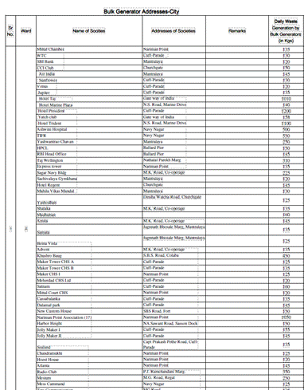
● Wet Waste to E-Vehicles: This plant processes vegetable peels and food waste collected from approximately 30 local eateries in South Mumbai. The generated bio-gas is used to charge e-vehicles, creating a localized, circular economy that reduces reliance on fossil fuels and cuts down on transportation costs and emissions. (Times of India, June 2022)
● Decentralized Dry Waste Centers: Complementing this, D Ward established a public-private initiative for managing dry plastic waste. Waste workers bring in segregated dry plastic waste to dedicated centers where it is sorted, shredded, and sent for upcycling into usable products like buckets and sportswear. (DNA, Oct, 2017)

The Process: Enforcement, Incentives, and Awareness
The success of D Ward's SWM model is heavily reliant on a multi-pronged approach implemented by the Brihanmumbai Municipal Corporation (BMC):
● Source Segregation Mandate: The BMC made waste segregation compulsory for bulk generators (societies over 20,000 sq. feet or generating over 100 kg of waste daily). D Ward proactively pushed this, even launching a pilot project in specific localities (Napeansea Road, Bhulabhai Desai Road) to achieve 100% source segregation.
● Incentives and Penalties: To boost participation, the BMC offered property tax rebates for societies that successfully implemented on-site composting units. Conversely, penalties were instituted for those failing to segregate their waste according to municipal rules.
● Community Engagement: Extensive awareness campaigns, including street plays and rallies, were organized to educate residents and encourage active participation in waste management efforts.
Conclusion
The D Ward case study exemplifies how an administrative ward, through a combination of stringent enforcement, financial incentives, community awareness, and innovative decentralized processing units (like the bio-energy plant), can make significant strides toward a zero-waste future. It underscores that localized waste treatment is a viable and effective strategy for large urban environments to reduce landfill dependency and create value from waste. (UN-Habitat, 2018)
OVERALL CONCLUSION:
Based on all three case studies, Solid waste management is a big necessity of the current times, as the quantity of waste generated is far more than manageable. At the same time, it is observed that various organizations, whether public or private, are taking necessary steps for the appropriate segregation, recycling, and waste disposal of the solid waste generated by themselves or by the community on the whole. (Gupta et al., 2015)

ACKNOWLEDGEMENT:
I would like to express my heartfelt gratitude to my guide Dr. Ambika Joshi, without whose guidance, things would not have been possible. The Principal and staff of Jai Hind College (Empowered, Autonomous) for always supporting my green initiatives. Ms. Rashmi Joshi, who helps with the solid waste management at various locations.

REFERENCES
1. Almeida, S., & Chiplunkar, A. (2016). Improving solid waste management in Indian cities. Asian Development Bank. (Gupta et al., 2015)
2. Brihanmumbai Municipal Corporation (BMC). (2016). Solid Waste Management User Manual. Municipal Corporation of Greater Mumbai. (Gupta et al., 2015)
3. Brihanmumbai Municipal Corporation (BMC). (2022). Annual Environment Status Report (AESR). Municipal Corporation of Greater Mumbai.
4. Centre for Science and Environment (CSE). (2020). Managing solid waste in India: State of India’s environment report. (Gupta et al., 2015)
5. Government of India. (2016). Solid Waste Management Rules, 2016. Ministry of Environment, Forest and Climate Change. (Gupta et al., 2015)
6. Gupta, N., Yadav, K. K., & Kumar, V. (2015). A review of municipal solid waste management in India. International Journal of Environmental Sciences, 6(1), 10–27. (Gupta et al., 2015)
7. Hemming, D., et al. (2021). Urban sustainability and waste reduction strategies in developing countries. United Nations Environment Programme. (UN-Habitat, 2018)
8. Konark Group. (2019). Biogas and decentralized waste processing technologies: A practical guide.
9. National Green Tribunal (NGT). (2019). Orders on municipal solid waste compliance in metropolitan cities. (Gupta et al., 2015)
10. NSS India. (2022). Environmental initiatives and community participation module. Ministry of Youth Affairs & Sports.
11. Planning Department, Government of Maharashtra. (2021). Mumbai’s environmental infrastructure: Current status and challenges.
12. Stri Mukti Sanghatana. (2019). Community composting and women-led waste initiatives in Mumbai. (Stri Mukti Sanghatana, 2019)
13. United Nations Habitat (UN-Habitat). (2018). Managing urban waste: A global report on solid waste practices. (Gupta et al., 2015)
14. World Bank. (2018). What a Waste 2.0: A global snapshot of solid waste management to 2050. (Gupta et al., 2015)

