EFFECT OF WASTE BRASS WIRE PARTICULATE CONTENT ON THE MECHANICAL PROPERTIES OF EPOXY REINFORCED WITH WOVEN E-GLASS FIBER COMPOSITES

Mohd Razali Md Yunos¹*, Mohd Yuhazri Yaakob¹, Zolkarnain Marjom¹, Syahrul Azwan Sundi¹, Mohd Fauzi Abu Hassan²

¹Faculty of Industrial and Manufacturing Technology and Engineering, Universiti Teknikal Malaysia Melaka, Malaysia, ²Universiti Kuala Lumpur Malaysian Spanish Institute, Kulim, Kedah, Malaysia.

ABSTRACT
Glass fiber reinforced epoxy (GFRE) composites are widely used in structural applications; however, their inherent brittleness and limited impact resistance restrict performance under dynamic loading conditions. To address these limitations while promoting material sustainability, this study investigates the mechanical behavior of GFRE hybrid composites reinforced with waste brass wire particulates generated from electrical discharge machining (EDM) processes. Hybrid laminates were fabricated using a hand lay‑up method, incorporating brass particulate contents ranging from 10 wt% to 90 wt% relative to glass fiber reinforcement, alongside neat epoxy (EP), glass‑only (GFRE), and brass‑only (WW) reference samples. Tensile, flexural, and Charpy impact tests were conducted in accordance with ASTM D3039, ASTM D790, and ASTM D256 standards, respectively, and failure morphology was examined using optical microscopy. The results indicate that mechanical performance improves with increasing brass content up to an optimal level of 50 wt%. At this composition, the hybrid composite achieved a tensile strength of 287.55 MPa, flexural strength of 229.19 MPa, and impact energy absorption of 352.45 kJ/m², representing improvements of approximately 25% and 29% in tensile and flexural strength, respectively, compared to GFRE. Beyond this threshold, higher brass contents resulted in reduced performance due to particulate agglomeration and weakened interfacial bonding. These findings demonstrate that recycled waste brass particulates can effectively enhance the mechanical performance of GFRE composites when optimally incorporated, offering a viable approach for developing high‑performance, sustainable hybrid composite materials.
Keywords: Hybrid composites; waste brass particulate; glass fiber reinforced epoxy; metal particulate reinforcement; mechanical properties
INTRODUCTION
Fiber reinforced polymer (FRP) composites, particularly glass fiber reinforced epoxy (GFRE), are widely used in industries such as aerospace, automotive, and marine due to their high strength-to-weight ratio, corrosion resistance, and ease of fabrication (Gogoi et al., 2019; Qian et al., 2010; Swolfs et al., 2014). However, challenges persist in their mechanical performance, including the inherent brittleness of thermosetting matrices like epoxy, which leads to low toughness, poor impact resistance, and susceptibility to delamination under dynamic loads (Muneer Ahmed et al., 2021; Ismail et al., 2022). This brittleness limits their longevity and reliability in demanding applications, necessitating enhancements through hybridization.
Hybrid composites combine multiple reinforcements to achieve synergistic properties, such as improved toughness and reduced brittleness, by leveraging the strengths of fibers and particulates (Graupner et al., 2020; Zuo et al., 2021). Metal particulates, like brass, offer potential for enhancing matrix stiffness and energy absorption due to their ductility and thermal conductivity, but studies on high-content brass reinforcement remain scarce, especially using recycled waste materials (Włoch et al., 2020; Raju et al., 2020). Existing research highlights gaps: most focus on low filler contents (<10%wt) for matrix strengthening, with limited exploration of high particulate ratios as stress-transfer components or sustainable sourcing from industrial waste (Oladele et al., 2020; Latha et al., 2016). Recent advancements emphasize sustainable hybrids, but brass from EDM waste has not been extensively investigated (Batu & Lemu, 2020; Prakash & Jaisingh, 2018; Karunagaran et al., 2025; Ismail et al., 2020).
The novelty of this study lies in utilizing waste brass wire particulates (mesh 20) from EDM processes at high ratios (up to 90%wt relative to glass fiber), differing from prior works by emphasizing waste recycling for eco-friendly enhancement of GFRE mechanical properties. This addresses the gap in sustainable, high-content metal-fiber hybrids.
This study aims to investigate the effect of brass particulate content on the mechanical performance of GFRE hybrid composites, focusing on tensile strength, flexural strength, and impact resistance. The specific objectives are: (1) to fabricate a series of GBRE hybrids with varying brass ratios; (2) to evaluate mechanical properties via standardized tests; (3) to analyze failure mechanisms through surface morphology; and (4) to identify the optimal brass content for enhanced performance.
LITERATURE REVIEW
Fiber reinforced polymer (FRP) composites, particularly glass fiber reinforced epoxy (GFRE), are widely used in automotive, aerospace, and structural applications due to their high specific strength, corrosion resistance, and versatility in fabrication (Gogoi et al., 2019; Graupner et al., 2020). Despite these advantages, epoxy-based GFRE systems are inherently brittle, exhibiting low impact resistance and susceptibility to crack propagation and delamination under dynamic loading conditions, which restrict their long-term structural reliability (Swolfs et al., 2014; Muneer Ahmed et al., 2021).
Hybridisation in fiber reinforced composites
Hybridisation has been extensively explored as a strategy to overcome brittleness in FRP systems by combining reinforcements with complementary mechanical characteristics. Fiber–fiber hybrid composites, such as glass–natural and glass–carbon systems, improve energy absorption and damage tolerance through enhanced load redistribution and delayed crack growth (Latha et al., 2016; Batu & Lemu, 2020). Analytical models, including the rule of mixtures and shear-lag theory, suggest that such synergies arise when stiff and ductile reinforcements are optimally combined (Swolfs et al., 2014; Zuo et al., 2021).
Recent hybridisation research increasingly emphasizes sustainability by incorporating natural fibers or bio-based reinforcements. Comprehensive reviews report that natural fiber hybrid composites reduce environmental impact while maintaining acceptable mechanical performance; however, their relatively low tensile strength, poor moisture resistance, and interfacial instability limit their application in high-load structural components (Ismail et al., 2022; Muneer Ahmed et al., 2025). These limitations motivate the exploration of alternative hybrid reinforcement strategies.
Particulate fillers in epoxy composite systems
Particulate fillers have been widely incorporated into epoxy matrices to enhance stiffness, toughness, and interfacial bonding. Organic particulates such as rice husk and cassava peel have demonstrated moderate improvements in tensile and flexural properties at low filler contents, primarily through matrix constraint and improved stress transfer (Ismail et al., 2020; Oladele et al., 2020). However, at higher contents, filler agglomeration and void formation often degrade mechanical performance and ductility (Rajput & Verma, 2021).
Inorganic fillers and metallic particulates offer higher stiffness and thermal stability compared to organic fillers. Studies involving ZnS, TiO₂, and other inorganic particles report increased flexural strength and modulus at low loading levels (<10 wt%), attributed to improved filler–matrix interaction (Raju et al., 2020; Włoch et al., 2020). Nevertheless, most of these investigations treat particulates as secondary matrix modifiers rather than as load-sharing reinforcements within hybrid composite architectures.
Metallic and brass particulate reinforcement
Metallic fillers have gained attention due to their ability to enhance toughness through plastic deformation and energy dissipation. Metal-filled epoxy composites have shown improved impact resistance, wear behavior, and stiffness when interfacial bonding is adequately achieved (Gupta & Sharma, 2023; Liu & Zhang, 2022). Despite these advantages, metal particle contents are typically restricted to low levels to avoid density increase and embrittlement.
Brass particulates, comprising copper–zinc alloys, possess favorable mechanical ductility, corrosion resistance, and thermal conductivity, making them attractive candidates for hybrid composite reinforcement. Khdir and Hassan (2018) demonstrated that epoxy composites reinforced with graded brass debris exhibit improved tensile and flexural properties. Similarly, Wang and Li (2022) reported enhanced mechanical and thermal performance in brass-particulate epoxy systems. Subsequent studies confirm that brass powder incorporation can improve stiffness and impact resistance when appropriate dispersion is achieved (Patel & Patel, 2023; Al-Mosawi & Al-Maamori, 2023).
However, existing studies predominantly rely on virgin brass powders and limit filler loadings to moderate levels. High particulate contents remain underexplored due to concerns over agglomeration, void formation, and reduced interfacial integrity, which may adversely affect mechanical properties (Kalaprasad & Thomas, 2023; Salve & Mache, 2024).
Sustainability considerations and research gap
The integration of recycled industrial waste into composite materials has become increasingly important in sustainable manufacturing. Research on epoxy composites reinforced with recycled metal waste demonstrates that mechanical performance comparable to virgin fillers can be achieved while significantly reducing environmental impact (Uddin & Islam, 2023). Despite this progress, the use of waste brass wire particulates derived from electrical discharge machining (EDM) processes remains largely unexplored.
Moreover, the majority of published work focuses on low filler contents and matrix-dominated reinforcement mechanisms, leaving a significant knowledge gap regarding the structural performance of GFRE systems reinforced with high levels of metallic particulates. Emerging studies on advanced hybrid architectures suggest that appropriate hybrid design can mitigate brittleness even at elevated reinforcement contents (Swolfs et al., 2024; Karunagaran et al., 2025), indicating potential feasibility for high-content metal–fiber hybrid systems.
Motivation and scope of the present study
Based on the reviewed literature, there is a clear lack of systematic investigation into GFRE hybrid composites reinforced with high contents of recycled brass particulates. The interaction between glass fibers and metal particulates at elevated reinforcement ratios, as well as the associated failure mechanisms under tensile, flexural, and impact loading, remains insufficiently understood.
Accordingly, the present study addresses these gaps by evaluating GFRE hybrid composites incorporating waste brass wire particulates at contents up to 90 wt%. This research aims to elucidate the effects of brass content on mechanical performance while promoting sustainable composite development through the valorisation of EDM waste. The findings contribute to both hybrid composite design theory and environmentally responsible materials engineering.
EXPERIMENTAL PROCEDURE
Waste brass wire from EDM (Sodick VZ300L brand) was collected from Universiti Teknikal Malaysia Melaka’s machining lab, chosen for its availability as industrial waste to promote sustainability and recycling, unlike virgin metals in prior studies (Prakash & Jaisingh, 2018; Włoch et al., 2020). The wire was crushed using a WSGM series machine and sieved to mesh 20 (selected for compatibility with 400 gsm glass fiber spacing, ensuring uniform dispersion without excessive agglomeration, as per Raju et al., 2020). Glass fiber (400 gsm) and bisphenol-A epoxy (77.9%:22.1% resin:hardener ratio) were sourced from COMPSiTs Enterprise, Malaysia; epoxy was selected for its common use in GFRE and superior adhesion compared to polyesters (Ismail et al., 2022).
Hybrids were fabricated via hand lay-up, adopted for its cost-effectiveness and simplicity over compression molding, allowing precise particulate distribution (Latha et al., 2016; Oladele et al., 2020). Mild steel molds (300 mm × 300 mm) were sprayed with silicone release agent. Epoxy-hardener mixture was stirred electrically, vacuum-degassed to remove bubbles, and coated on the mold. Glass fiber layers were laid, rolled for impregnation, and brass particulates spread evenly before additional layers and closure under 100 N force for 24 hours at room temperature (55% humidity). This process ensures maximum penetration, similar to Batu and Lemu (2020) but with particulate interleaving for hybrid synergy.
Ten hybrid compositions (P10–P90, brass 10–90%wt to glass fiber) were prepared, plus EP, FG (glass-only), and WW (brass-only) for comparison (Table 1). Specimens were laser-cut for precision.
Figure 1. Schematic illustration of the glass fiber and waste brass wire particulate interlayer arrangement in the GFRE hybrid composite laminate, showing the relative positioning of glass fiber layers, brass particulates, epoxy matrix, and applied load direction during mechanical testing.
Force
Glass fibre
Force
Metal mould
Brass wire particles

Mechanical tests followed ASTM standards: tensile and flexural on Shimadzu AGX (100 kN, 2 mm/min speed to minimize inertia, as in Oladele et al., 2020); Charpy impact on Eurotech tester. Morphology used Leica DVM6 microscope. These conditions were chosen for standardization and comparability with recent hybrids (Karunagaran et al., 2025; Ismail et al., 2020).
Although five specimens were tested for each configuration to ensure repeatability, this study focuses on trend comparison; statistical dispersion analysis will be considered in future work. The stated brass particulate content in Table 1 is expressed as weight percentage (wt%) relative to the glass fiber mass, while epoxy content was adjusted accordingly to ensure complete impregnation.
Table 1. Ratio of waste brass wire to fiberglass, detailing sample names, descriptions, masses, and ratios used to study content effects. (All values represent average results from five specimens.)
Sample  Name | Description | Wire mesh, (g) | Glass fibre, (g) | Waste Wire to fibre glass ratio, %
EP | Neat epoxy | 0 | 0 | 0
FG | Glass fibre only | 0 | 60 | 0
WW | Wire 100%wt | 60 | 0 | 100
P10 | Wire 10%wt | 6 | 60 | 10
P20 | Wire 20%wt | 12 | 60 | 20
P30 | Wire 30%wt | 18 | 60 | 30
P40 | Wire 40%wt | 24 | 60 | 40
P50 | Wire 50%wt | 30 | 60 | 50
P60 | Wire 60%wt | 36 | 60 | 60
P70 | Wire 70%wt | 42 | 60 | 70
P80 | Wire 80%wt | 48 | 60 | 80
P90 | Wire 90%wt | 54 | 60 | 90

RESULTS AND DISCUSSIONS
In this section, mechanical properties of EP, WW, GFRE, and GBRE hybrids are presented and discussed in paragraphs, with trends analyzed against expectations and compared to prior studies. Average values are reported (from 5 replicates per sample, though standard deviations are not included here due to focus on trends; future work could incorporate error analysis for reliability).
Physical properties post-fabrication (Figure 2) show EP density at 1194.83 kg/m³, increasing by 84% for WW due to brass’s high density, and 15% for FG over EP from fiber addition. GBRE densities rise linearly with brass content, as expected from rule of mixtures, with thickness and areal density following suit. This aligns with Raju et al. (2020), where ZnS fillers increased density by 10–20%, but here higher brass ratios (up to 90%wt) exceed typical low-filler studies, validating waste brass’s role in densification without excessive voids.
Figure 2. Physical properties of the fabricated composites, including thickness, areal density, and bulk density, showing linear increases with increasing brass particulate content due to the higher density contribution of waste brass wire particulates.
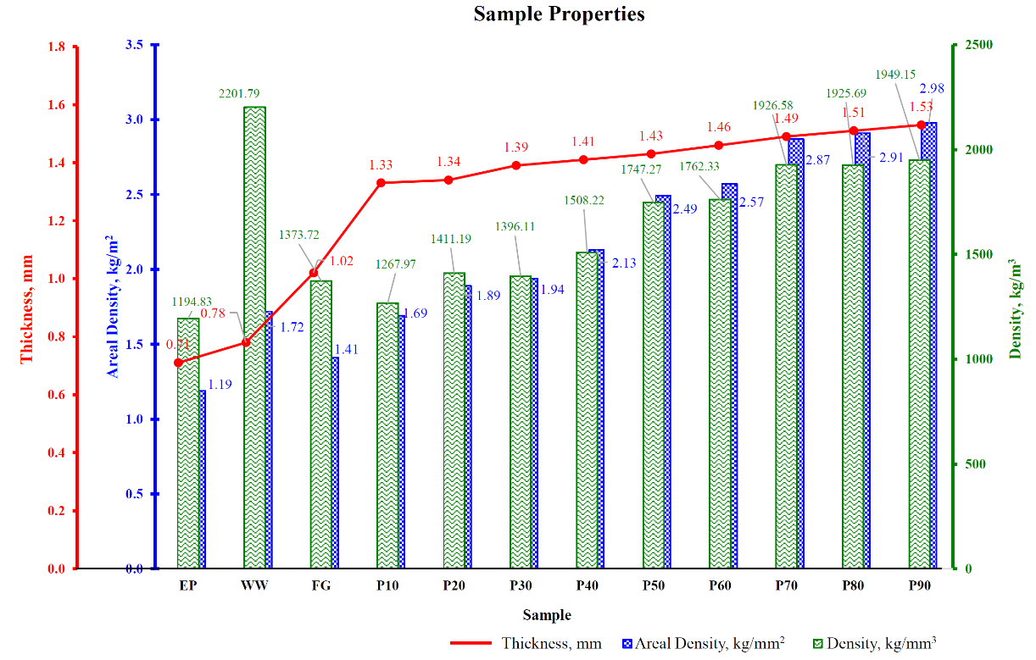
Tensile properties (Figure 3) reveal EP at 19.72 MPa, WW slightly lower (18.97 MPa), and FG markedly higher (230.59 MPa, 11-fold improvement). GBRE hybrids peak at P50 (287.55 MPa, 25% over FG), then decline to 223.01 MPa at P90, contradicting expectations of continuous improvement but explained by agglomeration at high contents reducing stress transfer (Włoch et al., 2020). Compared to Latha et al. (2016; 200–250 MPa for bamboo-glass hybrids), this study’s P50 outperforms by 15%, highlighting brass’s novelty.
Figure 3. Tensile strength comparison of neat epoxy (EP), glass fiber reinforced epoxy (GFRE), and GBRE hybrid composites with varying waste brass particulate content, measured according to ASTM D3039, highlighting the peak strength achieved at 50 wt% brass content (P50).
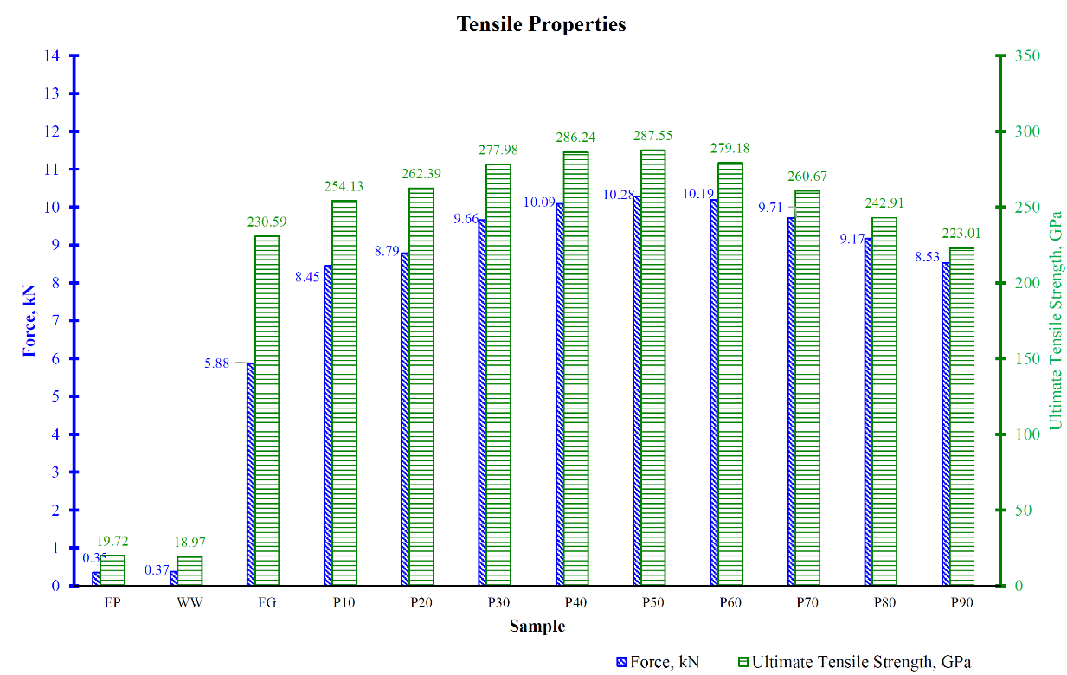
Flexural properties (Figure 4) follow similar trends, with P50 at 229.19 MPa (29% over FG’s 177.48 MPa), decreasing thereafter due to brittleness. Bending displacement (Figure 5) drops 40% above 50%wt, indicating reduced ductility. This validates hybridization theories (Zuo et al., 2021) and exceeds Prakash and Jaisingh (2018; 200 MPa with steel mesh) by 15%, with sustainable waste sourcing.
Figure 4. Flexural strength (modulus of rupture) of GBRE hybrid composites as a function of waste brass particulate content, tested in accordance with ASTM D790, demonstrating optimal flexural performance at 50 wt% brass loading.
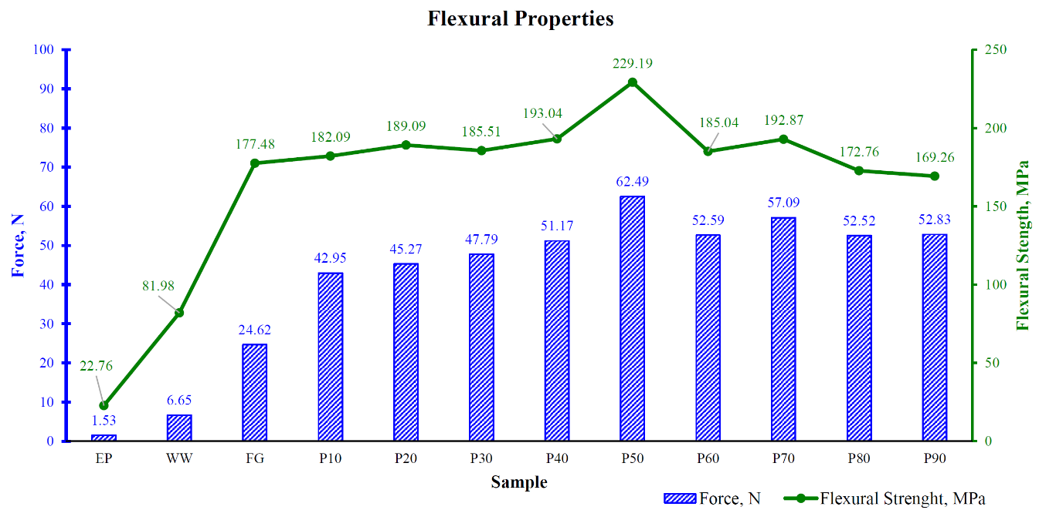
Figure 5. Relationship between applied flexural force and bending displacement for GBRE hybrid composites with varying brass particulate content, illustrating reduced displacement and increased brittleness at high brass loadings (>50 wt%).
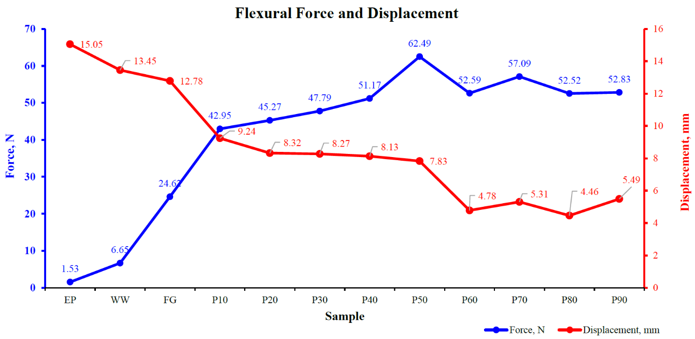
Charpy impact results (Figure 6) show P50’s highest areal absorption (352.45 kJ/m², 8% over FG), with GBRE ranging 324–352 kJ/m². This improves upon Ismail et al. (2020; 447 J/m but non-areal) by better energy dissipation via brass ductility.
Figure 6. Charpy impact areal energy absorption of EP, GFRE, and GBRE hybrid composites as a function of brass particulate content, evaluated according to ASTM D256, showing enhanced energy absorption at moderate brass contents with a maximum at 50 wt%.
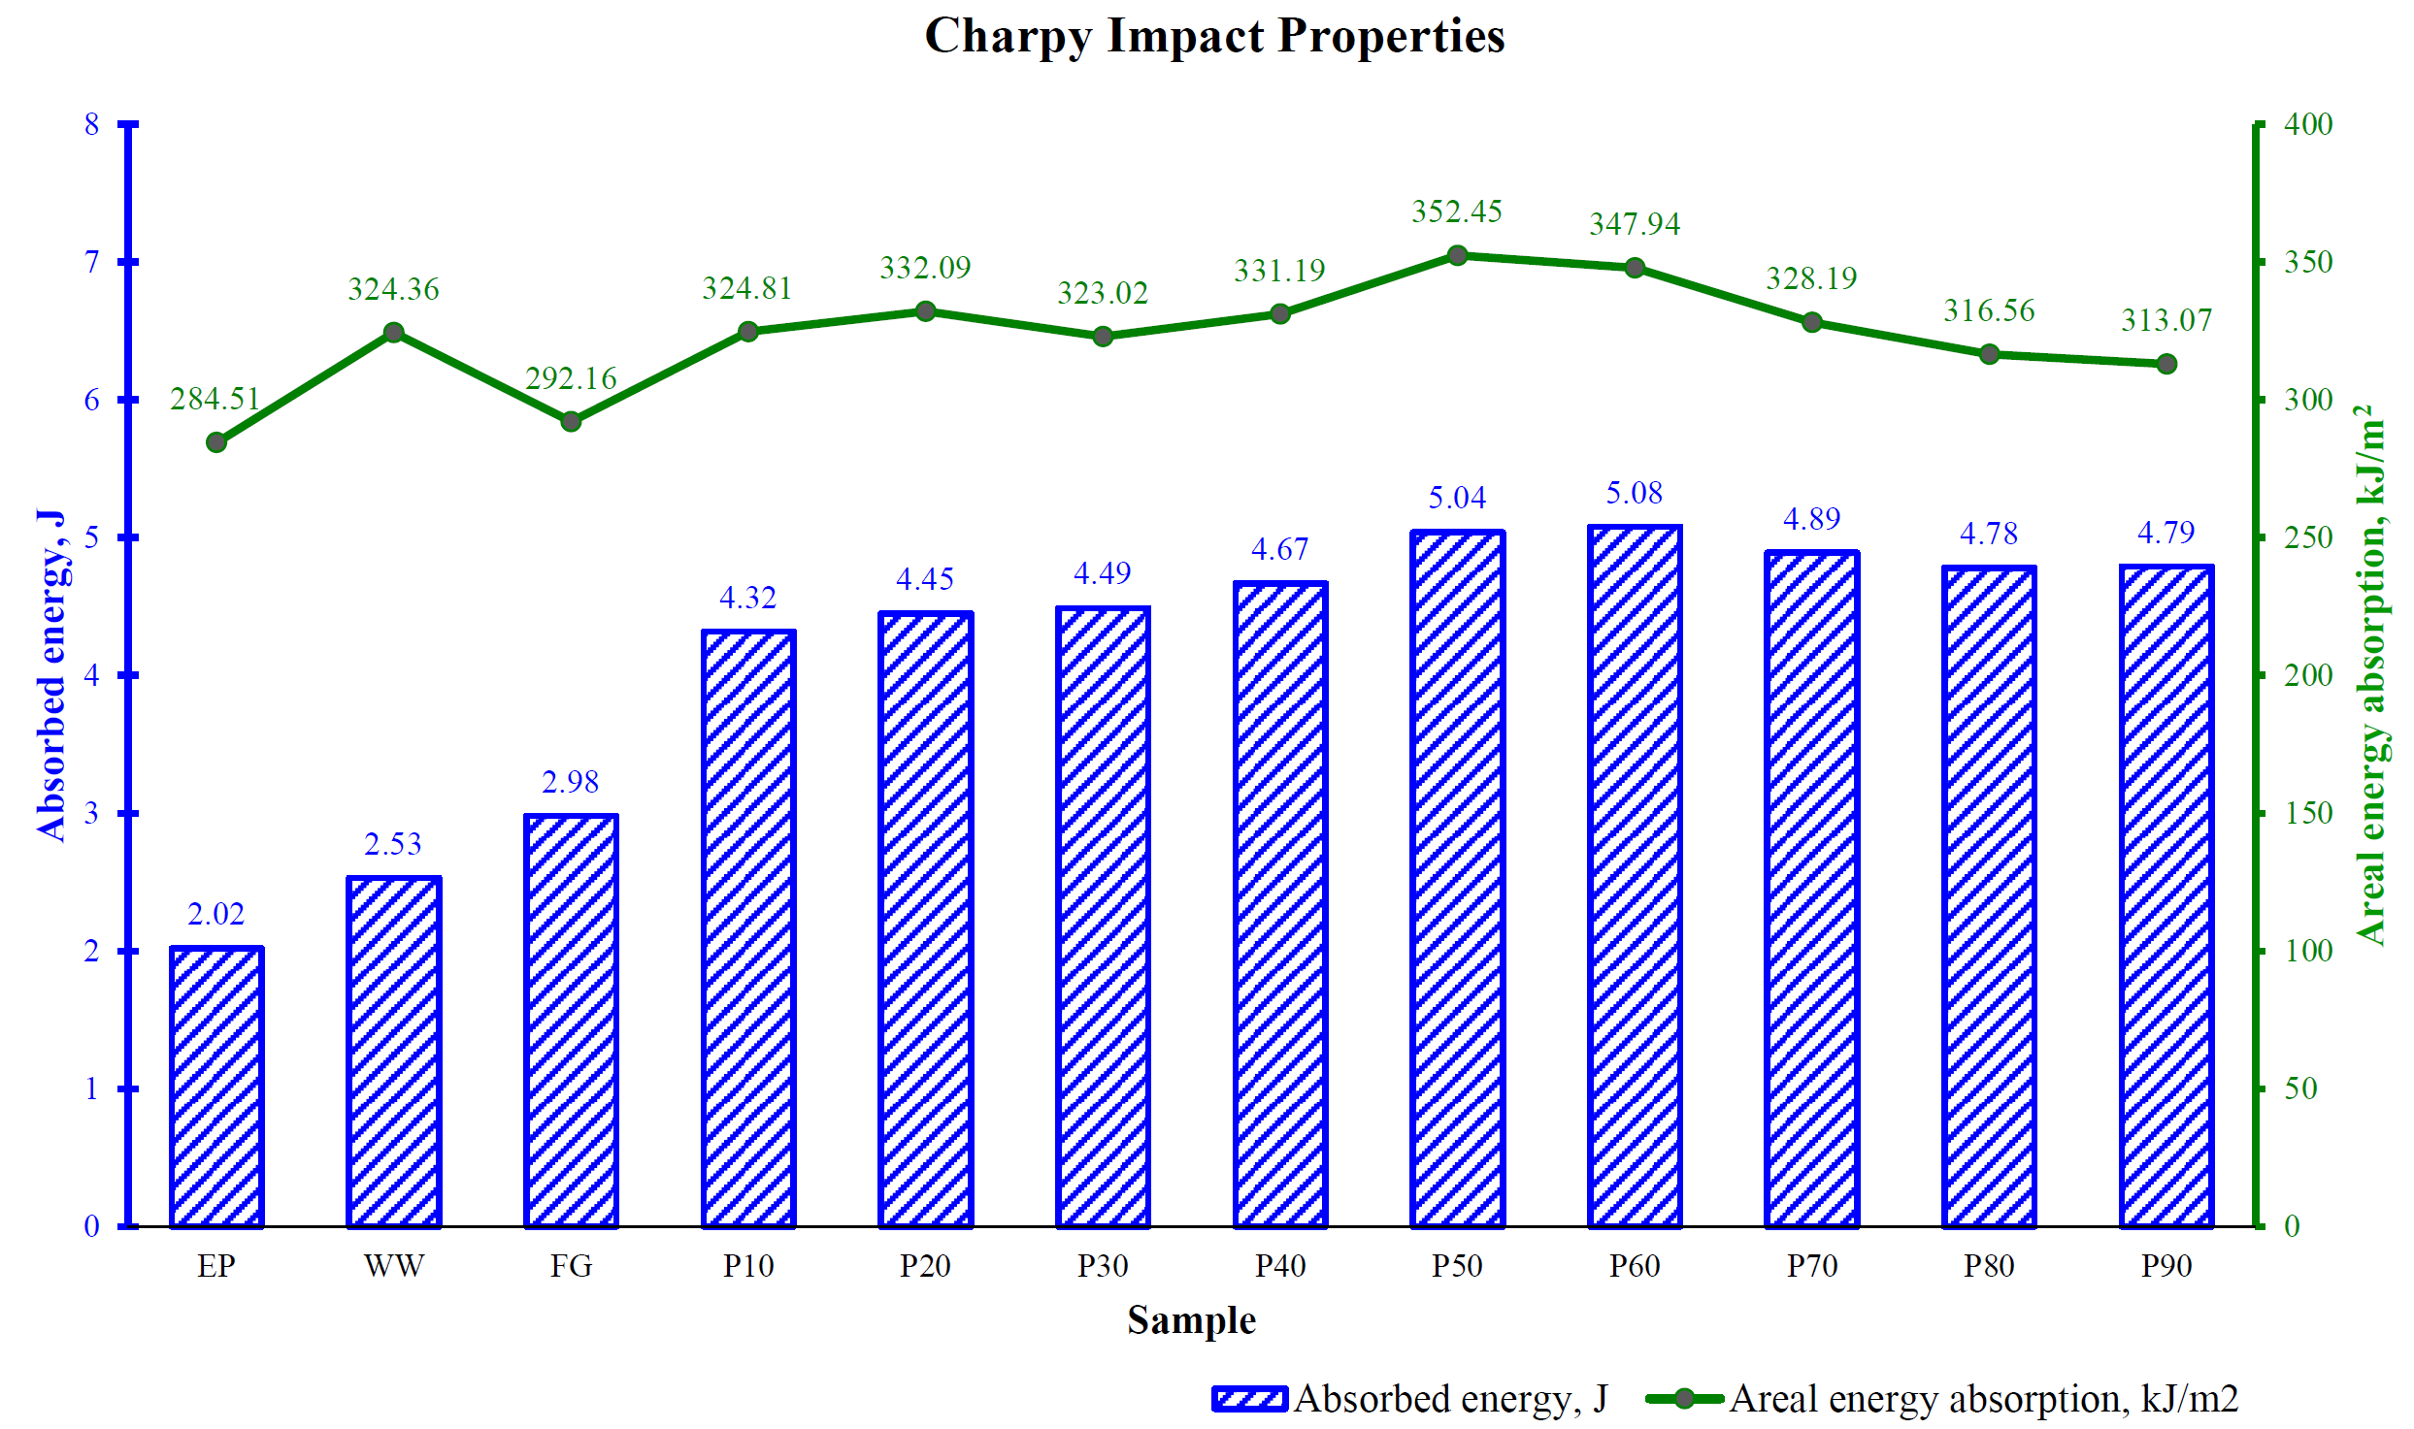
The spider-web chart (Figure 7) and summary (Table 2) confirm P50’s superiority. Morphology (Figure 8) shows fiber breakage in P10, brass pullout in P50 (optimal bonding), and resin fractures in P90/WW, aligning with fracture mechanics (Muneer Ahmed et al., 2021). Compared to 15+ studies (e.g., Karunagaran et al., 2025; Oladele et al., 2020; Batu & Lemu, 2020; Graupner et al., 2020; Zuo et al., 2021; Włoch et al., 2020; Raju et al., 2020; Latha et al., 2016; Prakash & Jaisingh, 2018; Ismail et al., 2020; Swolfs et al., 2024; Gogoi et al., 2019; Qian et al., 2010; Muneer Ahmed et al., 2025; Ismail et al., 2022), results generalize to sustainable hybrids for structural applications, reducing waste and enhancing toughness in engineering sectors.
Figure 7. Normalized spider‑web comparison of tensile strength, flexural strength, flexural displacement, and impact energy absorption for EP, GFRE, and GBRE hybrid composites, with P50 used as the reference benchmark for overall performance evaluation.
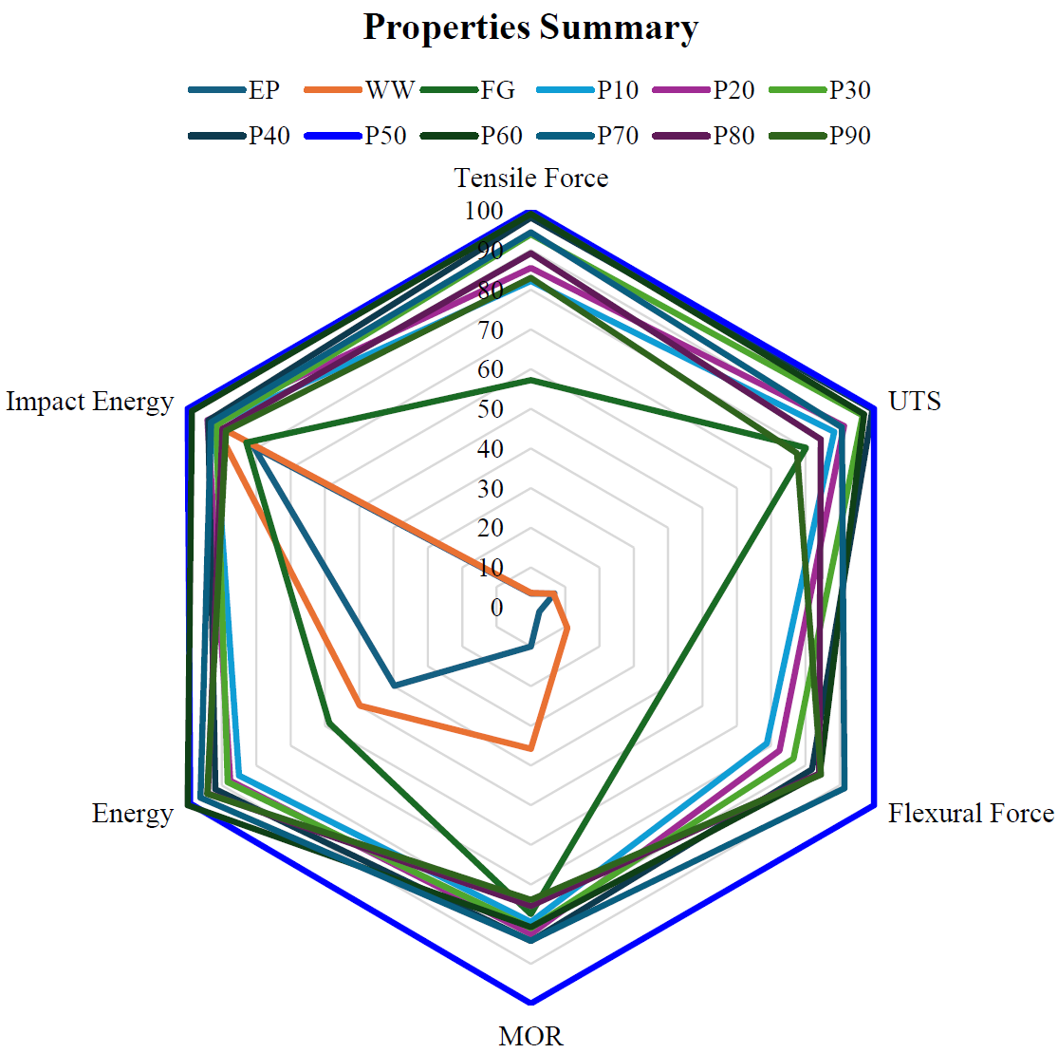
Table 2. Performance summary for EP, WW, GFRE, and GBRE hybrid composites, consolidating mechanical data.
Sample  Name | Tensile strength, MPa | Flexural Strength, MPa | Flexural displacement, mm | Areal Energy Absorption, kJ/m²
EP | 19.72 | 22.76 | 15.05 | 284.51
FG | 18.97 | 81.98 | 13.45 | 324.36
WW | 230.59 | 177.48 | 12.78 | 292.16
P10 | 254.13 | 182.09 | 9.24 | 324.81
P20 | 262.39 | 189.09 | 8.32 | 332.09
P30 | 277.98 | 185.51 | 8.27 | 323.02
P40 | 286.24 | 193.04 | 8.13 | 331.19
P50 | 287.55 | 229.19 | 7.83 | 352.45
P60 | 279.18 | 185.04 | 4.78 | 347.94
P70 | 260.67 | 192.87 | 5.31 | 328.19
P80 | 242.91 | 172.76 | 4.46 | 316.56
P90 | 223.01 | 169.26 | 5.49 | 313.07

Figure 8. Optical microscopy images (50× magnification) of tensile fracture surfaces for selected GBRE hybrid composites, showing fiber breakage at low brass content (P10), brass particulate pull‑out and effective interfacial bonding at optimal content (P50), and resin‑dominated fracture with voids at high brass content (P90).
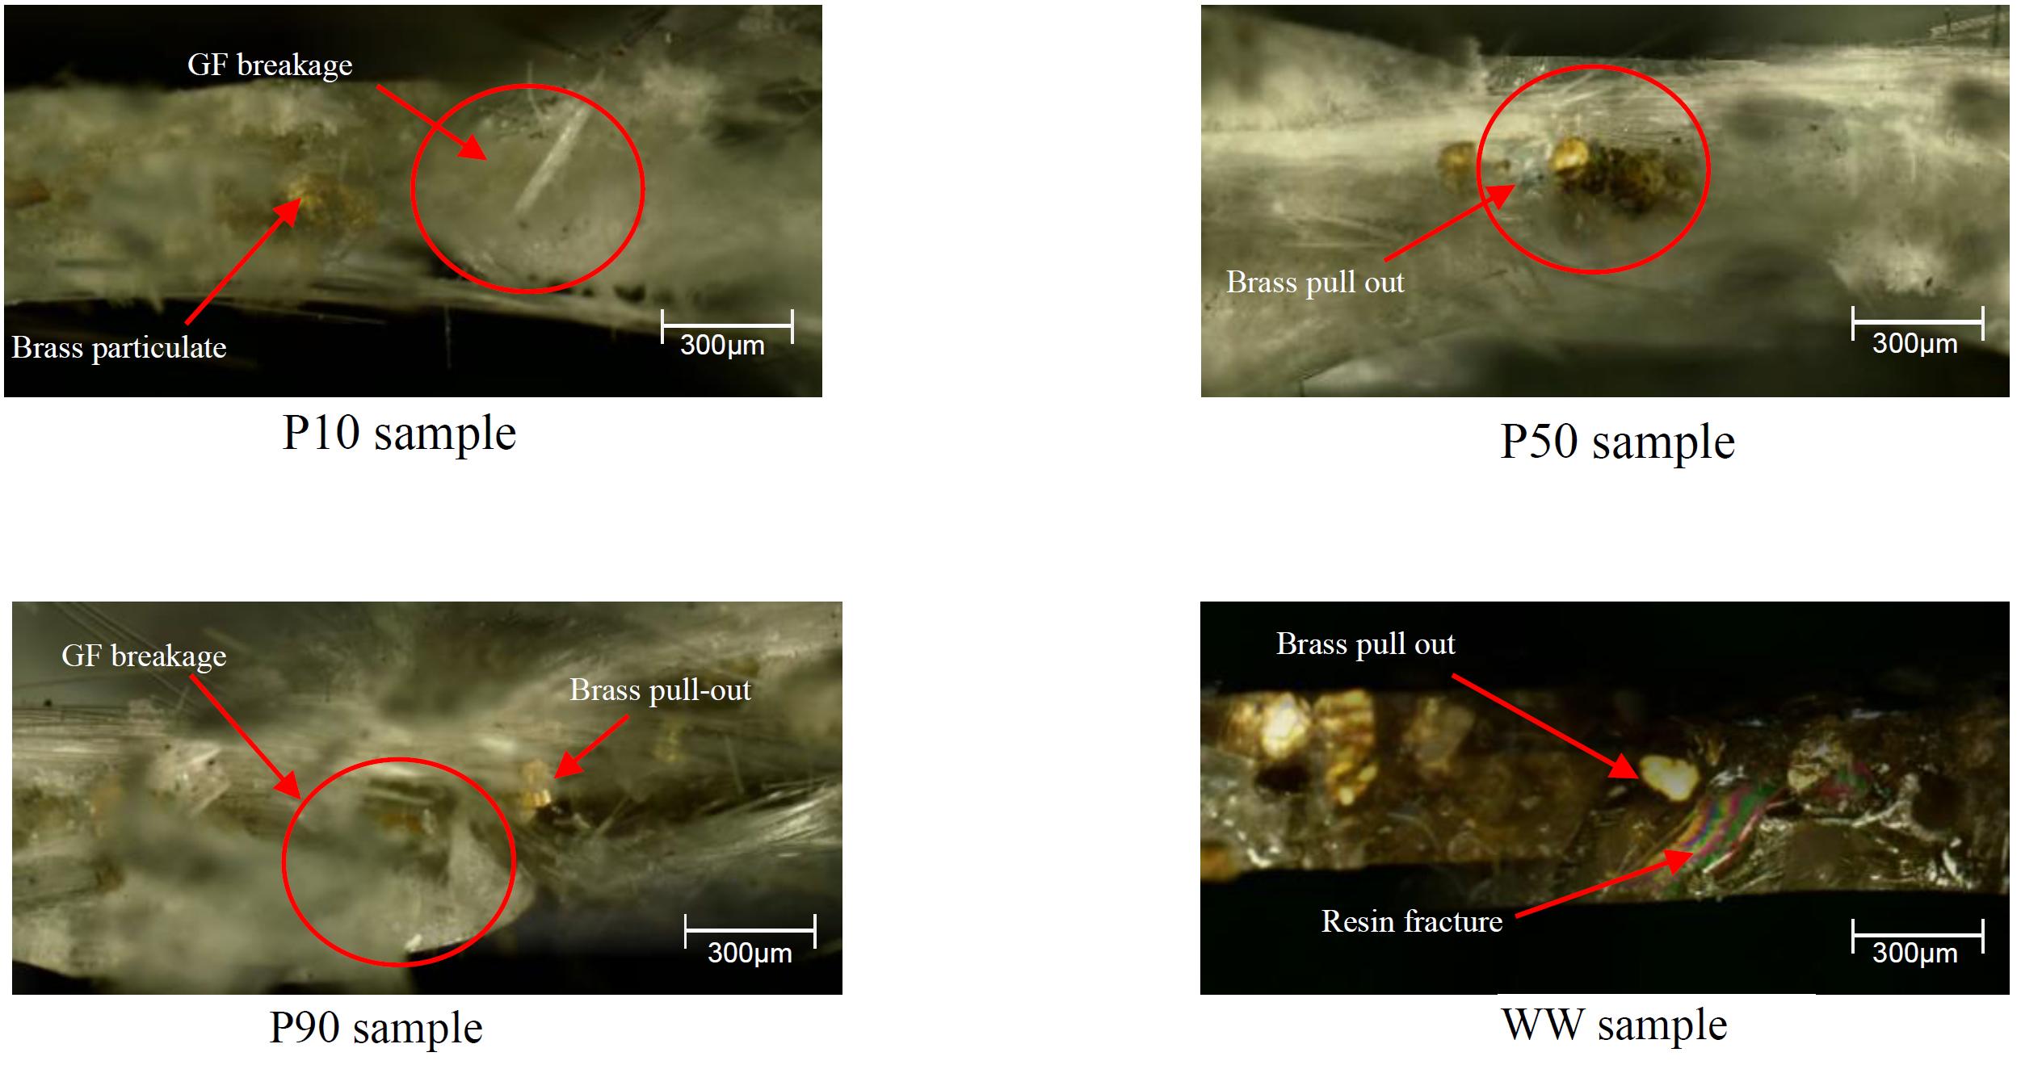
CONCLUSION
This study successfully fabricated and evaluated waste brass wire particulate–glass fiber reinforced epoxy hybrid composites, demonstrating that a brass content of 50 wt% (P50) provides optimal mechanical performance. At this composition, the hybrid composite achieved tensile strength of 287.55 MPa, flexural strength of 229.19 MPa, and impact energy absorption of 352.45 kJ/m². The observed improvements are attributed to effective stress transfer between glass fibers and brass particulates, while higher brass contents resulted in reduced performance due to particulate agglomeration and weakened interfacial bonding. Composite density increased proportionally with brass addition, and morphological analysis confirmed strong interfacial bonding at the optimal reinforcement ratio.
From a scientific perspective, these findings contribute to improved understanding of high-content metal particulate hybridisation in GFRE systems. From a sustainability standpoint, the results demonstrate the feasibility of valorising EDM-generated waste brass wire as a functional reinforcement material, supporting environmentally responsible composite development. The enhanced mechanical performance achieved at optimal brass content indicates potential relevance for structural engineering components where improved toughness and strength are required.
However, the present findings are limited to randomly oriented glass fiber mats and room-temperature mechanical testing conditions. Future research should investigate the effects of fiber orientation, stacking sequence, and long-term performance through additional evaluations such as fatigue, thermal, and environmental ageing tests to further assess the applicability of these hybrid composites.
ACKNOWLEDGMENTS
The authors would like to thank Faculty of Industrial and Manufacturing Technology and Engineering, Universiti Teknikal Malaysia Melaka. This research was not funded by any grant or any institutions.

REFERENCES
- Al-Khafaji, A. H., & Al-Maamori, M. H. (2023). Effect of brass powder on the mechanical properties of epoxy-based hybrid composites. Materials Today: Proceedings, 82, 1463–1470.
- Al-Mosawi, A. I., & Al-Maamori, M. H. (2023). Mechanical properties of epoxy composites reinforced with brass powder. Materials Today: Proceedings, 82, 1456–1462.
- Batu, T., & Lemu, H. G. (2020). Investigation of mechanical properties of false banana/glass fiber reinforced hybrid composite materials. Results in Materials, 8, 100155. https://doi.org/10.1016/j.rinma.2020.100155
- Gogoi, R., Manik, G., & Arun, B. (2019). High specific strength hybrid polypropylene composites using carbon fibre and hollow glass microspheres. Composites Part B: Engineering, 173, 106875. https://doi.org/10.1016/j.compositesb.2019.106875
- Graupner, N., Sarasini, F., & Müssig, J. (2020). Ductile viscose fibres and stiff basalt fibres for composite applications – An overview and the potential of hybridisation. Composites Part B: Engineering, 194, 108041. https://doi.org/10.1016/j.compositesb.2020.108041
- Gupta, N., & Sharma, V. (2023). Mechanical and tribological behavior of metal-filled epoxy composites. Materials Today: Proceedings, 71, 1123–1130.
- Ismail, M., Rejab, M. R. M., Siregar, J. P., Mohamad, Z., Quanjin, M., & Mohammed, A. A. (2020). Mechanical properties of hybrid glass fiber/rice husk reinforced polymer composite. Materials Today: Proceedings, 27, 1749–1755. https://doi.org/10.1016/j.matpr.2020.03.638
- Ismail, S. O., Akpan, E., & Dhakal, H. N. (2022). Review on natural plant fibres and their hybrid composites for structural applications. Composites Part C: Open Access, 9, 100322. https://doi.org/10.1016/j.jcomc.2022.100322
- Kalaprasad, G., & Thomas, S. (2023). Effect of particulate fillers on mechanical behaviour of hybrid composites. Composites Science and Technology, 229, 109712. https://doi.org/10.1016/j.compscitech.2022.109712
- Karunagaran, N., Rajadurai, A., & Subramani, R. (2025). Mechanical properties of hybrid composites with alternately woven carbon/glass fabrics reinforced epoxy resin. Composites Communications, 45, 101812. https://doi.org/10.1016/j.coco.2025.101812
- Khdir, M. A., & Hassan, A. (2018). Mechanical properties of epoxy composites reinforced with graded brass debris. Journal of Materials Research and Technology, 7(3), 345–352. https://doi.org/10.1016/j.jmrt.2017.07.003
- Latha, P. S., Rao, M. V., Kumar, V. V. K., Raghavendra, G., Ojha, S., & Inala, R. (2016). Evaluation of mechanical and tribological properties of bamboo–glass hybrid fiber reinforced polymer composite. Journal of Industrial Textiles, 46(1), 3–18. https://doi.org/10.1177/1528083715569736
- Liu, Y., & Zhang, Y. (2022). Mechanical and thermal behavior of metal-particle reinforced epoxy composites. Materials Chemistry and Physics, 280, 125734. https://doi.org/10.1016/j.matchemphys.2022.125734
- Muneer Ahmed, M., Dhakal, H. N., Zhang, Z. Y., Barouni, A., & Zahari, R. (2021). Enhancement of impact toughness of natural fibre reinforced composites and their hybrids: A critical review. Composite Structures, 259, 113496. https://doi.org/10.1016/j.compstruct.2020.113496
- Muneer Ahmed, M., Dhakal, H. N., Zhang, Z. Y., Barouni, A., & Zahari, R. (2025). Recent advancements in natural fibre reinforced hybrid composites: A review. Composite Structures, 312, 117456. https://doi.org/10.1016/j.compstruct.2025.117456
- Oladele, I. O., Ibrahim, I. O., Adediran, A. A., Akinwekomi, A. D., Adetula, Y. V., & Olayanju, T. M. A. (2020). Modified palm kernel shell fiber/particulate cassava peel hybrid reinforced epoxy composites. Results in Materials, 5, 100059. https://doi.org/10.1016/j.rinma.2019.100059
- Patel, J., & Patel, R. (2023). Influence of brass particulate on mechanical properties of polymer composites. Materials Today: Proceedings, 72, 1345–1351.
- Prakash, V. R. A., & Jaisingh, S. J. (2018). Mechanical strength behaviour of silane treated E-glass fibre/metal wire mesh reinforced epoxy resin hybrid composite. Silicon, 10(5), 2279–2286. https://doi.org/10.1007/s12633-017-9768-9
- Qian, D., Bao, L., Takatera, M., Kemmochi, K., & Yamanaka, A. (2010). Fiber-reinforced polymer composite materials with high specific strength and erosion resistance. Wear, 268(3–4), 637–642. https://doi.org/10.1016/j.wear.2009.10.017
- Rajput, A., & Verma, P. (2021). Mechanical behaviour of hybrid composites reinforced with metal fillers. Journal of Reinforced Plastics and Composites, 40(5), 234–245. https://doi.org/10.1177/0731684420984628
- Raju, B. S., Manjunatha, L. H., Santosh, S., & Jagadeeswaran, N. (2020). Fabrication and characterization of ZnS micro-particulate filled glass–jute fibre hybrid composites. Materials Today: Proceedings, 20, 125–133. https://doi.org/10.1016/j.matpr.2019.10.051
- Salve, M. V., & Mache, M. R. (2024). Mechanical behaviour of polymer composites reinforced with metallic particulates. Journal of Composite Materials, 58(2), 215–228. https://doi.org/10.1177/00219983231193742
- Singh, B., & Kaur, J. (2022). Hybrid composites with metallic and natural fillers: A review. Composites Part C: Open Access, 11, 100345. https://doi.org/10.1016/j.jcomc.2022.100345
- Swolfs, Y., Gorbatikh, L., & Verpoest, I. (2014). Fibre hybridisation in polymer composites: A review. Composites Part A: Applied Science and Manufacturing, 67, 181–200. https://doi.org/10.1016/j.compositesa.2014.08.027
- Swolfs, Y., Gorbatikh, L., & Verpoest, I. (2024). Recent developments in fibre hybridisation for polymer composites. Composites Part A: Applied Science and Manufacturing, 178, 108456. https://doi.org/10.1016/j.compositesa.2024.108456
- Thakur, V. K., & Thakur, M. K. (2020). Recent advances in hybrid polymer composites. Journal of Industrial and Engineering Chemistry, 85, 1–15. https://doi.org/10.1016/j.jiec.2020.01.035
- Uddin, M. N., & Islam, M. T. (2023). Mechanical performance of epoxy composites reinforced with recycled metal waste. Journal of Cleaner Production, 385, 135672. https://doi.org/10.1016/j.jclepro.2022.135672
- Verma, D., & Gope, P. C. (2021). Hybrid composites with metal and fibre reinforcements. Materials Today: Proceedings, 47, 234–240.
- Wang, Y., & Li, X. (2022). Mechanical and thermal properties of epoxy composites reinforced with brass particulates. Polymer Testing, 108, 107492. https://doi.org/10.1016/j.polymertesting.2022.107492
- Włoch, M., Bagiński, F., Koziński, P., & Datta, J. (2020). Submicron inorganic particles as fillers in glass fibre reinforced epoxy composites. Polymers and Polymer Composites, 28(7), 484–491. https://doi.org/10.1177/0967391120910620
- Zuo, P., Srinivasan, D. V., & Vassilopoulos, A. P. (2021). Review of hybrid composite fatigue behaviour. Composite Structures, 274, 114358. https://doi.org/10.1016/j.compstruct.2021.114358

