Secure Hybrid Intelligence Framework for Smart Energy Networks Using AI and Blockchain

Introduction
The rapid transformation of conventional power systems into intelligent and interconnected energy networks has accelerated the adoption of smart grids as a key enabler of sustainable and efficient energy management. Smart energy networks integrate advanced sensing devices, distributed energy resources, renewable energy systems, intelligent control mechanisms, and communication infrastructures to facilitate real-time monitoring and autonomous decision-making across the power ecosystem. Unlike traditional centralized electricity grids, modern smart grids support bidirectional energy and information flows, enabling active participation of consumers, prosumers, utility operators, and distributed generation units. The increasing deployment of solar photovoltaic systems, wind farms, electric vehicles, and energy storage technologies has significantly enhanced grid flexibility while simultaneously introducing new challenges related to data management, cybersecurity, operational reliability, and energy transaction transparency. Efficient management of smart energy networks requires continuous analysis of large volumes of heterogeneous data generated by smart meters, sensors, renewable energy assets, and grid control devices. However, the growing digitalization of power infrastructures has expanded the vulnerability of smart grids to cyberattacks, data manipulation, unauthorized access, and privacy breaches. Conventional centralized management systems often rely on trusted intermediaries and static security mechanisms that may struggle to cope with the dynamic and distributed nature of modern energy ecosystems. Furthermore, increasing energy transaction activities among distributed participants necessitate secure, transparent, and tamper-resistant mechanisms capable of maintaining trust across multiple stakeholders. As a result, there is a growing need for intelligent and decentralized frameworks that can simultaneously enhance operational efficiency, data security, and system resilience. Recent advances in Artificial Intelligence (AI) have demonstrated significant potential for improving smart grid performance through intelligent forecasting, predictive maintenance, demand response management, fault detection, and energy optimization. Machine learning and deep learning techniques can analyze historical and real-time energy data to support adaptive decision-making and autonomous grid control. Simultaneously, Blockchain technology has emerged as a promising solution for establishing decentralized trust, ensuring data integrity, and facilitating secure peer-to-peer energy transactions without dependence on centralized authorities. Jimenez et al. [1] proposed an AI-assisted automated bidding framework for electricity markets that integrates solar-storage systems with blockchain-based energy tokenization mechanisms. The study demonstrated how AI algorithms can optimize bidding strategies while blockchain technology provides secure and transparent transaction management. Blockchain-based smart contracts can automate energy trading processes, enforce transaction rules, and provide transparent audit trails across distributed energy networks. The convergence of AI and Blockchain technologies offers a powerful opportunity to create secure and intelligent smart energy infrastructures capable of addressing both operational and cybersecurity challenges. Despite the significant progress achieved in smart grid research, several limitations continue to hinder the development of fully autonomous and trustworthy energy systems. Many existing AI-based energy management frameworks primarily focus on forecasting accuracy and operational optimization while providing limited support for secure data sharing and decentralized trust management. Similarly, blockchain-enabled smart grid solutions often emphasize transaction security and transparency but lack advanced intelligence mechanisms for adaptive decision-making and predictive analytics. The absence of an integrated architecture capable of combining intelligent automation with decentralized security may result in scalability challenges, inefficient resource utilization, delayed decision-making, and increased exposure to cyber threats. Therefore, a unified framework that leverages the complementary strengths of AI and Blockchain is essential for enabling next-generation smart energy networks. To address these challenges, this paper proposes a Secure Hybrid Intelligence Framework, as illustrated in Fig. 1. The proposed framework integrates AI-driven analytics modules with blockchain-based security and transaction management layers to establish a reliable, transparent, and intelligent energy ecosystem. AI components continuously monitor energy generation, consumption patterns, network conditions, and equipment health to support predictive analysis and optimized operational decisions. Simultaneously, the blockchain layer ensures secure data storage, decentralized authentication, transparent energy transactions, and immutable record management through smart contracts. The hybrid architecture facilitates trustworthy communication among utility providers, consumers, prosumers, and distributed energy resources while enhancing cybersecurity and operational resilience.
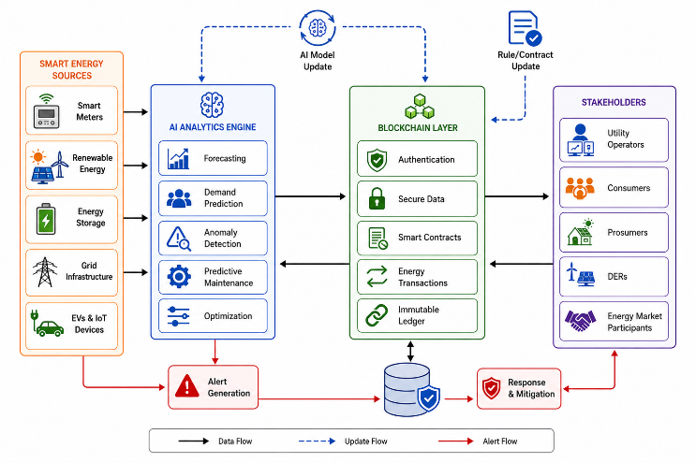
Fig. 1. Conceptual Overview of Secure Hybrid Intelligence Framework for Smart Energy Networks Using AI and Blockchain
By combining intelligent data analytics, decentralized trust mechanisms, automated energy transactions, and adaptive decision-making within a unified architecture, the proposed framework aims to improve energy efficiency, strengthen cybersecurity, enhance transparency, and support sustainable smart grid operations. The integration of AI and Blockchain enables proactive threat detection, secure information exchange, efficient resource allocation, and real-time optimization of energy services across distributed environments. Furthermore, the framework supports scalable deployment in future energy infrastructures characterized by high penetration of renewable energy resources, IoT-enabled devices, and decentralized energy markets. The main contributions of this paper are as follows:
- A secure hybrid intelligence framework that integrates Artificial Intelligence and Blockchain technologies for smart energy network management.
- An AI-driven analytical engine for real-time energy forecasting, anomaly detection, predictive maintenance, and operational optimization.
- A blockchain-enabled security layer that ensures decentralized trust, secure data sharing, transparent energy transactions, and smart contract automation.
- A comprehensive architecture that enhances energy efficiency, cybersecurity, scalability, transparency, and resilience in next-generation smart grid environments.
The remainder of this paper is organized as follows. Section II presents the literature review related to Artificial Intelligence, Blockchain, and smart grid security frameworks. Section III describes the proposed Secure Hybrid Intelligence Framework and its architectural components. Section IV discusses the experimental design, implementation methodology, and performance evaluation results. Finally, Section V concludes the paper and outlines future research directions.

Literature Survey
This section reviews recent studies related to AI-driven energy optimization, blockchain-enabled security frameworks, intelligent energy forecasting, and hybrid AI-blockchain architectures. Baby et al. [2] developed an integrated cyber-physical framework for renewable energy systems in smart industrial environments. Their work emphasized the coordination of renewable energy resources, intelligent monitoring systems, and industrial automation components. The framework enhanced operational efficiency and energy utilization within industrial settings. Although the study addressed cyber-physical integration challenges, it provided limited consideration for decentralized trust management and secure peer-to-peer energy transactions. Akki and Abdessalam [3] presented a comprehensive survey on blockchain-assisted artificial intelligence for securing critical infrastructure networks. The authors highlighted the growing importance of integrating AI-based threat detection with blockchain-enabled trust mechanisms to strengthen infrastructure protection. Their analysis identified numerous benefits of combining both technologies, including enhanced cybersecurity, anomaly detection, and decentralized authentication. Kiran et al. [4] introduced a real-time smart energy consumption analysis framework based on Edge AI and secure IoT architectures. The proposed system utilized intelligent edge analytics to process energy consumption data while maintaining secure communication among connected devices. The study demonstrated improvements in response time and energy monitoring efficiency. Nevertheless, the framework did not incorporate blockchain-based validation mechanisms for ensuring transaction transparency and immutable data storage. Sharma and Kumar [5] investigated the role of Artificial Intelligence in enhancing data security and privacy within smart city environments. Their research highlighted the capability of AI algorithms to identify cyber threats, strengthen privacy protection mechanisms, and improve intelligent security management. The study established the significance of AI-driven security solutions in large-scale digital ecosystems. Sukanya et al. [6] proposed advanced AI-enhanced blockchain consensus mechanisms aimed at improving scalability and energy efficiency in distributed ledger systems. The study demonstrated that intelligent consensus optimization could significantly reduce computational overhead while maintaining blockchain security. The results showed improved transaction processing efficiency and resource utilization. Kotla [7] examined the integration of AI and blockchain technologies for smart grid cybersecurity and identified several models, methodologies, and open research challenges. The study emphasized the complementary nature of AI-driven intelligence and blockchain-based trust management for protecting critical energy infrastructures. The author highlighted the need for unified architectures capable of supporting intelligent threat detection, secure communication, and decentralized energy management. Dwivedi and Prasad [8] developed a hybrid AI-based secure task scheduling framework for IoT-enabled smart cities that incorporated fuzzy anomaly detection and blockchain validation mechanisms. The framework improved resource allocation efficiency while enhancing security through decentralized transaction verification. Although the study demonstrated the effectiveness of combining AI and blockchain technologies, its application focused on smart city task scheduling rather than energy network optimization and management. Reddy et al. [9] proposed a deep learning-based framework for detecting encrypted and malicious network traffic within intelligent communication environments. Their research demonstrated the effectiveness of deep neural networks in identifying sophisticated cyber threats and abnormal network behavior. The findings highlighted the importance of AI-driven cybersecurity mechanisms for protecting critical infrastructures. Rahman et al. [10] introduced an AI-powered framework for energy forecasting and storage optimization in smart grids. The proposed system utilized advanced machine learning algorithms to predict energy demand and optimize battery storage utilization. The results demonstrated significant improvements in forecasting accuracy and energy resource management. Jadhav and Pujar [11] reviewed AI-driven distributed Software Defined Networking (SDN) approaches for energy-efficient routing in large-scale IoT networks. Their study highlighted the benefits of intelligent routing algorithms in reducing network congestion, improving communication efficiency, and optimizing energy consumption. While the proposed concepts support scalable IoT infrastructures, they provide limited solutions for trust establishment and secure energy transaction management in smart grids. K et al. [12] presented an AI-powered framework for autonomous energy optimization and real-time anomaly detection in IoT-driven wireless sensor networks. The proposed model utilized intelligent learning algorithms to continuously monitor network conditions, optimize energy consumption, and identify abnormal system behavior. Sharma and Kumar [13] further emphasized the importance of AI-driven security and privacy preservation in smart digital infrastructures. Their work demonstrated how intelligent analytics can proactively identify vulnerabilities and strengthen cyber defense mechanisms. Although the study provided valuable insights into AI-based protection strategies, it did not address decentralized trust establishment and immutable record management requirements for distributed energy ecosystems. Vignesh et al. [14] proposed an AI-enhanced blockchain framework for autonomous forensic evidence integrity verification. The framework combined AI-based verification techniques with blockchain-enabled immutable record management to ensure evidence authenticity and traceability. The study demonstrated the effectiveness of integrating intelligent analytics and distributed ledger technologies for maintaining data integrity. However, the application domain focused on digital forensics rather than smart energy network management.

Proposed Methodology
The proposed methodology integrates intelligent data acquisition, AI-driven analytics, blockchain-enabled security mechanisms, decentralized energy transaction management, and system performance evaluation to establish a secure and adaptive energy ecosystem. The framework is designed to address challenges associated with distributed energy resource coordination, cyber threats, data integrity, privacy protection, energy trading transparency, and dynamic energy demand fluctuations while ensuring efficient and reliable grid operation.

Smart Energy Network Monitoring and Data Acquisition
The first layer of the proposed framework consists of interconnected smart energy network components responsible for energy generation, distribution, consumption, and monitoring. These components include renewable energy generation units such as solar photovoltaic systems and wind turbines, smart meters, battery energy storage systems, electric vehicles, substations, distributed energy resources, intelligent sensors, and consumer premises. These entities continuously generate large volumes of operational data related to energy production, consumption patterns, equipment status, network conditions, voltage levels, frequency measurements, and transaction activities. The collected information is transmitted through secure communication channels to the intelligent management platform for further processing and analysis. Various operational parameters including renewable energy output, energy demand variations, storage availability, power quality indicators, network congestion levels, and device health conditions are continuously monitored.

AI-Driven Energy Analytics and Intelligent Decision-Making
The second component of the framework focuses on intelligent energy analytics using Artificial Intelligence techniques. The collected operational data are pre-processed and analysed using machine learning and deep learning algorithms to extract actionable insights and support autonomous decision-making. The AI engine performs multiple analytical functions including load forecasting, renewable energy generation prediction, anomaly detection, demand response optimization, fault diagnosis, and predictive maintenance. Historical and real-time energy data are utilized to identify consumption trends, forecast future energy requirements, and estimate renewable energy availability. Advanced learning models continuously adapt to changing operational conditions and improve prediction accuracy over time. In addition, anomaly detection mechanisms monitor network behavior to identify unusual activities that may indicate equipment failures, operational abnormalities, or potential cyberattacks. The intelligent analytics layer enables proactive energy management and supports optimized allocation of resources based on anticipated system conditions.

Blockchain-Based Security and Trust Management
The third stage of the proposed methodology introduces a blockchain-enabled security layer responsible for ensuring data integrity, transparency, decentralized trust, and secure information exchange. All critical operational records, energy transactions, device authentication events, and network activities are securely recorded within a distributed ledger infrastructure. The blockchain network eliminates dependency on centralized authorities by enabling participating entities to validate and verify transactions through consensus mechanisms. Each transaction is cryptographically secured and linked to previous records, creating an immutable audit trail that prevents unauthorized modifications and data tampering. Smart contracts are deployed to automate transaction validation, enforce predefined operational policies, and manage access control across distributed participants. The decentralized nature of blockchain technology enhances trust among utility providers, consumers, prosumers, and energy market operators.

Secure Energy Transaction and Resource Coordination Layer
Following the establishment of a secure trust infrastructure, the framework performs decentralized energy transaction management and resource coordination. This layer facilitates peer-to-peer energy trading among distributed participants while ensuring secure and transparent transaction execution. Smart contracts automatically evaluate transaction requests, verify energy availability, execute settlement procedures, and update ledger records without requiring intermediary involvement. The coordination mechanism continuously analyses available generation resources, storage capacities, energy demands, and market conditions to determine optimal energy exchange strategies. Distributed energy resources can autonomously participate in local energy markets and negotiate energy transactions based on predefined operational objectives. The integration of AI-generated forecasts with blockchain-based transaction management enables intelligent coordination of energy flows across the network.

System Security Assessment and Adaptive Response Mechanism
Once intelligent decision-making and transaction management processes are operational, the framework continuously evaluates network security and system reliability. Various security indicators including unauthorized access attempts, abnormal communication patterns, suspicious transaction activities, device authentication failures, and network vulnerabilities are monitored in real time. Simultaneously, operational metrics such as load balancing performance, renewable energy utilization, system stability, and service availability are continuously assessed. If potential cyber threats, operational anomalies, or reliability degradation are detected, the adaptive response engine automatically initiates corrective actions. These actions may include transaction validation reinforcement, access restriction enforcement, intelligent resource reallocation, fault isolation, and network reconfiguration. AI-driven threat detection mechanisms collaborate with blockchain-based verification processes to ensure rapid identification and mitigation of security incidents.

Performance Evaluation and Comparative Analysis
The final stage of the methodology evaluates the effectiveness of the proposed Secure Hybrid Intelligence Framework using multiple security, operational, and energy-related performance metrics. The evaluation considers forecasting accuracy, transaction processing efficiency, cybersecurity resilience, blockchain transaction integrity, energy utilization effectiveness, renewable energy integration, system scalability, network reliability, and operational cost optimization. The performance of the proposed framework is compared with conventional smart grid management systems that utilize centralized architectures and traditional security mechanisms. Energy-related metrics assess the framework's ability to optimize resource allocation and improve operational efficiency, while security-oriented metrics evaluate resistance against cyber threats, data manipulation attempts, and unauthorized access activities.

Result and Analysis
The performance evaluation of the proposed Secure Hybrid Intelligence Framework for Smart Energy Networks Using AI and Blockchain was conducted under multiple smart grid operating scenarios involving varying energy demand levels, distributed energy resource participation, cybersecurity threat conditions, and energy transaction workloads. The proposed framework was compared with conventional centralized smart grid management systems, AI-based energy management frameworks, and blockchain-enabled energy transaction platforms. The evaluation focused on measuring energy forecasting accuracy, cybersecurity resilience, transaction transparency, system reliability, and operational efficiency.

System Configuration and Experimental Environment
The simulation environment was designed to emulate a large-scale smart energy network consisting of renewable energy generation units, smart meters, battery storage systems, electric vehicles, substations, distributed energy resources, utility control centers, and consumer nodes. The implementation was carried out using an Intel Core i7 processor with 16 GB RAM running Ubuntu Linux. The simulation framework was developed using Python along with machine learning and blockchain development libraries including NumPy, Pandas, TensorFlow, Scikit-Learn, Web3.py, Matplotlib, and PyBlockchain. The experimental network consisted of more than 1,000 interconnected devices generating continuous energy consumption, generation, and transaction data. Multiple operating scenarios including normal operation, peak demand conditions, renewable energy variability, and cybersecurity attack simulations were considered. Furthermore, varying blockchain transaction loads and distributed participant configurations were incorporated to evaluate the adaptability and scalability of the proposed hybrid framework under realistic smart energy network environments.

Comparative Security and Energy Management Performance Analysis
As shown in TABLE I, the proposed Secure Hybrid Intelligence Framework achieved the highest forecasting accuracy, cybersecurity resilience, and operational efficiency among all evaluated approaches. The AI-driven analytics engine effectively predicts energy demand and detects anomalous activities, while the blockchain layer ensures secure transaction execution and data integrity.
- Comparative Performance of Smart Energy Network Management Frameworks
Framework | Forecasting Accuracy (%) | Cybersecurity Resilience (%) | Operational Efficiency (%)
Conventional Smart Grid Management | 84.7 | 81.5 | 83.2
AI-Based Energy Management | 92.8 | 87.6 | 91.4
Blockchain-Based Energy Platform | 88.3 | 94.1 | 89.7
Proposed Hybrid AI-Blockchain Framework | 98.2 | 98.7 | 97.9

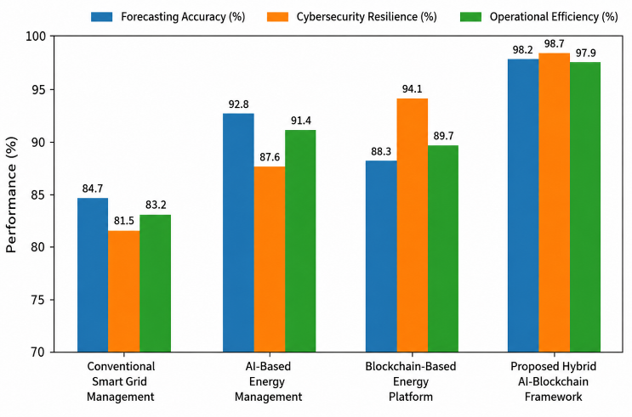
Fig. 2. Comparative Forecasting Accuracy, Cybersecurity Resilience, and Operational Efficiency Analysis
Fig. 2 demonstrates that the proposed hybrid framework consistently outperforms conventional approaches by achieving superior energy prediction accuracy, enhanced cyberattack resistance, and improved operational efficiency. The integration of intelligent analytics and decentralized trust mechanisms enables secure and reliable energy management across distributed environments.

Blockchain Transaction Performance and Trust Analysis
The transaction management evaluation examines the effectiveness of the proposed framework in supporting secure and transparent energy trading operations among distributed participants, as shown in TABLE II.
- Comparative Blockchain Transaction & Trust Management Analysis
Framework | Transaction Success Rate (%) | Data Integrity Score (%) | Trust Management Efficiency (%)
Conventional Centralized Platform | 85.4 | 82.7 | 80.9
AI-Based Management System | 89.8 | 87.5 | 86.3
Existing Blockchain Platform | 95.6 | 96.8 | 95.1
Proposed Hybrid AI-Blockchain Framework | 99.1 | 99.4 | 98.8

The proposed framework achieved the highest transaction success rate, data integrity performance, and trust management efficiency among all evaluated solutions. Blockchain-enabled smart contracts successfully automate energy transaction verification and settlement processes while maintaining complete transparency and immutability. Furthermore, AI-assisted transaction monitoring identifies abnormal trading activities and enhances network security.
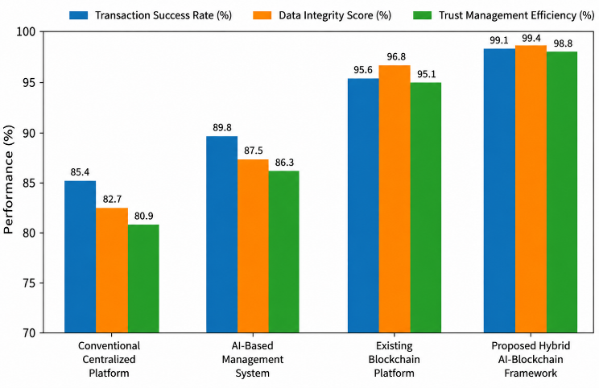
Fig. 3. Comparative Blockchain Transaction Success Rate and Trust Management Analysis
Fig. 3 illustrates that the proposed framework provides highly secure and transparent transaction management capabilities while supporting efficient decentralized energy market operations.

Scalability and Network Reliability Analysis
The scalability analysis evaluates the effectiveness of the proposed framework as the number of connected devices and energy market participants increases, as listed in TABLE III.
- Scalability & reliability Performance Under Different Network Sizes
Number of Connected Devices | Conventional Reliability (%) | Blockchain Platform Reliability (%) | Proposed Hybrid Framework Reliability (%)
500 Devices | 88.2 | 94.7 | 99.1
1000 Devices | 86.9 | 94.1 | 98.8
2000 Devices | 85.4 | 93.5 | 98.4
5000 Devices | 83.7 | 92.8 | 98.1
10000 Devices | 81.5 | 91.9 | 97.6

The proposed framework maintains consistently high reliability performance even as the smart energy network expands to accommodate thousands of interconnected devices. The AI engine continuously adapts to changing operational conditions, while the blockchain infrastructure efficiently manages increasing transaction volumes without compromising security or transparency. The framework successfully supports large-scale distributed energy ecosystems while maintaining stable network operation and secure communication.
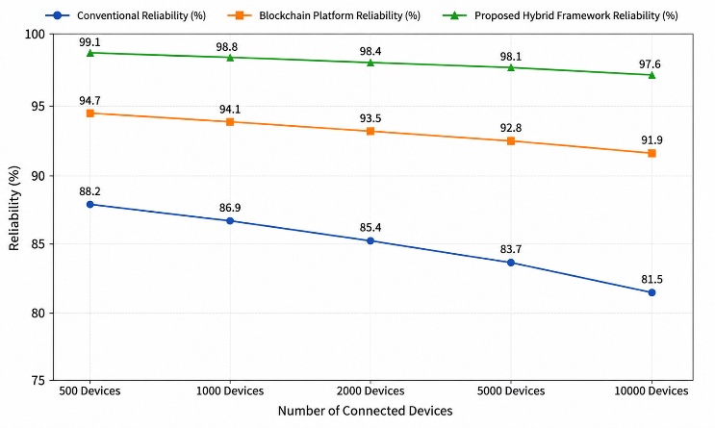
Fig. 4. Scalability Analysis of Secure Hybrid Intelligence Framework Under Increasing Smart Energy Network Size
The results presented in Fig. 4 confirm that the proposed framework provides superior scalability, cybersecurity resilience, transaction transparency, forecasting accuracy, and operational reliability for next-generation smart energy networks.

Conclusion and Future Scope
This paper presented a Secure Hybrid Intelligence Framework for Smart Energy Networks Using AI and Blockchain that integrates intelligent analytics, decentralized security mechanisms, and automated energy transaction management within a unified architecture. The proposed framework leverages Artificial Intelligence for energy forecasting, anomaly detection, predictive decision-making, and operational optimization, while Blockchain technology ensures secure data sharing, transparent transactions, decentralized trust management, and tamper-resistant record keeping. The experimental evaluation demonstrated that the hybrid framework significantly improves forecasting accuracy, cybersecurity resilience, transaction integrity, operational efficiency, and network reliability compared to conventional smart grid management approaches. Furthermore, the integration of AI-driven intelligence with blockchain-enabled security provides an effective solution for addressing critical challenges related to cyber threats, data privacy, trust establishment, and distributed energy resource coordination in next-generation smart energy networks. The scalability analysis also confirmed the framework’s capability to support large-scale deployments involving thousands of interconnected devices and energy participants while maintaining high levels of security and performance. In future work, the framework can be extended through the integration of federated learning techniques to enable privacy-preserving collaborative intelligence across distributed energy systems. The incorporation of edge and fog computing architectures can further reduce latency and enhance real-time decision-making capabilities. Additionally, future research may explore quantum-resistant blockchain mechanisms, explainable AI models for transparent energy management decisions, advanced consensus protocols for energy-efficient transaction validation, and digital twin technologies for predictive simulation and autonomous grid control.

References
- A. J. Jimenez, E. J. Becil, M. E. Alebicto, R. G. Salgado and R. Gomez, "Leveraging AI Algorithms for Automated Bidding in Electricity Markets: A Solar-Storage Hybrid Approach With Blockchain-Based Energy Tokenization," 2025 IEEE Electrical Insulation Conference (EIC), South Padre Island, TX, USA, 2025, pp. 1-3, doi: 10.1109/EIC63069.2025.11123269.
- H. Baby, A. M. Mohan, S. Gopal and K. P. T.K, "Integrated Framework for Renewable Energy Systems in Smart Industrial Environments: A Cyber-Physical Perspective," 2025 International Conference on Signal Processing, Computation, Electronics, Power and Telecommunication (IConSCEPT), Karaikal, India, 2025, pp. 1-5, doi: 10.1109/IConSCEPT66142.2025.11437194.
- N. Akki and A. M. Abdessalam, "Securing Critical Infrastructure Networks Using Blockchain-Assisted Artificial Intelligence: A Survey," 2026 6th International Conference on Innovative Research in Applied Science, Engineering and Technology (IRASET), FEZ, Morocco, 2026, pp. 1-7, doi: 10.1109/IRASET68627.2026.11538495.
- K. S. Kiran, S. Y. M and G. Ketepalli, "Real-Time Smart Energy Consumption Analysis Using Edge AI and Secure IoT Frameworks," 2026 IEEE International Conference for Convergence in Computing Technology (I3CTCON), Lonavala, India, 2026, pp. 1-5, doi: 10.1109/I3CTCON68242.2026.11508031.
- V. Sharma and S. Kumar, "Role of Artificial Intelligence (AI) to Enhance the Security and Privacy of Data in Smart Cities," 2023 3rd International Conference on Advance Computing and Innovative Technologies in Engineering (ICACITE), Greater Noida, India, 2023, pp. 596-599, doi: 10.1109/ICACITE57410.2023.10182455.
- M. Sukanya, R. Balasubramaniyan, V. S. Pandi, T. A. Abu-Saleem, A. Dutt and M. Dinesh, "Advanced Consensus Mechanisms for Blockchain with AI: Enhancing Scalability & Energy Efficiency in Distributed Ledger Systems," 2025 International Conference on Smart & Sustainable Technology (INCSST), Chikodi, India, 2025, pp. 1-6, doi: 10.1109/INCSST64791.2025.11210323.
- A. R. Kotla, "AI Integrating Blockchain with Smart Grid Cyber Security: Models, Methods, and Open Research Issues," 2025 4th International Conference on Applied Artificial Intelligence and Computing (ICAAIC), Salem, India, 2025, pp. 1997-2003, doi: 10.1109/ICAAIC64647.2025.11330706.
- A. K. Dwivedi and S. K. Prasad, "A Hybrid AI-Based Secure Task Scheduling Framework for IoT-Enabled Smart Cities with Fuzzy-Anomaly Detection and Simulated Blockchain Validation," 2025 International Conference on Electronics and Computing, Communication Networking Automation Technologies (ICEC2NT), Pune, India, 2025, pp. 1-6, doi: 10.1109/ICEC2NT65402.2025.11379964.
- P. C. S. Reddy, P. Shirley Muller, S. N Koka, V. Sharma, N. Sharma and S. Mukherjee, "Detection of Encrypted and Malicious Network Traffic using Deep Learning," 2023 International Conference on Ambient Intelligence, Knowledge Informatics and Industrial Electronics (AIKIIE), Ballari, India, 2023, pp. 1-6, doi: 10.1109/AIKIIE60097.2023.10390386.
- M. N. Rahman, M. M. Islam, V. Vavilov, M. S. Rahman, J. G. Singh and A. R. Rinatovich, "AI-Powered Energy Forecasting and Storage Optimization in Smart Grids," 2025 5th International Conference on Electrical, Computer and Energy Technologies (ICECET), Paris, France, 2025, pp. 1-6, doi: 10.1109/ICECET63943.2025.11472521.
- M. P. Jadhav and A. Pujar, "A Review on AI Driven Distributed SDN for Energy -Efficient Routing in Large Scale IoT Network," 2025 6th International Conference on Electronics and Sustainable Communication Systems (ICESC), Coimbatore, India, 2025, pp. 1221-1229, doi: 10.1109/ICESC65114.2025.11212255.
- K. K, V. Krishna, S. R. Rao Thirumala Pragada, R. Kantamani, J. C. Nath and S. Singh, "Next Generation AI Powered Framework for Autonomous Energy Optimization and Real Time Anomaly Detection in IoT Driven Wireless Sensor Networks," 2025 International Conference on Intelligent Computing, Information and Control Systems (ICOIICS), Lalitpur, Nepal, 2025, pp. 745-751, doi: 10.1109/ICOIICS67115.2025.11390384.
- V. Sharma and S. Kumar, "Role of Artificial Intelligence (AI) to Enhance the Security and Privacy of Data in Smart Cities," 2023 3rd International Conference on Advance Computing and Innovative Technologies in Engineering (ICACITE), Greater Noida, India, 2023, pp. 596-599, doi: 10.1109/ICACITE57410.2023.10182455.
- C. S. Vignesh, G. Sreekar, N. Chandu, P. Pracheth and C. Anitha, "AI-Enhanced Blockchain Framework for Autonomous Forensic Evidence Integrity Verification," 2026 International Conference on Electronics and Renewable Systems (ICEARS), Tuticorin, India, 2026, pp. 1343-1349, doi: 10.1109/ICEARS67481.2026.11416539.

