IMPROVING THE EFFECTIVENESS OF KOREAN INTERPRETING TRAINING AT THE UNIVERSITY OF SCIENCES, THAI NGUYEN UNIVERSITY

ABSTRACT
This study analyses the current situation of Korean interpreting training at the University of Sciences, Thai Nguyen University, and proposes solutions for enhancing its effectiveness. It combines document analysis, a questionnaire survey of students, lecturer interviews, pedagogical observation, and statistical analysis of learning outcomes. The findings show that the interpreting courses have been organised along a progression from basic to advanced levels and integrate theory with practice. However, the training process still presents several issues, such as limited hands-on practice time, a limited range of audiovisual materials and simulated professional scenarios, inconsistently implemented practice activities, assessment criteria that are not yet fully standardised, and infrequent feedback to learners. Students continue to face difficulties with listening comprehension, vocabulary, memory, expression, rapid response, performance-related anxiety, and self-study methods; at the same time, the use of translation technologies and AI tools has not been adequately guided. Accordingly, the study proposes solutions organised around three groups of stakeholders—institutional administrators, lecturers, and students—focusing on programme organisation, materials development, pedagogical innovation, the standardisation of assessment, the strengthening of academic coordination, self-study guidance, and the guided and responsible use of technology.
Keywords: interpreting training; Korean interpreting; interpreting competence; teaching methods; assessment; self-directed learning.

1. Introduction
In recent years, cooperation between Viet Nam and the Republic of Korea has expanded considerably across many fields, including the economy, education, culture, labour, and people-to-people exchange. The Republic of Korea is currently the largest foreign investor in Viet Nam, with more than 10,000 projects and total investment capital exceeding US$92 billion. The strong growth of Korean enterprises has generated an increasing demand for personnel capable of using Korean across many fields, including interpreting and business management [17].
In parallel with this economic cooperation, the demand for learning Korean in Viet Nam has risen sharply in recent years. Korean language and Korean studies education in the country has expanded substantially in both scale and the number of learners. According to statistics from the Korean Education Center in Vietnam, as of April 2025, Viet Nam had 48 universities offering Korean language or Korean studies programmes, with more than 27,000 enrolled students; the total number of Korean learners exceeds 50,000 when non-specialised programmes and other training institutions are included [18]. This indicates that the demand for learning and using Korean in Viet Nam is currently very large, and it raises the need to improve the quality of training for Korean-proficient personnel, especially in fields with strong professional application such as translation and interpreting.
In this context, Korean language training at universities must go beyond equipping learners with linguistic knowledge to fostering the ability to use Korean in real professional environments. In particular, interpreting skills have increasingly become an important requirement for students of Korean studies, as they are highly applicable in Korean business environments and in activities involving cultural exchange, education, tourism, and international cooperation. Interpreting is not merely a matter of converting one language into another but also a process of processing information, conveying meaning, regulating communication, and connecting cultures among the participants in an interaction. Korean interpreting training therefore plays an important role in forming students’ professional competence after graduation.
At the University of Sciences, Thai Nguyen University, the Korean interpreting courses—which cover interpreting between Korean and Vietnamese have been incorporated into the curricula of the Korean Studies programme and the English–Korean Bilingual programme in order to equip students with the ability to practise oral interpreting in Korean communicative situations. This is consistent with the practical needs of the northern midland and mountainous region, which is home to numerous Korean enterprises and satellite companies linked to major corporations such as Samsung, as well as educational, labour, and exchange activities between Viet Nam and the Republic of Korea. In addition, research on the career orientation of Korean studies students at the University of Sciences, Thai Nguyen University, shows that interpreting is one of the career paths chosen by many students after graduation [12].
Interpreting is a highly practice-oriented activity that requires learners not only to possess a solid linguistic foundation but also to mobilise multiple competences simultaneously-listening comprehension, memory, note-taking, the analysis and processing of information, language transfer, situational handling, and expression under time constraints. The effectiveness of interpreting training therefore depends on many factors, including programme content, the duration and form of practice, the system of audiovisual materials, the way practice is organised, assessment, and learners’ capacity for self-directed learning. At the University of Sciences, Thai Nguyen University, the courses Korean Interpreting and Advanced Korean Interpreting play an important role in forming the professional competence of Korean studies students. However, the appropriateness of the training content, the adequacy of the materials, the effectiveness of practice activities and assessment, and the difficulties students encounter during their studies have not yet been examined systematically. Moreover, the use of machine translation tools and AI in learning raises the need to evaluate both their supportive role and the risk of learner dependence.
Against this background, the study examines the current situation of Korean interpreting training at the University of Sciences, Thai Nguyen University, and accordingly proposes a number of solutions for improving the effectiveness of the interpreting courses. It has practical significance in contributing to the quality of the Korean Studies programme and to meeting the demand for Korean-proficient personnel amid the deepening cooperation between Viet Nam and the Republic of Korea.
Interpreting training, interpreting competence, and Korean translation and interpreting training have attracted the attention of many researchers in Viet Nam and abroad. These studies address various aspects, such as the nature of interpreting, interpreting competence, training methods, assessment, and curriculum development.
Internationally, scholarship on interpreting emerged relatively early and has developed into a well-established field. One of the most influential works is Basic Concepts and Models for Interpreter and Translator Training by Daniel Gile [1]. Gile proposed the “Effort Model,” arguing that interpreting involves the simultaneous coordination of multiple cognitive efforts such as listening comprehension, memory, note-taking, expression, and the coordination of information. The work emphasises the pressure of processing information in real time and the role of practice in developing interpreting competence.
In Introducing Interpreting Studies [2], Franz Pöchhacker systematised the basic theoretical issues of interpreting studies, including the concept of interpreting, the types of interpreting, interpreting competence, interlingual communication, and interpreter training. According to Pöchhacker, interpreting is not only a matter of language transfer but also a process of intercultural communication carried out under conditions of real-time information processing.
In the field of interpreter education, David B. Sawyer, in Fundamental Aspects of Interpreter Education: Curriculum and Assessment [3], examined curriculum design, learning outcomes, and competence-based assessment of interpreting. Sawyer argued that interpreter education should shift from a model of knowledge transmission to one of developing professional competence.
Robin Setton and Andrew Dawrant, in Conference Interpreting: A Complete Course [4], proposed a model for training conference interpreters based on the integration of linguistic competence, listening comprehension, memory, note-taking, discourse processing, and background knowledge. Their work emphasises the role of practice and the simulation of professional environments in interpreter training.
From the perspective of translation pedagogy, Dorothy Kelly [5] argued that translator and interpreter training should be organised in a learner-centred manner, strengthening interaction, feedback, and formative assessment. Christiane Nord [6], for her part, drew on functionalist theory to emphasise the role of the communicative purpose, the recipient, and the cultural context in translation.
In addition to studies on interpreter training, many scholars have examined the nature of translation and interpreting. Nida and Taber [14] proposed the theory of dynamic equivalence, emphasising the effective transfer of communicative effect rather than linguistic form. Vermeer [15], with Skopos theory, held that translation is governed by its communicative purpose. Toury [16] approached translation from sociological and cultural-studies perspectives, viewing it as an activity shaped by social norms and the context of language use. In particular, Seleskovitch and Lederer [13] developed the Interpretive Theory of Translation, arguing that the interpreter must convey meaning rather than transfer individual linguistic units.
In the Republic of Korea, interpreting competence and interpreter and translator training have also received strong attention. Woo Changhyun [7] identified the core competences required in Korean language education and in interpreter and translator training, such as communicative competence, problem-solving, information processing, self-directed learning, linguistic competence, and cultural competence. Lee Juyeon [8] studied students’ perceptions of interpreting competence and found that, after training, learners more clearly recognise the role of background knowledge, concentration, information processing, and problem-solving in interpreting.
In Viet Nam, Lê Hùng Tiến [9] argued that translator and interpreter training aims not only to enhance foreign-language competence but also to foster interlingual communicative competence and professional competence. In a later study, Lê Hùng Tiến [10] systematised modern translation-pedagogy approaches and offered numerous suggestions for reforming translator and interpreter training in Viet Nam.
With regard to Korean translation and interpreting training, Trần Thị Hường, Nguyễn Thị Thu Vân, and Đỗ Thúy Hằng [11] pointed to current limitations such as the lack of practice materials, the absence of simulated professional environments, and the gap between in-school training and the practical requirements of the labour market. They proposed strengthening practice and reforming training methods to align more closely with professional practice.
Closely related to the present study, Dương Thị Huyền and Trần Thị Thanh Hương [12] surveyed the career orientations toward interpreting of Korean studies students at the University of Sciences, Thai Nguyen University. The results showed that interpreting is one of the common career choices of students after graduation and underlined the need to improve the quality of the interpreting courses.
Overall, studies in Viet Nam and abroad have addressed many aspects of interpreting training, including the theoretical foundations of interpreting, interpreting competence, teaching methods, assessment, and Korean translation and interpreting training. However, most have focused on general theory or on the situation at large institutions. Few have systematically analysed the situation and proposed solutions for improving the effectiveness of the Korean Interpreting and Advanced Korean Interpreting courses at the University of Sciences, Thai Nguyen University, in relation to learner characteristics, actual training conditions, and current professional demands. Accordingly, the present study builds on earlier work while focusing on the current situation of Korean interpreting training at the university and, on that basis, proposes a number of solutions for improving the effectiveness of the interpreting courses within the Korean Studies programme.

2. Research methods
To clarify the current situation and propose solutions for improving the effectiveness of Korean interpreting training at the University of Sciences, Thai Nguyen University, this study employed a combination of the following research methods.
First, document analysis and synthesis were used to systematise the theoretical issues related to interpreting training, translator and interpreter training, interpreting competence, and the teaching of interpreting in higher education. The materials included works on translation theory, interpreter education, translation and interpreting curricula, textbooks, and the detailed syllabi of the Korean Interpreting and Advanced Korean Interpreting courses within the Korean Studies programme. On this basis, the study established a theoretical framework as the foundation for analysing the current situation and proposing solutions appropriate to the university’s training conditions.
Second, the study used a questionnaire survey to gather information about the teaching and learning of the Korean interpreting courses. The target population comprised 247 students of the K20 and K21 cohorts of the Korean Studies programme who had taken or were taking the Korean Interpreting and Advanced Korean Interpreting courses at the University of Sciences, Thai Nguyen University, of whom 160 returned usable questionnaires, accounting for 64.8% of the target population. The sample was selected using convenience sampling combined with eligibility criteria aligned with the target population. Among the respondents, the K20 cohort had completed both courses, whereas the K21 cohort had completed the Korean Interpreting course and was progressing through the programme. The sample therefore provides a reasonably comprehensive account of the learning process, the difficulties encountered, and the needs of Korean studies students for developing interpreting competence. The survey focused on students’ perceptions of the role of the interpreting courses, the appropriateness of the teaching content, textbooks and materials, teaching methods, forms of assessment, the difficulties encountered during study, the use of technology and artificial intelligence (AI) in learning, and the need to develop interpreting skills. The survey data were processed using descriptive statistics in order to capture the current situation of Korean interpreting training from the learners’ perspective.
In addition, the study conducted semi-structured interviews with the lecturers who directly teach the Korean Interpreting and Advanced Korean Interpreting courses. The interviews focused on teaching methods, assessment practices, students’ entry-level competence, difficulties encountered during teaching, and suggestions for improving the effectiveness of interpreting training.
Participant observation was also conducted while the researchers taught, organised practice activities, and assessed students in the Korean Interpreting and Advanced Korean Interpreting courses in classes K20A, K20B, K21A, and K21B. The observation focused on students’ learning attitudes, their participation in practice activities, and their listening comprehension, memory, expression, handling of interpreting situations, and degree of initiative during practice. This participant observation provided practical evidence to support the survey results and helped identify the difficulties students commonly encounter in developing Korean interpreting competence.
The study also used descriptive statistical and comparative analyses to examine students’ learning outcomes and assessment results across cohorts. Comparing results across cohorts helped to clarify variations in learning quality, the degree to which course requirements were met, and the issues arising in assessment. In this way, the study considered not only numerical scores but also the extent to which they reflect students’ actual interpreting competence.
Drawing on the data collected, the study combined qualitative analysis with descriptive statistical analysis to clarify the factors affecting the effectiveness of Korean interpreting training, including the curriculum, course duration, textbooks and materials, teaching methods, forms of assessment, the teaching staff, the application of technology, and students’ learning awareness. Combining the student survey, the lecturer interviews, and the learning outcomes enabled data triangulation, strengthening the reliability and objectivity of the study. On this basis, the study proposes a number of practical solutions for improving the effectiveness of Korean interpreting training at the University of Sciences, Thai Nguyen University, in line with the training objectives and the university’s implementation conditions.

3. Results and discussion

3.1. Theoretical and practical foundations
3.1.1. Theoretical foundations
Interpreting is the activity of conveying a message orally from a source language to a target language during communication that takes place directly or indirectly among parties using different languages. According to Pöchhacker (2016), interpreting is a form of interlingual and intercultural communicative mediation in which the interpreter conveys information under conditions of real-time communication [2].
Although both belong to the field of translation, interpreting and written translation have distinct characteristics. According to Seleskovitch and Lederer (1989), translation deals mainly with written texts, whereas interpreting deals with spoken language during direct communication [13]. Translators have time to consult references, deliberate, and revise the text before finalising it, whereas interpreters must receive, process, and convey information within a very short time.
Gile (2009) also pointed out that translators tend to process language in small units such as words, phrases, and sentences, whereas interpreters must focus on the overall meaning of the discourse to ensure communicative effectiveness [1]. According to Pöchhacker [2] and Setton and Dawrant [4], the common types of interpreting include consecutive interpreting, simultaneous interpreting, sight translation, and dialogue interpreting. In university training, consecutive interpreting and dialogue interpreting are generally regarded as the foundation for developing professional competence. Interpreting therefore demands a higher level of listening comprehension, memory, information processing, and expression. For Korean, interpreting is influenced by many linguistic and cultural features, such as the SOV sentence structure, the honorific system, indirect modes of expression, and communicative norms that depend on social relationships [7], [8]. Students of Korean interpreting therefore need to develop linguistic competence and intercultural communicative competence simultaneously.
Several modern translation theories are also significant for interpreting training. The theory of dynamic equivalence proposed by Nida and Taber [14] holds that translation should aim to produce an equivalent communicative effect for recipients in the source and target languages. This view helps learners recognise that the goal of interpreting is not to transfer individual words but to convey the message. The functionalist theory of Nord [6] and the Skopos theory of Vermeer [15] both regard translation as a purposeful communicative act. The translator must take into account the recipient, the communicative purpose, and the context of language use in order to select an appropriate transfer strategy. The Interpretive Theory of Translation of Seleskovitch and Lederer [13] is an important theoretical foundation for interpreting training. According to these two authors, the interpreting process comprises three stages: comprehension of the source discourse, deverbalisation, and reverbalisation. The interpreter must grasp the meaning of the message before re-expressing it in the target language. In addition, Gile’s Effort Model [1] holds that interpreting involves the simultaneous coordination of multiple cognitive efforts such as listening comprehension, memory, note-taking, expression, and the coordination of information. This model explains why students often encounter difficulties in interpreting and provides a basis for designing appropriate training content. Drawing on the studies above, the present study defines interpreting competence as comprising the following components: linguistic competence, listening comprehension, memory, note-taking, language transfer, expression, cultural competence, situational handling, professional competence, technological competence, and self-directed learning.
With respect to training, interpreting training can be approached from two basic orientations. The first treats interpreting as a tool supporting the development of foreign-language competence. According to Sawyer [3], modern interpreting training should follow a competence-development orientation. Under this orientation, interpreting helps learners consolidate their vocabulary, grammar, listening comprehension, and expression. The second is a professionally oriented approach, in which learners are trained in specialised skills so that they can take part in real interpreting work after graduation. Setton and Dawrant [4] argued that interpreting competence can only be formed through regular practice in environments close to professional reality. For Korean studies students, these two orientations should be harmoniously combined. In the early stage, the interpreting courses help students consolidate their linguistic competence; in the advanced stage, the courses should focus more on professionally oriented practical competence.
In addition, diverse materials, simulation activities, and continuous practice play a critical role in developing students’ interpreting competence. Woo Changhyun (2024) and Lee Juyeon (2021) argued that interpreting competence is formed through continuous, goal-directed practice. Learners need to be exposed to diverse types of input, including everyday conversation, speeches, interviews, discussions, workplace communication, and specialised situations [7], [8]. Teaching should combine technical guidance with regular practice. In this process, the lecturer designs situations, guides methods of information processing, organises practice, comments on errors, and provides individual feedback to learners.
Assessment is also an important element in interpreting training. Kelly (2005) emphasised the role of learner-centred teaching, regular feedback, and interactive learning activities in translator and interpreter training [5]. Sawyer (2004) argued that assessment in interpreting training should follow competence-based lines, combining formative and summative assessment [3]. For a highly practice-oriented course, assessment should reflect learners’ actual communicative ability. Establishing a clear system of assessment criteria not only enhances the objectivity of assessment but also provides a basis for innovating teaching methods, strengthening feedback, and improving the effectiveness of Korean interpreting training. Drawing on the studies of Sawyer (2004), Kelly (2005), Pöchhacker (2016) [2], and Setton and Dawrant (2016) [4], the author developed assessment criteria for interpreting competence that should encompass the accuracy of the content, the completeness of the information, expressive ability, fluency, pronunciation, intonation, the handling of terminology, intercultural communicative competence, the ability to improvise, and professional conduct in performing interpreting tasks. Assessment should be accompanied by specific feedback so that students can identify their strengths and weaknesses and find directions for adjustment during their studies.
These theoretical foundations indicate that the effectiveness of Korean interpreting training depends on many factors: the curriculum, learning outcomes, practice duration, textbooks and materials, teaching methods, forms of assessment, lecturer competence, and students’ self-study awareness. These factors provide the basis for the analysis of Korean interpreting training at the University of Sciences, Thai Nguyen University, that follows.
3.1.2. Practical foundations
At the University of Sciences, Thai Nguyen University, the Korean interpreting courses were incorporated into the Korean Studies programme under Decision No. 1809/QĐ–ĐHKH dated 26 August 2025, with the courses arranged as shown in Table 1 below.
Table 1. Curriculum content of the Korean interpreting courses
Course | Credits | Semester | Prerequisite course | Standard hours
Korean Interpreting | 4 | Semester 5 | Advanced Korean 1 | 195
Advanced Korean Interpreting | 3 | Semester 6 | Korean Interpreting | 150
Note: The Korean Interpreting course comprises 45 hours of theory, 30 hours of practice, and 120 hours of self-study; the Advanced Korean Interpreting course comprises 30 hours of theory, 30 hours of practice, and 90 hours of self-study.
According to the Korean Studies curriculum, students’ interpreting competence is developed along a progression from basic to advanced through two courses: Korean Interpreting, comprising 4 credits and scheduled in semester 5; and Advanced Korean Interpreting, comprising 3 credits and scheduled in semester 6. The prerequisite for Korean Interpreting is Advanced Korean 1, while Advanced Korean Interpreting requires students to have completed the Korean Interpreting course. This arrangement reflects the continuity of the programme, whereby students acquire a linguistic foundation before practising basic interpreting skills and then continue to develop interpreting competence at a more advanced level. This structure is consistent with the views of Sawyer (2004) and Lê Hùng Tiến (2017), who held that foreign-language competence is the foundational condition for forming and developing interpreting competence.
In terms of workload, the Korean Interpreting course has a total of 195 standard hours, comprising 45 hours of theory, 30 hours of practice, and 120 self-study hours. The Advanced Korean Interpreting course has a total of 150 standard hours, comprising 30 hours of theory, 30 hours of practice, and 90 self-study hours. The two courses therefore total 345 standard hours, including 75 hours of theory, 60 hours of practice, and 210 self-study hours. Although the programme allocates time for theory, practice, and self-study, the direct practice time for each course is only 30 hours. Given the nature of interpreting, which requires learners to practise regularly the skills of listening comprehension, memory, note-taking, information processing, language transfer, and expression under time constraints, this allocation does not create many opportunities for students to practise repeatedly and to encounter diverse situations. Of the 345 standard hours, self-study accounts for 210 hours, a considerably larger share than theory and in-class practice combined. This structure indicates that self-study plays an important role in students’ learning. However, how effectively the self-study hours are used depends further on students’ self-study methods, their initiative in practising, and their ability to exploit the available materials.
In terms of materials, the Korean Interpreting course uses the textbook “Korean Interpreting” edited by Lã Thị Thanh Mai and Đặng Nguyễn Thùy Dương (Vietnam National University Press, Hanoi). The textbook comprises 15 lessons corresponding to 15 communicative topics familiar in everyday life, appropriate to students’ level and learning environment. The Advanced Korean Interpreting course uses the textbook “Advanced Translation” by Lã Thị Thanh Mai and Đỗ Thúy Hằng, together with “Vietnamese–Korean Translation: From Theory to Practice” edited by Trần Thị Hường. The course content is delivered over 15 weeks and covers more specialised topics such as interpreting in meetings, work discussions, interviews, presentations, and speeches.
Overall, the textbooks currently in use have content appropriate to the training objectives; the topics are selected on the basis of learners’ actual needs and closely follow the communicative situations commonly encountered in study, life, and work. However, most of the current materials mainly provide texts or conversation scripts without an accompanying set of audio files, videos, and realistic simulated scenarios for listening-and-interpreting practice.
The survey results regarding students’ need for additional audiovisual materials for interpreting practice are shown in Figure 1.
Figure 1. Korean studies students’ need for additional audiovisual materials for interpreting practice
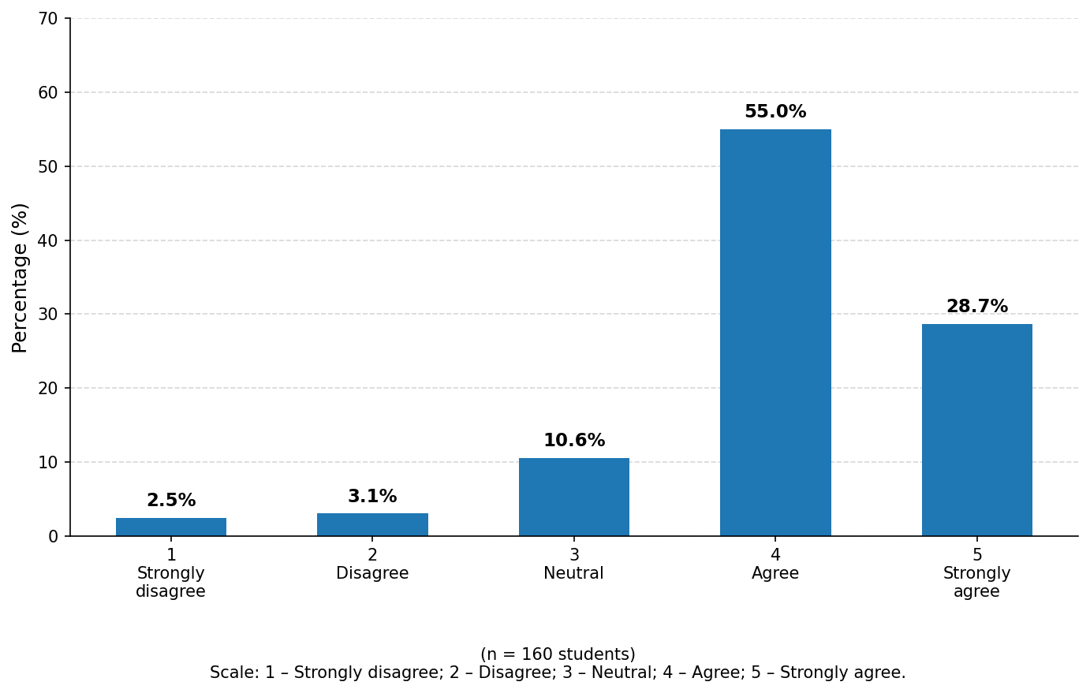
As shown in Figure 1, for the statement “Additional audiovisual materials are needed to support the study and development of interpreting skills,” 134 of 160 students selected Agree and Strongly agree (levels 4 and 5), accounting for 83.8%. Of these, 55.0% selected Agree and 28.7% selected Strongly agree. This result shows that most students require additional audiovisual resources to support the study and development of interpreting skills, especially listening comprehension, information processing, and real-time response in authentic communicative situations. These figures indicate that, although the current textbooks meet the requirements of content and topics relatively well, they remain limited in audio materials, videos, and simulated professional scenarios. This is one of the factors affecting the effectiveness of students’ practice in listening-based interpreting, real-time information processing, and rapid response.
In terms of teaching methods, lecturers combine the explanation of theory, guidance on interpreting techniques, and the organisation of in-class practice. Interviews with the lecturers who directly teach the Korean Interpreting and Advanced Korean Interpreting courses show that activities such as dialogue interpreting, paired and group interpreting practice, listening practice, and feedback on interpreting performance are carried out regularly, helping students form basic interpreting skills. However, current teaching still relies mainly on the textbooks and on pre-designed situations. Professionally oriented forms of practice-such as simulating real interpreting situations, developing rapid response, practising interpreting note-taking, handling lengthy utterances, and interpreting under time pressure-are not yet organised regularly. This may limit students’ opportunities to develop the specific professional competences they need, especially rapid response, real-time information processing, and adaptation to authentic communicative situations.
In terms of assessment, the Korean interpreting courses currently combine continuous assessment scores with the end-of-course examination. The assessment content includes attendance, regular assignments, mid-term tests, and the final examination. The main forms of assessment are listening-based oral interpreting and listening-based written translation tasks, which are broadly appropriate to the nature of an interpreting course. However, students’ learning outcomes in the Korean Interpreting and Advanced Korean Interpreting courses show that student performance remains uneven across classes. This is clearly shown in Table 2.
Table 2. Assessment results of the Korean interpreting courses across student cohorts in the 2022–2026 period
Class | Course | Excellent (%) | Good (%) | Average (%) | Weak (%) | Failing (%)
K20A | Korean Interpreting | 10.29 | 22.06 | 33.82 | 25.00 | 8.82
K20A | Advanced Korean Interpreting | 1.49 | 14.93 | 34.33 | 34.33 | 14.93
K20B | Korean Interpreting | 18.18 | 30.30 | 31.82 | 19.70 | 0.00
K20B | Advanced Korean Interpreting | 14.29 | 19.05 | 30.16 | 33.33 | 3.17
K21A | Korean Interpreting | 3.85 | 23.08 | 26.92 | 26.92 | 19.23
K21A | Advanced Korean Interpreting | – | – | – | – | –
K21B | Korean Interpreting | 1.59 | 22.22 | 31.75 | 33.33 | 11.11
K21B | Advanced Korean Interpreting | – | – | – | – | –
Source: Office of Testing & Student Management
The results in Table 2 show that completion levels for the interpreting courses still vary across classes. For the Korean Interpreting course, the combined proportion of students achieving Excellent and Good ranged from 23.81% in class K21B to 48.48% in class K20B. The proportion classified as Weak and Failing was relatively high in some classes, specifically 46.15% in class K21A and 44.44% in class K21B. For the Advanced Korean Interpreting course, class K20A had an Excellent-and-Good proportion of 16.42%, while the Weak-and-Failing proportion reached 49.26%; in class K20B, the two corresponding proportions were 33.34% and 36.50%. These overall course grades reflect only the level of course completion in aggregate and do not separately reveal students’ attainment in each competence component, such as listening comprehension, memory, note-taking, the accuracy and completeness of the content, expressive ability, pronunciation and intonation, the handling of terminology, and improvisation in communicative situations. Relying solely on overall grades therefore makes it impossible to identify clearly which skills students are weak in and what forms of support they require.
Interviews with the lecturers who directly teach the courses show that, although assessment already includes attendance, regular assignments, mid-term tests, and the final examination, the courses do not yet have a shared set of criteria for assessing interpreting competence. Some criteria are still described in general terms and have not been operationalised into specific indicators and attainment levels; the allocation of marks and the application of criteria are not yet fully consistent across lecturers. In addition, feedback after testing is not provided regularly and does not yet focus adequately on each of the learner’s competence components.
In terms of teaching staff, the Korean Interpreting and Advanced Korean Interpreting courses are taught by lecturers with expertise in Korean. The teaching staff have teaching experience and a sense of responsibility and have taken part in translation and interpreting work and in language support across various contexts. This is a favourable condition for delivering the interpreting courses and guiding students in developing the necessary professional skills. However, the lecturer interviews show that, alongside these advantages, teaching the interpreting courses still involves certain difficulties. Because few lecturers are involved in teaching interpreting and they must simultaneously take responsibility for many other specialised courses, the time available for developing materials, designing practice situations, updating authentic input, and conducting in-depth research on interpreting training is limited. This somewhat constrains the diversification of materials and the organisation of professionally oriented practice activities.
On the part of students, the survey results show that most Korean studies students clearly recognise the role of the interpreting courses in their studies and in their career orientation after graduation. Specifically, 41.3% selected level 4 (Necessary) and 46.9% selected level 5 (Very necessary), accounting for a combined 88.2% of respondents. The proportion rating the courses as strongly unnecessary or unnecessary accounted for only 6.9%. This result shows that most students highly value the significance and professional worth of the Korean interpreting courses and recognise the importance of interpreting skills for their studies and employment after graduation (Figure 2).
Figure 2. Students’ perceptions of the necessity of the interpreting courses
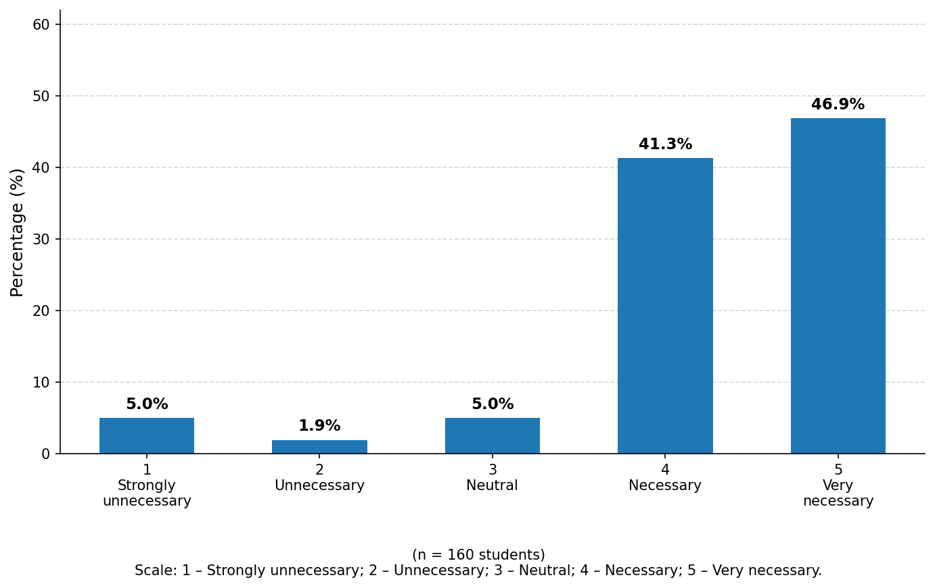
However, the survey results also show that students still face numerous difficulties in studying and developing interpreting skills, as shown in Figure 3.
Figure 3. Students’ difficulties in studying Korean interpreting
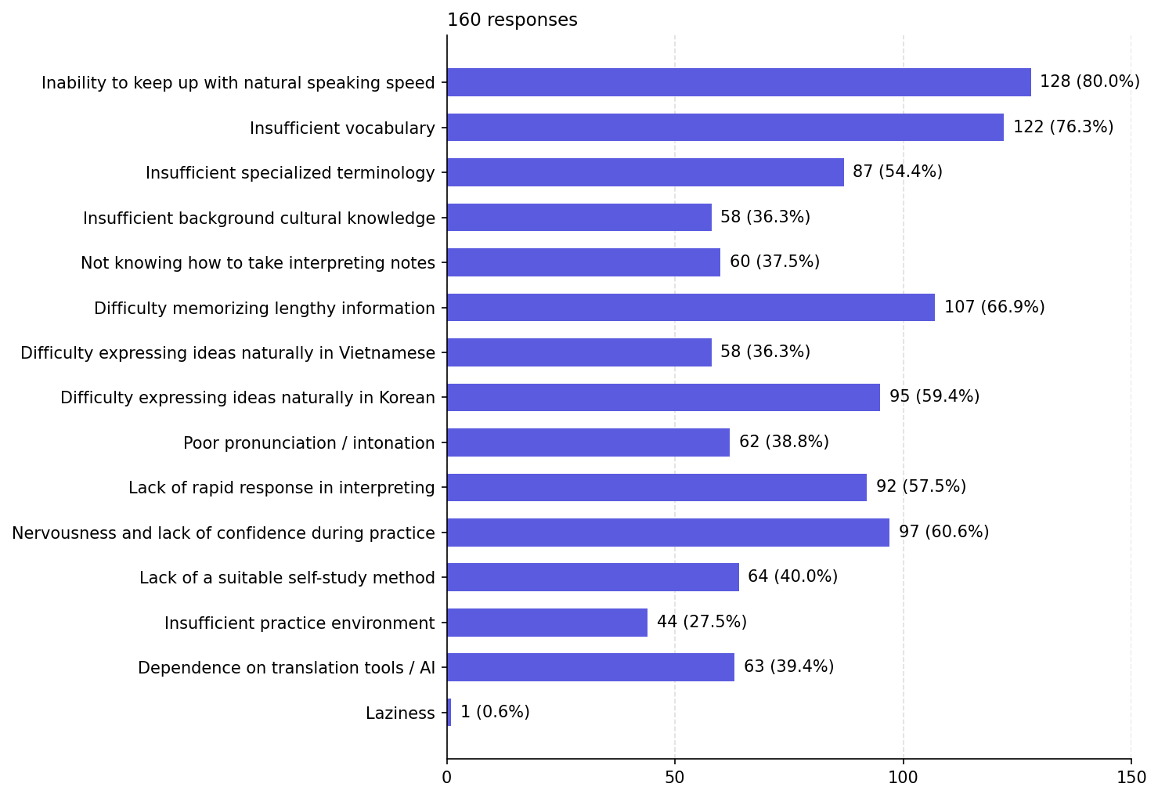
As shown in Figure 3, students’ most common difficulty is the inability to keep up with natural speaking speed, selected by 128 of 160 students (80.0%), followed by insufficient vocabulary (76.3%) and difficulty memorising lengthy information (66.9%). Difficulties related to practice were also relatively common, including nervousness and lack of confidence during practice (60.6%), difficulty expressing ideas naturally in Korean (59.4%), a lack of rapid response in interpreting (57.5%), and insufficient specialised terminology (54.4%). In addition, 38.8% of students considered their pronunciation and intonation to be poor, 37.5% did not know how to take interpreting notes, and 27.5% considered the practice environment to be insufficient.
Notably, 64 of 160 students (40.0%) reported that they did not have a suitable self-study method; at the same time, 63 of 160 students (39.4%) admitted that they still depended on translation tools or AI in their studies. Set against the 210 self-study hours prescribed for the two courses, this result shows that a proportion of students do not yet have a method for exploiting the self-study time effectively. Therefore, besides requiring students to practise proactively, it is necessary to strengthen guidance on content, progression, learning products, and self-assessment, and to position technology and AI as supporting tools rather than as a replacement for the learner’s own language processing.
Overall, although most students recognise the role of the interpreting courses, learners still face numerous difficulties in linguistic competence, component skills, affective challenges during practice, self-study methods, and the proactive use of technology. The analysis indicates that Korean interpreting training at the University of Sciences, Thai Nguyen University, has achieved some initial results but still has issues that require attention. At the level of management and the academic unit, these include limited in-class practice time, an insufficiently rich set of audiovisual materials and a limited practice environment, and the need to strengthen academic coordination and the assessment of each competence component. For lecturers, there is a need to continue diversifying practice activities, simulating professional situations, providing feedback, and guiding self-study. For students, there is a need to improve self-practice methods, strengthen initiative in practice, and use translation tools and AI in a guided and responsible manner. These observations provide the practical basis for the solutions proposed for institutional administrators, lecturers, and students in the following section.

3.2. Solutions for improving the effectiveness of Korean interpreting training at the University of Sciences, Thai Nguyen University
The findings show that the effectiveness of Korean interpreting training is shaped simultaneously by the conditions of management and training organisation, lecturers’ teaching methods, and students’ learning awareness and methods. The solutions therefore need a clear division of responsibilities among the university and the academic unit, the lecturers, and the students.
3.2.1. At the institutional level
First, adjust course content and delivery to increase practice opportunities and provide differentiated instruction.
The current programme arranges the interpreting courses along a relatively reasonable progression, from Korean Interpreting to Advanced Korean Interpreting, with prerequisite requirements. Adjustment therefore does not require changing the entire structure of the programme but should focus on the proportion and organisation of practice activities.
The university and the department should review the allocation of course hours for each course and consider shifting an appropriate portion of theoretical content to practice in the form of listening, memory, note-taking, consecutive interpreting, rapid response, and the simulation of professional situations. A system of tasks at multiple levels could also be developed to accommodate differences in linguistic competence and learning outcomes among groups of students. Students who are still struggling would benefit from support in consolidating vocabulary, listening comprehension, and expression, whereas more advanced students could be given tasks involving faster delivery, longer passages, and greater subject-matter specialisation.
Beyond the regular timetabled hours, the university could arrange thematic practice sessions, club activities, or extracurricular interpreting-practice programmes to increase practice opportunities without substantially increasing the programme’s credit load.
Second, build and standardise a system of audiovisual materials and a bank of interpreting exercises.
The survey results show that most students require additional audiovisual materials to support the study and development of interpreting skills. The university and the department should therefore build a shared system of materials, including audio files, videos, scenario scripts, terminology lists, and exercises in memory, note-taking, consecutive interpreting, and rapid response.
These materials should be classified by topic, level, speaking speed, utterance length, and degree of specialisation. Each topic should include input ranging from slow to natural speed, from short to long utterances, and from scripted situations to semi-natural or simulated real communication. The content should be linked to common contexts of Korean use, such as business, recruitment, education, tourism, cultural exchange, conferences, and Viet Nam–Republic of Korea cooperation.
The university also needs a mechanism to support the time, funding, and storage required for lecturers to build, update, and share materials. Materials development should not rest with individual lecturers alone but should follow a shared departmental plan.
Third, develop a core team of lecturers and strengthen academic coordination.
Because few lecturers are currently involved in teaching interpreting and they also teach many other courses, the university should plan to develop a core team of specialised or semi-specialised lecturers in Korean translation and interpreting. These lecturers should be given opportunities to take part in refresher courses, conferences, and training on interpreting-training methods, materials design, competence assessment, and the use of technology in teaching.
The department could establish a disciplinary working group on translation and interpreting to coordinate syllabus development, agree on teaching progression, share materials, compile exercises, organise class observation, and exchange teaching practices and professional experience. Such a group would help reduce the pressure on individual lecturers, increase continuity, and ensure consistency across classes, cohorts, and courses.
The university may also invite interpreters, industry experts, Korean lecturers, or alumni with professional experience to take part in thematic sessions, guide practice, or share real cases.
Fourth, build a competence framework and a shared set of assessment criteria.
The department should develop a unified set of criteria for assessing interpreting competence for both the Korean Interpreting and Advanced Korean Interpreting courses. These criteria should include components such as accuracy, completeness of information, expressive ability, fluency, pronunciation and intonation, the handling of terminology, situational response, intercultural communicative competence, and professional conduct.
The university and the department should specify the requirements of each level, the allocation of marks, and the principles for applying the criteria in mid-term tests, end-of-course examinations, and continuous assessment. Cross-marking and moderation exercises among lecturers are also recommended to limit differences in the understanding and application of the criteria.
Fifth, expand the practice environment and connect with professional practice.
To address the limitations of the practice environment, the university and the department should strengthen coordination with Korean enterprises, educational organisations, cultural centres, external-relations units, and Viet Nam–Republic of Korea exchange programmes. Students could take part in observation, language support, or practice in activities appropriate to their level and under the guidance of lecturers.
It is also advisable to maintain an interpreting club, translation-practice groups, academic competitions, and simulated-event sessions to create a regular practice environment outside the timetabled hours.
3.2.2. For lecturers
First, standardise the organisation of learning activities before, during, and after class.
Before class, lecturers should provide the topic, vocabulary, terminology, and preparatory materials so that students can prepare their background knowledge. Students may be asked to look up terminology, listen to a passage of input in advance, or build a personal vocabulary list. During class, practice activities should be sequenced from simple to complex: listening and identifying the main idea; listening and memorising information; noting keywords; summarising; transferring language by sentence or passage; consecutive interpreting; handling situations; and simulating professional activities. After class, lecturers should assign practice tasks with specified deliverables, such as audio recordings, videos, learning journals, or self-assessment sheets. This process turns the self-study workload prescribed in the programme into a guided activity rather than leaving it to students’ spontaneous initiative.
Second, innovate teaching methods to develop each component of interpreting competence.
For difficulties in keeping up with natural speaking speed, lecturers can use input of gradually increasing speed and guide students in recognising keywords, main ideas, transition markers, and discourse structure. Repeated listening, segmented listening, and shadowing may be combined before moving to listening at natural speed.
For limited vocabulary and specialised terminology, each topic should include a list of key terms, vocabulary-preparation exercises, and activities for using terminology in context. Students should be guided in building a personal terminology notebook rather than learning isolated words.
For difficulties in memorising and handling lengthy utterances, lecturers can strengthen exercises in memory, summarisation, the analysis of information structure, and interpreting note-taking. Note-taking can be taught along a progression from noting keywords, symbols, and figures to representing the logical relationships among ideas.
For limited rapid response and natural expression, additional exercises in retelling, reformulation, paraphrasing, rapid interpreting, handling unexpected situations, and rendering the same content in several ways are recommended.
For nervousness and lack of confidence, lecturers should organise practice at progressive levels, from individual to paired, small-group, and whole-class presentation; create opportunities for students to redo a task after receiving feedback; and limit the pressure of marks during the initial practice stage.
Third, strengthen regular feedback and support differentiated instruction.
Lecturers should monitor students’ progress through short, regular tasks rather than relying solely on mid-term and final examination marks. Feedback should indicate clearly which component a student is struggling with-for example, listening comprehension, memory, conveying content, expression, pronunciation, terminology, or situational handling.
Students with low results would benefit from supplementary tasks and guidance toward an appropriate practice plan, whereas more advanced students could be given more challenging input and more professionally oriented tasks. This approach helps address differences in competence among classes and among groups of learners.
Fourth, carry out assessment according to a unified competence framework.
Lecturers should use the shared criteria developed by the department and make them public to students from the outset of the course. In addition to the overall mark, results should be reported for each competence component so that students can recognise their strengths and areas for improvement.
Forms of assessment should be diversified, including listening and summarising, memorising information, note-taking, consecutive interpreting, dialogue interpreting, situational handling, and professional simulation. Lecturer assessment may be combined with self-assessment and peer assessment, although the lecturer remains primarily responsible for the official results.
Storing some products in audio or video form helps lecturers monitor students’ progress over time and provide more specific feedback.
Fifth, guide students in the responsible use of technology and AI.
Lecturers should specify the purpose and limits of using tools such as ChatGPT, Papago, or Google Translate. Students should carry out the listening, analysis, and expression tasks themselves before consulting such tools, then compare the results, identify errors, and explain the adjustments they have made.
AI may be used to create additional practice situations, check forms of expression, expand vocabulary, or support feedback, but it should not replace students’ own processes of listening comprehension, memory, and language transfer.
3.2.3. For students
First, foster a sense of responsibility and build a regular self-study plan.
Students should recognise that interpreting competence cannot be formed through class hours alone but requires regular, systematic practice. Each student should build a weekly self-study plan that clearly identifies the content, duration, deliverables, and self-assessment criteria.
Self-study should include listening practice, shadowing, summarising, note-taking, expanding vocabulary and terminology by topic, oral interpreting, and recording and re-listening to one’s own performances. Students should keep their practice work as a learning portfolio in order to monitor progress and identify skills that still need improvement.
Second, proactively address limitations in language and interpreting skills.
Students should build a personal vocabulary and terminology notebook by topic; regularly practise listening to Korean at various speeds and with various voices; practise re-expressing content in both Korean and Vietnamese; and develop their memory, note-taking, and summarising skills.
To build confidence, students should take an active part in paired and group practice, volunteer to present before the class, and regard mistakes as part of developing competence. Repeated practice after receiving feedback is important for developing rapid response and natural expression.
Third, take an active part in practice environments outside the classroom.
Students should take an active part in the Korean language club, interpreting-practice groups, academic competitions, exchange programmes with Korean speakers, conferences, events, and language-support activities appropriate to their competence. Such activities extend practice time, increase adaptability to real situations, and help develop professional conduct.
More advanced students can help support practice groups and share materials with classmates under the guidance of lecturers, thereby creating a collaborative learning environment within the department.
Fourth, use technology and artificial intelligence proactively and responsibly.
Students should not use translation tools or AI to produce a finished result before processing the task themselves. The appropriate procedure is to listen, take notes, express, and self-assess first, and only then use technology to compare, detect errors, and make adjustments.
Students should record the errors detected with the support of these tools, check the accuracy of the information, and avoid mechanically copying translation options that do not suit the context. Used responsibly, technology brings out the supportive role of AI without diminishing learners’ thinking, responsiveness, and linguistic autonomy.

4. Conclusion
Korean interpreting training is an important component of the Korean Studies programme at the University of Sciences, Thai Nguyen University, contributing to students’ ability to use Korean in professional environments. Given the increasing demand for Korean-proficient personnel, improving the effectiveness of interpreting training matters not only for the quality of the university’s provision but also for meeting the practical requirements of the labour market.
Based on theoretical and practical analysis, this study shows that Korean interpreting training at the university has achieved some initial results. The Korean Interpreting and Advanced Korean Interpreting courses have been incorporated into the programme, and the teaching content is linked to common communicative situations and some basic professional contexts. Lecturers have combined theoretical guidance with practice, and students have begun to recognise the role of interpreting skills in their career orientation after graduation.
However, the training process still has a number of limitations. The main limitations include limited practice time, a limited range of audiovisual materials, the absence of a systematically developed bank of interpreting exercises, the infrequent simulation of real situations, assessment criteria that are not yet sufficiently specific, the small number of specialised lecturers, and the limited self-study capacity of some students. These factors are closely interrelated and jointly affect the development of learners’ interpreting competence.
Based on these findings, the study proposes a number of solutions for improving the effectiveness of Korean interpreting training at the University of Sciences, Thai Nguyen University: refining the programme and teaching content; developing the system of textbooks, audiovisual materials, and a bank of practice exercises; reforming teaching methods to strengthen practice and the simulation of professional situations; improving assessment along competence-based and formative lines; developing a team of specialised lecturers; and enhancing students’ awareness, self-study methods, and appropriate use of technology.
These findings suggest that improving the effectiveness of Korean interpreting training requires coordinated, sustained efforts involving the university, the lecturers, and the students. The university orients the programme, ensures training conditions, and develops staff; lecturers organise, guide, give feedback on, and assess the learning process; and students are the primary agents responsible for developing their own interpreting competence. If these solutions are implemented in ways that are responsive to institutional conditions, the quality of Korean interpreting training at the University of Sciences, Thai Nguyen University, will gradually improve, contributing to the training of Korean-proficient personnel with practical competence, adaptability, and a stronger ability to meet professional requirements in the current context.

REFERENCES
[1] Gile, D. (2009). Basic concepts and models for interpreter and translator training. John Benjamins Publishing Company.
[2] Pöchhacker, F. (2016). Introducing interpreting studies. Routledge.
[3] Sawyer, D. B. (2004). Fundamental aspects of interpreter education: Curriculum and assessment. John Benjamins Publishing Company.
[4] Setton, R., & Dawrant, A. (2016). Conference interpreting: A complete course. John Benjamins Publishing Company.
[5] Kelly, D. (2005). A handbook for translator trainers: A guide to reflective practice. St. Jerome Publishing.
[6] Nord, C. (1997). Translating as a purposeful activity: Functionalist approaches explained. St. Jerome Publishing.
[7] Woo, C. (2024). Learning competencies required for Korean language education and Korean interpretation and translation. Language and Culture, 20(4), 175–196.
[8] Lee, J. (2021). Students' understanding of interpreting competence: A longitudinal study. Interpretation and Translation, 23(1), 161–184.
[9] Lê, H. T. (2017). On the theoretical foundations of translator and interpreter training in Vietnam. Journal of Foreign Studies, 33(2), 105–117.
[10] Lê, H. T. (2022). An overview of translation pedagogy approaches worldwide and implications for translator and interpreter training in Vietnam. Journal of Foreign Studies, 38(1), 1–14.
[11] Trần, T. H., Nguyễn, T. T. V., & Đỗ, T. H. (2022). Lessons from translator and interpreter training in South Korea for improving translator and interpreter education in Vietnam. Journal of Foreign Studies, 38(1), 69–90.
[12] Dương, T. H., & Trần, T. T. H. (2024). Interpreting career orientation among Korean Studies students at Thai Nguyen University of Sciences. Thai Nguyen University Journal of Science and Technology, 229(8), 139–146.
[13] Seleskovitch, D., & Lederer, M. (1989). Pédagogie raisonnée de l'interprétation. Didier Érudition.
[14] Nida, E. A., & Taber, C. R. (1969). The theory and practice of translation. Brill.
[15] Vermeer, H. J. (1989). Skopos and commission in translational action. In A. Chesterman (Ed.), Readings in translation theory.
[16] Toury, G. (1995). Descriptive translation studies and beyond. John Benjamins.
[17] Government News (VGP). (2025). South Korea's investment in Viet Nam hits US$92 bln. https://en.baochinhphu.vn/south-koreas-investment-in-viet-nam-hits-us92-bln-111250515092839514.htm
[18] Korean Education Center in Vietnam. (2025). Status of Korean language and Korean studies education in Vietnam. http://www.kecvn.com/sub/sub3_7.php

