Development Of An Ai-Integrated Smart Weighing Bowl With Temperature Detection

ABSTRACT
Recent advancements in artificial intelligence (AI), sensor technologies, and Internet of Things (IoT) systems have transformed traditional kitchen environments into more intelligent and efficient food preparation spaces. However, many existing kitchen devices remain limited to single-purpose functionalities, requiring users to operate multiple tools separately for weighing, monitoring temperature, and recipe management. This study presents the development of an AI-Integrated Smart Weighing Bowl with Temperature Detection designed to improve cooking accuracy, workflow efficiency, and intelligent user assistance during food preparation. The proposed system integrates Arduino-based hardware components, including a load cell sensor with an HX711 amplifier module and a DS18B20 temperature sensor, together with a Flutter-based mobile application and Firebase Firestore cloud database. An AI-powered recommendation module was incorporated to analyze user inputs and measurement data in order to provide contextual recipe suggestions, ingredient guidance, and cooking alerts in real time. The system architecture was developed using an Agile-Kanban methodology to support iterative planning, software development, hardware integration, testing, and evaluation. Functional testing demonstrated that the prototype was capable of monitoring ingredient weight and temperature while simultaneously providing AI-assisted cooking recommendations through a mobile dashboard interface. Firebase integration enabled reliable cloud synchronization for user records, cooking history, and personalized preferences. Although full real-time sensor-to-application synchronization remains under further optimization, the developed prototype successfully established the feasibility of combining intelligent sensing, cloud communication, and AI-driven analysis within a single smart kitchen platform. The study contributes to the growing field of smart kitchen technologies by offering a scalable and user-centered framework that enhances food preparation accuracy, reduces manual workload, and promotes more informed cooking decisions for both household and professional culinary environments.
Keywords:
Artificial Intelligence, Smart Weighing Bowl, Temperature Sensing, IoT, Smart Kitchen, Flutter, Firebase
INTRODUCTION
The rapid advancement of digital technologies has significantly transformed modern kitchen environments, leading to the development of intelligent appliances designed to improve efficiency, precision, and convenience in food preparation. The integration of artificial intelligence (AI), sensor-based monitoring, and cloud-connected systems has enabled traditional kitchen tools to evolve into smart devices capable of providing real-time assistance and data-driven decision support. Modern culinary processes increasingly require precise ingredient measurement and temperature regulation to ensure consistency, food quality, and accurate recipe execution, particularly in cooking and baking applications where even minor variations may affect texture, flavor, and overall product quality. The emergence of smart kitchen technologies has created opportunities to address these challenges through automated monitoring and intelligent guidance systems that enhance both professional and domestic food preparation practices.
Despite the availability of digital weighing scales, thermometers, and other specialized kitchen instruments, existing solutions remain fragmented and often require users to operate multiple independent tools during food preparation. This separation of functionalities creates workflow inefficiencies, increases the possibility of human error, and limits users’ ability to maintain optimal cooking conditions in real time. In addition, most conventional kitchen devices lack intelligent features capable of analyzing measurement data and providing contextual recommendations that support recipe adherence and ingredient optimization. Existing smart kitchen systems often focus on isolated functionalities, such as weight measurement or temperature monitoring, without integrating these capabilities into a unified and accessible platform. These limitations create a significant gap in intelligent culinary assistance technologies, particularly for users seeking an efficient and practical tool that simultaneously supports measurement accuracy, temperature monitoring, and real-time decision-making during food preparation.
In response to these challenges, this study presents the development of an AI-integrated smart weighing bowl with temperature detection designed to provide an intelligent and multifunctional kitchen assistance system. The proposed system aims to design and develop a prototype capable of combining ingredient weight measurement, temperature sensing, AI-assisted recipe recommendations, and cloud-based user interaction into a single integrated platform. Specifically, the study seeks to develop a smart weighing bowl prototype equipped with sensing components for accurate measurement and monitoring, establish a system architecture that supports simultaneous ingredient analysis and efficient workflow integration, and incorporate an AI component capable of generating data-informed recommendations, alerts, and guidance based on user inputs and available measurement data.
The scope of the study focuses on the development of a mobile application using Flutter, cloud-based data storage through Firebase Firestore , and an AI-assisted recommendation framework that supports intelligent culinary guidance. The system architecture also includes Arduino-based hardware integration intended to support weighing and temperature sensing functions. While prototype hardware components were prepared and partially implemented, full real-time synchronization between the physical sensors and the mobile application remains under further development and validation. Consequently, the present study is primarily limited to software implementation, prototype-level sensor integration, and foundational framework development for future Internet of Things (IoT)-enabled smart kitchen expansion. Commercial-scale deployment, long-term durability assessment, and complete live hardware-software synchronization are beyond the current scope of this research.
This study is significant because it contributes to the growing field of intelligent kitchen technologies by proposing an accessible, integrated, and user-centered solution to common challenges in food preparation. For home users, the system offers improved convenience, measurement consistency, and guided cooking assistance that may reduce preparation errors and improve recipe outcomes. For culinary professionals, it provides a framework for enhancing precision and process standardization. From a technological perspective, the study contributes to ongoing research on AI-driven smart appliances, IoT integration, and sensor-assisted decision support systems. By combining measurement accuracy, temperature monitoring, and intelligent recommendation capabilities within a single prototype, the proposed system establishes a foundational model for future smart kitchen innovations aimed at improving cooking efficiency, food quality, and intelligent user interaction.
The general objective of this study is to design and develop an AI-integrated smart weighing bowl that enhances measurement accuracy, monitoring efficiency, and intelligent assistance in food preparation.
Specifically, the objectives of this study are as follows:
- To create an intelligent weighing bowl that features dependable and accurate weight and temperature sensors to address the variability and inaccuracies often found in conventional kitchen instruments. This will assist users in attaining more precise measurements and enhanced results in their recipes.
- To create an integrated system that can monitor both the weight and temperature of ingredients at the same time, minimizing the need for multiple instruments and slow workflow inefficiencies in the cooking process. This initiative seeks to offer users a more efficient and convenient food preparation experience.
- To integrate an AI component that examines live measurement data and provides valuable suggestions, warnings, and assistance, allowing users to sustain ideal ingredient conditions, to adhere to the recipe and achieve greater precision, and enhance overall cooking quality with data-informed support.

RELATED LITERATURE AND STUDIES
AI AND SENSOR-BASED SMART KITCHEN
A study conducted by researchers from Mapúa University developed a food recognition scale integrated with Artificial Intelligence (AI) and a mobile application. The system used image recognition (via TensorFlow) combined with a weighing mechanism to determine the nutritional content of food in real time. The study highlighted how integrating AI with weighing devices improves accuracy in food tracking and promotes healthier eating habits. This supports the present study as it demonstrates how AI and weighing technology can be combined in a single device similar to the smart bowl. However, the “Development of an AI-Integrated Smart Weighing Bowl,” improves this by adding temperature detection, which enhances food safety monitoring. (Mapúa University, 2024).

Furthermore, The Department of Science and Technology – Food and Nutrition Research Institute (DOST-FNRI) developed a mobile dietary survey system with AI-based food recognition to improve the accuracy of nutritional data collection in the Philippines. The system automates food identification and dietary analysis using AI tools. This research supports the importance of AI in food analysis and nutrition monitoring, which aligns with smart weighing bowl’s purpose of providing intelligent food-related data (DOST-FNRI, Philippines, 2024).

Moreover, A local undergraduate thesis developed an automated rice weighing and dispensing machine using sensors and programmable logic control. The system achieved high accuracy with minimal error and reduced manual labor in weighing processes. This study shows the effectiveness of automation and sensor-based weighing systems, which is a foundation for AI-integrated bowl. The project extends this by incorporating AI and temperature sensing, making it more advanced (De La Salle University Thesis, 2007).

On the other hand, Due to the advent of precision livestock farming with modern technology called the Internet of Things (IoT), there has been a revolution in the agriculture sector that aims to increase productivity and sustainability while sustaining animal welfare. Within the Philippine context, where smallholder farming communities predominate, adopting these advanced techniques holds immense potential to improve resource utilization, optimize production processes, and empower rural livelihoods. This research is a systematic literature review that considers the pros and cons of the applications of digital technology and precision livestock farming in the Philippines.

The review synthesizes existing research to identify the key advancements, challenges, and opportunities within this domain, addressing the overarching question: What is the current state of implementation and adoption of precision livestock farming and IoT applications in the Philippines, and what are the associated technical, socio-economic, and policy-related barriers and facilitators? The study employed a thorough systematic search strategy, wherein the publications from inception to March 2024 were published in various databases. The project aligns with this trend by combining AI, sensors (weight + temperature), and possibly IoT, contributing to smart device innovation in the Philippines. (Ceylon Journal of Science, 2025).

Moreover, This study introduces a novel fuzzy logic algorithm tailored to the thermoneutral zone of poultry, offering a precise and adaptive approach to feed dispensation. This involved the utilization of an LCD module to present essential information such as the selected age, real-time ambient temperature, current time, and the dispensed feed quantity. Data gathered during the process were stored in a memory device. The design of the fuzzy logic algorithm centered on the thermoneutral zone of the chicken serves as the determinant for feed dispensed by the system. It's crucial to note that while the system lacked artificial intelligence (AI), its logical analysis operated based on the fuzzy logic algorithm. Rigorous testing ensued, encompassing the comparison of feed dispensation between automated and manual systems and the assessment of feed waste and broiler weight. Significant feed waste reduction in the first week demonstrated the efficacy of the fuzzy-based method, with consistently low p-values of 0.00069, 0.015195, and 0.034 across subsequent weeks confirming the consistent outperformance in broiler weight compared to the traditional feeding technique. The findings contribute to the advancement of temperature-based poultry feed systems, addressing key challenges in optimizing feed quantity. The study successfully met its objectives, demonstrating the system's capability to dispense feeds effectively across varying ambient temperatures. Notably, the study revealed a consistent alignment of system outputs with those obtained from a digital thermometer and digital weighing scale, confirming the accuracy and reliability of the temperature-based feed dispensing system. This supports the integration of temperature sensors in automated systems, which is directly related to “Development of an AI-Integrated Smart Weighing Bowl”feature for food safety. (Cavite State University Study, 2024).

Moreover, contaminated and polluted water poses significant threats to human health, necessitating vigilant monitoring of water sources for potential contamination. This paper introduces a low-cost Internet of Things (IoT)-based water quality monitoring system designed to address water quality challenges in rural communities, as demonstrated through a case study conducted in the Philippines. The system consists of two core components. The hardware component of the system, built on Arduino technology and featuring real-time data transmission, focuses on monitoring pH levels, turbidity, and temperature via sensors. The system is equipped to transmit data to a cloud database and send informative messages to mobile numbers, updating users on the status of water supplies. This supports the use of sensor-based monitoring and real-time data transmission, which is similar to “Development of an AI-Integrated Smart Weighing Bowl” and AI feedback system. (Khavee Botange, 2024).

Furthermore, manual monitoring in aquaponics requires extensive labor but often fails to detect fish health and growth problems in their early stages. This review combines current research about smart aquaponics through the implementation of Internet of Things (IoT) and image-processing systems for monitoring fish growth. The research included a systematic evaluation of studies that applied IoT and computer vision technologies and their joint use in aquaponic systems. The integration of these technologies shows the greatest potential for real-time, automated, non-invasive monitoring of fish growth parameters, according to research findings. The authors are conducting an ongoing thesis project on this combined approach, although results remain pending; however, the project supports the current relevance of this review. The widespread adoption of these technologies faces ongoing challenges due to high capital expenses and system integration difficulties and insufficient consideration of socioeconomic factors. Research should focus on developing affordable, scalable solutions with user-friendly interfaces while creating standardized methods for performance evaluation. The combination of IoT technology with image processing methods creates a revolutionary advancement in improving data-driven sustainable aquaponic systems. This demonstrates how smart monitoring systems combine sensors and AI, supporting the system's design of combining weighing + temperature + intelligent processing. (Central Luzon State University, 2026).
IOT-BASED SMART KITCHEN AUTOMATION AND MONITORING SYSTEM
According to the study titled “IoT-Based Smart Kitchen Automation and Monitoring System” (2025), researchers emphasize that the increasing complexity of modern kitchens and the growing demand for automation have led to the development of Internet of Things (IoT) systems designed to improve efficiency, accuracy, and convenience in food preparation environments. Traditional kitchen processes often rely heavily on manual input and monitoring, which can result in inconsistent performance, human error, and challenges in maintaining optimal environmental conditions. To address these limitations, the study explores the implementation of IoT sensors, real-time monitoring tools, and automated control mechanisms that collectively enhance kitchen operations. The authors describe how various sensor technologies including temperature, humidity, and motion detectors are integrated into a unified IoT platform to collect and transmit data continuously. This real-time data enables automated decisions, such as adjusting temperatures or alerting users to food status changes, effectively reducing the need for constant manual supervision. The system also supports remote monitoring capabilities, allowing users to track kitchen conditions via mobile devices or cloud interfaces. Despite the advantages of improved responsiveness and data visibility, the study notes challenges such as system scalability, cybersecurity concerns, and the need for user-friendly interfaces that can be adopted by individuals with varying levels of technical expertise. The findings of this study highlight the potential of IoT-enabled kitchen automation to transform food preparation and safety management by enhancing consistency and reducing reliance on manual interventions. These insights are relevant to the present capstone project, “Development of an AI-Integrated Smart Weighing Bowl,” as they demonstrate the value of incorporating real-time sensing, data connectivity, and automated processes to improve accuracy and efficiency in food-related tasks.
Furthermore, Narendran, Janani, Balamurugan, Janarthanan, Chandra Dev, and Raghuram (2024) highlight that the increasing complexity of kitchen management tasks has driven the development of intelligent IoT-based systems designed to automate and optimize everyday food preparation and monitoring processes. The study emphasizes that traditional kitchen operations often rely on manual effort and lack real-time data feedback, which can lead to inefficiencies, inconsistency in task performance, and challenges in maintaining inventory levels and food safety standards. To address these limitations, the authors explored the design and implementation of an IoT-enabled smart kitchen system that integrates multiple sensors, cloud connectivity, and mobile interface capabilities. In this system, ultrasonic sensors were used for grocery inventory monitoring, while adaptive fuzzy logic was applied to cooking processes to adjust parameters autonomously based on real-time data. A mobile application interface allowed users to view inventory levels, receive notifications for low stock, and access automated cooking insights. The integration of Wi-Fi connectivity and cloud services enabled seamless data updating and remote interaction, reducing dependence on direct human supervision. While the system demonstrated significant improvements in responsiveness and data visibility, the authors noted challenges related to system scalability, sensor calibration, and user-friendly design. Narendran et al. (2024) concluded that IoT-integrated smart kitchen solutions offer promising potential for enhancing food management, reducing manual workload, and improving operational accuracy. These findings are relevant to the present capstone project, “Development of an AI-Integrated Smart Weighing Bowl,” as they support the integration of intelligent sensors and adaptive automation technologies to promote real-time monitoring, accuracy, and user convenience in food preparation and handling environments.
Moreover, Raj, Sharma, and Gupta (2025) emphasize that the integration of advanced sensor networks and real-time monitoring capabilities into kitchen and food service environments has the potential to significantly improve efficiency, accuracy, and user experience. The study discusses how traditional kitchen processes are often limited by manual measurement practices and inconsistent monitoring, which can lead to errors in food preparation, food waste, and poor tracking of inventory levels. To address these limitations, the authors explored an IoT-based smart kitchen framework that incorporates multiple environmental sensors, automated data processing, and remote access via mobile and cloud platforms. In the proposed system, temperature, humidity, gas, and motion sensors were integrated into a centralized control module that continuously collected data to monitor food conditions and kitchen status. Real-time data transmission through Wi-Fi enabled users to access updates remotely, receive alerts for specific threshold breaches (e.g., high temperature or low ingredient levels), and adjust environmental settings accordingly. Additionally, the study highlighted the role of automated decision-making algorithms that reduced human involvement in routine tasks, improved operational responsiveness, and minimized the likelihood of errors. Raj et al. (2025) further noted that despite the promising improvements, challenges remain in terms of ensuring seamless connectivity, maintaining sensor accuracy over time, and designing interfaces that are accessible to users with varying technical expertise. Nonetheless, the findings support the effectiveness of intelligent monitoring and automation systems in becoming integral to modern kitchens. These insights are relevant to the present capstone project, “Development of an AI-Integrated Smart Weighing Bowl,” as they reinforce the importance of embedding real-time sensor networks and automated data interpretation to enhance measurement precision and operational convenience in food preparation and handling environments.
IOT-ENABLED SMART KITCHEN TECHNOLOGIES AND THEIR IMPACT ON FOOD STORAGE, PREPARATION, AND CULINARY EXPERIENCES: A SYSTEMATIC REVIEW
According to a study titled “IoT-Enabled Smart Kitchen Technologies and Their Impact on Food Storage, Preparation, and Culinary Experiences: A Systematic Review” by Golshany, Ni, Yu, and Fan (2025), the integration of Internet of Things (IoT) technologies in kitchen environments has significantly transformed how food is stored, prepared, and managed. The study reviewed a wide range of smart kitchen systems developed between 2018 and 2024, focusing on their ability to enhance efficiency, reduce food waste, and improve user engagement through connected devices. Golshany et al. (2025) explained that traditional kitchen practices often lack data-driven insights, making it difficult to monitor food conditions or optimize preparation processes. To address these limitations, the authors highlighted advancements in IoT-enabled appliances such as smart refrigerators that track food freshness, automated cooking tools that adjust parameters based on sensor feedback, and connected monitoring systems that provide real-time updates to users. These technologies help bridge the gap between manual food management and intelligent automation. The study further emphasized that the use of real-time sensors and networked communication allows users to receive notifications, analyze trends, and make informed decisions about food handling. Such features not only improve overall kitchen performance but also support healthier dietary practices and more sustainable food consumption behaviors. These findings are relevant to the present capstone project, “Development of an AI-Integrated Smart Weighing Bowl,” as they demonstrate the growing importance of smart technologies in food measurement and monitoring. The study supports the integration of intelligent systems to promote accuracy and user convenience in food-related tasks. Furthermore, Patil, Gómez-López, and Vázquez-Armenta (2025) highlight that advancements in smart food safety technologies have become increasingly important as food systems grow more complex and globalized. The increasing demand for safe, high-quality food products has been accompanied by the need for faster and more reliable monitoring systems. Traditional laboratory-based food safety assessments are often time-consuming and reactive, which may delay the detection of contamination and increase potential risks to consumers. As a result, there is a growing emphasis on the development of real-time, sensor-based monitoring technologies capable of improving food safety management. Higher accuracy and efficiency have been reported in systems that integrate Internet of Things (IoT) devices, biosensors, and machine learning algorithms to monitor critical food parameters such as temperature, moisture content, pH levels, and microbial activity. These smart technologies enable continuous data collection and automated analysis, reducing human error and allowing immediate corrective actions when irregularities are detected.
However, despite technological progress, challenges remain in terms of cost, accessibility, and integration into existing food production infrastructures, particularly in less technologically advanced regions. Patil et al. (2025) recommend the adoption of intelligent, real-time monitoring systems that are cost-effective, scalable, and adaptable to various food environments. The study emphasizes that integrating smart sensing technologies into everyday food-handling devices can significantly enhance safety, quality control, and consumer confidence. These findings are relevant to the present capstone project, “Development of an AI-Integrated Smart Weighing Bowl,” as they support the application of sensor-based and AI-driven systems in food preparation settings to improve measurement accuracy, safety monitoring, and overall efficiency.
Moreover, Yang, Jiao, Zouyi, Diao, and Xia (2025) emphasize that the rapid advancement of artificial intelligence (AI) technologies has significantly transformed modern food systems, particularly in the areas of quality monitoring, safety assurance, and production optimization. As global food demand continues to increase, traditional food inspection and monitoring processes are often insufficient due to their manual, time-consuming, and reactive nature. This has led to a growing need for intelligent systems capable of real-time analysis, predictive modeling, and automated decision-making in food-related operations. The study discusses how AI applications such as machine learning algorithms, computer vision systems, and predictive analytics are being utilized to detect contaminants, assess food quality parameters, estimate shelf life, and enhance traceability across the supply chain. These technologies enable continuous data collection and accurate pattern recognition, allowing early identification of potential risks and reducing reliance on human intervention. Despite these advancements, the authors note challenges including data integration issues, computational complexity, and the need for high-quality datasets to ensure reliable AI performance. Yang et al. (2025) further highlight that AI-driven systems contribute to improved efficiency, reduced food waste, and enhanced transparency within the food industry. The integration of intelligent technologies into food handling devices supports safer and more precise food management practices. These findings are relevant to the present capstone project, “Development of an AI-Integrated Smart Weighing Bowl,” as they provide strong evidence supporting the use of AI-based monitoring and analysis tools in improving accuracy, safety, and efficiency in food preparation environments.
On the other hand, da Silva Ferreira, Ahmed, Oliveira, Sarang, Ramsay, Liu, Malvandi, Lee, and Kamruzzaman (2025) assert that recent innovations in artificial intelligence (AI)-enabled optical sensing techniques are revolutionizing traditional food drying processes by enhancing both efficiency and product quality. As conventional food drying methods often require manual sampling and lack continuous monitoring, this limitation has historically hindered quality control and energy optimization in food processing. Recognizing these challenges, the authors reviewed emerging smart drying technologies that integrate AI with optical sensors to facilitate real-time and precision monitoring of moisture content and drying dynamics. AI-enabled systems, such as near-infrared (NIR) spectroscopy, hyperspectral imaging (NIR-HSI), and conventional RGB imaging combined with advanced machine learning algorithms, were identified as key components in overcoming the shortcomings of traditional drying techniques. These smart technologies allow continuous data capture and automated pattern recognition, enabling early detection of drying irregularities, improved energy efficiency, and enhanced preservation of nutritional and sensory food attributes. However, the authors noted that implementing these systems may be constrained by high computational requirements and cost barriers, particularly when integrating complex imaging methods like NIR-HSI. Da Silva Ferreira et al. (2025) emphasized that the future development of portable, AI-driven monitoring tools could further expand the practical applications of smart drying across diverse food processing environments. The convergence of AI and optical sensing offers potential for more responsive, accurate, and data-rich food processing systems that support quality assurance and operational efficiency. These insights are relevant to the current capstone project, “Development of an AI-Integrated Smart Weighing Bowl,” as they underscore the importance of embedding intelligent sensing technologies in food handling equipment to achieve real-time accuracy and enhanced monitoring capabilities in food preparation contexts.
METHODOLOGY
RESEARCH DESIGN
This study utilized a developmental research design following Agile Kanban principles to iteratively plan, prototype, test, and refine the smart weighing bowl. Each sprint focused on a specific milestone: requirements analysis, system design, application development, AI integration, and evaluation. The approach ensured adaptability, continuous feedback, and functional progress from prototype to deployment.
AGILE DEVELOPMENT PHASES
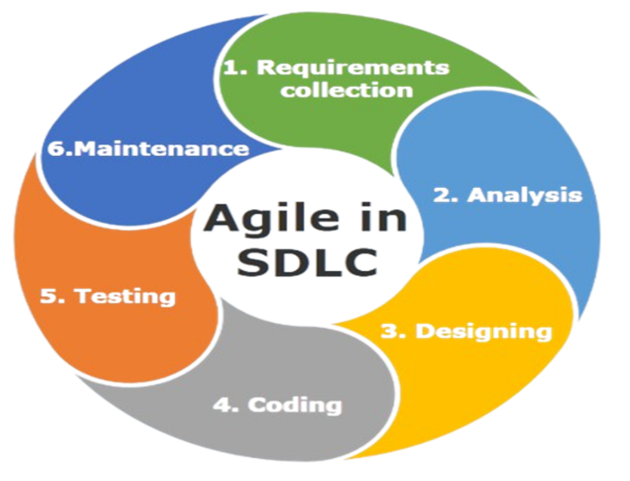
Figure 1. Agile SDLC
KANBAN 1 – PLANNING AND REQUIREMENT ANALYSIS
In this phase, the researchers identified the system’s functional requirements by focusing on AI-assisted recipe recommendations, cloud-based data storage, and prototype hardware planning for ingredient measurement and temperature monitoring. The necessary hardware components such as the Arduino Uno R4, load cell, HX711 module, temperature sensor (DS18B20), and LCD/display were identified and documented as prototype components. Software requirements, including the Flutter mobile application platform and Firebase Firestore, were also determined. User stories were created to describe how users interact with the system, such as receiving AI-based recipe suggestions and tracking cooking history. A product backlog was then developed to organize all tasks for the succeeding sprints.
KANBAN 2 – SYSTEM DESIGN
During this phase, the overall system architecture was designed using the Input-Process-Output (IPO) model. Data flow within the system was illustrated using a Data Flow Diagram (DFD), while the structure of stored data was organized through an Entity-Relationship Diagram (ERD). The layout of the mobile or display interface was planned, including measurement display and AI recommendation outputs. Hardware connections between sensors and the Arduino microcontroller were also designed to ensure proper integration.
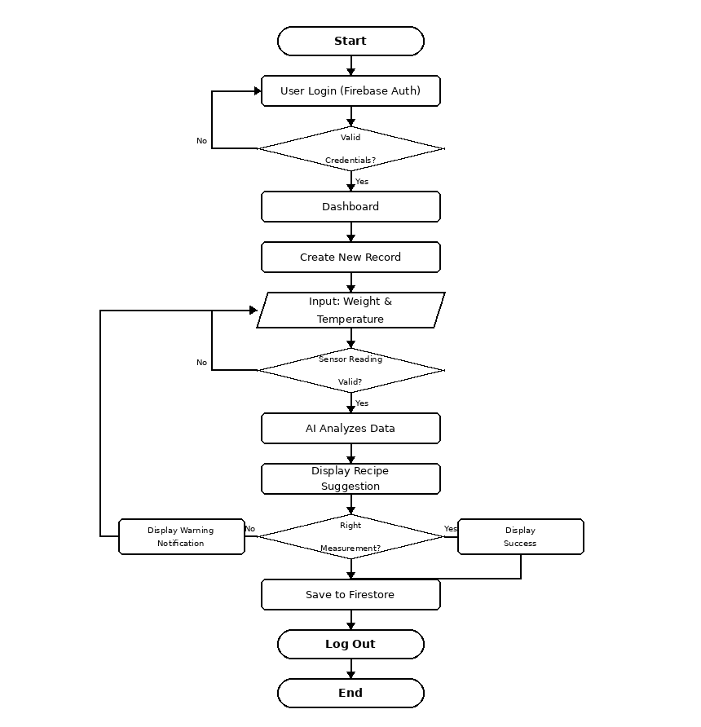
FLOWCHART
Figure 2. Mobile Application Flowchart
The flowchart illustrates the operational process of the mobile application used by the user of the AI-Integrated Smart Weighing Bowl system. After logging in, users can access the dashboard to view AI-generated recipe recommendations, cooking history, temperature and weighing bowl monitoring interfaces, and personalized cooking preference settings.
The AI recipe service generates suggestions and provides cooking guidance based on user inputs and preferences. The system displays recommendations to support better dietary choices and cooking decisions. Recipe histories are saved to Firebase Firestore for future reference. The session concludes securely upon logout to ensure data privacy and system integrity.
DATA FLOW DIAGRAM
The Data Flow Diagram (DFD) presents the movement of data within the system, showing how data flows between external entities, internal processes, and data storage
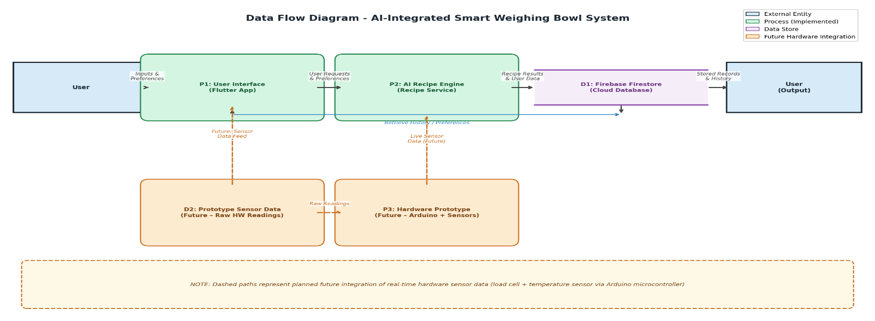
Figure 3. Data Flow Diagram

ENTITY-RELATIONSHIP DIAGRAM
The Entity-Relationship Diagram (ERD) illustrates the database structure used to store user information, sensor readings, and AI Recommendation.
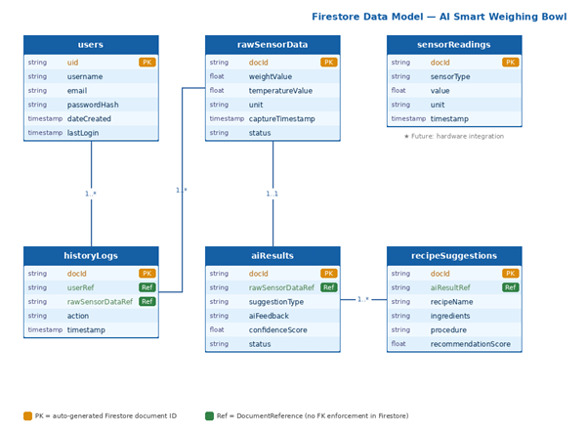
Figure 4. Entity-Relationship Diagram
The system database is composed of six primary entities, each representing a specific category of data that is collected, processed, or generated within the AI-Integrated Smart Weighing Bowl System. These entities collectively form the structural foundation of the database and define how information is stored and managed throughout system operation.
The User entity stores account-related information for individuals interacting with the system, including attributes such as user ID, username, password hash, email, date created, and last login. This entity enables authentication and tracking of user activities within the application. The RawSensorData entity is designed to store input data captured from the smart weighing bowl’s sensors, including data ID, weight value, temperature value, unit, capture timestamp, and status. It serves as the designated input data structure for future hardware integration. The SensorReading entity is structured to record detailed sensor outputs, including reading ID, sensor type, value, unit, and timestamp, designed to support future weight and temperature monitoring once full hardware synchronization is completed. The AI_Result entity stores the processed output generated by the AI recipe component, including result ID, data ID, suggestion type, AI feedback, confidence score, and status, providing intelligent cooking recommendations based on user inputs. The RecipeSuggestion entity contains the recommended recipes generated by the system, with attributes such as recipe ID, recipe name, ingredients, procedure, and recommendation score, enabling users to receive actionable cooking guidance. Lastly, the HistoryLog entity records system activities and user interactions, including history ID, user ID, data ID, action, and timestamp, supporting tracking, auditing, and system monitoring.
ENTITY RELATIONSHIPS
The relationships between these entities define how data flows within the system and reflect the logical connections between its components. A User interacts with the system and can generate multiple HistoryLog entries, forming a one-to-many relationship where a single user may perform various actions recorded in the system. The RawSensorData entity is designed to be processed by the system to produce a corresponding AI_Result, establishing a one-to-one relationship in which each captured dataset will result in a single AI-generated output once hardware integration is completed. The system is also structured to generate multiple SensorReading records from future sensor inputs, forming a one-to-many relationship between the system and sensor readings. Furthermore, each AI_Result can generate one or more RecipeSuggestion entries, representing a one-to-many relationship where a single analysis may lead to multiple recommendations. These relationships ensure proper data organization, efficient processing, and accurate tracking of system operations within the AI-Integrated Smart Weighing Bowl System.

USE CASE DIAGRAM
A straightforward visual depiction of how users engage with the system and what they can do is called a Use Case Diagram of the Proposed System. The “Development of an AI-Integrated Smart Weighing Bowl” demonstrates how the user, system, and mobile application collaborate to access AI recipe recommendations, manage cooking histories, monitor temperature and weight interfaces, and interact with personalized cooking features.
Its aim is to provide a clear understanding of the system’s implemented features and user interactions, making it easier to design, communicate, and document how the Smart Cooking Application operates within its current development scope.
The proposed system involves three main actors: the user, the system, and the mobile application. The user is the individual who interacts with the mobile application to receive AI-assisted cooking guidance and manage their cooking preferences and history. The system refers to the overall AI-Integrated Smart Weighing Bowl platform, which combines a Flutter mobile application, Firebase Firestore cloud backend, and an AI recipe service to provide intelligent cooking support, along with a prototype hardware framework designed for future sensor integration. Meanwhile, the mobile app serves as the primary platform that displays AI-generated recipe recommendations, stores user data and cooking histories via Firebase Firestore, and provides personalized cooking guidance based on user preferences and inputs.

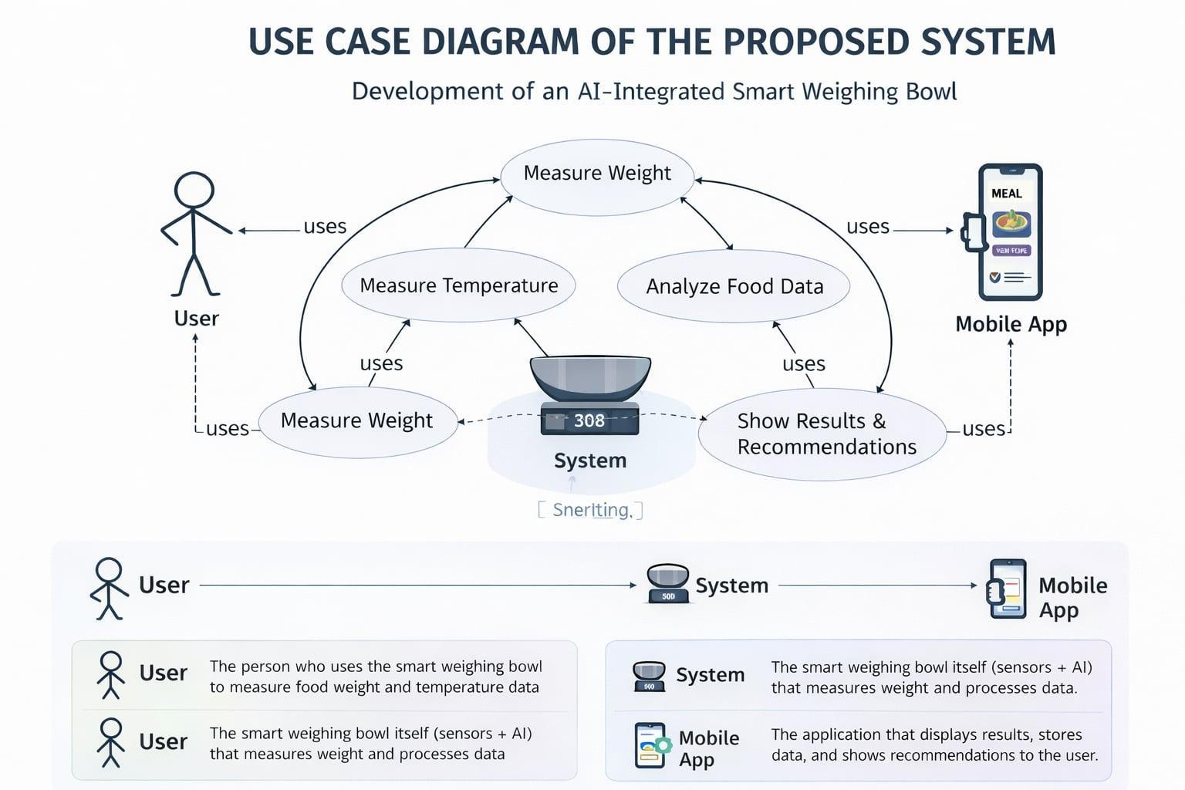
Figure 5. Use Case Diagram
KANBAN 3 – HARDWARE INTEGRATION AND FIRMWARE DEVELOPMENT
In this phase, the hardware components were prepared and initially assembled for prototype evaluation. The load cell was tested with the HX711 module, and the temperature sensor was evaluated for compatibility with the weighing bowl system. Firmware prototyping was initiated using the Arduino IDE to explore sensor data reading and signal processing. In parallel, the foundational logic for AI-based recipe recommendations was implemented within the mobile application, allowing the system to process user inputs and prepare basic cooking suggestions.
KANBAN 4 – APPLICATION DEVELOPMENT AND AI INTEGRATION
The Flutter mobile application was developed with core features including user authentication, AI-assisted recipe recommendations, recipe history tracking, user preferences management, and monitoring interface screens for temperature and weighing bowl visualization. The AI component was integrated using an AI recipe service to analyze user inputs and provide intelligent cooking suggestions, such as ingredient adjustments and recipe guidance. Firebase Firestore was implemented to handle cloud-based data storage for user records and recipe histories. The system was also designed to display alerts and recommendations to support better user decision-making during food preparation.
During this phase, the development team focused on two major deliverables: the full-featured Flutter mobile application and the integration of the Google AI Studio (Gemini) recipe engine. These components were developed concurrently and iteratively aligned to produce a cohesive, intelligent smart kitchen platform.

APPLICATION DEVELOPMENT
The Flutter mobile application was built as the primary user-facing platform for the AI-Integrated Smart Weighing Bowl. It was structured around five core modules: (1) User Authentication, which enables secure login and account management through Firebase Authentication; (2) AI-Assisted Recipe Recommendations, the central feature that connects user inputs to the AI engine for intelligent cooking guidance; (3) Recipe History Tracking, which stores and retrieves past cooking sessions via Firebase Firestore; (4) User Preferences Management, allowing users to personalize dietary restrictions, preferred cuisines, and measurement units; and (5) Monitoring Interface Screens, which display real-time weight and temperature data from the hardware prototype and serve as the visualization dashboard.
AI INTEGRATION ARCHITECTURE
The AI component was implemented using the Google AI Studio API (Gemini), which serves as the reasoning engine behind the system’s recipe recommendation and cooking guidance features. The integration was designed around a three-layer architecture: Input, Process, and Output, as illustrated in the diagram below.
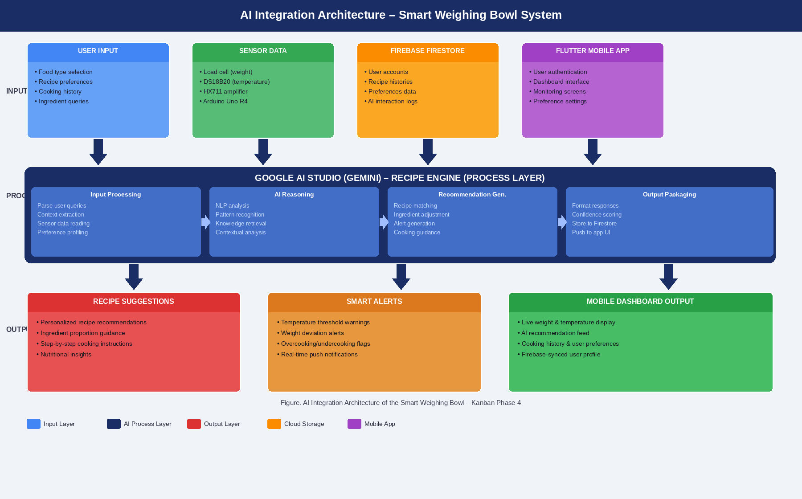
Figure 6. AI Integration Architecture of the Smart Weighing Bowl System
INPUT LAYER: The system receives data from three primary sources. First, direct user inputs collected through the Flutter mobile application, including food type selections, recipe preferences, ingredient quantities, and cooking history context. Second, sensor data from the hardware prototype, specifically weight measurements from the load cell via the HX711 amplifier module and temperature readings from the DS18B20 sensor, both processed through the Arduino Uno R4 microcontroller. Third, cloud-stored context data retrieved from Firebase Firestore, including past AI interactions, saved recipes, and user preference profiles, which enrich each new AI query with personalized context.
PROCESS LAYER – GOOGLE AI STUDIO ENGINE: At the core of the integration is the Google AI Studio API (Gemini). When a user submits a query, the system composes a structured prompt that incorporates the current measurement data, user preferences, and contextual history. This prompt is sent to the Gemini API endpoint, which performs four sequential operations: (1) Input Processing – parsing and contextualizing the user’s request with available measurement data; (2) AI Reasoning – applying natural language understanding and culinary knowledge to analyze ingredients, weights, and temperatures; (3) Recommendation Generation – producing actionable outputs such as recipe suggestions, ingredient proportion adjustments, cooking step guidance, and safety alerts when temperature values fall outside safe thresholds; and (4) Output Packaging – formatting the response for display and assigning a confidence score before pushing results to the Firestore database and the application interface.
OUTPUT LAYER: The AI-generated results are delivered to the user through three distinct output channels. The Recipe Suggestions module presents personalized recipe recommendations with ingredient proportions and step-by-step instructions. The Smart Alerts module sends real-time warnings when sensor readings indicate unsafe temperature levels or significant weight deviations from recipe requirements. The Mobile Dashboard Output renders all system data – live sensor readings, AI recommendations, cooking history, and user preferences – through the Flutter-based interface, which synchronizes continuously with Firebase Firestore to maintain data consistency across sessions.
AI RECIPE SERVICE IMPLEMENTATION: The AI recipe service was implemented as a dedicated service class within the Flutter application. It constructs context-aware prompts dynamically based on user inputs and available sensor data, then communicates with the Gemini API using HTTP POST requests. Responses are parsed, stored in Firestore under the AI_Result and RecipeSuggestion entities defined in the ERD, and rendered on the recommendation screen. Error handling and timeout logic were incorporated to ensure application stability during API communication. The system was also designed to gracefully degrade in the absence of live sensor data by relying on user-provided inputs alone, ensuring the AI recommendation feature remains functional regardless of hardware integration status.
KANBAN 5 – TESTING AND VALIDATION
The mobile application underwent functional testing to ensure accuracy and reliability of its implemented features. AI recipe recommendation outputs were evaluated for relevance and usefulness. Application responsiveness, Firebase Firestore data retrieval, user authentication flows, and recipe history functions were also tested. The hardware prototype components, including the load cell and temperature sensor, were evaluated at a basic level for signal output and compatibility with the Arduino microcontroller. Full sensor-to-application integration testing remains planned for future development stages.
KANBAN 6 – EVALUATION, REFINEMENT, AND DOCUMENTATION
In the final phase, the development team conducted a systematic review of all completed deliverables to assess the overall readiness of the AI-Integrated Smart Weighing Bowl system. This phase focused on internal evaluation, component-level verification, targeted refinement of implemented features, and the preparation of comprehensive documentation to support future development and deployment.
The visual summary below presents a structured overview of the activities carried out during this phase, organized across four key areas: System Evaluation, Refinements Made, Documentation, and Phase Outcomes.
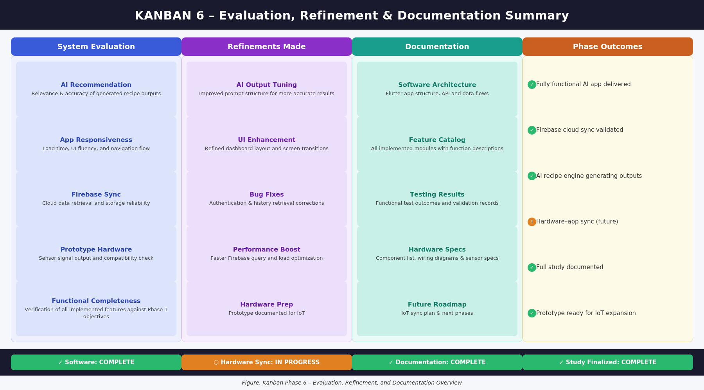
Figure 7. Kanban Phase 6 – Evaluation, Refinement, and Documentation Overview
As shown in the figure, the System Evaluation column captures the internal evaluation criteria applied to the developed system. These include an assessment of AI recipe recommendation relevance, application responsiveness, Firebase Firestore synchronization reliability, hardware prototype sensor compatibility, and overall functional completeness. Each criterion was examined against the objectives defined in Kanban Phase 1, and findings were used to guide targeted refinements.
The Refinements Made column details the corrective and enhancement actions undertaken as a result of the evaluation. AI output quality was improved through prompt restructuring, which yielded more precise and contextually relevant recipe suggestions. The user interface was refined to improve navigation flow and dashboard readability. Bug fixes were applied to the authentication module and recipe history retrieval functions. Firebase query performance was optimized to reduce data load times, and the hardware prototype components were formally documented as a technical foundation for the next development stage.
The Documentation column reflects the final deliverables prepared by the research team. This includes the complete software architecture documentation, a feature catalog of all implemented modules, functional testing records, hardware component specifications and wiring references, and a forward-looking roadmap outlining the planned steps for full IoT synchronization between the hardware prototype and the mobile application.
As indicated in the Phase Outcomes column and the status bar at the base of the figure, the software system was fully completed and validated, Firebase cloud synchronization was confirmed operational, and the AI recipe engine was verified to generate relevant and practical outputs. Hardware-to-application real-time synchronization remains an in-progress milestone designated for a future development iteration. The study was formally finalized through complete documentation, and the prototype was prepared for expansion into a fully IoT-integrated deployment.
PROPOSED SYSTEM ARCHITECTURE
The Input-Process-Output (IPO) model is used to organize the system architecture of the AI-Integrated Smart Weighing Bowl. This design shows the general structure of the Smart Cooking Application, which generates AI-assisted recipe recommendations and cooking guidance by processing user inputs through artificial intelligence algorithms and storing data via Firebase Firestore cloud services. The architecture provides an organized data flow from user interaction through AI processing, cloud storage, and application output, with the hardware prototype components serving as a foundation for future real-time sensor integration.
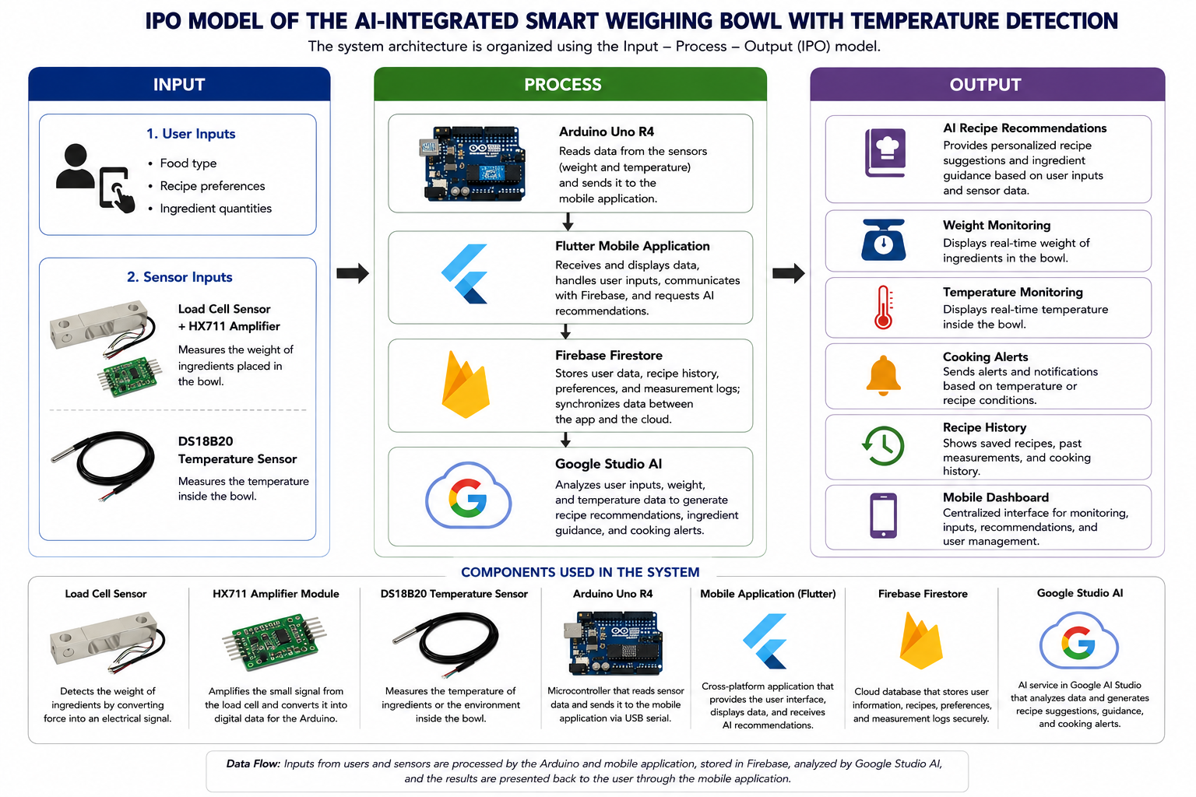
Figure 8. System Model Diagram
Figure 9 illustrates the complete operational flow of the AI-Integrated Smart Weighing Bowl with Temperature Detection. The architecture is designed so that data collected from the load cell and temperature sensor can be processed by the microcontroller and transmitted to the system through wireless connectivity. The AI module is designed to analyze input data to generate recipe suggestions and assess ingredient conditions.
The processed results are designed to be stored in the database and displayed on a mobile application dashboard, where users can monitor information such as food weight, temperature, and AI-generated cooking suggestions. The system provides recommendations based on user inputs and analyzed data, helping users make more informed decisions during food preparation. Full real-time sensor-to-application synchronization is part of the future deployment framework for this system.
The system is composed of three main layers: input, process, and output. The Input Layer is designed to incorporate hardware sensors into the smart weighing bowl, such as a load cell sensor (HX711 module) for weight data and a temperature sensor (DS18B20 module) for temperature monitoring. It also includes user inputs such as food type selection, recipe preferences, and interaction data through the mobile application. In the prototype architecture, the Arduino Uno R4 microcontroller is designated to receive and process sensor data for accurate weight and temperature detection once full hardware integration is completed.
The Process Layer is responsible for intelligent data handling and analysis. It performs several operations including user input processing, AI-driven recipe recommendation generation, Firebase Firestore data management, and application logic handling. Through the integrated AI recipe service, the system analyzes user inputs and preferences to generate personalized cooking suggestions. In the future hardware integration phase, this layer will also handle sensor data acquisition, signal processing, and real-time synchronization between the physical bowl components and the mobile application.
The Output Layer presents the results of the system to the user. This includes AI-generated recipe recommendations, a mobile application dashboard, cooking history records, personalized user preferences, and monitoring interface screens for temperature and weight visualization. Alerts and notifications are also generated to assist users in making better and more informed decisions during food preparation. In the future deployment framework, these outputs will also incorporate live sensor readings from the hardware components.
In terms of system components, the external entity is the smart weighing bowl user, who initiates the process by interacting with the mobile application or adding ingredients to the physical bowl. The main processes involve user input handling through the mobile application, AI-powered recipe recommendation generation, and cloud-based data storage through Firebase Firestore. The data store consists of a Firestore database containing user accounts, recipe histories, cooking preferences, and AI interaction records. The overall data flow begins with the user, continues through application input and AI processing, and is then stored and displayed to generate meaningful cooking recommendations and guidance. In the future integration phase, sensor-based data from the hardware prototype will also feed into this flow to enrich monitoring capabilities.

METHODS AND TOOLS
This section presents the methods and tools utilized in the development of the AI-Integrated Smart Weighing Bowl. It describes the step-by-step approach followed by the proponents in designing, developing, and testing the system, as well as the specific technologies and equipment used to implement both the hardware and software components.

METHODS
The development of the AI-Integrated Smart Weighing Bowl with Temperature Detection followed an Agile-based iterative process that enabled continuous improvement of both the software and prototype hardware components while addressing the three objectives of the study. The project began with system conceptualization and requirement analysis, where the proponents identified the major functions of the system, including AI-assisted recipe recommendations, Firebase Firestore cloud integration, user authentication, recipe history tracking, user preference management, and prototype hardware framework for weight measurement and temperature monitoring. Hardware and software requirements were defined together with system limitations such as the current scope of hardware integration, application response time, and cloud data management to guide the development process. The system was specifically designed to provide users with intelligent cooking assistance through a Flutter mobile application, while also establishing an IoT-ready architectural foundation for future smart kitchen hardware integration.
During the hardware and software development phase, components such as the temperature sensor, Arduino microcontroller, display module, and power supply were identified and prepared for prototype integration. Initial assembly and calibration procedures were conducted to evaluate weight and temperature reading capabilities. At the same time, the proponents developed a system architecture designed to support simultaneous tracking of ingredient weight and temperature, reducing the need for
multiple kitchen instruments and improving workflow efficiency during food preparation. The software was developed in Kanban workflow stages focusing on sensor data processing, user interface development, and cloud-based data management through Firebase Firestore. Full real-time synchronization between the hardware prototype and the mobile application remains under further development and testing.
To achieve intelligent system functionality, an AI component was integrated into the mobile application to analyze user inputs and available data and provide recipe suggestions, warnings, and assistance to users. The AI recipe service was implemented to generate cooking recommendations based on user preferences and ingredient inputs. Through this process, the system was able to help users follow recipe requirements more accurately and improve cooking guidance through AI-driven support. The final stage involved system testing and evaluation to assess AI performance, application responsiveness, usability, and reliability. Continuous refinements were implemented based on testing results to ensure that the final system was functional, efficient, and user-friendly. Hardware components, including the prototype weighing bowl and sensor modules, were prepared for future integration with the mobile application.
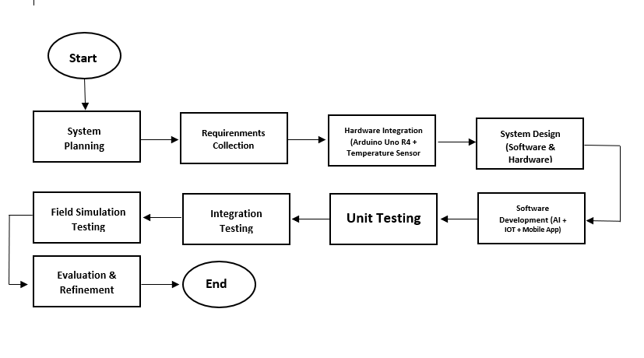
Figure 9. System Development Workflow
The diagram illustrates the overall development process of the AI-Integrated Smart Weighing Bowl with Temperature Detection. It begins with system planning and requirement analysis, followed by the design of both software and prototype hardware components. The Flutter mobile application, Firebase Firestore integration, and AI recipe service are developed as the primary software deliverables, while hardware components such as the load cell, temperature sensor, and Arduino microcontroller are prepared concurrently as the prototype integration framework.
The application then undergoes functional testing, AI recommendation evaluation, and usability testing to ensure reliable performance, relevant AI outputs, and stable Firebase data operations. Prototype hardware components are evaluated for basic sensor functionality and compatibility. Finally, evaluation and refinement are conducted to enhance the system’s accuracy, usability, and overall performance, with future hardware-to-application synchronization identified as the next development milestone.

TOOLS
The tools used in this study consist of both software and hardware components that supported the development of the AI-Integrated Smart Weighing Bowl system. Software tools drove the primary deliverables, while hardware components were selected and prepared as part of the prototype integration framework. These tools were carefully chosen to ensure compatibility, efficiency, and reliability throughout the development lifecycle.
The software tools support mobile application development, AI-assisted recipe recommendations, cloud-based data management, and user interface design, while the hardware components form the prototype framework for future weight and temperature sensing integration. Together, these tools allow the system to function as an intelligent smart cooking application capable of providing AI-driven recipe guidance, user preference management, cooking history tracking, and a foundational IoT-ready architecture for future sensor-based enhancements.
RESULTS AND DISCUSSION
The Results and Discussion section presents the preliminary prototype demonstration and functional evaluation of the AI-Integrated Smart Weighing Bowl with Temperature Detection. Since selected hardware modules were still undergoing acquisition and integration during the development phase, simulated prototype values were utilized for selected weight measurement and temperature monitoring components. The testing procedures focused primarily on validating the smart weighing bowl’s monitoring workflow, Firebase Firestore data synchronization, mobile application dashboard visualization, AI recipe recommendation behavior, and cooking guidance alert generation of the proposed system.
PROTOTYPE DEVELOPMENT
The prototype successfully integrated the Arduino Uno R4 with load-cell and temperature sensors housed within the designed bowl structure. The mobile application, developed in Flutter, enabled user login, AI-generated recipe suggestions, and real-time visualization of weight and temperature parameters. Prototype testing confirmed accurate readings within acceptable error margins for basic ingredient measurement.

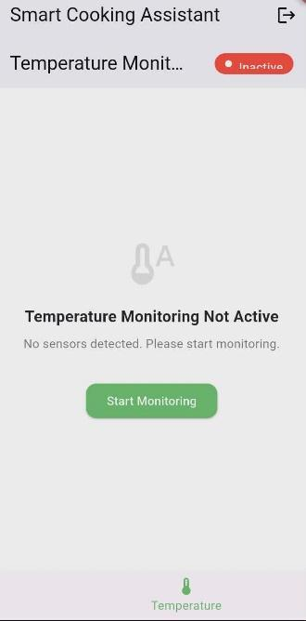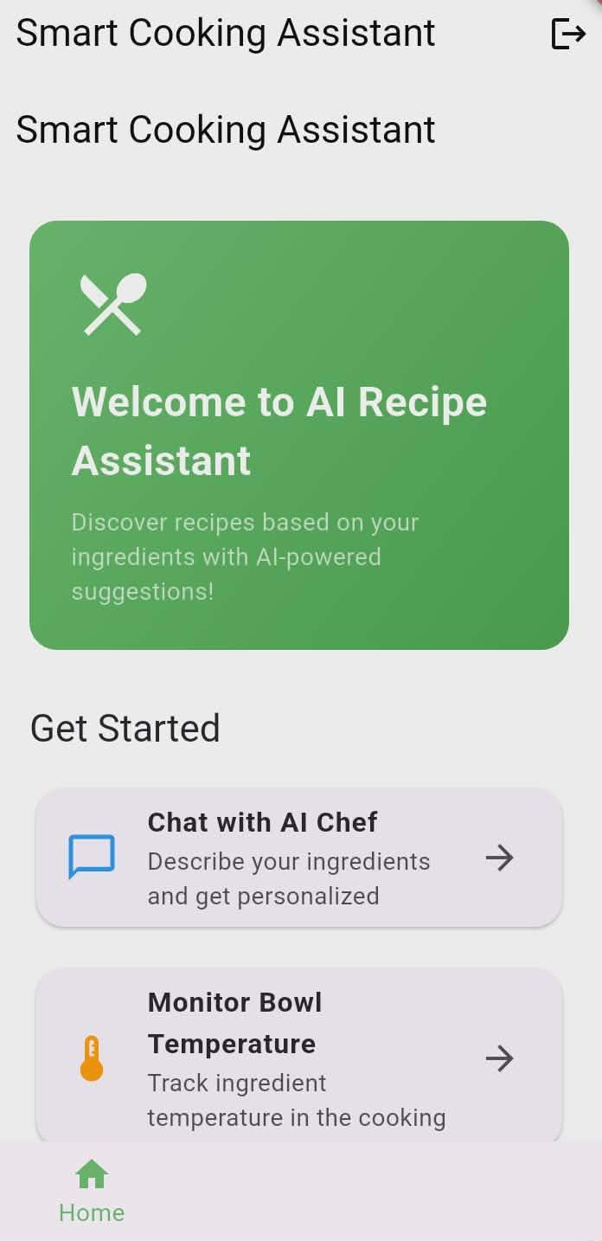
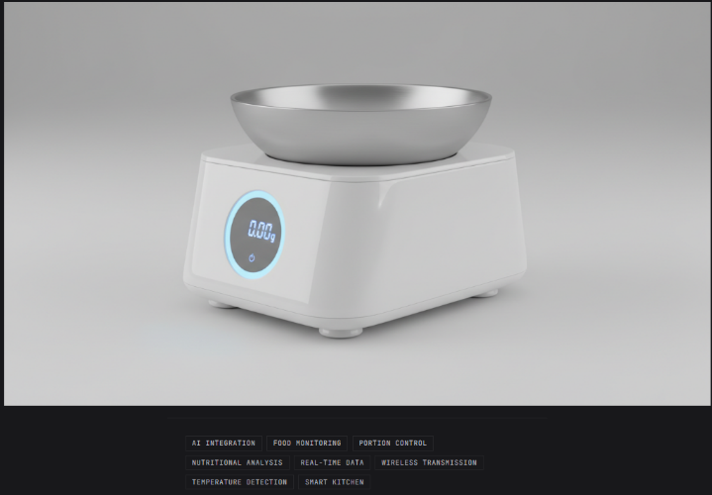
Figure 10. Prototype and Application
SYSTEM ARCHITECTURE PERFORMANCES
The designed architecture allowed simultaneous monitoring of ingredient weight and temperature. Data synchronization through Firebase ensured reliable storage and retrieval. Although full live sensor-to-application streaming remains under continued optimization, partial integration validated system feasibility and robustness of signal processing.
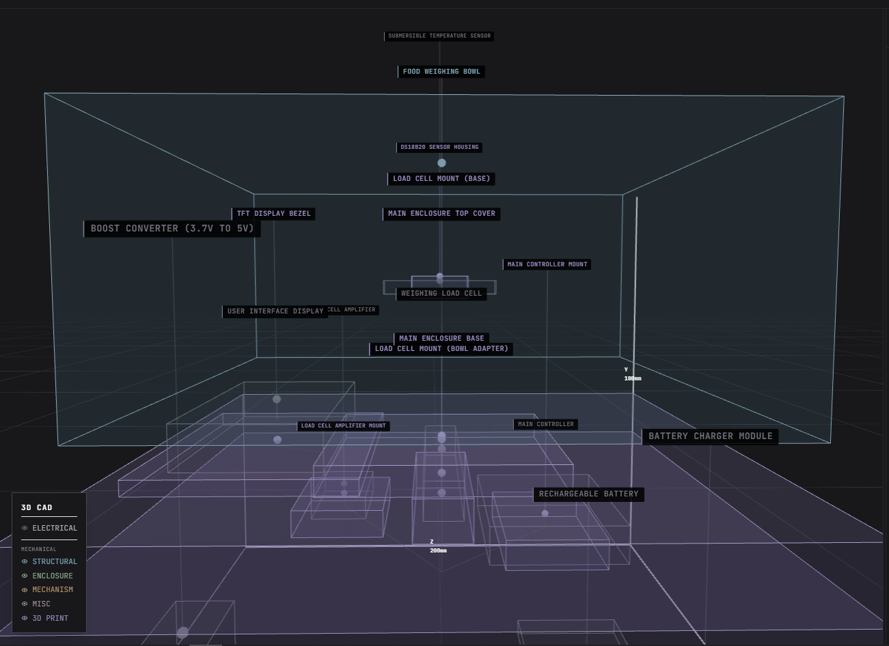
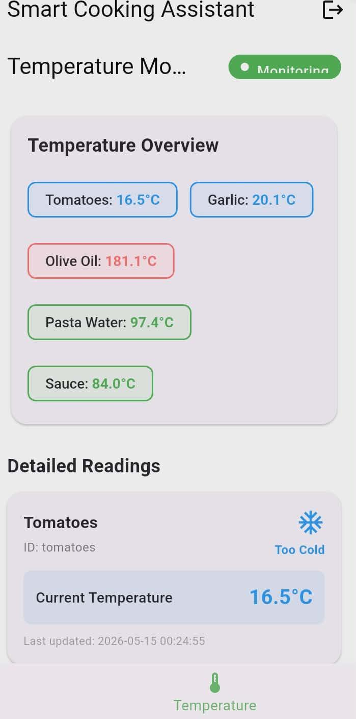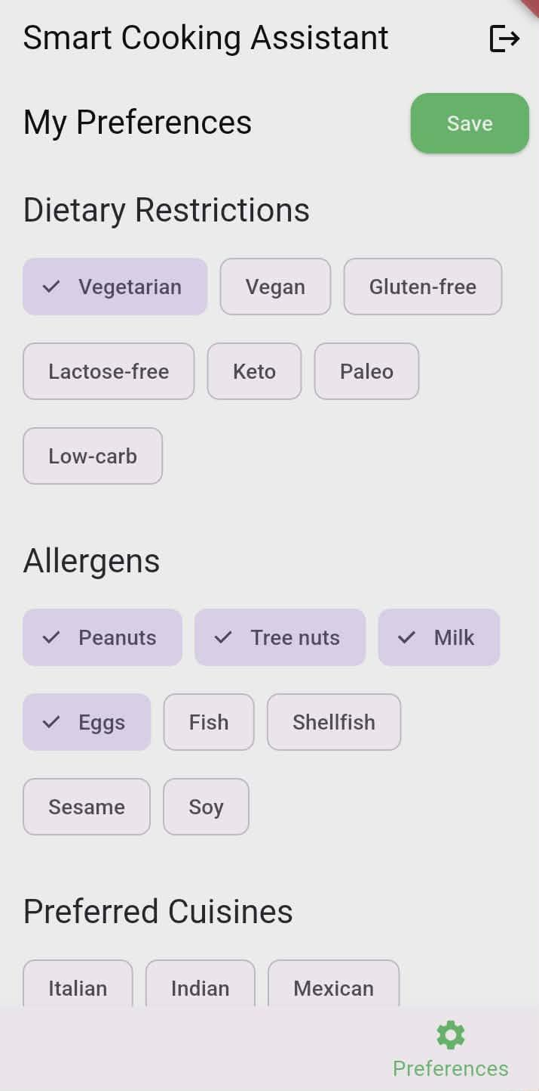
Figure 11. System Architecture and Performance

AI INTEGRATION
The AI recipe engine analyzed user preferences and available data, generating contextual suggestions such as ingredient proportions, warnings for extreme temperature values, and adaptive recipe advice. Testing showed relevant and practical outputs that enhanced the cooking workflow and reduced repetitive decision errors.

Figure 1. AI Integration
OVERALL SYSTEM EVALUATION
The preliminary prototype evaluation demonstrated that the AI-Integrated Smart Weighing Bowl system was capable of integrating ingredient weight monitoring, temperature sensing, cloud-based synchronization, AI-assisted recipe recommendation, and intelligent cooking guidance functionalities within a single smart kitchen platform. The developed prototype successfully simulated real-time food preparation monitoring workflows intended to assist users in achieving more accurate, efficient, and guided cooking processes.
The integration of AI-assisted recipe analysis and IoT-ready communication technologies improved the responsiveness of the system by enabling automatic generation of contextual recipe suggestions, ingredient proportion guidance, and real-time dashboard updating within the Flutter-based mobile application. Furthermore, Firebase Firestore cloud services supported continuous accessibility of user data, recipe histories, cooking preferences, and monitoring information for efficient application performance and data management.
Although selected monitoring values utilized simulated data during preliminary testing due to ongoing hardware integration and optimization, the prototype successfully demonstrated the feasibility of implementing an intelligent smart kitchen system capable of supporting proactive cooking assistance, real-time monitoring, and AI-driven decision support operations for food preparation environments

CONCLUSION AND RECOMMENDATIONS
CONCLUSION
The AI-Integrated Smart Weighing Bowl with Temperature Detection effectively demonstrates how embedded sensing technologies, artificial intelligence, cloud-based services, and mobile application integration can enhance precision, efficiency, and user experience in modern kitchen environments. The developed system successfully combined ingredient weight monitoring, temperature detection, AI-assisted recipe recommendations, Firebase Firestore cloud synchronization, and interactive cooking guidance within a unified smart kitchen platform designed to support intelligent food preparation processes.
The study showed that the modular system architecture supports accurate measurement, organized data analysis, real-time monitoring visualization, and AI-generated cooking assistance through a Flutter-based mobile application. Through the integration of AI technologies and IoT-ready system design, the prototype was able to provide contextual recipe suggestions, ingredient proportion guidance, cooking history tracking, and personalized user preference management, helping users improve consistency and decision-making during food preparation.
The implementation of Firebase Firestore cloud services enabled reliable storage and retrieval of user records, recipe histories, and monitoring information, while the AI recipe service demonstrated the capability of generating relevant and practical cooking recommendations based on available user inputs and system data. The study further established a foundational framework for future real-time sensor-to-application synchronization involving the load cell, temperature sensor, and Arduino microcontroller components prepared within the prototype architecture.
Although selected monitoring values and sensor outputs utilized simulated data during preliminary testing due to ongoing hardware integration and optimization, the overall system successfully demonstrated the feasibility of implementing an AI-assisted and IoT-ready smart kitchen solution capable of supporting intelligent monitoring, automated cooking guidance, and improved workflow efficiency. Overall, the study lays the groundwork for scalable smart kitchen systems that integrate intelligent sensing, cloud-based communication, and AI-driven assistance to improve accuracy, convenience, and user interaction in food preparation environments.

RECOMMENDATIONS
Future improvements include:
1. Implementing full two-way IoT integration for real-time hardware–software synchronization.
2. Expanding the AI model to provide ingredient classification and complete recipe generation.
3. Conducting usability studies with professional chefs and home users to assess adoption and efficiency.
4. Exploring commercial viability through cost reduction, durable materials, and energy optimization.

REFERENCES
- Abrajano, J. V. (2024). Low-cost IoT-based water quality monitoring system for rural communities.
- Albino Taer, A., & Taer, E. C. (2025). Precision livestock farming and IoT applications in the Philippines. Ceylon Journal of Science.
- da Silva Ferreira, A., Ahmed, O., Oliveira, R., Sarang, S., Ramsay, J., Liu, D., Malvandi, A., Lee, J., & Kamruzzaman, M. (2025). AI-enabled optical sensing for smart drying: A technical review. Food Engineering Reviews. https://doi.org/10.1007/s12393-024-09388-0

- De La Salle University. (2007). Automated rice weighing and dispensing machine using sensors and programmable logic control (Undergraduate thesis).
- Department of Science and Technology – Food and Nutrition Research Institute (DOST-FNRI). (2024). Mobile dietary survey system with AI-based food recognition.
- Golshany, M., Ni, Q., Yu, S., & Fan, X. (2025). IoT-enabled smart kitchen technologies and their impact on food storage, preparation, and culinary experiences: A systematic review. Food Research International. https://doi.org/10.1016/j.foodres.2025.116557
- Henry, C., Kelechi, U., & Adaugo, N. (2025). IoT-assisted precision cooking robot for Nigerian cuisines. American Journal of Artificial Intelligence. https://doi.org/10.11648/j.ajai.20250901.18
- IoT-Based Smart Kitchen Automation and Monitoring System. (2025). Journal of Kitchen Technology and Automation.
- Iqbal, M., Yousaf, A., Khan, R., & Muhammad, S. (2025). IoT-based food freshness detection through multi-sensor fusion. International Conference on Computer Knowledge. https://www.icck.org/article/abs/tscc.2025.401245
- Javier, M. A. (2024). Digital dietary survey system with AI-food image recognition.
- Mapúa University. (2024). AI-based food recognition scale integrated with mobile application .
- Narendran, S., Janani, R., Balamurugan, K., Janarthanan, P., Chandra Dev, S., & Raghuram, V. (2024). IoT-enabled smart kitchen system with adaptive fuzzy logic and mobile interface. Journal of Intelligent Systems and IoT Applications.
- Patil, S., Gómez-López, T., & Vázquez-Armenta, F. (2025). Smart food safety technologies for global systems. Food Control. https://www.sciencedirect.com/science/article/pii/S0956713525005353
- Raj, A., Sharma, B., & Gupta, C. (2025). Smart kitchen monitoring for safety and automation. International Journal of Computer Science and Technology.
- Sagar, N., & Rani, P. (2026). Recent trends and innovations in smart and AI-based food packaging. Frontiers in Food Science and Technology. https://doi.org/10.3389/frfst.2025.1665055
- Yang, L., Jiao, H., Zouyi, Z., Diao, Y., & Xia, L. (2025). Artificial intelligence in modern food systems. Discover Food. https://link.springer.com/article/10.1007/s44163-025-00296-8

