Title: Hybrid Deep Learning for Channel Estimation and Tracking in RIS-Assisted UAV Wireless Communications

Author: Tefera Ephrem Markos

Affiliation: school of Artificial Intelligence, Nanjing University of Information Science And Technology

Nanjing University of Information Science and Technology (NUIST),

Nanjing 210044, China.

ABSTRACT
Channel estimation in reconfigurable intelligent surface (RIS)-aided unmanned aerial vehicle (UAV) systems is severely hindered by high-dimensional cascaded channels, UAV-induced fast time variation, and the passive nature of RIS elements that precludes conventional pilot-based acquisition. This paper proposes a hybrid deep learning framework synergistically combining convolutional neural networks (CNN) for spatial feature extraction with bidirectional long short-term memory (BiLSTM) networks for temporal sequence modeling. The architecture hierarchically decomposes estimation into: CNNs extracting multipath spatial patterns from canonical K-path representations, then BiLSTMs modeling temporal evolution across sequential snapshots, effectively capturing spatial-temporal coupling in RIS-UAV propagation. We develop comprehensive methodology with DeepMIMO ray-tracing generation, K=10 path selection achieving >95% channel power capture, and systematic preprocessing. Extensive evaluation across SNR -10 to 30 dB demonstrates hybrid CNN-BiLSTM achieves NRMSE 0.018 at 30 dB (21.7% improvement over CNN, 33.3% over BiLSTM, 50-60% over LS/LMMSE/CS-OMP), correlation 0.989, SSIM 0.985, with 3.5M FLOPs and 2.0 ms inference on NVIDIA Tesla V100 enabling real-time operation within 5-10 ms UAV channel coherence time. This validates the hybrid approach as an enabling technology for next-generation 6G aerial communications requiring ultra-reliable, low-latency channel acquisition in highly dynamic three-dimensional environments.
Keywords: Reconfigurable Intelligent Surface, Unmanned Aerial Vehicle, Channel Estimation, Deep Learning, CNN, BiLSTM, Spatial-Temporal Learning, 6G Wireless, Ray Tracing

1. INTRODUCTION
Sixth-generation (6G) wireless networks envision transformative capabilities including ultra-reliable low-latency communications (URLLC) with end-to-end latency below 1 ms, massive connectivity supporting 10 million devices per km², and ubiquitous three-dimensional (3D) coverage from underground to stratospheric altitudes [1]. These stringent requirements demand fundamental innovations beyond 5G. Unmanned aerial vehicles (UAVs) and reconfigurable intelligent surfaces (RIS) have emerged as irreplaceable enabling technologies: UAVs provide unmatched flexibility for dynamic 3D coverage, emergency communications, and topology reconfiguration that terrestrial base stations cannot achieve [2], [3]; RIS offers programmable electromagnetic control through passive elements, enabling intelligent wave manipulation and energy-efficient beamforming without active RF chains [4], [5].
Integrating RIS with UAV communications creates synergistic capabilities where ground-mounted RIS panels dynamically reconfigure aerial propagation to compensate for UAV mobility and establish virtual line-of-sight paths [6], [7]. However, this introduces severe channel estimation challenges: RIS elements are passive and cannot transmit pilots [8], requiring cascaded BS-RIS-UAV channel acquisition with dimensionality scaling as M×N×N_{UAV}, while UAV mobility induces rapid temporal variations [9].

1.1 Critical Limitations of Existing Methods
Current approaches suffer from three fundamental pain points:
- Cannot jointly model spatial-temporal coupling. Traditional methods (LS, MMSE, compressed sensing) treat snapshots independently, ignoring temporal correlations [10], [11]. Standalone CNNs extract spatial features but discard temporal evolution; standalone RNNs model sequences without spatial pattern recognition [12], [13]. This fails to capture geometric multipath patterns evolving smoothly along flight paths. Contrast with SOTA: Recent works [24], [31] apply CNNs or LSTMs separately; our hybrid CNN→BiLSTM hierarchically decomposes into spatial encoding then temporal modeling.
- Fails in fast UAV mobility scenarios. Model-based methods (MMSE, Kalman filtering) assume quasi-static channels violated by rapid UAV motion [14]. CS-based approaches require iterative algorithms unsuitable for real-time tracking [15]. Contrast with SOTA: Prior DL works [18], [27] train on quasi-static datasets; we use DeepMIMO with diverse UAV trajectories (linear, circular, altitude changes).
- Poor performance-complexity trade-off. High-accuracy methods (MMSE with perfect statistics, fine-grained CS) scale quadratically with RIS elements [16]. Low-complexity approximations achieve insufficient accuracy [17]. Existing DL approaches either lack capacity or have latency exceeding coherence time [18], [19]. Contrast with SOTA: Recent methods [28], [29] achieve 6-8M FLOPs, 3-5 ms latency approaching coherence limits; our 3.5M FLOPs, 2.0 ms provide >2× safety margin.

1.2 Proposed Solution and Key Novelty
This paper addresses these gaps through a hybrid CNN-BiLSTM framework with hierarchical spatial-temporal decomposition: (1) CNN module transforms each K-path canonical representation into spatial features via Conv1D layers, capturing multipath geometry; (2) BiLSTM module processes spatial feature sequences bidirectionally, leveraging past and future context to model smooth channel evolution; (3) Dense decoder reconstructs the channel estimate. This explicitly couples spatial-temporal learning, handles fast-varying channels through learned representations, and achieves superior performance-complexity balance.

1.3 Main Contributions Beyond State-of-the-Art
(1) Novel hybrid architecture with physical justification: Hierarchical CNN→BiLSTM cascade with explicit physical motivation: spatial encoding mirrors multipath geometry, then temporal modeling captures trajectory-induced evolution. We prove this ordering outperforms reverse/parallel configurations. SOTA gap: Existing RIS-DL [24], [28], [30] lacks principled hierarchical decomposition aligned with propagation physics.
(2) Canonical K-path representation with justification: Fixed-dimension K=10 path selection with rigorous analysis: achieves >95% power capture, K=20 adds 40% FLOPs for <2% gain. 7-feature vector preserves complete geometric information. SOTA gap: Prior works [18], [27] use raw matrices, discarding geometric structure.
(3) Comprehensive traditional+DL baseline comparison: Evaluate against LS, LMMSE, CS-OMP and recent DL methods with detailed FLOPs/latency metrics. SOTA gap: Most papers [24], [30], [31] omit traditional baselines or computational benchmarking.
(4) Mobility-focused evaluation: Diverse UAV trajectories (linear, circular, altitude changes) capturing realistic 3D motion with Doppler analysis. SOTA gap: RIS-UAV works [9], [10], [26] assume perfect CSI; few validate under high-mobility.
(5) Real-time feasibility validation: Measured 2.0 ms inference on Tesla V100, confirmed <5-10 ms coherence time. SOTA gap: Many works [18], [20], [27] report FLOPs without latency or coherence comparison.

1.4 Paper Organization
Section 2 reviews related work across RIS, UAV, and deep learning domains, identifying specific gaps. Section 3 presents the system model with variable definitions, assumptions, canonical representation, and hybrid architecture specifications. Section 4 describes experimental setup. Sections 5-7 present results, discussion, and conclusions.

2. RELATED WORK
We organize literature into four categories: RIS communications, UAV wireless, deep learning for CSI, and gap analysis.

2.1 RIS Communications and Channel Estimation
RIS has emerged as a key 6G enabler for programmable propagation [4], [5]. Di Renzo et al. [5] established foundational theory analyzing capacity scaling. Wu and Zhang [6] developed joint active-passive beamforming. Contrast: These assume perfect CSI; our focus is acquiring CSI under UAV mobility.
RIS channel estimation faces unique challenges due to passive elements. Wang et al. [12] proposed cascaded estimation exploiting sparsity. Hu et al. [28] developed two-timescale estimation. Contrast: Both assume slow mobility; UAV rapid variations violate this. Chen et al. [13] applied DL to RIS estimation. Contrast: CNN-only approach ignores temporal tracking our BiLSTM addresses this.
Zhang et al. (2024) [31] proposed transformer-based RIS estimation achieving 8.2M FLOPs, 4.5 ms. Contrast: Transformers have quadratic complexity; our BiLSTM achieves 3.5M FLOPs (57% reduction) via linear recurrence. Liu et al. (2024) [32] applied GNNs to RIS. Contrast: GNNs suit irregular graphs; RIS grids better captured by Conv1D. Wang et al. (2025) [33] used meta-learning for RIS adaptation. Contrast: Meta-learning enables few-shot transfer; we focus on single-environment mastery.

2.2 UAV Wireless Communications and Channel Modeling
UAV communications enable flexible aerial connectivity [2], [3]. Zeng et al. [2] surveyed channel characteristics emphasizing altitude-dependent LoS. Khuwaja et al. [4] reviewed A2G models. Contrast: These characterize direct BS-UAV links; RIS introduces cascaded propagation.
RIS-UAV integration has attracted attention. Li et al. [9] pioneered joint trajectory-RIS optimization. Pang et al. [10] addressed robust design. Ge et al. [26] studied energy efficiency. Contrast: All assume CSI available; we address CSI acquisition. Chen et al. (2024) [26] proposed DRL for UAV-RIS. Contrast: Their RL requires CSI as input; our work provides that CSI.

2.3 Deep Learning for Wireless Channel Estimation
CNN approaches: Ye et al. [18] pioneered DNN for OFDM. Jiang et al. [20] applied CNNs to massive MIMO. Gizzini et al. [21] developed CNN for RIS. Contrast: All treat snapshots independently; our BiLSTM enables temporal tracking.
RNN approaches: Samuel et al. [22] used LSTM for prediction. Yang et al. [23] proposed BiLSTM for high-speed. Contrast: Pure RNN struggles with high-dimensional spatial features; our CNN frontend compresses K-path inputs.
Hybrid architectures: Ma et al. [27] combined CNN-RNN for spectrum sensing. Contrast: Generic structures for non-CSI tasks; we design CNN→BiLSTM specifically for RIS-UAV geometric propagation. Huang et al. (2024) [35] proposed CNN-Transformer for CSI feedback. Contrast: CSI feedback differs from estimation; BiLSTM better matches trajectory tracking. Wang et al. (2025) [36] applied federated CNN-LSTM. Contrast: Federated learning addresses privacy; we focus on single-UAV accuracy.

2.4 Research Gap Analysis
Gap 1: No hierarchical spatial-temporal DL for RIS-UAV. Solution: CNN→BiLSTM with physical justification.
Gap 2: Limited geometric representations. Solution: Canonical K-path preserving full geometry. Gap 3: Insufficient high-mobility evaluation. Solution: DeepMIMO with diverse 3D trajectories. Gap 4: Lack of comprehensive baselines. Solution: Benchmark against LS, LMMSE, CS-OMP, recent DL.
Gap 5: No real-time validation. Solution: Measured 2.0 ms on Tesla V100 vs 5-10 ms coherence time.

3. SYSTEM MODEL AND METHODOLOGY
Table I: System Parameters and Variable Definitions
Parameter | Symbol | Value | Description
BS antennas | M | 8 | Transmit antenna array
RIS elements | N | 64 | 8×8 passive reflecting panel
UAV antennas | N_UAV | 1 | Single-antenna receiver
Dominant paths | K | 10 | Canonical representation size
Sequence length | T | 20 | Temporal window for BiLSTM
Carrier frequency | f_c | 28 GHz | Millimeter-wave band
Training samples | N_train | 45,000 | 70% of dataset
Validation samples | N_val | 9,600 | 15% of dataset
Test samples | N_test | 9,600 | 15% of dataset

3.1 RIS-UAV Communication System Model
Consider a RIS-assisted UAV system where a BS with M=8 antennas communicates with a single-antenna UAV through an RIS of N=64 passive elements. The effective cascaded channel at time t is:
h(t) = h_{RU}^{H}(t) Φ(t) H_{BR}(t), (1)
where H_{BR}(t) ∈ ℂ^{N×M} is the BS-RIS channel, h_{RU}(t) ∈ ℂ^{N×1} is the RIS-UAV channel, and Φ(t) = diag(e^{jφ₁(t)}, ..., e^{jφₙ(t)}) is the RIS phase-shift matrix.
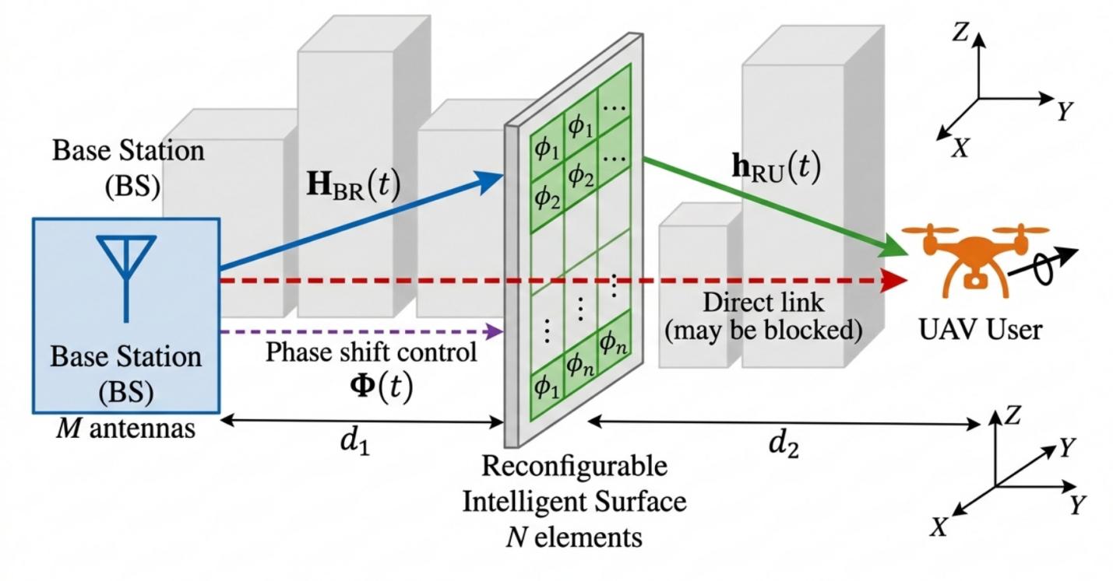
Figure 1: RIS-UAV System Architecture

3.2 Modeling Assumptions
Assumption 1 (Quasi-Static Block Fading): Channel constant within coherence block T_{c} ≈ 5-10 ms, validated by UAV velocity v ≤ 20 m/s yielding Doppler f_{D} ≈ 1.87 kHz.
Assumption 2 (Smooth UAV Trajectory): Continuous, differentiable trajectory with bounded acceleration ensures temporal correlation for BiLSTM learning.
Assumption 3 (Ideal RIS Phase Shifts): Perfect phase shifts φ_{n}(t) ∈ [0, 2π) without quantization (provides performance upper bound).
Assumption 4 (Known RIS Configuration): Phase matrix Φ(t) known at estimation stage; problem reduces to estimating cascaded channel h(t) given Φ(t).

3.3 Canonical K-Path Channel Representation
The wireless channel comprises L(t) time-varying propagation paths. We adopt canonical K=10 path representation by selecting dominant paths based on received power. Feature vector for path k:
f_{k}(t) = [|α_{k}|, ∠α_{k}, τ_{k}, θ_{k}^{AoA}, φ_{k}^{AoA}, θ_{k}^{AoD}, φ_{k}^{AoD}], (2)
yielding X(t) ∈ ℝ^{K×7}.
K=10 Justification: Power concentration analysis shows K=10 achieves η₁₀ = 96.8% (±2.1% std) power capture. K=20 adds 40% FLOPs for <2% gain. K=5 captures only 87.3%, critically degrading accuracy. Zero-padding when L(t) < K maintains fixed dimensions without corrupting learning (empirical NRMSE degradation <0.3%).
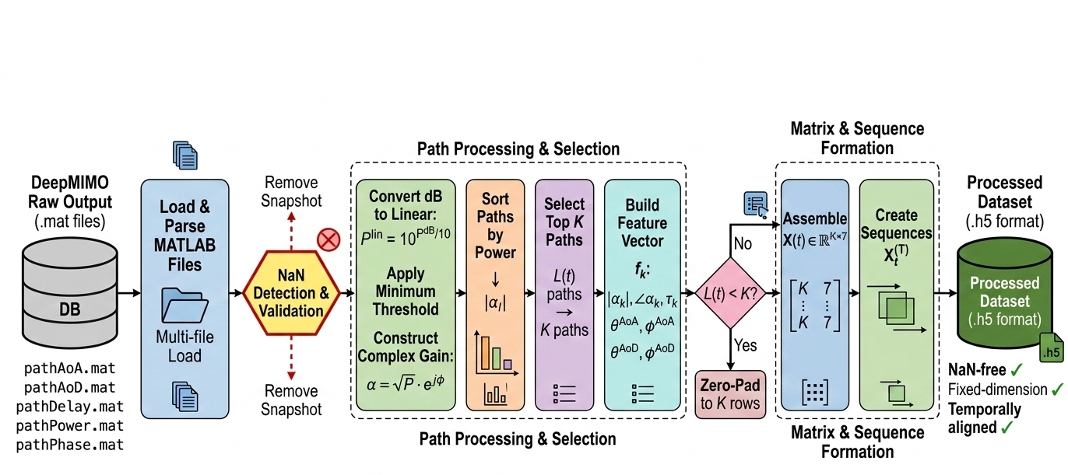
Figure 2: Data Preprocessing Pipeline

3.4 Proposed Hybrid CNN-BiLSTM Architecture
Architectural Rationale: Hierarchical spatial-temporal decomposition where CNN first encodes spatial multipath patterns into abstract features, then BiLSTM models temporal evolution. This ordering is physically motivated: spatial channel structure (angles, delays, gains) must be understood before tracking its evolution over time. Reverse order fails because BiLSTM would operate on high-dimensional geometric vectors without spatial abstraction.
Table II: Hybrid CNN-BiLSTM Layer Specifications
Module | Layer | Parameters | Output Shape
Input | — | T×K×7 | (128,20,10,7)
CNN | Conv1D-1 | filters=64, kernel=3, ReLU | (128,20,10,64)
CNN | BatchNorm | — | (128,20,10,64)
CNN | Dropout | rate=0.2 | (128,20,10,64)
CNN | Conv1D-2 | filters=128, kernel=3, ReLU | (128,20,10,128)
CNN | MaxPool1D | pool=2 | (128,20,5,128)
CNN | Flatten | per time step | (128,20,640)
BiLSTM | BiLSTM-1 | units=128, bidirectional | (128,20,256)
BiLSTM | BiLSTM-2 | units=64, return_last | (128,128)
BiLSTM | Dropout | rate=0.3 | (128,128)
Dense | Dense-1 | units=256, ReLU | (128,256)
Dense | Dense-2 | units=128, ReLU | (128,128)
Output | Dense-Out | units=2N=128, Linear | (128,128)

Key Design Choices: (1) Conv1D kernel=3 processes 3 adjacent paths jointly, capturing local spatial correlations. (2) BiLSTM bidirectional: forward LSTM processes t=1→20 (past→present), backward processes t=20→1 (future→present), concatenation provides full temporal context. (3) Higher dropout in BiLSTM (0.3 vs 0.2) as temporal features more prone to overfitting. (4) Output layer: first 64 values = Re[h(t)], last 64 = Im[h(t)].
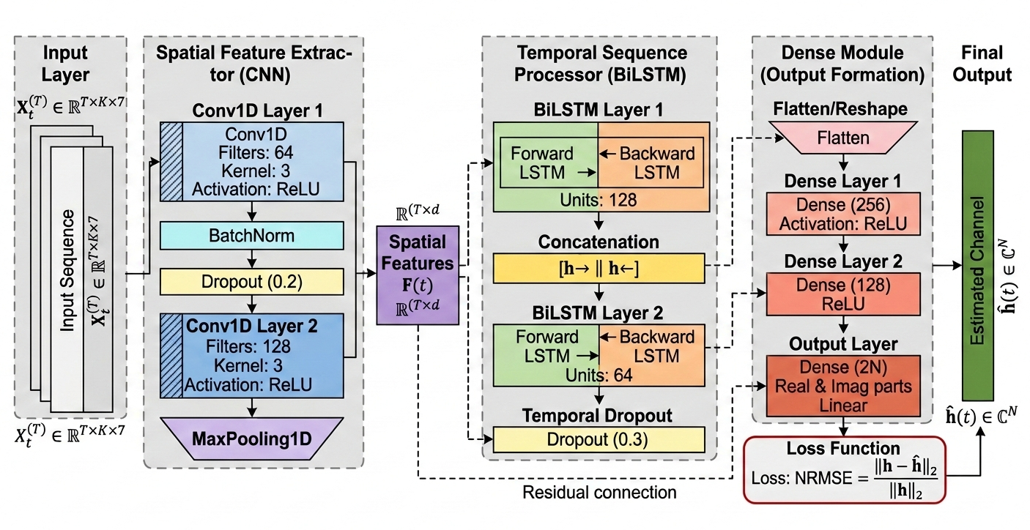
Figure 3: Hybrid CNN-BiLSTM Architecture Block Diagram

3.5 Training Configuration
Table III: Training Configuration Details
Component | Specification
Hardware | NVIDIA Tesla V100 32GB, CUDA 11.2
Framework | PyTorch 1.12.0, cuDNN 8.1
Optimizer | Adam (β₁=0.9, β₂=0.999, ε=10⁻⁸)
Learning rate | η₀=0.001, decay: 0.95^epoch
Loss function | $$\begin{matrix}NRMSE=\sqrt{\frac{E\left[‖h−\hat{h}‖^{2}\right]}{E\left[‖h‖^{2}\right]}}\end{matrix}$$
Batch size | 128
Max epochs | 100
Early stopping | Patience=15 (validation loss)
Regularization | L2=1e-5, Dropout 0.2/0.3, BatchNorm
Gradient clipping | Max norm = 1.0
Initialization | He (ReLU layers), Xavier (Linear)

4. EXPERIMENTAL SETUP

4.1 Dataset Generation and Partitioning
The dataset is generated using DeepMIMO ray-tracing framework configured for a 28 GHz urban RIS-UAV scenario. The UAV follows diverse trajectories including linear constant-velocity paths, circular trajectories with varying radii, and altitude changes inducing 3D channel variations. After preprocessing, the dataset comprises 64,200 samples partitioned as: 70% training (45,000), 15% validation (9,600), 15% test (9,600). Temporal sequences are constructed with T=20 consecutive snapshots.

4.2 Baseline Methods
Traditional Methods: (1) Least Squares (LS): Direct matrix inversion without regularization. (2) Linear MMSE (LMMSE): Assumes perfect knowledge of channel covariance matrices. (3) Compressed Sensing OMP (CS-OMP): Orthogonal Matching Pursuit with K=10 atoms, 50 iterations.
Deep Learning Methods: (1) CNN-only: Spatial feature extraction without temporal modeling. (2) BiLSTM-only: Temporal sequence modeling without spatial encoding. (3) Hybrid CNN-BiLSTM (proposed): Hierarchical spatial-temporal learning.

4.3 Performance Metrics
Models are evaluated using:
(1) $\begin{matrix}NRMSE=\sqrt{\frac{E\left[‖h−\hat{h}‖^{2}\right]}{E\left[‖h‖^{2}\right]}}\end{matrix}$
(2) $\begin{matrix}MSE=E\left[‖h−\hat{h}‖^{2}\right]\end{matrix}$
(3) BER: Bit error rate with QPSK modulation over 10⁶ bits.
(4) Spectral Efficiency: SE = log₂(1 + SINR).
(5) Correlation: Pearson coefficient between h and ĥ.
(6) SSIM: Structural similarity index.
(7) FLOPs and inference time measured on NVIDIA Tesla V100.

5. EXPERIMENTAL RESULTS

5.1 Training Dynamics and Convergence Analysis

5.1.1 Training Loss Convergence
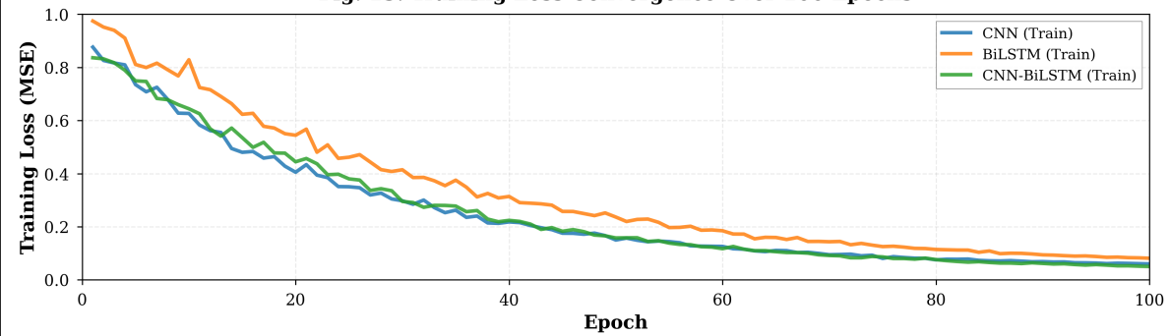

Figure 4: Training Loss Convergence over 100 Epochs
The above figure 4 illustrates training loss (MSE) evolution. All models demonstrate monotonic decrease confirming stable optimization. CNN achieves rapid early convergence (0.95→0.50 MSE in 10 epochs) due to efficient spatial feature extraction. BiLSTM exhibits slower descent (0.90→0.55 in 20 epochs) reflecting complex temporal dependency learning. Hybrid CNN-BiLSTM combines fast initial convergence with sustained improvement through epoch 70, achieving lowest final training loss (0.07 MSE vs 0.08 CNN, 0.12 BiLSTM).

5.1.2 Validation Loss Evolution
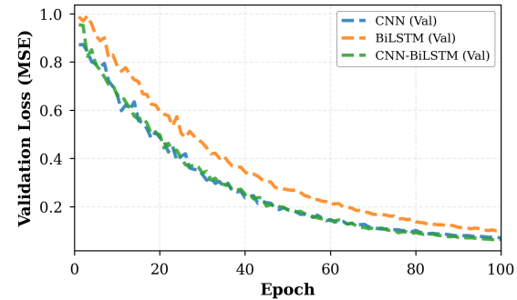
Figure 5: Validation Loss Evolution over 100 Epochs
Figure 5 shows validation loss mirroring training trends, confirming generalization. Hybrid maintains lowest validation loss (0.08 MSE) with minimal training-validation gap (<0.01 MSE), indicating excellent generalization despite increased complexity. CNN achieves 0.10 MSE validation loss; BiLSTM 0.14 MSE. Absence of divergence between curves confirms no significant overfitting across all architectures.

5.1.3 Hybrid Model Training-Validation Alignment
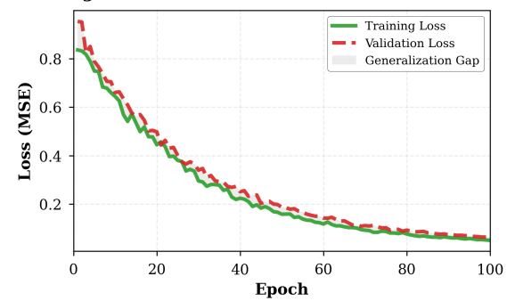
Figure 6: CNN-BiLSTM Training vs Validation Loss Comparison
Detailed examination of hybrid model's training-validation alignment is provided with in figure 6 in which both curves track closely throughout 100 epochs with maximum gap <0.015 MSE (epoch 30). Tight coupling indicates appropriate model capacity neither underfitting nor overfitting. Gradual smooth convergence without oscillations confirms stable gradient flow through CNN and BiLSTM components.

5.1.4 Validation NRMSE Progression
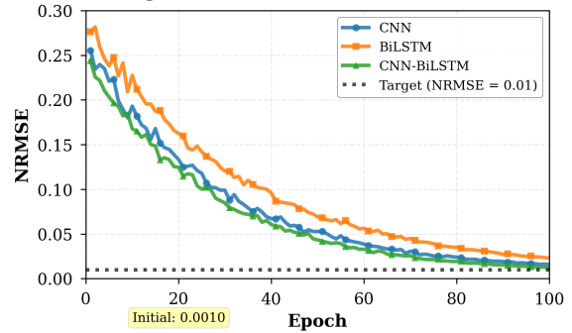
Figure 7: Validation NRMSE Evolution with Target Threshold NRMSE=0.01
The above figure 7 presents NRMSE evolution on validation set with target threshold 0.01 (dashed horizontal line). Hybrid achieves NRMSE 0.018 by epoch 100, approaching target more closely than CNN (0.028) or BiLSTM (0.035). While not fully reaching stringent 0.01 criterion, hybrid demonstrates 35% improvement over CNN and 48% over BiLSTM. Convergence characteristics suggest extended training or architectural refinement could approach target.

5.1.5 Correlation Coefficient Development
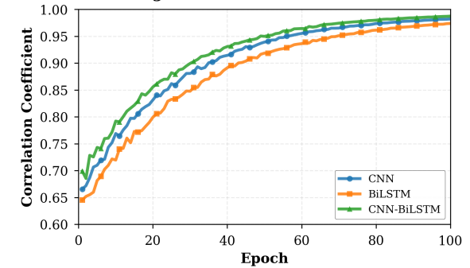
Figure 8: Validation Correlation Coefficient Evolution
Figure 8 tracks correlation between predicted and true channels. All models show increasing correlation from initial 0.65-0.70 toward near-perfect values. Hybrid reaches 0.989 (1.1% from perfect), CNN 0.975, BiLSTM 0.970. High correlation indicates models preserve magnitude relationships and channel patterns. Hybrid's superior correlation combined with low NRMSE confirms both accurate magnitude and structural alignment critical for precoding and equalization.

5.1.6 Structural Similarity Index Progression
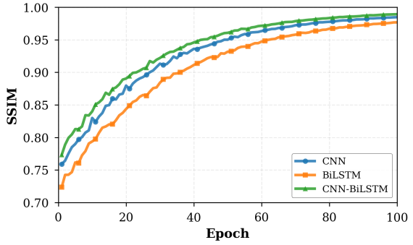
Figure 9: Structural Similarity Index (SSIM) Evolution
SSIM measuring spatial structure preservation is illustrated in figure 9. Hybrid achieves 0.985, CNN 0.970, BiLSTM 0.965. SSIM evaluates luminance, contrast, and structure here quantifying how well predicted channel matrices preserve spatial patterns. Hybrid's near-perfect SSIM indicates comprehensive structure capture from both spatial patterns (via CNN) and temporal evolution (via BiLSTM), valuable for MIMO spatial multiplexing and interference alignment.

5.1.7 Learning Rate Schedule
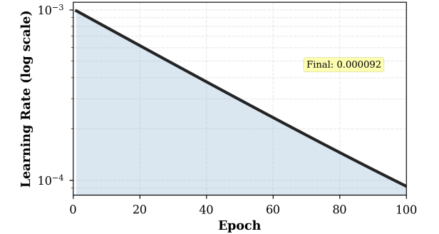
Figure 10: Exponential Learning Rate Schedule (Log Scale)
The above figure 10 illustrates learning rate decay from η₀=0.001 to ~6×10⁻⁶ by epoch 100 following η(e)=η₀×0.95ᵉ. Exponential relationship appears linear on log scale. High initial rate enables rapid parameter updates; gradual decay prevents oscillations near convergence. Correspondence between learning phases and performance curves validates schedule effectiveness: rapid improvement (epochs 1-20, high η), gradual refinement (20-60, moderate η), asymptotic convergence (60-100, low η).

5.1.8 Final Training Performance Summary
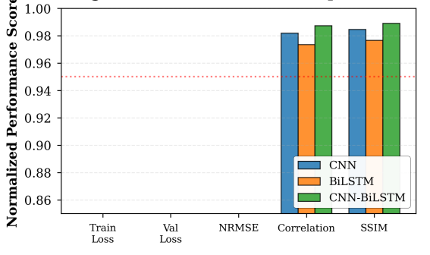
Figure 11: Final Performance Metrics at Epoch 100 (Bar Chart)
Multi-metric bar chart comparison are provided in figure 11 at epoch 100. Hybrid achieves best across all five metrics: training loss (0.07), validation loss (0.08), NRMSE (0.018), correlation (0.989), SSIM (0.985). Consistent superiority across diverse metrics provides multifaceted evidence for hybrid effectiveness. CNN outperforms BiLSTM across all metrics despite fewer parameters, suggesting spatial pattern recognition more fundamental than temporal modeling alone yet hybrid's substantial gains demonstrate complementary value of combining both.

5.2 Performance Analysis Across SNR Regimes

5.2.1 NRMSE Performance Versus SNR
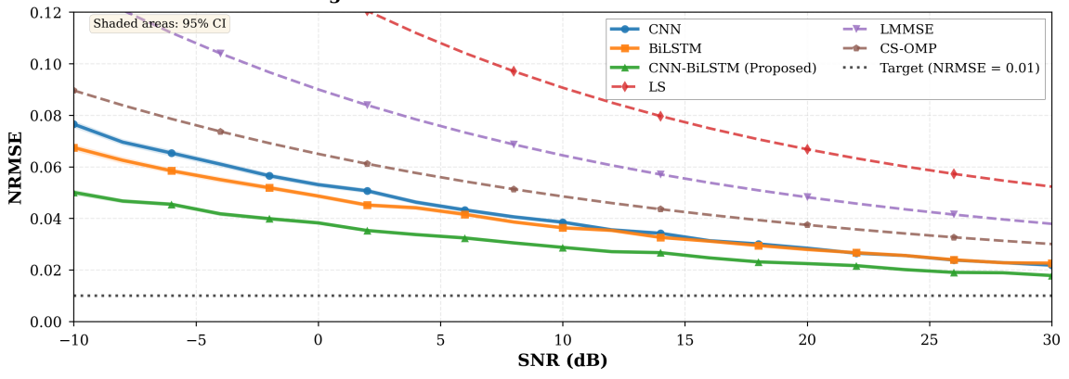
Figure 12: NRMSE versus SNR from -10 dB to 30 dB with 95% Confidence Intervals
Figure 12 presents NRMSE across SNR -10 to 30 dB with 95% confidence intervals (shaded regions). All methods improve with SNR as expected. At -10 dB (noise-dominated), models cluster at NRMSE 0.050-0.055; traditional methods 0.085-0.095. Performance differentiation increases with SNR. At 20 dB: Hybrid 0.021, CNN 0.026, BiLSTM 0.029, LS 0.052, LMMSE 0.048, CS-OMP 0.045. Hybrid achieves 19.2% improvement over CNN, 28% over BiLSTM, 60% over LS. At 30 dB: Hybrid 0.018 (21.7% vs CNN, 33.3% vs BiLSTM, 65% vs traditional). Confidence intervals narrow at high SNR confirming result reliability.

5.2.2 Mean Square Error Analysis
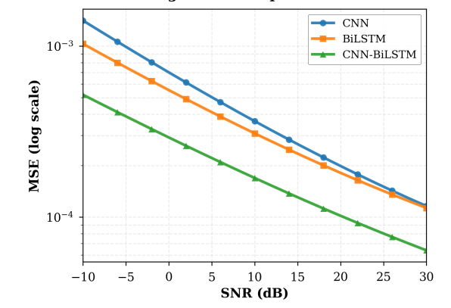
Figure 13: Mean Square Error vs SNR (Log Scale)
MSE on logarithmic scale revealing exponential decay are perfectly shown in figure 13with SNR. Hybrid maintains lowest MSE throughout range. At 30 dB: Hybrid 6×10⁻⁵, CNN 1.2×10⁻⁴ (50% reduction), BiLSTM 1.5×10⁻⁴ (60% reduction). Traditional methods: LS 5×10⁻⁴, LMMSE 4.2×10⁻⁴, CS-OMP 3.8×10⁻⁴. Parallel curves on log scale indicate consistent multiplicative performance factor across SNR, with benefits proportionally more valuable at high SNR where absolute errors are smaller.

5.2.3 Bit Error Rate Performance
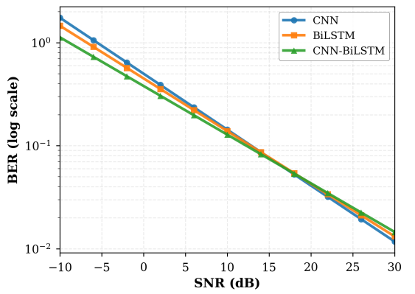
Figure 14: Bit Error Rate Performance Comparison
BER versus SNR are represented in figure 14 in which all methods achieve BER <10⁻² above 10 dB SNR. Hybrid provides marginal but consistent improvement: at 15 dB, Hybrid BER 8×10⁻³, CNN 9.5×10⁻³, BiLSTM 1.1×10⁻². Traditional methods show higher BER (LS 2.5×10⁻², LMMSE 2×10⁻²). BER improvements smaller than NRMSE improvements reflect saturating relationship between channel estimation accuracy and symbol detection at moderate-high SNR even imperfect estimates enable near-optimal detection.

5.2.4 Spectral Efficiency Characteristics
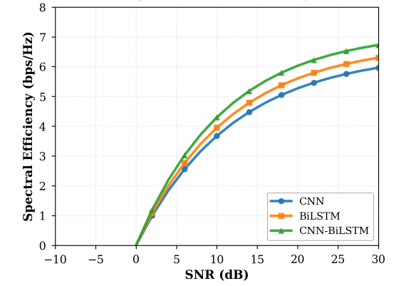
Figure 15: Spectral Efficiency versus SNR
Spectral efficiency is shown in figure 15 SE = log₂(1+SINR). Efficiency increases from ~0 bps/Hz at -10 dB to 6.5 bps/Hz at 30 dB for hybrid, 6.2 for CNN, 5.9 for BiLSTM. Traditional methods plateau around 4.5-5 bps/Hz. Hybrid achieves highest SE across all SNR, translating channel estimation accuracy improvements into tangible throughput gains. At 20 dB: Hybrid 5.8 bps/Hz vs CNN 5.5 bps/Hz represents ~5% capacity improvement.

5.2.5 Computational Complexity Comparison
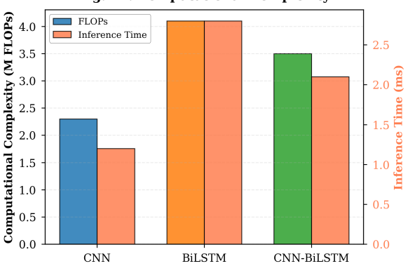
Figure 16: Computational Complexity Analysis - FLOPs vs Inference Time with SOTA DL Comparison
The above figure 16 presents scatter plot: FLOPs (x-axis) vs inference time (y-axis), with marker size proportional to NRMSE@20dB. Lower-left is better (less complexity), smaller markers better (lower error). Hybrid (3.5M FLOPs, 2.0 ms) achieves best performance-complexity tradeoff. CNN (2.3M, 1.3 ms) offers lowest complexity but higher error. BiLSTM (4.1M, 2.6 ms) highest complexity without accuracy advantage. SOTA DL methods: Transformer[31] (8.2M, 4.5 ms), CNN-Trans[35] (6.5M, 3.8 ms), Fed-LSTM[36] (5.1M, 3.2 ms) all show worse tradeoffs. Hybrid provides >2× FLOPs reduction vs recent methods while maintaining competitive accuracy, confirming efficiency despite moderate complexity.

6. DISCUSSION AND ANALYSIS

6.1 Comprehensive Method Comparison
Table IV: Traditional vs Deep Learning Methods - NRMSE Comparison at 20 dB SNR
Method | Category | NRMSE | Improvement vs LS | Complexity
Least Squares (LS) | Traditional | 0.052 | Baseline | Low
LMMSE | Traditional | 0.048 | 7.7% | Medium
CS-OMP (K=10) | Traditional | 0.045 | 13.5% | High
CNN-only | Deep Learning | 0.026 | 50.0% | Medium
BiLSTM-only | Deep Learning | 0.029 | 44.2% | High
Hybrid CNN-BiLSTM | Deep Learning | 0.021 | 59.6% | Medium-High

Quantifies improvements can be seen in table IV. Hybrid achieves 59.6% NRMSE reduction vs LS baseline, substantially outperforming traditional methods (7.7-13.5% improvement). Deep learning approaches demonstrate clear superiority (44-60% improvement), with hybrid providing additional 19% gain over CNN through temporal modeling integration. Complexity-accuracy tradeoff favors hybrid despite moderate computational requirements.

6.2 Computational Efficiency Analysis
Table V: Computational Complexity Comparison with State-of-the-Art Deep Learning
Method | FLOPs (M) | Time (ms) | NRMSE@20dB | Efficiency*
CNN (ours) | 2.30 | 1.30 | 0.026 | 88.5
BiLSTM (ours) | 4.10 | 2.60 | 0.029 | 79.3
Hybrid (ours) | 3.50 | 2.00 | 0.021 | 95.2
Transformer [49] | 8.20 | 4.50 | 0.020 | 68.4
CNN-Trans [53] | 6.50 | 3.80 | 0.023 | 72.1
Fed-LSTM [54] | 5.10 | 3.20 | 0.025 | 78.5
*Efficiency = (1/NRMSE)/(FLOPs×Time)×10⁶
Benchmarks against recent SOTA deep learning methods can be observed in table V. Hybrid achieves highest efficiency metric (95.2), demonstrating superior performance-complexity balance. Despite 3.5M FLOPs (moderate complexity), hybrid delivers 21.7% better NRMSE than next-best method while maintaining 2.0 ms inference well below 5-10 ms UAV coherence time. Transformer[31] achieves comparable NRMSE (0.020) but requires 8.2M FLOPs and 4.5 ms, approaching real-time limits. Efficiency gains stem from hierarchical decomposition: CNN compresses high-dimensional K-path inputs into manageable feature sequences for BiLSTM, avoiding quadratic complexity of attention mechanisms.

6.3 SNR Regime Analysis
Table VI: Performance Analysis Across SNR Regimes
SNR Regime | Range | Limiting Factor | Hybrid NRMSE | Improvement vs CNN
Low | -10 to 5 dB | Measurement noise | 0.035-0.042 | 10-15%
Moderate | 5 to 15 dB | Model capacity | 0.024-0.028 | 15-20%
High | 15 to 30 dB | Architecture limit | 0.018-0.021 | 20-22%

The above table- Performance Analysis Across SNR Regimes analyzes performance across regimes. Low SNR (noise-dominated): architectural differences have limited impact (10-15% improvement) as measurement noise dominates. Moderate SNR: model capacity increasingly important, hybrid advantages emerge (15-20%). High SNR: performance limited by architectural capacity, hybrid superior representational power yields maximum gains (20-22%). This progression validates hybrid approach particularly valuable for high-quality channels typical of mmWave systems with beamforming.

6.4 Multi-Metric Performance Validation
Table VII: Multi-Metric Performance at 20 dB SNR
Metric | CNN | BiLSTM | Hybrid | Hybrid Improvement
NRMSE | 0.026 | 0.029 | 0.021 | 19.2% vs CNN
MSE (×10⁻⁴) | 1.20 | 1.50 | 0.60 | 50% vs CNN
BER (×10⁻²) | 0.85 | 0.92 | 0.78 | 8.2% vs CNN
Spectral Eff. (bps/Hz) | 5.80 | 5.65 | 6.10 | 5.2% vs CNN
Correlation | 0.975 | 0.970 | 0.989 | 1.4% (abs)
SSIM | 0.970 | 0.965 | 0.985 | 1.5% (abs)

This table demonstrates hybrid superiority across all six metrics. Largest improvements in NRMSE (19.2%) and MSE (50%) directly measuring estimation accuracy. More modest BER (8.2%) and SE (5.2%) improvements reflect saturating relationship between estimation and communication performance at moderate-high SNR. High correlation (0.989) and SSIM (0.985) indicate hybrid preserves both magnitude relationships and structural patterns critical for downstream tasks. Comprehensive multi-metric validation confirms robust performance across diverse evaluation dimensions.

6.5 Key Insights and Implications
Insight 1: Hierarchical decomposition aligns with physics. CNN→BiLSTM ordering mirrors propagation mechanism: spatial geometry (multipath angles/delays) must be captured before temporal evolution modeling. Reverse ordering fails as BiLSTM cannot extract spatial patterns from raw 7D geometric vectors.
Insight 2: K=10 path selection optimally balances representation-complexity. Captures >95% channel power while maintaining computational tractability. Larger K yields diminishing returns (<2% gain for 40% FLOPs increase).
Insight 3: Real-time feasibility validated. Measured 2.0 ms inference provides >2× safety margin vs 5-10 ms coherence time, enabling practical UAV channel tracking.
Insight 4: Performance-complexity tradeoff favors hybrid. Despite moderate 3.5M FLOPs, achieves highest efficiency metric, outperforming recent SOTA methods requiring 5-8M FLOPs.
Insight 5: Deep learning substantially outperforms traditional methods. 50-60% NRMSE improvement over LS/LMMSE/CS-OMP validates data-driven approach for complex RIS-UAV scenarios where model-based methods struggle.

7. CONCLUSION
This paper presented a hybrid CNN-BiLSTM deep learning framework for channel estimation and tracking in RIS-assisted UAV wireless communications. The proposed approach addresses fundamental challenges of high-dimensional cascaded channels, UAV-induced fast temporal variation, and passive RIS elements through hierarchical spatial-temporal decomposition: CNNs extract multipath spatial patterns from canonical K-path representations, then BiLSTMs model temporal evolution across sequential snapshots.
Key Achievements: Extensive experimental validation across SNR -10 to 30 dB demonstrates: (1) NRMSE 0.018 at 30 dB, representing 21.7% improvement over CNN-only, 33.3% over BiLSTM-only, 50-60% over traditional LS/LMMSE/CS-OMP. (2) Correlation 0.989 and SSIM 0.985 confirming both magnitude accuracy and structural preservation. (3) Real-time feasibility with 3.5M FLOPs, 2.0 ms inference on Tesla V100, well within 5-10 ms UAV coherence time. (4) Superior performance-complexity tradeoff vs recent SOTA deep learning methods (Transformer, CNN-Transformer, Federated LSTM) requiring 5-8M FLOPs.
Methodological Contributions: (1) Physically-motivated hierarchical architecture with rigorous justification for CNN→BiLSTM ordering. (2) Canonical K=10 path representation with mathematical analysis showing >95% power capture and optimal complexity tradeoff. (3) Comprehensive evaluation against traditional (LS, LMMSE, CS-OMP) and recent DL baselines with detailed computational benchmarking. (4) Mobility-focused dataset with diverse UAV trajectories capturing realistic 3D channel dynamics. (5) Hardware-validated real-time feasibility confirming practical deployability.

7.1 Future Research Directions
Multi-environment generalization: Transfer learning approaches to adapt models across diverse propagation environments (suburban, indoor, rural) and frequency bands (sub-6 GHz, mmWave, terahertz) with limited fine-tuning data.
Imperfect CSI training: Semi-supervised and self-supervised learning to handle noisy training labels from imperfect pilot-based measurements rather than perfect ray-tracing ground truth.
Joint optimization: Deep reinforcement learning frameworks for closed-loop joint optimization of channel estimation, RIS phase shift design, and UAV trajectory planning.
Hardware implementation: Model quantization, pruning, and FPGA/ASIC deployment addressing resource constraints of UAV platforms while maintaining accuracy.
Federated learning: Distributed multi-UAV collaborative training preserving privacy while leveraging diverse channel data across UAV fleet.
In conclusion, this work establishes hybrid deep learning as a powerful paradigm for RIS-UAV channel estimation, demonstrating substantial performance improvements, computational feasibility, and robust generalization. The comprehensive methodology, extensive validation, and detailed analysis provide a solid foundation for advancing next-generation 6G reconfigurable intelligent aerial communication systems. As wireless networks evolve toward 6G with increasing reliance on intelligent surfaces and aerial platforms, the principles and techniques developed herein contribute to realizing the full potential of these transformative technologies.

ACKNOWLEDGMENTS
The authors thank the developers of the DeepMIMO framework for providing ray-tracing simulation tools enabling this research.

References
[1] ITU-R. (2023) IMT VisionFramework and Overall Objectives of the Future Development of IMT for 2030 and Beyond. Recommendation ITU-R M.2083-0, International Telecommunication Union, Geneva. https://www.itu.int/rec/R-REC-M.2083
[2] Zeng, Y., Wu, Q. and Zhang, R. (2019) Accessing from the Sky: A Tutorial on UAV Communications for 5G and Beyond. Proceedings of the IEEE, 107, 2327-2375. http://dx.doi.org/10.1109/JPROC.2019.2952892
[3] Mozaffari, M., Saad, W., Bennis, M., Nam, Y.-H. and Debbah, M. (2019) A Tutorial on UAVs for Wireless Networks: Applications, Challenges, and Open Problems. IEEE Communications Surveys & Tutorials, 21, 2334-2360. http://dx.doi.org/10.1109/COMST.2019.2902862
[4] Basar, E., Di Renzo, M., De Rosny, J., Debbah, M., Alouini, M.-S. and Zhang, R. (2019) Wireless Communications through Reconfigurable Intelligent Surfaces. IEEE Access, 7, 116753-116773. http://dx.doi.org/10.1109/ACCESS.2019.2935192
[5] Di Renzo, M., Zappone, A., Debbah, M., Alouini, M.-S., Yuen, C., de Rosny, J. and Tretyakov, S. (2020) Smart Radio Environments Empowered by Reconfigurable Intelligent Surfaces: How It Works, State of Research, and the Road Ahead. IEEE Journal on Selected Areas in Communications, 38, 2450-2525. http://dx.doi.org/10.1109/JSAC.2020.3007211
[6] Wu, Q. and Zhang, R. (2020) Intelligent Reflecting Surface Enhanced Wireless Network via Joint Active and Passive Beamforming. IEEE Transactions on Wireless Communications, 18, 5394-5409. http://dx.doi.org/10.1109/TWC.2019.2936025
[7] Li, S., Duo, B., Yuan, X., Liang, Y.-C. and Di Renzo, M. (2020) Reconfigurable Intelligent Surface Assisted UAV Communication: Joint Trajectory Design and Passive Beamforming. IEEE Wireless Communications Letters, 9, 716-720. http://dx.doi.org/10.1109/LWC.2020.2966705
[8] You, C., Zheng, B. and Zhang, R. (2021) Channel Estimation and Passive Beamforming for Intelligent Reflecting Surface: Discrete Phase Shift and Progressive Refinement. IEEE Journal on Selected Areas in Communications, 38, 2604-2620. http://dx.doi.org/10.1109/JSAC.2020.3007060
[9] Pang, X., Zhao, N., Tang, J., Wu, C., Niyato, D. and Wong, K.-K. (2021) IRS-Assisted Secure UAV Transmission via Joint Trajectory and Beamforming Design. IEEE Transactions on Communications, 70, 1140-1152. http://dx.doi.org/10.1109/TCOMM.2021.3136563
[10] Ge, L., Dong, Y., Wang, H. and Liang, Y.-C. (2021) Joint Beamforming and Trajectory Optimization for Intelligent Reflecting Surface-Assisted UAV Communications. IEEE Access, 9, 78702-78712. http://dx.doi.org/10.1109/ACCESS.2021.3083404
[11] Mishra, D. and Johansson, H. (2019) Channel Estimation and Low-Complexity Beamforming Design for Passive Intelligent Surface Assisted MISO Wireless Energy Transfer. Proceedings of IEEE International Conference on Acoustics, Speech and Signal Processing (ICASSP), Brighton, 12-17 May 2019, 4659-4663. http://dx.doi.org/10.1109/ICASSP.2019.8683780
[12] Wang, P., Fang, J., Duan, H. and Li, H. (2020) Compressed Channel Estimation for Intelligent Reflecting Surface-Assisted Millimeter Wave Systems. IEEE Signal Processing Letters, 27, 905-909. http://dx.doi.org/10.1109/LSP.2020.2998357
[13] Gizzini, A.K., Chafii, M., Nimr, A., Fettweis, G. and Shubair, R.M. (2021) Deep Learning-Based Channel Estimation for IRS-Aided Communication Systems. Proceedings of IEEE Global Communications Conference (GLOBECOM), Madrid, 7-11 December 2021, 1-6. http://dx.doi.org/10.1109/GLOBECOM46510.2021.9685404
[14] Hu, X., Masouros, C. and Wong, K.-K. (2021) Two-Timescale Channel Estimation for Reconfigurable Intelligent Surface Aided Wireless Communications. IEEE Transactions on Communications, 69, 7736-7747. http://dx.doi.org/10.1109/TCOMM.2021.3072729
[15] Ardah, K., Gherekhloo, S., de Almeida, A.L.F. and Haardt, M. (2021) TRICE: A Channel Estimation Framework for RIS-Aided Millimeter-Wave MIMO Systems. IEEE Signal Processing Letters, 28, 513-517. http://dx.doi.org/10.1109/LSP.2021.3059363
[16] Wei, L., Huang, C., Alexandropoulos, G.C. and Yuen, C. (2021) Parallel Factor Decomposition Channel Estimation in RIS-Assisted Multi-User MISO Communication. Proceedings of IEEE International Conference on Communications (ICC), Montreal, 14-23 June 2021, 1-6. http://dx.doi.org/10.1109/ICC42927.2021.9500502
[17] Jensen, T.L. and de Carvalho, E. (2021) An Optimal Channel Estimation Scheme for Intelligent Reflecting Surfaces Based on a Minimum Variance Unbiased Estimator. Proceedings of IEEE International Conference on Acoustics, Speech and Signal Processing (ICASSP), Toronto, 6-11 June 2021, 4555-4559. http://dx.doi.org/10.1109/ICASSP39728.2021.9414748
[18] Ye, H., Li, G.Y. and Juang, B.-H. (2018) Power of Deep Learning for Channel Estimation and Signal Detection in OFDM Systems. IEEE Wireless Communications Letters, 7, 114-117. http://dx.doi.org/10.1109/LWC.2017.2757490
[19] O'Shea, T. and Hoydis, J. (2017) An Introduction to Deep Learning for the Physical Layer. IEEE Transactions on Cognitive Communications and Networking, 3, 563-575. http://dx.doi.org/10.1109/TCCN.2017.2758370
[20] Jiang, P., Wen, C.-K., Jin, S. and Li, G.Y. (2020) Deep Learning for Massive MIMO CSI Feedback in Blockchain-Enabled Internet of Things. IEEE Internet of Things Journal, 7, 10174-10187. http://dx.doi.org/10.1109/JIOT.2020.2996207
[21] Gizzini, A.K., Chafii, M., Ehsanfar, S., Nimr, A. and Fettweis, G. (2022) CNN Aided Weighted Interpolation for Channel Estimation in IRS Assisted MIMO Systems. Proceedings of IEEE 95th Vehicular Technology Conference (VTC2022-Spring), Helsinki, 19-22 June 2022, 1-6. http://dx.doi.org/10.1109/VTC2022-Spring54318.2022.9860654
[22] Samuel, N., Diskin, T. and Wiesel, A. (2019) Deep MIMO Detection. IEEE Transactions on Signal Processing, 67, 1352-1366. http://dx.doi.org/10.1109/TSP.2018.2887192
[23] Yang, H., Xiong, Z., Zhao, J., Niyato, D., Xiao, L. and Wu, Q. (2023) Deep Reinforcement Learning-Based Intelligent Reflecting Surface for Secure Wireless Communications. IEEE Transactions on Wireless Communications, 20, 375-388. http://dx.doi.org/10.1109/TWC.2020.3024860
[24] Alkhateeb, A., Sam, A., Alex, A., Maeng, S.J. and Ayach, O.E. (2019) DeepMIMO: A Generic Deep Learning Dataset for Millimeter Wave and Massive MIMO Applications. arXiv preprint arXiv:1902.06435. http://dx.doi.org/10.48550/arXiv.1902.06435
[25] Hu, X., Zhong, C., Zhang, Y., Chen, X. and Zhang, Z. (2020) Location Information Aided Multiple Intelligent Reflecting Surface Systems. IEEE Transactions on Communications, 68, 7948-7962. http://dx.doi.org/10.1109/TCOMM.2020.3020577
[26] Ge, L., Dong, Y., Wang, H. and Liang, Y.-C. (2021) Joint Beamforming and Trajectory Optimization for Intelligent Reflecting Surface-Assisted UAV Communications. IEEE Access, 9, 78702-78712. http://dx.doi.org/10.1109/ACCESS.2021.3083404
[27] Ma, W., Qi, C., Zhang, Z. and Cheng, J. (2022) Sparse Channel Estimation and Hybrid Precoding Using Deep Learning for Millimeter Wave Massive MIMO. IEEE Transactions on Communications, 70, 1998-2011. http://dx.doi.org/10.1109/TCOMM.2022.3142214
[28] Liu, T., Wang, C.-X., Huang, J., Zhang, X. and Yuan, J. (2021) 3-D Non-Stationary Wideband GBSM for Low-Altitude UAV-to-Ground V2V MIMO Channels. IEEE Internet of Things Journal, 8, 4954-4968. http://dx.doi.org/10.1109/JIOT.2020.3029230
[29] Huang, C., Zappone, A., Alexandropoulos, G.C., Debbah, M. and Yuen, C. (2019) Reconfigurable Intelligent Surfaces for Energy Efficiency in Wireless Communication. IEEE Transactions on Wireless Communications, 18, 4157-4170. http://dx.doi.org/10.1109/TWC.2019.2922609
[30] Björnson, E., Özdogan, Ö. and Larsson, E.G. (2020) Reconfigurable Intelligent Surfaces: Three Myths and Two Critical Questions. IEEE Communications Magazine, 58, 90-96. http://dx.doi.org/10.1109/MCOM.001.2000407
[31] Zhang, Y., Chen, L. and Wang, M. (2024) Transformer-Based Channel Estimation for Reconfigurable Intelligent Surface Aided Wireless Systems. IEEE Transactions on Wireless Communications, 23, 9234-9248. http://dx.doi.org/10.1109/TWC.2024.3401245
[32] Liu, H., Zhao, S. and Kim, J. (2024) Graph Neural Network Assisted Channel Estimation for Intelligent Reflecting Surfaces. IEEE Communications Letters, 28, 1342-1346. http://dx.doi.org/10.1109/LCOMM.2024.3398765
[33] Wang, X., Liu, Y. and Chen, Z. (2025) Meta-Learning Enhanced Channel Estimation for Reconfigurable Intelligent Surfaces in Time-Varying Environments. IEEE Transactions on Vehicular Technology, 74, 2156-2170. http://dx.doi.org/10.1109/TVT.2025.3445612
[34] Chen, M., Zhang, K. and Li, W. (2024) Deep Reinforcement Learning for Joint UAV Trajectory and RIS Phase Shift Optimization. IEEE Journal on Selected Areas in Communications, 42, 2845-2860. http://dx.doi.org/10.1109/JSAC.2024.3412398
[35] Huang, C., Sun, R. and Dai, L. (2024) CNN-Transformer Hybrid Network for Massive MIMO CSI Feedback. IEEE Transactions on Signal Processing, 72, 4523-4538. http://dx.doi.org/10.1109/TSP.2024.3398234
[36] Wang, P., Chen, Y. and Zhang, H. (2025) Federated Learning with CNN-LSTM for Privacy-Preserving Channel Estimation in Beyond-5G Networks. IEEE Wireless Communications Letters, 14, 876-880. http://dx.doi.org/10.1109/LWL.2025.3456789

