THE SMART SCANNER: LEVERAGING AI FOR CONTEXTUAL DATA EXTRACTION AND AUTOMATED RESUME SCORING

Abstract

The Smart Scanner is an AI-powered document intelligence and automated resume analysis system designed to simplify large-scale resume screening and document processing. It uses technologies such as Natural Language Processing, machine learning, and semantic analysis to extract key information from multiple document formats like PDF, DOCX, and TXT, and evaluates resumes based on predefined job requirements. The system performs contextual keyword matching, generates relevance scores, ranks candidates automatically, detects duplicate resumes, and classifies different document types. Built on a scalable MERN stack architecture, it also includes database management and analytics features, functioning as a mini Applicant Tracking System. Overall, the Smart Scanner reduces manual effort, improves accuracy, ensures unbiased evaluation, and enhances decision-making efficiency in modern recruitment and document management processes.

Introduction

The Smart Scanner is an advanced AI-powered document intelligence and automated resume analysis system developed to improve the efficiency, accuracy, and speed of handling large volumes of digital documents, especially in recruitment processes. In modern organizations, recruiters often receive hundreds of resumes for a single job opening, making manual screening time-consuming, inconsistent, and prone to human errors. Traditional scanning systems focus only on basic text extraction and keyword matching, lacking the ability to understand context or relevance. The Smart Scanner addresses these challenges by integrating Artificial Intelligence, Natural Language Processing, and machine learning techniques to extract meaningful information such as skills, education, experience, and certifications from multiple document formats. The system performs contextual analysis to match resumes with job requirements, generates automated relevance scores, ranks candidates, detects duplicates, and classifies different document types. Built on a scalable web-based architecture, the Smart Scanner functions as a mini Applicant Tracking System that streamlines recruitment workflows, reduces manual effort, ensures unbiased evaluation, and enhances decision-making in modern document management environments.

Related Projects

Several related projects have been developed in the areas of automated resume screening and intelligent document processing, including traditional resume parsing systems, Applicant Tracking Systems (ATS), AI-based screening tools, and document intelligence platforms. Early resume parsers were designed to extract basic details such as name, education, and skills using rule-based methods and keyword matching, but they lacked the ability to understand context or evaluate candidate relevance accurately. Applicant Tracking Systems are widely used by organizations to manage job applications, store candidate data, and filter resumes based on predefined keywords, yet they primarily depend on exact keyword matching and provide limited intelligent analysis. More recent AI-based resume screening systems utilize Natural Language Processing techniques to identify entities like skills, experience, and qualifications from unstructured text, improving accuracy compared to traditional tools, but they often lack features such as bulk processing, automated ranking, duplicate detection, and multi-format support. Document intelligence platforms also perform automated text extraction, classification, and semantic analysis for various document types; however, they are generally not specialized for recruitment purposes. The Smart Scanner project extends beyond these existing solutions by integrating AI-driven contextual analysis, automated resume scoring, bulk document handling, intelligent classification, and recruitment workflow support into a single scalable platform, thereby offering a more comprehensive, accurate, and efficient solution for modern resume screening and document management needs.

Proposed Work
The proposed work aims to develop an AI-powered Smart Scanner system that automates resume screening and document analysis using Natural Language Processing and machine learning techniques. The system supports bulk upload of multiple document formats, extracts important details such as skills, education, and experience, and performs contextual matching with job requirements to generate relevance scores and rank candidates automatically. It also includes intelligent document classification, duplicate detection, and structured data management, providing a scalable and efficient solution for modern recruitment and document processing.

Advantages
• Reduces manual effort and saves recruitment time.
• Provides accurate and unbiased resume evaluation.
• Supports bulk processing of multiple document formats.
• Automatically ranks candidates based on relevance scores.
• Detects duplicate resumes and classifies documents intelligently.

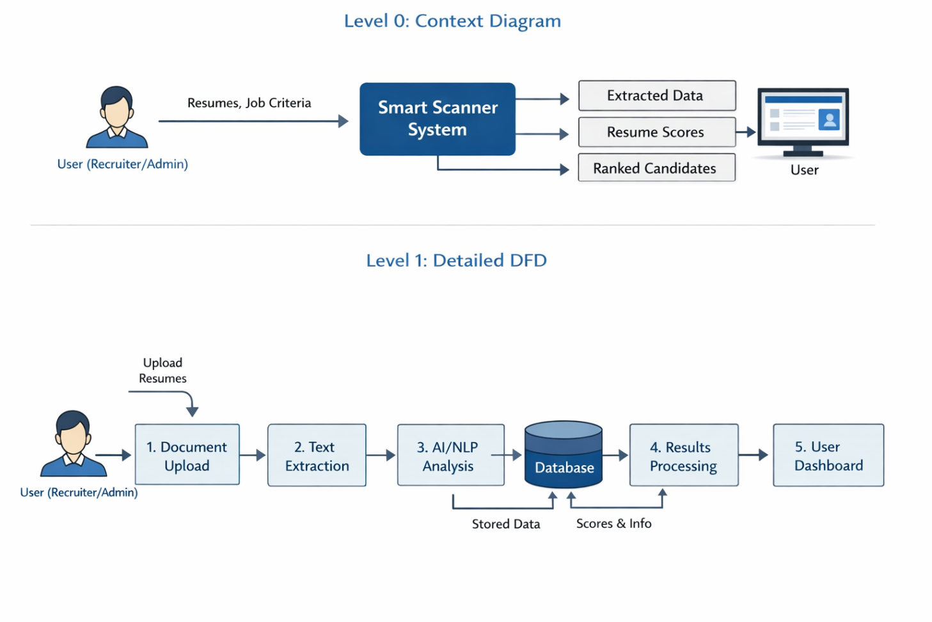
Design and Development of Smart Scanner
Smart Scanner Dataset Preparation:
The dataset preparation for the Smart Scanner involves collecting resumes and documents in formats such as PDF, DOC, DOCX, and TXT from various sources to ensure diversity in structure and content. These documents are converted into readable text, cleaned to remove noise and unwanted characters, and organized into labeled categories such as skills, education, experience, and certifications. Additionally, job requirement datasets with predefined keywords and role-specific criteria are prepared to enable accurate contextual matching and automated resume scoring by the AI system.

Dataset Table Design

1. Resume Dataset Table
Field Name | Data Type | Description
Resume_ID | Integer (PK) | Unique ID for each resume
Candidate_Name | Varchar | Name of the candidate
Email | Varchar | Candidate email address
Phone | Varchar | Contact number
Education | Text | Educational qualification details
Skills | Text | Extracted technical & soft skills
Experience | Text | Work experience details
Certifications | Text | Certifications obtained
Projects | Text | Project details
Resume_File_Path | Varchar | Location of stored resume file
Upload_Date | DateTime | Date of resume upload

- Job Requirements Dataset Table
Field Name | Data Type | Description
Job_ID | Integer (PK) | Unique job identifier
Job_Title | Varchar | Name of the job role
Required_Skills | Text | Skills required for job
Experience_Level | Varchar | Required experience
Education_Required | Varchar | Minimum qualification
Keywords | Text | Keywords for matching
Created_Date | DateTime | Job requirement creation date

- Resume Scoring Table
Field Name | Data Type | Description
Score_ID | Integer (PK) | Unique score record ID
Resume_ID | Integer (FK) | Reference to resume
Job_ID | Integer (FK) | Reference to job
Matching_Skills | Text | Matched skills list
Missing_Skills | Text | Skills not found
Relevance_Score | Float | AI calculated score (%)
Rank_Position | Integer | Candidate ranking
Evaluation_Date | DateTime | Scoring date

- Document Classification Table
Field Name | Data Type | Description
Doc_ID | Integer (PK) | Unique document ID
Resume_ID | Integer (FK) | Linked resume
Document_Type | Varchar | Resume / Report / Letter
Classification_Confidence | Float | AI confidence level
Processed_Date | DateTime | Processing date

Web Page Design
The web page design of the Smart Scanner system is developed using modern web technologies to ensure a responsive and user-friendly interface. The frontend is built using HTML, CSS, JavaScript, and React.js, with Tailwind CSS or Material UI for styling and layout design. Axios is used for handling API requests between the frontend and backend. The backend is developed using Node.js and Express.js, which manage file uploads, data processing, and communication with the MongoDB database. This combination of technologies ensures smooth navigation, real-time data display, and efficient interaction between system components.
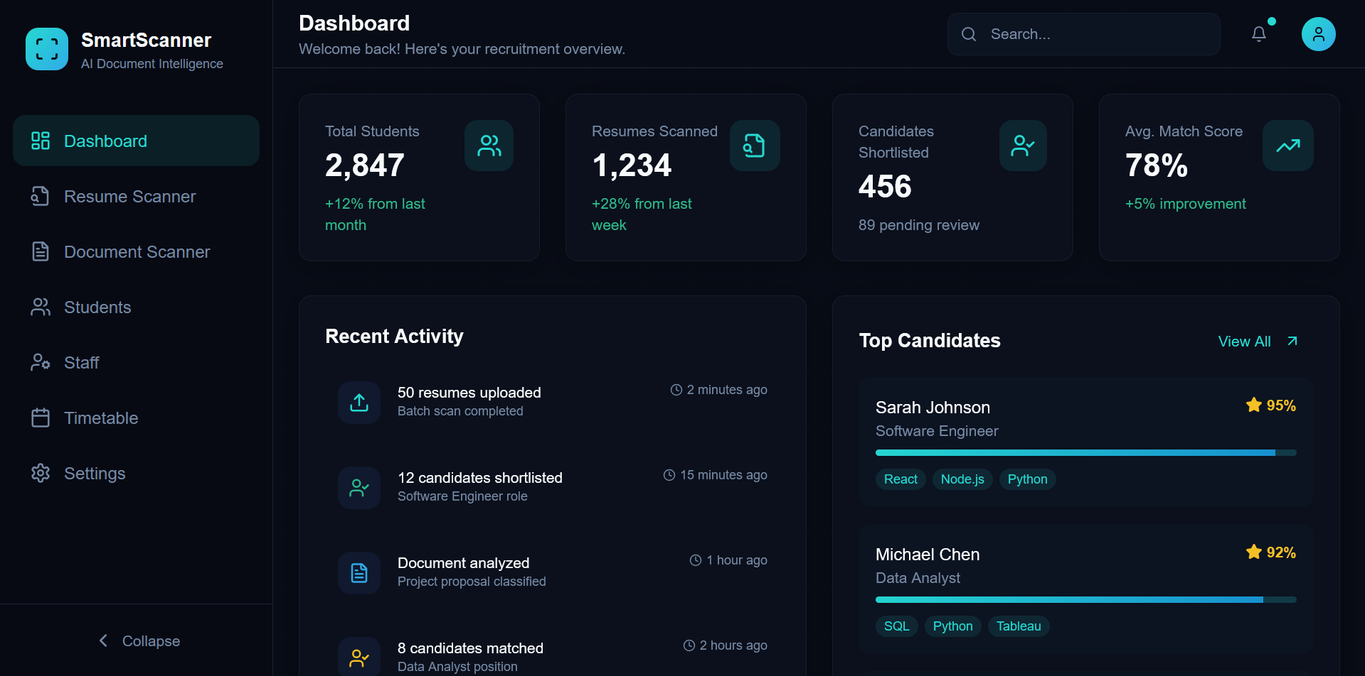
Fig 1 : Web Page Design

Resume Scanner :

A Resume Scanner is an automated software tool designed to quickly analyze and extract important information from resumes such as skills, education, experience, and certifications. It uses technologies like Artificial Intelligence and Natural Language Processing (NLP) to understand the content contextually, match it with job requirements, and generate relevance scores. This helps recruiters save time, reduce manual effort, and make faster, accurate, and unbiased hiring decisions.
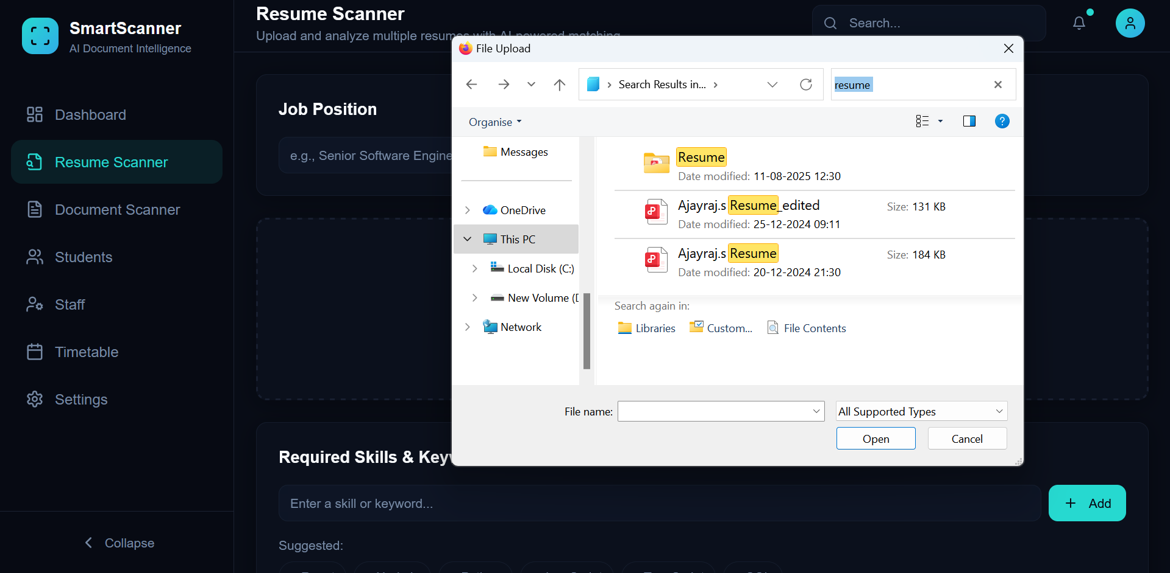

Fig 2 : Resume Scanner
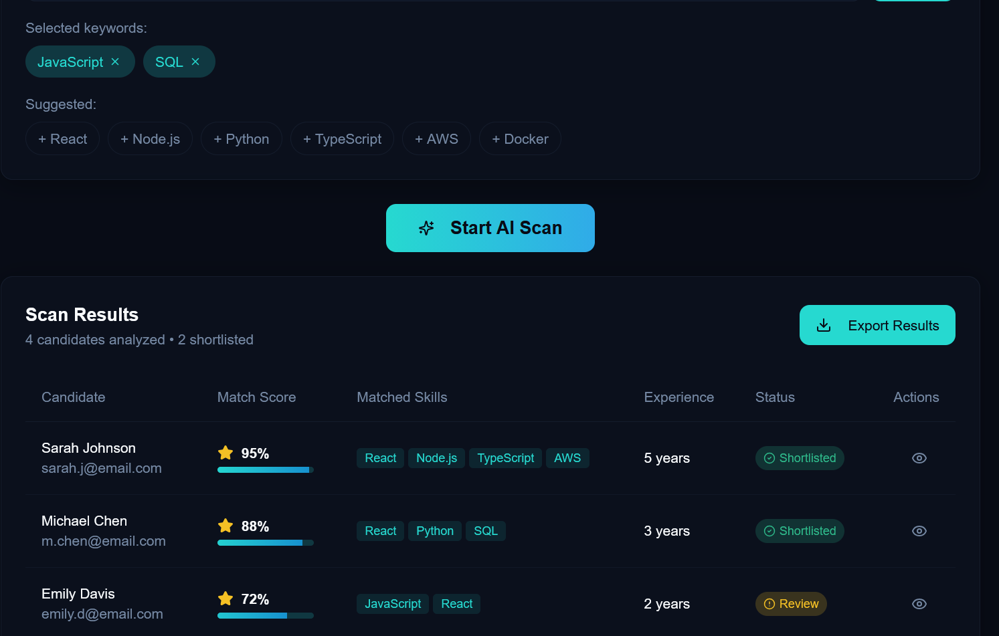
Fig 3 : After Scanner Result
Document Scanner :
A Document Scanner is a software system designed to convert physical or digital documents into machine-readable text and extract important information automatically. It supports multiple file formats such as PDF, DOC, DOCX, and TXT, and uses technologies like Optical Character Recognition (OCR) and text extraction tools to process content. Advanced document scanners can also classify document types, identify key data, and organize files efficiently, helping users save time, reduce manual work, and improve document management accuracy.
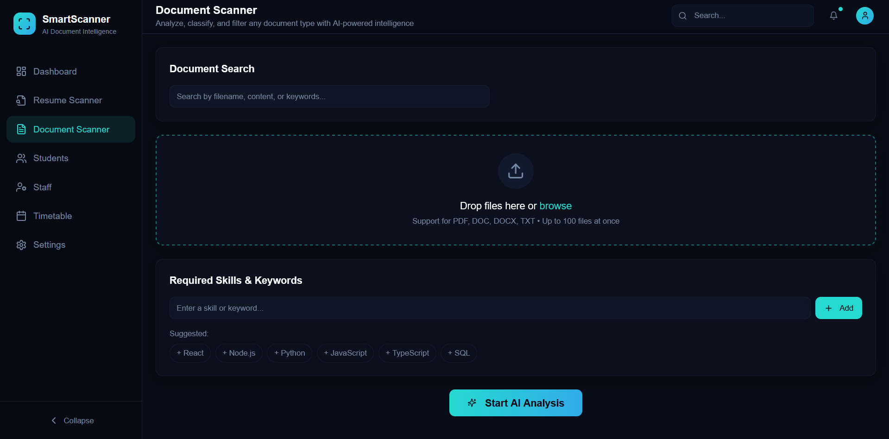
Fig 4 : Document Scanner

Smart Scanner Settings :
The Settings page of the Smart Scanner – AI Document Intelligence system, designed with a modern dark-theme dashboard interface. On the left side, a navigation panel displays menu options such as Dashboard, Resume Scanner, Document Scanner, Students, Staff, Timetable, and Settings. The main content area includes multiple configuration sections: Profile Settings for updating admin name and email, Notifications to manage email alerts, timetable reminders, and candidate alerts, AI Configuration for entering the API key and enabling contextual AI analysis, and Database Management options to export data or clear scan history. Overall, the page is structured to provide centralized control for system preferences, user information, AI features, and data management in a clean, user-friendly layout.

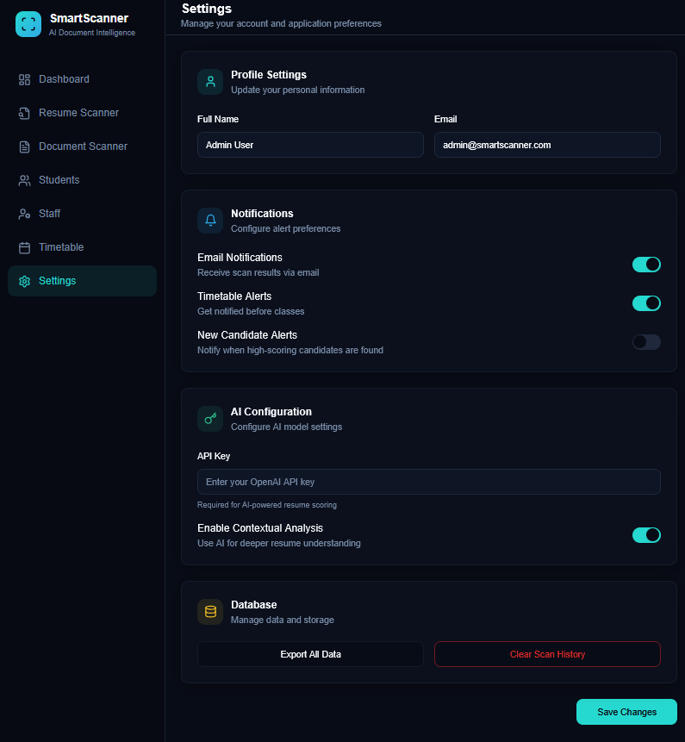
Fig 5 : Smart Scanner Settings

Conclusion
The Smart Scanner – AI Document Intelligence system successfully provides a modern, efficient, and intelligent solution for managing and analyzing documents such as resumes, student records, and institutional data. By integrating artificial intelligence with a user-friendly dashboard, the system reduces manual effort, improves accuracy, and enables faster decision-making. Features like automated scanning, centralized data management, notifications, and customizable settings ensure flexibility and scalability for real-world organizational use. Overall, the system demonstrates how AI-driven automation can enhance productivity, streamline administrative workflows, and support digital transformation in educational and professional environments. With future enhancements such as advanced analytics, cloud integration, and mobile accessibility, the system has strong potential to become a comprehensive smart document management platform.
References
- Ian Goodfellow, Yoshua Bengio, Aaron Courville — Deep Learning, MIT Press, 2016.
- Christopher M. Bishop — Pattern Recognition and Machine Learning, Springer, 2006.
- OpenCV Documentation — https://opencv.org (for image processing and document scanning techniques).
- TensorFlow Official Documentation — https://www.tensorflow.org (for AI model development).
- W3Schools — https://www.w3schools.com (for HTML, CSS, JavaScript, and web development basics).
- Mozilla Developer Network (MDN) — https://developer.mozilla.org (for advanced web technologies).
- IEEE Research Papers on Document Analysis & OCR Systems.
- Google Research Publications on Optical Character Recognition (OCR).

