“Corn (Clavus) Treated with Individualized Homoeopathic Medicine: A Case Report”

DOI: https://doi.org/xxxx/xxxx
Received: XX December 2025; Accepted: XX December 2025; Published: XX January 2026

ABSTRACT
A corn, also known as a Clavus, is a thickening of the skin caused by intermittent pressure and friction. These forces result in hyperkeratosis, both clinically and histologically. Chronic pain can result from a corn's significant skin thickening, particularly in the forefoot. It is not a viral, fungal, or bacterial infection. In order to protect the skin and its inner layers from external pressures, corn is composed of thicker skin layers. The first signs are typically sensitive, painful areas on the toes, which quickly develop into corns if not treated. Most of corn is caused by an individual's footwear. Homoeopathy can be helpful in treating a number of skin problems, as shown by the case study of a young person who received 2-3 months of treatment for corn using a homoeopathic similimum selected based on individualization. The case was treated with antimonium crudum. The physician has supplied homoeopathic similimum. The remedy was antimonium crudum.
Keywords: Corn, Homoeopathy, Holistic Approach, Individualization, Similimum

INTRODUCTION
A particular type of localized superficial hyperkeratosis is corn. It usually occurs when pressure is applied, such as on the soles and toes. The horny cuticle growth usually has a firm core. Corn can be painful, particularly if you rub it. Corn usually regenerates after removal. The deeper layer of the dermis is penetrated by the deep inner core of a corn.

Pathophysiology⁽²⁾
Corns are caused by of mechanical skin trauma that results in hypertrophy of the epidermis. The friction and pressure between the foot's bones and poor fitting shoes are the most common causes of the stratum corneum growth, which is an abnormal physiological reaction. One of the stratums corneum's primary roles is to act as a barrier against mechanical damage. When this barrier breaks down, equilibrium is disturbed and cytokines are released into the epidermis, increasing stratum corneum production. A firm clump of keratin called a radix or nucleus occurs as a corn forms, pressing painfully into the papillary dermis and damaging the stratum corneum. This occurs when mechanical forces from the outside are focused on a particular area of the skin. All around the world, corn is a common problem.. The development of corn can affect everyone who can maintain their own weight. Twenty to sixty-five percent of those 65 years of age or older have been shown to develop foot hyperkeratotic lesions. Even though anybody can develop a clavus, most people develop the risk factors for clavus formation after puberty as a result of increasing foot deformities, traumatic footwear use, and the onset of repetitive motion injuries.
Clinically, three types of corn can be defined. The earliest kind is hard corn, or Heloma durum. It is particularly common in the interphalangeal joints, the top of the toe, and the outside of the little toe. The second is soft corn. It typically happens in the gaps between the digits and between the fourth and fifth toes. The third type, known as periungual, appears on or around the edge of a nail. We also found seed corn, which is a different kind of corn. Seed corns, which are clusters of microscopic corns, can be very sensitive if they are on a weight-bearing foot. The ball of the foot is typically affected.
MATERIAL AND METHODOLOGY:
Case: A 31 year old male patient residing in Jaipur reported to the OPD of Swasthya Kalyan Medical College and Research Centre Sitapura, Jaipur on 14th may 2025, with complaints of hard, rough, dry skin developed of the left foot just below the great toe just below the great toe since 2-3 months.

History of Presenting Complaint
- Hard, rough, dry and painful corn on the plantar surface of the left foot toe, just below the left toe for 2-3 months.
- The patient gave a history of minor injury while walking barefoot, after which the corn developed on the plantar surface of the left toe, just below the great toe.
- Pain described as sharp, stitching < walking and on pressure.
- Pain is relieved by rest.
- Lesion is horny and tender on touch causing discomfort while walking.

Associated Complaints
- Constipation after heavy meals; stool hard, dry with straining; relief after evacuation.
- Stomach discomfort after heavy meals; relieved by belching and taking rest.
General Symptoms

Mental Generals
- Patient is cheerful and talkative, maintains friendly relations with others.
- Responsible and cooperative by nature, carries out his duties sincerely.
- Helpful and polite, respects elders and behaves well with others.
- Becomes irritable when disturbed or when discomfort increases, prefers not to be interrupted while working.
- Sometimes anxious about his health, but usually stays calm.

Physical Generals
- Physical appearance: Moderately built and nourished. His height was 5 feet 9 inches, and he weighed 65 kg
- Appetite: Normal, 2 meals/day (2-3 chapatti/meal)
- Thirst: Normal;2-3L/day
- Desire: likes spicy food; prefers freshly cooked warm meal • Aversion: N/S
- Stool: Regular, once a daily; usually normal in consistency but becomes hard and dry with straining after heavy meals
- Urine: D₄₋₅/N_{1-2,} No complaint
- Perspiration: Prominent on the axilla and non-offensive
- Sleep: Sound sleep (6-7hrs/night)
- Thermal reaction: Hot

Family History
- Mother- Healthy and alive
- Father- Hypertension (Taking allopathic medicines)
Physical Examination
- B.P- 122/90 mm of hg
- Pulse- 82/min
- R.R- 20/min

Local Examination (Skin Examination)
Inspection-revealed a single, circular, thick and yellowish corn on the plantar aspect of the left great toe, extending slightly towards the lateral side. The surface appeared rough, dry and elevated from the surrounding skin.
Palpation – the area was hard and tender with pain on pressure or while walking.
No redness, discharge or swelling was seen around the affected area.

Analysis of Symptom
Mental Generals | Physical Generals | Particular General
Cheerful and talkative | Desire for spicy and freshly cooked warm food | Hard, rough, dry and painful corn on the sole of the left foot
Responsible and cooperative | Stool usually normal but become hard and dry with straining after heavy meals | Sharp stitching pain < walking and on pressure, > by rest
Helpful and polite | Thermal- hot | Constipation after heavy meals and stool is dry, hard with straining
Irritable when disturbed |  | Stomach discomfort after heavy meals relieved by belching and taking rest
Sometime anxious about health

Predominant Miasm ⁽³⁾
The case was a combination of sycosis and psora miasm.
SYMPTOMS | MIASM | INTENSITY | JUSTIFICATION
Hard, rough, dry and painful corn on the plantar surface of the left foot, just below the toe. | Sycosis | +++ | Indicates localized overgrowth of epithelial tissue, typical of proliferative pathology.
Pain on walking and pressure. | Sycosis | ++ | Chronic localized inflammation with mechanical aggravation.
Lesion is horny and tender on touch. | Sycosis | ++ | Sensitivity of overgrown tissue, common in sycotic lesions.
Constipation after heavy meals | Psora | ++ | Functional disturbance of digestion without any structural change.
Stool dry hard with straining | Psora | ++ | Indicates sluggish intestinal function typical of psoric disturbance.
Stomach discomfort after heavy meals and | Psora | + | Functional gastric disturbance, non- destructive in nature.
relieved by rest and belching.
Cheerful, talkative, polite and cooperative nature. | Psora | + | Balanced, expressive temperament typical of psoric constitution.
Irritable when disturbed or while working | Psora | ++ | Emotional sensitivity and irritability on interruption.
Sometimes anxiety health about his health. | Psora | + | Mild anxiety about health, functional disturbance not pathological.

Evaluation of Symptoms
- Cheerful and talkative
- Responsible, cooperative, polite and respectful by nature
- Irritable when disturbed or while working
- Sometimes anxious about his health
- Desire for spicy and freshly cooked warm food
- Stool hard and dry after heavy meals
- Hard, rough, painful corn on the plantar surface of left toe just below the toe
- Pain on walking and on pressure and relieved by rest
- Lesion horny and tender on touch
- Stomach discomfort after heavy meals and relieved by belching and rest

Totality of Symptoms
- Cheerful and talkative
- Responsible, cooperative and polite
- Becomes irritable when disturbed or while working
- Sometimes anxious about his health
- Desire for spicy food and prefers warm meal
- Constipation after heavy meals
- Hard, rough, painful corn on the plantar surface of left foot just below the toe
- Pain on walking and pressure

Reportorial Totality ⁽⁴⁾
The repertorisation was done from synthesis repertory version 9.1 on RADAR software, version 10.0
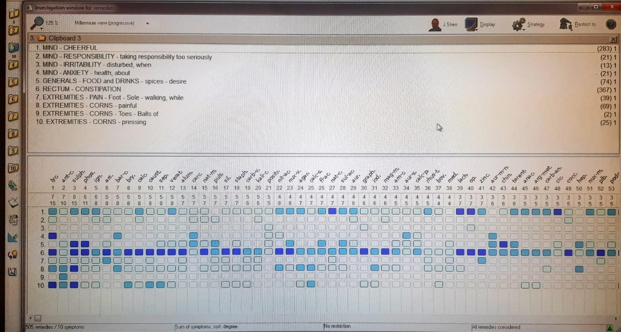

Repertorial Analysis
Lycopodium-15/7
Antimonium Crudum – 10/7
Sulphur- 15/6
Phosphorus- 11/6

Prescription
On the basis of the totality of symptoms and repertorisation Antimonium Crudum 200C was prescribed.
Date | Prescription
14th May 2025 | Antimonium Crudum 200/1 dose  Phytum 30/TDS/15 days

Justification for prescription ^{(5,6)}
Antimonium Crudum was selected because it covers the totality of symptoms.
The patient had a painful corn with horny skin and pain worse on walking or pressure, which matches the remedy picture. The complaint of constipation is also covered by the medicine. Mentally, the patient is cheerful and becomes irritable when disturbed, when also suits antimonium crudum.

Follow Ups
Date | Symptoms | Prescription
29/05/2025 | Slight relief in pain on walking. Corn still hard and elevated, but tenderness reduced. Slight relief in constipation. No new complaints. | R_{x} Rubrum 30/TDS ×15 days
13/06/2025 | Pain and discomfort decrease further. Corn margins becoming soft, rough hard centre still present. Stomach complaints improved. | R_{x} Rubrum 30/TDS × 15 days
28/06/2025 | Marked improvement in pain and tenderness. Corn flattering, central area showing signs of peeling. Patient able to walk comfortably. | R_{x} Rubrum 30/TDS × 15 days
13/07/2025 | Corn almost healed. Lesion surface smooth, no pain on walking. Skin normal in color and texture. Patient feels completely better. | R_{x} Rubrum 30/TDS × 1 month

14/05/2025 29/05/2025
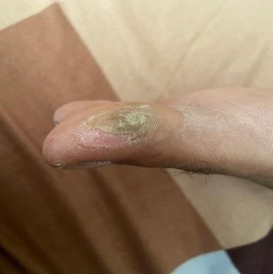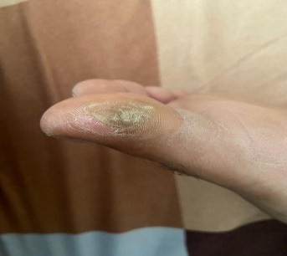

13/06/2025 28/06/2025
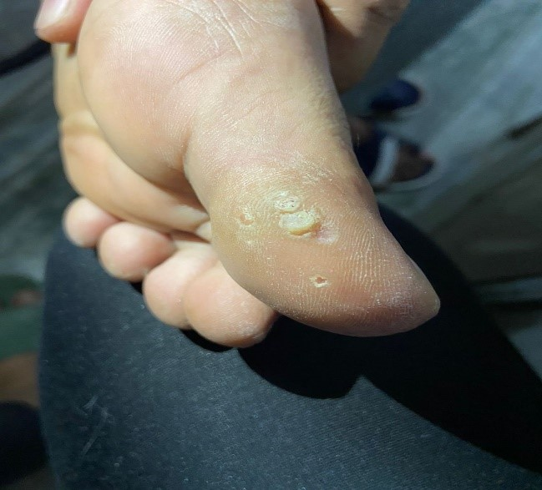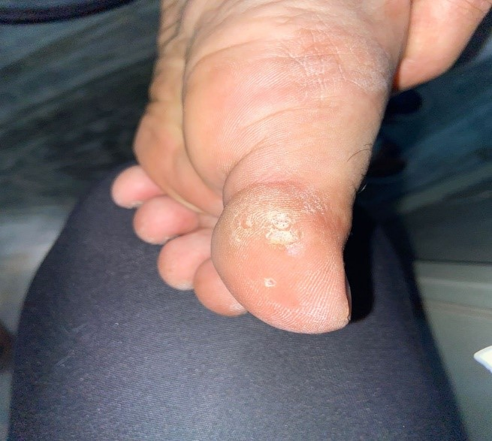
13/07/2025
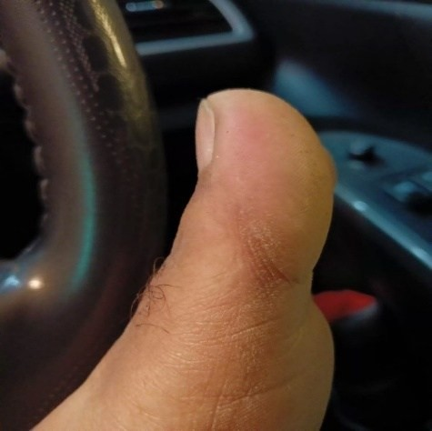

DISCUSSION^{(5,6)}
A localized hyperkeratotic lesion caused by continuous pressure and friction is called a corn (clavus). With a high chance of recurrence, conventional treatment can provide short-term relief. To cure such diseases, homeopathy treats both the local pathology and the constitutional susceptibility.
In this case, the patient complains of a painful, hard corn on the plantar area that was aggravated by walking and pressure. Constipation caused by heavy meals, stomach discomfort, a desire for spicy food, and specific mental features were all associated general symptoms that obviously formed a totality. Antimonium crudum, which is well advised in corns, callosities, and hyperkeratosis, especially as associated with digestive problems after heavy meals, was selected following repertorisation and materia medica discussion.
After Antimonium crudum 200 was given to the patient, the corn's size and pain significantly decreased. It also reduced associated digestive problems, and there was no recurrence during the follow-up period. This shows how successful an individualized homeopathic approach can be.

CONCLUSION
This case shows the importance of individualized homeopathic treatment in corn management. Both the local lesion and the associated constitutional complaints were effectively treated by antimonium crudum 200, which was selected based on the totality of symptoms. Thus, in hyperkeratotic conditions like corns, homeopathy offers non-invasive, safe, and holistic treatment with a reduced likelihood of recurrence.

REFERENCE
- Penman, I. D., Ralston, S. H., Strachan, M. W. J., & Hobson, R. (Eds.). (2022). Davidson’s principles and practice of medicine (24th Ed.). Elsevier Health Sciences.
- Das S. A concise textbook of surgery. 11th ed. Delhi, India: S. Das; 2021.
- Bhattacharya, P. M. (2023). Encyclopaedia of Hahnemann’s Organon of medicine: With a comparative & critical study of the 5th & 6th editions. B Jain.
- Homeopathy software online. (n.d.). Com. Retrieved January 12, 2026, from http://www.radaropus.com.
- Boericke, W. (n.d.). Pocket Manual of Homoeopathic Materia Medica and Repertory. B. Jain Publishers.
- Kent, J. T. (2023). Lectures on homoeopathic materia medica: Together with Kent’s “new remedies” incorporated & arranged in one alphabetical order. B Jain.

