Weather–based water Level Prediction Model for Hydropower Planning in Zambia.

1. Introduction
Extremes in weather patterns have been caused by climate change. The sub-Saharan African region has been affected by climate change. Zambia in particular has also been adversely affected. [1]The 2023/2024 rainy season was characterized by severe drought caused by El Niño conditions. This climate change had a disastrous impact on agriculture, one of the economy's mainstays, with maize production falling by more than 50% compared to previous seasons. This deficiency resulted in a food deficit for almost six million people, contributing to a dramatic increase in food costs. The drought also drastically decreased the availability of water for both home and industrial purposes. Climate change created unpredictability in weather patterns. This led to significant fluctuations in water availability, resulting in power shortages and economic disruptions. Additionally, the drought had a significant impact on cattle output and resulted in low to below rainfall.

This low rainfall pattern resulted in low water levels in the water basins used for electricity generation, resulting in prolonged load management for both home and industrial use.
Drought is a major phenomenon that limits social-economic activities invariably.The last 25 years has revealed an increase in drought occurances [2]leading to a decline in the water levels not only in Zambia but in many regions..
In Zambia, hydropower generating accounts for 83% to 84% of the country's electrical production[3].This therefore makes the stability of water levels in major reservoirs such as Kariba and Kafue Gorge critical for energy security.
Despite the wealthy of information weather-based forecasting is not widely included into the planning of power generation. Studies reveal that there is a direct relationship between [3] power generation and water levels. specifically, in the context of hydropower.

That relationship is described by the formula:
P = ρgQhη[4], where:
P: is the power (usually in watts or kilowatts).
ρ: (rho) is the density of water (approximately 1000 kg/m³).

g: is the acceleration due to gravity (approximately 9.81 m/s²).
Q: is the volumetric flow rate of water (volume per unit of time, e.g., cubic meters per second).
h: is the effective head (the vertical distance the water falls).
η: (eta) is the overall efficiency of the hydropower system.
For practical calculations K: is a constant that combines the density of water (ρ), gravity(g), and typical turbine efficiency(η). Hence P=K×Q×h.
This paper aims to develop a weather-based water level forecast model for planning and power production in order to improve Zambian hydroelectric power generation planning and dependability by constructing a predictive model that uses weather data to estimate reservoir water level.
2. Methodology
This study focused exclusively on developing a water level prediction model utilizing key meteorological and hydrological variables. These variables included rainfall, temperature (both maximum and minimum), relative humidity, wind speed, evaporation, as well as historical water level records, with a specific emphasis on the Kariba North Bank reservoir. The Kariba North Bank, located in the Southern Province of Zambia, plays a critical role in the country’s energy infrastructure. Notably, during the most severe load shedding periods, the Kariba North Bank contributed approximately 48% of Zambia’s total available power supply. This underscored the importance of accurately forecasting water levels at this site to support effective water resource management and ensure energy security. It has the second largest installed capacity in the power distribution outlay.
The dam is sustained by a substantial catchment basin that receives inflows primarily driven by precipitation across a diverse network of upstream locations. The hydrological inputs influencing water levels at the Kariba North Bank reservoir are derived from rainfall patterns observed in multiple key towns within the catchment. These towns include Kapombo, Kalabo, Kaoma, Kasempa, Livingstone, Mongu, Mwinilunga, and Sesheke, each contributing varying volumes of runoff based on localized precipitation events. To accurately quantify and analyze the temporal variability and spatial distribution of rainfall impacting the inflow regime, comprehensive precipitation datasets were systematically collected for a continuous period of 25 years. This longitudinal dataset enabled the assessment of hydrological trends to support water resource management, and facilitates predictive modeling of reservoir inflows under different climatic scenarios.
Historical water level data available and collected was from 1958- 2025.This was to give the model sufficient data to gain insight into the water level patterns. Below is a visual outlook of the water level data from 1963 to 2025.The two diagrams provide insights into the water flow pattern at Kariba North Bank from 1963 to 2025 based on water level data.

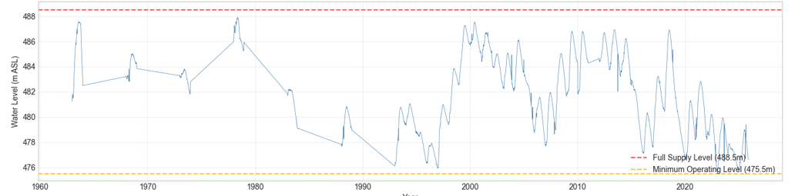
Figure 1: Full Historical Record for Kariba North Bank from1963-2025
The line graph shows the water level (in meters above sea level, m ASL) across the years. The water level fluctuates between approximately 475.5m and 488.5m. The red dashed line at 488.5 m indicates the Full Supply Level, which is the maximum optimal water level. The orange dashed line at 475.5m marks the Minimum Operating Level, below which operation may be compromised. Notable observations: Water levels show cyclical fluctuations with periods of rise and decline. Peaks occurred around the late 1970s, late 1990s, and early 2010s, approaching or nearing the full supply level. Significant drops below the minimum operating level are not frequent but become more common approaching 2025.After 2010, the water level shows a general downward trend with more frequent dips near the minimum operating level.Between 1963 and The cyclical behavior of the line graph is consistent with the weather pattern.It also captures the an array of varying water levels.The levels resonates with variation in weather patterns.The average height is slightly higher than 480m.
Although the general trend is a downward decline,this depicted a higher trend compared to the period from 2020 to 2025.The rest of the graph shows a further dip in the water levels.The fact that the falling variations occur across five-year periods is noteworthy. The height fluctuates throughout the course of five years.The six (6) five-year segments are the result.The lowest height between 1963 and 1980 is about 482 meters.The lowest height recorded between 1985 and 1999 is 476 meters. There is also a minor variation in the nest cycle. The subsequent cycle increases to 478 meters.The subsequent five-year cycle drops even further to 477m.The final cycle rises just higher and yet falls to 477m, whereas the subsequent cycle rises and falls back to 477m. The five year segments synchronise with the elnino cyle and its subsequent effects on weather variables affecting the water level.Studies reveal that elnino the cycle repeats it sef every five years

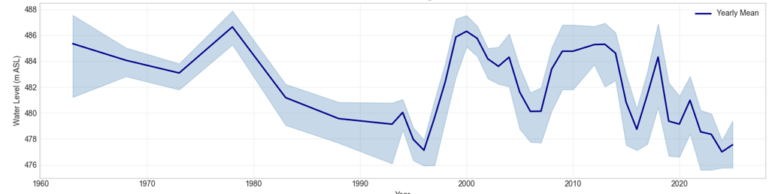
Figure 2: Annual water range and mean
The Annual Water Level Range and Mean graph shows the yearly mean water levels as a dark blue line with a surrounding shaded area representing the annual range (variability) of water levels. The pattern of the yearly mean aligns with the top graph, showing peaks around 1980 and 2000, with declines in the 1980s and early 1990s.The shaded area indicates variability within each year; some periods (e.g., around 2000 and 2010) show larger annual fluctuations. From around 2010 onwards, the mean water level decreases with noticeable variability, reflecting instability or stress in the water system..The overall trend suggests a decline in water levels and
increased fluctuation in recent years.An overview of the water levels at Kariba North Bank have historically fluctuated within operational limits but show a trend of decline and increased variability in recent decades. Peaks near full supply occur roughly every 20 years, but recent data points to challenges in maintaining high water levels. This pattern may indicate environmental or anthropogenic factors affecting water availability or consumption, highlighting the need for careful water resource management to prevent operation below minimum levels.The water level distribustion was captured as compiled below in the histogram and line graph.

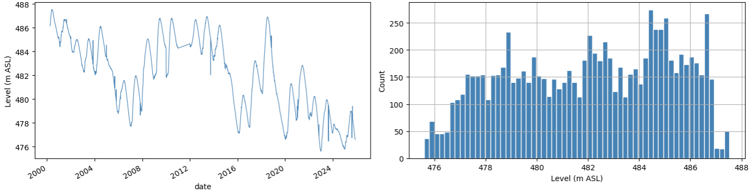
Figure 3a:Water level distribution from 2000-2025 (25years) Figure 3b:water level count distribution

Data Sets

Hydrological and meteorological data was collected. Six important wind Weather parameters were collected..Historical water levels,Relative humidity ,Precipitation (rainfall),windspeed temperature both maximum and minimum temperature, evaporation.In order to improve predictions even though historical water level is the dominant signal. Previous studies reveal that most models only use water level data with little aggregation or no other meteorological parameters. In [5]Authors used Temperature , humidity and precipitation plus historical water levels for as far back as 20yearsThey did not utilize evaporation and speed In this paper Rainfall data, Evaporation, wind speed and Relative humidity, both Maximum and Minimum temperature Table below shows their contribution of each weather parameter to the water level. The data was split into three categories each covering a specific period of time: the training data set covered the period from 2000-2019.This is the dataset that was purely used for training the model, The second set spanned from 2020 to 2021 was for model validation.The model used early stopping to avoid overfitting. Finally the test set spanned from 2022 to 2025 as shown in the table below. It must be noted that the data was used as stated without shuffling
Split | Period | Purpose
Train | 2000-2019 | Model Learning
Validation | 2020-2021 | Early stopiing
Test | 2022-2025 | Final Evalution
Table 1: Data splits

The Five most important lag features are listed in the table and their Feature score contribution to the model. They were listed in the order of feature score starting with the most contributing features on top and the least contributing feature at the bottom Thes features hel pt to understand the impact of each feature on the model

Table 2: Individual Weather Feature Contributions
Feature | Feature Importance Score | % of Total | Justification
PRECIP (rainfall) | 0.0145 | 1.45% | Direct linkage: rain → inflow → water level rise
EVAPPN1(evaporation) | 0.0089 | 0.89% | Loss mechanism during dry season
TMPMAX (max temp) | 0.0076 | 0.76% | Proxy for evaporation intensity
RHMEAN (humidity) | 0.0042 | 0.42% | Modulates evaporation dynamics
WNDSPD(windspeed) | 0.0021 | 0.21% | Secondary evaporation factor
TMPMIN(min temp) | 0.0018 | 0.18% | Corrective signal during cold seasons
Total Weather Contribution | 0.0391 | 3.91% | Justification: Even 0.5-4% improvement in operational forecasting = millions in avoided power shortages

The data sets were prepared and preprocessed for modelling in the following step by step process to ensure data integrity, duplicate records were removed. The data was standardized to a daily frequency to maintain uniform temporal resolution. Missing values were interpolated to create continuous time series, all outliers deleted and dealt with using both the z-score and the interquartile range methods. Feature scaling was applied for normalization training. To enhance model inputs the following features were constructed for lagged water level values from previous times steps (Lags 1,3,7,14 and 30
days). Cumulative totals for rainfall over 7-daya and 30 day windows were obtained to capture precipitation trends. Incorporated deviations from average temperature to reflect climatic influences.
Seasonal encoding categorical features were added representing the month and hydrological year for seasonal pattern recognition.
Baseline Model: XGBoost Regression
Extreme gradient boosting is a machine-learning (ML) algorithm. In this study, the algorithm was employed to train the model. The algorithm employs an ensemble of decision trees.
Each tree is little and ineffectual on its own. For example, if the water_lag over 90 days is less than 475.2, the error is -0.8; otherwise, the correlation is +0.3. Boosting trees learn from each other's mistakes. Suppose Tree 1 predicts the water level. It is incorrect by some amount, therefore Tree 2 is taught to anticipate the error Tree 1 made, and then Tree 3 predicts the remaining error from Tree 1 + Tree 2, with the ultimate prediction being Tree1 + Tree2 + Tree3 +... +
Tree100.Each new tree focuses on what previous trees did incorrectly. Then it uses gradient descent math to figure out which direction reduces error the fastest and builds the next tree to go in that direction [6]. That is the "Gradient" in XGBoost. The X represents its ability to achieve extreme optimizations. Regularization to prevent overfitting and intelligent handling of missing values. The training model uses parallel processing to learn quickly, and then prunes trees to keep them simple.
Various training models have been employed in different research contexts. The authors in [7] utilized a mixture of Autoregressive Integrated Moving Average (ARIMA) and
Seasonal Autoregressive Moving Average (SARIMA).XGBoost regression was selected above Seasonal Auto Regressive Integrated Moving Average (SARIMA) and Long Short-Term Memory (LSTM).Authors in [8] used a hybrid method to predict water levels for a wet land in Korea.
However, both SARIMA and ARIMA only captures short patterns and SARIMA captures seasonality but are unable to capture complex weather patterns. Thus XGBoost was chosen due to its ability to capture intricate, nonlinear correlations in the data, XGBoost regression was selected as the baseline model for water level prediction. Tree-based models work well with water level data that has engineered lag rolling characteristics. This model does not require a lot of preprocessing and can handle missing data natively. The model exhibits strong prediction performance typical of hydrological and environmental systems, and it can also represent nonlinear interactions like those encountered in rainfall-runoff processes. On this dataset, the training is substantially quicker than deep learning methods.
The data splits consist of three XGBoost curves: training set, validation set, and test set. The training data set were for the efficient training of the model until the model learnt the patterns. The data was divided as follows: the training set ranged
from 2000-03-31 to 2019-12-31.The validation data extended from 2020-01-01 to 2021-12-31, whereas the test set stretched from 2022-01-01 to 202511-18.The sample size for each set is as shown in the table11-18.
Table 3: Data splits and Sample size
Split | Period | n Samples
Train | 2000–2019 | 7,301
Validation | 2020–2021 | 730
Test | 2022–2025 | 1,465

XGBoost was trained with an early halt on the validation set. Training was automatically terminated when the validation Root Mean Square Error stopped improving after 50 consecutive rounds. The optimal iteration boosting round was 769.This value represented the number of decision trees. Each round equals one new decision tree added to the ensemble. XGBoost builds models sequentially, fixing errors from previous trees. The validation curve flattens rather than raising again, whereas the train and validation curves closely follow each other. Validation RMSE would eventually increase if it over fitted. In this case, the model's generalization would be poor. With a root mean square error of 0.0309, the validation and training curves showed considerable divergence, with a large initial gap between them that persisted until the model assimilated the patterns. The model used early stopping. It trained up to approximately 800 trees but picked the version at round 769 as final. Using all 800 would slightly hurt validation performance. XGBoost uses unique evaluation measures during training to reduce loss, avoid overfitting, and guide hyperparameter tweaking. The precise metric tracked depends on the machine learning assignment.This is standard practice to avoid overfitting

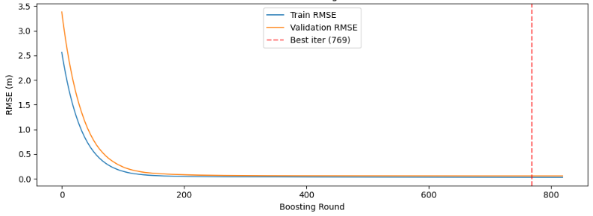
Figure 5: XGBOOST Learning Curves

In order to determine each feature's contribution to the water level, the training model employed feature engineering and chose several features. Due to its lack of built-in awareness, XGBoost makes use of latency features. As a result, lags directly inform it that water levels move slowly on their own. It handles each row independently; for instance, it is unaware that 100 is one day ahead of 99. Data is divided based on a specific feature. With appropriate feature engineering, XGBoost frequently performs exceptionally well on tabular time-series and is quicker to train. Because they combined auto encoders with neural networks and multilayer perception, the authors in [5] applied machine learning and deep
learning because they were prediction rainfall which is a time series and has sequential dependency and hence deep learning. Non-linear features are extracted from time series rainfall data by auto-encoders. The multilayer perception (MLP) algorithm uses the extracted information but does not perform the actual prediction task. They employed the sigmoid function to connect the auto-encoder outputs to the MLP. But XGBoost often does very well on tabular time-series (as was the case with our data set) with proper feature engineering and is faster to train.

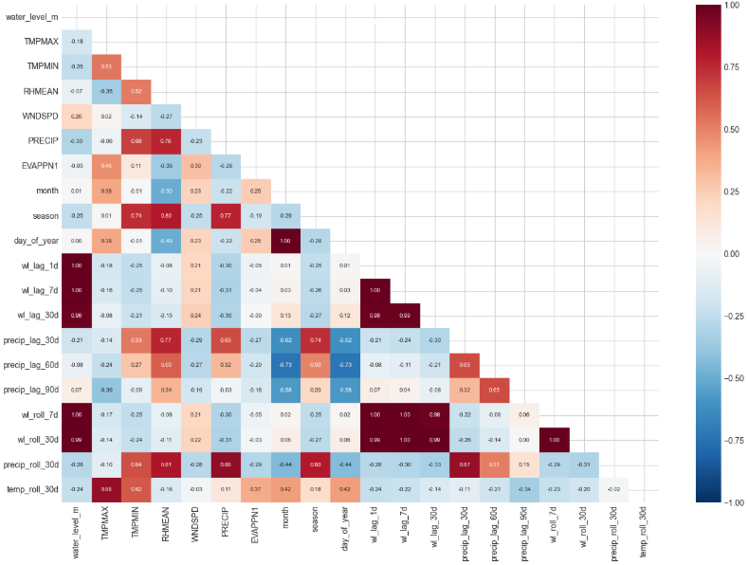
Figure 6: Feature Correlation matrix

The correlation matrix in figure illustrates how closely each feature in the water level model is related to the others. It's an important step in choosing ML features and understanding the drivers of water level. The colour coding in the diagram represents the Pearson correlation coefficient.The dark red indicates a strong positive correlation. Dark Blue indicates a strong negative correlation and white /Light connotes weak or no correlation.

3.Results
The results of the prediction model are illustrated in the diagram below: The models prediction was close to the predicted water level with a Root Mean Square error (RMSE) of 0.0309. Almost all points sit right on the 45-degree line. That means when the true level was 480 m, the model predicted ∼480 m. The spread is minimal, indicating a near perfect prediction. The model predicts daily water level at Kariba North Bank in meters above sea level (m ASL).
Three water levels to take note off are the low water level
475 Masl.This is 10–15% capacity of the Kariba North basin. representing low supply predominatly in the dry season.The second water level is th 480m ASL representing 50-70% capacity. This is a transitional level when thw ater level beigin to increase significantly.
The third and final level is the 485m ASL. This is 95-100% capacity when the pool is full capacity and thus it correlates with full supply. This model will allow energy planners to:
1. Forecast generation 30–90 days ahead up to three(3) years as indicated by the model.
2. Help Zambezi river Authority(ZRA) Plan the water sharing mechanism between Zambia and Zimbabwe.ZRA, a bi-national organization, adjusts water allocation based on hydrological reviews, considering rainfall, river inflows, andwater levels in the dam.This will subsequently help Zambia electricity supply co-operation (Zesco) to plan Load shedding across ZESCO regions.
3. Coordinate regional power trading (SAPP electricity market.
4. Optimize water release to balance generation + irrigation + downstream flows

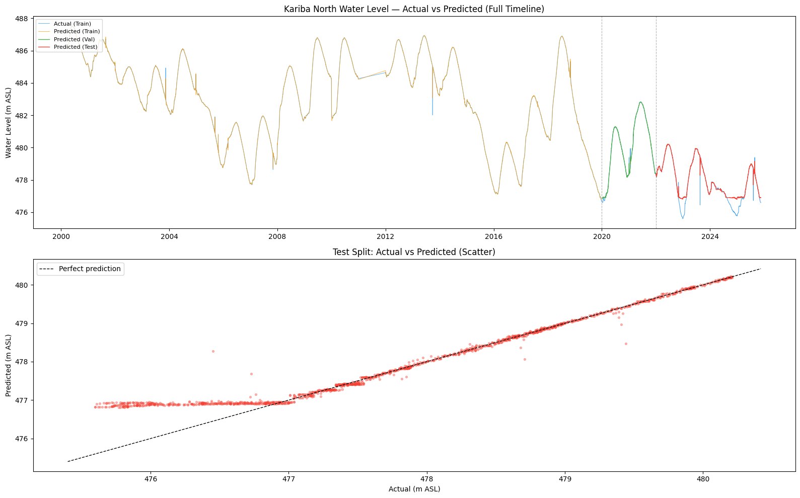

Figure 7:Prediction model based on Kariba North

From the line graph the predicted in training (2000- 2019) track closely to the actual. The same phenomenon is observed in the validation from (2020-2021). This also observed in the test period from 2022 to 2025. The blue line actual recorded water levels from 2000–2019
The Orange line model-predicted water levels over the same period. The two lines track each other extremely closely. The model captures both the seasonal up-down cycle and the multi-year drought/recovery periods like 2015–2016.
Errors are visually tiny the gaps can barely be seen between actual and predicted. Three validation metrics were utilized to depict the models accuracy. The Root mean square (RMSE), the Mean Average Error (MAE) and the $R^{2}$ Score (coefficient of determination).

The Root Mean Square Error (RMSE) is given by:
$$\text{RMSE}=\sqrt{\frac{1}{n}\sum_{i=1}^{n}{(}y_{\text{true},i}-y_{\text{pred},i})^{2}}$$
$y_{\text{true},i}$=Actual measured water level on a day i
$y_{\text{pred},i}=$Predicted water level on a day i
$y_{true i}-$ $y_{pred,i}$=Error for the day
(….)² =Square it so negative errors don’t cancel positive ones
$$\sum_{i=n}^{n}{= Add up the squared errors for all n days in your test set}$$
$\frac{i}{n}$ = Take the average → “Mean Squared Error”
()² = Square root brings it back to original units, meters

Table 4: Data Splits
Split | Period | n Samples | RMSE (m) | MAE (m) | R² | Interpretation
Train | 2000–2019 | 7,301 | 0.0309 | 0.0141 | 0.9999 | Model memorizes training period perfectly
Validation | 2020–2021 | 730 | 0.0557 | 0.0284 | 0.9990 | Excellent generalization to unseen 2020-2021
Test | 2022–2025 | 1,465 | 0.3602 | 0.2872 | 0.9152 | Strong performance on truly held-out future data

The Units are in meters (same as water level). The lower the value the better. The training RMSE is 0.0309 which translates to ±3.6cm error. During the validation stage the RMSE was 0.0557m and the Test RMSE was 0.3602 m which means the average prediction is within ±36 cm. The second is the mean absolute Error(MAE).
$$\text{ MAE}=\frac{1}{n}\sum_{i=1}^{n}{\text{∣}}y_{\text{true},i}-y_{\text{pred},i}\text{∣}$$
This value is also better when its Lower. Less sensitive to outliers than RMSE. The Test MAE was 0.2872 m which translates into a typical error is 29 cm giving a more robust view. Then third parameter is the R² Score (Coefficient of Determination). This particular Parameter is represented by the formula. The range is always 0 to 1 for a good model. If the value is greater than 0.8 it is excellent. Beyond this it outstanding 0.9 is outstanding Only negative for terrible models. The benchmark For our model the test $R^{2}$ value is 0.915 which translates to 91.5% of variance.
$R^{2}=1-\frac{\sum_{i=1}^{n}{(}y_{\text{true},i}-y_{\text{pred},i})^{2}}{\sum_{i=1}^{n}{(}y_{\text{true},i}-\overset{ˉ}{y})^{2}}$ Where $\overset{ˉ}{y}$ is the mean of true values.

Residual analysis

We conducted a residual analysis to assess the model's correctness..Residual analysis is a statistical technique
that measures how well a regression model fits the data. Examining the variations between observed and estimated
values (residuals) aids in evaluating the model's accuracy, reliability, and capacity to detect underlying trends[9].
It checks for underlying patterns to ensure the model is valid and does not violate important statistical assumptions.
From the tripatide grahs in figure 4, the residual statistics mean was 0.1476 m and the standard deviation was
0.3304 m .Residual values are distributed around zero. The distribution of values around the zero axis represents a
model, with higher accuracy The normal distribution of values is that they should oscillate around zero.Persitent patterns
indicte systematic bias.Spikes at regime changes such as
sudden floods . If the distribution is away from the zero axis represents model with a low degree of inaccuracy.For residual histogram the normal is the bell-shape.The values are all centered around Zero.This indicates that there is no systematic bias i.e under or over prediction.Long tail indicate occasional large errors. For the Residual verse Predicted graph reveals the scatter homoscedasticitically distributed with a fan shape revealing heterostadicity demonstrating variance changes with predicted level.

.

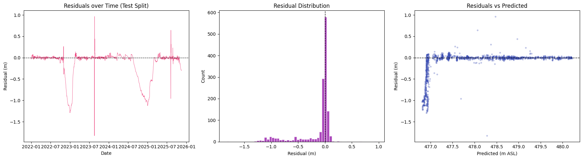
Figure 8a: Residual Model Analysis Figure 8b:Residual distribution Figure 8c Residual vsPredicted:
4. Discussion

The Zambezi River Authority (ZRA) manages water allocation between Zambia and Zimbabwe for hydroelectric power generation at the Kariba Dam. This allocation is equally shared between Zambia Electricity supply co-operation (ZESCO) and Zimbabwe' power Company (ZPC). The ZRA, as a bi-national organization, adjusts water distribution based on quarterly hydrological assessments, which take into account rainfall, river inflows, and dam water levels. [10]For instance, in 2021, the ZRA increased the allocation to 42 billion cubic meters, split equally between the two countries. In 2025, the allocation was set at 27 billion cubic meters, again shared equally. The primary purpose of this water allocation is to support hydroelectric power generation at Kariba Dam, with adjustments predicated on environmental conditions. Based on the models results Zambezi River Authority(ZRA) and Zambia Electricity Supply co-operation(ZESCO) can use this to predict if water levels will hit 475.5 m Minimum Operating Levels up to 3years ahead. Power planning of up to 0.1m error can be achieved. This approximately =~500 million m³= ∼200 GWh of generation. This kind of accuracy lets them schedule Electricity imports or alternative sources of generation. Considering ungauged periods Thus If the gauge fail, the model can fill using weather upstream data.

5.Conclusion

The bottom line is that this a high model accuracy machine learning regression that learns the Kariba’s seasonal pattern and response to inflows and outflows. The predictive model indicates that the Zambezi River Authority’s (ZRA) water allocation for Kariba Dam can be reliably estimated using quarterly hydrological indicators, including seasonal rainfall forecasts, Zambezi River inflows, and Lake Kariba water levels. Historical data from 2021 to 2025 confirm that water allocations vary directly with these factors, while maintaining equal distribution between Zambia’s ZESCO and Zimbabwe’s ZPC. Although the model effectively captures the main factors influencing ZRA’s decisions, its accuracy depends heavily on the reliability of Southern African Regional Climate Outlook Forum (SARCOF) regional climate forecasts and the availability of timely inflow data. To enhance long-term forecasting, future improvements should integrate climate indices such as El Niño and La Niña, along with changes in upstream catchment land use. Overall, the model serves as a valuable tool for anticipating hydroelectric generation constraints and supporting energy planning in both countries amid climate variability.
Future work
To enhance long-term forecasting, future improvements should integrate climate indices such as El Niño and La Niña, along with changes in upstream catchment land use. Overall, the model serves as a valuable tool for anticipating hydroelectric generation constraints and supporting energy planning in both countries amid climate variability.Weather data was monthly, not daily. The pipeline expanded monthly values across all days in that month before merging with daily data water level. This is an acknowledged recommend daily meteorological data acquisition from Zambia Meteorological department in future

REFERENCES

[1] “2024 Annual Report,” Networks Heterog. Media, vol. 20, no. 1, pp. 104–112, 2025, doi: 10.3934/nhm.2025007.
[2] A. Dash et al., “Drought Prediction and Water Quality Estimation using Satellite Images and Machine Learning,” 2018.
[3] “Seasonal Rainfall Forecast for the 2023/2024 Season,” 2024.
[4] L. L. Oo, S. Y. Win, and K. Z. Lin, “Design of Blade for 5kW Propeller Turbine,” Int. J. Sci. Eng. Appl., vol. 7, no. 10, pp. 336–340, 2018, doi: 10.7753/ijsea0710.1002.
[5] “Water Level Prediction Model Applying a Long Short-Term Memory (LSTM)-Gated Recurrent Unit(GRU) MEthod for Flood Prediction.”
[6] M. M. Gokce and E. Duman, “Performance Comparison of Simple Regression, Random Forest and XGBoost Algorithms for Forecasting Electricity Demand,” 3rd Int. Informatics Softw. Eng. Conf. IISEC 2022, pp. 15–20, 2022, doi: 10.1109/IISEC56263.2022.9998213.
[7] S. L. J. Shabu, J. Refonaa, D. Devi, D. Aishwarya, K. K. Babu, and K. P. Reddy, “Rainfall prediction using machine learning techniques,” AIP Conf. Proc., vol. 2850, no. 1, pp. 92–97, 2024, doi: 10.1063/5.0208435.
[8] Z. Haoxing and C. System, “Water level Prediction Through Hybrid SARIMA and ANN Models Based on TIme Series Analysis :Red Hills Reservoir Case Study.”.
[9] Vibhu Verma, “A Comprehensive Framework for Residual Analysis in Regression and Machine Learning,” J. Inf. Syst. Eng. Manag., vol. 10, no. 31s, pp. 34–46, 2025, doi: 10.52783/jisem.v10i31s.4958.
[10] “Update on the Hydrological Outlook at the Kariba Dam | Zambezi River Authority.” https://www.zambezira.org/media-centre/press-release/update-hydrological-outlook-kariba-dam-5 (accessed Apr. 14, 2026).

