Interactive Effects of Variety, Phosphorus–Sulphur Fertilization, and Arbuscular Mycorrhizal Fungi on Growth and Yield of Mustard (Brassica spp.)

Abstract
Mustard (Brassica juncea L.), a crucial crop of global nutrition and industry, has become one of the most important crops for agricultural and renewable energy. In this study, we evaluated the influence of mustard variety, levels of fertilizer and AMF inoculation on growth and yield components to maximize mustard productivity. The study was conducted at the BINA substation in Bangladesh to evaluate the impact of these factors on important yield-contributing parameters. Thus, two mustard varieties (BARI sarisha-17 and Binasarisha-9) were evaluated with three fertilizer treatments and arbuscular mycorrhizal fungi (AMF) inoculation under field condition. The results showed that BARI sarisha-17 exhibited better vegetative growth, while Binasarisha-9 outperformed BARI sarisha-17 in terms of seed yield indicating higher harvest index. Fifty percent of fertilizer increased plant height and seed weight while both AMF inoculation treatments improved pod length, number of seeds per pod and seed quality. Importantly, the highest seed yield of 1.71 t ha⁻¹ was obtained from the Binasarisha-9 × F50 × I1 cross combination, reflecting that application of specific agronomic practices can enhance mustard productivity. This work offers valuable guidelines for optimizing mustard cultivation through variety, nutrients and microbial treatments towards the enrich of crop output of diverse agronomic environments.
Keywords: Brassica, Arbuscular mycorrhizal fungi (AMF), Phosphorus–sulphur fertilization, Interactive effects, Harvest index
Introduction
Mustard (Brassica juncea L.) is an economically important oilseed crop cultivated globally for its oil, which is rich in essential fatty acids, including omega-3 and omega-6, vital for human health [1], [2]. It is also a key raw material for biodiesel production, contributing to the renewable energy sector [3], [4]. As a widely grown crop in tropical and subtropical regions(Singh et al., 2021), mustard plays an essential role in crop rotation systems, improving soil fertility and enhancing agricultural productivity [5]. In addition to its nutritional and industrial value, mustard cultivation provides vital economic benefits to farmers [6], [7]. However, like many crops, its productivity is influenced by various biotic and abiotic factors, including variety [8], fertilizer management [9], and inoculation with beneficial microorganisms [10].
The growth and yield of mustard are subject to the interplay of various factors. Variety selection is a crucial determinant of mustard yield as different varieties exhibit varying levels of tolerance to environmental stresses and growth characteristics. For instance, varieties like BARI sarisha-17 and Binasarisha-9 differ in their growth patterns; BARI sarisha-17 exhibits greater plant height [11]. Fertilizer application is another critical factor influencing mustard yield and its growth traits [12]. Fertilizers provide essential nutrients that boost plant growth, improve seed quality, and increase yield potential [12]. Different fertilizer levels, such as F100, F50, and F0 (no fertilizer), can result in significant variations in growth parameters like plant height, number of branches, and seed weight[13].
Inoculation, the process of introducing beneficial microorganisms into the soil or plant system, is also a critical aspect of enhancing mustard growth [14]. Inoculation with rhizobium and other microorganisms can improve nutrient uptake, especially nitrogen fixation, which is essential for plant growth [8]. Although inoculation's impact on plant height and branch number may be minimal, it can significantly influence seed characteristics, such as pod length and seed weight, which are critical components for determining overall yield [15].
In recent studies, various combinations of variety, fertilizer levels, and inoculation have shown substantial effects on mustard's growth, yield, and yield-contributing traits [16]. Plant height, branch number, pods per plant, seeds per pod, and thousand seed weight are significantly influenced by variety [11] and fertilizer application [13]. Moreover, inoculation has been found to have a positive effect on seed yield and seed quality, suggesting its potential as an agronomic tool for enhancing mustard productivity [8]. However, while certain traits exhibit significant improvement under specific treatments, the overall yield response to these factors remains complex, with some treatments performing better in vegetative growth and others in seed production [17].
The current study aims to investigate the combined effects of variety, fertilizer levels, and inoculation on mustard growth, yield, and yield-contributing traits. By examining these factors, this research aims to provide a clearer understanding of how these treatments interact to optimize mustard productivity. The objective of the study is to evaluate the impact of different varieties, fertilizer treatments, and inoculation on mustard’s growth parameters and yield, identifying the most effective combinations for improving mustard production under varying agronomic conditions.
Method and materials
The experiment was conducted during the rabi season (November 2020 to February 2021) at the BINA substation, Magura, Bangladesh (23°29′13″ N, 89°24′57″ E; 16 m a.s.l.) (Figure 1), on a calcareous clay loam soil characterized by pH 7.6 and low organic carbon content (<1%). The study was laid out in a randomized complete block design with three replications, comprising a factorial combination of two mustard (Brassica spp.) varieties (BARI sarisha-17 and Binasarisha-9), three fertilizer levels, and two arbuscular mycorrhizal fungi (AMF) inoculation treatments. Each experimental plot measured 4.0 m × 2.0 m with appropriate spacing between plots and blocks.
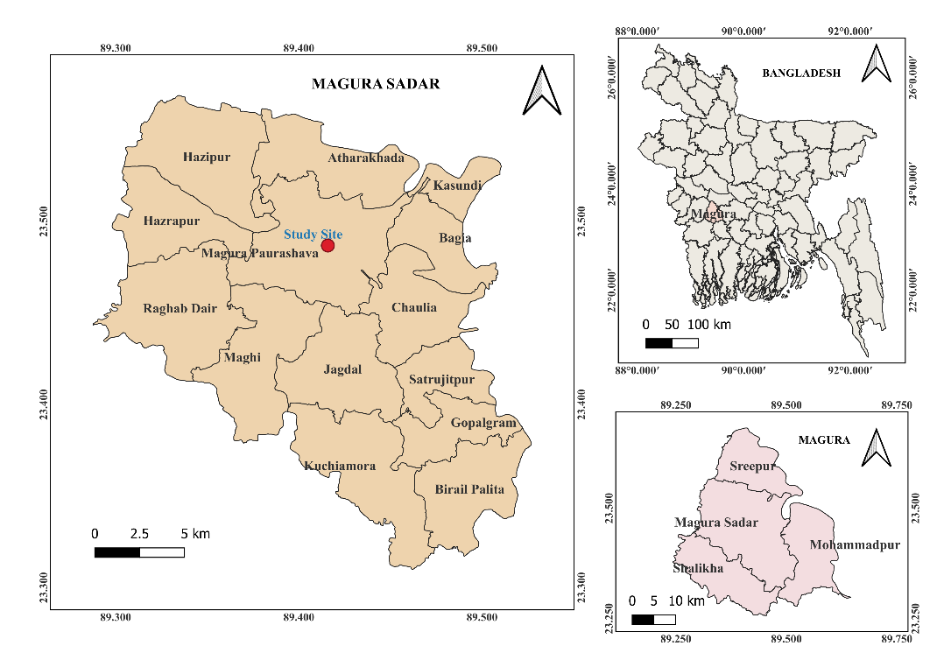
Figure 1. Experimental site of this study.
Fertilizer treatments consisted of F0 (0% of recommended phosphorus and sulphur), F50 (50% of recommended dose), and F100 (100% of recommended dose), representing graded levels of phosphorus and sulphur fertilization. The recommended dose was based on standard fertilizer recommendation guidelines for mustard cultivation, where phosphorus and sulphur were applied proportionally according to treatment levels, while omitted in F0. Uniform basal applications of other essential nutrients were applied to all plots, including nitrogen (120 kg ha⁻¹ as urea), potassium (40 kg ha⁻¹ as muriate of potash), magnesium and sulphur (as gypsum where applicable), zinc (4 kg ha⁻¹ as zinc sulphate), and boron (0.8 kg ha⁻¹ as boric acid), following established agronomic recommendations [18], [19], [20]. Fertilizers were incorporated into the soil during final land preparation.
AMF inoculation was applied at two levels: I0 (no inoculation) and I1 (inoculation at 50 g plot⁻¹). A commercial inoculum (‘Serakinkon’, Central Glass Co., Tokyo, Japan) containing approximately 50 spores g⁻¹ of Gigaspora margarita was used [21] and applied to the root zone at sowing. Seeds were sown in rows at a rate of 8 kg ha⁻¹. Standard crop management practices, including irrigation at 30 and 60 days after sowing, manual weeding, thinning, and pest control using imidacloprid (0.25 mL L⁻¹), were uniformly maintained across all treatments.
Data on growth and yield parameters were collected from ten randomly selected plants per plot using standard procedures. The recorded traits included plant height, number of branches per plant, pods per plant, pod length, seeds per pod, 1000-seed weight, and seed yield (t ha⁻¹). Statistical analysis was performed using analysis of variance (ANOVA) appropriate for a randomized complete block design, and treatment means were compared using the Least Significant Difference (LSD) test at the 5% probability level, following standard statistical procedures[22], [23].
Results and discussion
Effects of Variety, Fertilizer Levels, and Inoculation on Growth and Yield of Mustard
The effects of variety, fertilizer levels, and inoculation on growth, yield, and yield-contributing traits of mustard revealed significant variations across treatments. Plant height was significantly influenced by both variety and fertilizer levels, with BARI sarisha-17 producing taller plants (97.30 cm) than Binasarisha-9 (90.77 cm), representing a 7.2% increase (p ≤ 0.01) (Table 1). Among fertilizer treatments, F100 (96.82 cm) and F50 (96.28 cm) were statistically similar but significantly higher than F0 (89.00 cm). Inoculation had no significant effect on plant height. Branch number per plant varied significantly with variety (p ≤ 0.001), where BARI sarisha-17 (5.86) produced more than double the branches of Binasarisha-9 (2.79), while fertilizer and inoculation effects were non-significant. Pods per plant and pod length were not significantly affected by variety or fertilizer; however, inoculation significantly increased pod length, with I1 (5.86 cm) exceeding I0 (5.19 cm) by 12.9% (p ≤ 0.01). Seeds per pod were strongly influenced by variety (p ≤ 0.001), with BARI sarisha-17 (36.27) outperforming Binasarisha-9 (26.40) by 37.4%. Inoculation also had a significant positive effect, increasing seeds per pod from 30.51 (I0) to 32.16 (I1) (p ≤ 0.05), while fertilizer levels showed no significant differences. Thousand seed weight was significantly affected by all factors; BARI sarisha-17 (3.46 g) had slightly higher seed weight than Binasarisha-9 (3.34 g), and F100 (3.44 g) and F50 (3.40 g) were significantly greater than F0 (3.36 g). Inoculation also enhanced seed weight, with I1 (3.43 g) exceeding I0 (3.37 g) (p ≤ 0.01). Seed yield exhibited highly significant variation across all factors (p ≤ 0.001), with Binasarisha-9 producing markedly higher yield (1.28 t ha⁻¹) than BARI sarisha-17 (0.77 t ha⁻¹), representing a 66.2% increase. Among fertilizer treatments, F50 (1.17 t ha⁻¹) yielded highest, followed by F100 (1.07 t ha⁻¹) and F0 (0.84 t ha⁻¹). Inoculation significantly improved yield by 14.6%, with I1 (1.10 t ha⁻¹) outperforming I0 (0.96 t ha⁻¹).
Table 1. Effect of variety (A), fertilizer levels (B), and irrigation regimes (C) on growth, yield, and yield contributing characters of mustard (Brassica spp.)
Trait | Factor | Levels | Mean ± SE | LSD (0.05) | F-value | P-value | Sig.
Plant Height (cm) | Variety (A) | BARI sarisha-17 | 97.30 ± 1.21 | 3.56 | 14.50 | 0.00096 | **
 |  | Binasarisha-9 | 90.77 ± 1.21 | 3.56 | 14.50 | 0.00096 | **
 | Fertilizer (B) | F100 | 96.82 ± 1.49 | 4.36 | 8.64 | 0.00170 | **
 |  | F50 | 96.28 ± 1.49 | 4.36 | 8.64 | 0.00170 | **
 |  | F0 | 89.00 ± 1.49 | 4.36 | 8.64 | 0.00170 | **
 | Inoculation (C) | I0 | 95.76 ± 1.21 | NS | 4.03 | 0.057 | NS
 |  | I1 | 92.31 ± 1.21 | NS | 4.03 | 0.057 | NS
Branches plant⁻¹ | Variety (A) | BARI sarisha-17 | 5.86 ± 0.19 | 0.56 | 127.56 | <0.001 | ***
 |  | Binasarisha-9 | 2.79 ± 0.19 | 0.56 | 127.56 | <0.001 | ***
 | Fertilizer (B) | F100 | 4.63 ± 0.24 | NS | 1.44 | 0.259 | NS
 |  | F50 | 4.25 ± 0.24 | NS | 1.44 | 0.259 | NS
 |  | F0 | 4.08 ± 0.24 | NS | 1.44 | 0.259 | NS
 | Inoculation (C) | I1 | 4.34 ± 0.19 | NS | 0.03 | 0.871 | NS
 |  | I0 | 4.30 ± 0.19 | NS | 0.03 | 0.871 | NS
Pods plant⁻¹ | Variety (A) | BARI sarisha-17 | 73.83 ± 2.35 | NS | 1.00 | 0.328 | NS
 |  | Binasarisha-9 | 77.16 ± 2.35 | NS | 1.00 | 0.328 | NS
 | Fertilizer (B) | F100 | 79.49 ± 2.88 | NS | 1.91 | 0.172 | NS
 |  | F50 | 75.47 ± 2.88 | NS | 1.91 | 0.172 | NS
 |  | F0 | 71.53 ± 2.88 | NS | 1.91 | 0.172 | NS
 | Inoculation (C) | I0 | 77.07 ± 2.35 | NS | 0.89 | 0.355 | NS
 |  | I1 | 73.93 ± 2.35 | NS | 0.89 | 0.355 | NS
Pod Length (cm) | Variety (A) | BARI sarisha-17 | 5.42 ± 0.13 | NS | 1.28 | 0.270 | NS
 |  | Binasarisha-9 | 5.62 ± 0.13 | NS | 1.28 | 0.270 | NS
 | Fertilizer (B) | F100 | 5.62 ± 0.15 | NS | 0.29 | 0.752 | NS
 |  | F50 | 5.47 ± 0.15 | NS | 0.29 | 0.752 | NS
 |  | F0 | 5.48 ± 0.15 | NS | 0.29 | 0.752 | NS
 | Inoculation (C) | I1 | 5.86 ± 0.13 | 0.37 | 14.23 | 0.00105 | **
 |  | I0 | 5.19 ± 0.13 | 0.37 | 14.23 | 0.00105 | **
Seeds pod⁻¹ | Variety (A) | BARI sarisha-17 | 36.27 ± 0.52 | 1.52 | 181.65 | <0.001 | ***
 |  | Binasarisha-9 | 26.40 ± 0.52 | 1.52 | 181.65 | <0.001 | ***
 | Fertilizer (B) | F100 | 32.47 ± 0.63 | NS | 2.40 | 0.114 | NS
 |  | F50 | 30.80 ± 0.63 | NS | 2.40 | 0.114 | NS
 |  | F0 | 30.73 ± 0.63 | NS | 2.40 | 0.114 | NS
 | Inoculation (C) | I1 | 32.16 ± 0.52 | 1.52 | 5.05 | 0.035 | *
 |  | I0 | 30.51 ± 0.52 | 1.52 | 5.05 | 0.035 | *
1000 Seed Weight (g) | Variety (A) | BARI sarisha-17 | 3.46 ± 0.013 | 0.037 | 47.72 | <0.001 | ***
 |  | Binasarisha-9 | 3.34 ± 0.013 | 0.037 | 47.72 | <0.001 | ***
 | Fertilizer (B) | F100 | 3.44 ± 0.016 | 0.046 | 8.10 | 0.0023 | **
 |  | F50 | 3.40 ± 0.016 | 0.046 | 8.10 | 0.0023 | **
 |  | F0 | 3.36 ± 0.016 | 0.046 | 8.10 | 0.0023 | **
 | Inoculation (C) | I1 | 3.43 ± 0.013 | 0.037 | 13.14 | 0.0015 | **
 |  | I0 | 3.37 ± 0.013 | 0.037 | 13.14 | 0.0015 | **
Seed Yield (t ha⁻¹) | Variety (A) | Binasarisha-9 | 1.28 ± 0.013 | 0.039 | 718.28 | <0.001 | ***
 |  | BARI sarisha-17 | 0.77 ± 0.013 | 0.039 | 718.28 | <0.001 | ***
 | Fertilizer (B) | F50 | 1.17 ± 0.016 | 0.048 | 110.30 | <0.001 | ***
 |  | F100 | 1.07 ± 0.016 | 0.048 | 110.30 | <0.001 | ***
 |  | F0 | 0.84 ± 0.016 | 0.048 | 110.30 | <0.001 | ***
 | Inoculation (C) | I1 | 1.10 ± 0.013 | 0.039 | 50.98 | <0.001 | ***
 |  | I0 | 0.96 ± 0.013 | 0.039 | 50.98 | <0.001 | ***
*** = Significant at p ≤ 0.001 ; ** = Significant at p ≤ 0.01; Significant at p ≤ 0.05 (significant); Not significant (p > 0.05)
The results indicate a significant divergence between vegetative vigor and reproductive efficiency in the studied mustard varieties. While BARI sarisha-17 displayed superior growth traits—including a 7.2% increase in plant height (97.30 cm) and markedly higher branch counts (5.86) and seeds per pod (36.27)—Binasarisha-9 achieved a substantially higher seed yield of 1.28 t ha⁻¹, representing a 66.2% increase. This inverse relationship suggests that Binasarisha-9 possesses a superior harvest index, potentially due to more effective grain filling or higher net assimilation rates despite having fewer branches (Sharma & Sharma, 2015; Reza, 2025). Phosphorus and sulphur fertilization significantly enhanced plant height and seed weight, with the F50 treatment producing the highest yield (1.17 t ha⁻¹). The statistical similarity between F50 and F100 for several growth parameters suggests a plateau in nutrient response, where moderate application optimizes nutrient use efficiency in calcareous clay loam soils [24], [25]. Furthermore, AMF inoculation (I1) significantly improved pod length (12.9%), seeds per pod, and 1000-seed weight, resulting in a 14.6% increase in overall yield. This benefit is attributed to the role of mycorrhizae in increasing phosphorus availability and nutrient uptake, which directly supports reproductive development and pod formation [26], [27]. Ultimately, the synergy observed in the Binasarisha-9 × F50 × I1 combination (1.71 t ha⁻¹) represents the optimal management strategy for maximizing mustard productivity.
Combined Effects of Variety, Fertilizer, and Inoculation on Yield and Yield Attributes
The combined effects of variety, fertilizer levels, and inoculation (A×B×C) significantly influenced growth, yield, and yield-contributing traits of mustard, as indicated by the variation in mean values and LSD comparisons (Table 2). Plant height ranged from 82.93 cm to 104.80 cm, with the tallest plants observed in BARI-17 × F50 × I0 (104.80 cm), which was statistically similar to BARI-17 × F100 × I0 (101.73 cm) but significantly higher than the shortest treatment, Binasarisha-9 × F0 × I1 (82.93 cm). The number of branches per plant was markedly higher in BARI sarisha-17 combinations (5.20–6.27) compared to Binasarisha-9 (2.40–3.73), with all BARI-17 treatments grouped under the highest significance class (a). Pods per plant varied from 65.73 to 88.55, with the maximum recorded in Binasarisha-9 × F100 × I0 (88.55), significantly surpassing several lower-performing treatments such as BARI-17 × F0 × I0 (65.73). Pod length showed notable variation, with the highest value (6.20 cm) observed in BARI-17 × F100 × I1 and BARI-17 × F0 × I1, both significantly superior to the lowest value (4.47 cm) in BARI-17 × F0 × I0. Seeds per pod ranged from 22.93 to 38.00, with the maximum in BARI-17 × F100 × I1 (38.00), statistically like BARI-17 × F100 × I0 (37.60), while the lowest was recorded in Binasarisha-9 × F50 × I0 (22.93). Thousand seed weight (TSW) varied between 3.24 g and 3.54 g, with the highest in BARI-17 × F100 × I1 (3.54 g), significantly greater than the lowest in Binasarisha-9 × F0 × I0 (3.24 g). Seed yield exhibited the most pronounced differences, ranging from 0.4792 to 1.7083 t ha⁻¹ (Figure 2). The highest yield was achieved by Binasarisha-9 × F50 × I1 (1.7083 t ha⁻¹), which was significantly superior to all other treatments, followed by Binasarisha-9 × F100 × I1 (1.3042 t ha⁻¹). In contrast, the lowest yields were recorded in BARI-17 × F0 × I0 (0.4792 t ha⁻¹) and BARI-17 × F0 × I1 (0.4958 t ha⁻¹), both significantly inferior. Overall, treatments involving Binasarisha-9 combined with fertilizer application and inoculation produced higher yields, while BARI-17 combinations generally exhibited superior vegetative and reproductive traits but lower yield performance. The coefficients of variation were within acceptable ranges (1.58–18.85%), indicating good experimental precision.
The significant interaction between variety, fertilizer levels, and AMF inoculation (A×B×C) underscores a complex physiological synergy where nutrient management and microbial symbiosis optimize mustard productivity. While BARI sarisha-17 exhibited superior vegetative vigor—achieving the maximum plant height (104.80 cm) in the BARI-17 × F50 × I0 treatment and consistently higher branch counts (5.20–6.27)—these traits did not directly translate to the highest grain output. Instead, the Binasarisha-9 × F50 × I1 combination emerged as the most efficient, producing a peak seed yield of 1.7083 t ha⁻¹. This suggests that Binasarisha-9 possesses a superior harvest index and greater nutrient use efficiency under moderate fertilization (F50) and mycorrhizal inoculation (I1) compared to BARI-17, which may experience physiological trade-offs or source-sink limitations [11], [23]. The positive impact of phosphorus and sulphur fertilization, particularly when coupled with AMF, aligns with findings that such combinations enhance root development and nutrient uptake through increased phosphorus availability [25], [28]. Furthermore, the significant improvement in 1000-seed weight (3.54 g) and seeds per pod (38.00) in inoculated BARI-17 treatments confirms that AMF effectively bolsters reproductive components, even when overall yield is limited by varietal genetics [24]. Ultimately, the interaction results highlight that yield is not solely a function of vegetative size but is optimized by the specific compatibility of Binasarisha-9 with bio-chemical inputs.
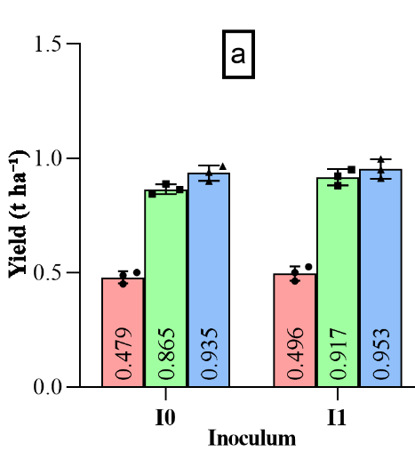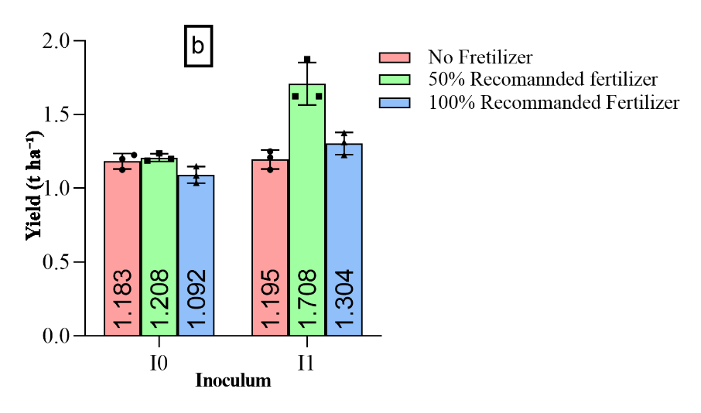
Figure 2. (a) Seed yield (t ha⁻¹) of BARI Sarisha-17 at different fertilizer levels with I0 = no AMF inoculation and I1 = with AMF inoculation (b) Seed yield (t ha⁻¹) of Binasarisha-9 at different fertilizer levels with I0 = no AMF inoculation and I1 = with AMF inoculation.

Table 2. Combined effect of variety × fertilizer × irrigation (A×B×C) on yield and yield attributes of mustard showing multiple comparison (LSD at 5% level)
Treatment | Height | Branch | Pods | Pod Length | Seeds | TSW | Yield (t ha⁻¹)
BARI-17 × F50 × I0 | 104.80 a | 5.73 a | 77.53 ab | 4.67 cd | 35.93 ab | 3.47 abc | 0.8647 e
BARI-17 × F100 × I0 | 101.73 ab | 6.27 a | 73.80 ab | 5.20 bcd | 37.60 a | 3.45 abcd | 0.9353 e
BARI-17 × F100 × I1 | 97.93 abc | 5.87 a | 78.60 ab | 6.20 a | 38.00 a | 3.54 a | 0.9531 e
BARI-17 × F50 × I1 | 96.27 abc | 5.87 a | 75.20 ab | 5.80 ab | 36.33 ab | 3.49 ab | 0.9173 e
BARI-17 × F0 × I0 | 93.00 c | 5.20 a | 65.73 b | 4.47 d | 36.33 ab | 3.44 bcde | 0.4792 f
BARI-17 × F0 × I1 | 90.07 cd | 6.20 a | 72.13 ab | 6.20 a | 33.40 b | 3.39 cdef | 0.4958 f
Binasarisha-9 × F50 × I1 | 91.13 cd | 2.93 b | 70.73 b | 5.80 ab | 28.00 cd | 3.38 def | 1.7083 a
Binasarisha-9 × F100 × I1 | 95.53 bc | 2.67 b | 77.02 ab | 5.60 ab | 28.93 c | 3.45 abcd | 1.3042 b
Binasarisha-9 × F50 × I0 | 92.93 c | 2.47 b | 78.40 ab | 5.60 ab | 22.93 e | 3.28 gh | 1.2083 bc
Binasarisha-9 × F0 × I1 | 82.93 d | 2.53 b | 69.87 b | 5.53 abc | 28.27 cd | 3.36 efg | 1.1950 c
Binasarisha-9 × F0 × I0 | 90.00 cd | 2.40 b | 78.40 ab | 5.73 ab | 24.93 de | 3.24 h | 1.1833 cd
Binasarisha-9 × F100 × I0 | 92.07 c | 3.73 b | 88.55 a | 5.47 abc | 25.33 cde | 3.33 fg | 1.0917 d
LSD (0.05) | 8.72 | 1.38 | 16.90 | 0.90 | 3.72 | 0.09 | 0.096
CV (%) | 5.47 | 18.85 | 13.22 | 9.60 | 7.01 | 1.58 | 5.53

Correlation Among Growth, Yield, and Yield-Contributing Traits of Mustard
The correlation analysis showed several significant relationships among traits (Figure 3). Plant height (PH) was positively correlated with branches per plant (BPP) (r = 0.577, p ≤ 0.001), seeds per pod (SPP) (r = 0.466, p ≤ 0.01), and thousand seed weight (TSW) (r = 0.505, p ≤ 0.01), while its association with yield per plant (YPP) was weakly negative (r = −0.148). BPP exhibited strong positive correlations with SPP (r = 0.789, p ≤ 0.001) and TSW (r = 0.647, p ≤ 0.001), but a significant negative correlation with YPP (r = −0.680, p ≤ 0.001). Seeds per pod (SPP) was also strongly and positively correlated with TSW (r = 0.732, p ≤ 0.001) yet negatively associated with YPP (r = −0.578, p ≤ 0.001). Pods per plant (PPP) and pod length (PL) showed weak and non-significant correlations with most traits, including YPP (r = 0.134 and r = 0.204, respectively). Thousand seed weight (TSW) had a moderate negative correlation with YPP (r = −0.305). Trait distributions indicated variation ranges of approximately 70–110 cm for PH, 60–90 for PPP, 25–40 for SPP, and 3.2–3.6 g for TSW. Overall, most growth and seed traits were positively interrelated but showed weak or negative associations with yield.
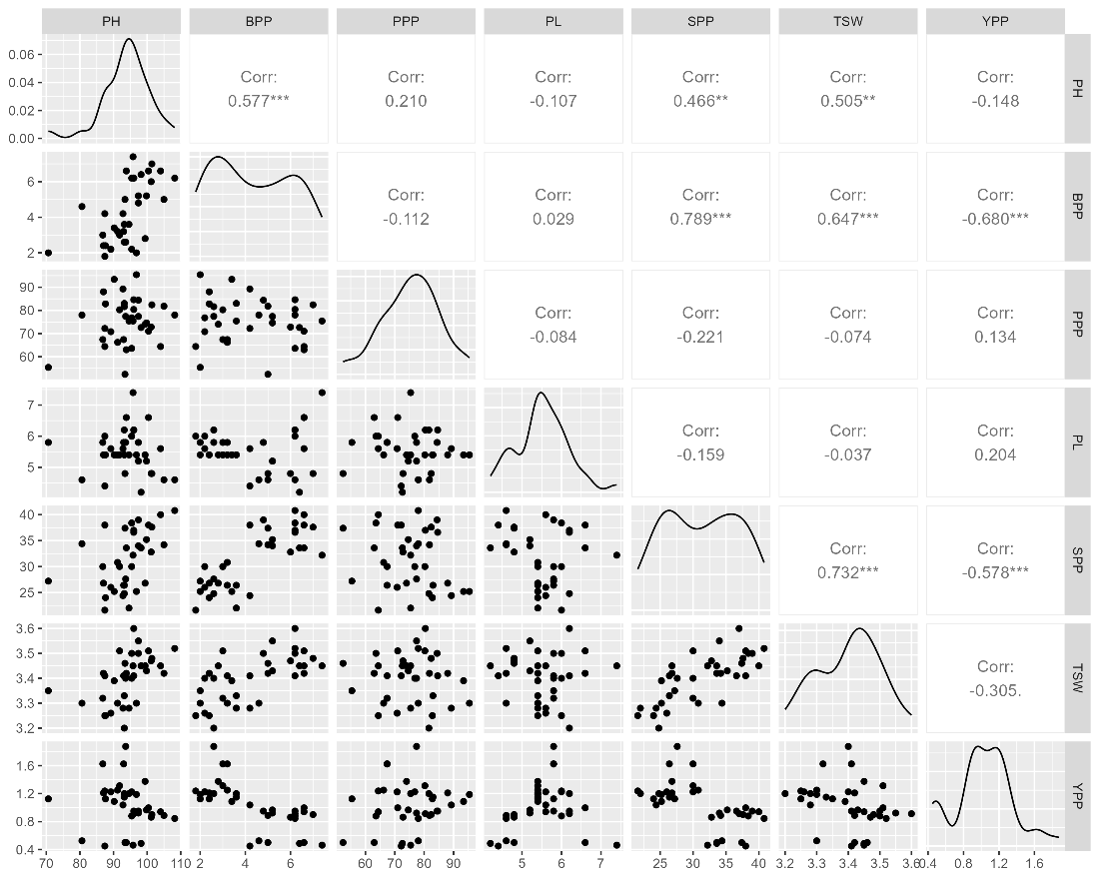
Figure 3. Correlation Matrix Showing Relationships Among Key Growth and Yield Traits of Mustard
Amitav, the correlation results reveal a profound physiological trade-off between vegetative vigor and reproductive efficiency, as evidenced by the significant negative associations between yield per plant and key growth traits like branches per plant ($r=-0.680$) and seeds per pod ($r=-0.578$). While plant height (70–110 cm) was positively linked to branches and seed weight ($r=0.505$), its negative correlation with yield suggests that excessive biomass production acted as a metabolic sink, diverting resources away from final grain filling. This interpretation is supported by established research where primary branches and seeds per siliqua exhibited negative direct correlations with mustard seed yield due to source-sink imbalances [29]. Furthermore, the negative association between height and yield often stems from a reduced harvest index in taller genotypes [30]. This phenomenon explains the observed performance gap between varieties; for instance, previous evaluations show Binasarisha-9 produces significantly higher seed output (4.02 g/plant) compared to BARI Sarisha-17 (2.83 g/plant), despite the latter's superior height and branching [11]. Although some literature suggests that height and branching typically favor productivity [31], the current findings highlight a resource competition scenario where moderate thousand seed weight (3.2–3.6 g) and height did not compensate for inefficiencies in total biomass allocation.
Conclusion
This Study highlights the pivotal influence of genotype, fertilizer application rates, and arbuscular mycorrhizal fungi inoculation on mustard growth and productivity. Despite exhibiting inferior vegetative attributes, Binasarisha-9 demonstrated superior seed yield potential, with F50 fertilizer levels and AMF inoculation substantially improving seed quality and overall performance. The Binasarisha-9 × F50 × I1 combination yielded the highest seed production, emphasizing the value of genotype-specific agronomic strategies. These outcomes furnish a practical framework for elevating mustard yields across diverse farming contexts, thereby advancing sustainable oilseed agriculture.
References

[1] A. Sharma et al., “Biochemical Characterization and their Correlations in Brassica juncea Genotypes,” Int. J. Curr. Microbiol. Appl. Sci., vol. 8, no. 01, pp. 2408–2417, Jan. 2019, doi: 10.20546/ijcmas.2019.801.254.
[2] S. Sharma, M. Bala, G. Kaur, S. Tayyab, and S. R. Feroz, “Chemical Composition of Oil and Cake of Brassica juncea: Implications on Human and Animal Health,” 2022, pp. 29–55. doi: 10.1007/978-3-030-91507-0_3.
[3] V. Bawa and S. Kumar Rai, “Nature of Importance of Various Parameters for Ideal Biofuel Crops: Special Reference to Rapeseed Mustard,” in Oilseed Crops - Uses, Biology and Production, IntechOpen, 2023. doi: 10.5772/intechopen.107102.
[4] G. N. Jham et al., “Wild Brazilian Mustard (Brassica juncea L.) Seed Oil Methyl Esters as Biodiesel Fuel,” J. Am. Oil Chem. Soc., vol. 86, no. 9, pp. 917–926, Sep. 2009, doi: 10.1007/s11746-009-1431-2.
[5] S. Kumar et al., “Soil microbial and nutrient dynamics under different sowings environment of Indian mustard (Brassica juncea L.) in rice based cropping system,” Sci. Rep., vol. 11, no. 1, p. 5289, Mar. 2021, doi: 10.1038/s41598-021-84742-4.
[6] N. K. Bisen, N. K. Singh, and R. S. Solanki, “Productivity Enhancement of Rapeseed-Mustard through Front Line Demonstration in Seoni District of Madhya Pradesh, India,” Int. J. Curr. Microbiol. Appl. Sci., vol. 9, no. 4, pp. 1983–1989, Apr. 2020, doi: 10.20546/ijcmas.2020.904.237.
[7] D. Jain, H. Kumar, and B. Singh, “Impact of cluster front line demonstration on mustard in Udaipur district of Southern Rajasthan, India,” Int. J. Chem. Stud., vol. 8, no. 4, pp. 313–317, Jul. 2020, doi: 10.22271/chemi.2020.v8.i4e.9707.
[8] N. Basharat et al., “Improving Growth and Nutrient Quality of Mustard Varieties Through Rhizobacterial Inoculation,” Oct. 25, 2024. doi: 10.21203/rs.3.rs-5320810/v1.
[9] S. N. Srity, Md. T. Ahmed, S. A. Upama, Md. H. Rashid, Md. R. Uddin, and U. K. Sarker, “Response of Mustard Yield (cv. BARI Sarisha-14) to Different Fertilizer Management Under Subtropical Condition,” Journal of Agroforestry and Environment, vol. 17, no. 1, pp. 20–25, Jun. 2024, doi: 10.55706/jae1704.
[10] R. S. Meena et al., “Response of polymers and nutrient management on growth, yield, and quality of Indian mustard (Brassica juncea),” The Indian Journal of Agricultural Sciences, vol. 90, no. 11, pp. 2237–2240, Dec. 2020, doi: 10.56093/ijas.v90i11.108602.
[11] Md. S. Reza, Md. K. A. Nadim, Md. M. Islam, S.- Al-Mahmud, and M. R. Khan, “Field Evaluation and Biochemical Profiling of Mustard Genotypes for Sustainable Oilseed Production in Satkhira, Bangladesh,” Turkish Journal of Agriculture - Food Science and Technology, vol. 13, no. s1, pp. 2338–2345, Sep. 2025, doi: 10.24925/turjaf.v13is1.2338-2345.7816.
[12] N. Meshram and J. Bisen, “Response of inorganic and organic sources of nutrients on growth, yield and quality of Mustard (Brassica juncea L.),” International Journal of Research in Agronomy, vol. 8, no. 10, pp. 90–94, Oct. 2025, doi: 10.33545/2618060X.2025.v8.i10b.3957.
[13] E. Öztürk, “Critical dose of nitrogen and phosphorus for the enhanced growth, yield, and quality components in mustard (sinapsis arvensis L.) in a semi arid environment,” Turkish Journal Of Field Crops, vol. 26, no. 2, pp. 244–252, Dec. 2021, doi: 10.17557/tjfc.1038570.
[14] R. Sharma, S. Sindhu, and S. S. Sindhu, “Bioinoculation of Mustard (Brassica juncea L.) with Beneficial Rhizobacteria: A Sustainable Alternative to Improve Crop Growth,” Int. J. Curr. Microbiol. Appl. Sci., vol. 7, no. 05, pp. 1375–1386, May 2018, doi: 10.20546/ijcmas.2018.705.163.
[15] S. R. Chaudhuri et al., “Microbe-Based Strategy for Plant Nutrient Management,” in Biological Wastewater Treatment and Resource Recovery, InTech, 2017. doi: 10.5772/67307.
[16] S. S. Islam, A. T. M. M. Billah, A. K. Hasan, R. Karim, and T. Khomphet, “Evaluating the impact of Trichoderma biofertilizer and planting dates on mustard yield performance using the InfoCrop growth model,” PLoS One, vol. 18, no. 5, p. e0285482, May 2023, doi: 10.1371/journal.pone.0285482.
[17] K. J. Jankowski, A. Szatkowski, and D. Załuski, “The effect of nitrogen management on seed yield and quality in traditional and canola-quality white mustard,” Sci. Rep., vol. 14, no. 1, p. 26127, Oct. 2024, doi: 10.1038/s41598-024-76582-9.
[18] B. Biswal and S. Rawat, “Influence of potassium and boron on growth and yield components of mustard (Brassica juncea L.),” International Journal of Advanced Biochemistry Research, vol. 9, no. 9S, pp. 197–201, Jan. 2025, doi: 10.33545/26174693.2025.v9.i9Sc.5518.
[19] A. Halim et al., “Field Assessment of Two Micronutrients (Zinc and Boron) on the Seed Yield and Oil Content of Mustard,” Seeds, vol. 2, no. 1, pp. 127–137, Mar. 2023, doi: 10.3390/seeds2010010.
[20] B. Pramanick et al., “An innovative approach to improve oil production and quality of mustard (Brassica juncea L.) with multi-nutrient-rich polyhalite,” Heliyon, vol. 9, no. 3, p. e13997, Mar. 2023, doi: 10.1016/j.heliyon.2023.e13997.
[21] A. Sarkar et al., “Growth and quality parameters of Tea (Camellia sinensis) mediated by arbuscular mycorrhizal fungi,” Nova Biotechnologica et Chimica, vol. 19, no. 2, pp. 232–239, Dec. 2020, doi: 10.36547/nbc.v19i2.673.
[22] S. Yousefzadeh and N. Sabaghnia, “Growth characters and yield of dragonhead in relation to fe2o3 nano-scale fertilizer and sowing density,” The Journal “Agriculture and Forestry,” vol. 62, no. 2, Jun. 2016, doi: 10.17707/AgricultForest.62.2.04.
[23] P. Sharma, “Relationship of photosynthesis and related traits to seed yield in oilseed Brassicas,” Journal of Applied and Natural Science, vol. 7, no. 2, pp. 851–856, Dec. 2015, doi: 10.31018/jans.v7i2.695.
[24] D. P. Singh, P. K. Upadhyay, M. P. Singh, and A. Srivastava, “Effect of phosphorus and sulphur level on growth, yield and oil content of mustard (Brassica juncea L.),” International Journal of Agricultural Sciences, vol. 14, no. 2, pp. 376–380, Jun. 2018, doi: 10.15740/HAS/IJAS/14.2/376-380.
[25] N. J. Jadav, J. K. Parmar, T. V. Gangwal, and M. V. Patel, “Effect of phosphorus, sulphur and phosphate solubilizing bacteria on yield, nutrient uptake and soil fertility after harvest of mustard,” An Asian Journal of Soil Science, vol. 11, no. 2, pp. 307–317, Dec. 2016, doi: 10.15740/HAS/AJSS/11.2/307-317.
[26] G. M. Abdel-Fattah, W. M. Shukry, M. M. B. Shokr, and M. A. Ahmed, “Application of Mycorrhizal Technology for Improving Yield Production of Common Bean Plants,” Int. J. Appl. Sci. Biotechnol., vol. 4, no. 2, pp. 191–197, Jun. 2016, doi: 10.3126/ijasbt.v4i2.15103.
[27] S. Rosalina, I. Sasli, and T. Abdurrahman, “Morphophysiological Response of Edamame Soybean to Arbuscular Mycorrhizal Fungi (AMF) and Bioactive Compost Charcoal in Tidal Swamp Land,” Jurnal Teknik Pertanian Lampung (Journal of Agricultural Engineering), vol. 14, no. 5, pp. 1661–1670, Sep. 2025, doi: 10.23960/jtepl.v14i5.1661-1670.
[28] D. Potdar, H. Purohit, R. Meena, and K. Ombase, “Effect of phosphorus and biofertilizers with and without FYM on mustard and soil fertility,” Int. J. Chem. Stud., vol. 9, no. 1, pp. 2948–2951, Jan. 2021, doi: 10.22271/chemi.2021.v9.i1ao.11678.
[29] S. Dwivedi, M. Singh, R. K. Yadav, P. K. Saini, and H. Tripathi, “Correlation and Path Analysis for Seed Yield and Its Component Traits in Indian Mustard (Brassica juncea L. Czern and Coss.),” International Journal of Environment and Climate Change, vol. 13, no. 11, pp. 1044–1054, Oct. 2023, doi: 10.9734/ijecc/2023/v13i113253.
[30] S. Rout, S. A. Kerkhi, and C. Chauhan, “Character Association and Path Analysis among Yield Components in Indian Mustard [Brassica juncea (L.) Czern and Coss],” Int. J. Curr. Microbiol. Appl. Sci., vol. 7, no. 1, pp. 50–55, Jan. 2018, doi: 10.20546/ijcmas.2018.701.007.
[31] A. Saiyad, P. Patel, J. Patel, K. Prajapati, and B. Patel, “Study of correlation and path coefficient among the quantitative and qualitative characters of Indian mustard [Brassica juncea (L.) Czern and Coss],” Int. J. Chem. Stud., vol. 8, no. 2, pp. 2112–2116, Mar. 2020, doi: 10.22271/chemi.2020.v8.i2af.9063.

