DEVELOPMENT OF AN INTEGRATED AI-BASED LEARNING DISABILITY IDENTIFICATION AND SUPPORT APPLICATION

ABSTRACT
This study presents the development of an Integrated AI-Based Learning Disability Identification and Support Application designed to assist teachers in the early detection and intervention of students with learning disabilities, particularly dyslexia, dysgraphia, and dyscalculia. In the Philippine educational context, early identification of learning difficulties remains a persistent challenge due to limited access to diagnostic tools, trained specialists, and reliable assessment methods. Teachers often rely on subjective observation alone, resulting in delayed or inaccurate identification and insufficient support for affected learners.
The proposed application addresses these gaps through three integrated modules: an AI-driven performance analysis module that detects potential indicators of learning disabilities by examining patterns in student quiz results, activity completion, response time, and behavioral data; a teacher-oriented dashboard that presents analyzed data through visual summaries to support evidence-based instructional decisions; and a personalized recommendation module that generates adaptive teaching strategies tailored to each student's identified learning needs. A chatbot assessment assistant further supports data collection by engaging students through guided interactive tasks. The system is designed to function both online and offline, ensuring accessibility in low-resource school environments.
Using a developmental research design and the Waterfall Model as the Software Development Life Cycle framework, the application was built using React Native with Expo Go for cross-platform mobile development, Node.js for backend processing, and pre-built AI APIs for machine learning analysis. The system was designed, developed, tested, deployed, and refined through iterative phases to ensure reliability, usability, and educational effectiveness. This study does not aim to replace professional diagnosis but serves as a practical early-detection and support tool that empowers teachers with accessible, data-driven insights, promoting inclusive education and enabling timely interventions for students with diverse learning needs.
Keywords: learning disability identification, artificial intelligence in education, dyslexia detection, machine learning, inclusive education
INTRODUCTION
In today's rapidly evolving educational environment, the early identification and support of students with learning difficulties have become increasingly important. Among these, dyslexia is one of the most common yet under-recognized learning disorders, affecting a student's ability to read, decode words, and process written language. In developing countries like the Philippines, dyslexia often goes undetected due to limited access to diagnostic tools, educational specialists, and structured screening methods. This lack of early identification delays intervention and may lead to persistent academic challenges, decreased confidence, and reduced overall learning outcomes.
In many public schools, teachers play a critical role in identifying students who may be experiencing reading difficulties. However, without adequate training and reliable assessment tools, identification is often based solely on classroom observations and general academic performance. This approach can be inconsistent and subjective, leading to cases where students with dyslexia are either misidentified or remain undiagnosed. As a result, appropriate interventions are delayed, making it more difficult for learners to catch up academically.
A local study by Cariño and Bailey (2024) titled "Knowledge, Attitudes and Interaction on Dyslexia among Selected Filipino Public School Teachers" revealed that many teachers have limited knowledge about the characteristics and appropriate interventions for dyslexic learners. The study emphasized the need for accessible and practical tools that can assist teachers in recognizing early signs of dyslexia and providing timely support, even without formal specialization in educational psychology.
Despite increasing awareness of inclusive education, there remains a lack of integrated, accessible systems that combine automated detection, teacher assistance, and continuous student progress monitoring—particularly those that can operate offline. Existing educational technologies often focus on content delivery rather than on the early identification of specific learning difficulties, such as dyslexia.
The development of an Integrated AI-Based Learning Disability Identification and Support Application aims to address this need by focusing on the early detection and support of dyslexia. The proposed system will collect and analyze student data, including reading speed, writing samples, quiz performance, and task completion time. Using machine learning algorithms, the application will identify patterns that may indicate dyslexia and generate data-driven insights.
By automating early screening and providing actionable recommendations, the application enables teachers to make informed decisions and implement timely interventions. Ultimately, this innovation promotes equitable learning opportunities by ensuring that students with dyslexia receive the support they need at an early stage. In the Philippine educational context, where resources and access to specialized assessment remain limited, this system offers a practical, scalable, and impactful solution for improving early identification and support for learners with dyslexia.
Statement of the Problem
In many Philippine schools, the early detection of learning disabilities remains a persistent challenge due to limited access to diagnostic tools and professional evaluators. Teachers often rely on manual observation or general performance trends to assess a child's learning ability, which may result in delayed or inaccurate identification of conditions such as dyslexia, dysgraphia, or dyscalculia. Without timely and data-driven intervention, affected students may experience long-term academic struggles, decreased motivation, and reduced self-confidence.
Specifically, this study seeks to address the following problems:
- Limited availability of intelligent and data-driven tools for early detection of learning disabilities. Many Philippine schools rely primarily on manual observation and general academic performance to identify students who may have learning disabilities, leading to inconsistent assessments and delayed identification.
- Lack of accessible analytical support for teachers in interpreting student learning patterns. Teachers often face difficulty in analyzing complex student performance data due to the absence of user-friendly tools that translate learning analytics into understandable insights.
- Insufficient personalized and adaptive learning support for students with learning challenges. Existing educational tools commonly used in schools do not provide individualized recommendations or adaptive strategies tailored to students' specific learning needs.
Objective of the Study
The main goal of this study is to design and develop an Integrated AI-Based Learning Disability Identification and Support Application that assists teachers in the early detection and intervention of students with potential learning disabilities. Specifically, the objectives are:
- To develop an AI-driven module capable of analyzing student performance data to identify potential indicators of learning disabilities, providing teachers with a more objective and data-supported approach to early identification.
- To design and integrate a teacher-oriented dashboard that presents analyzed learning data in a clear and organized format, allowing educators to monitor student progress and make timely, evidence-based decisions even in offline environments.
- To develop a personalized support module that generates customized teaching strategies and intervention recommendations for students with identified learning challenges.
Scope and Limitations
This study focuses on the development of an Integrated AI-Based Learning Disability Identification and Support Application designed to assist teachers in identifying and supporting students with potential learning challenges. The application primarily targets common learning disabilities such as dyslexia, dysgraphia, and dyscalculia by analyzing student performance data and behavioral patterns from classroom-related tasks and assessments. It aims to provide teachers with a data-driven and accessible platform that promotes early detection and intervention within the classroom setting.
The scope of the application includes several integrated modules that enhance its functionality and accessibility. It will feature an AI-powered screening module capable of processing text-based inputs, such as writing activities, quizzes, or short reading exercises, to detect possible signs of learning difficulties. In addition, a student performance dashboard will be developed to visually present analytical insights such as accuracy rates, completion time, and recurring error types. A teacher recommendation assistant will also be integrated to generate personalized instructional strategies based on each student's identified learning pattern. Furthermore, the application will include a chatbot-based assessment assistant that interacts with students through simple, guided tasks, helping the AI collect data and refine its understanding of their learning behavior. To make it more adaptable, the application will be designed to function both online and offline, ensuring accessibility even in schools with limited internet connectivity.
However, the limitations of this study must also be recognized. The application will not serve as a formal medical or psychological diagnostic tool, as only licensed professionals can provide official diagnoses of learning disabilities. Instead, it will act as a supportive early-detection tool, offering teachers practical insights for classroom intervention. Additionally, the accuracy and reliability of the AI model will depend on the quality and quantity of training data available; hence, its effectiveness may vary across different schools or student populations. The system will also exclude integration with large-scale educational databases or learning management systems, focusing instead on a localized prototype suited for small to medium-sized schools.
Overall, this study aims to develop a flexible and scalable educational application that empowers teachers to make informed, data-supported decisions while promoting inclusivity and awareness in the classroom. Although it does not replace professional diagnosis, it represents a significant step toward a more responsive and technology-assisted learning environment in Philippine education.
Significance of the Study
This study contributes to the growing need for inclusive and technology-assisted education in the Philippines by promoting early intervention for students experiencing learning difficulties while empowering teachers with accessible, data-driven tools.
Students. The application provides a safe and supportive digital environment that helps identify learning difficulties at an early stage, promoting a more inclusive learning atmosphere.
Teachers. Teachers will benefit from the application's analytics, visualization, and recommendation features, enabling more informed and efficient instructional decisions.
Schools. The application serves as an innovative and scalable educational tool that strengthens advocacy for inclusive learning and promotes data-driven decision-making.
Future Researchers. This study provides a foundation for further exploration into the integration of artificial intelligence in education and inclusive learning systems.
Definition of Terms
Artificial Intelligence (AI). Technology that enables the application to simulate human-like reasoning and decision-making, used to interpret student performance data and generate smart recommendations.
Chatbot Assessment Assistant. An interactive AI feature that communicates with students through short questions or learning activities, collecting data to detect potential learning challenges.
Dashboard. The digital interface designed for teachers that displays student performance metrics in a clear and visually informative format.
Dyscalculia. A learning difficulty affecting a student's ability to understand and manipulate numbers, detected through consistent mathematical errors and difficulty with numerical sequences.
Dysgraphia. A writing-related learning difficulty characterized by poor handwriting, inconsistent spelling, or challenges in organizing written thoughts.
Dyslexia. A learning difficulty that impacts reading accuracy, fluency, and comprehension, detected through analysis of spelling inconsistencies and reading errors.
Inclusive Education. An educational approach ensuring all students have equal access to quality learning opportunities through adaptive support and early detection.
Learning Disabilities. Neurological conditions affecting how students acquire, process, or express information, focusing on dyslexia, dysgraphia, and dyscalculia.
Machine Learning. The application's capability to automatically learn and improve from patterns in student data to identify possible indicators of learning disabilities.
Recommendation Module. The part of the application that generates personalized teaching strategies and adaptive learning plans based on identified learning patterns.
REVIEW OF RELATED LITERATURE AND STUDIES
This chapter presents a review of related literature and studies that provide theoretical and empirical foundations for the development of an Integrated AI-Based Learning Disability Identification and Support Application. It discusses relevant concepts, frameworks, and findings concerning the use of artificial intelligence (AI), machine learning (ML), and educational technologies in identifying and supporting students with learning disabilities.
Related Literature
Artificial Intelligence (AI) has become a transformative force in education, particularly in addressing diverse learning needs. Garzón et al. (2025) explained that AI systems can analyze large volumes of student data to identify patterns that are often difficult to detect manually. These patterns include learning behaviors, performance trends, and cognitive differences that help in understanding individual student needs. Through this capability, AI can detect possible learning difficulties at an early stage while also adapting instructional content based on each learner’s profile. Zawacki-Richter et al. (2019) further noted that artificial intelligence enhances inclusivity by providing intelligent tools that assist educators in identifying and supporting struggling students.
Machine learning (ML), a subset of AI, plays an important role in early detection of learning disabilities. Bernardo et al. (2021) emphasized that ML algorithms can analyze student performance data to predict learning difficulties before they become more evident through traditional assessments. Using classification techniques such as decision trees and support vector machines, these models can categorize learners based on risk and performance patterns. Supporting this, Drotár et al. (2020) found that handwriting-based ML models can detect dysgraphia by analyzing writing pressure, speed, and consistency, showing that machine learning provides a more objective approach compared to manual assessment.
Several scholars have also explored the potential of deep learning models for detecting dyslexia and dysgraphia. Aldehim (2024) discussed the success of convolutional neural networks (CNNs) in processing images of handwriting and reading samples, identifying subtle differences between typical and atypical learners. Similarly, Zaibi et al. (2024) highlighted the use of recurrent neural networks (RNNs) for analyzing sequential data such as reading speed and eye movement patterns, which can be critical indicators of dyslexia. These findings suggest that intelligent models can capture nuances of learning behavior that traditional testing cannot.
In addition, AI-powered chatbots have been introduced as supportive learning tools. Okonkwo et al. (2021) explained that chatbots can interact with students through question-and-answer systems, providing immediate feedback and assistance. Labadze (2023) added that these systems can simulate personalized tutoring experiences, making learning more accessible, especially for students who struggle in traditional classroom settings. Chatbots also generate useful interaction data that can be used to improve learning models.
Beyond conversational AI, learning analytics has become a significant component of AI-driven education systems. Siemens and Baker (2019) emphasized that learning analytics involves the systematic collection and analysis of educational data to understand and optimize learning processes. When integrated with artificial intelligence, learning analytics enables the prediction of student performance trends, engagement levels, and academic risks. This allows educators to implement timely interventions and support strategies. The combination of AI and learning analytics therefore strengthens the overall ability of educational systems to monitor and respond to student needs effectively.
Natural language processing (NLP) also plays an important role in enhancing AI-based educational tools. Winkler and Söllner (2018) explained that NLP enables systems to understand, interpret, and respond to human language in a meaningful way. This technology is widely used in applications such as automated essay scoring, conversational tutoring systems, and feedback generation tools. In the context of learning disabilities, NLP can analyze written and spoken language patterns to identify difficulties related to reading comprehension, grammar usage, and language processing. This makes it a valuable tool in supporting learners with dyslexia and other language-based challenges.
Furthermore, multimodal learning analytics has emerged as a more comprehensive approach to understanding student behavior. Ochoa and Worsley (2016) emphasized that combining multiple data sources—such as text input, speech, facial expressions, and interaction logs—provides a more holistic understanding of how students learn. This approach enhances the accuracy of detecting learning difficulties by capturing both cognitive and behavioral indicators. Multimodal systems are particularly effective because they integrate different forms of learner data, allowing AI models to generate more reliable and context-aware predictions.
Assistive AI technologies have also significantly contributed to inclusive education. Holmes et al. (2019) highlighted that tools such as text-to-speech systems, speech-to-text applications, and intelligent tutoring systems help remove barriers for students with disabilities. These technologies enable learners to access educational content in alternative formats, ensuring that students with different abilities can participate in learning activities equally. This supports the broader goal of inclusive education by promoting accessibility and equity in learning environments.
Human-AI collaboration remains a critical principle in the implementation of artificial intelligence in education. Luckin et al. (2016) argued that AI should function as an augmenting tool rather than a replacement for teachers. In this model, AI systems provide data-driven insights, predictive analytics, and automated support, while teachers retain control over instructional decisions. This collaboration ensures that the human element of teaching is preserved while benefiting from the efficiency and analytical power of AI technologies.
Finally, ethical considerations are essential in the development and use of AI in education. Slade and Prinsloo (2013) emphasized issues related to data privacy, consent, and ethical data usage, particularly when handling sensitive student information. Similarly, Doshi-Velez (2017) highlighted the importance of explainable artificial intelligence (XAI), which ensures that AI-generated decisions can be understood and interpreted by educators. This transparency is crucial in educational settings, where trust and accountability are necessary for effective implementation.
Artificial Intelligence (AI) has increasingly been integrated into the Philippine educational system to support diverse learners, particularly those with special educational needs. Dela Cruz and Santos (2021) found that AI-supported learning tools significantly improved student engagement by providing interactive and adaptive content tailored to individual learning styles. These tools allow students to learn at their own pace, which is especially beneficial for learners who experience difficulties in traditional classroom instruction. The study further emphasized that AI systems can assist teachers in monitoring student progress more efficiently, especially in large classroom settings where individualized attention is limited. This demonstrates that AI contributes not only to learning enhancement but also to instructional efficiency and inclusivity in Philippine education.
In terms of academic monitoring and early intervention, Reyes et al. (2023) developed a learning analytics system designed for Filipino classrooms that allows teachers to visualize student performance trends. Their findings revealed that data-driven dashboards helped educators identify at-risk learners earlier than conventional observation methods. This early detection capability enabled timely instructional adjustments and targeted interventions. The study highlights the importance of integrating AI-based monitoring tools in local schools, particularly in improving decision-making processes and reducing reliance on subjective assessment.
Garcia and Lopez (2022) examined the use of digital learning applications in improving literacy skills among elementary students in the Philippines. Their study showed that technology-assisted platforms significantly enhanced reading comprehension and learner engagement, especially in public school environments. Students exposed to interactive digital tools demonstrated higher motivation and improved task completion rates. These findings suggest that AI-supported learning systems can play a critical role in strengthening foundational academic skills in local educational settings.
The use of conversational AI has also been explored in Philippine classrooms. Bautista et al. (2023) found that AI-powered chatbots improved student participation and reduced learning anxiety by providing immediate feedback and personalized responses. Learners reported feeling more comfortable asking questions through chatbot interfaces compared to traditional classroom interactions. This indicates that conversational AI can create a more supportive and less intimidating learning environment, particularly for students who struggle with confidence or learning difficulties.
Similarly, Villanueva et al. (2023) emphasized the effectiveness of analytics dashboards in supporting teacher decision-making. Their study revealed that visual data representations allowed teachers to quickly identify students who were underperforming and apply appropriate interventions. This supports the idea that AI systems can enhance instructional efficiency by simplifying complex academic data into understandable and actionable insights.
Santos and Ramirez (2022) investigated language-based digital learning tools and found that these technologies improved reading and writing performance among Filipino learners. The study highlighted that automated feedback and guided exercises helped students develop literacy skills more effectively. This demonstrates the potential of AI-driven language tools in addressing academic challenges in foundational education.
Cruz et al. (2024) focused on multimodal learning analytics and found that integrating multiple sources of student data, such as behavioral logs, academic performance, and interaction patterns, significantly improved assessment accuracy. Their findings suggest that a holistic approach to data analysis provides a deeper understanding of learner behavior, especially in identifying students who may require additional support.
Mendoza and Torres (2024) examined assistive AI technologies in Philippine schools and found that these tools significantly improved participation among students with disabilities. By providing alternative ways of accessing learning materials, such as text-to-speech and interactive interfaces, AI helped reduce barriers to education. The study emphasizes the importance of inclusive technologies in promoting equal learning opportunities.
Ramos (2023) highlighted the ethical challenges of AI implementation in education, particularly in terms of data privacy and security. The study emphasized that protecting student information is essential in maintaining trust in AI systems. It also recommended that educational institutions adopt strict data governance policies to ensure responsible use of learner data.
Finally, Aquino (2022) found that teachers benefited significantly from visual analytics tools that simplified the monitoring of student performance. These tools enabled educators to make faster, more accurate decisions regarding student interventions and instructional planning. The study reinforces the importance of designing AI systems that are user-friendly and supportive of teacher needs.
Related Studies
Recent empirical studies have explored the application of artificial intelligence in identifying learning disabilities through data-driven approaches. Khan et al. (2022) developed a machine learning–based diagnostic system that analyzed students’ academic performance and behavioral data to detect signs of dyslexia. Their model demonstrated high prediction accuracy, showing that AI can effectively support early screening and reduce reliance on traditional observational methods. The study emphasized that early detection allows timely intervention, which is crucial in improving learning outcomes among students with difficulties.
Similarly, Sharma and Gupta (2021) implemented a deep learning framework that analyzed handwriting samples of elementary learners to identify patterns associated with learning disabilities. Their findings revealed that automated systems can detect subtle writing inconsistencies that are often missed in manual evaluation. This supports the idea that AI-based tools can enhance objectivity and accuracy in diagnosing learning difficulties, particularly in foundational skills such as writing.
Expanding beyond diagnostic systems, Chen et al. (2023) developed an intelligent tutoring system that dynamically adjusts lesson difficulty based on real-time student responses. Their study found significant improvements in student engagement and comprehension, especially among learners with identified learning difficulties. The researchers emphasized that integrating assessment and instruction within a single system promotes continuous learning support rather than isolated evaluation.
In a related study, Alqahtani et al. (2022) examined AI-driven adaptive learning platforms and found that continuous modification of instructional content based on learner performance significantly improved reading comprehension. This suggests that adaptive systems not only identify learning gaps but also actively respond to them, reinforcing the importance of personalized learning environments.
Okonkwo and Ade-Ibijola (2021) investigated the use of AI-powered chatbots in educational settings and found that these systems improved student engagement through interactive questioning and immediate feedback. The study highlighted that chatbots also help identify recurring learning difficulties by analyzing student responses over time, making them useful for both instruction and assessment.
Labadze et al. (2023) further supported this by demonstrating that AI chatbots can simulate individualized tutoring experiences. Their findings showed that students, particularly those with learning anxieties, benefited from non-judgmental and consistent interaction with AI systems. This reinforces the role of conversational AI in creating supportive and inclusive learning environments.
Drotár et al. (2020) conducted a study on handwriting analysis using machine learning algorithms and digital tablets. Their results showed that motion-based features such as writing speed, pressure, and consistency can effectively identify dysgraphia. This highlights the value of behavioral data in improving diagnostic accuracy for learning disabilities.
Zaibi et al. (2024) extended this approach by using sequential neural networks to analyze eye-tracking and reading-speed data. Their findings confirmed that behavioral indicators such as gaze movement and reading pace are strong predictors of dyslexia. This supports the integration of multimodal data in improving AI-based diagnostic systems.
Siemens and Baker (2019) examined learning analytics systems and found that analyzing student interaction data can help predict academic performance and engagement levels. Their study emphasized that data-driven insights allow educators to implement early interventions, improving student success rates.
Winkler and Söllner (2018) explored natural language processing (NLP) in education and found that it enhances automated feedback and conversational learning systems. Their research showed that NLP-based tools improve student understanding by providing immediate and context-aware responses.
Ochoa and Worsley (2016) studied multimodal learning analytics and found that combining different data sources such as text, audio, and behavioral signals significantly improves the accuracy of student assessment. This supports the idea that complex learning behaviors are better understood through integrated data analysis.
Holmes et al. (2019) investigated assistive AI technologies and found that tools such as speech-to-text and intelligent tutoring systems improve accessibility for learners with disabilities. Their study emphasized that AI plays a key role in reducing barriers to learning and promoting educational equity.
Luckin et al. (2016) examined human-AI collaboration in education and concluded that AI should function as an augmenting tool rather than a replacement for teachers. Their findings highlight that teachers remain central to instructional decision-making while AI provides supportive data and recommendations.
In the Philippine context, Dela Cruz and Santos (2021) examined the use of digital learning tools among students with special educational needs. Their study found that technology-enhanced instruction increased engagement and participation, especially among learners who struggle in traditional classroom settings. The results suggest that localized digital tools can make learning more accessible and responsive to diverse learner needs in Philippine schools.
Reyes et al. (2023) developed a learning analytics dashboard for teachers in Philippine secondary schools. Their findings showed that visual data representation significantly improved teachers’ ability to identify struggling students. The system allowed educators to make faster and more accurate instructional decisions, highlighting the importance of data-driven teaching in local educational settings.
Garcia and Lopez (2022) studied mobile-based learning applications and found that these tools improved literacy skills among elementary students in rural areas. Their research emphasized that accessible digital platforms are particularly effective in addressing learning gaps in under-resourced communities where traditional instructional support is limited.
Bautista et al. (2023) investigated AI-powered chat systems and found that Filipino students experienced increased motivation and reduced anxiety when interacting with conversational learning tools. The study highlighted that AI-based communication systems create a more comfortable learning environment, encouraging students to actively engage in learning activities.
Villanueva et al. (2023) examined the use of analytics dashboards in secondary education and found that teachers benefited from real-time monitoring of student performance. Their findings showed improved identification of at-risk learners, enabling timely intervention strategies that support academic success.
Santos and Ramirez (2022) explored language-based digital learning tools and found that Filipino learners showed improved reading comprehension and writing skills. The study emphasized that AI-supported language tools are effective in strengthening foundational literacy skills in early education.
Cruz et al. (2024) studied multimodal learning systems and found that integrating multiple forms of student data improved assessment accuracy. Their research highlighted the importance of adaptive systems in Philippine schools, particularly in environments with limited educational resources.
Mendoza and Torres (2024) investigated assistive technologies and found that AI-based tools significantly improved participation among students with disabilities. Their study emphasized that technology plays a critical role in promoting inclusive education in the Philippines.
Ramos (2023) examined ethical considerations in AI implementation and found that data privacy remains a major concern in Philippine educational systems. The study emphasized the need for strict data protection policies when implementing AI-based tools in schools.
Aquino (2022) studied teacher experiences with analytics tools and found that visual dashboards improved instructional planning and classroom management. Their findings suggest that AI tools help teachers manage diverse learners more effectively by simplifying complex performance data.
Synthesis
The reviewed literature and studies collectively establish that artificial intelligence plays a significant role in transforming education through early identification, personalized instruction, and continuous support for learners with diverse needs. AI systems, including machine learning, deep learning, and natural language processing, are capable of analyzing large-scale learner data to detect patterns associated with learning difficulties.
Local studies emphasize the contextual applicability of these technologies within the Philippine educational system. Findings consistently show that AI-based tools improve teacher monitoring, enhance student participation, and support learners with special educational needs. A common finding across both foreign and local studies is the effectiveness of integrating assessment and instructional support into a unified system.
Ethical considerations such as transparency, explainability, data privacy, and fairness are consistently identified as essential in AI-based educational systems. The synthesis reveals a clear research gap in a unified, accessible, context-aware AI system that simultaneously performs learning disability identification and provides adaptive learning support. This study addresses that gap.
METHODOLOGY
This chapter presents the methodology used in the development of the Integrated AI-Based Learning Disability Identification and Support Application. It describes the research design, data sets, data acquisition procedures, and the Software Development Life Cycle (SDLC) model employed. The chapter also discusses the system architecture, hardware and software requirements, and the methods and tools utilized.
Research Design
This study employed a developmental research design to develop and evaluate an Integrated AI-Based Learning Disability Identification and Support Application. Developmental research is a systematic approach focusing on the design, development, and evaluation of tools intended to solve identified problems within a specific context. The proponents adopted the Waterfall Model as the SDLC framework, which follows a sequential development process in which each phase must be completed before proceeding to the next.
Figure 3.1
Waterfall Model Used in the Study
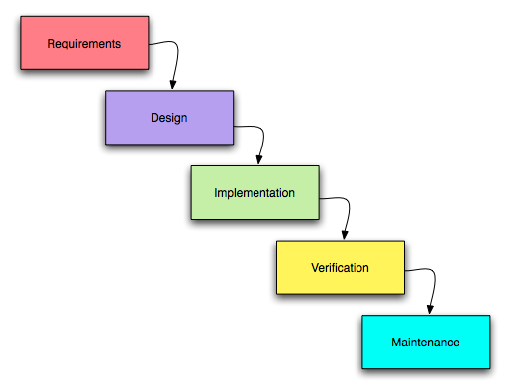
Requirement Phase
The Requirements Analysis Phase served as the foundation of the system development process. The proponents analyzed the educational problem, focusing on the difficulty of identifying learning disabilities early and the lack of accessible support tools. Literature and previous studies guided the identification of functional requirements, including the need for AI-based learning disability detection, interactive chatbot assistance, and performance monitoring dashboards.
Design Phase
The System Design Phase translated requirements into a technical blueprint for the system. The proponents planned the overall architecture, database structure, and data flow. The system's interface design was developed, including prototypes for student and teacher dashboards, AI analysis outputs, and chatbot interaction screens. Appropriate machine learning models for classification and prediction were selected.
Development Phase
The Development Phase transformed conceptual design into actual system components. Program code for the application was written, database structures were created, and AI algorithms for learning disability detection were integrated. Datasets were collected, organized, and preprocessed. AI models were trained and iteratively refined to ensure accurate detection of potential learning difficulties.
Testing Phase
The Testing Phase evaluated the reliability, accuracy, and usability of the developed system. Functional testing verified that all modules including the chatbot, dashboards, and AI analytics worked as intended. Usability testing assessed ease of navigation for both students and teachers, while errors detected were corrected to optimize system performance.
Deployment Phase
The Deployment Phase involved implementing the system in a controlled operational environment for demonstration and evaluation. Students and teachers were able to interact with the AI analysis, assessment modules, and analytics dashboards. Real-time observation of the system ensured smooth operation and effective data flow across modules.
Maintenance Phase
The Maintenance Phase focused on sustaining and improving system functionality after deployment. Minor updates, debugging, and interface enhancements were conducted to ensure long-term system stability. AI outputs and predictive models were refined based on user interaction and testing feedback to improve accuracy and reliability.
System Architecture
The proposed application is designed using a layered system architecture that ensures efficient data processing, AI integration, and user interaction. The architecture is composed of multiple layers that work together to collect learner data, analyze performance, provide adaptive support, and present analytics to educators.
Figure 3.2
System Architecture
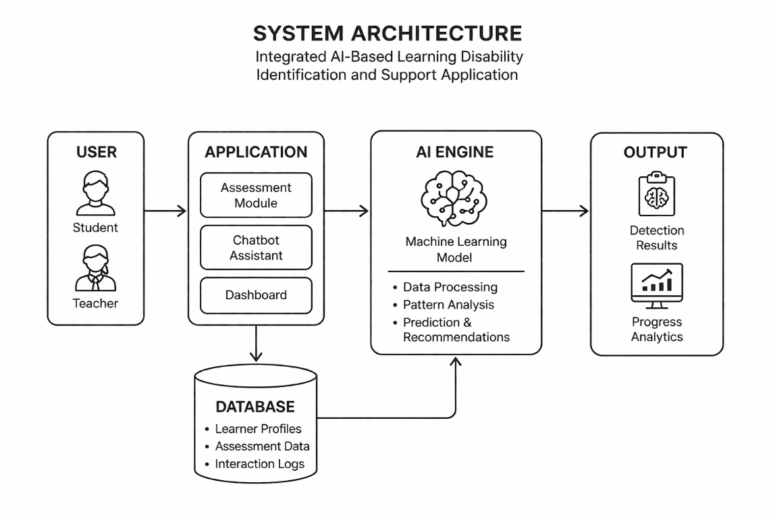
In the Input Stage, data is collected from both students and teachers, including assessment responses, activity completion records, and interaction data. The Process Stage involves transforming collected input data into actionable insights through AI-based analysis, including data preprocessing with cleaning, normalization, and feature selection. In the Output Stage, processed information is presented to users—students receive personalized feedback through the chatbot, while teachers access the analytics dashboard presenting visualizations such as graphs, charts, and heatmaps.
System Requirement
This section outlines the essential software and hardware requirements for the development and operation of the application.
Software Requirement
Category | Requirements | Description
Mobile Application Framework | React Native (Expo Go) | Cross-platform mobile application for Android and iOS with faster development and testing
Frontend Development | React Native Components | Handles user interface such as dashboards, chatbot interface, and navigation between screens
Backend Framework | Node.js | Manages server-side logic, API requests, and communication between mobile app and database
Database Management System | MySQL / Firebase | Stores user accounts, student performance data, and learning analytics securely
AI Integration | Pre-built AI APIs / ML APIs | Processes student data to detect learning difficulties and generate personalized recommendations
Authentication System | Firebase Authentication / JWT | Secures user login, registration, and role-based access control
Development Environment | Visual Studio Code (VS Code) | Primary code editor used for development, debugging, and project management
Mobile Testing Tool | Expo Go Application | Used to test and run the mobile application in real-time on physical devices
The application is developed using React Native with Expo Go to support cross-platform mobile development. Node.js with Express.js is used as the backend framework. MySQL or Firebase is used for secure storage. Pre-built AI APIs are integrated to analyze student responses. Firebase Authentication or JWT provides secure login and role-based access control.
Hardware Requirements
Category | Component | Specification | Description
Server Hardware | Processor | Multi-core (Intel i5/i7 or AMD) | Handles backend processing, API requests, and AI computations
Server Hardware | Memory (RAM) | 16 GB or higher | Ensures smooth handling of concurrent users and data processing
Server Hardware | Storage | 512 GB SSD or higher | Stores system database, user data, logs, and AI outputs
Server Hardware | GPU (Optional) | Dedicated GPU | Accelerates machine learning and AI-based computations
Client Devices | Student Devices | Smartphone/tablet (4–8 GB RAM) | Used to access the React Native mobile application
Client Devices | Teacher/Admin Devices | Laptop/desktop (8 GB RAM+) | Used for dashboards, analytics, and student monitoring
Network | Internet Connection | Stable broadband or mobile data | Required for API communication, data sync, and system access
Network | Security Setup | Firewall and secure network | Ensures protection of sensitive student data and system access
Backup System | Storage Backup | Cloud or external backup drive | Ensures protection against data loss
Methods and Tools
This section outlines the methods and tools used to achieve the three main objectives of the application. The system integrates artificial intelligence, mobile application development, and data-driven analytics to support early identification of learning disabilities, provide teacher monitoring tools, and deliver personalized learning support.
Methods
The methods combine AI-based analysis, web and mobile development, and data-driven decision-making to create a platform that is both interactive and reliable. Each component is developed and tested to ensure it functions effectively and supports educators in their instructional decisions.
A. Method for Developing the AI-Driven Student Performance Analysis Module
Figure 3.3
Development Process of the AI-Driven Student Performance Analysis Module
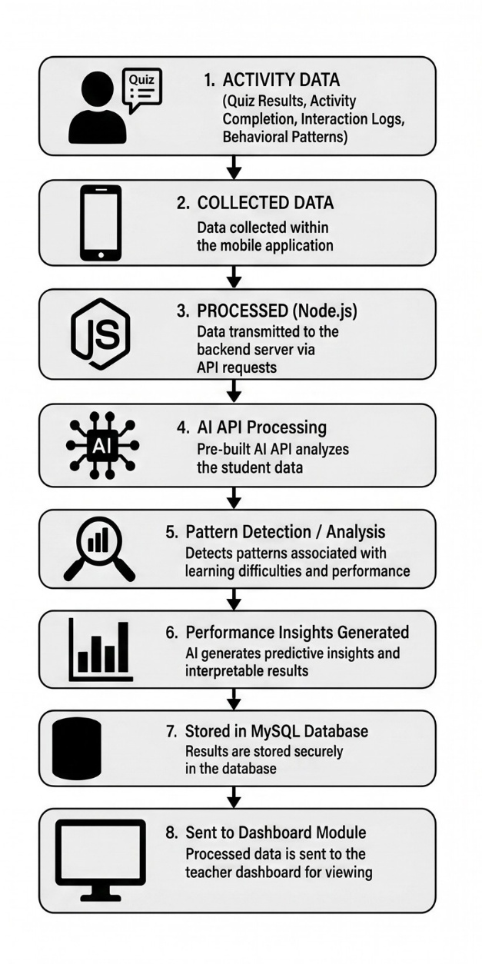

To achieve the first objective, the system will collect data such as quiz results, activity completion, interaction logs, and behavioral patterns within the mobile application. Instead of training machine learning models from scratch, the system will utilize pre-built AI APIs to process and analyze student data. Testing involves using sample student datasets to evaluate accuracy and consistency of AI-generated results.

B. Method for Developing the Teacher-Oriented Dashboard
Figure 3.4
Development Process of the Teacher-Oriented Dashboard Module
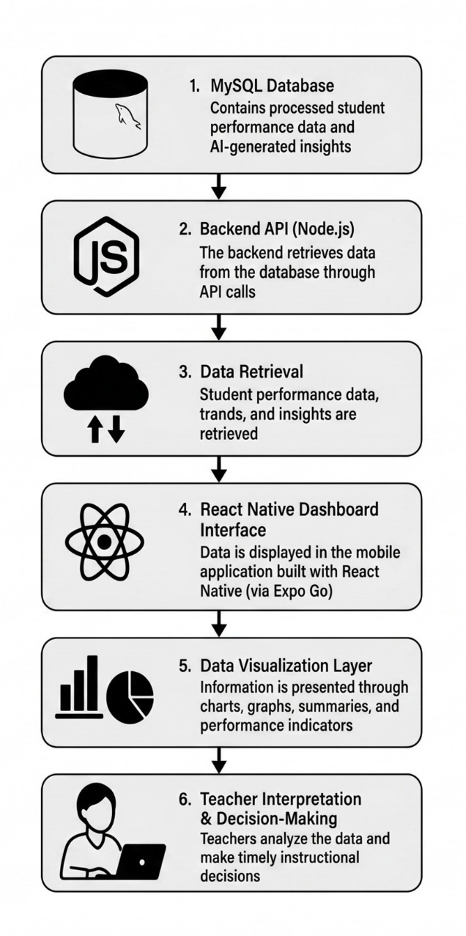

For the second objective, the system will develop a teacher-oriented dashboard using React Native components. The dashboard will display student performance trends, learning progress, and AI-generated insights using visual elements such as charts, graphs, and summaries. Testing focuses on usability, responsiveness, and data accuracy.

C. Method for Developing the Personalized Support and Recommendation Module
Figure 3.5
Development Process of the Personalized Support & Recommendation Module
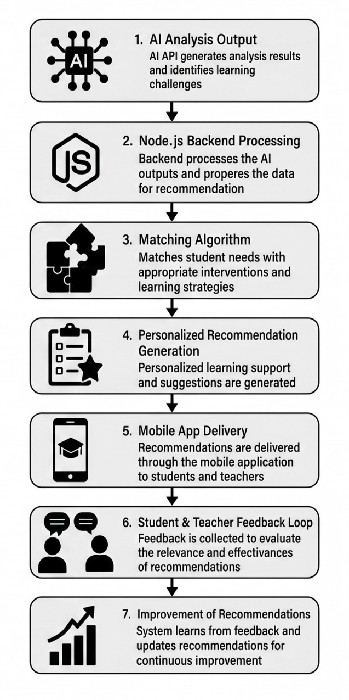

To achieve the third objective, the system will generate personalized learning recommendations based on AI analysis of student performance data. The Node.js backend will process AI API outputs and match them with appropriate intervention strategies. Testing will evaluate the relevance, clarity, and effectiveness of generated recommendations.
Tools
The tools used in the development of the proposed system are presented through system design diagrams that illustrate its structure, processes, and data flow. The succeeding sections present the Flowchart of the Proposed System, Data Flow Diagram, Entity-Relationship Diagram, and Use Case Diagram.

Flowchart of the Proposed System
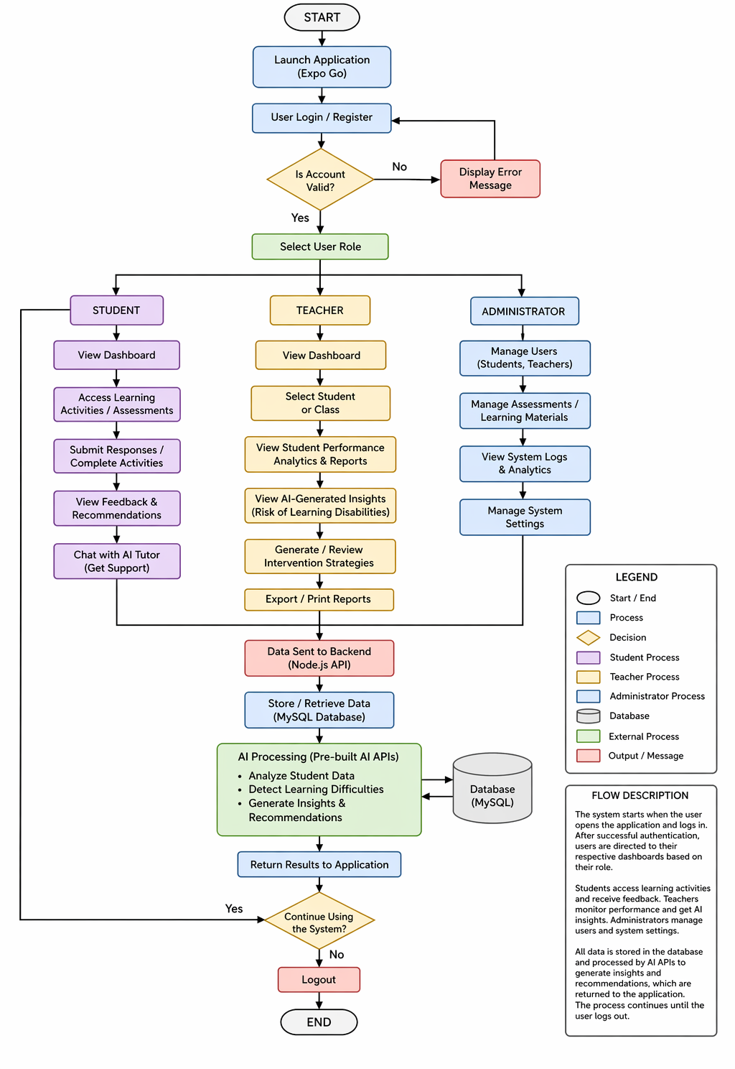

Data Flow Diagram of the Proposed System
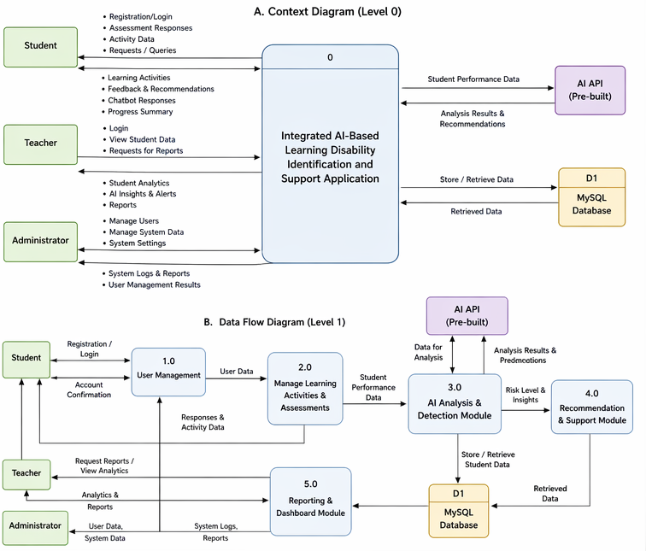

Entity-Relationship Diagram of the Proposed System
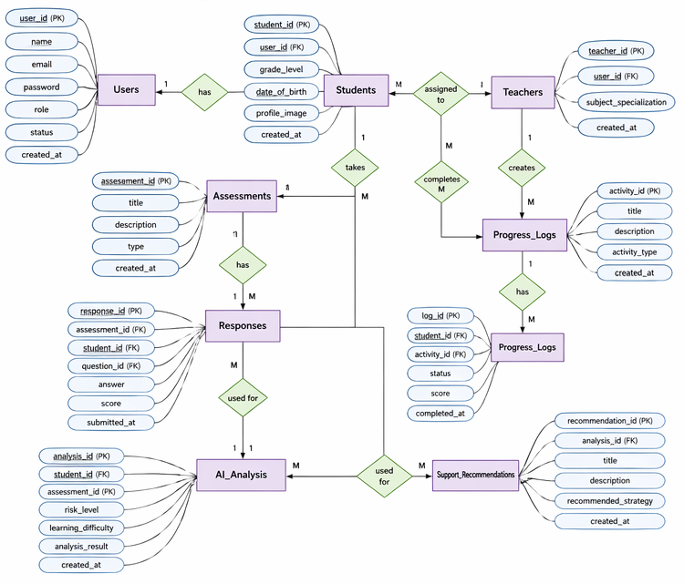
Use Case Diagram of the Proposed System
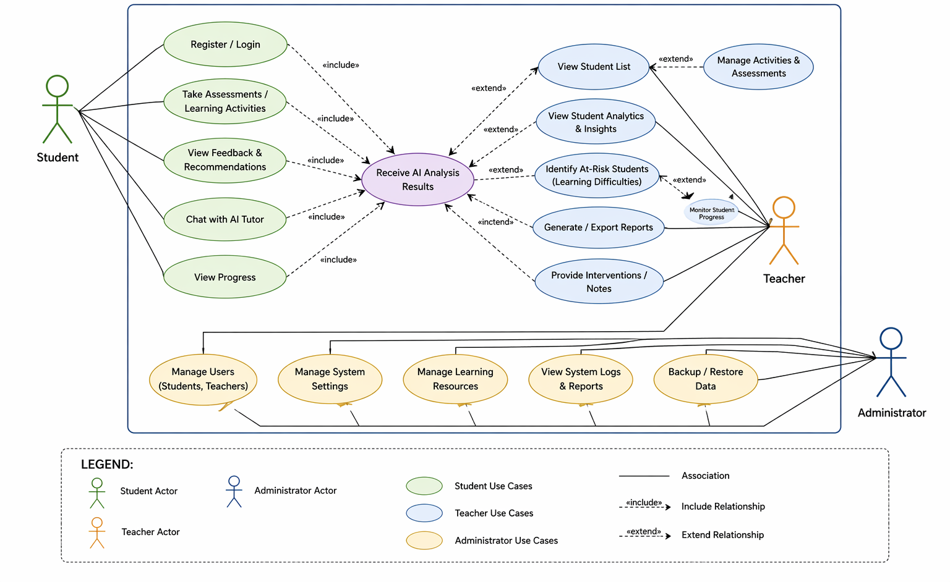

REFERENCES
1. Aldehim, G., Rashid, M., Alluhaidan, A. S., Sakri, S., & Basheer, S. (2024). Deep learning for dyslexia detection: A comprehensive CNN approach with handwriting analysis and benchmark comparisons. Journal of Disability Research, 3(2), Article e20240010. https://doaj.org/article/c5fbbc4b263a448ebb780acf7183f442
2. Drotár, P., Doležal, J., & Gajdoš, P. (2020). Machine learning methods for handwriting-based dysgraphia detection. Expert Systems with Applications. https://doi.org/10.1016/j.eswa.2020.113456
3. Garzón, J., Patiño, E., & Marulanda, C. (2025). Systematic review of artificial intelligence in education: Trends, benefits, and challenges. Multimodal Technologies and Interaction, 9(8), 84. https://doi.org/10.3390/mti9080084
4. Holmes, W., Bialik, M., & Fadel, C. (2019). Artificial intelligence in education: Promises and implications for teaching and learning. Center for Curriculum Redesign. https://discovery.ucl.ac.uk/id/eprint/10139722/
5. Labadze, L., et al. (2023). Educational chatbots and personalized learning environments. Education and Information Technologies. https://doi.org/10.1007/s10639-023-XXXXX
6. Ochoa, X., & Worsley, M. (2016). Augmenting learning analytics with multimodal sensory data. Journal of Learning Analytics, 3(2), 213–219. https://doi.org/10.18608/jla.2016.32.10
7. Okonkwo, C. W., & Ade-Ibijola, A. (2021). Chatbots applications in education: A systematic review. Computers and Education: Artificial Intelligence. https://doi.org/10.1016/j.caeai.2021.100033
8. Siemens, G., & Baker, R. S. J. d. (2019). Learning analytics and educational data mining. https://scholar.google.com/scholar?q=Siemens+Baker+learning+analytics
9. Winkler, R., & Söllner, M. (2018). Unleashing the potential of chatbots in education. https://scholar.google.com/scholar?q=Winkler+Sollner+chatbots+education
10. Zawacki-Richter, O., Marín, V. I., Bond, M., & Gouverneur, F. (2019). Systematic review of research on artificial intelligence applications in higher education. International Journal of Educational Technology in Higher Education, 16(1), 39. https://doi.org/10.1186/s41239-019-0171-0

