User Satisfaction with Indoor Environmental Quality and Wayfinding in Selected Nigerian Airport Terminals

Abstract
This study investigated user satisfaction with indoor environmental quality (IEQ) and wayfinding in selected airport terminal buildings in Nigeria amid increasing global emphasis on sustainable and user-centered design practices within the aviation sector. As airport terminals are key public spaces, the research focused on how IEQ factors such as air quality, thermal comfort, natural lighting, and acoustic comfort impact passenger experiences and satisfaction. A quantitative exploratory post-occupancy evaluation approach was adopted using a structured questionnaire survey administered across selected airport terminals in Nigeria. A total of 71 questionnaires were distributed across selected terminals, yielding 52 valid responses from airport users which were analyzed using descriptive statistics. The findings indicate a generally positive response to thermal comfort and air quality, suggesting that these aspects are adequately addressed in the studied terminal buildings. However, significant concerns were raised about wayfinding, acoustic comfort, and the overall passenger experience related to noise levels and orientation within the terminal. Based on these insights, the study recommended improvements in signage systems to enhance wayfinding, the introduction of noise reduction strategies to address acoustic discomfort, and the promotion of natural ventilation and lighting to further optimize the indoor environment. While the findings provide valuable user-centered insights into passenger satisfaction and terminal environmental conditions, the study was conducted as an exploratory post-occupancy evaluation and may benefit from broader sampling in future research.
Keywords: Airport Terminals, Indoor Environmental Quality, Nigeria, User Satisfaction, Wayfinding

INTRODUCTION
The aviation sector is facing increasing scrutiny regarding its environmental impact, necessitating the adoption of sustainable design practices, particularly in airport terminal buildings. As major transportation infrastructures that accommodate large volumes of passengers daily, airport terminals play a significant role in shaping travel experiences while also influencing environmental performance and operational efficiency. Consequently, sustainable airport design has emerged as a critical area of research and practice aimed at balancing environmental responsibility with passenger comfort and functional performance (Duliński, 2015; Han et al., 2020; Papagrigoriou et al., 2023). Similarly, sustainable and user-oriented terminal environments have been associated with improved airport image, operational efficiency, and passenger well-being (Korba et al., 2023; Han et al., 2020).
Beyond conventional IEQ parameters, studies have increasingly recognised the importance of spatial legibility and wayfinding systems in shaping passenger experiences within complex transportation facilities such as airports (Fewings, 2001). Efficient wayfinding systems, including clear signage, intuitive circulation patterns, and spatial orientation cues, are essential for reducing passenger stress, improving navigation, and enhancing overall user satisfaction, particularly in large and high-traffic terminal environments (Churchill et al., 2008; Correia and Wirasinghe, 2007). Poor wayfinding conditions may result in confusion, delays, anxiety, and negative perceptions of terminal functionality and service quality.
In developing countries such as Nigeria, where airport infrastructure is rapidly evolving in response to increasing passenger traffic and modernization initiatives, understanding the relationship between IEQ, wayfinding, and passenger satisfaction is essential for the development of sustainable and user-centered airport environments (Donnelly, 2021). Despite growing investments in airport development across Nigeria, there remains limited empirical research focusing on passenger perception of environmental comfort and navigational quality within Nigerian airport terminals. Existing studies within the broader airport sustainability discourse have largely concentrated on energy performance, operational efficiency, and environmental management, with comparatively limited attention given to user-centered environmental satisfaction in tropical African airport contexts (Papagrigoriou et al., 2023).
LITERATURE REVIEW
IEQ and Passenger Satisfaction in Airport Terminals
IEQ is integral to sustainable airport design, influencing both user satisfaction and health outcomes (Pichatwatana et al., 2017; Huang et al., 2021). Airport terminals are complex public environments that accommodate large volumes of passengers for varying durations, making environmental comfort an essential factor in shaping travel experiences and operational efficiency. As contemporary airport design increasingly shifts toward user-centered and sustainable approaches, the role of IEQ in enhancing passenger experience has become more prominent within airport planning and management discourse (Duliński 2015; Han et al., 2020). Research consistently demonstrates that improved thermal comfort and indoor air quality can positively influence passenger well-being, perceived comfort, and satisfaction within terminal environments (Niza et al., 2023; Herbig, et al., 2020). Thermal comfort, which relates to users’ satisfaction with indoor temperature and humidity conditions, remains one of the most influential dimensions of IEQ in public buildings and transportation facilities. Studies indicate that optimal thermal conditions within airport terminals contribute to improved user experiences, reduced discomfort, and increased passenger satisfaction ratings (Papagrigoriou et al., 2023). Similarly, effective ventilation systems and improved indoor air quality have been associated with healthier indoor conditions and improved passenger perceptions of environmental quality (Herbig, et al., 2020).

Natural lighting is another crucial factor in enhancing IEQ, positively affecting passenger mood and perception of space. Research has shown that terminals designed with adequate natural light receive higher satisfaction ratings from users, highlighting the importance of integrating natural elements into airport design (Kotopouleas and Nikolopoulou, 2018). Furthermore, acoustic comfort significantly impacts the overall passenger experience; excessive noise can detract from user satisfaction, especially in waiting areas (Yang, et al., 2024). Effective noise control measures have been shown to improve overall satisfaction by creating a more tranquil environment. In the Nigerian context, there is a pressing need to understand how these various dimensions of IEQ affect user satisfaction, especially given the country's growing aviation sector. Addressing this gap, the current research aims to evaluate how various dimensions of IEQ influence user satisfaction in selected airports in Nigeria.
Wayfinding and Spatial Navigation in Airport Terminals
Wayfinding refers to the processes through which individuals orient themselves and navigate within built environments using spatial cues, signage systems, circulation patterns, and environmental information (Arthur and Passini, 1992). In airport terminals, effective wayfinding systems are essential due to the complexity, scale, and high passenger movement associated with terminal operations. Airports are often characterised by large circulation networks, multiple service zones, security checkpoints, boarding gates, and commercial areas, all of which require clear and intuitive navigation systems to support efficient passenger movement and reduce travel-related stress (Fewings, 2001).
Recent studies have highlighted the growing importance of wayfinding systems in improving passenger satisfaction, operational efficiency, and spatial usability within airport terminals. Wang and Wang, (2025), observed that effective visual guidance systems significantly improve passenger decision-making and reduce cognitive load in complex airport environments, particularly under time-sensitive conditions. Similarly, recent airport accessibility studies have shown that ease of movement, navigational clarity, and terminal legibility strongly influence passenger perceptions of airport service quality and overall travel experience (Mazzulla et al., 2026).
Despite the growing recognition of wayfinding and IEQ as important dimensions of passenger experience, limited empirical studies have examined their combined influence on passenger satisfaction within airport terminals in developing countries, particularly in Sub-Saharan Africa. In Nigeria, existing airport studies have focused primarily on infrastructure development, operational performance, and sustainability initiatives, with comparatively limited attention given to user-centered environmental comfort and navigational efficiency. Addressing this gap, the present study evaluates passenger satisfaction with IEQ and wayfinding in selected Nigerian airport terminals, contributing empirical insights that may support improved passenger comfort, terminal usability, operational efficiency, and sustainable airport infrastructure development.
METHODOLOGY
Research Design and Sampling
This study adopted a quantitative post-occupancy evaluation (POE) approach to assess passenger satisfaction with IEQ and wayfinding systems within selected airport terminal buildings in Nigeria. The post-occupancy evaluation approach was considered appropriate because it enables the systematic assessment of user perceptions, experiences, and satisfaction within occupied built environments, particularly in transportation facilities where environmental comfort and spatial navigation significantly influence user experience.
The selection of the airport terminals was guided by the need to obtain representative passenger perceptions across varying operational and environmental contexts within the Nigerian aviation sector. A purposive sampling strategy was therefore adopted to ensure the inclusion of airport terminals with different functional characteristics, passenger traffic volumes, and operational categories. The selected sample comprised three international airports and four domestic airports in order to capture variations in terminal scale, passenger density, circulation complexity, and environmental conditions that may influence passenger satisfaction and wayfinding experiences and are shown in table 1.
Table 1: List of purposively sampled airports
S/N | Airport | Category
1 | Murtala Muhammed International Airport, Ikeja, Lagos | International
2 | Nnamdi Azikwe International Airport, Federal Capital Territory | International
3 | Akanu Ibiam International Airport, Enugu | International
4 | Margaret Ekpo International Airport, Calabar | Domestic
5 | Kaduna International Airport, Kaduna | Domestic
6 | Sam Mbakwe International Cargo airport, Owerri | Domestic
7 | Ibadan Airport, Oyo state | Domestic

Data Collection and Analysis
Primary data for the study were collected through the administration of structured questionnaires to airport users within the selected terminals. The questionnaire was designed to evaluate passenger perceptions of IEQ and wayfinding conditions within the airport environments. The instrument consisted of sections covering respondent demographic characteristics, perception of indoor environmental quality variables, wayfinding conditions, and overall passenger satisfaction within terminal spaces. Closed-ended questions and five-point Likert scale measurements were adopted to assess satisfaction levels regarding thermal comfort, indoor air quality, lighting quality, acoustic comfort, movement patterns, signage systems, spatial orientation, and overall environmental conditions. The Likert scale ranged from 1 representing “Very Dissatisfied” to 5 representing “Very Satisfied.”
A total of 71 questionnaires were distributed across the selected airport terminals, out of which 57 were retrieved, while 52 valid responses were considered suitable for analysis following data screening and validation procedures. The relatively modest sample size is consistent with the exploratory post-occupancy evaluation nature of the study, which prioritised preliminary user-centered assessment of IEQ and wayfinding conditions within occupied airport environments. Similar exploratory environmental satisfaction studies within complex public facilities have utilized moderate sample sizes due to operational and accessibility constraints associated with data collection in secured transportation environments (Kotopouleas and Nikolopoulou, 2018).
Retrieved data were coded and analyzed using Statistical Package for the Social Sciences (SPSS) and presented with descriptive statistics, including frequency distribution analysis, percentage distribution, and graphical representation of responses. The descriptive analytical approach was considered appropriate for the exploratory nature of the study because it enabled the identification of dominant passenger perceptions, environmental comfort trends, and wayfinding-related concerns within the selected airport terminals.

RESULTS
Respondent Characteristics
The analysis of the questionnaire distributed to airport users provides insightful demographic data essential for understanding user experiences within the airport environment as presented in table 2.
Table 2: Demographic Characteristics and Questionnaire Distribution of Respondents
Variable | Frequency (n) | Percentage (%)
Questionnaire Distribution
Questionnaires Issued | 71 | 100.0
Questionnaires Retrieved | 57 | 80.3
Valid Responses | 52 | 73.2
Respondent Category
Passenger | 15 | 28.8
Cargo Forwarder | 13 | 25.0
Waiting for Family/Friend | 9 | 17.3
Commercial Retailer | 14 | 26.9
Taxi Service | 1 | 1.9
Total | 52 | 100.0
Gender
Male | 30 | 57.7
Female | 22 | 42.3
Total | 52 | 100.0
Age Range (Years)
Below 18 | 2 | 3.8
19–30 | 10 | 19.2
31–40 | 16 | 30.8
41–50 | 12 | 23.1
51 and Above | 12 | 23.1
Total | 52 | 100.0
Marital Status
Single | 28 | 53.8
Married | 24 | 46.2
Total | 52 | 100.0
Educational Qualification
WAEC/SSCE | 4 | 7.7
ND/NCE | 10 | 19.2
B.Sc/HND | 19 | 36.5
MSc/MBA | 15 | 28.8
Ph.D. | 4 | 7.7
Total | 52 | 100.0

Table 2 presents a breakdown of the respondent categories, with a total of 71 questionnaires issued and 57 retrieved, resulting in 52 valid responses. Among the respondents, passengers comprised the largest group, accounting for 28.8%, while taxi service users represented the smallest segment at just 1.9%. This distribution highlights the predominant role of passengers in airport activities and the lesser engagement of taxi drivers in the survey, suggesting a focused interest on the experiences of those directly using airport services. It further elucidates the social demographic characteristics of the respondents. A notable finding is that 57.7% of respondents are female, indicating a higher representation of women among airport users. The age distribution reveals that the 31-40 age range is the most populated category, constituting 30.8% of respondents, which may reflect the demographic most likely to travel for both leisure and business purposes. Additionally, the marital status data shows that a majority (53.8%) of respondents are single, which might correlate with increased travel frequency among younger, unmarried individuals. Educational qualifications among the respondents show a significant level of higher education, with 36.5% holding a B. Sc or HND and 28.8% possessing an MSc or MBA.
User Perception on IEQ and Wayfinding
The assessment utilized closed-ended questions, enabling respondents to express their opinions succinctly through yes or no answers with the results presented in Figure 1.
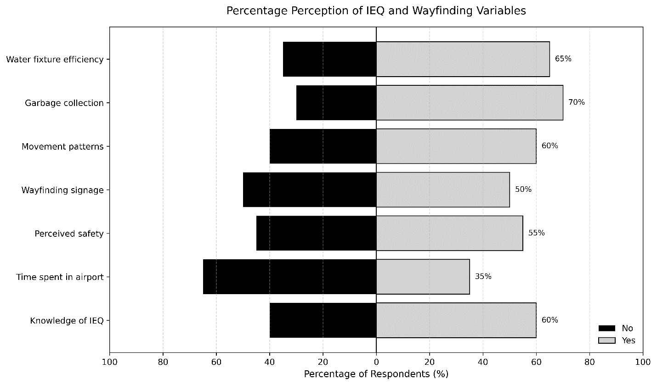
Figure 1: IEQ and wayfinding perception
Findings indicate several areas of concern. Notably, 45% of respondents expressed feelings of insecurity within the terminal buildings, highlighting a significant gap in perceived safety that may impact user confidence and comfort. Furthermore, 50% of respondents indicated dissatisfaction with the signage systems, reporting they were inadequate for effective wayfinding. Additionally, 40% of respondents reported a lack of awareness regarding indoor environmental quality metrics.

Indoor Environmental Satisfaction Evaluation
The evaluation of indoor environmental satisfaction through a five-point Likert scale provides a nuanced understanding of user satisfaction levels concerning various environmental factors within airport terminals with the results presented in Figure 2.
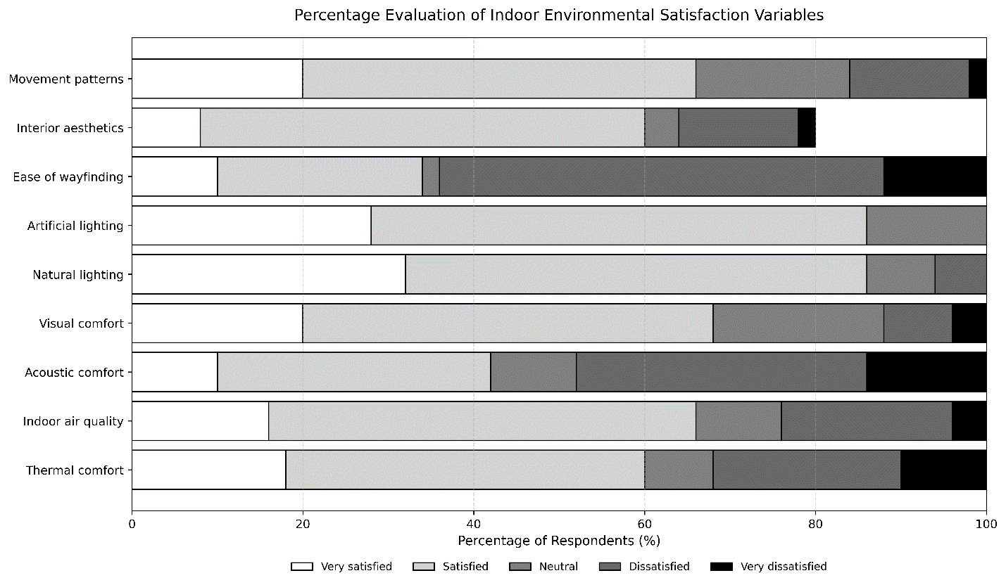
Figure 2: Indoor environmental satisfaction evaluation
The findings indicate that most respondents, over 50% expressed satisfaction with critical aspects of the airport environment, including thermal comfort, air quality, visual comfort, lighting, movement patterns, and overall aesthetics. However, the analysis reveals notable dissatisfaction among respondents regarding wayfinding directives. Additionally, the quality of acoustic comfort often influenced by factors such as noise levels and sound insulation emerges as another critical concern. Poor acoustic conditions can adversely affect passenger experience, creating an uncomfortable and distracting environment.
Impact of Natural Lighting and Ventilation
This section examines the perceived impacts of natural ventilation and lighting on occupant performance using a five-point Likert scale and the results are illustrated in Figure 3.
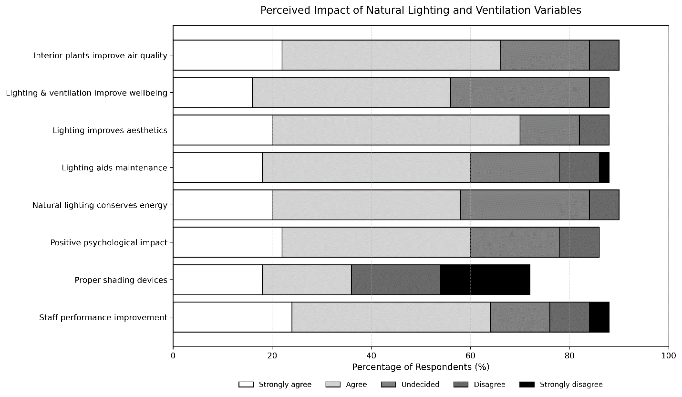
Figure 3: Impact of natural lighting and ventilation
Most respondents expressed a strong consensus that both natural lighting and ventilation significantly enhance staff performance. The agreement on the energy conservation benefits of natural ventilation and lighting highlights their role in reducing reliance on artificial systems. Respondents also noted improvements in the quality and aesthetics of interior spaces when natural elements are incorporated. Furthermore, well-ventilated spaces contribute to better indoor air quality, which is crucial for the health and well-being of both staff and travellers.
DISCUSSION
The findings of this study align with many of the key themes introduced in both the introduction and literature review, particularly regarding the importance of IEQ in enhancing user satisfaction and promoting sustainability in airport design. Consistent with the literature reviewed, the study found that passengers were generally satisfied with thermal comfort and air quality, validating previous research that suggests optimal thermal conditions and good air quality positively influence user experiences (Papagrigoriou et al., 2023; Niza et al., 2023). Similarly, the study confirms the importance of lighting quality as a significant component of passenger satisfaction within airport terminals echoing the findings of Kotopouleas and Nikolopoulou (2018), who highlighted that adequate natural light contributes to better user perceptions of space in airport terminals. Recent studies have further shown that naturally illuminated airport spaces contribute to improved visual comfort, enhanced spatial perception, and better passenger experience, particularly within waiting and circulation areas where users spend extended periods of time (Pichatwatana et al., 2017; Kotopouleas and Nikolopoulou, 2018). Respondents generally expressed positive perceptions regarding natural lighting conditions, which aligns with previous findings that adequate daylighting enhances visual comfort, spatial perception, psychological well-being, and user satisfaction in airports which is also in line with findings by Eze et al., (2025).
However, the study also revealed concerns regarding acoustic comfort and wayfinding, which were not fully addressed in the existing literature prior to this research. While the literature highlights the negative impact of noise on passenger satisfaction (Yang et al., 2024), this study emphasizes the need for targeted noise reduction strategies in Nigerian airports to improve the acoustic environment. The issue of wayfinding emerged as one of the most significant concerns identified by respondents which is consistent with findings by Bawa et al., (2025) on wayfinding in Nigerian Airports. Passengers expressed dissatisfaction with signage systems, spatial orientation, and movement patterns within some terminal buildings. This finding supports recent literature which emphasizes that wayfinding efficiency, navigational clarity, and spatial legibility significantly influence passenger perceptions of airport service quality and overall travel experience (Bawa et al., 2025; Mazzulla et al., 2026; Wang and Wang, 2025).
The findings of the study align with the broader discourse on sustainable and user-centered airport design by emphasizing the importance of continuous environmental evaluation and passenger-focused terminal planning. Contemporary airport sustainability frameworks increasingly recognised that sustainable terminal environments should not only address operational efficiency and energy performance but also prioritize passenger comfort, accessibility, environmental perception, and psychological well-being (Han et al., 2020). The recommendations proposed in this study, including improved signage systems, enhanced acoustic control strategies, and increased integration of natural lighting and ventilation, therefore contribute to sustainable airport design principles and support the growing body of research advocating for the integration of environmental quality and passenger experience considerations in airport architecture and management.
LIMITATIONS OF THE STUDY
The study adopted an exploratory post-occupancy evaluation approach based primarily on user perceptions and subjective assessments of IEQ and wayfinding within the terminal buildings. As such, the findings reflect user experiences and satisfaction levels rather than objective environmental performance measurements. The relatively modest sample size and purposive selection of airport terminals may also limit the broader generalizability of the findings across all airport terminals in Nigeria.
Data collection within airport environments presented certain operational and security-related constraints, including restricted access to some terminal areas, limited passenger interaction time, and varying passenger movement patterns, which affected response retrieval. Previous perception-based airport studies have shown that differences in terminal design, passenger flow, operational activities, and environmental conditions can influence user satisfaction and response pattern (Huang et al., 2021; Kotopouleas and Nikolopoulou, 2018). Future research may incorporate larger sample populations, comparative regional assessments, and broader passenger categories to enhance the generalizability and analytical depth of the findings.
CONCLUSION
The assessment of IEQ and wayfinding conditions in Nigerian airport terminals revealed varying levels of user satisfaction across different environmental attributes. While respondents generally expressed satisfaction with aspects such as thermal comfort and indoor air quality, notable concerns were identified regarding wayfinding effectiveness and acoustic comfort. Difficulties associated with navigation within terminal spaces suggest that existing wayfinding systems may not adequately support passenger movement, particularly for first-time users and visitors unfamiliar with airport layouts.
The findings further indicate the need for improvements in environmental and spatial design strategies to enhance user comfort and operational efficiency within airport terminals. In particular, respondents emphasized the importance of clearer and more strategically located signage to facilitate navigation and improve safety. Addressing deficiencies in wayfinding systems, alongside measures to improve acoustic conditions, would contribute to a more user-friendly airport environment.

RECOMMENDATIONS
Based on the findings, recommendations have been proposed to address specific issues identified by passengers as follows.
- Enhance Signage and Wayfinding Systems
Clear and intuitive signage is essential for guiding passengers through airport terminals efficiently and safely. Nigerian airports should prioritize the improvement of existing signage systems to ensure that passengers can easily find key areas such as gates, baggage claim, and amenities. Additionally, multilingual signage should be implemented to cater to the diverse international traveller base. Digital or interactive wayfinding solutions can further enhance navigation by offering real-time information about flight updates, gate changes, and terminal amenities. By making the navigation process simpler, airports can reduce confusion, improve safety, and create a smoother travel experience.
- Implement Noise Reduction Strategies
Acoustic comfort is a critical factor in improving passenger experience, especially in busy airport environments where noise levels can be high. Airports should invest in noise reduction strategies such as installing sound-absorbing materials in areas like seating zones, waiting areas, and high-traffic zones. Acoustic treatments such as carpets, ceiling panels, and acoustic partitions can significantly reduce ambient noise. Additionally, areas with excessive noise such as baggage claim or food courts should be designed in a way that minimizes sound spill into quieter zones, like lounges and seating areas.
- Promote Natural Lighting and Ventilation
Natural lighting and ventilation play a key role in creating a pleasant and healthy indoor environment. Airports should design terminals with larger windows, skylights, or light wells to allow more daylight to filter into interior spaces, improving both passenger mood and energy efficiency by reducing reliance on artificial lighting. Natural light has been shown to have positive effects on well-being, making airport terminals more comfortable places to spend time. Additionally, improving ventilation systems to ensure the continuous flow of fresh air in offices within the airport is essential. This could involve using natural ventilation strategies, such as operable windows or improved air filtration systems, to enhance air quality and provide a more refreshing atmosphere for passengers.
- Regular Evaluation of IEQ
To maintain high levels of user satisfaction, regular assessments of Indoor Environmental Quality (IEQ) should be conducted. Thermal comfort, air quality, lighting, and acoustics should be continuously monitored to ensure they align with passenger needs and expectations. Airports should develop systematic methods for evaluating these factors, such as periodic surveys, real-time environmental monitoring, and focus groups with travellers. Feedback from users can provide valuable insights into areas where improvements are needed and help airports stay proactive in addressing any emerging concerns regarding comfort or safety.
By adopting these recommendations, Nigerian airports can enhance user satisfaction, improve operational efficiency, and support sustainability initiatives, leading to a more comfortable and enjoyable airport experience for all passengers.

Consent to Participate
Voluntary consent was obtained prior to participation in questionnaire surveys.
Data Availability
The datasets used and/or analyzed during the current study are available from the corresponding author on reasonable request.
Competing Interest and Funding
None
REFERENCES
Arthur, P., & Passini, R. (1992). Wayfinding: People, Signs, and Architecture. McGraw-Hill Book Company.
Bawa, B. E., Erebor, E. M., & Rakiya, M. R. (2025). An Assessment of Key Architectural and Design
Considerations for Effective Wayfinding Systems in Airport Terminals in Nigeria. Environmental Management, 11(8).
Churchill, A., Dada, E., De Barros, A. G., & Wirasinghe, S. C. (2008). Quantifying and validating measures of
airport terminal wayfinding. Journal of Air Transport Management, 14(3), 151–158. https://doi.org/10.1016/j.jairtraman.2008.03.005
Correia, A. R., & Wirasinghe, S. C. (2007). Development of level of service standards for airport facilities:
Application to São Paulo International Airport. Journal of Air Transport Management, 13(2), 97–103. https://doi.org/10.1016/j.jairtraman.2006.10.002
Donnelly, A. (2021). Improving the Air Travelers Experience Through Airport Design. New York: State University of New York at Buffalo.
Duliński, W. (2015). Sustainable Airport Passenger Terminal Design - The Review of Selected Examples. Czasopismo Techniczne, 93-98.
Eze W.O., Dayomi M. A., Ademakinwa O. V., Obafemi O. I., & Olaoye G. O., (2025). Investigating Daylighting
Performance and Visual Comfort in Airport Terminals: A Passive Lighting Approach for Makurdi, Nigeria. International Journal of Advances in Engineering and Management, 7(8), 178–188. https://doi.org/10.35629/5252-0708178188
Fewings, R. (2001). Wayfinding and Airport Terminal Design. Journal of Navigation, 54(2), 177–184.
https://doi.org/10.1017/S0373463301001369
Han, H., Quan, W., Lho, L. H., & Yu, J. (2020). Eco-Design of Airport Buildings and Customer Responses and
Behaviors: Uncovering the Role of Biospheric Value, Reputation, and Subjective Well-Being. Sustainability, 12(23), 10059. https://doi.org/10.3390/su122310059
Herbig, B., Norrefeldt, V., Wargocki, P., Mayer, F., Ströhlein, R., Fang, L., & Ivandic, I. (2020). Impact of different ventilation strategies on aircraft cabin air quality and passengers’ comfort and well-being--the ComAir study. 2020 International Conference on Environmental Systems.
Huang, Y., Jia, X., Zhu, Y., Zhang, D., & Lin, B. (2021). Research on indoor spaces and passenger satisfaction with
terminal buildings in China. Journal of Building Engineering, 43, 102873. https://doi.org/10.1016/j.jobe.2021.102873
Korba, P., Sekelová, I.,Koščáková, M., & Behúnová, B. (2023). {Passengers’ knowledge and attitudes toward green initiatives in aviation. Sustainability, 61-87.
Kotopouleas, A., & Nikolopoulou, M. (2018). Evaluation of comfort conditions in airport terminal buildings.
Building and Environment, 130, 162–178. https://doi.org/10.1016/j.buildenv.2017.12.031
Mazzulla, G., Eboli, L., & Forciniti, C. (2026). Investigating the perceived quality of airport accessibility to define
regional development strategies. Case Studies on Transport Policy, 24, 101818. https://doi.org/10.1016/j.cstp.2026.101818
Niza, I. L., Bueno, A. M., & Broday, E. E. (2023). Indoor environmental quality (IEQ) and sustainable development goals (SDGs): technological advances, impacts and challenges in the management of healthy and sustainable environments. Urban Science, 96.
Papagrigoriou, N., Palantzas, G., & Nalmpantis, D. (2023). Airports and environmental sustainability: A review.
E3S Web of Conferences, 436, 11006. https://doi.org/10.1051/e3sconf/202343611006
Pichatwatana, K., Wang, F., Roaf, S., & Anunnathapong, M. (2017). An integrative approach for indoor environment quality assessment of large glazed air-conditioned airport terminal in the tropics. Energy and Buildings, 148, 37-55.
Wang, L., & Wang, X. (2025). Design mechanisms of airport visual guidance systems on passenger wayfinding
performance: Evidence from causal machine learning and a moderated mediation approach. Journal of Asian Architecture and Building Engineering, 1–17. https://doi.org/10.1080/13467581.2025.2589544
Yang, L., Chen, Z., & Zhen, M. (2024). Effects of thermal-acoustic interaction on airport terminal's indoor thermal comfort: A case study in cold region of China. Journal of Building Engineering, 86, 108834.

