DEVELOPMENT OF A 5 KG FOUNDRY SAND MIXER
Ayodeji Mufutau Adetona
Department of Mining Engineering,
Federal University of Technology and Environmental Studies, Iyin-Ekiti, Ekiti State, Nigeria.
adetonaayodeji@pg-student.oauife.edu.ng
Moshood Dehinde Shittu
Department of Materials Science and Engineering,
Obafemi Awolowo University, Ile-Ife, Osun State, Nigeria.
mdshittu@oauife.edu.ng
Wasiu Olayemi Atoyebi
Department of Materials Science and Engineering,
Obafemi Awolowo University, Ile-Ife, Osun State, Nigeria.
woatoyebi@oauife.edu.ng
Abstract
Foundry sand is mixed manually with the aid of shovel which does not give a homogeneous mix result which will lead to defect on the surface of the final foundry product. Medium and large-scale foundry make use of mechanical mixing process which involve using sand mixer of different capacity base on the volume of the casting to be made daily, such setup rely squarely on imported sand mixers. This study focused on developing locally fabricated 5 Kg laboratory mixer which will be used to mix foundry sand that will be used to carry out small scale casting. The laboratory size casting can be tested for its quality before embarking on large scale production. Major components of the 5 Kg foundry sand mixer include a 1 hp electric motor, gear box, shaft, mixing blades, blade support, frame, mixing pan and discharge door which are assembled via welding and fasteners such as bolts and nuts. The mixer performance was evaluated and 5 kg of foundry sand was mixed in 4.5 minutes and the mixer efficiency was 65.79%.
Keywords
Foundry sand, refractory sand, binder, additives, sand casting, casting, ferrous casting, non-ferrous casting, mixer, laboratory mixer, foundry mixer, electric motor, reduction gear
- Introduction
70 % of the world metal casting is produced via green sand metal casting. Sand casting is a major metal casting technique due to its low production cost and possibility of recycling its green sand. Green sand is a major material widely used in the foundry. It is used in performing both ferrous and non-ferrous casting. Foundry sand mixer is a device that achieve homogeneous mixture of green sand which is used for sand casting. Some developing countries like Nigeria, foundry sand is mix manually with the aid of a shovel which will not give a homogenous mixture (Aguwa, 2006). A laboratory size foundry sand mixer is developed in this study to help foundry houses achieve homogeneous green sand which will be used to perform a test sand casting before embarking on a large-scale production.
The major ingredients in sand casting are refractory sand such as silica, olivine, chromite, zircon because of their high thermal conductivity and low thermal expansion, binder such as clay and bentonite, additives and water. The major properties of a good moulding sand are high green strength, permeability and flowability (Weiss, 2018). Dai et al (2017) characterized foundry sand and observed that variation in the particle sizes of green sand have great influence on surface finish of the metal product. This implies that there must be homogeneous mixture of the green sand. Kaburu et al (2016) observed that it takes longer time to mix green sand using shovel than to use locally made foundry sand mixer. In the past decades, a lot of researchers have linked green sand parameters with casting quality. It has been proven that green sand parameters play important role in casting quality (Kumar et al (2010), ASM (1990)). The quality of the green sand is related to the defects present of the cast product (Kumar 2010). There is need to replacing the use of a manual means of mixing green sand with an automated one that is a foundry sand mixer. Shown in Figure 1 is a locally fabricated foundry sand mixer.

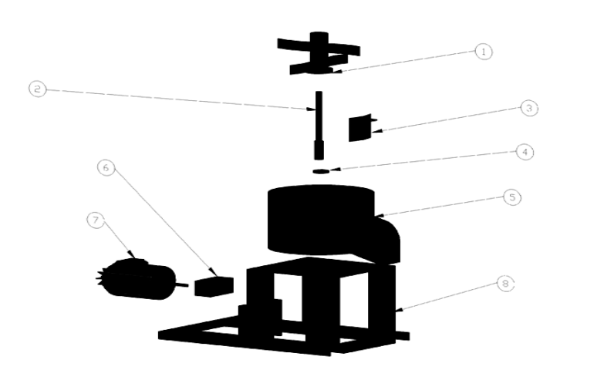

Figure 1: The exploded view of a foundry sand mixer.
Source: Osarenmwinda & Iguodala (2014)
- Materials and Methods
Materials used in this study are locally sourced.
  - Working Principle of a Foundry Mixer
A foundry mixer is a device used in the foundry for mixing binder, additives and base sand with water together homogeneously. A foundry mixer comprised of an electric motor, gear, shaft and mixing blade for mixing foundry sand evenly without leaving any portion unmixed. Foundry sand is measured at appropriate ratio and charged into the foundry sand mixer through the mixing pan and the machine is operated until a homogeneous mixture is achieved. The working principle of a foundry sand mixer is similar to concentrate mixer (Ali and Shakebuddin, 2022).
  - Design of Foundry Sand Mixer
Components used in this research was modelled around the imported foundry sand mixer to ensure maximum product output. All the components and the unit of the components used in design the foundry sand mixer is reported in Table 1. The following components are:
    - Main Frame
The main function of this component is to house the gear box and provide proper support for other components to be mount on it. Durability and strength are the major materials property considered while selecting materials for its design. Which led to using angle iron and 4mm thick mild steel for its design.
The main frame of the machine was designed using angle iron sectioned into 320 mm and 240 mm respectively. Four pieces of the 320 mm and 240 mm were weld together to form a base to house the machine gear box and 4 mm thick of 320 mm x 320 mm mild steel plate was placed at the top of the frame to serve as the base for the mixing pan.
    - Mixing Pan
The mixing pan is the housing unit for the foundry sand and to prevent foundry sand from sticking to the surface of the mixing pan, a 4 mm mild steel sheet with high strength was selected and used in designing this component. A rectangular shape sheet was fold to a cylindrical shape.
$D_{p}$ is the diameter of the mixing pan calculated using equation 1 using the width of the sheet which is 942.66 mm. Where the height of mixing pan is 120 mm. Which was used to calculate the volume of the mixing pan in equation 2.
The diameter of the mixing pan $D_{p}$ = $\frac{Crcumference }{π}$ (Equation 1)

$V_{p}$ is the mixing pan = $πr^{2}h$ (Equation 2)
    - Electric Motor
A 1 hp electric motor that convert electrical energy to mechanical energy was used to drive the gear box. it produced 746 rpm Reduction Gear Box. The speed of the electric motor procured is too high, there is need to reduce the revolution per minute with the aid of a reduction gear box. It can also transfer energy from the electric motor to the shaft that drive the mixing blade.
    - The blade and Blade Support
This component is responsible for the homogeneous mixture of the mould sand. The blade was made of 4 mm thick flat iron of length 65 mm weld to the shaft. The blades are made to be four to achieve homogeneous mixture of the moulding sand.
    - Trap Door for Delivery
Mild steel was selected for the design of this component because of its ability to resist corrosion. A 2 mm thick mild steel was placed to prevent the mould sand from discharging. The foundry sand mixer is design to be high even for effective discharge of mould sand.
    - Shaft
The shaft serves as support for the mixing blade and blade support. It is powered by mechanical energy generated by the electric motor which is reduced by the gear box. Some forces such as the weight of the blade, green compression strength of the moulding sand and centrifugal force caused by the shaft and the blade. The gear box reduces the speed produced by the electric motor by 25:1. Equation 3 is gear speed ratio. Which was used to determine the speed of the shaft. The speed of the shaft is calculated to be 62.4 rpm using the calculation stated below. This implies that generated by the motor have been reduced by 96 %
$\frac{S_{1}}{S_{2}}$ = $\frac{N_{1}}{N_{2}}$ (Equation 3)
Where $S_{1}$ is the speed of the motor = 1560 rpm
$S_{2}$ is the speed of the shaft
$N_{1}$ / $N_{2}$ is the gear ratio of 25 : 1
The angular velocity of the machine is calculated using equation 4. The angular velocity of the machine is 6.535 rad. The formula to determine the torque and the P of the machine is given in equation 4 and 5 respectively. The theoretical mass of mould sand the machine is designed for is 5 Kg. The force is calculated using equation 6 (Ali and Shakebuddin, 2022).
$ω= \frac{2πS_{2}}{60}$ (Equation 4)
T $= \frac{P}{ω}$ (Equation 5)
T = F x r (Equation 6)
F = M x g (Equation 7)
Where T = the torque
$ω=the angular velocity of the shaft$
Details of the machine such as speed of the motor, the speed of the shaft, the angular velocity of the machine, Torque, Force acting on the shaft, Power required, and the diameter of the mixing pan is recorded in Table 2.
  - Foundry Sand Mixer Testing
It is essential to test the efficiency of the machine by determine the work output against its work input. Different mass of foundry with binder and addictive inclusive were weighed at 1, 2, 3, 4, and 5 Kg respectively and charged into the foundry sand mixer and little water was poured while the machine was in operation. The time to achieve homogeneous mixture was taken and recorded. Check table 3 for the result.
  - Machine Efficiency
The efficiency of the machine is determine using equation 7.
Efficiency of the machine = $\frac{Power output}{Power input}$ x 100 %
= $\frac{490.13W}{746 W}$ x 100 %
= 65.79 %

- Result and Discussion
The components used in the design and fabrication of the foundry sand mixer is reported in Table 1. The efficiency of the foundry sand mixer is determined to be 65.7 % has compared to the 52% efficiency of the mixer developed by Osarenmwinda & Iguodala (2014). The reduction gear box reduced the speed of the electric motor drastically from 746 rpm to 62.4 rpm which is 96% reduction. Plate 1 shows the fabricated sand mixer. The final test carried out on the machine was recorded in Table 3. An homogeneous mixture of 5 Kg green sand can be achieved in 4.5 minutes as reported in Figure 2 which illustrate the mixing time of the foundry mixer.
Table1: Components and unit used
S/N | Components | Pieces
1. | 1 hp electric motor | 1
2. | Reduction gear box | 1
3. | Mixing pan | 1
4. | Main frame | 1
5. | Shaft | 1
6. | Trap Door | 1
7. | Blades | 4
8. | Blade support | 1

Table 2: Properties of the foundry sand mixer
S/N | Properties | Value
1. | Radius of mixing pan $R_{m}$ | 0.15 m
2. | Diameter of mixing pan $D_{m}$ | 0.3 m
3. | Force acting on the shaft | 50 N
4. | Torque of the machine | 75 Nm
5. | Power output | 490.13W
6. | Angular velocity | 6.535 rad
7. | Power input | 746 W
8. | Machine efficiency | 65.7 %
9. | Gear ratio | 25:1

Table 3: Foundry sand mixing time
S/N | Mass of the sand  (Kg) | Time  (Minute)
1 | 1 | 3
2 | 2 | 3.35
3 | 3 | 3.67
4 | 4 | 4.13
5 | 5 | 4.5

Figure 2: Mixing time against mass of green sand

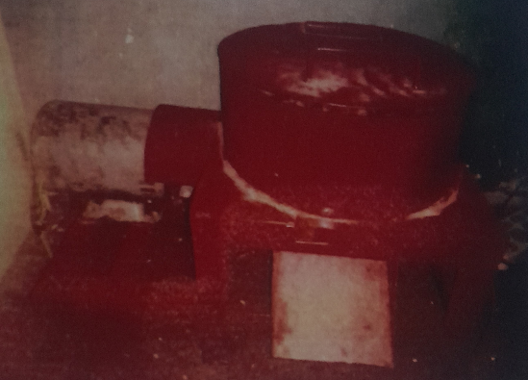
Plate 1: A 5 Kg Foundry Sand Mixer
4.0. Conclusion
The foundry sand mixer was design and fabricated using locally available materials while considering the required properties for each component. Components such as mixing pan, main frame, blade and blade support and shaft were fabricated using locally sourced materials. While motor and reduction gear are procured from local market. The diameter of the mixing pan, torque, angular velocity, power output and efficiency of the machine are 0.3 m, 75 Nm, 6.535 rad, 490 W and 65.7 % respectively. The machine has been proven to drastically help reduce the mixing time to achieve homogeneous mixture. It will also help the foundry shops to carry laboratory examination of a test metal casting using desired green sand compositions before embarking on mass production.
Acknowledgement
I acknowledge my academic father Prof. M. D. Shittu for his effortless contribution to the fulfilment of this project and the department of Materials Science and Engineering, Obafemi Awolowo University staff for their support.
Declarations
Availability of data and material
The datasets used in this study are available in the manuscript and supplementary materials file.
Competing interests
The authors declare that they have no competing interests.
Funding
This work is not funded
Author's contributions
A M Adetona: Methodology, writing of paper, formal analysis, visualization
W O Atoyebi: Investigation, Data curation and writing
M D Shittu: Conceptualization, Validation, Software, Supervision

References
Aguwa J. I., Effect of Critical Variable-Time on Concrete Production”. Journal of Science, Technology and Mathematics Education, 8(2), 2006, pp. 23-39
Ali, M. A. A., & Shakebuddin, M. (2022). Design and Fabrication of Portable Motor Driven Concrete Mixing Machine: A Review. International Journal for Research in Applied Science and Engineering Technology (IJRASET), 10(6), 64-67.
ASM International Committee (1990) Metals handbook for castings, vol 15, 10th edn. ASM International, Materials Park, OH
Dai, Y., Ma, Q. Y., Li, X. H., Zhang, X., Hu, F. P., Zhang, Y., & Xie, W. D. (2017). The research on characterization of crushability for foundry sand particles. Archives of Foundry Engineering, 17.
Kaburu, M. K., Nakuru, K., & Owino, G. O. (2016). Design of a portable foundry sand mixer. International Journal of Innovative Research in Engineering & Management (IJIREM), 3(6), 526-530.
Kumar, S., Satsangi, P. S., & Prajapati, D. R. (2011). Optimization of green sand casting process parameters of a foundry by using Taguchi’s method. The International Journal of Advanced Manufacturing Technology, 55(1), 23-34.
Osarenmwinda, J. O., & Iguodala, K. O. (2014). Design and fabrication of a foundry sand mixer using locally available materials. Nigerian Journal of Technology, 33(4), 604-609.
Weiss, D. (2018). Advances in the sand casting of aluminium alloys. In Fundamentals of Aluminium Metallurgy (pp. 159-171). Woodhead Publishing.

