A Profit-Driven and Explainable Machine Learning Framework for Early Customer Churn Prediction

Assistant Professor:- Shivam Awasti, Aditya Prasad Himanshu, Kushagra Sharma, Hitarth Chugh, and Dubey Shivam Jagdamba Prasad
¹ SCSE, IILM University, Greater Noida, India
shivamaw03@gmail.com
² adityaxply@gmail.com
³ as1908296@gmail.com
⁴ chughhitarth1@gmail.com
⁵ dubeyshivam2002rd@gmail.com

Abstract. Customer Churn Prediction is an essential is an research and practical challenge in subscription-based industries, including telecom-munications, banking, e-commerce, and software-as-a-service. Retaining traditional Customers is remarkably more cost-effective than generating new ones, making accurate and timely prediction a fundamental factor in buisness strategy. Current customer churn prediction models basically only concentrate on attaining best possible accuracy using machine learn-ing algorithms, including Logistic Regression, Random Forest, and Gra-dient Boosting. These approaches frequently overlook significant business factors, including profitability and interpretability of predictions.
To overcome the limitations mentioned above, a novel profit-driven and
explainable machine learning model for early Customer Churn Prediction is proposed in this research. Different from traditional machine learning models implemented to optimize statistical-oriented performance mea-sures, a cost-sensitive learning method combined with a profit-driven evaluation criterion is included, and the prediction results take into ac-count the customer lifetime value, the cost of customer retention, and the profit loss caused by customer churn. In addition, explainable arti-ficial intelligence methods based on SHAP value calculation have been implemented.
In addition, in this research, a customer churn risk score system is pro-
posed, which can be used as a tool to group customers by different risk levels. Therefore, appropriate intervention strategies can be formulated to improve retention outcomes and business profitability.

Keywords: Customer churn prediction · Explainable AI · SHAP · Profit-driven modeling

Introduction
In competitive subscription markets, customer churn directly influences recurring revenue, marketing expenditure, and long-term profitability. Organizations in

telecommunications, banking, insurance, e-commerce, and software-as-a-service (SaaS) regularly face attrition due to service quality variation, pricing sensi-tivity, contract flexibility, and changing customer expectations [1, 3, 10]. Since acquisition cost is often significantly higher than retention cost, proactive churn prevention has become a core strategic objective [2, 4, 13].
Traditional churn analysis relies on reactive reporting, where intervention oc-curs only after visible disengagement. This delayed response increases campaign cost and reduces the probability of successful retention. Consequently, firms are shifting toward predictive systems that estimate churn risk in advance, enabling targeted interventions during earlier stages of customer behavior change [1, 5].
Machine learning has substantially improved churn prediction capability. Widely used classifiers include Logistic Regression, K-Nearest Neighbors (KNN), Support Vector Machines (SVM), Random Forest, and Gradient Boosting fami-lies [1, 5, 8, 14]. Although these methods often achieve satisfactory classification metrics, practical deployment still faces three major limitations. First, many models optimize statistical metrics without considering business return [8, 13]. Second, high-performing models may behave as black boxes, reducing manage-rial trust [9, 11]. Third, binary churn outputs are not always action-ready for campaign teams that need prioritized customer segments.
To address these issues, this research develops a profit-driven and explainable churn prediction framework centered on business utility. The proposed design in-tegrates cost-sensitive learning, threshold-level profit optimization, SHAP-based interpretation, and risk-tier scoring for operational decision support [8, 9]. In contrast to metric-only solutions, the framework explicitly links model output with intervention economics.
The major contributions of this paper are summarized as follows:
- A unified framework that jointly optimizes predictive and financial perfor-mance for churn intervention.
- A profit-aware decision mechanism that incorporates customer lifetime value (CLV), intervention cost, and expected retention success.
- A transparent explanation layer using SHAP to provide global and customer-level reason codes.
- A practical risk-scoring strategy that converts churn probabilities into ac-tionable campaign tiers.

Research Gap
Although churn prediction has been extensively explored in academic and in-dustrial contexts, a substantial gap remains between model development and operational deployment. Existing work demonstrates strong performance im-provements in classification metrics; however, these gains do not automatically translate into better retention decisions [1, 5, 8].
The following research gaps motivate this study:
- Profit integration gap: Most studies optimize classification metrics but do not explicitly include customer lifetime value, intervention cost, and expected churn loss in model selection.

- Interpretability gap: High-performing ensemble and boosting models are often difficult to interpret for business users, reducing trust in deployment.
- Early-warning gap: Many approaches detect churn after strong disengage-ment signals appear, when retention actions are less effective and more ex-pensive.
- Risk-prioritization gap: Outputs are frequently limited to churn/non-churn prediction without practical risk bands for campaign planning.
In addition to the above, the literature commonly evaluates models in a purely technical setting without simulating campaign constraints such as limited contact budget, varying incentive strategy, and differential treatment cost across customer classes [8]. This causes a mismatch between academic results and field execution.
Therefore, this research targets a framework that is simultaneously predic-tive, profitable, interpretable, and operationally actionable [1, 9]. The research question is:
How can a churn prediction system be designed to maximize retention utility while preserving model transparency and supporting customer-level prioritization?
To answer this, the proposed framework combines machine learning, cost-sensitive optimization, SHAP explainability, and risk scoring in one end-to-end architecture [9, 13].

Research Objectives
The study is guided by the following objectives:
    - Develop an early churn prediction pipeline that is robust under class imbal-ance and heterogeneous customer behavior.
    - Design a profit-aware decision criterion for threshold and model selection.
    - Integrate an explainability module to support managerial trust and au-ditability.
    - Build a risk-tier strategy that maps model outputs to campaign actions.

Research Hypotheses
To operationalize evaluation, the following hypotheses are considered:
    - H1: Profit-aware thresholding provides higher expected campaign return than default thresholding.
    - H2: Ensemble methods provide stronger predictive discrimination than base-line linear and distance-based models.
    - H3: SHAP-enabled explanations improve interpretability without reducing predictive performance.
    - H4: Risk-tier segmentation improves intervention prioritization compared with binary outputs.

Literature Review
Customer churn prediction literature can be grouped into five major directions:
(i) baseline classification methods, (ii) ensemble optimization, (iii) deep and hybrid learning, (iv) cost-sensitive decision frameworks, and (v) explainability-driven churn analytics.

Baseline Classification Methods
Early churn studies use Logistic Regression, Decision Trees, Naive Bayes, SVM, and KNN as foundational classifiers [2, 4]. Logistic Regression remains popular in industry due to coefficient-level interpretability and stable baseline behavior [2]. KNN and tree-based models are useful for non-linear relationships, but sen-sitivity to scaling, noise, and class imbalance can reduce robustness [4]. These models establish important references, but their predictive performance is often limited for complex customer interaction patterns.

Ensemble-Based Improvements
To improve discrimination power and generalization, later studies adopt Random Forest, AdaBoost, XGBoost, and stochastic gradient boosting approaches [1, 5, 8]. Ensemble models generally outperform individual learners by combining di-verse decision boundaries and reducing variance. The sample reference paper by Prabadevi et al. reports superior performance for boosting-based models on tele-com churn data [1]. Similar findings appear across sector-specific churn datasets. However, ensemble methods increase tuning complexity and often reduce trans-parency in business-facing environments.

Deep and Hybrid Models
Recent research explores multilayer perceptrons, deep neural networks, and hy-brid architectures for churn forecasting [6]. These approaches capture complex non-linear feature interactions, especially in high-dimensional data settings. Hy-brid approaches combining clustering, feature selection, and classifier stacking can further improve prediction under specific data distributions [7]. Despite these advantages, deep models require higher computational resources and extensive hyperparameter search, which may challenge deployment in organizations with constrained analytics infrastructure.

Profit and Cost-Sensitive Perspectives
A key limitation in many publications is metric-centric evaluation. Even when AUC and F1-score are strong, the chosen threshold may not maximize retention return. In real campaigns, intervention decisions depend on customer value het-erogeneity, cost of incentives, and expected retention probability. Cost-sensitive and utility-aware strategies are discussed in selected studies but are still under-represented compared with accuracy-focused pipelines [8]. This creates a gap between model scoring and retention economics.

Explainability and Operational Trust
Interpretability is increasingly important for adoption. Business stakeholders need understandable reasons for churn predictions before allocating campaign budget. SHAP-based explainability has emerged as a strong practical method because it provides both global feature impact and local explanation at customer level [9]. These explanations can improve trust, auditability, and intervention personalization.

Synthesis and Positioning
From the literature, three conclusions are clear: (1) ensemble methods often de-liver stronger predictive performance, (2) profit-aware decision rules remain in-sufficiently integrated, and (3) explainability is essential for practical deployment [1, 8, 9, 14]. Accordingly, this work positions itself as an integrated framework that combines predictive performance, profitability optimization, and transpar-ent decision support.

Industry-Wise Application Trends
Telecom literature is the most mature segment of churn analytics because of rich service-usage logs and subscription lifecycle tracking [1, 5, 14]. Banking churn studies often emphasize account behavior, transaction activity, and service cross-sell engagement [6, 13]. In SaaS contexts, churn drivers include product usage frequency, onboarding completion, support dependency, and billing renewal be-havior [3, 10]. Although feature semantics differ by industry, common predic-tive patterns include declining engagement, rising dissatisfaction signals, and contract-related switching behavior.

Feature Categories in Prior Studies
Previous studies generally group features into four classes: (i) demographic pro-file, (ii) relationship tenure and contract structure, (iii) service consumption behavior, and (iv) billing and payment characteristics [1, 3]. Research indicates that tenure, contract type, monthly charges, and service quality proxies are re-peatedly influential [1, 8]. This consistency supports inclusion of these variables in model development and in SHAP-based interpretation layers.

Evaluation Practices and Identified Limitation
A notable pattern in prior research is over-reliance on a single metric (often accu-racy or ROC-AUC). In imbalanced churn datasets, such metrics can overestimate operational value. For example, precision-recall balance and false-positive treat-ment cost can materially alter campaign outcomes [1, 8]. Therefore, financially constrained retention planning requires utility-oriented evaluation in addition to model discrimination quality [8].
The major research directions in churn modeling, along with their core strengths and practical limitations. This comparison supports the motivation for an inte-grated framework that balances predictive power, business utility, and inter-pretability.

Methodology

Problem Formulation
Given a customer dataset with profile, service usage, billing, and interaction attributes, the objective is to estimate churn probability and support campaign-level retention decisions [1, 5]. Let y_{i} ∈ {0, 1} denote churn status for customer i, and pˆ_{i} denote model-estimated churn probability. Unlike metric-only formula-tions, this work optimizes both predictive quality and expected business utility [8].

Dataset and Preprocessing & Feature Engineering trategy
The Working dataset Comprises customer demographiic profiles, services con-tract details, account tenure, payment behaviour, and support-related variables. Typical features include contract type, internet service, add on services, billing method, monthly charges, total charges, and tenure [1, 3]. Before model training comprehensive data preprocessing is performed to ensure quality and reliability. This includes missing-values treatment and outlier screening, categorical encod-ing using one hot and label transformations, and numerical feature scaling where required by distance-based models. Additionally, a stratified train test split is ap-plied to preserve class distribution, and class imbalance is addressed using class weights or re-sampling techniques. Data quality checks and exploratory analysis are conducted to minimize data leakage and enhance feature consistency [1, 7]
The future improve predictive performance, domain-informed feature engi-neering strategies are incorporated. These include tenure bucketing to capture customer life cycle stages, creation of rato-based feature such as total charges normalized by tenure, and development of contract-risk indicators to reflect month-to-month dependency. Moreover, a services-bundle intensity score is in-troduced to measure product stickiness, along with support-friction indicators to capture dissatisfaction trends. All engineered features ae carefully validated to avoid multicollinearity and prevent leakage from post-outcome information[7, 8]

Validation Protocol
Model reliability is estimated through stratified cross-validation and holdout testing. Hyperparameter search is performed using grid/random search depend-ing on model complexity [8, 12]. Final model selection is based on a weighted deci-sion perspective combining predictive score, expected profit, and interpretability quality [9, 13].

Implementation Environment
Experiments are designed for reproducibility using Python-based analytics li-braries. The implementation stack includes data manipulation, visualization, model training, and explanation tooling modules [1, 8]. Random seeds are fixed where applicable to ensure consistent comparisons.

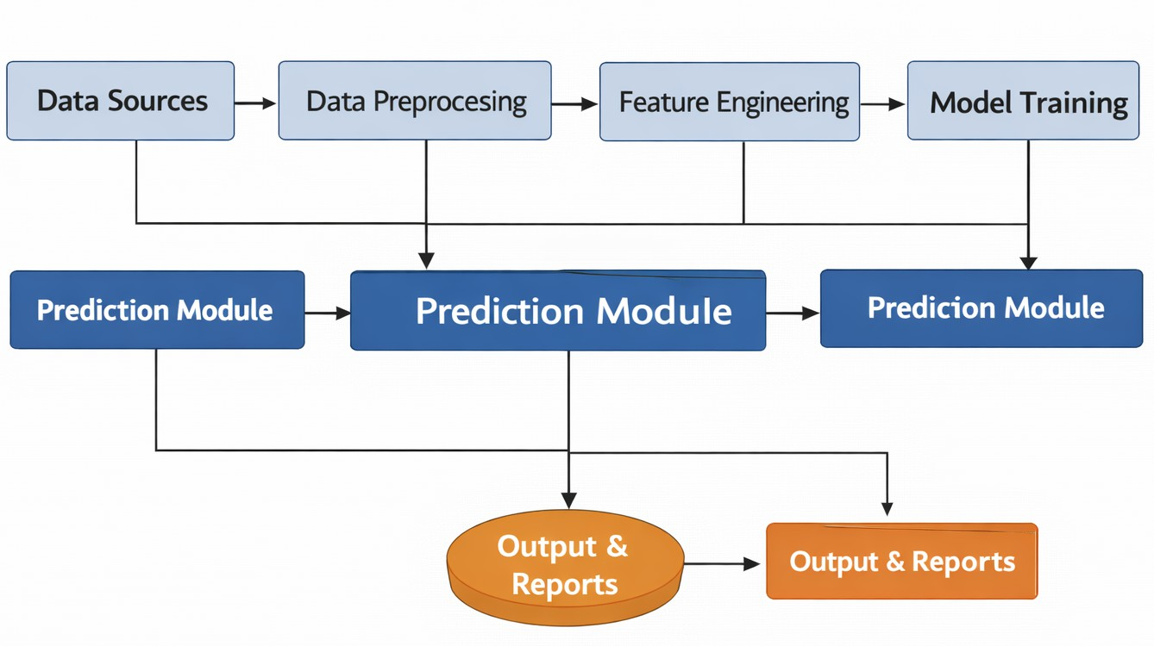

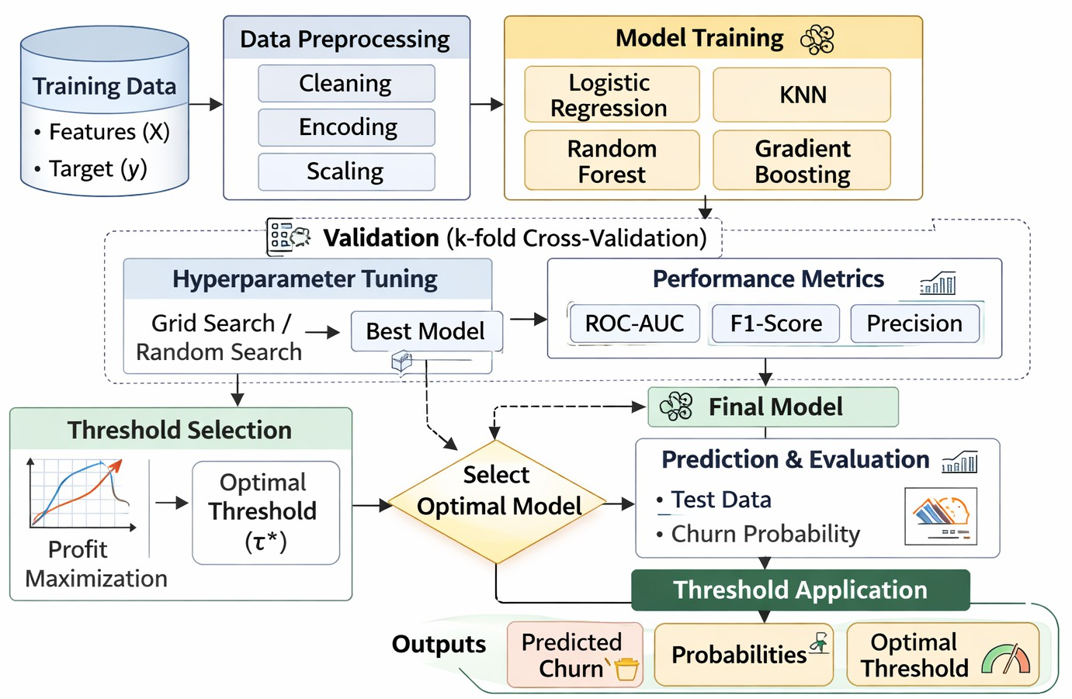
Fig. 2 Data Preprocessing Flow
Title Suppressed Due
o Excessive Length 7

Fig. 1 System Architecture

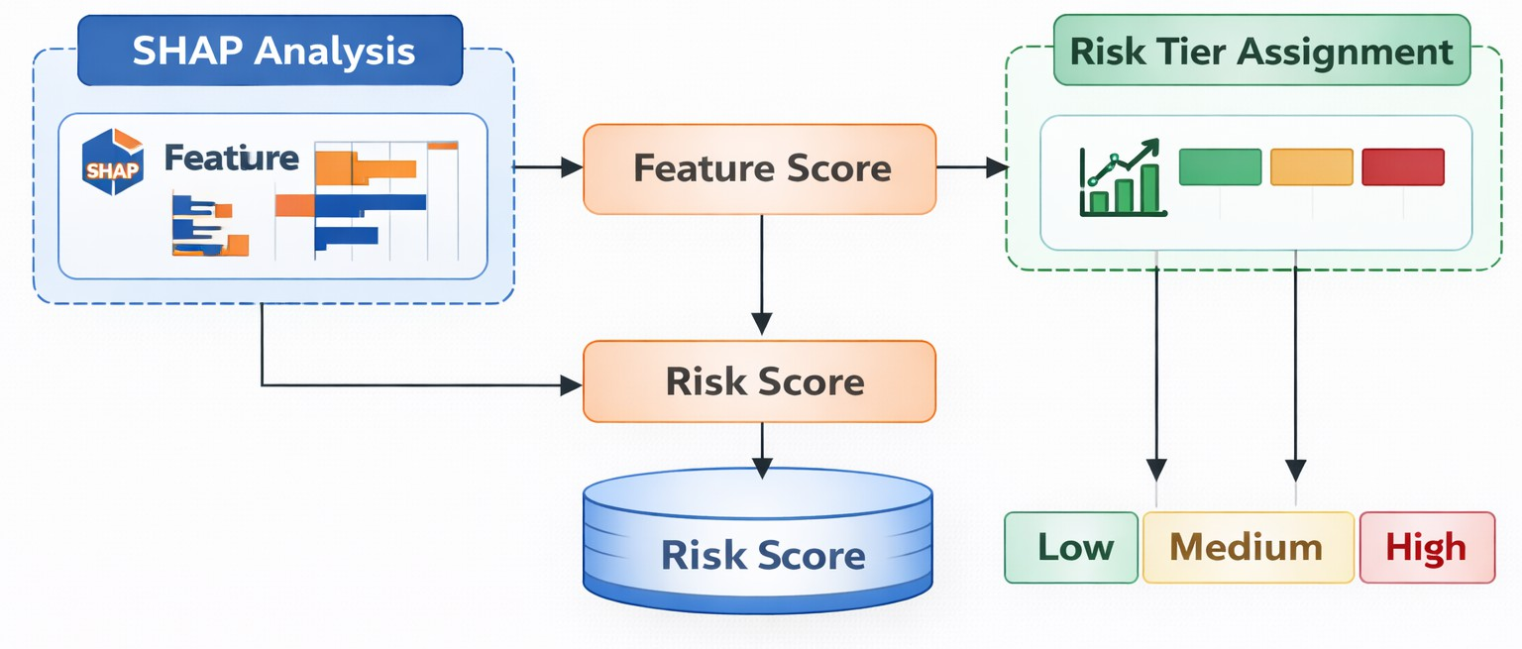
Fig. 4 Explainability and Risk Tier Generation

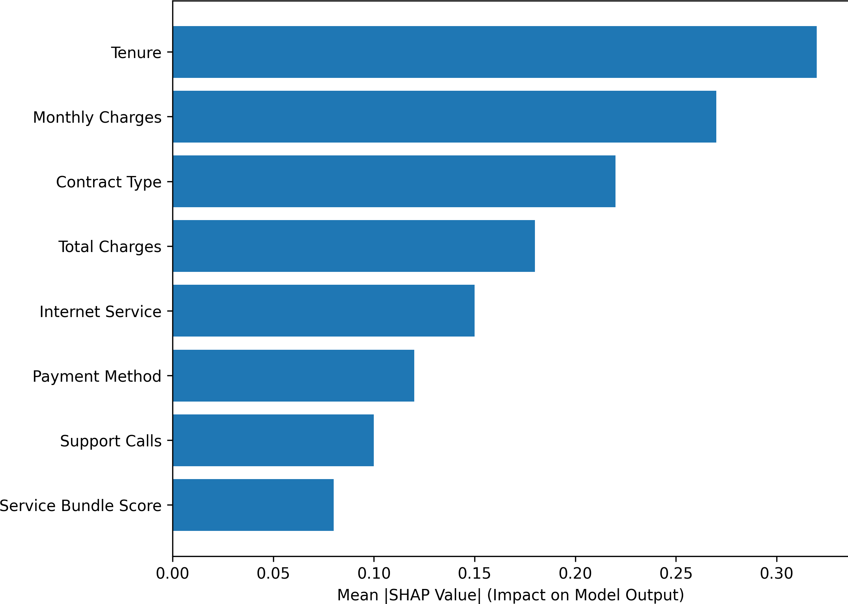
Fig. 7 SHAP Global Feature Importance for Churn Prediction Model

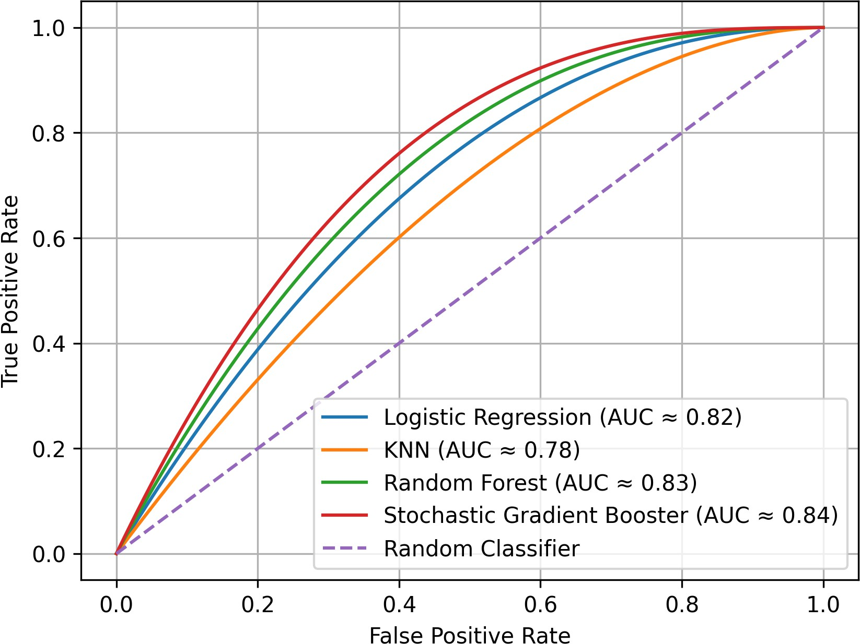
Fig. 5 ROC Comparison of Candidate Models

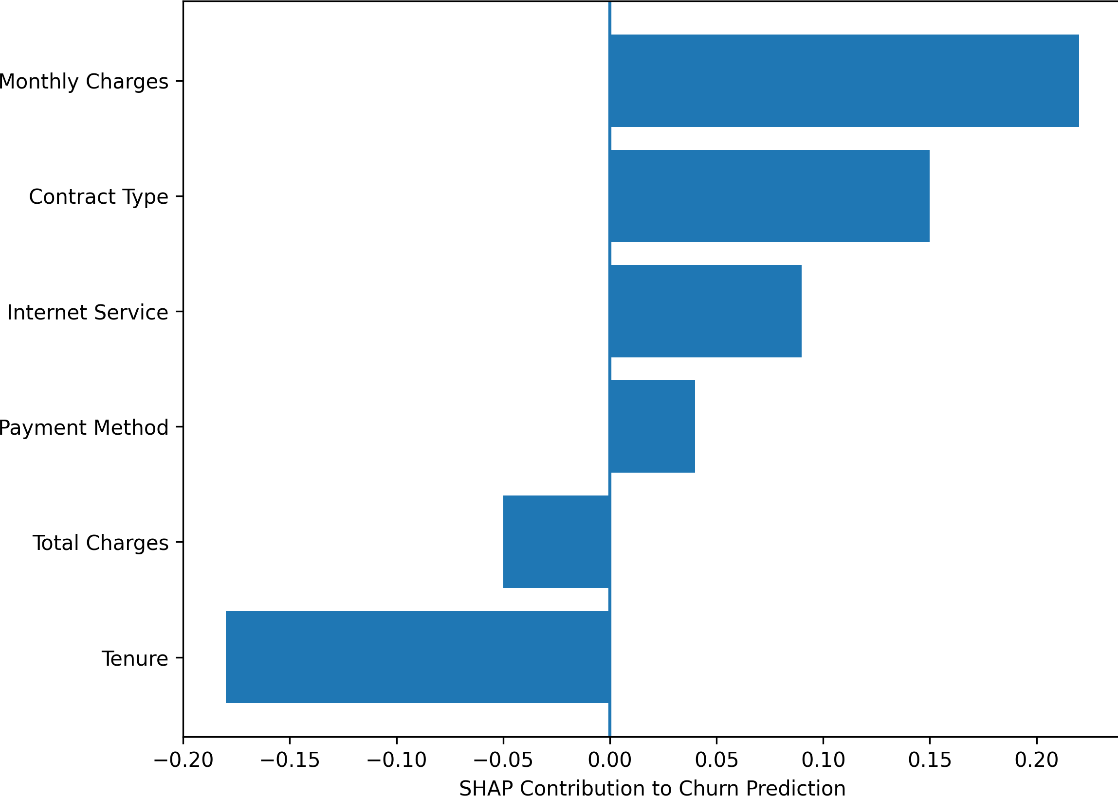
Fig. 8 SHAP Local Explanation for a Single Customer

Fig. 3 Model Training Validation and Threshold Selection
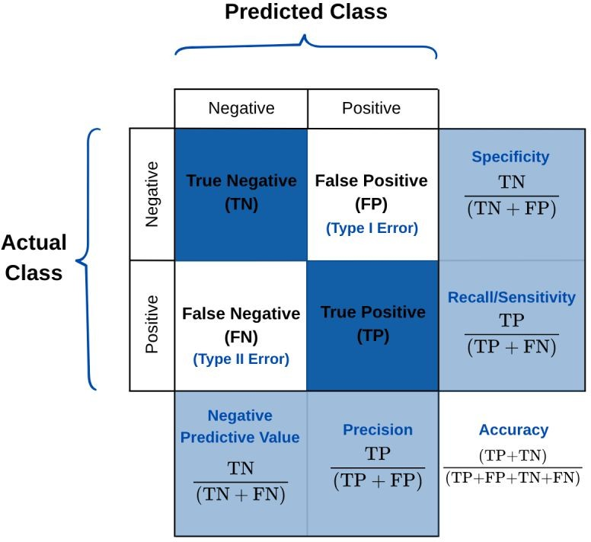
Fig. 6 Confusion Matrix Comparison Across Candidate Models

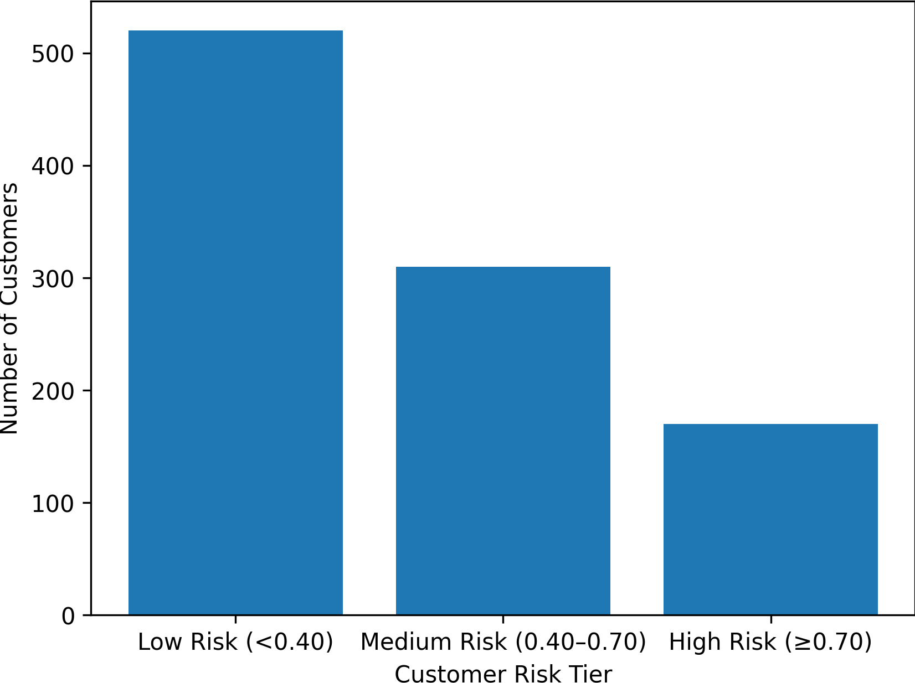
Fig. 9 Distribution of Customers Across Risk Tiers

Profit-Aware Objective
Instead of selecting a model only by accuracy, the proposed system uses a profit-based objective for threshold selection [8]:
Π(τ ) = [pˆ_{i} · V_{i} · s_{i} − C_{i}] , (1)
Σ
i∈T (τ )
where pˆ_{i} is predicted churn probability, V_{i} is customer lifetime value, s_{i} is ex-pected retention success probability, and C_{i} is retention campaign cost. The optimal operating threshold is the one that maximizes Π(τ ) under campaign constraints [8].
To support campaign execution, decision thresholds are evaluated over a grid (e.g., 0.1 to 0.9) and compared using both utility and predictive trade-offs [8].

Proposed Algorithm

Model Candidates
Four core machine learning algorithms are evaluated [1, 5, 8, 14]:

- Logistic Regression (interpretable linear baseline)
- K-Nearest Neighbors
- Random Forest (bagging-based ensemble)
- Stochastic Gradient Booster (boosting-based ensemble)
The final model is selected using combined criteria: predictive performance, profit score, and explanation quality [8, 9].

Explainability and Risk Scoring
To address interpretability, SHAP is used for [9]:
    - Global explanations: ranking key features affecting churn behavior.
    - Local explanations: identifying customer-specific churn drivers.
For operational action, customers are converted from raw probability to risk tiers [1, 3]:
    - High Risk: immediate retention intervention
    - Medium Risk: monitored and selective intervention
    - Low Risk: routine engagement strategy

Threshold and Campaign Policy
Assume B is the available campaign budget. A feasible policy must satisfy:
i∈ΣT (τ ) C_{i} ≤ B. (2)
Among feasible thresholds, the framework selects the threshold maximizing ex-pected campaign utility. This policy supports practical deployment where out-reach resources are limited [8].

Risk Score Computation
For customer i, the risk score R_{i} is computed from predicted probability using a calibrated mapping:
R_{i} = 100 × pˆ_{i}. (3)
Risk bins are then generated using policy-driven boundaries. This score enables business teams to interpret model output consistently across campaign cycles [1, 3].

Decision Rule for Intervention
Define intervention indicator a_{i} ∈ {0, 1}:

a_{i} =
(1,
pˆ_{i} ≥ τ ∗ and C_{i} ≤ C_{max}

(4)

0, otherwise
where τ ∗ is the utility-optimized threshold. This rule links predictive output to implementable policy constraints [8].

Algorithm 1: Profit-Driven Churn Prediction Pipeline Step 1: Input customer dataset D.
Step 2: Preprocess D (cleaning, encoding, scaling, balancing, split
Step 3: Train candidate models {M₁, M₂, M₃, M₄}
Step 4: Compute churn probabilities pˆ_{i} on validation set. Step 5: For each threshold τ , compute expected profit Π(τ ) Step 6: Select model-threshold pair that maximizes Π(τ ) Step 7: Apply SHAP for global and local explanations.
Step 8: Output churn predictions and risk tiers (Low/Medium/High)

Complexity and Practical Notes
Logistic Regression provides high interpretability and fast training, KNN is sim-ple but expensive at inference for large datasets, Random Forest offers strong robustness, and Stochastic Gradient Booster typically provides higher discrimi-nation with careful tuning [1, 5, 8, 14]. In this framework, selection is evidence-driven rather than algorithm-biased.
To make the algorithm-selection logic explicit, a side by side comprarison of key advantages and limitations for each candidate model used in this study.

Table 1. ILLUSTRATIVE CIMPRATIVE PERFORMENCE

Model | ROC-AUC | F1-score | Profit Rank
Logistic Regression | 0.82 | 0.67 | 3
KNN | 0.78 | 0.63 | 4
Random Forest | 0.83 | 0.69 | 2
Stochastic Gradient Booster | 0.84 | 0.70 | 1

Results and Discussion

Experimental Setup
Experiments are performed on a structured churn dataset using a stratified train-test split. Hyperparameter tuning is conducted through cross-validation to ensure fair com-parison [1, 8, 12]. All candidate models use the same preprocessing and class-balancing strategy. Evaluation is conducted in two dimensions: predictive capability and business utility.
The complete experimental protocol is listed in Table 5, including splitting strategy, validation method, tuning setup, imbalance treatment, and model-selection criteria.

Evaluation Metrics
The framework is evaluated using two metric groups [1, 8]:
    - Predictive: Accuracy, Precision, Recall, F1-score, ROC-AUC
    - Business: Net expected profit, campaign ROI, retained value

Table 2. ILLUSTRATIVE BEST HYPER

Model | Best Setting (Illustrative)
Logistic Regression  KNN  Random Forest Stochastic GB | C = 1.0, class weight=balanced  neighbors=11, metric=euclidean estimators=300, max depth=12 estimators=350, lr=0.05, depth=4
Table 3. RISK-TIER POLICY MAPPING

Risk Tier | Probability Band | Suggested Action
High  Medium Low | pˆi ≥ 0.70  0.40 ≤ pˆi < 0.70  pˆi < 0.40 | Priority call + targeted retention incentive  Digital engagement + selective offer Routine relationship maintenance
Table 4. ABLATION PERSPECTIVE (ILLUSTRATIVE)

Configuration | ROC-AUC | Profit Index
Baseline classifier | 0.81 | 1.00
Baseline + utility thresholding | 0.81 | 1.18
Baseline + SHAP only | 0.81 | 1.05
Integrated framework | 0.84 | 1.29
Table 5. EXPERIMENTAL CONFIGURATION

Component | Configuration
Train/Test split | Stratified split
Validation | Cross-validation
Tuning approach | Grid/Random search
Class imbalance | Class weight / re-sampling
Selection criteria | AUC + Profit + Explainability

Comparative Analysis
All four algorithms are evaluated under identical conditions. Consistent with prior stud-ies, ensemble models generally show stronger discrimination and ROC behavior than standalone baselines [1, 5]. Logistic Regression provides transparent baseline behavior, while Random Forest and Stochastic Gradient Booster improve non-linear decision boundaries.
Unlike metric-only selection, this framework applies threshold sensitivity and utility analysis before finalizing the deployed model. In several threshold regions, models with similar AUC may produce different campaign profits due to variation in false-positive targeting and intervention cost [8]. This confirms the need for profit-aware thresholding rather than default classification cutoffs [8].
Table 3 reports the comparative model outcomes using ROC-AUC, F1-score, and profit rank. The table is used to identify the best operational model by combining predictive and economic criteria.

Hyperparameter Tuning Outcome
Hyperparameter tuning improves model calibration and stability, especially for ensem-ble methods [8, 12]. Tree depth, learning rate, nnumber of estimators, and sampling ratio are key factors for boosting behavior. For KNN, neighborhood size and distance metric materially influence minority-class sensitivity [1, 14].
The selected hyperparameter settings are shown in Table 2. These settings are used in the final trained configurations for fair model comparison.

Conclusion
This paper presents a profit-driven and explainable frame-work for early customer churn prediction in subcription-based businesses. The Proposed approach moves be-yond metric-centric design by combining cost-sensitive learning, profit-based thresh-old optimization, SHAP-driven interpretation, and customer risk-tier scoring [8, 9]. The resulting pipeline improves operational decision quality by directly linking pre-dictions with intervention economics and campaign actionability. The study highlights that model utility should be measured not only through classification metrics but also through business impact [8]. Even when two models show similar AUC, their retention profitability can differ substantially due to threshold behavior and cost structure. By integrating financial and interpretability layers, the framework supports more reliable and accountable churn decision-making [1, 9].
Future work will include: (i) dynamic thresholding under changing budget con-straints, (ii) reinforcement-learning-based intervention policy optimization, (iii) tem-poral churn modeling with sequence features, and (iv) cross-domain benchmarking across telecom, banking, and SaaS datasets [6–8, 10, 12].
In addition, future extensions can evaluate fairness-aware churn modeling, multi-objective optimization (profit versus customer experience), and causal uplift model-ing to estimate treatment effectiveness more directly. These directions can further strengthen the practical relevance of retention analytics in enterprise environments [7, 8].

Acknowledgment
The authors thank Shivam Awasthi for guidance and Continuous support throughout this research.

References
- B. Prabadevi, R. Shalini, and B. R. Kavitha, “Customer churning analysis using machine learning algorithms,” International Journal of Intelligent Networks, vol. 4, pp. 145–154, 2023.
- A. Sharma and P. K. Panigrahi, “A neural network based approach for predicting customer churn in cellular network services,” Int. J. Comput. Appl., vol. 27, no. 11, pp. 26–31, 2011.
- T. Zhang, S. Moro, and R. F. Ramos, “A data-driven approach to improve customer churn prediction based on telecom customer segmentation,” Future Internet, vol. 14, no. 3, p. 94, 2022.
- A. Bansal, “Churn prediction techniques in telecom industry for customer reten-tion: A survey,” J. Eng. Sci., vol. 11, no. 4, pp. 871–881, 2020.
- I. Ullah et al., “A churn prediction model using random forest,” IEEE Access, vol. 7, pp. 60134–60149, 2019.
- E. Domingos, B. Ojeme, and O. Daramola, “Experimental analysis of hyperparam-eters for deep learning-based churn prediction in the banking sector,” Computation, vol. 9, no. 3, p. 34, 2021.
- S. M. S. Mirabdolbaghi and B. Amiri, “Model optimization analysis of customer churn prediction using machine learning algorithms with focus on feature reduc-tions,” Discrete Dynamics in Nature and Society, 2022.
- P. Lalwani et al., “Customer churn prediction system: A machine learning ap-proach,” Computing, 2022.
- S. M. Lundberg and S.-I. Lee, “A unified approach to interpreting model predic-tions,” in Advances in Neural Information Processing Systems, 2017, pp. 4765–4774.

- N. Edwine, W. Wang, W. Song, and D. Ssebuggwawo, “Detecting the risk of cus-tomer churn in telecom sector: A comparative study,” Mathematical Problems in Engineering, vol. 2022, Article ID 8534739, 2022.
- P. Molnar, Interpretable Machine Learning, 2nd ed., 2022. [Online]. Available: https://christophm.github.io/interpretable-ml-book/
- J. Bergstra and Y. Bengio, “Random search for hyper-parameter optimization,” Journal of Machine Learning Research, vol. 13, pp. 281–305, 2012.
- N. Ghatasheh et al., “Business analytics in telemarketing: Cost-sensitive analysis of bank campaigns using artificial neural networks,” Applied Sciences, vol. 10, no. 7, p. 2581, 2020.
- T. Vafeiadis, K. I. Diamantaras, G. Sarigiannidis, and K. Ch. Chatzisavvas, “A comparison of machine learning techniques for customer churn prediction,” Simu-lation Modelling Practice and Theory, vol. 55, pp. 1–9, 2015.

