AN INTELLIGENT SYSTEM FOR DROPOUT PREDICTION IN ONLINE COURSES USING MACHINE LEARNING
Priya A¹, Deepan N R², Gohul S³, Hariprasath S⁴, Vijayaragavan M⁵
¹Assistant Professor, Department of Computer Science and Business Systems,
KIT - Kalaignarkarunanidhi Institute of Technology, Coimbatore, Tamil Nadu, India.
Email: drpriyaa@kitcbe.ac.in
^{2,3,4,5}Students, Department of Computer Science and Business Systems,
KIT - Kalaignarkarunanidhi Institute of Technology, Coimbatore, Tamil Nadu, India.
Email: kit26.csbs09@gmail.com, kit26.csbs13@gmail.com, kit26.csbs16@gmail.com, kit26.csbs306@gmail.com

Abstract—The rapid growth of online learning platforms and Massive Open Online Courses (MOOCs) has improved accessibility to education; however, high dropout rates continue to affect learning outcomes and course effectiveness. While existing solutions mainly focus on analyzing data from external learning systems, this work presents a unified EdTech platform that integrates course creation, student learning, and dropout prediction within a single environment. The proposed system enables instructors to design and manage courses by uploading video lectures, assignments, and quizzes, while learners access and interact with the content through the same platform. Student engagement data such as percentage of videos watched, assignment submission status, quiz performance, and inactivity duration are automatically collected and preprocessed to support machine learning-based dropout prediction. Random Forest and Extreme Gradient Boosting (XGBoost) models are employed to estimate dropout risk in real time, and the results are displayed on an instructor dashboard for monitoring learner progress. A notification module is incorporated to send email alerts to learners identified as at risk, supporting timely intervention and improved engagement. The platform is designed to be flexible, scalable, and adaptable to different course structures without reliance on external LMS data. Experimental evaluation using a synthetic dataset representing realistic learner behavior demonstrates that early engagement indicators are effective predictors of dropout risk. This work provides a practical and end-to-end solution for online course management and learner retention through integrated educational analytics.
Index Terms— Online Learning Platform, Dropout Prediction, Machine Learning, Student Engagement, Educational Analytics, Random Forest, XGBoost.

I. INTRODUCTION
With the rapid expansion of online learning platforms and Massive Open Online Courses (MOOCs), education has become more flexible and accessible to a wide range of learners worldwide. However, high dropout rates continue to be a major challenge in online education, as many learners fail to complete the courses they enroll in. These dropouts negatively affect learners’ academic and professional growth and also reduce the credibility and effectiveness of online learning platforms. Common reasons for dropout include low engagement with learning materials, irregular participation, poor performance in quizzes and assignments, and prolonged periods of inactivity. Most existing platforms primarily focus on content delivery and assessment management but lack an integrated mechanism to continuously monitor learner behavior and predict dropout risk in real time. Instructors often depend on manual tracking or basic analytics, which is time-consuming, error-prone, and difficult to scale for courses with a large number of participants. To address these limitations, this project proposes an integrated EdTech platform that allows instructors to design and manage courses by uploading videos, assignments, and quizzes, while learners access and interact with the course content through the same system. The platform automatically collects engagement and performance data such as percentage of videos watched, assignments completed, average quiz scores, and days of inactivity. Machine learning models, including Random Forest and Extreme Gradient Boosting (XGBoost), analyze these features to estimate dropout risk at an early stage of the course. The predicted risk levels are displayed on an instructor dashboard, enabling timely intervention, while an automated notification module sends alerts to at-risk learners to encourage re-engagement. By combining course delivery, learner analytics, and predictive modeling into a single platform, the proposed system aims to reduce dropout rates, improve learner engagement, and support data-driven decision-making in online education.
II. LITERATURE SURVEY
Student attrition in MOOCs and online learning platforms continues to be a significant challenge affecting both learner success and institutional credibility. High dropout rates are commonly caused by low participation, irregular attendance, poor academic performance, and prolonged inactivity. As a result, student dropout prediction using machine learning has become an important area of research in educational data mining. Recent studies focus on identifying early engagement patterns and academic indicators that can accurately predict dropout risk and support timely intervention.
A. Dropout Prediction in MOOCs using Machine Learning (WCNPS 2021, University of Brasília)
This study analyzed early engagement data from MOOCs, including video viewing, assignment submissions, quiz attempts, forum activity, and login frequency to predict student dropout. After preprocessing, multiple algorithms such as Random Forest, AdaBoost, SVM, and Logistic Regression were evaluated, where Random Forest and AdaBoost achieved about 81% accuracy within the first few days of course participation. The study highlighted that early engagement indicators are strong predictors of persistence and emphasized the need for real-time platform integration for effective intervention.

B. Student Dropout Prediction in Finnish Higher Education (Technology in Society, 2024)
Using large-scale LMS data, this research evaluated behavioral and academic features across different time intervals. Accumulated credits, failed courses, and LMS interactions were key predictors, and CatBoost achieved high and stable accuracy. The study showed that combining academic and behavioral data improves prediction performance and stressed the importance of embedding analytics directly into educational platforms for timely support.

C. Hybrid Fuzzy and Machine Learning Models for Dropout Prediction (ICTACT, 2016)
This work proposed a hybrid model using fuzzy inference, logistic regression, and decision trees to manage uncertainty in student data. It included behavioral, demographic, and academic factors such as attendance, stress, and engagement. The model achieved high accuracy and improved interpretability, demonstrating that combining fuzzy logic with ML can better represent real-world learning behaviors, though practical deployment requires LMS integration.

D. Explainable Machine Learning for Dropout Prediction (Applied Soft Computing, 2023)
This study used XGBoost with SHAP-based explainability to predict dropout using engagement and academic features. The model achieved around 86% accuracy and provided interpretable insights into important risk factors such as video completion and quiz performance. The authors emphasized that explainable AI is crucial for educational systems to enable meaningful instructor interventions.

III. EXISTING SYSTEM
In the current online learning environment, platforms such as Coursera, NPTEL, Udemy, edX, and conventional Learning Management Systems (LMS) like Moodle and Blackboard mainly focus on content delivery and basic performance tracking. Instructors can upload videos, documents, and assessments, while students can access materials and submit assignments. These systems generally provide static reports such as quiz scores, attendance percentages, and assignment submissions, but do not support continuous real-time engagement monitoring.
Although learner activity data is recorded, most platforms do not convert this data into actionable insights. Instructors usually become aware of student difficulties only after poor assessment results or complete disengagement, which limits timely intervention. Some systems use simple rule-based methods such as attendance thresholds, which cannot capture complex behavioral patterns involving multiple engagement factors.
Most existing LMS platforms also lack integrated machine learning or AI-based prediction models to estimate dropout risk. Data is often analyzed manually using spreadsheets, making the process time-consuming and unsuitable for large-scale courses. Additionally, current platforms offer limited analytics dashboards and minimal automated intervention mechanisms for supporting at-risk students.
Overall, existing systems are reactive, rely on static reports, lack intelligent prediction capabilities, and do not provide integrated tools for early intervention. These limitations highlight the need for an intelligent EdTech platform that combines course delivery, real-time analytics, and machine learning-based dropout prediction within a single unified system.

IV. PROPOSED SYSTEM / METHODOLOGY:
1. System Architecture:
The proposed system architecture is designed to support real-time learner monitoring, intelligent dropout prediction, and early intervention through an integrated web-based learning platform.
• Input Layer – Collects raw data from the EdTech platform including student profiles, course enrollments, instructor-created content, academic records, and detailed activity logs such as video views, quiz attempts, assignment submissions, and forum interactions.
• Preprocessing Layer – Cleans and transforms collected data by handling missing values, removing duplicate records, encoding categorical attributes like course type and user roles, and normalizing numerical features such as scores and activity counts.
• Feature Engineering Layer – Extracts meaningful learning indicators such as engagement frequency, content completion ratio, average assessment performance, inactivity duration, and learning pace to represent both behavioral and academic patterns.
• Model Training Layer – Uses machine learning algorithms including Random Forest and XGBoost to train predictive models on historical learner data to identify dropout risks and classify students into different risk categories.
• Prediction Layer – Generates real-time predictions whenever new activity data is received, producing probability scores that indicate the likelihood of student dropout and updating learner risk status dynamically.
• Intervention Layer – Triggers automated alerts to instructors, personalized notifications to students, and recommends supportive learning resources such as revision materials or practice assessments for at-risk learners.
• Visualization Reporting Layer – Provides interactive dashboards for instructors and administrators showing course-wise engagement levels, dropout trends, student risk distribution, and effectiveness of intervention strategies.

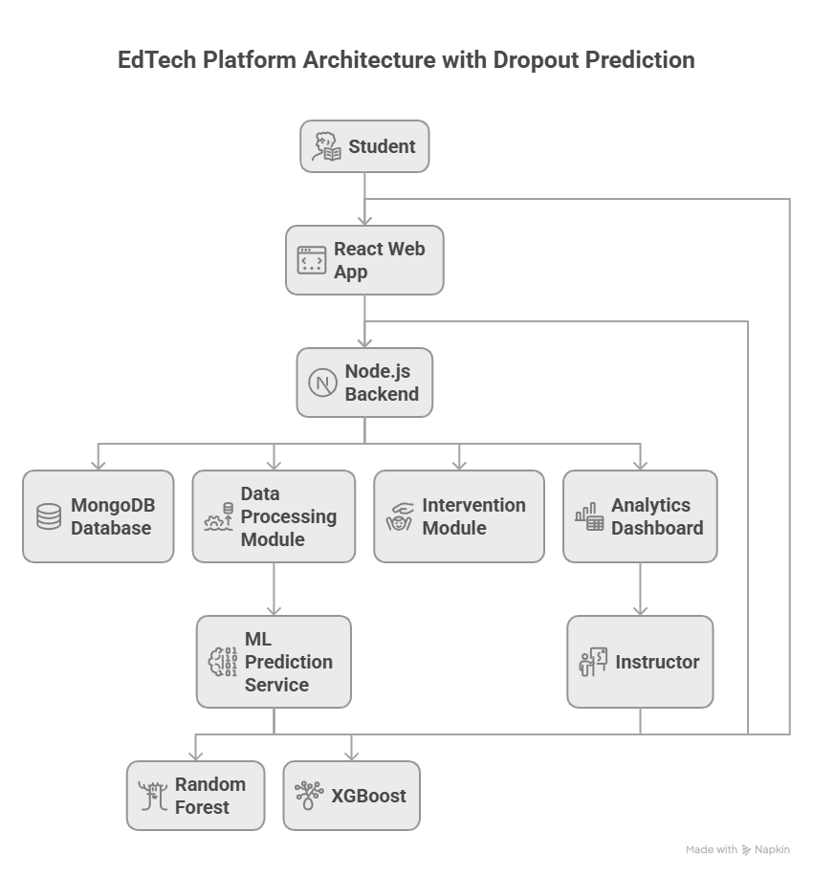
2. Machine Learning Methodology:
2.1. Data Collection:
In the proposed EdTech platform, student learning data is automatically collected from user interactions within the system. Unlike external LMS-based data collection, the platform records real-time activity generated by students during course participation. This provides continuous monitoring of both academic performance and engagement behavior.The collected data includes:
- Behavioral Activity Data:
This includes login frequency, time spent on course modules, percentage of video watched, number of sessions per day, and access to learning materials. These indicators reflect student consistency and dedication to the course.
- Performance Data:
This consists of quiz scores, number of attempts per quiz, assignment submissions, coding exercise results, and progress through learning modules. Low assessment scores or irregular submissions often indicate academic difficulty.
- Engagement Signals:
These include participation in discussion forums, interaction with learning activities, delays between successive logins, and inactivity duration. Extended inactivity strongly correlates with dropout probability.
By combining behavioral, academic, and engagement data, the system builds a complete learning profile for each student directly from the platform database.

2.2. Data Preprocessing:
The collected platform data may contain missing values, noise, or inconsistent records. Therefore, preprocessing is performed before feeding data into machine learning models.
- Data Cleaning: Missing values such as skipped assignments are handled using imputation techniques or flagged as inactivity indicators. Abnormal session durations are filtered to avoid misleading engagement measures.
- Normalization: Features such as quiz scores, login counts, and time spent are scaled to a common range to prevent bias during training.
- Categorical Encoding: Course category, difficulty level, and learning mode are encoded using label encoding or one-hot encoding.
- Labeling: Students are labeled as Dropout or Non-Dropout based on course completion status, converting the problem into a binary classification task.
This process ensures the dataset is structured and suitable for predictive modeling.

2.3. Feature Engineering:
Feature engineering enhances prediction accuracy by generating meaningful indicators from raw data.
- Engagement Ratio: Ratio of submitted assignments to total released assignments.
- Quiz Performance Index: Average quiz score divided by number of attempts.
- Inactivity Duration: Maximum consecutive days without login.
- Learning Pace: Number of modules completed per week.
- Consistency Score: Variance in daily login frequency.
These derived features capture learning patterns that raw metrics cannot reveal directly.

2.4. Model Training:
To build reliable prediction models, two ensemble learning algorithms are employed: Random Forest and XGBoost. These models are trained using historical platform data containing labeled student outcomes.
2.4.1. Random Forest
Random Forest combines multiple decision trees trained on random subsets of data and features. It reduces overfitting and improves robustness.
Advantages:
- Handles high-dimensional educational datasets
- Tolerant to noise and missing values
- Provides feature importance for interpretability
This helps instructors understand which behaviors most strongly influence dropout risk.
2.4.2. XGBoost
XGBoost builds trees sequentially, where each tree corrects previous prediction errors. It focuses on difficult classification cases and improves prediction precision.
Advantages:
- Captures complex non-linear relationships
- Handles class imbalance effectively
- Provides high predictive accuracy
Both models are compared, and the best-performing model is selected for deployment.
2.5. Model Evaluation:
Model performance is evaluated using multiple metrics to ensure reliable predictions:
- Accuracy: Overall correctness of predictions
- Precision: Correctly predicted dropouts among all predicted dropouts
- Recall: Ability to detect actual dropout students
- F1-Score: Balance between precision and recall
- ROC-AUC Curve: Measures classification effectiveness across thresholds
These metrics ensure that the system avoids excessive false alarms while identifying most at-risk students.

2.6. Prediction and Intervention Integration:
Prediction results are integrated directly into the instructor analytics dashboard. Students are categorized into low, medium, and high-risk groups.
Based on prediction output, the platform supports:
- Automated reminders for incomplete activities
- Instructor notifications for high-risk students
- Personalized learning recommendations
- Additional practice materials for weak areas
This closes the loop between prediction and educational intervention, improving learning retention.

3. Module Description
The proposed system is a complete EdTech learning platform integrated with a machine learning–based dropout prediction module. The system is divided into multiple functional modules to ensure smooth learning delivery, efficient course management, and early identification of at-risk learners. Each module communicates with the centralized backend database and analytics services.

3.1. Student Module
The Student Module provides learners with access to all learning activities and course resources available on the platform. It acts as the primary interface through which students interact with educational content.
Main functionalities include:
- User registration and secure authentication
- Enrollment into available courses
- Access to video lectures, PDFs, presentations, and coding exercises
- Attempting quizzes and submitting assignments
- Viewing progress reports and completion status
- Receiving notifications and learning reminders
Every interaction performed by the student is logged and stored in the database, including login time, content access duration, quiz attempts, and assignment submission timestamps. These activity logs serve as important inputs for the dropout prediction model. The module ensures continuous data generation required for behavioral analysis.

3.2. Instructor Module
The Instructor Module allows educators to design, manage, and monitor their courses. It also provides analytical insights about student engagement and dropout risk.
Key functionalities include:
- Course creation and editing
- Uploading of learning materials such as videos, notes, and assignments
- Creating quizzes and assessments
- Viewing enrolled student lists
- Monitoring student activity and performance metrics
- Receiving alerts for high-risk students
Through this module, instructors can track which students are falling behind in course progress or assessment performance. Based on the prediction results generated by the ML system, instructors can provide personalized guidance, extra materials, or direct communication to improve retention.

3.3. Course Management Module
The Course Management Module controls the lifecycle of courses and learning paths within the platform. It ensures structured delivery of educational content and organized assessment scheduling.
Major responsibilities include:
- Course categorization by subject, difficulty, and skill level
- Module-wise content organization
- Scheduling of assessments and deadlines
- Tracking completion criteria for certification
- Managing prerequisites between learning modules
This module also standardizes the content structure so that learning activity metrics can be consistently measured across different courses. It supports adaptive learning workflows by adjusting content availability based on student progress.

3.4. Analytics and Monitoring Module
The Analytics Module processes raw activity data into meaningful performance indicators. It serves as the bridge between platform data and machine learning analysis.
Functions of this module include:
- Aggregating student activity logs
- Calculating engagement metrics such as login frequency and study duration
- Generating performance trends from assessments
- Visualizing progress dashboards for instructors and administrators
- Preparing feature datasets for ML model training and prediction
This module enables early identification of abnormal learning behavior patterns such as declining participation, irregular study habits, and sudden inactivity. These indicators are continuously forwarded to the prediction engine.

3.5. Dropout Prediction Module
The Dropout Prediction Module applies machine learning algorithms to identify students who are likely to discontinue their courses. It operates as an intelligent decision-support system within the platform.
Key processes include:
- Receiving processed feature sets from the analytics module
- Applying trained Random Forest and XGBoost models
- Generating dropout probability scores for each student
- Categorizing learners into low, medium, and high-risk groups
- Updating risk status periodically based on new activity data
The module works continuously in the background and adapts to changes in student behavior. Risk predictions are pushed to the instructor dashboard, enabling timely academic interventions. This predictive mechanism helps institutions reduce attrition rates and improve learning outcomes.

3.6. Administration Module
The Administration Module manages overall system operations and platform-level controls.
It provides:
- User account management and access control
- Instructor verification and approval
- Course quality monitoring
- Platform usage statistics
- System configuration and security management
This module ensures data integrity, user privacy, and system reliability while supporting large-scale usage.

V IMPLEMENTATION TECHNOLOGY
The proposed EdTech platform is implemented using a modern full-stack web architecture where the frontend is developed using React.js to provide a responsive and interactive user interface for both instructors and students. The backend is built using Node.js with the Express.js framework to handle user authentication, course management, content delivery, assessment handling, and communication between system components through RESTful APIs. MongoDB is used as the database to store user profiles, course details, video links, assignments, quiz data, and activity logs in a flexible document-based structure suitable for dynamic educational data. For the machine learning component, Python is used along with libraries such as Pandas and NumPy for data preprocessing, Scikit-learn for implementing Random Forest models, and XGBoost for advanced boosting-based prediction. The trained machine learning models are deployed as a separate microservice using Flask or FastAPI, which communicates with the Node.js backend through API endpoints to provide real-time dropout risk predictions. This architecture enables scalable, modular, and efficient integration of intelligent analytics with the core EdTech platform functionalities.

VI FUTURE ENHANCEMENT
In future work, the proposed EdTech platform can be extended by deploying it on cloud infrastructure to support large-scale users and ensure high availability and data security. Real-time dropout prediction can be implemented using continuous behavioral data streams, enabling immediate and adaptive interventions such as automated reminders, personalized learning support, and instructor alerts. Integration with popular Learning Management Systems (LMS) like Moodle and Google Classroom through APIs can enable automatic data synchronization and reduce manual data handling. A mobile application can also be developed to improve accessibility and engagement through instant notifications and flexible learning access. Additionally, recommendation systems can be introduced to provide personalized learning paths and resource suggestions based on individual performance and engagement levels. Advanced analytics dashboards can support institutional decision-making by identifying course-level and instructor-level performance trends. Finally, the prediction models can be enhanced using deep learning techniques and continuous retraining pipelines, along with the inclusion of psychological and social interaction indicators, to further improve prediction accuracy and reduce false dropout alerts.

VII REFERENCES
[1] E. B. M. Magalhães, G. A. Santos, F. C. D. Molina Júnior, J. P. C. L. da Costa, F. L. L. de Mendonça and R. T. de Sousa Júnior, “Student Dropout Prediction in MOOC using Machine Learning Algorithms,” in Proc. 6th Workshop on Communication Networks and Power Systems (WCNPS), University of Brasília, Brazil, 2021.

- M. Vaarma, “Predicting student dropouts with machine learning: An empirical study in Finnish higher education,” Technology in Society, 2024.
- A. Saranya and J. Rajeswari, “Enhanced prediction of student dropouts using fuzzy inference system and logistic regression,” ICTACT Journal on Soft Computing, 2016.
- Mathivanan.P, "Computer Vision Empowered Assistive Technology for Blind People," 2024 International Conference on Emerging Research in Computational Science (ICERCS), Coimbatore, India, 2024, pp. 1-7, doi:
10.1109/ICERCS63125.2024.10895124.
- J. G. C. Krüger, J. Barddal, M. D. S. Cordeiro et al., “An explainable machine learning approach for student dropout prediction,” Applied Soft Computing, 2023.
- T. Ohkawauchi and E. Tanaka, “Predicting Student Dropout Risk Using LMS Logs,” IAAI Letters, 2024.
- S. Dass, “Predicting Student Dropout in a Self-Paced MOOC Course,” Information (MDPI), 2021.
- Mathivanan. P and K. Mahalakshmi, "Privacy-Secure and Decentralized Biometric Authentication Models Using
Federated Learning Frameworks," 2024 International
Conference on System, Computation, Automation and Networking (ICSCAN), PUDUCHERRY, India, 2024, pp. 1-7, doi: 10.1109/ICSCAN62807.2024.10894284.

- J. Niyogisubizo, “Predicting student's dropout in university classes using a stacking ensemble,” Heliyon /Elsevier (or related conference/journal), 2022.
- Y. Zheng et al., “MOOC dropout prediction using a fusion deep model with self-attention,” Computers & Education (ScienceDirect), 2022.
- Mathivanan.P, D.Mohanapriya, "Enhancing Assistive Technologies With Brain-Computer Interfaces (BCIS) and AI for Optimizing Neurorehabilitation Approaches to Recovery," in Neural Network Technologies and Brain-Computer Interfaces: Innovations and Applications, 2025, DOI: 10.4018/979-8-3693-9445-8.ch015.

- H. Huang, “A systematic review of MOOC engagement patterns and dropout factors,” PLoS/PMC (systematic review), 2023.
- E. Y. Seo et al., “Predictive modelling of student dropout risk,” PeerJ / Scientific Reports (open access), 2024.
- M. M. Tamada, “Predicting Students at Risk of Dropout in Technical Courses using LMS and academic data,” Electronics (MDPI), 2022.
- J. Swacha, “Predicting Dropout in Programming MOOCs through Engagement Features,” Electronics (MDPI), 2023. [14] S. Alghamdi et al., “Data Balancing Techniques for Predicting Student Dropout,” Data (MDPI), 2023.
- O. Goren et al., “Early Prediction of Student Dropout in Higher Education,” in Proc. Educational Data Mining (EDM) Conference, 2024.
- M. Rebelo Marcolino et al., “Student dropout prediction through machine learning: CatBoost and Moodle logs,” Scientific Reports / Nature (or comparable journal), 2024–2025.

- Mohanapriya, D, Mathivanan, P, "CardioMyocardium MRI Image Segmentation Using DeepLabv3 and ResNet for Early Detection" in Proceedings of 5th International Conference on Artificial Intelligence and Smart Energy, ICAIS 2025. Information Systems Engineering and Management, vol 41. Springer, Cham. DOI:10.1007/978-3-031-90478-3_38
Information Systems Engineering and Management, vol 41. Springer, Cham. DOI:10.1007/978-3-031-90478-3_38

