Tablet Translation in English Learning: A Single Case Study
Oluwatimilehin Amos Akinade
University of Greater Manchester, Bolton, Greater Manchester, United Kingdom
DOI: https://doi.org/10.47772/IJRISS.2026.1026EDU0019
Received: 20 December 2025; Accepted: 27 December 2025; Published: 06 January 2026
ABSTRACT
The single case study under consideration explores how tablet-enabled translation assisted in facilitating inclusive education in an English classroom of Year 7 at an English high school. Using Sociocultural Theory that focuses on learning as a process that is socially mediated (Vygotsky, 1978), the paper discusses how an Arabic-speaking new student could gain access to the content of the curriculum, become an engaged and active participant by using a tablet-based translation tool. Real-time translation of learning materials and assessments prompted the student to work alongside peers equitably. The data sources comprised worksheets, handwritten notes, translated outputs, classroom observations and teacher reflections which were analysed thematically to determine the patterns of access, engagement, and social inclusion. Ethical measures covered anonymisation and confidentiality. The findings of this one case study indicate how widespread digital tools may reduce the language barrier, level the playing field, and teach the inclusive pedagogy in a classroom environment.
Keywords: Tablet-assisted translation; Inclusive education; English as a Second Language (ESL); Educational technology; Linguistic diversity; Sociocultural Theory
INTRODUCTION
Inclusive education teaches that every learner, no matter their background or ability should be able to access high quality learning opportunities (UNESCO, 2020). Linguistic diversity is seen as a significant obstacle particularly to new students that might not participate in the curriculum as they might be less proficient in the language of instruction (OECD, 2021). These obstacles may lead to social isolation, poor performance, and a disability in the long run.
Technology has been extensively advocated as a mechanism of countering educational discrepancies. Although a lot of research is conducted on on-line or distance learning, the concepts of Open and Distance Learning (ODL), specifically through the use of technology to eliminate obstacles to access and participation, are also applicable in the face-to-face classroom (Tait, 2018; Commonwealth of Learning [COL], 2017). The use of affordable and daily digital tools can open opportunities that otherwise would be unavailable to learners, and this is in line with the inclusive nature of ODL.
The translation technologies using tablets are of special interest in the linguistically diverse classroom. Such tools scaffold the learning process and assist in acquiring knowledge in the target language as they provide access to curriculum resources in the first languages of students in real-time, as the native languages of students contribute to learning and equity. (Bower, 2019; Pimmer et al., 2020).
The case study investigates the way a school issued tablet functioned as a translation aid during a Year 7 English lesson on the Jim Crow laws, so that a newly arrived Arabic-speaking student can receive lesson information, be able to interact with classmates and be mediated by technology. The paper is contextualized through Sociocultural Theory, where tools are used to mediate socially interactive learning. While Sociocultural Theory offers an approach to comprehending learning through the prism of mediated social activity, Open and Distance Learning principles are utilized in this case as an access and equity framework. This difference explains why ODL is not considered as a universal theory of learning but as a conceptual instrument used to explain the role of technology in ensuring equity in participation (Farley & Burbules, 2022).
METHODOLOGY
Research Design
The study used a qualitative case study design that involved studying one intervention in a natural classroom (Yin, 2018). This method can be used to delve into the student experience as he/she undertakes a lesson with the help of tablet-based translation.
Context and participants
The study was conducted in a heterogeneous Year 7 English classroom in an English high school. The class included 20 students between the ages of 11 and 12, including a new Arabic-speaking student whose functional English was poor. The teaching was about Jim Crow laws, designed for mainstream English learners.
Data Sources
- Primary evidence: Photographs of instructional sheets, handwritten notes in Arabic, and translated outputs using the tablet.
- Observation: Teacher reflections on student engagement, including smiles, confidence, and active participation.
- Student outputs: Arabic-written responses translated back into English for grading.
Ethical Considerations
This research adhered to the ethical standards of the educational research involving minors (BERA, 2018). It did not focus on special practice in the classroom and entailed no extra risk outside of regular instruction. No personal information was provided, all data were anonymised. Pictorial texts were not identifiable and were only used to illustrate things. The dual role of the teacher was recognised and reflective awareness utilised to reduce biasness. The information was managed safely and utilized as research.
Data Analysis
The data instruction included the acquaintance with the worksheets in the classroom, translated outputs and observation notes. The patterns and isolated occurrences were separated with the examination of repetitive interactions and the triangulation of worksheets, teacher reflections, and translated student outputs.
Thematic data analysis was used to determine trends on access, engagement and inclusion with consideration given to the active and positive engagement of the student. As it is, the indicators that have been identified as smiles, confidence and participation are perceived in the light of the teacher-researcher and may be subjective. The researcher applied reflexivity to ensure the critical discussion and contextualization of the interpretations (Peel, 2021).
RESULTS
These results are summarised under three sectors of access to content, involvement in learning, and equal evaluation.
Access to Content
The tablet-based translation system offered real-time Arabic versions of the of lesson resources, which enabled the student to follow instructions and access curriculum materials and books with peers.
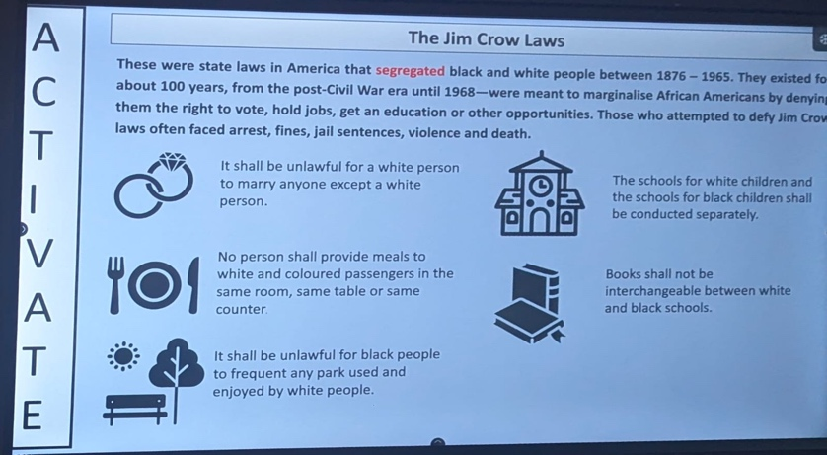
Figure 1:English worksheet prepared by the teacher for lesson
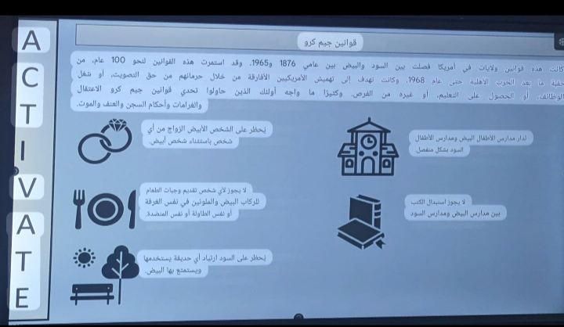
Figure 2:Tablet translating instructional sheet into Arabic
Learning participation
Through the translation at the prompt level, the student was active in group work, and he/she shared ideas as well as responding in English where necessary. The student was observed to be smiling, confident and actively involved in the classroom discussions, which indicated that the student was engaged not only mentally, but also socially. Although these observations are positive, they are considered as indicative patterns and not the actual measure of engagement. They are perceived in the framework of teacher reflection, and possible bias is realized (Cents-Boonstra et al, 2021).
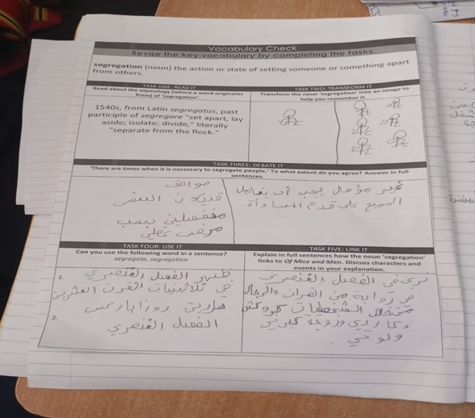
Figure 3A: Task performed with translation assistance.
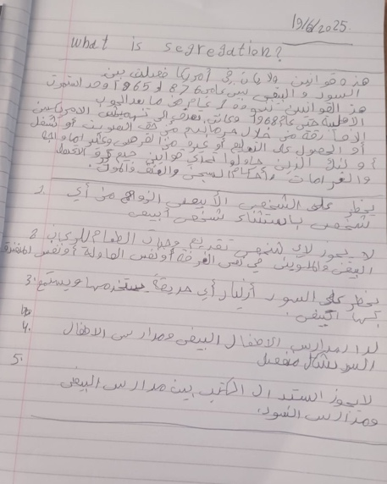
Figure 3B: Student’s handwritten note in Arabic.
Equitable Assessment
The student completed tasks in Arabic, which were later translated into English for grading. This approach decoupled language proficiency from content knowledge, enabling fair assessment.
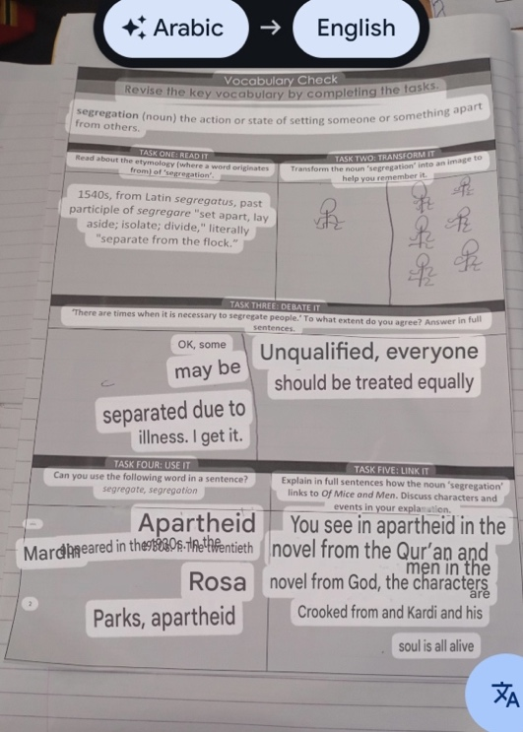
Figure 4A: Task translated for grading.
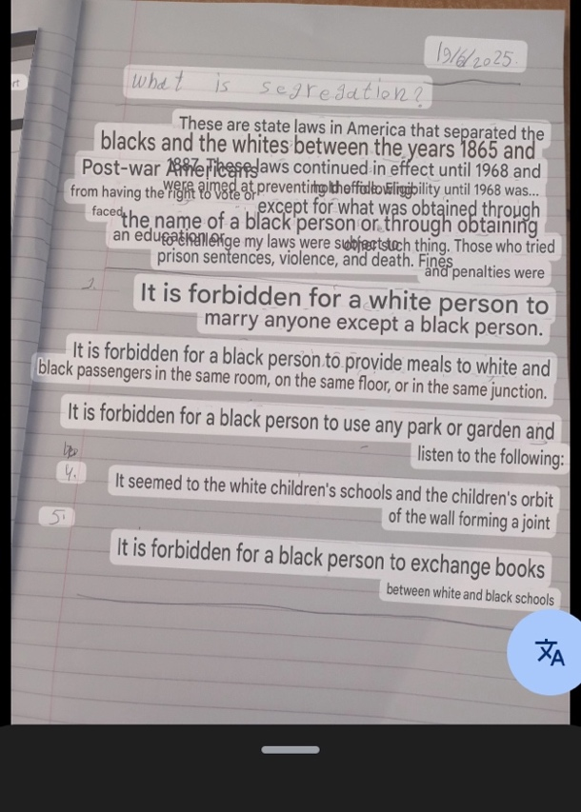
Figure 4B: The handwritten Arabic notes translated to English.
Results summary
The intervention facilitated:
- Equitable access to curriculum content.
- Active, confident participation in learning.
- Fair assessment decoupled from language proficiency.
DISCUSSION OF FINDINGS
Since the present study covers only one lesson in one classroom, the results are descriptive, not general. They show possible ways to include them through translating tablets, but they also emphasize that additional studies are required to comprehend the consequences over time and its increased scales.
The results of this case study demonstrate that tablet-based translation can serve as an intermediary between the languages of origin and the language of instruction of students and, as such, promote equity and inclusion in a mainstream English classroom. Three broad domains, access to content, engaging in learning, and fair assessments, came into focus each of which is consistent with the wider principles of Open and Distance Learning (ODL) and the expanding literature on technology-enabled inclusion.
Technology as a Mediator of Access
One of the core ideas of ODL is the elimination of the obstacles that limit the ability of learners to engage despite the geographic, economic, or linguistic barriers (Tait, 2018). The characteristic of the tablet as an access mediator, in this case, was to turn the exclusionary English-only curriculum into something that can be read in Arabic. The tool facilitated the rights of the learner to enjoy equal access to curriculum content on equal terms with their classmates by facilitating translation in real-time. Such a conclusion aligns with more detailed considerations of UNESCO (2020) on inclusive technologies as an enabler of Sustainable Development Goal on quality education (SDG 4).
Participation and Social Inclusion
Other than access, the translation tool also helped the student to contribute towards group activities and classroom discussion. Inclusion depends on participation; once learners have the ability to contribute, they can become actively involved in the learning community other than being mere recipients of an instruction. According to the study of Pimmer et al. (2020), mobile and digital solutions can support such active engagement and, specifically, in multilingual and resource-poor conditions. This is demonstrated in the current case: although the efforts made by the student were scaffolded by means of translation, they still constituted authentic activity that alleviated the social isolation and led to the increased feeling of belonging.
Equitable Assessment Practices
Equity in assessment is an issue that is raised consistently within a linguistically diverse classroom. The risks of traditional assessment are connected with the possibility to mix the knowledge and the level of language (OECD, 2021). The fact that the teacher in this situation allowed answering the question in Arabic and translated it making it possible to grade made her implement an equity-based assessment strategy. This is based on the position of Bower (2019) who asserts that technology allows restructuring the field of assessment as the ability to decouple linguistic knowledge and content knowledge will offer a more valid understanding of learning outcomes.
Implications for ODL and Inclusive Pedagogy
The pedagogical implications of the study still follow the ODL philosophy even though the study took place in a face-to-face classroom. Both situations are characterized by the sincerity in providing learning opportunities to people that otherwise would not receive them. Use of common digital tools, including tablets, facilitates the flexibility of ODL principles to mainstream schooling: those principles are not only associated with distance education and can be integrated in-situ to contribute to inclusion and equity. In addition, the intervention reveals that the issue of access and success ODL is concerned with is not only limited to the physical distance; it also applies to linguistic and cultural boundaries (Byram, 2020).
Challenges and Considerations
Despite the opportunities embedded in technology-mediated inclusion has its own barriers. The use of translation tools can be used un-balancedly; hence, limiting students a chance to grow competent in the language of instruction. The teachers who are to be trained should know how to incorporate translation into their materials so that they do not displace it with language acquisition. Ethics also plays a very significant role, although in this study anonymity was achieved, institutional regulations on data protection and the consent should be tackled with care in the wide use. Despite the fact that the tablet translation was effective as a mediator, pedagogical planning is required to prevent the fact that it will limit the English language development. The intervention is a scaffolding plan, and the long-term dependence without supported instructions might be the limitation of linguistic learning (Groves & Mundt, 2015).
Contribution to the Field
This case includes a practical in-the-field experience of how technology-mediated translation can facilitate the promotion of inclusive practices in high-income classroom environments, addressing a lack of studies of this kind that tend to consider low-resource or distance scenarios. It reflects the flexibility of the concept of ODL to new issues especially the diversity of languages in a more globalised classroom.
CONCLUSION AND RECOMMENDATIONS
The experience presented in this case study has demonstrated that tablet-based translation can be used to promote inclusive education as a means of facilitating equitable access, participation and assessment of linguistically diverse students in an inclusive classroom. The intervention accommodated non-native speakers by overcoming the challenges that might draw a line in their participation by translating instructional material into Arabic, making it possible to involve students in group learning, and facilitating fair assessment approaches. The conclusions confirm that the principles of Open and Distance Learning (ODL), especially the introduction of technology as the means of expanding access and enhancing equity are relevant even in the face-to-face situation. When applied as a scaffold during the first stages of language development, and when taking place with a planned pedagogical guidance, tablet-based translation seems the most useful. Although this case demonstrates the possibility of inclusion that is mediated by technology, more general assertions need to be approached cautiously, and the effects of such changes over the long term and their generalizability need to be examined in the future (Bower, 2019).
There are three important facts that the study supports. Technology has the potential to act as an access moderator, firstly, not leaving linguistic obstacles to set disadvantages to students. Second, it is beneficial in terms of enhancing social inclusion as it allows people to engage in group learning. Third, it has the potential to transform the assessment practices by removing the connection between the demonstration of knowledge and language proficiency. All together, these learning underscore the power of tech-based learning that can bring about inclusive pedagogy.
On the basis of these results some recommendations are offered:
1. To teachers: Allowing translation technologies should be a strategic approach to guiding learning and should simultaneously promote the gradual acquisition of language of instruction.
2. Schools: Schools ought to embrace inclusive policies that acknowledge the importance of the use of everyday digital tools in minimising inequities including training the teachers to use the tools in an effective manner.
3. To policymakers: Linguistic diversity needs to be treated as a particularly within education systems as an equity concern and language-diverse contexts need to be promoted as innovative applications of technology within such contexts to respond to this equity concern within inclusive education systems.
Finally, the case shows that the inclusive education is, first of all, not a theory or a policy but an educational practice (everyday classroom) that can be implemented quite easily with the help of technologies. Interventions such as these are the essence of ODL: they break down the barriers, make participation possible, and open out the learning to everyone.
REFERENCES
- Al-Azawei, A., Serenelli, F., & Lundqvist, K. (2016). Universal design for learning (UDL): A content analysis of peer-reviewed journal papers from 2012 to 2015. Journal of the Scholarship of Teaching and Learning, 16(3), 39–56. https://doi.org/10.14434/josotl.v16i3.19295
- BERA. (2018). Ethical guidelines for educational research (4th ed.). British Educational Research Association.
- Bower, M. (2019). Design of technology-enhanced learning: Integrating research and practice. Emerald Publishing.
- Braun, V., & Clarke, V. (2006). Using thematic analysis in psychology. Qualitative Research in Psychology, 3(2), 77–101. https://doi.org/10.1191/1478088706qp063oa
- Byram, M. (2020). Teaching and assessing intercultural communicative competence: Revisited. Multilingual matters.
- Cents-Boonstra, M., Lichtwarck-Aschoff, A., Denessen, E., Aelterman, N., & Haerens, L. (2021). Fostering student engagement with motivating teaching: An observation study of teacher and student behaviours. Research Papers in Education, 36(6), 754-779. https://doi.org/10.1080/02671522.2020.1767184
- Farley, I. A., & Burbules, N. C. (2022). Online education viewed through an equity lens: Promoting engagement and success for all learners. Review of Education, 10(3), e3367.
- Garcia, I., & Pena, M. I. (2011). Machine translation-assisted language learning: Writing for beginners. Computer Assisted Language Learning, 24(5), 471–487. https://doi.org/10.1080/09588221.2011.582687
- Groves, M., & Mundt, K. (2015). Friend or foe? Google Translate in language for academic purposes. English for Specific Purposes, 37, 112–121. https://doi.org/10.1016/j.esp.2014.09.001
- Lee, J., Warschauer, M., & Lee, H. (2019). The effects of using machine translation on EFL students’ writing. Language Learning & Technology, 23(2), 184–202.
- OECD. (2021). The state of global education: Addressing inclusion and equity. OECD Publishing.
- Peel, K. L. (2021). Professional dialogue in researcher-teacher collaborations: Exploring practices for effective student learning. Journal of Education for Teaching, 47(2), 201-219.
- Peters, O. (2010). Distance education in transition: Developments and issues (5th ed.). BIS Verlag.
- Pimmer, C., Mateescu, M., & Gröhbiel, U. (2020). Mobile and ubiquitous learning in higher education settings: A systematic review of empirical studies. Computers in Human Behavior, 63, 490–501. https://doi.org/10.1016/j.chb.2016.05.057
- Saito, H., & Ebsworth, M. E. (2004). Seeing English language teaching and learning through the eyes of Japanese EFL and ESL students. Foreign Language Annals, 37(1), 111–124.
- Tait, A. (2018). Education for development: From distance to open education. Journal of Learning for Development, 5(2), 101–115.
- UNESCO. (2020). Education in a multilingual world. UNESCO.
- Yin, R. K. (2018). Case study research and applications: Design and methods (6th ed.). SAGE.

