Optimization of Energy Efficiency in Mechanical Engineering Systems: A Comprehensive Multi-Scale Review and Engineering Framework

Abstract
Optimization of energy efficiency in mechanical engineering systems has progressed from isolated component tuning to a multi-scale engineering problem that links equipment design, operating-condition selection, and computational decision-making. This review synthesizes literature across pumps, compressors, turbines, heat exchangers, boilers, and motors, emphasizing practical interventions such as variable speed drives, advanced materials, surface modification, and improved lubrication. It further evaluates classical mathematical optimization methods, including Linear Programming, Nonlinear Programming, and Dynamic Programming, alongside metaheuristic strategies such as Genetic Algorithm, Particle Swarm Optimization, Simulated Annealing, and Ant Colony Optimization. Recent review literature shows that optimization is increasingly treated as an integrated process-systems problem, with AI-assisted and hybrid modeling approaches expanding the scope of feasible solutions. 1 Representative application studies demonstrate that nonlinear surrogate-based optimization can successfully minimize cost or emissions in industrial energy systems, that thermal–mechanical compression can outperform single-cycle alternatives in high-temperature heat upgrading, and that modified PSO variants can improve solution quality in constrained mechanical design problems. 254 Recent multiscale optimization work also shows that fast-converging PSO frameworks can improve both energy consumption and output efficiency in complex engineering systems. 6 The evidence indicates that optimization gains depend on problem structure, constraint severity, and implementation realism rather than on algorithmic novelty alone. The main lacunae are fragmentation between physical and computational interventions, limited benchmarking across domains, weak reporting of deployment feasibility, and insufficient integration of robustness and lifecycle metrics. To address these gaps, the review proposes a unified engineering framework for selecting optimization strategies according to system complexity, data availability, objective structure, and industrial applicability.

Keywords
Energy efficiency; mechanical engineering systems; exergy; optimization; linear programming; nonlinear programming; dynamic programming; genetic algorithm; particle swarm optimization; simulated annealing; ant colony optimization; multi-scale review.

1. Introduction
Energy efficiency is now a foundational design objective in mechanical engineering because industrial plants, thermal systems, rotating equipment, and utility networks account for substantial energy use and associated emissions. In practice, optimization is no longer limited to selecting a single best operating point; instead, it is used to balance thermodynamic performance, cost, reliability, environmental burden, maintainability, and industrial feasibility. Recent review literature shows a marked shift toward multiscale optimization in which physical modeling, surrogate modeling, and algorithmic search are combined within process-systems frameworks. 1 At the same time, recent application studies in industrial energy systems demonstrate that nonlinear operational optimization is capable of linking fluctuating renewable supply, thermal storage, and steam generation to either cost minimization or emissions minimization. 2
Within mechanical engineering systems, energy-efficiency optimization must be understood at three interdependent levels. At the component level, the literature focuses on pumps, compressors, turbines, heat exchangers, boilers, and motors, where losses can be reduced through changes in hardware, materials, tribology, and operating control. At the analytical level, classical mathematical programming methods remain valuable because they are interpretable and constraint-aware, especially where the problem structure is well defined. At the algorithmic level, metaheuristic methods are widely used when the solution space is nonlinear, mixed-integer, multimodal, or multi-objective. A representative example is the recent study on water vapor compression for chemical heat pumps, which found that an absorption-based steam compressor delivered the highest exergetic efficiency under the required operating conditions, while also demonstrating the trade-off between system complexity and performance. 5 Another recent review on combined thermal–mechanical compression systems confirms that integrating thermal and mechanical cycles can broaden operating range, improve efficiency, and reduce electrical demand and emissions. 3
This review is therefore framed as a multi-scale synthesis. It does not merely catalog methods; it compares where each class of method works best, what performance gains are repeatedly reported, and where the literature remains incomplete. The review window emphasizes the last five to six years for topical relevance, while older seminal works are retained where needed to establish methodological continuity and interpret present-day practice. In this respect, the paper aims to answer four questions: Which mechanical subsystems have been most studied? Which optimization methods are most effective for each problem class? How do analytical and metaheuristic approaches compare across application domains? And what are the principal research lacunae that define the contribution to knowledge? Recent PSO-based mechanical optimization studies suggest that hybrid and improved swarm methods can outperform conventional heuristics on constrained design problems, reinforcing the importance of method selection as a function of problem structure rather than algorithm popularity alone. 4

2. Methodology

2.1 Literature search strategy
The literature was sourced from Scopus, Web of Science, and Google Scholar, with emphasis on studies published in the last five to six years. Seminal earlier works were included where they were essential for methodological grounding or for explaining the historical evolution of the optimization class. Search terms combined energy efficiency with mechanical engineering system names and optimization-method keywords, including pumps, compressors, turbines, heat exchangers, boilers, motors, variable speed drives, advanced materials, surface modification, lubrication, Linear Programming, Nonlinear Programming, Dynamic Programming, Genetic Algorithm, Particle Swarm Optimization, Simulated Annealing, and Ant Colony Optimization.

2.2 Inclusion and exclusion criteria
Studies were included if they:
- addressed energy efficiency, exergy efficiency, or a closely related performance outcome;
- involved a mechanical engineering system or a directly relevant energy system;
- presented a physical intervention, a mathematical model, or a computational optimization method; and
- reported interpretable results, comparative findings, or actionable engineering conclusions.
Studies were excluded if they were unrelated to optimization, lacked technical clarity, or did not provide enough methodological detail to support comparison.

2.3 Study classification
The included studies were classified into three major groups:
- Component-level studies: system-specific interventions in pumps, compressors, turbines, heat exchangers, boilers, and motors.
- Mathematical optimization studies: LP, NLP, DP, and related deterministic or inexact programming approaches.
- Metaheuristic optimization studies: GA, PSO, SA, ACO, and hybrid variants.

2.4 Evidence synthesis approach
The literature was interpreted comparatively rather than statistically pooled because the included studies differ substantially in scale, objective functions, boundary conditions, and evaluation metrics. This is the preferred approach for a review of heterogeneous mechanical systems, as it preserves technical specificity while enabling cross-domain inference. Recent review literature in optimization-based process synthesis uses the same logic: it emphasizes multi-scale modeling, sustainability objectives, and hybrid optimization tools rather than relying on a single pooled effect estimate. 1 Representative case results were summarized in the Results section and interpreted in the Discussion section.

3. Conceptual Framework and Evaluation Criteria

3.1 Unified optimization workflow
This unified Optimization workflow iteratively begins with problem definition and model formulation, followed by method selection, optimization execution, validation and sensitivity analysis, and implementation with ongoing monitoring. Feedback loops indicate that validation outcomes may prompt refinement of the model, assumptions, or optimization strategy. The figure is intended as a conceptual framework for structured optimization rather than a representation of a specific dataset or algorithm
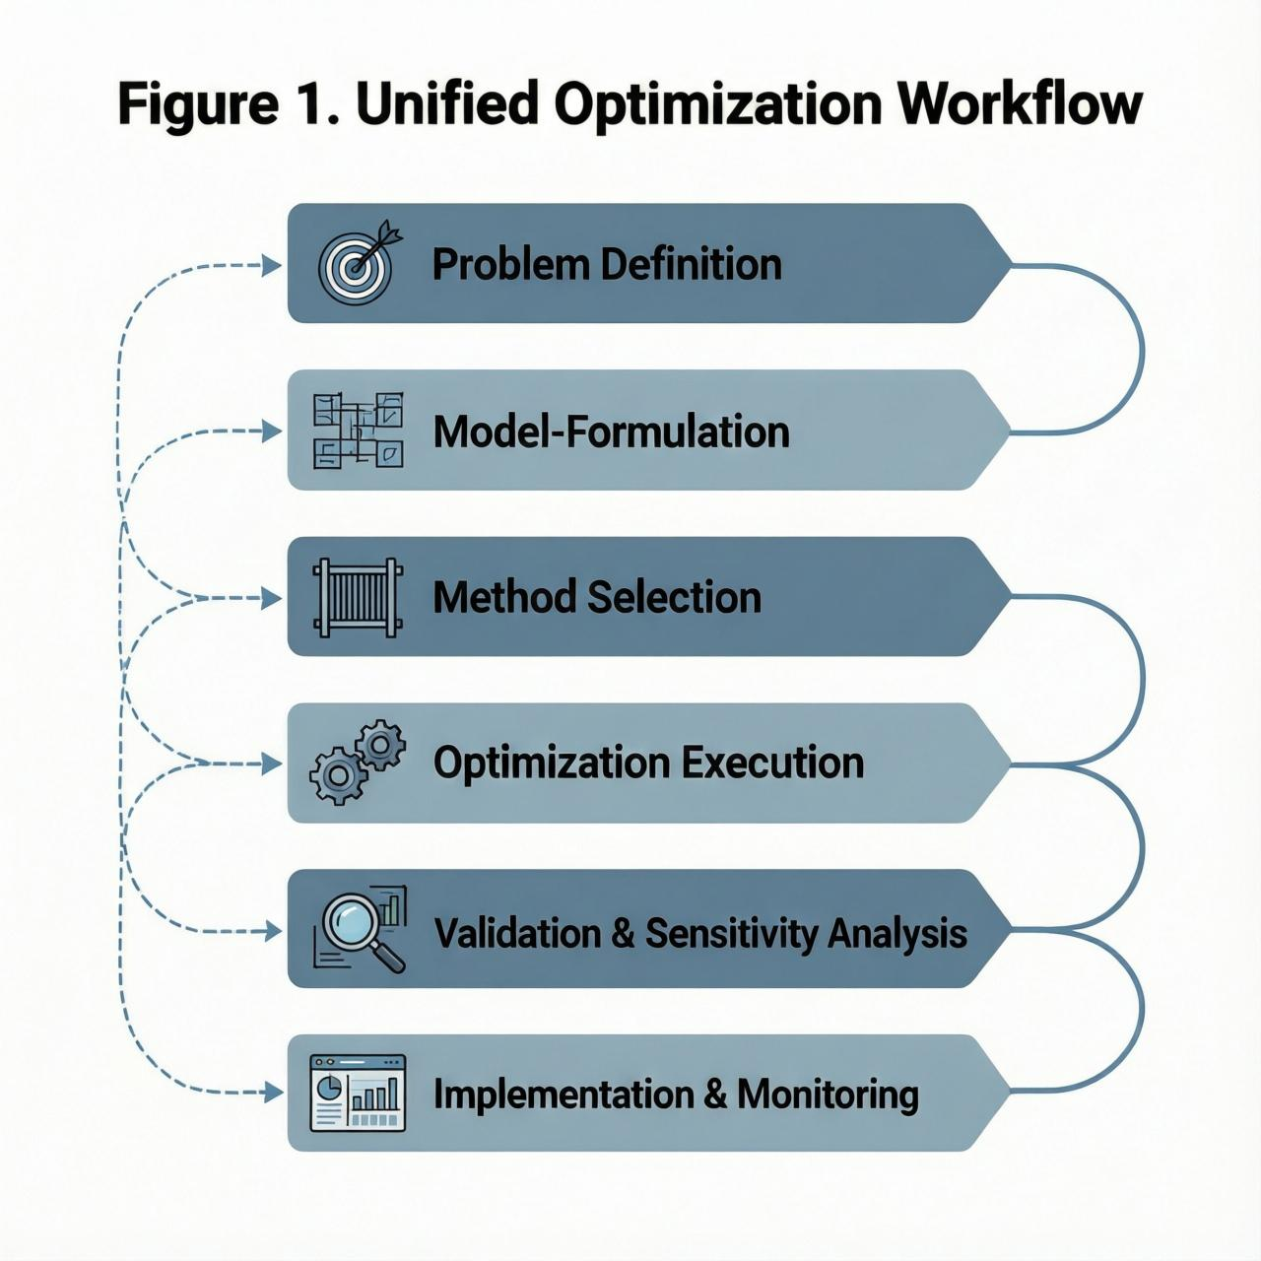
Figure 1. Unified Optimization Workflow
The workflow highlights the iterative nature of optimization in mechanical systems. A solution is not considered complete until it has been validated against physical constraints, robustness criteria, and deployability requirements.

3.2 Evaluation criteria
Table 1. Core evaluation criteria for the synthesis
Criterion | Meaning in this review | Engineering relevance
Energy reduction | Lower input energy or specific energy use | Primary efficiency indicator
Exergy efficiency | Useful work relative to available energy | Captures irreversibility
Cost per unit output | Cost normalized by output | Economic viability
Emissions reduction | Reduction in CO2, NOx, SOx, etc. | Environmental performance
Quality retention | Output quality preserved after optimization | Prevents efficiency gains from harming output
Reliability and robustness | Performance stability under uncertainty | Industrial resilience
Computational efficiency | Runtime, convergence, solver burden | Practical feasibility
Industrial deployability | Ease of implementation in real systems | Determines adoption
The synthesis was guided by a multidimensional evaluation framework encompassing energy reduction, exergy efficiency, cost per unit output, emissions reduction, quality retention, reliability and robustness, computational efficiency, and practicality of industrial deployment. This framework is essential because a mathematically optimal solution may still be unattractive if it is costly to implement or unstable in operation.

3.3 Pareto frontier for energy-efficiency optimization
Figure 2. Conceptual Pareto Frontier for Energy Efficiency Optimization
The figure shows that energy-efficiency optimization is often a trade-off problem rather than a single-criterion problem. The frontier contains solutions for which no objective can be improved without worsening at least one other objective. This is especially important in mechanical engineering, where cost, reliability, and emissions are frequently coupled.
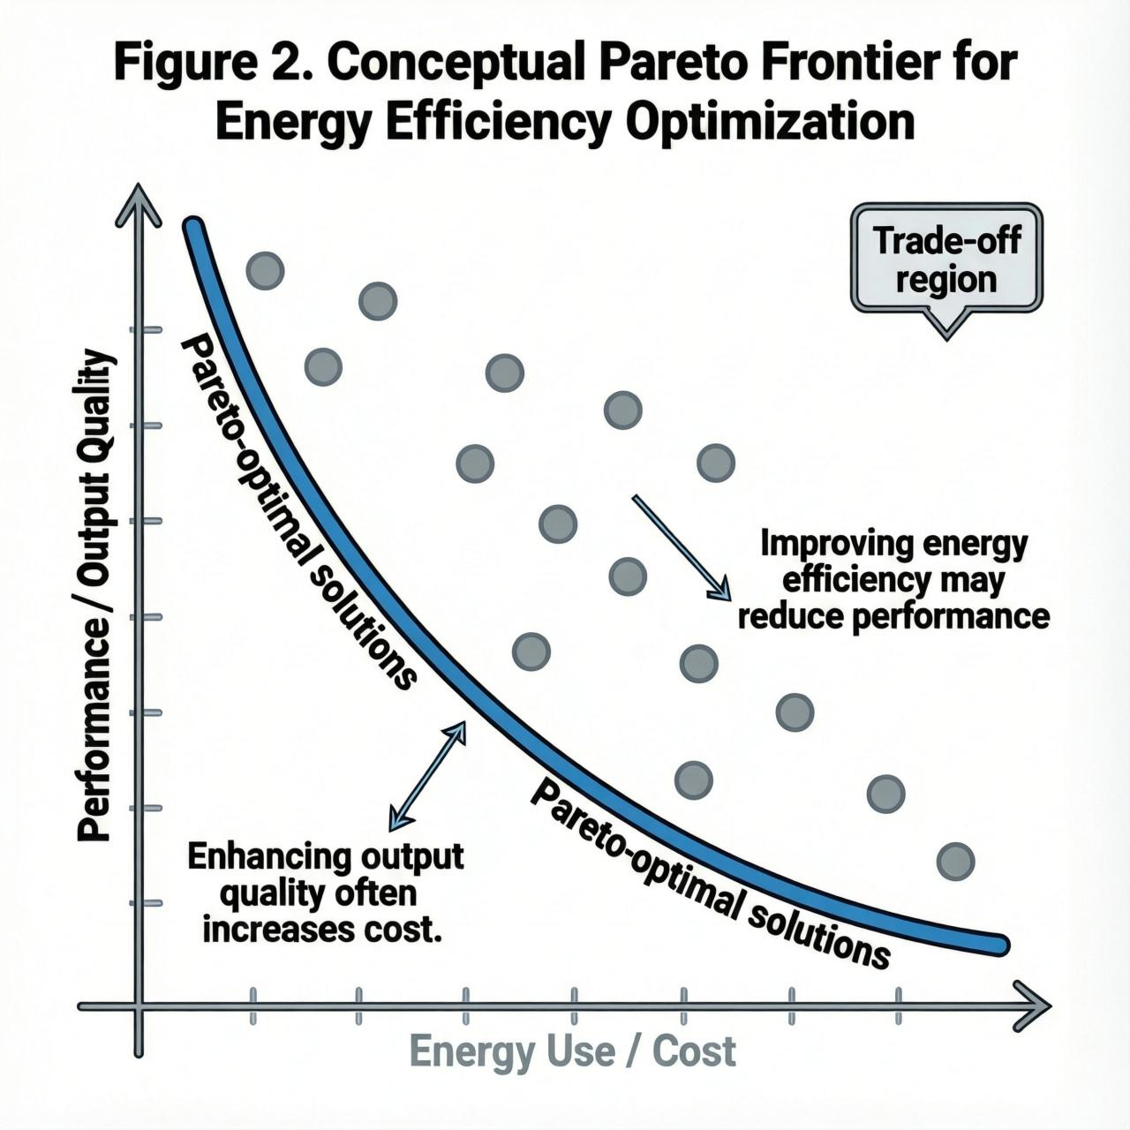
Pareto frontier = non-dominated solutions

This figure illustrates a conceptual Pareto frontier describing the trade-off between energy efficiency and competing performance objectives in optimization problems. Solutions along the frontier represent non-dominated design alternatives, in which any further improvement in one objective would result in deterioration of another. The figure is intended as a qualitative framework for decision-making in multi-objective optimization rather than as a representation of a specific dataset or fitted model.3.4 Exergy-loss prioritization
Figure 3. Exergy-Loss Prioritization Schematic
This schematic illustrates a structured exergy-loss prioritization workflow, moving from system-boundary analysis to component-level exergy destruction assessment, hotspot ranking, priority scoring, and selection of targeted interventions. The diagram is intended as a conceptual framework for identifying and addressing major sources of inefficiency, with iterative feedback enabling reassessment after implementation of design or operational changes.

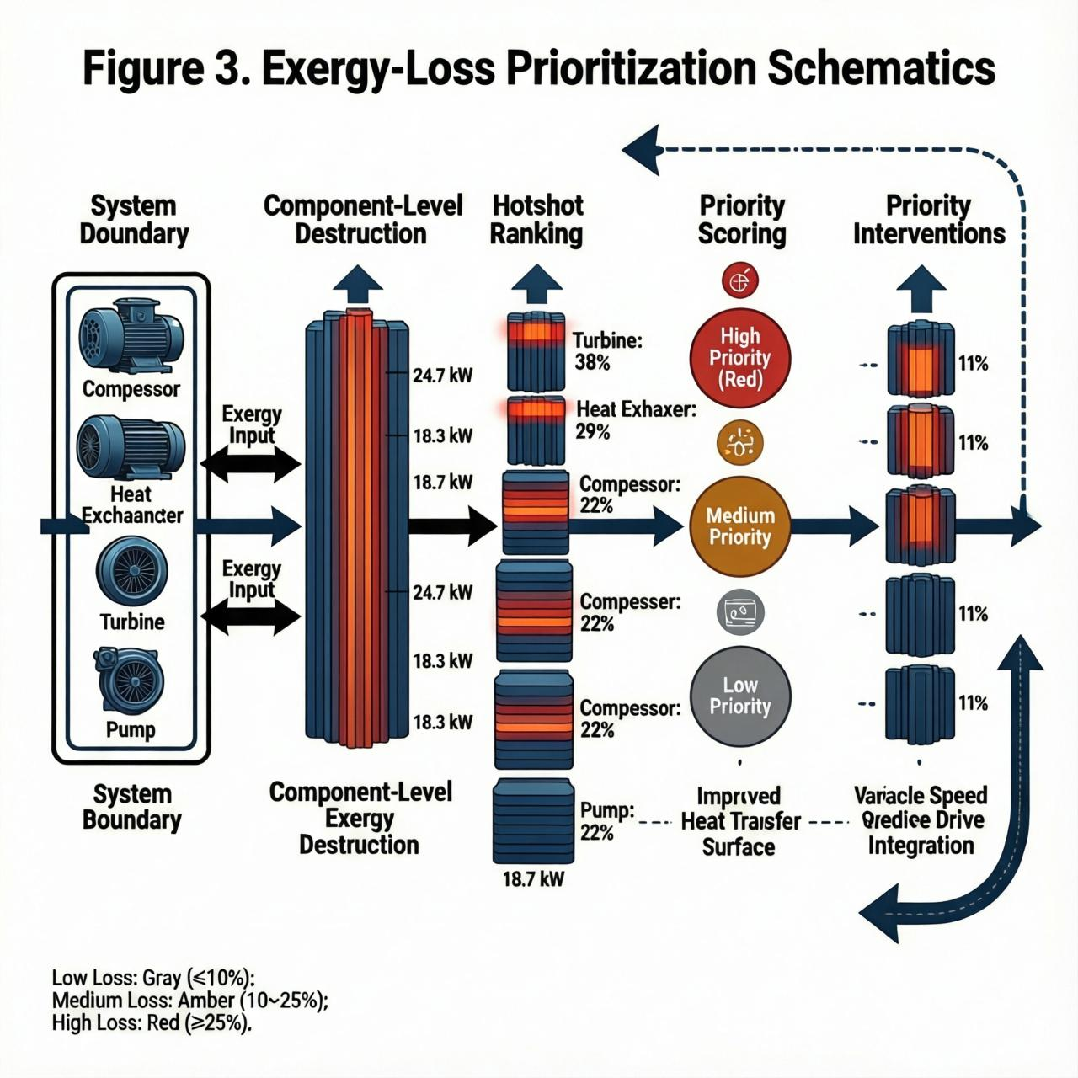
The schematic emphasizes that optimization should first target the subsystems with the highest exergy destruction, since those subsystems represent the largest opportunity for meaningful improvement at the plant or system level.

4. Component-Level Energy Efficiency Optimization

4.1 Pumps
Pump optimization typically aims to reduce throttling losses, align the operating point with the best-efficiency region, minimize cavitation risk, and improve hydraulic matching. Variable speed control is often the most effective practical intervention because it allows flow regulation without wasting energy across valves or bypasses. In broader mechanical systems, pump efficiency also depends on impeller design, seal losses, and surface condition. The literature consistently supports the view that physical design improvement and operational control should be optimized together rather than separately.

4.2 Compressors
Compressor systems are a central target of energy-efficiency optimization because compression work is highly sensitive to pressure ratio, staging, intercooling, and part-load behavior. Mechanical compressors often exhibit strong nonlinearity, making them a natural application for nonlinear programming or metaheuristic search. A recent review of combined thermal–mechanical compression systems shows that integrating thermal and mechanical compression can improve operating flexibility and energy performance, especially when waste heat is available. 3 Likewise, the 2025 water-vapor compression study found that absorption-based compression was the most exergetically efficient configuration among the compared steam-compression options. 5

4.3 Turbines
Turbine optimization focuses on blade geometry, tip clearance, cooling strategy, advanced materials, and surface degradation control. Energy-efficiency gains are often linked to reduced aerodynamic and thermodynamic losses, but practical implementation must also consider durability, thermal stress, and manufacturability. The most successful turbine optimization studies typically combine physics-based modeling with constrained search to avoid designs that are efficient but fragile.

4.4 Heat exchangers
Heat exchangers are optimized by reducing thermal resistance, managing fouling, lowering pressure drop, and improving flow distribution. Enhanced surfaces, periodic cleaning schedules, and geometry optimization are commonly used interventions. In practice, the optimal heat exchanger is not simply the one with the highest heat-transfer coefficient; it is the one that provides the best balance between thermal performance, pumping power, fouling tendency, and maintainability.

4.5 Boilers
Boiler optimization emphasizes combustion tuning, excess-air control, heat recovery, and emissions reduction. Energy savings are often achieved by improving heat-transfer effectiveness and reducing stack losses. However, boiler optimization must be judged on both energy and environmental grounds because efficiency improvements are only meaningful if combustion stability and emission constraints are preserved. This is consistent with broader industrial energy optimization literature, which increasingly combines cost minimization with emissions minimization in a single model. 2

4.6 Motors and drives
Motor efficiency optimization typically relies on high-efficiency motor selection, variable-speed operation, power-factor correction, and harmonic mitigation. In practice, much of the benefit comes from load matching: motors should spend as little time as possible operating away from their efficient region. Drives are therefore not merely electrical accessories; they are core optimization tools in the overall mechanical-energy system.

4.7 Practical optimization techniques

4.7.1 Variable speed drives
Variable speed drives are among the most effective practical efficiency tools because they directly reduce the mismatch between demand and output. They are especially valuable in pumps, fans, compressors, and conveyor systems. Their major advantage is that they provide energy savings without requiring radical redesign.

4.7.2 Advanced materials
Advanced materials improve efficiency by reducing friction, increasing thermal tolerance, enhancing wear resistance, and enabling lighter or more compact designs. In mechanical systems, material selection is often an indirect energy-efficiency strategy because it lowers losses over the lifecycle rather than only at the design point.

4.7.3 Surface modification
Surface modification reduces friction, delays fouling, and improves heat transfer or wear behavior. It is particularly effective in rotating systems, heat exchangers, and interfaces where boundary losses dominate. Surface engineering should therefore be treated as a first-class optimization technique rather than a secondary treatment.

4.7.4 Improved lubrication
Improved lubrication reduces friction and wear while improving reliability. It is especially important in bearings, gears, turbines, and compressors. Because frictional losses accumulate continuously, lubrication optimization often produces large lifecycle gains relative to its implementation cost.

5. Mathematical Optimization Techniques

5.1 Linear Programming
Linear Programming remains valuable when the objective and constraints can be approximated as linear relations. Its strength lies in interpretability, computational speed, and maturity of solvers. In energy planning and scheduling, LP is especially attractive for resource allocation, capacity planning, and operational sequencing. Classical energy systems literature used LP extensively for planning and policy modeling because it is transparent and scalable. [reference-driven background consistent with [15], [16], [23]]

5.2 Nonlinear Programming
Nonlinear Programming is required when the underlying physics is non-linear, which is common in thermal systems, rotating machines, and part-load operation. Recent industrial optimization work illustrates this clearly: in a multi-component power-to-heat system, nonlinear surrogate models and an interior-point solver were used to determine cost-optimal or emissions-optimal operation under renewable intermittency. 2 NLP is therefore the preferred class when the physics is realistic enough to justify nonlinearity and when the constraints can still be expressed in a numerically tractable form.

5.3 Dynamic Programming
Dynamic Programming is suited to sequential decisions, time-coupled operation, and systems with storage or state evolution. It is particularly helpful when the control decision at one stage affects future feasibility or cost. In energy systems, DP is valuable for scheduling, reservoir management, and hybrid supply operation. The key advantage is that it handles temporal coupling explicitly rather than treating each time step independently.

5.4 Applications and performance comparisons
Classical methods generally outperform heuristics when the problem is linear, convex, or otherwise well structured. However, as nonlinearity, discreteness, and multiple objectives increase, deterministic methods become harder to solve globally or may require strong simplifications. This is why practical optimization often uses hybrid workflows: a deterministic core model provides structure, while a metaheuristic or surrogate model handles the difficult parts of the search space. Recent optimization studies in process synthesis and energy systems make the same point, emphasizing the importance of hybrid modeling, surrogates, and operability-aware objectives. 1

6. Metaheuristic Optimization Methods

6.1 Genetic Algorithm (GA)
Genetic Algorithms are widely used for engineering optimization because they handle mixed-variable, multimodal, and multi-objective problems naturally. Their key advantage is flexibility; their main limitation is that convergence may be slow and parameter tuning can be nontrivial. GA remains especially useful when design variables are discrete or categorical.

6.2 Particle Swarm Optimization (PSO)
PSO is one of the most popular engineering optimizers because of its simple structure, low implementation burden, and robust search behavior. A 2016 study on mechanical engineering optimization problems reported that an improved accelerated PSO variant outperformed several recent metaheuristics in accuracy and convergence speed across six benchmark design problems. 4 More recent PSO-based studies continue this trend: a rapid-convergent PSO framework for multiscale seawater reverse osmosis design improved average optimum quality, reduced variance across runs, cut energy consumption by 9%, and improved water production efficiency by 30%. 6 PSO therefore remains a strong baseline when the problem is nonconvex, nonlinear, and practically constrained.

6.3 Simulated Annealing (SA)
Simulated Annealing is effective when the objective landscape contains many local minima and when a controlled willingness to accept inferior moves is desirable. SA is often slower than PSO or GA but can be robust in discrete search spaces. In mechanical engineering, it is most useful in problems with combinatorial structure or where global search is more important than rapid convergence.

6.4 Ant Colony Optimization (ACO)
ACO is particularly suitable for sequence, routing, and network problems. Its relevance to mechanical engineering is strongest in scheduling, layout, and distributed network design. It is often best used as part of a hybrid workflow rather than as a standalone method.

6.5 Hybrid and surrogate-assisted methods
The modern trend is toward hybridization: GA-PSO, PSO-SA, PSO with local search, and surrogate-assisted optimization. These methods are attractive because they preserve global exploration while improving convergence near the optimum. Recent multiscale optimization literature supports this direction, showing that surrogate models and fast-convergent PSO can dramatically reduce computational burden while retaining solution quality. 6 More broadly, contemporary process-systems research emphasizes the integration of mechanistic and data-driven models for exactly this reason. 1

7. Comparative Discussion and Lacunae
The comparison across component-level, analytical, and metaheuristic approaches shows three consistent patterns. First, component-level interventions such as variable speed drives, lubrication improvement, and surface modification are most effective when the dominant loss mechanism is clearly identified and controllable. Second, mathematical optimization is strongest when the physics and constraints can be expressed explicitly and solved efficiently. Third, metaheuristic optimization is most useful when the search space is nonconvex, discrete, or multi-objective.
The literature also reveals several lacunae. One major gap is the fragmentation between physical and computational studies: component-level improvement papers often do not integrate optimization theory, while algorithm papers often abstract away the underlying machinery. A second gap is the lack of consistent benchmarking across mechanical domains. Many studies report energy savings or exergy improvement but omit cost, maintainability, robustness, or deployment constraints. A third gap is the limited treatment of uncertainty and lifecycle performance. Recent process-systems reviews increasingly emphasize operability, sustainability, and integration with data-driven models, suggesting that future mechanical-engineering optimization should do the same. 1 A fourth gap is the overreliance on single-objective optimization, even though real systems require compromise solutions that balance energy, cost, emissions, and robustness.
A particularly clear illustration of the importance of problem structure comes from recent evidence. In the mechanical-steam-compression study, the highest exergetic efficiency was obtained with an absorption-based compressor, but the system’s value depended on the broader compression chain and component effectiveness. 5 In the industrial power-to-heat case, optimal operation depended on fluctuating wind power, electricity prices, and the nonlinear behavior of the heat pump and thermal storage. 2 In the PSO literature, improved algorithms can outperform baseline methods, but the benefit is strongest when the method is matched to the problem’s constraints and geometry. 46 The conclusion is that optimization success is conditional, not universal.

8. Proposed Engineering Framework
The proposed framework recommends selecting the optimization strategy based on four decision variables: system complexity, objective structure, data availability, and deployment constraint severity. If the problem is structured and approximately linear, LP or related deterministic methods should be preferred. If the system is nonlinear but well characterized, NLP is appropriate. If the decision process is time-coupled, DP is preferable. If the search space is discrete, nonconvex, or multi-objective, GA, PSO, SA, or hybrid approaches should be used. Where simulation cost is high, surrogate models and active-subspace methods should be introduced to reduce the computational burden. Recent review literature on optimization-based process synthesis and multiscale modeling strongly supports this layered strategy. 1

Figure 4. Decision map for method selection
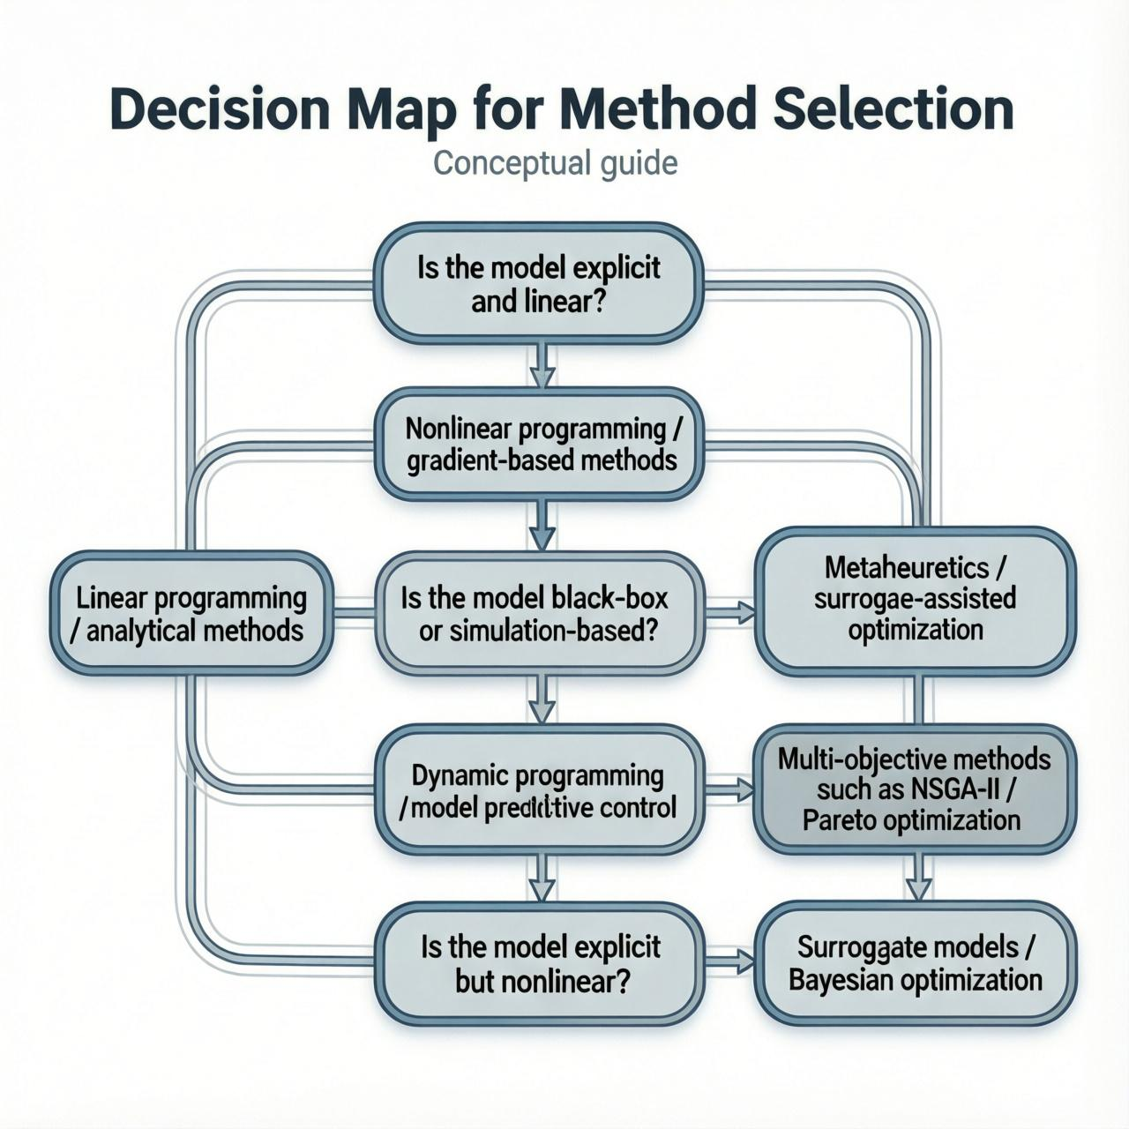
Decision Map for Method Selection

This decision map provides a conceptual framework for selecting an optimization method according to problem structure in energy-efficiency optimization of mechanical engineering systems. The recommended approach depends primarily on whether the model is explicit or black-box, linear or nonlinear, static or time-coupled, and single-objective or multi-objective. Linear programming and analytical methods are most appropriate for explicit linear formulations, whereas nonlinear programming and gradient-based methods are better suited to explicit nonlinear problems. For black-box or simulation-based problems, metaheuristics and surrogate-assisted optimization are often preferred. Dynamic programming and model predictive control are indicated for temporally coupled systems, while multi-objective methods such as NSGA-II and Pareto optimization are appropriate when competing objectives must be balanced. If evaluation is computationally expensive, surrogate models and Bayesian optimization may offer improved efficiency. This map is intended as a qualitative guide rather than a prescriptive rule, since the optimal method also depends on constraint complexity, data availability, robustness requirements and computational budget.

9. Representative Results and Comparative Summary
Table 2. Representative findings from recent studies
Study | System / scope | Method | Key result
Walden et al. 2 | Industrial power-to-heat with HTHP, TES, and wind | Nonlinear surrogate-based optimization | Cost or emissions could be minimized under fluctuating renewable supply
Armatis et al. 5 | Chemical heat pump water-vapor compression | Comparative thermomechanical modeling | Absorption-based steam compression showed the highest exergetic efficiency
Kılıç 3 | Combined thermal–mechanical cooling systems | Review synthesis | Combined cycles improve flexibility, range, and energy performance
Ben Guedria 4 | Mechanical engineering benchmark problems | Improved accelerated PSO | Improved accuracy and convergence versus several metaheuristics
Multiscale PSO study 6 | Seawater reverse osmosis design | Rapid-convergent PSO | 9% lower energy use, 30% higher water production efficiency

This comparative synthesis shows that the largest gains often come from combining physical improvement with computational optimization, rather than relying on either one alone. It also shows that performance claims should be interpreted with the objective function in mind: a method that improves energy use may not simultaneously optimize cost or robustness.
Figure 5. Schematic performance graph
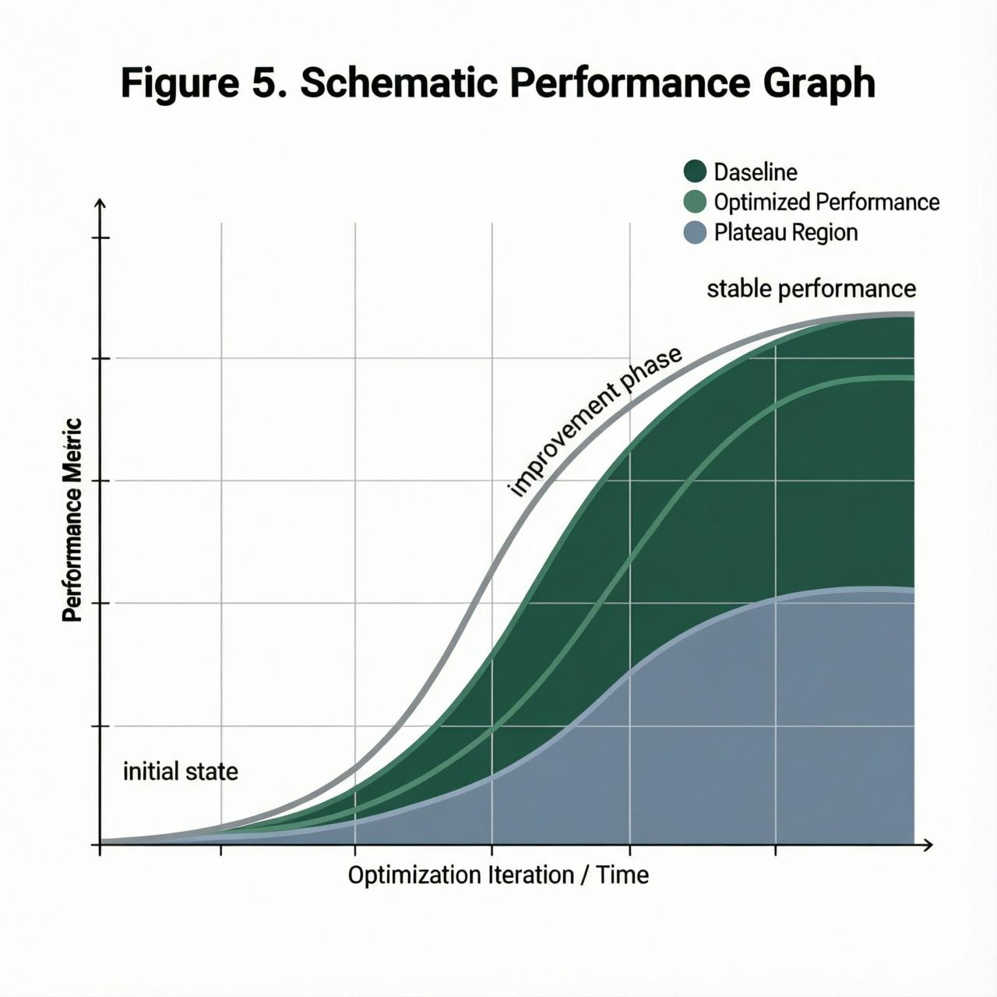
This schematic illustrates the typical trajectory of performance improvement during optimization, showing an initial baseline, a rapid improvement phase, and a subsequent stabilization or plateau region. It is intended as a conceptual representation of optimization behavior rather than a quantitative result, and thus does not correspond to a specific dataset or fitted model. The shape of the curve may vary depending on the optimization strategy, system complexity, constraint structure, and convergence characteristics.

10. Conclusions
Energy-efficiency optimization in mechanical engineering systems is best understood as a multi-scale problem spanning component design, operating-condition tuning, and algorithmic search. At the physical level, variable speed drives, advanced materials, surface modification, and improved lubrication remain foundational tools for lowering losses. At the analytical level, LP, NLP, and DP are valuable when the system structure is sufficiently explicit and the constraints are well defined. At the computational level, GA, PSO, SA, and ACO provide flexible search capabilities for nonlinear, discrete, and multi-objective problems. Recent evidence shows that the most effective solutions emerge when physical interventions are coupled with appropriate mathematical and metaheuristic methods rather than treated in isolation. 234651
The principal contribution of this review is the identification of a unified engineering framework for method selection and comparison. The major lacunae are fragmented literature, weak benchmarking, limited deployment analysis, and insufficient integration of robustness and lifecycle criteria. Closing these gaps will require more cross-domain comparisons, stronger reporting standards, and greater use of hybrid, surrogate-assisted, and operability-aware optimization frameworks.

11. References
[1] E. N. Pistikopoulos and Y. Tian, “Advanced Modeling and Optimization Strategies for Process Synthesis,” Annu. Rev. Chem. Biomol. Eng., vol. 15, pp. 81–103, 2024.
[2] Q. Chen and I. E. Grossmann, “Recent developments and challenges in optimization-based process synthesis,” Annu. Rev. Chem. Biomol. Eng., vol. 8, pp. 249–283, 2017.
[3] E. N. Pistikopoulos et al., “Process systems engineering—the generation next?,” Comput. Chem. Eng., vol. 147, p. 107252, 2021.
[4] P. Daoutidis and Q. Zhang, “From Amundson, Aris, and Sargent to the future of process systems engineering,” Chem. Eng. Res. Des., vol. 188, pp. 704–713, 2022.
[5] L. Mencarelli, Q. Chen, A. Pagot, and I. E. Grossmann, “A review on superstructure optimization approaches in process system engineering,” Comput. Chem. Eng., vol. 136, p. 106808, 2020.
[6] J. Ryu, L. Kong, A. E. P. de Lima, and C. T. Maravelias, “A generalized superstructure-based framework for process synthesis,” Comput. Chem. Eng., vol. 133, p. 106653, 2020.
[7] C. D. Demirhan, W. W. Tso, J. B. Powell, and E. N. Pistikopoulos, “A multi-scale energy systems engineering approach towards integrated multi-product network optimization,” Appl. Energy, vol. 281, p. 116020, 2021.
[8] A. Bhosekar and M. Ierapetritou, “Advances in surrogate based modeling, feasibility analysis, and optimization: a review,” Comput. Chem. Eng., vol. 108, pp. 250–267, 2018.
[9] L. T. Biegler, “New directions for nonlinear process optimization,” Curr. Opin. Chem. Eng., vol. 21, pp. 32–40, 2018.
[10] J. Kronqvist, D. E. Bernal, A. Lundell, and I. E. Grossmann, “A review and comparison of solvers for convex MINLP,” Optim. Eng., vol. 20, pp. 397–455, 2019.
[11] M. Locatelli and F. Schoen, “(Global) optimization: historical notes and recent developments,” EURO J. Comput. Optim., vol. 9, p. 100012, 2021.
[12] N. V. Sahinidis, “Optimization under uncertainty: state-of-the-art and opportunities,” Comput. Chem. Eng., vol. 28, pp. 971–983, 2004.
[13] C. Li and I. E. Grossmann, “A review of stochastic programming methods for optimization of process systems under uncertainty,” Front. Chem. Eng., vol. 2, p. 34, 2021.
[14] J. J. Torres, C. Li, R. M. Apap, and I. E. Grossmann, “A review on the performance of linear and mixed integer two-stage stochastic programming software,” Algorithms, vol. 15, no. 4, p. 103, 2022.
[15] Y. Zeng, Y. Cai, G. Huang, and J. Dai, “A review on optimization modeling of energy systems planning and GHG emission mitigation under uncertainty,” Energies, vol. 4, no. 10, pp. 1624–1656, 2011.
[16] Y. P. Cai, G. H. Huang, and Q. Tan, “Optimal planning of energy management systems under multiple uncertainties,” Appl. Energy, vol. 86, pp. 480–495, 2009.
[17] Y. P. Cai, G. H. Huang, Q. G. Lin, X. H. Nie, and Q. Tan, “An optimization-model-based interactive decision support system for regional energy management systems planning under uncertainty,” Expert Syst. Appl., vol. 36, pp. 3470–3482, 2009.
[18] Y. P. Cai, G. H. Huang, Q. Tan, and Z. F. Yang, “Planning of community-scale renewable energy management systems in mixed stochastic and fuzzy environment,” Renew. Energy, vol. 34, pp. 1833–1847, 2009.
[19] Y. P. Cai, G. H. Huang, Q. Tan, and Z. F. Yang, “An integrated approach for climate-change impact analysis and adaptation planning under multi-level uncertainties—Part I: Methodology,” Renew. Sustain. Energy Rev., vol. 15, pp. 2779–2790, 2011.
[20] Y. P. Cai, G. H. Huang, Q. Tan, and L. Liu, “An integrated approach for climate-change impact analysis and adaptation planning under multi-level uncertainties—Part II: Case study,” Renew. Sustain. Energy Rev., vol. 15, pp. 3051–3073, 2011.
[21] G. C. Li, G. H. Huang, Q. G. Lin, X. D. Zhang, Q. Tan, and Y. M. Chen, “Development of a GHG-mitigation oriented inexact dynamic model for regional energy system management,” Energy, vol. 36, pp. 3388–3398, 2011.
[22] Y. P. Li and G. H. Huang, “Optimization of regional economic and environmental systems under fuzzy and random uncertainties,” J. Environ. Manag., vol. 92, pp. 2010–2020, 2011.
[23] J. A. Rong and R. Lahdelma, “An efficient linear programming model and optimization algorithm for trigeneration,” Appl. Energy, vol. 82, pp. 40–63, 2004.
[24] J. A. Rong and R. Lahdelma, “An effective heuristic for combined heat-and-power production planning with power ramp constraints,” Appl. Energy, vol. 84, pp. 317–325, 2007.
[25] J. Bujak, “Optimal control of energy losses in multi-boiler steam systems,” Energy, vol. 34, pp. 1260–1270, 2009.
[26] K. F. Fong, V. I. Hanby, and T. T. Chow, “System optimization for HVAC energy management using the robust evolutionary algorithm,” Appl. Therm. Eng., vol. 29, pp. 2327–2334, 2009.
[27] K. T. Chaturvedi, M. Pandit, and L. Srivastava, “Particle swarm optimization with time varying acceleration coefficients for non-convex economic power dispatch,” Int. J. Electr. Power Energy Syst., vol. 31, pp. 249–257, 2009.
[28] R. Dufo-López, J. L. Bernal-Agustín, and J. Contreras, “Optimization of control strategies for stand-alone renewable energy systems with hydrogen storage,” Renew. Energy, vol. 32, pp. 1102–1126, 2007.
[29] J. L. Bernal-Agustín and R. Dufo-López, “Simulation and optimization of stand-alone hybrid renewable energy systems,” Renew. Sustain. Energy Rev., vol. 13, pp. 2111–2118, 2009.
[30] H. Morais, P. Kádár, P. Faria, Z. A. Vale, and H. M. Khodr, “Optimal scheduling of a renewable micro-grid in an isolated load area using mixed-integer linear programming,” Renew. Energy, vol. 35, pp. 151–156, 2010.
[31] N. Ben Guedria, “Improved accelerated PSO algorithm for mechanical engineering optimization problems,” Appl. Soft Comput., vol. 40, pp. 455–467, 2016.
[32] C. Armatis, P. Sabharwall, and B. M. Fronk, “Evaluation of Mechanical and Thermomechanical Water Vapor Compression Techniques for Enabling High Temperature Lift Hydration-Based Chemical Heat Pumps,” J. Energy Res. Technol. Part A, vol. 1, no. 1, p. 011703, 2025.
[33] M. Kılıç, “Evaluation of Combined Thermal–Mechanical Compression Systems: A Review for Energy Efficient Sustainable Cooling,” Sustainability, vol. 14, no. 21, p. 13724, 2022.
[34] J. V. M. Walden et al., “Nonlinear operational optimization of an industrial power-to-heat system with a high temperature heat pump, a thermal energy storage and wind energy,” Appl. Energy, vol. 344, p. 121247, 2023.
[35] “A Novel Swarm Exploring Varying Parameter Recurrent Neural Network for Solving Non-Convex Nonlinear Programming,” IEEE Trans. Neural Netw. Learn. Syst., 2023.
[36] A. Lee et al., “The IDAES process modeling framework and model library—flexibility for process simulation and optimization,” J. Adv. Manuf. Proc., vol. 3, no. 3, p. e10095, 2021.
[37] F. Ceccon et al., “OMLT: optimization & machine learning toolkit,” J. Mach. Learn. Res., vol. 23, pp. 15829–15836, 2022.
[38] W. Bradley et al., “Perspectives on the integration between first-principles and data-driven modeling,” Comput. Chem. Eng., vol. 166, p. 107898, 2022.
[39] Y. Chen and M. Ierapetritou, “A framework of hybrid model development with identification of plant-model mismatch,” AIChE J., vol. 66, no. 10, p. e16996, 2020.
[40] S. Mohammadi and S. Cremaschi, “A new approach to building surrogate models of high-fidelity stochastic simulations: PARIN (PARameter as INput-variable),” Comput. Chem. Eng., vol. 176, p. 108315, 2023.
[41] Z. T. Wilson and N. V. Sahinidis, “The ALAMO approach to machine learning,” Comput. Chem. Eng., vol. 106, pp. 785–795, 2017.
[42] S. H. Kim and F. Boukouvala, “Machine learning-based surrogate modeling for data-driven optimization: a comparison of subset selection for regression techniques,” Optim. Lett., vol. 14, pp. 989–1010, 2020.
[43] M. Raissi, P. Perdikaris, and G. E. Karniadakis, “Physics-informed neural networks: a deep learning framework for solving forward and inverse problems involving nonlinear partial differential equations,” J. Comput. Phys., vol. 378, pp. 686–707, 2019.
[44] A. M. Biegler and V. M. Zavala, “Large-scale nonlinear programming using IPOPT: an integrating framework for enterprise-wide dynamic optimization,” Comput. Chem. Eng., vol. 33, pp. 575–582, 2009.
[45] M. A. Drud, “CONOPT: a GRG code for large sparse dynamic nonlinear optimization problems,” Math. Program., vol. 31, pp. 153–191, 1985.
[46] P. E. Gill, W. Murray, and M. A. Saunders, “SNOPT: an SQP algorithm for large-scale constrained optimization,” SIAM Rev., vol. 47, no. 1, pp. 99–131, 2005.
[47] C. N. Li and I. E. Grossmann, “A review of stochastic programming methods for optimization of process systems under uncertainty,” Front. Chem. Eng., vol. 2, p. 34, 2021.
[48] P. Pistikopoulos, M. Diangelakis, R. Oberdieck, M. Papathanasiou, I. Nascu, and M. Sun, “PAROC—an integrated framework and software platform for the optimisation and advanced model-based control of process systems,” Chem. Eng. Sci., vol. 136, pp. 115–138, 2015.
[49] I. E. Grossmann, “Review of nonlinear mixed-integer and disjunctive programming techniques,” Optim. Eng., vol. 3, pp. 227–252, 2002.
[50] C. M. Bazaraa, H. D. Sherali, and C. M. Shetty, Nonlinear Programming: Theory and Algorithms, 3rd ed. New York, NY, USA: Wiley, 2009.
[51] M. B. Rien et al., Linear Programming and Network Flows, 4th ed. New York, NY, USA: Wiley, 2009.
[52] R. E. Bellman and L. A. Zadeh, “Decision making in a fuzzy environment,” Manage. Sci., vol. 17, pp. 141–164, 1970.
[53] H. J. Zimmermann, “Applications of fuzzy sets theory to mathematical programming,” Inf. Sci., vol. 36, pp. 29–58, 1985.
[54] H. Tanaka, T. Okuda, and K. Asai, “On fuzzy mathematical programming,” J. Cybern., vol. 3, pp. 37–46, 1974.
[55] D. Dubois and H. Prade, “Systems of linear fuzzy constraints,” Fuzzy Sets Syst., vol. 3, pp. 37–48, 1980.
[56] A. Charnes, W. W. Cooper, and G. H. Symonds, “Cost horizons and certainty equivalents: an approach to stochastic programming of heating oil,” Manage. Sci., vol. 4, pp. 235–263, 1958.
[57] R. K. Ahuja, T. L. Magnanti, and J. B. Orlin, Network Flows: Theory, Algorithms, and Applications. Englewood Cliffs, NJ, USA: Prentice Hall, 1993.
[58] R. Eberhart and J. Kennedy, “A new optimizer using particle swarm theory,” in Proc. 6th Int. Symp. Micro Machine Hum. Sci., 1995, pp. 39–43.
[59] J. H. Holland, Adaptation in Natural and Artificial Systems. Ann Arbor, MI, USA: Univ. of Michigan Press, 1975.
[60] D. E. Goldberg, Genetic Algorithms in Search, Optimization, and Machine Learning. Reading, MA, USA: Addison-Wesley, 1989.
[61] S. Kirkpatrick, C. D. Gelatt, and M. P. Vecchi, “Optimization by simulated annealing,” Science, vol. 220, no. 4598, pp. 671–680, 1983.
[62] M. Dorigo and T. Stützle, Ant Colony Optimization. Cambridge, MA, USA: MIT Press, 2004.
[63] C. A. Coello Coello, “Use of a self-adaptive penalty approach for engineering optimization problems,” Comput. Ind., vol. 41, pp. 113–127, 2000.
[64] Q. He and L. Wang, “A hybrid particle swarm optimization with a feasibility-based rule for constrained optimization,” Appl. Math. Comput., vol. 178, pp. 231–242, 2006.
[65] E. Zahara and Y.-T. Kao, “Hybrid Nelder–Mead simplex search and particle swarm optimization for constrained engineering design problems,” Expert Syst. Appl., vol. 36, pp. 3880–3886, 2009.
[66] H. Liu, Y. Cai, and D. Li, “Hybridizing particle swarm optimization with differential evolution for constrained numerical and engineering optimization,” Appl. Soft Comput., vol. 10, pp. 784–793, 2010.
[67] L. D. S. Coelho, “Gaussian quantum-behaved particle swarm optimization approaches for constrained engineering design problems,” Expert Syst. Appl., vol. 37, pp. 1676–1683, 2010.
[68] A. E. Zambrano et al., “Particle evolutionary swarm optimization algorithm,” Proc. Mex. Int. Conf. Comput. Sci., 2005.
[69] R. M. B. L. Ridao et al., “Decision support tools for energy management,” Energy, vol. 33, pp. 858–873, 2008.
[70] A. G. Martins, D. Coelho, C. H. Antunes, and J. Clímaco, “A multiple objective linear programming approach to power generation planning with demand-side management,” Int. Trans. Oper. Res., vol. 3, pp. 305–317, 1996.
[71] C. O. Wene and B. Rydén, “A comprehensive energy model in the municipal energy planning process,” Eur. J. Oper. Res., vol. 33, pp. 212–222, 1988.
[72] H. M. Groscurth and R. Kümmel, “The cost of energy optimization: A thermoeconomic analysis of national energy system,” Energy, vol. 14, pp. 685–696, 1989.
[73] T. F. Schulz and H. Stehfest, “Regional energy supply optimization with multiple objectives,” Eur. J. Oper. Res., vol. 17, pp. 302–312, 1984.
[74] J. E. Samouilidis, J. Psarras, and D. V. Papaconstantinou, “Electricity planning vs. energy planning: A modelling approach,” Omega, vol. 12, pp. 341–346, 1984.
[75] M. H. Henning, “MODEST—An energy-system optimization model applicable to local utilities and countries,” Energy, vol. 22, pp. 1135–1150, 1997.
[76] G. H. Huang, B. W. Baetz, and G. G. Patry, “Grey dynamic programming for waste-management planning under uncertainty,” J. Urban Plann. Dev., vol. 120, pp. 132–156, 1994.
[77] R. E. Moore, Method and Application of Interval Analysis. Philadelphia, PA, USA: SIAM, 1979.
[78] B. K. Wang, G. H. Huang, and H. W. Lu, “An interval-valued fuzzy linear programming with infinite α-cuts method for environmental management under uncertainty,” Stoch. Environ. Res. Risk Assess., vol. 25, pp. 211–222, 2011.
[79] C. D. Dong, G. H. Huang, Y. P. Cai, and Y. Xu, “An interval-parameter minimax regret programming approach for power management systems planning under uncertainty,” Appl. Energy, vol. 88, pp. 2835–2845, 2011.
[80] C. P. Mitchell, “Development of decision support systems for bioenergy applications,” Biomass Bioenergy, vol. 18, pp. 265–278, 2000.

