A Review on Automatic Solar Grass Cutter with Multifunctional Abilities

INTRODUCTION
As concerns over energy consumption and environmental impact continue to grow, finding alternative solutions for everyday tasks has become more important than ever. The agricultural sector, particularly lawn care and grass cutting, has traditionally relied on fuel-powered machinery that
contributes significantly to air pollution, greenhouse gas emissions, and noise pollution. Traditional grass cutters use petrol or diesel engines, which release harmful gases including carbon monoxide, nitrogen oxides, and unburned hydrocarbons into the atmosphere. These conventional machines also require substantial fuel costs, extensive maintenance, and contribute to noise pollution in residential and agricultural areas. Gas-powered mowers, in particular, are notorious for emitting harmful pollutants, making them a major environmental concern in the outdoor maintenance sector. Farmers and landowners face additional challenges as they need separate machines for different agricultural operations such as grass cutting, seed planting, and pesticide/fertilizer spraying. This necessitates multiple equipment purchases, increases operational costs, and requires more manual labor and time investment. Solar energy, being a clean and renewable resource, presents an ideal alternative to conventional fuel-based systems. With advancements in photovoltaic technology and energy storage systems, solar-powered agricultural equipment has become increasingly viable. By harnessing solar energy and integrating automation, it is possible to create smart, efficient, and eco- friendly solutions for maintaining green spaces and supporting agricultural activities. Regular cutting and trimming is necessary for maintaining gardens, lawns, and agricultural fields. Traditionally, this process is carried out with manually operated equipment that is powered by non-renewable energy sources. These traditional IC engine based devices have many drawbacks, such as the constant release of toxic gases that cause noise and air pollution, expensive fuel, and a large amount of labor - intensive work. Additionally, the long hours needed to mow large areas can cause operator fatigue,

particularly in changing environmental conditions, which increases the risk of human error and reduces productivity. Research now focuses on creating self-sufficient and ecologically friendly solutions to these widespread issues. By using solar energy, a plentiful and free renewable resource, to power the device, the Automated Solar Grass Cutter lessens its dependency on expensive fuels and its impact on the environment. These systems incorporate a number of technologies to guarantee minimal human interaction, low maintenance, and low power consumption. Modern automated cutters frequently have safety features like infrared or ultrasonic sensors for obstacle detection, onboard power storage via a battery that charges concurrently with operation, and microcontrollers (like the ATmeg16) for guidance and control. Reducing human labor and increasing the cutting process's output efficiency are the ultimate goals of this automation.

LITERATURE SURVEY.
(Paper 1) Early Developments in Solar Grass Cutters;Various past projects on automatic solar grass cutters highlight significant advancements in the field of renewable energy-based agricultural automation. Early research focused primarily on replacing fuel-based systems with solar-powered alternatives to reduce pol-lution and operational costs.A. K. Rathore, R. B. Patel, and M. T. Thakkar (2018) presented a solar-powered auto- mated grass cutter at the IEEE International Conference on Electrical, Electronics, Com- puters, Communication, Mechanical and Computing (EECCMC). Their work demon- strated the feasibility of using photovoltaic panels to power grass cutting operations, establishing a foundation for subsequent research in this domain
(Paper 2) Prof. Pratibha Dubey, Mohd Saif Sayyed, Ms. Aditi Singh, and Durgesh Kumar Pandey wrote the paper "Solar Powered Automatic Grass Cutter." This essay examines the evolution of solar-powered automatic grass cutters and emphasizes how contemporary models supplant conventional fuel- powered and manually operated cutters. It describes how different sensors, microcontrollers, automation techniques, and renewable solar energy can be used to increase efficiency and safety. Additionally, the authors suggest an improved grass cutter model that
has an automatic irrigation system, obstacle detection, fire detection and extinguishing mechanism, and IoT monitoring via Node MCU and Blynk. The study compares technologies, summarizes various designs that are currently in use, and highlights gaps, primarily the absence of fire safety systems. It concludes that solar-powered automatic grass cutters can improve safety and usability while lowering pollution, labor costs, and operating expenses.
(Paper 3) Ms. Gitte Rajshree Rajeshwar, Ms. Chavan Akanksha Bhimrao, Ms. Kamble Dnyaneshwari Sajjan, Ms. Dalave Aishwarya Dilip, and Prof. R. K. Khandebharad wrote the paper "Solar Grass Cutter using Arduino UNO": The system for a fully automated solar-powered grass- cutting vehicle is described in the paper. The project's primary objective is to develop an eco- friendly device that minimizes pollution, addresses the growing cost of fuel, and lessens the need for human labor. The system is made to cut grass entirely automatically without the need for human intervention. Power Source: It eliminates the need for external charging by using a solar panel to charge 12V batteries (or 6V batteries in one implementation detail) that power the grass cutter motor and the vehicle movement motors. Control System: Every motor is operated by a microcontroller from the Arduino family, namely the Arduino UNO. * Avoiding Obstacles: To detect objects, an ultrasonic sensor is employed. The car advances if it detects no obstacles. The microcontroller prevents damage to the object, person, or animal by stopping the grass cutter motor when it detects an obstacle. The robot then moves forward and starts cutting grass again after turning to a clear area. Cutting Blades: To cover a larger area, the design incorporates two blades. It is possible to change the blades' height.
(Paper 4) rof. Shyam M. Ramnani, Bhushan R. Mekhe, Atul B. Kuttamathu, Swaroop S. Kotgire, and Abhijit U. Rajale wrote the paper "Unmanned Automated Lawn Mower." The design of an unmanned automated lawnmower is presented in this paper. To address the high cost and drawbacks of many traditional robotic mowers by creating an environmentally friendly and economically viable autonomous lawnmower. Without the need for human assistance, the machine simultaneously gathers the mowed grass and automatically cuts it.

Unlike other commercial models, it is self-guiding and doesn't need perimeter wires to keep the robot in the lawn. An Arduino UNO and Motor Drive Controller microcontrollers are used to operate the system. It makes use of several sensors. It avoids collisions with objects and people by using a variety of sensors, particularly ultrasonic sensors, to provide feedback. The path planning algorithm ensures the mower does not travel same path repeatedly by performing a 180°turn upon obstacle detection, resulting in an S- shape path.
(Paper 5). Professors Bamane Vivek Vishnu and
T.B. Yalsangikar wrote the paper "design & development of solar powered grass cutter." The design and construction of a solar-powered grass cutter for small-scale home and agricultural lawn maintenance are described in this paper. The objective is to use clean solar power to lessen reliance on non-renewable energy. A 12V, 5Ah battery is charged by the system using two 8W, 12V solar panels. For effective cutting, a 12V DC motor coupled to a metal cutter blade is powered by this stored energy. A 12V headlight bulb for use at night or in low light is an extra feature. The cutter can operate for up to 4 hours during the day on a full battery charge, according to mathematical analysis, and roughly 3 hours with the headlight came on (Paper 6) Mr. Tanmay H. Bhosale, Mr. Abhishek
A. Mhatre, Mr. Kedar S. Raut, Mr. Ashish A. Yadav (UG students), and their assistant professor, Prof. Supriya Shigwan, wrote the paper "Automatic Lawn Mower With Obstacle Avoidance": The design and development of an automatic lawnmower with obstacle avoidance is presented in this study. The intelligent robotic system is designed to automate lawn care, which is typically time-consuming and labor-intensive. An autonomous system, the automatic lawnmower incorporates a number of essential elements: 1) Microcontroller: Sensors and motors are controlled by an Arduino Uno or Raspberry Pi. 2) Sensors: For efficient, real-time obstacle detection, an ultrasonic sensor is incorporated. 3) Motors: The rotating cutting blade is powered by a separate high-speed DC motor, while DC motors are utilized for movement. 3) Power Supply: The system can be modified to run on solar power or a rechargeable battery (such as an 18650 battery).The working principle is organized as follows: System Initialization: Motors and sensors are activated.
Obstacle Detection: The path is constantly scanned by ultrasonic sensors. Making a Decision: The mower keeps cutting if there are no obstacles. The system halts and recalculates a different path if it detects an obstacle. The system stops and recalculates a different route based on predetermined avoidance logic if it detects an obstacle. Navigation Adjustment: To ensure effective grass coverage and avoid obstacles, the mower modifies its direction. The operation Completion: The mower stops when the area is covered or the battery is critically low.
(Paper 7) The author of "Solar Powered Autonomous Multipurpose Agriculture Robot," Prof. Sumitra Gaikwad Rachana Wakchaure, Himali Patil, and Charushila More In order to address contemporary farming issues like labor shortages, rising food demand, and environmental sustainability, this paper describes the design, development, and analysis of a Solar Powered Autonomous Multipurpose Agriculture Robot. The robot's concept, parts, advantages, and disadvantages are discussed in the review that follows. The robot is intended to be a multipurpose autonomous agricultural vehicle that can carry out crucial farming duties like grass cutting, pesticide spraying, and seeding. Utilizing solar energy as a clean, renewable energy source is the main innovation, with the goal of lowering reliance on conventional power sources and reduce the carbon footprint of traditional farming. An Arduino microcontroller powers the system, which is controlled remotely through a Bluetooth-connected, user-friendly Android application.
(Paper 8) Firas B. Ismail, Nizar F.O. Al-Muhsen, Fazreen A. Fuzi, and A. Zukipli wrote the paper "Design and Development of Smart Solar Grass Cutter." The design and development of a prototype smart solar grass cutter is presented in this paper. By using solar radiation as its main energy source and lowering air pollution, this gadget seeks to replace traditional, polluting grass cutters. Technology An Arduino UNO microcontroller and a smartphone via a Bluetooth module (HC-05) are used to operate this grass cutter remotely. It can function in both autonomous and non-autonomous modes, utilizing an ultrasonic sensor. Power: It is powered by a 12V, 10W PV panel which charges a 7Ah Li-ion battery. The system uses three DC motors: two for the rear tires and one for the blade

PROBLEM STATEMENT
There is a pressing need for an affordable, eco- friendly, and multipurpose agricultural machine that can:
Eliminate dependency on fossil fuels and reduce carbon emissions. Minimize operational and maintenance costs for farmers. Reduce manual labor and physical effort required for grass cutting and agricultural operations. Integrate multiple functionalities (cutting, spraying) in a single machine. Operate reliably in rural areas with limited access to conventional power sources. Provide a cost-effective solution suitable for small and medium-scale farmers. Environmental Degradation: High emissions and noise from IC engine movers are among the main issues covered by the reviewed literature. The necessity to switch from fossil fuels to renewable solar energy due to the energy crisis Labor Shortage: The rising expense and scarcity of qualified workers for lawn and farm maintenance Safety: Dangers of operating large, manual machinery.

OBJECTIVE
This project's primary goal is to create a solar- powered grass cutter that promotes sustainable operation while lowering reliance on non-renewable energy sources. It seeks to create an autonomous mowing system that can effectively navigate and detect obstacles. By integrating sensors and microcontroller-based control mechanisms, the project also aims to improve performance and safety. By increasing cutting efficiency and prolonging operating time, it also aims to reduce human labor. The project's overall goal is to offer an affordable, environmentally friendly grass- cutting solution appropriate for home and small- scale agricultural uses. Design and develop a solar-powered grass cutter that integrates multiple agricultural functionalities including grass cutting, and pesticide/fertilizer spraying to serve the farming community effectively. Implement solar energy technology to power the grass cutter, reducing reliance on fossil fuels and minimizing operational costs. Develop a machine capable of performing grass cutting using sharp, durable blades; seed planting with adjustable seeding mechanisms; and precision spraying of fertilizers and pesticides

SCOPE
The project encompasses:
Design and development of a solar-powered grass cutting system
Integration of seeding and spraying mechanisms Implementation of Arduino-based control system Obstacle detection using ultrasonic sensors Optional wireless control via Bluetooth
Suitable for small and medium-scale farms, lawns, and gardens
Adjustable blade height for different grass types and terrains
Prototype testing and performance validation

LIMITATIONS
Limited power output during cloudy or rainy weather; requires periodic charging if sunlight is insufficient. Current battery capacity may not support extended operation beyond 2–3 hours continuously. Restricted cutting power compared to high-power fuel-based cutters; may struggle with very thick or tall grass. Works best on flat or gently sloped terrain; may face difficulty on uneven, rocky, or steeply sloped surfaces.

BLOCK DIAGRAM
The solar-powered autonomous grass cutter system integrates several key components to achieve self- sustaining operation through clean energy and intelligent control. The main part of the system is a solar panel that converts solar radiation into 12V DC electrical energy by using the photovoltaic effect. This power is transferred to a rechargeable battery (Lead-acid or Lithium-ion, 12V, 4–7Ah) that serves as the essential energy reservoir, ensuring a consistent and unbroken power supply to all subsystems, enabling them to function even in the absence of sunlight or cloud cover. Sensing and Managing .The central intelligence of the system is the microcontroller, which serves as the control unit and employs 5V logic. It is usually an Arduino Uno with an ATmega328P processor. It is in charge of processing input signals from multiple sources, interpreting user commands (via manual switches or

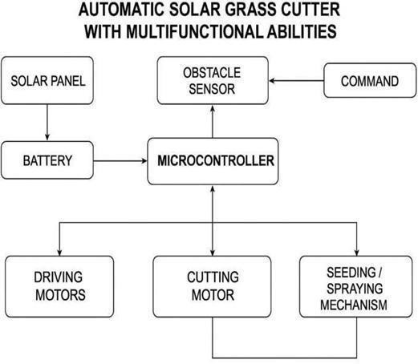
a Bluetooth module like HC-05), carrying out pre- programmed control algorithms, and producing accurate PWM signals to control the motors. It also receives regulated power from the battery. An obstacle detection system, typically an ultrasonic sensor (HC-SR04), continuously scans the surroundings for distance to an object determined by the returning echo's flight time. The microcontroller instantly applies obstacle avoidance logic when an obstacle is detected within a predetermined threshold (such as 30 cm), stopping motion, momentarily reversing, and turning to find a clear path before continuing. System locomotion is provided by DC geared motors with wheels that are controlled by H-Bridge motor drivers. The microcontroller uses PWM and logic signals to control speed and direction in order to perform forward, backward, and turning motions (e.g., a left turn is achieved by making the right motor faster or the left motor reverse). Enough torque is guarante ed by the geared design to travel over a range of terrains. The primary task, grass cutting, is accomplished by a high-torque DC motor that powers a rotary cutting blade assembly at high speeds (1000–3000 RPM). Sharp steel blades, a safety guard, and typically a mechanism for manually adjusting the cutting height are all included in the design of this cutting motor.regulates the timing sequences for these extra features. Cutting mode is activated.
Cutting mode is activated. Furthermore, the system might include a specialized seeding/spraying mechanism. The seeding function uses a DC motordriven rotating drum or vibrating plate to dispense seeds from a hopper at set intervals, whereas the spraying function uses DC-powered pumps to draw liquid from a reservoir and dispense it through nozzles on both sides. The microcontroller regulates the timing sequences for these extra functions to optimize coverage and resource utilization.

WORKING PRINCIPLE
- Solar Panel and Battery System
The solar panel captures sunlight and converts it into electrical energy through the pho-tovoltaic effect. When photons strike the solar cells, they excite electrons, creating a flow of electric current. The output is DC power, typically 12V with current depending on solar irradiance levels.This electrical energy is directed to charge a rechargeable battery (Lead-acid or Lithium-ion, 12V, 4–7Ah capacity). The battery serves as the main power reservoir, providing stable power supply to the microcontroller and motors even during periods of low sun-light or cloudy conditions. This energy storage mechanism ensures continuous operation independent of instantaneous solar availability.

Microcontroller (Control Unit)
The microcontroller, specifically an Arduino Uno with ATmega328P processor, acts as the brain of the system. It performs the following functions: Receives power from the battery via voltage regulation circuit
Processes input signals from obstacle sensors
Interprets user commands from Bluetooth module or manual switches
Executes programmed control algorithms Generates control signals for motor drivers Manages timing sequences for different operations
Monitors system status and implements safety protocols
The microcontroller operates on 5V logic levels and provides 14 digital I/O pins.

Component Name | Specification | Function
Arduino Uno | ATmega328P, 5V logic, 14  Digital I/O, 6 Analog Inputs, 16 MHz clock | Main controller for all logic and motor control
Solar Panel | 12V, 10W or  higher, 0.8A  out-put c | Converts sunlight to electrical energy
Battery | 12V, 4–7Ah,  Lead-acid or Li- ion, Rechargeable | Stores energy for motor use in absence of sunlight
Dual H- Bridge (L298N) | 5–35V operating voltage, 2A per channel, PWM capable | Drives and controls direction of DC motors
DC Motor – Cutter | 12V,  High Torque (3  kg.cm), 1000–  3000 RPM | Drives the grass-cutting blade
ESP(8266) | 32-bits microprocessor built in TCP/IP stack ,GPIO pins | Connect to device to WI-Fi and enable wireless data communication
ON/OFF  Switch | SPST, 12V  DC, 5A rating | Masterswitch
Wiring Terminals | 2-pin or 3-pin connectors, Screw type | Secure motor and power con-nections
Ultrasonic Sensor | HC-SR04, 2–  400 cm range, 5V sup-ply, 15mA current | Obstacle detection and navi- gation
Bluetooth Module | HC-05, 3.3V  logic, | Wireless control using mobile phone
Soil Moisture Sensor (Optional) | Analog/Digital output, 5V supply | Detects soil dryness for smart irrigation

CIRCUIT DIAGRAM

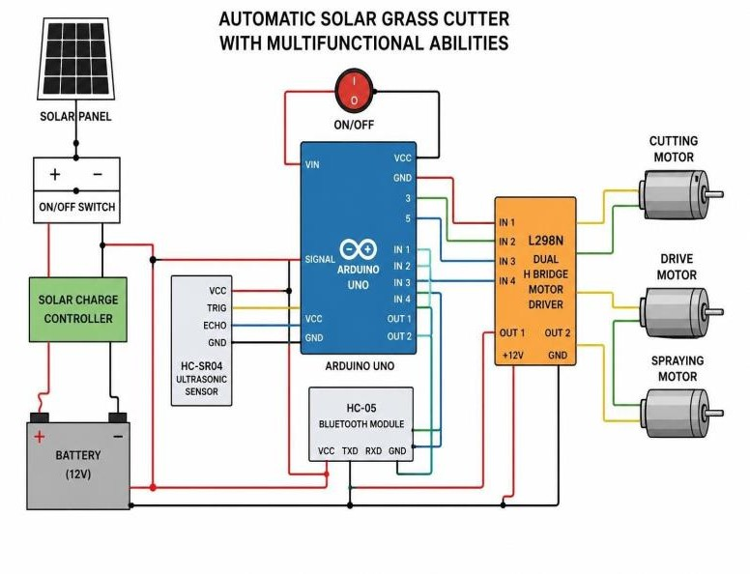
The solar panel is used as the main source of power for the system. It is connected to a charge controller circuit, which helps regulate the charging process and protects the battery from overcharging (this controller is optional but highly recommended) .The battery supplies power to the system through an ON/OFF switch, which acts as the main power control. This switch allows the entire system to be turned ON or OFF easily. After the switch, the power is distributed to different components .The Arduino Uno receives power through its VIN pin, which can accept an input voltage between 7V and 12V. The Arduino’s internal voltage regulator then converts this to 5V required for its operation .The L298N motor driver is directly supplied with 12V, which is needed to drive the motors efficiently. All components share a common ground (GND) connection. This ensures that all parts of the circuit have the same reference voltage and allows current to return properly, resulting in stable and reliable system operation. Arduino Uno (Main Controller)- The Arduino Uno acts as the main controller of the system. It controls all sensors and motors based on the program uploaded to it. The Arduino receives 12V DC power through its VIN pin. The onboard voltage regulator converts this 12V into 5V, which is used to power the microcontroller and connected components such as sensors and modules. Pin Configuration and Function Motor Direction Control , Digital pins 8, 9, 10, and 11 are connected

to IN1, IN2, IN3, and IN4 of the L298N motor driver. These pins are used to control the direction of rotation (forward, reverse, left, right) of the DC motors Motor Speed Control .Digital pins 5 and 6 are used as PWM pins and connected to ENA and ENB of the L298N motor driver. By varying the PWM signal, the speed of the motors can be controlled .Ultrasonic Sensor (HC-SR04)- Digital pins 2 (Trigger) and 3 (Echo) are connected to the HC-SR04 ultrasonic sensor. The Arduino sends a trigger pulse and measures the echo time to calculate the distance of obstacles. Bluetooth Module (HC-05)-Digital pins 0 (RX) and 1 (TX) are connected to the HC-05 Bluetooth module. This allows wireless communication between the Arduino and a mobile device for remote control. Dual H-Bridge Motor Driver (L298N)-The L298N dual H-bridge motor driver is used to control the speed and direction of DC motors using low-power control signals from the Arduino. It acts as an interface between the Arduino and high-current motors. The L298N receives logic signals from Arduino digital pins and can control two DC motors per module. Motor Connections-Motor A (OUT1, OUT2): Used for the cutting motor or left driving motor. Motor B (OUT3, OUT4): Used for the seeding/spraying motor or right driving motor If the system requires more than two motors, either: an additional L298N module is used, or relay modules are used to control individual motors. Production and Charging of Power-To optimize exposure, the solar panel is positioned atop the chassis. A circuit for a voltage regulator or charge controller receives the output. Logic for Autonomous Navigation The "Sense-Think-Act" cycle is how the robot functions. Initialization: The system begins by setting up the sensors and motors. Forward Motion: By turning both rear motors in a clockwise direction, the robot advances. Obstacle Detection: A trigger pulse is sent by the ultrasonic sensor.[cite_start]An interrupt is set off if the echo is received within a certain amount of time (calculating distance < 30 cm). The Node MCU serves as a hotspot or connects to a local Wi-Fi network for models with IoT integration. To control movement or toggle functions like pumps or cutters, an Android app (like Blynk) transmits virtual pin data to the microcontroller. Using Bluetooth commands, some designs enable cutting in particular patterns (such as triangles or circles) to enhance aesthetics.

ALGORITHM

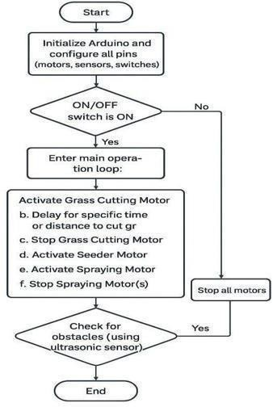

- FINAL RESULTS
The prototype of the Automatic Solar Grass Cutter with Multifunctional Abilities was successfully developed and assembled according to the design specifications outlined. The mechanical structure was fabricated using lightweight yet durable materials including aluminum frame members, acrylic panels, and PVC components. All electrical connections were properly insulated and secured to withstand vibration during operation. The solar panel demonstrated satisfactory performance in direct sunlight, providing sufficient power to charge the battery while supporting light loads. However, charging efficiency dropped significantly under cloudy conditions, highlighting the system’s dependency on good weather
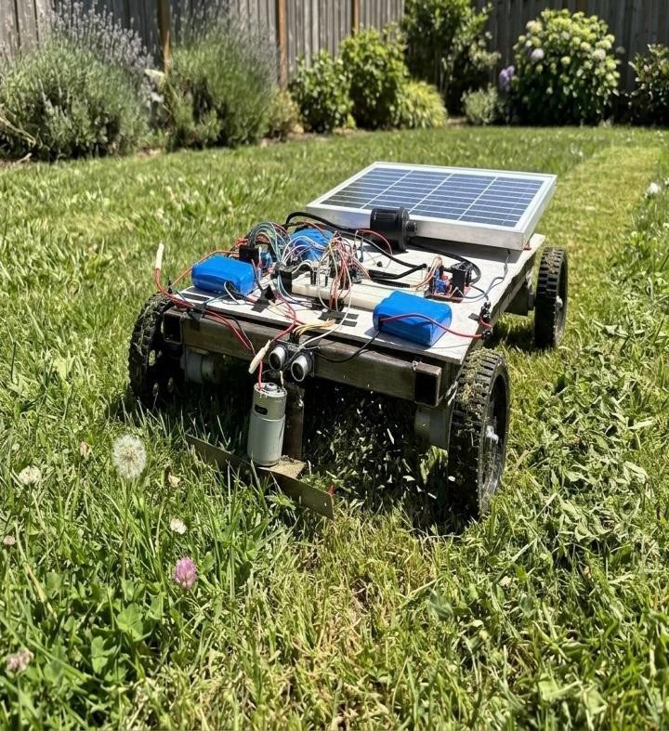

The load torque required for the robot was calculated based on the total weight and wheel radius. The total weight of the system was assumed to be 5 kg, and the wheel radius was 0.05 m. The total force acting on the system was calculated using F=mg=49N. Hence, the total torque required using T=F×r=2.45Nm.Since four motors are used in the system, the torque is equally distributed among them. Therefore, the torque required per motor is 0.61Nm.Considering practical losses and safety factor, the required torque per motor is approximately 1 to 1.5 Nm. Thus, the selected motors are suitable for efficient operation of the robot.

Weight(kg) | Torque(Nm)
2 | 0.98
3 | 1.47
4 | 1.96
5 | 2.45
6 | 2.94

The graph shows the relationship between load (weight) and torque. As the weight increases, the torque required also increases linearly. This indicates that higher load demands higher torque from the motors for proper movement of the robot.
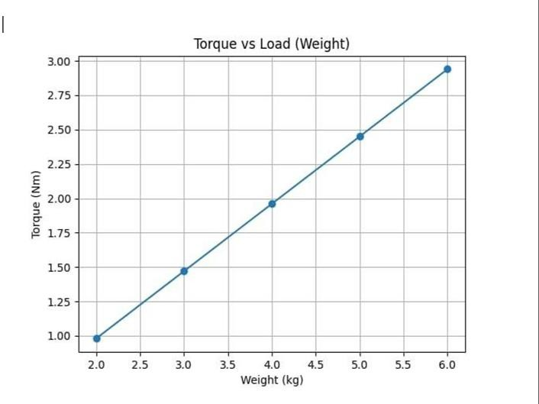
The project successfully achieved its primary objective of developing a solar-powered grass cutter with multifunctional capabilities. All three core functions—grass cutting, seeding, and spraying—were implemented and demonstrated to work effectively.
Sustainable Energy Utilization: The solar panel and battery system provided ad-equate power for 2–3 hours of operation, validating the feasibility of solar energy for this application. While weather dependency is a limitation, the

battery storage ensures operation during non- sunny periods.
Multi-Functional Capability: The integration of cutting, seeding, and spraying in a single platform was successfully demonstrated. This eliminates the need for farmers to purchase and maintain three separate machines, representing significant cost savings.

CONCLUSION
The Automatic Solar Grass Cutter with Multifunctional Abilities represents a successful integration of renewable energy, automation, and agricultural functionality. While the current prototype has limitations, it demonstrates the viability of solar-powered agricultural automation and provides a foundation for future enhancements. As climate change concerns intensify and sustainable practices become imperative, technologies like this play a crucial role in transitioning agriculture toward environmentally friendly methods. With continued development addressing the identified limitations and incorporating proposed enhancements, this system has strong potential for commercial deployment and widespread adoption. The project not only achieves its technical objectives but also contributes to broader goals of sustainable development, environmental protection, and agricultural modernization. It demonstrates that with appropriate engineering innovation, renewable energy can effectively power practical agricultural equipment, paving the way for cleaner, more efficient farming practices.

REFERENCES
[1] Sanyal, S., and S. R. Chowdhury (2018). creation of a micro-controller-based smart solar charge controller for energy-efficient charging. 194–198, International Conference on Computing, Power, and Communication Technologies (ICCPCT). 1. M. Karthick and associates (2020). A solar-powered lawnmower with a battery monitoring system was designed and put into operation. Journal of Physics: Conference Series, 1716(1), 012019. [2] G. Hassan and associates (2019). Solar-Powered Battery Charging System
Modeling and Performance Analysis for Self- Driving EVs. 10(2), 793-801, International Journal of Power Electronics and Drive Systems (IJPEDS).
[3] Bhargav and colleagues (2021). A thorough analysis of various MPPT methods for solar photovoltaic systems. ICACCI, the International Conference on Advances in Computing, Communications, and Informatics, 1–7. II. Self- governing Navigation and Robotics . [4] Everett, H. R., Borenstein, J., and Feng, L. (1996). What location am I? Mobile Robot Positioning Sensors and Techniques. Michigan University. (Classic reference on navigation methods). [5] Ulrich, I., and Borenstein, J. (2000). VFH*: Fast mobile robots with real-time obstacle avoidance. 1558–1563 in IEEE International Conference on Robotics and Automation (ICRA), 2(2). (See Vector Field Histogram-based Obstacle Avoidance Reference).
[6] Zou and colleagues (2022). An overview of algorithms for autonomous robot path planning. Systems, Man, and Cybernetics: IEEE Transactions on Systems, 52(1), 173-187.
[7] Rösmann and colleagues (2017). Using a time- elastic band, autonomous robots can navigate flexibly while avoiding obstacles. ICRA, International Conference on Robotics and Automation, 5956-5962. III. Application-Specific Systems & Autonomous Lawn Mowers. [8] Jain and colleagues (2019). Robotic Solar-Powered Grass Cutter and Sprayer. International Journal of Engineering, Science, and Management Research, 2(5), 23-28. (Directly addresses multifunctionality).
[9] I. F. Akyildiz et al. (2020). A review of current trends and challenges in wireless sensor networks for precision agriculture. IEEE Communications Surveys & Tutorials, 22(4), 2200-2228. (Context for intelligent seeding and spraying). [10] Reddy, B.
V. R., and G. K. Rao (2018). The design and construction of an automatic grass cutter that runs on solar power. Journal of Scientific and Engineering Research International, 9(4), 98-102.
[11] A. Mali and associates (2023). creation of an intelligent, self-governing lawnmower with obstacle detection and Bluetooth control. IRJET, International Research Journal of Engineering and Technology, 10(2), 481-486. [12] Khodke, K. R., Kukreja, H., Kotekar, S., kukade, N., & Shende, C.
J. (2018). "Literature Review of Grass Cutter Machine." International Journal of Emerging Technologies in Engineering Research (IJETER),

6(2), febuary . [13] Ismail, F. B., Al-Muhsen, N. F. O., Fuzi, F. A., & Zukipli, A. (2019). "Design and Development of Smart Solar Grass Cutter." International Journal of Engineering and Advanced Technology (IJEAT), 9(2), December. [14] Sivarao,
T. J. S. A., Hambali, M., & Faizul. (n.d.). "Review of Automated Machines towards Devising A New Approach in Developing Semi-Automated Grass Cutter." International Journal of Mechanical & Mechatronics Engineering IJMME-IJENS, 10(04).
[15] Baingane, T., Nagrale, S., Gumgaonkar, S., Langade, G., Ramteke, S., & Dhumal, P. V. M. (2018). "Review on Fully Automated Solar Grass Cutter." International Research Journal of Engineering and Technology (IRJET), 5(02), February. [16] Kalaskar, M., Adhau, V., Tanpure, Y., Thakare, G., Chavan, J., & Mohod, T. (2022). "Review Paper on Agricultural Solar Grass Cutter." International Journal For Research in Applied Science and Engineering Technology (IJRASET), 10(III), March. [17] Bhalodi, T., Bhujbal, N., Doshi, K., Goregaonkar, R., & Jagtap, S. (2020). "Environmental Friendly Solar Grass Cutter." International Journal of Research in Engineering, Science and Management (IJRESM), 3(7), July. [18
]Bhandare, V., Shivani, L., Deshmane Kalyani, Khade Shruchi, Gurav Pranav, & Chinta Shrikant. (2018). "Automated Solar Grass Cutter: An Overview."International Journal for Research in Applied Science & Engineering Technology (IJRASET), 6(II), February. [19] ―Solar Grass Cutting Robot‖ IJIRT,Volume 8 Issue 1 , June 2021
, ISSN: 2349- 6002 Yash Adhao¹, Hrushikesh Sawale², Aishwarya Zope³, Prof. Dipali Dhake

