Plastic Consumption in The Era of Sustainability: A Bibliometric Analysis Integrating Economic, Manufacturing, Social and Maqasid Al-Shariah Perspectives

Abstract
This study offers a bibliometric analysis of studies about plastic consumption in the context of sustainability; utilizing data obtained from Scopus. The collection comprises peer-reviewed papers from 2020 to 2026, obtained on 31 March 2025, hence emphasizing recent and pertinent scholarly advancements. The analysis uses VOS viewer to visualize term co-occurrence, theme groupings, and temporal research trends. The results indicate four predominant research clusters: technological systems, economic and industrial performance, consumer behaviors, and education/social awareness. Initial research is predominantly technology-oriented, focusing on system optimizations, algorithms, and efficiency in tackling plastic-related issues. Recent research indicates a transition towards sustainability-focused themes, encompassing consumer attitudes, eco-friendly products, and environmental factors, frequently based on frameworks like the Theory of Planned Behaviors. Notwithstanding this evolution, the findings reveal a disjointed knowledge framework with minimal interdisciplinary integration. Moreover, ethical and value-oriented viewpoints are still inadequately examined. This study emphasizes the necessity for a comprehensive and interdisciplinary methodology that amalgamates technological, economic, and behavioral insights with ethical frameworks, such as Maqasid al-Shariah, to promote sustainable plastic consumption and foster enduring environmental and societal welfare.

Keywords: Plastic consumption; Sustainability; Bibliometric analysis; Consumer behavior; Maqasid al-Shariah

Introduction
The widespread problem of plastic use calls for a strong research framework that goes beyond traditional disciplinary boundaries to fully deal with its many environmental, economic, and social effects (Zhang et al., 2023). To fully understand this phenomenon, we need to look at more than just the technological and economic reasons. We also need to look at the complex parts of consumer behaviour and the ethical frameworks that underline it (Mat et al., 2022).
This study utilises bibliometric analysis to thoroughly delineate the intellectual landscape of plastic consumption research in the context of sustainability, thereby identifying major themes, dominant ideas, and developing trends from 2020 to 2026. This analytical methodology enables the discernment of significant deficiencies in current literature, especially regarding multidisciplinary integration and the inclusion of ethical considerations (Ahmad et al., 2023; De et al., 2025).
It specifically seeks to clarify the application of theoretical frameworks such as the Theory of Planned Behaviour and Norm Activation Theory, while simultaneously emphasising the insufficiently examined intersection of religiosity, environmental knowledge, and policy influences in shaping pro-environmental behaviour (Hadi, 2025; Permadi et al., 2025). This effort aims to fill the identified research gaps, especially the methodological and empirical gaps related to the influence of social norms and perceived behavioural control on plastic recycling, as well as the theoretical gap in combining different frameworks (Arman, 2025).
Furthermore, despite increasing environmental consciousness, a significant attitude-behavior gap endures, wherein pro-environmental sentiments frequently do not manifest in tangible green consumption behaviours (Permadi et al., 2025). This disconnect highlights the necessity for research that examines the intricate interactions of psychological, socio-cultural, and ethical factors affecting the shift from environmental awareness to proactive pro-environmental behaviour, especially in the realm of online shopping (Shafi et al., 2024).
Maqasid al-Shari'ah, which focuses on principles of well-being, responsibility, and resource conservation, can help close this gap by adding an ethical dimension to promote sustainable consumption habits (Sari et al., 2025; Shompa et al., 2024). This conceptual integration corresponds with the wider academic dialogue that promotes the inclusion of behavioural science insights and global perspectives to cultivate a more environmentally conscious consumer culture (Shafi et al., 2024).
Moreover, although the Theory of Planned Behaviors is commonly employed in green consumption studies, its inadequacies in comprehensively addressing the complexities of pro-environmental behaviours necessitate the investigation of more holistic models and variables, including consumers' awareness of recycling infrastructure and their interaction with media channels (Kutaula et al., 2024; Shafie et al., 2024). This encompasses the analysis of how variables such as green perceived value and trust influence the correlation between environmental concern and real purchasing behaviors, especially in emerging markets (Permadi et al., 2025).
In conclusion, the bibliometric study indicates that research on plastic sustainability is swiftly advancing and becoming more interdisciplinary. The discipline is marked by substantial empirical contributions, ongoing innovation, and an increasing focus on consumer-related aspects. The absence of integrative review studies indicates that the knowledge base is still disjointed, requiring additional initiatives to amalgamate current research and formulate cohesive theoretical frameworks. This study adds to the body of knowledge by giving a systematic assessment of trends in publications and research patterns. This information is useful for academics, policymakers, and industry professionals who want to find better ways to create and use plastic in a way that is good for the environment.

Literature Review
This section will review plastic consumption and sustainability literature, focusing on consumer behaviour model theory and application. This review will examine the Theory of Planned Behaviour's explanatory capacity and constraints in forecasting green purchasing behaviour, especially in situations where an attitude-behavior gap requires cognitive and contextual elements (Alhamad et al., 2023; Corsini, 2024). This study will examine how socio-cultural factors, such as religiosity and cross-cultural differences, affect pro-environmental intentions and behaviours in emerging economies like Pakistan and Malaysia, where environmental issues are crucial but often neglected in green consumption research. The Theory of Reasoned Action and the Theory of Planned Behaviour have been expanded to include constructs like perceived efficacy and plastic concern to better understand consumer behaviour towards recycled products (Corsini et al., 2024; Noubar et al., 2023). Developing targeted interventions to close the gap between pro-environmental attitudes and behaviours requires this comprehensive approach, which often enhances the predictive power of the original TPB framework by adding additional elements.
The Theory of Planned Behaviour has been improved by incorporating convenience, environmental concern, and ethical beliefs to explain plastic bag use (Ying & He, 2023). Attitudes, subjective norms, and perceived behavioural control influence an individual's desire to undertake an activity and their actual behaviour, according to the Theory of Planned activity (Yulianti et al., 2023).
This theory states that positive attitudes, perceived social pressure, and self-confidence affect behavioural intentions (Kaur et al., 2023; Tanakinjal, 2021). Later research has demonstrated that the Theory of Planned Behaviour is highly predictive in pro-environmental settings such reusable bag use and responsible consumption (Atif et al., 2024). Despite its widespread use and predictive power, the Theory of Planned Behaviour (TPB) has been criticised for failing to fully address the complex factors that affect sustainable consumer behaviour, especially in cross-cultural settings where socio-cultural factors strongly influence the intention-behavior relationship (Elhoushy & Lanzini, 2020). Religiosity moderates the relationships between Theory of Planned Behaviour drivers and pro-environmental intents, specifically for recycled product purchases (Zhang et al., 2022). To better predict consumer intentions for green products, the Theory of Planned Behaviour (TPB) is often supplemented with other theoretical elements like environmental concern and willingness to pay (Auliandri et al., 2018; Wang et al., 2026). This emphasises the need to add elements to the TPB model to better understand pro-environmental conduct (Nejad et al., 2024). Attitude, subjective norms, and perceived behavioural control precede behavioural intention (Laheri et al., 2024), but the Theory of Planned Behaviour (TPB) may only explain a small portion of environmental action variance (Ohtomo & Ohnuma, 2014). This limitation often needs prior behaviour, ethical norms, or personal beliefs to forecast complex pro-environmental activities (Ashwini & Aithal, 2023; Kotyza et al., 2024). The model states that attitudes, subjective standards, and perceived behavioural control determine an individual's desire to engage in an action, which directly predicts that behaviour (Liu et al., 2024).
Maqasid al-Shari'ah, an Islamic legal framework, provides a unique perspective for assessing these variables, especially in societies where religious beliefs strongly influence daily conduct and consumer habits. These frameworks can help explain pro-environmental behaviour by integrating spiritual and ethical considerations ignored in classic psychology models. The original Theory of Planned Behavior's simplicity, while beneficial, may limit its explanatory capacity in complex behavioural circumstances, requiring the addition of other variables to improve prediction (Tafsir et al., 2016). Expanded TPB frameworks now include felt moral obligation, environmental ethics, and emotional intelligence to predict pro-environmental conduct (Kang, 2021).
The Extended Theory of Planned Behaviour iteratively refines the original model by adding psychological and contextual factors to better understand behavioural intentions (Fatmi et al., 2020; Savari & Khaleghi, 2025). The Theory of Planned Behaviour (TPB), originally designed to address the shortcomings of the Theory of Reasoned Action in contexts where individuals lack complete volitional control, integrates perceived behavioural control from Bandura's Self-Efficacy Theory to improve its explanation of individual behaviour (Julendra et al., 2021).
This integration acknowledges that perceived ease or complexity of a behaviour strongly influences intention (Nugroho et al., 2017). Self-efficacy and contextual constraints affect an individual's perception of their ability to do a behaviour (Jalil et al., 2023).

Methodology
This study applies a quantitative research methodology with bibliometric analysis to investigate the evolution of scholarly literature on plastic usage from economic, manufacturing, social, and Maqasid al-Shariah viewpoints. Data was retrieved from the Scopus database on March 31, 2026, assuring the dataset's consistency and dependability. A structured search technique was used, including keywords such as "plastic consumption," "plastic waste," "plastic economy," "manufacturing," "industry," "social impact," "sustainability," and Islamic-related terms like "maqasid shariah" and "Islamic sustainability." The study examined peer-reviewed journal articles published in English between 2000 and 2025, including topics such as economics, engineering, environmental science, and social sciences. Non-relevant papers, duplicates, and non-journal publications were eliminated to ensure data quality. The extracted data, which included bibliographic information such as authors, titles, keywords, sources, and citation counts, were analysed with bibliometric software such as VOSviewer and Biblioshiny. The study used performance analysis to identify significant authors, journals, and nations, as well as scientific mapping tools including co-authorship, keyword co-occurrence, and citation network analysis to investigate research patterns and thematic structures. In addition, thematic evolution analysis was used to investigate changes in study focus across time. To improve accuracy, data cleaning and validation techniques were used, such as duplication removal and keyword standardisation. Despite its strengths, this study is limited to the Scopus database and English-language publications, and it recognises the very small number of studies that incorporate Maqasid al-Shariah into plastic consumption research.

Result & Discussion
Publication Trends and Growth Pattern
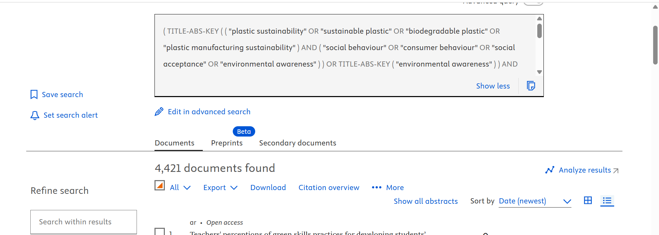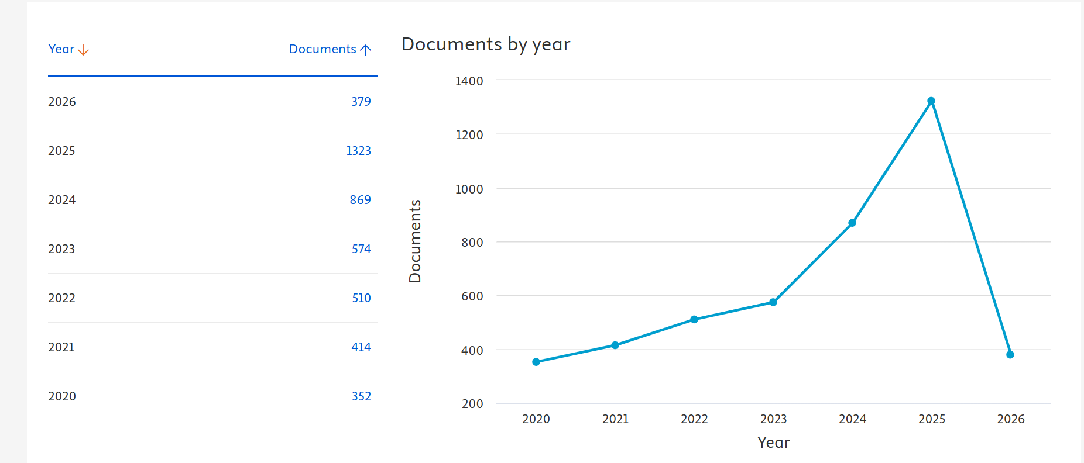
Figure 1: Year of document
According to Figure 1, the bibliometric study found a total of 4,421 papers on plastic sustainability, biodegradable plastics, manufacturing sustainability, and consumer behaviour. The temporal distribution of publications between 2020 and 2026 shows a constant rising trend, indicating a rapidly expanding study domain. Between 2020 and 2023, the number of publications climbed steadily from 352 to 574 documents, indicating a gradual scholarly engagement with sustainability challenges in plastic manufacturing and use. A considerable increase is seen in 2024 (869 documents) and 2025 (1,323 documents), indicating the pinnacle of research activity in the dataset. This fast rise can be ascribed to increased worldwide awareness of plastic pollution, tougher environmental restrictions, and alignment with international sustainability frameworks such as the Sustainable Development Goals (SDGs), including SDG 12 (Responsible Consumption and Production).
The apparent fall in 2026 (379 documents) should be taken with caution, as it reflects incomplete indexing for the current year rather than a reduction in research activities. Overall, the trend shows that plastic sustainability research is accelerating, indicating a high level of academic and industrial interest in this field..

Distribution of Document Types
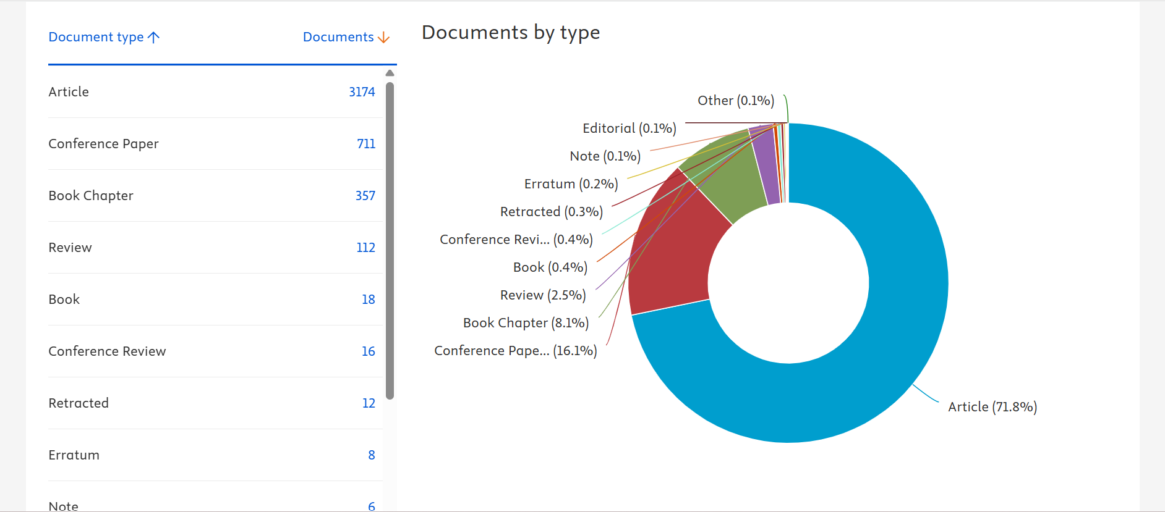
Figure 2: document types
Figure 2 shows that journal articles make up 71.8% (3,174 documents) of total publications. This emphasis on empirical and experimental research shows the domain's maturity and scientific rigour.
Conference papers make up 16.1% (711 documents), demonstrating the dynamic nature of engineering, materials science, and manufacturing research. These early findings, novel methodologies, and new technologies indicate that the discipline is evolving. Book chapters (8.1%) and review articles (2.5%) are less common. A paucity of review papers suggests a lack of field-wide synthesis and theoretical consolidation. This gap highlights the value of bibliometric and systematic review studies in integrating perspectives and identifying research paths. Other document kinds, such as books, conference reviews, and editorial notes, make up less than 2%, suggesting their low influence on domain knowledge.

Analysis Bibliometric of network visualization
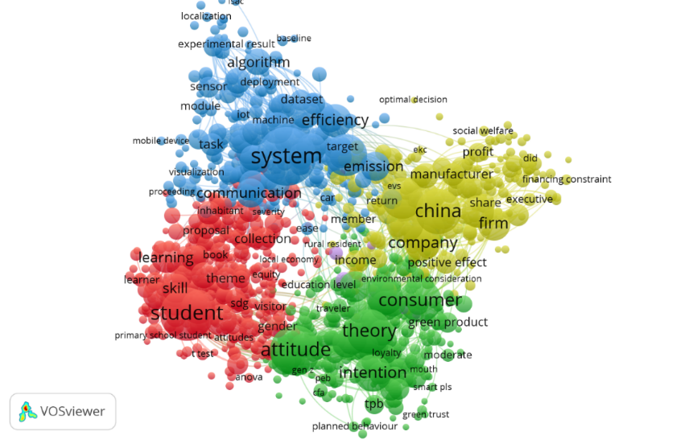
Figure 3: Network visualization
Figure 3 shows that the bibliometric network visualisation delineates research on plastic use in the sustainability period into four predominant clusters: technological systems, economic and industrial performance, consumer behaviour, and education/social awareness. The predominant cluster pertains to systems and efficiency, suggesting that contemporary research predominantly focuses on technology solutions, including smart systems, IoT integration, and emission control in manufacturing processes. This indicates that the dialogue is predominantly influenced by engineering and data-centric methodologies focused on enhancing plastic output and mitigating environmental consequences.
A robust economic cluster focused on enterprises, profitability, and industrial activity, particularly in China, underscores the persistent prevalence of profit-driven viewpoints in plastic consumption studies. Simultaneously, the consumer behaviour cluster, based on theories like the Theory of Planned Behaviour, indicates an increasing focus on attitudes, intentions, and eco-friendly purchase choices. The education and social awareness cluster further enhances this by underscoring the significance of students, learning, and the Sustainable Development Goals (SDGs) in fostering enduring sustainable habits. Nonetheless, the comparatively tenuous links among these clusters suggest a disjointed knowledge framework, wherein technological, economic, and social components are not thoroughly amalgamated.
From the standpoint of Maqasid al-Shariah, the findings indicate a substantial deficiency in the literature. Although aspects pertaining to wealth (economic benefits) and knowledge (education) are evident, there is a paucity of explicit incorporation of ethical, environmental, and spiritual dimensions, including the safeguarding of life, the environment, and future generations. This indicates that contemporary research is predominantly secular and utilitarian, devoid of a comprehensive, value-oriented framework. This paper proposes the inclusion of Maqasid al-Shariah to address existing inadequacies, providing a more balanced and morally informed approach to sustainable plastic use.

Analysis Bibliometric of overlay visualization
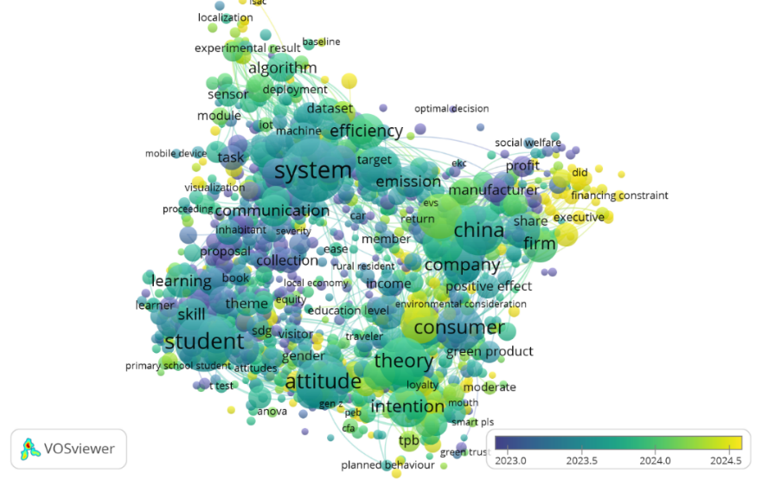
Figured 4 : overlay visualization
Figure 4 shows that the overlay visualisation (time-based analysis) enhances the bibliometric findings by depicting the progression of research trends in plastic usage from earlier studies (blue/purple) to more recent ones (yellow). The preliminary phase of research is characterised by terminology such as system, communication, dataset, and algorithm, signifying that first investigations were predominantly centred on technological advancement and system optimisation in manufacturing and waste management. This signifies a fundamental stage in which efficiency, monitoring systems, and data-driven methodologies were emphasised to tackle plastic-related issues.
Recent patterns (green to yellow nodes) indicate a distinct transition towards consumer-centric and sustainability-focused themes, encompassing customer behaviour, attitudes, intentions, eco-friendly products, and profitability. This signifies a shift in research emphasis from solely technical solutions to behavioural change, market dynamics, and sustainable consumption habits. The growing significance of terminology such as manufacturers, firms, and financial constraints indicates that industries are more involved in sustainability, reconciling environmental responsibility with economic performance. The incorporation of environmental factors into company and consumer choices signifies a shift towards a more comprehensive sustainability dialogue.
Nonetheless, despite this favourable development, the visualisation continues to indicate a restricted presence of ethical and value-oriented frameworks, especially from the Maqasid al-Shariah viewpoint. Although contemporary studies initiate discussions on environmental issues and social welfare, they predominantly stay entrenched in secular and economic frameworks. This underscores a vital research opportunity to integrate Maqasid-based values, including environmental conservation, preservation of life, and safeguarding future generations, into contemporary sustainability dialogues. This integration would enhance the conceptual rigour of the subject by integrating technological, economic, and behavioural progress with a thorough ethical framework..

Analysis Bibliometric of density visualization

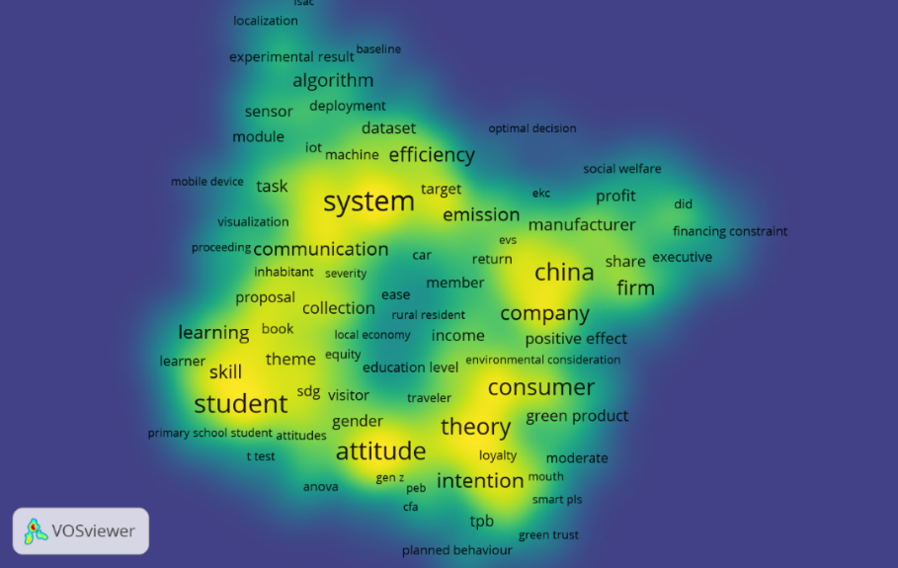
Figure 5 : Density visualization
According to Figure 5, the density visualisation, presumably created with VOSviewer, emphasises the most significant and commonly co-occurring keywords within the dataset. The most luminous (yellow) regions surrounding phrases such as system, student, attitude, intention, consumer, company, and China signify the principal study focal points. The map indicates two primary theme clusters: a technical/engineering cluster (e.g., system, algorithm, efficiency, communication, emission) and a behavioral/social science cluster (e.g., student, attitude, intention, learning, skill). The closeness of phrases indicates conceptual connections, demonstrating that research frequently combines technology systems with human or organisational aspects.
The use of terms such as consumer, green products, environmental concern, and emission indicates a significant focus on sustainability or environmental study, particularly in relation to economic variables like firm, company, and manufacturer. The geographical term China signifies that a significant amount of the research is contextually specific or empirically rooted in that area. The map illustrates an interdisciplinary domain where technological advancement, environmental issues, and human attitudes converge, highlighting the growing focus on the impact of systems and regulations on consumer intentions and organisational results.

Discussion & Recommendation
The bibliometric analysis shows that sustainability research on plastic usage is transdisciplinary and structurally split. Technology, economic and industrial performance, consumer behaviour, and education/social awareness are the four main clusters in network visualisation, demonstrating that the field has developed through parallel but poorly integrated research streams. System-related language (e.g., system, algorithm, efficiency, communication) suggests that engineering and data-centric methods to improve manufacturing processes and reduce emissions dominate initial and ongoing research. This shows a technology-focused paradigm where innovation and operational efficacy address sustainability challenges. Despite technological advances, plastic trash's environmental impacts require more research (Hossam et al., 2025). Due to the limited interconnection between these clusters, conceptual and methodological integration for comprehensive sustainability solutions is still in its infancy, especially for ethical and socio-cultural aspects of plastic consumption (Arini et al., 2024; Sousa, 2023; Tan, 2025).
Economic terms like firm, company, profit, and manufacturer, especially in China, emphasise industrial and market-oriented views. Sustainability is often described as a balance between environmental and financial responsibility. Consumer-centric conceptions like attitude, intention, and consumer behaviour in frameworks like the Theory of Planned Behaviour show a shift toward understanding sustainable consumption's behavioural underpinnings. The education cluster emphasises students, learning methods, and SDG-focused thinking in generating lasting behavioural change. Despite these advances, cluster interconnections are inadequate, suggesting the sector is fragmented and requires a comprehensive approach that incorporates technical innovation, economic systems, and human behaviour. This fragmentation shows a significant failure to translate consumer awareness into effective waste management strategies, especially given the global drop in single-use plastics and the rising demand for biodegradable alternatives (Ye et al., 2022).
The overlay shows research priority over time. Previous study focused on technological infrastructure and system optimization, as evidenced by dataset, algorithm, and communication. Recent studies show a rising focus on firm-level decision-making, financial constraints, and sustainability issues such green products, customer aspirations, and environmental concerns. This transition reflects a growing study domain, but the density visualisation suggests that core research hotspots remain focused on a small range of prominent issues, which may limit theoretical diversity and creativity. Few ethical and value-oriented issues are represented, suggesting secular, utilitarian paradigms dominate study.
This gap is significant for Maqasid al-Shariah. Wealth preservation (economic sustainability) and intellect (education and awareness) are addressed, but life, the environment, and future generations are not. Literature on sustainability often ignores moral and ethical issues in favour of technological and economic factors. These perspectives may help us understand plastic use and its social and environmental impacts. This integration would acknowledge that environmental sustainability issues, particularly flexible packaging, sometimes have disconnected research that fail to understand their extensive consequences (Farrukh et al., 2022). This fragmentation, knowledge asymmetry, and cynicism of green claims widen the consumer attitude-behavior gap on sustainable practices (Ashwini & Moodbidri, 2026).
According to bibliometric findings, future research on plastic usage should be more integrated and comprehensive within sustainability. Interdisciplinary frameworks that integrate system innovation with consumer behaviour and policy interventions are needed to reconcile technical, economic, and behavioural fragmentation. Technology and efficiency-focused solutions are important, but they must be complemented by a deep understanding of human behaviour, beyond intention-based frameworks like the Theory of Planned Behaviour to include actual behavioural practices, habits, and contextual factors. Industry and consumers should work together to promote sustainable consumption through eco-friendly product design, circular economy initiatives, and ethical marketing.
Future study should go beyond China to include other cultural and socio-economic settings to improve generalizability. To understand plastic consumption patterns and regulatory regime efficacy over time, longitudinal and policy-oriented research is recommended. This study highlights the need to incorporate ethical and value-oriented methods, particularly from the Maqasid al-Shariah perspective, into sustainability debate. Including principles like environmental stewardship, social responsibility, and intergenerational justice would create a more holistic and ethical framework that connects technological and economic advancement with societal and environmental welfare. This comprehensive framework may improve understanding of socio-cultural and ethical-religious micro-foundations affecting sustainable consumption, which could inform business strategies that authentically resonate with consumer preferences (Vergura et al., 2023). To improve scientific understanding and plastic waste reduction strategies, future research should examine more stakeholder actions and situations (Pham et al., 2025).

Conclusion
In conclusion, the bibliometric analysis using VOSviewer demonstrates that research on plastic consumption in the sustainability era is characterized by a multidisciplinary yet fragmented structure, dominated by technological systems, economic performance, consumer behavior, and educational perspectives. While the field has evolved from a primarily technology-driven focus toward more consumer- and sustainability-oriented themes, significant gaps remain in integrating these dimensions into a cohesive framework. The prominence of models such as the Theory of Planned Behavior highlights the growing attention to behavioral factors, yet ethical and value-based considerations are still limited. This indicates that current research largely operates within technical and economic paradigms, with insufficient emphasis on holistic sustainability principles. Therefore, advancing the field requires not only interdisciplinary integration but also the incorporation of ethical frameworks, such as Maqasid al-Shariah, to ensure that efforts to address plastic consumption are aligned with broader environmental, social, and intergenerational responsibilities.

References
- Ahmad, N., Ramli, I. M., & Khan, H. H. A. (2023). Mapping the Plastic Waste Research Landscape: A bibliometric analysis of the interdisciplinary nature of plastic waste research. Environment-Behaviour Proceedings Journal, 8, 231. https://doi.org/10.21834/e-bpj.v8isi15.5101
- Alhamad, A. M., Ahmed, E. R., Akyürek, M., & Baadhem, A. M. S. (2023). Green Marketing and Attitude Affect the Consumer Buying Behavior of Green Product in Turkey. Indikator Jurnal Ilmiah Manajemen Dan Bisnis, 7(2), 1. https://doi.org/10.22441/indikator.v7i2.19814
- Arini, R. E., Wahyudi, E., & Bunyamin, I. A. (2024). Mengukur Dampak Penelitian Pengelolaan Sampah Plastik terhadap Praktik Lingkungan yang Berkelanjutan: Analisis Bibliometrik. Jurnal Multidisiplin West Science, 3(5), 567. https://doi.org/10.58812/jmws.v3i05.1189
- Arman, S. M. (2025). A Bibliometric Analysis Of The Theory Of Planned Behavior In The Circular Economy. Scientific Papers of Silesian University of Technology Organization and Management Series, 2025(216), 9. https://doi.org/10.29119/1641-3466.2025.216.1
- Ashwini, V., & Aithal, P. S. (2023). Development of a New Conceptual Model: Consumers’ Purchase Intention towards Eco-friendly Bags. International Journal of Management Technology and Social Sciences, 154. https://doi.org/10.47992/ijmts.2581.6012.0317
- Ashwini, Y., & Moodbidri, S. (2026). Trust-enabled drivers of Gen Z consumers’ willingness to pay for sustainable packaging: an extended TRUST-PACT model. Frontiers in Sustainability, 7. https://doi.org/10.3389/frsus.2026.1762826
- Atif, R. M., Ahmed, F., Khan, M. B., & Amir-ud-Din, R. (2024). Behavioral insights into reusable bag adoption: Evaluating the effectiveness of the theory of planned behavior in Lahore. Journal of Infrastructure Policy and Development, 8(8), 4958. https://doi.org/10.24294/jipd.v8i8.4958
- Auliandri, T. A., Armanu, A., Rohman, F., & Rofiq, A. (2018). Does green packaging matter as a business strategy? Exploring young consumers’ consumption in an emerging market. Problems and Perspectives in Management, 16(2), 376. https://doi.org/10.21511/ppm.16(2).2018.34
- Corsini, F., Gusmerotti, N. M., Bartoletti, E., Testa, F., Appolloni, A., & Iraldo, F. (2024). Addressing Plastic Concern: Behavioral Insights into Recycled Plastic Products and Packaging in a Circular Economy. Circular Economy and Sustainability, 4(3), 1961. https://doi.org/10.1007/s43615-024-00367-5
- De, T., Singh, N., Ibrahim, B. S. K. K., Dikkatwar, R., & Chaudhary, M. K. (2025). Mindful, responsible, and sustainable consumption: a hybrid review of evolving research trends. Discover Sustainability, 6(1). https://doi.org/10.1007/s43621-025-01343-1
- Elhoushy, S., & Lanzini, P. (2020). Factors Affecting Sustainable Consumer Behavior in the MENA Region: A Systematic Review [Review of Factors Affecting Sustainable Consumer Behavior in the MENA Region: A Systematic Review]. Journal of International Consumer Marketing, 33(3), 256. Taylor & Francis. https://doi.org/10.1080/08961530.2020.1781735
- Farrukh, A., Mathrani, S., & Sajjad, A. (2022). A Systematic Literature Review on Environmental Sustainability Issues of Flexible Packaging: Potential Pathways for Academic Research and Managerial Practice. Sustainability, 14(8), 4737. https://doi.org/10.3390/su14084737
- Fatmi, F. O., Ahmad, A. N., & Kartika, B. (2020). Determinants affecting purchase intention of halal products: an article review. Journal of Halal Product and Research, 3(2), 63. https://doi.org/10.20473/jhpr.vol.3-issue.2.63-79
- Hadi, Q. A. (2025). Integrating Religiosity and Public Policy to Foster Green Behavior: A Muslim Perspective. Journal of Islamic Economic Laws, 8(2), 186. https://doi.org/10.23917/jisel.v8i02.13105
- Hossam, Y., Nagdy, H., Adel, R., Mehanny, S., Fahim, I. S., Gomaa, O. M., Keshavarz, T., & Al-Kabbany, A. (2025). Emerging AI Solutions for Hazardous PET Waste in Marine Environments: A Review of Underexplored Paradigms [Review of Emerging AI Solutions for Hazardous PET Waste in Marine Environments: A Review of Underexplored Paradigms]. EarthArXiv (California Digital Library). California Digital Library. https://doi.org/10.31223/x54b37
- Jalil, M. I. A., Hamzah, A. A., William, J. J., Shaikh, I. M., & Ahsan, M. H. (2023). Exploring Motivational Factors for Muslims’ Cash Waqf Participation. The Journal of Muamalat and Islamic Finance Research, 1. https://doi.org/10.33102/jmifr.506
- Julendra, A. K. M., Mulyani, S. S., & Insani, A. M. (2021). ANALYSIS OF COMMUNITY CASH WAQF INTENTION TO SUPPORT SUSTAINABLE DEVELOPMENT GOALS (SDGs): THEORY PLANNED BEHAVIOUR APPROACH. Airlangga International Journal of Islamic Economics and Finance, 4(1), 46. https://doi.org/10.20473/aijief.v4i1.26383
- Kang, W. (2021). Predicting Pre-service teachers’ intention to implement education for sustainable development: A fuzzy-set qualitative comparative analysis. Cypriot Journal of Educational Sciences, 16(5), 2412. https://doi.org/10.18844/cjes.v16i5.6344
- Kaur, B., Gangwar, V. P., Dash, G., Khan, N., & Alkhoraif, A. (2023). ‘Our Planet, Our Health’ - Impact of Health Consciousness and Environmental Concern on Green Purchase Behavior: Role of Reference Groups. Polish Journal of Environmental Studies. https://doi.org/10.15244/pjoes/172037
- Kautish, P., Sharma, R., Mangla, S. K., Jabeen, F., & Awan, U. (2021). Understanding choice behavior towards plastic consumption: An emerging market investigation. Resources Conservation and Recycling, 174, 105828. https://doi.org/10.1016/j.resconrec.2021.105828
- Khan, S. N., Minhas, N., & Neale, N. (2025). Bridging the green gap: examining consumer green perceptions in an extended model of theory of planned behavior. Future Business Journal, 11(1). https://doi.org/10.1186/s43093-025-00593-9
- Kotyza, P., Čábelková, I., Pierański, B., Malec, K., Borusiak, B., Smutka, Ĺ., Nagy, S., Gaweł, A., López‐Lluch, D., Kis, K., Gál, J., Gálová, J., Mravcová, A., Knežević, B., & Hlaváček, M. (2024). The predictive power of environmental concern, perceived behavioral control and social norms in shaping pro-environmental intentions: a multicountry study. Frontiers in Ecology and Evolution, 12. https://doi.org/10.3389/fevo.2024.1289139
- Kumar, V. (2024). Emerald Horizons: A Bibliometric Analysis of Green Marketing’s Evolutionary Trajectory. Research Square (Research Square). https://doi.org/10.21203/rs.3.rs-3878119/v1
- Kutaula, S., Gillani, A., Gregory‐Smith, D., & Bartikowski, B. (2024). Ethical Consumerism in Emerging Markets: Opportunities and Challenges. Journal of Business Ethics, 191(4), 651. https://doi.org/10.1007/s10551-024-05657-4
- Laheri, V. K., Lim, W. M., Arya, P. K., & Kumar, S. (2024). A multidimensional lens of environmental consciousness: towards an environmentally conscious theory of planned behavior. Journal of Consumer Marketing, 41(3), 281. https://doi.org/10.1108/jcm-03-2023-5875
- Liu, M., Shi, Z., & Zhang, Z. (2024). How Environmental Policy Perception and Social Media Use Impact Pro-Environmental Behavior: A Moderated Mediation Model Based on the Theory of Planned Behavior. Sustainability, 16(17), 7587. https://doi.org/10.3390/su16177587
- Mat, A., Othman, A. K., Rahman, M. K. B. A., & Siyavooshi, M. (2022). Investigating Sustainable Consumption Behavior Vis-à-vis Islamic Values: A systematic review. Environment-Behaviour Proceedings Journal, 7(21), 373. https://doi.org/10.21834/ebpj.v7i21.3478
- Nejad, S. G., Skeiseid, H. V., & Derdowski, L. A. (2024). Understanding Consumption Reduction Through the TPB: Moderating Effects of the Need for Evaluation and Self-Referencing Individual Differences. Journal of Intelligence, 12(11), 119. https://doi.org/10.3390/jintelligence12110119
- Noubar, H. B. K., Holagh, S. R., & Sadri, A. (2023). Identifying Factors Affecting Green Consumer Purchase Behavior on E-Commerce Websites. TalTech Journal of European Studies/TalTech Journal of European Studies., 13(1), 40. https://doi.org/10.2478/bjes-2023-0003
- Nugroho, A. P., Hidayat, A., & Kusuma, H. (2017). The influence of religiosity and self-efficacy on the saving behavior of the Іslamic banks. Banks and Bank Systems, 12(3), 35. https://doi.org/10.21511/bbs.12(3).2017.03
- Ohtomo, S., & Ohnuma, S. (2014). Psychological interventional approach for reduce resource consumption: Reducing plastic bag usage at supermarkets. Resources Conservation and Recycling, 84, 57. https://doi.org/10.1016/j.resconrec.2013.12.014
- Permadi, I., Nugroho, A., & Widyastuti, S. (2025). Bridging the Attitude-Behavior Gap in Green Consumption: A Systematic Literature Review and Integrative Framework. SHILAP Revista de Lepidopterología. https://doi.org/10.31538/iijse.v8i3.9201
- Pham, H. V., Robertson, K., Thyne, M., Hamlin, R. L., & Rundle‐Thiele, S. (2025). Reducing single-use plastics (SUPs) consumption: A synthesis of I and S level approaches. Sustainable Futures, 10, 101087. https://doi.org/10.1016/j.sftr.2025.101087
- Sari, N. P., Artha, B., Bahri, B., Sari, U. T., Hadi, A. S., Aditya, A., Asri, C. P., & Dinka, C. A. (2025). Consumer Behavior in Islamic Perspectives: A Theoretical Review. Miftah Jurnal Ekonomi Dan Bisnis Islam, 3(2), 107. https://doi.org/10.61231/miftah.v3i2.410
- Savari, M., & Khaleghi, B. (2025). Analysis of psychological and social factors affecting climate change adaptation and mitigation behaviors among Iranian rice farmers. Scientific Reports, 15(1). https://doi.org/10.1038/s41598-025-15580-x
- Shafi, S., Mohamed, W. N., Damaianti, I., & Salleh, H. S. (2024). Environmental Consciousness in the Digital Era of Online Shopping: A Systematic and Bibliometric Review. International Journal of Design & Nature and Ecodynamics, 19(3), 971. https://doi.org/10.18280/ijdne.190327
- Shafie, N. I., Rahman, N. H. A., Harun, R., Ismail, S., & Shafie, N. A. (2024). Consumer Green Products through the Lens of Bibliometrics: Trends analysis. Information Management and Business Review, 16, 514. https://doi.org/10.22610/imbr.v16i3s(i)a.4220
- Shompa, Z. A., Akbar, M. A., & Mohadis, H. M. (2024). Harmonizing Maqasid al-Shari’ah with sustainable waste management practices: a conceptual framework for principles and implementation. International Journal of Islamic and Middle Eastern Finance and Management, 18(1), 142. https://doi.org/10.1108/imefm-02-2024-0061
- Sousa, F. D. B. de. (2023). Consumer Awareness of Plastic: an Overview of Different Research Areas. Circular Economy and Sustainability, 3(4), 2083. https://doi.org/10.1007/s43615-023-00263-4
- Tafsir, R. B., Dharmmesta, B. S., Nugroho, S. S., & Widyaningsih, Y. A. (2016). Green Product Purchasing Phenomenon: Exploring The Gaps Of Theoretical, Methodological And Empirical. MIMBAR Jurnal Sosial Dan Pembangunan, 32(2), 372. https://doi.org/10.29313/mimbar.v32i2.1924
- Tan, Q. L., Hashim, S., & Zheng, Z. (2025). Mapping global trends in green consumption (2014–2024): A bibliometric analysis of emerging insights and directions. Sustainable Futures, 9, 100667. https://doi.org/10.1016/j.sftr.2025.100667
- Tanakinjal, G. H., Gugkang, A. S., & Rithuan, H. (2021). Sustainable initiatives in the food industry: Role of businesses and regulators. Innovative Marketing, 17(4), 88. https://doi.org/10.21511/im.17(4).2021.08
- Vergura, D. T., Zerbini, C., Luceri, B., & Palladino, R. (2023). Investigating sustainable consumption behaviors: a bibliometric analysis. British Food Journal, 125(13), 253. https://doi.org/10.1108/bfj-06-2022-0491
- Wang, J., Li, G., & Luh, D.-B. (2026). Influential factors shaping consumers’ green packaging purchase intentions. Frontiers in Psychology, 16, 1730088. https://doi.org/10.3389/fpsyg.2025.1730088
- Ye, Q., Umer, Q., Zhou, R., Asmi, A., & Asmi, F. (2022). How publications and patents are contributing to the development of municipal solid waste management: Viewing the UN Sustainable Development Goals as ground zero. Journal of Environmental Management, 325, 116496. https://doi.org/10.1016/j.jenvman.2022.116496
- Ying, S., & He, H. (2023). Understanding consumers’ purchase intentions of single-use plastic products. Frontiers in Psychology, 14. https://doi.org/10.3389/fpsyg.2023.1105959
- Yulianti, F., Zulfikar, R., & Lamsah. (2023). The Altruistic Connection: Unraveling How Altruism Drives Eco-Friendly Consumer Behavior in Green Marketing (Literature Review). International Journal of Professional Business Review, 8(10). https://doi.org/10.26668/businessreview/2023.v8i10.3656
- Zhang, J., Quoquab, F., & Mohammad, J. (2023). Plastic and sustainability: a bibliometric analysis using VOSviewer and CiteSpace. Arab Gulf Journal of Scientific Research, 42(1), 44. https://doi.org/10.1108/agjsr-10-2022-0225
- Zhang, Q., Husnain, M., Usman, M., Akhtar, M. W., Ali, S., Khan, M. A., Abbas, Q., Ismail, R., Rehman, T., & Akram, M. (2022). Interplay of eco-friendly factors and islamic religiosity towards recycled package products: A cross-cultural study. Frontiers in Psychology, 13. https://doi.org/10.3389/fpsyg.2022.840711

