Om R. Khedkar¹, Mr. Aditya Kakad², Dr. Swati Deshmukh³
1.Student, Shraddha Institute of Pharmacy, Washim , Maharashtra, India.
2.Assistant Professor, Department of Pharmacy, Shraddha Institute of Pharmacy, Washim, Maharashtra, India.
3. Principal, Department of Pharmacology, Shraddha Institute of Pharmacy, Washim, Maharashtra, India.

ABSTRACT
The present study aims to create and test a herbal peel-off mask using natural ingredients like pineapple, turmeric, aloe vera, rice water, rose water, and glycerine. This product is designed to be effective, safe, and eco-friendly. The mask is made to clean, detoxify, and renew the skin without the harmful effects of synthetic beauty products. Pineapple extract, which contains bromelain and vitamin C, helps to exfoliate and brighten the skin by removing dead skin cells and impurities. Turmeric extract, rich in curcumin, offers strong anti-inflammatory, antioxidant, and antibacterial benefits that help reduce acne and skin blemishes. Aloe vera gel and glycerine act as natural moisturizers, keeping the skin hydrated and calm, while rice water and rose water add a refreshing feel and give the skin a natural shine. Evaluation showed favourable pH, texture, drying time, and skin compatibility. It provides a natural, cost-effective, and sustainable option compared to chemical-based skincare products.
Keywords: Herbal peel-off mask; Pineapple extract; Turmeric extract; Aloe vera; Antioxidant; Skin rejuvenation
1. INTRODUCTION
Herbal cosmetics are beauty products that use natural plant-based ingredients to provide benefits like making skin brighter, reducing inflammation, keeping it hydrated, nourishing it, and helping to reduce signs of aging.
These products help protect and improve the health of the skin. A peel-off mask is a type of treatment where a thin layer is applied to the face. Once it dries, it forms a film that can be easily peeled off, which helps remove dirt and impurities, clean out the pores, and tighten the skin. It also helps improve blood circulation, activates skin cells, and aids in removing pollutants from the skin. Acne is a common long-term skin condition that affects the oil glands. It mostly occurs in people between the ages of 12 and 25. According to a report called the Global Burden of Disease, about 85 % of teenagers and young adults suffer from acne vulgaris [1]. The main bacteria that cause acne are Propionibacterium acnes and Staphylococcus epidermidis, and both of these are known to be resistant to many antibiotics. In countries like Indonesia, traditional medicine has been using herbal plants for treating acne for a long time [2]. Peel-off facial masks are popular because they are easy to use and help reduce the size of pores, support skin healing, and make the skin look refreshed and rejuvenated. They act as both a cleanser and a refreshing treatment, and they may also help relax facial muscles [3].
Pineapple (Ananas comosus L. Merr.), which belongs to the family Bromeliaceae, is a tropical fruit that is valued for its high vitamin C content and bromelain, which helps exfoliate the skin and make it brighter [4–6]. Turmeric (Curcuma longa L.), a traditional medicinal plant, is well known for its curcuminoids, which have antioxidant, anti-inflammatory, antimicrobial, and wound-healing properties [7–16]. These natural ingredients make herbal peel-off masks a good alternative to synthetic cosmetics.
2. PLANT MORPHOLOGY
Plant Morphology of Pineapple
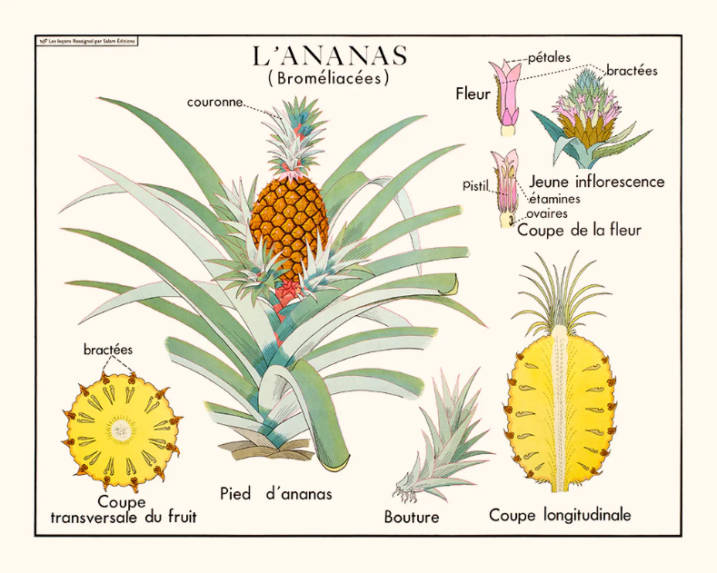
The pineapple, Ananas comosus L., is a perennial plant in the family Bromeliaceae, found naturally in tropical and subtropical areas. It has a short, thick stem with many long, stiff, narrow leaves that grow closely together in a tight circle. The plant is well-suited for hot and dry climates because its thick, waxy leaves and fleshy tissues help it hold onto water [17,18].

Fig.No.1: - Pineapple
Its root system is made up of thin, fibrous roots that grow close to the surface, usually within the top 15 to 30 cm of soil, which helps it quickly take in water and nutrients. The stem, also known as the corm, is thick and fleshy and acts as a storage area for food and water. The leaves are long, ranging from 30 to 100 cm in length, with a sword-like shape and spiral arrangement. At the top of the plant, the inflorescence grows, which has 100 to 200 bisexual flowers that develop into one big, composite fruit [17,18]. The pineapple fruit is shaped like a cylinder, made from the joining of many small berries. It has a scaly outer layer and a fibrous, yellow fruit pulp that contains bromelain and sugars. Most commercial pineapple varieties are seedless and are grown through vegetative methods like using the crown, slips, or suckers [18].
Plant Morphology of Turmeric
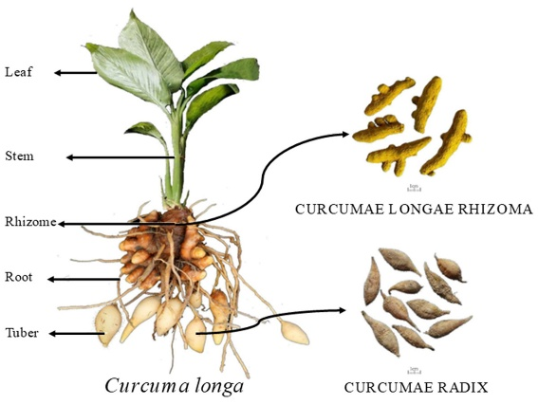
Turmeric, Curcuma longa Linn., is a perennial herb from the Zingiberaceae family that has aromatic rhizomes [19]. The underground rhizome is yellow to orange in color because of the compound curcumin, and it serves as the main storage and reproductive part of the plant. The above-ground part looks like a stem, but it's actually formed by rolled leaf sheaths. The leaves are large, spear-shaped, and grow in two rows. The inflorescence comes either from the rhizome or the stem, forming a spike made of bracts that hold yellowish-white flowers [19].

Fig.No.2: - Turmeric (Curcuma longa Linn).
The plant rarely produces fruits, and it's mainly propagated through rhizomes. The rhizome contains curcuminoids and essential oils like turmerone, atlantone, and zingiberene, which are responsible for its medicinal and cosmetic uses [20].
3. PEEL-OFF MASK
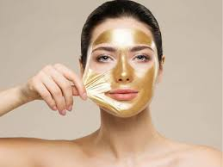
Herbal cosmetics are natural beauty products made from plant-based ingredients that help heal, calm, nourish, and improve the skin. They help protect, refresh, and repair the skin. Acne is a common skin issue among people aged 18-25, often causing discomfort and lowering confidence. Using herbal formulations is helpful because they are safe, effective, and gentle for sensitive skin [23].

Fig.No.3: - Peel-Off Mask
A peel-off mask is a thin liquid or gel that you apply to your face and let dry, forming a film that you can easily peel off. This process deeply cleanses your pores, removes dirt and dead skin cells, tightens and refreshes the skin, and improves blood circulation and cell activity. Herbal peel-off masks also deliver essential vitamins and nutrients to deeper layers of the skin, promoting nourishment and a natural glow [23].
3.1.Types of Peel-Off Masks
Modern cosmetic masks are generally divided into four types [24]:
1. Peel-Off Masks – Applied as a thin film, dried, and peeled to remove dead skin cells.
2. Sheet Masks – Sheets soaked in serum that offer specific benefits like brightening or anti-aging.
3. Leave-On Masks – Cream or gel-based masks that give deep hydration.
4. Charcoal/Clay Masks – Natural cleansers and detoxifiers.
Types of Facial Skin Suitable for Peel-Off Masks
Peel-off masks work well for oily, dry, sensitive, and normal skin types [25].

3.2. BENEFITS AND ADVANTAGES

Benefits of Applying Face Masks [26].
- Herbal face masks provide several skincare benefits by delivering essential nutrients to the skin.
- They nourish the skin, help reduce acne and blackheads, and remove dead skin cells.
- Face masks also create a calming and relaxing effect while restoring the skin's natural glow and brightness in a short time [26].
Advantages of Peel-Off Masks [27,28].
- Peel-off masks offer many cosmetic and therapeutic benefits.
- They help repair and revitalize the skin, improve hydration, and enhance the overall tone of the skin.
- These masks tighten pores, reduce wrinkles, and can be used for both cleansing and moisturizing.
- They are suitable for all skin types and effectively remove blackheads, whiteheads, and dead skin cells, leading to smoother and healthier skin.

4. RIGHT WAY TO USE A PEEL-OFF MASK
To get the best results, use a peel-off mask correctly by following these simple steps [29]:
1. Gently clean your face with a suitable facial cleanser to remove dirt and oil.
2. Apply the peel-off mask evenly across your face, making sure the layer is consistent.
3. Let the mask dry completely for about 15 minutes.
4. Carefully peel it off starting from the edges.
5. Rinse your face with cold water to close the pores and refresh the skin.

5. FACE SKIN PROBLEMS AND THEIR CAUSES
Facial skin is constantly exposed to environmental and body-related factors that can lead to various skin problems. The main skin issues and their causes are as follows [30]:
1. Acne and Pimples – Caused by excessive oil production, clogged pores due to dead skin and dirt, bacterial infection (Propionibacterium acnes), and hormonal imbalance.
2. Blackheads and Whiteheads – Occur from the buildup of sebum, keratin, and dead skin in pores, poor facial hygiene, and exposure to pollution and dust.
3.Dull and Uneven Skin Tone – Happens due to the accumulation of dead skin, pollution, UV damage, and lack of exfoliation.
4.Excess Oil and Greasiness – Caused by overactive oil glands, hormonal factors, and heavy use of makeup.
5.Aging Signs (Fine Lines and Wrinkles) – Result from decreased collagen production, sun exposure, and damage from free radicals.
6.Dry and Rough Skin – Caused by moisture loss, environmental stress, and dehydration.
6. MATERIAL AND METHODS [31,32].
The herbal peel-off mask was made using natural ingredients that have been proven to be good for the skin and body. Each ingredient was chosen for its special job and how well it works with the others.
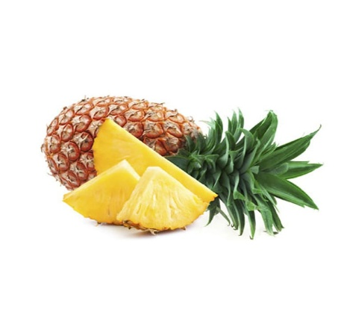
1. Pineapple (Ananas comosus L.)
- Biological Source: Pineapple consists of the fresh or dried fruit of Ananas comosus (L.) Merr
- Family: Bromeliaceae
- Synonym: Ananas comosus (L.)
- Part To be used: Fruit pulp
- Use Fig no.4: Pineapple
- It has bromelain, vitamin C, flavonoids, and organic acids.
- It helps with digestion, reduces inflammation, protects against free radicals, and brightens the skin, helping to remove dead skin and repair tissues.
2. Turmeric (Curcuma longa L.)
- Biological Source: Turmeric consists of the dried rhizomes of Curcuma longa Linn
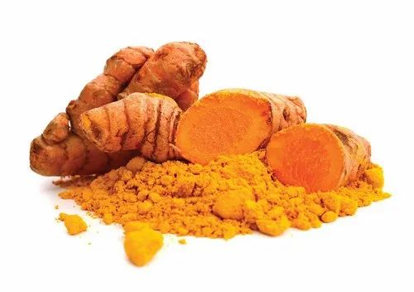
- Family: Zingiberaceae
- Synonym: Curcuma longa L.
- Part To be used: Roots
- Use : Fig no.5: Turmeric
- It contains curcuminoids like curcumin, demethoxycurcumin, and bisdemethoxycurcumin, along with volatile oils.
- It helps with reducing inflammation, protecting against free radicals, killing bacteria, and healing wounds, which can prevent acne and improve the skin's look.
3. Aloe Vera (Aloe vera L. Burm. f.)
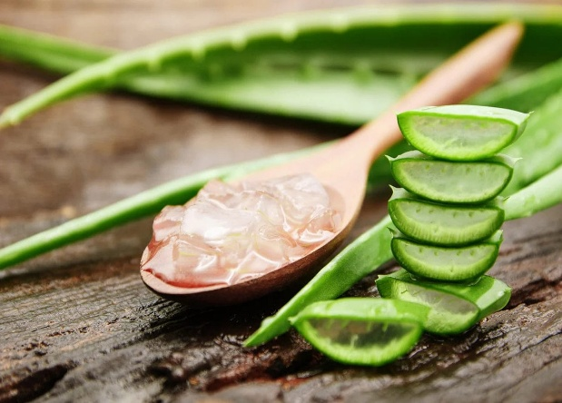
- Biological Source: Aloe gel consists of the mucilaginous gel obtained from the fresh leaves of Aloe vera (L.) Burm. F.
- Family: Asphodelaceae
- Synonym: Aloe vera (L.) Burm. F.
- Part To be used: Leaves
- Use :
- It has acemannan, glucomannan, vitamins A, C, and E, along with minerals. Fig no.6: Aloe Vera
- It helps to keep the skin hydrated, reduce inflammation, heal wounds, and soothe the skin.
4. Glycerine:
- Synonym:- Glycerol, Propane-1,2,3-triol,1,2,3- Propanetriol, E422 (as a food additive code)
- Molecular formula: - C3H8O3
- Molecular weight: - 92.09 g/mol
- Chemical name: - Propane-1,2,3-triol
- Properties: -
- Physical appearance: Clear, colourless, viscous liquid with a sweet taste.
- Odor: Odourless.
- Solubility: Miscible with water, alcohol, and most polar solvents; insoluble in oils.
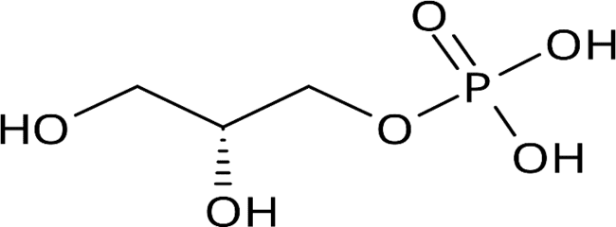
- Boiling Point:290 °C.
- Melting Point:18.2 °C.
- Density: Approximately 1.26 g/cm³.
- Hygroscopic: Absorbs moisture from the air. Fig no.7: Glycerin
- Uses: Cosmetic Industry: A key ingredient in moisturizers, creams, and lotions for its hydrating properties.
This is a moisturizer that helps prevent dryness and improves the smoothness of the mask.
5. Polyvinyl Alcohol (PVA)
This acts as the base that forms a film, giving the mask its peel-off feature
- Type: Synthetic polymer (polyhydroxy compound)
- Molecular Formula: (C₂H₄O)n
- Molecular Weight: Varies with degree of polymerization (commonly 20,000–200,000)
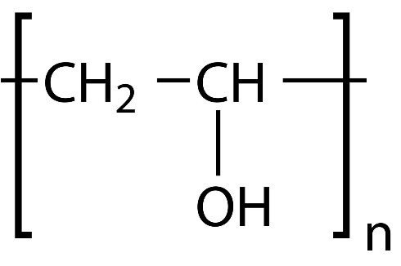
- Chemical Structure

Fig no.8: Polyvinyl Alcohol
- Uses
- Binder in tablets and capsules
- Film-forming agent in coatings
- Viscosity enhancer in ophthalmic solutions and gels
- This improves the strength, thickness, and stability of the formulation.
6. Polyvinylpyrrolidone (PVP)
- Type: Synthetic, water-soluble polymer
- Molecular Formula: (C₆H₉NO)n
- Molecular Weight: 10,000 – 700,000 (depending on grade, e.g., PVP K-30, K-90, etc.)
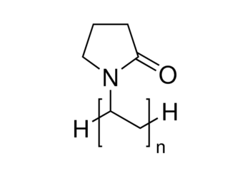
- Chemical Structure:

Fig no.9: Polyvinylpyrrolidone

- Uses
- Binder in tablet formulations
- Disintegrant (in cross-linked form – Crospovidone)

7. Xanthan Gum
- Molecular structure: β-D-glucose backbone (like cellulose) with trisaccharide side chains
- Chemical Formula: (C₃₅H₄₉O₂₉)n
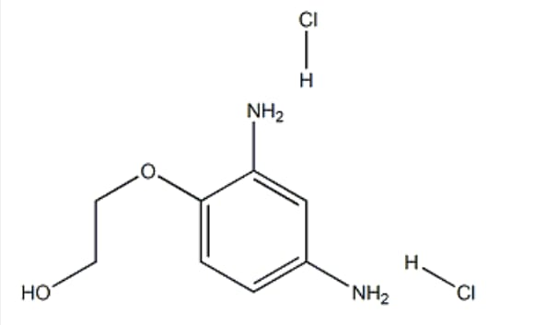

Fig no.10: Xanthan Gum
- Uses
- Suspending agent – Maintains uniform dispersion of insoluble particles
- Thickening agent – Used in gels, creams, syrups, and lotions
- Stabilizer and emulsifier – Enhances viscosity and stability of formulations
This helps thicken and stabilize the mixture, ensuring it has a smooth texture.
8. Methyl Paraben
- Chemical Nature
- Type: Synthetic ester (alkyl ester of p-hydroxybenzoic acid)
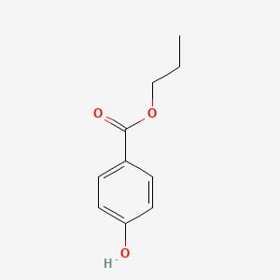
- Chemical Name: Methyl p-hydroxybenzoate
- Molecular Formula: C₈H₈O₃
- Molecular Weight: 152.15 g/mol
- Chemical Structure:

Fig no.11: Methyl Paraben

- Uses
- Widely used as an antimicrobial preservative in oral, topical, and parenteral formulations.
- Effective against fungi and some bacteria.
9. Propyl Paraben [32]
- Chemical Name: Propyl p-hydroxybenzoate
- Molecular Formula: C₁₀H₁₂O₃
- Molecular Weight: 180.20 g/mol
- Chemical Structure:

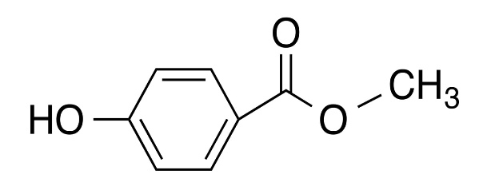
Fig no.12: Propyl Paraben
- Uses
- Used as a preservative in:
- Oral preparations: Syrups, suspensions
- Topical preparations: Creams, ointments, gels, and lotions

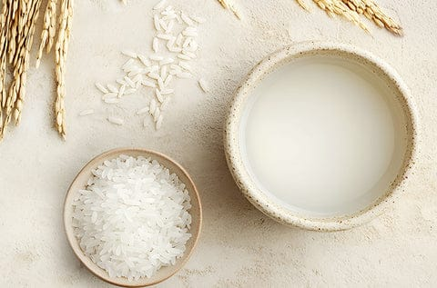
10. Rice Water (Oryza sativa L.)
- Biological Source: Rice water is the starchy water obtained after soaking or boiling rice (Oryza sativa Linn.), a member of the family Poaceae. It contains water-soluble vitamins, minerals, amino acids, and carbohydrates derived from rice grains.
Biological Name: Oryza sativa Linn. Fig no.13: Rice Water
- Family: Poaceae (Gramineae)
- Part of plant : seed
- Common Names: Tandulodaka
- Uses
- Skin care: Natural cleanser, toner, and moisturizer; improves skin texture and elasticity.
- Hair care: Strengthens roots, promotes growth, and adds shine; used in herbal shampoos and conditioners.
Anti-inflammatory: Soothes irritated or sunburned skin
- This contains starch, vitamins B1–B3, and minerals.
- It helps improve the skin's color and elasticity.
11. Rose Water
- Synonym: Rose Hydrosol, Rose floral Water
- Family: Rosaceae
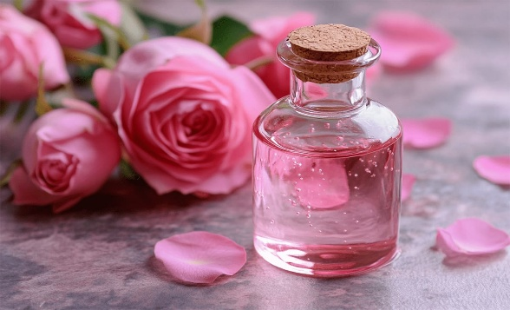
- Parts To be used: Rose Petals
- Medicinal Uses: Acne treatment, Toner, eye Car.
- Use : Fig no.14: Rose Water
- This serves as a natural toner and adds a pleasant fragrance.
- It also has mild anti-inflammatory properties.

7. METHOD OF FORMULATION [33]

Steps: -
- Take approximately 20 ml of rose water in a clean beaker and add 5 g of Polyvinyl Alcohol (PVA) slowly with continuous stirring. Heat the mixture at 80–90°C until a clear solution is obtained.
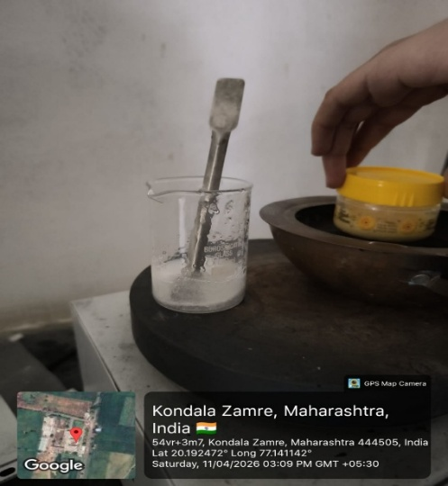
Fig no. 18: - preparation of sample

- In a separate beaker, disperse 1.5–2 g of Hydroxypropyl Methylcellulose (HPMC) in 10–15 ml of cold rose water. Allow it to hydrate properly to form a viscous solution.
- Add the prepared HPMC solution slowly into the warm PVA solution with continuous stirring to obtain a uniform gel-like base.
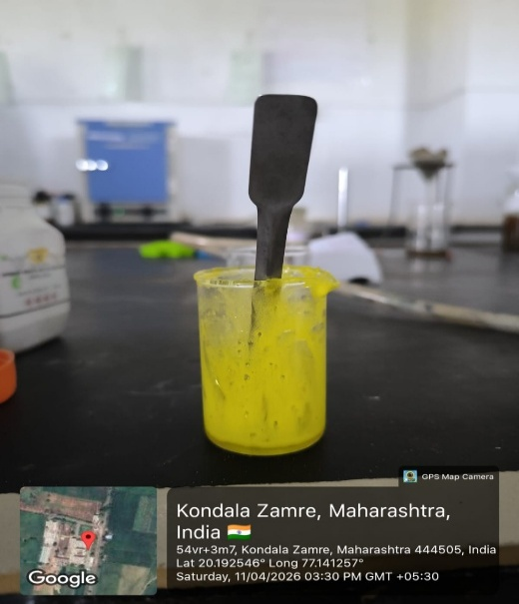
- Add Aloe vera gel (2.5 ml), pineapple extract (1 ml), turmeric extract (0.3 ml), rice water (5 ml), and glycerin (1 ml) to the base. Mix thoroughly to ensure uniform distribution.

Fig no. 19: - addition of ingrediant
- Dissolve methyl paraben (0.05 g) and propyl paraben (0.01 g) in a small quantity of warm water and add this solution to the formulation. Stir well.
- Add rose water quantity sufficient (q.s.) to make the final weight up to 50 g. Mix thoroughly to obtain a smooth and homogeneous gel.
- Transfer the prepared peel-off mask into a clean, dry, and airtight container.
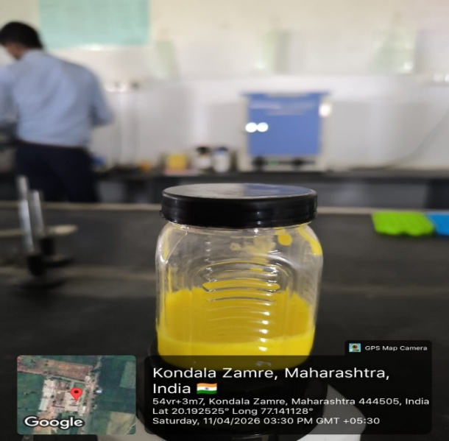

Fig no. 20: - prepaid sample

8. EVALUTION PARAMETER s [33]
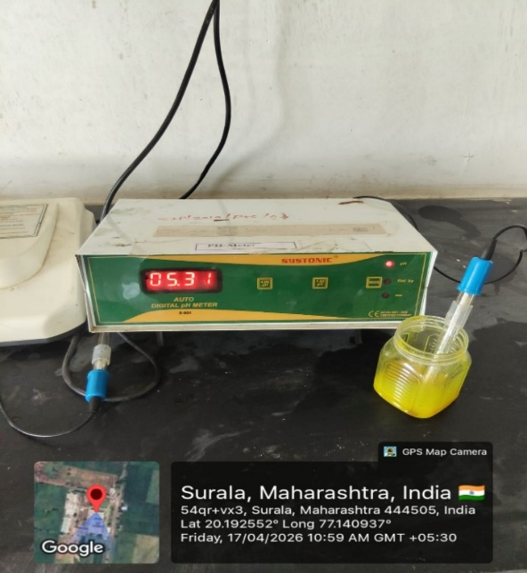
- Determination of pH: The pH of the formulation was measured using a digital pH meter.
Before using the meter, it was calibrated with standard buffer solutions at pH 4, 7, and 9.

Fir no. 21: - Determination of pH
- Physical evaluation: The physical characteristics of the formulation, such as color, appearance, consistency, and texture, were assessed.
- Colour: The color was checked against a white background.
- Consistency: The consistency was determined by applying the formulation onto the skin.
- Greasiness: The greasiness was evaluated by applying the formulation onto the skin.
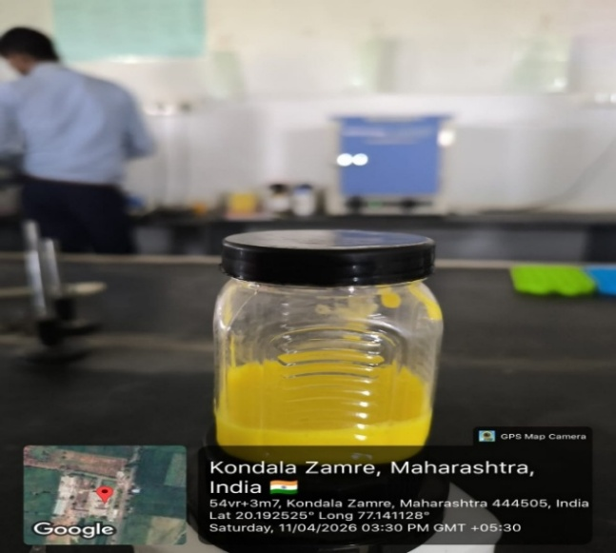
- Odor: The odor of the gel was examined by mixing the gel with water and then observing the odor.

Fig no. 22: - Physical evaluation
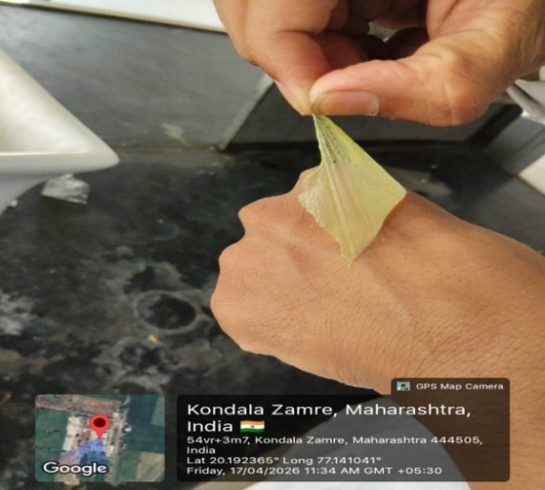
3) Peel Off Test: After applying the peel-off gel, it was evenly spread over the face and hands and left to dry. Studies indicate that the optimal drying time for a peel-off gel mask usually ranges from 15 to 30 minutes. A stopwatch was used to measure the drying time of the gel mask, which turned out to be 18 minutes. Once the mask was completely dry, it was easily peeled off the skin without breaking apart, as shown in the accompanying illustration.

Fig no. 23 : - Peel of test
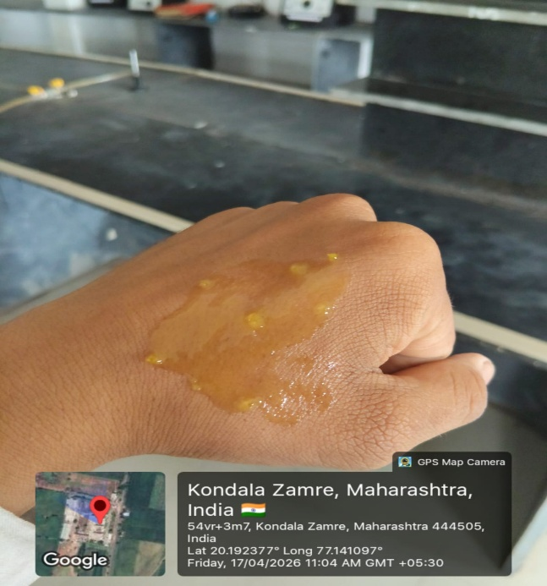
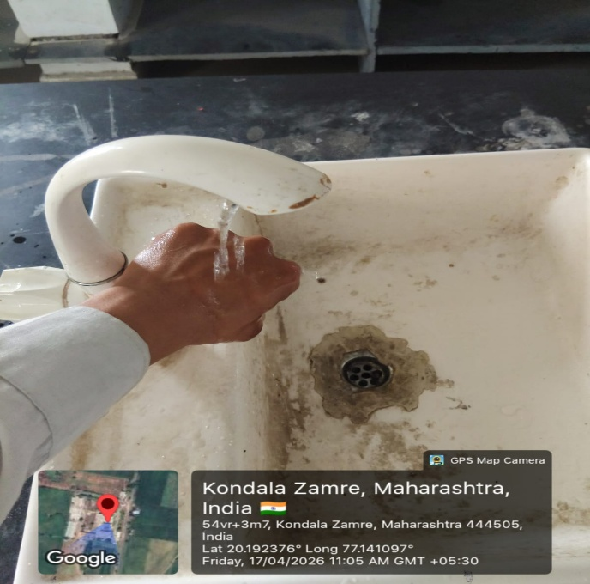
- Washability: The formulations were applied to the skin, and then washing with water was carefully observed. The washability of the prepared peel-off mask was satisfactory.
After
Before

Fig no. 24: - Washability test before and after

- Irritation Test: This test was conducted using a patch test. Any signs of skin irritation at the patch site might indicate an allergic reaction.
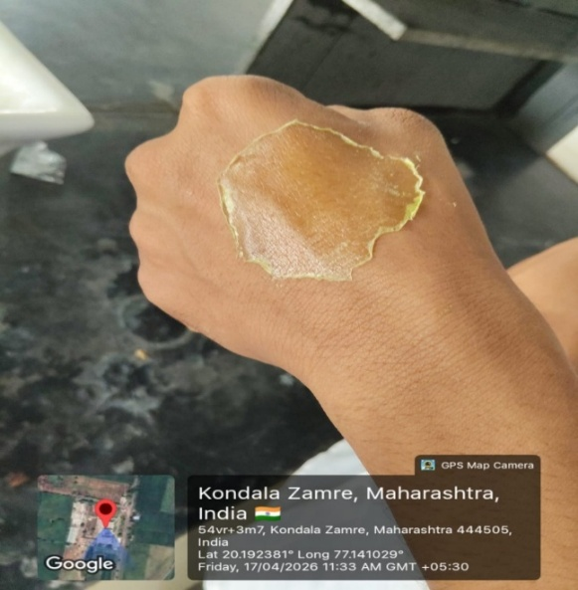

Fig no. 25: - Irritant test
- Spread Ability: To evaluate spread ability, excess gel sample was placed between two glass slides and pressed to a uniform thickness by applying a weight of --- grams on the pan.
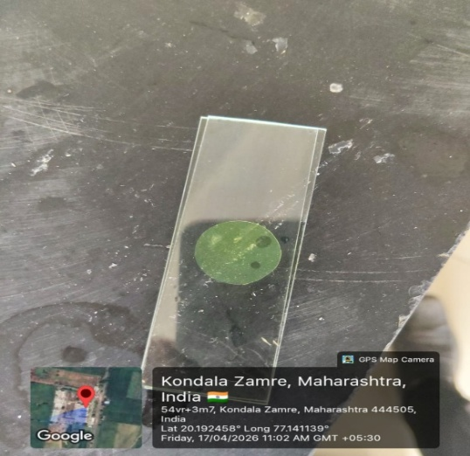
The time it took for the upper glass slide to separate from the lower plate indicated spread ability. The formula used was
S = m X ^{l} /_{t}
Where,
S- spreadability.
m-Weight tied to upper slide.
L: l Length moved on glass slide.
t- time taken.

Fig no. 26: - spread ability

9. RESULT
The formulated herbal peel-off face mask containing pineapple and turmeric extracts showed satisfactory evaluation results:
- Physical appearance: Smooth, uniform gel with good consistency and pleasant odor.
- pH: Found to be within the acceptable skin-friendly range, indicating suitability for topical application.
- Drying time: Approximately 18 minutes, which falls within the ideal range (15–30 minutes).
- Peel-off property: The mask formed a uniform film and was easily peeled off without breaking.
- Spreadability: Showed good spreadability, ensuring easy application on the skin.
- Washability: Easily washable with water.
- Irritation test: No signs of irritation or allergic reaction were observed, indicating it is safe for skin use.
10. SUMMARY AND CONCLUSION
12.1. Summary
We made a face mask using pineapple and turmeric to see if it works well. People are liking cosmetics more because they are safe and do not have many side effects. Pineapple helps with exfoliating, antioxidants and acne while turmeric helps with inflammation and germs. We used some ingredients like polyvinyl alcohol to make a film, polyvinylpyrrolidone, glycerin to keep skin moist and xanthan gum to keep it stable. We tested the face mask for things like pH, how it looks, how easy it spreads how long it takes to dry and if it irritates skin.The results showed that our face mask had a pH felt right dried well was easy to peel off and did not irritate skin. Our study showed that a face mask with pineapple and turmeric is safe works well and is good for skin. This face mask has properties, dries well and peels off easily without hurting skin. Pineapple and turmeric make it better for skin with benefits like fighting acne being an brightening skin. The face mask is also stable. People like it. So this face mask is an affordable product, for healthy skin.
12.2. Conclusion
In this study we found that our herbal peel-off face mask with pineapple and turmeric extracts is safe to use. The mask works well. Does not irritate the skin. It has film-forming properties and dries in an appropriate amount of time. The mask also peels off easily. Using ingredients like pineapple and turmeric extracts gives the mask extra benefits. These benefits include helping with acne fighting antioxidants and brightening the skin. The mask also remains stable. Users like it. So this herbal peel-off mask seems like an affordable option for taking care of your skin. It can help keep your skin healthy and look better. The pineapple and turmeric extracts make it a promising product. Overall it is a product, for topical application.
11. REFERENCES
- Zaenglein AL, Graber EM, Thiboutot DM, Strauss JS. Acne vulgaris and acneiform eruptions. Fitzpatrick's dermatology in general medicine. 2008;7:687-703.
- Kurokawa I, Danby FW, Ju Q, Wang X, Xiang LF, Xia L, Chen W, Nagy I, Picardo M, Suh DH, Ganceviciene R. New developments in our understanding of acne pathogenesis and treatment. Experimental dermatology. 2009 Oct;18(10):821-32
- Rahmawanty D, Yulianti N, Fitriana M. Formulation and evaluation the peel-off face mask contains quercetin with variations concentrations of gelatin and glycerin. Med Farm. 2015;12(1):17-2.
- Ayala-Zavala, J.F., Rosas-Domínguez, C., Vega-Vega, V. and González-Aguilar, G.A. (2010) Antioxidant Enrichment and Antimicrobial Protection of Fresh-Cut Fruits Using Their Own by Products: Looking for Integral Exploitation. Journal of Food Science, 75, R175-R181.
- Piana, C.F., Featherstone, A. and Boland, M. (2005) Vertical Integration in Ecuador: The Case of Fresh-Cut Pineapples. Review of Agricultural Economics, 4, 593-603.
- Jovanovic, M., Milutinovic, M., Kostic, M., Miladinovic, B., Kitic, N, Brankovic, S. and Kitic, D. (2018) Antioxidant Capacity of Pineapple (Ananas comosus (L.) Merr.) Extracts and Juice. Lekovite Sirovine, 38, 27-30.
- E. Pagano et al.The clinical efficacy of curcumin containing nutraceuticals: an overview of systematic reviews Pharmacol Res (2018)
- D. Pieper et al. Systematic review finds overlapping reviews were not mentioned in every other overvie J Clin Epidemiol (2014)
- A. Sahebkar A systematic review and meta-analysis of randomized controlled trials investigating the effects of curcumin on blood lipid levels Clin Nutr [Internet] (2014)
- F. Yuan et al. A Systematic Review and Meta-analysis of Randomized Controlled Trials on the Effects of Turmeric and Curcuminoids on Blood Lipids in Adults with Metabolic Diseases Adv Nutr (2019)
- A. Demmers et al. Effects of Medicinal Food Plants on Impaired Glucose Tolerance: a Systematic Review of Randomized Controlled Trials Diabetes Res Clin Pract (2017)
- L.E. Simental-Mendía et al. A systematic review and meta-analysis of the effect of curcuminoids on adiponectin levels Obes Res Clin Pract (2019)
- J. Wu et al. Efficacy and side effect of curcumin for the treatment of osteoarthritis: a meta-analysis of randomized controlled trials Pak J Pharm ScI (2019)
- Y. Panahi et al. Antioxidant and anti-inflammatory effects of curcuminoid-piperine combination in subjects with metabolic syndrome: a randomized controlled trial and an updated meta-analysis Clin Nutr (2015)
- G. Derosa et al. Effect of curcumin on circulating interleukin-6 concentrations: a systematic review and meta analysis of randomized controlled trials [Internet] Pharmacological Research. Elsevier Ltd (2016)
- A. Sahebkar et al. Curcumin downregulates human tumor necrosis factor-α levels: a systematic review and meta-analysis of randomized controlled trials Pharmacol Res [Internet] (2016)
- Bartholomew, D. P., Paull, R. E., & Rohrbach, K. G. (2003). The Pineapple: Botany, Production and Uses. CABI Publishing, Wallingford, UK.
- Morton, J. (1987). “Pineapple.” In: Fruits of Warm Climates. Julia F. Morton, Miami, FL, pp. 18–28.
- Kirtikar, K. R., & Basu, B. D. (2003). Indian Medicinal Plants (Vol. 4, pp. 2427–2431). Dehradun: International Book Distributors.
- Nadkarni, K. M. (1976). Indian Materia Medica (Vol. 1, pp. 414–418). Bombay: Popular Prakashan.
- Marks, R., & Miller, K. (2020). Anatomy and Physiology of the Skin. In: Dermatology, 5th Edition, Elsevier Health Sciences.
- Zouboulis, C. C. (2009). Sebaceous gland: the key player in skin physiology and pathology. Journal of the European Academy of Dermatology and Venereology, 23(8), 946–952.
- Purnapatre, S. M., & Pundkar, A. S. (2025). Formulation and evaluation of herbal peel off mask. World Journal of Pharmaceutical and Medical Research (WJPMR), 11(5), 233–244.
- La Udu, A., Suparman Supardi, & Yuyun. "Formulation Of Gel Mask Preparation Peel Off Rom Basil Leaf Extract (Ocimum sanctum Linn)". International Journal of Multidisciplinary Learners, 2024; 1(1): 148-155.
- Sharma, S., & Dutta, A. (2020). Formulation and evaluation of herbal peel-off mask for different skin types. International Journal of Pharmaceutical Sciences and Research, 11(7), 1000–1006.
- Samarth, N., Band, N., Sonare, M., & Gadge, M. (2023). Review on herbal peel off mask – An approach to anti-aging and skincare. International Journal of Pharmaceutical Sciences, 3(1). Article ID IJPS/250301063. P. R. Patil Institute of Pharmacy, Talegaon (S.P.) Ashti, Wardha.
- Research Article on Formulation and Evaluation of Activated Charcoal Peel Off Mask by Sweta Kulkarni in International journal of pharmacy Research & Technology July-December 2019 ,Vol 9, Issue 2.
- S. Lokhande ,Article on Formulation and Evaluation of Polyherbal peel off mask ;Asian journal of Pharmaceutical Research and Development; 2024;23-28;12(3).
- R.Shamly H.Nasrin ,Design and Formulation and Optimization of peel off Face Mask Gel for the treatment of Rosacea, journal of pharmaceutical research science and technology (2022) vol 6
- Sharma, P., & Chaudhary, A. (2020). Formulation and evaluation of herbal peel-off face mask. Journal of Drug Delivery and Therapeutics, 10(5), 187–192.
- Kokate C.K., Purohit A.P., Gokhale S.B. Pharmacognosy, Nirali Prakashan.
- Khandelwal K.R. Practical Pharmacognosy, Nirali Prakashan.
- Mahajan, S. B., Patil, H., Solanki, K., Tare, T., Wagh, S., Sonare, P., & Bairagi, V. A. (2024). Formulation and Evaluation of Multi-Herb Peel Off Mask. International Journal of Pharmaceutical Sciences Review and Research, 84(4), 143–149. https://doi.org/10.47583/ijpsrr.2024.v84i04.022

