Implementation of a Real-Time Cyber Incident Monitoring Tool

Abstract
In a world where cyber threats are constantly changing, the capability to monitor, detect, and analyze security incidents in real time has become an important part of modern cybersecurity frameworks. The following paper proposes a hybrid approach that includes rule-based detection, artificial intelligence, and machine learning in order to improve the precision and speed of cyber incident monitoring. The proposed system architecture leverages a MERN-based web platform for user interaction and visualization, while introducing automation modules using Python and JavaScript for data collection and preprocessing. Data aggregation is performed from diverse and dynamic sources, including publicly available threat portals, dark web forums, and community-based security repositories. Collected data will then be contextually analyzed and classified to identify patterns, anomalies, and possible threats. The proposed framework can show scalability, adaptability, and more effective incident response while reducing human intervention. This work contributes to the development of intelligent data-driven cybersecurity systems capable of proactive defense strategies in real-world environments.
Keywords: Machine Learning, Cyber Security, Incident Monitoring, Web Scraping, Threat Intelligence.
- Introduction
In today's hyper-connected digital world, cyber-attacks have become alarmingly frequent and sophisticated. The identification, analysis, and mitigation of threats before they become major incidents continue to be a relentless challenge for organizations across industries-from technology firms all the way to cybersecurity agencies. Unfortunately, most existing mechanisms for the monitoring of cyber incidents tend to operate within their isolated silos with no central mechanism for real-time tracking and quick incident reporting. This results in delayed responses with fragmented data analyses and reduced situational awareness overall.
A hybrid framework that merges rule-based logic and artificial intelligence/machine learning has been developed to efficiently streamline incident detection and improve response accuracy. The system couples automated data ingestion pipes that curate intelligence from the various online ecosystems, ranging from cybersecurity forums and publicly listed repositories to dark web sources, hence affording a more holistic perspective on potential threats.
It also integrates a web-based interface based on the MERN stack for interactive visualization and user management, which lets cybersecurity professionals do their analysis intuitively and accessibly. It has been designed as a prototype to demonstrate how centralized automation combined with hybrid intelligence can substantially raise the efficiency of the monitoring of cyber threats and decision-making processes.
The proposed system is described in this paper, with an emphasis on design and implementation: hybrid approach, scalable architecture, and the ability for faster data-driven responses. Equipped to bridge the gap in fragmented monitoring tools and intelligent automation, the framework lays down the ground for next-generation cyber defense infrastructure.
2. Proposed System
The system will provide an automated real-time pipeline for monitoring cyber incidents that can help organizations identify, classify, and interpret the threats targeting CII. It integrates web scraping, machine learning, and a MongoDB-backed storage and visualization layer to build timely insights that help cybersecurity teams respond more accurately and confidently.
The overall architecture is structured into three coordinated modules:
- Data Scraping and Collection
- Data Processing and Machine Learning Analysis
- Data Storage and Visualization
Each module is responsible for a particular function, but all three functions run in a continuous cycle: acquisition of relevant threat data, intelligent analysis of the data, and presentation through visual means for strategic decisions.
A. Data Scraping and Collection
The first module of the system deals with the automated extraction of cyber threat data from various online sources. Since cybersecurity information is dispersed across blogs, advisories, and forums, this module is important in the offering of a complete view of the evolving threat landscape.
Data Sources
The scraper targets publicly available sources, including:
- Cybersecurity blogs and portals, such as The Hacker News or Bleeping Computer.
- Official advisories by organizations like CERT-In and US-CERT.
- Threat intelligence platforms: e.g., IBM X-Force Exchange, AlienVault OTX
- Public forums and discussion boards where attack trends and threat indicators are discussed.
Implementation
It is implemented in Python using the Scrapy and BeautifulSoup libraries, which guarantee efficiency and automation of data extraction. The structured information (incident title, attack type, date, source, and sector of impact) will be captured alongside the unstructured text of incident descriptions or reports. Most records will contain:
- Incident Title
- Date and Time
- Attack Type (e.g., Phishing, DDoS, Malware)
- Source or Origin
- Target Sector
- Brief Description
Data collected is temporarily kept in JSON or CSV format and then forwarded for preprocessing. Duplicate entries, irrelevant content, and malformed data are filtered automatically to maintain the accuracy and consistency of the dataset.
B. Data Processing and Machine Learning Analysis
After the data is collected, it undergoes a preprocessing and analytical phase to ensure quality and extract meaningful insights using machine learning. This module transforms raw, unstructured data into classified and interpretable information.
Data Preprocessing
Data preprocessing is an essential stage during which the system performs:
- Cleaning: Removal of missing or redundant entries.
- Normalization: Organizing different data fields into a standard form.
- Noise Filtering: Removing irrelevant words or symbols, typically done using techniques from NLP.
Feature Extraction: Identifying attributes such as attack vector, time, frequency, and impact severity.
These operations are performed in Python using its libraries: Pandas and NumPy for handling data and NLTK for text normalization and tokenization.
Machine Learning Models
Analysis and classification of incidents rely on mainly two ML techniques:
a) Attack Classification - Supervised Learning:
A Random Forest Classifier is trained on a labeled dataset of previous cyber incidents. It automatically categorizes new incidents into classes such as Malware, Phishing, Ransomware, and DDoS. This helps security analysts quickly understand the nature and severity of each attack.
b) Anomaly Detection (Unsupervised Learning): It uses K-Means Clustering as a mechanism to identify unusual behavior or spikes in attack frequency. In this way, the solution provides early identification of emerging or zero-day threats by segregating anomalous patterns from the normal distribution of data. c) NLP-based text analysis: The BoW and NLP convert the textual incident descriptions into numerical vectors. They are used to extract keywords and identify trending threat vectors across time and geography. The processed, structured, and labeled data is then sent for long-term storage and visualization in the MongoDB database.
C. Data Storage and Visualization
The processed data will be securely stored and represented visually using MongoDB, together with a custom-built visualization layer, thereby helping the cybersecurity analysts in observing patterns and trends as they happen.
Data Storage
MongoDB acts as the main data repository because of its flexibility, scalability, and JSON-like structure. Each incident related to cybersecurity is represented as a document with key attributes-attack type, date, sector, and severity. MongoDB's indexing and aggregation abilities enable real-time queries and allow analytical operations such as filtering incidents by attack type, country, or date.
Visualization Layer
The visualization layer serves as the front-end interface and allows the user to understand and analyze the cybersecurity data represented visually. It directly fetches data from MongoDB through aggregation queries and displays the insights with the help of interactive charts built on Plotly and Chart.js.
Visualization Components
This dashboard comprises various types of visualizations that support different analytical needs:
-Bar Graphs: Show the frequency of the attack types- --daily, weekly, or monthly.

-Pie Charts: Pictorial representation of the distribution of incidents, either by attack type or region.
-Timeline Charts: Show the temporal tendency of cyber incidents and enable analysts to identify periods of increased activity.
Sector-Wide Segregation: Incidents are categorized and represented on sectoral grounds, namely energy, healthcare, finance, education, and government. This helps organizations focus on sector-specific vulnerabilities and emerging risks.
Dashboard Functionality
The dashboard provides an easy-to-use interface through which one can:
Incidents can be filtered by time range, sector, or attack type.
-Real-time updates from MongoDB whenever new data is inserted.
Overview of high-risk periods, dominant attack types, and severely targeted sectors.
-Dynamic alerts for repeated or serious attack incidents.
Purpose and Benefits This layer of visualization convert raw information to intelligence, thereby enhancing situational awareness and reducing incident response time. With these visualizations, cybersecurity professionals are able to: - Identify emerging attack patterns. - Compare sectoral vulnerabilities. - Observe attack trends in real-time to plan informed defenses.
3. System Interface Overview
The system involves an interactive, user-friendly Web interface that supports SOC analysts in visualizing and assessing real-time cyber incidents against CII. The interface will be presented in such a way that it guarantees ease of navigation, clarity of incident severity, and actionable insights supportive of quick decision-making. The overall platform involves different modules like authentication, incident visualization dashboards, sectoral threat analysis, timeline views, and user profile management.
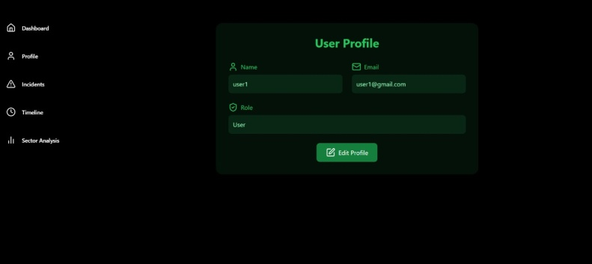
figure 3.1: Login Page
This screen serves as a secure authentication gateway to enter the system. It requires a registered e-mail and password for entry. The interface includes all the usual elements: text input fields, a "Sign In" button, and another link to register for new users. The minimal design allows quick and distraction-free login, maintaining security.
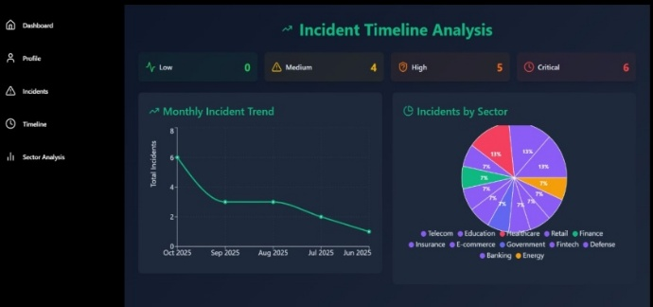
figure 3.2: Analytics Page
This dashboard provides a clear, primary analytical interface for SOC analysts. It shows the classification of cyber incidents, based on their severity, on four levels: Low, Medium, High, and Critical. This helps to achieve rapid situational awareness. The Monthly Incident Trend visualization on the dashboard plots the incident volume fluctuation over time to show emerging attack patterns and seasonal variations.
It also provides an Incidents by Sector distribution chart that maps the threats against various critical industry domains, such as telecommunications, finance, education, and retail. This sector-wise insight assists analysts in prioritizing defense strategies and investing resources more appropriately toward sectors showing higher risk exposure.
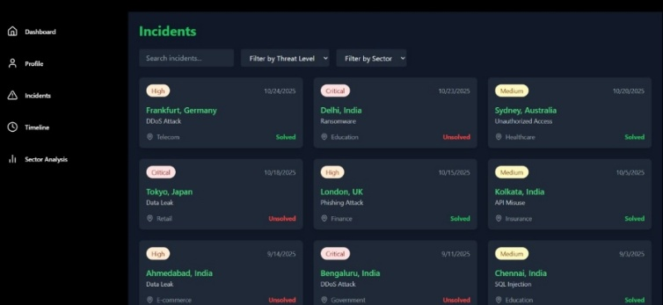
figure 3.3: Incidents Page
It provides a tabular representation of individual incident records and captures the essential attributes of an incident, such as geographic origin (city and country), the category of cyber threat (for example, Distributed Denial of Service, ransomware, data leakage), impacted sector, date of occurrence, incident resolution status (resolved or unresolved), and corresponding severity classification (low, medium, high, or critical). This screen has sector-based and severity-based filtering options and a keyword search functionality that allows analysts to query and refine incident datasets efficiently. It presents data in a structured fashion and best supports effective prioritization of incident response activities, thereby enhancing situational awareness for SOC teams.
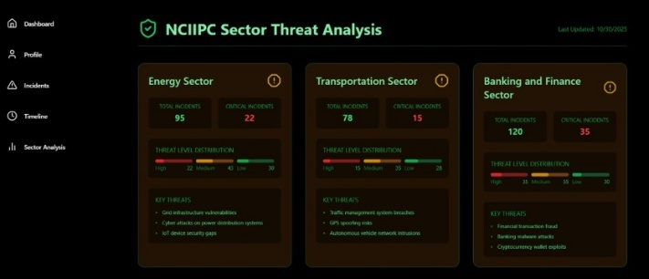
figure 3.4: Comparison Page
This module provides a comparative overview of cyber incidents across key CII sectors. In each sector, it displays the total and critical incident counts, together with a severity-based threat level distribution-high, medium, and low. Key recurring threat patterns are summarized, showing the primary attack vectors affecting each sector. The structured insight at the sector level will thus enable the SOC analyst to pinpoint high-risk domains and prioritize targeted mitigation strategies.
4. Results and Discussion
This real-time cyber incident monitoring system is able to automate the process of collecting, structuring, and visualizing ongoing cyber incidents against CII. The web scraping framework extracted incident data from various publicly available threat reporting portals and security feeds, the processing pipeline normalized the data into consistent formats suitable for ingestion into monitoring platforms. This generated dashboards for continuous visualization of incident trends and distributions of their severity and sector-specific threat exposures. On resulting dashboards, the SOC analysts were able to get aggregated threat intelligence both at the macro and micro granularity levels that allow supporting rapid incident triage and situational awareness.
The visual analytics component of the system allowed analysts to extract such patterns as increasing attack frequency against the Banking and Finance sector or repeated vulnerability exploitation in Energy infrastructure systems. The correlation of threat severity with the affected sectors also underlined the areas needing urgent reinforcement on the defensive side. Enabling real-time monitoring instead of post-incident reporting, the framework contributes to enhancing proactive cyber defense readiness. The larger-scale deployment of such monitoring solutions contributes to national-level cyber resilience by reducing detection delays, improving coordinated response, and increasing transparency over the evolving cyber-risk landscape. Such systems are a guarantee of economic stability, public services, and national security, especially for those countries relying substantially on digital infrastructures.
5. Future Scope
The current system effectively monitors cyber incidents in real-time using web scraping, machine learning, and MongoDB for data collection, classification, and visualization. In the future, this framework can improve by including live threat intelligence feeds and APIs like VirusTotal, AbuseIPDB, AlienVault OTX, and MITRE ATT&CK. This addition would allow the correlation of scraped data with verified indicators of compromise (IOCs) for better threat detection.
The machine learning pipeline currently uses algorithms such as Random Forest and K-Means. It can be further strengthened by adopting deep learning and natural language processing models such as LSTM, BERT, or other transformer-based architectures. These models can help identify zero-day attacks and decipher semantic relationships in threat data. Furthermore, adding automation and real-time alerting through email, SMS, or Telegram bots will turn the current passive monitoring dashboard into an active alert system. The project can also expand to integrate with SIEM tools. This integration allows verification between open-source data and internal network logs, creating a unified cybersecurity monitoring system. Lastly, to support growth and performance as data volume increases, the MongoDB database can be set up in a distributed or sharded environment like MongoDB Atlas. This setup ensures efficient big data handling and real-time analytics, even with high data loads.
6. Conclusion
With the rapid growth and increasing complexity of cyber activities, timely insights into new threats have never been more critical. This work reflects our hands on experience in creating a real time cyber incident monitoring system. This system helps organizations understand and respond to the changing cybersecurity landscape more effectively. By combining automated information gathering with smart data analysis, the system shows how digital technologies can turn scattered cyber data into useful knowledge for better decision making. The results highlight both the benefits and the drawbacks of using data driven solutions to improve awareness and readiness in cybersecurity operations. Additionally, this study emphasizes the need to create systems that are clear, actionable, and easy for security professionals to use. Ultimately, the project aims to close the gap between human decision making and intelligent automation, promoting a more proactive and resilient way to manage cyber risks.

