A Revit-Based Plugin for Acoustic Performance Integration in Sustainable Interior Architecture
Laurantine Awah¹, Fonbeyin Henry Abanda^{2*}, Ngome Ngome³ and Ambe Sangbong⁴
¹Ecole Nationale Supérieure des Travaux Publics, B.P 510, Yaoundé, Cameroon
²Ecole Nationale Supérieure des Travaux Publics, B.P 510, Yaoundé, Cameroon
³ETS PRO-SPACE, Yaoundé, Cameroon
⁴DME Systems Sarl, Douala, Cameroon
* Correspondence: fonbeyin@gmail.com)

Abstract
Indoor acoustic performance is increasingly recognized as a key component of sustainable interior design, influencing occupant’s comfort, perception, and productivity. Effective acoustic analysis requires the integration of geometric data, such as spatial layout, with non-geometric data, including material sound absorption properties. While early-stage analysis is essential to avoid costly retrofits, current practices rely heavily on standalone tools like ODEON Room Acoustics Software, which often limit integration with the broader design workflow. Building Information Modelling (BIM) provides a holistic platform where acoustics can be embedded alongside architectural, structural, and sustainability considerations. This study addresses the gap between acoustic and sustainable interior design by developing a custom Revit plugin using the Autodesk Revit API in C#. The plugin calculates reverberation time (RT60) through Sabine’s and Eyring’s formulas, extracting geometric and material data from Revit and an external material database. Results are reintegrated into the BIM model as new attributes, enabling visualization within Revit, export as .csv files, and frequency-based data highlighting. Findings show that embedding acoustic analysis within BIM enhances efficiency, supports informed material selection, and enables performance-based decision-making in sustainable interior design. By integrating sound quality with sustainability goals, this approach contributes to healthier, more comfortable, and environmentally responsible interior environments.

Keywords: Acoustic Performance; BIM; Decision Support Systems; Sustainable Interior Design; Reverberation Time

1. Introduction
Acoustic studies advanced considerably during the 18th, 19th, and early 20th centuries, with a significant milestone achieved by Wallace Sabine in the late 19th century. Sabine quantified the relationship between room characteristics and reverberation time, laying the foundation for modern acoustic design [1](Addis, 2009). More recently, the focus has shifted toward integrating acoustics as a core element of interior design, balancing aesthetics, functionality, and comfort through the use of advanced natural materials and innovative technologies such as Building Information Modelling (BIM) [2](Salpriyan et al., 2025). Today, acoustic design is recognized as essential not only in performance spaces but also in offices, industrial facilities, and everyday interiors. Strategies typically combine spatial planning, material selection, and, where necessary, electronic devices to optimize sound quality and enhance user well-being.

Addressing acoustic deficiencies is crucial in sustainable interior design because acoustic comfort directly impacts occupant health, well-being, and productivity [3](Li et al., 2020). Furthermore, sustainability frameworks such as LEED increasingly emphasize acoustic performance, requiring noise control and sound insulation as part of certification processes aligned with the UN Sustainable Development Goals [4](Thede, 2024). Poor acoustic conditions can undermine space functionality, leading to discomfort, stress, reduced satisfaction, and lower building efficiency. The application of BIM in acoustic design provides substantial benefits by enabling early and integrated assessment of key parameters, including reverberation time and sound pressure levels. This allows designers to optimize both acoustic comfort and sustainability from the project’s initial stages [5](Sušnik et al., 2021). BIM also facilitates collaboration within the AEC industry by reducing errors and ensuring that acoustic solutions are seamlessly coordinated with other building systems.

BIM authoring software supports acoustic design by visually mapping and simulating interior sound performance. It can quickly detect deficiencies, propose alternative solutions, and generate instant reports to inform decision-making and improve collaboration among project stakeholders [6](Châteauvieux-Hellwig et al., 2022). By embedding acoustics into BIM workflows, projects can deliver more comfortable and productive indoor environments while minimizing costly post-construction modifications. However, despite these advantages, the field of interior acoustics faces persistent challenges. These include a lack of critical evaluation of design methods, the need for more effective sustainable strategies, and limited application of BIM-based acoustic tools in practice. Such gaps can compromise decision-making and lead to performance issues. This creates a pressing need for innovative approaches to integrating acoustic analysis into BIM-enabled workflows.

From this context, the central research question arises: how can BIM be leveraged to integrate acoustic design effectively into sustainable interior building projects? To address this, the study aims to develop a BIM-enabled framework that supports informed decision-making by incorporating acoustic solutions into sustainable interior design. Specifically, the research seeks to identify, evaluate, and optimize acoustic design methods while demonstrating BIM’s potential to improve both design processes and sustainability outcomes.

The study will pursue the following objectives:
- To identify and critically evaluate existing methods for addressing acoustic deficiencies in interior design, with emphasis on sustainability and occupant comfort.
- To determine the most effective acoustic strategies, or hybrid approaches, that align with sustainable design principles.
- To investigate current practices, tools, and challenges in using BIM for interior acoustic design.
- To develop and implement a BIM-based workflow integrating acoustic simulation for improved sustainability and performance.
- To assess the benefits and limitations of BIM in delivering sustainable acoustic interior environments.

The scope of the research is limited to exploring BIM applications in interior acoustic design, focusing on BIM software and tools for analysis and evaluation. It will primarily involve a review of existing literature and case studies, with limited primary data collection or experimentation. Findings may also be influenced by the specific context and location of case studies.

The manuscript is structured into four main sections: Section 2 presents the literature review; Section 3 outlines the research methodology; Section 4 discusses the findings; and Section 5 concludes the study with a summary and reflections.

2. Literature Review

2.1 Applications and Benefits of BIM in Interior Acoustic Design

BIM is increasingly applied in interior acoustic design to improve sound quality, streamline workflows, and support decision-making throughout the building lifecycle. Early integration of acoustic considerations within BIM frameworks allows designers and acoustic experts to estimate key parameters during conceptual design, ensuring that acoustic standards can be achieved more cost-effectively [6] (Châteauvieux-Hellwig et al., 2022). BIM tools further enable mapping of wall types and materials with predicted or measured acoustic data, which can be visualised in 2D and 3D formats for rapid evaluation and reporting. By reducing information loss and interoperability issues often encountered between BIM authoring platforms and acoustic simulation tools, these frameworks improve both accuracy and efficiency [5] (Sušnik et al., 2021). Moreover, BIM provides a structured means of organizing materials and construction specifications, enhancing data management and supporting acoustic calculations ([7], [8]) (Al-Ashmori et al., 2020; Markham, 2010).

The benefits of BIM-enabled acoustics are significant. During early design stages, BIM supports prediction, simulation, and testing of acoustic parameters such as reverberation time and sound insulation, enabling rapid iterations and optimization prior to construction [9] (Nik-Bakht et al., 2021). As a centralized digital platform, BIM also strengthens interdisciplinary collaboration, reduces errors, and facilitates knowledge-sharing across the project lifecycle [10] (Mastino et al., 2018). Automated evaluation of geometry and material properties further streamlines the design process, improving decision-making and saving both time and costs [11] (Wu et al., 2013). Finally, integration with external simulation tools has proven effective in expanding the accuracy and scope of acoustic analysis, particularly for complex interior spaces [12] (Kim et al., 2013a).

2.2 Techniques for Integrating Acoustics in BIM

Several approaches have been developed to integrate acoustic analysis into BIM environments. [11] Wu et al. (2013) designed a prototype using Autodesk Revit, the Revit API, the DirectX toolkit, and C# programming to calculate reverberation time (RT60) and sound level intensity (SLI). Although effective for single-room analysis, this method became computationally inefficient when applied to larger, more complex buildings. Other studies, such as [13] Tan et al. (2017) and [12] Kim et al. (2013b), focused on linking BIM authoring tools with external acoustic simulation platforms. By exporting material data in IFC or DWG formats for further analysis in platforms such as in Enhanced Acoustic Simulator for Engineers (EASE), these methods enabled acoustic evaluation but were restricted by the use of standardized material coefficients and interoperability limitations.

More recently, [6] Châteauvieux-Hellwig et al. (2022) and [9] Nik-Bakht et al. (2021) introduced approaches that combine Revit modelling with Dynamo and Python scripts to calculate reverberation time and airborne sound insulation. While this method addresses interoperability concerns, its application is restricted to certain acoustic parameters and becomes more complex when detailed furniture or material assemblies are involved. In general, although BIM has shown strong potential for supporting interior acoustic design, challenges remain with respect to scalability, diversity of materials, and integration with advanced simulation tools. These limitations highlight the ongoing need for more robust, flexible, and comprehensive BIM-enabled acoustic frameworks.

3. Research Methods
3.1 Description of Project
The architectural design process for this project followed a structured methodology that translated ideas into concrete design outputs. It began with graphic design, where project concepts were expressed visually through sketches, drawings, and models. This stage served as a vital communication tool, ensuring that both the aesthetic and functional aspects of the design were clearly conveyed to stakeholders, including clients, engineers, and builders. Through graphic representation, the project’s intent became more accessible and understandable to all participants.

Following this, plans, elevations, sections, and construction details were developed as essential technical documents. Floor plans provided horizontal projections, outlining the arrangement of spaces, walls, doors, and windows, while elevations depicted the vertical external appearance of the façades. Sections offered vertical cuts through the structure, revealing the internal spatial relationships and ceiling heights. Construction details supplied precise specifications on materials, joints, and techniques. Together, these documents provided a comprehensive framework to guide both design development and the construction process.

Overall, the project process combined analysis of functional units, spatial dimensions, and site conditions with design synthesis. The synthesis phase incorporated planimetric layouts, exterior composition, and the articulation of interior–exterior relationships. Each stage: graphic design, technical drawings, and construction details played a crucial role in shaping a coherent, functional, and contextually appropriate architectural solution.

3.2 Software and Sound Mathematical Models Used in the Project
The project integrated multiple software and visualization tools to improve design, modeling, and presentation.
- Revit: Core BIM tool for parametric modeling, coordination, documentation, and generating plans, sections, elevations, perspectives, and material quantities.
- Lumion: Real-time rendering for immersive visuals, lighting, landscaping, and animated walkthroughs.
- 3ds Max: Focused on interior rendering with textures, lighting, and photorealistic outputs.
- InDesign: Produced professional layouts and interactive workflows for client presentations.
- Photoshop: Enhanced renderings by refining colors, textures, and adding effects.
- Sabine and Eyring methods: Based on the research findings, current computational methods for acoustic analysis face several challenges, including high computational load, complex result interpretation, and interoperability limitations. To address these constraints and streamline integration within Revit, the Sabine and Eyring methods have been selected as the foundational algorithms for developing the acoustic analysis plugin prototype. The plugin runs calculation of Reverberation time at average sound absorption coefficient less than or equal to 0.2 (α˂=0.2) and greater than (α>0.2) for Sabine and Eyring methods respectively [14] (Mateus & Pereira, 2023).

At α˂=0.2, RT60 is Calculated using Sabine’s equation (Eq 1.1)
$${RT}_{60}=(0.161)\frac{V}{A}$$
$$A=α_{1}S_{1}+α_{2}S_{2}+α_{3}S_{3}+…$$

At α>0.2, RT60 is Calculated using Eyring’s equation (Eq 1.2)
$${RT}_{60}=(0.161)\frac{V}{Sα_{k}}$$
$$α_{k}=- \ln{(1-α)}$$
$$α=(α_{1}S_{1}+α_{2}S_{2}+…α_{n}S_{n})/S$$
Where,
- V: volume of space
- A: effective absorbing area
- S: boundary surface area
- α: average absorption coefficient
- αk: Eyring sound absorption coefficient

In practice, most acoustic analyses rely on either the Sabine or Eyring method individually. In the case of this work, both approaches have been considered and integrated into the plugin. The advantage is that it gives a more appropriate result based on room characteristics and absorption conditions, thereby enhancing analytical flexibility and accuracy. This dual-method integration supports comparative evaluation and improves result reliability across diverse architectural scenarios.

3.3 BIM-Based Framework for Interior Acoustic Design with Sustainability Assessment
The integration of BIM with acoustic design offers a transformative pathway to addressing both performance and sustainability, particularly in complex environments such as churches where large volumes pose unique acoustic challenges. Building on the case study, the research advanced toward developing a BIM-based framework that incorporated sustainable strategies alongside acoustic performance. The aim was to enhance occupant comfort while promoting energy efficiency and material sustainability, ensuring that the acoustic design contributes holistically to the overall quality of the built environment.

3.3.1 Framework Flowchart
Figure 1 illustrates the BIM-enabled acoustic analysis framework integrated with sustainability assessment, providing a structured visualization for a proper analysis on sustainable interior acoustic design. The flowchart functions as a structured guide illustrating how acoustic performance and environmental sustainability interact within a BIM framework.

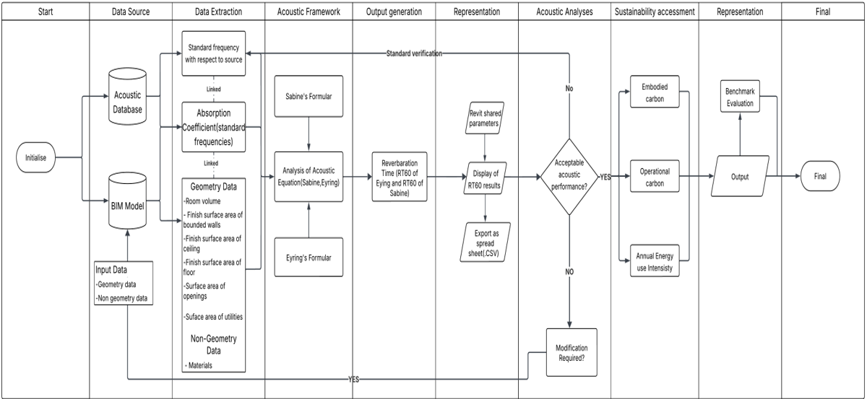

Figure 1. BIM-enabled acoustic framework with sustainable analysis integration

3.3.2 Acoustic Plugin Structure
The plugin within the Integrated Development Environment is divided into two main classes: The RTQulenApp.cs (ribbon and button) and the RT60_Acoustics.cs (command logic). The RTQulenApp is the application class that defines and displays the Ribbon and Tab within the user interface while the RT60_Acoustics command class carries the proper functions for the computation of the reverberation time. Figure 2 illustrates the detailed backend structure of the plugin.
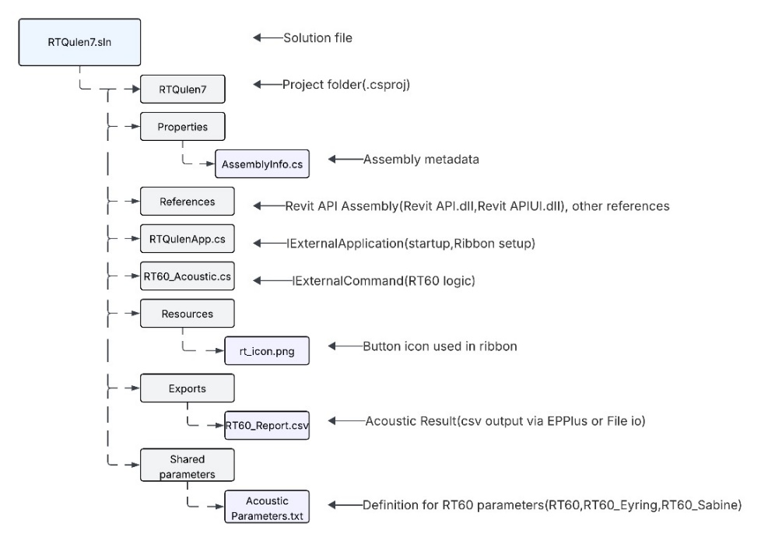
Figure 2. Backend Structure of the plugin

3.3.3 Plugin Integration in BIM Authoring software, Revit Autodesk
When the Revit file is opened, the system prompts the user to enable a new functionality presented as a tab titled "Laurantine Acoustic Tools". This tab contains specialized features for reverberation analyses as indicated in Figure 3. To proceed, click “Load” on the prompt to accept the integration. Once successfully loaded, the Laurantine Acoustic Tools tab will appear on the Revit ribbon, granting access to run the reverberation time calculation.
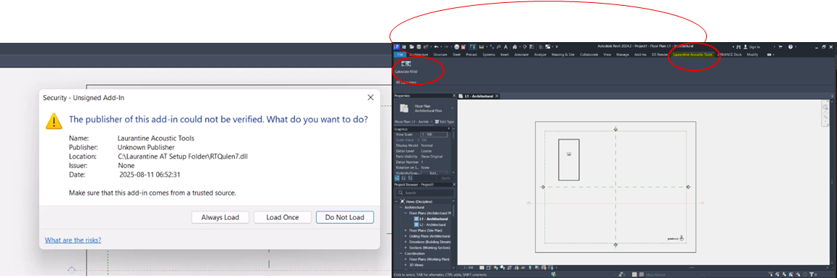
Figure 3. Installation verification and Illustration of plugin tab in the Revit Interface, “Laurantine Acoustic Tools”.
The shared parameters created by the plugin automatically must be verified within the Revit interface. These parameters are RT60, RT_Eyring, RT_Sabine, Avg_Absorption, RT60_Use and RT60_PlanText as indicated in Figure 4.
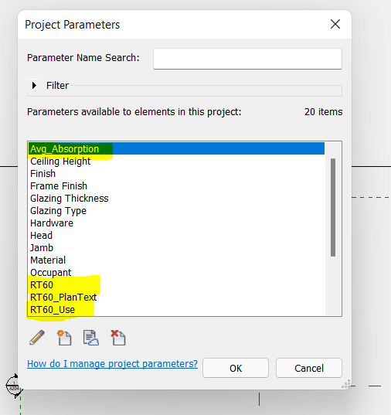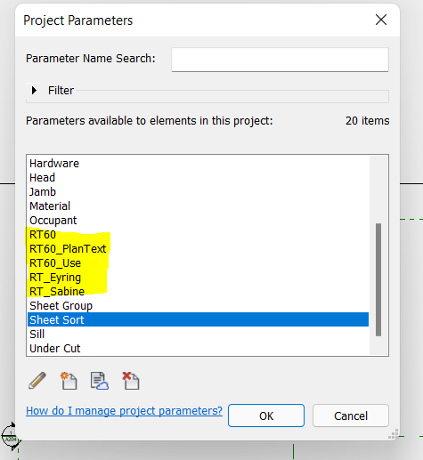
Figure 4. Integrating the calculated Acoustic shared parameters within the Revit Autodesk interface.

Here we clearly see that the shared parameters have been correctly updated within the Revit database and can be called or referred to by the user. The plugin authentication for shared parameters therefore works. The shared parameter, RT60_PlanText carries the summary of the results of the other shared parameters to facilitate the visualization process when attached to the room tag.

3.3.5 Application of Plugin on a Case Study
The church was selected as a case study because its expansive, reverberant interior presents distinctive acoustic challenges that influence speech intelligibility, musical performance, and the overall occupant’s experience within sustainable architectural design. The 3D model of the Church is presented in Figure 5.

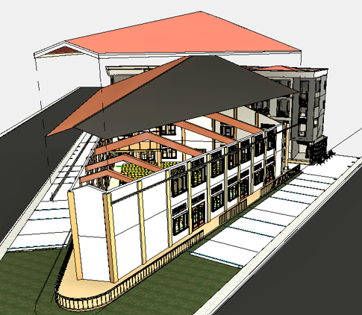
Figure 5. The Church as a case study building

The following absorption coefficients provided in Villagracia (2016) were adopted for the different materials:
- Walls – Plaster (Absorption coefficient =0.05)
- Floors – Default material according to Revit (the plug fallback value for Absorption coefficient being default is =0.1)
- Ceilings – Wood (Absorption coefficient =0.1)
- Doors – Wood frames with glass infills (glass infill considered due to dominant material surface, hence Absorption coefficient =0.07)
- Windows – wood frames with glass infills (glass infill considered due to dominant material surface, hence Absorption coefficient =0.07)

To test the functionality and verify whether the plugin was working as designed, it was applied to a series of alterations in the church building. These included running the software with no chairs and then after placing chairs, changing the floor material to grey concrete, and modifying the chair material to wood. All this was done within the Revit environment. The outcomes of these tests will be discussed in the following paragraphs.
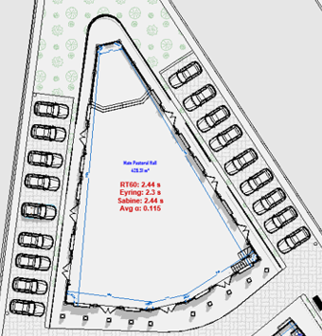 | 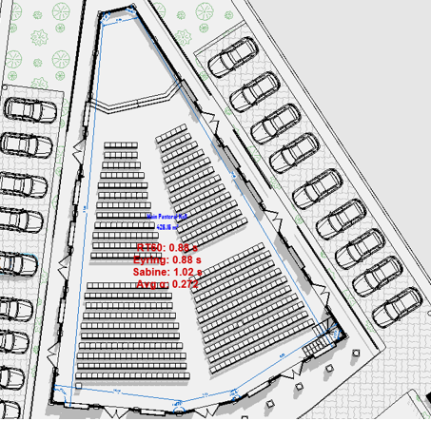
Pre-furniture analysis | Post-furniture analysis
Figure 6. Acoustic performance of the case study without and chairs introduced

For the pre-furniture analysis (see figure 6), the Sabine method was selected as the appropriate model, yielding a reverberation time (RT60) of 2.44 seconds. The choice to use the Sabine method was informed by the fact that the average absorption coefficient of 0.115 of the church volume of building envelope is less than 0.2 (threshold used to determine the applicability of Sabine over Eyring) [14] (Mateus & Pereira, 2023). The resulting RT60 aligns well with acoustic expectations for a church or worship hall, indicating a suitable reverberant character for speech and music. This aligns with both pre-treatment conditions and the acoustic characteristics of specific church typologies reported in[15] Nowoświat et al (2020) with individual reverberation time measurements of 2.44 seconds (and similar values such as 2.40 s, 2.46 s, and 2.55 s) specifically at the 4000 Hz octave band in a dome-shaped Pentecostal church before acoustic adaptation [15] (Nowoświat, Olechowska & Marchacz, 2020). However, it is important to note that the design remains incomplete, as there is no furniture attributed to this space.

For the post-furniture analysis (see Figure 6), wool finishing was considered for the chairs with an absorption coefficient of 0.35. The introduction of these chairs significantly increased the overall absorption within the space or hall, resulting in a substantial reduction in reverberation time (RT60) to 0.88 seconds. Given that the average absorption coefficient rose to 0.272 > 0.2, the Eyring model was adopted for this analysis phase. The Eyring model is adopted with absorption coefficient is greater than [14] (Mateus & Pereira, 2023). However, on using the Eyring model the RT60 value gotten is 0. 88s.The resulting RT60 falls below the acoustic benchmark for worship halls, which typically require a minimum of 1.4 seconds to support speech intelligibility and musical resonance [16] (Church Acoustics2025).

To address this discrepancy, the floor finish material was modified from the default value (absorption coefficient = 0.1) to cast grey concrete floor screed with a lower absorption coefficient of 0.02. This adjustment was made to reduce overall absorption and assess whether the RT60 could be increased to meet the target acoustic performance. As shown in Figure 7, the introduction of a cast grey concrete floor screed (absorption coefficient = 0.02) leads to an increase in RT60 to 1.06 s. Despite this improvement, the Eyring model remains applicable, as the average absorption coefficient is 0.231> 0.2 threshold. However, the RT60 value remains below the recommended range for worship halls, which typically require a minimum of 1.4s.

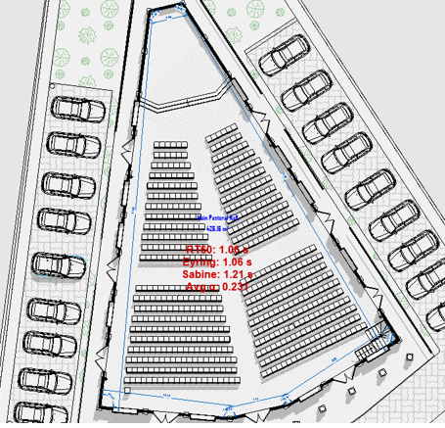 | 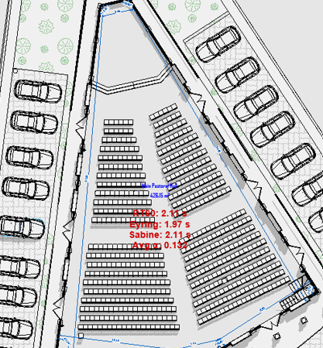
Floor material introduced | Chair material changed to wood
Figure 7. Acoustic performance with the floors attributed to standard materials and material of chairs changed to wood.
In this phase of the analysis, the chairs made of wool finishes are modified entirely as wooden chairs with an absorption coefficient of 0.07. The results in Figure 7. shows that, with the introduction of the chairs as a wood, the RT60 value increases to 2.11s and the Sabines model is adopted because the average absorption coefficient is 0.132 > 0.2. The Sabine’s model is used whenever the absorption coefficient is greater than 0.2[14] (Mateus & Pereira, 2023) . The value of RT60 clearly satisfies the expected RT60 for a worship hall which ranges from 1.4s to 2.5s. A reverberation time (RT60) range of 1.4s to 2.5s for a worship hall aligns with findings in several studies concerning the acoustics of religious buildings, particularly when considering specific frequency bands or conditions after acoustic adaptations. For instance, a study on the dome-shaped Pentecostal Church in Katowice, Poland, reported a reverberation time (RT) of 2.44 seconds at the 4000 Hz octave band for a specific measurement point before acoustic adaptation [15] (Nowoświat et al 2020). The mean reverberation time at 4000 Hz across all measurement points in this church was 1.81 seconds. Even after acoustic adaptation, where the overall mean reverberation time (averaged from 500 Hz to 1000 Hz) was reduced to 1.1 seconds, several individual measurement points at the 250 Hz octave band still exhibited values within your specified range, such as 2.49s, 2.10s, 2.18s, 2.21s, 2.27s, 2.29s, and 2.37s. Similarly, the Church of São Carlos Borromeu in Curitiba, Brazil, a building featuring a modern architectural style, showed spatial average reverberation times (RT) across various octave bands that frequently fell within this range. Specifically, the mean RT was 1.42 seconds at 125 Hz, 1.52 seconds at 1000 Hz, 1.66 seconds at 2000 Hz, and 1.48 seconds at 4000 Hz. These measurements were considered compatible with good speech clarity due to low reverberation [17](de Sant’Ana et al., 2011). Another example is the Church of Saints Marcellino and Pietro in Cremona, Italy, which underwent acoustic improvements to better suit musical performances [18] (Parrinelli et al., 2025). After implementing a comprehensive acoustic solution involving acoustic panels and a wooden floor, the average reverberation time was significantly reduced to 1.94 seconds, fitting directly within your reported range and aligning with optimal values for concert halls[18] (Parrinelli et al., 2025). The aforementioned applications confirm that the plugin functions well in Revit 2024. It has also been tested and proven to run smoothly in Revit 2025 and Revit 2026.

4. Research Findings and Discussions
4.1 Existing Methods for Addressing Acoustic Deficiencies in Interior Design, with Emphasis on Sustainability and Occupant Comfort
This objective reviewed traditional and computational methods for addressing acoustic deficiencies, with emphasis on sustainability and comfort. Traditional techniques include reverberation time analysis using Sabine’s and Eyring’s formulas, sound absorption, insulation, and diffusers. Sabine’s is best for low-absorption conditions, while Eyring provides greater accuracy in highly absorptive spaces. Computational methods such as FEM, BEM, and FDTD allow precise modelling of complex geometries but remain resource intensive. Sustainable approaches extend beyond performance, incorporating life cycle assessments, natural fibres like bamboo and jute, and indoor environmental quality standards. However, the lack of comprehensive evaluation frameworks often leaves practitioners with fragmented guidance. The research applied both traditional and computational approaches, confirming their relevance in improving speech clarity and overall performance. Findings align with studies advocating sound-absorbing materials and design interventions such as padded seating, curtains, acoustic panels, and architectural strategies like sloping ceilings ([15], [17])(Nowoświat et al., 2020; Queiroz de Sant’Ana & Zannin, 2011). A key difference lies in methodological emphasis: this study focused on computational models integrated into BIM for new construction, while much of the literature prioritised in-situ measurements, psychoacoustic evaluations, and reversible strategies for heritage contexts([19], [18]) (Di Loreto et al., 2025; Parrinelli et al., 2025).

4.2 Acoustic Strategies and Hybrid Approaches Aligned with Sustainable Design
The second objective was to identify a hybrid strategy that balances acoustic and environmental performance. A BIM-enabled framework was developed that integrates acoustic analysis early in the design process, avoiding late-stage retrofits. It applied Sabine’s formula for absorption coefficients ≤0.2 and Eyring’s for higher values, while also embedding carbon assessments and energy metrics. In a church case study, initial RT60 dropped too low with fabric chairs (0.88s), but targeted changes replacing chairs with wood and modifying floor finishes restored it to 2.11s, an optimal value for worship spaces. Importantly, this acoustic optimisation was achieved while maintaining LETI and RIBA carbon benchmarks (308.438 kgCO₂e/m²). The findings align with literature on multifunctional and natural materials. Examples include spray-deposited insulation providing both thermal and acoustic performance [15] (Nowoświat et al., 2020) and bio-based solutions such as cork, hemp fibre, and rammed earth combining low environmental impact with good acoustics [20] (Cascone et al., 2025). While heritage research stressed reversible measures like draperies and removable panels [19] (Di Loreto et al., 2025), this study advanced a digitally integrated approach for new construction, complementing more context-driven strategies.

4.3 Current Practices, Tools, and Challenges in Using BIM for Interior Acoustic Design
The third objective explored BIM integration into acoustic workflows, where existing practice is dominated by standalone tools like COMSOL, EASE, and ODEON. These tools require exporting BIM data, often causing interoperability issues and data loss. Although custom Dynamo or Python scripts have extended capabilities, they remain limited in scope and rarely integrate sustainability. Challenges such as incomplete absorption databases, difficulties modelling furniture or complex spaces, and high computational demands further constrain practice. To address this, the study developed “Laurantine Acoustic Tools,” a Revit plugin that automated acoustic calculations, extracted geometry and material data, and integrated sustainability metrics. The tool visualised reverberation times directly in BIM and allowed iterative simulations to balance acoustic and environmental goals. Unlike existing workflows which depend on semi-manual transfers or external software ([21],[20],[22]) (Álvarez-Díaz et al., 2024; Cascone et al., 2025; Khosakitchalern & Seghier, 2025) this workflow was fully embedded in BIM, improving scalability, interoperability, and real-time usability.

4.4 BIM-Based Workflow Integrating Acoustic Simulation for Sustainability

The fourth objective developed the plugin in C# using the Revit API. It extracted room geometries and surface data, applied Sabine and Eyring formulas, and reintegrated results as BIM parameters. It also linked to sustainability metrics (embodied carbon, operational energy, daylighting) through Revit Insight. CSV export supported further analysis, although software compatibility issues were noted in newer Revit versions. In a Douala church case study, the plugin enabled iterative adjustments that restored RT60 values to recommended ranges while meeting sustainability targets, highlighting the potential of integrated digital workflows. Comparable workflows demonstrate the wider trend towards automation and multi-objective optimisation. [21] Álvarez-Díaz et al. (2024) proposed an IFC4Acoustic parser for SPL calculations in renovation projects, [20]Cascone et al. (2025) optimised wall assemblies using multi-criteria analysis, and [22] Khosakitchalern & Seghier (2025) applied generative design to classroom acoustics and cost efficiency. While these approaches advanced the field, they remained partly reliant on external tools, whereas this study achieved a more integrated and accessible BIM-embedded workflow.

4.5 Benefits and Limitations of BIM in Delivering Sustainable Acoustic Interiors

The research confirmed BIM’s benefits in acoustic design: centralised integration of parameters, real-time decision support, enhanced collaboration, and sustainability assessment. Automated calculations reduced manual workload and costly retrofits, consistent with literature on multi-criteria optimisation and efficiency ([20],[21]) (Cascone et al., 2025; Álvarez-Díaz et al., 2024). Nonetheless, limitations persist, including computational demands, interoperability barriers, limited material data, and semi-manual processes [23] (Yin & Ai, 2024). A unique challenge in this research was Revit CSV export errors, extending literature critiques that emphasize incomplete data and standardization gaps. Overall, BIM offers strong potential for delivering sustainable acoustic spaces, though both technical and systemic issues must still be addressed.

5. Conclusions
This study set out to explore how BIM can be leveraged to integrate acoustic analysis within sustainable interior design. By combining traditional approaches, such as Sabine’s and Eyring’s reverberation formulas, with computational modelling, the research demonstrated that effective acoustic design requires both precision and adaptability to context. The findings confirmed the enduring value of traditional methods for rapid assessments while showcasing the advantages of computational tools and BIM integration in managing complex geometries and material variability.

A key contribution of this research was the development of the Laurantine Acoustic Tools plugin, a BIM-based application that automates reverberation time calculations, integrates material and geometric data, and embeds sustainability metrics directly within Revit. Tested through a church case study, the plugin illustrated how iterative design adjustments can simultaneously optimise acoustic comfort and environmental performance, thereby reducing reliance on late-stage retrofits. This digitally integrated workflow advances existing practices, which often rely on external tools and semi-manual data transfers, by offering a more user-friendly and scalable solution.
The research also highlighted a hybrid acoustic strategy that balances performance and sustainability. The application of Sabine and Eyring formulas according to absorption thresholds, combined with embodied carbon and operational energy assessments, ensured that acoustic optimisation was aligned with sustainability benchmarks such as LETI and RIBA standards. This approach complements existing literature on multifunctional and bio-based materials while distinguishing itself by advancing digital integration over purely physical interventions.

The study confirmed BIM’s major benefits in acoustic interior design, including real-time decision-making, centralised collaboration, and sustainability alignment. However, limitations were also evident, particularly regarding computational demands, incomplete acoustic material databases, interoperability challenges, and software compatibility issues such as CSV export errors in newer Revit versions. These findings underline the importance of both technical refinements at the plugin level and broader efforts toward standardisation in BIM-acoustic workflows.

In conclusion, this research contributes to bridging the gap between acoustic design and sustainable interior architecture. It demonstrates that embedding acoustic analysis directly within BIM environments not only enhances efficiency but also supports more holistic, sustainability-driven design decisions. Future work should expand the plugin’s functionality to include psychoacoustic measures, broader material datasets, and integration with generative design tools. Such advancements will further strengthen the role of BIM as a platform for delivering comfortable, resilient, and environmentally responsible interior spaces.

Author Contributions: Laurantine Awah and Fonbeyin Abanda conceived and designed the study. The methodology was developed by Fonbeyin Abanda, while Laurantine Awah implemented the software. Validation was conducted by Ngome Ngome, and the formal analysis was performed by Ambe Sangbong. Laurantine Awah prepared the original draft of the manuscript, and Fonbeyin Abanda together with Ambe Sangbong reviewed and edited it. Overall supervision of the work was provided by Fonbeyin Abanda.
Funding: This research received no external funding.
Acknowledgments: During the preparation of this manuscript/study, the author(s) used ChatGPT 5.0 for proof-read the manuscript. The authors have reviewed and edited the output and take full responsibility for the content of this publication.”

Conflicts of Interest: The authors declare no conflicts of interest.”

References

[1] Addis. (2009). A brief history of design methods for building acoustics. Structurae.Net. https://structurae.net/en/literature/conference-paper/brief-history-of-design-methods-for-building-acoustics
[2]Salpriyan, P. M., Krishna, K., & Singh, T. (2025). Recent developments in natural fibre polymer composite materials for interior design applications: an overview from acoustic perspective. SpringerPM Salpriyan, K Krishna, T SinghInternational Journal on Interactive Design and Manufacturing (IJIDeM), 2024•Springer, 19(3), 1563–1589. https://doi.org/10.1007/S12008-024-01935-7
[3] Li, S., Liu, L., & Peng, C. (2020). A review of performance-oriented architectural design and optimization in the context of sustainability: Dividends and challenges. Sustainability (Switzerland), 12(4). https://doi.org/10.3390/SU12041427
[4] Thede, J. (2024). Achieving LEED acoustics credits: Three project case studies. The Journal of the Acoustical Society of America, 156(4_Supplement), A28–A28. https://doi.org/10.1121/10.0034990
[5] Sušnik, M., Tagliabue, L. C., & Cairoli, M. (2021). BIM-based energy and acoustic analysis through CVE tools. Energy Reports, 7, 8228–8237. https://doi.org/10.1016/J.EGYR.2021.06.013
[6] Châteauvieux-Hellwig, C., Abualdenien, J., & Borrmann, A. (2022). BIM-based framework for indoor acoustic conditioning in early stages of design. Advanced Engineering Informatics, 53. https://doi.org/10.1016/J.AEI.2022.101675
[7] Al-Ashmori, Y. Y., Othman, I., Rahmawati, Y., Amran, Y. H. M., Sabah, S. H. A., Rafindadi, A. D. u., & Mikić, M. (2020). BIM benefits and its influence on the BIM implementation in Malaysia. Ain Shams Engineering Journal, 11(4), 1013–1019. https://doi.org/10.1016/J.ASEJ.2020.02.002
[8] Markham, B. (2010). Building information management: An acoustics consultant’s perspective. The Journal of the Acoustical Society of America, 127(3_Supplement), 2001–2001. https://doi.org/10.1121/1.3385182
[9] Nik-Bakht, M., Lee, J., & Dehkordi, S. H. (2021). BIM-based reverberation time analysis. Journal of Information Technology in Construction, 26, 28–38. https://doi.org/10.36680/J.ITCON.2021.003
[10] Mastino, C., Bella, A. Di, … G. S.-… C. on S.,(2018). BIM application in design and evaluation acoustic performances of buildings. Research.Unipd. ItCC Mastino, A Di Bella, G Semprini, A Frattolillo, M Marini, V Da Pos25th International Congress on Sound and Vibration 2018, ICSV 2018, 2018•research.Unipd.It. https://www.research.unipd.it/handle/11577/3357281
[11] Wu, C., Conference, M. C.-30th C. W. I., & 2013, undefined. (2013). BIM-based acoustic simulation Framework. Itc.Scix.NetC Wu, M Clayton30th CIB W78 International Conference, 2013•itc.Scix.Net. https://itc.scix.net/pdfs/w78-2013-paper-66.pdf
[12] Kim, S., Coffeen, R. C., & Sanguinetti, P. (2013a). Interoperability Building Information Modeling and acoustical analysis software-A demonstration of a performing arts hall design process. Pubs.Aip.Org, 19, 46. https://doi.org/10.1121/1.4800300/18242211/PMA.V19.I1.015136_1.ONLINE.PDF
[13]Tan, Y., Fang, Y., Zhou, T., Wang, Q., & Cheng, J. C. P. (2017). Improve Indoor Acoustics Performance by Using Building Information Modeling.
[14] Mateus, D., & Pereira, A. (2023). Proposal of a simplified methodology for reverberation time prediction in standard medium size rooms with non-uniformly distributed sound absorption. https://doi.org/10.1051/aacus/2023025
[15] Nowoświat, A., Olechowska, M., & Marchacz, M. (2020). The effect of acoustical remedies changing the reverberation time for different frequencies in a dome used for worship: A case study. Applied Acoustics, 160, 107143.
[16] Church Acoustics: How to Improve Sound Clarity & Reduce Echo in Worship Spaces. (2025). Retrieved September 14, 2025, from https://www.acousticalsurfaces.com/blog/acoustics-education/church-acoustic-treatments/?utm_source=chatgpt.com
[17] Queiroz de Sant’Ana, D., & Zannin, P. H. T. (2011). Acoustic evaluation of a contemporary church based on in situ measurements of reverberation time, definition, and computer-predicted speech transmission index. Building and Environment, 46(2), 511–517.
[18] Parrinelli, S., Giampiccolo, R., Landi, A. G., & Antonacci, F. (2025). Improving the Acoustics of the Church of Saints Marcellino and Pietro in Cremona (Italy) for Musical Performances. Acoustics, 7(3), 42.
[19] Di Loreto, S., Ricciutelli, A. & Montelpare, S. (2025) ‘A prototype methodology for acoustic heritage preservation: integrating H-BIM and legal frameworks for the protection of intangible cultural assets’, Applied Acoustics, 236, p. 110759.
[20] Cascone, S., Anastasi, V. & Caponetto, R. (2025) ‘Performance Optimization of Building Envelope Through BIM and Multi-Criteria Analysis’, Sustainability, 17(12), p. 5294.
[21] Álvarez-Díaz, S., Mulero-Palencia, S., Andrés-Chicote, M. & Martarelli, M. (2024) ‘An innovative approach to automate BIM data retrieval and processing for building acoustic comfort calculations based on the IFC standard’, Building and Environment, 266, p. 112072.
[22] Khosakitchalern, C. & Seghier, T.E. (2025) ‘Evaluating and Optimizing Acoustical Reverberation Time and Material Cost for Classrooms Using Building Information Modeling (BIM) and Generative Design (GD) Tools’, Nakhara: Journal of Environmental Design and Planning, 24(1), pp. 1–22.
[23] Yin, J. & Ai, X. (2024) ‘Acoustic performance analysis of wooden structure building wall by integrating BIM technology and impedance tube method’, PLoS ONE, 19(8), p. e0308481.

