Distance Based Assessment of Noise Pollution in Residential Areas Surrounding Major Market Hubs in Awka South LGA, Anambra State

By

Agbili Martin Onyedikachukwu
mo.agbili@unizik.edu.ng

And

Ogbo Ojiako Godfrey
og.ogbo@unizik.edu.ng

Abstract
This study examined distance-based variations in environmental noise levels in residential areas surrounding two major market hubs, Amaenyi and Eke Awka, in Awka South Local Government Area, Anambra State, Nigeria. Anchored on Distance-Decay Theory, the aim was to determine whether noise intensity decreases with increasing radial distance from market cores and to assess compliance with World Health Organization (WHO) and National Environmental Standards and Regulations Enforcement Agency (NESREA) residential limits. A cross-sectional field measurement design was adopted. Ambient noise levels were recorded using a calibrated digital Sound Level Meter, and equivalent continuous sound levels (Leq) were measured across three radial bands: 0–50 m, 50–100 m, and beyond 100 m. Descriptive statistics, percentage attenuation analysis, and linear regression were used to evaluate spatial patterns. Results indicate a clear inverse relationship between distance and mean noise levels. At Amaenyi, mean levels declined from 89.6 dB (0–50 m) to 75.4 dB (>100 m), while Eke Awka showed a reduction from 101.1 dB to 82.5 dB. Regression analysis confirmed strong distance–noise relationships (R² = 0.972 and 0.841, respectively). However, all measured values exceeded WHO (55 dB) and NESREA (50 dB) residential limits across all distance bands. The study concludes that although attenuation occurs with distance, existing spatial separation is inadequate to ensure residential acoustic safety, highlighting the need for improved land-use planning and regulatory enforcement.

1.0 Introduction
Rapid urbanization remains one of the most significant drivers of environmental transformation globally. The United Nations (2019) and Cohen (2006) identify accelerated urban growth, particularly in low and middle income countries, as a major contributor to environmental stressors including air pollution, land degradation, and acoustic pollution. As urban populations expand and economic activities intensify, environmental noise has emerged as one of the most pervasive and least regulated by-products of urban development (Basner et al., 2014; Goines & Hagler, 2007). Unlike visible pollutants, environmental noise is intangible, yet its impacts are measurable and cumulative.
In urban systems, multiple anthropogenic activities contribute to elevated ambient sound levels. Transportation networks, commercial exchanges, informal trade, construction activities, and decentralized electricity generation through small scale generators collectively increase background noise intensity (Stansfeld & Matheson, 2003). Empirical studies demonstrate that environmental noise exposure is strongly associated with urban density and land use intensity, with commercial and mixed-use zones consistently recording higher sound pressure levels than low density residential areas (Brown & van Kamp, 2009). In rapidly expanding cities, where economic and residential activities intersect spatially, the potential for chronic acoustic exposure increases substantially.
Environmental noise is no longer regarded merely as a nuisance. The World Health Organization has formally classified environmental noise as a significant environmental health risk. Its Environmental Noise Guidelines for the European Region and earlier community noise guidelines establish exposure thresholds beyond which adverse health outcomes become increasingly probable (WHO, 2011; WHO, 2018). Chronic exposure to elevated sound levels has been linked to sleep disturbance, hypertension, ischemic heart disease, impaired cognitive performance among children, and reduced quality of life (Babisch, 2006; Münzel et al., 2018). Basner et al. (2014) further demonstrate that long term exposure to environmental noise activates stress pathways, contributing to cardiovascular morbidity. These findings reposition environmental noise from a secondary environmental concern to a structured public health issue requiring systematic monitoring and regulatory attention.
The challenge is particularly acute in developing countries where urban growth is often rapid and spatial planning mechanisms are weakly enforced. Oyedepo and Saadu (2010) and Arku et al. (2011) observe that unplanned spatial expansion and limited regulatory oversight amplify exposure risks in African cities. In Nigeria, multiple studies report ambient noise levels exceeding both national and international permissible limits, especially in commercial and mixed use zones (Olayinka & Abdullahi, 2010; Ighoroje et al., 2009). Dominant noise sources typically include road traffic, small scale enterprises, generator usage, religious activities, and informal commercial interactions (Onuu & Menkiti, 1996; Oyedepo, 2012). These studies collectively indicate that urban noise pollution in Nigeria is systemic rather than incidental.
Among the various urban noise nodes, major market hubs represent particularly intense acoustic environments. Markets function as focal points of economic exchange, attracting high vehicular density, loading and unloading operations, amplified advertising through loudspeakers, and dense clusters of traders and consumers. Empirical investigations in Nigerian market settings have recorded sound pressure levels significantly above the recommended daytime residential limit of 55 dB(A) established by the World Health Organization (WHO, 2018; Oyedepo & Saadu, 2010). Unlike industrial facilities that are often spatially zoned away from residential districts, markets are commonly embedded within the urban fabric. As a result, noise generated within commercial cores frequently spills into adjacent residential neighborhoods, creating potential exposure gradients (Brown & van Kamp, 2009).
This situation is compounded by mixed land use patterns that characterize many Nigerian cities. Rapid urban growth, informal housing development, and limited zoning enforcement have led to the coexistence of residential and commercial land uses within shared spatial corridors (Agbola, 1998; Arku et al., 2011). Urban planning theory emphasizes land use compatibility and the need for buffer zones to mitigate environmental externalities such as noise (Cullingworth & Caves, 2014). However, in practice, minimal separation often exists between commercial hubs and residential dwellings. Consequently, proximity becomes a critical determinant of environmental noise exposure. This observation aligns with the distance decay principle, which suggests that the intensity of a spatial phenomenon diminishes with increasing distance from its source (Batty, 2008).
Within this broader national context, Awka, the capital city of Anambra State, has experienced sustained demographic and commercial growth over the past decades (National Population Commission, 2006; Anambra State Government Reports). As an administrative and commercial center, Awka South Local Government Area hosts several major markets that function as primary economic nodes. These markets include Amaenyi market, Eke Awka market, Quarta market, First market Ifite, Second Market Ifite and Government house market among others. The expansion of these markets has intensified vehicular movement, generator usage, and informal trading activities within surrounding neighborhoods. Simultaneously, residential developments have proliferated around these commercial corridors, reflecting the mixed land use dynamics identified in southeastern Nigerian cities (Agbola, 1998).
Despite this spatial intermingling, there remains limited spatially explicit assessment of how ambient noise intensity varies with radial distance from major market hubs within Awka South LGA. Existing environmental documentation in Anambra State is largely descriptive, with minimal structured quantification of acoustic gradients across defined residential buffers. Consequently, environmental noise in Awka South should be conceptualized not solely as an environmental management issue but as an integrated spatial planning and public health concern requiring empirical investigation.
Although environmental noise pollution has received increasing scholarly attention in Nigeria, the thematic focus of existing studies has been uneven. A significant proportion of research concentrates on road traffic corridors and industrial clusters as dominant contributors to urban noise exposure (Oyedepo & Saadu, 2010; Ighoroje et al., 2009; Olayinka & Abdullahi, 2010). Market hubs differ from typical traffic corridors because they combine multiple concurrent noise sources. Vehicular congestion, generator use, loading and unloading operations, amplified announcements, and intense human interaction occur simultaneously within relatively confined spaces (Ogbeifun et al., 2022; Oyedepo, 2012).

Conceptual and Theoretical Framework
This study is anchored in Distance-Decay Theory, which posits that the intensity of a spatial phenomenon decreases with increasing distance from its source (Batty, 2008). In acoustics, sound pressure levels decline logarithmically as they radiate outward under standard propagation conditions, consistent with the inverse square law (Beranek & Vér, 1992). Although urban morphology—such as building density and reflective surfaces—may modify attenuation patterns, a measurable reduction in acoustic intensity is theoretically expected across radial distance bands (Brown & van Kamp, 2009).
Applied to major market hubs, this theory suggests that environmental noise should be highest at the commercial core and progressively decrease within surrounding residential areas. By operationalizing distance as the primary independent variable and sound pressure level as the dependent variable, this study empirically tests whether observed attenuation patterns in Awka South LGA conform to theoretical expectations or reflect distortions arising from mixed land use and high-density urban development.

2.0 Materials and Methods

2.1 Research Design
The study adopted a cross-sectional field measurement design to assess ambient environmental noise levels across defined radial distances from selected major market hubs. A distance-based assessment framework was employed to evaluate attenuation patterns consistent with the distance-decay principle (Batty, 2008).

2.2 Study Area
This study was carried out in Awka South Local Government Area (LGA), situated in Awka, the capital of Anambra State in southeastern Nigeria. Awka South represents the urban core of the state and accommodates a concentration of administrative, commercial, educational, and residential functions. Rapid population growth and commercial intensification have resulted in closely integrated land uses across the city.
Two major market hubs were purposively selected for investigation: Amaenyi Market and Eke Awka Market. These markets were selected due to their high commercial activity and their direct spatial interface with surrounding residential neighborhoods. In many cases, residential buildings share immediate boundaries with market corridors, creating minimal separation between commercial noise sources and living spaces.
The study area is characterized by a tropical climate with distinct wet and dry seasons. Urban form within the selected locations consists of compact building arrangements, interconnected road networks, and limited planned buffer zones between commercial and residential land uses. The close spatial integration of markets and housing makes the area suitable for examining distance-based variations in environmental noise levels.

2.3 Noise Measurement Procedure
Ambient noise levels were measured using an Aicevoos AS-K3 model digital Sound Level Meter (SLM) conforming to international acoustic measurement standards. Measurements were recorded in A-weighted decibels [dB(A)], which reflect human auditory sensitivity and are recommended for environmental noise assessment (WHO, 2018).
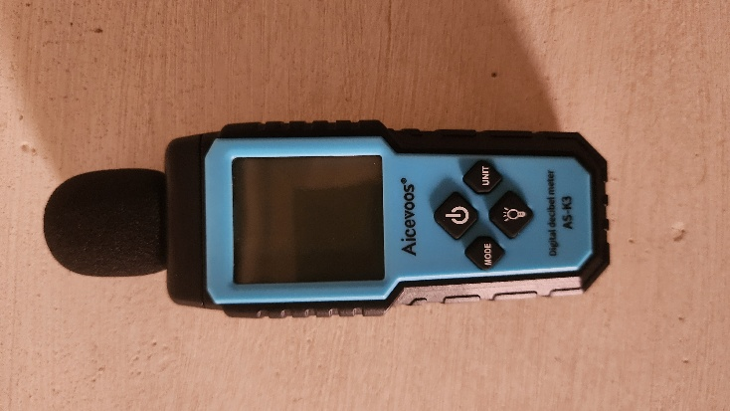
Aicevoos AS-K3 model digital Sound Level Meter (SLM)
The equivalent continuous sound level (Leq) was used as the primary acoustic indicator. Leq represents the steady sound level that contains the same acoustic energy as the fluctuating noise measured over a specified period (Beranek & Vér, 1992).
To ensure reliability:
- The instrument was calibrated prior to field deployment.
- Measurements were taken at approximately 1.5 meters above ground level to approximate human ear height.
- The microphone was positioned away from reflecting surfaces to minimize interference.
- Each reading was recorded over standardized time intervals (10 minute sampling periods).
- Minimum and Maximum readings were taken for 10 minutes each

2.4 Distance Classification and Sampling Framework
A structured radial distance approach was adopted. Measurement points were established along transects extending outward from the geometric center of each market hub into surrounding residential areas.
Distance bands were classified as follows:
- 0–50 meters (Immediate commercial interface)
- 50–100 meters (Transitional zone)
- 100 and above meters (Outer residential buffer)
At each distance band, multiple sampling points were selected to enhance representativeness and reduce spatial bias. These readings were then checked against the NESREA and WHO standard permissible limits in Table 1 below.
Table 1: Comparison of WHO and NESREA Permissible Environmental Noise Limits
Regulatory Body | Area Category | Daytime Limit (dB(A)) | Night-time Limit (dB(A)) | Reference
WHO | Residential (Outdoor) | 55 | 40–45 | WHO (2018)
NESREA | Residential | 50 | 35 | NESREA (2009)
NESREA | Mixed Use | 60 | 45 | NESREA (2009)
NESREA | Commercial | 70 | 60 | NESREA (2009)
NESREA | Industrial | 90 | 70 | NESREA (2009)

2.5 Temporal Sampling
Measurements were conducted during peak market activity periods (morning and afternoon) and off-peak periods where feasible. This approach accounts for temporal variability in acoustic intensity, consistent with environmental noise monitoring protocols (WHO, 2018).

2.6 Data Analysis
Recorded sound pressure levels were:
- Averaged within each distance band.
- Compared across radial intervals to assess attenuation patterns.
- Evaluated against recommended daytime residential thresholds of 55 dB(A) as specified by the World Health Organization (WHO, 2018).
Descriptive statistics (mean, minimum, maximum, and standard deviation) were computed. Attenuation gradients were analyzed to determine whether observed patterns conform to theoretical distance-decay expectations.
3.0 Findings
Table 2: Distance Based Assessment Of Noise Level at 2 Surveyed Markets in Awka
Location | Distance (m) | Min (dB) | Max (dB) | Mean (dB) | SD (dB)
Amaenyi | 0–50 | 86.4 | 92.7 | 89.6 | 1.6
Amaenyi | 50–100 | 67.3 | 93.5 | 80.4 | 6.6
Amaenyi | 100 and above | 61.6 | 89.2 | 75.4 | 6.9
Eke Awka | 0–50 | 97.3 | 104.8 | 101.1 | 1.9
Eke Awka | 50–100 | 74.1 | 95.5 | 84.8 | 5.4
Eke Awka | 100 and above | 68.3 | 96.6 | 82.5 | 7.1

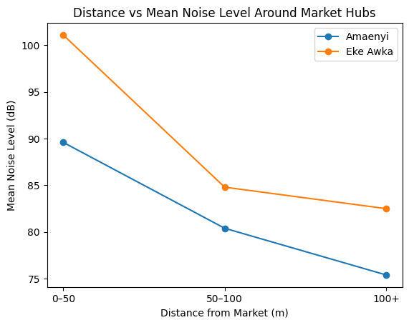
Figure 1: Distance vs Mean Noise Level Around Market Hubs
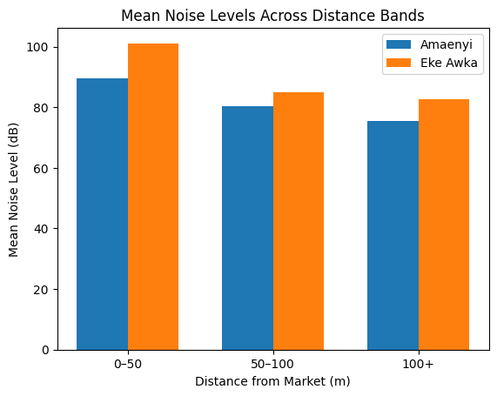
Figure 2: Mean Noise Levels Across Distance Bands
Figure 1 and Figure 2 illustrates the relationship between radial distance from selected market hubs and mean environmental noise levels in Awka South LGA. A clear inverse relationship between distance and noise intensity is observed for both Amaenyi and Eke Awka markets, consistent with the distance-decay principle.
At Amaenyi Market, mean noise levels declined progressively from 89.6 dB within the 0–50 m band to 80.4 dB at 50–100 m and further to 75.4 dB beyond 100 m. This steady reduction indicates a relatively consistent attenuation gradient, suggesting that acoustic energy disperses predictably with increasing residential separation from the market core.
Similarly, Eke Awka Market recorded the highest mean noise level (101.1 dB) within the 0–50 m zone, followed by a marked reduction to 84.8 dB at 50–100 m and a more moderate decline to 82.5 dB beyond 100 m. Although attenuation is evident, the rate of decline between 50–100 m and 100+ m is comparatively smaller than that observed at Amaenyi, indicating sustained acoustic intensity at greater distances. This pattern may reflect secondary noise sources, high traffic density, or commercial spillover beyond the immediate market boundary.
Overall, the figure demonstrates that proximity to major market hubs is a strong determinant of residential noise exposure. However, the persistence of elevated noise levels beyond 100m particularly at Eke Awka suggests that attenuation may be insufficient to reduce sound levels to internationally recommended residential thresholds. These findings underscore the limited effectiveness of existing buffer distances and highlight the need for improved land-use planning and environmental noise regulation within mixed-use urban environments.
Table 3: Percentage Attenuation
Location | 0–50 → 50–100 | 50–100 → 100+ | Overall Attenuation
Amaenyi | 10.27% | 6.22% | 15.85%
Eke Awka | 16.13% | 2.71% | 18.40%
The percentage attenuation analysis reveals distinct spatial decay behaviors between the two market hubs. At Eke Awka, a substantial reduction in mean noise level (16.13%) is observed between the 0–50 m and 50–100 m bands, indicating strong initial attenuation immediately beyond the market core. However, attenuation beyond 50 m declines sharply, with only a 2.71% reduction between 50–100 m and 100+ m. This marked reduction in decay rate suggests that acoustic energy remains relatively persistent at greater distances, potentially due to secondary noise sources, traffic spillover, or dense mixed-use development that limits effective sound dissipation.
In contrast, Amaenyi demonstrates a more gradual and consistent attenuation pattern, with a 10.27% reduction between 0–50 m and 50–100 m and a further 6.22% decline beyond 100 m. Although the initial reduction is less pronounced than that observed at Eke Awka, the continued decrease across successive distance bands reflects a more stable attenuation gradient and comparatively more predictable spatial diffusion of sound energy.
Overall attenuation remains modest for both markets, with total reductions of 15.85% (Amaenyi) and 18.40% (Eke Awka) from the nearest to the farthest residential bands. Given that both locations record high baseline noise levels, these reductions are insufficient to achieve substantial acoustic relief within 100 m of the market core. This suggests that existing spatial separation between commercial and residential land uses provides limited buffering effectiveness and may not adequately mitigate environmental noise exposure in surrounding neighborhoods.

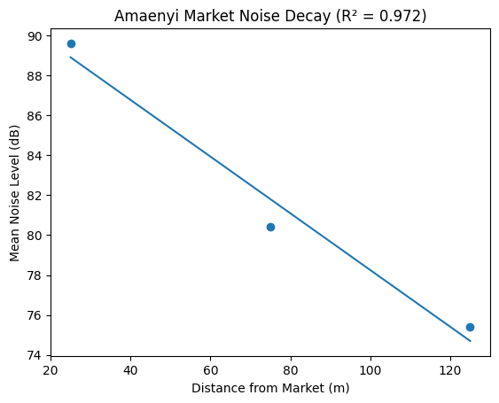

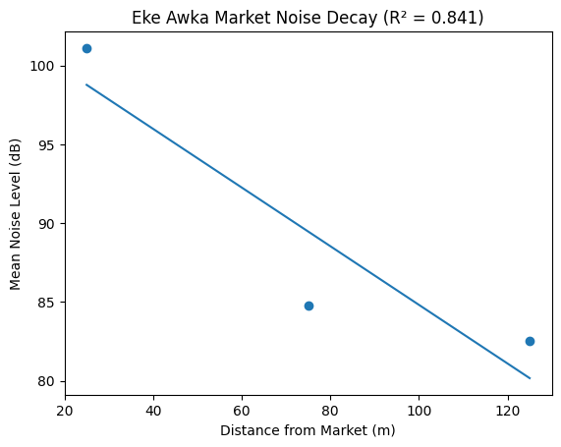

Linear regression analysis revealed a strong inverse relationship between distance and mean noise level at Amaenyi Market (R² = 0.972), indicating that distance accounts for approximately 97% of observed variation in acoustic intensity. At Eke Awka Market, the relationship remained strong but comparatively weaker (R² = 0.841), suggesting possible influence of secondary noise sources and mixed-use spatial configuration beyond the primary commercial core.
Table 4: Comparison of Measured Mean Noise Levels with WHO and NESREA Permissible Residential Limits in Awka South LGA
Location | Distance (m) | Mean (dB) | WHO Residential Limit (55 dB) | Exceedance Above WHO (dB) | NESREA Residential Limit (50 dB) | Exceedance Above NESREA (dB) | Compliance Status
Amaenyi | 0–50 | 89.6 | 55 | +34.6 | 50 | +39.6 | Non-compliant
Amaenyi | 50–100 | 80.4 | 55 | +25.4 | 50 | +30.4 | Non-compliant
Amaenyi | 100+ | 75.4 | 55 | +20.4 | 50 | +25.4 | Non-compliant
Eke Awka | 0–50 | 101.1 | 55 | +46.1 | 50 | +51.1 | Non-compliant
Eke Awka | 50–100 | 84.8 | 55 | +29.8 | 50 | +34.8 | Non-compliant
Eke Awka | 100+ | 82.5 | 55 | +27.5 | 50 | +32.5 | Non-compliant
Table 4 shows that all measured noise levels at both Amaenyi and Eke Awka markets exceed WHO (55 dB) and NESREA (50 dB) residential limits across all distance bands, indicating complete non-compliance. Noise intensity decreases with distance from the market core, but even beyond 100 meters, levels remain 20–46 dB above WHO limits and 25–51 dB above NESREA limits. Eke Awka records the highest exposure, reaching 101.1 dB within 0–50 m. Overall, proximity to the markets results in sustained and significant residential noise pollution, with no safe buffer distance observed within the measured range.

4.0 Discussion
The present study provides empirical evidence supporting the applicability of the distance-decay principle to environmental noise dispersion within mixed-use urban environments. The observed inverse relationship between radial distance and mean noise level at both Amaenyi and Eke Awka markets aligns with theoretical expectations that acoustic intensity diminishes as distance from a dominant source increases (Batty, 2008; Beranek & Vér, 1992). However, while attenuation was evident across successive residential bands, the magnitude of reduction was modest and insufficient to achieve compliance with internationally recommended residential thresholds. These findings reinforce concerns that proximity to major commercial hubs in rapidly urbanizing Nigerian cities significantly shapes residential noise exposure.
The mean noise levels recorded within the immediate 0–50 m zone (89.6 dB at Amaenyi and 101.1 dB at Eke Awka) substantially exceed the 55 dB(A) daytime residential limit recommended by the World Health Organization (WHO, 2018). Comparable exceedances have been documented in other Nigerian urban contexts. Oyedepo and Saadu (2010) reported mean daytime values ranging from 68 to 94 dB(A) in Ilorin, while Olayinka and Abdullahi (2010) recorded similarly elevated levels in Ibadan’s commercial districts. The magnitudes observed at Eke Awka, particularly values exceeding 100 dB within 50 m of the market core, are consistent with findings by Ighoroje et al. (2009), who identified commercial hubs and traffic corridors as dominant urban acoustic hotspots in Benin City. These parallels suggest that market-induced noise exposure is not unique to Awka South LGA but reflects a broader pattern across Nigerian urban systems.
Although attenuation occurred with increasing distance, the persistence of high mean values beyond 100 m is particularly noteworthy. At Amaenyi, noise levels declined from 89.6 dB to 75.4 dB across the measured gradient, representing an overall attenuation of 15.85%. At Eke Awka, a total reduction of 18.40% was observed. While statistically meaningful, these reductions remain environmentally insufficient, as even the outer residential zones recorded mean levels well above WHO guidelines. Similar limited attenuation patterns have been observed in densely built urban environments where mixed land use compresses effective buffer zones (Brown & van Kamp, 2009). In contrast, studies conducted in more spatially segregated urban settings often report sharper attenuation gradients due to greater separation between commercial and residential land uses (Stansfeld & Matheson, 2003). The modest attenuation observed in Awka therefore underscores the influence of urban morphology and land-use integration on acoustic persistence.
The percentage attenuation analysis further highlights differences between the two markets. Eke Awka exhibited a strong initial decline (16.13%) between 0–50 m and 50–100 m, followed by a markedly weaker reduction (2.71%) beyond 100 m. This pattern suggests rapid early energy dispersion but subsequent stabilization of ambient sound levels, potentially influenced by secondary sources such as adjacent traffic corridors, generator usage, or spillover commercial activity. Similar nonlinear attenuation behaviors have been reported in complex urban soundscapes where multiple concurrent sources reduce the dominance of a single primary emitter (Basner et al., 2014). By contrast, Amaenyi demonstrated a more gradual and consistent decline across bands, indicating relatively more predictable acoustic diffusion. This difference may reflect variations in market size, traffic density, spatial layout, or surrounding infrastructure.
The regression results provide additional insight into attenuation dynamics. The strong coefficient of determination observed at Amaenyi (R² = 0.972) indicates that approximately 97% of the variation in mean noise level is explained by distance, suggesting a highly structured spatial decay pattern. At Eke Awka, the relationship remained strong but weaker (R² = 0.841), implying the influence of additional environmental or anthropogenic factors beyond simple radial distance. Brown and van Kamp (2009) note that urban sound propagation is often mediated by reflective surfaces, street canyon effects, and building density, all of which may distort ideal logarithmic decay. The relatively lower explanatory power at Eke Awka may therefore reflect the complexity of its built environment and commercial intensity.
From a public health perspective, the persistence of elevated noise levels across all residential bands is concerning. Chronic exposure to sound levels exceeding 70 dB(A) has been associated with increased cardiovascular risk, sleep disturbance, and stress-related morbidity (Babisch, 2006; Münzel et al., 2018). Even the lowest mean value recorded in this study (75.4 dB at Amaenyi beyond 100 m) surpasses thresholds associated with adverse health outcomes. These findings corroborate Basner et al. (2014), who emphasize that long-term environmental noise exposure contributes to activation of physiological stress pathways. The results therefore suggest that residents living within at least 100 m of major market hubs in Awka South LGA may be exposed to sustained acoustic conditions with potential cumulative health implications.
The findings also carry important implications for urban planning and land-use regulation. Urban planning theory emphasizes land-use compatibility and the need for buffer zones between noise-generating activities and residential areas (Cullingworth & Caves, 2014). However, the modest attenuation observed in this study indicates that current spatial separation distances are insufficient to ensure acoustic protection. In line with observations by Agbola (1998) and Arku et al. (2011), rapid urban expansion and weak zoning enforcement in Nigerian cities have resulted in dense residential–commercial adjacency. The data presented here provide empirical evidence that such proximity translates into sustained environmental noise exposure.
Furthermore, the limited reduction in noise levels beyond 100 m suggests that simple horizontal distancing may not be adequate as a standalone mitigation strategy in high-density urban settings. Complementary interventions such as traffic management, regulation of generator usage, acoustic insulation measures, and enforcement of permissible sound levels during peak trading hours may be required. International experience indicates that multi-level mitigation approaches combining spatial planning with regulatory enforcement are more effective than reliance on distance alone (WHO, 2018).
While the findings strongly support the relevance of distance-decay theory, they also reveal its practical limitations in complex urban contexts. The theory predicts systematic attenuation; however, in environments characterized by overlapping commercial activities and limited buffering infrastructure, attenuation may be constrained. This aligns with Basner et al. (2014), who argue that real-world urban soundscapes often deviate from idealized propagation models due to multiplicity of sources. Therefore, while distance remains a significant determinant of noise exposure in Awka South LGA, it is not the sole controlling variable.
In summary, this study confirms that proximity to major market hubs significantly influences residential noise exposure in Awka South LGA, consistent with established urban acoustic literature. However, attenuation across measured distance bands remains insufficient to achieve recommended environmental standards, highlighting persistent exposure risk. The results underscore the urgent need for strengthened land-use planning, enforcement of environmental noise regulations, and targeted mitigation strategies to protect residential wellbeing within rapidly urbanizing Nigerian cities.

5.0 Conclusion
This study conducted a distance-based assessment of environmental noise levels in residential areas surrounding two major market hubs; Amaenyi and Eke Awka in Awka South LGA, Anambra State. The findings confirm that proximity to commercial market hubs is a significant determinant of residential noise exposure. Mean noise levels recorded within the 0–50 m band at both markets were substantially above the 55 dB(A) daytime residential guideline recommended by the World Health Organization (WHO, 2018), with peak values exceeding 100 dB(A) at Eke Awka.
Consistent with Distance-Decay Theory, noise intensity declined with increasing radial distance from the market core. However, the rate of attenuation was modest and insufficient to reduce sound levels to acceptable residential standards even beyond 100 m from the source. While Amaenyi exhibited a relatively consistent attenuation gradient (R² = 0.972), Eke Awka demonstrated a weaker but still strong relationship (R² = 0.841), suggesting the influence of additional secondary noise sources and complex urban morphology.
Overall, the persistence of elevated noise levels across all measured distance bands indicates that existing spatial separation between commercial and residential land uses in Awka South LGA does not provide adequate acoustic buffering. The results therefore highlight environmental noise as not merely a localized nuisance within market cores but a broader spatial planning and public health challenge affecting surrounding residential communities.

6.0 Recommendations
Based on the findings of this study, a multifaceted approach is required to mitigate environmental noise exposure in residential areas surrounding major market hubs in Awka South LGA. First, urban planning authorities should strengthen zoning enforcement to ensure clearer separation between commercial and residential areas. Future development should adopt buffer distances based on empirical acoustic data rather than arbitrary standards. Where relocation is impractical, mitigation measures such as sound barriers, vegetation belts, and improved building insulation should be implemented.
Regulatory oversight of key noise sources such as public address systems, generators, vehicular loading, and traffic congestion must also be reinforced. Routine monitoring and strict enforcement of permissible noise limits are essential. Traffic management strategies, including designated loading zones and time-restricted vehicle access, can further reduce sustained noise levels. Public awareness initiatives should educate residents and traders on the health risks of prolonged noise exposure. Additionally, environmental agencies should establish continuous monitoring programs and integrate noise control into public health planning to support long-term urban environmental management.

References
- Agbola, T. (1998). The housing of Nigerians: a review of policy development and implementation in the housing sector..
- Arku, G., Luginaah, I., Mkandawire, P., Asiedu, A. B., & Agudzie, Y. (2011). Housing and health in three contrasting neighborhoods in Accra, Ghana. Social Science & Medicine, 72(11), 1864–1872. https://doi.org/10.1016/j.socscimed.2011.03.021
- Babisch, W. (2006). Transportation noise and cardiovascular risk: Updated review and synthesis of epidemiological studies indicate that the evidence has increased. Noise and Health, 8(30), 1–29.
- Basner, M., Babisch, W., Davis, A., Brink, M., Clark, C., Janssen, S., & Stansfeld, S. (2014). Auditory and non-auditory effects of noise on health. The Lancet, 383(9925), 1325–1332. https://doi.org/10.1016/S0140-6736(13)61613-X
- Batty, M. (2008). The size, scale, and shape of cities. Science, 319(5864), 769–771. https://doi.org/10.1126/science.1151419
- Beranek, L. L., & Vér, I. L. (1992). Noise and vibration control engineering: Principles and applications. John Wiley & Sons.
- Brown, A. L., & van Kamp, I. (2009). WHO environmental noise guidelines for the European Region: A systematic review of transport noise interventions and their impacts on health. International Journal of Environmental Research and Public Health, 6(11), 3121–3139. https://doi.org/10.3390/ijerph6113121
- Cohen, B. (2006). Urbanization in developing countries: Current trends, future projections, and key challenges for sustainability. Technology in Society, 28(1–2), 63–80. https://doi.org/10.1016/j.techsoc.2005.10.005
- Cullingworth, J. B., & Caves, R. W. (2014). Planning in the USA: Policies, issues, and processes (4th ed.). Routledge.
- Goines, L., & Hagler, L. (2007). Noise pollution: A modern plague. Southern Medical Journal, 100(3), 287–294.
- Ogbeifun, N. P., & Njokede, F. O. (2022). Assessment of Noise Pollution in Oba Market, New Benin Market & Oregbeni Market, Benin City, Edo State. NIPES Proceedings in Science and Technology, 1, 216-225.
- Ighoroje, A. D. A., Marchie, C., & Nwobodo, E. D. (2009). Noise pollution in Benin City: A pilot study. African Journal of Biomedical Research, 12(1), 23–27.
- Münzel, T., Sørensen, M., Gori, T., Schmidt, F., Rao, X., Brook, F. R., Chen, L. C., & Brook, R. D. (2018). Environmental stressors and cardio-metabolic disease: Part II—Mechanistic insights. European Heart Journal, 38(8), 557–564. https://doi.org/10.1093/eurheartj/ehx347
- National Environmental Standards and Regulations Enforcement Agency (NESREA). (2009). National environmental (noise standards and control) regulations, 2009. Federal Republic of Nigeria.
- National Population Commission. (2006). 2006 population and housing census of the Federal Republic of Nigeria. Federal Republic of Nigeria.
- Olayinka, O. S., & Abdullahi, A. S. (2010). Noise pollution levels in commercial areas of Ibadan, Nigeria. African Journal of Biomedical Research, 13(2), 125–131.
- Onuu, M. U., & Menkiti, A. I. (1996). Evaluation of noise pollution in Aba, Nigeria. Nigerian Journal of Physics, 8, 1–5.
- Oyedepo, S. O. (2012). Noise pollution in urban areas: The neglected dimension of environmental pollution. Journal of Environmental Science and Technology, 5(4), 259–271.
- Oyedepo, S. O., & Saadu, A. A. (2010). Evaluation and analysis of noise levels in Ilorin metropolis, Nigeria. Environmental Monitoring and Assessment, 160(1–4), 563–577. https://doi.org/10.1007/s10661-008-0719-2
- Stansfeld, S. A., & Matheson, M. P. (2003). Noise pollution: Non-auditory effects on health. British Medical Bulletin, 68(1), 243–257. https://doi.org/10.1093/bmb/ldg033
- United Nations. (2019). World urbanization prospects: The 2018 revision. United Nations Department of Economic and Social Affairs.
- World Health Organization. (2011). Burden of disease from environmental noise: Quantification of healthy life years lost in Europe. WHO Regional Office for Europe.
- World Health Organization. (2018). Environmental noise guidelines for the European Region. WHO Regional Office for Europe.
- Anambra State Government. (Year). [Relevant environmental or demographic report title]. Government of Anambra State.

