Exploring Socioeconomic Factors that Influence Economic Growth, Poverty and Saving Ability in Indonesia

Authors: 1. Muhammad Saleh Mire (salehmire1957@gmail.com)
2. Aji Sofyan Effendy (aji.sofyan.effendi@feb.unmul.ac.id)

Abstract

This study aims to determine and assess the effects of government and private foreign debt, education, credit, and inflation on economic growth, poverty, and saving ability, using panel data from 34 provinces in Indonesia during 2017-2023. The results, using a path analysis model, indicate that an increase in private foreign debt (PFD) leads to increased economic growth; in other words, a higher PFD leads to higher economic growth. Meanwhile, for government foreign debt (GFD), the opposite occurs; in other words, a higher GFD leads to higher economic growth. Furthermore, education leads to a decrease in poverty but has a positive impact on saving ability. Furthermore, credit has no effect on economic growth or poverty but has a significant positive impact on saving ability Inflation has no effect on either poverty or savings.

Keywords:

GFD, PFD, Economic Growth, Education, Poverty, Credit, Inflation, and Saving Ability
JEL codes: I20; J30

1. Introduction
Savings are a source of investment financing and vital capital for a nation's economic development. They are used to stimulate economic activity, thereby increasing economic growth and employment, particularly through domestic savings generated by the government and community sectors. Indonesia's savings percentage only reached 38.13% in 2023. This relatively small government savings is due to the significant burden of development costs. Although revenues increase, expenditures sometimes exceed them, resulting in a deficit that can be covered by debt, particularly foreign loans. This debt actually has two conflicting dimensions: one is a solution to finance development, particularly urgent projects such as road infrastructure and education. The other dimension is that debt can be viewed as a burden on the state budget (APBN), which can pose risks to macroeconomic stability. However, this debt is still expected to increase state revenue and improve people's saving capacity. However, behind these benefits and expectations, there is an anomaly where people have been spending more than they can afford, creating dissaving; in other words, people have been dipping into their savings to meet basic needs (Kompas, 2024). Thus, one of the efforts to overcome financing is foreign debt, because the capacity of the government and society is still very limited.
Foreign debt has a direct and total negative impact on domestic savings. Furthermore, the use of foreign aid is ineffective in supporting the development process. This is characterized by the influence of domestic savings, which substitute for domestic savings, making domestic savings ineffective in financing development (Kuncoro, 2000). Foreign debt appears to remain an integral part of the Indonesian economy for the long term. Problems causing the swelling of foreign debt, such as the large amount of agreed debt, the current account continuing to be a deficit, and the large need for development funds, make foreign debt unavoidable. However, optimism is needed to overcome the problem of foreign debt and its negative impacts. Foreign debt, both from the government and the private sector, is a source of development funding that is expected to trigger greater and more stable economic growth, thus driving economic growth and reducing poverty, which ultimately leads to increased public savings as the primary source of development financing or investment.
Although cumulative domestic savings continue to increase, this increase has not been enough to offset existing investment needs. Therefore, efforts to mobilize national savings by mobilizing funds from the public and government through financial institutions and other sources of funding need to be further enhanced. One way to achieve this goal is to encourage entrepreneurial enthusiasm and ultimately encourage people to save. The savings capacity of the Indonesian population can be seen from the savings-to-GDP ratio, where Indonesia ranks second (31.03%), after Singapore at 54.41%, followed by Malaysia at 28.52%, and Thailand at 29.1%. Meanwhile, other ASEAN countries average below Indonesia at 23%. However, Indonesia's second-place position is not in line with the decline in savings, particularly among the lower classes (BI, 2024). This reflects the ongoing phenomenon of savings depletion among the public. Bank Indonesia (BI) data shows a decline in funds, particularly in current accounts of -29.1% and time deposits of -6.4%. The data also shows a high level of income allocated to consumption at 74.40%. Savings stagnated at 15.1% among customers across all economic classes. This contrasts with Indonesia's economic growth of around 5%
Furthermore, public savings can be affected by inflation rates because high inflation rates cause real incomes to decline, resulting in a decline in real income. This condition can cause people to dip into their savings to meet their consumption needs, especially for basic necessities. Inflation can be directly related to saving, because rising inflation can reduce people's purchasing power, especially among the lower-middle class. Thus, inflation can negatively impact people's ability to save. However, inflation does not have a completely negative impact on the development process. When inflation is mild, it usually has a positive effect, meaning it can encourage economic growth, increasing national income and encouraging people to work and save for investment. Conversely, in severe inflation, namely during hyperinflation, the economy is chaotic and sluggish, people become less enthusiastic about working, resulting in a decline in national income, which also means a decline in economic growth, which can lead to sluggish public savings.
The savings problem of certain communities (lower-middle class) which is the largest percentage, can be seen from Figure 1 where savings fluctuate, but tend to experience a sharp decline, especially after 2022. Assuming that people continue to spend to meet their needs, especially in terms of basic food, while income remains the same, even decreases, it can be said that people use or eat their savings because of the pressure of needs that do not recognize time and preparation. Thus, in general, this results in economic conditions in general experiencing a decline in activity which results in a widening gap between savings and domestic investment, although this condition can be balanced by debt receipts, but people still experience a decrease in income, especially the lower-middle class which also has an impact on the income of the upper middle class which causes overall economic activity to experience a decline, marked by plummeting economic growth and sharply decreasing employment opportunities that can cause chaos in a country.

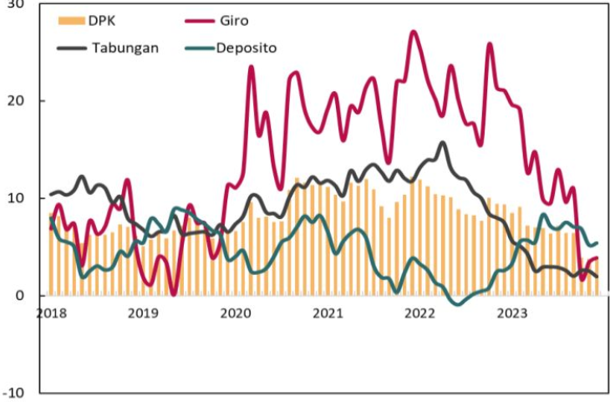

Gambar 1. Perkembangan Tabungan yang tercakup dalam DPK
Sumber: BI, 2023.

Public savings during the Covid-19 pandemic experienced a significant decline, forcing people to generally spend their savings on continuing their economic activities, particularly food and non-food consumption (BI, 2025). This fact is supported by the increasingly declining savings ratio to national income. However, with the government officially announcing the end of Covid-19 in 2023, public deposits have increased again, although other types of savings have not shown a sharp decline (Figure 1). This decline could be due to several economic factors, such as government foreign loans, private foreign loans, inflation, and credit, which can drive economic growth and reduce poverty rates, which in turn can increase people's ability to save.
Credit and savings are two essential elements, like two sides of a coin in banking. The first side is savings collected from the public, and the other side is the savings distributed by banks through credit. Therefore, the higher the savings rate, the higher the credit that can be distributed to the public. Furthermore, if this credit serves as an investment for various businesses, it will encourage increased productivity, enabling the public to earn higher incomes, especially for employees and even civil servants, which in turn will increase their ability to save..
Several factors that can determine the rise and fall of the savings rate are economic growth and poverty. Furthermore, these two factors can be further determined by several factors such as debt, both in the form of private and government debt. So the ability to save can be influenced directly or indirectly, mediated by economic growth and poverty. Economic growth is expected to have a positive influence, while poverty is expected to hinder the ability to save. Likewise, education, credit, and inflation can determine the level of saving, both directly and indirectly through economic growth and poverty, Figure 2.

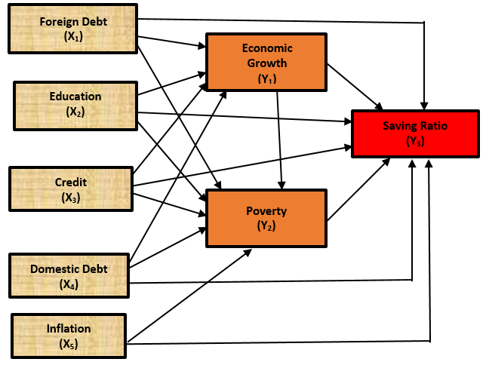
Gambar 2. Kerangka Pemikiran

Based on the description of the background that has been explained, the objectives of this research are to study and analyze the influence of foreign debt, education, credit, domestic debt and inflation on economic growth both partially and simultaneously, to study and analyze the influence of foreign debt, education, credit, domestic debt and inflation as well as economic growth on poverty both partially and simultaneously and finally to study and analyze the influence of foreign debt, education, credit, domestic debt, inflation, economic growth and poverty on saving both partially and simultaneously.
2. Literature Review
2.1. Saving
The concept of savings according to Keynes (namely, relative income determines a country's consumption. With a decrease in income, they try to make as little consumption expenditure as possible. If during the next recovery period, income rises in the same direction as the highest level ever achieved in the previous period, then the upward movement in consumption will also take place slowly and the increase is mostly for the recovery of savings. The concept of savings according to Keynes, that savings made by households depend on the size of the household's income level. The greater the amount of income received, the greater the amount of savings made. The meaning of savings.
Capital formation is a crucial factor in the economic development process, particularly for developing countries. This capital formation is only possible through increased public savings. The lack of capital in development planning is due to the scarcity of public savings and prolonged debt from foreign credit. This means prolonging their dependence on creditor countries. Therefore, development based on one's own strength is a safer and more certain method. The sources of funds used for mobilizing domestic capital come from public savings (domestic savings), which consist of (1) public savings, (2) government savings. Government savings are the difference between domestic revenues and government expenditures. Meanwhile, public savings are the ability of the public to set aside a portion of income that is not consumed. These public savings become greater when public income is also high. Therefore, to stimulate public savings, public income must be increased (Todaro, 2009).
The relationship between consumption savings and income can be explained by the identity function of consumption and savings, Y = C + S, where: Y = Income C = Consumption S = Savings (Saving). The amount of savings is graphically determined by the Marginal Propensity To Save (MPS) curve. If C = a + MPC (Y), where C = consumption a = the amount of consumption at an income level equal to zero MPC = Marginal Propensity To Consume As is known, the amount of desire to save is indicated by the difference between income and consumption. Then the savings function can be formed as follows: S = Y-C If C = a + MPC (Y), then S = Y-[a + MPC (Y)], so that S = Y-a-MPC (Y) = Y-MPC (Y)-a or S = (1-MPC) Y-a, so S = -a + (1-MPC)

2.2. Economic Growth
Economic growth is an increase in the long-term capacity of the country concerned to provide various economic goods to its population. A strong economy is reflected in high economic growth. The economic growth of a country can be influenced by the existence of an open economic system (Todaro and Smith, 2013). Next according to Adam Smith explained that economic growth is a process of combining population growth with technological progress. In line with David Ricardo, he stated that economic growth is a process of attraction between two forces, namely “the law of diminishing returns” and technological progress. Apart from that, proponents of classical economic growth theory really prioritize liberal or laissez faire principles, where all economic activities are expected to be free without any government interference, in this case supporting economic openness, both trade openness and financial openness. The linear growth theory stages of growth theory developed by Rostow, also formulates development patterns through 5 stages including 1) Modern economic stage; 2) Take-off precondition stage; 3) Take off stage; 4) stage towards maturity and 5) stage towards high consumption. Furthermore, the economic growth theory according to Harrod–Domar also explains the same thing, to achieve a steady level of economic growth in a country’s economy lies in the active role of investment (Jhingan, 2015). Harrod-Domar stated that the level of investment in a country can make a major contribution in encouraging economic growth, especially. On the basis that investment has two major objectives in the economy, namely as a source of income and capital to increase production capacity (Branson, 1992).
The mathematical model used by Solow is the Cobb-Douglas function with the equation:
, α+β=1

Where: Y = Total production, A = Technology level, K = Capital or total capital stock and L = Number of workers. This equation can be linearized to obtain:
.
Next, by differentiating this equation regarding K and L, growth is obtained
So it can be seen that growth is the elasticity of capital times its growth plus the elasticity of labor plus the growth of labor. There is a level of economic growth that comes from 3 sources, namely capital accumulation, increasing the number of workers and improving technology.
Neoclassical economic growth theory is known as the Solow growth model. This model was built to determine how the influence of capital stock growth, labor force growth, and technological progress interact in the economy, as well as how they affect the output of goods and services in a country as a whole. According to Solow’s theory, there are several things that can be done to stimulate economic growth. Increasing the savings portion will increase capital accumulation and accelerate economic growth. Apart from that, increase appropriate investment in the economy, both in physical and non-physical forms. Encouraging technological progress can increase income per worker so that providing opportunities for innovation in the private sector will have a big influence on economic growth. Technological advances, many economists view this component as the most important. Technological progress in its simplest form, technological progress occurs due to improvements in old ways of completing work that was previously carried out traditionally (Cypher and Dietz, 2004). In the development process, economic growth, science and technological development have a broader role besides capital as recommended by endogenous growth theory (new growth theory). Science and technology can be the main input to encourage desired economic growth with the assumption that technology is not only exogenous but endogenous.
Endogenous growth theory which attempts to explain that the sources of growth are increased capital accumulation in a broad sense. Capital in this case is not only physical but also non-physical in the form of science and technology. This technological development will develop innovation thereby increasing productivity and leading to increased economic growth. New discoveries originate from the learning by doing process, which can give rise to new discoveries that increase production efficiency. This efficiency can increase productivity. So in this case the quality of human resources is a factor that influences economic growth. The endogenous growth model emphasizes human capital and research and development (R&D), the main drivers of economic growth.

2.3. Concept and Determinants of Poverty
Poverty is the inability of a person to access existing resources. This results in the inability to utilize the factors of production available everywhere. Haughton, J., and Khandker (2009) state that poor people are individuals who lack sufficient income and consumption to lift themselves above the minimum acceptable level. In short, poor people are those living below the poverty line set by a national or international institution. The definition of poverty encompasses not only economic aspects but has expanded to encompass various aspects of life, including other social dimensions, such as health, education, and even the political dimension. Although the definition of poverty is the inability to meet minimum standards of needs, both food and non-food. This type of poverty is also called absolute poverty, contrasted with relative poverty. Furthermore, in Indonesia, structural poverty and temporary poverty are recognized. Structural poverty is certainly worse than temporary poverty, because in this type of poverty it is difficult to escape poverty, because it has become chronic poverty which is characterized by powerlessness (deprivation), discrimination (discriminated), and living in areas that do not support improvements in life (Weiss, 2005).
Poverty can be classified into five classes according to Sumodingrat (1999), namely: 1) Absolute Poverty, in addition to being seen from the fulfillment of minimum basic needs that allow a person to live decently, is also determined by the level of income to meet needs. Absolute poverty is poverty that does not refer to or is not based on the poverty line. 2) Relative Poverty, when the income of a group of people in society is lower than other groups without considering whether they are included in the category of absolute poverty or not. The emphasis is on the existence of income inequality in society between the rich and the poor or known as the term unequal distribution of income. 3) Structural Poverty, refers to the attitude of a person or society caused by cultural factors that do not want to try to improve their standard of living despite efforts from outside parties to help them. 4) Chronic Poverty, is divided into three based on its causes, namely: a. Socio-cultural conditions that encourage unproductive attitudes and habits of society. b. Limited resources and isolation (areas that are critical for natural resources and remote areas) c. Low levels of education and health care, limited employment opportunities, and the community's inability to participate in the market economy. 5) Temporary poverty, occurs due to: changes in the economic cycle from normal conditions to economic crisis, seasonal changes, and natural disasters or the impact of something that causes a decline in the level of community welfare.Selanjutnya, Suradi (2013) menyatakan bahwa ada lima jenis atau teori kemiskinan yang sementara ini dapat disampaikan yaitu; kemiskinan individu, kemiskinan kultural, kemiskinan struktur politik dan ekonomi, kemiskinan geografi dan kemiskinan akumulasi. Selanjutnya Bagong Suyanto (2008), masyarakat miskin tidak memiliki surplus pendapatan untuk bisa ditabung bagi pembentukan modal dan pendapatan yang diperoleh hanya cukup untuk memenuhi kebutuhan konsumsi pokok sehari-hari.Apabila dilihat berdasarkan pola waktu, kemiskinan dapat dibedakan menjadi empat, meliputi (1) persistent proverty, yaitu kemiskinan yang telah kronis atau turun menurun; (2) cyclical poverty, merupakan kemiskinan yang mengikuti pola Siklus ekonomi secara keseluruhan; (3) seasonal poverty, adalah kemiskinan musiman yang sering dijumpai pada kasus nelayan dan pertanian; dan (4) accident poverty, yaitu kemiskinan yang tercipta karena adanya bencana alam, konflik, dan kekerasan, atau dampak dari suatu kebijakan tertentu yang menyebabkan menurunnya tingkat kesejahteraan suatu masyarakat. (Kuncoro,1997).
Measuring poverty levels can essentially be done using two approaches: headcount and poverty gap. Headcount estimates the number of people below the poverty line, while the poverty gap calculates the amount of funding needed to address poverty. Both approaches are used to determine the poverty level of a community. Poverty gap measures take various forms depending on the desired outcome. In addition to estimating the amount of funding needed to eradicate poverty, this measure is often expressed relatively, namely by comparing the poverty gap with other variables such as GDP (Gross Domestic Product), the income of the poor, the income of the non-poor, government spending, foreign aid, or export value.
Poverty arises from the inability to meet the necessities of life, especially in terms of food, so poverty is generally associated with the ability in terms of income. However, poverty can also be caused by other problems or so-called non-income poverty. This type of poverty in Indonesia is a more serious problem than poverty in terms of income. Lack of welfare dimensions, such as education, health and access to basic infrastructure, almost half of the Indonesian population has experienced poverty (The World Bank, 2006). Therefore, the inherent characteristics of the poor are the failure to fulfill basic rights, limited adequate food sufficiency and quality and fulfillment of nutritional requirements, and low purchasing power are problems for the poor. In addition, there are also deficiencies such as low access and quality of educational services, limited employment and business opportunities, and lack of capital.
The process of poverty begins with the unequal ownership of production factors such as capital. If a segment of society has been unable to improve their lives, this will continue, and it will be difficult to improve their standard of living, so government policies are needed. This situation is further exacerbated by unsupportive political power. A power structure that does not allow the poor to control sources of income will make it even more difficult to escape the shackles of poverty (Arief, 1998). Furthermore, Friedman, M. (1962) stated that poverty means unequal opportunities to accumulate a social power base. This social power base includes: (1) Productive capital such as land, means of production, housing, health. (2) Financial resources. (3) Social and political organizations that can be used for the common good such as cooperatives, political parties, social organizations. (4) Social networks. (5) Knowledge and skills. (6) Information that is useful for the advancement of life.
Todaro, (2014) argues that differences in poverty are caused by factors, namely: (i) geographical differences, population and income; (ii) historical differences, some were colonized by different countries; (iii) differences in natural and human resources; (iv) differences in the private and state sectors; (v) differences in industrial structures; (vi) differences in the degree of dependence on the economic and political power of other countries, and (vii) differences in the distribution of power, political structures and domestic institutions. Furthermore, Bradshaw (2005) suggests that there are five factors causing poverty, namely: (i) poverty caused by deficiencies within the individual himself, in this case the individual is considered responsible for their own poverty conditions because they are considered to work less hard or have genetic deficiencies such as being less intelligent or lacking intelligence; (ii) poverty caused by a poor cultural system and support for poor subcultures, namely poverty created through the transmission of beliefs, values, and social abilities from generation to generation; (iii) poverty caused by economic, political conditions and social distortion or discrimination so that people have limited opportunities and resources in efforts to increase their income and welfare; (iv) poverty caused by differences in geographical conditions; and (v) poverty caused by cumulative and cyclical dependencies between individuals and resources, where individuals who do not have resources are unable to participate in broader economic activities which results in low tax payments.
Basically, the causes of poverty can be divided into two, namely natural and structural factors, so based on this, poverty is divided into two; structural poverty and natural poverty. Natural poverty arises as a result of limited assets and/or resources and/or because of a very low level of technological development. This means that the cause of a society becoming poor is a natural factor. This structural poverty can be interpreted as an atmosphere of poverty experienced by a society whose main cause originates, and therefore can be sought in the social structure that applies in society itself. In line with that, they can only escape the prison of poverty through a process of fundamental structural change (Hardiyanti, 2006). Furthermore, Soetrisno (1997) stated that the emergence of poverty is closely related to the culture of life in society, injustice in the ownership of production factors and the use of development approach models adopted by a country. So the causes of poverty include various aspects, one of which is the individual factor. This means that whether a poor person will become not poor is determined by attitudes such as work motivation in him. There is a drive from within oneself to progress, to respect oneself, to feel worthy and worthy of doing or pursuing and so on.

3. The Method
This type of research is quantitative, taking the type of study of comparative causality that processes numerical data that can be calculated using statistical formulas. The data analysis technique used in this study is path analysis which estimates the direct and indirect influence of exogenous variables on endogenous variables although in this study we only look at and discuss the direct effect, both effects are available in the statistical program used for estimation in this study.
This type of research is quantitative, taking the type of study of comparative causality that processes numerical data that can be calculated using statistical formulas. The data analysis technique used in this study is path analysis which estimates the direct and indirect influence of exogenous variables on endogenous variables although in this study we only look at and discuss the direct effect, both effects are available in the statistical program used for estimation in this study. This study uses secondary data, namely data that is already available and collected by certain institutions and it is panel data. The data was taken from the Indonesia Central Statistics Agency (BPS) Bank Indonesia and the Ministry of Finance of the Republic of Indonesia. The data used is secondary data from 2017 to 2014 which covers 34 provinces in Indonesia..
Based on the conceptual relationship in the framework of thinking, mathematically functional relationships can be written as
Based on the conceptual relationship in the framework of thinking, mathematically functional relationships can be written as

Y₁= f(X₁, X₂, X₃, X_{4,} X₅) ............................... (3.1)
Y₂ = f(X₁, X₂, X₃, X₄, X₅,Y₁) ............................... (3.2)
Y₃ = f(X₁, X₂, X₃, X₄, X₅,Y₁, Y₂) ............................... (3.3)

Whereas:
X1 = private debt (amount of private foreign loans not guaranteed by the government, dollars)
X2 = education (average length of schooling of the population aged 15 years and over, years)
X3 = credit (amount of finance provided to entrepreneurs, price, rupiah)
X4 = government debt (amount of money borrowed by the government from abroad, dollars)
X5 = inflation (continuous increase in general prices over a year,%)

Y1 = economic growth (increase in the number of goods and services,%)
Y2 = poverty (percentage of poverty according to BPS,%)
Y3 = saving ability (amount of money people save in banks, rupiah)
............................... (3.4)
....... (3.5)
...(3.6)

Result and Discussions
Model fit test
Chi-square statistic, as stated earlier, is the most fundamental test to measure overall fit, it is very sensitive to the size of the sample used and the relation of exogenous variables, almost the same as the model Regresi Linear Berganda. The model is considered good if the Chi-square value is small. The smaller the value, the more feasible the research, meaning that the more it describes the match between the variance of the sample taken and the research population. The results of data processing that have been carried out using the AMOS 18 program are as shown in Table 1.

Tabel 1. Goodness of Fit Index
No. | Goodness of fit Measure | Cut-off Criteria | Estimation  (cut off Value) | Fit Situation
1 | Chi-Square ()  Significance Probability (p) | smaller the better  0.05 | 5.7111  0.456 | Fit
2 | RMSEA (the Root Mean Square Error of Approximation) | ≤ 0.05 | 0.000 | Fit
3 | NFI (Normed of Fit Index) | 0.95 | 0.992 | Fit
4 | IFI (Incremental Fit Indices) | 0.95 | 1.000 | Fit
`5 | CMIN/DF (the minimum Sample Discrepancy Function) | ≤ 2 | 0.952 | Fit
6 | TLI (Tuckler Lewis Index) | 0,95 | 1.002 | Fit
7 | CFI (Comparative Fit Index) | 0,95 | 1.000 | Fit
8 | Hoelter’s Index | 200 | 523 | Fit
Sumber: Malkanthie, 2015; Wan, 2022 and Amos Result

Research findings
As is known, this research divides Indonesia's provinces into 2 regions, so the estimation results consist of two components. The estimation results for Region 1, which is called Non-Natural Resource Base Areas, D=0, can be seen in Figure 4

The results of data processing using the statistical program, AMOS, obtained Figure 1 with the estimated parameter values ​​for the regression equation, Figure 4.
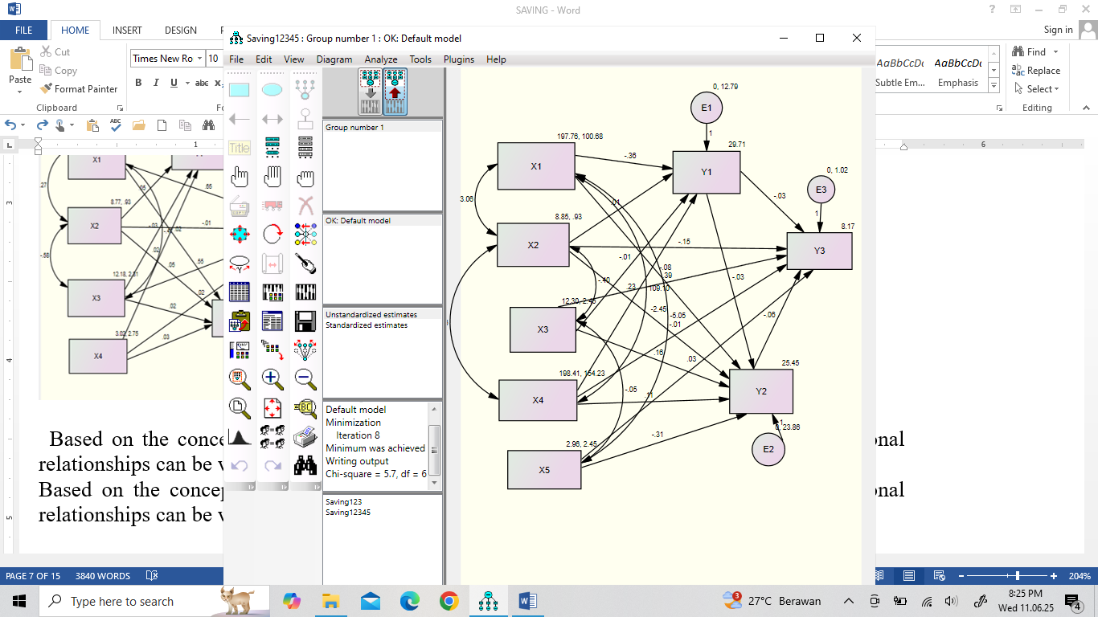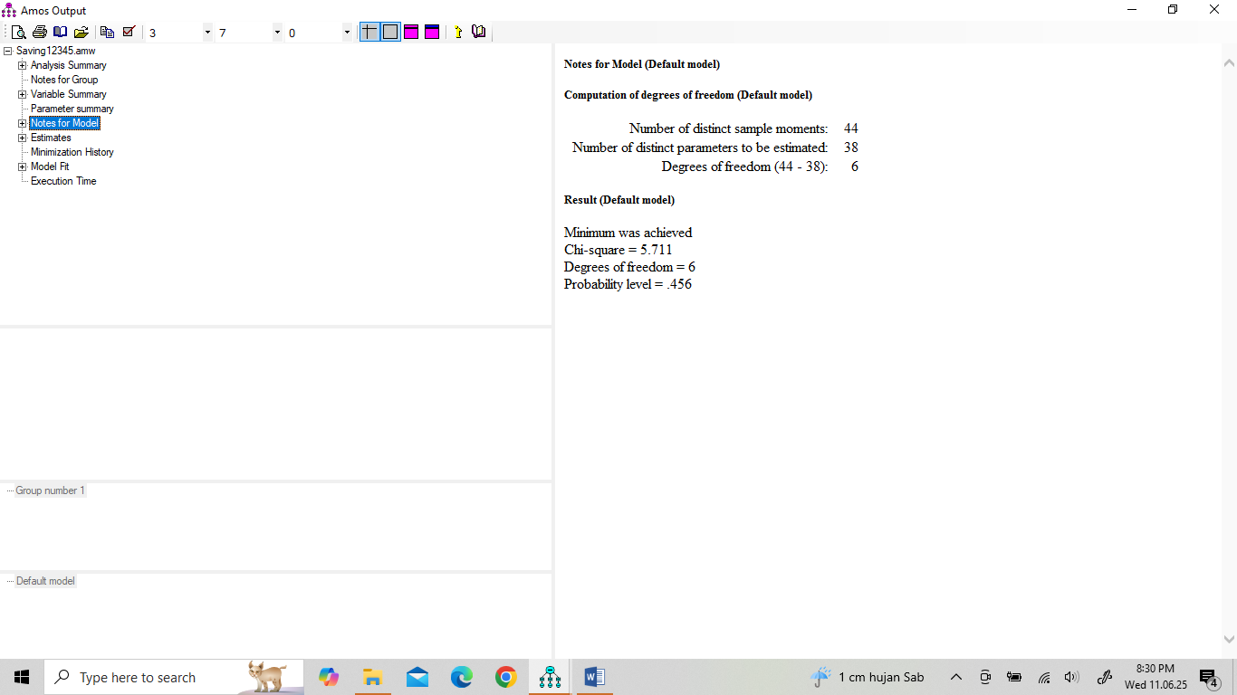

Figure 4. Coefficient of Regression with value of Chi-Square

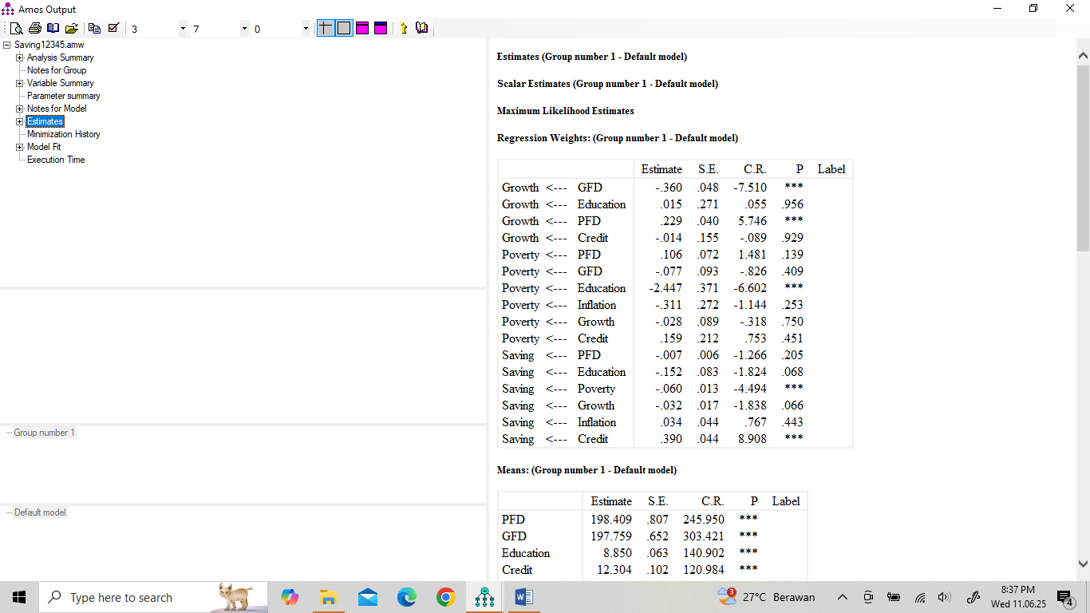

Figure 5. Coefficient of Regression 2 with Probabilities

Figure 4. Hasil Estimasi dari Pengolahan Data .
Recourse: Amos 18 data processing results.

Based on Figure 4 and Figure 5, the number of regression equations that can be formed is 3 as is the number of dependent variables.

.................................... (3.7)

...... (3.8)
……...(3.9)

Based on equation (3.7) it is known that PFD has a significant positive effect on economic growth at the confidence level α = 0.05 in Indonesia with an elasticity of 0.23. On the other hand, GFD has a significant negative effect at the same confidence level with an elasticity of -2.45%. If PFD increases by 1% then economic growth increases by 0.23% conversely if GFD increases by 1% then economic growth decreases by 0.36%. This finding is in accordance with supporting research from (Oktaviana et al., 2024) that state debt has a significant effect on Indonesia's economic growth, but contradicts research conducted by Syaparuddin (2015) which states that increasing foreign debt results in a slowdown or decline in economic growth during the 1990-2013 period. Furthermore, in the same equation it is also known that education and credit do not have a significant effect on economic growth at the confidence level α = 0.05. In accordance with the theory of human investment, education should have a positive impact on economic growth, but this can be hampered by the quality of education that does not meet expectations, inadequate access to education and market needs that do not match educational output.

Furthermore, regarding poverty, it is known from equation (3.8) that private foreign debt (PFD) has a positive effect on poverty, but is not significant at the confidence level of α = 0.05. Meanwhile, government foreign debt (GFD) has also not been able to reduce poverty significantly at the confidence level of α = 0.05. In the same equation, it is also known that there are 2 (two) variables that can reduce the poverty rate or have a negative impact on poverty, namely education with an elasticity of -2.45%, meaning that if education increases by 1%, poverty decreases by 2.45%. This fact is the government's effort to foster, build in the implementation of education so that outputs are obtained who have knowledge and skills that are readily used so that poor people can improve their quality of life through expanding employment opportunities that increase their income. It is known that education is a long-term investment that can improve the quality of human resources so that they are able to participate in development in various fields of production. So education can create entrepreneurs, especially in MSMEs, which have a direct impact on reducing poverty as part of a community empowerment program to be more independent or get out of the poor population group. Furthermore, globally, education is one of the keys to poverty alleviation as stated in the Sustainable Development Goal (SDG). Furthermore, the same equation also shows that economic growth has a significant negative effect on poverty, in other words, economic growth has significantly reduced poverty at the confidence level of α = 0.05 with an elasticity of -0.03, which means that if economic growth increases by 1%, poverty will decrease by 0.03%. Thus, education, both directly and indirectly through economic growth, will reduce poverty rates. This fact is in accordance with research conducted by Balisacan et al, (2010) which shows that growth is not the only factor to affect the rate of poverty change; other factors also directly influence the welfare of the poor, as well as having an indirect effect through their impact on growth itself, so it is clear that the problem of poverty is a multidimensional social symptom with an approach using the Multidimensional Poverty Index (MPI).

Finally, the mathematical equation 3.9 shows that education has a significant negative effect on saving ability at the confidence level α = 0.07 with an elasticity level of -0.15, meaning that if education increases by 1% then saving ability decreases by 0.15% assuming other variables included in the model remain constant. Furthermore, the same equation also shows that the amount of credit can increase people's ability to save. This fact is supported by statistical references with a very strong significance level of α = 0.01% with an elasticity level of 0.39, meaning that if the level of credit provision increases by 1% then the ability to save increases by 39%, so it is inelastic. Furthermore, it can also be seen that inflation and government debt do not have a significant effect on saving ability, but it is known that government foreign debt used to improve connectivity is expected to increase people's income which in turn will increase saving ability, but as described in the background that people's ability recently tends to decline, especially for most of the lower middle class in general dissaving. Meanwhile, inflation shows that the Indonesian economy is protected from hyperinflation, which is indicated by the fact that inflation does not have an impact on people's saving ability.
The same equation also shows that economic growth negatively impacts savings. This is not significant at α = 0.05, but is significant at α = 0.10. This suggests a negative impact of economic growth on people's savings. This contradicts research that suggests a high level of savings is in line with household disposable income. The real deposit rate has a significant positive impact, but the magnitude of this impact is relatively small (Prema-Chandra Athukorala & Pang-Long Tsai, 2010). Furthermore, the equation shows that poverty reduces people's savings. This suggests that poverty is caused or characterized by low income levels, resulting in lower productivity and health outcomes, which in turn leads to a decrease in savings. It is known that the key to alleviating poverty is increased investment, but this investment is hindered by low savings, so the cycle of poverty has not been fully overcome.

5. Conclusions and Recommendations
5.1. Conclusion
Based on of the previous discussion dan analisis statistik yang telah diuraikan, the following conclusions are drawn:
1. Government foreign debt has a significant negative impact on economic growth. In other words, higher levels of foreign debt lead to lower economic growth, while the opposite is true for private foreign debt. In other words, higher levels of private domestic debt lead to significantly increased economic growth.
2. Education leads to a decrease in poverty but has a positive impact on increased savings. Furthermore, this education variable has no effect on economic growth.
3. Credit has no impact on economic growth or poverty but has a significant positive impact on increased savings. Furthermore, inflation has no effect on either poverty or saving capacity.
4. Poverty has a significant negative impact on increased savings, while economic growth has no significant impact on people's ability to save.
5.2. Recommendation
The suggestions to be put forward based on the discussion and conclusions that have been stated, among others:
1. The government's foreign debt has had a negative influence on economic growth, so the government needs to be careful in managing debt, while private debt has had a positive influence on economic growth, but the government should be more careful and provide strict supervision and regulation with hedging principles and debt ratio limits.
2. Education should receive more attention from the government to get a higher portion or budget than before, for the full development of human potential and can be accessed more evenly
2. The government should continue to expand the provision of more productive credit to increase the people's saving capacity, especially providing adequate credit fisliats with lower interest rates.
3. Poverty continues to be sought to decrease both in number and prevalence because it has had a negative impact on people's ability to survive

Reference
Arief, Sritua (1998), Teori dan Kebijaksanaan Pembangunan, PT. Pustaka CIDESINDO, Jakarta.
Athukorala, Prema-Chandra & Tsai, Pang-Long, (2023). Determinants of Household Saving in Taiwan: Growth, Demography and Public Policy, The Journal of Development Studies, 39(5), 65-88.

Acemoglu, Daron. ( 2016). Introduction to Modern Economic Growth. Department of Economics, Massachusetts Institute of Technology. Retrieved from: https://www.theigc.org/sites/default/files/2016/06/acemoglu-2007.pdf
Ackley, Gardner. 1961. Macroeconomic: Theory and Policy. Macmillan Library, New York.
BPS-Statistic of Indonesia (2024). Statistical Yearbook of Indonesia. Publication Number : 03200.24003
BPS. 2023. Produk Domestik Regional Bruto Provinsi-Provinsi di Indonesia Menurut Pengeluaran, 2018-2022. Jakarta

Balasan, Arsenio M., Pernia, Ernesto M. & Asra, Abuzar, (2010). Revisiting Growth and Poverty Reduction in Indonesia: What do subnational data show?. Bulletin of Indonesian Economic Studies, 39 (3), 329-351.

Bank Indonesia, 2025. Laporan Kelembagaan Bank Indonesia, Triwulan IV 2023. Retrieved from https://www.bi.go.id/id/publikasi/laporan/Documents/LKBI-Tw.IV-2023.pdf
Bradshaw, T. K. (2005). Theories of Poverty and Anti-Poverty Programs in Community Action. Roda, CA: California State University.
Branson, William H. (1992). Macroeconomics Theory and Policy. Hopper & Row Publishers, Singapore.
Arief, Sritua. (1998). Teori dan Kebijaksanaan Pembangunan. Center for Information and Development Studies (CIDES), Jakarta.

BPS. 2023. Produk Domestik Regional Bruto Provinsi-Provinsi di Indonesia Menurut Pengeluaran, 2018-2022. Jakarta

Cypher, J.M. (2014). The Process of Economic Development. Routledge, Taylor & Prancis Group, London, New York.
Hardiyanti, Puji. (2006). Kemiskinan dan Upaya Pemberdayaan Masyarakat. Jurnal Pengembangan Masyarakat Islam, 2 (1), 33-45.

Haughton, J.H. and Khandker, S.R. (2009). Poverty + Inequality, Handbook on Poverty and Inequality. The World Bank, Washington, DC.

Jhingan, M.L. 2021The Economics of Development Amp Planning. Retrieved from: https://archive.org/details/in.ernet.dli.2015.118935

Keynes, J.M. (1936). The General Theory of Employment, Interest and Money. Macmillan and Co. Landon.

Kuncoro, M. 1997. Ekonomi Pembangunan Teori, Masalah dan Kebijakan, Yogyakarta: UPP-AMP YKPN.

Kuncoro, M. 2010. Dasar-dasar Ekonomi Pembangunan, UPP STIM, YKPN, Yogyakarta.

Oktaviana, M., Rafinda, A., & Rusmana, O., (2024) Analisis Pengaruh Utang Negara terhadap Pertumbuhan Ekonomi Indonesia Periode 2004-2023 Berdasarkan Data LKPP. Akuntansi ’45, 5(2), 598-972.

Kompas, 2024. Kompas Profesional., Makan Tabungan. Retrieved from https://www.kompas.id/label/makan-tabungan?open_from=automate_body_url.

Malkanthie, Asoka. 2015. Structural Equation Modeling with AMOS Book. March 2015DOI: 10.13140/RG.2.1.1960.4647

Sumodiningrat, G. (2009). Kemiskinan: Teori, Fakta dan Kebijakan. IMPAC, Universitas Michigan.
Suradi, S. (2013). Perubahan Sosial dan Ketahanan Keluarga: Meretas Kebijakan Berbasis Kekuatan Lokal. Sosio Informa : Kajian Permasalahan Sosial Dan Usaha Kesejahteraan Sosial, 18(2). https://doi.org/10.33007/inf.v18i2.74
Suyanto, B. (2013). Anatomi Kemiskinan dan Strategi Penanganannya: Fakta Kemiskinan Masyarakat Pesisir, Kepulauan, Perkotaan dan Dampak dari Pembangunan di Indonesia. In-Trans Publishing. Malang.
Syaparuddin, Etik Umiyati, E., Kusuma J., (2015). Pengaruh Utang Luar Negeri terhadap Pertumbuhan Ekonomi Indonesia, Thailand, Malaysia, Filipina, Vietnam dan Burma Periode 1990--2013. Jurnal Paradigma Ekonomika, 10(1), 206-220.
Soetrisno, Loekman. 1997. Kemiskinan, Perempuan dan Pemberdayaan. Yogyakarta : Kanisius.

Todaro, Michael P. (2009). Economic Development. Boston : Pearson Addison Wesley, New York.
Todaro, Michael P. and Smith, Stephen C. 2020. Economic Development. Pearson, Addison-Wesley Boston Columbus Indianapolis New York San Francisco.
Todaro, Michael P. and Smith, Stephen C. 2014. Economic Development. Pearson, Boston Columbus Indianapolis New York San Francisco Upper Saddle River Amsterdam.
Wan, T. T. H. (2002). Evidence-based health care management: Multivariate modeling approaches (1st ed.). Norwell, MA: Kluwer Academic Publishers.

Weiss, J. (2005). Poverty Targeting in Asia, Research Director, Asian Development Bank Institute, Tokyo, Japan.

