Architecture of Colonial Plantations and Elements of Discrimination and marginalisation in resource allocation in Cameroon: the case of Cameroon Development Corporation (CDC) Fako Division, South West Region
, Salamatou, Amadu Ismaila, Ngoe Fritz Eseokwea, Norah Aziamin Asongu

Abstract
This research work is an analysis of the colonial legacy of large agro-industrial plantations established following the 1896 Ordinance, which led to the expropriation of indigenous lands by the Germans who colonised Cameroon. After the defeat of Germany in the First World War (1914-1918), its colony in Cameroon was partitioned into English and French Cameroon respectively. German possessions in Kamerun were equally partitioned between the two colonial powers. Part of the German plantations located in the present South West region were handed over to British colonial administration under an ordinance signed in 1947 to named Commonwealth Development Corporation(CDC). After independence of the both French Cameroons and English Cameroon in 1960 and 1961 respectively under a federated system, and reunification the name of the corporation was changed to Cameroon Development Corporation(CDC) to reflect the independence status of the country. The objective of this research is to examine and compare the infrastructure and management systems provided to workers during the colonial periods and to understand whether changes that have taken place decades after independence have improved human conditions and infrastructure in workers camps. It was realised that conditions in the workers camps have undergone drastic deterioration both in working conditions and in provision of amenities among workers as there have been insignificant innovations to improve living conditions of the workforce especially the labourers who make up the largest segment of the workers population. According to study evidence, infrastructure inherited from German colonial period notably housing, railways, bridges, and living conditions have undergone drastic deterioration, which calls for concern. The results of the study have also indicated vast discrepancies in the allocation of housing between workers camps and executives' residential areas. Further evidence shows that discriminatory practices endemic during colonial period have been continued in contemporary period of the company’s history This research attempts to demonstrate that architectural heritage in the executive and workers camps has become a driving force for maintaining and spreading colonial ideologies in the management of the corporation. It recommends the company to embark on massive improvement in the company infrastructure, working and the living conditions of the workers as the only way of alleviating workers deplorable conditions.
Keywords: architecture, camps, plantations, discrimination, idéologies, colonial, CDC

1.0 Introduction
Colonization and industrialization of Europe were major concerns of European powers during the 19th and 20th century. To advance industrialisation in metropolitan Europe, colonisation transformed their oversea possession into agricultural experimentation which grew and expanded production of raw materials for development of industrial empires in Europe (Daniel, 1980). In Africa and elsewhere production patterns were altered to align with the need of European industries. To maintain constant supplies of raw materials the Germans established vast plantation of crops like cocoa, rubber, banana that were needed for the growth of industrial capital. In contemporary Germany the historiographical works of Reinhart (2006) Pape, E. (2016), and Chantal Metzger (2017) and public discussion and debates in Germany reveal divergent expositions on the country's colonial past. According to Chantal (2017), the idea of marginalisation during the short-lived German colonial period is projected due to its short duration (30 years) as compared to the English and French empires whose colonial impact have lasted for decades after independence. Thus, although African countries were granted independence the economic structures were still managed in the same ways by independent governments whose economies were structure to facilitate the exploitation and exploitation of resources to the detriment of the economic and social development of workers and the former colonies in aggregate. It is on this basis that after independence of African countries, the economic interest of former colonial masters were protected to the detriment of workers, and living conditions of workers and infrastructure deteriorated. The Germans made huge profits from forced labour in plantations and diverted profits to Germany instead of reinvesting for economic growth of the colonies. According to Daniel (1980) Germany and other colonial powers in the African continent laid the foundation of poverty and underdevelopment in their former colonies. The aim of colonial powers in Cameroon was not to develop the country but to use the territory as reservoir for extracting and expropriating economic resources to the detriment of economic and social development in the country. Andrian Schlegel &Aram Ziai (2021) notes the impact of this German colonization on formerly colonized populations and expresses dismay over the country’s actions to the colonised people. Aram exposes the brutality of German colonizers and injustices perpetuated through discrimination and marginilisation in all facets of social and economic life of the colonies. This reflected the poor living conditions former German plantations whose plantation executives were Germans or Europeans. Jefferson (1974) notes that in spite the brutal history of the German colonisation in Cameroon, the structures left behind after their defeat in the First World war are lasting effigies that requires innovation by subsequent administrations. These innovations and other improvement were expected to take place to reflect the developing nature of the country.
Rather these infrastructure notably in workers camps of former plantations located in the South West region of Cameroon are in dare need of repairs and maintenance. According to Norah and Ngoe (2021) the deplorable nature of most CDC camps buildings and other installation left by the Germans requires adaptable innovations that could improve camp life and living standards. The studies noted the dilapidated nature of housing, hygiene and sanitations were the greatest course for concern. It was expected that the housing situation in CDC camps would improve significantly after the country’s independence but the reverse is true. The deplorable state of housing in the workers camps with no repairs or innovation over decades are glaring examples of continuity of imperial administration in the workers camps even decades after independence. Norah and Ngoe(2022) laments the glaring inequalities between residential areas of workers and company executives who enjoy social benefits, incentives and motivations which are non-existent in workers camps. Workers continue to endow injustice and discrimination in squatter camps with their families in spite huge profits accumulated during the colonial periods and after independence when profits were supposed to be re-invested for the welfare of workers.
For instance, allocation of houses to workers have been based on work category rather than household occupation.. The lowest categories of workers who constitutes more than 90% of the workforce have endured the worst forms of injustices and social exclusion inherited from respective colonisers. According to ---(2018) after independence institutions left by colonial Germany and Britain were supposed to must have undergone innovations working conditions and housing conditions significantly improved.
In addition, even the advantages of free medical treatment formerly granted to CDC workers have been withdrawn thus increasing the burden of responsibilities of the already vulnerable workforce; especially the plantation labourers This continuation of discrimination in the company’s workforce have been viewed by researchers, academics and statesmen as reconstruction of colonial past (1884-1914) from German Kamerun and later the British administration that took control of the company after the Versailles settlement(Daniel 1980; Salamatou 2019).
. In this perspective, the large plantation system, in addition to contributing to the economic growth of colonial Germany, Britiain and Cameroon respectively has strongly marked the organization of environment and social groups by the imperial administration. Housing, railways, and bridges, roads despite their dilapidation continue to embody inequalities in land occupation and development in contemporary South West Cameroon. According to Andrian and Ziai(2021) inequalities existing between the workers' camps and the senior executives' residences, reveal a perpetuation of the model of social distinction and discrimination whose foundations were laid during the German and the later British colonial period.

1.1 Objectives of the study
- Give presentation of workers camps and living conditions during German and British Colonial period by documentation.
- Examine the current housing situation and living standards among different categories of workers in the corporation.
1.2 Methodology
The study was conducted in five towns harboring CDC plantations and workers camps and installations. The towns were purposively selected because they were constructed by the German colonial administration. Although the corporation has constructed new workers camps over the years due to expansion of land holdings and influx of workers ; the selected camps are the among the oldest camps that were left behind by the Germans colonial administration after the defeat of Germany in the First World War (1914-1918). These reasons justified the choice of selection for the study zones. Among the camps selected for the study are CDC camps at Tiko( Upper Costaiins, Middle Costain,and WaterTank, Likomba), Moliwe, Limbe(Bota Middle Farms),and Ideanau along the West Coast of Africa. The age of these camps visibly exposes systematic detoriation of housing infrastructure in workers camps from the colonial to the contemporary period in Cameroon
1.2.1 Location of the study area
The study was carried out in Fako division which is key administrative area in Cameroons South West region. The division is known for its rich biodiversity, fertile soils from Mount Cameroon, and access to the sea which facilitated the export of agricultural raw material to metropolitan Europe during the colonial and post colonial periods. Limbe is the capital town of Fako Division. Major urban centres in the division include Buea (Régional capital) which doubles as capital of German Cameroon, Tiko and Muyuka. The fertile volcanic soils and its rich biodiversity attracted the development of plantations by the German imperialists. Fako division covers an area of 2,093km² . As of 2005 population estimâtes the division had a population of about 466,412. In recent years the division has witnessed population growth attributed internal migrations into cities of the division. The division comprises of five administrative subdivision of Limb(formerly called Victoria), Buea, Muyuka, Tiko,and Idenau. Fako owes its origin to western colonisation of Cameroon by Germany. Fako division consists of the following indigenous tribes, namely Balongs, Mungo, Isubu (Bimbia), Wovia(Bota), Bakweri who constitutes the majority. Figure 1 indicates the sites surveyed in the study.
Figure 1. Location of the surveyed sites in the South West Régions:
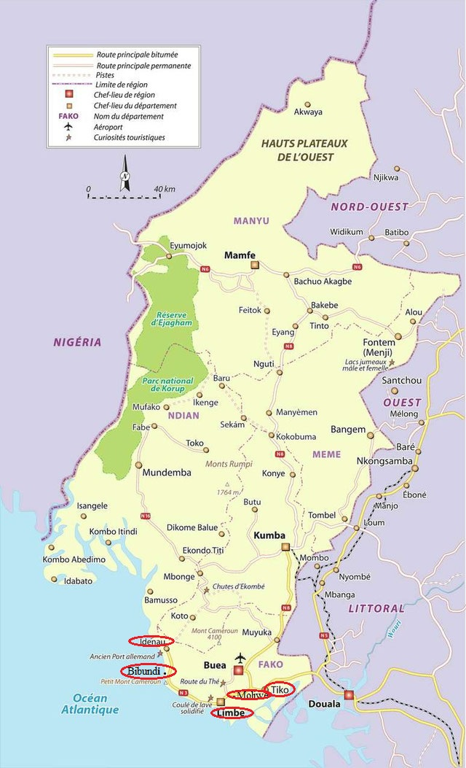
Source: https://www.osidimbea.cm/collectivites/sud-ouest/
The circled areas are areas where the study was carried out. These areas located in the maritime area of the South West region attracted German plantations due to nearness to the sea and land fertility attributed to volcanic soils.

1.2.2 Presentation of Cameroon Development Corporation(CDC) in Fako division
What is known in contemporary Cameroon as Cameroon Development Corporation was formerly a German company established among other plantations between 1885 and 1914. After the defeat of Germany in the first World War (1914-1918) German possession in Southern or British Cameroon were taken over by the British government. The Commonwealth Development Corporation(CDC) as from 1947 took over from West African Plantation Victoria (WAPV) and West African Fruit Company(AFC) owned by the Germans. The Commonwealth Development Corporation ordainance was tabled in Lagos, the then capital of Nigeria by Mr.F.E.V Smith who became the Corporations first chairman. There after the property became property of Commonwealth Development Corporation (CDC), set up under auspices of British Post-war Labour Government. The name CDC was born to replace the former German plantations. When French Cameroon (la Republique du Cameroon) gained independence in January I960 and West Cameroon or British Cameroon was granted independence by joining French Cameroon under a federation in 1961, the company was still managed by the British Government. The CDC continued to be managed alongside other British assets for fourteen years(1960-1974) and handed over to Cameroon under the name Cameroon Development Corporation(CDC) with same abbreviation.
The Cameroon Development Corporation is a government parastatal in the country’s Agricultural sector with head office at Bota-Limbe. It is the largest agro-industrial complex in Cameroon, and second highest labour employer after the Cameroon government. Initially the company activities were limited in the South West region and Fako division, in particular. However, its activities have expanded to other divisions of the South West region like Ndian, Meme and Kupe Muanenguba, and the Littoral region. CDC plantations cover a total area of approximately 42,027 hectares of land, 38000 hectares of mature plantation at production stage. Rubber plantations covers 22,262 hectares, while oil palm trees covers 15,240 hectares, and banana 4525 hectares. The corporation constitutes a vibrant workforce of 22,036 employees including temporal workers , ranking it second employer of labour after the state of Cameroon.the company produces between 18,000 to 20,000 tonnes of rubber, 18000 to 19000 tonnes palm oil, 6000 tonnes of palm kernel and an average of between 90000 and 110,000 tonnes of banana annually. Before the advent of privatisation advocated by the IMF/World Bank Structural Adjustment Programme (SAP), CDC also produced tea in Tole-Buea and also Ndu in the North West region where the corporation established processing plants for the crop.the corporation ceased tea production as a result of privatisation of the tea sector.
The establishment of CDC in Fako division has led to the occupation of vast areas of land used for agriculture for the cultivation of mainly industrial trees without taking to consideration food demand for the ever-growing populations of the division. Land grabbing and dispossession of large peasant communities from land has never been done with sustainable compensations to empower the communities. The phenomenon was inherited from subsequent colonial administration who were granted no limit of expansion of their plantations (Owono, 2005).
The resulting economic, social and environmental consequences have evolved into land conflicts with both urban and rural communities who are desperately in need of land for agriculture and urban expansion. The company has been ordered to give up parts of its occupied land for expansion of settlements in the towns of Tiko and Limbe subdivisions(Tiko Rural Council, 2016). According to the Ministry of State Property and Land Tenure (2008), CDC occupies more than 50% of the land mass in Fako division. Between 2018 and 2022, the Cameroon Development Corporation went through a major crisis due to the Anglophone crisis which negated production, displaced plantation workers with significant majority killed. This crisis led to a decrease in the workforce, from 22,000 to 15,000 workers, and activites of the corporation suspended with workers unpaid for several years. Today, following the Cameroonian State's settlement of five years of salary arrears amounting to 35.7 billion FCFA, a new impetus has been given to this agro-industrial enterprise (https://ecomatin.net/cameroun-letat-regle-357-milliards-fcfa-darrieres-de-salaires-a-la-cdc-grace-a-trois-banques-locales)
. However, the situation of the workers remains worrying, particularly in the plantation camps where discrimination in the award of amenities between executives of the company and labours is glaring.
2.0 Data Collection
Data collection is in two stages, primary and secondary data
2.1 Primary data sources.
The data was primarily obtained by observation of the workers camps constructed during the colonial period. The infrastructure observe in the camps include residential homes, offices, recréation facilities, water and electricity supply.including areas of sewage and waste disposal in the workers camps. Executive residential areas were visited to understand the ammenities available and the nature of houses allocated by categorisation of workers. Other areas covered by the study included factories, roads, railways and plantations. Some information was obtained through discussions with staff at the Head office of CDC at Bota-Limbe and offices in Tiko, Moliwe, and Idenau. Focus Group discussions were held with officials and members of the workforce in plantations of rubber, and oil Palm.
2.2 Secondary data sources.
Secondary data sources were from desk review by documentation from CDC archives where the colonial history of the company was obtained. Through documentation a clear presentation of the company contemporary and past history was obtained. Other sources include textbooks on colonialism, scientific journals and websites. Documentary evidence helped to build historical elements to support the study objectives The following information was obtained from the CDC archives : types and structure of residential homes based on workers category, materials used in construction, household occupation of rooms and apartments, toilets, bathrooms, water supply, including hygiene and sanitation in workers

3.0 Results and discussions
3.1 Presentation of workers residential areas in colonial German plantations
Information about workers residential areas in colonial plantations known as the Cameroon Development Corporation (CDC) was obtained through documentation from historical archeology which provided data on cocoa, banana ,oil palms and tea cultivation which supplemented information from colonial archives(FA/R175). It also provided sample shipments of agricultural items, experimentation sites for crops, and promotion of the crops among local populations, European plantations, and indigenous plantations. Other information obtained were concrete traces left on the spatial layout of villages and dwellings, and the objects produced to meet the needs of the economy. A critical examination of documentation revealed the daily lives of workers in the plantations, which reflected some elements of class character under capitalism. Reconstruction of lifestyles of plantation workers revealed abusive inequality between plantation workers Africans or indigenous people or natives and company executives who were mostly Europeans(Germans). Relationship between company executives and plantation workers were synonymous to masters and subjects, urban and rural environments, traditional agriculture and industrial agriculture. According to Daniel (1980) discrimination in colonial plantations was based on race with Europeans claiming racial superiority over the indigenous blacks considered inferior to the white or Europeans races. This discrimination reflected the types of houses allocated to plantation workers and even advantages granted to them. Thus, the social dichotomy, which existed among workers in the German plantations, provided the fundamental background of discrimination, which was handed down to British who took over Germans assets after their defeat in the First World War. This discrimination among plantation workers and executives was synonymous to a plague handed from the colonial periods to independence in plantations owned by the colonialists in most of Africa (Eric 1966; Jefferson 1974). Discrimination in German plantations reflected the manner in which land was acquired as blacks were forced offer free labour, some of their villages burnt, kings killed or imprisoned while the economic age brackets were forced to work in the plantations without wages. Workers who escaped free labour were caught and summarily executed or sentenced to prison with hard labour without trial. Eric (1966) terms German colonisation as abusive and most brutal form of colonisation ever experienced in the African continent.
According to Jefferson (1974), fear of being killed or imprisoned made it virtually impossible for workers to revolt against the brutal German colonial administration. The fear of extermination suppressed revolt among the indigenous populations whose land was forcefully expropriated for the expansion of German plantations. Thus economic active groups had no choice than to work in plantations since most of their land had been confiscated for plantation agriculture. Indigenous populations were forced to abandon local agriculture for food production for export crops that yielded revenue for tax payment to the colonial administration( ). .
In Cameroon workers camps or residential areas were not constructed to improve the welfare of labourers in the estates. According to -----( ), initially the Germans constructed camps meant to accommodate workers according to categories. Majority of Cameroonian labour force had not acquired western education like their European or German counterparts who were placed in top executive positions in most companies( ) The architectural model designed by the Germans was not significantly improved during British colonisation and after independence as the lower classes of workers continued to feel the impact of poor housing and accommodation over the decades. Ngoe and Yaya(2013) argues that German plantation workers were suppose to be granted good accommodation since material for construction of residential homes were extracted or expropriated from the environment under the free labour schemes. According to this studies there was no justification for the Germans refusal to guarantee good accommodation to the non-executive arm of its plantation labour force, than discrimination perpetuated by white supremacy. . Indigenous communism offered free labour to advance colonial interest to the detriment of the indigenous communities. Most of the plantation workers camps were thus constructed by use of forced labour which yielded supernormal profits to the colonialists. Walters-(1974 ) and Jefferson(1974) argues that if colonialism was meant to develop indigenous communities, taxes and huge profits made from export of agricultural and mineral resources were supposed to be reinvested or ploughed back for economic growth and development of the colonies.
Most of the plantation camps were constructed from wood, terracotta bricks, volcanic stones, which were transported mostly by head loads to the various construction sites as motorable roads linking extractive centres were scarce or unavailable (Roger 1993; George 2000). The few railways constructed in the present South West region were only limited to coastal towns like Tiko and Victoria currently called Limbe. These sea port towns facilitated the exports of agricultural produce to Germany.
Figure1: Map showing German Plantations in the present South West region during the German colonial era.
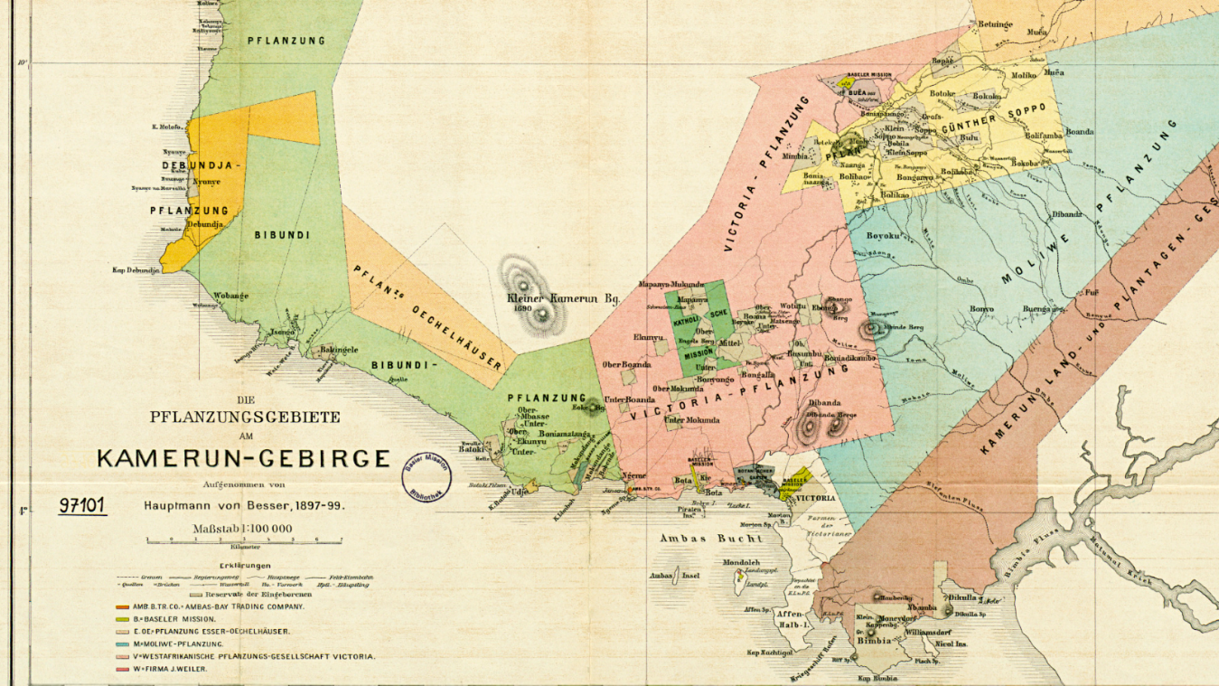
Source: Sketch by Hauptmann von Besser made between 1897 and 1899.
Note: Map of German Kamerun was different from the present Map of Contemporary Cameroon which have divided the country into regions after ceding away parts of of German Kamerun to Tchad, Central Africa, Gabon, and the Congos(Congo Kinsasha and Congo Brazavaille). .
3.2 Typology of Workers Housing during the German Colonial Era
In the colonial era, workers' camps were spaces characterized by linear housing or settlements. During German colonial rule most of the houses were meant for plantations labourers who were neither educated nor learned. The building were square shaped and each room had an area of 4m² meant to accommodate two natives who worked in the plantation in various capacities like cleaners, night watchmen and field labour who dominated the workforce(.CDC Archives accessed March 2025) Figure 1 from the company archives is a picture taken by Burck(1938) around the camp of Moliwe in the Present Limbe subdivision. The middle of the camp shows a common area used as kitchen for all workers in the camps. The resident of the supervisor was separated from the workers camp due to his executive position in the establishment and was constructed to meet European standards. Figure 2 shows the Bungalow model of executive residential area in Bota- Victoria (renamed Limbe)
The camps were meant exclusively for male workers due to the labour intensive nature of plantation work. According to ---------( ) company executives were instructed by the hierarchy not to allow the native to live with female partners. Women were allowed to come and stay within a limited period of time and return to their communities. Though this sounds inhuman, it was common practice during the German colonial period (1885-1915). Most men suffered from emotional stress and trauma orchestrated by absence of women. When native women visited their peers without official permission the workers were penalised. According to ---- (1973) the situation in German plantation was similar to those in South Africa and Zimbabwe(Rhodesia) where male black workers were permitted to visit their families only during leave periods. As males took permanent residence in camps most of the native communities had imbalanced ration between gender populations. Both men and women were separated voluntarily as men in their economic active age preferred working in the plantations due to unemployment in native town and villages. In German Plantations of the present South West region, the forced sexual deprivations evolved to a new phenomenon were women came into workers camps during pay period for commercial sex. According to Ngoe and Nora (2021) forced separation between men and women marked the genesis of commercial sex and prostitution in German colonial periods and later during the British era of colonialization in what is today known as the South West region of Cameroon.
A critical view figure 1 and figure 2 from the company archives indicated glaring disparities between workers camps and executives residential area. The company provided the executive residential homes with furniture, notably; chairs, beds and mattresses, gas cookers, refrigerators. and other household items like cupboards and wardrobes. If an executive officer such as estate managers were transferred from one plantation area to another, an inventory was taken to make sure that items which were missing or damaged were replaced before the coming of the new tenant(see figure2).

Figure 1. Woman watering grass lawns of company executive house at Moliwe
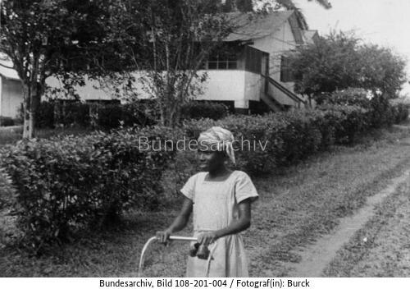

Source: Image Burck 1938. Archives Federal Republic of Germany.
Figure 1 shows a modern house equipped with lawn, gardens, flower beds and parking spaces for cars. In addition, each executive house had “boys quarters” which were homes for workers employed as cooks or house helps for Europeans. The workers enjoyed special non-monetary advantages like clothing, food items like meat, which were not given to labourers in the workers camps. The company executives enjoyed recreation facilities like bars and restaurants which were exclusively for the executives or Senior service.senior service clubs were meant for white and a few privileged blacks who had acquired some skills to deserve executive positions. In fact, from documentary evidence there were virtually no skilled workers of black African origin to deserve such prestigious positions. There were also canteens for executive workers only.
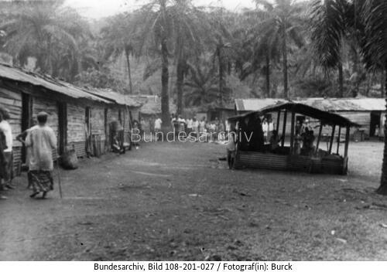
Figure 2: A workers camp during the German colonial period.

Source: Image Burck 1938. Archives Federal Republic of Germany.
Figure 2 show a workers camp during the German colonial period. The central structure earlier mentioned is a cooking space for all workers. The workers fetched water from the unpolluted streams before the introduction of portable water in the later years. One of the salient reasons for use of common space for cooking was because Germans realised that indigenous or native people lived communal lives. A ninety-year-old man who happened to see these structures in Moliwé ,Tiko and Idenau confessed discrimination in every element of camp life in the 1920s and thirties. African labourers were allocated empty rooms with no beds or mattresses to sleep, nor were there any infrastructure for descent living as found in executive quarters which were reserved for Europeans or Germans. Workers fabricated bamboo beds that were placed on dry grass gathered from the field. There were no beds, a phenomenon that brought skins diseases attributed to poor hygiene and sanitation among the workers. Workers prepared food on firesides made up of three stones with an elevation where the pot was placed. Wood was the only source of energy for preparing food. Items like kerosene driven cookers were scarce and only available to executive workers. The German colonial economy was not monetized, as most of the services offered were free ( ).
German colonial administration constructed railways linking the some estates and workers camps. Railways transport by locomotive was meant to transport workers assigned to work in distant fields, and exports of agricultural products overseas through Tiko whaff and Victoria sea ports. There was a small railway bus (trolley) which was specially designed to transport executive officers of the company into the estates. There was a special unit of workers who were mandated to cut and transport wood for the running of the locomotive engines and also to the executive homes were wood was also indispensable for use in cooking and heating. . These railway network was to be expanded to link most towns in Fako which produced export crops for metropolitan industries, but for the defeat of Germany during 1914-1918 war. Initially the main crops cultivated by German plantation in West Cameroon was cocoa and Banana which were grown in Tiko and Ekona respevtively. Transportation of banana from Ekona to Tiko was done by road through trucks, which were offloaded on railway carriages to Tiko wharf. Tiko wharf was linked to Cocoa, banana, palms and rubber plantations in Tiko by railway( CDC Head Office Bota, 2008). .
3, 3 Transition from German Colonial rule to British administration in plantations.
After the defeat of Germany during World War 1 German possessions, institutions and business continued to function in British Cameroon but were, being closely monitored by the new British administration who governed the territory as mandated territory under the League of Nations until 1947 when German plantations in Southern Cameroon were officially taken over by the British colonial administration as Commonwealth Development Corporation (CDC). Apart of some structural changes in plantations, housing situation remained unchanged from the previous German administration. The British introduced wage payments for all categories of workers including the executive officers in the plantation. No changes were made in housing situation despite changes in household populations. Infrastructure like railways constructed by the German colonial administration continued to function, while certain crops were eliminated like cocoa were gradually eliminated from plantations due to high productions costs. Cocoa plantations were replaced by either rubber, banana and oil palms. The replacement of cocoa plantations by other crops continued till after independence of French Cameroon and British Cameroon in 1960 and 1961 respectively (CDC Head Office, Bota-Limbe, 2016). The Germans made huge profits from all crops because they were no wages paid to labour apart of material gifts, notably oil palms, salt, sugar, tea, fish, wine etc, and other household edibles.( ). Thus, the Commonwealth Development Corporation (CDC) gradually eliminated cocoa plantations for cultivation of , banana, oil palms and rubber in the study area and elsewhere. Local farmers were encouraged to cultivate cocoa from which sales were controlled by monopolistic and oligopolistic firms, which had monopoly over export trade(Ngoe and Tassah, 2024). The expansion of. plantations increased the demand for labour in the coastal plantations of former British Cameroon or West Cameroon.
Most of the workers camps were constructed by the German administration using industrial bricks and wood in the study area . As migrations into plantation for employment took a new phase, housing and accommodation allocations were restructured. One of the major innovations brought by the Commonwealth Development Corporation (CDC) was construction of factories and provision of water and electricity in most of the plantation camps. Electricity was supplied from the factories to most of the camps under study like Tiko and Likomba camps. . Electricity supply in these camps was generated from the rubber factory. The same was applicable to Bota whose energy supply was from the Bota palm oil processing factory. The Commonwealth Development Corporation also introduced free medical care for its workers (CDC Archives, 1949) and introduction of pension scheme for all plantation workers. However, the system of housing allocation and other discriminatory practices were fully protected. The Commonwealth Development Corporation also encouraged workers of all categories to live with their families as some social amenities were granted to the m. Another form of discriminatory practices was preference for employment given to young men and women parented by plantation workers than non-plantation workers. In the early days, promotion within the ranks of CDC workforce was not necessarily based on academic qualification but fieldwork experience. It is for these reasons that many people employed as field labourers could rise to the rank of field overseer, when recruited with First School Leaving Certificate. At each phase of promotion, the worker was allocated a house that befits his new rank. Even when people are employed with university degrees, which could award them managerial positions, they are engaged to do manual labour on the field for more than six months as probation period. Any newly recruited worker who refused to do probation period on the field automatically loosed the job, and is replaced.
3.3.1 Allocation of residential homes based on Work Category
The Commonwealth Development Corporation (CDC) allocated residential homes for its workers based on rank and job experience. The categorisation was from category one to twelve which is the highest category. Among the various categories of workers were skilled, semi-skilled and unskilled workers. Among the unskilled workers are literate and semi-literate workers. Table 1 shows the allocation of residential homes based on work category. The houses are classified into senior executives, Medium or intermediate and junior executives. In the early days of British colonialism in Southern Cameroon, there was a camp warden mandated for allocation of houses in the camp. The warden had data on the various types of houses that are vacant. Residential quarters for unskilled and semi-skilled workers constituted the plantation workers camp who constituted more than 90% of the workforce in the corporation. The semi-skilled and unskilled workers were the most disadvantageous when it concerns allocation of houses. Allocations of houses in the camps are not does take into consideration household numbers or number of people in the family. Workers between category 1 to 4 are mostly unskilled workers who happened to be illiterates or semi-illiterates. They constituted field workers who did grass clearing, harvesting, transportation, and cleaning. Others include guards (day and night watchmen), nursery workers in case of plantation extension, including truck drivers and locomotive drivers, checkers, and headmen. Cooks had the advantage of being allocated in the senior service “boys” quarters where accommodation was specious. During the colonial period these categories 1 to category 4 were allocated to a sleeping room and a kitchen with a small veranda. A single building was shared into two separate apartments composed of a sleeping room and a kitchen each. The two workers shared a single veranda. The sleeping room also served as parlour used for eating. The bed space was shielded by a blind. For couples, children were made to sleep on mats on the floor while parents slept on the bed. Privacy was limited. In the camps more than twenty household shared a single toilet building for men and women. Privacy was scandalous and abusive. The camp workers were not given the opportunity to launch complains about marginalisation in housing. Even the workers trade unions introduced by the British colonial administration were weak. Trade union leaders, most of whom were field labourers were often intimidated by the executives of the company who enjoyed privileges in housing and other facilities. In essence the colonial administration stifled strike actions. Workers were free to launch complains but forbidden to strike. According to ……( ) most trade union leaders who succeeded in provoking strike action were summarily expelled and lost their jobs.
The next category of workers were junior staffs who did clerical work in offices and other semi-skilled workers like, technicians, notably electricians, carpenters, and foremen, This category of workers who were mostly from category five to seven occupied a single sleeping room, one parlour, a kitchen and a store. These categories of workers shared a common toilet with the rest of the camp workers. In CDC camps of Tiko, Victoria (now Limbe), and Idenau the Commonwealth Development Corporation provided water in all the camps though the use of common toilet facilities remained unresolved for camp workers
Category 8 and 9 were intermediates classes who enjoyed who also lived away from the worker camps and provided with better housing and accommodations by the corporation, Main while, and categories 10 to categories 12 were of the senior service categories who were executive officers in the company. They had the most decent accommodation. During the colonial periods, only the Europeans enjoyed the position of senior service. Senior service grade of workers were allocated service cars in addition to their private cars. They were also granted recreational facilities like clubs, swimming pools, which were exclusively for white senior service workers. These experiences fall in line with earlier research work by (Walters 1974) and (Daniel, 1980) in the gold and coal mines of South Africa where black worker of same qualification earned one-third of their white counterparts and were poorly accommodated by the companies. Whatever can be said about colonialism; whether by the Germans or the British, they had one thing in common: to provide an environment for exploitation of resources through the creation of few privileged educated or uneducated elites used to expropriate capital to metropolitan countries while the domestic economies of the colonies remained underdeveloped. These traits were handed down to the CDC administration after independence with insignificany modification. According to -----( ), after independence little or nothing was achieved to improve the welfare of workers because the traits of discrimination were intensified to the extent that workers started losing the few privileges granted by the imperial administration. This left the corporation in gross environmental, social and economic problems of untold dimension
According to Norah and Ngoe (2021) after independence when administration of the company was handed over to Cameroon, the problems were aggravated due to insuffient and inefficient managerial skills including political interventions, which undermined managerial decisions that governed the company. For example instead of building more workers camps or improving the existing camps, workers welfare were grossly undermined by the country’s centralised administration which added to its existing problems to the extent that the company was being earmarked for privatisation during the late 1980s and early 1990s under IMF/World Bank Structural adjustment Programme(SAP)
4.0 Housing and living conditions in contemporary Cameroon Development Corporation Plantations
It was revealed that the increasing number of job seekers and the inability of the corporation to expand workers camps in the study zone have created serious accommodation problems to an extent that workers have been abandoning free house to hiring s spaces in neighbourhood townships in spite their depressed wages. This phenomenon was revealed in earlier studies in Fako division by Ngoe and Yayah (2013) and also documented by the Tiko Rural Council, 2015). The company retained the phenomenon of allocating houses based on workers category which grossly undermines household occupation despite influx of job seekers and internally displaced migrants who are direct victims of the Anglophone crisis. The crisis have affected production and productivity in the corporation due to interruption of productive activities in the plantations for several years. These interruptions grossly reduced company output accumulated billions francs indebtedness due to non-payment of salaries and falling living standard in an environment where living standards had been low due to institutional discrimination handed over by subsequent colonial administration(CDC,2024)
It was further revealed that before population influx into workers camps, CDC was already experiencing endemic shortage of houses in workers camps that affected living standards of camp workers. The ongoing Anglophone crisis and increased Internally Displaced Persons (IDP) merely increased the company’s already existing housing problems. These problems were not limited to the camps in the study area but to all workers camps of the corporation. Ngoe and Yayah (2013) in earlier studies revealed that CDC have been experiencing difficulties to expand housing units due to opportunity cost of losing vast areas of land was higher than profits obtained from the land. In this study the CDC has been facing pressure from rural councils to give up their some parts of their land possessions for urban expansion and also internal pressure for demand of workers housing units. Studies by Norah and Ngoe(2022) reveals that while CDC could temporary minimise workers demand for improved housing, it was becoming difficult to ignore council demand for the corporation to release permanently some parts of its vast land possessions for urban expansion in Fako division. Germans who made no agreement with indigenous populations on limits to land expropriations and dispossessions of land possession. The same observations were made in earlier studies by Bussagli and Douliac (2005:7). According to this study the Southern Cameroon Government was suppose to embark on development schemes that gave more access to indigenous people in Fako division to access to land after independence in 1961 than adhering to colonial agenda for dispossession. Studies by Assola et al (2016) revealed the same phenomenon in German plantations taken over by French corporations in Littoral region of French Cameroon.
These problems also affected construction of new houses in places like Tiko whose land have been confiscated by the CDC. Confiscation of arable land by the corporation also brought the ugly phenomenon of food shortages. This land confiscation and dispossession was not limited to the colonial era as state laws and constitution legally protect corporations in Cameroon. This protection gave the company the right to expand its land holding to the detriment of indigenous populations and peasants who depend on land for livelihood. Both low income and high-income worker were caught in web of inflation due to acute food shortages and shortage of land for agriculture. According to Tiko Rural Council (2015), the company was forced to gradually give up its land possession to reduce pressure on land in Tiko and Limbe subdivisions.
This phenomenon of land dispossession was by monocultures in the South West region was identified in earlier studies by EMIS(2010-2014) in Pamol Cameroon plc, in Ekondo titi Subdivision where towns and villages around Pamol installation have been deprived of agricultural lands and are facing problems of expansion due to activities of Pamol.
Figure 4 shows the dilapidated nature of CDC workers camps in the study zone at Likomba- Tiko subdivision and at Idenau village and subdivision in Fako division. The dilapidated nature of the building have been attributed to neglect and absence of innovations during the last century. It was revealed that most of the camp residential quarters are exploding with population, lack of income and unemployment. Due to high population growth rate in the camps household occupation in workers camp and living conditions further depreciated when the corporation had suspended salary payments because of the Anglophone crisis.
Figure 4. Dilapidated roofs of CDC workers camp at Likomba-Tiko
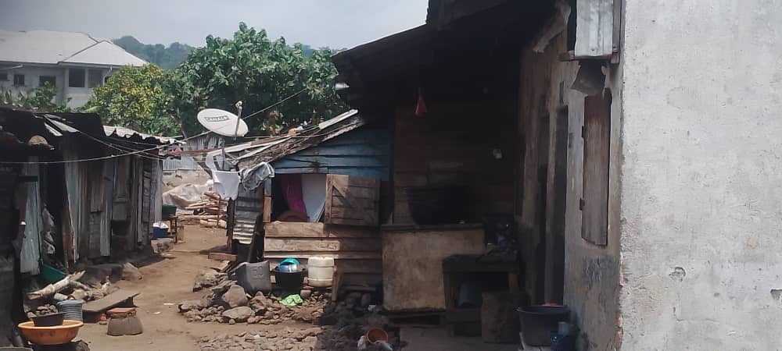
Source: Salamatou; Field work report on Architecture of colonial Plantations
in the South West region, March 2025
Workers reactions to shortage of homes and facilities
Based on study observation and revelations , increased demand for accommodation in workers camp attributed to migration from other parts of Cameroon, and increased birth rate among workers have given rise to a situation whereby the existing housing units and facilities have been unable to contain from demand from work force. In a group discussion in Moliwe camp a fifty three year old palm harvester who now lives in his personal house in Mile 4 Limbe Bonadikombo revealed that most of the houses have undergone depreciation with leaking roofs and most of the walls had developed deep cracks which have been habitat to rates, cockerages and earth worms. Besides these features in camps constructed by the Germans it was observed that bad weather conditions worsens the plight of most households as water leakages from dilapidated roofs come pouring on the limited spaces used as sitting spaces and kitchens. These experiences were not limited to Moliwe camps but to most camps left behind by the German colonizers in Ideanau, Tiko and Bota. Appeals made by workers for company to carryout innovations to improve living standards have never yielded positive outcomes. Faced with these precarious situation worker have reacted in various ways in different camps of the corporation. While some worker have constructed temporal extension to ease accommodation problems other have decided to hire accommodation elsewhere. A thirty year old young woman attached to the stores department of CDC Moliwé revealed that inability to cope with the deteriorating housing situation led her abandon free accommodation offered by the company and hire a relatively more comfortable home out of Moliwe. These revelations are similar to those in earlier studies by Ngoe and Manu (2016) on”HIV/AIDS and Commercial Agricultural sector in Cameroon” which revealed that inadequate accommodation and lack of privacy in camps of plantations have to led to deviant outcomes which have accelerated the spread of HIV/AIDS and other sexually transmissible disease among households in workers camps. Cameroon Development Corporation Man-Power Analysis (2005-2009) for the company earlier revealed the health statistics of some of its corporations workers with respect to HIV/ AIDS as disturbing from voluntary screening results in various workers camps.
In Idenau workers camps the worker testified the lack of privacy in the use of facilities such as toilets and bathrooms. . .It was revealed that more than twenty household were assigned to a single latrine building while more than thirty assigned for use of taps provided by the corporation. The latrine building consists of two separate apartments. Each apartment consists of a common entrance. Beside the entrance are two bathrooms separated by a wall. Opposite the two bathrooms are two latrine holes equally separated by common wall. Both men and women carry water from any source to bath in their apartment, as there is no water in the facility. During a focus group discussion, it was revealed that the present structure of building hosting toilets and bathrooms in the camp was a modification of the structure left by the German colonial administration. Formerly toilet and bathroom consisted of a single facility for both men and women. There was no consideration for gender in the structure because the facilities were designed for use only for men since the German colonial administration recruited mostly men to work in the plantation (Adrian an Aram, 2021; Elouga 2011). The difference between the colonial structure and contemporary structures was not significant because non-provided water in the structures. This partly explains the endemic problems of hygiene and sanitation in workers camp. Users fetched water from external sources to bath or flush the latrine holes. Most users failed to flush and material used are mostly had paper which are not so bio-degradable. Over the years both degradable and non-biodegradable materials blocked the latrine holes. It was observed that users dumped faeces in the bathroom portion of the some of the facilities, making it difficult for users to bath. A visit to one of the structures portrayed an unbelievable scenario where rats, swarms of flies, cockerages and other insects had made their permanent habitat in the latrines holes, cracks on walls and other areas deemed habitable by the competitors
It was revealed that during the colonial period and years after independence cleaners were employed by the corporation to tidy the structures. During a group discussion it was revealed that young men seeking employment have been rejecting the offer of cleaning toilets and bathrooms in the workers camps. the activity is popularly regarded as degrading and unethical to majority of enlightened job seekers. To avoid congestion and protect privacy many workers have constructed temporal structures serving as bathrooms. . These largely unplanned structures have been associated with environmental problems attributed to drainage of waste water from the tentative structures. It was observed that during the dry season fumy waste water from the bathrooms produced ordour, which attracted insects like mosquitoes while at nigh the water becomes breeding grounds for rates. It was equally revealed that the most common disease among camp inhabitants were malaria, typhoid and airborne diseases such as cough. During the rainy season these pools of standing water were transformed to mud were water passages have been blocked. These revelations are similar to those exposed in earlier studies by----- ( ) and -----( ) respectively in industrial tree plantations producing rubber and oil palm in Eastern Nigeria and some maritime areas of Ghana respectively. Figure 5 shows bathroom extensions in workers camps at Idenau .
.Figure 5: Bathroom extensions in at Idenau camp .
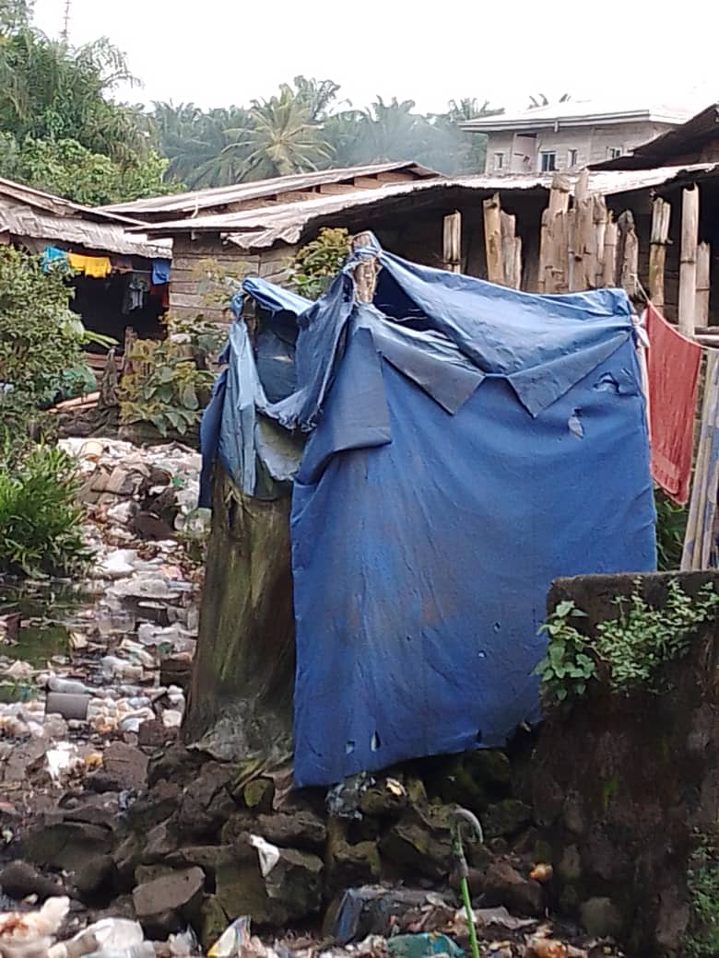
Source: Field work report on architecture of colonial plantations in South West region
It is rather disheartening and embarrassing that instead of improving living standards of workers many decades after independence the greater majority of camp workers still endure in squalor. These photo taken at a CDC camp at Idenau shows how infrastructure left behind by colonial master have deteriorated to the extent that most of the camps environment no longer serve their purpose. According to the study absence of innovations and repairs of these structures only goes along way to expose discrimination and marginalisation of workers camps as prove of continuation of colonial legacy. According to respondents ,workers in camps are poorly paid and find it difficult to raise money to improve their immediate environment. They have no alternative means of generating income because over the decades most of the indigenous land have been expropriated by the Cameroon Development Corporation in blatant violation of human rights. According to respondents, most of the latrines constructed by colonial administration of the company have been overused and full. In a focus group discussion, some women revealed they do not make use of the toilets because there are no cleaners. They revealed that making use of the toilets is to expose themselves to dangers of skin diseases, veneral infection and other complications.
It was revealed that most of the women have special containers, notably buckets, where they defecate and throw either in the palms plantations or directly into the Atlantic Ocean. Some of the respondents revealed that quite a larger majority of men and women in the camp defecate on plastic bags which are disposed in the estate. This situation in workers camps is a reflection of earlier studies by Envirionmental Management Initiative and Strategies (EMIS) in the years 2010 to 2013 in Pamol plantation in Ndian and also by the National Centre for Education, Ministry of Scientific Research and Innovations(CNE-MINRESI,2016) in CDC Ekona and Mayanja camps, still in Fako division.
On the other hand vast differences in residential quarters of estate managers, Field assistants, accountants, engineers, medical doctors revealed glaring disparities in environment and living standards earlier revealed. An engineer and a ield manager who requested for enormity showed deep concern about the residential areas and general living conditions of workers. In addition, it was observed that even workers in high-risk operations in the field and factories were not given protective wears to prevent them from insect and snakebites common in oil palms plantations. According to Owono (2005); Norah and Ngoe(2021) workers in plantations are suppose to be given special concern by management because it is through their activities that revenue is generated for the growth and stability of plantation investments, either by multinational corporation or government parastatals.
Conclusion
This study which shows German agro-industrial legacy in the South West region of Cameroon was carried out in the workers camps of Cameroon Development Corporation in the towns of Tiko, Limbe ( formerly named Victoria during the colonial period) and Idenau. These camps were earmarked for the study because they were the pioneer workers camps constructed by the German colonial administration. After the defeat of Germany during the first world war German possessions in British Cameroon( presently South West and North West regions)were handed officially handed over to the British colonial administration in 1947. The study realised the neglect of colonial structures in the company evidenced by physical degradation of the infrastructure left by the Germans and British colonial administrations in the study area. Beyond physical deterioration of infrastructure, the structured class discrimination characterised by subsequent colonial administration have remained a colonial legacy which has been maintained in the company after independence. The environment of camp workers compared to that of the company’s executive remains an index of social and economic discrimination that have been transcended to contemporary administrators of the government parastatal. The state of workers camps in the corporation remains course for concern very little changes have been embarked to improve the degraded housing conditions and living conditions of the labourers who constitutes the unkilled and semi-skilled workforce. The plight of these economic groups whose activities contribute to huge revenue to the corporation have not been adequately attended to. Adequate attention has to be directed to workers camp to improve their living, working and housing condition to guarantee harmony among various categories of workers. The architecture prevalent in the camps have materialised and reproduced social domination by the privilege workers, abusive inequality and class conflicts, which have transformed the colonial heritage into an avenue of structural discrimination which have been difficult to evict. Unless the colonial legacy projecting discrimination between the various workers groups is eliminated or at least minimised there are all indicators that the company could be heading towards ticking ‘’time-bombs’’ which may be difficult to diffuse in a century which has created awareness to the rights of workers, championed by right groups. To prevent unfavourable outcome it is necessary for CDC to embark on meaningful reforms that will improve the general working and living conditions of workers in all its establishments.
.

Recommendations .
The following recommendations have been advanced to ameliorate the endemic problems created by the German and British colonial policies in the plantations.
- Transformation of existing workers residential areas by constructing new houses with modern infrastructure and facilities to improve workers welfare and living standards. The present architectural design from the colonial administration must be improved to include recreational facilities, self-contained houses equipped with water, electricity including flush toilets for camp workers. The ancient design whereby workers shared the same toilet facilities should be abolished and replaced with structures that protect privacy and restore human dignity. Among the structure are common latrine and bathrooms for men and women.

- The corporation should restore its hospitals and give free medical treatment as it had been during the British colonial periods and early years of independence. Most of the low-income workers are unable to pay medical bills for their families. It was rather unfortunate that most of the corporation hospitals were taken control by the government without taken to consideration the plight of workers in low-income brackets constituting more than 90% of the labour force. Most of these workers are in high risk occupations in the plantations and other installations and require adequate medical attention in case of accidents.
- There is also need to establish recreational facilities in all CDC workers camps. The recreational structures should take into reflect the cultural, traditional, and religious backgrounds of worker. This will also require restructuring of the existing architectural design of the camps.

Références bibliographiques
Adrian Schlegel & Aram Ziai. (2021). La politique africaine de l’Allemagne. IFRI.
Bourdieu, P. (1979). La distinction. Critique sociale du jugement. Éditions de Minuit.
Brunet, R., Ferras, R., & Théry, H. (1993). Les mots de la géographie, dictionnaire critique. Reclus - La documentation française.
Bussagli, M., & Dauliac, J. P. (2005). Qu’est-ce que l’architecture ? Edition Grund.
Calbérac, Y. (2002). L’espace du camp. Une lecture concentrationnaire des townships d’Afrique du Sud. Tracés. Revue de Sciences humaines, (1). Consulté le 19 octobre 2025 sur http://journals.openedition.org/traces/4126. https://doi.org/10.4000/traces.4126
Chantal Metzger. (2017). L’empire colonial allemand. Brève histoire – Longue mémoire. Outre-Mers. ID : 10670/1.35k5ka.
Coulangeon, P. (2004). Classes sociales, pratiques culturelles et styles de vie : le modèle de la distinction est-il (vraiment) obsolète ? Sociologie et sociétés, 36(1), 59–85. https://doi.org/10.7202/009582ar
Elouga, M. (2011). Archéologie historique au Cameroun : champ d’exploration, perspectives théoriques et méthodologiques. Annales de la faculté des Arts Lettres et Sciences Humaines, I(12), 325. Les Grandes Edition (LGE).
George, P., & Verger, F. (2000). Dictionnaire de la Géographie. PUF.
Karl, M., & Engels, F. (1848). Manifeste du parti communiste.
Pape, E. (2016). Les débats postcoloniaux en Allemagne. Un état des lieux. Raison présente, (199), 9–21. https://doi.org/10.3917/rpre.199.0009
Posnansky, M., & Decorse, C. R. (1986). “Historical Archaeology in Sub-Saharan Africa – A Review”. Historical Archaeology, 20(1), 1–14.
Salamatou. (2019). « Archéologie Historique au Cameroun. Les Sites de L’occupation allemande dans le Mbam (Ndikiniméki, Bafia et Nyamanga II) ». WAJA, (47), 199. Ibadan.
Smidth, P. (2006). Historical archaeology in Africa: representation, social memory and oral traditions. Altamira Press.

