INTEGRATING RICE HUSK PRODUCT IN THE DESIGN OF RICE MILLING FACTORY IN DASS LOCAL GOVERNMENT BAUCHI (TOWARDS WASTE MANAGEMENT)

SOLOMON CALEB SALE, Department of Architecture, ATBU, Bauchi
DR. E. A. SAID, Department of Architecture, ATBU, Bauchi
PROF. A. M. BABAYO, Department of Architecture, ATBU, Bauchi
MR. BOT C. NYAM, Department of Architecture, ATBU, Bauchi
MR. IBRAHIM Y. HARUNA, Department of Architecture, ATBU, Bauchi

Abstract
This thesis investigates the integration of rice husk-based products and sustainable energy systems into the architectural and industrial design of a modern rice milling factory. Rice milling is a critical integral aspect of food provision; however, the process is accompanied by significant environmental waste, primarily in the form of rice husk. Traditionally viewed as an agricultural waste product, rice husk constitutes approximately 20% of paddy weight and presents significant disposal and environmental challenges. A substantial volume that poses severe environmental and health concerns when managed through unregulated dumping or open-air burning. This research addresses the mismanagement of solid waste in the rice industry by developing an innovative design strategy that integrates rice husk waste into the architectural framework of a rice milling factory. The study aimed to minimize environmental impact and add value to by-products by proposing an integrated facility for both primary milling and secondary production. The study proposes a circular economy framework where the factory serves as a symbiotic hub for both grain processing and byproduct valorization. By adopting a multi-stage milling process route, the design prioritizes vertical gravity flow to maximize energy efficiency and "Head Rice Yield."
To achieve this, three research objectives were formulated: to identify the quantity of rice husk generated in the study area, to determine current disposal methods, and to synthesize an architectural solution for waste integration. The study employed a qualitative research methodology, utilizing comprehensive literature reviews and case studies of existing industrial facilities. Findings revealed a significant gap in current industrial practices, where secondary production is rarely co-located with primary milling. The proposed design incorporates innovative features, including specialized rice husk storage and handling systems dedicated to the secondary production of ceiling boards and particle boards. By transitioning from a linear waste model to a circular economy framework, this research contributes to sustainable industrial practices and provides a blueprint for resource-efficient architectural design that promotes environmentally friendly rice production in Dass Local Government Area, Bauchi State.

1.0 INTRODUCTION

1.1 Background of the Study
Milling of Rice is an important chain supply in terms of both quantity and quality to support food chain security Yanter, et al, (2021). Rice has been the main staple food for more than half of the world population Mohidem, et al. (2022). Furthermore, it has been emphasized that rice is not only a key source of food, but also a major employer of labor and source of income for the poor Sadiq, et al. (2022) In rice producing areas, the enterprise provides employment for more than 80% of the inhabitants in various activities along the production/distribution chain from cultivation to consumption. Izuogu, et al,(2022), note that rice milling industry alone in Nigeria is capable of contributing significantly to employment generation, boosting the economy and maintaining the food security of the country.
The process of converting paddy into well-milled, edible, silky-white rice, involves a several steps including pre cleaning, parboiling, drying, dehusking (milling), whitening, and polishing that must be carried out with utmost care in order to produce high-quality rice IRRI (2025).
However, Bodie, et al., (2019) noted that rice milling generates significant amount of byproduct- specifically rice husk, rice bran, and broken rice, which collectively account for about 20- 30% of the total weight of the paddy rice. El Safty (2025) also noted that rice milling generates massive quantities of rice husk, much of which is managed through environmental harmful methods such as open filed burning and improper landfilling. However, (Chakranarayan, et al 2024) suggested That the integration of value-added activities and cleaner production (CP) technologies transforms rice milling from a standard commodity business into a sustainable, high-profit enterprise by utilizing rice by –products that were previously treated as waste and the mills can generate multiple revenue streams while significantly reducing their environmental footprint
Rice milling factory shall be a major catalyst for transformation of the production and milling of rice in Bauchi and neighbouring states bearing in mind the utilization of the waste product such as rice husk which could be used as raw materials in production of other value materials.

2.0 Rice milling
Rice milling is a fundamental post-harvest processing step that transforms harvested paddy (Oryza sativa) into edible and marketable rice. The primary objective of milling is to remove the outer husk and bran layers to produce polished white rice that meets quality standards for consumer consumption. Milling not only increases the nutritional and economic value of rice but also ensures its storage stability and marketability (Omics Group, 2025).
In a typical rice mill, various operations are undertaken, including pre-cleaning, de-husking, de-braning, whitening, and polishing. De-husking removes the hard outer shell of the paddy, while de-braning and polishing improve the appearance, texture, and edibility of rice (Mihretu, 2025). In an ideal milling process this will result in the following fractions: 20% husk, 8-12% bran depending on the milling degree and 68-72% milled rice or white rice depending on the variety.

2.1 Milling Technologies and Processes
Modern rice milling systems can range from simple single-pass units to multi-stage processes involving advanced machinery. Mills designed for commercial use generally incorporate automated and integrated workflows to enhance efficiency and throughput. These designs often include rubber roller de-huskers, friction polishers, graders, and electronic sorting systems to enhance head-rice yield and reduce breakage Industry overview, (Nextech Agrisolutions, 2026)

2.2 Rice Milling Options
Four basic options have been identified and highlighted and explained below:
1. Hand Milling
2. One step milling process
3. Two-step process and
4. Multistage process
Source: International Rice Research Institute
2.3 Equipment Use for Rice processing. This include:
Pre-Cleaning Equipment, De-Stoner, Dehusker Equipment, Under Runner Disc Sheller, Paddy Separator, Gravity Separator, Friction Polisher, Steel Polisher-Horizontal Friction (Engelberg Type), Abrasive Polisher, Polishing- Conical Stone, Polisher-Horizontal Abrasive, Oscillating Screen Separator, Length Grader, Separating Bins, Mist Polisher, Color Sorter, Bagging Station, Rice Husk Storage Tank

2.4 Rice Mill Factory
A rice mill factory is defined as an industrial facility where harvested paddy rice undergoes a series of mechanical transformations—including cleaning, de-hulling, milling, polishing, grading, and packaging—to produce edible rice (Kumar & Singh, 2025). Beyond simple processing, these facilities are essential pillars of agricultural economies, driving food security and value addition by transforming a raw byproduct into a high-value commodity (Adewumi et al., 2024; GRRI, 2023)

2.5 Industrial Architecture
Industrial Architecture has evolved significantly over the year, with a growing focus on sustainable energy efficiency, and innovative design (S3DA Design. 2026), It is regarded as a kind of independent building type that stems from the second half of the 19th century. The idea that industrial architecture became a distinct "building type" in the 19th century is a foundational concept in the field, while the shift toward "sustainability" is the contemporary layer of that evolution Bradley, (2023). Its main task is to provide good working conditions for the production process and the workers in it (Nigerian Factory Act, 1987). The design of industrial buildings has shifted from a focus on functionality and efficiency to a more holistic approach that incorporates sustainability, flexibility, and aesthetics Gou, (2026).
2.6 Modern industrial architecture
Industrial architecture can be defined as the architecture of the built-up environment within which industrial process occurs. This became prominent in lower half of the 19th century. When structural steel and reinforced concrete were developing large spaces for industrial processes and machines were possible. This tends towards vigorous expansion and fresh solutions to problems (Encyclopedia Americana vol. VII). Modern industrial facilities are no longer just consumers of energy but are designed as active energy hubs Modern industrial architecture, however, is characterized by Functionalism—the principle that the building’s form must be dictated by the internal flow of materials (Bradley, 2023). According to Jones (2024), contemporary factory design is no longer just about housing a process; it is about "resource-integrated shells" that minimize energy waste and maximize byproduct utility.
2.7 Classes of Industries
1. Light Industries
2. Medium Duty Industries
3. Heavy Duty Industries

2.8 Factory layout
It was posed that factory layout is a complex and broad subject that covers several disciplines, which involves civil, electrical, industrial, and mechanical engineers, as well as architects, and even managers and urban planners are not left out.

2.9 Factors to determine the design of factory layout
Despites the numerous benefits of a befitting factory layout, according to (Okpala and Chukwumuanya 2016) posed that, the goals of designing factory layouts are to achieve a minimum number of materials handlings, reduce bottlenecks, minimize machine interference, and also enhance flexibility, throughput, safety, and employee’s morale. To achieve optimum layout effectiveness when designing a factory layout, many factors of operation need to be seriously considered.

2.10 Types of factory layout
The modern manufacturing factories are designed to have advanced and sophisticated plant layouts Okpala & Chukwumuanya, (2016). The three basic types of layouts by which production sections are organized in a plant, which are defined by the type of workflow are process layout, product layout, and fixed-position layout. The fourth type of plant layout which has gained wide acceptance and often regarded as a hybrid layout is called cellular layout. However, some manufacturing companies have a combination of more than one type of layouts.

2.11 The factory layout design
After selecting the type of layout that is best suited for a manufacturing company’s production processes, the next plan according to Okpala and Chukwumuanya (2016) is to choose a comprehensive design of the layout in order to ascertain the following:
- The plant location,
- Machines and equipment.
- The staff that comprise of the operation’s work centre,
- The space to be assigned to each unit or department, and,
- The work that will be performed by each of the units.
However, it was proposed by Okpala and Chukwumuanya (2016) and, Kovács and Kot (2017) that, the major objectives of a well-designed factory layout include the following:
- Safety:
- Conducive environment
- Accessibility:
- Flexibility and room for expansion:
- Length of flow:
- Clarity of flow:

2.12 General facilities for factory
Apart from alterations within the envelope, there may also be requirement for extension and the design should anticipate this.

Figure 7: Required requirements for factory
Source:https://www.google.com/eia18/04/2021

3.0 Research Methodology
Ethical Considerations:
To ensure ethical considerations, the research was guided by the four ethical principles: truthfulness, thoroughness, objectivity and relevance. All information and data collected from the case studies conducted are a true reflection of the cases as at the time the data were collected.
3.1 Data Presentation:
This data presentation and analysis provides an overview of the research data collection and analysis procedures and key findings. The result of this study will contribute to the growing body of knowledge on waste management, and innovative building materials, ultimately informing the design of more environmentally conscious and socially responsible rice milling factories. To get accurate result base on the objective of the research the whole wards in Dass local government were visited and various result were presented base on the following criteria;
- The number of rice mill in each ward
- The milling options
- The milling capacity of the mills
- The quantity of rice husk per each bag 100kg of paddy
- An average milling production per annual
3.2 Milling Options. All the mills visited makes use of the of One Step Milling Process. This method usually involves a single machine and single process of milling which can be repeated till desired result is obtained, below are some of its characteristics base on the literature
- Steel friction mill
- Very high pressure
- Low white rice recovery (50-55%)
- Head rice less than 30%
- Often used for par boiled rice
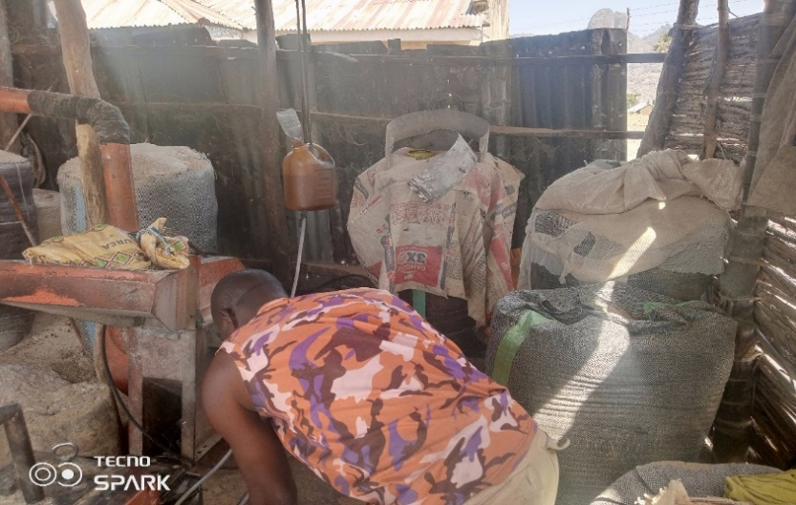
Plate i: one of the milling shade in Baraza Ward
Source: Researcher’s case study, 2023
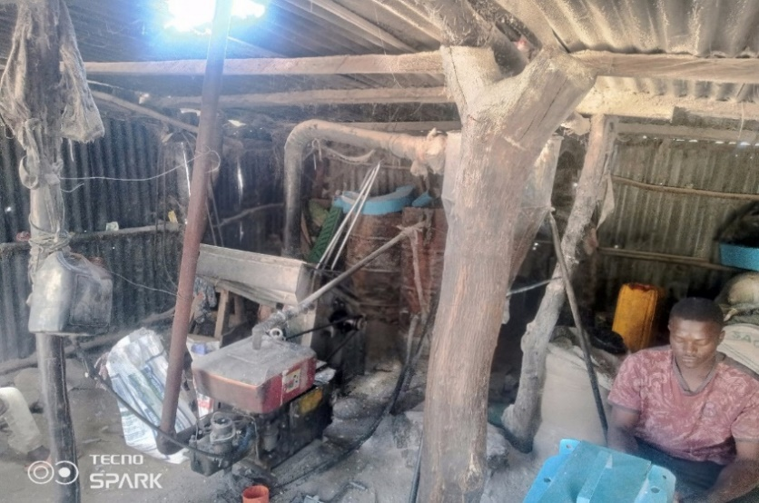
Plate XLiii: one of the milling shade in Durr Ward
Source: Researcher’s case study, 2023
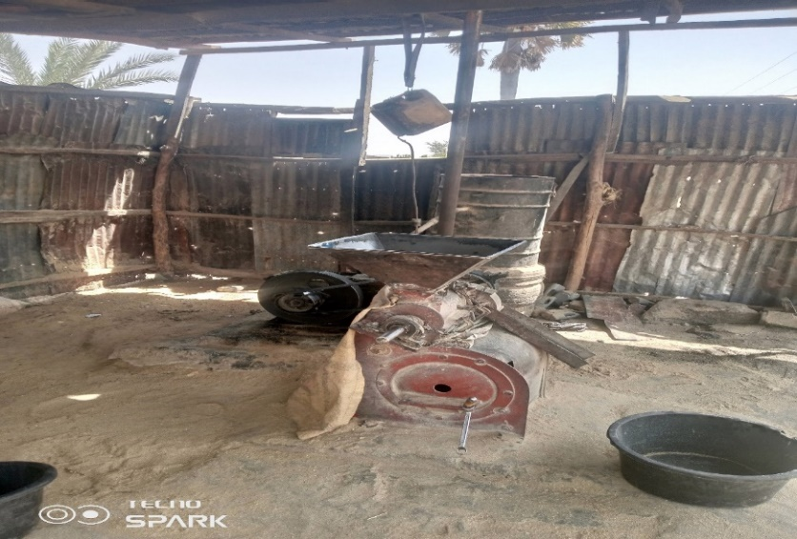
Plate XLIV: one of the milling shade in Polchi Ward

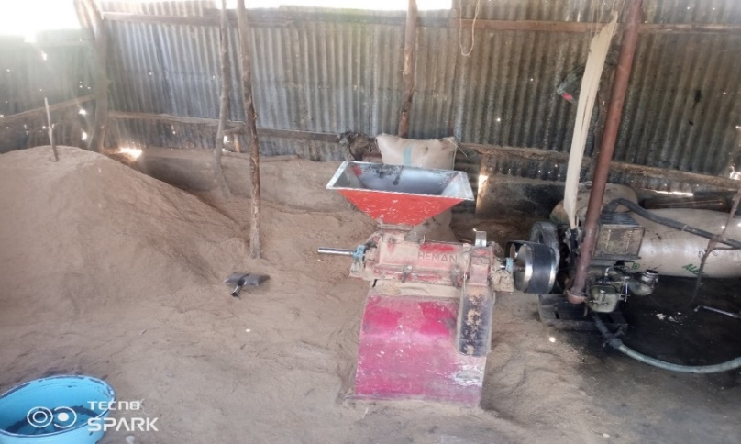
Plate XLV: one of the milling shade in Wandi Ward
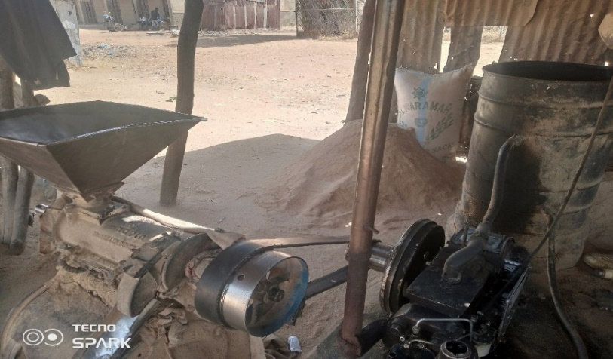
Plate XLVI: one of the milling shade in Bununu South Ward
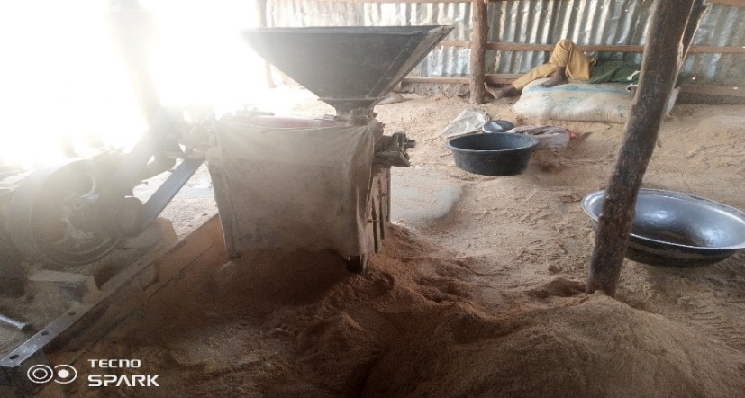
Plate XLVII: one of the milling shade in Bununu Central Ward
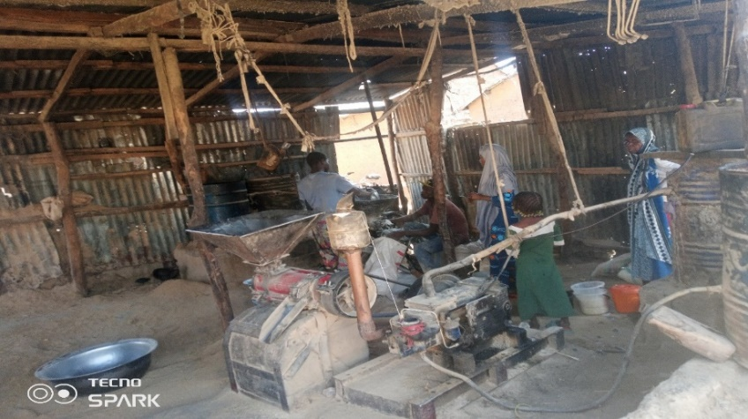
Plate XLVIII: one of the milling shade in Bundot Ward

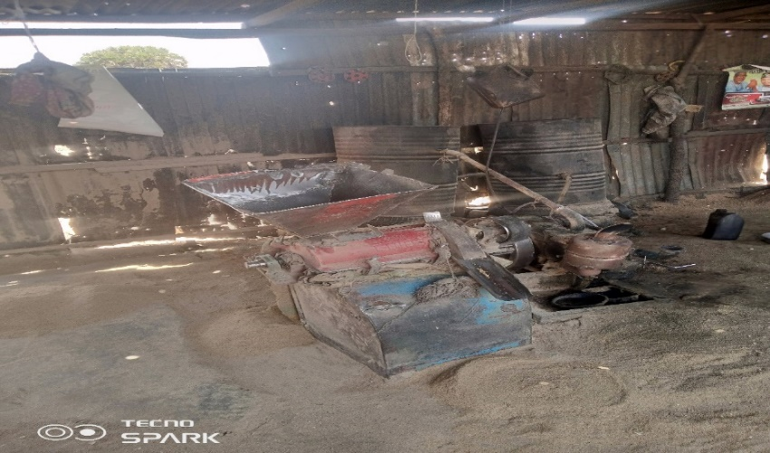
Plate XLIX: one of the milling shade in Dot Ward
3.3 The milling capacity of the mills. This differ from months and days with all the millers given a response of milling of up to 30-50 bags of 100kg per day in the month of October to December which is usually the peak period of milling as a result of harvest period while in other months of January to September the milling declines to sometimes 0 per day with the exception of Tuesdays and Wednesdays with a milling capacity of 10- 25bag of 100kg as a result of the market day usually on Wednesdays of every week. The milling capacity differs from one mill to the other depending on customer’s preference and services provided by millers. Also those milling around the main Dass market tends to have more patronage than those around the villages as people tend to mill around the market for easy access on market days
3.4 The quantity of rice husk per each bag 100kg of paddy.
This differ from the type of rice and the level of ripeness of the paddy the more the ripeness of the paddy the less the quantity of rice husk from the paddy and vice versa, also the quantity of rice husk differs from parboiled and raw paddy, as more rice husk is generated from raw rice as compared to parboiled rice however for every 3bags of 100kg milled rice there is an average full up of 1bag of 100kg

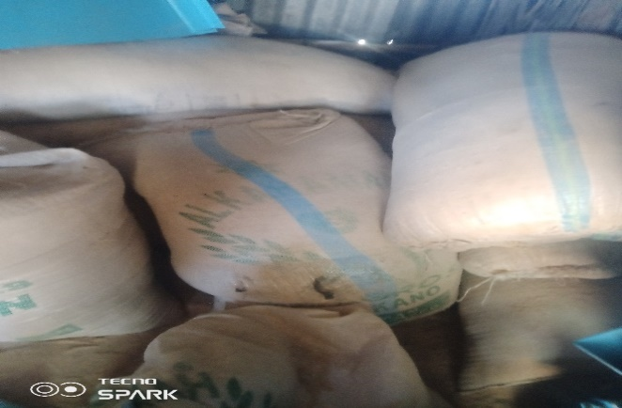
Plate L: gathering of husk in sacks for disposal

Table 7 showing the average milling in various wards of Dass local Government Area of Bauchi State
SN | WARDS | NO OF MILL | AVERAGE MILLING (TON) |  |  |  | AVERAGE WASTE GENERATED (TON)
  Below 10T. | 10-50T. | 50-100T. | above 100T
  Below 10T. | 10-50T. | 50-100T. | above 100T
1 | BAGEL/ BAJAR | 2 |  | √ |  |  | √
2 | BUNDOT | 15 |  |  |  | √ |  |  |  | √
3 | BUNUNU | 10 |  |  | √ |  |  | √
4 | BUNU SOUTH | 5 |  | √ |  |  | √
5 | BARAZA | 5 |  | √ |  |  | √
6 | DOT | 8 |  |  | √ |  |  | √
7 | DUR | 6 |  | √ |  |  | √
8 | POLCHI | 4 |  | √ |  |  | √
9 | WANDI | 8 |  |  | √ |  |  | √
10 | ZUMBUL | 2 | √ |  |  |  | √

Waste Disposal. To determine the methods used for the disposing of rice husk waste in the study area the Integrated Sustainable Waste Management (ISWM) approach was used as yardstick of measurement, they include: Recycle, Reuse, Reduce, Land fill, burning (open burning), animal feeds, and composting. However cross case analysis is used to analyse the waste disposal methods in various locations
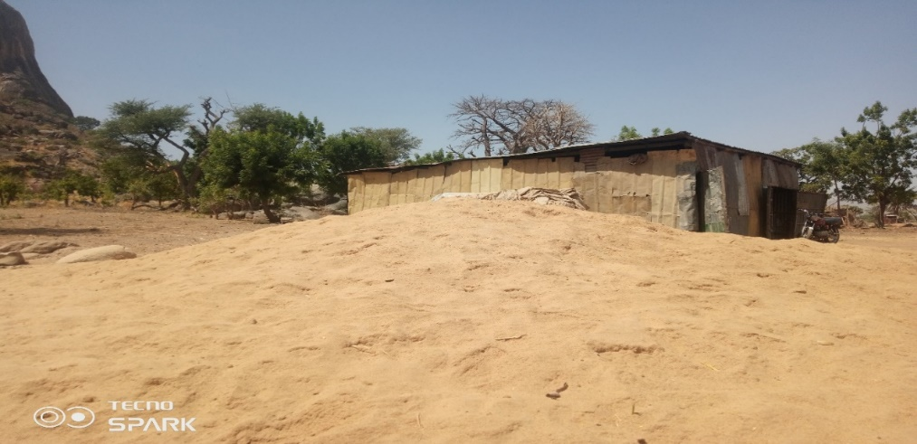
Plate LI: open dumping of rice husk at Bundot dass,
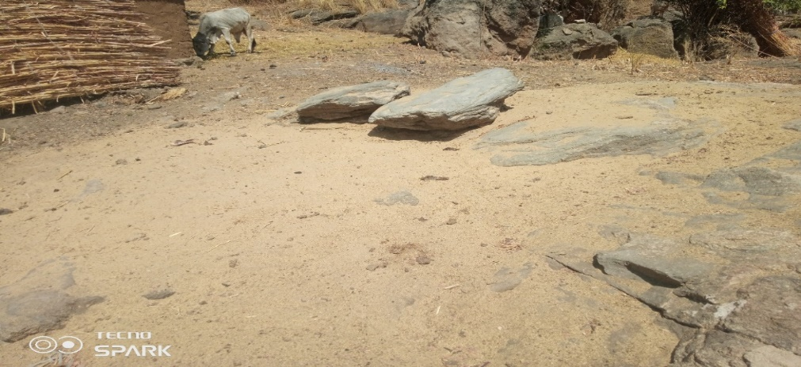
Plate LII: feeding Animal with rice husk at Wandi ward of dass local government

Plate LIII: Rice husk spread on the filled to decay and serve as composed at Wandi ward of Dass Local Government

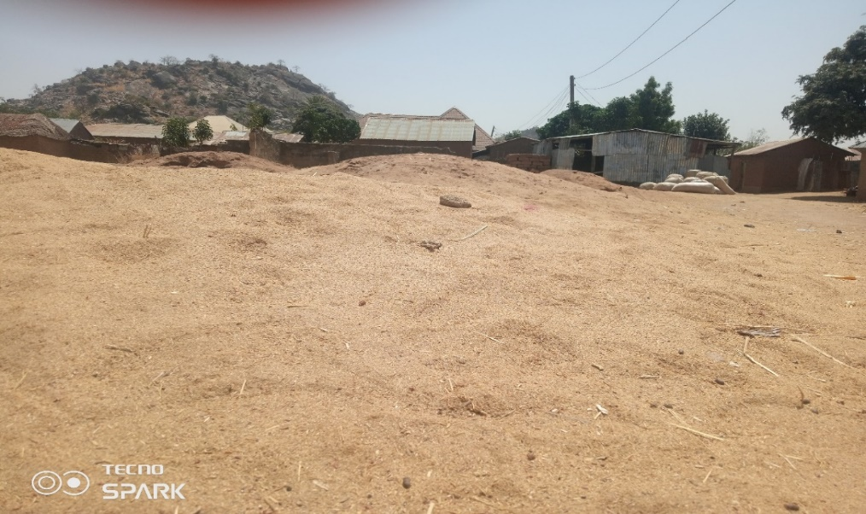
Plate LIV: open dumping of rice husk at Dot Dass
Table 8 showing the Waste disposal methods Adopted by various Wards
S/N | WARD | Open burning | Animal feed | Open Dumping | Reduce | Reuse | Recycle | composting
1 | Bagel/ Bajar | √ | √ | √ | - | - | - | √
2 | Bundot | √ | √ | √ | - | - | - | -
3 | Bununu Central | √ | √ | √ | - | - | - | -
4 | Bununu South | √ | √ | √ | - | - | - | -
5 | Baraza | √ | √ | √ | - | - | - | √
6 | Dot | √ | √ | √ | - | - | - | -
7 | Durr | √ | √ | √ | - | - | - | √
8 | Polchi | √ | √ | √ | - | - | - | √
9 | Wandi | √ | √ | √ | - | - | - | √
10 | Zumbul/ lukshi | √ | √ | √ | - | - | - | √
4.0 Case Study; This work studies some factories within and outside the country Nigeria. Case study of factories include industrial buildings that process and mill rice. The case study analysis brief history and growth scope of the buildings, mode of operation, schedule of accommodations and appraisal.
4.1 Case Study one: IRS RICE Milling factory Kano
Founded in 2003 by the Islamic Scholar and Industrialist Sheik Khalifa. The Rice mill received a boost in 2011 by a huge investment made by Fidelity Bank. It has continually grown since then. It is 100% indigenous and make use of indigenous rice. It has the 24,000 metric tons Capacity per annum Products of white parboiled rice it have 231 staff: 76 permanent staff and 152 temporary staff, it source it raw materials from industrial farmers, local markets and company. It has the following facilities: Administrative block, Production hall, Ware House, Functional generator room
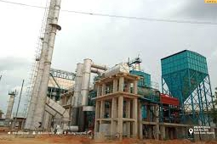
Plate LV: IRS RICE MILLING FACTORY KANO
Source: www. U. Tube.com (2020)
4.1.1 Mode of Operation
The machines are installed to produce white parboiled rice by the use of modern processing and milling equipment. Some of the equipment are modern rice hullers, husking machine, whitening machines, sorting machines, length grading machines and the automatic weighing and baggaging machines.
4.1.2 Architecture
The use of simple portal frame steel structures with cladding made of roofing sheets except for the administration building which is sandcrete block work well finished. The functional activity of the factory can easily be supervised by the strategic citing of the administrative block.
4.1.3 Materials and Construction
Portal frame roofing system is used for the production hall. Some parts of the exterior walls are only covered with roofing sheets. The roof is pitched with long span aluminum roofing sheets laid on the steel sections of the partial frames. Parts of the exterior walls are painted with text coat paints while some parts with gloss paints.
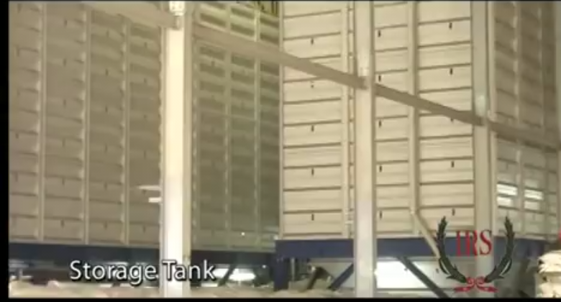
Plate LVI: IRS RICE MILLING FACTORY KANO
Storage tank
Source: www. U. Tube.com (2020)
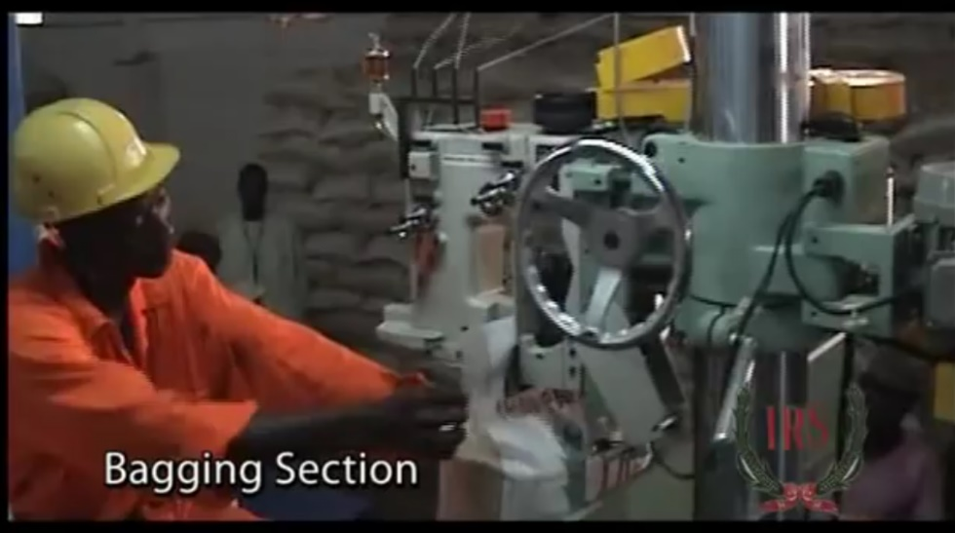
Bagging Section
Source: www. U. Tube.com (2020)
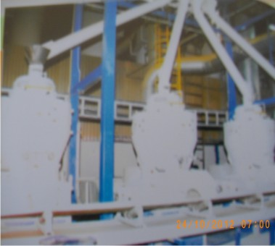
Plate LXIII: Milling machine
4.1.4 Appraisal
Merits
- Only one major entrance to the factory this intensify the security of products
- Good location of administrative area for easier accessibility by public
- Entirely simple design used
Demerits
- Inadequate space for expansion
- No defined parking in the site
- No off loading and loading bays within the site
- No supporting facilities for staff
4.2 Case Study ii. Amk Alayam Modern Rice Industry
Client: Mr. AMK Duraisamy
Location : Tiruppur, Tamil Nadu, India.
Year of establishment: 1975
Legal status: Partnership
Turn over: US$10 – 25 Milllion
Nature of Business: - Manufacture
- Wholesaler
- Buyer-Company
- Trader
Staff: 101 to 500 people
Architects/Engineers: Buhler, Germany
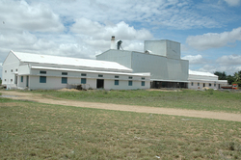
Plate LIX: Picture Showing Amk Alayam Modern Rice Industry
4.2.1 Brief History
Alayam Modern Rice Industry started as a small rice factory with a capacity of very few annual turnovers which covered 13 cents at Kangeyam main road named as Valamathi Rice Mill in 1951 with manual grinding. In 1971, another rice mill was started, the mill occupied 1 acre of land and 80 cents at Coimbatore road. Five years later another 4 acres of land and 18 cents was acquired on Pharapuram road. After its venture in 1964, tamilian modern industry focuses on providing quality with good service. Having great potential Mr. AMK. Duraisamy himself has provided himself in the field of rice industries. He organized Aalayam Hi-tech Rice Industries who with diplomatic ideas bring success. From those humble beginnings they grew a vision that has converted into millions worth enterprise, turning out a wide range of rice varieties to suit diverse needs of its customers around the globe.
4.2.2 Production Process
There are varying processes and stages in production of rice, the Alayam Hi-tech rice industry apply the procedure briefly describes.
Harvesting is the process of gathering the crops, this is followed by threshing which the process of beating paddy plants in order to separate the seeds or grains from the straw. This is usually followed by a primary process of cleaning, soaking, steam boiling, cooling then drying. In this primary process the cleaning is done with a paddy shaker to remove stones and dust particles.
4.2.3 Appraisal
Merits
- Enough space for circulation within the production area
- Only one major entrance to the factory this intensify the security of products
- Enough site for future expansion
- Storage and production are attached and well linked to other auxiliary functions.
- Good location of administrative area for easier accessibility by public
- Entirely simple design used
- The use of modern factory layout in organization
Demerits
- Inadequate offices for administrative staff
- Few supporting facilities for staff
- Inadequate finished product storage
4.3 Case Study 3: dhana lakshmi
Client: Dhana Lakshmi
Location: Dhalavaipuram, Tamillvadu, India
Architects:Buhler of Switzerland, and Germany
Engineer: Singam of India
Products: ADT 36, Idly Special, Raw rice Half Boiled rice, Full Boiled rice, Rosekate White parboiled rice
4.3.1 Brief History
Dhanalakshmi Hi-Tech Modern Rice Mill, shortened to DHM Rice Mill is a proud manufacturer of SINGAM MARK (Lion Brand in English) rice varieties. It is a second generation rice mill with Hi-Tech status. they inherited their brand name and expertise from Dhanalakshmi Rice Mill, an upcoming silver jubilee concern known for its best quality offering till date.
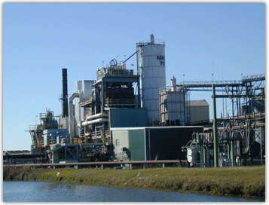
Plate LX: Picture Showing Dhanalakshmi Modern Rice Mill
4.3.2 Architecture
The DMH modern rice mill has the main production plant and storage area detached from the offices and Auxiliary functions. The production plant is linked to both the raw material and finished product stored. The conveyance of rice during processing is carried out with conveyor belt and tabular pipes.
The storage of raw materials is adequately ventilated and linked to the drying area then it is transferred to the rice mill. The rice mill is fully automated. Hence, minimal or absence of manual labor at the factory production plant.
The offices are constructed using steel structural portal frames and covered with ventilated facades of aluminium and glass. The production plant is a Hi-Tech factory design. Considering the simple portal frames, thermal insulation facades of aluminium and concate and glass.

4.3.3 Appraisal
Merits
- Enough space for circulation within the production area
- The use of modern machines in production process
- Flexible enough to adopt to functional changes
- Wall cladding for administration unit
- Waste management is ensured by the collection of by products and putting them into re-use
Demerits
- The administration unit is totally detached from the production hall
- Poor soundproof of the production hall
- Exposed sophisticated machine could cause accidents
- No enough supporting facilities for staff
4.4 TIAMIN RICE MILL
- Client: Tiamin Multi Services and Global Limited
- Location:Yuli Office, Maiduguri Road, Ganjuwa LGA, Nigeria
- Products: ADT 36, Idly Special, Raw rice Half Boiled rice, Full Boiled rice, Rosekate White parboiled rice
4.4.1 Brief History
Tiamin rice mill Bauchi is a part of larger rice farm project situated in udubo, Gamawa Local Government Area of Bauchi State. The project was initiated by Tiamin Rice Limited, and its managing director, Aminu Ahmed, plays a crucial role in its development. The ticemilwas designed to process 600 metric tons of rice dail, making it a substantial contributor to Nigerias rice production. In addition to the mill, the project also includes a massive rice farm spanning 10,000 hectares, which is expected to produce 120,000 metric tons of rice annually.
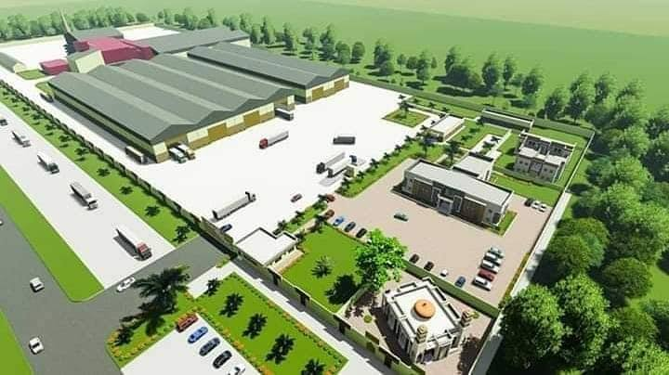
Plate LXI: Picture Showing Tiamin Rice Mill General Layout
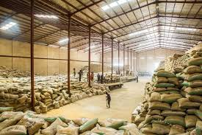
Plate LXIII: Picture Showing warehousing
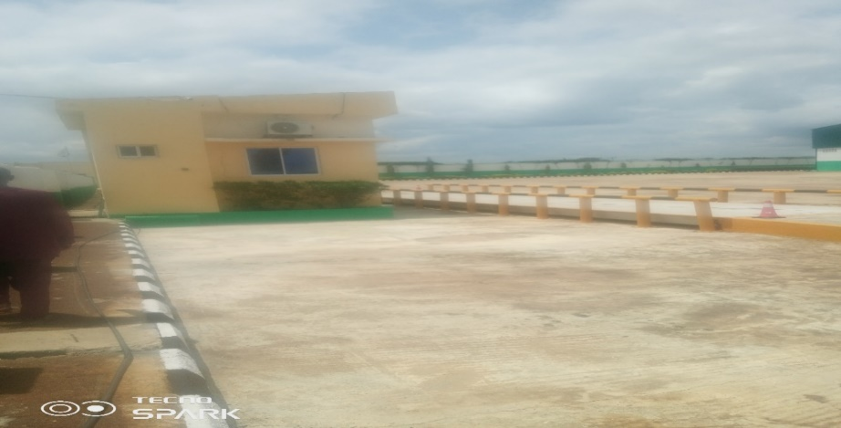
Plate LXIV: Picture Showing Tiamin scaling area
4.4.2 Appraissl
Merits
- Enough space for circulation within the production area
- The factory is easily accessible as located along an express road
- The use of modern machines in production process
- Flexible enough to adopt to functional changes
- Machine driven production process
- Waste management is ensured by the collection of by products and putting them into re-use
Demerits
- The administration unit is totally detached from the production hall
- Poor soundproof of the production hall
- Exposed sophisticated machine could cause accidents
- The is no much space for expansion of the production area

Table 9: Cross Case analyses of IRS rice mill, AMK rice mill, Dhana Lakshin rice mill, and Tiamin rice mill
SN | List | IRS  Rice mill | AMK Alayam | Dhana  Lakshin | Tiami  Rice mill
1 | Inspection/weighing unit | + | + | + | +
2 | Processing unit | + | + | + | +
3 | Laboratory unit | + | + | + | +
4 | Utilities unit | + | + | + | +
5 | Farm workshop and maintenance unit | - | + | + | -
6 | Administrative block | + | + | + | +
7 | Accounting section | + | + | + | +
8 | Worker’s facilities | + | + | + | +
9 | Staff quarters | - | - | + | -
10 | Generator house | + | + | + | +
11 | Clinic | - | - | + | -
12 | Reservoir | + | + | + | +
13 | Tools making unit (about 60% of the machine part are been produced by the unit) | - | - | + | +
14 | Landscape | - | - | + | +
15 | Adequate natural ventilation | + | + | - | +
16 | Adequate natural lightening | + | + | - | _

5.0 Summary
This research works looks into the best practices where by waste generated in the process of milling of rice could be best handle and be used in a sustainable way within the rice milling factory, the research looks at various methods used in milling of rice and their advantages this in turns helps the researcher to know the best and effective method that is used in milling of rice thereby applying it in the research works. Based on findings by the researcher, the researcher finds out that rice husk waste is a major problem in milling and have some negative effect in the environment, however the researcher suggested solutions by coming up with design of rice mill where it serves two purposes of milling and production of ceiling board within the factory
Conclusion
The integration of rice husk products in the design of a rice milling factory is a viable solution towards effective waste management. Rice husk, a significant by product of rice milling, can be transformed into valuable products such as energy, animal feeds, construction and building materials. By incorporating rice husk processing facilities into the factory design, rice millers can reduce waste disposal costs, generate additional revenue, and contribute to more sustainable and environmentally friendly industry. Also the waste which was seen by millers as a problem could be directly put to use in the factory.

5.1 Recommendation
In area of our findings from this research, issues have been discovered and addressed using design. It is thereby recommended that Rice Mill Factory should be constructed in line with the principle of sustainability in order to reduce the rate of waste within factories.
Rice millers should conduct comprehensive feasibility studies to determine the viability of integrating rice husk processing facilities into their factory.
Rice millers should invest in modern rice husk processing technologies that can efficiently convert rice husk into valuable products
Develop strategic partnership: rice millers should develop strategic partnerships with companies that specialize in rice husk product development and marketing
Rice millers should implement effective waste management system that can handle rice husk waste efficiently and minimize environmental impacts.
Rice millers should provide training and capacity building programs for their employees to ensure they have the necessary skills and knowledge to operate and maintain rice husk processing facilities
Governments and regulatory agencies should provide policy support and incentives to encourage rice millers to adopt sustainable waste management practices and integrate rice husk processing facilities into their factory design
Lastly there is the need to promote awareness and education among rice millars, policymakers, and the general public on the importance of sustainable rice husk management and its potential benefits

REFERENCES

Kumar, p., Kumar, V., and Shrma, S. (2019) Rice milling waste; Areview journal of environmental science and health, part B, 54, 1-13.
Yanter H, Tumarlan t, and Budi R. (2021) Effort to improve rice milling capacity in Tidal Swamp Agroecosystem in Bany Uasin Regency South Sumatra.

