Productivity Enhancement of a Single-Slope Solar Still Using Square Hollow Tubular Fins and Paraffin-Wax Thermal Energy Storage: An Energy, Exergy and Economic Investigation

Abstract
Solar distillation offers a low-cost, decentralised route to potable water for off-grid communities, yet the low productivity of the conventional single-basin single-slope solar still (CSS) remains its principal limitation. This study experimentally investigates the simultaneous use of square hollow tubular fins and latent-heat thermal energy storage (TES) to enhance still productivity. Two geometrically identical 0.5 m² single-slope stills were fabricated and operated side by side at Ahmedabad, India (23°N), one retained as the CSS and the other progressively modified. The work was conducted in two phases. In Phase-1, the basin liner was fitted with 32 square hollow fins (20 mm × 20 mm), and paraffin wax (3 kg) was added beneath the liner as the TES medium. In Phase-2, the fins were extended below the liner into the storage chamber to raise the effective thermal conductivity of the wax. Performance was assessed through daily productivity, energy efficiency and exergy efficiency, supported by a validated thermodynamic model and an economic analysis. The optimum basin water depth was identified as 2 cm. Relative to the CSS, fins alone increased daily yield by 64.3%, while the combined fins-plus-TES configuration almost doubled the yield (+100.7%) and raised daily energy efficiency from 24% to 48%. Nocturnal output of the storage-integrated still reached about 5.3 times that of the CSS, and the exergy efficiency rose markedly during the night-time discharge cycle. Extending the fins into the storage chamber yielded a further 55.7% improvement over the CSS but only 4.8% over the above-liner configuration, indicating limited cost-effectiveness. The payback period fell from 144 days for the CSS to 81 days for the modified still. The results establish hollow-finned latent-heat storage as an effective and economical productivity-enhancement strategy for passive solar stills.
Keywords: Solar still; Thermal energy storage; Square hollow fins; Paraffin wax; Energy efficiency; Exergy analysis; Solar desalination; Economic analysis
1. Introduction
Although nearly 70% of the Earth is covered with water, access to safe potable water remains a pressing problem for communities in developing regions. Of the global water mass, about 97% is brackish or seawater and only 3% is freshwater, of which roughly 2% is locked in polar glaciers (Velmurugan et al., 2008b). Rapid population growth, industrial pollution and climate change continue to deplete natural freshwater resources, making economical desalination technologies increasingly important.
Solar desalination converts saline or brackish water into potable water using thermal energy from the Sun. Because rural populations are dispersed over large areas, decentralised and inexpensive purification systems are particularly attractive. The solar still is well suited to this role: it can be built from locally available materials, requires negligible maintenance and uses no external energy input (Sharon & Reddy, 2015). Desalination processes are broadly divided into membrane-based methods and thermal methods. Energy-intensive technologies such as multi-stage flash distillation, multi-effect distillation, vapour compression and reverse osmosis are economical only where cheap energy is abundant (Shatat et al., 2013), whereas solar distillation is ideal for small-scale, low-demand applications.
In a single-basin single-slope still, saline water held in a black-painted, well-insulated basin is heated by transmitted solar radiation. Water evaporates, condenses on the cooler inner surface of an inclined glass cover, and the condensate drains under gravity into a collecting channel. The productivity of such a still is governed by climatic parameters (solar radiation, wind velocity, ambient temperature) and operational parameters (basin water depth, absorber area, inlet water temperature, glass-water temperature difference and glass inclination). Since climatic parameters are uncontrollable, performance improvement must be sought through the operational parameters (Rajaseenivasan et al., 2016a).
The chief drawback of the conventional still is its low daily yield, and two further limitations compound this: poor productivity during peak hours owing to the limited absorber area, and negligible output after sunset because of the absence of a heat source. Increasing the effective absorber area by attaching fins to the basin liner addresses the first limitation, while integrating a latent-heat thermal energy storage (TES) medium that stores surplus daytime energy and releases it after sunset addresses the second. Paraffin wax is a widely used phase-change material (PCM) because of its suitable melting range, chemical stability, low cost and wide availability; its principal weakness is low thermal conductivity, which slows charging and discharging (Bose & Valan, 2016).
The present work experimentally investigates a single-slope still enhanced with square hollow tubular fins and paraffin-wax TES. Hollow fins are adopted in preference to solid fins to minimise the loss of basin water mass while increasing the absorber area, and the hollow cavities additionally serve as storage volume for the PCM. The specific objectives are: (i) to determine the optimum basin water depth for the conventional still; (ii) to quantify the productivity enhancement due to fins; (iii) to quantify the combined enhancement due to fins and TES; (iv) to develop and validate an energy model of the system; (v) to evaluate performance using exergy (second-law) analysis; and (vi) to assess economic feasibility through a payback and water-cost analysis. A novel feature of the study is the extension of the fins below the basin liner, directly into the storage chamber, to raise the effective thermal conductivity of the wax and thereby improve storage efficiency.
2. Literature Review
The conventional passive single-slope still has been modified extensively to improve its productivity. Reported strategies fall into three broad groups: unconventional cover geometries, augmentation of the passive still, and active integration with external heat sources.
2.1 Unconventional Still Designs
Pyramid stills (PSS) expose a larger fraction of the basin to incident radiation and offer a high condensing area, making them more productive and economical than the CSS (Nayi & Modi, 2018; Yadav & Sudhakar, 2015). Kabeel (2009) reported maximum instantaneous and average daily efficiencies of 45% and 30% respectively for a square PSS with a concave jute-cloth wick, while Taamneh and Madhar (2012) achieved a 25% productivity rise using a fan to accelerate evaporation. Hemispherical stills (HSS) increase the energy admitted through the cover; Arunkumar et al. (2012) observed a 42% efficiency gain with water flow over the condensing cover, and Ismail (2009) reported an average efficiency of 33% with about 50% conversion of saline water. Tubular stills (TSS) benefit from a large condensation area; multi-effect TSS designs have improved yield by up to 80% over single-effect configurations (Zheng et al., 2013), and a tracking parabolic-concentrator TSS raised productivity by 676% with a 45% reduction in cost per litre (Elashmawy, 2017).
2.2 Augmentation of Passive Stills
Energy-absorbing and wick materials increase basin absorptivity and evaporation area. Black-dye, charcoal and similar additives have produced yield gains in the range of 7–25% (Ouar et al., 2017), and black-soil basins have shown up to 20% higher efficiency than painted basins (Riahi et al., 2015). Fins are a particularly effective augmentation because they enlarge the absorber area and the basin heat capacity. Velmurugan et al. (2008a) reported a 45.5% productivity rise with a fin-type still, El-Sebaii et al. (2015) obtained 13.7% with optimised fin configuration parameters, and Rajaseenivasan and Srithar (2016b) achieved 36.7% with square fins and 45.8% when square fins were combined with a wick surface. Omara et al. (2011) reported 40% and 21% enhancements for finned and corrugated absorbers respectively, while Alaian et al. (2016) obtained 23% using a pin-finned wick. Other passive routes include corrugated and inclined stills, multi-effect diffusion stills and multi-basin stills.
2.3 Thermal Energy Storage in Solar Stills
Integrating sensible- or latent-heat storage extends productivity into the off-sunshine hours. Sensible media such as sand, jute cloth and pebbles have been used successfully (Sakthivel et al., 2010; Tabrizi & Ashkan, 2010). Latent-heat storage using PCMs offers a higher storage density at near-constant temperature. El-Sebaii et al. (2009) demonstrated improved daily output from a single-basin still with PCM storage, and Kabeel and Mohamed (2016) reported significant gains under Egyptian conditions. The low thermal conductivity of paraffin wax, however, restricts the charge–discharge rate; reported remedies include the addition of metal foams, nanoparticles, encapsulation and metallic fins within the storage volume (Dhaidan & Khodadadi, 2017; Xiao et al., 2013). Exergy-based assessments by Asbik et al. (2016) and Sarhaddi et al. (2017) confirmed that PCM storage reduces irreversibility during the night-time discharge cycle, raising the second-law efficiency.
2.4 Research Gap
While fins and PCM storage have each been studied widely, comparatively little work has combined hollow fins that simultaneously enlarge the absorber area and house the storage medium. Moreover, the effect of extending the basin-liner fins directly into the storage chamber, to overcome the low conductivity of paraffin wax, has not been systematically reported together with a complete energy, exergy and economic assessment. The present work addresses this gap by experimentally evaluating square hollow tubular fins integrated with paraffin-wax storage in two configurations and benchmarking the results against the conventional still and against the published literature.
3. Materials and Methods
Experiments were conducted on single-slope stills incorporating fins and energy storage, separately and in combination, in two phases at Ahmedabad (23°1′33″N, 72°35′14″E). Phase-1 and Phase-2 trials were carried out in February and May respectively, on clear sunny days with comparable insolation.
3.1 Conventional Solar Still (CSS)
The conventional single-basin single-slope still comprised four components: the basin, the glazing, the insulation and the distillate channel. The basin liner was fabricated from 1.006 mm galvanised-iron sheet with an absorber area of 0.5 m², cleaned and finished with matt black corrosion-resistant paint to maximise absorption. The glazing was a 4 mm glass cover inclined at 12°, close to the site latitude, and oriented to the south. A rubber-framed, bolted joint prevented vapour leakage. Insulation consisted of 50 mm Thermocol (thermal conductivity 0.037 W m⁻¹ K⁻¹) on the base and sides. Condensate was collected by a 1.1 m long, 0.0254 m diameter CPVC channel inclined at 3°.
3.2 Measuring Instruments
Twelve calibrated Type-K (chromel–alumel) thermocouples (sensitivity 41 µV °C⁻¹; range −270 to 1260 °C), calibrated against a Fluke 9150 dry-bath furnace, measured basin-water, basin-liner, glass-cover, chamber, PCM and ambient temperatures, read through a 12-point indicator. A solarimeter (accuracy ±1 W m⁻², range 0–2500 W m⁻²) measured global horizontal radiation. Hourly distillate was measured with a graduated collecting jar.
3.3 Modified Solar Still (MSS)
To overcome the low productivity of the CSS, the basin liner was fitted with 32 square hollow pipes (20 mm × 20 mm, wall thickness 1.2 mm, height 50 mm) acting as fins (Fig. 1). Hollow fins were chosen over solid fins to minimise the reduction in water mass and to provide additional storage volume; the number, height and pitch followed the procedure of El-Sebaii et al. (2015) so as to limit inter-fin shadowing. The hollow cavities and a separate chamber beneath the liner held paraffin wax as the latent-heat storage medium, selected for its low cost, wide availability and suitable melting point of 56 °C, well within the operating range of the still. The thermo-physical properties of the wax are listed in Table 1.
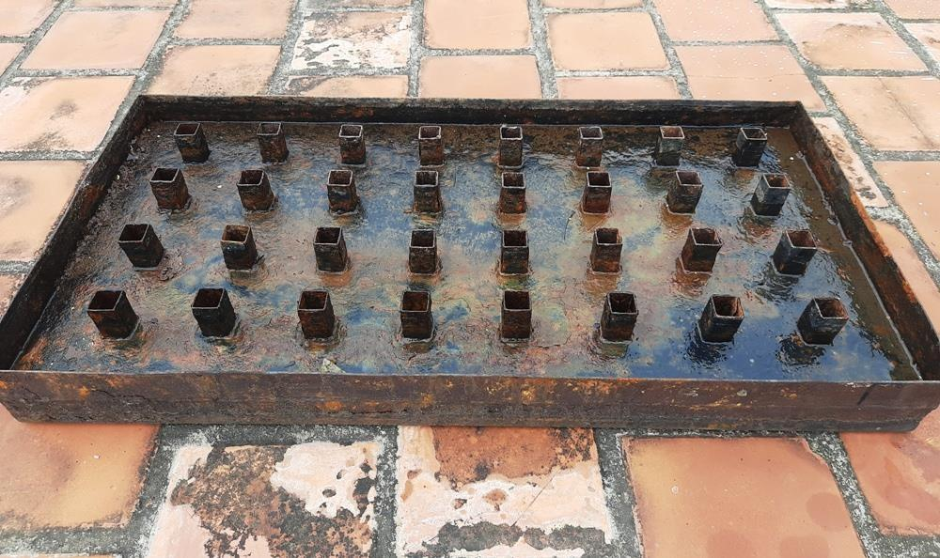
Fig. 1. Photograph of the basin liner fitted with 32 square hollow tubular fins.
Table 1. Thermo-physical properties of paraffin wax.
S. No. | Property | Value
1 | Density, solid / liquid (kg m⁻³) | 818 / 760
2 | Specific heat, solid / liquid (J kg⁻¹ K⁻¹) | 2950 / 2510
3 | Thermal conductivity (W m⁻¹ K⁻¹) | 0.24
4 | Melting point (°C) | 56
5 | Latent heat of melting (kJ kg⁻¹) | 226
4. Experimental Setup and Procedure
Two geometrically identical 0.5 m² single-slope stills were fabricated and operated side by side under a sheet-metal enclosure that provided structural support and additional insulation (Fig. 2). One still was retained as the CSS and the other was progressively modified. In Phase-1 the fins were attached above the basin liner and the wax stored beneath it. In Phase-2 the fins were extended below the liner so that they made direct contact with the wax, increasing the effective conductivity and hence the charge–discharge rate of the storage medium.
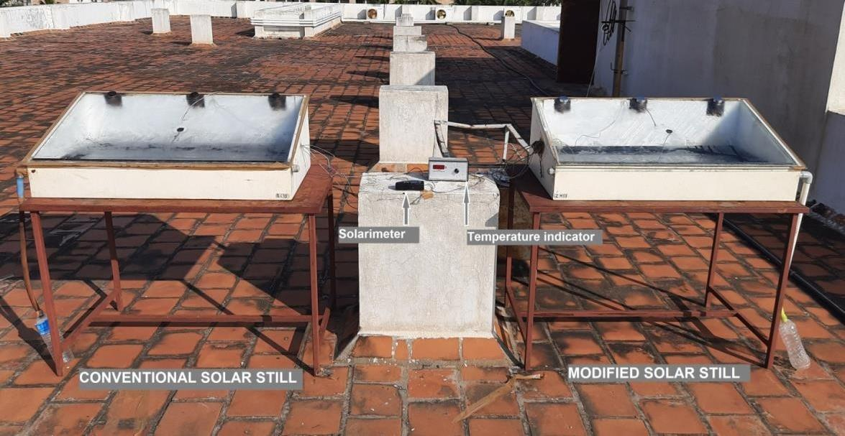
Fig. 2. Photograph of the experimental setup showing the conventional and modified stills with the solarimeter and temperature indicator.
The studied configurations are denoted as follows. Phase-1: conventional still (CSS); still with pin fins (SSWPF); still with pin fins and TES, fins above the liner (SSWPF+TES). Phase-2: still with fins only (SSWF); fins above the liner with TES (SSWF1+TES); fins above and below the liner with TES (SSWF2+TES).
Trials were performed for basin water depths of 1, 2, 3 and 4 cm to identify the optimum. The stills were charged with fresh brackish water each morning, checked for vapour leakage, and oriented to the south. Hourly readings of basin-water, basin-liner, chamber, glazing, ambient and PCM temperatures, together with distillate volume, were recorded from 09:00 to 22:00 on each clear-sky trial day. The TES configuration was tested with 2, 3 and 5 kg of wax; 3 kg was retained for the comparative trials.
4.1 Daily Efficiency
The daily energy efficiency of the still is the ratio of the energy used to evaporate the daily yield to the total incident solar energy over the basin area:
η_d = ( Σ m_w L_w ) / ( A Σ I_s ) (1)
where m_w is the hourly yield (kg m⁻²), L_w the latent heat of evaporation of water (J kg⁻¹), A the basin area (m²) and I_s the incident solar radiation (W m⁻²). Since A and L_w are constant, η_d is a function of yield and insolation, η_d = f(m_w, I_s).
4.2 Uncertainty and Error Analysis
Uncertainties in the derived results were estimated by the method of Holman (2012). For a result R = R(x₁, x₂, …, xₙ) dependent on independent measured variables with individual uncertainties w₁, w₂, …, wₙ, the overall uncertainty is:
w_R = [ (∂R/∂x₁ · w₁)² + (∂R/∂x₂ · w₂)² + … + (∂R/∂xₙ · wₙ)² ]^{1/2} (2)
The instrument accuracies, ranges and percentage errors are summarised in Table 2. The largest single contribution arises from the collecting jar (±10 mL).
Table 2. Accuracy, range and percentage error of the measuring instruments.
Sl. | Instrument | Accuracy | Range | Least value | Error (%)
1 | Thermocouple | ±0.1 °C | 0–100 °C | 28 °C | 0.357
2 | Temperature indicator | ±1 °C | 0–300 °C | 28 °C | 3.57
3 | Solarimeter | ±1 W m⁻² | 0–2500 W m⁻² | 30 W m⁻² | 3.33
4 | Collecting jar | ±10 mL | 0–1000 mL | 100 mL | 10
5. Energy, Exergy and Economic Modelling
5.1 Energy Analysis
First-law energy balances were written for the three principal components — glass cover, basin water and basin liner — under the usual assumptions of negligible temperature stratification, a vapour-tight enclosure, quasi-steady operation, constant water properties and negligible bottom and side losses (Agrawal et al., 2017). For the glass cover, the absorbed solar energy balances the convective and radiative losses to the ambient. The convective loss from the outer glass surface is h_cg(T_g − T_a), with h_cg expressed as a function of wind speed, and the radiative loss follows the Stefan–Boltzmann law with glass emissivity ε_g = 0.89.
For the basin water, the transmitted and absorbed radiation balances the evaporative, convective and radiative exchanges with the glass cover. The convective coefficient between water and glass follows the Dunkle (1961) correlation, and the evaporative heat-transfer rate is proportional to the productivity. The radiative exchange uses a water–glass view factor of 0.9, with ε_w = 0.96. For the basin liner, the absorbed radiation is partitioned between the energy gained by the liner, the heat transferred to the basin water and the heat transferred to the PCM. The hourly yield is obtained from the evaporative heat-transfer coefficient h_ew (Shukla & Sorayan, 2005).
5.2 Exergy Analysis
The exergy (second-law) efficiency is the ratio of the exergy associated with the yield to the exergy input through solar radiation (Sharshir et al., 2017):
η_ex = Ex_out / Ex_in (3)
The exergy output associated with the distillate is:
Ex_out = ( m_ew L / 3600 ) [ 1 − (T_a / T_w) ] (4)
and the exergy input from solar radiation is (Tiwari et al., 2009):
Ex_in = A I(t) [ 1 − (4/3)(T_a/T_sun) + (1/3)(T_a/T_sun)⁴ ] (5)
where T_sun = 6000 K. The full equation set was implemented in a spreadsheet model to predict the component temperatures, productivity, and the energy and exergy efficiencies as functions of solar intensity.
5.3 Economic Analysis
The capital recovery factor (CRF), first annual cost (FAC), sinking-fund factor (SFF), annual salvage value (ASV) and total annual cost (TAC) were computed with an interest rate i = 12% per year and a useful life n = 10 years, taking the salvage value as 20% of the capital cost and the annual maintenance cost (AMC) as 15% of the FAC (Agrawal & Rana, 2019):
CRF = [ i (1+i)ⁿ ] / [ (1+i)ⁿ − 1 ] (6)
TAC = FAC + AMC − ASV (7)
The annual cost of distilled water per litre and the payback period follow from the total annual cost, the annual yield Q and the market water price (Rs 15 per litre). The fabrication costs of the CSS and MSS are compared in Table 3; the fins and wax add only about Rs 750 to the capital cost.
Table 3. Material cost comparison for the conventional (CSS) and modified (MSS) stills.
Sl. | Material | CSS (Rs) | MSS (Rs)
1 | Solar still basin | 375 | 375
2 | Square pipe (fins) | – | 150
3 | Sheet-metal enclosure | 1140 | 1140
4 | Tempered glass | 1000 | 1000
5 | Paraffin wax | – | 600
6 | Thermocol sheet | 180 | 180
7 | Plumbing materials | 300 | 300
8 | Fabrication | 1500 | 1500
9 | Paint, sealant, etc. | 1000 | 1000
 | Total cost | 5495 | 6245
6. Results and Discussion
6.1 Effect of Basin Water Depth
Trials at 1, 2, 3 and 4 cm depths were conducted under comparable insolation, with the peak radiation reaching about 950 W m⁻² near 13:00 and falling to 300 W m⁻² by 17:00, giving 8–9 effective sunshine hours. As shown in Fig. 3, the 1 cm depth produced the highest forenoon yield but its output fell steeply in the afternoon, eroding the early gain. The 2 cm depth delivered superior and more balanced output across both sessions, while the 3 and 4 cm depths, owing to the higher water heat capacity, yielded little in the forenoon and peaked late. A depth of 2 cm was therefore adopted as optimum for all subsequent modified-still trials.
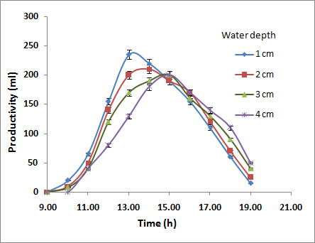
Fig. 3. Hourly variation of productivity of the CSS for basin water depths of 1, 2, 3 and 4 cm.
The validated model reproduced the measured basin-liner, basin-water and glass-cover temperatures with an average deviation of 12.3% and a maximum of 16% at the 2 cm depth, confirming acceptable agreement between theory and experiment.
6.2 Effect of Square Hollow Fins (Phase-1)
Adding fins increased both the absorber area and the basin heat capacity, raising the basin-water temperature and accelerating evaporation, particularly during the peak sunshine hours. As Fig. 4 shows, the SSWPF yielded about 70% more than the CSS up to noon and maintained its lead through the afternoon, as the elevated heat capacity sustained a higher water–glass temperature difference even as the insolation declined. The peak hourly yields are compared in Table 4: the finned still reached 370 mL h⁻¹ against 210 mL h⁻¹ for the CSS. Over the full day, fins raised the productivity by 64.3% (Table 6) and the daily efficiency from 24% to about 40% (Table 5).
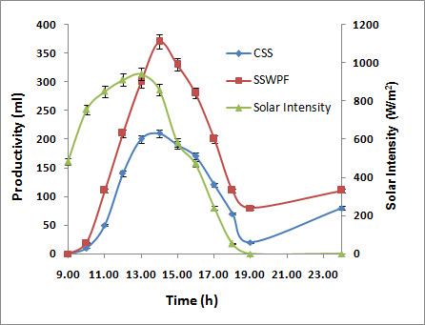
Fig. 4. Comparison of hourly productivity of the CSS and the finned still (SSWPF) with respect to solar intensity.
Table 4. Comparison of peak hourly productivity for the CSS, SSWPF and SSWPF+TES.
S. No. | Still type | Peak yield (mL) | Time period
1 | CSS | 210 | 13:00–14:00
2 | SSWPF | 370 | 13:00–14:00
3 | SSWPF+TES | 375 | 14:00–15:00
6.3 Effect of Combined Fins and Thermal Energy Storage (Phase-1)
Adding 3 kg of paraffin wax beneath the finned liner almost doubled the daily yield, from 1290 mL for the CSS to 2590 mL for the SSWPF+TES (Fig. 5). During the early hours the storage still produced slightly less than the CSS, because part of the basin-liner heat charged the wax; thereafter the modified still led decisively, and its output continued well beyond sunset as the stored latent heat was released. The peak hourly yield of 375 mL occurred at 15:00, when the insolation had already fallen to 587 W m⁻², demonstrating the time-shifting effect of the storage. As summarised in Table 6, fins contributed a 64.3% rise and the fins-plus-TES combination a 100.7% rise relative to the CSS, with TES alone adding 22.2% over the finned still. The corresponding daily-efficiency gains are given in Table 5.
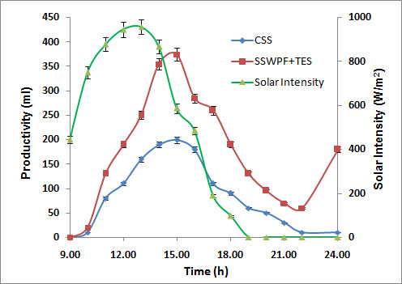
Fig. 5. Comparison of hourly productivity of the CSS and the combined finned, storage-integrated still (SSWPF+TES) with respect to solar intensity.
Table 5. Enhancement in daily efficiency due to the Phase-1 modifications.
S. No. | Still type | Daily efficiency (%) | Increase vs CSS (%)
1 | CSS | 24.0 | reference
2 | SSWPF | 39.88 | 66.2
3 | SSWPF+TES | 48.08 | 100.4
Table 6. Enhancement in daily productivity due to the Phase-1 modifications.
S. No. | Still type | Daily yield (mL day⁻¹) | Increase vs CSS (%)
1 | CSS | 1290 | reference
2 | SSWPF | 2120 | 64.34
3 | SSWPF+TES | 2590 | 100.7
The nocturnal yield of the storage still exceeded five times that of the CSS: the slow forenoon charging penalty was more than recovered during the overnight discharge. The hourly exergy efficiency of both stills remained below 10% during strong sunshine, owing to high exergy destruction at the basin liner, but that of the SSWPF+TES rose sharply after about 16:00, reaching roughly 70% during the night-time discharge cycle, when the near-isothermal release of latent heat minimised irreversibility (Asbik et al., 2016; Dincer & Cengel, 2001). Overall, the combined modification approximately doubled the daily efficiency of the CSS.
6.4 Effect of Extended Fins in the Storage Zone (Phase-2)
In Phase-2 the fins were extended below the basin liner into the wax to raise its effective thermal conductivity. The PCM temperature history (Fig. 6) shows that the extended-fin still (SSWF2+TES) reached the melting range earlier and attained a higher peak (64 °C versus 61 °C) than the above-liner configuration (SSWF1+TES), reducing the charging period from 4 h to 3 h and accelerating the subsequent discharge. The cumulative-yield comparison (Fig. 7) confirms that the storage-integrated stills overtook the CSS and the fins-only still after about 19:00; however, the difference between SSWF1+TES and SSWF2+TES remained modest because of the comparatively low insolation during the experimental period.
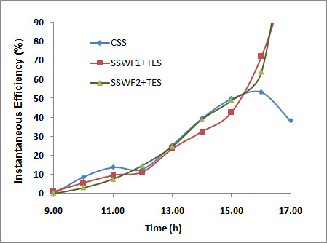
Fig. 6. Hourly variation of the instantaneous efficiency illustrating the charge–discharge behaviour of the PCM for SSWF1+TES and SSWF2+TES relative to the CSS.
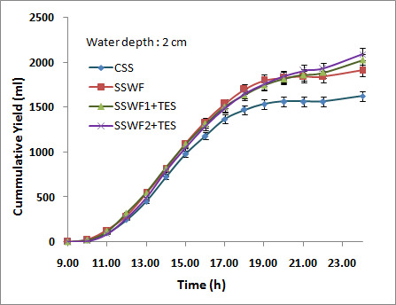
Fig. 7. Comparison of cumulative yield of the CSS, SSWF, SSWF1+TES and SSWF2+TES (Phase-2).
As summarised in Table 7, the Phase-2 modifications raised the daily yield by 17.5%, 48.6% and 55.7% for SSWF, SSWF1+TES and SSWF2+TES respectively relative to the CSS. The incremental gain of the extended fins over the above-liner configuration was only 4.8% in productivity and 7.7% in efficiency. The nocturnal yields of SSWF1+TES and SSWF2+TES were about 2.5 and 2.8 times that of the CSS. Given the small incremental benefit, extending the fins into the storage zone is not recommended once the additional cost is considered, although the modification is expected to perform better in summer when the insolation is higher.
Table 7. Enhancement in daily productivity due to the Phase-2 modifications.
S. No. | Still type | Daily yield (mL day⁻¹) | vs CSS (%) | vs SSWF1 (%)
1 | CSS | 1625 | reference | –
2 | SSWF | 1910 | 17.54 | –
3 | SSWF1+TES | 2415 | 48.61 | reference
4 | SSWF2+TES | 2530 | 55.69 | 4.8
6.5 Economic Analysis
Although the fins and wax raised the capital, first-annual and maintenance costs, they lowered the cost of water per litre and shortened the payback period. As shown in Table 8, the annual net earnings rose by roughly 60% across the modifications, and the payback period fell from 114 days for the CSS to 83 days for the SSWF2+TES. Expressed per kilogram of distillate, the annual water cost dropped from about Rs 1.12 for the CSS to Rs 0.63 for the storage-integrated still, confirming the economic viability of the proposed enhancement.
Table 8. Outcomes of the economic analysis (all monetary values in US$).
Still type | Capital | FAC | AMC | TAC | Water/L | Net earn. | Payback (d)
CSS | 74.38 | 13.16 | 1.97 | 14.28 | 0.0120 | 235.28 | 114
SSWF | 76.43 | 13.60 | 2.04 | 14.77 | 0.0106 | 270.07 | 103
SSWF1+TES | 82.58 | 14.61 | 2.19 | 15.86 | 0.0089 | 341.86 | 88
SSWF2+TES | 84.59 | 14.97 | 2.25 | 16.26 | 0.0088 | 372.73 | 83
6.6 Comparison with Previous Work
Table 9 benchmarks the present enhancements against representative published studies. With the exception of the fins-only winter configuration (SSWF, +17.5%), every modified system investigated here outperformed the corresponding literature designs. In particular, the storage-integrated stills delivered strong performance even during the winter trials, underlining that combining an absorber-area enhancement (fins) with latent-heat storage is more effective than either measure alone.
Table 9. Comparison of productivity enhancement with previous finned and modified solar stills.
S. No. | Author(s) | Modification | Increase (%)
1 | Omara et al. (2011) | Vertical finned / corrugated still | 40 / 21
2 | El-Sebaii et al. (2015) | Vertical finned still | 13.7
3 | Alaian et al. (2016) | Pin-finned wick surface | 23
4 | Rajaseenivasan & Srithar (2016b) | Square fins / square fins + wick | 36.7 / 45.8
5 | Velmurugan et al. (2008a) | Vertical finned still | 45.5
6 | Present work (Phase-1) | SSWPF / SSWPF+TES | 64.3 / 100.7
7 | Present work (Phase-2) | SSWF / SSWF1+TES / SSWF2+TES | 17.5 / 48.6 / 55.7
7. Conclusion
An experimental investigation of a single-basin single-slope solar still enhanced with square hollow tubular fins and paraffin-wax latent-heat storage was carried out in two phases at Ahmedabad, supported by a validated thermodynamic model and an economic analysis. The principal conclusions are:
- A basin water depth of 2 cm gave the best balance of forenoon and afternoon productivity and was adopted as optimum; the energy model matched the measured temperatures within an average deviation of 12.3%.
- Square hollow fins above the basin liner raised the daily productivity by 64.3% and the daily efficiency from 24% to about 40%, with a peak hourly yield of 370 mL against 210 mL for the CSS.
- Combining fins with 3 kg of paraffin-wax storage almost doubled the daily yield (+100.7%) and the daily efficiency (+100.4% / ~48%) relative to the CSS, shifting peak output to mid-afternoon and raising nocturnal yield to about 5.3 times that of the CSS.
- The exergy efficiency of the storage-integrated still rose markedly during the night-time discharge cycle, reaching about 70% as the near-isothermal release of latent heat reduced irreversibility, whereas the CSS remained below about 7%.
- Extending the fins into the storage chamber raised the daily yield by 55.7% over the CSS but only 4.8% over the above-liner configuration; the small incremental benefit does not justify the additional cost under the tested conditions.
- The modification reduced the cost of distilled water from about Rs 1.12 to Rs 0.63 per kilogram and shortened the payback period from 114–144 days to 81–83 days, confirming economic viability.
Overall, square hollow fins combined with paraffin-wax latent-heat storage constitute an effective and economical means of enhancing the productivity of passive solar stills, extending useful output well beyond sunset.
8. Future Scope
- Investigating storage media with higher thermal conductivity and specific heat, or nanoparticle- and metal-foam-enhanced PCMs, to raise storage efficiency.
- Exploring alternative storage-chamber geometries and fin arrangements to improve charge–discharge dynamics without excessive cost.
- Applying improved basin and side-wall insulation to reduce the daytime exergy destruction identified at the basin liner.
- Repeating the extended-fin trials during summer, when higher insolation is expected to amplify the benefit of in-storage fins.
- Studying the influence of fin number, dimensions and geometry, and the effect of in-storage fins on usable storage volume, which were held fixed in this work.
9. Acknowledgements
The authors gratefully acknowledge the Mechanical Engineering Department, Gandhinagar Institute of Technology, Gandhinagar University, for providing the laboratory and rooftop facilities used in this work, and thank the faculty and technical staff for their guidance and support during the experimental campaign.

References
Agrawal, A., & Rana, R. S. (2019). Theoretical and experimental performance evaluation of single-slope single-basin solar still with multiple V-shaped floating wicks. Heliyon, 5(4), e01525.
Agrawal, A., Rana, R. S., & Srivastava, P. K. (2017). Heat transfer coefficients and productivity of a single slope single basin solar still in Indian climatic condition: Experimental and theoretical comparison. Resource-Efficient Technologies, 3(4), 466–482.
Ahsan, A., Imteaz, M., Rahman, A., Yusuf, B., & Fukuhara, T. (2012). Design, fabrication and performance analysis of an improved solar still. Desalination, 292, 105–112.
Alaian, W. M., Elnegiry, E. A., & Hamed, A. M. (2016). Experimental investigation on the performance of solar still augmented with pin-finned wick. Desalination, 379, 10–15.
Arunkumar, T., Vinothkumar, K., Ahsan, A., Jayaprakash, R., & Kumar, S. (2012). Experimental study on various solar still designs. ISRN Renewable Energy, 2012, 569381.
Asbik, M., Ansari, O., Bah, A., Zari, N., Mimet, A., & El-Ghetany, H. (2016). Exergy analysis of solar desalination still combined with heat storage system using phase change material (PCM). Desalination, 381, 26–37.
Bose, P., & Valan, A. A. (2016). A review on thermal conductivity enhancement of paraffin wax as latent heat energy storage material. Renewable and Sustainable Energy Reviews, 65, 81–100.
Dhaidan, N. S., & Khodadadi, J. M. (2017). Improved performance of latent heat energy storage systems utilizing high thermal conductivity fins: A review. Journal of Renewable and Sustainable Energy, 9(3), 034103.
Dincer, I., & Cengel, Y. A. (2001). Energy, entropy and exergy concepts and their roles in thermal engineering. Entropy, 3, 116–149.
Dunkle, R. (1961). Solar water distillation: The roof type and a multiple effect diffusion still. International Developments in Heat Transfer, 805–902.
Elashmawy, M. (2017). An experimental investigation of a parabolic concentrator solar tracking system integrated with a tubular solar still. Desalination, 411, 1–8.
El-Sebaii, A. A., Al-Ghamdi, A. A., Al-Hazmi, F. S., & Faidah, A. S. (2009). Thermal performance of a single basin solar still with PCM as a storage medium. Applied Energy, 86(7–8), 1187–1195.
El-Sebaii, A. A., Ramadan, M. R. I., Aboul-Enein, S., & El-Naggar, M. (2015). Effect of fin configuration parameters on single basin solar still performance. Desalination, 365, 15–24.
Holman, J. P. (2012). Experimental methods for engineers. McGraw-Hill.
Ismail, B. I. (2009). Design and performance of a transportable hemispherical solar still. Renewable Energy, 34(1), 145–150.
Kabeel, A. E. (2009). Performance of solar still with a concave wick evaporation surface. Energy, 34(10), 1504–1509.
Kabeel, A. E., & Mohamed, A. (2016). Improving the performance of solar still by using PCM as a thermal storage medium under Egyptian conditions. Desalination, 383, 22–28.
Nayi, K. H., & Modi, K. V. (2018). Pyramid solar still: A comprehensive review. Renewable and Sustainable Energy Reviews, 81, 136–148.
Omara, Z. M., Hamed, M. H., & Kabeel, A. E. (2011). Performance of finned and corrugated absorbers solar stills under Egyptian conditions. Desalination, 277, 281–287.
Ouar, M. L. A., Sellami, M. H., Meddour, S. E., Touahir, R., Guemari, S., & Loudiyi, K. (2017). Experimental yield analysis of groundwater solar desalination system using absorbent materials. Groundwater for Sustainable Development, 5, 261–267.
Rajaseenivasan, T., Tinnokesh, A. P., Kumar, G. R., & Srithar, K. (2016a). Glass basin solar still with integrated preheated water supply — Theoretical and experimental investigation. Desalination, 398, 214–221.
Rajaseenivasan, T., & Srithar, K. (2016b). Performance investigation on solar still with circular and square fins in basin with CO₂ mitigation and economic analysis. Desalination, 380, 66–74.
Riahi, A., Yusof, K. W., Singh, B. S. M., Olisa, E., Sapari, N., & Isa, M. H. (2015). The performance investigation of triangular solar stills having different heat storage materials. International Journal of Energy and Environmental Engineering, 6(4), 385–391.
Sakthivel, M., Shanmugasundaram, S., & Alwarsamy, T. (2010). An experimental study on a regenerative solar still with energy storage medium — Jute cloth. Desalination, 264, 24–31.
Sarhaddi, F., Farshchi Tabrizi, F., Aghaei Zoori, H., & Mousavi, S. A. H. S. (2017). Comparative study of two weir type cascade solar stills with and without PCM storage using energy and exergy analysis. Energy Conversion and Management, 133, 97–109.
Sathyamurthy, R., Kennady, H. J., Nagarajan, P. K., & Ahsan, A. (2014). Factors affecting the performance of triangular pyramid solar still. Desalination, 344, 383–390.
Sharon, H., & Reddy, K. S. (2015). A review of solar energy driven desalination technologies. Renewable and Sustainable Energy Reviews, 41, 1080–1118.
Sharshir, S. W., Elsheikh, A. H., Peng, G., Yang, N., El-Samadony, M. O. A., & Kabeel, A. E. (2017). Thermal performance and exergy analysis of solar stills — A review. Renewable and Sustainable Energy Reviews, 73, 521–544.
Shatat, M., Worall, M., & Riffat, S. (2013). Opportunities for solar water desalination worldwide: Review. Sustainable Cities and Society, 9, 67–80.
Shukla, S. K., & Sorayan, V. P. S. (2005). Thermal modeling of solar stills: An experimental validation. Renewable Energy, 30(5), 683–699.
Taamneh, Y., & Madhar, M. T. (2012). Performance of pyramid-shaped solar still: Experimental study. Desalination, 291, 65–68.
Tabrizi, F. F., & Ashkan, Z. S. (2010). Experimental study of an integrated basin solar still with a sandy heat reservoir. Desalination, 253, 195–199.
Tiwari, G. N., Dimri, V., & Chel, A. (2009). Parametric study of an active and passive solar distillation system: Energy and exergy analysis. Desalination, 242(1–3), 1–18.
Velmurugan, V., Gopalakrishnan, M., Raghu, R., & Srithar, K. (2008a). Single basin solar still with fin for enhancing productivity. Energy Conversion and Management, 49, 2602–2608.
Velmurugan, V., Deenadayalan, C. K., Vinod, H., & Srithar, K. (2008b). Desalination of effluent using fin type solar still. Energy, 33(11), 1719–1727.
Xiao, X., Zhang, P., & Li, M. (2013). Preparation and thermal characterization of paraffin/metal foam composite phase change material. Applied Energy, 112, 1357–1366.
Yadav, S., & Sudhakar, K. (2015). Different domestic designs of solar stills: A review. Renewable and Sustainable Energy Reviews, 47, 718–731.
Zheng, H., Chang, Z., Chen, Z., Xie, G., & Wang, H. (2012). Experimental investigation and performance analysis on a group of multi-effect tubular solar desalination devices. Desalination, 311, 62–68.
Zheng, H., Xiong, J., Xie, G., & Wang, H. (2013). Experimental and numerical study on a new multi-effect solar still with enhanced condensation surface. Energy Conversion and Management, 73, 176–185.

