The Dual Engine of Empowerment: How SHGs and MFIs are Driving Socio Economic Growth in Sahibganj, Jharkhand.
Aditi Murmu¹, Dr. Nasir Ahmed²
¹PhD Research Scholar, Department of Commerce and Business Management, Ranchi University, Ranchi Jharkhand -834001, Email-aditimurmu1999@gmai.com
²Assistant Professor, Gossner College, Ranchi University, Ranchi Jharkhand-834001https://www.ijltemas.in/indian-author/

Abstract
This study evaluates the socio-economic transformation of Sahibganj, a riverine district in Jharkhand, through the “dual engine” of Self-Help Groups (SHGs) and Microfinance Institutions (MFIs). Traditionally hindered by geographic isolation and a lack of formal banking infrastructure, Sahibganj has evolved into a high-density institutional network with 12,559 SHGs as of 2026. Utilizing secondary data from the Sa-Dhan Bharat Microfinance Reports and Jharkhand Economic Surveys, the research analyzes the impact of micro-credit on marginalized communities, specifically Santhal and Mal Paharia tribes.
The findings reveal a robust 75.6% growth in SHGs mobilization between 2019 and 2026, characterized by high social inclusivity; nearly 64% of groups comprise historically underserved categories. Economically, the shift from “survival loans” to productive asset creation strengthened by a ₹44.29 Cr Community Investment Fund (CIF) has reduced the number of "zero-income" women from 42.85% to 2.85%. Socially, the “Bank Sakhi” model and participation in Producer Groups have elevated women into leadership roles, with bank advances to women tripling the national benchmark. Despite these strides, a low Credit-Deposit (CD) ratio of 38.37% and rural infrastructure gaps suggest that while institutional saturation has been achieved, formal banking absorption remains a challenge. The study concludes that Sahibganj has successfully transitioned to a mature phase of responsible lending, where high financial discipline evidenced by a low 0.76% NPA ratio marks the emergence of rural women as professional-grade economic stakeholders.

Keywords: Self-Help Groups (SHGs), Microfinance Institutions (MFIs), Financial Inclusion, Women's Empowerment, Rural Entrepreneurship, Sahibganj, Jharkhand.

1.Introduction
In the riverside villages of Sahibganj, a quiet revolution is unfolding, not led by politicians or industrialists, but by women with small passbooks and big dreams. In a state like Jharkhand, which is famous for its vast mineral wealth but still struggles with deep poverty, Sahibganj has become a testing ground for a new kind of success. Tucked between the flowing Ganges and the rugged Rajmahal Hills, this district is home to the Santhal tribes and Mal Paharia communities who were once considered “unbankable” by big financial institutions. For years, geography was destiny here; frequent floods and a lack of paved roads meant that formal banks were miles away, leaving families at the mercy of local moneylenders.
Today, that old story is changing thanks to a “dual engine” of growth: Self-Help Groups (SHGs) and Microfinance Institutions (MFIs). The SHG model, powered by the National Rural Livelihood Mission (NRLM), brings together neighbors to save and support one another. These groups provide the foundation, while MFIs provide the “credit fuel” needed to launch small businesses. According to the Sa-Dhan Bharat Microfinance Report 2025, Sahibganj is now a bustling financial hub with 24 active institutions including 18 micro-lenders and 6 banks ensuring that even the most remote home has access to capital without needing property as a collateral.¹
This transformation is about much more than just loans; it is about bringing the bank to the doorstep of the rural poor. The Jharkhand Economic Survey 2024-25 highlights a massive leap in infrastructure, with 83,366 Banking Correspondents (known locally as “Bank Sakhis”) and thousands of ATMs now operating statewide.² Since 95% of microfinance borrowers are women, they have moved from the sidelines to the center of their family's economic life. From owning livestock to selling local “Palash” brand honey, these women are turning small credits into lasting assets.
However, the journey is now entering a more mature phase. While earlier reports showed a rush of new borrowers, the Sa-Dhan 2025 data reveal an 18% drop in the number of clients in Jharkhand.¹ This is not a sign of failure, but of “responsible lending” a shift to make sure families do not take on more than they can repay. Simultaneously, NRLM has organized over 1.03 lakh women into Producer Groups, helping them move from simple survival to collective business power.³ Even with these strides, reaching every “last mile” in this riverine district remains a challenge. This study explores how microfinance has sparked a new beginning in Sahibganj, asking if the rise in available credit has truly improved the quality of life for the families living in the shadows of the Rajmahal Hills.

1.1 Self-Help Groups (SHGs)
A Self-Help Group is a small, voluntary neighborhood circle, usually comprising of 10 to 20 women. The main goal of a SHG is to encourage members to save money together. Each member contributes a small portion of their earnings into a shared pot. From this collective fund, members can take out “internal loans” at very low interest rates to handle family emergencies or buy supplies for a small trade. Because the group is built on trust and friendship, it creates “social capital” giving women the confidence to solve problems together and stay away from local moneylenders who charge high, unfair rates.

1.2 Microfinance Institutions (MFIs)
Microfinance Institutions are formal business organizations like specialized banks or lending companies that focus on helping the poor. Unlike big traditional banks, MFIs do not ask for a house or land as a guarantee (collateral). Instead, they provide small “business loans” to people who have low incomes but big ideas. These institutions provide the professional financial fuel that allows a woman to move beyond just saving money to actually launching a larger project, such as opening a retail shop, raising livestock, or starting a small manufacturing unit.

1.3 SHG-Bank Linkage Framework
​The SHG-Bank Linkage Programme (SHG-BLP) was established by NABARD in 1992, following a successful five-year pilot phase, to bridge the gap between formal financial institutions and the “unbankable” rural poor without requiring collateral. In Jharkhand, this initiative has flourished under the Jharkhand State Livelihood Promotion Society (JSLPS), which has successfully integrated over 3.62 lakh SHGs into the formal banking system as of early 2026.⁴ The program has evolved from simple savings habits to active credit participation, with nearly 67% of groups now mapped for bank loans and maintaining a remarkably low NPA ratio of less than 1% in areas like Sahibganj.⁵ This success is largely attributed to the “Bank Sakhi” model where trained local women act as financial intermediaries and the digital modernization of records through NABARD’s e-Shakti initiative, effectively turning small savings groups into a sustainable pipeline for rural entrepreneurship.

1.4 Sahibganj District: At a Glance⁶
Sahibganj district is administratively organized into nine Community Development Blocks: Sahibganj, Mandro, Borio, Barhait, Taljhari, Rajmahal, Udhwa, Pathna and Barharwa, which are managed under the Sahibganj and Rajmahal subdivisions. According to the 2011 Census, the district is home to 1,150,567 people (589,391 males and 561,176 females) with a relatively high population density of 558 persons per sq. km. The demographic landscape is characterized by a significant tribal presence, with Scheduled Tribes, primarily Santhals and Mal Paharias, making up 26.8% of the population, while Scheduled Castes account for 6.29%. While the district maintains a healthy overall sex ratio of 952 (rising to 960 for children aged 0-6), challenges remain in education; the 2011 literacy rate stood at 52.04%, with a notable gap between male (60.34%) and female (43.31%) literacy, though recent state estimates indicate a positive trend pushing overall literacy toward the 60-62% range.

2. Statement of the Problem
Despite the rapid institutional expansion of Self-Help Groups (SHGs) in Sahibganj which saw a 75.6% growth in mobilization between 2019 and 2026, a significant “credit gap” remains within the formal banking system.² Although the district has achieved a 94% success rate in PMJDY account targets, indicating high institutional saturation, the local Credit-Deposit (CD) ratio remains at a low 38.37%. This figure is substantially below the RBI’s 60% benchmark, suggesting that while rural women are organized and financially disciplined (evidenced by a low 0.76% NPA ratio), the formal banking infrastructure is not yet fully absorbing or supporting their entrepreneurial potential.¹ Furthermore, severe rural infrastructure bottlenecks persist; only 14% of ATMs are accessible in rural areas, leading to an over-reliance on Banking Correspondents (BC Sakhis) to bridge the "last mile" connectivity gap.

3. Review of Literature
3.1 Pradeep & Rai (2016)⁷: Investigated SHGs in Mangalore as collective platforms for resource pooling and technology adoption. They found that group participation empowers marginalized women to challenge patriarchal norms and increases their involvement in household decision-making. Beyond individual gains, the study highlights how these groups act as a “social safety net” that reduces external economic risks for the entire family. The authors emphasize that the transition from passive savers to active micro-entrepreneurs is the critical turning point for rural welfare.

3.2 Sultana et al. (2017)⁸: Used logistic regression to compare SHG members in Chennai, analyzing how microfinance influences economic and knowledge-based empowerment. The results indicated that while microfinance builds significant self-confidence and courage, its social impact is often more immediate and measurable than direct economic gain. The research specifically notes that the “knowledge-based” empowerment understanding banking and legal rights serves as a permanent asset for women. This suggests that even if a business venture fails, the intellectual and social capital gained through the SHG remains transformative.

3.3 Khan et al. (2020)⁹: Applied a quasi-experimental design in Kashmir to assess empowerment in conflict-affected regions. They discovered that microfinance has a significant moderate impact on economic and psychological status, proving that structured financial programs can enhance female agency even in complex socio-political environments. The study is unique in identifying “psychological empowerment” as a precursor to economic success, noting that improved self-perception is vital for business resilience. It concludes that microfinance serves as a stabilizing force that fosters long-term peace-building by economically anchoring households.

3.4 Mahalakshmi (2024)¹⁰: Evaluated microfinance as a national strategic tool for India’s socio-economic development. The study concluded that SHG-Bank Linkage Programmes effectively increase the cash-flow of rural households and contribute to the overall national economy. The author argues that for microfinance to be truly effective, it must evolve from simple credit delivery to a “credit-plus’ approach involving marketing and skill training. Ultimately, the success of the model rests on maintaining the voluntary, self-governing nature of these groups to prevent institutional over-reach.

4. Research Gap
Current literature on microfinance in India extensively documents the social and psychological empowerment of women. Studies by Pradeep & Rai (2016)⁷ and Sultana et al. (2017)⁸ emphasize how SHG participation challenges patriarchal norms and builds self-confidence through “knowledge-based” empowerment. Similarly, research by Khan et al. (2020)⁹ highlights the role of microfinance in fostering “psychological empowerment” as a precursor to economic success in complex environments.
However, there is a distinct lack of research focusing on the transition from “survival-level” individual micro-credit to “macro-enterprise” collective growth within riverine and geographically isolated districts like Sahibganj. While existing studies focus on the delivery of credit, this research addresses the gap in understanding the maturity phase of SHGs, specifically how marginalized tribal and minority communities (who comprise 64% of groups in Sahibganj) are shifting from “survival loans” to productive asset creation through Producer Groups and Farmer Producer Organizations (FPOs). This study fills this void by analyzing the “dual engine” of SHGs and MFIs as a model for moving rural households from subsistence to professional-grade economic stakeholder status.

5. Objectives of the Study
- To evaluate the growth and outreach of SHGs in Sahibganj, Jharkhand.
- To analyze the impact of micro-credit on the economic status (income, assets) of rural households in the district of Sahibganj.
- To assess the social changes (decision-making, mobility) among women after joining SHGs in Sahibganj.

6. Research Methodology
This study employs a secondary data research design to analyze the socio-economic impact of Self-Help Groups (SHGs) and Microfinance Institutions (MFIs) in Sahibganj, Jharkhand. By synthesizing existing datasets, the research provides a comprehensive overview of the district's financial evolution and its effects on rural households.

6.1. Data Sources
The study draws on a diverse range of high-quality, published data to ensure accuracy and regional relevance. Key sources include:
Industry Reports: The Sa-Dhan Bharat Microfinance Reports (2024 & 2025) were utilized to track the growth, institutional footprint (24 active entities), and lending trends in the district.
Government Publications: Data regarding infrastructure and macro-economic trends was extracted from the Jharkhand Economic Surveys (2023-24 & 2024-25).
Programmatic Data: Progress on social mobilization and the “Lakhpati Didi” initiative was sourced from National Rural Livelihood Mission (NRLM) and JSLPS progress reports.
Demographic Data: Baseline population statistics, literacy rates, and sex ratios were obtained from the Census of India and the District Census Handbook for Sahibganj.

6.2. Data Collection Process
The data collection process involved a systematic review of the literature available in the public domain. Specific data points were targeted to align with the study’s objectives:
Institutional Outreach: Identifying the number of MFIs and SHGs active across the nine blocks of Sahibganj.
Economic Indicators: Tracking changes in household assets, income levels, and loan repayment rates.
Social Metrics: Reviewing qualitative case studies and survey findings on women’s participation in decision-making and the “Bank Sakhi” model.

7. Data Analysis

7.1 SHGs Social Category³
From table 1, the social composition of 12,559 Self-Help Groups (SHGs) in Sahibganj reveals a highly inclusive mobilization strategy, with a dominant 63.6% of groups belonging to historically marginalized communities. The Others (OBC/General) category represents the largest share at 36.5% (4,578 groups), closely followed by Schedule Tribes, who constitute exactly one-third of the total at 33.3% (4,185 groups). Minority communities also show substantial engagement, accounting for 23.7% (2,972 groups) of the institutional structure, while Schedule Castes comprise 6.6% (824 groups). This distribution, as detailed in the summary table, underscores a significant focus on social equity, ensuring that nearly two-thirds of the district’s SHG network is composed of ST, SC, and Minority members as shown in figure 1.

Table 1: SHGs Social Category
Social Category | Number of SHGs
Schedule Tribe | 4185
Schedule Caste | 824
Minorities | 2972
Others (OBC/General) | 4578
Total | 12559

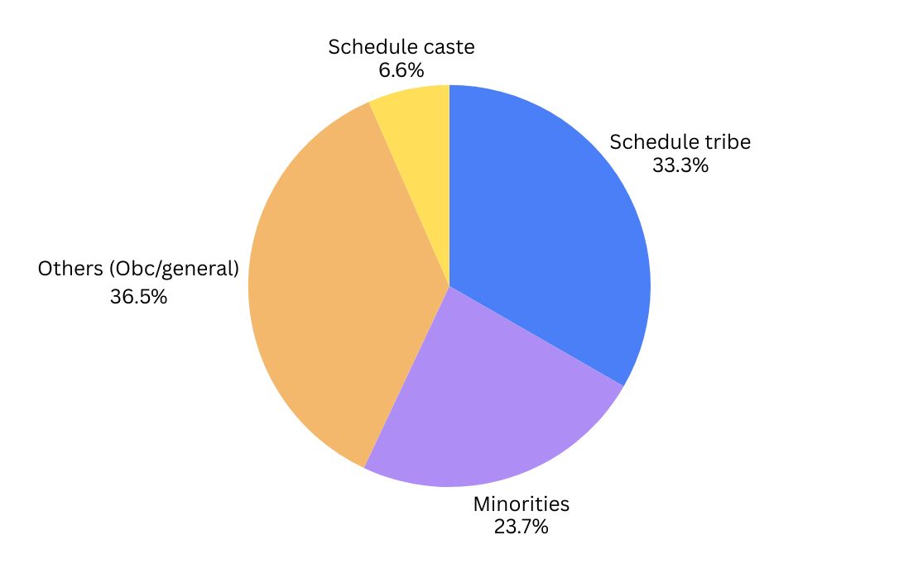
Figure 1: Percentage Distribution of SHGs by Social category

7.2 SHGs member social category³
Table 2 shows the membership data for the 1,29,762 individuals across nine blocks of Sahibganj revealing a diverse socio-economic landscape where participation is heavily influenced by regional demographics. High-volume blocks like Barharwa (20,142) and Udhwa (19,208) lead the district, driven largely by significant Minority and Other category participation. Conversely, Scheduled Tribe (ST) members form the backbone of the program in blocks such as Borio (8,270), Barhait (8,086), and Taljhari (7,073), representing the district’s primary corridors for tribal empowerment. While Scheduled Caste (SC) representation is generally lower, it peaks notably in Barharwa (4,034). Additionally, the district demonstrates a commitment to inclusivity with 893 PWD members, led by Barhait (250). Overall, the program shows a 75.6% growth rate in group formation, effectively tailoring its reach to the specific demographic strongholds of each administrative block as shown in figure 2.

Table 2: SHGs member social category
Block Name | SC | ST | Minority | Others | Total
Barhait | 1664 | 8086 | 2155 | 4104 | 16009
Barharwa | 4034 | 1872 | 8910 | 5326 | 20142
Borio | 654 | 8270 | 1416 | 3286 | 13626
Mandro | 758 | 5457 | 1424 | 2905 | 10544
Pathna | 1018 | 7008 | 1363 | 3194 | 12583
Rajmahal | 848 | 954 | 4345 | 9410 | 15557
Sahibganj | 967 | 976 | 1922 | 6439 | 10304
Taljhari | 779 | 7073 | 909 | 3028 | 11789
Udhwa | 776 | 781 | 9223 | 8428 | 19208
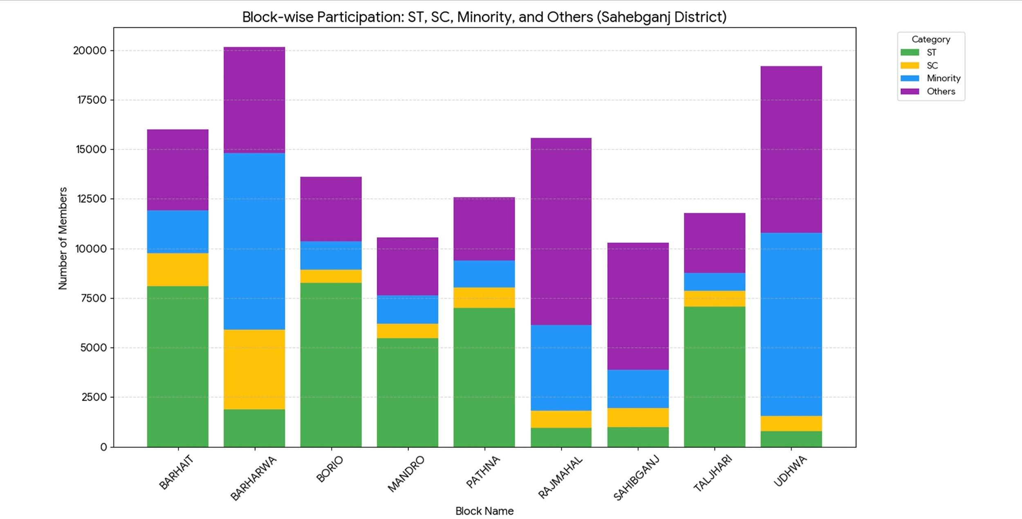
Figure 2: Block-wise Participation of Members by Social Category in Sahebganj

7.3 SHG Expansion and Institutional Growth (2019–2026)³
Table 3 shows the longitudinal growth of Self-Help Groups (SHGs) across Sahibganj’s nine blocks from 2019-20 to 2025-26 revealing a consistent district-wide expansion, characterized by a sharp acceleration phase between 2022 and 2024. Barharwa emerged as the lead performer, achieving the highest cumulative total of approximately 1,880 groups, followed closely by Udhwa (1,780) and Barhait (1,620), despite Barhait receiving higher relative funding. While most regions showed aggressive upward trajectories, blocks like Sahibganj and Mandro maintained a steadier, shallower growth curve, concluding the period with fewer than 1,000 units each. This diverging momentum suggests that while community mobilization was successful across the board, the intensity of institutional building varied significantly, likely influenced by localized interventions and varying allocation strategies per block as shown in figure 3.

Table 3: SHG Expansion and Institutional Growth (2019–2026)
Block Name | 2019-20 | 2020-21 | 2021-22 | 2022-23 | 2023-24 | 2024-25 | 2025-26
Barhait | 863 | 1014 | 1125 | 1254 | 1502 | 1542 | 1617
Barharwa | 825 | 924 | 1075 | 1180 | 1474 | 1706 | 1883
Borio | 790 | 969 | 1017 | 1178 | 1284 | 1344 | 1400
Mandro | 682 | 690 | 735 | 792 | 874 | 910 | 1000
Pathna | 587 | 643 | 749 | 885 | 1070 | 1133 | 1274
Rajmahal | 924 | 941 | 964 | 1070 | 1272 | 1333 | 1440
Sahibganj | 642 | 669 | 703 | 804 | 873 | 912 | 939
Taljhari | 888 | 927 | 968 | 1022 | 1050 | 1103 | 1233
Udhwa | 951 | 1139 | 1219 | 1479 | 1646 | 1693 | 1773
Total | 7152 | 7916 | 8555 | 9664 | 11045 | 11676 | 12559

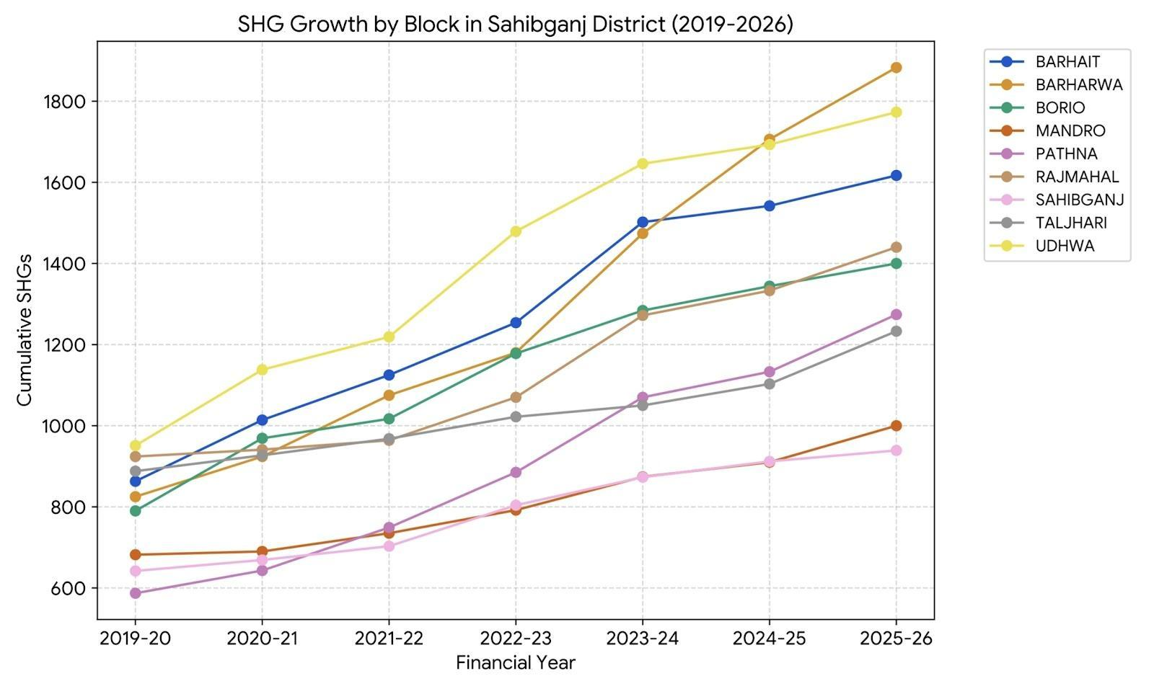
Figure 3: Cumulative Growth of Self-Help Groups (SHGs) by Blocks in Sahibganj District (2019-26)

7.4 Aggregate District-Level SHG Mobilization (2019–2026)³
From table 3, the aggregate growth of Self-Help Groups (SHGs) in Sahibganj from 2019-20 to 2025-26 demonstrates a robust and uninterrupted expansion, with the total volume increasing from 7,152 to 12,559 units. This represents a substantial overall growth of 75.6%, driven by the net formation of 5,407 new groups over the seven-year period. A notable acceleration occurred between 2022 and 2024, peaking with a record annual addition of 1,381 groups in the 2023-24 fiscal year. Following this surge, the district maintained steady momentum, adding nearly 1,000 groups annually and signaling a sustainable “maintenance and expansion” phase as shown in figure 4.

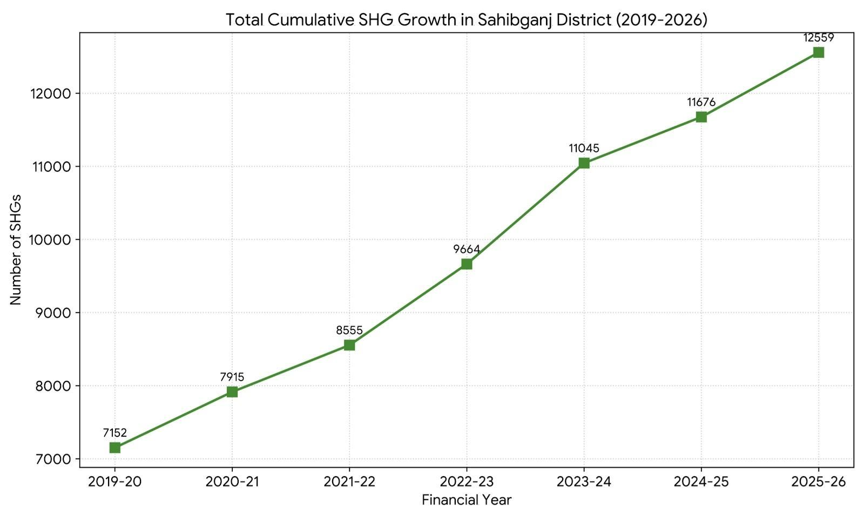
Figure 4: Total Cumulative SHGs Growth in Sahibganj District (2019-2026)

7.5 Block-wise Financial Allocation (2019–2026)³
Table 4 Shows that the financial distribution across Sahibganj from 2019 to 2026 demonstrates a consistent prioritization of the Community Investment Fund (CIF) over the Revolving Fund (RF), with total allocations reaching ₹44.29 Cr and ₹16.29 Cr respectively. Barhait leads the district with the highest total disbursement (₹7.25 Cr CIF and ₹2.61 Cr RF), followed by Udhwa and Barharwa, while Sahibganj and Mandro represent the lower tier of funding. Across the district, the CIF is approximately 172% higher than the RF, reflecting a clear strategic preference for larger community investment grants over revolving credit. This descending distribution, where the top-performing block received over three times the RF of the lowest-performing block, suggests that funding is indexed to block-specific metrics such as SHG density or localized poverty indices.This deep penetration into the rural landscape provides a massive institutional foundation for scaling financial interventions, such as Community Investment Funds (CIF) and Revolving Funds (RF), across the district as shown in figure 5.

Table 4: Block-wise Financial Allocation (2019–2026)
Block Name | RF Amount (Rs) | CIF Amount(Rs)
Barhait | 26055000 | 72547000
Barharwa | 25230000 | 6152000
Borio | 21675000 | 58365000
Mandro | 10350000 | 44425000
Pathna | 16875000 | 46093000
Rajmahal | 15765000 | 56083000
Sahibganj | 8160000 | 42100000
Taljhari | 14550000 | 46750000
Udhwa | 24240000 | 66965000
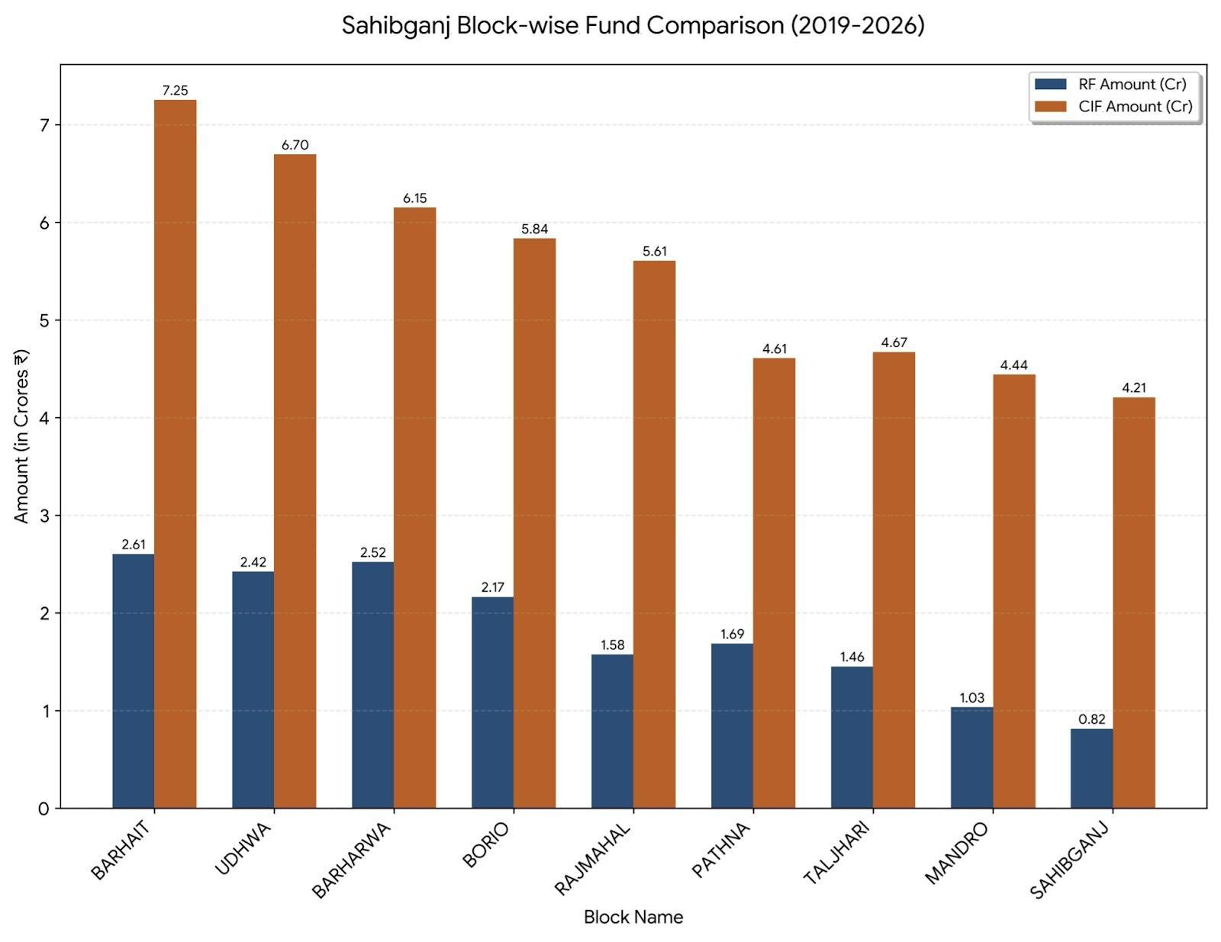
Figure 5: Sahibganj Block wise Fund Comparison (2019-26)

7.6 Non-Performing Assets Against Shgs⁵
From table 5, the total NPA amount in Sahebganj district has seen a significant upward trend over the last four financial years, rising from 63.50 Lakh in FY 2022-23 to a peak of 177.59 Lakh in FY 2024-25, before slightly stabilizing at 166.41 Lakh in FY 2025-26. While blocks like Mandro have experienced a sharp surge in defaults (climbing to 67.53 Lakh), others like Pathna and Barhait have shown remarkable recovery in the latest reporting period. Despite the increase in absolute NPA value, the district's overall credit health remains relatively stable at a 0.76% NPA ratio, as the total loan portfolio has simultaneously expanded from approximately 8,667 Lakh to over 21,963 Lakh as shown in figure 6.

Table 5: Year-wise Comparison of Outstanding Loans and Non-Performing Assets (NPA) (FY-2022-26)
Financial  year | Outstanding account | Outstanding amount (in lakh) | NPA account | NPA amount (in lakh) | NPA %  (By Amt)
2022-23 | 6642 | 8667.90 | 73 | 63.50 | 0.73%
2023-24 | 7275 | 13374.03 | 126 | 143.67 | 1.07%
2024-25 | 8039 | 18244.38 | 121 | 177.59 | 0.97%
2025-26 | 8532 | 21963.20 | 126 | 166.41 | 0.76%

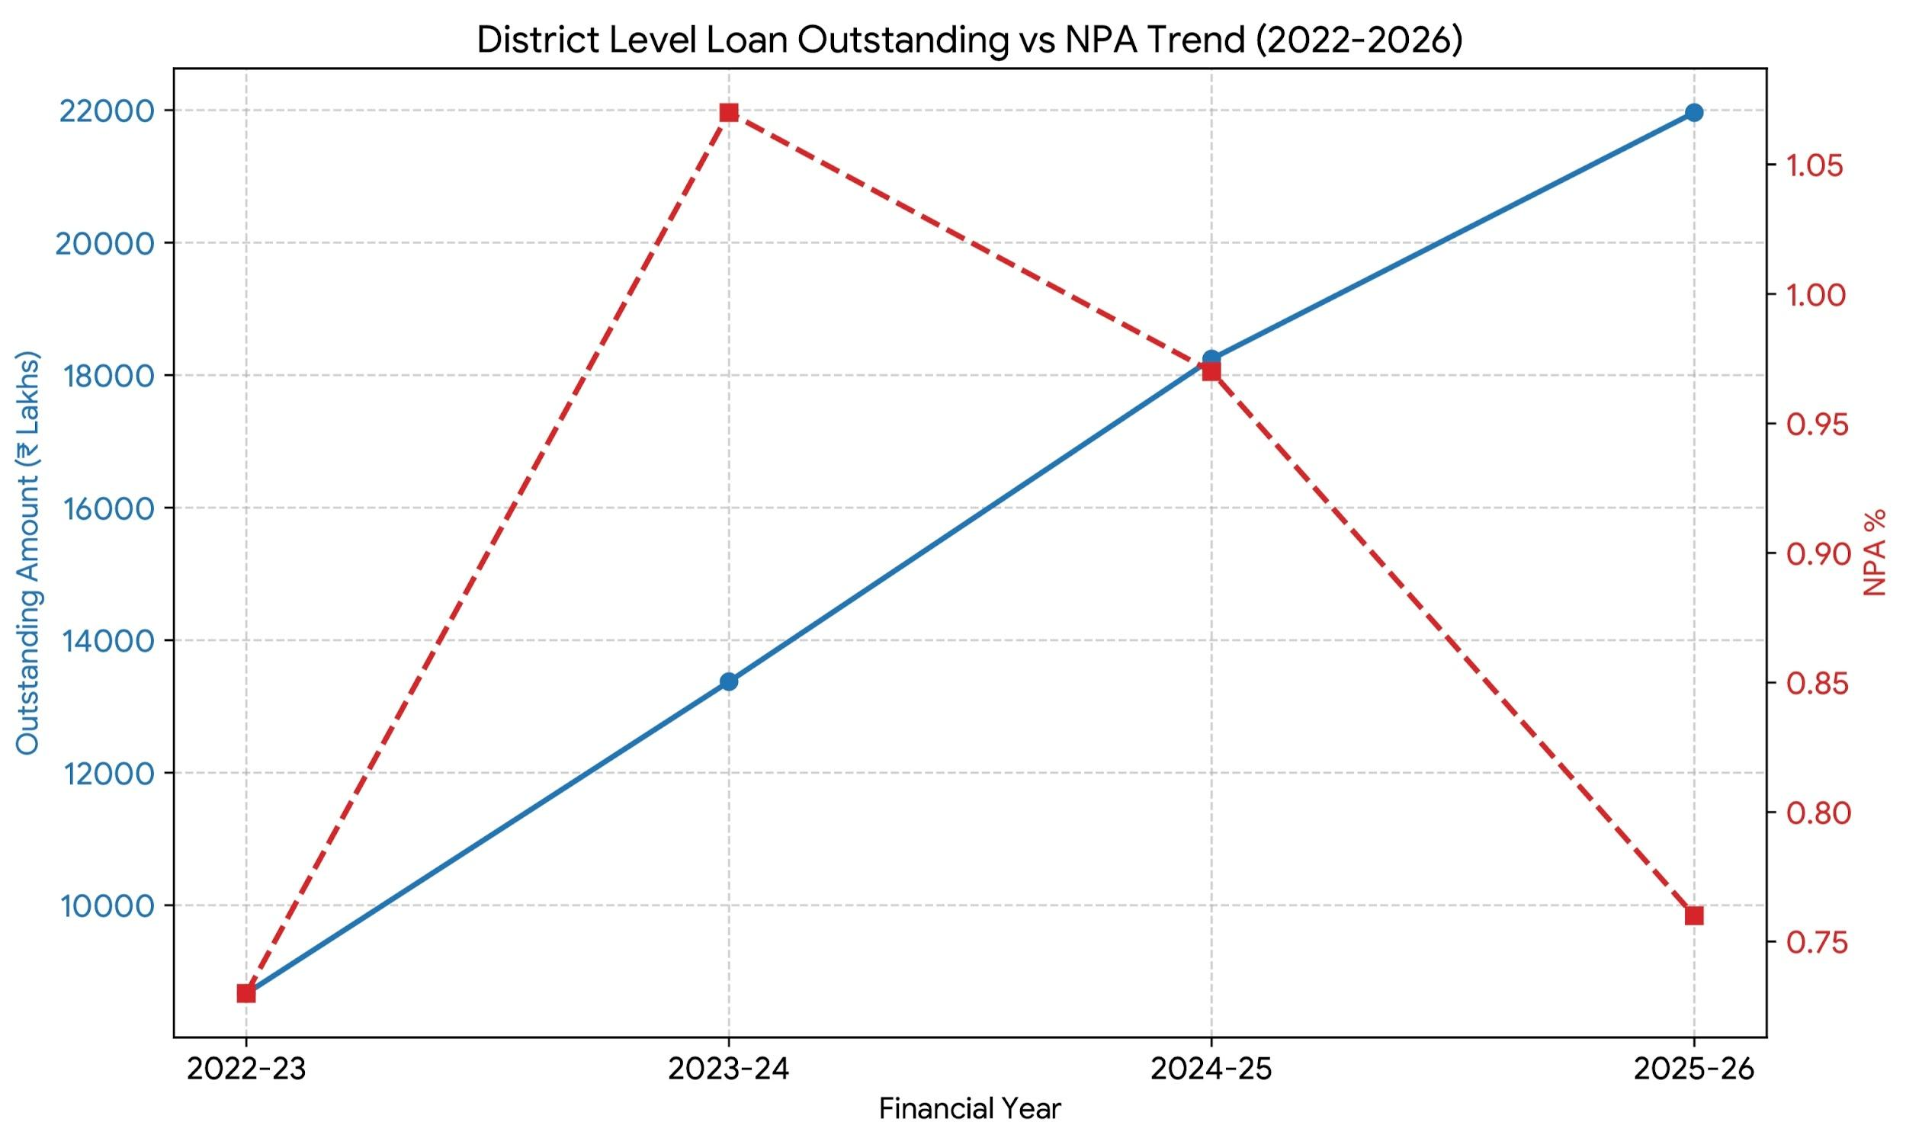
Figure 6: District level loan Outstanding Vs NPA Trend (2022-2026)

7.7 Jharkhand Economic Surveys Report (2023–25)²

7.7.1 Growth and Outreach of SHGs
The surveys reveal a paradoxical landscape of high institutional effort but low credit absorption in Sahibganj.

Institutional Saturation: Sahibganj is a focal point of the Targeted Financial Inclusion Intervention Programme (TFIIP), achieving a 94% success rate in PMJDY account targets. The district hosts 84 bank branches, with Public Sector Banks (PSBs) driving 64% of the outreach.
Infrastructure Gap: Despite the growth, rural infrastructure remains a bottleneck; only 42% of bank branches in the state are rural, and only 14% of ATMs are accessible in these areas. This has led to a heavy reliance on Banking Correspondents (BCs), which doubled in the region to over 83,000 by 2024.
The “Laggard” Challenge: While SHG formation is robust (part of the 2.91 lakh groups statewide), Sahibganj’s Credit-Deposit (CD) Ratio stands at 38.37%. This is significantly below the 60% RBI benchmark, suggesting that while SHGs are being formed and outreached, the formal banking system is not yet fully absorbing their credit potential.

7.7.2 Impact of Micro-credit on Economic Status (Income, Assets)
Micro-credit has shifted from a survival tool to an enterprise-building mechanism in the district.
Shift to MSME and Agriculture: State-wide credit to MSMEs (where most SHG enterprises operate) surged by 42% in a single year. However, Sahibganj achieved less than 70% of its Agricultural Credit Plan (ACP) targets, highlighting that SHGs are likely filling a critical gap where formal agricultural loans fail to reach.
Income Transformation: Comparative data shows a drastic reduction in “zero-income” women dropping from 42.85% to 2.85% post-SHG intervention. In Sahibganj, this is strengthened by diversified livelihoods like Lac cultivation and livestock, with community-led businesses generating crores in turnover.
Asset Creation: The synergy between SHG savings and government schemes is evident; Jharkhand’s 97.86% completion rate for rural housing (PMAY-G) far exceeds the national average, indicating that micro-credit is often used to supplement asset building.

7.7.3 Social Changes (Decision-making, Mobility) Among Women
The surveys categorize financial inclusion not just as an economic metric, but as a tool for “Social Recognition.”

Financial Autonomy: The share of bank advances specifically to women reached 14.7% in 2024 (nearly triple the 5% benchmark). This fiscal visibility directly correlates with increased household decision-making power.
Leadership and Collective Power: The transition of women from individual borrowers to stakeholders in 45 Farmer Producer Organizations (FPOs) and over 2,500 Producer Groups has enhanced their social mobility. In Sahibganj, women are now managing specialized units like Mustard and Lac processing mills, moving them from laborers to owners.
Financial Discipline: A key indicator of social responsibility and management skill is the 2.64% reduction in NPAs in Sahibganj (2022-23). This reflects high financial literacy and community-enforced discipline among women SHG members.

7.8 Sa-Dhan Bharat Microfinance Reports (2024 & 2025)¹

7.8.1 Evaluate the Growth and Outreach of SHGs and MFIs in Sahibganj
The district has moved from early-stage mobilization to a high-density institutional network, though it currently faces a phase of “cautious expansion”.
Institutional Density (2025): Sahibganj now hosts 14 Micro Lending Institutions (MLIs) and 3 specialized Banks/SFBs. Major players like Annapurna, CreditAccess, and Bandhan Bank have established deep rural footprints.
Outreach Contraction (2024–2025): Reflecting a state-wide trend in Jharkhand, loan accounts decreased by 13% (from 49.15 lakh to 42.64 lakh) as of March 2025. This indicates a shift from “quantity” to “quality,” where lenders are focusing on active, disciplined borrowers rather than rapid client acquisition.
Last-Mile Connectivity: The deployment of BC Sakhis (Banking Correspondent Sakhis) in Sahibganj has been pivotal. These local women bridge the gap where physical bank branches (only 42% rural statewide) cannot reach, ensuring that the "outreach" is not just on paper but functional at the doorstep.

7.8.2 Analyze the Impact of Micro-credit on Economic Status (Income, Assets)
Micro-credit is being redirected from consumption to productive asset creation, specifically through government-backed livelihood missions.
Average Financial Stake (2025): The average loan balance in Jharkhand stands at ₹26,145. While this is a slight dip from 2024, it reflects a “calibration” to prevent over-leveraging (capped at ₹2 lakh per household).
Income Transformation: The Lakhpati Didi Scheme is the primary driver for income growth in Sahibganj. By linking SHG members to climate-smart agriculture and micro-enterprises, the goal is to shift households from subsistence to an annual income of at least ₹1 lakh.
Asset Quality and Repayment: While bank reports show a specific NPA of 166.41 Lakh (FY 2025-26), the Sa-Dhan 2025 report notes that 91% of loans are now used specifically for income generation, ensuring that the credit taken creates a “paying asset” (like livestock or processing units) rather than just debt.

7.8.3 Assess Social Changes (Decision-making, Mobility) among Women
The most significant impact of microfinance in Sahibganj is the formalization of women’s roles in the rural economy.
From Borrowers to Entrepreneurs: The Sa-Dhan 2025 report emphasizes a shift toward Enterprise-Bank Linkages. In districts like Sahibganj, women are moving beyond small SHG loans to larger enterprise loans, which grants them higher status in domestic financial decision-making.
Digital and Physical Mobility: The use of BC Sakhis has empowered women with financial literacy at the doorstep. Women no longer need to travel long distances to banks, but they have gained the mobility to manage community-level funds and “Nookad Nataks” (awareness plays), increasing their social visibility and confidence.
Credit as a Tool for Resilience: By focusing on Emergency Healthcare and Microinsurance, micro-credit has provided women a “buffer” against shocks. This reduces their dependence on male family members or informal moneylenders during crises, fundamentally altering the power dynamics within the household.

8. Summary of Findings
Growth and Social Inclusion
The district of Sahibganj has witnessed a remarkable transformation in its social landscape, with the number of SHGs growing by over 75% between 2019 and 2026. This expansion is not just about numbers; it represents a deep commitment to reaching those who have been historically overlooked. Today, nearly two-thirds of the district's 12,559 groups are composed of members from marginalized communities, including 33.3% from Scheduled Tribes and 23.7% from Minority groups. While blocks like Barharwa and Udhwa have become the primary hubs for group formation, the movement has successfully penetrated every corner of the district, creating a massive institutional foundation for rural development.

Financial Evolution and Credit Health
Financially, the strategy has shifted from providing small “survival” loans to making significant investments in community potential. The district has prioritized the Community Investment Fund (CIF), which at ₹44.29 Cr is significantly higher than the standard Revolving Funds. This approach ensures that funding is directed where it is needed most, with blocks like Barhait receiving the highest disbursements based on localized poverty needs rather than just group volume. Most impressively, the district has maintained excellent financial discipline; even as the total loan portfolio surged to over ₹21,963 Lakh, the actual percentage of bad debt (NPAs) dropped to a healthy 0.76%, showcasing the high level of financial literacy among members.

Economic and Social Empowerment
The real-world impact of this movement is visible in the daily lives of women across Sahibganj. The number of women with no personal income has dropped from nearly 43% to less than 3% post-intervention, as micro-credit has evolved into a tool for building livestock businesses and processing mills. Beyond income, there has been a profound shift in social dynamics. With women now accounting for 14.7% of all bank advances, they are gaining substantial influence over household financial decisions and moving into leadership roles within Producer Organizations. While challenges like rural infrastructure gaps remain, the rise of “BC Sakhis” has ensured that financial services are now accessible right at the village doorstep.

9.Conclusion
Sahibganj has successfully moved past the initial phase of simply forming groups and has entered a more mature stage where SHGs act as engines for real economic change. The district has achieved a high level of “institutional saturation”, meaning the network is now dense enough to reach almost every corner of the community. However, there is a visible “credit gap” in the formal banking system; while the groups are organized and ready, the local Credit-Deposit ratio of 38.37% suggests that banks are not yet fully tapping into the potential of these rural enterprises.
Despite these infrastructure hurdles, the program has proven to be a powerful tool for social change. By shifting the focus from small “survival” loans to larger community investments, the district has empowered women to move from being individual borrowers to becoming owners of businesses like mustard and lac processing mills. The high repayment discipline highlighted by a low 0.76% NPA ratio demonstrates that the women of Sahibganj are not just participating in the program, but are managing it with professional-grade financial responsibility.

10. Suggestions
- Upgrade from Micro-loans to Macro-enterprises: Banks should be encouraged to move beyond small, one-off loans and instead offer larger “Enterprise-Bank Linkage” packages for mature groups that are ready to scale up their production.
- Invest in “Hard” Rural Infrastructure: While the “BC Sakhi’ model has been a brilliant workaround for rural banking, the district still needs better physical infrastructure, specifically more rural ATMs, and more accessible bank branches to support growing businesses.
- Provide Specialized Support for “Slow-Growth” Areas: Blocks like Mandro and Sahibganj, which have shown flatter growth curves or higher default rates, should receive targeted financial literacy training and closer mentorship to help them catch up with high-performing blocks like Barhait.
- Turn Producers into Market Leaders: To truly boost incomes, the district should continue helping women move further up the supply chain. Instead of just producing raw materials, SHGs should be supported in owning the processing and branding of goods through Farmer Producer Organizations (FPOs).
- Maintain a “Quality First” Approach: As the district reaches its mobilization targets, the focus should shift from forming new groups to ensuring the existing 12,559 groups remain active, disciplined, and linked to modern markets.

11. Limitations of the Study
This study is mainly limited by its use of secondary data from government and institutional reports, which means it depends on the accuracy and timing of those existing records. Because the 2011 Census is the last official primary source available, some demographic information (like literacy rates) may not reflect the most recent changes. Additionally, while the research provides a clear "big picture" of the district’s growth, it may not capture the day-to-day personal experiences of every household in the remote areas of the Rajmahal Hills.

Reference
1. Sa-Dhan https://share.google/DpbvGH9VptCFFh6fM

2.Finance Department Govt. of Jharkhand https://share.google/4Z8Yqod4nlhWMpYQ2

3. NRLM https://share.google/IZZGIdFvy5emZygSm

4. (JSLPS)https://share.google/C082lP5E9BFvm3tz7

5. NRLM Bank Linkage https://share.google/TQBNNY5ORN022opca

6. Sahibganj https://share.google/Z8AclBs0cci5l2k4P

7. Pradeep, M. D., & Rakshitha Rai, R. P. (2016). Women Empowerment through Self Help Groups-Interventions towards Socio-Economic Welfare. International Journal of Management, IT & Engineering, 6(1), 424-441.

8. ALLEVIATION, T. P. (2017). Impact of microfinance on women empowerment through poverty alleviation: An assessment of socio-economic conditions in Chennai city of Tamil Nadu. Asian Journal for Poverty Studies, 3(2), 175-183.

9. Khan, S. T., Bhat, M. A., & Sangmi, M. U. D. (2023). Impact of microfinance on economic, social, political and psychological empowerment: Evidence from women’s self-help groups in Kashmir Valley, India. FIIB Business Review, 12(1), 58-73.

10.Mahalakshmi, S. (2024). Impact of microfinance institution on socio economic development of India. International Journal of Creative Research Thoughts (IJCRT), 12(8), a277–a285

