SHORT TERM EFFECT OF MAGNESIUM SULPHATE ON THE COMPRESSIVE STRENGTH OF SUPERPLASTICIZED LATERIZED CONCRETE
*Olusola J.Aª, Afuye I.Tª,
ª Department of Building, Bamidele Olumilua University of Education, Science and Technology, Ikere-Ekiti, Ekiti State, Nigeria.
*Corresponding author
Email: olusola.joseph@bouesti.edu.ng; +2347039105303
Abstract
This study investigated the short term effect of magnesium sulphate on the compressive strength of plasticized laterized concrete with a view to establishing its suitablility in aggressive environment. It examined the effect of magnesium sulphate on varying Laterite contents with a constant water-cement ratio on the compressive strength of laterized content. The percentage replacement of laterite as substitute in fine aggregate were varied in the increment of 0%, 20% and 30% respectively. All cubes were cast and cured in water for 7, 14, 28 days respectively. The cast plasticized laterite concrete cube size is 100x100x100mm which were crushed using compression testing machine. During its preparation, Superplasticizer were added for easy workability i.e that the concrete might flow. Part of the cubes were transferred to magnesium sulphate concentrate solution of 1% and 3% after 28days of curing in water for another 28 days making 56 days. It was discovered that the concrete cube decreases in strength when exposed to varying percentages of magnesium sulphate solution. The study concluded that plasticized Laterite concrete is not suitable for use in magnesium sulphate concentrate environment.
Key words: Laterized Concrete, Magnesium sulphate, superplasticizer.

INTRODUCTION
Materials as a constructional resource and a crucial factor of production constitute a major percentage of cost on any construction work. The cost of building materials continues to increase as the majority of the population continues to fall below the poverty line. It is of great importance to look and consider ways on how the cost of the widely accepted conventional materials such as cement, steel, sand, granite, gravel and wood can be reduced to affordable level without compromising standards. In an attempt to search and give this a solution, the use of readily available local materials or alternative materials suitable for the production of any component of a building were sourced for and developed. Alternative materials must offer more benefits than the conventional materials or system they replace. They must reduce costs, increase design flexibility, enhance sustainability, perform multiple functions, have superior performance characteristics, or meet a market niche (Venkatarama Reddy, 2004). Researching into the use of alternative materials is to develop new materials that can serve multiple functions, increase cost-effectiveness and efficiency, and using more sustainable materials.
The first published work on laterized concrete, according to osunade (2002a) and salau (2003), appears to have been by adepegba (1975a) study in which the strength properties of normal concrete were compared with those of laterized concrete. The conclusion of that study was that a concrete in which laterite fines are used instead of sand, can be used as a structural material in place of normal concrete. In another study, balogun (1982) discovered that the most suitable mix of laterized concrete for structural purposes is (1:11/2:3) with a water/cement ratio of ratio 0.65, provided that the laterite content is kept below 50 percent. According to udoeyo et al., (2006), strength performance of laterized concrete is generally affected but the replacement level of sand and the mix richness. In all the recast, besides Lasisi et al. (1990), attentions have not been focused on long term durability performance of laterized concrete with superplasticizer. Further works are needed to be carried out to complement and ascertain the veracity of their findings. This study therefore intends to study sulphate attack on laterized concrete with superplasticizer.

MATERIALS AND METHODS
The type of cement for the experiment was Limestone Portland Cement (LPC Dangote Brand) which conforms with the requirements in ASTM C150 (2005). The sand, laterite and granite were also purchased from a local supplier in ile-ife, Osun state. The equipment used include wheel barrow, weighing balance, shovel, hand trowel, head pan, bucket, moulds (100mm x 100mm cubes), tamping rod, spade, curing tanks, curing tanks, curing rubbers, moulds oil, watering cans, mechanical sieves of varying standard sizes, compressive strength testing machine. Granite stone of 20mm maximum size was used as coarse aggregate. Potable water free from impurities was used in carrying out the experiment. The water-cement ratio used for the study was 0.65.
Production of Concrete Cubes
The moulds (100 x 100 x 100) mm were used in casting the concrete cubes. The specimens were made by mixing the constituent aggregates with varying percentage replacement of sand with laterite and addition of superplastisizer to enhance the workability of the concrete as shown in table 1. The concrete cubes were cured in water for 28 days. The water absorption rate was determined after 28 days curing age.
Table 1: Laterized concrete samples
Laterite (%) | Sand (%) | Water-cement ratio | Superplasticizer (Kg) | No of cubes
0 | 100 | 0.65 | 0 | 12
20 | 80 | 0.65 | 0.1 | 12
30 | 70 | 0.65 | 0.2 | 12

RESULTS AND DISCUSSION
The result of the residual compressive strength of laterized superplasticized concrete cubes subjected to three regimes of exposure at 0%, 1%, and 3% concentrate of magnesium sulphate solution (after twenty-eight days of full immersion curing in water at ambient temperature ) for a period of 56 days are present in Tables 2 and Figures 1 to 3.
It should be noted that all specimens were exposed to the test solutions after initial 28 days curing in water at ambient temperature. According to Ata (2012) based on his results, the immersion in magnesium sulphate solution initially resulted in a slight increase in compressive strength. Though in all cases, specimens continuously stored in water exhibited increasing compressive strength. This decrease in residual compressive strength of specimens exposed to sulphate solution, according to brown and Tina (2000), occurs as result of the pore space in the concrete specimen losing its capacity to accommodate additional amounts of ettringite, therefore leading to generation of potential damaging expansion forces within the concrete specimens. This explains the reason for subsequent reduction in strength as seen in Table 2. Also increase in laterite content and in sulphate concentration leads to a continual decrease of compressive strength of laterized concrete and the compressive strength of control volume reduces only at exposure to sulphate environment.
Table 2: Residual Compressive strength of laterized superplasticized concrete samples exposed to Magnesium Sulphate concentrate solution at different curing ages.
Percentage Replacement of sand(%) with laterite | Superplasticizer (Kg) | Curing Age (Days) | Compressive strength (KN/mm²) @ 0% MgSO₄ | Compressive strength (KN/mm²) @ 1% MgSO₄ | Compressive strength (KN/mm²) @ 3% MgSO₄
0% | 0 | 7  14  28  35  42  56 | 14.17  16.17  18.50  20.33  22.83  25.00 | 17.67  16.33  15.33 | 17.00  15.00  13.33
20% | 0.1 | 7  14  28  35  42  56 | 8.83  10.17  14.33  15.50  16.33  18.33 | 13.83  12.83  10.33 | 17.00  15.00  13.33
30% | 0.2 | 7  14  28  35  42  56 | 6.00  8.50  9.83  10.50  11.33  13.50 | 9.67  9.00  8.00 | 9.00  7.67  6.50

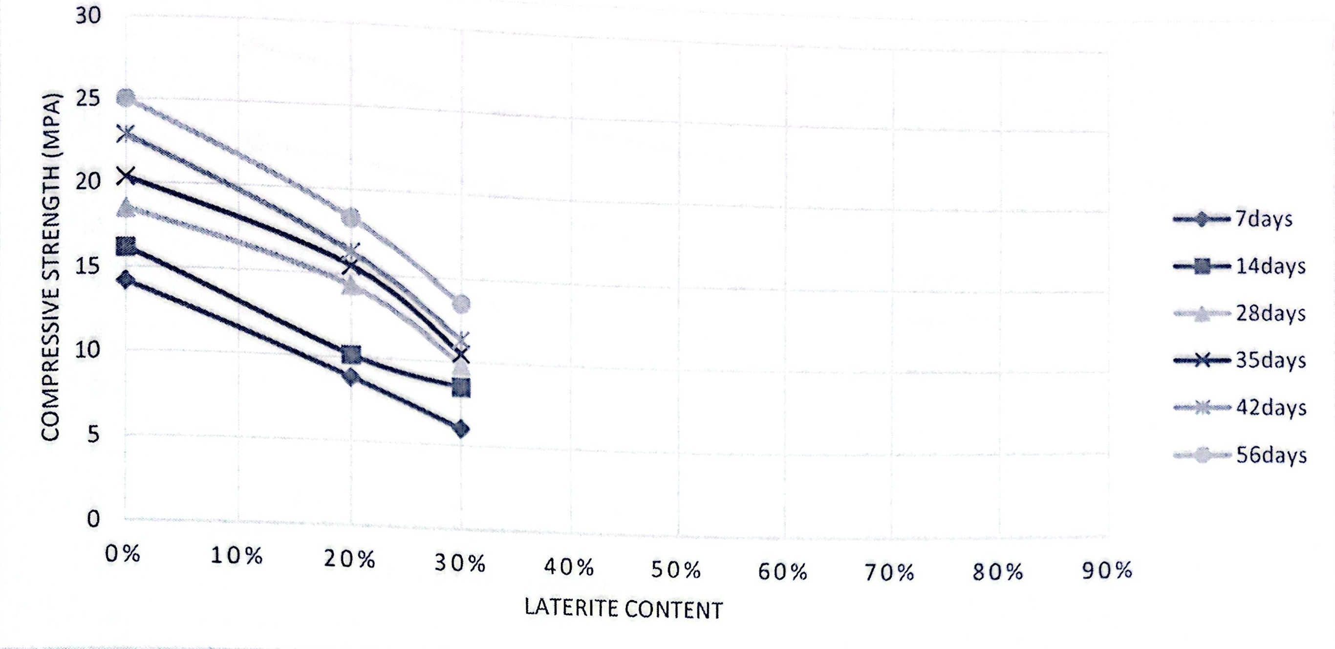
Figure 1: Effect of Laterite content on compressive strength of laterized plasticized concrete.
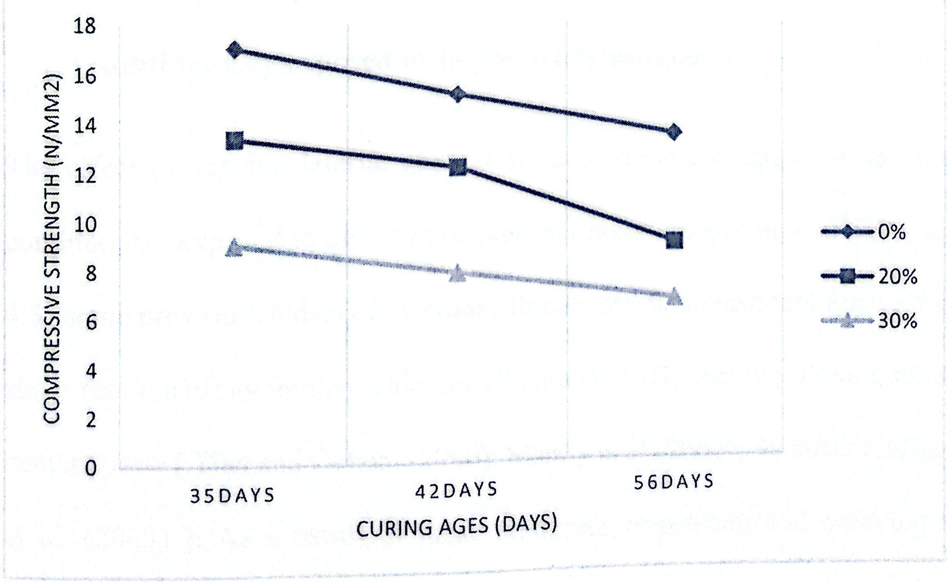
Figure 2 Residual compressive strength of laterized superplasticized concrete exposed to 1% magnesium sulphate concentrate solution.
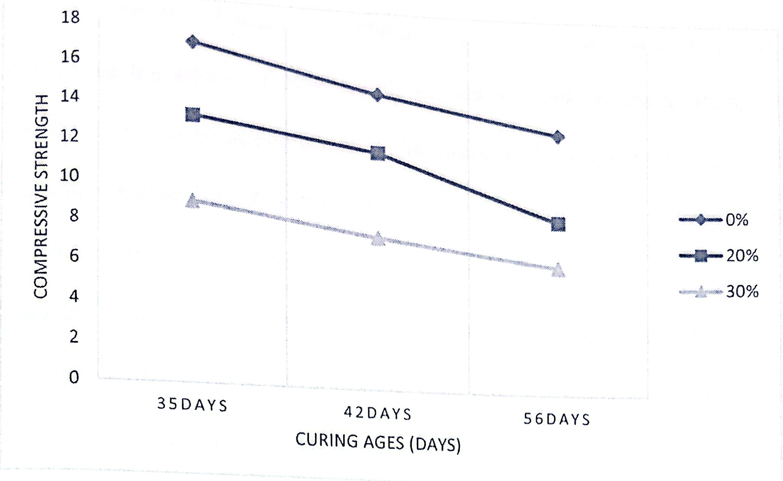
Figure 3: Residual compressive strength of laterized superplasticized concrete exposed to 3% magnesium sulphate concentrate solution.
CONCLUSION
The level of concentration of the sulphate solution influenced the rate of attack on laterized superplasticized concrete. The higher the concentration the faster the rate of attack. Also the higher the percentage laterite content, the faster the rate of sulphate attack in laterized superplasticized concrete.
REFERENCES
- Adepegba, D. (1975a). A comparative study of normal concrete with concrete which contained laterite instead of sand. Building Science, 10(2), 135–141. https://doi.org/10.1016/0007-3628(75)90029-8
- Adepegba, D. (1975b). The effect of water content on the compressive strength of laterized concrete. Journal of Testing and Evaluation, 3, 449–453.
- Akpinar, P. (2010). A combined study of expansive and tensile strength evolution of mortars under sulphate attack: Implications for durability assessment. Materiales de Construcción, 60, 59–68.
- Ata, O. (2007). Effects of varying curing age and water–cement ratio on the elastic properties of laterized concrete. Civil Engineering Dimension, 9(2), 85–89.
- Balogun, L. A. (1982). Effect of varying sand content in laterized concrete. International Journal of Cement Composites and Lightweight Concrete, 4(4), 235–241.
- Lasisi, F., & Osunade, J. A. (1990). Short-term studies on the durability of laterized concrete and lateritic-cement mortars. Building and Environment, 25(1), 77–83.
- Neville, A. (2004). The confused world of sulfate attack on concrete. Cement and Concrete Research, 34, 1275–1296.
- Tian, B. (2000). Does gypsum formation during sulfate attack on concrete lead to expansion? Cement and Concrete Research, 30, 117–123.

