AI-Based Sales Forecasting Model for Digital Marketing

Siddhartha Negi¹, Vinita Tomar²*, Tarunim Sharma³, Ankush Kumar⁴
^{1,2,3,4}Maharaja Surajmal Institute, New Delhi, India
* Correspondance ²vinitatomar@msijanakpuri.com

ABSTRACT:
In today’s competitive marketplace, accurately forecasting sales is crucial for business success. This article explores how artificial intelligence (AI) can transform digital marketing by utilizing advanced IT systems to collect and analyze customer feedback, providing valuable insights into consumer preferences and behaviors. The proposed method combines Support Vector Machines (SVMs) and Artificial Neural Networks (ANNs) to identify potential customers and uncover meaningful patterns in feedback. By integrating machine learning techniques, businesses can make data-driven decisions to refine marketing strategies, improve customer targeting, and personalize communication. This AI-powered approach enhances marketing performance by enabling more effective promotional strategies and better customer engagement, ultimately improving competitive positioning. By leveraging AI algorithms like SVMs and ANNs, companies can discover hidden patterns within large datasets, leading to better decision-making and increased customer satisfaction. The result is improved marketing efficiency and the ability to thrive in a more competitive environment, driving growth and fostering long-term success.
Keywords: Machine Learning, Support Vector Machines, Sales Prediction, Digital Marketing

- INTRODUCTION:
Sales forecasting is crucial for businesses to manage inventory and resources effectively. Traditional methods like moving averages and autoregressive models struggle with complex, high-dimensional data. Cantón Croda et al. [1] showed that artificial neural networks (ANNs) can capture intricate patterns in sales data, while Support Vector Machines (SVMs) efficiently handle non-linear relationships and high-dimensional data. SVM’s use of kernel functions allows it to model complex factors like seasonality, consumer behavior, and economic trends, making it ideal for sales prediction. Studies by Biswas et al. [2] and Ahmed et al. [3] demonstrate how machine learning models enhance sales forecasting and inventory management.
This research investigates the use of SVM for sales forecasting, comparing it to traditional models and other machine learning approaches. The study focuses on optimizing SVM parameters, exploring kernel functions, and assessing feature selection to improve model accuracy. By addressing challenges like kernel selection and hyperparameter tuning, the research aims to provide a scalable, reliable forecasting model to help businesses make informed decisions and gain a competitive edge in dynamic markets.

- LITERATURE REVIEW:
AI is transforming organizational functions, particularly in recruitment, employee upskilling, business operations, and customer engagement. In recruitment, Rathore [5] highlights how AI streamlines candidate screening and matching, reducing hiring time and costs, though more research is needed on the challenges faced by HR professionals and candidates. In employee upskilling, Jaiswal et al. [6] argue that as AI automates routine tasks, employees must develop skills like data analysis and continuous learning to complement AI workflows, though these findings may not apply universally. AI is also optimizing business operations, as Soni et al. [4] show how AI improves decision-making and predictive analytics, although challenges like integration and employee adaptation remain. Additionally, Ahmed et al. [3] explore how AI-powered sentiment analysis refines marketing strategies by analyzing customer preferences, though more empirical research is needed.
AI is also revolutionizing export sales forecasting, with Sohrabpour et al. [7] demonstrating how Genetic Programming (GP) enables nuanced predictions beyond historical data, though its high computational demand limits its applicability. In AI-worker coexistence, Zirar et al. [8] discuss job security concerns and the need for upskilling, emphasizing the importance of transparent AI adoption. Biswas et al. [2] show how AI-based sales forecasting using Artificial Neural Networks (ANNs) improves sales predictions, though its reliance on a single product category limits generalizability. Kasem et al. [9] demonstrate that AI applications in customer profiling and segmentation enhance marketing strategies but may oversimplify customer behaviors. Jasmin Bharadiya [10] examines how the integration of AI in business intelligence (BI) enhances predictive analytics, customer service, and ethical decision-making, fostering agile operations. Lastly, Cantón Croda et al. [1] show that ANNs can forecast sales effectively even with limited data, outperforming traditional methods in small datasets.

Author(s)
  Summary
  Shortcomings
Rathore (2023) | Explores the role of AI in recruitment and selection, highlighting its ability to streamline candidate screening, matching, and engagement, reducing hiring time and costs. | Limited empirical research on the practical challenges and perceptions of AI among HR professionals and candidates.
Jaiswal et al (2021) | Analyzes the need for employee upskilling in AI-enabled workplaces, identifying essential skills like data analysis, digital literacy, and continuous learning. | Findings are based on India's IT sector and may not apply universally across industries or geographic regions.
Soni et al (2020) | Examines AI’s role in improving decision-making, predictive analytics, and operational efficiency, with insights into AI commercialization trends. | Lacks detailed analysis of organizational challenges in AI deployment, such as integration and employee adaptation.
Ahmed et al (2022) | Investigates AI-powered sentiment analysis for enhancing customer engagement and marketing strategies using natural language processing and machine learning. | The research is largely theoretical and lacks empirical case studies addressing challenges like data quality and sentiment interpretation in diverse segments.
Sohrabpour et al (2021) | Proposes a genetic programming framework for export sales forecasting, emphasizing external factors and variable correlations for nuanced predictions in volatile markets. | High computational power requirements and limited applicability outside specific case studies and industries.
Zirar et al (2023) |  | Based on short-term studies, with limited empirical validation of AI’s long-term impact on workplace dynamics.
  Addresses AI’s integration in workplaces, focusing on worker distrust, augmentation of human skills, and the need for continuous upskilling.
Biswas et al (2022) | Utilizes artificial neural networks (ANNs) to improve sales forecasting accuracy in e-commerce, specifically for mobile phone sales. | Limited to a single product category and dataset, raising concerns about versatility and potential biases.
Kasem et al (2023) | Investigates AI in customer profiling using RFM analysis and clustering algorithms to enhance targeted marketing and engagement. | Intensive data requirements and oversimplification of customer behavior due to reliance on clustering techniques.
Bharadiya (2023) | Highlights AI’s impact on business intelligence (BI), emphasizing predictive analytics, chatbots, and explainable AI for better decision-making and customer service. | Focuses on benefits but provides limited discussion on practical challenges like implementation and operational hurdles.
Cantón Croda (2018) | Demonstrates the use of ANNs for accurate sales forecasting with limited historical data, outperforming traditional methods like moving averages. | Limited dataset (12 months) and specific industry context (chemical company in Mexico), raising questions about broader applicability.

- METHODOLOGY:
The number of e-commerce consumers is steadily increasing, and customer reviews have emerged as a valuable source of information. The primary objective of this research is to comprehend the current demand and acceptance of specific e-commerce products. The authors employed the SVM feature within SPSS to analyze customer reviews. This research primarily focuses on investigating the impact of positive and negative feedback on sales outcomes.
- Data Collection and Preprocessing:
We gathered data from relevant sources, such as customer feedback, purchase histories, and market trend. Then we cleaned this data to handle missing values, outliers, and inconsistencies, and ensured that it is normalized or standardized for SVM.
- Feature Selection and Extraction:
The identification of relevant features influencing sales is done. For SVM-based models, feature engineering might be necessary to ensure that only significant variables influencing sales are included, improving model efficiency and accuracy.
- Model Training with SVM:
Configure an SVM model to classify sales trends or regression analysis for sales prediction. The data would be divided into training and testing sets, and SVM parameters (such as kernel type, regularization parameter, and margin parameters) would be optimized to enhance predictive accuracy.
- Model Validation and Evaluation:
The trained SVM model would be validated using metrics like Mean Squared Error (MSE), Mean Absolute Error (MAE), or accuracy, depending on the specific sales forecasting objectives. Cross-validation can be used to ensure model robustness.
- Mean Absolute Error (MAE):
MAE is the average of the absolute differences between the actual and the predicted values. It measures the average magnitude of errors in a set of predictions, without taking into consideration their direction.
Formula:
$$MAE= \sum_{i=1}^{n}{\left|\frac{y_{i}- x_{i}}{n}\right|}$$
where:
MAE = mean absolute error
y_{i} = prediction
x_{i} = true value
n = total number of data points
A lower MAE value indicates better model performance. It is especially useful for understanding the typical size of errors in predictions. Unlike squared metrics, MAE is less sensitive to outliers.
- Mean Squared Error (MSE):
The average of the squared discrepancies between actual and anticipated values is determined by MSE. It is helpful when large errors are especially undesired since it penalizes larger errors more severely than smaller ones by squaring the errors.
Formula:
$$MSE=\frac{1}{n}\sum_{i=1}^{n}{{\left(Y_{i}- \hat{Y_{i}}\right)}^{2}}$$
where:
MSE = mean squared error
n = number of data points
Y_{i} = observed values
$$\hat{Y_{i}}=predicted values$$
A lower MSE indicates a better model. MSE emphasizes larger errors, so it can be useful when you want to heavily penalize larger discrepancies between actual and predicted values. However, the value can be harder to interpret directly as it is in squared units of the output variable.
- Root Mean Squared Error (RMSE):
RMSE is the square root of MSE and brings the error metric back to the same units as the actual and predicted values, making it more interpretable in context.
Formula:
$$RMSD= \sqrt{\frac{\sum_{i=1}^{N}{{\left(x_{i}- {\hat{x}}_{i}\right)}^{2}}}{N}}$$
where:
RMSD = root mean square deviation
N = number of non-missing data points
x_{i} = actual observations time series
$${\hat{x}}_{i}=estimated time series$$
Lower RMSE values indicate better fit. RMSE is sensitive to outliers due to the squaring of errors, but it provides an interpretable scale for the model error by being in the same units as the original output variable.
- R-squared (R²) Score:
R2 quantifies the percentage of the dependent variable's variance that can be predicted based on the independent variables. In essence, it measures how effectively the forecasts account for the actual data's variability.
Formula:
$$R^{2}=1- \frac{RSS}{TSS}$$
where:
R² = coefficient of determination
RSS = sum of squares of residuals
TSS = total sum of squares
R² ranges from 0 to 1. An R² of 1 means the model perfectly explains the variability of the data, while an R² of 0 means it does not explain any variability beyond the mean of the data. Negative values of R² can occur when the model performs worse than simply using the mean as a predictor.

- ANALYSIS:
4.1 Experimental Settings:
The model is trained using customer feedback and sales data from platforms like Amazon and Snapdeal, with preprocessing to handle outliers, missing values, and standardize variables. Features such as reviews, ratings, and product attributes are selected to predict demand and sales.
A Support Vector Machine (SVM) model is used for sales prediction, with key parameters tuned for accuracy. The dataset is split for training and testing, with cross-validation ensuring generalization. Hyperparameter optimization further improves prediction accuracy.
4.2 Experimental Results:
The model demonstrates high accuracy in sales forecasting, with low error metrics: Mean Squared Error (MSE) of 0.13, Mean Absolute Error (MAE) of 0.29, and Root Mean Squared Error (RMSE) of 0.36. The R2 score of 0.99 shows that it explains 99% of the variance in sales data, highlighting its reliability and effectiveness for real-world use.
Table 1 below shows the performance metrics of the Machine Learning Model.

Table 1: Performance Metrics
Proposed Model | Algorithm used | Mean Absolute Error (%) | Mean Squared  Error (%) | Root Mean Squared  Error (%) | R² Score (%)
AI Based Sales Forecasting Model For Digital Marketing | Support Vector Machines (SVM) | 29 | 13 | 36 | 99

Figure 1 shows the scatter plot that compares the predicted sales values against the actual sales data. Points lying close to the 45-degree diagonal line indicate high predictive accuracy. In this case, the points cluster tightly around the diagonal, confirming the model's strong alignment between predictions and actual outcomes
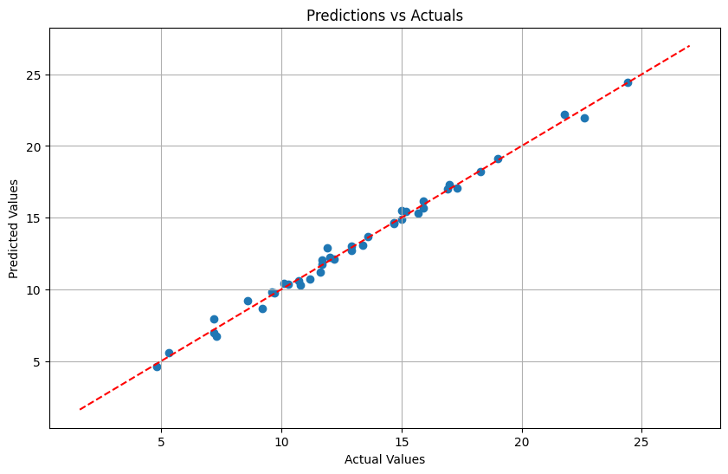
Figure 1: Scatter Plot
Figure 2 illustrates a random distribution around the horizontal axis (residual = 0) in the residual plot, which indicates the difference between the expected and actual values (residuals) against the predicted values. Since there are no obvious patterns that point to the absence of underfitting or overfitting, this randomness shows that the model does not show systematic bias in its predictions.

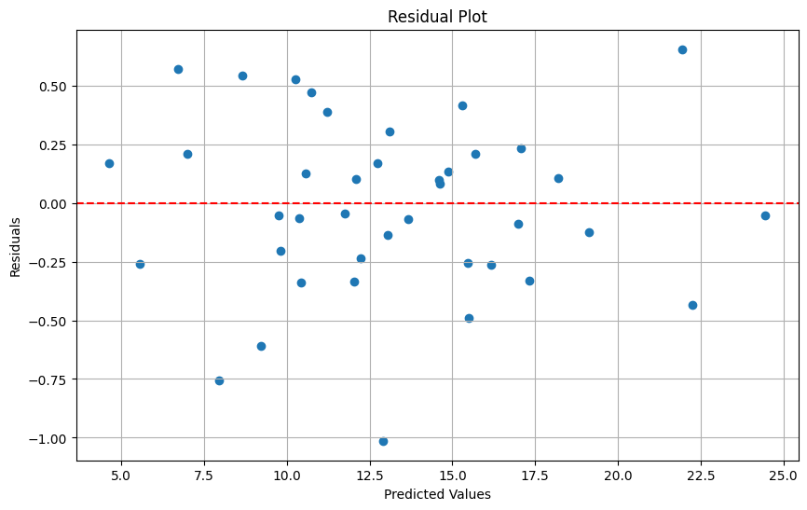
Figure 2: Residual Plot
In Figure 3 the histogram of residuals illustrates the distribution of errors. In this case, the residuals form a bell-shaped curve centered around zero, suggesting that errors are normally distributed. This normality assumption is crucial for many statistical evaluations and further supports the robustness of the model.
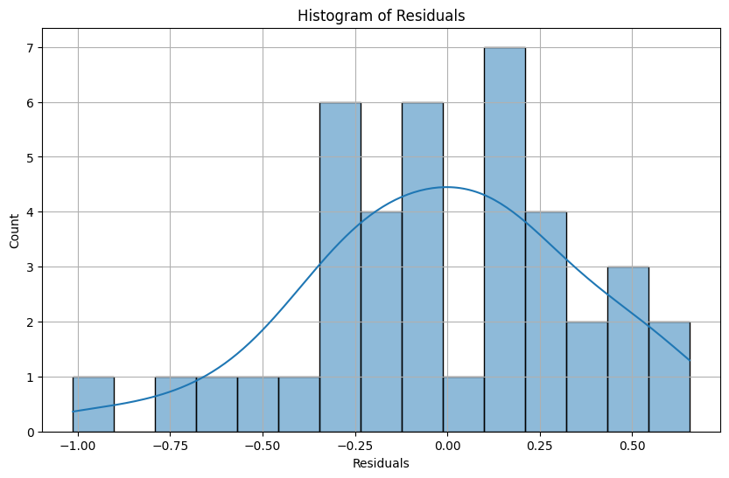
Figure 3: Histogram

Figure 4 shows the quantile-quantile (Q-Q) plot that compares the distribution of residuals to a theoretical normal distribution. The points fall closely along the reference line, indicating that the residuals closely follow a normal distribution.
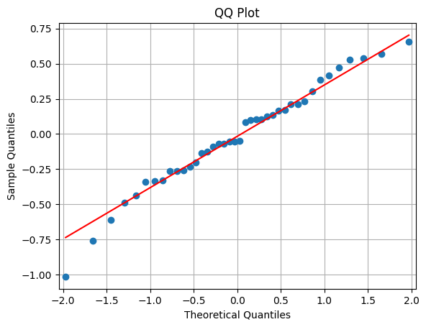
Figure 4: QQ Plot
Figure 5, the learning curve demonstrates the model's training and validation errors as a function of training sample size. Initially, as the sample size increases, both errors decrease, showing improved generalization. Beyond a certain sample size, the validation error stabilizes at a low level, confirming that the model effectively learns patterns in the data without overfitting. The low gap between training and validation errors highlights the model's balanced performance.
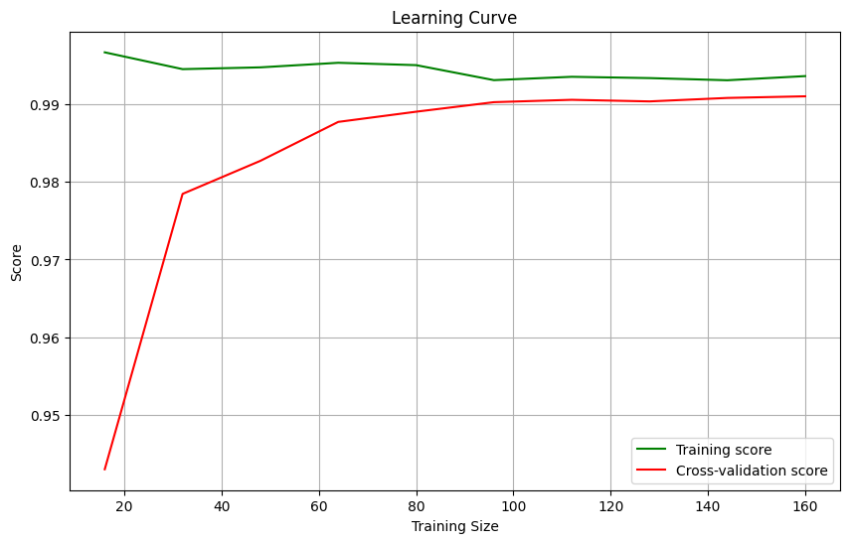
Figure 5: Learning Curve

- Conclusion and Future Scope:

This research highlights the effectiveness of AI, particularly Support Vector Machine (SVM) and Neural Network models, in accurate sales forecasting for digital marketing. The model demonstrated high precision with low error metrics (MSE: 0.13, MAE: 0.29, RMSE: 0.36, R2: 0.99), proving its ability to capture complex sales data patterns. It outperforms traditional forecasting methods by handling nonlinear relationships in customer feedback and demand, offering valuable insights for strategic decision-making in inventory and marketing. Future research could expand the model’s applicability across industries, integrate more data sources, and explore real-time predictions, while combining SVM with other techniques for improved accuracy and scalability in e-commerce applications.
- References:
- Cantón Croda, R. M., Gibaja Romero, D. E., & Caballero Morales, S. O. (2018). Sales Prediction through Neural Networks for a Small Dataset. International Journal of Interactive Multimedia and Artificial Intelligence, 5(4), 35-40.
- Biswas, B., Sanyal, M. K., & Mukherjee, T. (2022). AI-Based sales forecasting model for digital marketing. International Journal of E-Business Research, 19(1), 1-14.
- Ahmed, A. A. A., Agarwal, S., Kurniawan, I. M. G. A., Anantadjaya, S. P. D., & Krishnan, C. (2022). Business boosting through sentiment analysis using artificial intelligence approach. International Journal of System Assurance Engineering and Management, 13(Suppl. 1), S699-S709.
- Soni, N., Sharma, E. K., Singh, N., & Kapoor, A. (2020). Artificial intelligence in business: From research and innovation to market deployment. Procedia Computer Science, 167, 2200-2210.
- Rathore, S. P. S. (2023). The impact of AI on recruitment and selection processes: Analyzing the role of AI in automating and enhancing recruitment and selection procedures. International Journal For Global Academic & Scientific Research, 2(2), 51-63.
- Jaiswal, A., Arun, C. J., & Varma, A. (2021). Rebooting employees: Upskilling for artificial intelligence in multinational corporations. Artificial Intelligence and International HRM: Challenges, Opportunities and a Research Agenda.
- Sohrabpour, V., Oghazi, P., Toorajipour, R., & Nazarpour, A. (2021). Export sales forecasting using artificial intelligence. Technological Forecasting & Social Change, 163, 120480.
- Zirar, A., Ali, S. I., & Islam, N. (2023). Worker and workplace Artificial Intelligence (AI) coexistence: Emerging themes and research agenda. Technovation, 124, 102747.
- Kasem, M. S., Hamada, M., & Taj-Eddin, I. (2023). Customer profiling, segmentation, and sales prediction using AI in direct marketing. Neural Computing and Applications, 36, 4995-5005.
- Bharadiya, J. (2023). Machine Learning and AI in Business Intelligence: Trends and Opportunities. International Journal of Computer, 48(1), 123-134.

