Adaptive Use of Recreational Pool Infrastructure: A Case for Enhancing Flexibility in Aquatic Recreational Centers in Obio/Akpor.
ANAH Chioma Rosemary¹, OHOCHUKU Chinwennwo Phillips¹, DIMKPA Kelechukwu¹
¹Department of Architecture, Rivers State University, Port Harcourt, Nigeria
*Corresponding author: ANAH Chioma Rosemary¹ (chioma.anah@ust.edu.ng)
ABSTRACT
Aquatic recreational centers are often designed as a single-purpose, event-driven infrastructure. These host many events, mostly for aquatic recreation. Within the aquatic recreational centers, there is also the pool infrastructure, which is the key focus of this study. The monofunctional design often leads to underutilization; therefore, there was a need for this study to find these adaptive strategies to make these facilities useful throughout their lifespan. This study critically examined the potential of applying adaptive strategies to enhance the functional flexibility of pool infrastructure within Obio/Akpor. The study was guided by two objectives: to examine adaptive strategies that can be integrated into recreational pool structures and to determine architectural design strategies that enable a single pool infrastructure to serve multiple users. A qualitative-method design was employed through literature review, case study analysis of existing aquatic recreational centers, and assessment of conceptual materials. Findings revealed that modular design elements, movable bulkheads, adjustable pool floors, reconfigurable deck systems, smart technology integrations, and inclusive access features significantly improve efficient functionality and long-term sustainability. The study contributed to knowledge through a context-specific comparative framework, identifying why event-driven models fail, introducing pool geometry as a predictable variable for adaptive use, and an integrated model that combines structural flexibility, technological flexibility, technological integration, and user-centric design that is tailored to Obio/Akpor’s climate and demographic realities. The study concluded that adaptive strategies are integral to the success of aquatic recreational centers. It recommended adopting modular systems, the use of durable and moisture-resistant materials, real-time smart sensors, and user-centered planning strategies in future Nigerian aquatic developments.
Keywords: Adaptive Use, Flexibility, Recreational pool infrastructure, Aquatic Recreational Centers.

INTRODUCTION
In the 21st century, people really need to know how modern buildings can deal with all the changes that are happening. Kassem (2025) stated that modern architecture needs to be able to handle changes in the population, climatic extremes, and how people use the buildings in different ways. Recreational centers are important for infrastructure, which is necessary for the economy to do well, and for people to want to visit. (Okanigwe, Dimkpa, & Pyamene, 2024). These challenges are more pronounced in the public recreational framework, where the designs are narrower and event-driven, which leads to them being obsolete within years of completion. Existing aquatic recreational centers are no exception to this vulnerability in the sense that they feature fixed layouts and are not commonly repurposed when their original function becomes unsustainable. On the other hand, there is currently an increased need for spaces that can readily accommodate different activities and evolving user needs (Ikpoko and Ohochuku, 2025; Kronenburg, 2017).
In Nigerian facilities, the publicly available swimming pools follow a similar and predictable path: huge amounts of money are invested in the construction of a narrowly defined purpose-built infrastructure, mostly sports-related, thus leading to abandonment after brief use. This article looks at how adaptive use techniques can be integrated into recreational pool infrastructure to ensure the functionality and flexibility of aquatic recreational centers in Port Harcourt.
THE STUDY AREA: OBIO/AKPOR
Obio/Akpor, located within the Port Harcourt metropolis, experiences a tropical wet climate with an average temperature of 27°C. Most months of the year experience a large amount of precipitation.
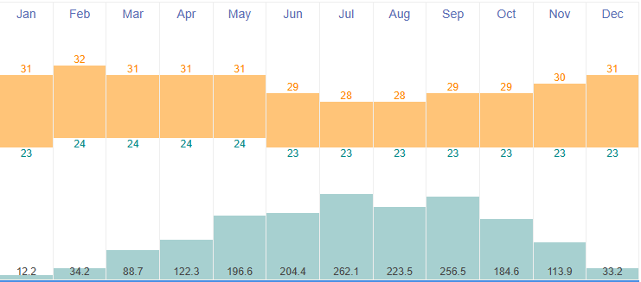
Figure 1: Graph of Temperature
Source: timeanddate.com
Obio/Akpor sees a high annual precipitation of 1732.2mm per year, with July being the wettest month of the year, and its temperature ranges between 23 °C and 32 °C.
Orientation Of the Building
- East-West orientation: Align the Building to maximize ventilation
- Orientation of the building should be in a way that maximizes the use of natural ventilation and lighting (Ikpoko & Ohochuku, 2025; Okoro & Ohochuku, 2024)
- Deploy the use of sun-shading devices where necessary to reduce the impact of sun-glare.
STATEMENT OF THE PROBLEM
Aquatic recreational facilities in Nigeria are mainly designed as event-driven and single-purpose frameworks that place priority on a narrow range of activities, mostly either competitive swimming or recreational use, without thinking about how they would function long-term, or the different needs of future users. This type of design usually results in inflexibility: the pool infrastructure cannot accommodate the evolving demographic of users and recreational activities, or periods when the building is not in use and becomes economically unsustainable. The patterns of abandonment and deficit of recreational infrastructure have been well documented in Nigeria, more particularly in Port Harcourt. Nnadi (2025) stated that while residents expressed their desires for recreational activities, the existing facilities were either inaccessible or inappropriate. Although adaptable design strategies like adjustable floors and modular spaces have been recommended in contemporary facilities (Fiyinfoluwa et al., 2022; Schmidt et al., 2010), this issue persists, and there is still a limited study on how architectural design strategies can address the shortcomings in the context of aquatic recreational centers. This article seeks to resolve the problems by investigating adaptive design strategies of pool infrastructure and implementing them in the design for a flexible aquatic recreational center that meets diverse user needs and evolving activities.
AIM AND OBJECTIVE OF THE STUDY
This study is aimed at investigating how adaptive use strategies can enhance the functional flexibility of recreational pool infrastructure within Obio/Akpor aquatic recreational centers. The objectives of this study are listed below.
- To identify adaptive use and flexibility strategies that can be fully integrated into recreational pool infrastructure to support diverse activities.
- To determine architectural design strategies and adaptable spatial arrangements that enable a single pool infrastructure to serve multiple activities and user needs.
RESEARCH QUESTIONS
The following research questions guided the study:
- What adaptive use and flexibility strategies can be applied to recreational pool infrastructure to support diverse activities?
- To evaluate how adaptive pool infrastructure can enhance the long-term functionality, utilization, and adaptability of aquatic recreational centers in Obio/Akpor.
LITERATURE REVIEW
The existing literature on flexibility and adaptability in architecture has grown immensely, and yet it is still separated amongst building types, with even fewer applications to aquatic recreational centers in developing countries. Recent research has clarified the distinction between adaptability and flexibility. Kassem et al (2025) proposed a combined structure that treats flexibility as a sociocultural essential, and not just a design add-on. Using a multi-criteria approach, De Prais, Lacerda, and Neuenfeldt (2022) show that flexibility is a cluster of dependent factors rather than a single determining factor. However, as recent studies have highlighted, there is an increasing number of studies that illustrate how single-purpose facilities sometimes fall short of meeting the diverse needs of the communities (Schmidt et al., 2010; Ikpoko and Ohochuku, 2025). In European contexts, strategies like adjustable flooring and movable bulkheads are becoming a part of pool infrastructure to increase its flexibility and the overall use of the aquatic recreational center. These strategies increase the ability for diverse activities to be carried out in both the pool infrastructure and seamless transitions between different functions in the aquatic recreational center. The conclusion is that the application of the principle of flexible design is therefore not a mere technical luxury; it is a realistic requirement. (Ikpoko & Ohochuku, 2025)
Adaptive Use of Pool Infrastructure
Adaptive use refers to using an already existing framework for something other than what it was designed for. This concept is important in making sure that the structure lasts longer and is most useful in energy-hungry and single-use buildings like swimming pools.
Design Strategies for Adaptive Use in Pool Infrastructure
1. Movable Bulkheads and Adjustable Pool Floors
The pool infrastructure can be made flexible using movable bulkheads. They work like barricades that are placed at points in the pool. They help divide the pool into sections of length; for example, a 50-meter pool used for swimming can be used to change the pool into two 25-meter pools or one 25-meter pool and a smaller 15-meter teaching pool. Adjustable pool floors are mechanical systems that control water depth. These allow a single basin to serve different users: competitive swimmers (long uninterrupted lanes), learners (short controlled pools), and recreational users.
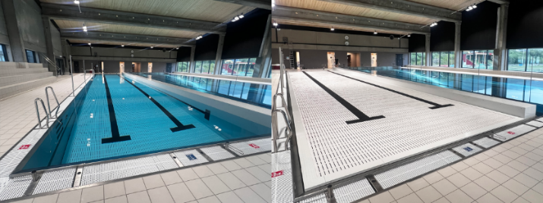
Figure 4: Movable pool floor system with the floor lowered (Left) and leveled (Right)
Source: https://tieleman.eu/en/movable-pool-floor-public-pool/, accessed 21 April 2026
2. Modular and Flexible Pool Layouts
Kholi (2025) showcased how modular architectural concepts can be used in sports facility designs, using structural and spatial components made to be assembled, taken apart, or rebuilt in response to changing needs. When applied to aquatic centers, the modular strategies might include:
- Demountable pool structures: These are ready-made pool basins that may be moved or added in response to shifting demand. The construction of the first wooden modules for a completely dismantlable indoor swimming pool in Stuttgart, using modular timber construction by 4a Architekten, shows that these principles are not merely hypothetical (4a Architekten, 2025)
- Reconfigurable deck systems: Deck surfaces that can be altered to suit both wet and dry purposes interchangeably.
3. Pool Geometry Configurations
The shape and size of the pool basin (bowl) are really important in determining what other alternatives it can be converted to. Rectangular-shaped pools are most suited for tiered seating, while pools with curved shapes and varying depths mimic the shape of skate bowls. This idea is seen in adaptive pool projects: an unused school pool converted to a learning centre with stepped seats, where the depth naturally formed the seating, and another converted to a skatepark due to existing geometry.
Flexibility and Adaptability in Aquatic Facilities
Design Strategies for Adaptability
To achieve adaptability, four techniques have been defined as a set of abilities that define the building's physical capability. Structural Flexibility, Technical Integration, space utilization, and user-centric design are noted strategies for enhancing adaptability in buildings. (Ikpoko & Ohochuku, 2025)
A. Structural Flexibility
Structural flexibility allows for spaces to transform to support a diverse range of activities effectively (Ikpoko & Ohochuku, 2025). Various methods reflect this strategy and are listed below
i. Modular Design Elements
A very practical way of building structural flexibility is through modular design. This method relies on systematically prefabricated parts that are easy to put together, take apart, or rearrange (Ikpoko & Ohochuku, 2025), in place of permanent or fixed construction. In aquatic centers, this translates to modular pool components, such as movable bulkheads to adjust pool lengths or adjustable pool deck cabanas. These modules can be altered to suit a different number of users or functions, thus providing lasting flexibility in both design and use (Ikpoko & Ohochuku, 2025; Umezinwa, 2024).
ii. Retractable Seating and Multi-purpose Pool Areas
Retractable seating systems enable a quick transition from full-capacity function setups to open-plan layouts suitable for a variety of non-sporting events (Ikpoko & Ohochuku, 2025). An aquatic center can host swimming competitions, aerobics, and community events - if its seats and pool layout are designed to adapt from the onset. For example, bleachers or poolside seats that fold into the walls to free up space for dry activities. This feature enables a smooth transformation, such as turning a sports stadium into a facility for community meetings or cultural events (Ikpoko & Ohochuku, 2025; Umezinwa, 2024). On a similar note, a single tank can hold coordinated swimming, competitive swimming, or leisure activities due to the multi-purpose pool zone, which features adjustable lane lines and depths.
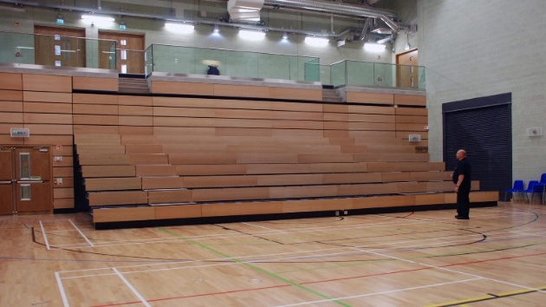
Figure 3: Vertical Retractable Raked Seating
Source: https://www.audiencesystems.com/retractable-seating/, accessed 21 April 2026.
B. Technological Integration
Within an aquatic recreational center, technology does more than just manage the building; it also makes the area flexible, cozy, and friendly for a number of users. Use of smart climate and responsive lighting, along with modern audio-visual tools, increases functional adaptability (Ikpoko & Ohochuku, 2025).
i. Smart Climate, Humidity Control, and Lighting Systems
Features like daylight collection improve energy efficiency and lower utility bills by adjusting lighting based on the available natural light (Ikpoko & Ohochuku, 2025; Umezinwa, 2024). In recreational aquatic centers, this translates to sensors that measure pool temperature and air humidity in real time to maintain satisfaction in spaces that shift functions. However, the successful use of technology relies on careful financial planning. In practical terms, Alolote and Dimkpa (2022) found that when electrical work is estimated using the measurement of each item, the final cost is off by only 10%, whereas if a single guess is used for the job, the error would be off by nearly 25%. This further shows that architects really need to work well with quantity surveyors from the design phase so that the use of technology makes sense and is sustainable.
C. Space Utilization
Both wet and dry spaces need to be designed for multiple uses, through convertible surfaces and temporary dividers. Smart space planning entails the application of adaptable flooring systems and movable walls (Ikpoko & Ohochuku, 2025).
i. Movable Walls and Convertible Flooring Systems
Movable walls give a space the ability to divide or open up on demand, manage sound, and maximize the effective use of floor space. For flooring, adaptable systems like removable deck surfacing, wet-rated mats enable the same dry area to transition between different types of uses without permanent commitment. These two systems – movable walls and adaptable flooring- work hand in hand to enable smooth transitions between different activities and support diverse user needs.
D. User-Centric Design
User-centered design is a design method that prioritizes the users. Consideration of all ages, abilities, and backgrounds needs to be met in a truly flexible aquatic center. Strategies include integrating accessibility features, inclusive design concepts, and user-friendly solutions (Ikpoko & Ohochuku, 2025).
i. Inclusive Access Features.
Methods like pool lifts, transfer walls, and non-slip decking allow physically challenged users and the elderly to enter the water with ease. For people with visual or cognitive impairments, there are other well-considered decisions, like color-contrasted signage and sufficient illumination, that improve wayfinding (Ikpoko & Ohochuku, 2025).
ii. Universal Changing and Amenity Spaces
The use of movable seats, grab bars, and gender-neutral, accessible changing rooms allows the same area to serve diverse users throughout the day.
METHODOLOGY
This study relied heavily on a qualitative research design, which is most appropriate for evaluating context-dependent events. It includes examination of international case studies, case study analysis of various aquatic recreational centers, alongside case-in-point review. Through a combination of previous studies and academic viewpoints on adaptability and flexibility, the literature review showcased the theoretical framework. This methodology acquired information from -
i. Design documentation: Conceptual materials and interior images from multiple Aquatic centers were analyzed to examine: Structural flexibility (Movable & Reconfigurable), Technological integration (Smart & Adaptive Systems), Space Utilization (multipurpose), User-centric design, and adaptive use of pool infrastructure
ii. Case Study Selection Criteria
Relevance to the study
Geographic Location and Microclimate
Scale and Typological Relevance
The selected case studies include:
Derby Swimming Complex, United Kingdom
Northcote Aquatic Recreational Center, Australia
MKO Abiola Stadium Swimming Complex, Abuja
DISCUSSION
Derby Swimming Complex, United Kingdom
The Derby swimming complex shows a refined application of flexibility strategies to pool designs. The facility includes a 10-lane 50-meter competition pool, which was configured with two submersible booms that allow for separation into 3 sections, and adjustable flooring in two of those sections that allows for depth variation. The modular ‘wet box and dry box’ it employs is a technique for spatial organization because it allows independent modification of each area while ensuring a clear functional separation.
Adaptability strategies: Integration of its in-pool movable bulkheads and movable floors enables fast rearrangement to support different activities. Its modular volume strategy emphasizes clear separation of functions while allowing for reconfiguration of each space individually.
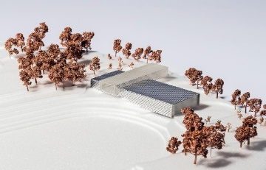
Figure 5: A 3d model showing the modular design separating the ‘wet box and dry box.’
Source: https://www.cladglobal.com/architecture_design_news?codeid=334402 accessed 17 April 2026
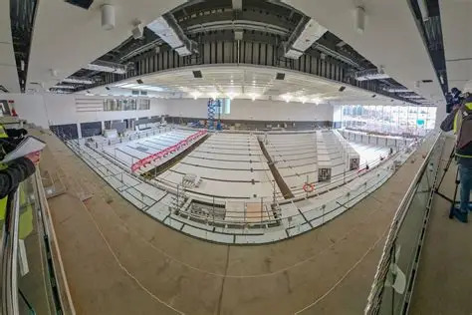
Figure 6: A panoramic view of the main pool during construction, showing the slots for the booms and the adjustable floors
Source: https://www.derbytelegraph.co.uk/news/derby-news/gallery/stunning-photos-video-inside-new-6313428 accessed 15 April 2026
Northcote Aquatic and Recreation Centre, Melbourne, Australia
Originally designed in 1968 and remodeled in 2023. Demonstrates example of user-centric design- community engagement with the potential users of the facility made sure that the design was responding to actual user needs rather than assumptions made by the designer. The inclusive room strategy, used in changing rooms and the pool, represents a comprehensive implementation of inclusive design principles. The inclusion of both aquatic and non-aquatic activities ensures that the facility will still be in use, even when the aquatic section is not in use.
Material use- Using mass timber in this design showcased that bio-based materials can work out acoustically and still meet sustainability goals. The structure is basically made of steel, with the pool hall having low-carbon timber parts. The material was chosen to increase longevity.
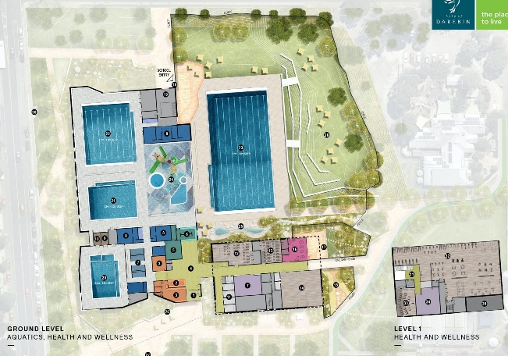
Figure 8: Layout plan of Northcote ARC, showing integration of multiple pools for different purposes. Increases longevity.
Source: https://yoursay.darebin.vic.gov.au/NARC#lg=1051&slide=10, accessed 24 April 2026
MKO Abiola Stadium Swimming Complex, Abuja
Originally designed in 1988 to host national sporting activities and social events. The MKO Abiola stadium exhibits less advanced technology, relying more on basic infrastructure than on sophisticated building management systems. Lack of use of structural flexibility limits functionality. Despite the fact that there are other activities infused into the center, due to the sheer scale of the facility and the lack of after-event consideration, the facility is not at optimum use during non-event periods.
INTERPRETATION OF RESULTS
In terms of structural flexibility, although international case studies like Derby’s swimming complex implemented examples like movable bulkheads and moving floors, there was a general lack of application of modularity in structure and furniture. The application is limited to the aquatic zones of the structure and is not fully integrated into the facility.
Material selection needs to balance reflection and absorption while still prioritizing durability and sustainability (Kenny & Ohochuku, 2025). In aquatic centers, this logic has extra weight but with added resistance to both humidity and chemicals. The use of timber in Northcote ARC shows that durable materials can achieve visual quality and acoustics. More so, the construction materials used in the local case studies were outdated and unsustainable (because they were created to be permanent fixtures), limiting their functional range.
User-centered design: According to Okanigwe, Dimkpa, and Abraham (2024), “architects and designers in building and construction must have a good understanding of how recreational facilities are being planned to help avoid traffic congestion, accidents, and insecurity in this proposed recreational facility”. User-centered design came out as a non-negotiable foundation for long-term resilience in buildings. The international case studies showed how the inclusion of users and an inclusive approach to the facility can create designs that satisfy a wide range of users and increase long-term use. On the other hand, MKO Abiola revealed the consequences of event-driven design and not using this principle.
Spatial Utilization can be done either by scheduling or by changing the arrangement. Scheduling can be done alternating user groups at different times, like Northcote. International case studies like Northcote and Derby’s make use of movable partition walls and movable floors with demountable seating, respectively.
Adaptive Use of existing pool infrastructure is a concept that is yet to be adapted into the local context, but it is a useful and resource-efficient strategy. More so, using pool geometry to design pools in such a way that even in the event of disuse, they can still be used for other activities is relevant in developing contexts.
CONCLUSION
This study showed how techniques used for flexibility and adaptability can influence aquatic recreational facilities with a focus on the Nigerian setting. The integration of variable spatial flexibility and adaptability strategies is important in ensuring that aquatic recreational centers meet the range of demands of contemporary use and are fundamental elements in the effective design of a functional aquatic center. The versatility is based on structural flexibility, using movable bulkheads, retractable seats, demountable walls, and open-plan spatial configurations, which aid the project in addressing the need for facilities that integrate multiple activities into a single structure. Backed up with technical integrations ensures the systems work well and do not get in the way. Centering the design on users' preferences and activities establishes baseline spatial behavior, while integrating adaptive use of pool infrastructure from the design phase increases the qualities to ensure fixed layouts are not a problem in the future, and that the facility keeps running.
Taken together, these dimensions show that effectively integrating adaptability strategies is not to be seen as an afterthought but rather a part of the design principle. By uniting technology integration, structural flexibility, user-centered designs, and adaptive use strategies, aquatic recreational facilities become lively places that respond to what the users need. This method makes the centre more valuable in the long run, and it also enhances the recreational and functional experiences for swimmers, families, and the general public.
RECOMMENDATIONS
The results from the study have led to the following design recommendations that improve flexibility and adaptability in aquatic recreational centers:
1. Designing multi-functional pool zones: Design areas and pools that support different types of activities from competitive swimming to recreational pools.
2. Adopt flexibility strategies and solutions: Integration of modularity and retractability in design elements for dry-land activities or seasonal programs, and to enhance the multifunctionality of the aquatic center.
3. Consideration for adaptive use of the pool beyond aquatic activities: Consideration of the future. Design rectangular and curved pools with removable and adjustable depths to ensure future conversions.
4. Integration of technology: Deploy real-time smart sensors for air quality, light, and water temperature.
5. Selection of durable and moisture-resistant materials: Use materials that have slip-resistant finishes, perforated acoustic panels, and are made of steel and timber to balance humidity resistance and add to visual comfort.
6. Plan for inclusive spaces and engage users in the early design stage: Provide accessible spaces with grab bars and pool lifts to serve an inclusive and diverse range of users. Consultation with the general public and intended users to avoid patterns seen in event-driven facilities.

REFERENCES
- 4a Architekten. (2025, November 3). Stuttgart: First Modular & Dismantlable Indoor Swimming Pool. Retrieved from 4a Architekten: https://4a-architekten.de/en/aktuell/hallenbad-holzmodulbau-stuttgart
- Allen, B. F., & Abbey, O. C. (2025). Enhancing Circulation and Flexibility in the Design of a Cultural. International Journal of Engineering and Modern Technology (IJEMT) E-ISSN 2504-8848 P-ISSN 2695-2149 Vol 11., 11(8), 2504-8848. doi:10.56201/ijemt.vol.11.no8.2025.pg78.89
- Alolote, I. A., & Dimkpa, K. (2022). Assessing the cost accuracy of electrical works towards sustainable procurement of building services. International Journal of Construction Management, 22(10), 1974-1982. Retrieved from https://doi.org/10.1080/15623599.2020.1760758
- De Paris, S., Lacerda, L. C., & Neuenfeldt, J. A. (2021). The use of an analytic hierarchy process to evaluate the flexibility and adaptability in architecture. Archnet-IJAR: International Journal of Architectural Research., 16(1), 26-45. doi:https://doi.org/10.1108/ARCH-05-2021-0148.
- FaulknerBrowns Architects. (2025, October 9). FaulknerBrowns reveal modular stacked design for Derby swimming complex. Retrieved from CLADglobal: https://www.cladglobal.com/architecture_design_news?codeid=334402
- Fiyinfoluwa, S. A., Adedapo, O., Kehinde, K., & Shalom, O. (2022). Space Adaptability Strategies and Building Performance in Selected Entertainment Centres in Nigeria. IOP Conference Series: Earth and Environmental Science. doi:10.1088/1755-1315/1054/1/012022
- Ikpoko, G., & Ohochuku, C. P. (2025). Designing for Multi-Functionality in Sports Facilities: Strategies for Flexibility and Adaptability in University Athletics Spaces. International Journal of Engineering and Modern Technology (IJEMT), 11(7), 14.32. doi:10.56201/ijemt.vol.11.no7.2025.pg14.32
- Kassem, A., Eldanaf, T. S., Camponogara, M., & Hamdan, W. (2025). Designing for change: Performative and flexible approaches to contemporary housing. Front. Built Environ., 11. doi:10.3389/fbuil.2025.1677525
- Kenny, U. D., & Ohochuku, C. P. (2025). Integrating Variable Acoustics into Multipurpose Performance Halls. International Journal of Engineering and Modern Technolog , 11(9), 320.334. doi:10.56201/ijemt.vol.11.no9.2025.pg320.334
- Kholi, J. (2025, May). Using modular architectural strategies for versatility in adaptive stadium design in Ahmedabad, Gujarat. Retrieved from Institutional Repository IR@SPA Bhopal: http://dspace.spab.ac.in:80/handle/123456789/2846
- Nnadi, L. (2025). An Assessment of Residents' Attitude Toward Recreational Activities/Facilities in Port Harcourt City and Obio/Akpor Local Government Area. Retrieved from Afrilibrary: https://www.a.afribary.com/works/luckycomplete-work
- Okanigwe, P. P., Dimkpa, K., & Pyamene, A. (2024). Enhancing Safety and Crowd Management; A Way of Promoting Tourism in Recreational Facility. Iconic Research and Engineering Journals e-ISSN: 2456-8880 , 8(1), 328-335. Retrieved from https://www.irejournals.com/paper-details/1706069
- Okoro, E. I., & Ohochuku, C. P. (2024). Design Strategies for Thermal Comfort in Faculty of Architecture Building, Port-Harcourt, Nigeria. Research Journal of Pure Science and Technology., 7(3), pg 114.131. doi:10.56201/rjpst.v7.no3.2024.
- Olatunji, A. S., Olarotimi, A. D., Adedeji, A. A., & Ayoola, L. O. (2025). Assessment of Problems Associated with the Management of Public Infrastructure in Ondo West LGA, Ondo State, Nigeria. Ibadan Planning Journal, 11(1). doi:https://doi.org/10.60787/ipj.vol11no1.1799
- Schmidt III, R., Eguchi, T., Austin, S., & Gibb, A. (2010). What is the meaning of adaptability in the building industry? 16th International Conference on" Open and Sustainable Building, 17-19. Retrieved from https://www.irbnet.de/daten/iconda/CIB17993.pdf
- Studio DERA. (2025, November 21). Studio DERA converts former swimming pool into learning space. Retrieved from Architects' Journal: https://www.architectsjournal.co.uk/buildings/studio-dera-converts-former-swimming-pool-into-learning-space
- Umezinwa, E. C., Barnaby, J., Okonkwo, M. M., Ibekwe, D. A., Onuorah, I. M., Ilouno, D. O., & Aniakor, U. C. (2024). Optimizing adaptability: Design strategies for indoor basket halls and fitness centers. International Journal of Research Publication and Reviews, 5(5), 9553–9562. doi:https://doi.org/10.55248/gengpi.5.0524.1366

