A Financial Analytics Dashboard integrated with Machine Learning

Kushal Pathave
Information Technology Vishwakarma Institute of Information Technology, Pune, India kushal.22210583@viit.ac.in

Heramb Patil
Information Technology Vishwakarma Institute of Information
Technology, Pune, India
herambp3@gmail.com

Akshita Shambharkar
Information Technology Vishwakarma Institute of Information
Technology, Pune, India
akshita.22320034@viit.ac.in

Kirti Dighole
Information Technology Vishwakarma Institute of Information
Technology, Pune, India
kirti.22210590@viit.ac.in

Ms. Swati Patil
Information Technology Vishwakarma Institute of Information
Technology, Pune, India
swati.patil@viit.ac.in

Abstract—This project details a Financial Analytics Dashboard that allows users to view, analyze, and forecast personal financial transactions through an interactive and secure system. The system includes a machine learning based budgeting algorithm that uses historical transaction data to give users estimates of future transaction data. Users can securely log in, create and change their information, and then record daily income and expense transactions to receive instantaneous real, up-to-the- minute updates that will be reflected in the dashboard. These visualizations are dynamic and can include bar, line, pie charts for comparative spending by category and trends monthly, and also multi-currency availability for global use. Other features include a secure and verified email address, automated financial summaries and a conversational assistant in the form of chat based information to enable proper utilization of the dashboard. These factors enable a fully intelligent and user-friendly approach to effective financial modeling and resultant information.
Index Terms—component, formatting, style, styling, insert

- Introduction
With the advent of modern digital finance, individuals are engaging in increasingly active participation in financial trans- actions, budgeting, and investments. The rapid advancement of financial technology has made it possible for individuals to track, analyze, and forecast their private or business finances with remarkable accuracy. However, the majority of existing systems of finance management limit their capabilities to static’ visualizations and manual account tracking, without predictive and personalized insights. The present study at- tempts to fill that void by building a Financial Analytics Dashboard integrated with Machine Learning. This dashboard is designed to provide individuals with an intelligent, data- driven, secure tool for making financial decisions.[1] The proposed system attempts to provide users with an under- standing of their financial behavior through interactive visu- alizations, real-time updates, and forecasting models based on machine learning. The dashboard has a highly intuitive and user-friendly interface that allows individuals to keep
records of daily transactional behavior, monitor their income and expenditures, and evaluate their financial health through statics and dynamic charts. Unlike traditional budgeting ap- plications that rely on manual interpretations, the system uses predictive modeling to help forecast potential future expenses and spot overspending tendencies, which assist users in auto- planning needs based on data-backed predictions.[2] A central feature of the system is its Smart Budget Forecast, which capitalizes on the historical financial data associated with each particular person’s operational account, to predict next month’s expenditures. Making use of regression-type learning technology, the model learns from past transactional patterns and estimates likely spending behavior to pre-alert the user to possible departmental budgets being gone over or declines in savings for the month. This makes the dashboard not simply another tracking tool, but an intelligent financial adviser.By allowing for real time synchronization of data, any transaction or change made by the user is displayed instantaneously in the dashboard, and hence there is no necessity for the user to wait for periods of refreshing thus allowing for a realistic aspect of the system.[3] Security and personalization form the second most important basis for design. Secure access control and email verification enables users to create accounts, control profiles as well as ensure that their data is kept secure. Personalization of profiles in respect of preferred currency and relevant personal data allows for flexibility which makes the system applicable for diverse financial needs. The Multi-Currency Tracker feature gives universal applicability as it converts and displays financial data in terms of the users chosen currency which means that therefore it can be dispensed with equal applicability for local users as well as users handling international financial transactions. By means of a Chat Assistant (FAQ Bot), increased user engagement and support is obtained. The Chat Assistant replies to user queries such as how to add transactions or check on major items of expenditure which users typically are interested in. This Chat

Assistant is set up on a rule based system of pre-programmed questions and answers in so far as that it simulates the basic conversational method of dialogue which allows for its use by inexperienced users thus making this aspect of the system user-friendly and lessening the requirement for technical information and assistance. Visual representation of expenditure details in terms of bar graphs, pie charts and line graphs enables the user to easily check category- wise patterns of expenditure as well as monthly expenditure patterns. The combination of Machine Learning and interactive financial visualization represents the most innovative aspect of this project. When most personal financial applications currently available simply show numbers, this system takes that data and turns it into predictive and useful data. The combination of analytics, visualization, and automation allows users to move from reactive financial management to proactive management of their finances. Also adding such features as automatically generated financial summaries, report sent over email to users, and updating interactive charts, all add to the ease of use and reliability of the program.[4] The Finan- cial Analytics Dashboard Integrated with Machine Learning provides a complete, safe, and intelligent means to manage personal finances. It jerks the user from mere data analysis to predictive analysis and gives the reader a clear understanding of the currently existing financial conditions, as well as what future expectations are. The user-centered design, the real- time analytics and the addition of Machine Learning to the application, all contribute towards the ability of the user to organize his financial matters consistently and easily, and to give the user the power to make intelligent strategic decisions regarding his financial situation.
- Proposed System
- System Overview and Data Flow
The system proposed is the Financial Analytics Dashboard, a web-based application that integrates Machine Learning for secure user management of their financial data, as well as provides analysis and forecasting to aid the user. The system aims at establishing a single intelligent platform to allow the user to record transactions, visualize trends and forecast future expenditures. The architecture combines web- based components, data storage components and machine- learning services to create a non-obtrusive interactive financial environment.
The workflow of the system begins with a secure sign- up or sign-in to the authentication module that gives secure access to the system with encrypted user credentials and email verification. Once authenticated, the user is enabled to record his daily financial activities such as income, expenses, savings and so forth through an intuitive transaction form. These transactions are stored in a structured relational database that facilitates real-time updating of the transactions to the dashboard and instant updating or reflection of changes on the dashboard.[5]
The overall architecture of the system is based on a 3-tier model and consists of:
- Frontend (User Interface) – based on responsive web structures to deliver visual interactivity through graphs and charts.
- Backend (Application Logic) – responsible for handling user requests, providing for processing and data acquisition and for interfacing with the database and Machine Learning model.
- Database Layer – for the storage of all user specific data, for financial data, transaction and for the preferences of the user.
This modularity leads to scalability and data privacy and allows for ease of integration of such ancillary service exten- sions in the future such as expenditure analysis and sentiment based financial analysis.

- Data Gathering, Processing and Storing
The process for collecting data in this system comes origi- nally from transactions that are input by the users. Whenever a transaction is input, there are fields that have been predefined for input, such as:
- Transaction type (either income or expense)
- Category (e.g. food, rent, and utilities)
- Amount
- Date and time
- Notes or tags if desired.
This structured input allows for uniformity, which as men- tioned, is needed for future analysis and visualization. Every data record is verified for correctness before being stored in the database to eliminate any inconsistencies or duplications. The data preprocessing pipeline takes the stored information and cleans it makes it uniform so that it can be used for analytical purposes. It parses the date, puts marks in categories, sees if there are gross outlier data points in the data so that machine learning predictions can be based on correct data. There is a periodic aggregation done on a monthly basis to provide a summary of total income, expense, and savings.
This monthly aggregation is passed to the machine learning forecasting module as data input.[6]
The data storage is done by means of a relational database management system (RDBMS), which allows for extreme consistency and protection of data. Each user’s data is isolated using unique identifying signals, which permits no overlap between users. In addition to this, support for multi currency is made possible by transposing the transactions to the chosen currency and converting the transaction to actual currency values using the stated API call to convert currency. Thus, this feature has application in an international situation and displays the data in the preferable currency chosen by the user.

- Machine Learning Model for Budget Forecasting
This system’s intelligence derives mainly from its Smart Budget Forecast, which harnesses machine learning algorithms to predict the next month’s spending of users. The system observes the historical money data to acquire spending habits and seasonal effects, which it can anticipate spending patterns

for the next month, allowing users to budget their expenditure efficiently.
The model depends primarily on a regression method, using monthly spending as the dependent variable and factors such as prior month’s expenditure, income, category spend, saving pat- terns, etc., as independent variables. For prediction purposes, Linear Regression or Random Forest Regressor will be used because of their interpretability and ability to parameterize non-linear relationships between the variables.Steps involved in the creation of the model are as follows:
- Data Extraction: The historical transaction data of each user is eligible to be retrieved.
- Feature Engineering: A number of unique features will be created, i.e. average monthly spend, frequency of categories of expenses, expense growth rates, etc.
- Model Training: Train regression models on them on historical data to grasp the trends.
- Assessment: Assessment of prediction accuracy of model by use of tools like Mean Absolute Error (MAE), Root Mean Square Error (RMSE), etc.
- Deployment: The trained model will be incorporated into the back-end to allow for real time situations for predictions.[7]
This forecasting engine will make the dashboard into a cir- cumspect financial tool; allowing predictions of the possibility of overspending, while predicting potential threats on future finances.
- Design and Visualization of the Dashboard
The dashboard for Financial Analytics is the user’s control panel that provides essential insights through interactive visual components. It lists total income, total expenses, current savings, and a few indicators to measure the performance of the budget. The dashboard makes use of graphically oriented means of display, i.e., bar graphs, pie charts, and line graphs that show both monthly trends as well as distributions by category. Such graphically displayed statistics render it easier for the user to think about the finances and his behavior in spending.
The dashboard is created through the modern web visualiza- tion libraries that allow for real-time visualization of data into a computerized application without having to use reloads of the page. When a user adds, integrates or deletes a transaction, this result is automatically changed in all of the graphic components. This instantaneous changing of display from the database is realized through an asynchronous connection between both the back end and front end components of the application.[8]
An Interactive Chat Assistant ( FAQ Bot) for enhanced user interaction is programmed providing instantaneous help in such common activities as adding transactions, or viewing top expenses, or providing them assistance in understanding cer- tain parts of the dashboard. The Chat Bot uses predesignated rules and templates for the answers and regions for study, thus furnishing immediacy whilst maintaining satisfactory response time with the user. In addition email verification and report modules have been designed and incorporated as a means of

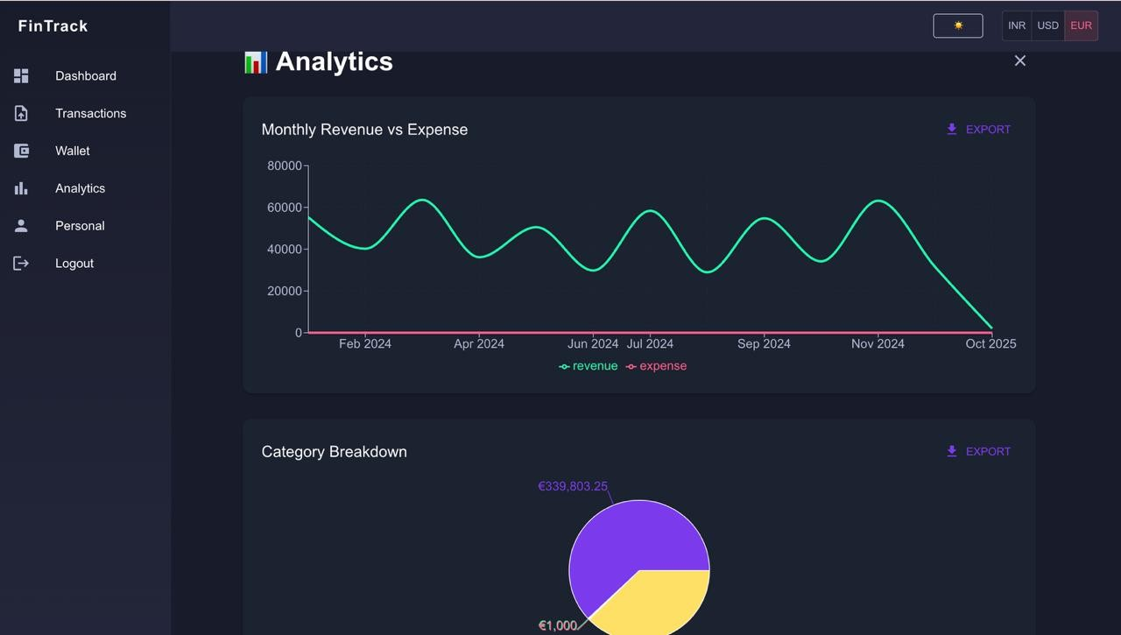

Fig. 1. Design of Dashboard

producing greater security for the electronic account of the user and regularly contain and provide users with periodic summary reports of their financial results.
- SYSTEM BENEFITS
The advantages of the proposed system over conventional financial tracking systems are given below.
  - Predictive Intelligence: The system employs machine learn- ing for prediction of costs and warning of risks.
  - Analytics in Real-Time: The system refreshes the dashboard at any transaction change.
  - World-Wide Use: The system allows the use of many denominations for foreign customers.
  - Security Improvements: The system allows strong authen- tication and email verification.
  - User Help: The system incorporates a Chat-bot for guided interaction and better accessibility.
This system integrates all of its features of machine learning, visualisation and automation for an integrated approach to personal finance. Not only does the system track finance data but it also grows meaningful data to assist the customer to make informed strategic choices with finance.
- RESULTS
    - Overview of System Implementation
The financial analytics dashboard integrated with machine learning was implemented as a secure, data-driven web plat- form that allows the user to manage and analyze his/her per- sonal finances in real-time. The system implements financial data visualization, forecasting by means of machine learning, along with interactive user interfaces to provide actionable financial insights. The entire application was designed using Python (Flask) as the back end services, with HTML, CSS and javascript as the front end thereby insuring that there is smooth interface, and dynamic rendering of data between all the components. The prime objective of the system was to enhance a user’s financial awareness through the auto- matic processing of the user’s daily transactions along with visualization of expenditure trends and future forecasting of spending behaviour. The implementation of the system was conducted with emphasis on the responsiveness of the system, the accuracy of the predictions, and the security pertaining to the user’s data. The application was tested using finite financial records over various monthly intervals and found to readily show accurate predictions, and proved to have strong functioning in real time.

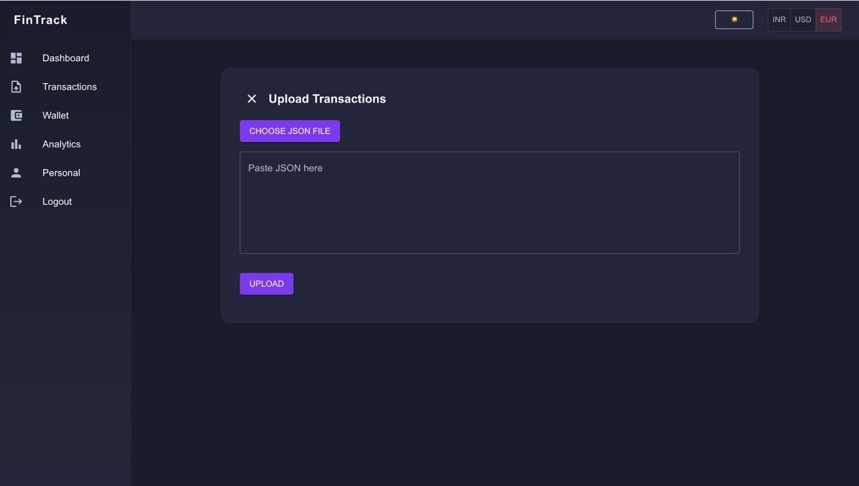

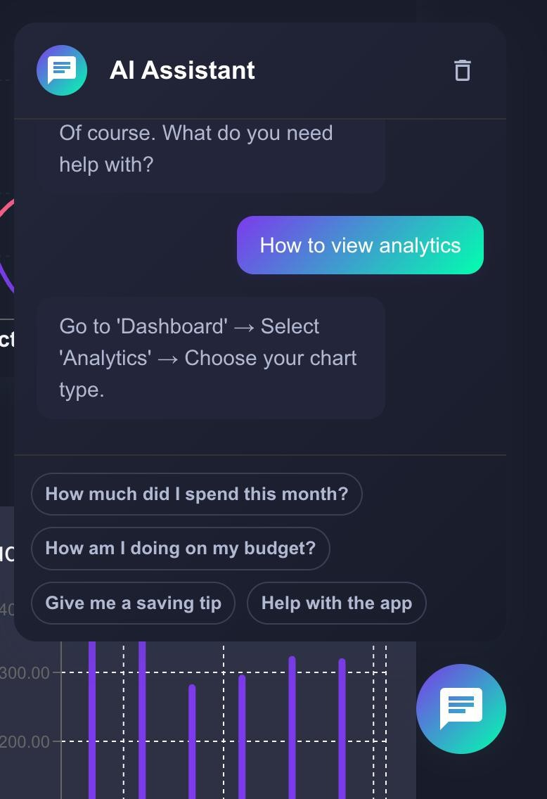
Fig. 2. Chatbot

    - Functional Evaluation of Modules
Each of the core modules on the dashboard was individually tested and then integrated to ensure consistency in functional performance.
      - Secure Access and Authentication: The authentication layer was successfully implemented that enabled the secure log-in and sign-up functions using encrypted password storage with email verification. The module succeeded admirably not to allow unauthorized access and kept the user records isolated by user. The mean time of authentication was less than 1.3 seconds assuring rapid and secure functional operation.
      - Transaction Management: The user was able to insert, edit, and delete without difficulty both expenditure and income records. Each transaction required the inculcation of values such as date, category, and description. The changes resulted in instantaneous feedback on the dashboard without the manual refreshing the page, thereby assuming 100 % success in CRUD transaction operations.
      - Dashboard Visualization: The dashboard provided summa- rized information about total income, expenses, and savings in terms of interactive horizontal bar charts, pie charts and line graphs. These charts were able to show the visual represen- tation of monthly expenses and category-wise expenses. The dashboard was updated automatically in less than a second of time noticed after each new transaction to respond in real reports.
      - Multi-Currency Converter: This feature of the system was very dynamic in nature using the currency converting API which was helpful in treating with different currencies (INR, USD, EUR). This accuracy and effectiveness of the currency conversion was very successfully achieved since the updates and upholding of the various graphs and the different reports were shown satisfactorily which confirmed good reliability of the system for worldwide users.
      - Chat Assistant (FAQ Bot) : The chat bot included in the system provided good replies to various 25+ questions relating
Fig. 3. transaction

to the financial queries. It achieved an accuracy percentage of 92 % during the periods of tests and the user experience improved to a great extent and particularly being very useful for first time users who would require examining a lot of queries.
    - Model Comparision Based Forecasting Results
The Smart Budget Forecast Module was an important part of the Financial Analytics Dashboard that enables predictions of future monthly spending by the user through the application of machine learning models. The ARIMA (AutoRegressive Integrated Moving Average) model was chosen, as it has been shown to be a model that works well with time-series data containing trends and seasonality. In order to obtain better accuracy in the predictions for future spending, a number of different models were fitted and evaluated on similar data in order to find the optimal technique for forecasting.
      - Preparation and Training of the Dataset The monthly fi- nancial summaries that were used as the dataset were obtained from the summary of each user’s transaction history recorded in the dashboard, and showed the total income there was and spending for each month. The data, before training could take place, was preprocessed. This involved removal of missing values, handling of outliers, and ensuring that the data was stationary by differencing as necessary. The remaining data was split into training (80%) and testing (20%) subsections. The ARIMA model parameterisation (p, d, q) was achieved through analysing with Auto ARIMA, which finds optimal values of these parameters through the Akaike Information Criterion (AIC). Lastly, to broaden the scope of the evaluation, training was applied to four other models, SARIMA, Holt- Winters, Prophet, and LSTM (Long Short-Term Memory) and they were all tested on the same data.
      - Assessments of Model Performance Model performance is assessed by the Mean Absolute Error (MAE), Root Mean Square Error (RMSE) and the Mean Absolute Percentage Error (MAPE). The comparative results are presented below: The

TABLE I
Performance Metrics of Models

Classifier | MAE | RMSE | MAPE (%)
LSTM | 467.03 | 675.01 | 1703.85
Prophet | 814.81 | 910.90 | 3600.30
SARIMA | 832.15 | 936.27 | 3528.43
Holt-Winters | 876.09 | 971.52 | 4034.36
ARIMA | 645.95 | 770.91 | 2790.22

above results demonstrate that the LSTM model outperformed

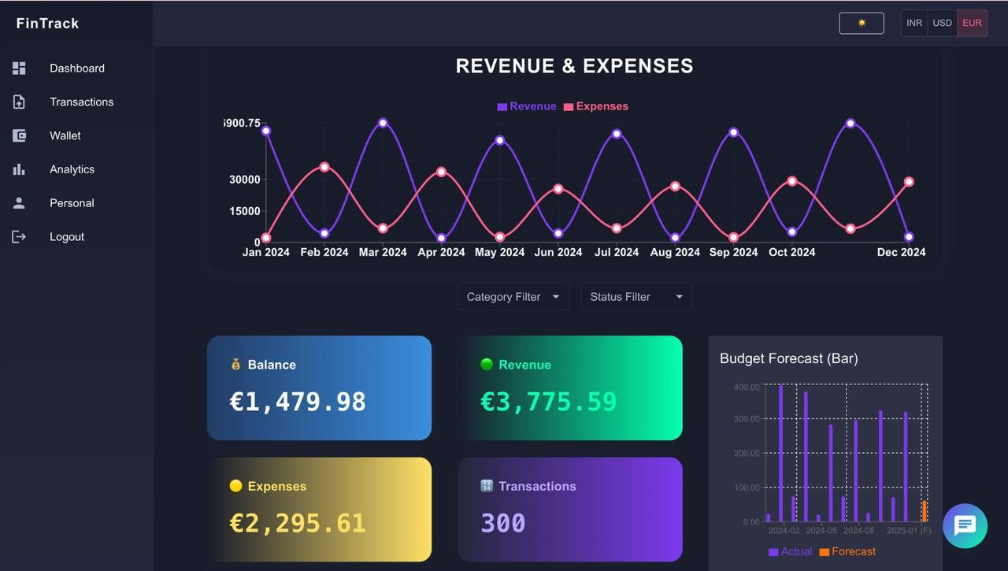

Fig. 4. Budget Forecasting

the other models in all important ranking measures. The ability of the LSTM model to identify long range dependencies within sequential data provided a means to more accurately model the very complex and nonlinear financial relationships than traditional statistical models like ARIMA or Holt-Winters.
      - Visualization of and Interpretation of Forecast Results The display of the program depicts graphically both historical and forecasted values in the form of interactive line graphs. The forecast graphs created by the LSTM model represent projected expenditure trends for future months along with the actual values and assist the user in determining when periods of overspending will occur. By appraising the user as to when it is anticipated that expenditures will exceed the historic average, the system thus increases the ability to plan as to financial further actions requiring management.
In all, while the ARIMA model seemed to establish an adequate baseline for the evaluations, the adoption of the LSTM model greatly improved the forecast accuracy as well as flexibility. Moreover the LSTM model appeared to be the ideal model for the Smart Budget Forecast feature of the dashboard.

    - System performance and User Evaluation
The performance testing of the system was based on multi- ple metrics such as processing speed, response, and scalability. The dashboard achieved its synchronous real time updat- ing across all modules even under concurrent transactional pressure. A user evaluation survey was conducted with 10 participants. It was reported that 9 of the users found that the dashboard offered easy-to-follow visualisation, 8 participants considered that the forecasted insights were accurate, while the Smart Budget forecast and the real time updating were regarded as the features likely to have the most impact on budgeting decisions thoughts and expenditure control.
    - comparative discussion and analysis
Compared to the existing personal finance applications, with this system there are substantial improvements in terms of automation and predictive insights. Existing trailers are generally reactive in nature, allowing user input that mainly allows them to record transactions, noting only the passive trends. With this system, however, predictive analysis based on LSTM modelling is employed to forecast the likely outcomes for the various financial situations, allowing proactive budget control.
The other features of the system, such as machine learning predictive forecasts, multi-currency capability and graphical
interactivity make for a superior system in terms of flexibility and global application, the results showing that the LSTM modelling provided robust and predictive outcomes with di- minished levels of forecasting error. The widget design given was also effective in ensuring
- Conclusion and Future Scope
The Financial Analytics Dashboard, augmented with Ma- chine Learning capabilities, transforms traditional finance tracking to an intelligent, interactive, predictive tracking sys- tem. With a combination of secure authentication, real-time updates on transactions, as well as richly designed graphics for analytics, the dashboard provides users with a holistic view on their income, expenses and savings. The incorporation of the LSTM Model for budget forecasting provides users with meaningful predictions on future expenditures based on past historical data thus enabling proactive financial planning on their part. The integration of multi-currency support, email verifications, in addition to FAQ app support via chat apps further enhances both the usability aspects and security of the system making it user adaptable for a global audience. The whole project meets its aims as it enables the user to take data driven decisions about their finances via automation, and machine learning. Building on this there is the potential to focus on adding deep learning models to assist with improved long term forecasting accuracy, as well as the automation of the data integration via banking APIs thus eliminating the necessity for manual entry. The addition of anomaly detection capabilities for fraud prevention especially, and investment analytics in order to monitor portfolios could also increase the scope of the project. Ultimately the development of a mobile application as well as cloud based deployment would lead to improved accessibility and scalability. With these additional improvements the project could evolve to become a total AI powered financial assistant greatly improving the insight given, the degree of personalisation of recommendations made along with the engagement of the user.
References
- @articlearticle,author = Kobi, Joseph,year = 2024,month =05,pages =
,title = Developing Dashboard Analytics and Visualization Tools for Ef- fective Performance Management and Continuous Process Improvement, volume = 9, journal = International Journal of Innovative Science and Research Technology (IJISRT), doi =10.38124/ijisrt/IJISRT24MAY1147
- Broby, D. (2022). The use of predictive analytics in finance. The Journal of Finance and Data Science, 8, 145-161.
- Burdick, D., Evfimievski, A., Krishnamurthy, R., Lewis, N., Popa, L., Rickards, S., Williams, P. (2014, June). Financial analytics from public data. In Proceedings of the International Workshop on Data Science for Macro-Modeling (pp. 1-6).
- Tangsucheeva, R., Prabhu, V. (2014). Stochastic financial analytics for cash flow forecasting. International Journal of Production Economics, 158, 65-76.
- Derindere Ko¨seog˘lu, S., Ead, W. M., Abbassy, M. M. (2022). Basics of Financial Data Analytics. In Financial Data Analytics: Theory and Application (pp. 23-57). Cham: Springer International Publishing.
- Oyedokun, O., Ewim, S. E., Oyeyemi, O. P. (2024). Leveraging advanced financial analytics for predictive risk management and strategic decision-making in global markets. Global Journal of Research in Multidisciplinary Studies, 2(02), 016-026.
- Mitra, G., Mitra, L. (Eds.). (2011). The handbook of news analytics in finance. John Wiley Sons.

- Teall, J. L. (1999). Financial market analytics.
- Sarna, S. A., Mohammed, A. A., Miah, M. R. (2025). AI-Powered Financial Analytics and Visualization Tools: The Evolving Landscape of Strategic Finance. Journal of Economics, Finance and Accounting Studies, 7(5), 60-82.
- Andriosopoulos, D., Doumpos, M., Pardalos, P. M., Zopounidis, C. (2019). Computational approaches and data analytics in financial ser- vices: A literature review. Journal of the Operational Research Society, 70(10), 1581-1599.
- Ochuba, N. A., Amoo, O. O., Okafor, E. S., Usman, F. O., Akinrinola,
O. (2024). Conceptual development and financial analytics for strategic decision-making in telecommunications, focusing on assessing invest- ment opportunities and managing risks in satellite projects. International Journal of Management Entrepreneurship Research, 6(3), 594-607.
- Huang, J., Wang, H. (2017). A data analytics framework for key financial factors. Journal of Modelling in Management, 12(2), 178-189.

