THE POLITICAL ECONOMY OF CHINESE ENGAGEMENT IN CAMEROON: BETWEEN DEVELOPMENT, DEPENDENCY AND EXPLOITATION, 1971–2026.

ABSTRACT
Since the establishment of diplomatic relations between Cameroon and the People’s Republic of China in 1971, Sino-Cameroonian relations have evolved into one of Africa’s most important bilateral partnerships. China has become a major actor in Cameroon’s economic transformation through investments in infrastructure, trade, mining, energy, telecommunications and development finance. While these engagements have contributed significantly to national development, concerns have increasingly emerged regarding economic dependency, environmental degradation, labour exploitation and the broader implications for Cameroon’s sovereignty. This article examines the political economy of Chinese engagement in Cameroon between 1971 and 2026. Using a qualitative historical approach and drawing on secondary sources, the study is guided by Dependency Theory and Neo-Colonialism to analyse the opportunities and challenges associated with China’s growing presence in the country. The findings indicate that Chinese investments have facilitated major infrastructural developments, including roads, ports, hydroelectric dams, and telecommunications networks. However, these gains have been accompanied by challenges such as growing dependence on external financing, unequal trade relations, illegal mining activities, environmental degradation, labour disputes, and limited technology transfer. The study concludes that Chinese engagement in Cameroon represents a complex relationship in which development and dependency coexist. It argues that the long-term benefits of this partnership depend largely on the capacity of the Cameroonian state to effectively regulate foreign investment and protect national interests. The article recommends strengthening mining governance, environmental regulation, labour protection, local content policies, economic diversification, and transparency in foreign investment agreements to ensure sustainable development and safeguard economic sovereignty.
KEYWORDS: Political Economy, Economic Developments, Dependency, Neo-Colonialism, Sovereignty, China, Cameroon,

INTRODUCTION
The relationship between Cameroon and China constitutes one of the most enduring and consequential partnerships in contemporary Africa and Asia relations. Over the last five decades, China has moved from being a relatively marginal diplomatic partner to becoming a central actor in Cameroon’s development agenda. Chinese funded projects are visible throughout the country, from roads and dams to ports, hospitals, telecommunications infrastructure, and mining operations. China’s growing influence reflects broader shifts in global political economy, particularly the rise of China as a major global power and Africa’s increasing importance in China’s foreign policy strategy. Official discourse from both Beijing and Yaounde presents the relationship as a mutually beneficial partnership founded on solidarity among developing nations. Yet beneath this rhetoric lies a growing debate about the implications of China’s expanding presence. Concerns about illegal mining activities, labour abuses, environmental degradation, and the dominance of Chinese firms in strategic sectors have led many observers to question whether the relationship represents genuine development cooperation or a contemporary form of economic neo-colonialism. This article critically examines the evolution of Chinese engagement in Cameroon between 1971 and 2026. It explores the historical foundations of the relationship, its economic and political dimensions, and the extent to which Chinese involvement has contributed to development, dependency, and exploitation.
THEORETICAL FRAMEWORK: DEPENDENCY AND NEO-COLONIALISM
This study is anchored in Dependency Theory and the concept of Neo-Colonialism, both of which provide valuable frameworks for understanding the dynamics of Chinese engagement in Cameroon. Dependency Theory argues that developing countries often remain economically dependent on more powerful nations through unequal trade, investment and financial relationships. Rather than promoting genuine economic transformation, such relationships may reinforce structural dependence by positioning developing countries as suppliers of raw materials and consumers of manufactured goods (Prebisch, 1950).
In the context of Cameroon, Dependency Theory helps explain concerns that Chinese engagement may perpetuate an economic structure in which Cameroon exports timber, minerals, oil and agricultural products while importing manufactured goods and technology from China. Although Chinese investments have contributed to infrastructure development and economic growth, they may also deepen dependence on foreign capital, expertise and markets.
The concept of Neo-Colonialism, advanced by Nkrumah (1965), complements this perspective by arguing that political independence does not necessarily guarantee economic sovereignty. According to this view, powerful states can exercise influence over weaker nations through economic, financial and cultural mechanisms rather than direct political control. Such influence may manifest through loans, investments, trade agreements, and strategic partnerships that shape national development priorities. Together, Dependency Theory and Neo-Colonialism provide a useful lens for analysing whether Chinese engagement in Cameroon has promoted sustainable development or reproduced patterns of economic dependence and external influence. The study employs these frameworks to examine the extent to which China’s growing presence has contributed simultaneously to development, dependency, and exploitation in Cameroon.
HISTORICAL EVOLUTION OF SINO-CAMEROONIAN RELATIONS
The evolution of Sino-Cameroonian relations since 1971 reflects a remarkable transformation from diplomatic normalization to a comprehensive strategic partnership encompassing politics, trade, infrastructure, defence, education, culture, and development finance. The relationship has unfolded through several distinct phases, each corresponding to broader changes in both China’s foreign policy and Cameroon’s development priorities (Zoubir, 2014; Bone, 2020).
The Foundations of Diplomatic Relations (1971–1982)
The formal relationship between Cameroon and the People’s Republic of China began on 26 March 1971, when Cameroon officially recognised Beijing as the legitimate government of China and severed diplomatic relations with Taiwan. This decision represented a major geopolitical shift and formed part of China’s broader effort to secure diplomatic recognition across Africa during the Cold War. The agreement was mutually beneficial. China agreed to end its support for the Union des Populations du Cameroun (UPC), which had opposed the Ahidjo government, while Cameroon endorsed the One-China Policy and established full diplomatic relations with Beijing (Bone, 2020; Zoubir, 2014).
The early years of the relationship were characterised by high-level diplomatic exchanges. In March 1973, President Ahmadou Ahidjo paid an official state visit to China and met Chairman Mao Zedong, becoming one of the first African leaders to visit China after the most turbulent years of the Cultural Revolution. Ahidjo returned to Beijing in 1977 to meet Mao’s successor, Hua Guofeng, further consolidating bilateral relations. These visits laid the political foundations for long-term cooperation and signaled a growing convergence of interests between Yaoundé and Beijing (Bone, 2020).
During this period, cooperation focused largely on symbolic but politically significant development projects. China assisted in the construction of public infrastructure, health facilities, and government buildings, thereby projecting itself as a reliable development partner distinct from Cameroon’s former colonial powers. Trade and cultural cooperation agreements signed during the 1970s strengthened people-to-people exchanges and economic interaction, while educational cooperation began to emerge as an important pillar of bilateral relations (Onana Ntsa, 2021; Zoubir, 2014).
Consolidation under Paul Biya (1982–2000)
The resignation of President Ahidjo in 1982 and the accession of Paul Biya did not disrupt relations with China. Instead, cooperation expanded considerably. One of the most significant developments was the financing of the Lagdo Hydroelectric Dam, supported through a Chinese loan estimated at approximately US$75 million. Completed during the 1980s, the project became one of the earliest major symbols of Chinese development assistance in Cameroon and remains an important component of the country’s energy infrastructure (Zoubir, 2014).
The 1980s also witnessed the institutionalization of economic cooperation. In 1986, both countries established the China-Cameroon Economic and Trade Mixed Committee, creating a formal mechanism for coordinating bilateral economic relations. Numerous agreements covering trade, technical cooperation, agriculture, and economic assistance were signed throughout the decade. Chinese companies began participating in road construction, geological surveys, water infrastructure projects, and agricultural development programmes, marking the beginning of China’s transition from a traditional aid provider to a significant economic actor within Cameroon (China.org.cn, 2006; Zoubir, 2014).
Military cooperation also expanded during this period. By the early 1980s, the two countries had concluded several defence agreements involving the supply of military equipment, training programmes, patrol boats, communication systems, and logistical support. Exchanges between military delegations became increasingly frequent and established the foundations for future security cooperation that would later intensify in response to regional security challenges (Bone, 2020; Danga, 2025).

Economic Expansion and Strategic Partnership (2000–2013)
A new phase began with the establishment of the Forum on China–Africa Cooperation (FOCAC) in 2000, which transformed China’s engagement across Africa. For Cameroon, FOCAC opened access to new lines of credit, concessional loans, infrastructure financing, scholarships, technical assistance, and investment opportunities. Chinese engagement became increasingly driven by economic considerations, particularly the search for natural resources, export markets, and strategic commercial partnerships (China.org.cn, 2006; Mudoh, 2022).
The rapid growth of bilateral trade during the early twenty-first century reflected China’s emergence as a major economic partner. Chinese enterprises became active in sectors such as telecommunications, construction, transport, energy, forestry, mining, and manufacturing. During this period, Cameroon increasingly exported raw materials, including timber, cotton, crude oil, cocoa, and agricultural products to China while importing manufactured goods, machinery, vehicles, and industrial equipment. This trade structure would later become central to debates about dependency, unequal exchange, and economic sovereignty (Mudoh, 2022; Zoubir, 2014).
Educational and cultural cooperation also intensified. China expanded scholarship programmes for Cameroonian students, increased academic exchanges, and promoted Chinese language education through cultural cooperation initiatives. These programmes formed part of a broader Chinese soft-power strategy aimed at strengthening diplomatic influence and fostering long-term relationships with future African political, administrative, and business elites (Onana Ntsa, 2021).
Strategic Deepening and the Belt and Road Era (2013–2026)
The launch of China’s Belt and Road Initiative (BRI) in 2013 marked another turning point in Sino-Cameroonian relations. Although Cameroon formally joined the initiative later, Chinese investments increasingly focused on large-scale infrastructure projects designed to improve connectivity, facilitate trade, and support regional economic integration. Chinese financing became instrumental in the construction of highways, ports, hospitals, stadiums, hydroelectric dams, and urban infrastructure projects (Mudoh, 2022).
A landmark moment occurred in August 2018, when President Paul Biya attended the Beijing Summit of FOCAC and signed a Memorandum of Understanding on Belt and Road Cooperation with President Xi Jinping. The agreement reinforced China’s commitment to supporting major infrastructure projects, including the Douala–Yaoundé motorway, the Yaounde Nsimalen motorway, and the proposed Edea and Kribi motorway. It also symbolized the elevation of Sino-Cameroonian relations from a development partnership to a broader strategic relationship (Mudoh, 2022).
Security cooperation simultaneously deepened. China’s growing commercial interests in the Gulf of Guinea and Central Africa encouraged closer collaboration with Cameroon in combating maritime piracy, terrorism, and regional insecurity. Chinese support increasingly included military training, officer exchanges, logistical assistance, and defence cooperation linked to Cameroon’s efforts against Boko Haram in the Far North Region. These developments reflected China’s expanding security footprint in Africa and its desire to protect strategic economic interests (Danga, 2025; Bone, 2020).
By 2025, China had become one of Cameroon’s most significant bilateral partners, exerting considerable influence over infrastructure development, resource extraction, telecommunications, defence cooperation, education, and trade. Chinese-financed projects such as the Kribi Deep Sea Port, the Yaoundé–Douala Highway, the Memve’ele Hydroelectric Dam, and numerous public infrastructure projects transformed the country’s economic landscape (Mudoh, 2022).

Yet this expansion has also generated controversy. Concerns surrounding illegal mining activities, environmental degradation, labour disputes, growing debt obligations, limited technology transfer, and the dominance of Chinese firms in strategic sectors have fuelled debates about whether the relationship represents a genuine development partnership or a contemporary form of economic dependency. These tensions constitute the central paradox of Sino-Cameroonian relations: a partnership that has contributed substantially to development while simultaneously raising questions about sovereignty, autonomy, and the unequal distribution of benefits (Weng & Hilson, 2022; Zoubir, 2014).
POLITICAL INFLUENCE AND STRATEGIC PARTNERSHIPS
China’s political influence in Cameroon is exercised less through direct intervention and more through long-term strategic partnerships embedded in finance, diplomacy, security cooperation, and elite-level engagement. Since the establishment of diplomatic relations in 1971, political ties have evolved from symbolic solidarity into structured cooperation anchored in high-level state visits, multilateral coordination, and institutional agreements. A key political foundation of this relationship is Cameroon’s consistent adherence to the One-China Policy, which has remained a stable pillar of diplomatic alignment and has facilitated broader cooperation in other sectors (China.org.cn, 2006).
From the early 2000s onwards, political relations deepened significantly within the framework of the Forum on China, Africa Cooperation (FOCAC). Cameroon has participated in multiple FOCAC summits, notably the 2015 Johannesburg Summit, the 2018 Beijing Summit, and subsequent ministerial meetings, where development financing packages, infrastructure commitments, and cooperation frameworks were consolidated. The 2018 Beijing Summit was particularly significant, as Cameroon signed a Memorandum of Understanding under the Belt and Road Initiative (BRI), formally aligning its infrastructure development strategy with China’s global connectivity agenda. This agreement symbolized a transition from project-based cooperation to a more strategic, long-term developmental partnership (Cameroon Tribune, 2018).
Beyond diplomacy, China’s political influence in Cameroon is also reinforced through security and defence cooperation. In the context of regional insecurity, particularly the Boko Haram insurgency in the Far North region, Cameroon has increasingly engaged with multiple international partners, including China, in security capacity-building. In 2018, Biya and Xi Jinping concluded military relations from basic equipment transfers to structured training programmes, officer exchanges, and logistical support.
Plate 1: President Xi Jinping welcomes Cameroonian President Paul Biya with a ceremony at the Great Hall of the People in Beijing 2018
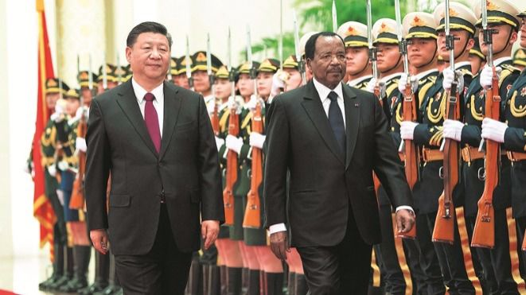
Source: Authors collection, March, 2026
Although China does not maintain military bases in Cameroon, its growing involvement in training and defence cooperation contributes to its strategic presence in the country (Danga, 2025).
Political influence is also indirectly exercised through elite networks and development finance mechanisms. Large infrastructure loans and contracts are often negotiated at the highest levels of government, involving state-owned Chinese enterprises and Cameroonian ministries. This creates a governance environment in which strategic economic decisions are closely tied to external financing arrangements. As a result, Chinese engagement is not only economic but also deeply embedded in state planning processes, influencing national development priorities, particularly in infrastructure and industrial policy.
ECONOMIC ENGAGEMENT AND INFRASTRUCTURE DEVELOPMENTS
Chinese economic engagement in Cameroon has become one of the most transformative dimensions of Sino-Cameroonian relations since the early 2000s, although its foundations date back to earlier cooperation agreements in the 1970s and 1980s. The evolution of this engagement reflected a gradual shift from modest development assistance to large-scale infrastructure financing, resource backed investments and contractor driven construction projects. Across different periods, China has positioned itself as a key partner in addressing Cameroon’s infrastructure deficit, particularly in transport, energy, and port development, while simultaneously expanding its role in strategic sectors of the economy.
One of the earliest significant infrastructure projects linked to Chinese cooperation was the Lagdo Hydroelectric Dam, developed during the 1980s with Chinese financial and technical support. Completed during this period of consolidation, the project symbolized the growing willingness of China to participate in Cameroon’s energy sector and laid the groundwork for later large-scale hydroelectric investments (Zoubir, 2014).
The Lagdo dam was built between 1977 and 1982 by the CWE. The reservoir is located on the Benue River, in a locality 50 km from Garoua, the capital of the Northern Region in Cameroon.
Plate 2: The Lagdo Hydroelectric Dam Project on the Benue River

Source: Authors collection, March, 2026
The project increased the plant’s capacity to 80 MW and represented an early demonstration of how Chinese involvement could combine financing and technical expertise in critical public infrastructure.
From the early 2000s onwards, Chinese engagement in Cameroon entered a far more intensive phase, closely associated with China’s global “go out” strategy and the institutional expansion of the Forum on China Africa Cooperation (FOCAC). One of the most significant developments during this period was the increasing focus on transport infrastructure corridors linking major economic hubs, particularly the commercial city of Douala, the political capital Yaounde, and the emerging deep-sea port at Kribi.
A landmark project in this regard was the Yaounde, Douala Highway, one of Cameroon’s most important transport arteries. The Yaounde Douala highway was constructed by the China First Highway Engineering Corporation (CFHEC), a subsidiary of the state owned China Communications Construction Company.
Plate 3: Yaounde, Douala Highway constructed by the China First Highway Engineering Corporation
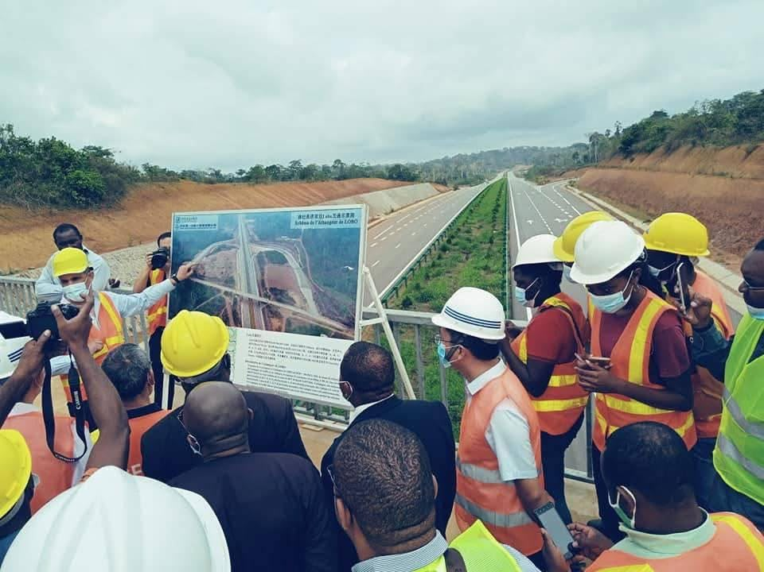
Source: Authors collection, March, 2026
The mega infrastructure project spanned roughly 196–215 km connecting the political capital to the largest port city, The first phase of this project was financed in 2012 through a preferential buyer’s credit of approximately US$482.8 million from China Eximbank, with implementation beginning in 2014 and major completion achieved around 2022. The highway, covering more than 200 kilometres in total, was designed to reduce congestion between Cameroon’s political and economic centres and improve national logistics efficiency (Aid Data, 2012). The project illustrates the growing role of Chinese policy banks in financing large-scale infrastructure through long-term loan arrangements tied to Chinese construction firms and contractors.
Closely linked to this transport corridor is the development of the Kribi Deep Sea Port, one of the most strategic infrastructure investments in Cameroon’s modern history. The Kribi Deepwater Port in Cameroon is a mega-infrastructure project built by the state-owned China Harbour Engineering Company (CHEC). Financed largely by the Export-Import Bank of China, the port transforms the remote town of Kribi (Mboro area) into a major maritime logistics hub for Central Africa The first phase of the port was completed in 2014 and became operational in 2018, significantly expanding Cameroon’s maritime capacity and reducing pressure on the congested port of Douala (Xinhua, 2022). The second phase, financed in part by approximately US$524 million in Chinese credit approved in 2017, further expanded container capacity, oil terminals, and bulk cargo handling facilities (Aid Data, 2017).
Plate 4: The Kribi Deep Sea Port built by the state-owned China Harbour Engineering Company
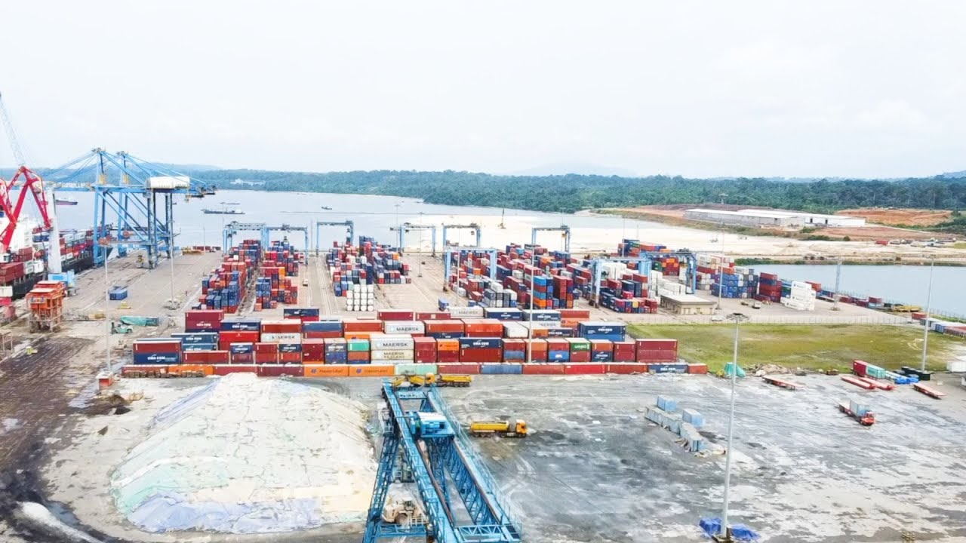
Source: Authors collection, March, 2026
The port has been widely described as a potential logistics hub for Central Africa, serving not only Cameroon but also landlocked countries such as Chad and the Central African Republic (SCMP, 2024).
Beyond transport infrastructure, Chinese engagement has also extended significantly into the energy sector, particularly hydroelectric power generation. One of the most notable projects is the Memve’ele Hydroelectric Dam. The Memve'ele Hydroelectric Power Station, located on the Ntem River in the Southern Region of Cameroon, close to Equatorial Guinea, is a diversion-type hydropower station. Construction began in the early 2010s with Chinese financial and technical participation.
Plate 5: An aerial view of Cameroon Memve'ele Hydroelectric Power Station.
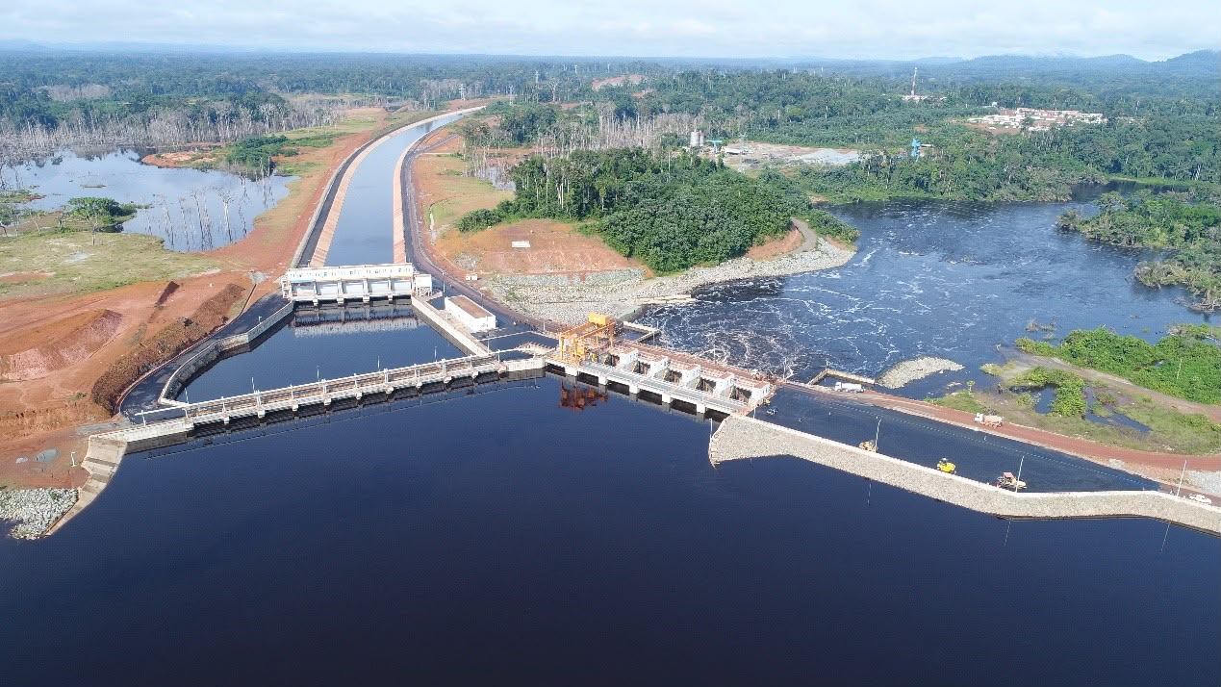
Source: Authors collection, March, 2026
The dam became operational in the late 2010s. Alongside earlier projects such as Lagdo, Memve’ele reflects China’s long-term role in expanding Cameroon’s electricity generation capacity and addressing chronic energy shortages that have constrained industrial development (Zoubir, 2014).
By the mid-2010s and into the 2020s, Chinese involvement in Cameroon had expanded beyond individual projects into a broader infrastructure system shaped by the Belt and Road Initiative (BRI). Although Cameroon did not formally join the initiative until later in its development, Chinese investments increasingly reflected BRI-style principles of connectivity, logistics integration, and regional trade facilitation. Major corridors linking Yaoundé, Douala, Kribi, and northern trade routes towards Chad illustrate this strategic orientation.
More recently, Chinese firms have also been involved in Cameroon’s telecommunications and digital infrastructure. Companies such as Huawei and ZTE have contributed to the expansion of mobile networks, fibre-optic systems, and digital connectivity projects. In a historic business opportunity visit to China in 2017, Paul Biya spoke with Peng Song, the North Africa Director of Huawei. Their diplomacy examined the Chinese operator's action for the development of Cameroon's digital economy. Both concluded investments focused in particular on the extension of the national fibre optic network, rural solar electrification, the national video surveillance plan and underwater fibre. During this historic visit, Biya noted:
"My visit to your premises demonstrates our cordial desire to continue the cooperation between my country and your company”
The president of Cameroon, His Excellency Paul Biya also mentioned the effective cooperation between Huawei and Camtel. He took this opportunity to reiterate Cameroon’s willingness to support the operation of Huawei Cameroon.
On June 27, China United Network Communications (China Unicom) signed an agreement with Cameroon Telecommunications and Huawei Marine Networks to establish the South Atlantic Inter Link, or SAIL. The SAIL cable network will span 6,000 kilometers to link the continents of Africa and America. The submarine cable project is designed to possess the largest data transmission capacity between the two continents, as well as provide high-quality and reliable intercontinental telecom services.
Plate 6: President Paul Biya Signing an Agreement with the North Africa Director of Huawei during the Sino-Africa summit on June 27, 2017
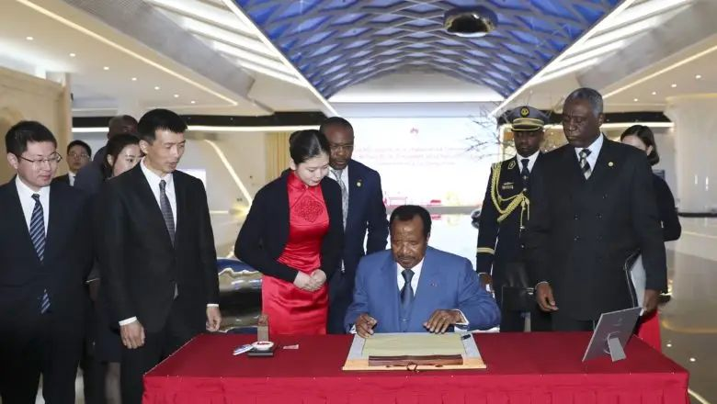
Source: Authors collection, March, 2026
These investments are part of a broader shift towards digital infrastructure development, which has become increasingly important in Cameroon’s national development strategy in the 2010s and 2020s. While these projects have improved connectivity, they have also raised concerns regarding technological dependence and cyber security governance, particularly given the strategic nature of digital infrastructure.
Overall, the scale of Chinese infrastructure engagement in Cameroon is now estimated in the billions of US dollars, with transport, energy, and port infrastructure representing the largest shares of investment. While these projects have undeniably contributed to addressing infrastructure deficits and improving national connectivity, they are also characterised by a high degree of external financing, contractor dominance, and debt-based funding structures. This dual reality reinforces the central argument of this study: Chinese infrastructure engagement in Cameroon simultaneously generates visible development gains while embedding long-term structural dependencies within the country’s political economy.
LABOUR RELATIONS AND ALLEGATIONS OF ABUSE AND EXPLOITATION
Labour relations within Chinese-owned and Chinese-operated enterprises in Cameroon constitute one of the most sensitive and publicly debated dimensions of Sino-Cameroonian economic engagement. While Chinese investment has contributed to job creation in construction, mining, retail, and infrastructure development, a series of high-profile incidents and recurring allegations of worker mistreatment have significantly shaped public perceptions. These controversies span sectors such as mining sites in the East, road construction projects across the country, urban retail businesses in Yaoundé and Douala, and, more recently, alleged financial crimes involving counterfeit currency operations (Weng & Hilson, 2022)..
One of the most widely reported recent incidents occurred in May 2026 at the Sino Mart supermarket in Yaounde, where a viral video showed a Cameroonian employee being violently flogged by individuals identified as supervisors or security personnel. The footage triggered national outrage, leading to the temporary closure of the establishment and the arrest of several suspects, including foreign nationals. The Minister of Labour and Social Security publicly condemned the act, describing it as a serious violation of workers’ rights and human dignity, and ordered an investigation into the circumstances surrounding the abuse. Although the supermarket later reopened, questions remain regarding accountability and enforcement of labour protections, reflecting broader concerns about workplace governance in foreign-owned enterprises.
Closely linked to this incident are broader allegations of physical abuse and coercive labour practices in Chinese-operated workplaces, particularly in informal or semi-formal sectors. Reports from civil society and media sources have repeatedly highlighted cases in which Cameroonian workers claim to have experienced physical violence, intimidation, and harsh disciplinary practices in certain Chinese-managed businesses. While such incidents are not universal across all Chinese firms, their recurrence in public discourse has contributed to a perception of unequal workplace power relations and weak enforcement of labour standards.
In the mining sector, particularly in the Eastern Region (including areas such as Bétaré Oya and Kadey), allegations of worker mistreatment are frequently intertwined with environmental and regulatory concerns. Workers in some mechanized mining sites have reportedly faced unsafe working conditions, limited protective equipment, long working hours, and disputes over wages. These conditions are exacerbated by the misinformation of mining operations, where subcontracting arrangements and ambiguous licensing structures complicate oversight. Studies on artisanal and small-scale mining in Cameroon have noted that foreign actors, including Chinese operators, often function within hybrid legal frameworks that make enforcement of labour and environmental regulations difficult (Weng & Hilson, 2022). In such contexts, labour vulnerability is closely linked to regulatory weakness rather than isolated acts of misconduct.
Similarly, in road construction and infrastructure projects, allegations have emerged regarding poor working conditions, hierarchical labour structures, and limited upward mobility for local workers. Large-scale infrastructure projects are often executed by Chinese construction firms under engineering, procurement, and construction (EPC) contracts, where managerial positions and technical roles are predominantly held by expatriate staff, while Cameroonian workers occupy lower-skilled labour positions. Critics argue that this division reinforces structural inequality within the workplace and limits meaningful technology transfer, thereby constraining long-term skills development.
A more complex and controversial dimension of labour-related allegations involves cases of financial crime and illegal economic activity, which have occasionally been linked in public discourse to foreign nationals, including Chinese actors. One widely circulated case concerns allegations of counterfeit currency production in Douala and Yaoundé, where investigations uncovered networks involved in the production and circulation of fake CFA franc banknotes. Some media reports have suggested the involvement of foreign nationals, including Chinese suspects, in these operations, although judicial processes are ongoing and outcomes remain subject to legal verification. In addition, authorities have previously dismantled counterfeit currency networks operating in Douala, highlighting the broader vulnerability of the financial system to organised fraud. It is important to distinguish between confirmed judicial findings and ongoing allegations, as the evidentiary status of such cases varies.
These incidents, whether related to workplace violence, mining conditions, or alleged financial crimes, have had a cumulative effect on public perceptions of Chinese economic presence in Cameroon. They have contributed to a narrative in which Chinese firms are sometimes viewed as operating with relative impunity, particularly in contexts where regulatory enforcement is perceived as weak or inconsistent. However, from a political economy perspective, it is essential to recognise that such dynamics are not solely attributable to foreign actors. Rather, they reflect broader structural issues, including institutional capacity constraints, labour inspection weaknesses, and governance challenges within Cameroon’s regulatory system.
At the same time, it would be analytically inaccurate to generalize these cases to the entire spectrum of Chinese engagement in Cameroon. Many Chinese enterprises operate within legal frameworks, comply with national labour regulations, and contribute positively to employment creation and infrastructure development. Nevertheless, the persistence of high-profile incidents and recurring allegations underscores a critical tension in Sino-Cameroonian labour relations: the coexistence of developmental contributions with contested labour practices and uneven enforcement of workers’ rights.
CONCLUSION
The evolution of Sino-Cameroonian relations between 1971 and 2026 reveals a deepening and increasingly complex partnership that spans diplomacy, infrastructural developments, trade, mining, security, and cultural exchange. China has emerged as one of Cameroon’s most important external partners, providing substantial financial resources and technical expertise that have contributed to visible improvements in national infrastructure and economic activity. However, this article has also demonstrated that these developmental gains coexist with significant structural challenges. Issues such as illegal mining, environmental degradation, labour disputes, trade imbalances, limited technology transfer, and reliance on external financing highlight persistent asymmetries within the relationship. While China presents its engagement as South-South cooperation grounded in mutual benefit and non-interference, empirical evidence suggests a more uneven reality in which economic benefits are unevenly distributed and governance challenges remain significant. From a theoretical perspective, these dynamics reflect core insights from Dependency Theory and Neo-Colonial analysis, particularly the argument that development can occur alongside structural dependence rather than replacing it. Cameroon’s continued reliance on primary commodity exports and external infrastructure financing reinforces patterns of unequal exchange within the global economy. At the same time, the absence of direct political control distinguishes this relationship from classical colonialism, suggesting a more complex form of influence mediated through finance, trade, and institutional cooperation. Ultimately, the central challenge is not whether China is inherently beneficial or harmful, but whether Cameroon possesses the institutional capacity to regulate external engagement in a way that maximizes national development outcomes while safeguarding sovereignty, environmental sustainability and labour rights.
POLICY RECOMMENDATIONS
To address the structural challenges identified in this study, particularly in mining governance, labour protection, and foreign investment regulation, the following policy measures are recommended to the Cameroonian government.
Firstly, Cameroon should strengthen mining governance and enforcement systems by fully digitizing mining license issuance and creating a transparent, publicly accessible national mining registry. This would reduce opportunities for illegal mining and improve oversight of both domestic and foreign operators. Additionally, the government should reinforce the operational capacity of the Ministry of Mines, Industry and Technological Development, including increased funding for field inspections, environmental monitoring, and enforcement units. Recent enforcement actions under interim Minister Dr. Fuh Calistus Gentry demonstrate that political will can curb illegal mining, but such interventions must be institutionalized rather than episodic to ensure long-term effectiveness.
Secondly, the government of Cameroon should implement stricter environmental compliance mechanisms for mining companies, including mandatory environmental rehabilitation bonds, periodic environmental audits, and stronger penalties for non-compliance. Mining operations in ecologically sensitive regions, particularly in the East (Lom-et-Djérem and Kadey divisions), should be subject to enhanced monitoring due to their high vulnerability to deforestation and water contamination. Also, the government should adopt and enforce local content policies in mining, construction, and infrastructure sectors. These policies should ensure increased participation of Cameroonian firms in supply chains; compulsory skills transfer programmes, and gradual localisation of technical and managerial positions within foreign enterprises. This is essential for reducing dependency and strengthening domestic productive capacity.
Furthermore, the government of Cameroon should strengthen labour inspection systems and workplace protection frameworks, particularly in foreign owned enterprises. This includes increasing labour inspectorate capacity, improving enforcement of the Labour Code, and establishing independent grievance mechanisms for workers in mining, construction, and retail sectors. Recurring labour disputes in foreign enterprises highlight gaps in enforcement rather than isolated incidents. To strengthen this aspect, the Cameroon state authorities should pursue a diversified industrial policy aimed at reducing reliance on raw material exports by promoting domestic processing of minerals, agricultural products, and timber. This would help shift the economy away from extractive dependency and enhance value addition within national borders, addressing a key concern raised in dependency theory literature.
Finally, the government should strengthen debt transparency and parliamentary oversight for all major infrastructure loans and public-private partnerships. Given the scale of externally financed infrastructure projects, public disclosure and independent review mechanisms are necessary to ensure alignment with long-term national development priorities and fiscal sustainability. Collectively, these reforms would enable Cameroon to better manage its relationship with China and other external partners in a way that strengthens sovereignty, promotes sustainable development, and reduces structural dependency.

SOURCES CONSULTED
Bone, M. China and Cameroon’s evolving political and military cooperation. Yaounde: The Diplomat, 2020.
Cameroon News Agency. Over 100 million FCFA in counterfeit banknotes seized in Douala. Cameroon: Cameroon news agency, 2025.
Danga, M. J. “Dynamics, contours and foundations of Sino-Cameroonian military cooperation”. Journal of Sino-African Studies (2025): 1971–2021
Frank, A. G. Capitalism and underdevelopment in Latin America. Monthly Review Press, 1967.
Mudoh, P. “Assessment of China’s foreign aid for Cameroon in 2009–2020”. Acta Politica Polonica, 53, (2022): 101–126.
Nguepjouo, D. “The specialization of China’s presence in Cameroon: The case of the mining sector”. The Extractive Industries and Society, 4(3), (2017): 513–524.
Nkrumah, K. Neo-colonialism: The last stage of imperialism. Ghana: Thomas Nelson & Sons, 1965.
Nshimbi, C. “Artisanal Mining Governance and Environmental Impacts in Central Africa”. African Geographical Review. 3 (2020): 23-34
Onana Ntsa, F. “Le Patrimoine Culturel des Relations Sino-Camerounaises”. état des lieux, enjeux et perspectives, (2021): 1971–2021.
SCMP. Chinese funding keeps Cameroon’s deep seaport expansion project afloat. China: South China Morning Post, 2024.
Weng, L., & Hilson, G. “Challenges with formalizing artisanal and small-scale mining in Cameroon: Understanding the role of foreign actors”. The Extractive Industries and Society, 9, (2022): 10-46.
Xinhua. Chinese-built highway inaugurated in southwestern Cameroon. China: China News Service, 2022.
Zoubir, Y. H. “China–Cameroon relations: Fortunes and limits of an old political complicity”. Journal of Contemporary African Studies, 32(1), (2014): 67–85.

