ASSESSMENT OF PASTORAL MINISTRY EXPECTATIONS AND EXPERIENCES AMONG CATHOLIC PRIESTS OF KANO DIOCESE, NIGERIA

ABSTRACT
This study assessed pastoral ministry expectations and experiences among priests of the Catholic Diocese of Kano, Nigeria. The objective of the study was to determine the level of pastoral ministry expectations and experiences among catholic priests in Kano Diocese, Nigeria. The study was grounded on Luigi Ruller’s Psycho-Social Dynamics of Christian Vocation Theory. The descriptive survey design was adopted. The Pastoral Ministry Expectations-Experience Scale instrument was adapted and utilized for data collection. A total sample of 53 priests were sampled in the study using the census sampling technique. These samples provided the data used in the study via questionnaires administered through Google Forms. Data were analyzed using the Statistical Package for the Social Sciences (SPSS), version 27. The findings showed that most priests experience a high level of alignment between their initial expectations and their actual ministerial experiences. The study recommended that: regular workshops and retreats focusing on mental health, stress management and spiritual growth of priests;. improved welfare of priests through basic material provisions, administrative guidelines and effective conflict resolution; seminaries and formation houses should ensure holistic approaches to formation, especially guiding seminarians to achieve self awareness; and priests should be encouraged to utilize opportunities for self-development and growth beyond formal formation programs. The study therefore suggested further research with different designs and among priests of different cultures in order to offer more insights into the dynamics of pastoral ministry expectations and experiences.

Keywords: Pastoral ministry, Expectations, Experience, Catholic Priest, Kano Diocese

1.0 INTRODUCTION
Pastoral ministry expectations are the prior ideas, beliefs, and hopes that Catholic priests have about the nature, demands, and spiritual benefits of their work. These expectations are often influenced by seminary training, theological teachings, personal spirituality, cultural factors, and ecclesiastical narratives, before priests' complete immersion in the practical aspects of ministry. Willimon (2002) asserts that numerous clergy commence their career with idealistic aspirations of “serving God’s people with joy and purpose,” only to confront intricate pastoral responsibilities that test their initial anticipations. These internalized expectations can include a sense of spiritual satisfaction stemming from sacramental roles, deep ties to parishioners, theological reflection (where you get to consider theology and morals) and a strong ecclesiastical infrastructure to support development. However, if such expectations are not met or thwarted, they can have a profound impact on a priest’s emotional and spiritual health.

Globally, a priest’s starting point of expectations are inextricably linked to his calling. A considerable number of research distinguishes between intrinsic motivations such as spiritual calling; desire to serve, and extrinsic motives which may include family pressures; escape from poverty; education (Brown, 2023). In the United States for instance, surveys have shown a drop in priest satisfaction from 62% who reported being satisfied “good or better” with the state of the Church in 2002, to 36% who reported they were “not so good or poor” in 2021. This change is most marked among younger priests (Landry, 2023). The pressures on priests are high and often entail filling functions for which a number of individuals were formerly responsible, not to mention the weariness, psychological fatigue and physical fatigue that can result from handling local parish downsizing or shuttering. The case is different among older priests (Landry, 2024). All these forces contribute to dwindling priestly morale.

In Africa, a study carried out in Cameroon amongst pastors of the Presbyterian Church delves into the different types of traumas these pastors as frontline workers are exposed to, the various self-care strategies they employ to address these traumatic situations and the setbacks they experience in accessing self-care facilities and or opportunities (Anye, 2025). The findings show that these pastors are significantly exposed to trauma through the cases they handle and the physical attacks they sometimes experience in the course of their work, especially in the context of the ongoing Anglophone crisis. The findings from Anye (2025) clearly indicate that the self-care efforts of Pastors, which are most often self-dependent are often insufficient in mitigating the cumulative effects of trauma, especially in the absence of formal psychological support systems.

Whether in Africa, Asia, or the West, priests generally cultivate an idealistic understanding of the priesthood as a sacred vocation whose goal is to save souls and serve God’s people. Such notions manifest in the mission of Nigerian clergy that aim to “make positive impact” on parishioners (Barau et al, 2022). In the Filipine and Latin America, priests discover meaning in sacraments and prayer (Lopez, 2021), and Australian priests perceive the priesthood as “the greatest thing a man can do” toward the welfare of God and others (Bullivant, 2024). Many priests, and those around, presume a priest to be almost super-human in virtue and endurance. This comes out strongly in the Latin American context, but it seems relevant everywhere. Priests often internalise the idea that they cannot fail or show weakness (Lopez, 2021). While striving for holiness is integral to their vocation, the unrealistic expectation of never needing help or rest can be damaging. It therefore raises a question about how well priests are trained to manage stress, acknowledge personal limitations, and balance their lives amidst expectations. This might be said to influence their lives through pburnout and mental stress.

In the Catholic Diocese of Kano, Nigeria, and similar locales, these expectations are shaped by a mix of deep faith, community leadership roles, and, at times, social prestige, all of which can be challenged by the realities of humble service, celibacy, and intercultural ministry (Barau et al, 2022). Barau equally noted that, specific areas such as financial accountability and being "careful with women and luxury" were less strongly affirmed by parishioners, ranking lowest in positive impact. Indigenous priests in Africa, including Kano, face particular financial challenges, often struggling to solicit funds for pastoral activities and their own maintenance, unlike missionaries who had external support (Nyabera et al, 2022). Furthermore, research highlights that some priests in Homa Bay, Kenya, feel unsupported, become dictatorial, are conspicuously absent, fail to observe evangelical vows, or exhibit poor administrative skills (Nyabera et al, 2022). This suggests that unfulfilled high expectations, such as being sent for further studies or appointed to desired parishes, can also lead to giving up on ministry or engaging in incompatible activities.

Despite the growing global effort in promoting pastoral well-being and work readiness, there seems to be limited understanding of the interplay between Catholic priests' pre-conceived expectations and the way in which they relate to their experiences in the pastoral ministry. While existing literature tends to pay more attention to external stressors such as aspects of workload, burnout and institutional support, it lacks an analysis of the psychological impact of internalised assumptions about pastoral life. Unmet expectations, whether spoken or unspoken, are a significant reason for dissatisfaction between pastors and congregations. This gap presents a critical pastoral and psychological concern. As a result, this research examined the ways in which pastoral expectations among Catholic priests from the Diocese of Kano reconcile or conflict with ministerial realities. Insights from this research could contribute to more sustainable methods of discernment, formation and pastoral support. Thus, the objective of the study was to determine the level of pastoral ministry expectations and experiences among catholic priests in Kano Diocese, Nigeria.

The study was anchored on the Psychosocial Theory of Christian Vocation proposed by Rulla which is relevant for this study as it offers diagnostic tools for investigating internal conflict that clergy experience between personal dispositions and external expectations as set out by ecclesiastical institutions and cultural expectations. In a society such as Kano where priests encounter numerous layers of communal duty, spiritual stewardship, and personal identity, Rulla’s approach offers a more nuanced explanation of how the unconscious (as evidenced by reasons related to need for approval, fear of failure, and unresolved family-related issues) may affect vocational decisions and ministerial satisfaction (Rulla, Imoda, & Ridick, 1976). By unveiling these concealed psychological drivers, the paper can go beyond superficial measures of the happiness of priests to explore elements that would be indicative of vocational authenticity and resilience.

More so, even as the spiritual and pastoral characteristics of a priest are spelled out in Church documents such as Pastores Dabo Vobis, Rulla’s theory provides empirical evidence to see whether priests “have the freedom within” or whether a priest has the right emotional maturity for the job. The blending of theological anthropology and psychological assessment will help deepen research instruments that allow the researcher to delve not only into what priests are expected to be but also into how they experience and internalize expectations that impact their identity and long-term flourishing (Rulla, 1986; Egenolf, 2003).

2.0 METHODOLOGY
2.1 Research Design
This study adopted the descriptive survey design. The design is considered suitable for this study since it involves a systematic and comprehensive collection of information about the opinions, attitudes, feelings, beliefs and behaviors of people through observation, interviewing or administration of questionnaires to a representative sample of the population of interest. This design is most appropriate for the study, due to the fact that the study is conducted to assess pastoral ministry expectations among Priests of the Catholic Diocese of Kano, Nigeria without manipulating the variables.

2.2 Population of the Study
In this study, the population comprises of all Catholic priests currently serving in the Diocese of Kano, which includes diocesan and religious order priests in parishes, institutions and mission fields. Priests who were on study leaves outside the diocese and priests on mission in other dioceses or countries were included in this study. According to Auwal (personal communication, August 15, 2025), the total number of priests on mission amounts to 10, and those on study leaves amount to 5, and the number of priests currently serving in the diocese, both diocesan and religious, is 61. Therefore, the total population for this study is 76.

2.3 Sampling Procedure and Sample Size
Given the relatively small and well-defined population of 76 priests, the study employed a census sampling technique, thereby including all participants to ensure comprehensive representation. This approach offers a balanced pathway to achieving representativeness while also capturing the depth and diversity of lived experiences. This sampling strategy aligns well with descriptive design. However, only 53 priests responded to the Google Form questionnaire and submitted. Thus, the return rate was approximately 70%.

2.4 Instrumentation and Data collection Procedure
The questionnaire instrument for this study was adapted and comprised of two parts. Section A: comprising the demographic characteristics of the respondents and Section B: comprising questions about the level of pastoral ministry expectations and experiences among priests. To ensure the validity of the instrument, the researcher checked the standardized questionnaires whose validities have been verified in a number of studies and opinions from experts’ in the field of psychology assisted in correcting the adapted questionnaire to fit the need of the current study. The reliability analysis produced a Cronbach’s Alpha coefficient of 0.785 for the raw items and 0.826 for the standardized items, thus considered appropriate for data collection. Data for this study was gathered through the administration of the questionnaires designed electronically using Google Forms, which was sent directly to the respondents' email addresses and WhatsApp. Their responses were accessed by the researcher at the end of the data collection period specified.
2.5 Data Analysis Procedure
Placed on a 5-point Likert scale (1 = Strongly Disagree to 5 = Strongly Agree), data for this study was analyzed using descriptive statistics with the aid of the Statistical Package for the Social Sciences (SPSS and the result were presented in tables and statistical charts for interpretation.

3.0 RESULTS AND DISCUSSION
3.1 Demographic Characteristics of Respondents
3.1.1 Age Distribution of the Participants
The study determined the age of the participants. The findings are summarised in Figure 1.
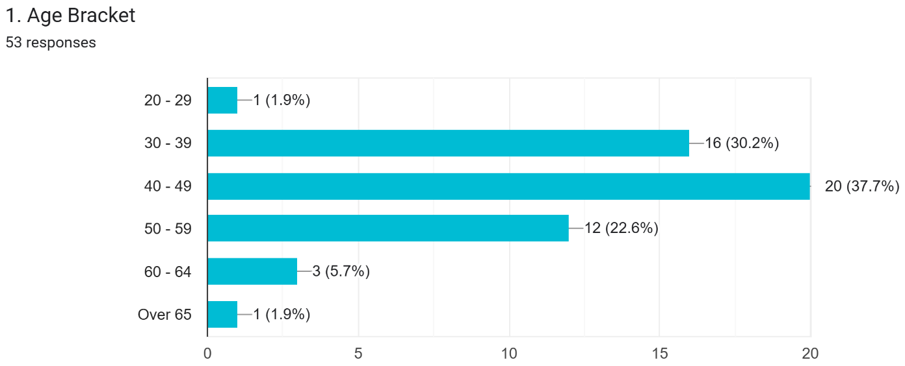
Figure 1 Age Distribution of Respondents
The age distribution of respondents in Figure 1 provides a demographic lens through which the pastoral experiences of priests in the Catholic Diocese of Kano can be understood. The data show a focus on the middle adulthood phase, which has important implications for the interpretation of ministerial expectations. The age group 40-49 years old has the highest percentage of respondents (37.7%). This group is often made up of priests who have reached a high level of vocational stability and pastoral maturity, and whose views are influenced by the pastoral pressures, administrative duties and relationship with parish communities they have experienced over the course of their ministry.

The 30–39 years cohort, comprising 30.2% of respondents, represents early to mid career priests who are transitioning from initial ministerial enthusiasm to more established pastoral identities. Their experiences are especially pertinent to the discussion of current issues in the life of the priest, such as stress, resilience and satisfaction in the ministry. The largest age group of priests is 50-59 years (22.6%). This is a group of senior clergy members with a wealth of pastoral experience, which brings in institutional knowledge and depth of expertise.

The age group 60–64 years accounts for 5.7% and the youngest (20–29 years) and oldest (over 65 years) age groups make up 1.9% each. The small proportion of these groups may be a sign of a small number of newly ordained or senior priests in the active diocesan workforce, or the result of differential participation in online surveys. This low representation does, however, provide a valuable insight into the composition of the diocese's active ministerial body as a group, which is overwhelmingly middle-aged.

In general, the age structure suggests a clergy population that is predominantly in the 30-59 age group, which is generally regarded as the most productive, responsible and demanding age group from a psychosocial perspective. The age of the respondents is very relevant to the study because it is one of the factors that affect the expectations, coping strategies and experience in priestly ministry.

3.1.2 Distribution of Duration in the Priesthood of Participants
The distribution of respondents according to their years of priesthood reveals important insights into the experiential composition of the clergy within the Catholic Diocese of Kano.

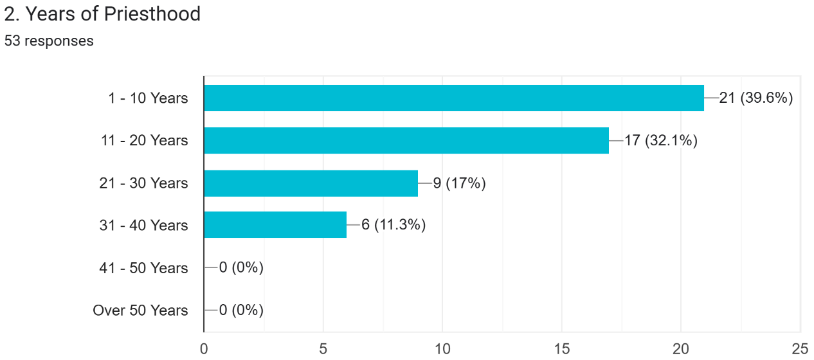
Figure 2 Duration in the Priesthood of Participants

The data in Figure 2 indicate that 39.6% of the priests have served between 1 and 10 years, making early-career clergy the largest group in the sample. This suggests a relatively young presbyterate, which may reflect a dynamic and energetic workforce, capable of responding proactively to evolving demands within the diocese. The second-largest group comprises priests with 11–20 years of ministerial experience (32.1%). Together, these two categories account for more than 70% of the respondents, indicating that the majority of priests in the diocese fall within the early to mid-career stages of their vocational path. This concentration of younger and mid-career clergy may have implications for pastoral expectations, adaptability to contemporary ministerial demands, and openness to ongoing formation initiatives.

Priests with 21–30 years of experience represent 17% of the sample, while those with 31–40 years constitute 11.3%. These groups reflect the more elderly segment of the clergy, whose accumulated pastoral experience may contribute significantly to diocesan stability and mentorship structures. Their presence, though smaller, provides an important counterbalance to the predominantly younger cohort. Notably, no respondents reported more than 40 years in the priesthood. The lack of representation from this group is itself a meaningful demographic signal, suggesting that the diocese’s pastoral workforce is largely composed of active, relatively younger priests. This demographic profile is particularly relevant to the study’s focus on pastoral ministry expectations, as years of experience often shape perceptions of ministerial demands, coping strategies, and overall well-being.

3.1.3 Primary Ministry Setting Distribution of Participants
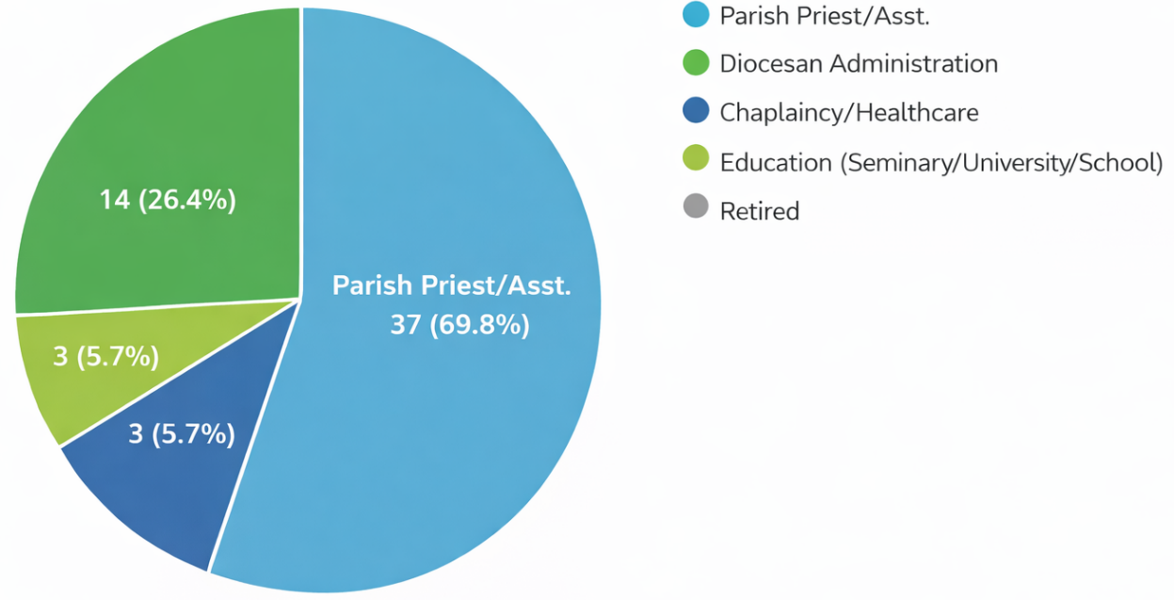

Figure 3 Primary Ministry Setting

The pie chart in Figure 3 shows the distribution of respondents across various ministry settings within the Catholic Diocese of Kano. Out of the 53 priests who participated in the survey, the Parish Priest/Assistant roles dominate the sample, accounting for 69.8% (37 respondents). This indicates that most priests in the diocese are engaged in direct pastoral ministry at the parish level, which aligns with the core structure of diocesan operations. The Education-related ministries (seminary, university, or school settings) represent 26.4% (14 respondents), reflecting a significant commitment to priestly formation and academic involvement.

Chaplaincy/Healthcare and Diocesan Administration each comprise 5.7% (3 respondents respectively), suggesting that the diocese has fewer priests assigned to specialised institutional or administrative roles. This distribution highlights the pastoral emphasis of the diocese, with a strong majority of priests serving in parish contexts. The presence of educational and specialised ministries, though smaller, suggests a diversified but parish-centred ministerial landscape.

3.2 The pastoral ministry expectations-experiences among Catholic priests in Kano Diocese, Nigeria.
The study sought to assess the level of pastoral ministry expectations and experiences of the respondents using the Pastoral Ministry Expectation-Experience Scale (PMEES). This scale pays attention to the preconceived expectations of the priests while also looking at their lived experiences in the priests in their ministry in the diocese of Kano, Nigeria.

Table 1
Level of Pastoral Ministry Expectation-Experience of Priests in Kano Diocese
Level of PMEES |  | Frequency | Percent | Valid Percent | Cumulative Percent
 | Moderate | 8 | 15.1 | 15.1 | 15.1
 | High | 41 | 77.4 | 77.4 | 92.5
 | Very high | 4 | 7.5 | 7.5 | 100.0
 | Total | 53 | 100.0 | 100.0
The results in Table 1 show that most priests in Kano Diocese experience a strong alignment between what they expected from pastoral ministry and what they now encounter in their daily priestly life. A large majority (77.4%) fall within the high level of expectation–experience alignment, indicating that their roles, spiritual life, welfare, relationships, and ministerial support generally meet their initial expectations. A smaller group (15.1%) reports a moderate level, suggesting that while their ministry remains positive, they encounter some gaps that temper their overall sense of fulfilment. Only a few priests (7.5%) report a very high level of alignment, reflecting exceptionally strong satisfaction and a deep sense of thriving in their pastoral roles. Overall, the data show that 92.5% of priests experience at least a high level of congruence between their expectations and their lived pastoral experiences, pointing to a largely positive and affirming ministerial environment in the diocese.
The researcher further conducted analysis of the data to explore the different levels of pastoral ministry expectations-experiences subscales. The results are as presented in Table 2.

Table 2

Descriptive statistics on Pastoral Ministry Expectation-Experience
Components of PMEES | N | Minimum | Maximum | Mean | Std. Dev.
Priesthood Roles | 53 | 2.40 | 5.00 | 3.8075 | .59609
Spiritual Fulfilment | 53 | 3.20 | 5.00 | 4.1434 | .45299
Welfare | 53 | 2.60 | 5.00 | 3.8491 | .48975
Priestly Relational Well-being | 53 | 3.00 | 4.60 | 3.8566 | .41764
Ministerial Support and Resilience | 53 | 2.80 | 4.80 | 3.7925 | .42601
Pastoral Ministry Expectation Experience Scale | 53 | 3.16 | 4.80 | 3.8898 | .35405

In Table 2, the consistently high mean scores across all components indicate that priests’ lived experiences tend to meet or come close to meeting their expectations. The Priesthood Roles show a relatively high mean, which suggests that priests feel largely aligned with their expected pastoral responsibilities. Their day-to-day ministerial life and duties appear to correspond well with what they anticipated before ordination. The moderate standard deviation (.596) indicates some variability, implying that while many priests feel fulfilled, a few may experience gaps between expectation and reality.

The component Spiritual Fulfilment appears to be the highest-rated component, showing that priests derive strong spiritual satisfaction from their ministry. Their prayer life, sacramental identity, and sense of divine purpose remain central sources of meaning. Welfare with a Mean = 3.85, reports generally imply positive experiences regarding welfare or material support, living conditions, and financial stability experienced by the priest. Although not as high as spiritual fulfilment, the score indicates that expectations around welfare are being reasonably met. The moderate variability suggests that some priests may still feel underserved in this area.

The component Priestly Relational Well-being reflects relationships with bishops, fellow priests, parishioners, and the wider community. The high mean indicates that priests experience supportive and healthy relationships, which are crucial for emotional and pastoral resilience. The relatively low standard deviation (.417) shows that this positive experience is fairly consistent across respondents.

The Ministerial Support and Resilience indicate a slightly lower but still strong mean, which suggests that priests feel moderately supported by diocesan structures and have developed resilience in their ministry. It may also indicate areas where institutional support could be strengthened in the form of administrative assistance or pastoral support. The overall PMEES mean (3.89), close to 4.0 demonstrates that priests’ expectations and experiences are broadly aligned. The low standard deviation (.354) indicates a high level of consistency across the sample.

Taken together, the data reveal that Catholic priests in Kano Diocese generally experience their pastoral ministry in ways that meet their expectations, especially in spiritual fulfilment and relational well-being. While some variability exists in welfare and role-related experiences, the overall pattern suggests a clergy body that is largely satisfied, spiritually grounded, and relationally supported.

3.3 Discussion of Findings
The assessment of descriptive statistics from the Kano Diocese reveals a predominantly positive alignment between Catholic priests’ pastoral ministry expectations and their lived experiences. Cumulatively, 92.5% of priests experience at least a high level of congruence between their expectations and lived reality, pointing to a largely positive and affirming ministerial environment within the Diocese. Further analysis of the Pastoral Ministry Expectation-Experience Scale (PMEES) subscales revealed consistently high mean scores across all components Notably, spiritual fulfilment emerged as the highest-rated dimension, underscoring the central role of spirituality in priests’ satisfaction and sense of purpose. While welfare and ministerial support received slightly lower, though still positive, mean scores, the standard deviations suggest some variability in these experiences, implying that while many priests feel supported and well-cared for, a subset may experience gaps in material support or institutional backing.

These findings resonate with and contradicts certain trends identified in the literature reviewed. For example, the findings of the present study contradicts those of López (2021) who found that almost 60% of Latin American priests exhibited moderate to high burnout symptoms, largely due to the crushing weight of unrealistic expectations and lack of support. But it supports Stravinskas (2021), who reported on a national survey of U.S. priests, and found that 80% would choose the priesthood again and roughly four in five expressed satisfaction with their priestly life, but also noted critical gaps in administrative preparation and support. In the African context, Nyabera (2022) and Ukwuije (2020) highlighted the challenges of overcrowded seminaries, inconsistent formators, and the disconnect between seminary ideals and parish realities—issues that, if unaddressed, can undermine priests’ sense of fulfilment and vocational identity.

The findings of this study offer meaningful insights when viewed through the lenses of Rulla’s Psycho-Social Dynamics of Christian Vocation Theory. According to Rulla, a key determinant of lasting satisfaction and well-being in religious life is the integration of the ideal self, which is shaped by religious, cultural, and personal ambitions and the real self, with its own psychological makeup and limitations (Rulla et al., 1976; Rulla, 1986). This aligns with Rulla’s assertion that unconscious motivations, emotional maturity, and the capacity for theocentric self-transcendence are crucial for vocational fulfilment (Rulla et al., 1976; Egenolf, 2003).

Furthermore, Rulla’s theory emphasises that psychological integration, emotional maturity, and authenticity are more important than external validation or perfect expectation alignment (Rulla, 1986). The findings of this present study reflects Rulla’s view that lasting vocational satisfaction is rooted in deep personal and spiritual integration rather than in surface-level congruence between expectation and experience.

4.0 CONCLUSION, RECOMMENDATIONS AND FUTURE DIRECTIONS
4.1 Conclusion
This study concludes that for priests in the Catholic Diocese of Kano, their expectations of aligns with their pastoral and ministerial roles. This underscores the central role of spirituality in priests’ satisfaction and sense of purpose. The results suggest a need to focus less on coping with external expectations and more on cultivating internal resources and external conditions that help the priests to flourish regardless of external factors.

4.2 Recommendations
Based on the findings of the study, the following recommendations are put forward:

For the Church administration, it is crucial to address the emotional and spiritual health of priests through regular workshops and retreats focusing on mental health, stress management and spiritual growth. Further, improving the well-being of priests through basic material provisions, administrative guidelines and effective conflict resolution will assist priests in their day-to-day work.

In seminaries and formation houses, a holistic approach to formation is highly encouraged. This should involve expanding the standard theological and spiritual formation to include courses on emotional intelligence, stress management, financial management and other skills needed for the effective running of churches. Seminary training should also include learning about self-awareness and authenticity, helping seminarians to develop their own identity and to be open to the challenges of ministry.

For Priests, it is important to invest in ongoing self-formation by proactively utilizing opportunities for self-development and growth beyond formal formation programs.

4.3 Limitation of the Study
While the current study significantly contributes to the body of knowledge on pastoral ministry expectations-experience, however, there were some limitations that may have affected the results. First is the small sample size of the population for this study. Increasing the size and diversity of participants from other dioceses or areas can increase the representativeness of the sample and allow for comparisons of differences. Furthermore, the questionnaire was sent via email and WhatsApp through a Google Form due to the geographical location of the researcher and the study site. Thus, those who lack access to digital devices and those in places with poor internet services were excluded from the research.

4.4 Suggestion for Further Research

In line with the limitations of the current study, the following are suggestions for future research:
- Research can extend to other geographical areas. Researchers can replicate this study in other dioceses and cultures to compare results and identify general trends that impact clergy well-being.
- Additionally, studies with longitudinal designs increase understanding of how expectations, experiences and satisfaction change over time, particularly as priests progress in their careers.
- Finally, researcher may consider including lay people’s perspectives to further enrich the finding of the current study. For instance, future research could explore the interactions between expectations and support from lay parishioners and priests' happiness and ministry effectiveness.

REFERENCES
- Anye, B. L., Oberprantacher, A., & Malagayo, R. (2025). Trauma and Self-Care in Peace Operations: The Case of Pastors of the Presbyterian Church in Cameroon (PCC), As Frontline Workers. https://diglib.uibk.ac.at/download/pdf/11563366.pdf
- Auwal, E. (August 15, 2025). Personal Communication. Office of Kano Diocesan secretary.
- Barau, L. M. (2023). Perception on the impact of the catholic priest lifestyle on parishioners in the catholic diocese of Kano. Aku: An African Journal of Contemporary Research, 4(2), 107-119. https://www.acjol.org/index.php/aku/article/view/3404
- Brown, B. E. (2023). Less virtuous than it seems: The motivations behind priestly vocations in Catholic Sri Lanka. HAU: Journal of Ethnographic Theory, 13(3), 715–735 https://researchgate.net
- Bullivant, S. (2024). ‘This Is the Greatest Thing a Man Can Do’: Vocational Journeys of Recently Ordained Catholic Priests in Australia. Religions, 15(8), 896. https://doi.org/10.3390/rel15080896
- Egenolf, P. (2003). Vocation and motivation: The theories of Luigi Rulla. The Way, 42(3), 81–93. https://www.theway.org.uk/back/423egenolf.pdf
- Landry, R. (2023). Identity and mission of the priesthood today. Catholic Preaching. https://catholicpreaching.com/wp/wp-content/uploads/2023/06/Landry-Identity-and-Mission-of-the-Priesthood-Today.pdf
- Landry, F. R. (2024, February 7). Staying strong in the priestly vocation and strengthening our brethren. Catholic Preaching. https://catholicpreaching.com/wp/wp-content/uploads/2024/02/Staying-Strong-in-the-Priestly-Vocation-and-Strengthening-Our-Brethren-1-1.pdf
- López, H. (2021). El síndrome de burnout en sacerdotes Latinoamericanos: un estudio exploratorio. Universidad de Salamanca. (Study summarized in Aceprensa article by Sánchez, A., 2022). https://aceprensa.com.
- Nyabera, J. K., Ojore, A. O., & Magesa, L. (2022). The effect of formation on priestly ministry amidst contemporary challenges in the Catholic Diocese of Homa Bay, Kenya. International Journal of Arts and Social Science, 5(9), 1-14. www.ijassjournal.com
- Rulla, L. M. (1986). Anthropology of the Christian vocation: Interdisciplinary bases. Rome: Gregorian University Press. https://ixtheo.de/Record/1092404503
- Rulla, L. M., Imoda, F., & Ridick, J. (1976). Entering and leaving vocation: Intrapsychic dynamics. Rome: Gregorian University Press. https://ixtheo.de/Record/1109826125
- Stravinskas, P. M. (2021, November 12). Happy and unhappy young priests: Analysis of a new study. Catholic World Report. (Analysis of CARA “Entering by the Narrow Gate” study) https://catholicworldreport.com.
- Ukwuije, B. U. (2020). Priestly formation in Africa in the light of the Ratio Fundamentalis Institutionis Sacerdotalis. Spiritan Horizons, 16(16), Article 17. Retrieved from https://dsc.duq.edu/spiritan-horizons/vol16/iss16/17
- Willimon, W. H. (2002). Pastor: The theology and practice of ordained ministry. Abingdon Press.

