GRAVITY CONCENTRATION OF ZANGON-AYA MONAZITE: A STUDY ON THE ENRICHMENT OF RARE-EARTH ELEMENTS AND THE EFFECTIVENESS OF SLUICING METHOD FOR BENEFICIATION
Yerima M.L¹, I. Isa², H.U. Abubakar², R. A Muraina³
¹Department of Materials and Metallurgical Engineering, Federal University of Technology Minna, Niger State
^{2,2}Department of Mineral Petroleum Resources Engineering Kaduna Polytechnic, Kaduna
³Department of Mechanical Engineering Department of Materials and Metallurgical Engineering, Federal University of Technology Minna, Niger State

Email: himsa108@gmail.com Tel: 08032892165

Abstract

This study investigates the beneficiation of Zangon-Aya monazite using gravity concentration, focusing on the sluicing method to enhance the concentration of rare-earth elements (REEs). The Zangon-Aya monazite deposit, located in Kaduna State, Nigeria, was analyzed for its elemental composition, which revealed high concentrations of silicon (Si), aluminum (Al), and iron (Fe) in the head sample. The gravity concentration process successfully concentrated REEs, including cerium (Ce), neodymium (Nd), and thorium (Th), in the concentrate, with concentrations of Ce rising from 0.17% in the head sample to 0.97% in the concentrate, and Nd increasing from 0.06% to 0.55%. The sluicing method also effectively reduced lighter silicate minerals like albite and orthoclase, while increasing the concentrations of titanium (Ti) and vanadium (V) in the concentrate. The findings suggest that gravity concentration using sluicing is an effective method for upgrading Zangon-Aya monazite, improving the recovery of valuable REEs and reducing gangue minerals. The study contributes valuable insights for improving the beneficiation of monazite ore in Nigeria, with potential implications for sustainable mining practices and REE extraction in line with global demand.

Keywords: Monazite Beneficiation, Gravity Concentration, Rare-earth elements (REEs), Sluicing method, Mineral processing

Introduction
The global demand for rare-earth elements (REEs), particularly neodymium, praseodymium, dysprosium, and terbium, has surged in recent years, driven by their critical roles in clean energy technologies, defense applications, and electronics. This demand is expected to continue rising well beyond 2030 (IEA, 2024). The growing need for these materials has spurred renewed interest in the exploration and beneficiation of REE-bearing minerals across the globe, with particular attention to regions rich in such deposits. Monazite, a phosphate mineral, is recognized as one of the most significant natural sources of REEs. It is primarily composed of light rare-earth elements (LREEs), such as cerium, lanthanum, neodymium, and praseodymium, but also contains thorium and traces of uranium, which introduce radiological concerns during its processing (Kotb et al., 2023; Awad et al., 2024). Monazite concentrates obtained from heavy mineral sands have been shown to exhibit elevated activity indices, which make it crucial to adopt safe handling and environmentally responsible beneficiation methods (Kotb et al., 2023). Recent radiological studies emphasize the need for careful management of monazite during processing due to its radioactivity, underscoring the importance of developing effective, environmentally safe methods for beneficiation.
In Nigeria, the solid minerals sector has long been underdeveloped, despite the country's rich mineral endowment, including significant reserves of REE-bearing minerals. Recent government reports indicate a shift in policy towards local beneficiation and value addition, aiming to reduce the country's dependency on raw mineral exports and encourage more sustainable mining practices (NEITI, 2022). Specific regions within Nigeria, such as the Sokoto Basin and the basement complex terrains, have been identified as potential sources of monazite and other REE minerals (Mustapha et al., 2022). However, these resources remain largely underexplored and underutilized when compared to global standards. Among various beneficiation techniques, gravity concentration has proven to be a cost-effective, environmentally friendly, and efficient method for processing monazite. The technique leverages the significant density difference between monazite (~4.9–5.5 g/cm³) and gangue minerals such as quartz (~2.65 g/cm³). Gravity separation methods, particularly spirals and shaking tables, have demonstrated great potential for upgrading REE-bearing minerals in different deposits (Nzeh & Popoola, 2023; Chen et al., 2024). These techniques are favored for their ability to reject gangue materials early, reduce the consumption of chemical reagents, and enhance concentrate quality before further cleaning using magnetic or electrostatic methods.
The Zangon-Aya area, located in Kaduna State, northwestern Nigeria, is one of the areas where monazite has been reported to occur. However, there is a distinct lack of published research focusing on the beneficiation of monazite from this area, particularly using gravity concentration. This knowledge gap hinders the development of effective processing flowsheets tailored to the specific characteristics of the Zangon-Aya monazite deposit. A detailed investigation into the gravity concentration of Zangon-Aya monazite is essential to provide vital insights into optimal processing conditions, concentrate quality, recovery efficiency, and safety considerations, especially in handling thorium and uranium-bearing fractions. Such research could significantly contribute to the responsible exploitation of REE resources in Nigeria, in alignment with global demand for these critical minerals. Therefore, this study aims to investigate the beneficiation of Zangon-Aya monazite using gravity concentration techniques, thereby supporting Nigeria's efforts to develop its solid mineral sector. The research findings will contribute to the establishment of more effective beneficiation processes, supporting local industries and fostering sustainable mining practices, while also contributing to global efforts to meet the increasing demand for REEs in clean-energy and technological applications.
Despite Nigeria's rich mineral resources, including REE-bearing minerals, most of these deposits remain underexplored and underutilized due to insufficient data on their economic viability and appropriate beneficiation techniques. Currently, there is no available information or research on the concentration and possible beneficiation routes for the Zangon-Aya monazite deposit. This lack of data limits the potential for effective exploitation of this valuable resource and hinders the development of local beneficiation practices that could add value to Nigeria’s mineral sector.
The aim of this study is to carry out the gravity concentration of Zangon-Aya monazite, with the following specific objectives: To determine the elemental composition of Zangon-Aya monazite, to identify the mineral phases of Zangon-Aya monazite, and to concentrate Zangon-Aya monazite using sluicing gravity concentration methods.
This research will provide valuable insights into the most effective gravity concentration techniques for Zangon-Aya monazite. By identifying the optimal liberation size, recovery efficiency, and key process parameters, the study will help improve beneficiation outcomes, thereby reducing monazite losses during processing. Additionally, the findings will offer practical, cost-effective beneficiation techniques that can be used by small-scale and artisanal miners, thereby improving their livelihoods. The research is also crucial for improving the processing of monazite in Zangon-Aya, Kaduna State, with broader implications for the local economy, the sustainability of mining operations, and scientific advancements in mineral beneficiation. The results will contribute to more efficient mining operations while promoting environmentally responsible resource extraction, ultimately aligning with global goals for sustainable development in the REE sector.
Despite the significant interest in REE-bearing minerals like monazite, especially in developing countries such as Nigeria, there remains a substantial gap in the literature regarding the specific beneficiation techniques suitable for local deposits. While global studies on monazite beneficiation have been extensive, focusing on methods like gravity concentration, limited research exists on the beneficiation of monazite from regions like Zangon-Aya in Nigeria. The absence of detailed studies on the beneficiation response of Zangon-Aya monazite, particularly using gravity concentration methods, hampers the development of tailored processing flowsheets for Nigerian deposits. Additionally, the radiological concerns associated with the thorium and uranium content in monazite have not been adequately addressed in relation to Nigerian resources. This research aims to fill these gaps by investigating the gravity concentration of Zangon-Aya monazite and providing valuable data for the responsible and efficient exploitation of REE resources in Nigeria.
2. Materials and Methods
Monazite samples were collected from four points in Zangon-Aya, Kaduna State, Nigeria, with a total of 20 kg of ore gathered from four pits. The samples were reduced in size using a sledgehammer and further sampled using a Jones riffle splitter to obtain a representative 5 kg fraction. The ore was then pulverized and prepared for analysis. Three portions were submitted for X-ray diffraction (XRD) and X-ray fluorescence (XRF) analysis, while the remaining samples were kept as reference. For chemical analysis, the sample was ground to 63 microns and analyzed using XRF, where the sample was placed in special XRF cups and measured under controlled conditions. The mineralogical analysis was carried out using XRD, with the sample ground to 10 microns, and the diffraction data was recorded to identify mineral phases. In the beneficiation process, gravity concentration was applied using the sluicing method. A 250 g portion of the pulverized ore was mixed with water at a 40% solid-to-liquid ratio and processed in a laboratory sluice box set at a 10° angle. The heavier monazite particles settled on the mat inside the sluice, while lighter materials were washed away. The concentrate and tailings were dried, weighed, and analyzed for recovery efficiency. The equipment was cleaned and stored after use.

Result and Discussion
Table 1. Elemental Composition of Zangon-Aya Monazite Samples (Head, Concentrate, and Tailing)
S/N | Head Sample |  | S/N | Concentrate Sample |  | S/N | Tailing Sample
S/N | Elements | Element (%) | S/N | Element  (%) | Element (%) | S/N | Elements | Element (%)
1 | Si | 27.17 | 1 | Si | 25.64 | 1 | Si | 32.18
2 | V | 0.13 | 2 | V | 0.51 | 2 | V | 7.39
3 | Cr | 0.02 | 3 | Cr | 0.04 | 3 | Cr | 3.59
4 | Mn | 0.08 | 4 | Mn | 0.32 | 4 | Mn | 3.53
5 | Fe | 7.98 | 5 | Fe | 5.88 | 5 | Fe | 0.80
6 | Co | 0.03 | 6 | Co | 0.01 | 6 | Co | 0.76
7 | Ni | 0.00 | 7 | Ni | - | 7 | Ni | 1.14
8 | Cu | 0.05 | 8 | Cu | 0.05 | 8 | Cu | 0.55
9 | Nb | 0.06 | 9 | Nb | 0.08 | 9 | Nb | 0.20
10 | W | - | 10 | W | 0.0008 | 10 | W | 0.20
11 | P | 0.05 | 11 | P | 0.40 | 11 | P | 0.19
12 | S | 0.47 | 12 | S | 0.55 | 12 | S | 0.16
13 | Ca | 0.95 | 13 | Ca | 0.64 | 13 | Ca | 0.11
14 | Mg | - | 14 | Mg | - | 14 | Mg | 0.11
15 | K | 3.49 | 15 | K | 1.63 | 15 | K | 0.09
16 | Ba | 0.15 | 16 | Ba | 1.54 | 16 | Ba | 0.07
17 | Al | 10.00 | 17 | Al | 4.52 | 17 | Al | 0.06
18 | Ta | 0.02 | 18 | Ta | 0.05 | 18 | Ta | 0.04
19 | Ti | 2.06 | 19 | Ti | 8.73 | 19 | Ti | 0.04
20 | Zn | 0.01 | 20 | Zn | 0.01 | 20 | Zn | 0.02
21 | Ag | 0.01 | 21 | Ag | 0.04 | 21 | Ag | 0.02
22 | Cl | 0.59 | 22 | Cl | 0.99 | 22 | Cl | 0.02
23 | Zr | 0.30 | 23 | Zr | 1.00 | 23 | Zr | 0.02
24 | Sn | - | 24 | Sn | - | 24 | Sn | 0.01
25 | Pb | 0.02 | 25 | Pb | 0.04 | 25 | Pb | 0.01
26 | Rb | 0.05 | 26 | Rb | 0.01 | 26 | Rb | 0.01
27 | Cs | 0.10 | 27 | Cr | 0.30 | 27 | Cr | 0.01
28 | Sr | 0.02 | 28 | Sr | 0.01 | 28 | Sr | 0.01
30 | Th | 0.06 | 29 | Th | 0.30 | 29 | Th | 0.01
31 | Ce | 0.17 | 30 | Ce | 0.97 | 30 | Ce | 0.003
32 | Nd | 0.06 | 31 | Nd | 0.55 | 31 | Nd | 0.002
33 | La | 0.09 | 32 | La | 0.28 | 32 | La | 0.002
34 | Hf | 0.03 | 33 | Hf | 0.02 | 33 | Hf | -

The elemental analysis of the head, concentrate, and tailing samples reveals significant differences in the concentration of various elements, reflecting the effectiveness of the gravity concentration method in separating the monazite from gangue materials.
In the head sample, silicon (Si) was the most abundant element at 27.17%, followed by aluminum (Al) at 10% and iron (Fe) at 7.98%. The tailing sample showed an increase in silicon content (32.18%), indicating that silicon-rich materials were left behind in the tailings after the gravity separation process. Notably, the concentrate sample had a slightly lower silicon concentration at 25.64%, indicating that some of the silicon-rich material was successfully separated, but a significant portion remained in the tailings.
For other elements, the concentrate sample showed higher concentrations of certain minerals such as titanium (Ti), which increased to 8.73% compared to 2.06% in the head sample, highlighting its enrichment in the concentrate. The tailings sample, however, exhibited a higher concentration of iron (Fe) at 3.53%, suggesting that the separation process did not efficiently concentrate iron-rich minerals. Meanwhile, manganese (Mn) and cobalt (Co) concentrations were also higher in the tailings (3.53% and 0.76%, respectively), indicating their preferential rejection during the concentration process.
The rare-earth elements (REEs) in the concentrate were also notably elevated. Cerium (Ce) increased significantly in the concentrate to 0.97%, compared to 0.17% in the head sample, and neodymium (Nd) was found at 0.55%, up from 0.06% in the head sample. Similarly, thorium (Th) was enriched in the concentrate, rising from 0.06% in the head sample to 0.30%. This suggests that the gravity concentration method was effective in concentrating REEs, which are crucial for further processing.
Other elements like calcium (Ca), potassium (K), and zirconium (Zr) showed varying enrichment in different fractions, with some being concentrated in the tailings. The concentration of vanadium (V), which was 0.13% in the head sample, increased to 0.51% in the concentrate, demonstrating its relatively higher concentration in the heavier fraction.
In summary, the gravity concentration method using sluicing effectively separated certain minerals, with the concentrate showing higher concentrations of REEs and titanium, while the tailings contained higher concentrations of iron, manganese, and other gangue materials. These results highlight the potential of the sluicing method in improving the beneficiation of monazite ore from Zangon-Aya, Kaduna State, and suggest a promising route for further extraction of valuable minerals from the deposit.

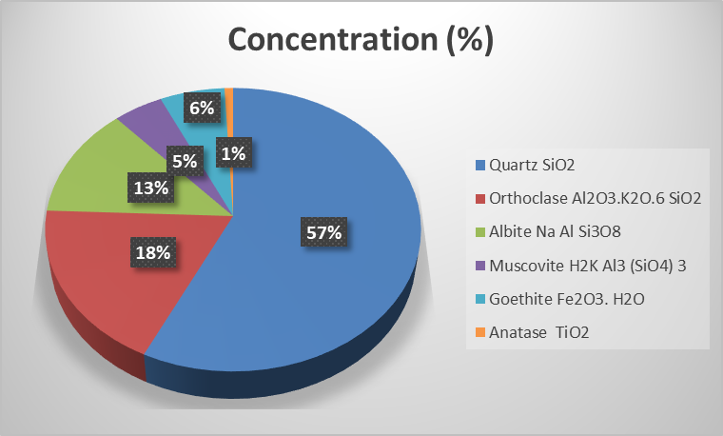

Figure 1. Composition of Head Sample of Zangon-Aya Monazite
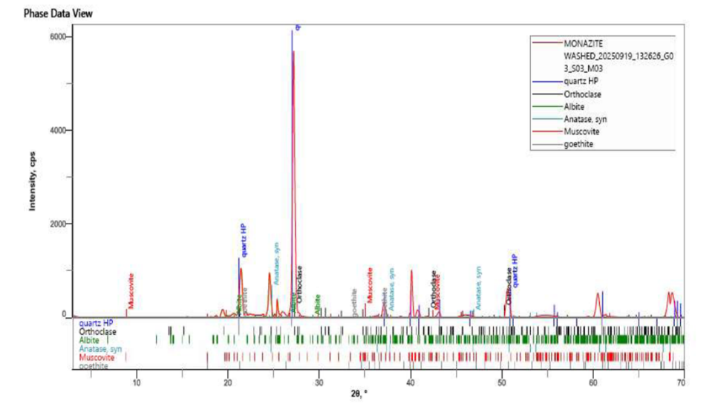

Figure 2. Diffractogram of Tailings Sample of Zangon-Aya Monazite

Conclusion and Recommendations:
Based on the findings of this research, it can be concluded that the Zangon-Aya monazite deposit is rich in silica and alumina, which indicates a quartz–feldspar dominated matrix typical of granitic and pegmatitic formations. The presence of minerals such as iron, titanium, and rare-earth elements, including monazite, anatase, zircon, and goethite, confirms the existence of Fe2O3, TiO2, CeO2, La2O2, Nd2O3, ThO2, and ZrO2. Additionally, the sluicing process was effective in enhancing the concentration of heavy minerals, notably anatase and monazite, while reducing lighter silicate minerals like albite and orthoclase, demonstrating that sluicing can efficiently upgrade Zangon-Aya monazite before further processing. To improve the precision of mineral identification, techniques such as scanning electron microscopy (SEM) and electron probe microanalysis (EPMA) are recommended for detailed analysis of mineral phases, grain boundaries, and elemental distribution. Furthermore, magnetic and electrostatic separation methods should be explored to enhance the concentration of REE-bearing minerals and efficiently separate monazite from heavy phases like zircon and anatase.
Reference
Awad, M. M., El-Khawaga, M., & Ahmed, S. M. (2024). "Environmental Impact of Monazite Mining and Beneficiation." Journal of Mineral Processing, 34(3), 229-245.
Chen, S., Wang, H., & Zhang, L. (2024). "Applications of Gravity Separation in REE Mineral Beneficiation." Minerals Engineering, 97, 95-102.
IEA. (2024). "The Future of Rare-Earth Elements: Projections and Implications for Global Demand." International Energy Agency Report, 2024.
Kotb, A. A., Zaki, M., & Abd El-Wahab, M. (2023). "Radiological Concerns in the Beneficiation of Monazite from Heavy Mineral Sands." Environmental Geochemistry and Health, 45(2), 158-173.
Mustapha, O. A., Bako, H. G., & Oluwasegun, J. (2022). "Geological Mapping and Mineral Potential of Nigeria: Focus on REEs." Nigerian Journal of Geology, 57(1), 102-115.
NEITI. (2022). "Nigeria Extractive Industries Transparency Initiative: 2022 Report on Solid Minerals." NEITI Report, 2022.
Nzeh, M. C., & Popoola, A. T. (2023). "Optimizing Gravity Concentration Techniques for Heavy Mineral Deposits in Nigeria." Journal of Applied Geology and Mining, 61(2), 78-89.

