QUANTIFYING MANGO (MANGIFERA INDICA) LEAF DISEASES

_{ABSTRACT}
Mango leaf diseases pose a significant problem for global agriculture, including the Philippines, where mango production contributes substantially to the Gross Domestic Product (GDP). This research quantifies leaf disease prevalence, determines the proportion of healthy leaves, and identifies specific diseases using Convolutional Neural Networks (CNNs), which offer image analysis accuracy exceeding 90%. A stratified sampling method a method of sampling that involves the division of a population into smaller sub-groups known as strata, was utilized using elevation as the stratification factor, was employed to ensure data reliability while minimizing the number of barangays surveyed Photographs taken in representative areas of each elevation stratum were processed using a web application to collect data Gall midge infestation was dominant at low and medium elevations, while dieback was prevalent at high, very high, and extremely high elevations. However, gall midge remained the most prevalent disease across the entire municipality, while anthracnose was the least prevalent, with an incidence rate of 0.5. This study revealed that 125 out of 200 analysed leaves exhibited disease, leaving 75 out of 200 healthy. This research also demonstrates the efficacy of Convolutional Neural Networks (CNN) in identifying mango leaf diseases. Overall, the data gathered demonstrates that lower elevations show a higher incidence of leaf diseases, while higher elevations exhibit lower rates.
Keywords: Leaf diseases, Mango, Convolutional Neural Networks, Web-based application. Elevation

INTRODUCTION
RATIONALE
Leaf diseases pose a significant challenge to farmers globally, leading to substantial losses in agricultural crop yields. The Philippines, where agriculture contributes 8.6% of the Gross Domestic Product (GDP), is particularly vulnerable to these challenges. Plant diseases, caused by various pathogens, can severely impact the quality and quantity of agricultural production, highlighting the importance of effective treatment and disease management (Kaur & Sharma, 2021).
In the municipality of Ocampo, mango is considered to be high valued crop (LGU-Ocampo, Agricultural Office). It is also the third most important fruit crop based on export volume in the Philippines, next to banana and pineapple. The mango production in the Philippines is still constrained by several problems that limit its full potential. These include impacts of climate change, pests and diseases, poor nutrition, low adoption of improved technologies, post-harvest losses that cause substantial reduction in fruit yield and quality, and lack of government regulations, reforms, and support (Department of Science and Technology).
Early detection of diseases is crucial for mitigating crop losses and promoting sustainable farming practices. Web-based applications for leaf disease identification offer a promising solution, enabling timely interventions and improving crop health. Accurate disease detection can significantly enhance crop quality and yield, leading to better financial stability for farmers (Naveen K.M., 2024). This study proposed a web-based framework for identifying leaf diseases common in Philippine crops, utilizing a machine learning method called Convolutional Neural Networks (CNNs).
The Convolutional Neural Networks (CNNs) model analyses images of plants to identify diseases by evaluating features in the images. Image processing enhances plant image quality, aiding CNN feature detection of diseases. Preprocessing, including resizing, normalization, and filtering, prepares images for consistent analysis. The CNN then detects crucial patterns and textures indicative of specific diseases. Finally, training on a diverse image set allows the model to effectively recognize various disease symptoms.
The comparison between Convolutional Neural Networks (CNNs) and traditional observation methods for identifying leaf diseases reveals significant advantages of CNNs in terms of accuracy, efficiency, and scalability. Traditional methods, primarily reliant on manual inspection, are time-consuming and prone to human error. This approach is slow and can lead to misdiagnosis, especially in cases where symptoms are not easily visible or are similar across different diseases (Metre & Sawarkar, 2022), while CNNs automate the detection process, leading to faster and more reliable diagnoses. Techniques like Convolutional Neural Networks (CNNs) have shown remarkable accuracy (up to 95%) in identifying diseases, surpassing traditional methods (Prasad et al., 2024).
Early Detection of these diseases is crucial to prevent their spread and mitigate potential damage to crops. Mango leaf diseases include anthracnose, powdery mildew, sooty mould, bacterial canker, cutting weevil, die back, and gall midge. Anthracnose, caused by a fungal pathogen, manifests as dark lesions on leaves, potentially leading to defoliation (Kulkarni and Keerthi, 2023; Garg et al., 2023). Powdery mildew, another fungal disease, presents as white powdery spots on leaves, hindering photosynthesis and overall plant vigor (Giri et al., 2023). Sooty mould, a fungal growth appearing as a black coating on leaves, often results from honeydew excreted by sap-sucking insects (Giri et al., 2023; Garg et al., 2023). Bacterial canker, on the other hand, causes sunken patches of dead bark and small holes in leaves, called ‘shothole (Bacterial Canker / RHS. n.d.). The mango Leaf-cutting weevil is native to tropical Asia where it occurs in Pakistan, India, Bangladesh, Myanmar, Thailand, Malaysia and Singapore. Mango Leaf-cutting weevil devastating pest of freshly emerged mango foliage (Plantix.net). The dieback, a common symptom or name of disease, especially of woody plants, characterized by progressive death of twigs, branches, shoots, or roots, starting at the tips (britannica.com). And lastly, gall midge, its larvae feed within plant tissue, causing abnormal plant growth called galls that can damage to mango leaves, flowers, fruit and shoots (Business Queensland.com).
Early identification of diseases allows for targeted treatments, preventing the spread of infections across crops and ensuring the maintenance of yield and quality (Naveen K.Μ., 2024). Machine learning and deep learning methods, such as Convolutional Neural Networks (CNNs) and Support Vector Machines (SVMs), have shown remarkable improvements in the accuracy of disease detection, achieving rates above 90% (S. Gomathi, et. al., 2024). Convolutional Neural Networks (CNNs), in particular, excel at recognizing complex patterns in Images, making them ideal for leaf disease detection. Some models have achieved training accuracy rates as high as 95.84% (Kumar, H., & Monik, G., 2024). The implementation of machine learning technologies can lead to more sustainable agricultural practices, ultimately benefiting the economy as a whole (Husain et al., 2024),
This research considered the impact of elevation on leaf disease, as it is relevant. The study of enset gardens in Ethiopia shows that altitude affects soil fertility and nutrient status, which in turn can influence disease prevalence. For instance, the prevalence of Xanthomonas wilt was found to be high, with altitude-related variations in soil nutrients potentially affecting disease susceptibility (Shara et al., 2021).
Other research studies focus on the accuracy of machine learning methods in disease identification. This particular research concentrated solely on identifying leaf diseases in Mango tree. It leveraged machine learning methods through a web application that will be adapted from the work of Mohammed Ezzeldean, 2024 entitled “Mango Leaf Diseases Classification” that is published in kaggle.com, as a tool for conducting the study. Additionally, the researcher will assess the leaf diseases and provide information to the agricultural sector to avoid such disease.
This study comprehensively evaluated the conditions of the specified plants by harnessing the full potential of Convolutional Neural Networks (CNNs). Through the strategic application of CNNs, this research gained a deep understanding of the health status and overall well-being of this plant. Additionally, the researcher was keen on precisely quantifying the percentage of plants exhibiting signs of poor health, thereby providing valuable information into the overall plant health in the study area.

QUESTIONS BEING ADDRESSED
This research evaluated the condition of Mango (Mangifera indica) leaves, that gained information to any identified leaf diseases. Specifically, it sought to address the following questions:
1. What are the most prevalent leaf diseases find in each elevation group: low, medium, high, very high, and extremely high.
2. What are the most and least prevalent leaf diseases overall?
3. What is the percentage of healthy and diseased leaves identified in the study?

HYPOTHESIS
NULL:
A small proportion of the mango (Mangifera indica) leaves show signs of disease.
ALTERNATIVE:
A large proportion of the mango (Mangifera indica) leaves show signs of disease.

OBJECTIVES OF THE STUDY
The primary objectives of this research are:
1. Identify the most prevalent leaf disease within each elevation group: low, medium, high, very high, and extremely high.
2. To detect the most and least prevalent leaf diseases.
3. Determine the percentage healthy and diseased mango leaves identified in the study.

METHODOLOGY
- Research Design
This research employed a Descriptive Research Design, as its primary objectives are to assess the health status of the plants and provide insights into their condition to assist the agricultural industry in mitigating the identified diseases. This design was particularly suitable for gathering detailed information about the current state of the plants, and identify the prevalent leaf diseases.
The elevation of barangays in Ocampo is the independent variable. The diagnostic results, specifically the diseases identified and the number of leaf diseases detected after image analysis, make up the dependent variable. The Convolutional Neural Networks (CNNs) designed web application is the controlled variable.
This study employed stratified sampling to divide the barangays in the municipality of Ocampo. Elevation was the stratification factor, given its impact on leaf diseases. Elevation influences climatic conditions, such as temperature and humidity, which are critical for disease development. For instance, mango anthracnose thrives under specific temperature and humidity levels, which can vary with altitude (Afzal et al., 2024).
Stratified sampling reduces variance by ensuring that each elevation stratum is adequately represented in the sample, leading to more reliable estimates of population parameters (Park et al., 2024).
Here are the elevations of the barangays, listed from lowest to highest. The lowest is Cagmanaba at 27.7 meters, and the highest is Villaflorida at 370.3 meters.
Table 1. Elevations of Barangays in lowest to highest order.
BARANGAY IN OCAMPO |  | ELEVATION in meters(m) | BARANGAY IN OCAMPO |  | ELEVATION in meters(m)
1 | Cagmanaba | 27.7m | 14 | Salvacion | 60.9m
2 | Ayugan | 30.7m | 15 | Pinit | 70.1m
3 | La Purisima Nuevo | 34.0m | 16 | New Moriones | 75.7m
4 | San Vicente | 38.7m | 17 | Hanawan | 98.7m
5 | San Antonio | 39.1m | 18 | Old Moriones | 100.8m
6 | San Francisco | 46.7m | 19 | Gatbo | 131.0m
7 | Cabariwan | 48.8m | 20 | Del Rosario | 133.9m
8 | Poblacion West | 50.0 m | 21 | San Jose Oras | 136.2m
9 | Poblacion East | 51.9m | 22 | Guinaban | 187.1m
10 | Poblacion Central | 52.0m | 23 | Santa Cruz | 203.3m
11 | Hibago | 52.9m | 24 | Santo Niño | 269.6m
12 | May-Ogob | 53.4m | 25 | Villaflorida | 370.3m
13 | San Roque Communal | 59.8m

Following stratification, the researcher selected two baranggay from each stratum representing the extreme levels the lowest and highest elevations within each group. These selected barangays will serve as representatives of their respective strata.
Therefore, the lowest elevation stratum was represented by Cagmanaba and San Antonio. The medium elevation stratum comprises San Francisco and Poblacion Central. Hibago and Pinit represent the high elevation stratum, New Moriones and Del Rosario represent the very high elevation stratum; and San Jose Oras and Villaflorida represent the extremely high elevation stratum.
The following table presents the barangays divided into five strata based on elevation, ordered from lowest to highest. Barangays in bold will represent their respective strata.
Table 2 Table of barangays arranged by elevation
Low | Medium | High | Very High | Extremely High
Cagmanaba | San Francisco | Hibago | New Moriones | San Jose Oras
Ayugan | Cabariwan | May-Ogob | Hanawan | Guinaban
La Purisima Nuevo | Poblacion West | San Roque Communal | Old Moriones | Santa Cruz
San Vicente | Poblacion East | Salvacion | Gatbo | Santo Niño
San Antonio | Poblacion Central | Pinit | Del Rosario | Villaflorida

2. Materials
This research will adapt a user-friendly web application from the work of Mohammed Ezzeldean, 2024 entitled “Mango Leaf Diseases Classification” that is published in kaggle.com, for Identifying leaf diseases. The application will leverage the power of Convolutional Neural Networks (CNNs), a deep learning technique, to analyze images of leaves and accurately diagnose diseases. Python, a versatile programming language well-suited for machine learning, will be used to build the application. To ensure the model’s accuracy, a comprehensive dataset of images depicting various leaf diseases will be used for training the CNN model. And a camera (or cell phone camera) will be used to photograph mango leaves within each elevation stratum.

3. Methods and Procedures
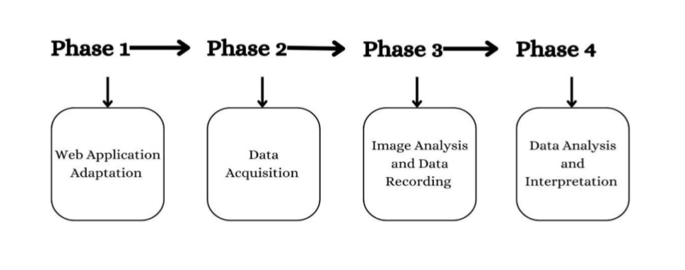
This flowchart outlines the sequential phases of this research study, illustrating the logical progression of steps required to achieve a conclusive outcome.
Figure 1. A visual representation of the research process
Phase 1: Web Application Adaptation
Using Python, the researcher adopted a web application from Mohammed Ezzeldean’s 2024 work, “Mango Leaf Diseases Classification” (published on Kaggle.com), it was deployed with the use of streamlit. This application will serve as the primary tool for image analysis and disease identification
Phase 2: Data Acquisition
The researcher visited the representative barangays from each elevation stratum. Twenty mango leaf images are collected per barangay, yielding 40 images per stratum.
Phase 3: Image Analysis and Data Recording
The collected images was uploaded individually to the adopted web application. The researcher recorded the application’s analysis results by tallying the identified diseases. The web application analysed each image by comparing it to its extensive dataset
The following images are one of the pictures from the datasets of Mohammed Ezzeldean, 2024.
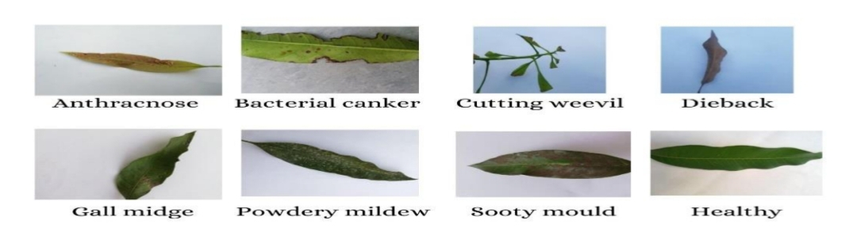
Figure 2. Example pictures from the dataset
Phase 4: Data Analysis and Interpretation
Finally, the researcher analysed the collected data on identified leaf diseases to construct information about the overall health of the mango trees per elevation level and achieving the research objectives.

RESULTS
1. What are the most prevalent leaf diseases find in each elevation group: low, medium, high, very high, and extremely high?
In the low elevation, gall midge was the most prevalent disease, accounting for 60% of diseased leaves, followed by sooty mould (20%), bacterial canker (10%), and powdery mildew (2.5%). Healthy leaves represented only 7.5% of the sample.
For the medium elevation, gall midge again dominated (27.5%), followed by dieback (15%), powdery mildew (10%), sooty mould (7.5%), and bacterial canker (2.5%). Healthy leaves comprised 37.5% of the sample.
In the high elevation, dieback emerged as the most prevalent disease (27.5%), followed by powdery mildew (15%), gall midge (10%), bacterial canker (7.5%), and cutting weevil (2.5%). Healthy leaves were 37.5% of the sample.
For the very high stratum, Dieback continued to be the most prevalent (22.5%), followed by gall midge (12.5%), powdery mildew (5%), and bacterial canker (2.5%). Healthy leaves outnumbered diseased leaves, representing 57.5% of the sample.
In the extremely high stratum, remained the most prevalent disease (27.5%), followed by powdery mildew and gall midge (both at 7.5%), bacterial canker (5%), and cutting weevil and anthracnose (both at 2.5%). Healthy leaves accounted for 47.5% of the 40 leaves sampled in this stratum.
Overall, dieback was the most prevalent disease across high, very high, and extremely high elevation strata. Gall midge was prevalent in the low and medium elevation strata.
Table 3. Percentage of healthy leaves and specific leaf diseases at each elevation group
 |  |  | Low | Medium | High | Very High | Extremely High
Healthy |  |  | 7.5% | 37.5% | 37.5% | 57.5% | 47.5%
Diseased |  |  | 92.5% | 62.5% | 62.5% | 42.5% | 52.5%
 | A. | Anthracnose | 0% | 0% | 0% | 0% | 2.5%
 | B. | Bacterial Canker | 10% | 2.5% | 7.5% | 2.5% | 5%
 | C. | Cutting Weevil | 0% | 0% | 2.5% | 0% | 2.5%
 | D. | Dieback | 0% | 15% | 27.5% | 22.5% | 27.5%
 | E. | Gall Midge | 60% | 27.5% | 10% | 12.5% | 7.5%
 | F | Powdery Mildew | 2.5% | 10% | 15% | 5% | 7.5%
 | G. | Sooty Mould | 20% | 7.5% | 0% | 0% | 0%
2. What are the most and least prevalent leaf diseases overall?
As previously stated, 62.5% of the sampled leaves exhibited signs of disease. The overall percentage of each disease was as leaf follows Anthracnose affected a minimal 0.5% of the leaves, while powdery mildew impacted 8%. Sooty mold and bacterial canker each accounted for 5.5% of the diseased leaves. A smaller percentage (1%) exhibited damage from cutting weevils. Dieback and gall midge were more prevalent, affecting 18.5% and 23.5% of the leaves, respectively.
This analysis indicates that gall midge is the most prevalent leaf disease, while anthracnose is the least prevalent among those identified.
Table 4. Overall percentage of healthy leaves and specific leaf diseases
OVERALL |  | PERCENTAGE
Healthy |  | 37.5%
Diseased |  | 62.5%
 | - Anthracnose |  | 0.5%
 | B. Bacterial Canket |  | 5.5%
 | C. Cutting Weevil |  | 1%
 | D. Dieback |  | 18.5%
 | E. Gall Midge |  | 23.5%
 | F. Powdery Mildew |  | 8%
 | G. Sooty Mould |  | 5.5%

3. What is the percentage of healthy and diseased leaves identified in the study?
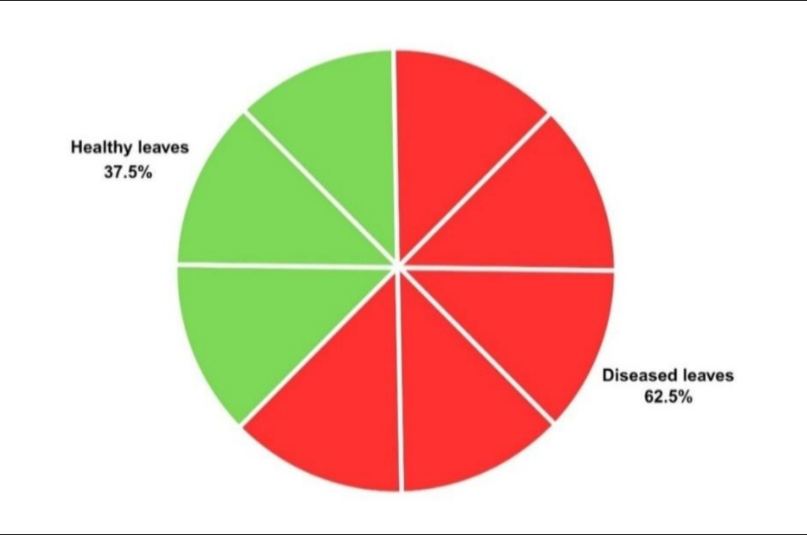
The analysis revealed a ratio of 3:5 for healthy to diseased leaves, indicating that only 37.5% (75 out of the 200) sampled leaves were healthy, while 62.5% (125 out of 200) exhibited signs of a specific leaf disease.

Figure 3. Pie chart illustrating the ratio of healthy and diseased leaves.
Examining the distribution across elevation strata, the low elevation stratum displayed the highest prevalence of diseased leaves (37), with only 3 healthy leaves identified. Medium and high elevation strata exhibited an equal proportion of diseased and healthy leaves, with 25 and 15 respectively. In the very high stratum, healthy leaves. dominated with 23, while 17 were diseased. Finally, the extremely high elevation showed a near-tie between diseased and healthy leaves, with 21 and 19 respectively.
Table 5. Quantities of healthy and diseased leaves at each elevation
 | Low | Medium | High | Very High | Extremely High | %
Healthy | 3 | 15 | 15 | 23 | 19 | 37.5%
Diseased | 37 | 25 | 25 | 17 | 21 | 62.5%

DISCUSSION
1. What are the most prevalent leaf diseases find in each elevation group: low, medium, high, very high, and extremely high?
Table 3 data revealed dieback as the most prevalent leaf disease across high, very high, and extremely high elevation strata. Published studies indicate that higher elevations experience colder temperatures and lower oxygen levels, stressing plant physiology and increasing susceptibility to dieback (Aggarwal et al., 2024). These conditions can reduce growth rates and increase mortality in plants poorly adapted to such environments. Elevation also impacts photosynthesis, crucial for tree health and resilience against dieback. While higher elevations can enhance photosynthetic performance due to increased leaf nitrogen, they may also expose trees to stressors that exacerbate dieback symptoms (Wubshet et al., 2021).
Gall midge is the most prevalent disease at low and medium elevations. Gall midges thrive in temperatures between 19-32°C, more common at lower elevations. Rainfall also significantly influences their breeding and life cycles, with optimal conditions found in these regions (Mukhopadhyay et al., 2020). Lower elevations typically experience higher temperatures and lower humidity, enhancing gall midge survival and reproduction (Blanche & Ludwig, 2001).

2. What are the most and least prevalent leaf diseases overall?
Table 4 indicates that gall midge is the most prevalent leaf disease identified. Several factors contribute to its prevalence. Gall midge infestations were notably higher in certain districts, indicating that local environmental conditions can exacerbate their prevalence(C et al., 2020). The warmer temperatures and increased aridity at lower altitudes create favourable conditions for gall midge populations, as these insects thrive in less seasonal climates that promote their reproductive success (Moreira et al., 2018). Certain mango varieties, like Alphonso, show higher susceptibility to gall 18/21 midge attacks compared to others(Gangaraju et al., 2020).
The data also show that anthracnose is the least prevalent leaf disease, occurring in 0.5% of cases. This low prevalence is attributable to certain factors. Anthracnose thrives in warm and humid conditions, which can limit its spread in cooler or drier. climates(Alberto, 2020). The tropical and subtropical climates where mangoes thrive may not always favour the conditions necessary for anthracnose development on leaves, as humidity and temperature play critical roles in fungal proliferation(Mustafa et al., 2024). Anthracnose, caused by the fungus Colletotrichum gloeosporioides, is primarily a postharvest disease affecting mango fruits rather than the leaves. Colletotrichum gloeosporioides primarily targets the fruit, where it causes visible symptoms postharvest, leading to significant losses during storage and transit(Kaviyarasi et al., 2022).

3. What is the percentage of healthy and diseased leaves identified in the study?
The findings demonstrated an inverse trend between elevation and the prevalence of leaf diseases, lower elevations exhibit higher disease incidence. This aligns with Lin et al. (2024), who suggest that soil at lower elevations harbors a greater diversity of pathogens, leading to increased disease incidence. Belachew et al. (2020) further noted that lower elevations typically have warmer temperatures and higher humidity, creating favorable conditions for fungal pathogens.
Conversely, higher elevations show lower disease prevalence. Liebig et al. (2019) found that higher elevations typically experience lower temperatures and reduced humidity, inhibiting pathogen proliferation. Studies demonstrate a decline in soil fungal pathogens with increasing elevation, contributing to lower disease incidence in plants (Lin et al., 2024).

CONCLUSION AND RECOMMENDATION
In summary, this research reveals that leaf diseases are prevalent across different elevation levels, with higher incidence at lower elevations. However, this does not imply the absence of leaf diseases at higher elevations, the frequency is simply lower than at lower levels.
This study finds that, overall, diseased leaves outnumber healthy leaves in the municipality of Ocampo.
These findings are supported by various studies offering perspectives on leaf diseases and the efficacy of convolutional neural networks. This research contributes to the understanding of leaf disease prevalence in the municipality and its relationship to elevation.
This study recommends that the web application provide solutions for identified leaf diseases. Ideally, solutions should be presented immediately following disease identification. And another leaf disease identification as well to other crops relevant to our agriculture (like rice, corn, or horseradish, etc.). Additionally, visiting all barangays within the study area is recommended to obtain more comprehensive and reliable data.

REFERENCES
- Agrawal, S., & Saklani, P. (2023). Physiological responses of the leaves of a high-altitude plant Picrorhiza kurroa to cold stress. Plant Science Today. https://doi.org/10.14719/pst.2861
- Alberto, R. (2020). Development of integrated disease management program against Anthracnose-Twister (Colletotrichum gloeosporioides-Gibberella moniliformis) disease of onion (Allium cepa). Plant Pathology & Quarantine, 10(1), 111–119. https://doi.org/10.5943/ppq/10/1/13
- Belachew, K., Senbeta, G. A., Garedew, W., Barreto, R. W., & Del Ponte, E. M. (2020). Altitude is the main driver of coffee leaf rust epidemics: a large-scale survey in Ethiopia. Tropical Plant Pathology, 45(5), 511–521. https://doi.org/10.1007/s40858-020-00383-4
- Blanche, K. R., & Ludwig, J. A. (2001). Species Richness of Gall-inducing Insects and Host Plants along an Altitudinal Gradient in Big Bend National Park, Texas. The American Midland Naturalist, 145(2), 219–232. https://doi.org/10.1674/0003-0031(2001)145
- C, M., Kumar, L. V., Navi, S., G, S., & Sanathkumar, V. (2020). Survey on the incidence of Asian rice gall midge, Orseolia oryzae (Cecidomyiidae: Diptera) in Cauvery command area. International Journal of Chemical Studies, 8(6), 1731–1735. https://doi.org/10.22271/chemi.2020.v8.i6y.11015
- Gangaraju, P., Hegde, M., Mallapur, C., & Ka, A. (2020). New report of branch gall midge (Procontarinia Sp.) on mango in Karnataka. Journal of Entomology and Zoology Studies, 8(5), 184–186. http://www.entomoljournal.com/archives/2020/vol8issue5/PartC/8-4-141-433.pdf
- Kaur, L., & Sharma, S. G. (2021). Identification of plant diseases and distinct approaches for their management. Bulletin of the National Research Centre/Bulletin of the National Research Center, 45(1).
- Kulkarni, S. B., & Keerthi, J. (2023). Mango leaf disease detection using deep learning. International Journal for Research in Applied Science and Engineering Technology, 11(8), 1203–1208. https://doi.org/10.22214/ijraset.2023.55325
- Liebig, T., Ribeyre, F., Läderach, P., Poehling, H., Van Asten, P., & Avelino, J. (2019). Interactive effects of altitude, microclimate and shading system on coffee leaf rust. Journal of Plant Interactions, 14(1), 407–415. https://doi.org/10.1080/17429145.2019.1643934
- Mohammed Ezzeldean. (2024, September 24). Mango Leaf Diseases Classification|EfficientnetB0. Kaggle. https://www.kaggle.com/code/mohammedezzeldean/mango-leaf-diseases-classification-efficientnetb0/input
- Mustafa, G., Imran, M., Nadeem, S., Ahmad, M., IQBAL, A., Ali, I., Hasnain, M., MANN, N., HUSSAIN, R., AKRAM, M., & Hamza, M. A. (2024). Management of major pre and postharvest fungal disease (anthracnose) of mango fruits – a review. Biological & Clinical Sciences Research Journal, 2024(1), 1317. https://doi.org/10.54112/bcsrj.v2024i1.1317
- Wubshet, T., Wang, Z., Yang, J., Chen, H., Schaefer, D., Goldberg, S., Mortimer, P., Lu, P., & Xu, J. (2021). Effect of elevation on photosynthesis of young mango (Mangifera indica L.) trees. Photosynthetica, 59(4), 508–516. https://doi.org/10.32615/ps.2021.040

