Multifocal Malignant Proliferating Trichilemmal Tumour: A Diagnostic Imitator Beyond the Scalp
Abstract: Malignant proliferating trichilemmal tumour (MPTT) is a rare cutaneous adnexal neoplasm arising from the outer root sheath of the hair follicle and represents malignant transformation of a proliferating trichilemmal tumour. It accounts for less than 0.1% of cutaneous malignancies and most commonly presents as a solitary scalp lesion in elderly women.
A 60-year-old male presented with progressively enlarging painful swellings over the scalp and left scapular region. Histopathological examination revealed a dermal epithelial tumour showing marked cytological atypia with abrupt trichilemmal keratinization. Periodic acid–Schiff staining demonstrated diastase-resistant cytoplasmic positivity. Immunohistochemistry showed focal CD34 expression with strong nuclear p53 and increased Ki-67 labeling index.
The findings were diagnostic of malignant proliferating trichilemmal tumour. Multifocal involvement in a male patient is extremely uncommon. Recognition of trichilemmal keratinization and the use of histochemical and immunohistochemical markers are essential to distinguish MPTT from squamous cell carcinoma and guide appropriate management.
Keywords: Malignant proliferating trichilemmal tumour, scalp, scapular lesion, adnexal tumour.

Introduction:
Malignant proliferating trichilemmal tumour (MPTT) is a rare follicular adnexal neoplasm showing differentiation toward the outer root sheath of the hair follicle¹,⁸. It represents the malignant end of the proliferating trichilemmal tumour (PTT) spectrum arising from trichilemmal (pilar) cysts²,⁶. These tumours occur predominantly on the scalp and are most often reported in elderly women⁷,⁸.
Although generally regarded as a low-grade malignancy, MPTT has the potential for local recurrence as well as regional and distant metastasis⁵. Clinically and histologically, it may closely mimic squamous cell carcinoma, making accurate histopathological evaluation essential for diagnosis.
Multifocal presentation is exceedingly rare. We report a case of synchronous MPTT involving the scalp and scapular region in a male patient and highlight the characteristic histopathological, histochemical, and immunohistochemical findings important for appropriate diagnosis.
Case Details:
A 60-year-old moderately built and nourished male farmer presented with two progressively enlarging, painful swellings over the left scapular and scalp regions, present for 18 months and 3 months respectively. Each lesion measured approximately 3 × 3 cm in size. Clinically, the swellings were immobile, globular, erythematous, with areas of serous discharge, non-pinchable overlying skin and firm to hard consistency. The patient complained of throbbing pain, which was aggravated on exposure to sunlight and relieved by analgesics. There were no other underlying comorbidities.
Clinically, the lesions were provisionally diagnosed as soft tissue swellings (Figure1, figure 2). On dermatological evaluation, the scalp swelling was suspected to be a pilar cyst and the left scapular lesion was considered a probable epidermoid cyst. Ultrasonography (USG) revealed heterogeneously hypoechoic lesions, raising suspicion of a neoplastic aetiology. Fine-needle aspiration cytology (FNAC) suggested features of a malignant adnexal neoplasm, possibly of eccrine or trichilemmal origin.
The patient subsequently underwent wide local excision of both lesions, followed by skin grafting at the affected site. The resected specimens were then submitted for histopathological examination to confirm the diagnosis.
Gross Findings:
- Left Scapular lesion: A skin-covered soft tissue mass measuring 4 × 3 × 3 cm. The external surface showed erosion. The cut surface showed grey-white, firm mass measuring 3 × 1.8 × 2.8 cm, located 0.3 cm from the superior and inferior margins, 0.2 cm from the skin surface, and 0.5 cm from the deep resected margin. The overlying skin showed grey-brown discoloration (Figures 3 and 4).
- Scalp lesion: A partially skin-covered soft tissue mass measuring 3.5 × 3.3 × 2 cm, with surface erosion (3 × 3 cm) and rim of surrounding skin. On sectioning, an irregular grey-white solid mass measuring 3 × 2.5 cm with foci of haemorrhage was identified. The tumour was abutting the anterior and superior margins and located 0.1 cm from the inferior margin, 0.3 cm from the deep margin and 0.5 cm from both lateral and medial margins. (Figure 5, figure 6)
Microscopic Findings:
Sections studied show skin and subcutaneous tissue with a tumor in the dermis, composed of interlacing trabeculae, cords and lobules of tumor cells. These cells display moderate to marked pleomorphism, abundant eosinophilic cytoplasm and vesicular pleomorphic nuclei with prominent nucleoli (Figures 7, 8, and 9). Mitosis 5-6 per 10 high-power fields. The tumor is invaginated by the sclerotic collagen bundles. Margins are infiltrative, with focal extension into the overlying epidermis. Abrupt keratinization, areas of necrosis, stromal desmoplasia and a mixed inflammatory infiltrate comprising lymphocytes, plasma cells and eosinophils are noted. Evidence of vascular invasion is seen.
Diffuse cytoplasmic PAS positivity resistant to diastase digestion indicates trichilemmal keratinization (Figure 10). Immunohistochemistry showed focal cytoplasmic CD34 positivity supporting outer root sheath differentiation, diffuse strong nuclear p53 positivity (Figures 11, figure 12) and nuclear Ki-67 positivity indicating heightened proliferative activity (Figure 13). Based on histomorphology and immunohistochemistry, a final diagnosis of malignant proliferating trichilemmal tumour was rendered.
Discussion
Malignant proliferating trichilemmal tumour (MPTT) is an uncommon malignant adnexal neoplasm arising from a pre-existing proliferating trichilemmal tumour within a pilar cyst²,⁶,⁷,⁸. The tumour predominantly affects elderly women with a marked female preponderance²,⁷,⁸.
Histologically, MPTT is composed of atypical squamoid cells arranged in lobules, cords, and trabeculae showing nuclear pleomorphism, mitotic activity, necrosis, and infiltrative margins. A defining feature is trichilemmal-type keratinization, characterized by abrupt keratinization without formation of a granular layer, reflecting outer root sheath differentiation²,⁷,⁸. This feature is important in distinguishing MPTT from squamous cell carcinoma (SCC), which demonstrates conventional keratinization with keratin pearl formation and a well-developed granular layer.
In the present case, diffuse PAS-positive and diastase-resistant cytoplasmic staining supported trichilemmal keratinization. Immunohistochemistry revealed focal CD34 positivity indicating outer root sheath differentiation, along with strong nuclear p53 expression and an increased Ki-67 labeling index, suggesting high proliferative activity. These findings correlated with previously reported profiles of MPTT and aided in differentiating it from SCC, which typically lacks CD34 expression²,⁷,⁸.
Clinically, MPTT usually presents as a slowly enlarging scalp mass; however, rapid enlargement, ulceration, or pain may indicate malignant behaviour. Complete surgical excision with tumour-free margins is the treatment of choice. Although the prognosis is generally favourable, local recurrence (24.4%), regional lymph node metastasis (15.4%), and distant metastasis (9.2%) have been reported⁵. Given the multifocal nature of the lesions in this case, careful margin assessment and long-term follow-up are recommended.
Conclusion
This case demonstrates the characteristic histopathological and immunohistochemical features of malignant proliferating trichilemmal tumour and emphasizes the rarity of multifocal lesions occurring in a male patient. Recognition of trichilemmal keratinization and appropriate use of histochemical and immunohistochemical studies are essential for distinguishing MPTT from squamous cell carcinoma.
MPTT is an uncommon cutaneous adnexal malignancy with potential for local recurrence and metastasis. Early diagnosis, complete surgical excision with tumour-free margins, and long-term follow-up are important to ensure optimal patient outcomes.

References
- Alshaalan Z, Patel P, Routt E, Ciocon D. Proliferating pilar tumour: Two cases and a review of the literature. J Drugs Dermatol. 2021;20(12):1346.
- Headington JT. Tumors of the hair follicle: A review. Am J Pathol. 1976;85(2):479–514.
- Current Diagnosis and Treatment Options for Cutaneous Adnexal Neoplasms with Follicular Differentiation. J Cutan Pathol. 2022;22(9):4759.
- Malignant proliferating trichilemmal tumours treated with radical radiotherapy: A case report and review. BMJ Case Rep. 2017;2017.
- Mastroianni A et al. Malignant proliferating trichilemmal tumors of the scalp: A systematic review. Dermatol Surg. 2021;47(8):1078–1086.
- Sau P, Graham JH, Helwig EB. Proliferating epithelial cysts: Clinicopathological analysis of 96 cases. J Cutan Pathol. 1995;22(5):394–406.
- Ye J, Nappi O, Swanson PE. Proliferating trichilemmal tumor: Clinicopathologic analysis of 76 cases. Mod Pathol. 2004;17(9):1152–1160.
- Weedon D. Skin Pathology. 5th ed. Elsevier; 2021.

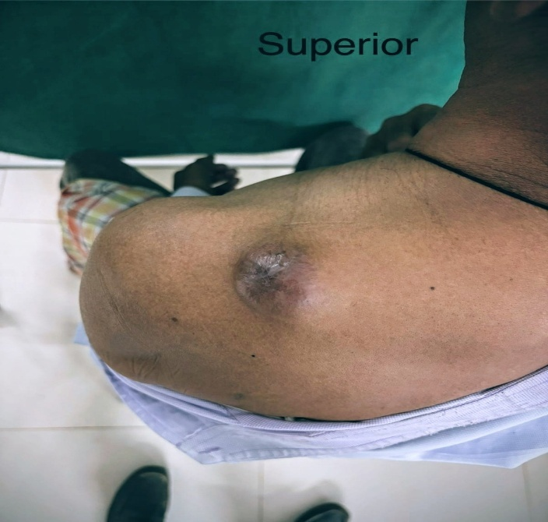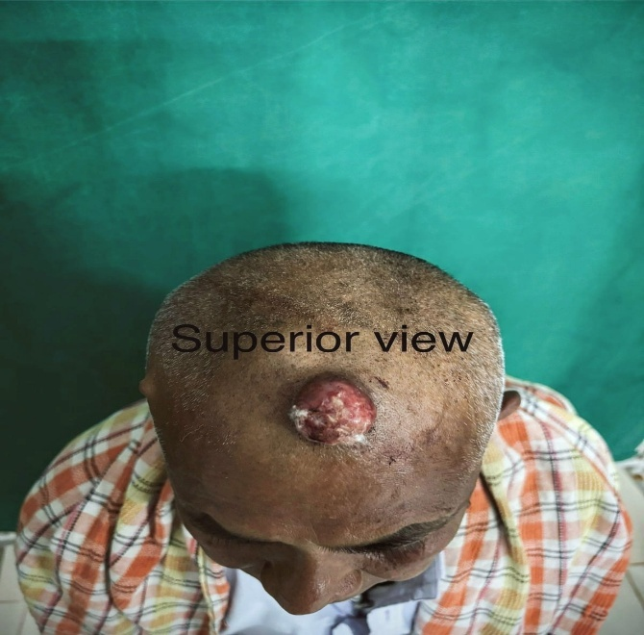
Figure 2
Figure 1
Figure 1 & 2: left scapular & scalp swelling- globular, firm to hard in consistency, painful swelling

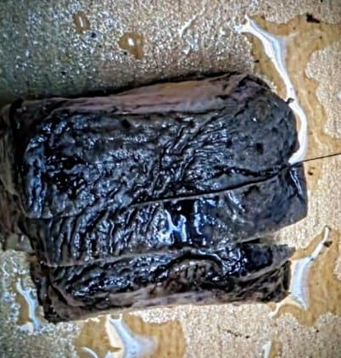
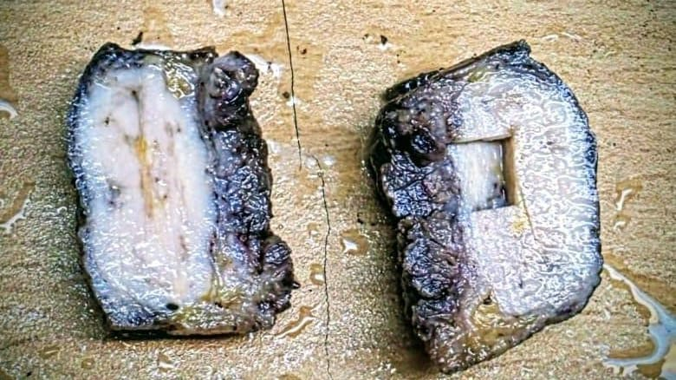
Figure 4
Figure 3
Figure 4: cut surface of from left scapular lesion showed grey-white, firm, and homogeneous, with interspersed grey-brown areas.

Figure 3: External surface of left scapular lesion showed grey-brown discoloration.

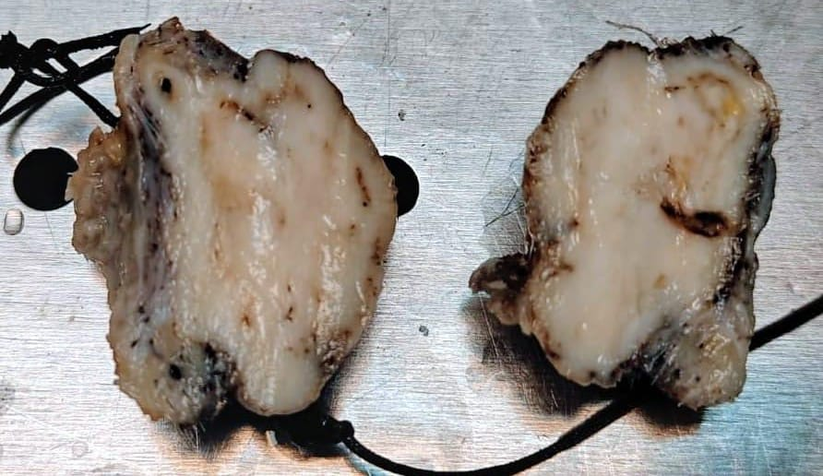
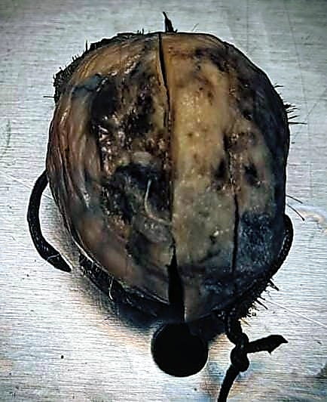
Figure 5
Figure 5: scalp lesion partially skin-covered soft tissue mass measuring 3.5 × 3.3 × 2 cm. The external surface shows an ulcerration measuring 3 × 3 cm
Figure 6: scalp lesion Sectioning showed irregular, solid, homogeneous grey-white tissue mass foci of haemorrhage
Figure 6

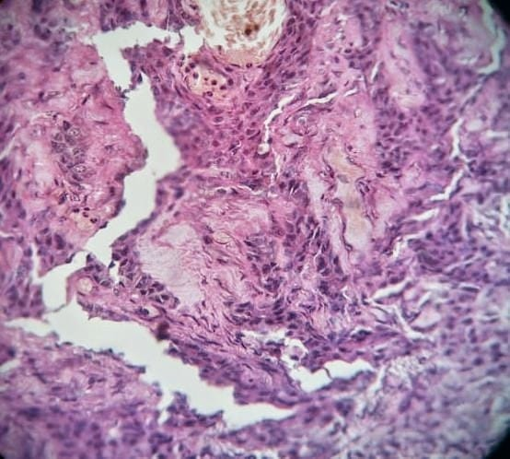
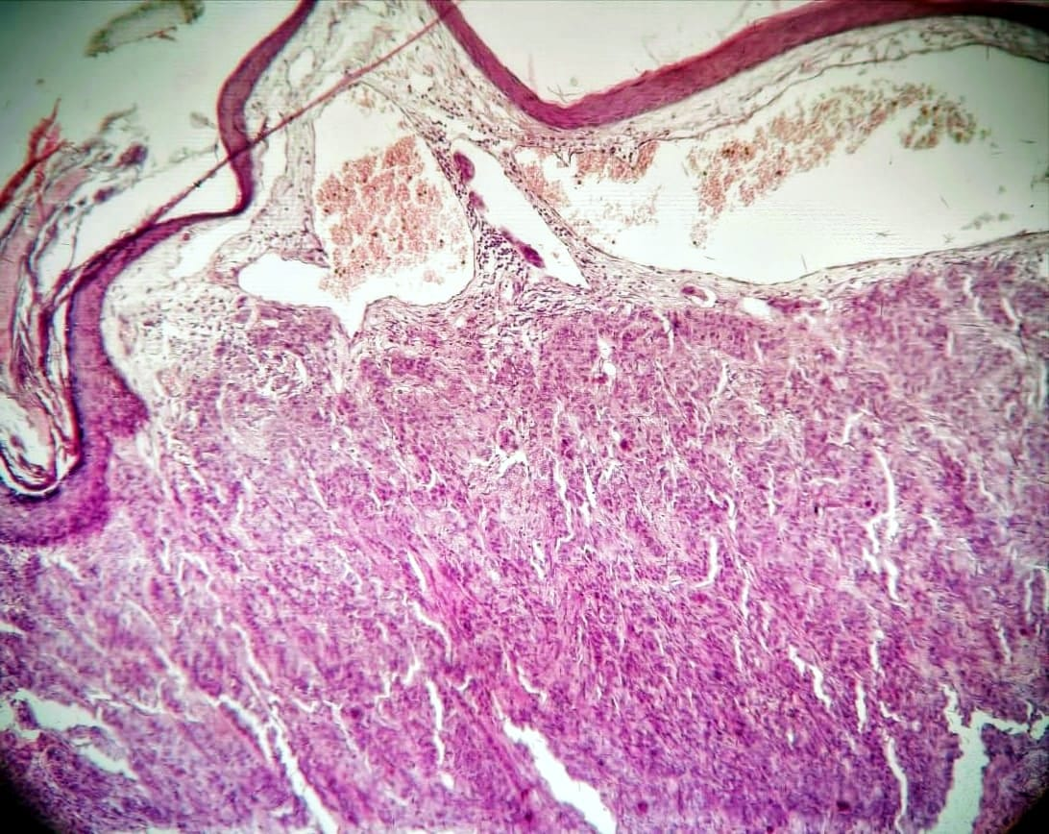
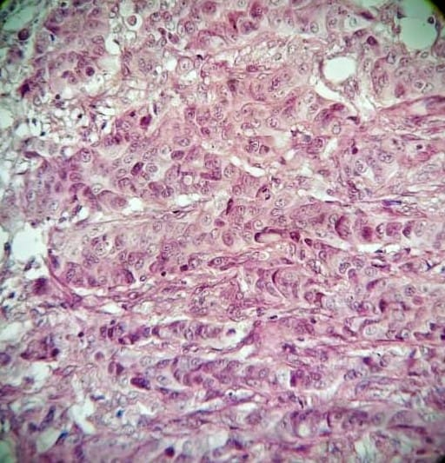
Figure 9
Figure 7
Figure 8
Figure 7: 4x H & E skin and subcutaneous tissue with a tumor in the dermis, composed of interlacing trabeculae, cords and lobules of tumor cells with intravascular tumour emboli.
Figure 8: 10x H & E Individual tumor cells are moderate to markedly pleomorphic with abundant eosinophilic cytoplasm, vesicular pleomorphic nuclei with visible nucleoli
Figure 9: 10x H & E Abrupt keratinization.

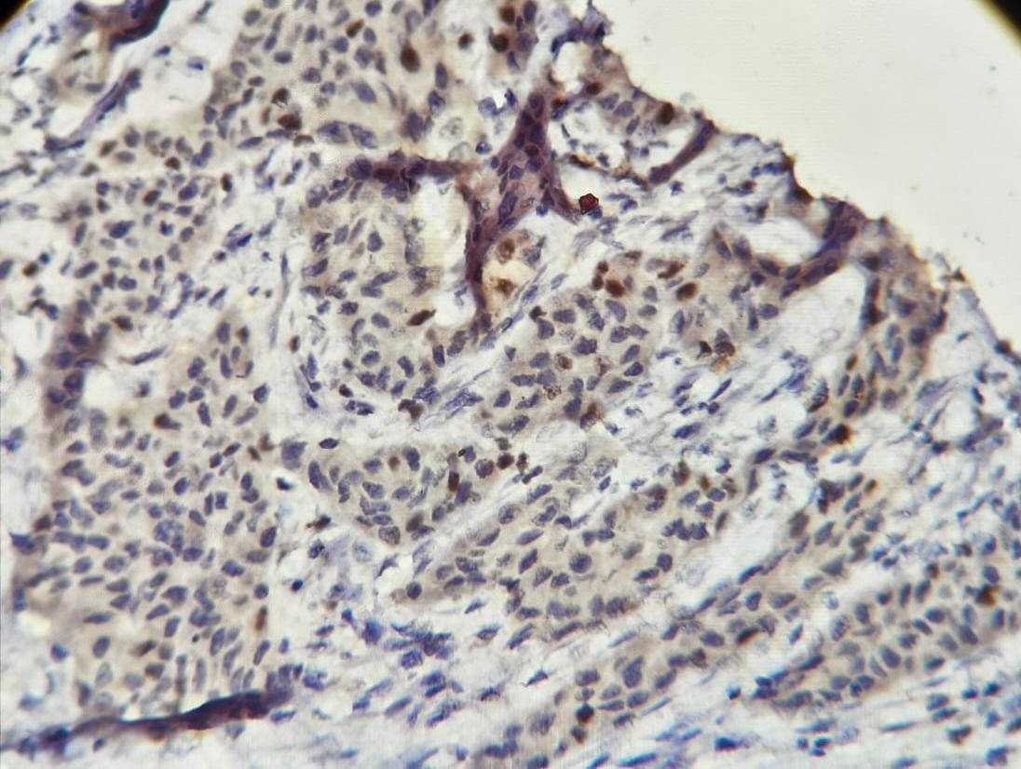
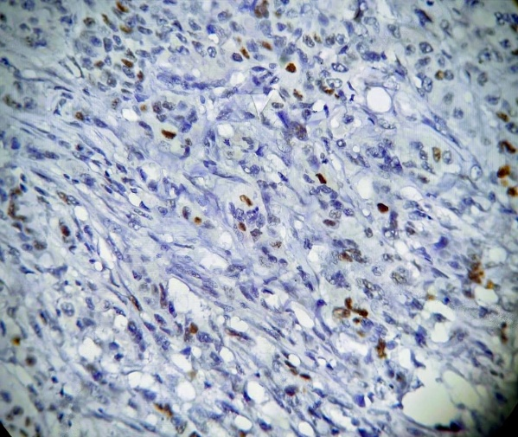
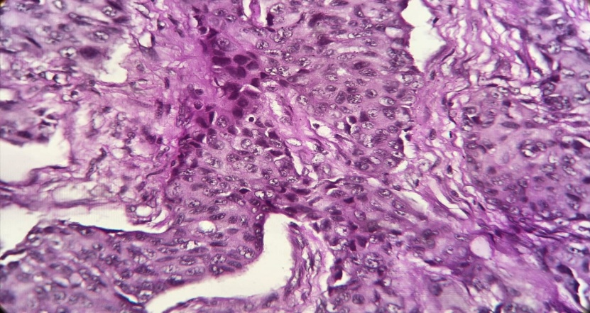
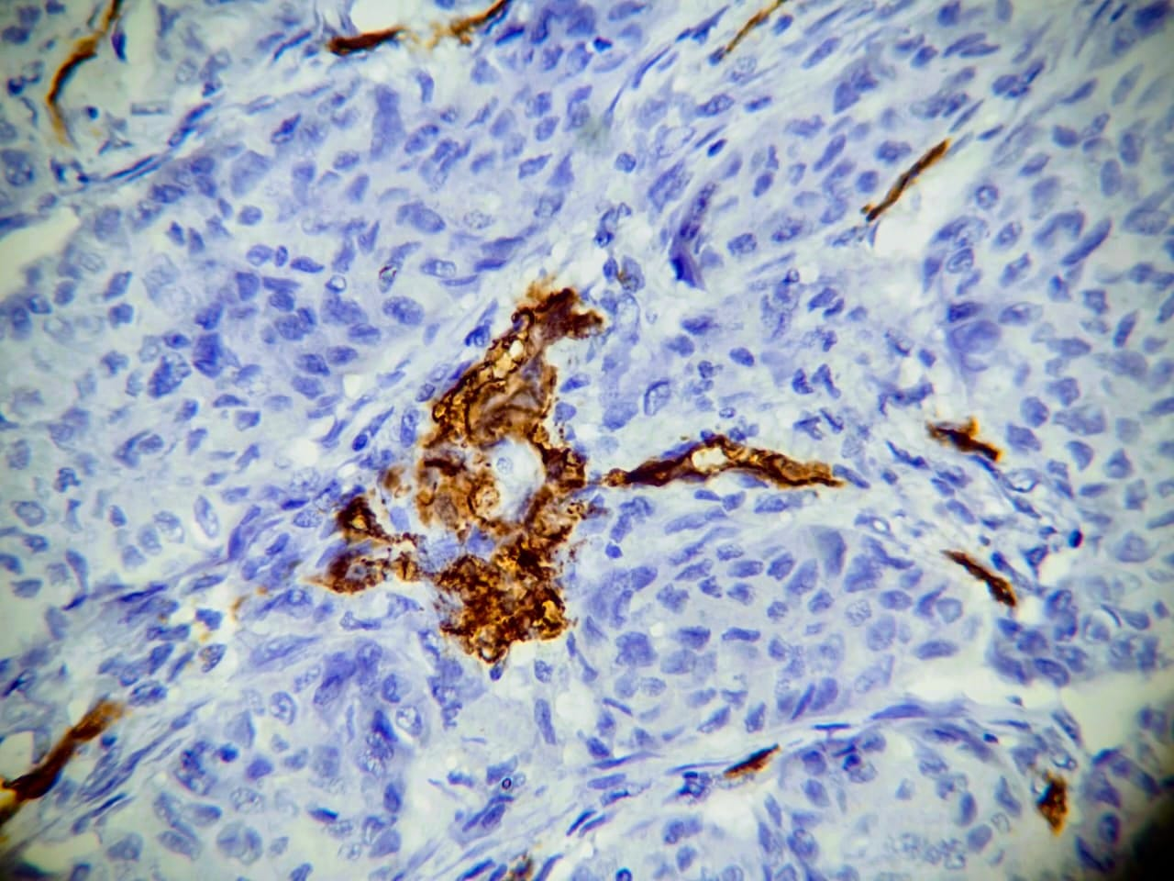
Figure 13
Figure 12
Figure 11
Figure 11: p53 immunostaining showing nuclear positivity in tumour cells, indicating malignant transformation (IHC, 10x)
Figure 12: CD34 immunostaining demonstrating focal nuclear membrane & cytoplasmic reactivity in tumour cells, supporting outer root sheath differentiation (IHC, 10x).
Figure 13: Ki-67 immunostaining showing positivity within tumour cell nuclei, highlighting proliferative activity (IHC, 10x).

Figure 10: Periodic acid–Schiff (PAS) staining demonstrated mild cytoplasmic positivity, indicating intracytoplasmic glycogen and confirming trichilemmal differentiation. (PAS, 10x).

Figure 10

