Mapping Polygraph: A Bibliometric Analysis and Evolving Scientific Trajectory

Praveen Kumar Yadav¹, Devansh Tripathi¹, Sweety Sharma^{2*}
¹LNJN NICFS, School of Forensic Sciences, National Forensic Science University, An Institute of National Importance, Ministry of Home Affairs, Govt. of India, Delhi Campus, Delhi-110085-India
² Department of Forensic Sciences, Manav Rachna University, Faridabad, Haryana,

*Corresponding Author
Dr. Sweety Sharma,
Assistant Professor,
Manav Rachna University, Faridabad, Haryana,
India
Email ID: sharmasweety511@gmail.com
ORCID: 0000-0002-7886-4672
Funding
Nil
Declaration of competing interest
None of the authors have any conflicts of interest to be declared.

Title – Mapping Polygraph: A Bibliometric Analysis and Evolving Scientific Trajectory
Abstract
The accurate detection of deception in human interactions has long been of interest across a broad array of contexts and has been studied in many fields, including psychology, communication, and law enforcement. The truth is the fundamental pillar and a vital prerequisite for serving justice to maintain the integrity of peace and harmony within society. But obtaining the truth and achieving its distinction from deception within civilized standards is what poses a challenge for all law enforcement agencies in any country. Although there has been a range of scientific techniques which can be used to detect lying by analyzing the physiological activities of the human body to aid in more efficient crime investigation and thereby serve justice, their admissibility in the court of law has become a topic of debate. Therefore, in this review, an attempt has been made to understand the underlying issues in the use of polygraph and legal issues associated with it. Recent developments in polygraph and stress detection are explored in this review paper. Furthermore, a comparison has been made with the legal position of the polygraph in India with other countries across the world using a bibliometric analysis tool.
Keyword
Lie Detection, Deception, Polygraph, and Admissibility in court of law

- Introduction
The detection of truth is at the heart of the legal process¹. However, scientists and lawyers live in different cultures with different goals. The most important goal for a scientist is to find the truth, whereas the goal for a lawyer is to get a decision from the jury. The courts and lawyers need to determine whether the accused is guilty or not, liable or not, competent or not, adult or not, insane or not, and so on, without a shadow of doubt i.e. whether the probability of certain facts is or is not high enough for a certain kind of judgement. Scientists have no special expertise on legal or policy issues. That is why courts in the past usually did not allow psychiatrists to testify on ultimate legal issues in trials following pleas of not guilty because of insanity. However, this restriction was removed by federal courts in last few decades².
Although scientists can determine error rates for methods of lie detection, the issue is not as simple as it looks. For a given situation, one might encounter two types of errors, which are false negatives and false positives. The first kind of errors, false negatives, are those types of errors in which the test results show that the person is not lying, when in fact the subject is lying. The second type of error, false positive, includes situations when the test results show that the person is lying, when in fact the subject is not lying. These error rates for different errors may vary considerably. For example, in case a prosecutor asks for the use of a lie detection technique on a defence witness to ensure the validity of an alibi of the accused, the error rate for false positives will matter more compared to that of false negatives. In another scenario, if the defendant asks for a lie detection test of the accusing witness to verify his claim of seeing the defendant running away from the crime scene, the rate of false negatives becomes more important than the rate of false positives. Therefore, it’s up to the court and lawyers to decide which error rate is the one that matters for each particular aspect of lie detection tests ^{1–3}.
The validity of a lie detection technique means its ratio of accuracy regarding the detection of deception and truthfulness. These tests often take several forms, and their validity can be measured in a number of ways. It is also important to note that these techniques rely on the assumption that the technique measures the same property with a certain degree of consistency. High reliability results in high repeatability. It is necessary for such methods to adequately measure the underlying traits; it has been designed to measure. This is known as “construct validity”. Criterion validity, another important aspect of validity, deals with the relationship between the test results and the ground truth.
All lie detection techniques, like all human cognitive behaviour, has its roots in neuroscience, but the term neuroscience-based lie detection describes newer methods of lie detection that aim to detect deception based on the information about activity in a subject’s brain. Such techniques include the most commonly used polygraph, along with other techniques such as narco-analysis and brain fingerprinting. The core issue of debate is the legality of using inhuman degrading methods to confess to the crime, as well as its self-implicating nature in many cases⁴. The regulations for the use of such techniques may vary from country to country. For example, the use of lie detection is legal in the United States, where lie detection techniques are used in a range of cases, including security screening and different criminal cases. In the upcoming sections, an attempt has been made to outline the legal issues associated with three main lie detection techniques, namely polygraph, narco-analysis, and brain fingerprinting. Furthermore, the legal statuses in different countries are also compared.
- Polygraph analysis
The polygraph, commonly called the “lie detector”, contrary to its name, does not detect lies or deception but only the psychological response that accompanies emotional reactions to guilt, shame, and anxiety. This technique relies upon the physiological actions within the body to detect deception ⁵. This technique rests its base on the psycho-somatic responses of the human body. Developed by William Moulton Marston in 1917, the first ever polygraph comprised primarily of a blood pressure cuff ^{6,7}. It was later expanded by John Larson, a police officer, in 1932 to include four measured physiological parameters: heart rate, blood pressure, respiratory rate and galvanic skin response⁶. It was also termed as the Cardio-Pneumo Psychograph, or polygraph, or lie detector⁸. The Respiratory rate, changes in blood pressure and galvanic skin responses that represent the bioelectric reactivity of the skin are the main parameters that account for the deception detection purpose herein⁹. The polygraph exam is scored on a scale of zero (no difference) to three (dramatic difference) by the examiner and is based on the degree of physiologic change from baseline¹⁰.
2.1. India
`In India, polygraph is currently used in the investigation of many criminal investigations conducted by CBI (Central Bureau of Investigation), judiciary and other law enforcement agencies at both state and national levels. It is used to verify statements, to accelerate the investigation process, scientific interrogation, and to corroborate the findings of the investigation. In a landmark judgment, the Madras High Court conveyed that the investigating agency is required to complete the investigation within a reasonable time; if not, the benefit of delay is given to the accused. If the accused fails to cooperate with the investigating process undertaken during custodial interrogation, to unravel the mystery surrounding the crime, a scientific investigation method may have to be carried out to find the truth. However, the use of deception detection techniques for criminal investigation was questioned on the grounds of fundamental rights violations, such as Article 20(3) and Article 21 in one of the Supreme Court judgments.
The legal provisions of expert evidence, in this case, the polygraph test, are presented in the Indian Constitution, the Code of Criminal Procedure (CrPC), Indian Evidence Act (IEA). In the Indian Constitution, there are various provisions which are related to the protection of the accused person. In the Constitution of India, the provisions of life, liberty and freedom have been given under Articles 20 and 21. Article 20(3) states that “no person accused of any offence shall be compelled to be a witness against himself”. Under this Article, only an accused person can avail the protection if he is compelled to be a witness against himself ⁴. Every civilized society guarantees the right against self-incrimination as a fundamental principle of fair trial in a criminal offence. According to this principle, a person accused of a criminal offence cannot be forced to incriminate himself or yield evidence against himself. It has been held that the protection is available only to the evidence which requires a volitional act on the part of the accused person, thus rendering it testimonial or communicative in nature, and it will not protect the taking of a blood sample, fingerprint, etc., from the accused. The protection would be available only from the time the person is charged with an offence; it does not extend to the pre-accusation or investigation stage if a strict interpretation of Article 20(3) is done. The immunity will not be available to a person against whom no accusation has been made when a compulsory process or notice is issued directing him under pain or penalty to produce a document, though ultimately it may incriminate him for the commission of an offence.
In the case of Sidhartha Vashist v. State ¹¹ It was held by the court that the interrelationship between the ‘right against self-incrimination and the ‘right to fair trial has been recognised in most jurisdictions as well as international human rights instruments. The guarantee of ‘presumption of innocence’ bears a direct link to ‘right against self - incrimination’ since compelling the accused person to give evidence would place the burden of proving innocence on the accused instead of requiring the prosecution to prove guilt.
In the case of M.P. Sharma v. Satish Chandra ¹², the Supreme Court has measured the principle underlying Article 20 (3) of the Indian Constitution, which says that no person accused of any offence shall be compelled to be a witness against himself. In this case, it was contended before the court that the guarantee under Article 20(3) of the Constitution against testimonial compulsion is confined only to oral evidence of a person standing his trial for an offence when he is called to the witness stand. The Supreme Court has said by rejecting this contention that there is no reason to confine the content of the Constitution guarantee to its barely literal import, and therefore, to limit it would be to rob the guarantee of its substantial purpose and to miss the substance for the sound.
In Ram Jawayya Kupar’s case ¹³ it was held by the court that in the absence of any law, any infringement in fundamental right must be struck down as unconstitutional Lie detection test comes under the general power of investigation (section 160-167, Cr.P.C) But it must be realized that it is a choice of the person to allow himself/herself to be put to Polygraph test or not and it should not be left to the discretion of police. Except it is allowed by the law, it must be illegal and unconstitutional. But if this test is conducted by the investigating authority, it must be conducted with the free consent of the person.
In Ramchandra Reddy v. State of Maharashtra¹⁴, It was held by the court that “The Lie Detector test is an examination which is conducted by various probes attached to the body of the person who is interrogated by the Expert. A baseline for this physiological characteristic is established by asking the subject questions whose answers the investigators know. Deviation from the baseline for truthfulness is taken as a sign of a lie. Consequently, there is no direct incursion of the body. In this test, the Polygraph is taken, which gives this reaction, and an expert would then explain these reactions in the Court, which would be his reading of the Polygraph from which would flow this conclusion, which are to be admitted or not admitted by a judge on appreciation of the statement and the objections raised thereto. In this case, the witness may answer or may not answer the questions. The response of his answers to questions as recorded on the Polygraph is required to be tendered as evidence when the occasion arises.”
In D.K. Basu v. State of West Bengal ¹⁵, the Honn’ble Supreme Court has emphasized on the importance of the preventing the cruel, inhuman, degrading treatment while a person is taken into custody. In the present context involuntary and forceful administration of any of the three scientific techniques like Narco-Analysis test, Polygraph test and Brain Mapping in a forensic laboratory or in a hospital, physically confining the subject will fulfill the requirement of custodial environment and thus will attract the provision under Article 20(3) and Article 21 of the Constitution. Each of the three scientific techniques causes the subject to lose his control over his responses. It is clear from the language of the Article 20(3) and Article 21 of the Constitution that the involuntary administration of the above three scientific techniques will amount to cruel, inhuman and degrading treatment in the context of Article 21.72
It has been given under Article 20(3) and Section 161(2) code of criminal procedure that, “No person accused of an offence shall be compelled to be a witness against himself” and “Such person shall be bound to answer truly all questions relating to such case put to him by such officer, other than questions the answers to which would tend to expose him to a criminal charge or to a penalty or forfeiture” respectively. In the Polygraph test, no force is used. The idea behind the protection against self-incrimination is to support a free situation in which the accused can be certain to furnish evidence in courts and be of significant aid in elucidating the truth in a case, with reference to material within their awareness and in their possession. Anything caused, by any kind of threat or inducement by a person directed towards the accused or likely to be accused of any offence, which causes him to act involuntarily and further the case against himself in any prosecution against him or which results or is likely to result in the incrimination of that person qua any offence, is violative of the fundamental right guaranteed under clause (3) of Article 20 of the Constitution of India ¹⁶
The scientific tests, like Polygraph, Narco-Analysis, Brain mapping test, etc., are now used in the investigation of a case. When such tests are conducted under the strict supervision of the expert, it cannot be said that there is any violation of the fundamental right guaranteed to a citizen of India. In the criminal justice system, forensic science occupies a very significant place, and it is admissible in the courts. Section 53(1) of Cr.P.C.(Criminal Procedure Code) provides for the medical examination of the accused by the medical practitioner at the request of the police officer. According to Sec 53(1) of Criminal Procedure Code – “when a person is arrest on a charge of committing an offence under such circumstances that there are reasonable grounds for believing that an examination of the person will afford, evidence as to the commission of an offence, it shall be lawful for a registered medical practitioner, acting at the request of the police officer not below the rank of sub-inspector, and for any person acting in good faith in his aid and under his direction, to make such an examination of the person arrested as is reasonable necessary to ascertain of the facts which through this Section, the forensic science gets an entry into the field of criminal investigation. The Amendment of 2005 made to Sec 53 of Cr.P.C. positive and protective towards the recognition of the importance of scientific tests, which include Narco-Analysis, Brain mapping, apart from others. By virtue of sec 161(2) of Cr.P.C., the legislation has protected the citizen’s rights against self-incrimination. According to Sec 161(2)-“every person is bound to answer truthfully all question, put to him by a police officer, other than the question the answer to which would have a tendency to expose that person to a criminal charge, penalty or forfeiture.” The right to silence has been granted to the accused, and no one can forcibly extract statements from the accused who has the right to keep silent during the investigation. Section 39 Cr.P.C. also casts an onerous duty upon any person to give relevant information to the police. This section, as well as other sections relating to information to investigators, has not been held unconstitutional. For an effective and efficient investigation, such a power to the investigator appears to be necessary for bringing criminals to justice. It can be easily inferred from the bare reading of the aforesaid section, along with the explanation that the term ‘examination ‘used in the explanation is very wide to include modern scientific techniques of investigation, including DNA Profiling.
  - USA
Before the last decades of the 20th century, the polygraph was used exclusively in the investigation of criminal cases. However, very soon the suspects started to refuse to take the test by challenging questions against the instrument’s validity¹⁷. In 1923, a Court of Appeals decision in the District of Columbia involving an early polygraph ¹⁸, initially ignored, but later, as scientific technology and expert testimony expanded, it was an important precedent in determining scientific evidentiary admissibility in most state and federal courts. In the late 1990’s, the polygraph began to be used in the United States by the police and for verifying the reliability of the public safety employees and managers⁹. As of 1997, State laws have tended to be less flexible. 22 states allowed polygraph evidence to some degree (usually stipulation by both parties), and 27 states plus D.C. did not allow it in criminal trials¹⁹. New Mexico is an interesting exception, having a general rule of admissibility about polygraph evidence which establishes minimum qualifications for polygraph examiners, and requires that the exam be recorded and shared with opposing counsel. Despite New Mexico's stance, major improvements in polygraph techniques, and federal court decisions that seem more flexible about the possible admission of this kind of evidence, there are still no federal courts that admit polygraph evidence substantively²⁰. Given the courts’ disappointing experiences with polygraph data, there is likely to be considerable judicial resistance³. Currently, a variety of private and government-sponsored polygraph schools are in operation, almost all of which are accredited by the American Polygraph Association. One of the most important of such schools is operated by the Department of Defence, known as the Department of Defence Polygraph Institute (DoDPI), which trains all polygraphers employed by the federal agencies.
  - South Africa
In the case of Mahlangu v CIM Deltak, which was heard before the Industrial Court, the court found that the use of voice analyst tests administered by an unregistered psychiatrist was unscientific, invalid, unethical and unlawful. This case was seen as the ground-breaking case for polygraph tests. Following the Mahlangu case, attitudes to Polygraph test evidence have followed several divergent lines:
1) Some cases have held the view that our courts do not accept the polygraph tests as reliable and admissible. Nor do they draw an adverse inference if an accused employee refuses to undergo such a test.
2) Polygraph test evidence is not admissible as evidence if there was no evidence on the qualifications of the polygraphist, and if he or she was not called to give evidence.
3) Although admissible as expert evidence, polygraph results standing alone cannot prove guilt.
4) Where there is other supporting evidence, polygraph evidence may be considered”.
However, a polygraph certainly may be considered where other supporting evidence is available, provided also that there is clear evidence on the qualifications of the polygraphist and if it is clear from the evidence that the test was done according to acceptable and recognizable standards. At the very least, the result of a properly conducted polygraph is evidence in corroboration of the employer’s evidence and can be considered as a factor in assessing the credibility of a witness and in assessing the probabilities. The mere fact that an employee, however, refuses to undergo a polygraph is not in itself sufficient to substantiate an employee’s guilt.”
3. Recent advancement in polygraph
3.1. Thermal imaging - This technology measures the skin temperature, which can be associated with lying. When an individual is lying, there is a slight increase in body temperature due to stress and anxiety. Thermal imaging is capable of detecting this change of body temperature and can be used to detect deception²². Blood flow rate can also be estimated by using the thermal videos of the interrogation, using the following formula²³.
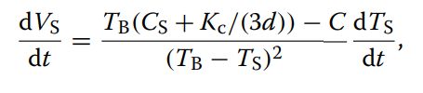
where CS = the heat capacity of skin
Vs = blood flow rate at the skin level
TB = blood temperature at the body core,
Ts = skin temperature,
Kc = thermal conductivity of skin,
d = the depth of the core temperature point from the skin surface
C = constant.
S. Satpathi et al. devised a novel method for determining the guilt of a person, which showed 89.28% accuracy using thermal video and statistical techniques^{23.} I. Pavlidis et al., also developed and designed a tested method for a polygraph method using thermal video acquisition, which achieved a correct classification rate of 84%^{24.}
Voice stress analysis - In this technique, the changes in frequency and intensity of an individual’s voice. When a person is lying, they experience stress, which can cause a change in their voice²². However, this is not considered a reliable technique because factors such as fatigue and nervousness can also affect a person's voice. The study conducted by gives light on the psychological stress and its influence on the acoustic properties of human voice²⁵. The Stroop test was done on Dutch speakers to examine the vocal features. Findings revealed that F0 (fundamental frequency) and jitter were prominent indicators of stress, and the relation between F0 and jitter was inversely proportional. Jitter being less influenced by lexical content and creating a non-verbal marker and high frequency energy showed dependency on verbal content²⁵.
Eye tracking Technology - It is based on the principle that a person's eye can reveal hidden thoughts and emotion and the pattern of eye movement maybe associated with deception. Specialized camera is present which tracks the eye movement and pupil dilation during questioning²². However, the reliability of this technique is debated. The study by Bessonova and Oboznov explores the significance of eye-tracking as a tool for the detection of lie²⁶. To differentiate between the truth and lie based on various stimulus, kinds of marker on eye movement were inferred. Study have also demonstrated that various deception parameters were additionally examined. Future scope based on types of markers across populations and integration of the advanced technology²⁶.
Photoelectric plethysmograph - the Standard tool for measuring the cardiovascular activity is sphygmomanometer with arm cuff. Similarly, we also have wrist cuff and finger cuff. This technique can be replaced with Photoelectric plethysmograph which is clipped two finger or ear. In this technique infrared light is sent into the tissue where its scattered by red blood cells and photosensor measure the light that is reflected or passed through the tissue where the monitor is placed. Thus, the amount of light that is passed through the tissue is directly related to the amount of blood through which it passed before reaching the sensor and change in blood volume is measured without relying on pressure cuff²¹. Mark Handler and Donald J. Krapohl incorporates photoplethysmograph (PPG) and polygraph testing to enhance the accuracy and diagnostic value of the examination. The change in blood volume caused by sympathetic nervous system activity is measured by the PPG, typically tested in a finger. Vasomotor data being unique, complements traditional polygraph measures like respiration, electrodermal activity and cardiovascular. The inclusion of the photoelectric plethysmograph in polygraphy provides a scientific approach to lie detection and increased validity of polygraph outcomes²⁷.
4. Public perception regarding polygraph
B. Barnes et al., (2025) research examines how public understandings of polygraph testing and suspect attitudes towards such testing whether a person refuses, volunteers, passes, or fails are used to judge truthfulness. While polygraph tests are typically inadmissible in court because of scientific reliability and general acceptance concerns²⁸⁻²⁹, they continue to be used regularly in criminal investigations and employment screening³⁰⁻³¹.
Although the results are inadmissible in most courts, the fact that the suspect refused or volunteered for the test frequently becomes public and may affect jurors, causing concern about possible bias³²⁻³³. In order to explore this phenomenon, the researchers administered a survey of 302 participants through Amazon Mechanical Turk, which instructed them to assess suspects in hypothetical situations where they had varying reactions to polygraph testing. Subjects were requested to rate trustworthiness in four situations: test refusal, volunteering and not getting results, passing, and failing. Subjects also gave their own opinions of the polygraph's accuracy. The findings indicated that individuals estimated the polygraph as being 71% accurate at detecting lies and 67% accurate at detecting truths, although varying accuracy perceptions were present³⁴.
Most importantly, the results showed that willingness to undergo a polygraph test greatly increased perceived trustworthiness, whereas refusal equated to test failure. Even volunteering to take a polygraph without exhibiting results boosted trust over refusal, indicating the mere act of volunteering sends a "badge of innocence"³⁵. Age, rather than gender or education, had some effect on trust ratings—older participants were more likely to distrust refusal and trust volunteering³⁴. In addition, people who thought polygraphs were reliable were more likely to make judgments about suspects on the basis of whether they would cooperate with the test or not, whether or not test results were revealed. This suggests that the public's opinion is influenced not just by test scores but by general assumptions regarding polygraph accuracy, despite criticism of the scientific basis of the test by forensic scientists³⁶⁻³⁷.
Although Canadian courts³⁸, British courts³⁹, and Israel⁴⁰ largely preclude polygraph evidence in criminal proceedings, analogous challenges exist worldwide in preventing such evidence from influencing jurors. But law enforcement still uses polygraphs as interrogation tools in ways that are often manipulative, relying on deceptive practices like the "false evidence ploy" to obtain confessions⁴¹. The experiment highlights how firmly entrenched lay thinking on polygraphs is, even when set against expert doubt and legal bans. Specifically, public personalities such as Christine Blasey Ford and Justin Fairfax have employed polygraph offers as credibility-promoting practices, irrespective of test admissibility⁴². Media reports on such cases perpetuate the idea that taking a polygraph proves one to be truthful despite scientific literature ongoingly questioning the validity of the test⁴³. This implies courts must be prudent not only in excluding polygraph evidence but also in keeping knowledge about whether a suspect volunteered or refused the test from jurors. Because jurors identify refusal with guilt, knowledge of a refusal could taint verdicts as much as knowledge about a failed test. The results yield strong evidence that willingness to take a polygraph test significantly affects public attitudes toward the honesty of a suspect, at times to the same extent as the outcome of the test itself. It points out a psychological contradiction: inasmuch as numerous individuals doubt the polygraph, they themselves employ the test—or the offer to take it—as a moral gauge of honesty. Courts thus should not merely continue to limit the admission of polygraph evidence but also be watchful of excluding any reference to test offers or refusals, since these signals unfairly influence juror determinations. These findings confirm the importance of explicit evidentiary requirements and underscore wider issues regarding the psychological and legal implications of using inherently defective forensic technology⁴⁴.
5. Collaboration of FSLs and Polygraph analysis
The research conducted by Kavishriyazhini (2025) provides an in-depth theoretical examination of the operation of forensic laboratories in India, with a specific focus on the polygraph test and its application in crime investigation. Forensic laboratories are central pillars in the criminal justice system, providing scientific examinations of tangible evidence like DNA, fingerprints, toxicological samples, and so on to assist investigative and judicial proceedings⁴⁵. Such laboratories are classified into different divisions, such as forensic chemistry, biology, toxicology, cyber forensics, and lie detection units, based on their specialist evidence analysis types. The report presents the structure, role of personnel, and operational hierarchy of these laboratories and states that central and regional forensic labs work together to handle evidence at different levels⁴⁶. Although their services are irreplaceable, Indian forensic laboratories tend to be underfunded, with case backlogs and a shortage of personnel hindering the prompt dispensation of justice⁴⁵. Polygraphy or the lie detector test works by monitoring physical reactions like changes in blood pressure, breathing, and galvanic skin response to ascertain veracity during questioning. Historically, it developed from primitive blood pressure devices employed by Lombroso to contemporary polygraph machines created by Marston, Larson, and Keeler in the early 20th century⁴⁷. The Indian judiciary has proceeded with caution, citing ethical issues and scientific validity questions. The Supreme Court of India, in the jurisprudentially significant Selvi v. State of Karnataka (2010), held that involuntary polygraph, narco-analysis, or brain mapping contravenes Article 20(3) of the Constitution, dealing with protection against self-incrimination. According to the National Human Rights Commission (NHRC) guidelines, polygraph examinations need to be voluntary, administered in the subject's presence with informed consent in front of a magistrate, and ideally by independent institutions such as hospitals, with free legal counsel and protection against violence or coercion⁴⁸.
Practical use of polygraphy is largely investigative and not acceptable as independent evidence in courts. Its importance is in corroborative proof in times of investigation, such as in intricate criminal cases like the Mumbai serial rapist-murderer case, where the role of forensic laboratories was fundamental in examining more than 880 DNA samples to ultimately identify the culprit⁴⁹. In the same way, during the Shraddha Walkar murder case, the Delhi police have employed polygraph testing in the Forensic Science Laboratory in Rohini within a larger strategy of evidence collection to construct the case against Aaftab Poonawala⁵⁰. Such high-profile cases highlight the role of forensic technology in solving complex crimes and achieving convictions, but also reveal the systemic shortfalls in forensic facilities and dependence on novel technologies. Thee need to implement practices of greater investment in forensic labs, ongoing professional training of forensic scientists, and incorporation of new technologies like artificial intelligence and functional MRI to improve investigative accuracy and efficiency. It emphasizes public education regarding forensic science to counteract misconceptions perpetuated by media depictions of such techniques as polygraphy. In the end, although polygraph tests provide investigative utility, their admissibility and reliability are still in dispute, underlining the necessity of forensic procedures that reflect legal standards and human rights safeguards. Forensic science, when adequately furnished and ethically utilized, is still the foundation of evidence-based criminal investigations within India's justice system⁵¹⁻⁵².
6. Bibliometric coupling and co-authorship density visualisation
The dataset for the bibliometric assessment on the legal aspect of polygraph analysis was exported using an online tool dimension.ai. The inclusion criteria during data extraction comprise only those papers which were available in full-text format. Documents include research articles, papers, and book chapters with a timeline range from 1998 to 2025. The publication from 2016-2025 has seen a drastic up and down as shown in fig.1, but the research remains constant on the topic of legal admissibility of polygraph in India. Documents specifically include only open-access articles.
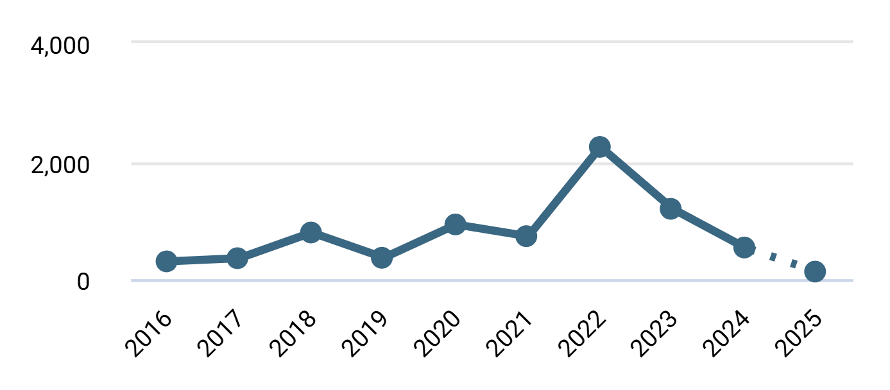
Figure 1. Publication form 2016-2025
In the VOSviewer software, bibliometric coupling with full counting methods for sources was conducted with a dataset derived from dimension.ai. A minimum of five documents was set for each source on the title of the legal aspect of polygraph analysis. After applying all the limits 68 sources were screened out, and a network between sources was created with a cluster of 6 and 395 links, as shown in Fig. 2. This link and cluster demonstrate the complex relation between various journals and sources which indulge in publishing and coupling the work on legal standards of polygraph analysis.
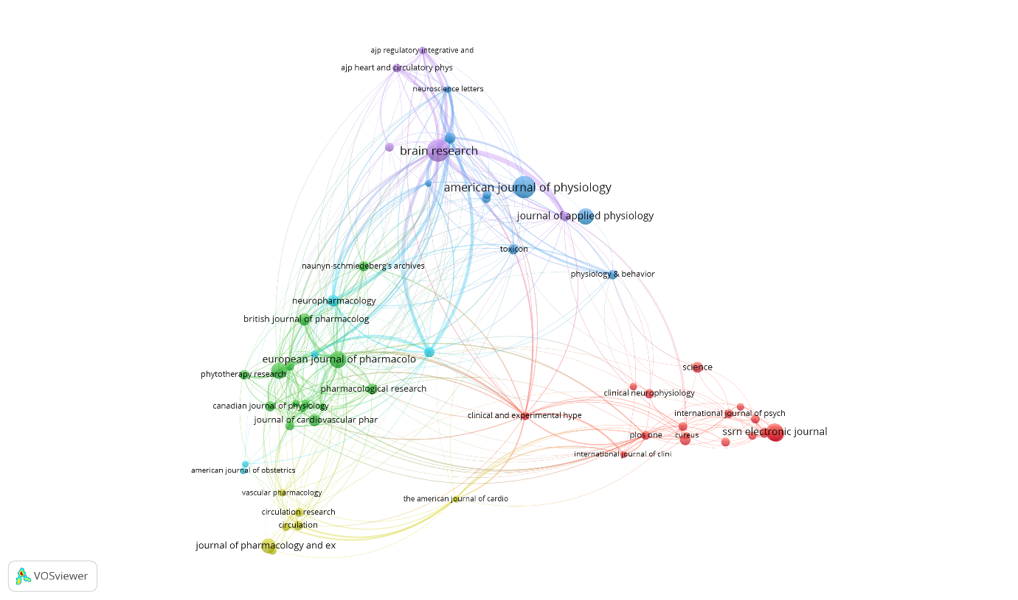
Figure 2. Bibliometric network of sources in legal aspect of polygraph analysis
Similarly, co- authorship among various countries presents worldwide working on legal aspect of polygraph analysis were taken into account of study and analysis with full counting method and excluding large dataset and taking maximum 25 organization per document. Minimum of five documents from each country were considered after limiting total of 43 countries were screened. For these countries the cluster of nine and link of 278 was reported and an overlay visualization network was created as shown in fig. 3. From the figure it is shown that india stands high after Uk and USA in work of legal admissibility on polygraph analysis which can also be well noted by visualizing the total link strength of 75 and average publication per year of India being 2007.90.
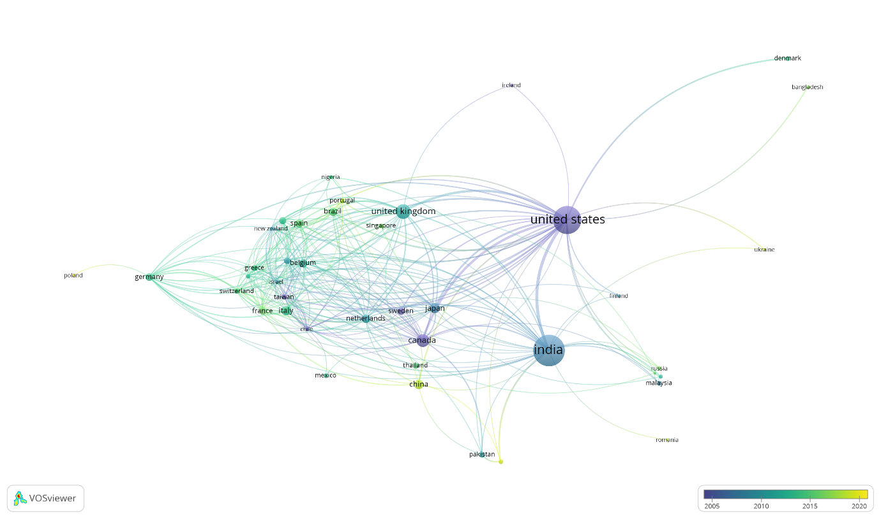
Figure 3. Co authorship Overlay Visualization of countries working on legal aspect of polygraph analysis
7. Conclusion
A crystal ball would be needed to conclude that neural lie detection has no chance of ever working or of being fair in trials. But many details need to be carefully worked out before such techniques should be allowed in courts. Whether the crucial issues can be resolved remains to be seen, but the way to resolve them is for scientists and lawyers to learn to work together and communicate with each other.
This article presents a grounded and thoughtful assessment of the emergence, utility, and challenges associated with polygraph use in the Indian criminal justice system. At its heart, the article affirms that while lie detection is not legally admissible as primary evidence, it plays a vital supplementary role in criminal investigations, especially where other forms of evidence are lacking or inconclusive. Paper highlights the ethical and legal grey zones surrounding the practice. The author points out that acceptance hinges on three pillars: reliability of the technique, standardized procedures, and competent administration. This appeal, directed at law enforcement, judiciary, and academic stakeholders, stresses the need for collaboration and intellectual openness to refine the practice rather than discard it due to its imperfections.

References
1. Rakoff JS. Lie detection in the courts: The vain search for the magic bullet. In: Bizzi E, Hyman SE, Raichle ME, Kanwisher N, Phelps EA, Morse SJ, et al., editors. Using imaging to identify deceit : Scientific and ethical questions. Cambridge: American Academy of Arts & Sciences, 2009; 40–5.
2. Sinnott-Armstrong W. Neural lie detection in courts. In: Bizzi E, Hyman SE, Raichle ME, Kanwisher N, Phelps EA, Morse SJ, et al., editors. Using imaging to identify deceit : Scientific and ethical questions. Cambridge: American Academy of Arts & Sciences, 2009; 35–9.
3. Appelbaum PS. The New Lie Detectors: Neuroscience, Deception, and the Courts. Law Psychiatry 2007;58(4):460–2.
4. Math SB. Supreme court judgement on polygraph, narco-analysis & brain-mapping : A boon or a bane. Indian J Med Res 2011;134(1):4–7.
5. Ford EB. Lie detection: Historical, neuropshychiatric and legal dimensions. Int J Law Psychiatry 2006;29:159–77.
6. Saxe L, Dougherty D, Cross TP. The validity of polygraph testing. Scientific analysis and public controversy. Am Psychol 1985;40(3):355–66.
7. Lykken DT. Tremor in the blood : Uses and abuses of the lie detector. Mc Graw Hill, 1998;
8. Lewis JA, Cuppari M. The polygraph: The truth lies within. J Psychiatry Law 2009;37:85–92.
9. Vicianova M. Historical Techniques of Lie Detection. Eur J Psychol 2015;11(3):522–34.
10. Porter S, Campbell MA. A. Vrij, Detecting Lies and Deceit: The Psychology of Lying and Implications forProfessional Practice. Expert Evid [Internet] 1999;7(3):227–32. Available from: https://doi.org/10.1023/A:1008978705657
11. SC. All India Reproter (AIR). 2010;
12. SC. All India Reporter (AIR). 1954;
13. SC. Supreme Court Report. 1955;
14. Academy TNSJ. Supreme Court Judgements of Legal Importance. 2010;
15. SC. All India Reporter (AIR). 1997;
16. SC. All India Reporter (AIR). 1961;
17. Bartol CR, Bartol AM, editors. Investigative psychology. In: Introduction to forensic psychology : Research and Application. Los Angeles: Sage Publication, 2008; 79–111.
18. Orsdel V. FRYE v. UNITED STATES. 1923;
19. Peters DD. Per Se Prohibitions of the admission of Polygraph Evidence as upheld in Scheffer are both violative of the constitution and the federal rules of evidence as applied by Daubert. Am J Crim Law 2000;27:249.
20. Citro VA. Playing “Pin the tail on the truth” in the eleventh circuit: Why polygraph evidence should be excluded on federal courts. Stetson Law Rev 2000;30:715.
21. John Synnott*, David Dietzel and Maria Ioannou, A review of the polygraph: history, methodology and current status, International Research Centre for Investigative Psychology, School of Human and Health Sciences,University of Huddersfield, Queensgate, Huddersfield, HD1 3DH, UK, 2015. Available from: http://dx.doi.org/10.1080/23744006.2015.1060080
22. Neta Dan, From the Roots to the Branches: Evolution of Polygraph Tests and Future Outlook.
23. Satpathi, S., Arafath, K.M.I.Y., Routray, A. et al. Analysis of thermal videos for detection of lie during interrogation. J Image Video Proc. 2024, 9 (2024). https://doi.org/10.1186/s13640-024-00624-5
24. Pavlidis, I., & Levine, J. (2002). Thermal image analysis for polygraph testing. IEEE Engineering in Medicine and Biology Magazine, 21(6), 56-64.
25. Rothkrantz, L. J., Wiggers, P., Van Wees, J. W. A., & van Vark, R. J. (2004). Voice stress analysis. In Text, Speech and Dialogue: 7th International Conference, TSD 2004, Brno, Czech Republic, September 8-11, 2004. Proceedings 7 (pp. 449-456). Springer Berlin Heidelberg.
26. Bessonova, Y. V., & Oboznov, A. A. (2018). Eye movements and lie detection. In Intelligent Human Systems Integration: Proceedings of the 1st International Conference on Intelligent Human Systems Integration (IHSI 2018): Integrating People and Intelligent Systems, January 7-9, 2018, Dubai, United Arab Emirates (pp. 149-155). Springer International Publishing.
27. Handler, M., & Krapohl, D. J. (2007). The use and benefits of the photoelectric plethysmograph in polygraph testing. Polygraph, 36(1), 18-25.
28. Albright, T. D. (2023). A scientist's take on scientific evidence in the courtroom. Proceedings of the National Academy of Sciences of the United States of America, 120, e2301839120. https://doi.org/10.1073/pnas.2301839120
29. Saxe, L., & Ben-Shakhar, G. (1999). Admissibility of polygraph tests: The application of scientific standards post-Daubert. Psychology, Public Policy, and Law, 5(1), 203–223. https://doi.org/10.1037/1076-8971.5.1.203
30. National Research Council. (2003). The polygraph and lie detection. National Academies Press.
31. Rutbeck-Goldman, A. (2017). An unfair and cruel weapon: Consequences of modern-day polygraph use in Federal pre-employment screening. UC Irvine Law Review, 7(3), 715–741.
32. People v. Espinoza, 838 P.2d 204 (Cal. 1992).
33. Krugler v. Texas, 902 S.W.2d 594 (Tex. App. 1995).
34. Barnes, B., Myers, B., Pond, R., & Meyer, K. (2023). The influence of false evidence ploy variants on perceptions of coercion and deception. Journal of Forensic Psychology: Research and Practice, 24(4), 500–523. https://doi.org/10.1080/24732850.2023.2178992
35. People v. Thornton, 11 Cal. 3d 738 (Cal. 1974).
36. Iacono, W. G., & Ben-Shakhar, G. (2019). Current status of forensic lie detection with the comparison question technique: An update of the 2003 National Academy of Sciences report on polygraph testing. Law and Human Beha vior, 43(1), 86–98. https://doi.org/10.1037/lhb0000307
37. Lykken, D. T. (1998). A tremor in the blood: Uses and abuses of the lie detector (2nd ed.). Plenum.
38. R. v. Beland, [1987] 2 S.C.R. 398 (Can.).
39. British Polygraph Society. (2024). Polygraph tests: Understanding their use and admissibility in the U.K. legal system. https://polygraph.org.uk/polygraph-tests-understanding-their-use-and-admissibility-in-the-uk-legal-system/
40. Ben-Shakhar, G., Bar-Hillel, M., & Kremnitzer, M. (2002). Trial by polygraph: Reconsidering the use of the guilty knowledge test in court. Law and Human Behavior, 26, 527–541. https://doi.org/10.1023/A:1020204005730
41. Inbau, F. E., Reid, J. E., Buckley, J. P., & Jayne, B. C. (2001). Criminal interrogation and confessions (4th ed.). Aspen Publishers.
42. St. George, D. (2019, March 31). Virginia Lt. Governor Justin Fairfax passed two polygraph tests about sex assaults, his office says. The Washington Post. https://www.washingtonpost.com/local/virginia-politics/virginia-lt-gov-justin-fairfax-passed-polygraph-tests-about-sex-assaults-his-office-says/2019/03/31/90b771f2-53ec-11e9-814f-e2f46684196e_story.html
43. Synnott, J., Dietzel, D., & Ioannou, M. (2015). A review of the polygraph: History, methodology and current status. Crime Psychology Review, 1(1), 59–83. https://doi.org/10.1080/23744006.2015.1060080
44. Saxe, L., & Ben-Shakhar, G. (1999). Admissibility of polygraph tests: The application of scientific standards post-Daubert. Psychology, Public Policy, and Law, 5(1), 203–223. https://doi.org/10.1037/1076-8971.5.1.203
45. Sharma, B. R. (2021). Forensic science in criminal investigation & trials (6th ed.). LexisNexis.
46. Government of India. (2024). Central forensic labs. https://www.mha.gov.in/MHA1/Par2017/pdfs/par2016-pdfs/rs-100816/2686%20E.pdf
47. Tyagi, S. P. (n.d.). Forensic evidence law & evidence (2nd ed.). Vinod Publications.
48. National Human Rights Commission. (2000). Guidelines for the administration of polygraph tests.
49. Forensic Yard. (2024). Forensics evidence in criminal cases. https://forensicyard.com/forensics-evidence-in-criminal-cases/
50. Business Standard. (2024). Shraddha murder case: Aftab Poonawalla goes through polygraph tests. https://www.business-standard.com/article/current-affairs/shraddha-murder-case-aftab-poonawalla-goes-through-polygraph-tests-122112300068_1.html
51. Fondelco. (2024). Forensic physics. http://www.fondelco.in/institute/forensic-physics.php
52. Jay A. Siegel. (2024). Forensic science. https://www.britannica.com/science/forensic-science

