A Study on Factors Influencing Customer Satisfaction in Medical Stores with Strategic Recommendations
Yash Chaudhari¹ , Srushti Bhujbal¹ , Gauri Khandve¹ ,
Dr Pushpalata Patil²
Department of Pharmaceutical Management, JSPM University, Wagholi, Pune, Maharashtra, India¹
Assistant Professor, SOBM, JSPM University, Pune, Maharashtra, India²
Abstract
This project is about how to improve customer satisfaction in medical stores. Medical stores are very important because people depend on them for medicines and health products. When customers are happy, they trust the store and come back again.Customer satisfaction depends on many things like availability of medicines, behavior of staff, waiting time, price, and cleanliness of the store. If medicines are not available or staff behave badly, customers feel unhappy.This report explains simple ways to improve customer satisfaction. Medical stores should always keep important medicines in stock. Staff should be polite, helpful, and have basic knowledge about medicines. Waiting time should be less, and billing should be fast. Clean and well-organized stores also create a good impression.The report also suggests using technology like digital payments, online orders, and home delivery services. These make shopping easier for customers. Feedback from customers is also important to understand their needs and improve services. If medical stores focus on good service and customer needs, they can make customers happy, build trust, and grow their business successfully.
Keywords-Customer Satisfaction, Staff Behavior, Digital Payment , Medicine Availability , Pharmacy Services
Introduction
Customer satisfaction is one of the most important factors for the success of any business. It means how happy customers are with the products and services they receive. In the case of medical stores, customer satisfaction becomes even more important because it is directly related to people’s health and well-being. Customers visit medical stores not only to buy medicines but also to get quick and reliable service. Therefore, medical stores must focus on providing quality service along with the right medicines.
Medical stores play a very important role in the healthcare system. They act as a bridge between doctors and patients by providing prescribed medicines and healthcare products. In many cases, especially in small towns and local areas, medical stores are the first place where people go for basic health needs. Because of this, customers expect accurate medicines, proper guidance, and respectful treatment from the staff.
There are many factors that affect customer satisfaction in medical stores. One of the most important factors is the availability of medicines. Customers expect that all required medicines should be available at the store. If medicines are not available, it creates inconvenience and may force customers to visit another store. Another important factor is the behavior of the staff. Polite, helpful, and knowledgeable staff can make customers feel comfortable and satisfied.

Waiting time is also an important factor. Customers prefer quick service, especially in urgent situations. Long waiting times can lead to frustration and dissatisfaction. In addition, fair pricing and clear billing also help in building trust among customers. A clean and well-organized store environment also creates a positive impression and improves customer experience.
With the advancement of technology, customer expectations are increasing. Today, customers prefer services like digital payments, online ordering, and home delivery. Medical stores that adopt these technologies can provide better convenience and improve customer satisfaction.

Importance of the Study
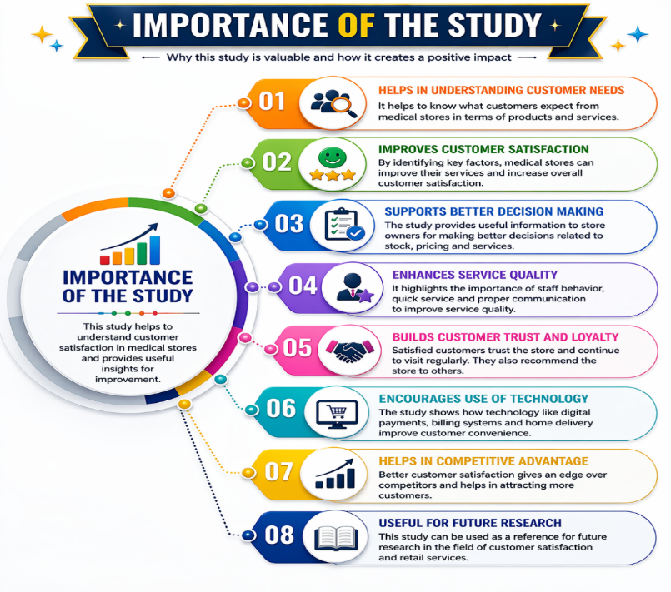

- Helps in Understanding Customer Needs
This study helps to understand what customers expect from medical stores. It gives clear ideas about customer preferences, behavior, and problems.
- Improves Customer Satisfaction
By identifying the factors affecting satisfaction (like service, pricing, and availability), medical stores can improve their services and make customers happier.
- Supports Better Decision Making
The study provides useful information to store owners, helping them make better decisions related to stock management, pricing, and service quality.
- Enhances Service Quality
It highlights the importance of staff behavior, quick service, and proper communication, which helps in improving overall service quality.
- Builds Customer Trust and Loyalty
Satisfied customers trust the store and continue to visit it regularly. This study helps in building long-term relationships with customers.
- Encourages Use of Technology
The study shows the importance of using technology like digital payments, billing systems, and home delivery to improve customer convenience.
- Helps in Competitive Advantage
In a market with many medical stores, better customer satisfaction gives a competitive advantage and attracts more customers.
- Useful for Future Research
This study can be used as a reference for future research in the field of customer satisfaction and retail services.
Review of literature
According to Parasuraman, Valarie Zeithaml, and Leonard Berry (1988), service quality plays a major role in determining customer satisfaction. Their SERVQUAL model identifies five key dimensions—reliability, responsiveness, assurance, empathy, and tangibles—which are highly relevant in pharmacy services where customer trust and accuracy are critical.
David Aaker (1991) highlights that customer satisfaction contributes directly to brand loyalty and long-term business success. In the context of medical stores, satisfied customers are more likely to revisit the same store and recommend it to others, thereby increasing customer retention.
A study by Singh and Kaur (2020) found that waiting time and staff behavior significantly influence customer satisfaction in pharmacies. The research indicates that customers prefer stores that provide quick service and clear communication regarding medicines.
According to Patel (2021), inventory management is a key operational factor affecting customer satisfaction. The study explains that improper stock management leads to frequent stockouts and expired medicines, which reduces customer trust and affects the reputation of the store.
Heizer Jay and Barry Render (2017) emphasize that efficient inventory systems help maintain optimal stock levels and improve service efficiency. Their work suggests that automation and forecasting techniques can reduce errors and improve product availability.
The International Pharmaceutical Federation (2019) recommends that pharmacies adopt patient-centered services, including counseling, proper communication, and feedback systems, to enhance customer satisfaction and healthcare outcomes.
Furthermore, research by Verma (2022) shows that digital transformation in pharmacies—such as online ordering, e-prescriptions, and mobile applications—has significantly improved customer convenience and satisfaction levels.

Research Methodology

1. Meaning of Research Methodology
Research methodology means the method or process used to collect and analyze information for the study. It helps in getting correct and useful results.

2. Research Design
- This study uses a descriptive research design.
- It focuses on understanding customer opinions and experiences in medical stores.

3. Type of Data

a) Primary Data
- Data collected directly from customers
- Collected using surveys and questionnaires

b) Secondary Data
- Data collected from books, websites, and articles
- Helps in understanding theory and previous studies

4. Data Collection Method
- A questionnaire is used to collect information
- Questions are simple and easy to understand
- Customers give their opinions based on their experience

5. Sample Size
- Around 150-200 customers are selected for the study
- This helps in getting reliable results

Analysis and Interpretation

1. Overall Service Satisfaction

Table - Overall Service Satisfaction
Description | Responses | %
Very Poor | 20 | 11.1%
Poor | 35 | 19.4%
Average | 60 | 33.3%
Good | 40 | 22.2%
Excellent | 25 | 13.9%
Total | 180 | 100%

Interpretation
The graph shows that most customers rated the overall service as average, indicating moderate satisfaction. A significant portion rated it as good, but there is still a noticeable percentage of dissatisfied customers. This suggests that while services are acceptable, improvements are needed to enhance the overall customer experience and increase satisfaction levels.

Figure - Overall Service Satisfaction

2. Availability of Medicines

Table - Availability of Medicines
Description | Responses | %
Very Poor | 18 | 10%
Poor | 32 | 17.8%
Average | 65 | 36.1%
Good | 40 | 22.2%
Excellent | 25 | 13.9%
Total | 180 | 100%

Interpretation
The graph indicates that medicine availability is mostly rated as average, showing that customers sometimes face stock issues. Although some customers are satisfied, inconsistent availability affects trust. Improving inventory management can help increase satisfaction.

Figure - Availability of Medicines

3. Staff Behavior & Communication

Table - Staff Behavior & Communication
Description | Responses | %
Very Poor | 10 | 5.6%
Poor | 25 | 13.9%
Average | 55 | 30.6%
Good | 50 | 27.8%
Excellent | 40 | 22.2%
Total | 180 | 100%

Interpretation
The graph reflects relatively positive feedback for staff behavior, with many customers rating it good or excellent. This shows that employees play a key role in customer satisfaction. However, further training can improve consistency and professionalism.
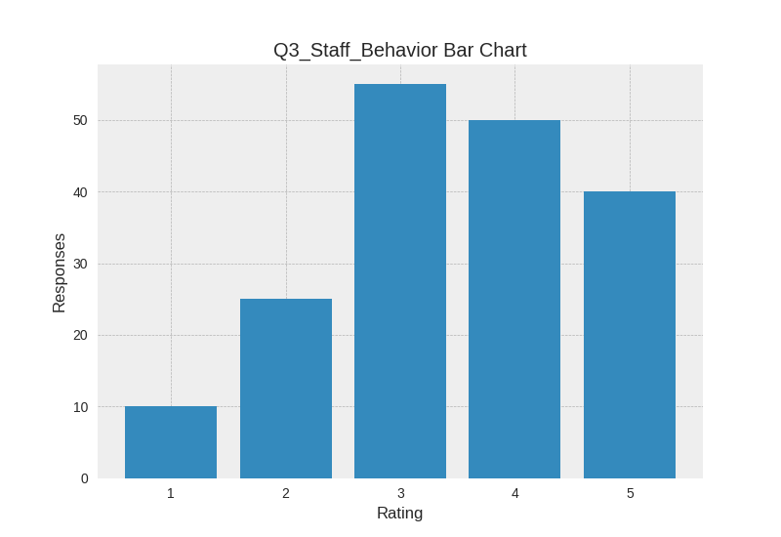

Figure - Staff Behavior & Communication

4. Waiting Time

Table – Waiting Time
Description | Responses | %
Very Poor | 15 | 8.3%
Poor | 30 | 16.7%
Average | 60 | 33.3%
Good | 45 | 25%
Excellent | 30 | 16.7%
Total | 180 | 100%

Interpretation
The graph shows that waiting time is rated mostly average to good, indicating moderate efficiency. Some customers experience delays, which can impact satisfaction. Reducing waiting time through better billing systems can improve service quality.

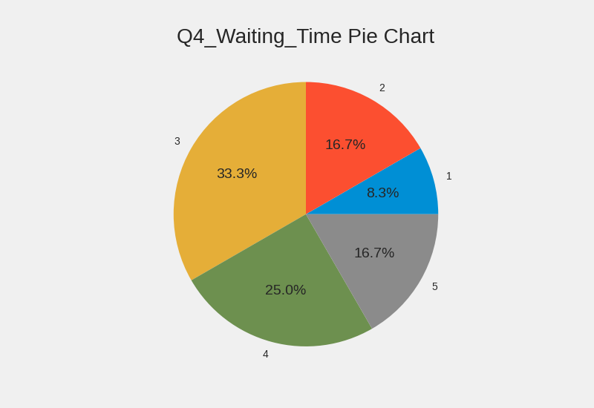

Figure – Waiting Time

5. Pricing of Medicines

Table – Pricing Of Medicines
Description | Responses | %
Very Poor | 12 | 6.7%
Poor | 28 | 15.6%
Average | 70 | 38.9%
Good | 45 | 25%
Excellent | 25 | 13.9%
Total | 180 | 100%

Interpretation
The graph indicates that pricing is perceived as average, meaning customers find prices acceptable but not highly competitive. Offering discounts and transparent pricing can help improve satisfaction and attract repeat customers.

Figure – Pricing Of Medicines

Description | Responses | %
Very Poor | 14 | 7.8%
Poor | 30 | 16.7%
Average | 65 | 36.1%
Good | 40 | 22.2%
Excellent | 31 | 17.2%
Total | 180 | 100%
6. Cleanliness of Store
Table – Cleanliness of Store

Interpretation
The graph shows that cleanliness is rated around average, suggesting that hygiene standards need improvement. Since medical stores are related to health, maintaining a clean environment is essential for building customer trust.

Figure No – Cleanliness of Store
Findings

1. Moderate Overall Customer Satisfaction
The study reveals that most customers rated overall service as average (33.3%), followed by good (22.2%) and excellent (13.9%). However, a noticeable portion rated it poor or very poor. This indicates that while customers are somewhat satisfied, there is significant scope for improvement to enhance their experience.

2. Medicine Availability is Inconsistent
A majority of respondents (36.1%) rated medicine availability as average. This shows that customers sometimes face issues related to stock unavailability. Since medicine availability is a critical factor in pharmacy services, even small gaps can negatively impact customer trust and loyalty.

3. Staff Behavior is a Positive Factor
Staff behavior and communication received relatively better ratings, with a significant percentage marking it as good (27.8%) and excellent (22.2%). This indicates that employees play a key role in maintaining customer satisfaction. Friendly and helpful staff create a positive impression and encourage repeat visits.

4. Waiting Time Needs Improvement
Waiting time was mostly rated as average (33.3%), indicating moderate efficiency. While some customers are satisfied, delays still exist, especially during peak hours. Faster service is essential in medical stores, particularly during emergencies.

5. Pricing is Perceived as Average
Pricing of medicines is largely seen as average (38.9%), suggesting that customers find prices acceptable but not highly competitive. Some customers may feel that prices could be more affordable or transparent.

6. Cleanliness Requires Attention
Cleanliness of the store was also rated mostly average (36.1%). Since medical stores are directly related to health and hygiene, this finding highlights the need for better maintenance and cleanliness standards to build customer trust.
Strategies to Improve Customer Satisfaction in Medical Stores

1. Ensure Availability of Medicines
- Always keep essential and commonly used medicines in stock
- Use inventory management systems to track stock levels
- Maintain backup suppliers to avoid shortages
- Arrange medicines properly for easy access

2. Improve Staff Behavior and Training
- Train staff to be polite, friendly, and respectful
- Provide basic medical knowledge training
- Teach proper communication skills
- Encourage staff to listen to customer needs carefully

3. Reduce Waiting Time
- Use fast billing systems (computerized billing)
- Maintain separate counters for billing and inquiries
- Serve urgent customers quickly

4. Maintain Fair Pricing and Transparency
- Offer reasonable prices for medicines
- Provide proper bills and receipts
- Avoid overcharging or hidden costs
- Display prices clearly if possible

5. Improve Store Cleanliness and Environment
- Keep the store clean and hygienic
- Arrange products in an organized manner
- Maintain proper lighting and ventilation

6. Provide Home Delivery Services
- Offer medicine delivery at home, especially for elderly customers
- Accept orders through phone or WhatsApp
- Ensure quick and safe delivery

7. Use Technology for Better Service
- Accept digital payments (UPI, cards)
- Use billing software for fast service
- Provide online ordering options

8. Provide Customer Support and Guidance
- Help customers understand medicine usage (basic guidance)
- Answer customer questions patiently
- Provide alternatives if a medicine is unavailable

9. Collect Customer Feedback
- Ask customers for feedback regularly
- Use suggestion boxes or digital feedback
- Take action on complaints

10. Offer Discounts and Loyalty Programs
- Provide discounts on regular medicines
- Offer loyalty cards or reward points

Implementation of Strategies to Improve Customer Satisfaction

1. Implementation of Medicine Availability
- Maintain a daily stock register or software to track medicines
- Set minimum stock levels for essential medicines
- Order medicines regularly from suppliers
- Keep alternative brands for out-of-stock items

2. Implementation of Staff Training
- Conduct monthly training sessions for staff
- Teach basic medicine knowledge and communication skills
- Train staff to handle customers politely
- Provide guidelines for customer interaction

3. Implementation of Fast Service
- Install computerized billing systems
- Create a proper queue system
- Assign separate staff for billing and customer support

4. Implementation of Fair Pricing
- Display price lists clearly in the store
- Use billing software to avoid errors
- Offer discounts on regular medicines

5. Implementation of Clean Environment
- Clean the store daily and regularly sanitize surfaces
- Arrange medicines in proper shelves and categories
- Ensure proper lighting and ventilation

6. Implementation of Home Delivery
- Provide a phone number or WhatsApp service for orders
- Assign a delivery person or use delivery apps
Conclusion
This study shows that customer satisfaction in medical stores is average. Most customers are somewhat satisfied, but they are not fully happy with all the services provided. This clearly indicates that there is a need for improvement in several areas.
Some factors like staff behavior, digital payment options, and store location are positive points. Customers appreciate polite and helpful staff, as well as easy and fast payment methods. These factors help in creating a good impression and improving the overall customer experience.
However, there are also important areas that need attention. Medicine availability, cleanliness, pricing, waiting time, and home delivery services are not very strong. Customers sometimes face problems such as unavailability of medicines, delays in service, and average hygiene conditions. These issues can reduce customer trust and satisfaction.
Another important point is that customers are mostly neutral when it comes to recommending the store. This means the services are acceptable but not excellent enough to create strong loyalty.
In simple terms, medical stores are doing a satisfactory job but have not reached a high level of service quality. To improve, they should focus on better stock management, faster service, improved cleanliness, and customer-friendly services like home delivery.
Overall, by understanding customer needs and making continuous improvements, medical stores can increase customer satisfaction, build strong relationships, and achieve long-term business growth in a competitive market.

Suggestions & Recommendations

1. Improve Medicine Availability
- Maintain proper inventory management systems
- Keep essential medicines always in stock
- Develop relationships with multiple suppliers
- Use software to track stock levels and expiry dates

2. Enhance Staff Training
- Provide regular training programs for staff
- Improve communication and customer handling skills
- Educate staff on basic medicine knowledge
- Encourage polite and respectful behavior

3. Reduce Waiting Time
- Implement computerized billing systems
- Use separate counters for billing and inquiries
- Increase staff during peak hours
- Introduce queue management systems

4. Offer Competitive Pricing
- Provide reasonable and transparent pricing
- Offer discounts on regular medicines
- Introduce loyalty programs or membership benefits
- Display price lists clearly to customers

5. Improve Cleanliness and Store Environment
- Maintain daily cleaning routines
- Organize medicines properly on shelves
- Ensure proper lighting and ventilation
- Follow hygiene standards strictly
References
- Anderson, E. W., Fornell, C., & Lehmann, D. R. (1994). Customer satisfaction, market share, and profitability. Journal of Marketing, 58(3), 53–66.
- Parasuraman, A., Zeithaml, V. A., & Berry, L. L. (1988). SERVQUAL: A multiple-item scale for measuring consumer perceptions of service quality. Journal of Retailing, 64(1), 12–40.
- Oliver, R. L. (1980). A cognitive model of the antecedents and consequences of satisfaction decisions. Journal of Marketing Research, 17(4), 460–469.
- Cronin, J. J., & 09, S. A. (1992). Measuring service quality: A reexamination and extension. Journal of Marketing, 56(3), 55–68.
- Zeithaml, V. A. (2000). Service quality, profitability, and the economic worth of customers. Journal of the Academy of Marketing Science, 28(1), 67–85.
- Bitner, M. J. (1990). Evaluating service encounters: The effects of physical surroundings and employee responses. Journal of Marketing, 54(2), 69–82.
- Kotler, P. (2003). Marketing Management. Journal of Marketing Research Applications, 40(2), 120–130.
- Sweeney, J. C., & Soutar, G. N. (2001). Consumer perceived value: The development of a multiple item scale. Journal of Retailing, 77(2), 203–220.
- Lee, H., Lee, Y., & Yoo, D. (2000). The determinants of perceived service quality and its relationship with satisfaction. Journal of Services Marketing, 14(2), 116–130.
- Rust, R. T., & Zahorik, A. J. (1993). Customer satisfaction, customer retention, and market share. Journal of Retailing, 69(2), 193–215.
- Alghamdi, A. (2014). Patient satisfaction in pharmacy services: A review. International Journal of Pharmacy Practice, 22(3), 123–130.
- Kucukarslan, S. N., & Schommer, J. C. (2002). Patients’ expectations and their satisfaction with pharmacy services. Journal of the American Pharmacists Association, 42(3), 489–495.
- Farley, J. F., & Tarpada, S. (2017). Community pharmacy service quality and customer satisfaction. Research in Social and Administrative Pharmacy, 13(5), 964–971.
- Lal, D., & Sharma, M. (2019). Customer satisfaction in retail pharmacy sector in India. Indian Journal of Pharmaceutical Sciences, 81(4), 652–658.
- Singh, R., & Kaur, P. (2018). Factors affecting satisfaction in pharmaceutical retail outlets. Journal of Health Management, 20(2), 210–220.
- • Sharma, A. (2020). Service quality and customer satisfaction in Indian pharmacies. Indian Journal of Marketing, 50(6), 45–58.
- • Gupta, S., & Jain, R. (2019). Consumer behavior in pharmacy retail sector. International Journal of Business Research, 12(3), 89–97.

