Research Repository System for Greater Research Accessibility for Senior High School Students in Alaminos City Division
¹Anjelyn A. Cabrezos, ^{*2}Brent Jacob B. Camero, ³Rhona Angela D. Ranit, ⁴Kyle D. Tamayo, ⁵Christian Paul O. Cruz
^{1, 2, 3, 4, 5} Pangasinan State University, Alaminos City Campus, Pangasinan, Philippines
*Corresponding Author Email: 22AC0507_ms@Psu.edu.ph
¹22AC0325_ms@Psu.edu.ph, ³22AC0664_ms@Psu.edu.ph, ⁴22ac0667_ms@psu.edu.ph, ⁵cocruz@psu.edu.ph
ABSTRACT
The limited access to completed research outputs continues to adversely affect research engagement of senior high school students especially in public school divisions, where the completed studies are kept in archives manually and institutionally scattered. As a result of fragmentation, there are multiple duplications, loss of time and then the phenomenon of ‘research stollenness’ as described by students. The failure to retrieve and extend research already done within their division. A web-based Research Repository System was designed and evaluated for possible use in the Alaminos City Division to improve accessibility of researches. These system offers a central, secure platform for uploading, searching for and retrieving approved research papers by authorized personnel. A descriptive-developmental research design was utilized, one that combines the development system with a quality evaluation based on the ISO/IEC 25010 software quality model. The evaluation of the system was participated by students and teachers from different high schools in the Division of Alaminos City. The evaluation results showed strong execution of functions, performance efficiency, usability, reliability, and security. According to the users, the system is easy to navigate and provides accurate search results. Moreover, downloads are fast, and overall satisfied. As the results show, the new repository will save students time spent in searching for relevant research materials and increase the visibility of the completed studies of the division. Furthermore, the system encourages schools to communicate with one another, sharing the outputs of their research. The study implies that the proposed system can resolve current accessibility issues, allowing the senior high school students and teacher to do research more orderly, efficiently, and sustainably.
Keywords: Research Repository System, Research Stollenness, Senior High School Student, Digital Repository, Web Based Application
I. INTRODUCTION
Research is a primary activity of Senior High School (SHS) education and an effective way of developing critical thinking and problem solving skills. The Philippines has been experiencing the acceleration of digital transformation in education, especially with the growing focus on remote academic resources [1]. Digital research repositories have become an indispensable tool for storing and sharing academic research work. Research has revealed that the use of digital repositories significantly enhances the accessibility to research work [2], better data management than by hand [3], and enables facilitation of lifelong learning through its flexible accessibility [4]. These platforms are in line with the current trends in digital education and sustainability in achieving quality education for all [5].
There are nine public SHS schools under the Alaminos City Division that have research projects. Hundreds of research papers are produced every year in every discipline. But the archiving process is manual: the printed copy is assembled in the schools, endorsed to the division office and filed in the filing cabinets. The fragmented process makes retrieval and collaboration across schools difficult, and student research outputs not seen by others, posing a major accessibility problem.
This manual method brings up several problems in the system. When we store things physically, it's hard for everyone to get to it because research is kept in cabinets in division offices [6]. It's not easy to get the information either because each file has to be manually sifted through. There's also a risk of losing documents because the files are stored in multiple places and not digitally, which can cause them to be damaged or misplaced [7]. From an academic perspective, when we don't have a system to search through previous research topics, there tends to be a lot of repeated or similar topics done, and students don't get to identify studies from previous years [8]. Doing their work like this blocks research productivity and prevents them from developing a collaborative academic culture.
This research presents a web-based Research Repository System for Alaminos City Division. The system offers a centralized digital space for uploading, searching, and obtaining research papers for both current and former research fellows in consideration of the evidence that institutional repositories increase their accessibility and visibility [9]. The system includes role-based access control, advanced search, and approval process. By digitizing the research papers of all nine schools, the repository removes the obstacles of the geographical separation and promotes collaborative research, which represent a shortcoming of conventional systems [10].
There exists a web-based Research Repository System for Alaminos City Division that increases research accessibility for senior high schools. The repository mitigates conventional limitations of manual archiving by facilitating digital storage and retrieval with advanced searching and role-based access control. ISO/IEC 25010 standards been applied to evaluate the system, which achieved an excellent acceptability score of 4.75 [11]. The system enjoyed a high level of functionality, usability, and security. The platform is a promising solution for centralizing research outputs and promoting academic collaboration among the nine Alaminos City Division public schools.
II. METHODOLOGY
The research adopted a descriptive-developmental research design which included descriptive study of current research management processes and systematic development of the Research Repository System. Using Agile methodology, incorporating an iterative development and continuous feedback and flexible planning, the system development was adaptive to the changing system requirements and user needs.
The process of system development followed a structured Software Development Life Cycle (SDLC) detailed in Figure 1 below, that comprised the requirements, design, implementation, testing, deployment and review phases. In each of these phases, the stakeholders were involved and prototyped and validated.
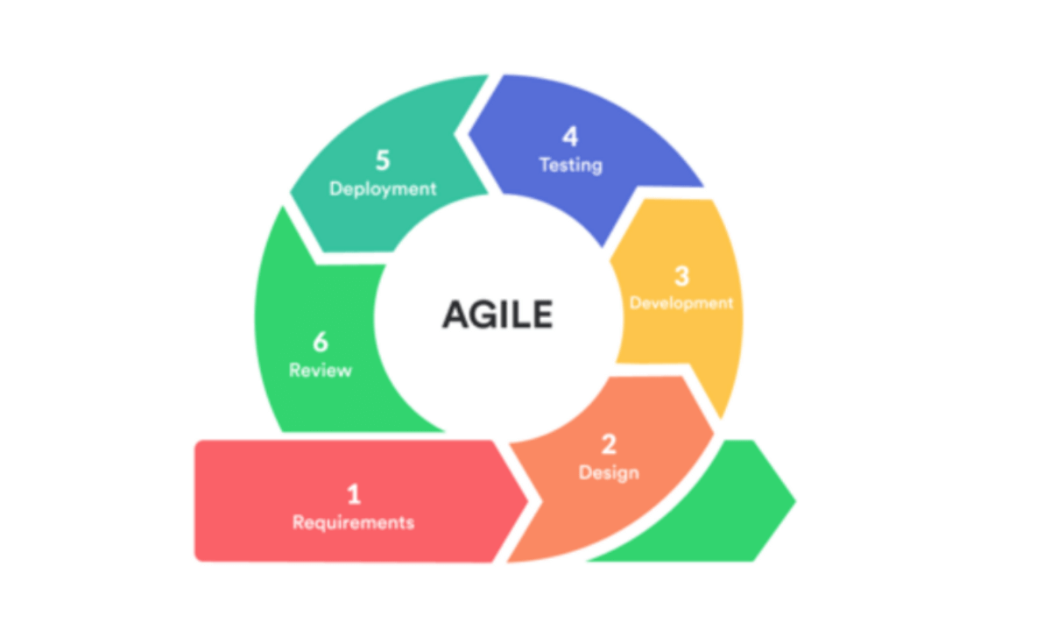
Figure 1. Agile Methodology
Source:https://targettrend.com/wpcontent/uploads/2021/03/Agile-Methodology-1.png
The development process started with a thorough step of gathering all the requirements. Data gathering via structured interviews and tailored surveys with the key stakeholders, who are students, teachers and research coordinators from the 9 public senior high schools under Alaminos City Division was done. Through this empirical investigation, firsthand experiences and pain points with the current manual archiving were collected. From these data, functional (user authentication, document upload/download, advanced search with filters, role-based access control, etc.,) and non-functional (system responsiveness, data security, and ease of use) user stories or specifications needed in the design of the system were identified.
System analysis and design the system analysis and design process involved applying various frameworks to achieve a user-friendly design. Input Process Output (IPO) model was used to derive system requirements and functions. Entity-Relationship Diagrams (ERDs), database schemas, and interface mockups were developed to demonstrate system architecture. Design tools Figma and Draw.io were used to generate wireframes and work flow diagrams. These tools helped to shape the system according to user's needs. Diagrams of the system architecture were developed to demonstrate the system workflow. Problem in problem solving techniques like fishbone diagram were used to identify root causes of problem. Features were mapped to the ISO/IEC 25010 software quality standards.
Iterative development the system was developed with an iterative approach, which included repeated cycles of testing, feedback, and improvement. User acceptance testing with school stakeholders verified that the final system not only addressed the accessibility of information, but also meets the practical needs of the students and teachers. The system was developed using Laravel (PHP framework) as the back-end logic, MySQL as the database, and Bootstrap/Tailwind CSS as the front-end design. Role based access, searchability, research submission functions, and an admin dashboard for monitoring and evaluation were developed to address the system's 5 functional requirements.
We used an iterative approach for development. After that, we conducted a testing phase and made the system better. The testing phase included Unit Testing, Integration Testing and User Acceptance Testing (UAT). It was held in collaboration with the students, tutors and IT people to ensure that the system fulfilled functional, performance and usability requirements. Some of the technologies used were Laravel for server-end development in PHP, MySQL for database management and Bootstrap/Tailwind CSS for front-end development. Some major functionalities include Role-Based Authentication, Search filters, Research Submissions and Administrative Interface.
After the testing and development, the system went into a pilot implementation among the nine senior high schools in the division. The pilot implementation occurred in phases to ensure smooth transition among the stakeholders. There was Phase 1, which involved training sessions, and the coordinators and subject teachers underwent training in the administration and approval process. Then, there was Phase 2, which involved training the students in a guided process covering account registration, submission, and searching functions.
Surveys completed by participants who attended training, feedback forms completed by users using the system after training, and structured interviews conducted with a sample of user groups (students, teachers, and coordinators) provided an ongoing collection of real-time user experiences and insights. Quantitative and qualitative (user) data related to usability challenges, suggestions for new/enhanced system features, and obstacles to workflow efficiencies were used to develop and prioritize solution(s) to enhance the system during each instructional development cycle (sprints). Examples of solutions developed would include the improvement of search capabilities and simplification of the submission interface. Development of solutions to improve the system through user experience and insights would continue through each cycle with an iterative upgrading of the system to reflect what works best for users.
Primary data were obtained through a mixed methods approach. Semi structured interviews were conducted with research coordinators and teachers to collect qualitative, detailed information about current archiving workflows and institutional challenges. Structured surveys were piloted with senior high school students to collect quantitative data on their research access experiences, challenges, and needs. Additionally, direct observations were performed in selected division and school offices to document the current manual archiving practices. Secondary data were gathered from current scholarly articles, journals, and conference papers to provide a theoretical foundation and establish the system design in line with best practices in digital repository development.
The study involved 87 respondents from the nine public senior high schools under the Alaminos City Division, comprising 57 students, 25 teachers, and 5 research coordinators. Purposive sampling a non-probability sampling technique was used to select all participants. This approach ensured that each respondent had direct, relevant experience with research submission, archiving, or retrieval, thereby guaranteeing that the collected data were both context-specific and rich in practical insight.
Table 1: Respondents of the Study
Respondents | Number of Respondents
Students | 57
Faculty | 25
Research Coordinator | 5
Total Respondents | 87
System analysis and design utilized Input Process Output modeling, Entity Relationship Diagrams, and system architecture diagrams. The system was developed using Laravel, MySQL, and Bootstrap/Tailwind CSS.
Evaluation followed the ISO/IEC 25010 software quality model, focusing on eight characteristics. Responses were quantified using the Scale of Measurement in Table 2.
Table 2: Scale of Measurement
Scale | Statistical Limits | Rating
1 | 1.00-1.80 | Poor
2 | 1.81-2.60 | Fair
3 | 2.61-3.40 | Good
4 | 3.41-4.20 | Very Good
5 | 4.21-5.00 | Excellent
III. RESULTS AND DISCUSSION
The Research Repository System was developed using a three-tier architecture (depicted in Figure 2) with the main intention of ensuring scalability, security, and maintainability. Using such an architectural plan, the system is therefore logically divided into three major tiers. These tiers include the presentation tier, which handles interactions with the web browsers; the application/business-logic tier, which handles major activities like authentications of users, searches, and workflow; while the remaining tier handles the storage of research-related documents using a MySQL database with the main intention of ensuring data security.
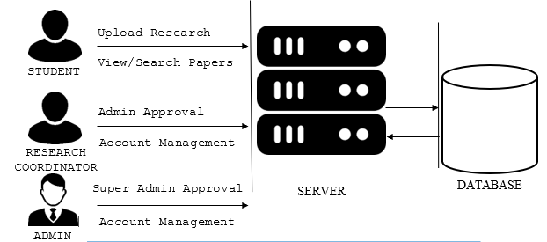
Figure 2. System Architecture Diagram
Utilizing several different frameworks for quality assurance within the systems analysis and the systems design. The input-process-output (IPO) model facilitated the, requirements of the system. To represent the architecture of the system, Entity Relationship Diagrams (ERDs), database schemas, and mock-ups of user interfaces were utilized. The system is based on a three-tier architecture; the presentation tier interacts with the end-user through any Internet browser, the application tier processes all of the business logic necessary to authenticate and search the database(s), and the data tier runs security measures in relation to storing the data within MySQL databases. The wireframes and workflow diagrams were completed with Figma and Draw.io, ensuring that user-centred design principles were applied throughout.
System evaluation using ISO/IEC 25010 standards has produced top quality results in every aspect of the quality characteristics described in Table 3. The overall weighted mean score of 4.75 demonstrates the effective service provided by the system to help solve problems associated with the accessibility of research resources within the Alaminos City Division.
Table 3: Summary of the Evaluation
Portability | Rate | Description
1. | Functional Sustainability | 4.77
2. | Performance Efficiency | 4.75
3. | Compatibility | 4.73
4. | Usability | 4.74
5. | Reliability | 4.72
6. | Security | 4.77
7. | Maintainability | 4.74
8. | Portability | 4.74
Weighted Mean | 4.75 | Highly Evident
The evaluation results, with an overall weighted mean of 4.75, demonstrate that the developed Research Repository System (RRS) is highly effective in meeting its objectives. The excellent ratings across all ISO/IEC 25010 characteristics confirm that the system successfully addresses the core accessibility challenges identified in this study. Specifically, the high scores in Functionality (4.77) and Usability (4.74) indicate that the features—such as advanced search and role-based workflows—are not only present but are also intuitive and meet the practical needs of students and educators, directly countering the inefficiencies of the manual archiving system [3, 7]. The top-tier result for Security (4.77) is critical, as it establishes stakeholder trust in the platform to safeguard intellectual work, mitigating the risks of loss or damage associated with physical documents [6]. Furthermore, the strong performance in Performance Efficiency (4.75) and Compatibility (4.73) ensures the system operates reliably within the existing technological context of the schools. These findings align with existing literature on the benefits of digital repositories, which emphasize improved accessibility, visibility, and collaborative potential [2, 9]. By providing a centralized, searchable database, the RRS effectively transforms the division's research archive from a static collection into a dynamic academic resource that prevents topic duplication and fosters a culture of shared learning [8].
IV. CONCLUSION
Successfully, this study has created, developed, and implemented a Web-Based Research Repository System specifically designed for the Alaminos City Division. The Repository System enhances upon Manual Research Archiving Challenges by providing Research Professionals with one singular, centralized, Digital Platform with enhanced Search Features, Role-Based User Access Control, and Rigid Security Protocols| Research Submission Workflow.
The Repository System was evaluated based upon the ISO/IEC 25010 Software Quality Standards and has scored exceptionally well overall (4.75), which indicates that the Repository provides all of the required software features for establishing; high levels of Functionality, Usability, Reliability, and Security.
The Repository will benefit all Research Professionals by Streamlining Research Storage and Retrieval; improving Collaboration between Academics and Teachers who work at the Nine (9) Public Senior High Schools in the Alaminos City Division Currently, for example, digitizing Research Outputs ensures that Academic Research is accessible to a broader audience, eliminates the need to store Physical Files, protects Intellectual Property from damage or destruction.
In addition, the Repository will support and provide continuous support for all Research Initiatives, create greater Engagement Between Students and Teachers by Improving Access to Resources for Students and Teachers. Furthermore, The Repository will be Universal, which means that other Educational Divisions Located throughout the Region will have the Capability of Using or Copying this Repository as They Indirectly Promote the Modernization of Research Management Practices and Encourage the Digital Transformation of Academic Resource Sharing.
V. REFERENCES
[1] A. Fernandez et al., "Digital transformation in academic
libraries and its impact on archiving," Library
Management, 2023.
[2] R. Smith and P. Walsh, "Enhancing research
accessibility through online repositories," Journal of
Library Science, 2022.
[3] J. Bautista, "Effective archiving systems for educational
institutions," Journal of Digital Library Research, 2022.
[4] R. E. Cruz and P. S. Gonzales, "The impact of open
educational resources in academic institutions," Journal
of Open Education Research, 2022.
[5] M. Tuazon and R. Quinto, "Evaluating the long-term
sustainability of digital repositories in universities,"
Higher Education Studies, 2023.
[6] J. Chigwada, "Risks to research records: Preservation
and protection challenges," International Journal of
Digital Archives, 2021.
[7] T. Anderson and H. Kanuka, "Improving usability in
educational digital repositories," Educational
Technology Research and Development, 2020.
[8] R. Tan et al., "Usability challenges in academic
repository systems," International Journal of Digital
Archives, 2023.
[9] M. Demetres et al., "The role of institutional repositories
in advancing scholarly communication," Journal of
Scholarly Publishing, 2020.
[10] A. García-Holgado et al., "Increasing research visibility
through digital repositories," Journal of Digital
Scholarly Communication, 2022.
[11] R. Daluyon, "Development of an electronic document
archiving system evaluated with ISO 25010," Journal
of Systems and Software Engineering, 2024.

