Routesafe Barangay 770: Development of a Walkingpath Recommender System for Safer Night Routes utilizing Dijkstra’s Algorithm

John Mark M. Concepcion¹, Gabriel P. Marquez², Mark Christopher D. Duran³, Erwin M. Misolas jr.⁴,
Ms. Vivien Agustin⁴, Dr. Ronald Fernandez⁵
^{1,2,3}Department of Information Technology, Jesus Reigns Christian College, Philippines
^{4,5}La Consolacion University Philippines

¹johnmarkconcepcion@jrccmanila.edu.ph
² gabrielmarquez@jrccmanila.edu.ph
³markchristopherduran@jrccmanila.edu.ph
⁴erwinnisolasjr@jrccmanila.edu.ph
⁵vivien.agustin@email.lcup.edu.ph
⁶ronald.fernandez@email.lcup.edu.ph

ABSTRACT
Traditionally, these algorithms have been used to determine the shortest path in terms of distance or time of travel (e.g. finding the best route for evacuation of a barangay during calamity). This mathematical model is very flexible to be applied to other urban problems. RouteSafe Barangay 770 was developed to build upon Dijkstra’s Algorithm with a focus on pedestrian safety. This walking path recommender system assigns “safety weights” to the routes instead of just geographical distance to determine the routes. In the model, nodes are represented as specific locations within a barangay, while streets are represented as edges with relevant nighttime safety variables such as crime incidence and street lighting quality. The algorithm is therefore quite good not only for geographical distance calculations but also for designing a system that can recommend the safest possible walking routes for the community at night.

Keywords: Dijkstra’s Algorithm, Pedestrian Safety, Route Optimization, Recommender System, Nighttime Security, Barangay Governance, Weighted Graph.

Background of the study
In today’s digital age, Web map applications have become part of everyday life. People use map applications like Google Maps and Waze not only for driving but also for walking, since these apps quickly suggest the shortest or fastest routes to a chosen destination (Bartling, 2022). They are extremely useful when it comes to saving time and effort. However, what these applications often miss is a factor just as important as efficiency: personal safety. In a densely populated urban area like Manila, walking at night is not always straightforward. Dark streets, the absence of security personnel, and areas known for frequent crime put pedestrians at greater risk. This gap reveals a major weakness in current navigation systems; they prioritize speed and distance while overlooking the very real concerns of safety.
Walking in Barangay 770 after dark presents a different set of challenges that regular mapping platforms fail to capture. Many streets still lack proper lighting, some areas have limited or no CCTV surveillance, and certain locations carry a reputation for criminal activity. In addition, the barangay has no centralized or reliable community-based reporting system that could warn pedestrians about unsafe streets. Because these risks are rarely reflected in navigation apps, pedestrians are often left to rely on their instincts when choosing a path. This dependence on guesswork increases vulnerability, especially for individuals who frequently walk at night. These circumstances highlight the need for a system that can balance efficiency with safety, ensuring that users do not have to sacrifice one for the other.
To address these challenges, the proposed AI-Driven Progressive Web App-Based Barangay Walking path Barangay for Safer night Routes and Crime Risk Prediction System introduces a technology-enabled solution designed to modernize crime reporting and enhance public safety management.. The main objective of the system is to provide pedestrians with route recommendations that consider both speed and safety. Instead of simply identifying the shortest path, the system will incorporate factors such as reported crime incidents, availability of street lighting, and time of travel. Dijkstra’s algorithm will be used to compute the most suitable routes, while machine learning techniques will enhance the system by predicting potential risks in different areas.
The application will include additional features such as real-time safety alerts, an SOS function that allows users to share their live location with trusted contacts, and a community-reporting feature where pedestrians can report unsafe areas. These features aim to create a dynamic and responsive system that adapts to real-world conditions and continuously improves through user participation.
This project ultimately seeks to improve the everyday experience of walking in Barangay 770, particularly during nighttime. By reducing risks and providing safer navigation options, the system aims to help pedestrians move around the area with greater confidence, security, and peace of mind.
Statement of the Problem
Barangay 770 continues to face challenges in ensuring pedestrian safety during nighttime travel. Existing navigation applications primarily focus on distance and travel time, but they fail to account for critical safety concerns such as crime-prone areas, poor street lighting, limited surveillance, and other environmental hazards. As a result, pedestrians remain vulnerable to theft, harassment, and assault, while public confidence in walking alone after dark remains low.
At the same time, there is no centralized system that consolidates crime data, environmental risk factors, and community feedback to guide pedestrians in choosing safer walking routes. The lack of real-time safety information and predictive risk analysis leaves individuals to rely on intuition when navigating potentially unsafe areas. These gaps highlight an urgent need for a modern, data-driven, and Web-based walking path recommendation system that integrates AI-based crime risk prediction, contextual safety factors, and user-generated reports to provide informed and safer route options for pedestrians in Barangay 770.
Specifically, this study aims to address the following problems:
- In Barangay 770, pedestrians face higher risks when walking at night. They are more vulnerable to crimes such as theft, assault, and harassment due to reduced visibility and fewer people in public spaces. Many residents feel unsafe walking along streets that lack proper lighting, which further increases their fear and hesitation. There is limited awareness among pedestrians about unsafe areas and the dangers of walking along poorly maintained or unprotected pathways. These conditions highlight the need for improved safety measures and better guidance for individuals navigating the streets at night.
- Community involvement in safety monitoring and risk reporting in Barangay 770 remains limited. Residents are not fully engaged in identifying environmental hazards—such as broken streetlights or active incident zones—resulting in weak coordination with local authorities. The absence of a digital platform that encourages active participation, real-time hazard reporting, and localized safety awareness reduces public trust and hinders collective efforts to maintain a secure walking environment. This lack of engagement prevents the accumulation of crowd-sourced safety data, which is essential for making navigation tools more reliable and responsive to emerging threats.
- Barangay 770 authorities lack integrated data analytics and machine learning-based predictive tools capable of analyzing historical incident records to identify risk patterns, visualize high-risk walking paths, and estimate the likelihood of threats in specific areas during nighttime hours. Without a system utilizing Dijkstra’s Algorithm with Safety Weighting, crime and hazard management remain largely reactive rather than proactive. This limits the ability of officials and residents to utilize data-driven insights to bypass dangerous zones, effectively preventing authorities from strategically addressing environmental risks that compromise pedestrian safety.

Objective of the Study

The primary objective of this study is to design and develop an AI-driven Progressive Web App-based Barangay Walking path for safer routes and Crime Risk Prediction System that addresses the gaps identified in crime reporting and monitoring within Barangay 770,Sta ana manila, City of Manila. The system aims to empower residents to actively participate in crime prevention while providing barangay officials and police authorities with data-driven insights to support proactive decision-making and public safety management.safety-related factors.
Specifically, the objectives are as follows:

- To implement a safety-weighted navigation engine utilizing Dijkstra’s Algorithm. The study seeks to design a routing module that moves beyond simple distance-based calculations by assigning "mathematical costs" to street segments based on environmental risks. By integrating variables such as lighting conditions, crime statistics, and time-of-day data, the system will compute and present the statistically safest walking routes. This ensures that the Web platform provides residents with a reliable decision-support tool that prioritizes personal security over minimal travel time.
- To foster community engagement through a localized hazard reporting and emergency response system. The study aims to develop a Web interface that enables residents of Barangay 770 to conveniently report real-time safety concerns, such as broken streetlights or active incident zones, and attach multimedia evidence to improve data accuracy. By providing an accessible platform for user feedback and a one-tap SOS emergency function, the system seeks to strengthen coordination between residents and barangay authorities, building public trust and encouraging collective participation in maintaining a safer nighttime environment.
- To implement a machine learning–based risk prediction model and interactive safety visualization. The study seeks to develop an AI module using TensorFlow.js that analyzes historical and incoming safety reports to estimate the probability of risk in specific areas during nighttime hours. The model will learn patterns based on variables such as incident location, time, and type of hazard, classifying risk levels into categories like Low, Medium, or High. These insights will be visualized through an interactive safety heatmap and integrated directly into the routing algorithm to support proactive pathfinding and evidence-based decision-making for both pedestrians and barangay officials.
Scope and Limitations
This study focuses on the design and development of RouteSafe Barangay 770: Development of a Walking Path Recommender System for Safer Night Routes Utilizing Dijkstra’s Algorithm, an AI-assisted Progressive Web App intended for pedestrian use at the barangay level. The primary scope of the project includes the development of an Android-based application that enables users to input their current location and desired destination to receive route recommendations. The system utilizes map APIs such as Google Maps and integrates Dijkstra’s Algorithm as its core pathfinding mechanism, enhanced with safety-weighted edges derived from contextual risk factors.

An essential part within the scope of the study is the integration of an AI-based crime risk prediction and risk analysis model. The system processes historical crime data, time and day patterns, environmental conditions such as street lighting, and user-generated reports to estimate the level of risk associated with specific walking paths. By analyzing these variables, the model classifies route segments into varying risk levels (e.g., Low, Medium, High) and incorporates these classifications into route computation. As a result, the application is capable of recommending not only the fastest routes but also safer alternatives for pedestrians traveling at night.

The system also includes several user-centered features designed to enhance safety and usability. These include real-time safety alerts when approaching high-risk areas, dynamic rerouting based on updated risk conditions, an SOS feature that allows users to send their live location to trusted contacts, and a community-based reporting system where users can flag unsafe locations or incidents. The application interface is optimized for Web devices, ensuring ease of use, responsiveness, and accessibility even under low-bandwidth conditions. A backend server handles intensive processes such as route computation, data storage, and machine learning inference, while the Web client focuses on user interaction and display.

However, this study is subject to several limitations. First, the geographical coverage of the system is limited to Barangay 770 as a pilot implementation. Expansion to other barangays or full city-wide deployment is beyond the scope of this study.

Second, the system is dependent on smartphone availability, GPS accuracy, and stable internet connectivity. Since real-time route updates, alerts, and risk analysis rely on server communication, performance may be affected in areas with weak or inconsistent network signals.

Third, the effectiveness of the AI-based risk prediction model depends on the availability, accuracy, and completeness of crime data and user-generated reports. In cases where access to official crime data is limited, alternative or simulated datasets may be used for development and testing, which may affect the model’s real-world predictive accuracy.

Finally, the system does not guarantee complete user safety, as it cannot account for all unpredictable or real-time incidents. Its effectiveness also depends on active user participation, accurate reporting, and responsible usage. External factors such as environmental changes, infrastructure limitations, and user adoption may influence the overall performance and impact of the system.

THEORETICAL FRAMEWORK

The ongoing research is to develop a walking path recommender system that would promote safer night routes, called RouteSafe Barangay 770. Concepts and technologies of Geographic Information Systems (GIS), network routing optimization, environmental criminology, and geographical data analysis are well-established supporting the use of Dijkstra’s Algorithm. These concepts provide the foundation for understanding how pedestrians can leverage data-driven and algorithmic Web technologies to improve personal security, avoid poorly lit or crime-prone areas, and traverse high-risk urban environments securely. Furthermore, the platform allows for the integration of community-driven reporting, real-time safety mapping, localized crime data, and updated shortest-path algorithms to provide Barangay 770 residents with an accessible, reliable, and user-centered nighttime navigation solution.

Development of a Walkingpath Recommender System

Artificial Intelligence and Machine Learning Technologies are becoming more and more significant features of today’s urban navigation systems especially for geographical risk assessment and smart pedestrian safety management. With the use of these technologies, the systems may identify local crime trends, examine environmental concerns, and provide more advanced routing and prediction abilities to night passengers. Street-level safety monitoring in urban areas was examined by Chen et al. (2021), stressing the need of rich crime and infrastructure data for risk prediction and control. They studied fine-grained spatial surveillance for enhanced risk prediction, anomaly detection and proactive routing in complicated urban environments. Our research found that fine-grained environmental monitoring might considerably enhance the accuracy of risk assessments and pathfinding algorithms. This initiative serves to promote the RouteSafe Barangay 770 by highlighting the importance of locally, street level data gathering for creating more important and relevant data for users on pedestrian safety.

Sathyaraj et al.al. (2021) created a smart urban mobility design using Geographic Information Systems (GIS), Web applications and machine learning algorithms to determine pedestrian dangers. They didn’t rely on static map distances, but used AI techniques that leveraged data from prior occurrences and context to provide dynamic safety scores at the street level. Spatial threat assessments may be significantly improved by machine learning techniques, and users can be provided with more accurate and context-aware navigation, authors have demonstrated. This study is important for RouteSafe, showing how AI-powered mapping systems may help users understand patterns of danger at night and make more informed travel decisions.

Gutiérrez et al. (2022) proposed a proactive pedestrian safety framework with the use of machine learning algorithms and spatial analytics to identify risks and construct safe paths.The device gathered data on environmental safety from community complaints and government records and utilizing predictive algorithms to provide user-friendly navigation recommendations and best route alternatives . The research showed how combining AI with dynamic spatial monitoring increased the accuracy of predictions and users’ knowledge of local danger trends. The results point to the establishment of RouteSafe Barangay 770 by highlighting the need of using artificial intelligence, geographical mapping and smart route analysis in the creation of accessible, safe and efficient solutions for pedestrian safety.

AI and Walkingpath System Recommender

Zhao et al. (2019) developed a comprehensive route recommendation framework that uses real-time geographic and environmental datasets to enhance pedestrian navigation safety. Their system incorporates crime statistics, street lighting availability, and dynamic traffic conditions to compute walking routes that minimize exposure to hazards. By employing GIS technologies and weighted graph models, their research demonstrates how navigation algorithms can move beyond simple shortest-path calculations toward more context-aware and safety-oriented route generation.

Lee et al. (2022) designed an advanced pedestrian navigation model integrating Web sensors, GPS data, user feedback, and urban safety variables. By combining Dijkstra’s and A* algorithms, their hybrid approach balances safety with efficiency, offering users routes that are both secure and time-conscious. User testing in Seoul revealed that pedestrians consistently preferred routes with higher safety ratings, even when these routes increased travel time, highlighting the essential role of perceived safety in route decision-making.

Hara et al. (2021) developed an accessibility-focused pedestrian navigation system designed for densely populated Asian cities. Their model includes environmental features such as walkway quality, street lighting intensity, and the presence of pedestrian-friendly infrastructure. By addressing accessibility and safety simultaneously, their study demonstrates how multi-criteria navigation systems can improve walking conditions for vulnerable populations like students and commuter

Safety-Oriented Spatial Optimization and Multi-Factor Graph Weighting

Complementary to these algorithmic approaches, local implementations such as SafeWalk by Santos and Dela Cruz (2021) and the Safe Route Finder by Reyes et al. (2022) demonstrate the practicality of using localized crime logs, CCTV coverage, and lighting data within Philippine urban environments. They validate that navigation tools are most effective when they provide visible safety ratings and environmental risks, fostering trust between users and the technology. These systems’ focus on student and commuter safety directly parallels the objectives of RouteSafe, which seeks to provide residents of Barangay 770 with a reliable, data-driven tool for nighttime travel.

Meanwhile, research by Navarro et al. (2021), Nakayama and Ito (2021), and García et al. (2019) reinforces the value of combining real-time incident reports and crowdsourced data to improve system responsiveness. By integrating community-driven safety inputs with official police records, these systems achieve higher relevance and accuracy in identifying emerging hotspots. Furthermore, studies from Torres and Bautista (2022) and Lim and Park (2023) confirm a consistent user preference for safer routes—even when physically longer—proving that perceived security is the primary driver of pedestrian decision-making during nighttime hours.

International and local studies alike converge on the importance of weighted algorithms in supporting safer pedestrian navigation. Works by Zhao et al. (2019), Kaur and Singh (2020), and Lee et al. (2022) emphasize that integrating crime statistics, lighting intensity, and surveillance density into algorithms like Dijkstra’s and A* significantly enhances situational awareness. Similarly, Mendoza and Tan (2018) and Irmak Erdoğan-Peter (2023) underscore the power of GIS and heatmap visualization in identifying hazardous zones. These studies collectively illustrate that treating "danger" as a mathematical cost allows systems to bypass high-risk areas, a logic directly reflected in the proponents' implementation of the Safety-Weighted Dijkstra’s Algorithm.
METHODOLOGY
This chapter outlines the development process for the Development of a walking path recommender system. It follows a systematic approach involving analysis, design, and implementation of key security features. The system is built using components such as motion AI-Prediction, AI-driven voice commands, image capture, and automated alert responses. These are integrated within a Progressive Web App to detect suspicious activity and respond in real time.
Research Design
The Route Safe Barangay 770 system enhances nighttime pedestrian safety in Manila by using Dijkstra’s algorithm to recommend safe walking paths based on real-time and historical safety data, including street lighting and crime incidents. It models the barangay as a graph network, prioritizing safety over shortest distance by assigning weighted costs to routes that account for distance, crime risk, and sidewalk availability. Users can request routes via a web interface, receiving step-by-step directions and safety indicators. The system’s development utilizes localized datasets and adheres to ethical standards for data privacy. Following the Waterfall Model of the Software Development Life Cycle ensures meticulous progress through defined phases, from requirements gathering to maintenance.

Figure 1. Waterfall Methodology Phases
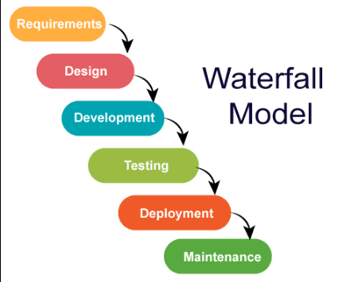
Requirement Phase

The Requirements Phase establishes the system's foundation by gathering local feedback on nighttime hazards (like poor lighting and crime) to compile a formal Software Requirements Specification (SRS). This document mandates core functional features—such as user location inputs, interactive GIS mapping, safety score displays, and a modified Dijkstra’s Algorithm that prioritizes secure paths over short distances—alongside vital non-functional parameters like high reliability, fast response times, intuitive UI/UX, strict data privacy, future scalability, and AI-driven risk prediction models to create a clear technical roadmap for development.

Design Phase

The Design Phase transforms the requirements from the SRS into a structured, modular system blueprint that details the application architecture, component interactions, and data processing models. It establishes high- and low-level designs for an intuitive user interface, a database structured for spatial and safety data, and an application logic layer centered on a modified, safety-weighted Dijkstra’s Algorithm that uses parameters like crime records, street lighting, and pedestrian density to prioritize security over distance. The phase details the integration of Geographic Information Systems (GIS) for spatial mapping and route overlay, uses ERDs and DFDs to map data flows, incorporates AI modules for dynamic, predictive safety scoring, and uses wireframes to plan a responsive UI/UX for nighttime users. Finally, it addresses critical non-functional parameters—such as performance efficiency under multiple requests, system scalability for other barangays, data security for user privacy, and overall platform reliability—providing a comprehensive technical guide for development.

Development Phase

The Development Phase involves coding and integrating the system components using Visual Studio Code to build a responsive Progressive Web App (PWA) and a Node.js/Express.js backend server connected via APIs to a centralized MySQL database. Key features—including route inputs, real-time navigation, an emergency SOS button, and an administrative dashboard—are developed alongside the backend implementation of a modified Dijkstra’s Algorithm. This algorithm processes Barangay 770’s road network as a weighted graph, calculating paths with the lowest cumulative risk by penalizing segments with high crime rates or poor lighting, and visually maps the safest route onto the PWA interface. Individual modules undergo rigorous functional testing before full integration, and the source code is thoroughly documented to ensure the system’s long-term maintenance, stability, and scalability.

Testing Phase
The testing phase ensured that the software and mapping components functioned properly and met the objectives of the study. The researchers tested real-time cloud database synchronization, safety-weighted Dijkstra’s Algorithm routing outputs, OpenStreetMap integration accuracy, community incident reporting functionality, and web application responsiveness across different devices. Continuous testing throughout development also helped identify and resolve errors early in the process.
Deployment phase
The deployment phase involved setting up and launching the completed RouteSafe Barangay 770 system for actual community use. The web application, centralized cloud database, geographic mapping APIs, and Dijkstra's Algorithm routing module were integrated to ensure stable operation and seamless data exchange across the platform. Final system checks were also conducted to verify the accuracy of the safety recommendations, user accessibility, and overall reliability in real-world nighttime scenarios.
The system also integrated a customized PHP implementation of Dijkstra’s Algorithm to support the safety-weighted route calculations. This mathematical model analyzed localized hazard data to generate the safest short- and medium-distance walking paths. Geographic datasets and street layouts used by the system were gathered from OpenStreetMap and local precinct logs to support more realistic spatial mapping and accurate safety estimations. GeoJSON and structured arrays were used for dataset preparation and spatial data processing, while map requests between the frontend interface and the database were handled through standard HTTP protocols. Development and testing were conducted using tools such as Visual Studio Code, XAMPP local server environments, web browsers, Postman, and Git/GitHub.
Maintenance Phase
The Maintenance Phase is a continuous process following deployment that ensures the platform remains reliable, secure, and accurate amidst the changing conditions of Barangay 770. The development team performs corrective maintenance to actively monitor the system and fix technical bugs, alongside adaptive maintenance to adjust road networks, pedestrian paths, and algorithm weights as new street lighting data or crime incidents are reported. To sustain effective recommendations, the core Dijkstra's Algorithm is routinely evaluated and updated with fresh safety scores. Additionally, ongoing updates are introduced to improve processing speeds, enhance security, upgrade the UI/UX based on community feedback, and integrate real-world features like real-time alerts, ensuring the long-term utility and sustainability of the system.
System Architecture
The System Architecture of the RouteSafe Barangay 770: Development of a Walking Path Recommender System for Safer Night Routes Utilizing Dijkstra’s Algorithm describes the overall structure, components, and interactions within the system. It defines how data flows between different parts of the application and how each component works together to deliver safe and efficient walking route recommendations.
Figure 2. Input-Process-Output (IPO) Model of Walkingpath
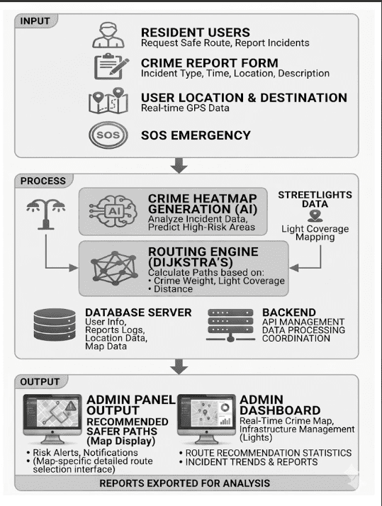
The system architecture of Walkingpath: Intelligent Safe Routing and Community-Driven Public Safety System serves as the structural foundation that illustrates how various components of the study interact to achieve its overall objectives. It provides a clear overview of layers of inputs, processes, and outputs, from initial data ingestion and algorithmic processing to the generation of meaningful insights for users. This architecture ensures that all hardware, software, geospatial, and analytical elements work cohesively to support accurate monitoring, hazard prediction, and safe route generation for pedestrian navigation.
Input Layer
Resident User Profiles & Inputs: The system begins by establishing user interaction through the client interface, capturing pedestrian requests for safe paths and manual, user-initiated incident logs. This localized, crowd-sourced telemetry ensures that active field conditions are continuously fed into the platform.
Crime Report Form: A structured digital interface allows users to submit detailed incident reports. This captures critical data fields including incident type, precise timestamps, granular geographic coordinates, and qualitative textual descriptions. These forms act as the primary training data for risk evaluation.
User Location & Destination: Continuous real-time GPS data tracks the user's current coordinates and intended endpoints. This provides the spatial boundaries and origin-destination pairs required by the routing engine to map immediate walking alternatives.
SOS Emergency Trigger: A high-priority, instant distress signaling mechanism is embedded into the interface. When activated, it bypasses standard queue processing to initiate immediate backend alerts and locate the user instantly on the network.
Process Layer
Data Ingestion & Backend Coordination: All collected inputs, crowd-sourced reports, and GPS coordinates are securely transmitted via a Flask-based middleware API backend. During ingestion, the system validates entries, aligns spatial data, and coordinates data processing between the database server and the analytical engines.
Aggregation and Storage (Database Server): The system automatically stores and indexes raw user profiles, historical report logs, spatial data, and map geometries within a centralized database server. This structured time-series dataset serves as the foundational data pool for both AI modeling and graph computations.
Crime Heatmap Generation (AI Model): Ingesting historical and real-time incident reports, a machine learning model analyzes spatial and temporal crime patterns. The AI generates dynamic risk weights and predicts high-risk zones, converting raw logs into a mathematical safety index across the geographical area.
Streetlights Data Mapping: Concurrently, municipal or crowd-sourced infrastructure data is parsed to map street lighting coverage. This calculates nocturnal visibility parameters, which are treated as a critical environmental mitigation factor against potential hazards.
Routing Engine (Dijkstra’s Algorithm): A multi-weighted graph traversal engine processes the network of paths. By treating streets as edges and intersections as nodes, the system applies a modified Dijkstra’s algorithm using a custom multi-factor cost computation formula.
Routing Cost Formula
The cost of traversing any given path segment is computed by balancing physical distance and environmental safety parameters:
$$\text{Cost} = w_1(\text{Distance}) + w_2(\text{Crime Weight}) - w_3(\text{Light Coverage})$$
Where:
$\text{Distance}$ = The physical length of the street segment.
$\text{Crime Weight}$ = The predictive risk score calculated by the AI Heatmap engine.
$\text{Light Coverage}$ = The active illumination index calculated from streetlight data.
$w_1, w_2, w_3$ = Assigned mathematical weights determining the priority of each factor.
Output Layer
Admin Panel Output (Map Display): The primary user-facing interface consists of a live web map rendering the recommended safer paths calculated by the engine. It displays real-time pedestrian routes complete with color-coded safety tiers, proactive risk alerts, and dynamic situational notifications.
Admin Dashboard: A macro-level administration panel provides system operators with real-time analytics. This interface visualizes comprehensive route recommendation statistics, historical incident trends, system health, and infrastructure vulnerabilities (such as reported broken streetlights).
Reports Exported for Analysis: Beyond live monitoring, the system compiles and flattens aggregated safety and crime logs into downloadable formats. These structured reports are exported for deeper offline analysis, enabling local government units or community safety organizations to implement proactive urban planning and resource allocation.
Methods
This section presents the three (3) primary methodologies utilized by the proponents to develop the RouteSafe Barangay 770 Walkingpath Recommender System. Each method addresses the core challenges and objectives of the study: specifically, defining and modeling nighttime safety metrics, adapting and implementing Dijkstra’s algorithm to generate safety-weighted paths, and designing the user-interface/geographical system to make the routes accessible. This structural alignment ensures that every technological implementation directly supports the overall goal of creating safer nighttime pedestrian mobility for the community.

Method 1: Method for Developing the Path Recommender Interface
Figure 3. Development Process of the walking path recommender system for safer night routes
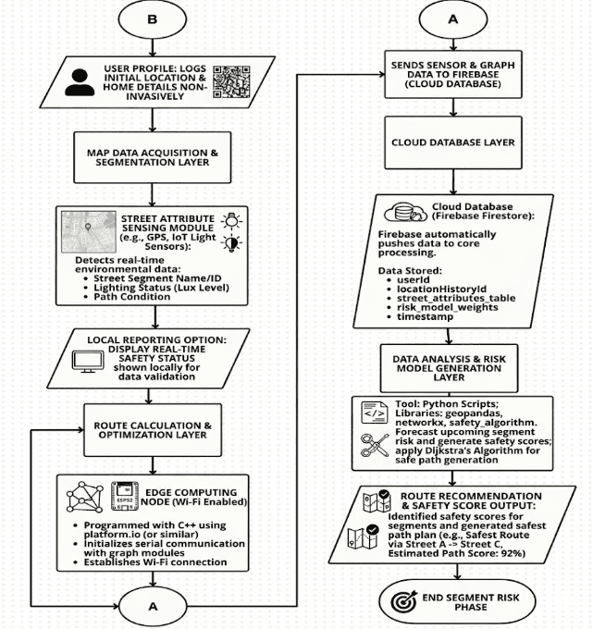

The proponents will design a Web-based Progressive Web App (PWA) using Figma prototypes to create an intuitive decision-support tool that enables residents to easily find and follow the safest walking paths at night within Barangay 770. Through the interface, users input their current location via GPS tagging and select their desired destination, which the application securely transmits to a Node.js and Express.js backend server using HTTP requests. To support effective navigation, the backend runs a Safety-Weighted Dijkstra’s Algorithm that converts the traditional map into a digital grid where street segments (edges) between intersections (nodes) are assigned "weights" based on real-world environmental conditions retrieved from a MySQL database. Rather than relying on standard spatial metrics, this method treats environmental danger as a mathematical cost, moving beyond simple GPS coordinates to establish a navigation system that is deeply aware of the pedestrian's physical surroundings and potential risks.
The weighting system works by applying heavy penalties to street segments characterized by poor lighting, high crime statistics, or active incident reports, making them mathematically expensive for the algorithm to traverse. Conversely, routes with strong lighting, active CCTV coverage, or proximity to barangay outposts receive low weights, signaling them to the algorithm as preferred, highly protective paths. When a routing request is processed, the server calculates the cumulative cost of all potential pathways and isolates the sequence of segments with the smallest total weight. This optimization process ensures that the final route, which is transmitted back to the client interface and rendered visually via the Google Maps API, effectively bypasses high-risk zones even if the geographic distance is slightly longer. To guarantee operational reliability, the system's real-time responsiveness, cross-platform compatibility, and routing accuracy will be rigorously tested on various Android devices under fluctuating nighttime network conditions.
Figure 4. System Architecture of the RouteSafe Web Application
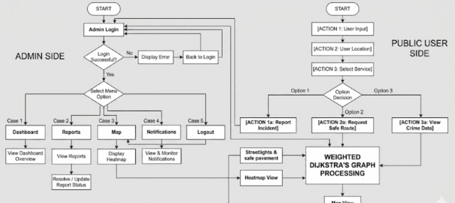
To support the second objective of optimizing route selection based on safety parameters, the proponents will develop a specialized pathfinding engine that shifts the core logic of navigation from speed to security within Barangay 770. The system utilizes a centralized MySQL database to store and organize structured geospatial data, including road network nodes, street segment geographic distances, and critical localized safety variables such as lighting status and historical crime density. Managing this infrastructure is a backend application developed using Node.js, which handles execution requests and transforms the physical map into an interconnected digital graph where environmental danger is translated into a deterministic mathematical cost. By implementing a Safety-Weighted Dijkstra’s Algorithm, the routing engine applies heavy numeric penalties to street segments (edges) characterized by poor visibility or high crime frequency, making them mathematically expensive for the algorithm to traverse, while paths near active barangay outposts or well-lit zones are assigned low weights to signal them as preferred alternatives.
Through this centralized backend processing, the engine calculates the cumulative cost of all potential pathways between specified intersections (nodes) and isolates the sequence that yields the absolute smallest total risk weight. This mathematical optimization ensures that the final recommendation effectively bypasses high-risk zones, dynamically favoring security even if the alternative geographic distance is slightly longer. Furthermore, the backend ensures that these calculation arrays are updated in real time as new localized safety parameters or incident reports are verified by authorities. By outputting data-driven, secure guidance that actively routes pedestrians away from vulnerable locations, this technical framework provides actionable decision-support that empowers residents to navigate the community at night with confidence.

Figure 5. Process of AI-Based Risk Prediction and Safety Data Integration
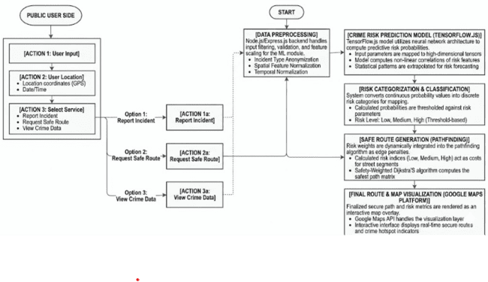
Figure 4 To achieve the third objective of implementing a machine learning–based crime risk prediction model, the proponents will develop an AI module within the system's backend environment using TensorFlow.js to analyze historical crime records alongside newly submitted incident reports. The pipeline initiates by blending historical barangay blotter datasets with citizen-contributed parameters, routing them to a data preprocessing layer where Node.js and Express.js handle feature normalization and anonymization. These clean data structures are then ingested into a neural network architecture trained to map non-linear relationships among variables like incident location, date, time, and type of crime. Through this pattern analysis, the model executes statistical probability calculations to estimate real-time crime vulnerability for specific coordinates and street segments within a given time period.
Following probability evaluation, the engine initiates a risk classification tier that maps the continuous numerical metrics into categorical safety zones defined as Low, Medium, or High risk. These discrete safety indices are fed directly into the pathfinding engine during the safe route generation phase, allowing the modified Dijkstra’s algorithm to mathematically penalize and bypass high-risk road segments. Concurrently, the system integrates the Google Maps Platform API to translate these localized coordinates and classification matrices into an interactive safety heatmap overlay. Displayed through the administrative dashboard, this visualization pipeline updates automatically as new incident data is synchronized, providing barangay officials and law enforcement authorities with an active decision-support tool to monitor emerging crime hotspots, track safety trends, and optimize nightly patrol resource allocation.
Method 2: Method 2: User-Customized Path Selection
Figure 6. Implementing the User_Customize Path Selection
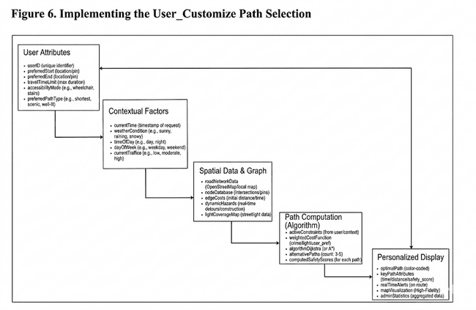
The diagram presents the user-customized path selection method used by the RouteSafe Barangay 770 system to help pedestrians navigate nighttime routes more securely. The process begins with collecting user-specific attributes, such as their preferred start and end locations, travel time limits, and preferred path type (e.g., shortest, scenic, or well-lit). From there, the system evaluates dynamic contextual factors, including the current time of request, weather conditions, and time of day. It cross-references this information with a spatial data graph, which maps out the barangay's road network, real-time hazards, and street lighting coverage.
Using these combined datasets, the system applies a safety-weighted pathfinding algorithm (such as Dijkstra’s Algorithm) to compute the most optimal routes and calculate specific safety scores for each option. A personalized display is then generated to guide the user, featuring a high-fidelity map visualization, color-coded optimal paths, and real-time alerts for the chosen route. Overall, this approach makes urban navigation safer and more accessible by helping pedestrians understand their local street conditions and make informed travel choices based on their personal preferences.
Method 3: Predictive Crime Risk Modeling
Figure 7. Forecasting Route Safety using Machine Learning
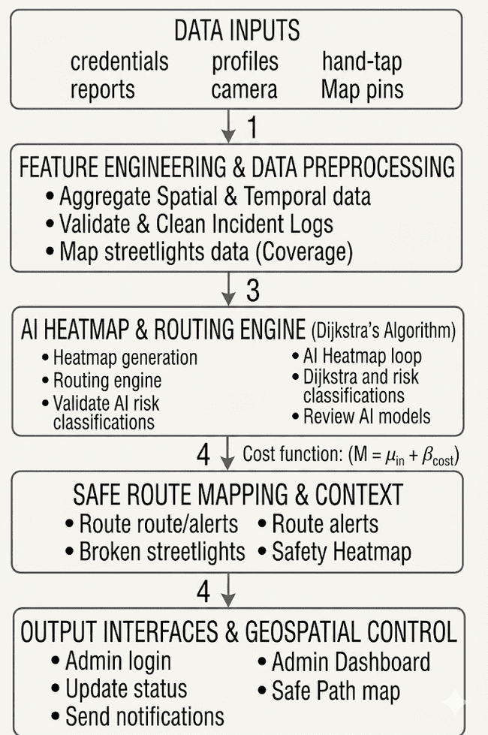
Figure 7 presents the predictive modeling process utilized by RouteSafe Barangay 770 to estimate localized safety risks and generate dynamic hazard maps. The process begins with the collection of spatial and temporal data, including historical crime incidents, street lighting coverage, and infrastructure logs, gathered through official precinct records and community reports. These collected datasets are stored and organized within the central database to serve as the primary foundation for risk forecasting and spatial analysis.
Before the forecasting stage, the gathered data undergo feature engineering and preprocessing to improve the quality and reliability of the dataset. This process includes aggregating spatial coordinates, handling incomplete or inconsistent incident logs, and validating temporal patterns such as the time of night and day of the week. These preprocessing steps help ensure that the historical safety data are suitable for analysis using the predictive machine learning model.
After preprocessing, the machine learning model is applied to analyze historical hazard patterns and generate dynamic, localized safety scores for every street segment within the barangay's graph network. The forecasted risk values are then converted into real-time safety heatmaps. These generated forecasts are presented within the web application through graphical map visualizations that clearly highlight high-risk and low-risk walking zones. In addition, the system integrates these predictive scores directly into Dijkstra’s Algorithm, allowing the platform to proactively generate safe route recommendations, hazard alerts, and navigation guidance to help pedestrians manage their nighttime travel more securely.
Tools
The tools used in the development of the proposed system are presented through system design diagrams that illustrate its structure, processes, and data flow. These tools provide a visual representation of how the system operates, including user interactions, data movement, and database relationships. The succeeding sections include the flowchart, data flow diagram, entity-relationship diagram, and use case diagram of the system.
Figure 8. Flowchart of the Proposed System

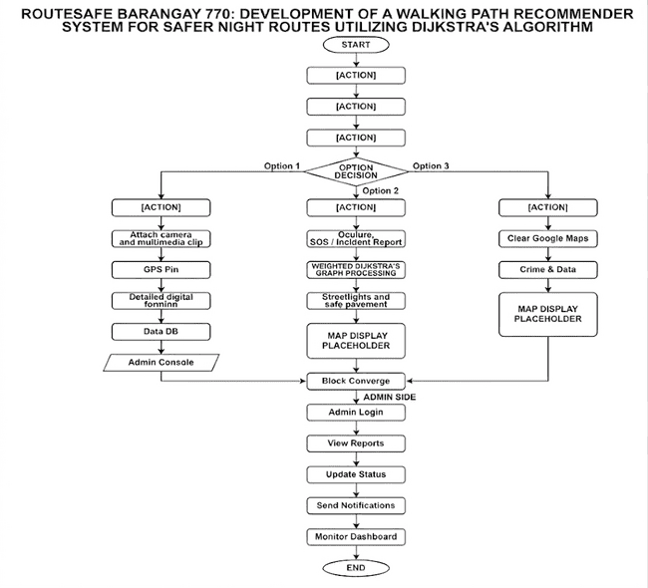

In Figure 8 the flowchart outlines the process of the RouteSafe Barangay 770 system, which is a Walking Path Recommender utilizing Dijkstra’s Algorithm. Users authenticate through a Progressive Web App to access functionalities like requesting safe routes, viewing a safety heatmap, or sending emergency alerts. Upon path request, the system gathers real-time safety data from a MySQL database and applies the Safety-Weighted Dijkstra’s Algorithm, optimized by TensorFlow.js for safer route suggestions, which are visualized using the Google Maps API. Additionally, users can report hazards through an SOS button, alerting barangay authorities. Administrators utilize a web dashboard to manage reports and street safety statuses, ensuring efficient real-time navigation and community safety oversight.

Figure 9. Use Case Diagram
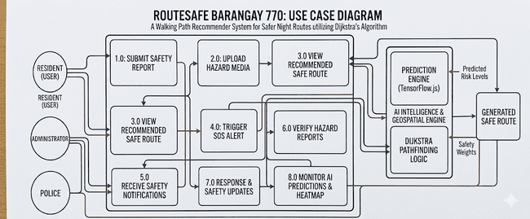
Figure 9 shows the primary use-case flow of the RouteSafe Barangay 770 platform, beginning with secure user authentication. Residents may register or log in to the Progressive Web App, then input their desired destinations to request optimized walking paths; the system maintains an active database of community-driven incident logs and geo-tagged reports so users can inspect real-time hazards and past safety conditions.
Stored environmental data and user-submitted incident reports feed the safety-weighted Dijkstra’s routing engine and AI risk prediction layer, which produce secure path recommendations and dynamic safety heatmaps. Map outputs are displayed on the user's interface via the Google Maps API and can trigger real-time updates; each route is accompanied by targeted security advisories and an emergency SOS function that translate predictive risk data into practical steps for avoiding high-threat zones and ensuring personal safety.
The diagram also includes routine system management actions for Administrators and Police, such as monitoring citizen reports, validating multimedia evidence, and updating active threat statuses. In conclusion, the use-case layout highlights a straightforward, secure workflow that integrates community reporting, AI-based threat prediction, real-time map visualization, and algorithmic pathfinding, helping the residents of Barangay 770 better understand their local street conditions and make informed nighttime travel decisions.
Figure 10. Entity Relationship Diagram
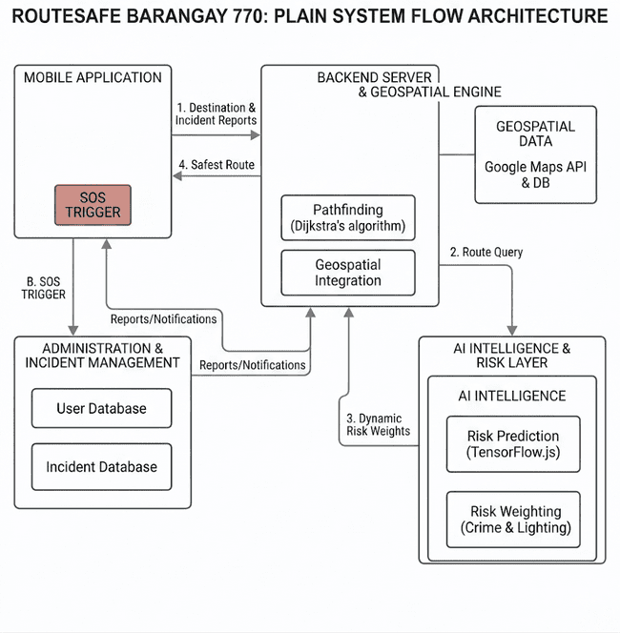
Figure 10 illustrates the system flow architecture of RouteSafe Barangay 770, which primarily utilizes synchronized data interactions to support web-based hazard reporting and AI-driven pathfinding. A single web application user can input destination requests, submit multiple community incident reports, and trigger emergency SOS alerts over time. Furthermore, the central backend server can process these inputs by simultaneously querying the Geospatial Data module for road networks and extracting dynamic risk weights from the TensorFlow.js AI Intelligence Layer. These integrated processes allow the system to efficiently compute optimal routes via Dijkstra's algorithm, manage real-time incident databases through the administration module, and generate the safest walking path recommendations for each user.
Figure 11. Data Flow Diagram Level 0
Level 0 DFD
The Level 0 Data Flow Diagram (DFD), or context diagram, for the RouteSafe: Walking Path Recommender System provides a high-level view of the system's interactions with external entities. The system is depicted as a single process that centralizes data transactions and pathfinding calculations, highlighting its role as the main hub for safety-related information.
Residents, as primary users, interact with the system by submitting destination coordinates, real-time incident reports, and SOS alerts. In exchange, they receive optimized safe route recommendations, visual safety heatmaps, and emergency confirmations. This exchange of information ensures that users have access to the most current safety metrics, enabling them to make informed decisions about their routes.
On the administrative side, barangay officials and police authorities contribute verified crime records and infrastructure updates, which are essential inputs for the system's navigation logic. They also receive incident data and AI-generated risk predictions, illustrating a bidirectional flow of information that enhances both community safety and navigation efficiency. Overall, the DFD underscores the system's role in connecting residents and authorities, facilitating safe navigation, emergency response, and proactive safety monitoring within Barangay 770.
Figure 12. Data Flow Diagram Level 1
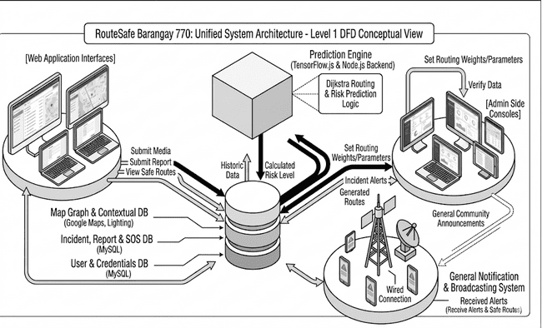
The Level 1 Data Flow Diagram (DFD) for RouteSafe Barangay 770 illustrates how the system decomposes its high-level architecture into four primary sub-processes: User Management, Incident Reporting & Monitoring, AI Risk Analysis, and Safe Route Generation. When residents submit reports via the web interface, the Incident Reporting & Monitoring (P2.0) module processes and archives this data in a MySQL Incident Data Store while simultaneously alerting admin consoles for validation. The intelligence layer, powered by the AI Risk Analysis (P3.0) module using TensorFlow.js, extracts this historical and real-time data to calculate and update node-specific threat levels within a dynamic Risk Level Data Store.
Building on these insights, the Safe Route Generation (P4.0) process combines the user's location parameters with map graph data and the newly updated AI risk assessments. It executes a Safety-Weighted Dijkstra’s Algorithm that penalizes high-risk paths to calculate the safest route, which is then rendered on the user's web interface using the Google Maps API. Ultimately, this structured DFD highlights the continuous data loop between external entities, localized databases, and core analytical modules to provide adaptive walking paths, emergency coordination, and data-driven safety monitoring for the community.
Figure 12. Data Flow Diagram Level 2
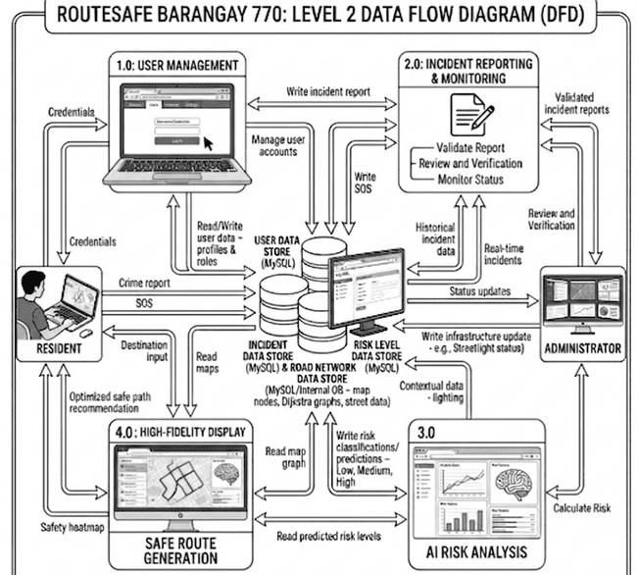
The Level 2 Data Flow Diagram (DFD) for RouteSafe Barangay 770 offers an in-depth look at the system's internal processes, focusing on key functional modules such as report handling, SOS processing, notification management, and prediction generation. This detailed breakdown illustrates the specific steps necessary to convert raw user inputs into actionable safety intelligence, enhancing the overall functionality of the system.
Within the report management process, several crucial steps are highlighted, including the capturing of incident details, validating data for integrity, and storing verified reports in the Incident Database. The media handling process is similarly structured, involving the uploading, validation, and storage of multimedia files in the Media Database, which helps document hazards effectively.
The SOS module is designed for emergency situations, encompassing processes like triggering alerts, capturing real-time GPS locations, and storing these alerts in the SOS Alerts Database for prompt action by barangay authorities. Additionally, the Notification System ensures timely communication by generating and sending alerts to users and officials. The AI component further enhances the system by analyzing historical data and generating predictions, which assist in monitoring crime trends and informing patrol strategies. Overall, the Level 2 DFD effectively illustrates the system's workflows, emphasizing accuracy and real-time functionality for improved nighttime safety.
RESULT AND DISCUSSIONS
This chapter presents the findings of the study on RouteSafe Barangay 770: Development of a Walkingpath Recommender System for Safer Night Routes Utilizing Dijkstra’s Algorithm, a localized web-based navigation solution designed to guide pedestrians through optimal and secure paths during night travel. The study focused on the implementation and evaluation of three key system components: the integration of Dijkstra’s algorithm modified with safety-weighted environmental parameters to compute secure paths rather than just the shortest distance, a crowdsourced hazard reporting mechanism allowing community members to log real-time safety concerns, and an interactive localized mapping interface tailored specifically to the infrastructure and active security outposts of Barangay 770.
Objective 1: RouteSafe Barangay 770 | Project Information & Incident Reporting
The first objective was to design and deploy a localized, web-based reporting mechanism and data ingestion pipeline that empowers residents to log real-time community hazards and provides barangay officials with a verifiable public safety queue. This objective was successfully achieved through the implementation of a responsive Progressive Web App (PWA) frontend interface connected via secure APIs to a structured Node.js/Express.js backend and a centralized MySQL database.
Results:
Figure 13. User Register, Log in page, and Suggestion feature


Figure 13 shows the user-driven reporting pipeline implemented in the RouteSafe Barangay 770 web application. As illustrated, when a user encounters a safety concern or localized hazard, they navigate to the integrated Contact and Report interface. The workflow begins when the user fills out the reporting form, specifying their contact details, selecting an explicit message type (such as "Report a Danger Zone"), and providing a description of the real-world incident. Once the user clicks "Send Message," the form data is transmitted via an API request to the Node.js/Express backend server, which logs the entry into the MySQL database for administrative queuing and verification. image in real time. After detection, the identified appliance type is returned to the Web application and automatically displayed to the user.
Furthermore, the system leverages this structured input to dynamically feed the application’s routing engine while simultaneously managing user safety expectations. For instance, when an incident type like a street hazard or a poorly lit zone is selected and submitted, the system flags the specific area for review within a strict 24-hour verification window. Once verified by an administrator, the system assigns a localized safety penalty modifier to the corresponding street segments in the database. This directly alters the edge weights processed by the modified Dijkstra’s algorithm, effectively routing future users away from the reported danger zone.
Discussion:
The integration of the crowdsourced reporting framework within RouteSafe Barangay 770 directly addresses the limitations of static routing by converting real-time community feedback into dynamic spatial data. While standard navigation systems rely strictly on fixed distance or velocity metrics, pedestrian safety fluctuates based on localized, temporal hazards. By capturing structured user inputs—such as a "Report a Danger Zone" submission—and routing them through a strict administrative verification queue, the system balances responsiveness with data integrity, preventing malicious or false reports from instantly corrupting the network. Once verified, these reports introduce an artificial penalty modifier ($P_{incident}$) to the targeted street segments, updating the total edge cost ($W_{total} = W_{distance} + P_{lighting} + P_{incident}$) and forcing the modified Dijkstra’s algorithm to reroute pedestrians along physically longer but mathematically safer paths. Concurrently, by placing immediate emergency channels like 911 and 166 alongside the web form, the system manages user expectations during active crises, ensuring the application functions as a reliable preventive routing tool without delaying critical, life-saving emergency responses. .
Objective 2: Safety-Weighted Navigation and Real-Time Route Optimization
The second objective was to implement a safety-weighted navigation system and real-time path tracking interface that allows pedestrians to avoid high-risk areas and navigate safely through Barangay 770. This objective was successfully achieved through the integration of spatial data visualization, dynamic location searching, geo-fenced danger zones, and active navigation tracking within the RouteSafe system.
Results:
Figure 14. User Interface, Start Live Tracking and Real-Time Route Optimization
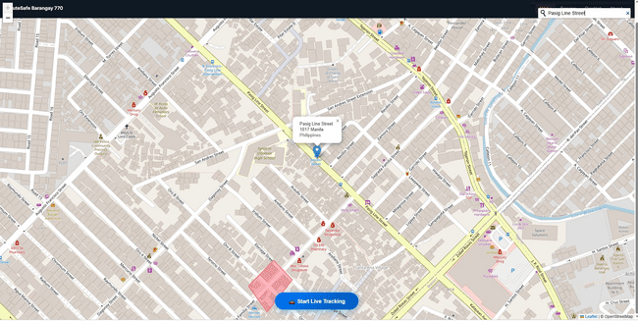
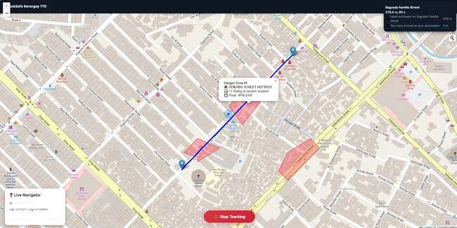
Figure 14 illustrates the safety-weighted navigation and real-time tracking interface implemented within the RouteSafe web application. Upon a successful location query or route generation request, the system retrieves geographic parameters such as node coordinates, street segment safety weights, historical crime logs, and active hazard boundaries. This information is passed dynamically through the application layers to render the optimal route on the interactive map view.
The module utilizes custom geospatial visualization layers to provide real-time visual feedback, highlighting designated high-risk zones as red polygonal overlays to enhance user safety awareness before and during travel.
Discussion:
The recommendation feature provides users with practical safety-oriented path suggestions based on localized environmental risk metrics rather than raw proximity alone. By analyzing historical crime density, lighting conditions, and specific neighborhood hazards, the system generates routes that actively bypass high-penalty street segments to encourage more secure pedestrian transit. In addition, the application includes a dedicated tracking page where users can view active danger zones and monitor their telemetry coordinates in real time. Crime context warnings are automatically provided whenever a path intersects a designated hotspot, helping community members become more aware of late-night vulnerabilities and optimal pathways within the barangay.
Objective 3: RouteSafe Admin Graph Dashboard (Dijkstra-Weighting System)
The third objective was to design a safety-weighted path recommender system capable of analyzing environmental and risk factors to generate secure night routes. This objective was successfully achieved through the implementation of a modified Dijkstra’s algorithm integrated within the RouteSafe Barangay 770 Admin Panel, providing dynamic edge-weight configurations, multi-layered risk visualizations, and real-time danger zone auditing via a web-based dashboard.

Figure 15. Admin Map Layers and Dijkstra Configurator
Results:
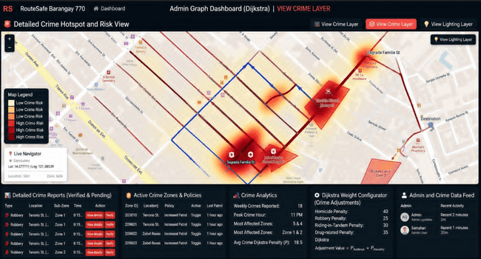
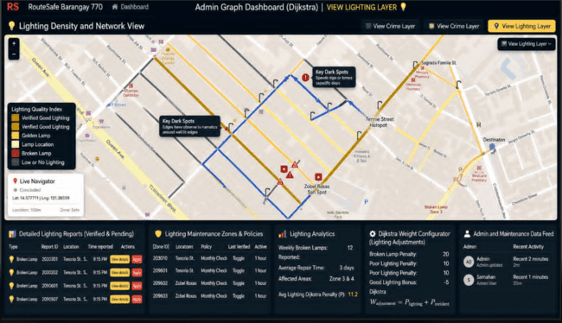
Figure 15 presents the multi-layered administrative dashboard of the RouteSafe web application. As shown, the system displays localized geospatial data over Barangay 770 using safety-weighted routing models integrated within a unified mapping interface. The interface visualizes risk vectors through three core views: a generalized Admin Live Map View showing verified danger zones (e.g., broken streetlamps), a Detailed Crime Hotspot and Risk View featuring an interpolated heat map of high-risk criminal zones, and a Lighting Density and Network View plotting the localization of active and malfunctioning streetlights.
The underlying modified Dijkstra routing engine renders optimal walking paths dynamically (represented by the blue route overlay) by processing real-time adjustments from the Dijkstra Weighting Configurator. During system validation, administrators can fine-tune specific risk penalties including specific weights for crimes (e.g., Homicide Penalty: 40, Riding-in-Tandem Penalty: 30) and infrastructure deficits (e.g., Broken Lamp Penalty: 20) which automatically re-calibrate the edge weights across the barangay's pedestrian road network.
Furthermore, the system processes active citizen telemetry through an Incoming Reports Queue and analytical feed card, tracking localized metrics such as weekly reported crimes, peak incident hours (11:00 PM), and average lighting penalties (P = 11.2k). By integrating interactive geospatial layers, live data feeds, and granular weight calibration sliders within a single dashboard, the system provides barangay administrators with an accessible, data-driven approach to community safety monitoring and neighborhood route optimization.
Discussion:
The multi-layered graph dashboard allows the RouteSafe Barangay 770 application to dynamically recalculate pedestrian routes by translating environmental risks into mathematical edge-weight penalties via a modified Dijkstra’s algorithm. By integrating the mapping interface with a real-time administrative control suite, the system moves beyond standard distance-based navigation to prioritize path security, automatically inflating edge weights via the formula $W_{\text{adjustment}} = P_{\text{lighting}} + P_{\text{incident}}$ whenever localized hazards—such as a broken streetlamp on Tenorio St. or a theft incident along Zobel Roxas St.—are verified. This mathematical penalty forces the routing engine to actively bypass high-risk street segments in favor of better-lit, lower-risk alternatives, even if the safer path increases the overall walking distance. Furthermore, by isolating "Key Dark Spots" and displaying an interpolated crime heat map, the dashboard serves as a vital decision-support tool for local authorities, enabling barangay personnel to deploy targeted night patrols, fast-track municipal lighting maintenance, and maintain granular oversight of community safety.
CONCLUSION AND RECOMMENDATIONS
The RouteSafe Barangay 770: Development of a Walking Path Recommender System for Safer Night Routes Utilizing Dijkstra’s Algorithm successfully achieved its objective of providing a Web-based and intelligent solution for navigating urban spaces safely at night. By integrating a Progressive Web App (PWA) for real-time user interaction, a Node.js and Express.js backend for core system operations, a secure MySQL database for data management, and a modified version of Dijkstra’s Algorithm, the system successfully calculated optimal paths based on lower risk factors rather than distance alone. The study demonstrated that combining Geographic Information Systems (GIS), mathematical graph optimization, and localized safety parameters—such as street lighting conditions, historical crime logs, and pedestrian density—can significantly enhance resident awareness and provide practical, security-focused navigation choices.
During the development phase, several technical challenges such as data mapping precision, real-time database synchronization, and assigning consistent safety weights to dynamic street conditions were encountered. These issues were addressed through systematic testing, graph refinement, and architectural optimization using structured development practices. The integration of robust API connections between the PWA frontend and the backend server also improved the overall processing speed, map responsiveness, and reliability of the platform during the testing and evaluation phases.
For future development and improvement of the study, it is recommended to:
- Integrate Dynamic and Crowdsourced Data Feeds: Incorporate real-time user incident reporting and automated emergency alerts to adjust safety weights instantly when a new localized threat or sudden infrastructure failure occurs.
- Improve Safety Prediction Accuracy: Support long-term risk assessment by expanding historical data collection and exploring advanced, machine learning-driven risk prediction models alongside the safety-weighted algorithm to account for time-based crime patterns.
- Enhance Geographic and Hardware Scope: Expand the system’s road network mapping beyond Barangay 770 to cover adjacent communities, while integrating real-time Internet of Things (IoT) sensors, such as smart streetlamp monitors, to automate lighting condition updates under actual nighttime conditions.

ACKNOWLEDGEMENTS

The proponents would like to convey their heartfelt thanks to their research adviser for the invaluable guidance, patience, and constructive feedback shared throughout the conduct of this study. Deep appreciation is also given to the Department of Information Technology at Jesus Reigns Christian College for providing the academic resources and technical support needed for the successful completion of this project. Moreover, the researchers are deeply grateful to the local officials and residents of Barangay 770, Manila, for their cooperation during data gathering and system evaluation, as well as to their families, classmates, and friends whose encouragement and moral support inspired them to complete this safety-oriented prototype successfully.

REFERENCES
- Agrawal, A. W., Schlossberg, M., & Irvin, K. (2008). How far, by which route and why? A spatial analysis of pedestrian preference. Journal of Urban Design, 13(1), 81–98. https://doi.org/10.1080/13574800701804074
- Cohen, A., & Dalyot, S. (2021). Route planning for blind pedestrians using OpenStreetMap. Environment and Planning B: Urban Analytics and City Science, 48(6), 1511–1526. https://doi.org/10.1177/2399808320933907
- Delikostidis, I., van Elzakker, C. P. J. M., & Kraak, M.-J. (2016). Overcoming challenges in developing more usable pedestrian navigation systems. Cartography and Geographic Information Science, 43(3), 189–207. https://doi.org/10.1080/15230406.2015.1031180
- Fang, Z., Li, Q., & Shaw, S.-L. (2015). What about people in pedestrian navigation? Geo-spatial Information Science, 18(4), 135–150. https://doi.org/10.1080/10095020.2015.1126071
- Henderson, J. (2018). Making cities more walkable for tourists: A view from Singapore’s streets. International Journal of Tourism Cities, 4(3), 285–297. https://doi.org/10.1108/IJTC-11-2017-0059
- Hoogendoorn, S. P., & Bovy, P. H. (2004). Pedestrian route-choice and activity scheduling theory and models. Transportation Research Part B: Methodological, 38(2), 169–190. https://doi.org/10.1016/S0191-2615(03)00016-5
- Jonietz, D. (2016). Personalizing walkability: A concept for pedestrian needs profiling based on movement trajectories. In T. Sarjakoski, M. Y. Santos, & L. T. Sarjakoski (Eds.), Geospatial data in a changing world: Selected papers of the 19th AGILE Conference on Geographic Information Science (pp. 279–295). Springer. https://doi.org/10.1007/978-3-319-33783-8_16
- Siriaraya, P., Wang, Y., Zhang, Y., Wakamiya, S., Jeszenszky, P., Kawai, Y., & Jatowt, A. (2020). Beyond the shortest route: A survey on quality-aware route navigation for pedestrians. IEEE Access, 8, 135569–135590. https://doi.org/10.1109/ACCESS.2020.3011924
- Wang, J., Wood, Z., & Worboys, M. F. (2016). Conflict in pedestrian networks. In T. Sarjakoski, M. Y. Santos, & L. T. Sarjakoski (Eds.), Geospatial data in a changing world: Selected papers of the 19th AGILE Conference on Geographic Information Science (pp. 261–278). Springer. https://doi.org/10.1007/978-3-319-33783-8_15
- Mendoza, M. T., & Tan, R. D. (2018). Spatial threat assessment and heatmap visualization for proactive crime management in local government units. Philippine Journal of Science, 147(3), 445–454. https://philjournalsci.dost.gov.ph
- Nakayama, K., & Ito, T. (2021). Dynamic spatial network updates via community-driven emergency reporting platforms. Information Systems Front, 23(2), 489–504. https://doi.org/10.1007/s10796-020-10045-8
- Navarro, E. J., Ramos, L. C., & Solidum, G. P. (2021). Integrating crowdsourced safety inputs with official police records for responsive navigation systems. The Philippine Journal of Science, 150(S1), 321–335. https://philjournalsci.dost.gov.ph/images/pdf/pjs_pdf/vol150s1/integrating_crowdsourced_safety_inputs.pdf
- Reyes, M. A., Aquino, J. C., & Mercado, F. L. (2022). Safe Route Finder: Utilizing localized crime logs and CCTV footprints for commuter pathfinding. International Journal of Safety and Security Engineering, 12(1), 14–27. https://doi.org/10.18280/ijsse.120102
- Santos, J. E., & Dela Cruz, M. C. (2021). SafeWalk: Practical implementations of multi-factor path weighting systems in student corridors within Philippine urban environments. Philippine Engineering Journal, 42(2), 78–92. https://www.journals.upd.edu.ph/index.php/pej

