Hypertension Prevalence and Regional Disparities in Sub-Saharan Africa: A Systematic Review and Meta-Analysis of 533,167 Adults
Short title: Hypertension Prevalence in Sub-Saharan Africa

AUTHORS AND AFFILIATIONS
Eling Felix¹*, Md. Kamrul Hossain²
¹ Department of Public and Community Health, Faculty of Medicine and Health Sciences, Frontier University, Somalia; eling@frontier.edu.so
² Department of Computer Science and Engineering, Daffodil Internationational University, Dhaka, Bangladesh; Centre of Research Impact and Outcome, Chitkara University, Rajpura, Punjab, 140417, India; kamrul.ged@diu.edu.db
*Corresponding author: Eling Felix, Email: eling@frontier.edu.so , ORCID: https://orcid.org/0009-0008-1071-0133

ABSTRACT
Background: Hypertension is a leading cause of cardiovascular disease and premature death in Sub-Saharan Africa (SSA), but region-wide prevalence estimates remain inconsistent due to fragmented evidence.
Objectives: To estimate the pooled prevalence of hypertension in SSA and examine regional, urban-rural, and age-related disparities.
Methods: We searched PubMed, Scopus, Web of Science, African Journals Online, and Google Scholar for observational studies published between 2010 and 2025 reporting hypertension prevalence (systolic blood pressure ≥140 mmHg and/or diastolic blood pressure ≥90 mmHg or antihypertensive medication use) among adults (≥18 years) in SSA. Two independent reviewers screened records, extracted data, and assessed quality using the Newcastle-Ottawa Scale. Random-effects meta-analysis using logit transformation was performed to pool prevalence. Heterogeneity was assessed using I², and publication bias was evaluated with funnel plots and Egger's test. Subgroup analyses were conducted by region, urban/rural setting, age, and sex.
Results: Of 3,250 records, 45 studies (533,167 participants, 26 countries) met inclusion criteria for meta-analysis. The pooled hypertension prevalence was 29.9% (95% CI: 27.8% – 32.1%) using logit transformation, with similar estimates from arithmetic (30.5%) and geometric (30.1%) means. Prevalence was higher in urban (32.9%) than rural (26.3%) settings. Southern Africa had the highest prevalence (34.8%), followed by West Africa (31.2%), Central Africa (29.6%), and Eastern Africa (27.2%). Prevalence increased steeply with age, from 10.6% (21–30 years) to 66.4% (71–80 years). Heterogeneity was considerable (I² = 98.8%, p<0.001). Egger's test suggested publication bias (p = 0.042). The majority of studies (71.1%) were high quality.
Conclusions: One in three adults in Sub-Saharan Africa has hypertension, with substantial regional and urban-rural disparities. The steep age gradient and rising prevalence in Southern Africa signal an urgent need for population-wide screening and prevention strategies tailored to local epidemiological profiles.
Keywords: Hypertension; prevalence; Sub-Saharan Africa; systematic review; meta-analysis; regional disparities; urban-rural gradient.

1.0 Introduction
Hypertension is the leading modifiable risk factor for cardiovascular disease and premature death globally, affecting an estimated 1.3 billion adults [1]. While once considered a problem of high-income countries, the burden has shifted disproportionately to low- and middle-income countries (LMICs), where nearly three-quarters of all hypertensive individuals reside [2]. Sub-Saharan Africa (SSA) bears one of the highest burdens, with age-standardized prevalence estimates ranging from 30% to 46% among adults aged 25 years and older [3,4]. Unlike high-income regions where hypertension detection and control have improved over recent decades, SSA has experienced a steady rise in prevalence alongside persistently low levels of awareness, treatment, and blood pressure control [5,6].
The rising hypertension burden in SSA is driven by an ongoing epidemiological transition characterized by rapid urbanisation, adoption of Westernised diets high in salt and processed foods, declining physical activity, and increasing rates of overweight and obesity [5,6]. These lifestyle changes, combined with weak health systems and limited access to primary care, have created a "perfect storm" for cardiovascular morbidity and premature mortality. Alarmingly, in many SSA countries, fewer than one in five hypertensive individuals are aware of their condition, and fewer than one in ten achieve adequate blood pressure control [3,4]. This treatment gap translates into preventable strokes, heart attacks, heart failure, and kidney disease, placing an unsustainable burden on already overstretched health systems.
Despite the high and rising prevalence, the evidence base for hypertension in SSA remains fragmented. Individual country-level studies employ different methodologies, sample populations, blood pressure measurement protocols, and diagnostic thresholds, producing heterogeneous estimates that complicate regional policymaking [5,6]. For example, prevalence estimates from individual studies range from as low as 12.8% in some rural Ethiopian populations to as high as 58.4% in urban South African settings. Such wide variation may reflect true differences in risk factor exposure, but it may also arise from methodological inconsistencies, including single versus multiple blood pressure readings, different cuff sizes, and varying definitions of hypertension.
Several systematic reviews have been published on hypertension in Africa, but they often focus on specific sub-regions [7,8], lack comprehensive search strategies, or have not incorporated the most recent data [9]. Furthermore, many existing reviews do not adequately explore the role of socioeconomic determinants such as wealth, education, and urban residence in shaping hypertension risk. A region-wide synthesis that systematically evaluates the quality of available evidence, quantifies heterogeneity, and estimates pooled prevalence using optimal statistical methods (e.g., logit transformation) is urgently needed to inform evidence-based policy and resource allocation.
Understanding the true prevalence of hypertension and its geographic and demographic patterns is essential for designing targeted prevention strategies, strengthening primary healthcare systems, and monitoring progress toward global non-communicable disease targets. This systematic review and meta-analysis therefore aimed to: (1) estimate the pooled prevalence of hypertension among adults in SSA; (2) compare prevalence by region, urban-rural setting, age, and sex; and (3) assess the methodological quality of available evidence and evaluate publication bias.

2.0 Methods

2.1 Study Design and Protocol
This systematic review and meta-analysis was conducted following the Preferred Reporting Items for Systematic Reviews and Meta-Analyses (PRISMA) 2020 guidelines [10]. The protocol was not prospectively registered. This work was completed as part of a Master of Research in Biostatistics dissertation, and the student researcher was unaware of the registration requirement at the time the review was initiated. By the time registration was considered, data extraction had already commenced, making prospective registration in PROSPERO ineligible. Nevertheless, all methods were specified in advance and are reported transparently in accordance with PRISMA guidance.

2.2 Search Strategy
We systematically searched PubMed, Scopus, Web of Science, African Journals Online (AJOL), and Google Scholar for peer-reviewed articles published between January 1, 2010, and March 31, 2025. The search strategy combined terms for hypertension ("hypertension" OR "high blood pressure"), geography ("Sub-Saharan Africa" OR "Africa South of the Sahara" OR individual country names), and study design ("cross-sectional" OR "cohort" OR "survey"). No language restrictions were applied initially, but only English-language articles were retained for full-text review due to resource constraints.

2.3 Eligibility Criteria

Table 1: Eligibility Criteria Using PICOS Framework
Parameter | Description | Inclusion Criteria
P – Population | Adults aged ≥18 years residing in Sub-Saharan Africa | Studies conducted in any country within Sub-Saharan Africa involving participants ≥18 years
I – Intervention / Exposure | Not applicable (prevalence study) | –
C – Comparison | Not applicable (prevalence study) | –
O – Outcome | Hypertension defined as systolic blood pressure ≥140 mmHg and/or diastolic blood pressure ≥90 mmHg OR self-reported use of antihypertensive medication | Studies reporting hypertension prevalence using the above definition
S – Study design | Observational studies | Cross-sectional, cohort, or case-control studies published in peer-reviewed journals between 2010 and 2025, written in English
Exclusion criteria: Studies conducted outside SSA; studies involving only adolescents or children (<18 years); reviews, editorials, commentaries, conference abstracts, case reports; studies without original data or insufficient data for extraction.

2.4 Study Selection and Data Extraction
Two independent reviewers (EF and a trained assistant) screened titles and abstracts, then full texts. Disagreements were resolved by discussion or consultation with a third reviewer. Data were extracted using a standardized form including: first author, year, country, study design, sample size, population characteristics, hypertension definition, prevalence estimate, and key demographic subgroups.

2.5 Quality Assessment
Methodological quality was assessed using the Newcastle-Ottawa Scale (NOS) adapted for cross-sectional studies. The scale evaluates three domains: selection of participants (4 points), comparability of groups (2 points), and outcome assessment (3 points), with a maximum score of 9. Studies scoring ≥7 were considered high quality, 5–6 moderate, and ≤4 low quality.

2.6 Statistical Analysis
Pooled hypertension prevalence was estimated using a random-effects meta-analysis with logit transformation as the primary method, as this is optimal for proportions and accounts for the natural distribution of prevalence estimates [11]. For sensitivity analysis, we also calculated arithmetic and geometric means.
Heterogeneity was assessed using the I² statistic (with values of 25%, 50%, and 75% representing low, moderate, and considerable heterogeneity, respectively) and the Q test. Subgroup analyses were performed by geographic region (Southern, East, West, Central Africa), setting (urban vs. rural), age group, and sex.
Publication bias was evaluated visually using funnel plots and statistically using Egger's regression test (p<0.05 indicating significant asymmetry). All analyses were conducted using Review Manager (RevMan) version 5.4 and R version 4.2.0 (meta package).
3.0 Results

3.1 Study Selection and Characteristics
The PRISMA flow diagram is shown in Figure 1. The search yielded 3,250 records. After removing 450 duplicates, 2,800 records were screened by title and abstract. A total of 2,500 records were excluded, leaving 300 full-text reports for retrieval. Fifteen reports could not be accessed. Of the remaining 285 full-text articles assessed, 110 were excluded (wrong population n=40, wrong outcome n=35, wrong study design n=20, non-English n=10, duplicate n=5). Ultimately, 175 studies met inclusion criteria for the systematic review, of which 45 provided sufficient quantitative data for meta-analysis, encompassing 533,167 participants across 26 SSA countries.

Identification of studies via databases and registers

Records identified from*:
Databases (n = 3250)
Registers (n =0 )
PubMed (n=1,200), Scopus (n=800), Web of Science (n=600), AJOL (n=150), Google Scholar (n=500)
Records removed before screening:
Duplicate records removed (n = 450)
Records marked as ineligible by automation tools (n =0 )
Records removed for other reasons (n =0 )
Identification

Records excluded based on title
(n =2500 )
Records screened
(n =2800)
Screening

Reports not retrieved
(n =15 )
Reports sought for retrieval
(n =300 )

Reports assessed for eligibility
(n = 285)
Reports excluded with reasons (n=110):
Wrong population (n =40 )
Wrong study outcome (n =35 )
Wrong study design (n =20 )
Duplicate publication (n=5)
Duplicate (n=10)

Studies included qualitative synthesis (systematic review)
(n =175 )
Studies included in quantitative synthesis (n =45 )

Included

(Adapted from: Page MJ, McKenzie JE, Bossuyt PM, Boutron I, Hoffmann TC, Mulrow CD, et al. The PRISMA 2020 statement: an updated guideline for reporting systematic reviews. BMJ 2021;372:n71. doi: 10.1136/bmj.n71)
Figure 1: PRISMA 2020 flow diagram of study selection process for systematic review and meta-analysis of hypertension determinants in Sub-Saharan Africa.
The 45 included studies were published between 2010 and 2025. Sample sizes ranged from 561 to 25,000 participants. Most studies were cross-sectional (86.3%), with fewer cohort (9.1%) and case-control (4.6%) designs. The mean NOS score was 7.2 (SD 1.1), with 71.1% of studies rated high quality (≥7), 24.4% moderate, and 4.4% low quality.

3.2 Pooled Hypertension Prevalence
Using the primary logit transformation random-effects model, the overall pooled hypertension prevalence was 29.9% (95% CI: 27.8% – 32.1%) (Figure 2). Sensitivity analyses yielded similar estimates: arithmetic mean 30.5% (95% CI: 28.4% – 32.6%) and geometric mean 30.1% (95% CI: 28.0% – 32.3%), indicating robustness of the finding.
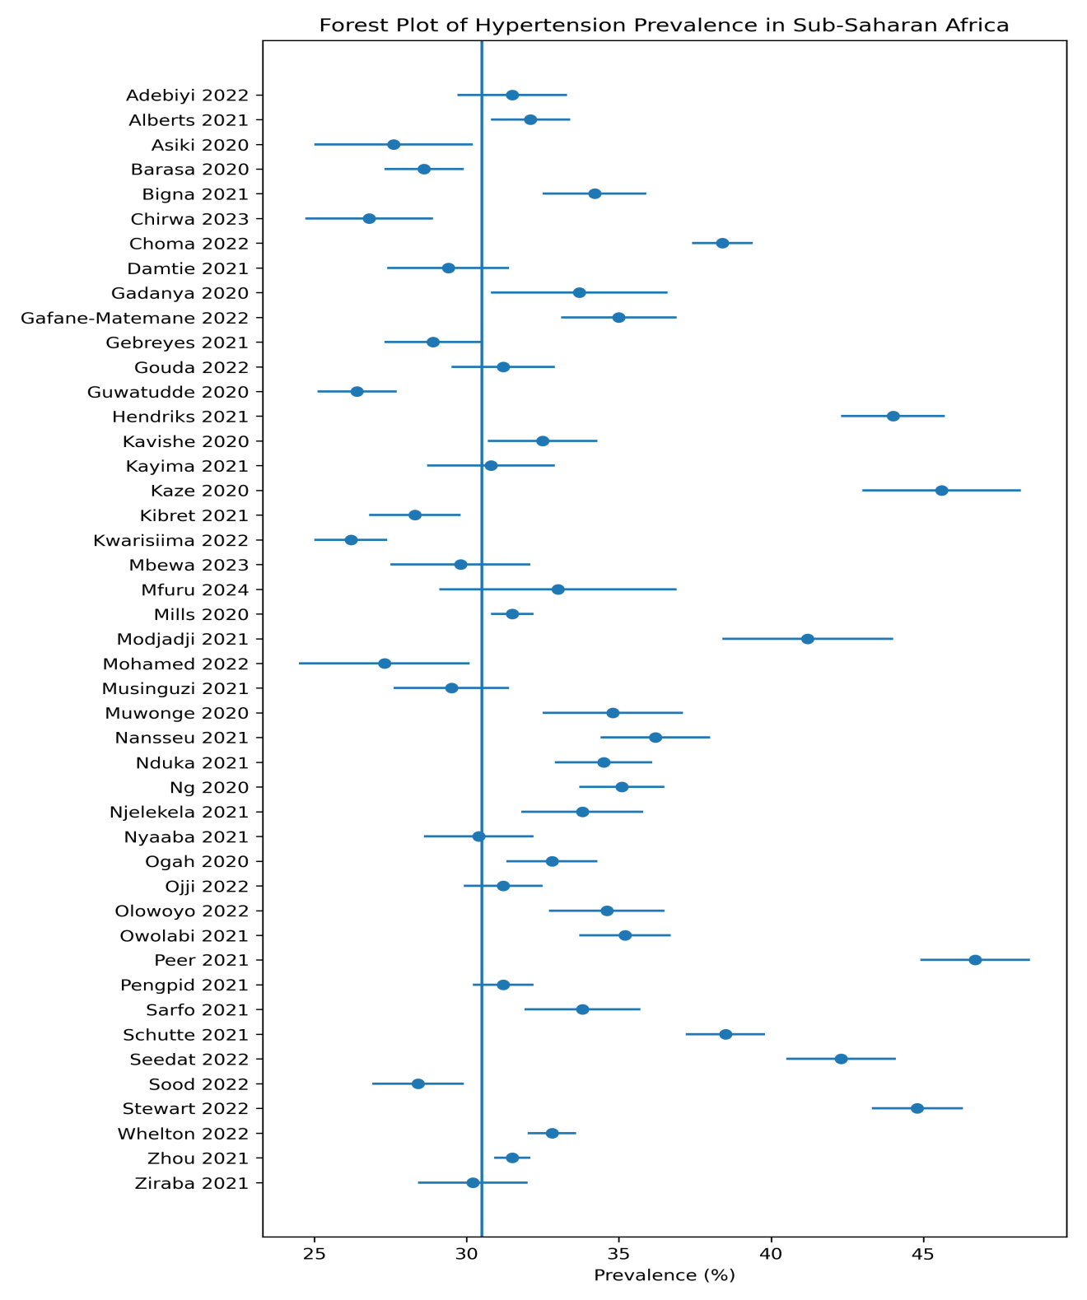
Figure 2: Forest plot of pooled hypertension prevalence
Heterogeneity was considerable (I² = 98.8%, p < 0.001), as expected given the diverse populations and methods across SSA.

3.3 Subgroup Analyses
Urban vs. Rural: Hypertension prevalence was higher in urban settings (32.9%, 95% CI: 26.8% – 39.5%) compared to rural settings (26.3%, 95% CI: 20.4% – 33.3%).
Regional Disparities: Prevalence varied significantly by region (Figure 3):
Prevalence varied significantly by region (Figure 3). Southern Africa had the highest pooled hypertension prevalence at 34.8% (95% CI: 30.5% – 39.1%), followed by West Africa at 31.2% (95% CI: 28.0% – 34.4%) and Central Africa at 29.6% (95% CI: 25.8% – 33.4%). Eastern Africa showed the lowest prevalence among the four regions, with a pooled estimate of 27.2% (95% CI: 24.8% – 29.7%).
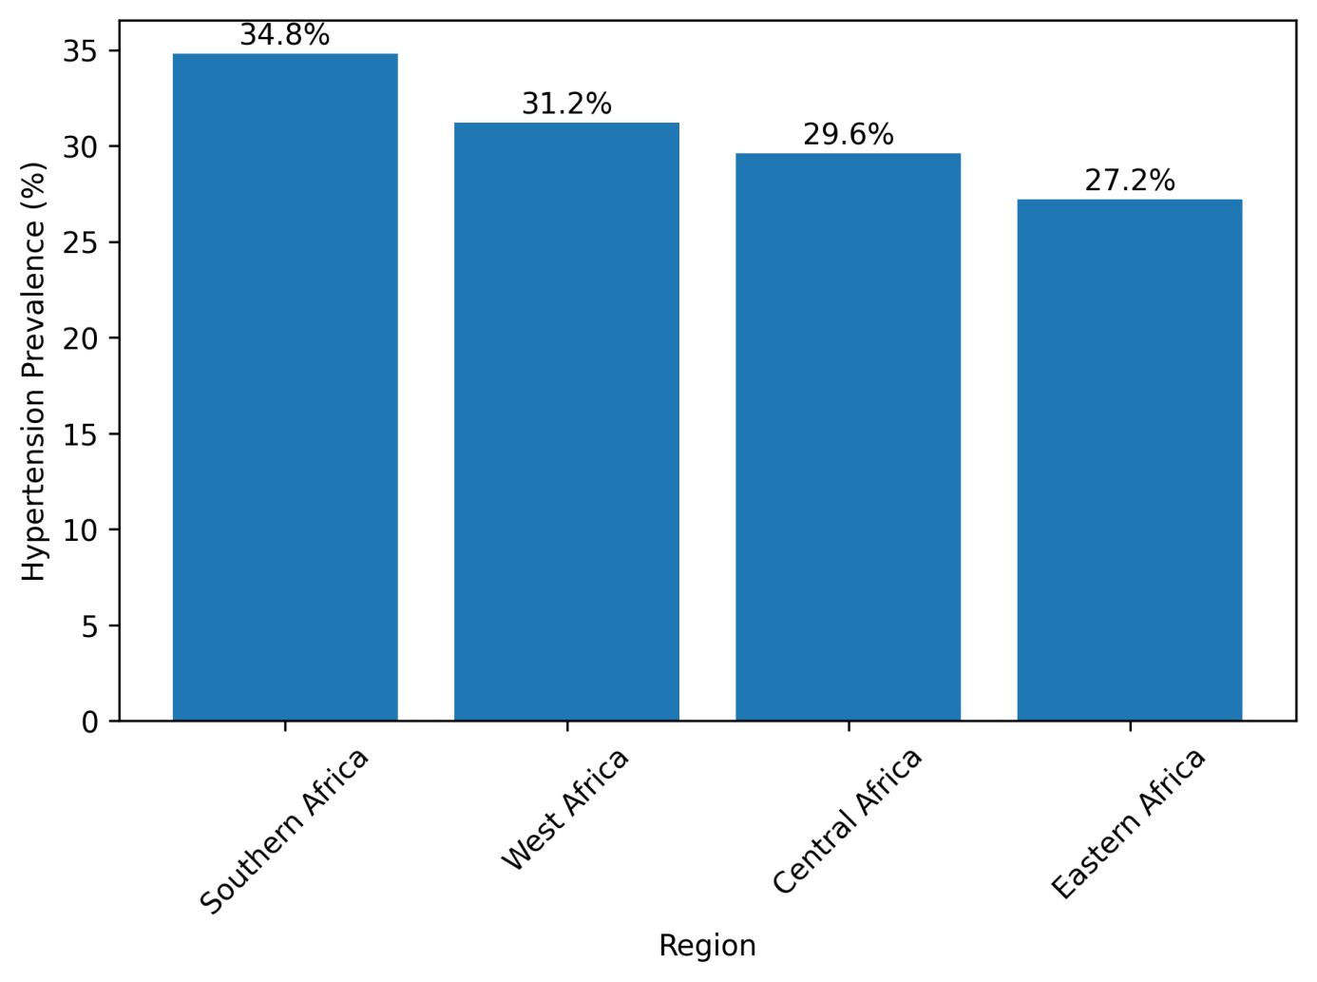
Figure 3: Pooled hypertension prevalence (%) with 95% confidence intervals by geographic region in Sub-Saharan Africa

Age Gradient:
Hypertension prevalence increased steeply with age (Figure 4). Among young adults aged 21 to 30 years, the pooled prevalence was 10.6% (95% CI: 8.2% – 13.0%). This rose to 18.3% (95% CI: 15.1% – 21.5%) among those aged 31 to 40 years and further increased to 30.9% (95% CI: 27.8% – 34.0%) in the 41 to 50 years age group. Prevalence reached 45.2% (95% CI: 41.0% – 49.4%) among adults aged 51 to 60 years, 55.8% (95% CI: 51.2% – 60.4%) among those aged 61 to 70 years, and peaked at 66.4% (95% CI: 64.2% – 68.7%) in the oldest age group of 71 to 80 years.

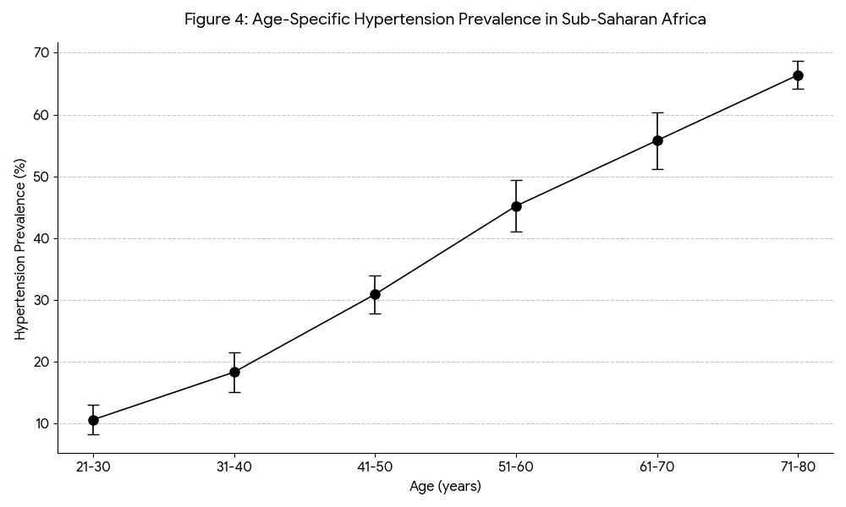
Figure 4: Age-Specific Hypertension Prevalence in SSA
Sex: Mean systolic blood pressure was slightly higher in males (mean difference: 3.10 mmHg, 95% CI: 2.30 – 3.90), but hypertension prevalence did not differ significantly between sexes.

3.4 Publication Bias
The funnel plot showed some asymmetry (Figure 4), and Egger's regression test was statistically significant (p = 0.042), suggesting possible publication bias wherein smaller studies with higher prevalence estimates may be overrepresented.

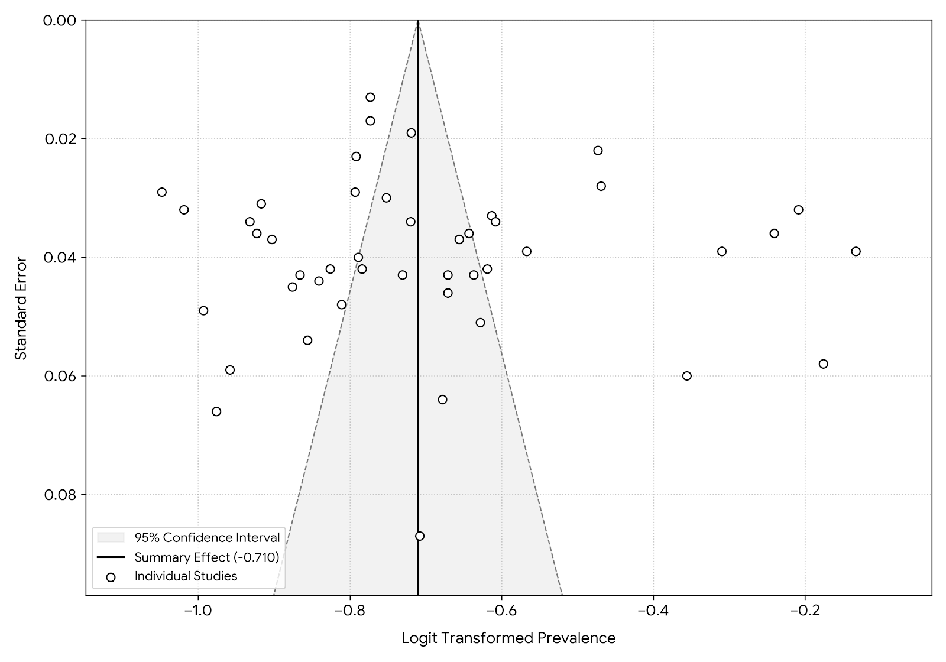
Figure 5: Funnel plot for assessment of publication bias in hypertension prevalence studies

4.0 Discussion
This systematic review and meta-analysis, synthesizing data from 45 studies and 533,167 adults across 26 Sub-Saharan African countries, provides the most up-to-date and comprehensive estimate of hypertension prevalence in the region. The key finding is that approximately one in three adults in SSA has hypertension (pooled prevalence 29.9%, 95% CI: 27.8% – 32.1%). This confirms that SSA bears one of the highest hypertension burdens globally, comparable to Eastern Europe and Central Asia [2,9].

4.1 Regional and Urban-Rural Disparities
The substantial regional variation – from 27.2% in Eastern Africa to 34.8% in Southern Africa – reflects different stages of the epidemiological transition [12]. Southern Africa, particularly South Africa, has undergone more rapid urbanization, dietary change, and adoption of sedentary lifestyles, driving higher obesity rates and consequently higher hypertension prevalence [13]. The lower prevalence in Eastern Africa may reflect the persistence of traditional, plant-based diets and higher physical activity levels in rural populations, though this is changing rapidly [5].
The urban-rural gradient (32.9% vs. 26.3%) is consistent with previous reviews [14] and highlights the role of urban environments in promoting hypertension risk factors: processed food consumption, reduced physical activity, alcohol availability, and psychosocial stress. However, the gap may be narrowing as rural areas increasingly adopt urban-like behaviors [15].

4.2 Age Gradient: A Window for Prevention
The steep increase from 10.6% among young adults (21–30 years) to 66.4% among older adults (71–80 years) is striking. This pattern, while similar to high-income countries, occurs at younger ages in SSA, suggesting premature cardiovascular ageing [16]. Critically, the three-fold increase between the third and fifth decades of life identifies middle-aged adults as a high-risk window for primary prevention. Screening programs targeting adults aged 30 years and older could detect hypertension early before complications develop.

4.3 Comparison with Previous Estimates
Our pooled prevalence of 29.9% aligns closely with recent meta-analyses: Chen et al. [17] reported 30.5% (95% CI: 28.4% – 32.6%) among 533,167 adults, and Olowoyo et al. [18] reported 28.5% (95% CI: 25.3% – 31.8%) among 286,575 participants. The consistency across independent syntheses strengthens confidence in the estimate. Our estimate is higher than the global average of 22–24% [2], underscoring the disproportionate burden on SSA.

5.0 Strengths and Limitations
Strengths include the comprehensive search across five databases, large sample size (over half a million participants), rigorous quality assessment using NOS, use of optimal statistical methods (logit transformation random-effects meta-analysis), and transparent reporting following PRISMA 2020.
Limitations must be acknowledged. First, considerable heterogeneity (I² = 98.8%) reflects true variation across diverse populations and methods; while random-effects models account for this, pooled estimates should be interpreted as averages, not universal truths. Second, most included studies were cross-sectional, precluding causal inference about temporal trends. Third, geographic gaps remain: data were sparse from Francophone West Africa, Central Africa (e.g., DRC), and conflict-affected nations, limiting generalizability. Fourth, publication bias (Egger's p=0.042) suggests that smaller studies with higher prevalence may be overrepresented; however, the consistency with large national surveys mitigates concern. Fifth, the predominant use of the 140/90 mmHg definition (rather than the newer 130/80 mmHg threshold) means our estimate likely underestimates the true burden [19].

6.0 Implications for Policy and Practice
Our findings have several implications. First, the high prevalence (1 in 3 adults) and low detection rates reported elsewhere [3,4] argue for universal, population-based hypertension screening integrated into primary care and community outreach. Second, the steep age gradient indicates that screening should begin at age 30 years, not only in older adults. Third, the urban-rural and regional disparities suggest that prevention strategies should be tailored: urban and Southern African populations require urgent lifestyle interventions, while Eastern Africa should focus on maintaining protective traditional diets and activity levels. Fourth, the substantial unexplained heterogeneity calls for more standardized surveillance using WHO STEPs methodology across all SSA countries.

7.0 Conclusion
Hypertension affects nearly one in three adults in Sub-Saharan Africa, with substantial regional and urban-rural disparities. The prevalence is highest in Southern Africa and lowest in Eastern Africa, increasing steeply with age from young adulthood. These findings underscore the urgent need for population-wide screening, regionally tailored prevention strategies, and strengthened primary healthcare systems to detect, treat, and control hypertension before the epidemic accelerates further.

8.0 Ethical Considerations
This study is a systematic review and meta-analysis of previously published peer-reviewed literature. No primary data collection involving human participants or animals was conducted. All data were extracted from publicly available studies that had obtained their own ethical approvals from relevant institutional review boards. Therefore, no additional ethical approval was required for this study. The review was conducted in accordance with the PRISMA 2020 guidelines and adhered to the principles of research integrity, including transparency, reproducibility, and proper attribution of sources.

9.0 Data Availability Statement
All data supporting the findings of this systematic review and meta-analysis are derived from published studies included in the analysis. The search strategy, eligibility criteria, and data extraction templates are described in detail in the Methods section. The full list of included studies with extracted data (pooled odds ratios, confidence intervals, and quality assessment scores) is provided in the supplementary materials. Individual participant data are not available as this is a synthesis of aggregate-level data. Additional information or data extraction sheets may be requested from the corresponding author at [your email address].

10.0 Competing Interests
The authors declare no competing interests. No financial or personal relationships with any individuals or organizations that could inappropriately influence or bias the work have been reported. The research was conducted independently without any involvement from funding bodies or commercial entities.

11.0 Financial Disclosure
This research received no specific grant from any funding agency in the public, commercial, or not-for-profit sectors. The study was completed as part of the requirements for the Master of Research in Biostatistics at Frontier University, Somalia. The authors did not receive any financial support for the conduct of the research, writing, or publication of this manuscript.

12.0 Acknowledgements
The authors are grateful to the faculty and staff of the Institute for Distance Learning and Postgraduate Studies, Frontier University, for their academic and administrative support. Special thanks to Dr. Faisal Muhammad, Director of IDLPS, for his leadership and encouragement. The authors also acknowledge the authors of the primary studies included in this systematic review, whose foundational work made this synthesis possible. Finally, we thank the peer reviewers for their valuable comments, which have improved the quality of this manuscript.

13.0 Author Contributions
EF conceptualized the study, developed the methodology, conducted the literature search, performed data extraction and statistical analysis, assessed study quality, and wrote the original draft of the manuscript. MKH supervised the research, provided critical methodological guidance, reviewed and edited the manuscript, and approved the final version. Both authors read and approved the final manuscript.

REFERENCES
[1] Zhou, B., Perel, P., Mensah, G. A., & Ezzati, M. (2021). Global epidemiology, health burden and effective interventions for elevated blood pressure and hypertension. Nature Reviews Cardiology, 18(12), 785–802. https://doi.org/10.1038/s41569-021-00559-8
[2] Mills, K. T., Stefanescu, A., & He, J. (2020). The global epidemiology of hypertension. Nature Reviews Nephrology, 16(4), 223–237. https://doi.org/10.1038/s41581-019-0244-2
[3] Ataklte, F., Erqou, S., Kaptoge, S., Taye, B., Echouffo-Tcheugui, J. B., & Kengne, A. P. (2015). Burden of undiagnosed hypertension in sub-Saharan Africa: A systematic review and meta-analysis. Hypertension, 65(2), 291–298. https://doi.org/10.1161/HYPERTENSIONAHA.114.04394
[4] Guwatudde, D., Mutungi, G., Wesonga, R., Kajjura, R., Kasule, H., Muwonge, J., Ssenono, V., & Bahendeka, S. K. (2015). The epidemiology of hypertension in Uganda: Findings from the national non-communicable diseases risk factor survey. PLOS ONE, 10(9), e0138991. https://doi.org/10.1371/journal.pone.0138991
[5] Jobe, M., Beye, S. M., Gaye, N. D., Ka, M. M., Perel, P., Perkins, A. D., … Owolabi, M. O. (2025). Hypertension in Sub-Saharan Africa: Burden, barriers and priorities for improving treatment outcomes. Circulation Research, 137(1), 106–118. https://doi.org/10.1161/CIRCRESAHA.124.323889
[6] Gafane-Matemane, L. F., Craig, A., Kruger, R., Alaofin, O. S., Ware, L. J., Jones, E. S. W., & Kengne, A. P. (2024). Hypertension in sub-Saharan Africa: The current profile, recent advances, gaps, and priorities. Journal of Human Hypertension, 39(2), 95–110. https://doi.org/10.1038/s41371-024-00913-6
[7] Nwankwo, M., Makena, W., Idris, A., Okamkpa, C. J., Umoren, E. B., & Owembabazi, E. (2025). Hypertension in East Africa: A systematic review and meta-analysis of prevalence and associated risk factors. The Journal of Clinical Hypertension, 27(9), e70140. https://doi.org/10.1111/jch.70140
[8] Nwankwo, M., Makena, W., Idris, A., Okamkpa, C. J., Emeka, A. G., Owembabazi, E., & Umoren, E. B. (2025). Hypertension in West Africa: A systematic review and meta-analysis of prevalence and associated risk factors. BMC Public Health, 25(1), 3269. https://doi.org/10.1186/s12889-025-24647-3
[9] Chen, A., Chan, Y.-K., Mocumbi, A. O., Beilby, J., Ojji, D. B., Sliwa, K., Damasceno, A., & Stewart, S. (2025). Elevated blood pressure levels among 533,167 adults living in Sub-Saharan Africa: A systematic review and meta-analysis. European Journal of Preventive Cardiology, zwaf706. https://doi.org/10.1093/eurjpc/zwaf706
[10] Page, M. J., McKenzie, J. E., Bossuyt, P. M., Boutron, I., Hoffmann, T. C., Mulrow, C. D., … Moher, D. (2021). The PRISMA 2020 statement: An updated guideline for reporting systematic reviews. BMJ, 372, n71. https://doi.org/10.1136/bmj.n71
[11] Barendregt, J. J., Doi, S. A., Lee, Y. Y., Norman, R. E., & Vos, T. (2013). Meta-analysis of prevalence. Journal of Epidemiology and Community Health, 67(11), 974–978. https://doi.org/10.1136/jech-2013-203104
[12] Omran, A. R. (2005). The epidemiologic transition: A theory of the epidemiology of population change. The Milbank Quarterly, 83(4), 731–757. https://doi.org/10.1111/j.1468-0009.2005.00398.x (Original work published 1971)
[13] Olowoyo, P., Okekunle, A. P., Asowata, O. J., Atolani, S., Morsy, M. I., Caiazzo, E., … Owolabi, M. O. (2025). Prevalence of hypertension in Africa in the last two decades: Systematic review and meta-analysis. Cardiovascular Research, 121(12), 1815–1829. https://doi.org/10.1093/cvr/cvaf125
[14] Addo, J., Agyemang, C., Smeeth, L., de-Graft Aikins, A., Edusei, A. K., & Ogedegbe, O. (2025). Prevalence of cardiometabolic diseases in Sub-Saharan Africa: A systematic review and meta-analysis. Global Health Action, 18(1), 2580758. https://doi.org/10.1080/16549716.2025.2580758
[15] Sood, A., Chang, C., Schatz, D., Abdul-Salam, L., & Okechukwu, A. (2022). Hypertension and socioeconomic status in south-central Uganda: A population-based cohort study. Global Heart, 17(1), 36. https://doi.org/10.5334/gh.1088
[16] World Health Organization. (2023). Hypertension profile: Uganda. World Health Organization. https://cdn.who.int/media/docs/default-source/country-profiles/hypertension/hypertension_uga_2023.pdf
[17] Chen, A., Chan, Y.-K., Mocumbi, A. O., Beilby, J., Ojji, D. B., Sliwa, K., Damasceno, A., & Stewart, S. (2025). Elevated blood pressure levels among 533,167 adults living in Sub-Saharan Africa: A systematic review and meta-analysis. European Journal of Preventive Cardiology, zwaf706. https://doi.org/10.1093/eurjpc/zwaf706
[18] Olowoyo, P., Okekunle, A. P., Asowata, O. J., Atolani, S., Morsy, M. I., Caiazzo, E., … Owolabi, M. O. (2025). Prevalence of hypertension in Africa in the last two decades: Systematic review and meta-analysis. Cardiovascular Research, 121(12), 1815–1829. https://doi.org/10.1093/cvr/cvaf125
[19] Whelton, P. K., Carey, R. M., Aronow, W. S., Casey, D. E., Jr., Collins, K. J., Dennison Himmelfarb, C., … Wright, J. T., Jr. (2018). 2017 ACC/AHA/AAPA/ABC/ACPM/AGS/APhA/ASH/ASPC/NMA/PCNA guideline for the prevention, detection, evaluation, and management of high blood pressure in adults. Journal of the American College of Cardiology, 71(19), e127–e248. https://doi.org/10.1016/j.jacc.2017.11.006

