DEEP LEARNING APPROACH TO DETECT PRESENCE OF PM10 AIR POLLUTANT USING ResNet-50 AND ADAM OPTIMIZER

- INTRODUCTION

Desperate situations require desperate measures. With the Indian construction market showing an estimated CAGR of 6.87% by 2031, there has been tremendous amount of construction being carried out in industrial, residential and other infrastructure developments [1]. Specifically in the transportation infrastructure development there has been a 60% growth in construction of national highways alone in the past decade. Wider roads and high speed highways result in more vehicles on the road and there by burning of more combustion fuels aiding visible air borne pollutants. With the growing population and explorations to reach new places road construction has penetrated through dense forests, high altitude bridges and under water railway tracks. All these heavy constructions are a primary source of generating airborne Particulate Matter (PM) air pollutant which is a mixture of multiple chemical species which may be liquid droplets, dry fragments of solid in different sizes and shapes. Air borne PM pollutants especially whose diameter is less than 10 microns or less are easily inhalable by humans directly to their lungs where they form a layer on the surface of the lungs and impair the respiratory functions of the individual [2]. There are multiple studies carried out by environmental safety regulatory bodies to curb the impact of PM10 toxic air pollutant on general public health. Impact of PM10 or PM2.5(more harmful) on an individual depends upon the duration to which he is exposed to the pollution. A 24-hour exposure is generally coined as a short term duration and a prolonged 2-3 month exposure is a long term and more dreadful health concern on respiratory system [3]. To detect presence of PM10 pollutants in the air, high resolution images of the atmosphere are considered and by implementing advanced convolutional neural network algorithms like ResNet50, pollutants whose diameter is less than 10 microns are identified. This work emphasizes the implementation of ADAM optimizer for enhanced results alongside ResNet50 architecture. Section 2 shows the existing deep learning models in identifying air pollutants from image dataset. Methodology and advantages of ADAM optimizer are showcased in section 3. Results and discussions are clearly discussed in section 4.

- EXISTING DEEP LEARNING MODELS IN AIR QUALITY MONITORING
PM10 is an air pollutant which is directly dependant on spatial-temporal conditions i.e. weather conditions at the location. Air pollutants are not linearly consistent throughout the day. During peak hours where there are more vehicles transit on the road, PM10 levels surge in the atmosphere. With these parameters in consideration many researchers have employed prediction algorithms to detect the presence of PM10 air pollutant from image datasets. The image-based datasets focussing on spatial features classify prediction based on CNN algorithms whereas time-series based image dataset employ RNN/LSTM based algorithms.
Early researchers used statistical data inputs to neural network algorithms. With the advent of convolutional neural networks image data sets are used as input to the CNN algorithms. Fortelli et al.(2016) used year long historical meteorological data and established relationships between various climatic conditions and their respective PM10 levels reported, this model failed to explain scalability while complex datasets are used. Wang et al.,(2018) model utilized CNN alongside sequence models and extracted both spatial and temporal features. These models highlighted the strength of CNNs in extracting spatial and temporal features from environmental photos such as haze smog etc but for simpler datasets..To overcome this, Chae et al., (2021) introduced
ICNN( Integrated CNN) which changes irregular environmental data into grid structure and achieved an accuracy of R2 =0.97 both for PM10 and PM2.5 air pollutants. A deep residual network like ResNet 50 was employed by Tejaswi et al., in 2024 to demonstrate efficient classification of AQI using satellite based or camera based images. In 2025, Kumar et al., used ResNet50 for classification from environmental images and sensor data by leveraging its residual learning and there by removing gradient problem and enhanced feature extraction.

There can also be hybrid algorithms which are dominant in the recent past few years by fusion of CNN with GRU or CNN with LSTM etc., LSTM based models reported in Wu et al., (2023) used ISSA+LSTM which effectively captured time-series based pollutant density data while marking a significant reduction in RMSE as compared to traditional CNN based standalone algorithms although tuning parameters for this hybrid algorithm is a challenging task. Recent advances in CNN based algorithms focussed on architectural enhancements using different filters and optimizations to further improve accuracy in prediction for complex datasets too. Chen et al.,(2025) proposed ConvLSTM architecture which significantly reduced the prediction error of the model and also suggested forecasting accuracy of PM10 levels surge in air. Even though hybrid models have better performance and prediction accuracy they have a fixed learning rate and are not adaptive to change in weather conditions. A better adaptive approach is employed in this work using Adam(Adaptive Moment) Optimizer which is faster and stable.
Table 1. shows different CNN based learning models employed and their remarks.
Year | Author(s)  [Ref No.] | Learning Model | Advantages | Disadvantages
2016 | Fortelli et al.[4] | Statistical + basic model | Simple, interpretable | Low accuracy, limited scalability
2018 | Wang et al.[5] | CNN + Seq2Seq (Deep STN) | Captures spatial & temporal features | High computational cost
2021 | Chae et al.[6] | Interpolated CNN (ICNN) | High accuracy (R² > 0.97), spatial modeling | Requires data preprocessing
2023 | Wu et al.[7] | ISSA-LSTM | Improved accuracy via optimization | Complex model tuning
2024 | Tejaswi et al.[8] | CNN (ResNet50) | Strong feature extraction, avoids vanishing gradient | Needs large image dataset
2025 | Kumar et al.[9] | ResNet50 | Efficient classification, deep representation | Limited temporal modeling
2025 | Chen et al.[10] | ConvLSTM + Attention | Handles spatio-temporal dynamics well | Computationally intensive
2025 | Liu et al.[11] | Residual 3D U-Net | Fast large-scale prediction, high generalization | Requires large training data

- METHODOLOGY USED

Advanced hybrid CNN models are widely used in image based datasets and they have high accuracy but take more time to tune parameters effectively. Adam optimizer significantly adapts to the hyper-learning parameters and is efficient in gradient -based optimization. In this work a pre-trined ResNet50 is the backbone for feature extraction from the image dataset. On this powerful architecture custom regression layers, frozen layers and Adam optimizers are employed for enhanced accuracy at a faster learning rate.
Initially the dataset is split into training dataset (80%), Validation (10%) and Testing (10%) to ensure a well-trained model while achieving hyperparameter tuning and unbiased performance as well. All images are resized to a standard resolution of 224x224 pixels in the pre-processing stage and normalized to achieve convergence after training. The convolutional base layers are frozen to maintain the learned weights thereby overcome overfitting problem. Further custom layers are added to makemthe model equipped to handle regression based tasks as and when needed. In the ResNet50 layer 49 convolutional layers are used with 1 fully connected layer and ReLU activation. Adam optimizer used for adaptive learning rate and reduce the Mean Square Error rate is apt for our regression problems and reduces errors significantly.

Figure 1 shows the workflow of the methodology used in this work.

Data Collection (PM10 Image Dataset)
↓
Dataset Splitting
(80% Training | 10% Validation | 10% Testing)
↓
Image Preprocessing
- Resize to 224×224
- Normalize pixel values
↓
Load Pre-trained ResNet50 Model
(Frozen Layers)
↓
Add Custom Layers
- GlobalAveragePooling2D
- Dense (128, ReLU)
- Dense (1, Linear)
↓
Model Compilation
- Optimizer: Adam
- Loss: Mean Squared Error (MSE)
↓
Model Training
↓
Validation & Performance Monitoring
↓
Testing & Final Evaluation
↓
PM10 Prediction Output

- RESULTS AND DISCUSSION
The ResNet50 CNN model with Adam optimizer is trained to analyze performance evaluation of critical parameters like impact of Image attention weights, weighted F1 score, Confusion matrix with different labels like heavily severe, unhealthy, moderate and Good. AN ablation study of the model architecture has also been analysed.
Feature extraction from images has been enhanced by combining the architecture of ResNet-50 with average fusion and attention mechanisms. The importance of image adta is 0.1 higher than the importance of Tabular data as shown in figure 3
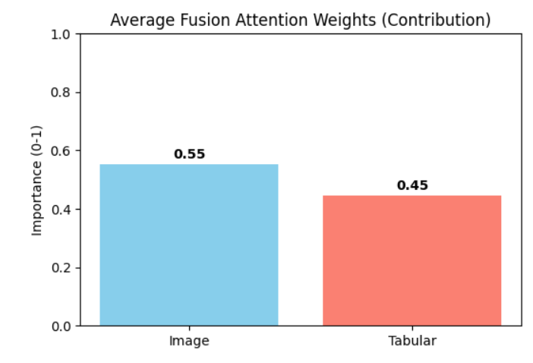
Figure 3: Impact of fusion attention weights
Prediction of the model to identify presence of PM10 air pollutant is achieved by employing a gradient- weighted Class activation mapping, that generates heatmaps using and better explains the images as shown in figure 4.
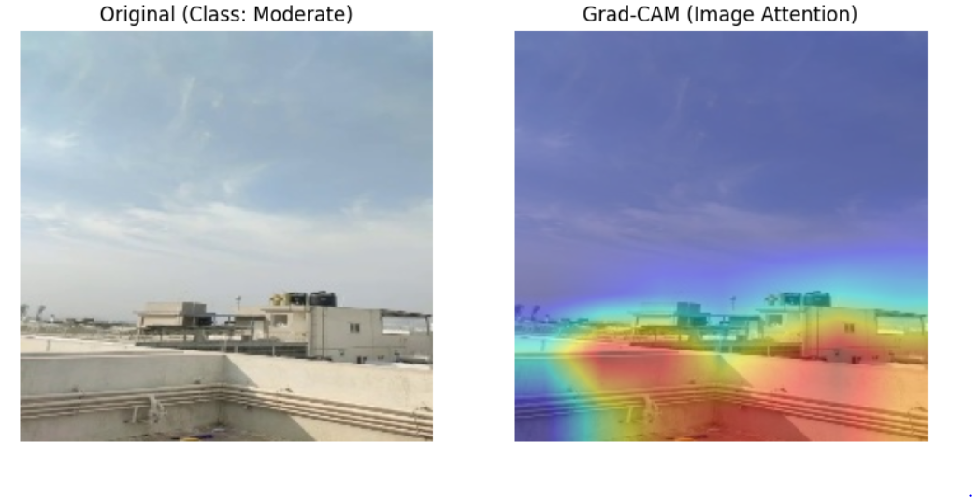
Figure 4: Comparison of original image and heatmap generated prediction image using Grad-Cam(Image Attention)
The test results of prediction are analysed using the confusion matrix having labels as Good, Moderate, Unhealthy, severely unhealthy for different levels of sensitivity shown in figure 5. The algorithm performed with near-perfect classification across all the specified AQI categories. All the stated classes have predicted with almost zero errors. The values concentrated for classes along the diagonal are Moderate (158), Good (154), and Unhealthy for different Sensitive Groups (286) are classified without errors. A single misclassification instance appears in the Unhealthy class predicted as a neighboring class. This indicates extremely high accuracy, precision, and recall across categories. The model demonstrates strong discriminatory power and minimal confusion between classes, suggesting it is highly reliable for AQI prediction tasks with well-separated category boundaries.
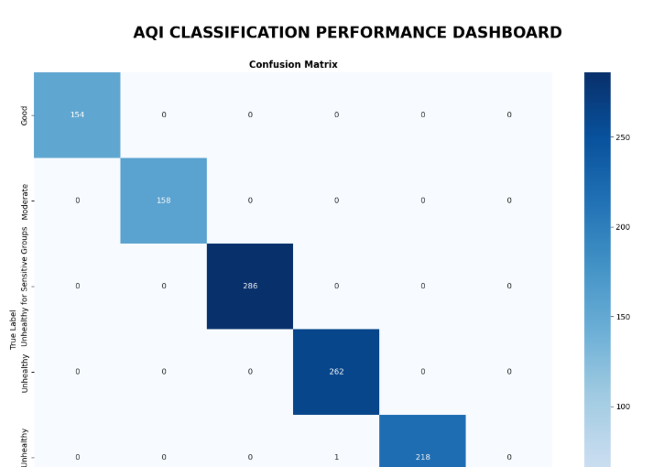
Figure 5: Confusion Matrix with different AQI classes
The RoC curve for the different classes is shown in figure 6.
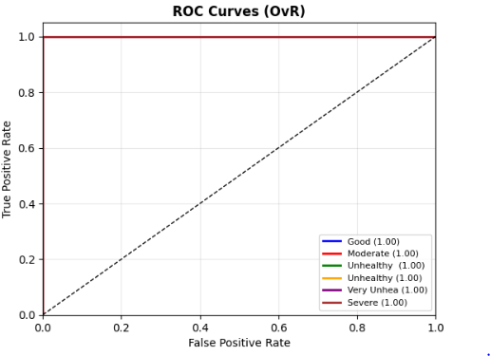
Here, the Area Under the Curve(AUC) scores for different AQI classes are also presented for ablation studies after running through the attention mechanisms and prediction accuracy have performed exceptionally well as shown in figure 7.
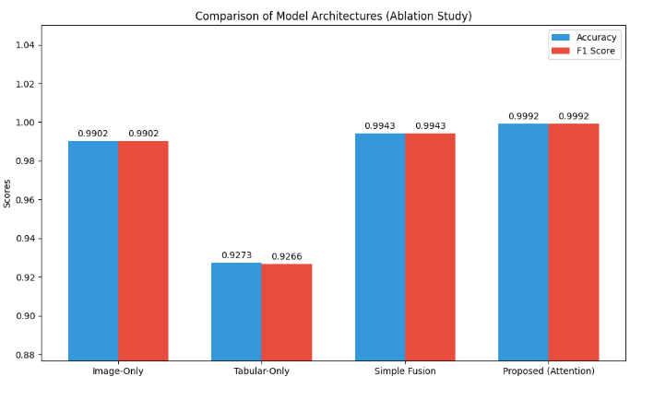
Figure 7: Ablation study of architecture with attention mechanisms
Table 2 shows the brief summary of all the critical parameters analysed for detecting the PM10 air pollutant from image dataset with Adam optimizer.
Table 2: Global Performance Summary
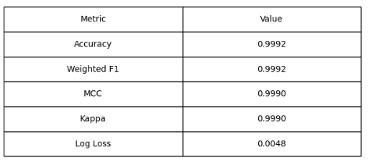
- CONCLUSION AND FUTURE SCOPE
ResNet50 model architecture is a proven feature extraction model which along with Adam optimizer and attention mechanisms achieves reliable performance in predicting with an accuracy of 0-9992.Deep learning models of image data for air quality prediction is a promising sensor-based method which offers both scalability and economical as well. In future potential overfitting can be addressed to effectively leverages transfer learning. The model robustness can be improved by employing multimodal data, from different sources such as and sensors, meteorological historical data apart from images. Advanced architectures built on ResNet50 base platforms may incorporate vision transformers, IoT based edge devices may result in efficient prediction in critical applications impacting public health and safeguarding the environmental.

REFERENCES
- https://www.mordorintelligence.com/industry-reports/grid-scale-battery-market?utm_source=prnewswire
- https://ww2.arb.ca.gov/resources/inhalable-particulate-matter-and-health
- Brągoszewska, E., & Mainka, A. (2022). Impact of Different Air Pollutants (PM₁₀, PM_{2.5}, NO₂, and Bacterial Aerosols) on COVID-19 Cases in Gliwice, Southern Poland. International Journal of Environmental Research and Public Health, 19(21), 14181. https://doi.org/10.3390/ijerph192114181
- Fortelli, A., Scafetta, N. and Mazzarella, A. (2016) Influence of synoptic and local atmospheric patterns on PM10 air pollution levels.
- Wang, H., Zhuang, B., Chen, Y., Li, N. and Wei, D. (2018) Deep inferential spatial-temporal network for forecasting air pollution concentrations.
- Chae, S., Shin, J., Kwon, S., Lee, S. and Kang, S. (2021) PM10 and PM2.5 real-time prediction models using an interpolated convolutional neural network. Scientific Reports.
- Wu, H., Yang, T. and Li, H. (2023) Air quality prediction model based on ISSA-LSTM
- Tejaswi, D., Manjusha, V., Parvathi, Y.M. and Priya, S.C.L. (2024) Air Pollution Detection Using Deep Learning. IARJSET.
- Kumar, C., Bora, K., Kashyap, B.J., Kalita, J. and Chetia, S. (2025) Air Quality Classification Using Deep Learning. JETIR.
- Chen, G., Chen, S., Li, D. et al. (2025) A hybrid deep learning air pollution prediction approach based on neighborhood selection and spatio-temporal attention. Scientific Reports.
- Liu, S., Geng, G., Xiang, Y. et al. (2025) A deep-learning model for predicting daily PM2.5 concentration.

