Title: Arriving to form with emotive aspects from design perspective (with case studies). Abstract:

Introduction:

Design as a process, is a goal-oriented activity which comes in relation to user satisfaction with respect to the design implementation. But there is no underlined theory or philosophy ever to reach the goal. Hence design has numerous languages, sometimes drawing attention to manufacturability, social attention, and sometimes with a degree of customization for niche market. The media, especially social media plays a significant role in orienting the consumers or users towards the different nuances of the product including form, ergonomics, features etc. (Charlotte and Fiell, P 2007).
Design intervention over a product is done with different perspectives. Some of them are as follows:
- Form or structure, it also plays a critical role in product definition,
- Functional novelty
- User-centricity

- Material used
- Production ease
- Cost centric
- Market centric and acceptance by niche users.

What is form? The Encyclopaedia describes it as, “derived from Latin word- forma, a term signifying figure or shape or that which is seen" (https://www.merriam-webster.com/dictionary/form 2025 and https://www.encyclopedia.com 2018). It may also be described as three-dimensional depiction of certain shape. The transformation of a shape to a form can be achieved through various ways. Few of them are as follows:
- Extrusion: A form forced out with desired cross-section. Just imagine a triangle being extruded to prism, a circle to cylinder etc (https://dictionary.cambridge.org/dictionary/ english/extruded 2025).
- Juxtaposing shapes: Platonic solids (Mittelholzer, M 2024) and Archimedean Solids (Bérczi, S 2000).
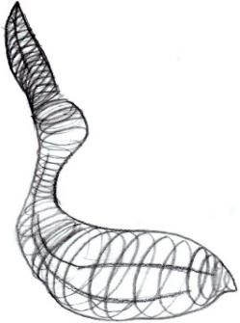
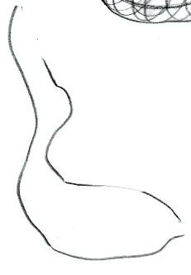
- Freehand wire-frame models: Extruding a regular or irregular shape indefinitely to a desired irregular form. Refer to Fig 1 and Fig 2 below. The wireframes are like latitudes and longitudes and act as guidelines.
Fig 1: Quick sketch depicting the contour of a pelican.
Fig 2: Wireframe sketch of a pelican.
The contour of the pelican in Fig 1 and wireframe sketch in Fig 2 depicts in brief, the journey from two-dimensional to three-dimensional visual communication. In Fig 2 the cross-section of the bird at small gaps in different portion of its body is evident.
Most of the forms are derived through either putting in application the three processes aforementioned, individually or mixing the processes.
Form is a visual language. It may also be described as- “execution of emotive aspects catering to particular scenario through certain three-dimensional structure.” It may or may not cater to functional needs. In other words, it is a mode of communication of certain emotive aspects as

per the perception of the users/ audience while catering to functional or non- functional requirements under given scenario.

Relevance of form:

Human beings are blessed with the ability to feel sensorially and articulate it as well. Anything which comes to human interface, emanate emotive aspects thereby influencing people's reactions, feelings, and perceptions. For example, a table with circular top is perceived to promote discussions with equality in hierarchy. In contrast a six-seater (or more) rectangular top table doesn’t follow equality in hierarchy. It emanates leadership structure (Jain, S, Saxena, S and Srivastava, A 2024).
When any product is selected to be purchased. It is ideally selected on the basis of its visceral design (appearances) and behavioural design (pleasure and effectiveness of use) largely. Certain factors combining the both plays a crucial role, i.e. performance of the product, features, quality assurance, brand, price point, form, handleability (ergonomics), colour, texture, warranty and other services provided by the brand etc. (Norman, D, A 2004). While designing a product a designer needs to emphasize primarily on the following factors:
    - Product functionality.
    - Manufacturability.
    - Addressing social goals.
    - Redefine a scenario with the product.

In this paper aforementioned point “d” will be emphasized. To redefine a scenario or micro-ecosystem with a product (other than its function and manufacturability), it needs to add something materialistic to the object that enhances the emotive value within specified context. Designers while developing products shoulder a responsibility of not only good functionality but also with the form which becomes a visual language and expression, thereby connecting with the users objectively with its emotive traits. Hence study of user psychology is essential.

Problem:

The word “aesthetic” is many a times associated with product forms in lay man language. The other factors to fall under visually appealing segment are material, colour, finish, texture etc. The implying of aesthetics becomes little subjective and shallow in context to form unless the deeper emotive aspects associated with the form in context to the environment, is not visually articulated. Visual articulation of certain feel factors through a form is a challenge. The

execution is expected to be objective and not at all subjective. So that everybody can associate with the feel factors portrayed by the form.

The Hypothesis:

Examining the challenge of visual articulation. Instead of being intuitive, certain cognitive methods or techniques can be applied to communicate the visual language through forms.
Taking a cue from Sapir-Whorf hypothesis or the “principle of linguistic relativity” (Kay, P., & Kempton, W. 1984 and Frothingham M, B, 2023) to visual language which is a medium of communication and expression. It is hypothesized that through the case studies, form appreciation and communication as well as form generation is revealed, and it offers certain parameters and scope for the practitioners as well as users/ audience to connect through visual communication, with the emotive aspects of the form.

Methodology:

Ethical approval for the study, was obtained verbally from the zoo keeper in the New Delhi Zoo to observe the animals from a distance and without disturbing them.
The study was not involved into any kind of medical research requiring human participants. Attribute listing, with close and detailed observation of the object/ form. Study of the object/form, observing each physical detail. The positioning, alignment, emphasis, flow of each of the physical elements over the form. Listing the physical attributes of the form.
Application of certain methods to search for ideas. Implicating, synectics (drawing analogies), with direct analogies and personal analogies. Applying, removal of mental block/ transformation techniques to identify fresh directions (Jones, C, J 1970). Focus group discussion to authenticate the findings at certain steps. The methodology is adopted over the case studies implicated with the following:
- Form appreciation and communication.
- Form generation.

Form appreciation and communication:

The exercise began by understanding monolithic forms. Monolithic forms are evolved or deduced out of single structure/ form/ block (Machado, R 1995). In this study monolithic forms were considered with the intention to understand an object that was selected from daily routine

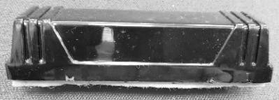
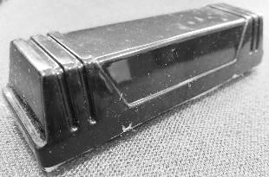
e.g. a white board duster. It was assumed to be a monolithic form. The images of the same is mentioned below in Fig 3 and Fig 4.
Fig 3: White board duster.
Fig 4: White board duster, assumed to be monolithic.
The form is visualized in detail and sketches of the form were drawn from various angles. The scale, proportions and the vision flow over the form were appropriated. The sketches are depicted in Fig 5, Fig 6, Fig 7 and Fig 8.
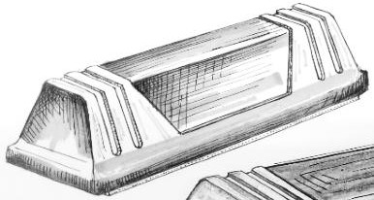
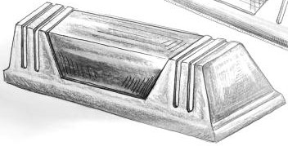
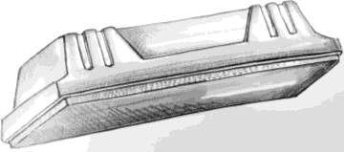
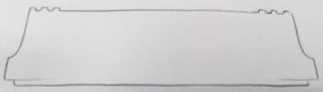
Fig 5: Sketch 1, of white board duster.
Fig 6: Sketch 2, of white board duster.
Fig 7: Sketch 3, of white board duster.
Fig 8: Sketch 4,
silhouette of duster.
Attribute listing of the form was done.

- Basic dimension of the form is length 5.5” x breadth 1.5” x height 1.5”.
- Base is broader. The form gets tapered while moving from base to the top.
- The grip which looks like fasteners at the two ends, visually keeps the body in position.

Form Appreciation:

The intention of the activity is to understand the objectified emotive traits associated with forms. The physical traits in the form effectuate the emotive traits. The emotions are required to be realized and it is done with the application of synectics and removal of mental block/ transformation techniques. Further it is required to be authenticated through focus group discussion.

Synectics:

It is a spontaneous activity of the brain towards exploration and drawing analogies (Jones, C, J 1970). The activity is performed to draw the visual relativity of the form and to obliterate any kind of subjectivity. A group of people belonging to different cultural backgrounds, educational fields, profession, age, experience were invited. It is to emphasize upon what one perceives is dependent on their culture as well, like theory of Linguistic Relativity (Kay, P., & Kempton, W. 1984 and Frothingham M, B, 2023). The activity is ideally carried in small group of six people. With clear understanding of the form, application of synectics (drawing analogies) was done, with direct analogies and personal analogies (Jones, C, J 1970).
Direct analogies are drawn from the immediate nature or biological environment. Personal analogies are bodily experience. What it would feel, if one imagines his or her body to be the object or into the act (Jones, C, J 1970).
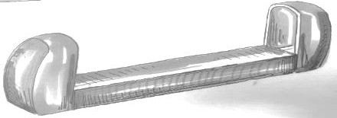
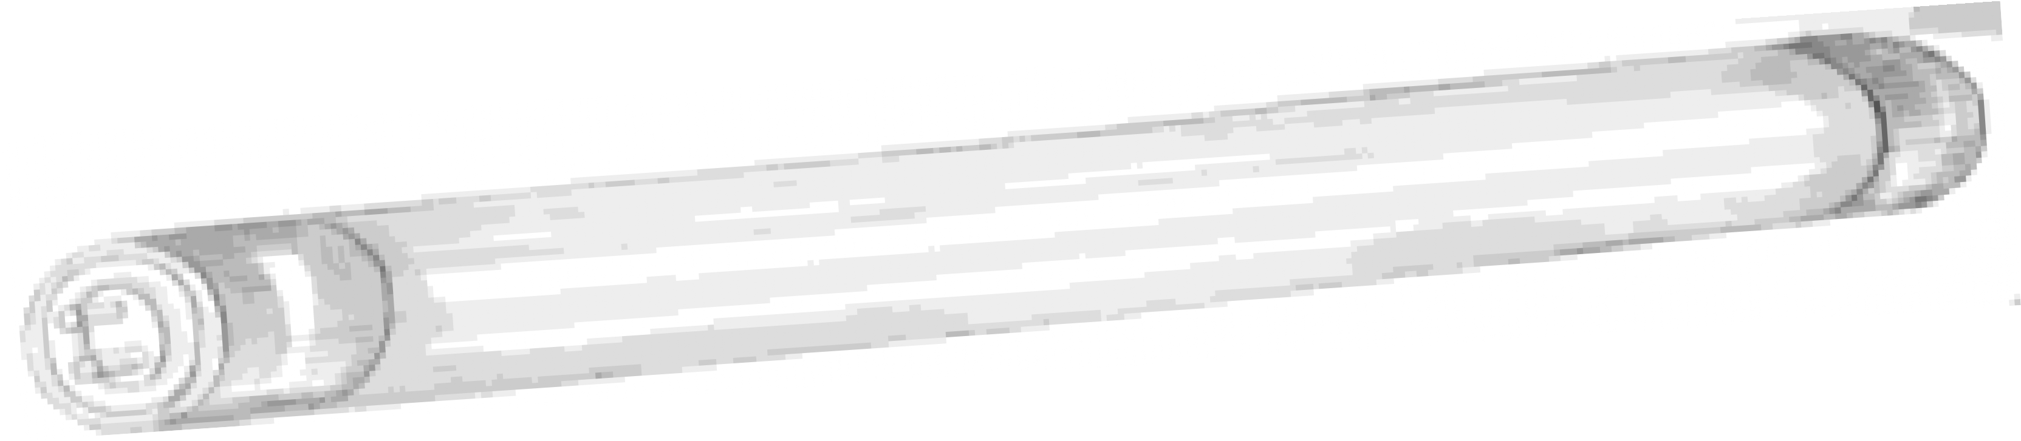
During the application of direct analogies, the analogies were drawn not only from immediate nature but also from physical objects and environment as well, to avoid getting stuck and keep the process unhindered. Through direct analogies the form of the object is compared with a tube-light frame from the physical environment. It is depicted in Fig 9 below.

Fig 9: Tube-light frame
Through the personal analogies the form of the object is compared with bodily experience (Jones, C, J 1970). It is depicted in Fig 10 below.
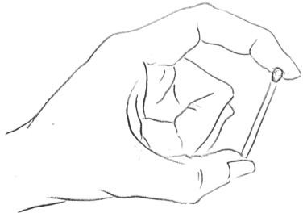

Fig 10: Holding a match stick from both ends.

During the process of personal analogy, while imagining one’s body as the object itself (object in Fig 3 and Fig 4) it felt like the following:
    - Feeling congestion: As because the body is fastened/ secured from both the ends.

    - Protected: The body is safeguarded from both the ends. It feels assured.
    - Stable: As because the body is like a frustum of a rectangular pyramid with base edging out of the silhouette.

Removal of mental block/ transformation techniques:

To break the bottle neck situation in imagining the feel factors associated with the physical traits the technique, removal of mental blocks/ transformation techniques was applied. It is also helpful in authentication of the emotive traits drawn. It acts as a tool to look at the same object in different ways. The transformations can be denoted as (Osborn, A, F 1963 and Jones, C, J 1970):
- Scale up or scale down
- Modify
- Rearrange the elements
- Put to other uses
- Substitute the elements
- Reverse
- Combine

Scale up or scale down: If the form as depicted in Fig 5 and Fig 6 is scaled up 20 times. It will be a huge block of approximately 9’ length x 2.5 breadth x 2.5’ height. A direct analogy of the same would draw comparison from big rocks/ boulders/public seating arrangements etc. During personal analogy it would feel like stable, not movable, heavy etc. If the form is scaled down 5 times. The dimensions will be approximately length 1.1” x breadth 0.3” x
height 0.3” (tentatively the dimension of a match box). The stability factor will still persist. Modify: Transforming the elements of the form. Few depicted in Fig 11, Fig 12 and Fig 13.

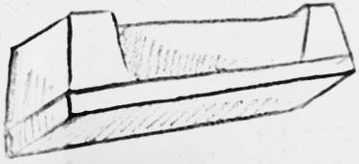
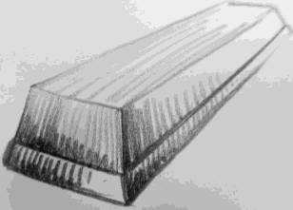
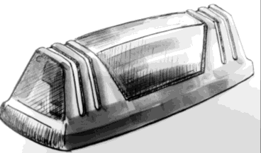
Fig 11: Modified the ends (fasteners) of the object.
Fig 12: Removal of
the ends (fasteners) of the object.
Fig 13: Retaining the ends (fasteners), but making the top and base a curved plane.

Fig 11, makes the form look like more protected, retaining the stability factor. Whereas in Fig 12, the ends are eliminated. The form feels like stable, but the feel of protection is not there. In Fig 13, the stability of the form comes under question with the curved top and base. However, it looks protected with the fasteners intact at the ends.
Rearrange the elements: The elements in the form are worked upon at their arrangements. For example, the fasteners are reduced in numbers at the ends. The fasteners are also rearranged in their orientation. Fog 14 and Fig 15 depicts the rearrangement of the end fasteners.

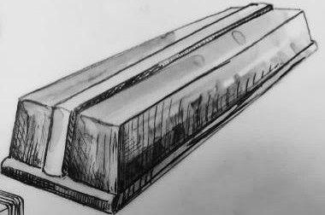
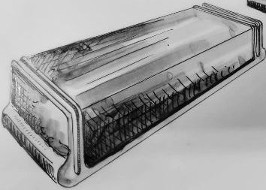
Fig 14: Rearranging the ends (fasteners), by making two fasteners at each end. Also reducing the width comparatively.
Fig 15: Rearranging the ends (fasteners), by shifting it to the mid of along the length of the body.

In the Fig 14 and Fig 15 with the reworking of the elements (fasteners at the end) the feel of protection is affected. It is felt to be reduced.
Put to other uses: The object is put to uses other than its obvious use. It is helpful in evaluating the emotive aspects associated with the form. It deviates the way one looks at the form.
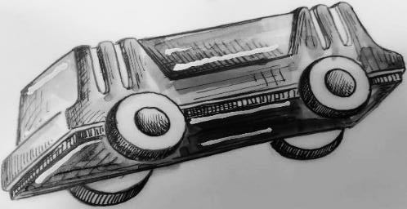
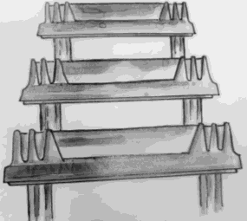
Fig 16: The form is put into other use. It is given mobility with
Fig 17: The form is put into architectural
In Fig 16, the form is depicted as an automobile. Overall structure is frustum of a rectangular pyramid with the bumpers (base) edging out of the silhouette. The pillars (end fasteners) are predominant. The emotive aspect that is expressed by the form is – “safe”.
In Fig 17, the form is used multiple times to create a somewhat, gateway tower. The structure evokes a feel of reverence largely because of the architectural scale. It generates emotive

aspects i.e. dignified, firm and calm. It is loosely connected if not immediately, with stable and protective.
Ssubstitute the elements: Certain tangible elements in the form are replaced with different elements to gauge the impact of emotive difference. For example, in Fig 18, the main body is replaced and a void is created. A pillar is set at the place. The emotive aspect – “protected” is lessened. The original form in Fig 5 and Fig 6, looks more stable because of lack of void in comparison to the form in Fig 18.
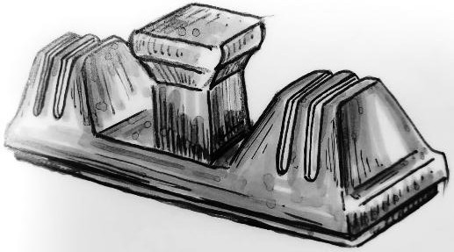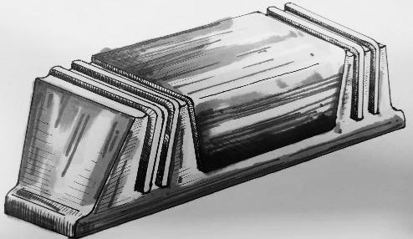

Fig 18: The end fasteners are
retained. But the body is substituted with a pillar.

Fig 19: The structure- “frustum of a rectangular pyramid” is inverted with the indentations reversed as protrusions.
Reverse: In this case the structure is reversed to evoke certain emotive aspects. In Fig 19, the object structure is reversed. The originally frustum of a rectangular pyramid is inverted. The indentations at the end fasteners are reversed as protrusions. It generates emotive aspects i.e. compressed, congestion and slowdown. After reversal the original form in Fig 5 and Fig 6 is revisited. The essence of “protected and stable” in Fig 5 and Fig 6 is felt more.
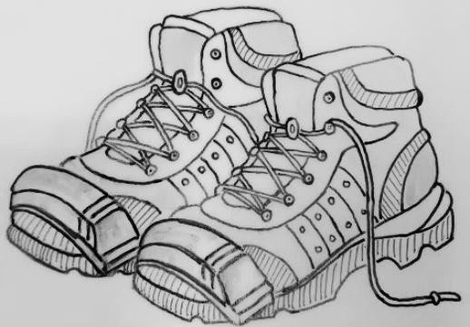
Combine: Combining the form with other forms. For example, the form is combined with hiking boots as toe cap in Fig 20, giving it a bulkier and sturdier look.

Fig 20: Combining the structure as a toe cap with a pair of boots.
All the factors described in removal of mental blocks/ transformation techniques are techniques to visualize the form in certain other way than the obvious way. After visualizing the form contextually in a particular way, the original form needs to be observed again. The comparison

helps in understanding the difference in visual language and expression. It eventually stimulates mapping the emotive aspects.
With the application of synectics and removal of mental blocks/ transformation techniques (Jones, C, J 1970), it is established that certain physical aspects in the form generate particular emotive traits. For example, the fasteners at the end of the object in Fig 5 and Fig 6, accentuates a feeling of protection. The form is a frustum of a rectangular pyramid with flat top and base. The base is edging out of the silhouette. It accentuates a feel of being stable.
The emotive aspects associated with the form i.e., “protection, stable and congestion,” is considered for the focus group discussions. The participants belonging to different educational and professional backgrounds i.e., architects, software professional, professor, civil engineer, government servants and marketing persons were invited to share their views (with reasons) with respect to the emotive aspects of the form in Fig 4. A total of 12 persons were invited. The activity was conducted with the intention to nullify any subjectivity associated with the identified emotive aspects. The identified emotive aspects/ feel factor associated with the form should be objective. After deliberation the group in consensus, accepted and zeroed down on – “secured/ protection” as the emotive aspect.
The entire process of deducing the objectified emotive traits of a form is form appreciation. The idea is to understand how one perceives the form and its expressions through its visual communication language (Kay, P., & Kempton, W. 1984 and Frothingham M, B, 2023). It is realized through application of synectics and removal of mental blocks/ transformation techniques to arrive to certain emotive aspects with authenticating and re-authenticating.

Form Communication:

With the fruition of form appreciation, it opens door to another activity i.e. form communication. How design professionals communicate the emotive traits/ feel factors through forms. The objects are expected to evoke the same feeling in to their users or audience. For this the monolithic form considered is the same white board duster as in Fig 4 (to keep things simple when it comes to comparison).
In the activity form communication, the intention was as follows:

- To accentuate a particular deduced emotive trait.
- To identify the opposite emotive trait of the deduced one. Then accentuate the opposite emotive trait in the form.

The rule for form communication was to evoke emotive traits by doing cosmetic changes only, over the form.
To accentuate the deduced emotive trait: The physical factors were revisited (attribute listing) which evoked the emotive trait – “secured/protection.”
Application of synectics (Jones, C, J 1970) was exercised in small group of six person as in chapter 5.2. A curved surface (Fig 21) in line to the curved line depicted in Fig 21, provides a basis for safeguarding or securing. It is similar to the hand gesture of blessing and approval, depicted in Fig 22. The gesture shows authority with grace. It tends to safeguard subsistence.
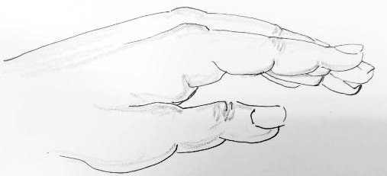
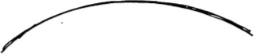
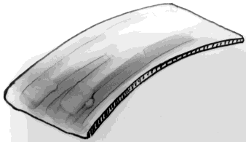
Fig 21: A curved surface in line to the
Fig 22: Gesture of the hand as visualized in direct analogy

Taking cue from the direct analogy as depicted in Fig 22 and Fig 21 a couple of forms were conceptualized (with cosmetic changes), as mentioned in Fig 23 and Fig 24.
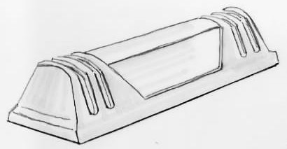
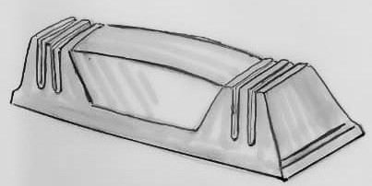
Fig 23: Form with curve plane at the back of the form.
Fig 24: The ends/ fasteners are following a curved plane at the top.
The form at Fig 23 has a slightly curved plane at the back. The ends/ fasteners are following the straight line. Secondly the form at Fig 24 has the end fasteners with slightly curved top. However, the back of the form is following a straight line.
Personal analogy (Jones, C, J 1970) is exercised with the two aforementioned concepts in Fig 23 and Fig 24. The feel of securing/ protection was nowhere being felt accentuated while doing personal analogy. On the other hand, it was felt that the form was gentler, or in other words comparatively less stern and also a bit affable. This is in comparison with the original form in Fig 4.

The exercise is repeated. Again, direct analogy (Jones, C, J 1970) is drawn. This time analogy is drawn from shoulder armor, depicted in Fig 25. A concept is drawn with cosmetic changes. It is retaining the original form except for creating the ridges of the end fasteners more profound with greater depth.
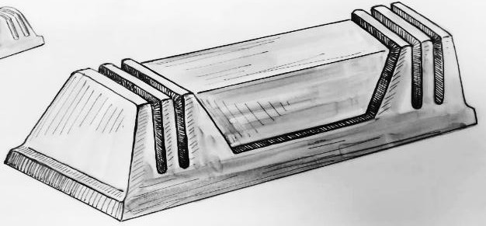
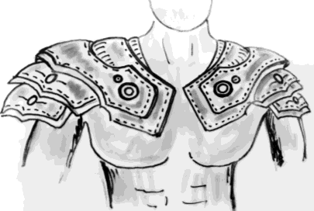

Fig 25: Generic Shoulder Fig 26: The concept with deeper ridges armour from medieval era. of the end fasteners.
Personal analogy is repeated with the form in Fig 26. The feeling of securing, safeguarding and protecting is felt to be accentuated in comparison to the original existing form in Fig 4. It is largely because feeling of rigidity and toughness is more enhanced in the concept in Fig 26.
To identify the opposite emotive trait: The physical factors were again revisited which evoked the emotive trait. In a graphical depiction if it is assumed that the emotive trait, “secured/protection,” is placed along the x axis, as depicted in Fig 27, the opposite of the emotive trait i.e. “attacked/ abused,” is expected to be on the negative side with same
magnitude.
y secured/protection

x
-6 -5 -4 -3 -2
-1
0
1 2
3
4
5 6

Fig 27: The graph line showing the emotive trait along the x axis.
To attain the opposite emotive traits (i.e. “attacked/ abused,”) in the original form as depicted in Fig 5 and Fig 6, it may be visualized in a fashion that the original emotive traits (i.e. “secured/protection”) is minimized, with cosmetic changes. While minimizing the emotive traits the magnitude will recede towards zero or further down in the graphical line.
Personal analogy (Jones, C, J 1970) was exercised with the original form as depicted in Fig 5 and Fig 6 keeping in view the emotive traits “attacked/ abused.” What it would feel, if one imagines his or her body to be the object and it is abused. The sketches in Fig 28 and Fig 29 portrays the feeling of getting crushed and abused (put under pressure).

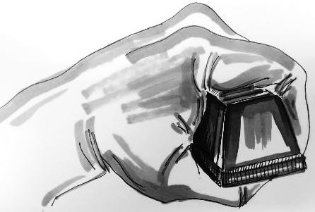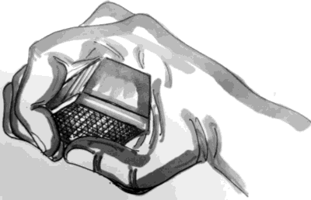
Fig 28: The form under pressure.
Fig 29: Force exerted over the form to crush it.

Concepts are drawn with cosmetic changes over the original form as depicted in Fig 5 and Fig
6. Minor squeeze is depicted with cosmetic changes to accentuate the feel of “put in under pressure/being crushed/ being abused.” The concepts are depicted in Fig 30 and 31.
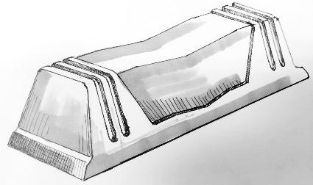
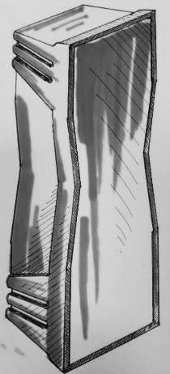
Fig 30: The form is squeezed/ crushed from side-ways.
Fig 31: Force applied from the top over the form, crushing the back and the base skirting slightly.
Personal analogy is repeated with the form in Fig 30 and Fig 31. It was felt that the feeling of being attacked/ abused is accentuated in comparison to the original existing form in Fig 4. It is as if a force is exerted upon the form. Especially the force is felt more in Fig 30.
The two activities over the form i.e., to accentuate the deduced emotive trait and to identify the opposite emotive trait resulted in outcomes in Fig 26, Fig 30 and Fig 31. The outcome of the activities was contemplated in focus group discussion for re-authentication. The focus group was same as in chapter 5.3.
The team was again invited to contemplate over the emotive traits in Fig 26 (accentuating the deduced emotive trait) and Fig 30 and Fig 31(showcasing the opposite emotive trait) in comparison to the original form in Fig 4. The objective was to revoke any subjectivity pertaining to the communication of the emotive traits. After rumination the focus group members (12 in all) in consensus, acquiesced on the following:

- Fig 26 manifests accentuation of the deduced emotive trait.
- In Fig 30 the feeling of being attacked/ abused is accentuated (opposite emotive trait).

The activity is performed to draw the visual reciprocity of the form through visual language and to obliterate any kind of subjectivity (Kay, P., & Kempton, W. 1984 and Frothingham M, B, 2023).

Form generation:

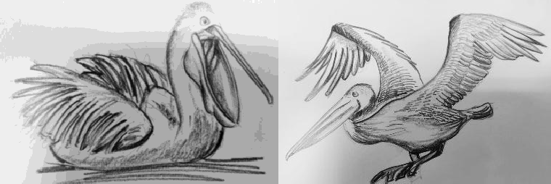
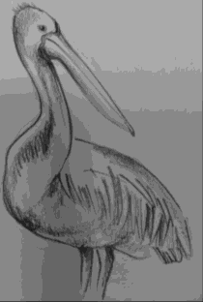
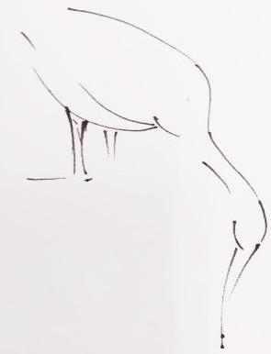
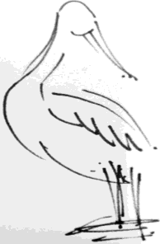
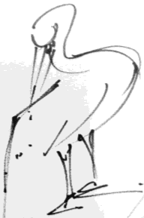
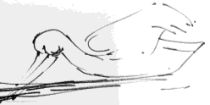
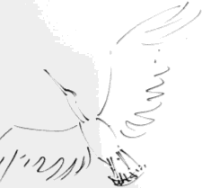
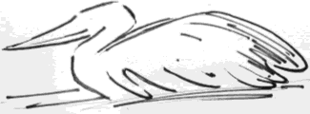
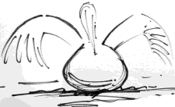
The objective in this exercise was to simplify any complex form to a monolithic form; by understanding and retaining its objectified emotive traits. The exercise focused on studying animals. Every animal carries certain unique physical characteristics along with the generic ones. In totality the physical aspects are in synergy. In this study pelican was chosen. Regular visits to the New Delhi Zoo (wherein the migratory birds are seen in open during winters) was made for approximately three weeks. Pelicans are social animal. Their activities were deeply observed. In different activities their body postures were observed from different angles. In the process numerous rapid sketches were worked upon. Few of the sketches are depicted in Fig 32, Fig 33 and Fig 34. In the sketches the scale, proportion and vision flow over the subject was appropriated.

Fig 32: Sketches of the pelican in different
postures.

Fig 33: Quick sketches of the pelican in different postures.

Few more sketches of the pelican are in Fig 33 below.
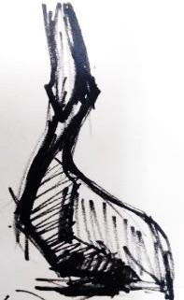
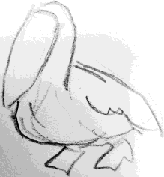
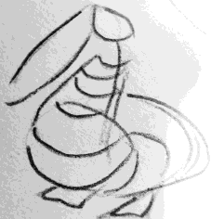
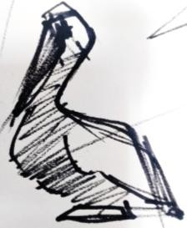
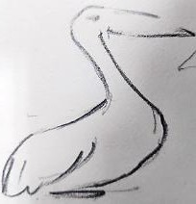

Fig 34: Quick sketches of the pelican in different postures.
With repeated sketches and spending approximately three weeks, the behavioral postures and the physical aspects of the pelican led to certain emotive traits. It is felt to be shy, innocent, cute and be in one's own world.
The need of application of synectics was felt with direct analogy and personal analogy to rationalize and justify. The process was done in group of six as in chapter 5.2 and chapter 5.4.
During the application of direct analogies, comparisons of visual and behavioural were drawn from kids in the age bracket of early childhood to middle childhood. The behaviour of the pelican along with the physical softness was related with children falling in the pediatric age group of approximately 3 years to 11 years i.e. early childhood to middle child hood (Althammer, A, et.al. 2023). Children are generally cute with their softness. They are innocent and stay mostly in their own world.
Personal analogies were drawn while imagining one’s body as the pelican itself and behaving the same way. It felt like the following:
- Be in one's own world – Due to its behavioural aspects.
- Innocent – Due to the physical softness of the body and behavioural aspects.

In the following depiction of sketches of the pelican in Fig 35, certain behavioural postures are highlighted to show the visual relativity with the emotive traits. The softer lines of the neck and chest as depicted in Fig 36, clearly manifests the emotive traits.

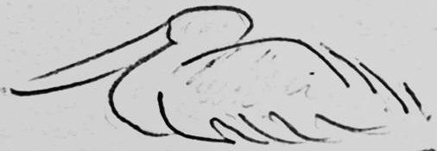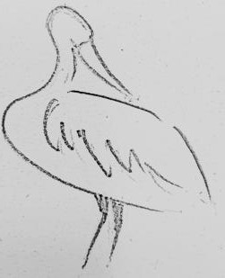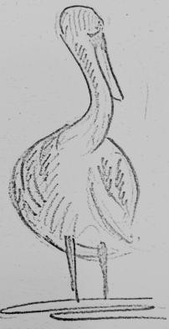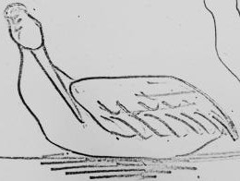

Fig 35: Certain postures of the pelican wherein the emotive traits are emphasized.
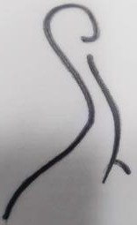
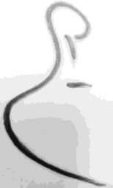
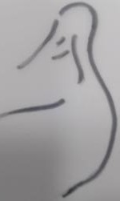
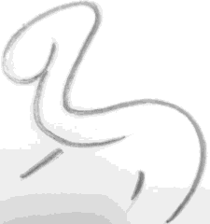
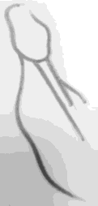

Fig 36: The softer lines of the neck and chest in different postures.
The emotive aspects associated with the pelican i.e. “shy, innocent, cute and be in one's own world,” is put forward for the focus group discussions. The focus group of 12 members was the same as in chapter 5.3. Numerous videos, photographs and sketches of the bird were shared with the members during the discussion. So that the members get familiarized. The activity is performed to draw the visual relativity of the form and to obliterate any kind of subjectivity.
It may be hypothesized from the theory of “Linguistic Relativity” also known as “Sapir-Whorf hypothesis,” that the nature of a visual language does sub-consciously stimulate the perception of the audience. It helps their imagination to correlate and expatiate (Kay, P., & Kempton, W. 1984 and Frothingham M, B, 2023). It was deliberated in the focus group discussion in context to the emotive traits. After contemplation the group in consensus, accepted and zeroed down on – “innocent and be in one's own world” as the emotive aspect.

6.1. Gesture drawing; working with right side of the brain:

Human brain is divided in two hemispheres namely the left hemisphere and the right hemisphere. The left side regulates acts and activities based on logical, rational and analytical awareness. It tends to figure things step by step, thinking in context of linked ideas in logical order. On the other hand, the right side of the brain tends to use non-verbal cognition to process

perceptions. Its approach is non-rational, intuitive and holistic. It tends to see the whole, feeling the movement and relation among the parts (Edwards, B 2008).
The pelican figures were observed in detail, especially in Fig 32, Fig 33, Fig 34 and Fig 35. Gesture drawing of the bird is drawn. Taking cue from Roger Wolcott Sperry’s work in the area of split-brain research (https://www.britannica.com/science/split-brain-syndrome 2025), the approach was to gather access to the subdominant visual, perceptual, right side of the brain, it is necessary to put forward a task that the verbal, analytic, left side of the brain will turn down. The following rules were followed (Edwards, B 2008):
- While drawing, the pencil is not supposed to be lifted from the surface of the sketch pad.
- Only the subject/figure is to be visualized while drawing. The drawing in formation is not to be seen. The drawing is to be to be seen only after it is done.
- Gesture drawings are to be drawn in different time frames i.e. 25 seconds, 20 seconds and reducing to 3-2 seconds, with the help of stop watch (the journey should be repeated few times).
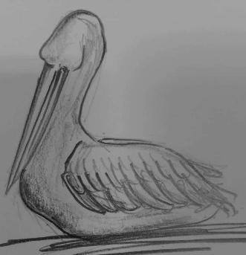
Fig 37 depicts the particular posture of the pelican in different angles highlighting the emotive traits – “innocent and be in one's own world.”

Fig 37: The posture considered.

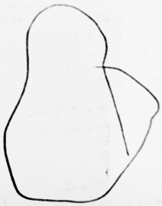
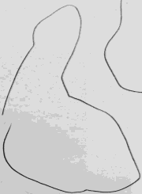
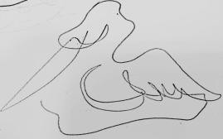
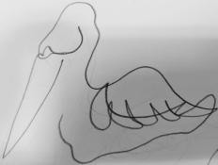
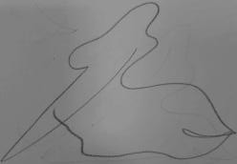
Gesture drawings were done keeping in view the rules mentioned above. The time line of gesture drawing depicted below in Fig 38- Fig 42, is 12 seconds to 3 seconds.
Fig 38: Gesture
Drawing in 12 seconds.
Fig 39: Gesture
Drawing in 10 seconds.
Fig 40: Gesture
Drawing in 7 seconds.
Fig 41: Gesture Fig 42: Gesture
Drawing in 4 Drawing in 3 seconds. seconds.

A three-dimensional monolithic wireframe model is created reflecting Fig 41and Fig 42. It is a simplified form of a living being i.e. pelican depicting the specified emotive traits. The monolithic wireframe model is depicted in Fig 43.
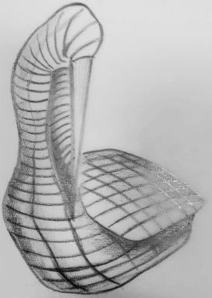
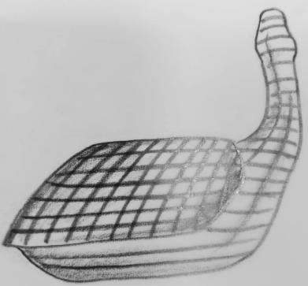
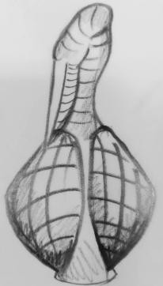

Fig 43: Wireframe diagram of the pelican at the same posture as in Fig 36 and Fig 42. View is from different angles.

The result of the entire form generation activity was again pondered upon in focus group discussion. The focus group was same as in chapter 5.3. All the postural sketches and videos were shared with the group. This was to familiarize the members with the journey. The activity was performed to correlated the emotive traits with the physical form and to obliterate any kind of subjectivity. After contemplation the group in consensus, accepted and zeroed down that in Fig 41 and Fig 42 the expression (emotive aspects of pelican) is portrayed in a simplified way. If it is visualized as a solid model the emotive essence is certainly felt.

Result:

The result in chapters 5.3, 5.4, 6.0 and 6.1 are outcome of divergent approach with generative thinking to arrive to the goal. In form communication (chapter 5.4) and form generation (chapter 6 and 6.1) the emotive traits are worked upon exploring a range of possibilities with open ended, non-linear approach intending towards unhindered generation of ideas (Aviña, G.E. et al. 2018), or communicating the emotive traits in simplified way.
The concepts depicted in Fig 26, Fig 30 and Fig 43 are prototyped virtually with software.

The virtual 3D model of form communication is depicted in Fig 44, 45 and 46. It replicates the concept in Fig 26, highlighting the emotive traits - “secured/protection.” Compared with the original form in Fig 4, Fig 5 and Fig 6 the concept evokes the emotive traits with cosmetic changes over the original form. The emotive trait is felt to be accentuated largely because the feeling of rigidity and toughness is more enhanced in the concept.

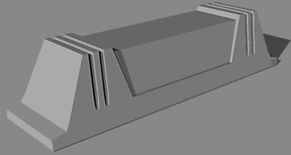
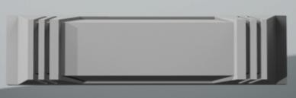
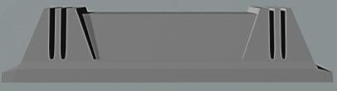
Fig 44: Virtual 3D model of form communication. It replicates the concept in Fig 26, highlighting emotive traits- “secured/protection.”
Fig 45: Top view of virtual 3D model of form communication as depicted in Fig 44.
Fig 46: Front view of virtual 3D model of form communication as depicted in Fig 44.

In Fig 47, 48, 49 and 50 the virtual 3D model of form communication replicates the concept in Fig 30 highlighting the opposite emotive traits i.e. “attacked/ abused,” with cosmetic changes to the original form as in Fig 6. It conveys a feel of crushing due to force that is exerted upon.

Fig 47: Virtual 3D model of form communication. It replicates the concept in Fig 30, highlighting emotive traits- “attacked/ abused.”
Fig 48: Top view of virtual 3D model of form communication as depicted in Fig 47.

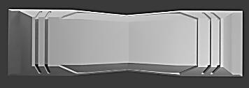
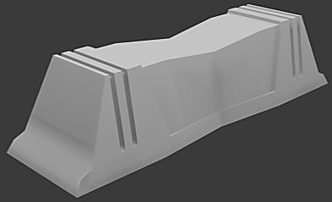
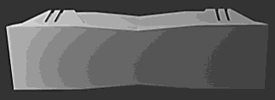

Fig 49: Bottom view of virtual 3D model of form communication as depicted in Fig 47.

Fig 50: Front view of virtual 3D model of form communication as depicted in Fig 47.

The effort in the exercise Form Generation chapter 6. was to reduce the visual complexity with a clear language. The intention was to make things easier to feel for a lay person. The virtual 3D model of form generation in Fig 43, is depicted in Fig 51, 52 and 53. It is a simplified monolithic form retaining the essence of emotive traits in pelican during study.

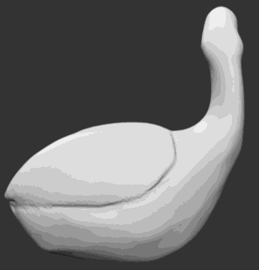
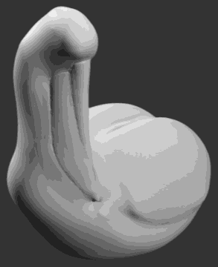
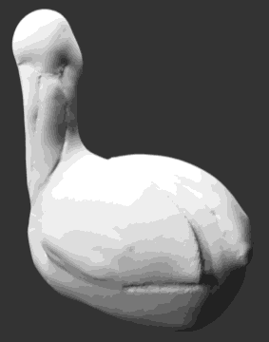
Fig 51: Virtual 3D model of form generation. It replicates the concept in Fig 43, highlighting emotive traits- “innocent and be in one's own world.”
Fig 52: Side view of virtual 3D model of form generation as depicted in Fig 51.
Fig 53: Semi back view of virtual 3D model of form generation as depicted in Fig 51.

Conclusion:

It is established that every tangible objects have their own dynamism. They are the carrier of expressions which are intended to be perceived in certain ways (Arnheim, R 2004). The dynamic affair is based on the communication of emotion as well as its perception. The study is beneficial for design students as well as practitioners in their early career. The activity is focussed at the reflective level studying perceptual understanding and visceral feeling. Visual language is a power of story-telling which is objectified (Norman, D, A 2004). The activities in the study improves the visualization skill. It intends to encapsulate the journey of visually communicating emotional feel through forms with the help of case studies through form communication and form generation. Various divergent techniques were put in use like synectics, removal of mental block/ transformation techniques and gesture drawings.
Focus group discussions were conducted time and again as a method of convergence. It was performed with an objective to draw the visual reciprocity of the form through visual language and to obliterate any kind of subjectivity (Kay, P., & Kempton, W. 1984 and Frothingham M, B, 2023).
Being from the design fraternity it becomes crucial to articulate the visual force or expression, stimulating through forms. It forms the backbone of design language. The control over the stimulating visual language should be such that, it affects the visual perception of the audience in an objectified way (Arnheim, R 2004).

The authors asserted that there was no plagiarism in their paper, including in text and images produced by Artificial Intelligence (AI)-Assisted Technology.

Disclosure statement:

This is to acknowledge that there are no financial or non-financial interests that have arisen from the direct applications of this research. The authors declare that they have no competing interests.

Declaration of funding:

No funding was received.

Practitioner Summary:
All tangible objects due to their physical aspects have their own intangible dynamism. Hence communicating through forms is a vital tool for designers. It’s a significant aspect in design application. The study focusses on certain techniques to articulate the visual force or expression, stimulating through forms.

Reference:
- Solso, R. L 1996, “Cognition & the Visual Arts,” Published by: MIT Press, ISBN-10: 0262691868, ISBN-13: 978-0262691864, pp 11- 149.
- Charlotte and Fiell, P 2007, “Design Now!” Published by: Taschen GmbH, Hohenzollern ring, ISBN 978-3-8228-5267-5, PP 6-412.
- 2025, https://www.merriam-webster.com/dictionary/form [17th Jun 2025, 08.55 AM].
- 2018, https://www.merriam-webster.com/dictionary/form [17th Jun 2025, 09.11 AM].
- 2025, https://dictionary.cambridge.org/dictionary/english/extruded [17th Jun 2025, 10.07 AM].
- Mittelholzer, M 2024, “A Detailed Study of the Classification of Platonic Solids,” Bachelor Thesis, Department of Mathematics, ETH Z¨urich, Swiss Federal Institute of Technology, Zurich Source: https://people.math.ethz.ch/~acannas/Student_Papers/BSc_Theses/2024, [12th Jun 2025, 06.05 PM].
- Bérczi, S 2000, “From the periodic system of Platonic and Archimedean solids and tessellations to the 4d regular polyhedra and tessellations (with extension to some 5d polytopes),” Journal: Symmetry: Culture and Science, Volume 11, ISSN 0865-4824, pp 125-137.

- Jain, S, Saxena, S, and Srivastava, A 2024, “Impact of Built Shape, Forms and Spaces on Human Psychology,” Published in: International Journal of Architectural Design and Planning, Volume 2, Issue 1, DOI (Journal): 10.37591/IJADP, pp 9-17.
- Norman, D, A 2004, “Emotional Design-Why we love (or Hate) everyday things,” Publisher: Basic Books, USA, ISBN-10: 0465051367, ISBN-13: 978-0465051366, pp 3-224.
- Kay, P., & Kempton, W. 1984, “What is the Sapir-Whorf hypothesis?” Published by: American anthropologist, vol. 86, no. 1, pp. 65–79, Source: JSTOR, http://www.jstor.org/stable/679389 [9th July 2025].
- Frothingham M, B, 2023, “Sapir–Whorf hypothesis (Linguistic Relativity Hypothesis),” Published by: Simply Psychology, London, Source: https://www.simplypsychology.org/sapir-whorf-hypothesis.html [9th July 2025].
- Jones, C, J 1970, ‘Design Methods’, Publisher: John Wiley & Sons, Inc, New York and Chichester, ISBN 0-471-28496-3, pp 190- 358.
- Machado, R 1995, “Monolithic Architecture,” Publisher: Prestel Pub, ISBN-10: 9783791316093, ISBN-13: 978-3791316093, pp 1-155
- Osborn, A, F 1963, “Applied Imagination,” Publisher: Charles Scribner's Sons, New York, ASIN: B000H5HJBQ, pp 32- 218.
- Althammer, A, et.al. 2023, “Systemic review of age brackets in pediatric emergency medicine literature and the development of a universal age classification for pediatric emergency patients - the Munich Age Classification System (MACS),” BMC Emerg Med. 2023 Jul 25;23(1):77. doi: 10.1186/s12873-023-00851-5. Erratum in: BMC Emerg Med.
2024 Aug 9;24(1):145. doi: 10.1186/s12873-024-01064-0. PMID: 37491219; PMCID: PMC10369835.
- Edwards, B 2008, “Drawing on the right side of the brain,” Publisher: Harper Collins, London, ISBN 9780007116454, pp 1-185.
- 2025, “Roger Wolcott Sperry,” Source: https://www.britannica.com/science/split-brain-syndrome [14th July 2025].
- Aviña, G.E. et al. 2018, “The Art of Research: A Divergent/Convergent Thinking Framework and Opportunities for Science-Based Approaches.” In: Subrahmanian, E., Odumosu, T., Tsao, J. (eds) Engineering a Better Future. Springer, Cham. https://doi.org/10.1007/978-3-319-91134-2_14, pp 167-186.

- Arnheim, R 2004, “Art and Visual Perception - A Psychology of the Creative Eye,” Published by: University of California Press; 2nd edition, ISBN-10: 9780520243835, ISBN-13: 978-0520243835, pp 410-463.

