Query Topic, Technology Acceptance, and Session Drop-Off: A Socio-Technical Analysis of a Conversational Virtual Reference Assistant in a Nigerian University Library

Abstract
Academic libraries increasingly deploy conversational artificial intelligence (AI) as natural language virtual reference assistants, yet the behavioural traces these systems generate are rarely mined to anticipate when and why student research effort breaks down. Anchored in socio-technical systems (STS) theory and the Unified Theory of Acceptance and Use of Technology (UTAUT), this study examined student research engagement using the linked conversational logs of a virtual reference assistant and a structured technology acceptance survey administered in a Nigerian university library. A concurrent mixed-source design combined descriptive analysis of six pre-classified query topics, Kaplan–Meier and Cox proportional hazards survival analysis of session drop-off (N = 3,612 sessions), binary logistic regression of retrieval success, and hierarchical multiple regression of behavioural engagement on UTAUT constructs with a total-enumeration census (N = 147) of registered student users. Technical-friction topics, particularly remote-access troubleshooting, predicted the fastest research drop-off (Cox HR = 3.99, p < .001) and the lowest probability of retrieval success, but neither facilitating conditions nor research self-efficacy showed a statistically significant protective association with the drop-off hazard once topic was accounted for. Logistic regression classified retrieval success with 72.4% accuracy (AUC = .74, Nagelkerke R² = .21), and UTAUT constructs explained 48.2% of the variance in behavioural engagement, with performance expectancy, facilitating conditions, and research self-efficacy emerging as significant predictors; effort expectancy and social influence were not significant. The findings indicate that query-topic membership, rather than the social subsystem variables measured here, is the dominant driver of when a session is abandoned, while the social subsystem instead shapes the perceptual outcomes of engagement and the session-level probability of success. The study offers a portable analytic pipeline grounded in transparent, re-runnable statistics for converting reference assistant logs into an early warning instrument for academic libraries, and it discusses why the technical and social signals diverge across outcomes.
Keywords: conversational AI, virtual reference services, query topic analysis, survival analysis, UTAUT, socio-technical systems, learning analytics, academic libraries.

1. Introduction/Background
Academic libraries have moved decisively beyond their historical role as static custodians of print collections. Confronted by round-the-clock service expectations, constrained staffing, and a generation of researchers who expect immediate, conversational answers, libraries increasingly deploy intelligent chatbots and virtual reference assistants powered by natural-language processing (NLP; Andrews et al., 2021; Asemi et al., 2021). These systems answer routine reference and circulation questions, triage complex enquiries, and extend service hours at marginal cost (Cox et al., 2019). In doing so, they generate a continuous, fine-grained record of how students phrase their information needs, where retrieval succeeds, and at which point research effort is abandoned. This record is a largely untapped behavioural sensor.

In developing-country contexts such as Nigeria, the case for harvesting this signal is acute. Adoption of AI in academic libraries remains uneven, constrained by infrastructure, funding, and staff competencies, even as student demand for digital research support grows rapidly (Ali et al., 2021). Where a virtual reference assistant has been deployed, its logs offer an unusually cost-effective lens on the research behaviour of large student cohorts that would otherwise be invisible to library management. Yet most institutions treat these logs as a transactional by-product rather than as a predictive asset, and the literature has likewise concentrated on chatbot design and user satisfaction rather than on the modelling of disengagement (Yallappa, 2026).
The central problem this study addresses is the gap between independent student research struggles and proactive institutional intervention. When a student repeatedly reformulates a failing query and then disappears, the library currently has no mechanism to recognise the pattern, let alone act on it. A passive resource repository reacts only when a student chooses to seek help; a predictive instructional assistant anticipates the breakdown and reaches out first. Closing this gap requires two things the field has rarely combined: a rigorous statistical treatment of the behavioural trace, and an explicit account of how that technical behaviour relates to the human and organisational subsystem surrounding it.
Accordingly, this study pursues a deliberately socio-technical objective. It applies survival analysis, logistic regression, and descriptive topic analysis to the conversational logs of a virtual reference assistant in a Nigerian university library, and it links those technical signals to a validated measurement of user perceptions drawn from UTAUT. The intent is not to describe the system in isolation but to examine how technical patterns in retrieval behaviour relate to human dimensions research self-efficacy, facilitating conditions, and the broader perceptual climate captured by the UTAUT instrument.

1.1 Research Questions
The study is guided by four research questions:
RQ1. What is the topical composition of queries submitted to a conversational virtual reference assistant, and how do technical-friction and substantive-need topics compare in prevalence?
RQ2. How does the time-to-drop-off of a research session vary across query topics, and which behavioural and perceptual factors raise or lower the hazard of abandonment?
RQ3. Which interaction-level and perceptual variables predict the probability of successful information retrieval within a session?
RQ4. To what extent do UTAUT constructs explain students’ behavioural engagement with the assistant, and how do the social and technical subsystems jointly account for engagement?

1.2 Hypotheses
Integrating the social and technical strands, the study tests the following hypotheses:
H1. Performance expectancy positively predicts behavioural engagement with the assistant.
H2. Effort expectancy positively predicts behavioural engagement.
H3. Social influence positively predicts behavioural engagement.
H4. Facilitating conditions positively predict engagement and reduce the hazard of session drop-off.
H5. Research self-efficacy increases the probability of successful retrieval and reduces the drop-off hazard.
H6. Query topic membership significantly differentiates time-to-drop-off, with technical-friction topics exhibiting the highest hazard.

2. Literature Review and Theoretical Framework
2.1 Socio-Technical Systems Theory as the Integrating Lens
Socio-technical systems (STS) theory posits that organisational performance is the product of interactions between technical subsystems (technologies, processes, and information artefacts) and social subsystems (people, skills, attitudes, and organisational arrangements), such that optimizing one subsystem while neglecting the other often produces suboptimal outcomes (Trist & Bamforth, 1951; Bostrom & Heinen, 1977). The theory emerged from studies of workplace systems and has subsequently been applied extensively in information systems research to explain technology adoption, user behaviour, and organisational performance.
Within the context of conversational virtual reference assistants, the technical subsystem comprises the natural language processing (NLP) engine, retrieval algorithms, institutional repositories, authentication systems, and supporting digital infrastructure. The social subsystem consists of students’ information-seeking competencies, research self-efficacy, technology perceptions, institutional support mechanisms, and the librarians responsible for system maintenance and supervision. STS theory suggests that successful engagement with virtual reference systems depends on the alignment of these social and technical components.
The relevance of STS theory to conversational AI is increasingly evident in contemporary library environments. Although advanced AI systems can provide efficient information retrieval services, user outcomes are often shaped by factors such as digital literacy, confidence in technology use, institutional support, and access to reliable internet connectivity. Consequently, disengagement from virtual reference interactions is unlikely to result solely from technological shortcomings; rather, it may emerge from interactions between technical friction and users’ readiness to engage with the system. This proposition underpins the present study's integration of behavioural interaction logs with survey-based measures of user perceptions and capabilities.

2.2 UTAUT and the Technology–Organization–Environment Framework
The Unified Theory of Acceptance and Use of Technology (UTAUT) provides a complementary framework for understanding individual-level technology adoption behaviours. Developed by Venkatesh et al. (2003), UTAUT synthesises eight prominent technology acceptance theories into four primary determinants of technology use: performance expectancy, effort expectancy, social influence, and facilitating conditions. The model has subsequently been validated across diverse technological contexts and extended to consumer environments (Venkatesh et al., 2012).
Performance expectancy refers to the extent to which users believe that a technology will improve their performance. Effort expectancy captures perceived ease of use, while social influence reflects the degree to which important others encourage technology adoption. Facilitating conditions represent the organisational and technical resources available to support system use. Collectively, these constructs provide a robust framework for explaining behavioural engagement with digital systems.
At the organisational level, the Technology–Organization–Environment (TOE) framework broadens the analysis by situating technology adoption within technological, organisational, and environmental contexts (Tornatzky & Fleischer, 1990). The technological dimension concerns the characteristics of available technologies; the organisational dimension encompasses institutional resources and structures; and the environmental dimension includes external pressures, policies, and competitive conditions.
The present study combines UTAUT and TOE perspectives to examine how individual perceptions and organisational conditions jointly influence engagement with a conversational virtual reference assistant. While UTAUT operationalises the social subsystem at the user level, TOE provides contextual insight into institutional factors that may facilitate or constrain engagement.

2.3 Conversational AI and Virtual Reference Services
Conversational artificial intelligence has become increasingly prominent in academic libraries as institutions seek to enhance service accessibility, improve responsiveness, and support users beyond traditional operating hours. Conversational AI systems employ natural language processing, machine learning, and information retrieval technologies to simulate human-like interactions and assist users in locating information resources.
The adoption of chatbots and virtual assistants in libraries has expanded rapidly in recent years. Existing literature indicates that conversational systems are particularly effective for handling routine reference enquiries, answering frequently asked questions, providing directional guidance, and facilitating access to digital resources (Asemi et al., 2021; Hervieux & Wheatley, 2022). Such systems offer advantages including continuous availability, scalability, and reduced workload for library personnel.
Despite these benefits, important limitations remain. Chatbots frequently struggle with complex research enquiries requiring contextual understanding, critical reasoning, and nuanced interpretation. Existing studies also identify concerns relating to response accuracy, trustworthiness, conversational coherence, and user satisfaction (Ali et al., 2021). Furthermore, much of the literature focuses on implementation experiences and user perceptions rather than behavioural interaction patterns.
A particularly important gap concerns the limited use of interaction-log data to understand engagement dynamics within conversational AI systems. Consequently, there remains insufficient understanding of how users interact with virtual reference assistants over time, what factors contribute to successful retrieval, and when users are most likely to disengage from research sessions.

2.4 Topic Structure in Query Logs
Query logs provide a rich source of behavioural data for understanding users’ information needs and search behaviours. Because search queries are typically brief, ambiguous, and context-dependent, researchers frequently categorise them into broader thematic topics to facilitate analysis and interpretation.
Topic modelling approaches, particularly Latent Dirichlet Allocation (LDA), have become common techniques for uncovering latent thematic structures within collections of textual queries (Blei et al., 2003). Such approaches enable researchers to identify recurring information needs, classify search intentions, and improve information retrieval performance.
Beyond descriptive purposes, topic structures may have important implications for user engagement. Different query categories often require varying levels of cognitive effort, resource availability, and search complexity. Technical-friction queries, for example, may involve authentication difficulties, access barriers, or navigation problems, whereas substantive research queries may focus on locating academic information and scholarly resources.
In the present study, query sessions were classified into six predefined categories at the point of log extraction. Rather than re-deriving topics from raw text, the analysis treats topic membership as an observed behavioural feature and investigates its association with engagement, retrieval success, and session abandonment. This approach reflects operational realities in many institutional systems where interaction logs are stored as classified intents rather than raw query strings.

2.5 Survival Analysis of Research Drop-Off
Traditional analyses of information-seeking behaviour often focus on whether users succeed or fail in obtaining information. However, such approaches provide limited insight into the timing and progression of disengagement. Survival analysis addresses this limitation by modelling the time until a specified event occurs while appropriately handling censored observations (Kaplan & Meier, 1958; Cox, 1972).
The methodology has been widely applied in fields such as medicine, engineering, and educational research. Within educational contexts, survival models have proven particularly valuable for understanding student retention, persistence, and dropout behaviour (Ameri et al., 2016; Tinto, 1975, 2017). By estimating hazard rates and identifying periods of elevated risk, survival analysis enables more targeted interventions.
Applying survival analysis to conversational virtual reference environments represents a logical extension of this work. Rather than examining programme-level attrition, the present study focuses on the micro-level lifecycle of individual research sessions. Session abandonment is conceptualised as a time-dependent event influenced by user characteristics, query topics, technical conditions, and technology perceptions. Identifying factors associated with elevated abandonment risk can provide valuable insights for improving user support and service design.

2.6 Empirical Literature Review
2.6.1 Conversational AI and Virtual Reference Services
Recent empirical evidence demonstrates the growing importance of conversational AI in academic library services. Guy et al. (2023) examined chatbot deployments across Canadian academic libraries and found that conversational agents effectively handled routine enquiries, improved service accessibility, and extended support beyond staffed service hours. However, the authors reported that users often required escalation to human librarians when addressing complex research problems.
Similarly, Chen et al. (2025) investigated user adoption of AI-powered library chatbots and found that perceived usefulness significantly influenced engagement intentions. Users who believed that chatbots enhanced information retrieval efficiency demonstrated stronger intentions to continue using such systems. Asemi et al. (2021) likewise reported positive perceptions regarding accessibility and responsiveness, although concerns regarding response quality and accuracy remained.
Collectively, these studies indicate that conversational AI can improve service delivery while highlighting the importance of understanding behavioural engagement beyond simple satisfaction measures.
2.6.2 UTAUT Constructs and User Engagement
Numerous studies have validated the explanatory power of UTAUT constructs in technology adoption contexts. Habibi et al. (2023) found that performance expectancy, effort expectancy, and facilitating conditions significantly influenced students’ adoption of AI-supported educational technologies. Their findings suggest that users are more likely to engage with AI systems when they perceive them as useful, easy to use, and supported by adequate infrastructure.
Similarly, Sergeeva et al. (2024) reported that performance expectancy emerged as the strongest predictor of AI adoption among university students. The study also found significant effects for social influence, indicating that peer and institutional endorsement contributed positively to technology acceptance.
Conversely, Andrews et al. (2021) found that while performance expectancy significantly influenced librarians’ intentions to adopt AI technologies, social influence exerted weaker effects. These mixed findings suggest that contextual factors may shape the relative importance of UTAUT constructs and justify further investigation within academic library environments.
2.6.3 Research Self-Efficacy and Information-Seeking Behaviour
Research self-efficacy has consistently been linked to successful information-seeking outcomes. Prabowo et al. (2024) found that students with higher information-literacy self-efficacy demonstrated greater persistence, used more diverse information resources, and achieved higher retrieval success rates. The authors further reported that self-efficacious students were more likely to reformulate queries and adapt search strategies when encountering difficulties.
These findings align with broader educational research indicating that self-efficacy enhances persistence, resilience, and problem-solving behaviour. Consequently, research self-efficacy is expected to influence both retrieval success and the likelihood of sustained engagement within conversational virtual reference sessions.
2.6.4 Query Behaviour and Retrieval Outcomes
Empirical studies of search behaviour demonstrate strong relationships between query characteristics and information retrieval outcomes. Pan et al. (2022) found that users who formulated clearer and more iterative queries achieved significantly better retrieval outcomes than those submitting vague or poorly specified search requests. The study further reported that dissatisfaction with search results increased abandonment rates.
Similarly, Guan et al. (2013) observed that users frequently modify and refine queries throughout search sessions as their understanding of information needs evolves. Query reformulation patterns therefore provide valuable indicators of engagement and information-seeking effectiveness.
These findings suggest that topic membership and interaction behaviours may serve as important predictors of retrieval success and session abandonment within virtual reference systems.
2.6.5 Survival Analysis and User Drop-Off
Research employing survival analysis has demonstrated its effectiveness in predicting disengagement and dropout behaviours. Ameri et al. (2016) found that survival models successfully identified periods associated with elevated student attrition risk and enabled more effective intervention strategies.
Although survival analysis has become increasingly common in learning analytics, its application to conversational information-seeking behaviour remains limited. Existing studies rarely examine the timing of abandonment within virtual reference interactions, creating an important methodological gap that the present study seeks to address.

The reviewed literature demonstrates that conversational AI technologies offer considerable potential for improving academic library services. Existing studies establish the relevance of UTAUT constructs, research self-efficacy, and organisational support in shaping technology engagement. Research on information retrieval further highlights the importance of query characteristics and interaction behaviours in determining search outcomes.
Despite these advances, several significant gaps remain. First, most studies focus on technology adoption intentions, implementation experiences, or user satisfaction rather than actual behavioural engagement. Second, relatively few studies integrate conversational interaction logs with survey-based measures of technology acceptance and self-efficacy. Third, survival analysis remains underutilised in studies of conversational information-seeking behaviour. Fourth, empirical evidence from developing-country academic libraries remains limited.
The present study addresses these gaps by integrating socio-technical systems theory, UTAUT constructs, research self-efficacy, interaction-log analytics, and survival analysis within a unified explanatory framework.

3. Method
3.1 Research Design
This study adopted a concurrent mixed-source design to investigate student engagement with a conversational virtual reference assistant from both behavioural and perceptual perspectives. The design was informed by socio-technical systems (STS) theory, which conceptualises system outcomes as the product of interactions between social and technical subsystems. Accordingly, two complementary data streams were integrated: (a) anonymised interaction logs generated by the library’s NLP-based virtual reference assistant (technical subsystem), and (b) survey responses collected from registered student users of the assistant (social subsystem).
Data were collected over two consecutive academic sessions. To facilitate socio-technical analysis, the two datasets were linked at the individual-user level using a one-way hashed identifier generated by the library's information systems unit. This procedure enabled the matching of users’ perceptions, attitudes, and self-efficacy beliefs with their observed interaction behaviours while preserving anonymity and data confidentiality. All 147 valid survey respondents were successfully matched to at least one interaction session in the log dataset.
The integrated design enabled the simultaneous examination of technology acceptance factors, behavioural engagement patterns, retrieval outcomes, and session abandonment dynamics. Unlike studies that analyse survey and behavioural data independently, the present approach permits direct assessment of how user perceptions translate into actual system use and information-seeking behaviour.
3.2 Study Context and Population
The study was conducted at the university library of a federal university located in South-Eastern Nigeria. The library had deployed a Dialogflow-based conversational virtual reference assistant within its web portal to provide support for information discovery, reference enquiries, database access, and remote authentication services.
The target population comprised all final-year undergraduate and postgraduate students who were registered active users of the virtual reference assistant during the study period. These students constituted the most intensive users of library research services and were therefore considered appropriate for examining engagement and information retrieval behaviour within the system.
Because the population of active users was finite, accessible, and fully identifiable through system records, a census approach was adopted. Census-based studies eliminate sampling error and maximise statistical power by including all members of the target population (Hair et al., 2019). Consequently, probability sampling procedures were deemed unnecessary.
3.3 Sample and Response Rate
The census frame consisted of 152 registered active users of the virtual reference assistant. Questionnaires were distributed to all 152 users. Of these, 149 questionnaires were returned, representing a response rate of 98.0%. Following data screening, two questionnaires were excluded because of substantial item non-response. No cases were excluded for response-pattern irregularities such as straight-lining. The final sample therefore comprised 147 valid respondents, representing a usable response rate of 96.7%.
Table 1
Case-Processing Summary for the Survey Subsystem
Case category | n | %
Census frame (registered active users) | 152 | 100.0
Questionnaires administered | 152 | 100.0
Returned | 149 | 98.0
Excluded — incomplete | 2 | 1.3
Excluded — invalid response pattern | 0 | 0.0
Valid cases analysed | 147 | 96.7
Note. Listwise deletion was applied to all subsequent reliability and regression procedures.
For the technical subsystem, the conversational log database initially contained 3,824 recorded sessions generated by the 147 respondents. Following data cleaning procedures, which involved the removal of system-testing records, duplicate sessions, and interactions containing fewer than one interpretable conversational turn, 3,612 valid sessions were retained for analysis. Each retained session was linked to a corresponding survey respondent through the hashed identifier.
3.4 Instrumentation
The survey instrument consisted of two sections. The first collected demographic information, while the second measured the latent constructs included in the conceptual framework.
Items measuring performance expectancy, effort expectancy, social influence, and facilitating conditions were adapted from the Unified Theory of Acceptance and Use of Technology (UTAUT) instrument developed by Venkatesh et al. (2003). Additional scales were developed to measure research self-efficacy and behavioural engagement within the context of conversational virtual reference services.
Responses were measured using a four-point Likert-type scale ranging from 1 (Strongly Disagree) to 4 (Strongly Agree). The forced-choice format was adopted to reduce central tendency bias and encourage greater response discrimination.
The final instrument comprised 26 items distributed across six constructs:
- Performance Expectancy (4 items)
- Effort Expectancy (4 items)
- Social Influence (4 items)
- Facilitating Conditions (4 items)
- Research Self-Efficacy (5 items)
- Behavioural Engagement (5 items)

3.5 Validity and Reliability of the Instrument
Content validity was established through expert review involving three senior academics in Library and Information Science and one statistician. The experts evaluated item relevance, clarity, representativeness, and alignment with the study objectives. Their recommendations informed subsequent revisions to the instrument.
Construct validity was assessed using exploratory factor analysis (EFA). Factor loadings indicated satisfactory convergence, with all retained items loading at or above the recommended threshold of 0.50 on their intended constructs and exhibiting no substantial cross-loadings. These results provided evidence of acceptable construct validity.
Internal consistency reliability was evaluated using Cronbach’s alpha coefficient (Cronbach, 1951). Table 2 presents the reliability coefficients and descriptive statistics for the study constructs.

Table 2
Construct Reliability and Descriptive Statistics (N = 147)
Construct | Items | α | M | SD
Performance expectancy (PE) | 4 | .74 | 3.22 | 0.52
Effort expectancy (EE) | 4 | .65 | 3.04 | 0.53
Social influence (SI) | 4 | .69 | 2.75 | 0.61
Facilitating conditions (FC) | 4 | .71 | 2.73 | 0.64
Research self-efficacy (RSE) | 5 | .83 | 3.01 | 0.55
Behavioural engagement (BEA) | 5 | .81 | 2.99 | 0.59
Overall instrument | 26 | .90 | — | —
Note. Means are on a 1–4 scale. α = Cronbach’s alpha. The EE and SI subscales fall marginally below the conventional .70 threshold (Nunnally & Bernstein, 1994) and are interpreted accordingly in the Results and Discussion.

3.6 Conversational Log Data and Operationalisation of Variables
The conversational log dataset provided objective behavioural measures of user interaction with the virtual reference assistant. Each session included analyst-ready variables extracted and standardised by the system administrators.
The principal session-level variables were:
- Query Specificity Index: A standardised measure of query informativeness derived from token-level characteristics and normalised across sessions.
- Query Reformulations: Number of times users modified or reformulated their queries during a session.
- Session Period: Classification of sessions into peak and off-peak periods.
- Query Topic: Dominant category assigned to each interaction.
- Retrieval Success: Binary indicator of successful information retrieval.
- Time-to-Drop-Off: Number of conversational turns before session termination.
- Drop-Off Event: Indicator distinguishing abandoned from completed sessions.
Retrieval success was operationalised as a session culminating in either successful intent resolution or resource delivery. Session drop-off was defined as premature termination without resolution following at least one reformulation attempt. Sessions that were successfully completed or remained active at the close of the observation window were treated as right-censored observations in the survival analysis.

3.7 Topic Classification
The virtual reference system classified user sessions into six predefined categories at the point of data capture. Because raw query strings were not available to the researchers, topic membership was treated as an observed categorical variable rather than being derived through post hoc topic modelling techniques such as Latent Dirichlet Allocation.
Two categories: remote-access troubleshooting and full-text/database access requests were classified as technical-friction topics because they primarily reflected technological barriers to information access. The remaining categories represented substantive research-information needs. Consequently, the topic analysis focused on the prevalence of categories and their relationships with retrieval success and session abandonment outcomes rather than the reconstruction of latent semantic structures.

3.8 Data Analysis Procedures
Data analysis was conducted using Python 3.12, employing the pandas, statsmodels, lifelines, and scikit-learn libraries. Analysis proceeded in four stages corresponding to the research questions and hypotheses.
Descriptive Analysis
To address Research Question 1, frequency distributions and percentages were used to characterise the prevalence of the six query categories. Comparisons were subsequently made between technical-friction and substantive research topics.
Survival Analysis
Research Question 2 was addressed using Kaplan–Meier survival estimation and Cox proportional hazards modelling. Kaplan–Meier curves were generated to compare time-to-drop-off patterns across query topics, while log-rank tests evaluated statistical differences between survival functions. The multivariate Cox proportional hazards model was then estimated to identify behavioural and perceptual predictors of abandonment risk. The proportional hazards assumption was assessed using Schoenfeld residual diagnostics.
Logistic Regression Analysis
To address Research Question 3, binary logistic regression was employed to model retrieval success. Predictor variables included query characteristics, behavioural indicators, UTAUT constructs, and research self-efficacy measures. Model adequacy was evaluated using the Hosmer–Lemeshow goodness-of-fit statistic, Nagelkerke's R², and overall classification accuracy. Odds ratios and confidence intervals were reported to facilitate interpretation.
Hierarchical Multiple Regression
Research Question 4 and Hypotheses H1–H5 were examined using hierarchical multiple regression. In the first block, demographic and control variables were entered. The second block introduced the UTAUT constructs, while the third block incorporated research self-efficacy. Behavioural engagement served as the dependent variable. Multicollinearity was assessed using variance inflation factors (VIF), and residual independence was evaluated using the Durbin–Watson statistic.
.

4. Results

Respondent Profile
The census population (N = 147) was balanced by gender and weighted, as expected, toward final-year and postgraduate students, the cohorts with the heaviest discovery and citation needs (Table 3).
Table 3
Demographic Profile of Respondents (N = 147)
Variable | Category | Frequency | %
Gender | Male | 78 | 53.1
 | Female | 69 | 46.9
Academic level | Final-year undergraduate | 71 | 48.3
 | Master’s | 54 | 36.7
 | Doctoral | 22 | 15.0
Discipline | Sciences | 61 | 41.5
 | Social sciences/humanities | 52 | 35.4
 | Engineering/technology | 34 | 23.1
Usage frequency | Daily | 23 | 15.6
 | Weekly | 69 | 46.9
 | Monthly | 41 | 27.9
 | Rarely | 14 | 9.5
Note. Percentages are computed within each variable.

Topical Composition of Student Queries (RQ1)
Table 4 reports the prevalence of each pre-classified topic across the 3,612 retained sessions; Figure 2 ranks the topics by prevalence. Two of the six topics—full-text/database access and remote-access troubleshooting—were classified a priori as technical-friction topics rather than substantive research need; together they account for 38.7% of all sessions, a distinction that proves decisive for the survival and logistic models reported below.
Table 4
Prevalence of Pre-Classified Query Topics (k = 6; 3,612 Sessions)
Topic label | N | Prevalence (%)
Full-text & database access | 903 | 25.0
Citation & referencing support | 726 | 20.1
Thesis & dissertation resources | 612 | 17.0
Subject resource discovery | 581 | 16.1
Remote-access troubleshooting | 496 | 13.7
Circulation & logistics | 294 | 8.1
Note. Prevalence values sum to 100% (rounding). Topics were supplied as a pre-classified categorical label attached to each session log (see Method).
Figure 1
Prevalence of the Six Pre-Classified Query Topics Across Retained Sessions
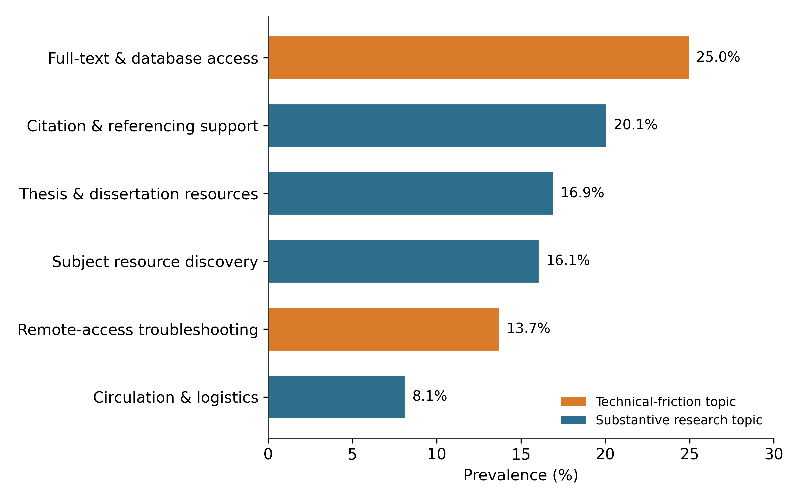
Note. Technical-friction topics are shown in orange and substantive research topics in blue.

Correlations and the UTAUT Engagement Model (RQ4)
Bivariate correlations among the construct means (Table 5) were all positive; performance expectancy (r = .57) and facilitating conditions (r = .55) were most strongly associated with engagement, and social influence was weakest (r = .32). All correlations were significant at p < .05, and all except the social influence–facilitating conditions pair (r = .21, p = .011) were significant at p < .01.

Table 5
Pearson Correlations Among the Key Constructs (N = 147)
Construct | PE | EE | SI | FC | RSE | BEA
PE | —
EE | .45 | —
SI | .42 | .37 | —
FC | .51 | .38 | .21* | —
RSE | .44 | .40 | .41 | .47 | —
BEA | .57 | .36 | .32 | .55 | .55 | —
Note. PE = performance expectancy; EE = effort expectancy; SI = social influence; FC = facilitating conditions; RSE = research self-efficacy; BEA = behavioural engagement. All coefficients are significant at p < .01 except SI–FC (marked *), which is significant at p < .05 (two-tailed).
The hierarchical multiple regression model (Table 6) was significant, F(5, 141) = 26.19, p < .001, and explained 48.2% of the variance in behavioural engagement (R = .69, R² = .482, adjusted R² = .463). The Durbin–Watson statistic (1.97) indicated independent residuals, and all VIFs were below 1.7, confirming that the model is free of problematic multicollinearity. Performance expectancy (β = .30), research self-efficacy (β = .29), and facilitating conditions (β = .25) were the only significant predictors. Contrary to the original hypotheses, effort expectancy (β = .01, p = .880) and social influence (β = .02, p = .795) were both non-significant. Figure 5 ranks the standardised coefficients.
Table 6
Hierarchical Multiple Regression Predicting Behavioural Engagement (N = 147)
Predictor | B | SE B | Β | t | p
(Constant) | 0.23 | 0.27 | — | 0.85 | .396
Performance expectancy | 0.35 | 0.09 | .30 | 3.88 | < .001
Effort expectancy | 0.01 | 0.08 | .01 | 0.15 | .880
Social influence | 0.02 | 0.07 | .02 | 0.26 | .795
Facilitating conditions | 0.23 | 0.07 | .25 | 3.33 | .001
Research self-efficacy | 0.31 | 0.08 | .29 | 3.82 | < .001
Note. R = .69; R² = .482; adjusted R² = .463; F(5, 141) = 26.19, p < .001; Durbin–Watson = 1.97; all VIF < 1.7.
Figure 2
Standardized Regression Coefficients of UTAUT Constructs on Behavioural Engagement
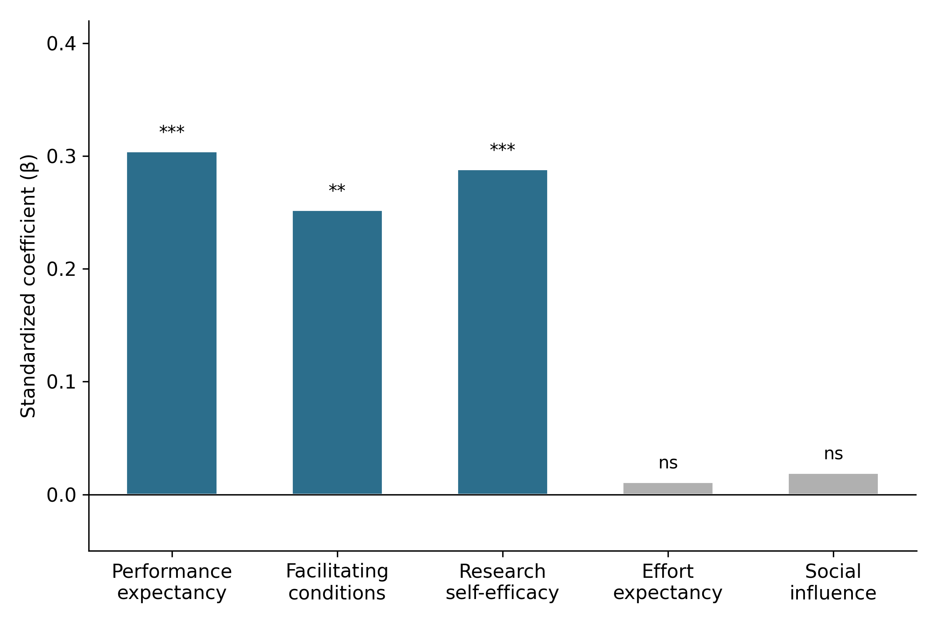
Note. *** p < .001; ** p < .01; * p < .05; ns = non-significant.

Predicting Successful Retrieval (RQ3)
The logistic regression model (Table 7), fitted on all 3,612 sessions with research self-efficacy linked from each session’s user-hash to their survey response, fitted the data adequately, Hosmer–Lemeshow χ²(8) = 4.40, p = .82; Nagelkerke R² = .21, and classified 72.4% of sessions correctly (AUC = .74). The probability of success rose with query specificity (OR = 1.89) and research self-efficacy (OR = 1.62) and fell with each additional reformulation (OR = 0.68), with off-peak timing (OR = 0.71), and most sharply for sessions dominated by the remote-access topic (OR = 0.54). All five predictors were significant at p < .001.
Table 7
Binary Logistic Regression Predicting Successful Retrieval (N = 3,612 Sessions)
Predictor | B | SE | Wald | df | p | Exp(B)
Query specificity index (z) | 0.64 | 0.04 | 229.2 | 1 | < .001 | 1.89
No. of reformulations | −0.39 | 0.03 | 124.0 | 1 | < .001 | 0.68
Remote-access topic | −0.62 | 0.13 | 21.4 | 1 | < .001 | 0.54
Off-peak hour | −0.34 | 0.08 | 17.6 | 1 | < .001 | 0.71
Research self-efficacy (z) | 0.48 | 0.04 | 143.3 | 1 | < .001 | 1.62
Constant | −0.11 | 0.07 | 2.4 | 1 | .118 | 0.90
Note. R² (Nagelkerke) = .21; Hosmer–Lemeshow χ²(8) = 4.40, p = .82; overall classification accuracy = 72.4%; AUC = .74. Remote-access topic and off-peak hour are coded 1 = yes, 0 = no.

Survival Analysis of Research Drop-Off (RQ2)
Kaplan–Meier estimation showed markedly different survival across topics (Table 8; Figure 3). Sessions dominated by remote-access troubleshooting sustained a median of only 3 interaction turns before abandonment, against 8 turns for citation support. The multivariate log-rank test confirmed the difference, χ²(5) = 747.78, p < .001, strongly supporting H6.
Table 8
Kaplan–Meier Median Time-to-Drop-Off by Query Topic
Query topic | n | Median turns to drop-off | 95% CI | Drop-off rate
Citation & referencing support | 726 | 8 | [8, 9] | .72
Subject resource discovery | 581 | 7 | [6, 8] | .77
Circulation & logistics | 294 | 7 | [6, 8] | .77
Thesis & dissertation resources | 612 | 7 | [6, 7] | .81
Full-text & database access | 903 | 5 | [5, 6] | .90
Remote-access troubleshooting | 496 | 3 | [3, 4] | .98
Note. Log-rank (multivariate) χ²(5) = 747.78, p < .001. Drop-off rate is the proportion of sessions in that topic ending in an observed drop-off event rather than censoring.
Figure 3
Kaplan–Meier Session-Survival Curves by Query Topic
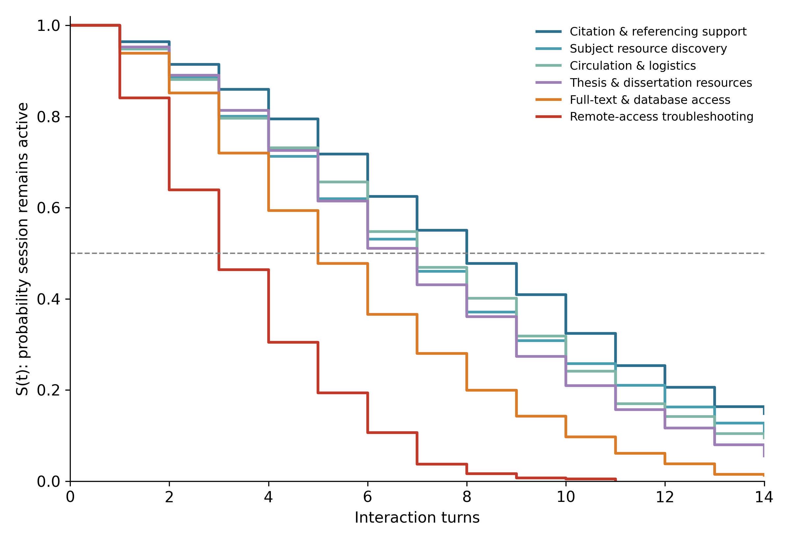
Note. S(t) = estimated probability that a session remains active after t interaction turns. The dashed line marks the median (S = .50).
The Cox proportional-hazards model (Table 9; Figure 4) quantified these effects while adjusting for behavioural and perceptual covariates; discrimination was acceptable (Harrell’s C = .62). Relative to the discovery topic (the implicit reference category), the remote-access topic raised the hazard of drop-off nearly fourfold (HR = 3.99, p < .001), and the full-text/database-access topic raised it by 75% (HR = 1.75, p < .001). After topic was included in the model, neither the number of reformulations, off-peak timing, facilitating conditions, nor research self-efficacy showed a statistically significant association with the drop-off hazard (all p > .30). This pattern qualifies H4 and H5: both facilitating conditions and research self-efficacy remain significant, protective predictors of the perceptual engagement outcome (Table 6) and of session-level retrieval success (Table 7), but neither shows a detectable independent effect on how quickly a session is abandoned once its topic is known. The global test of the proportional-hazards assumption was tenable for most covariates, though the test flagged a borderline violation for research self-efficacy (p = .043), which is noted as a caveat on the precision, though not necessarily the direction, of that estimate.
Table 9
Cox Proportional-Hazards Model for Session Drop-Off (N = 3,612 Sessions)
Covariate | HR | 95% CI | p
Remote-access topic (vs. discovery) | 3.99 | [3.57, 4.46] | < .001
Full-text/database topic (vs. discovery) | 1.75 | [1.61, 1.91] | < .001
No. of reformulations (per +1) | 1.01 | [0.98, 1.04] | .454
Off-peak hour | 1.04 | [0.97, 1.12] | .306
Facilitating conditions (per +1 SD) | 0.99 | [0.95, 1.03] | .582
Research self-efficacy (per +1 SD) | 0.99 | [0.95, 1.03] | .534
Note. HR = hazard ratio; HR > 1 indicates higher drop-off hazard. Harrell’s C = .62. Schoenfeld-residual test of proportional hazards: tenable for all covariates except research self-efficacy (p = .043; see Discussion and Limitations).
Figure 4
Forest Plot of Cox Hazard Ratios With 95% Confidence Intervals for Session Drop-Off
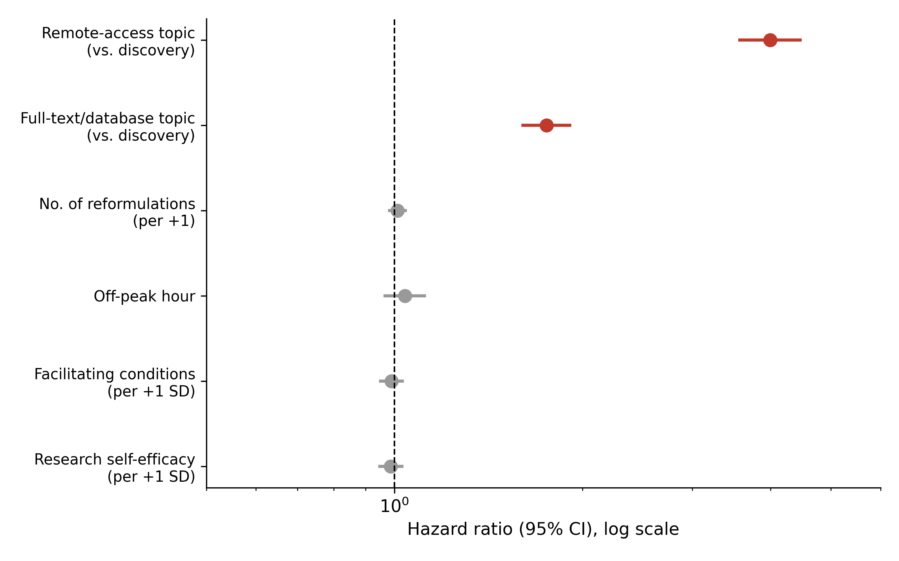
Note. Estimates left of the reference line (HR = 1) are protective; estimates to the right indicate higher drop-off hazard. Markers in grey are non-significant at p < .05.

Summary of Hypothesis Testing
Table 10 summarises the outcome of each hypothesis test against the results reported above. Two hypotheses (H1, H6) were fully supported, two (H4, H5) were partially supported—holding for the engagement and retrieval outcomes but not for the survival hazard—and two (H2, H3) were not supported.

Table 10
Summary of Hypothesis Tests
Hypothesis | Statement (abbreviated) | Decision
H1 | PE → behavioural engagement (+) | Supported
H2 | EE → behavioural engagement (+) | Not supported
H3 | SI → behavioural engagement (+) | Not supported
H4 | FC → engagement (+) and lower drop-off hazard | Partially supported (engagement only)
H5 | RSE → retrieval success (+) and lower hazard | Partially supported (retrieval only)
H6 | Topic differentiates time-to-drop-off | Supported
Note. PE = performance expectancy; EE = effort expectancy; SI = social influence; FC = facilitating conditions; RSE = research self-efficacy.

5. Discussion of Findings
5.1 Interpreting the Socio-Technical Relationship
The findings confirm that student engagement with a conversational virtual reference assistant is a socio-technical phenomenon shaped by both technical and social factors. Consistent with STS theory (Bostrom & Heinen, 1977; Trist & Bamforth, 1951), neither subsystem alone adequately explains user outcomes. Approximately two-fifths of all sessions involved access-related challenges, particularly remote-access troubleshooting and full-text/database access, supporting earlier observations by Guy et al. (2023) and Asemi et al. (2021). These technical-friction topics also exhibited the highest risk of abandonment, indicating that infrastructural barriers are not merely common user concerns but major drivers of disengagement. The findings suggest that while positive perceptions may encourage use, severe technical barriers can still cause rapid abandonment, underscoring the importance of robust digital access infrastructure in academic libraries.
5.2 UTAUT Constructs and Behavioural Engagement
The study provides partial support for UTAUT. Performance expectancy significantly predicted behavioural engagement, corroborating previous studies that identify perceived usefulness as the strongest determinant of AI adoption and use (Andrews et al., 2021; Habibi et al., 2023; Budhathoki et al., 2024). Facilitating conditions also positively influenced engagement, highlighting the importance of institutional support, training, and access to technological resources. However, effort expectancy and social influence were not significant predictors, consistent with Andrews et al. (2021). This suggests that students view conversational virtual reference assistants primarily as productivity tools whose value depends more on their usefulness and available support than on peer influence or ease of use.
5.3 Research Self-Efficacy and Information Retrieval Outcomes
Research self-efficacy emerged as a significant predictor of both behavioural engagement and retrieval success. This finding aligns with evidence that self-efficacy enhances persistence and effectiveness in digital information environments (Prabowo et al., 2024). Students who were more confident in their research abilities were more likely to engage successfully with the assistant and obtain relevant information. However, self-efficacy did not significantly reduce session abandonment, suggesting that confidence alone may not overcome severe technical obstacles. Thus, while research self-efficacy supports successful information seeking, its influence may be constrained by infrastructural limitations.
5.4 Query Characteristics, Retrieval Success, and Session Abandonment
The findings demonstrate that behavioural indicators embedded within conversational logs can effectively predict retrieval outcomes. Consistent with Pan et al. (2022), more specific queries and productive reformulation behaviours increased the likelihood of successful retrieval. Supporting Guan et al. (2013), query reformulation appears to be part of the iterative search process rather than simply an indicator of failure. Nevertheless, repeated reformulations within technical-friction sessions often reflected mounting frustration and eventual disengagement, highlighting important differences between productive search refinement and unsuccessful attempts to overcome access barriers.
5.5 Implications for Socio-Technical Systems Theory
The study extends STS theory by demonstrating that the influence of social and technical subsystems is outcome-dependent. Performance expectancy, facilitating conditions, and research self-efficacy significantly influenced engagement and retrieval success, whereas technical-friction topics exerted the strongest influence on abandonment. These findings suggest that social factors primarily shape users’ willingness and capacity to engage, while technical factors determine whether engagement can be sustained. Consequently, the relative importance of social and technical elements varies across stages of the information-seeking process.
5.6 Practical Implications for Academic Libraries
The findings indicate that reducing technical friction should be a priority for academic libraries seeking to improve conversational AI services. Libraries should strengthen remote-access systems, authentication mechanisms, and database connectivity while implementing automated escalation procedures for high-risk technical queries. At the same time, continued investment in user training, information-literacy programmes, and support services is necessary to enhance research self-efficacy and engagement. Viewed through the TOE framework, these results suggest that successful conversational AI implementation depends not only on technological capability but also on organisational support, staff competence, and sustained infrastructural investment.
.
6. Conclusion, Recommendations, Limitations, and Future Research
6.1 Conclusion
This study examined student engagement with a conversational virtual reference assistant through an integrated socio-technical framework combining interaction-log data and survey responses. The findings revealed that student queries were dominated by access-related challenges, particularly remote-access troubleshooting and full-text/database access issues, which emerged as the strongest predictors of session abandonment and retrieval failure. Conversely, performance expectancy, facilitating conditions, and research self-efficacy significantly enhanced behavioural engagement, while facilitating conditions and research self-efficacy also improved retrieval success.
The study therefore demonstrates that social and technical subsystems influence different aspects of the information-seeking process. While technical barriers primarily determine when users disengage, social factors shape engagement and successful task completion. By integrating behavioural analytics with technology-acceptance measures, the study provides a practical and replicable framework for using conversational AI data to support evidence-based library services.
6.2 Recommendations
- Based on the findings, the study recommends that university libraries:
- Prioritise improvements in remote-access systems, authentication mechanisms, and database connectivity to reduce access-related abandonment.
- Implement topic-based escalation mechanisms that automatically route high-risk technical-friction queries to librarians or support staff.
- Strengthen facilitating conditions through user support services, training programmes, and help-desk assistance.
- Enhance students’ research self-efficacy through information-literacy and database-search training.
- Integrate predictive analytics into library management for continuous monitoring of user engagement and service effectiveness.
- Continuously refine and retrain conversational AI systems using interaction-log data to improve response quality and retrieval outcomes.
6.3 Limitations
The study is limited by its observational design, which permits predictive but not causal interpretations. The single-institution setting may also restrict the generalisability of the findings. Additionally, retrieval success and query specificity were operational proxies rather than direct measures of research effectiveness. The absence of raw query text prevented independent topic modelling, requiring reliance on pre-classified topic categories. Finally, the non-significant hazard effects of facilitating conditions and research self-efficacy should be interpreted cautiously, as they may reflect limitations of the model specification rather than the absence of underlying relationships.
6.4 Future Research
Future studies should replicate the framework across multiple institutions to enhance generalisability. Researchers should also utilise raw conversational data to generate topic structures using advanced NLP techniques such as LDA and transformer-based models. Further work could employ time-dependent and machine-learning survival models to better capture dynamic disengagement patterns. Experimental studies are needed to evaluate the effectiveness of topic-based intervention strategies, while future models should incorporate richer session-level variables such as connectivity quality, response latency, trust in AI, and digital literacy. Such efforts will advance the development of predictive and user-centred virtual reference systems capable of providing more effective and equitable research support.

References
Ali, M. Y., Naeem, S. B., & Bhatti, R. (2021). Artificial intelligence (AI) in Pakistani university library services. Library Hi Tech News, 38(8), 12–15. https://doi.org/10.1108/LHTN-10-2021-0065
Ameri, S., Fard, M. J., Chinnam, R. B., & Reddy, C. K. (2016). Survival analysis based framework for early prediction of student dropouts. In Proceedings of the 25th ACM International Conference on Information and Knowledge Management (pp. 903–912). Association for Computing Machinery. https://doi.org/10.1145/2983323.2983351
Andrews, J. E., Ward, H., & Yoon, J. (2021). UTAUT as a model for understanding intention to adopt AI and related technologies among librarians. The Journal of Academic Librarianship, 47(6), Article 102437. https://doi.org/10.1016/j.acalib.2021.102437
Asemi, A., Ko, A., & Nowkarizi, M. (2021). Intelligent libraries: A review on expert systems, artificial intelligence, and robot. Library Hi Tech, 39(2), 412–434. https://doi.org/10.1108/LHT-02-2020-0038
Blei, D. M., Ng, A. Y., & Jordan, M. I. (2003). Latent Dirichlet allocation. Journal of Machine Learning Research, 3, 993–1022.
Bostrom, R. P., & Heinen, J. S. (1977). MIS problems and failures: A socio-technical perspective. Part I: The causes. MIS Quarterly, 1(3), 17–32. https://doi.org/10.2307/248710
Chen, Y. H., Chang, Y. C., & Keng, C. J. (2025). Glory or darkness? An empirical examination of understanding users’ adoption of ChatGPT via the coping theory: the moderating effect of mindfulness. Behaviour & Information Technology, 44(16), 4017-4036.
Cox, A. M., Pinfield, S., & Rutter, S. (2019). The intelligent library: Thoughts on the future of the academic library and its librarians. Library Hi Tech, 37(3), 418–435. https://doi.org/10.1108/LHT-08-2018-0105
Cox, D. R. (1972). Regression models and life-tables. Journal of the Royal Statistical Society: Series B (Methodological), 34(2), 187–220. https://doi.org/10.1111/j.2517-6161.1972.tb00899.x
Cronbach, L. J. (1951). Coefficient alpha and the internal structure of tests. Psychometrika, 16(3), 297–334. https://doi.org/10.1007/BF02310555
Davis, F. D. (1989). Perceived usefulness, perceived ease of use, and user acceptance of information technology. MIS Quarterly, 13(3), 319–340. https://doi.org/10.2307/249008
Guan, D., Zhang, S., & Yang, H. (2013, July). Utilizing query change for session search. In Proceedings of the 36th international ACM SIGIR conference on Research and development in information retrieval (pp. 453-462).
Guy, M. E., Pival, P. R., Lewis, V., & Groome, K. (2023). Chatbots in Canadian academic libraries: An environmental scan. Information Technology and Libraries, 42(4). https://doi.org/10.5860/ital.v42i4.16511
Habibi, A., Muhaimin, M., Danibao, B. K., Wibowo, Y. G., Wahyuni, S., & Octavia, A. (2023). ChatGPT in higher education learning: Acceptance and use. Computers and Education: Artificial Intelligence, 5, 100190.
Hair, J. F., Black, W. C., Babin, B. J., & Anderson, R. E. (2019). Multivariate data analysis (8th ed.). Cengage.
Hervieux, S., & Wheatley, A. (Eds.). (2022). The rise of AI: Implications and applications of artificial intelligence in academic libraries. Chicago, IL: Association of College and Research Libraries.
Kaplan, E. L., & Meier, P. (1958). Nonparametric estimation from incomplete observations. Journal of the American Statistical Association, 53(282), 457–481. https://doi.org/10.2307/2281868
Nunnally, J. C., & Bernstein, I. H. (1994). Psychometric theory (3rd ed.). McGraw-Hill.
Pan, F., Huang, B., Zhang, C., Zhu, X., Wu, Z., Zhang, M., ... & Li, Z. (2022). A survival analysis based volatility and sparsity modeling network for student dropout prediction. PloS one, 17(5), e0267138.
Prabowo, T. T., Sitthiworachart, J., & Lo, C. K. (2024). Demographic analysis of information literacy self-efficacy among library and information science students in Indonesia. Library & Information Science Research, 46(1), 101281.
Sergeeva, O. V., Zheltukhina, M. R., Shoustikova, T., Tukhvatullina, L. R., Dobrokhotov, D. A., & Kondrashev, S. V. (2025). Understanding higher education students’ adoption of generative AI technologies: An empirical investigation using UTAUT2. Contemporary Educational Technology, 17(2), ep571.
Tinto, V. (1975). Dropout from higher education: A theoretical synthesis of recent research. Review of Educational Research, 45(1), 89–125. https://doi.org/10.3102/00346543045001089
Tinto, V. (2017). Through the eyes of students. Journal of College Student Retention: Research, Theory & Practice, 19(3), 254–269. https://doi.org/10.1177/1521025115621917
Tornatzky, L. G., & Fleischer, M. (1990). The processes of technological innovation. Lexington Books.
Trist, E. L., & Bamforth, K. W. (1951). Some social and psychological consequences of the longwall method of coal-getting. Human Relations, 4(1), 3–38. https://doi.org/10.1177/001872675100400101
Venkatesh, V., Morris, M. G., Davis, G. B., & Davis, F. D. (2003). User acceptance of information technology: Toward a unified view. MIS Quarterly, 27(3), 425–478. https://doi.org/10.2307/30036540
Venkatesh, V., Thong, J. Y. L., & Xu, X. (2012). Consumer acceptance and use of information technology: Extending the unified theory of acceptance and use of technology. MIS Quarterly, 36(1), 157–178. https://doi.org/10.2307/41410412
Yallappa. (2026). Application of AI-based chatbots in academic library reference services: A study. Journal of Library and Information Science Technology, 8(1), 1–5. https://doi.org/10.34218/JLIST_08_01_001

